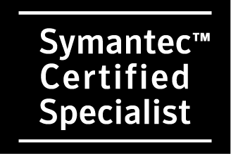

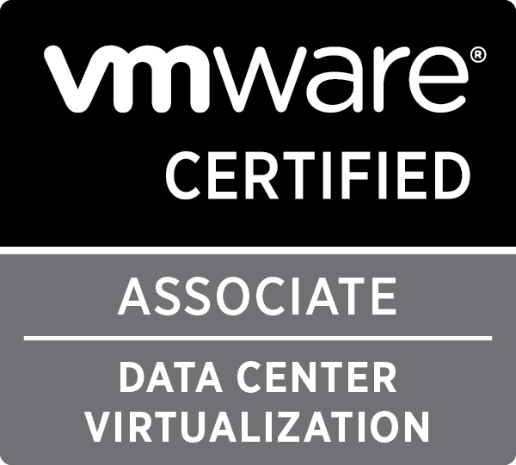
JayaSyam Naru
Mob. : +65 - 9008 6408
E-mail: jayasyam@gmail.com
Career Objective
A position, which can enhance my skills and work potential, invigorate an urge to perform and achieve goals keeping in mind the aesthetics of professionalism. Self-motivated and goals oriented person preferring to work with an organization, which provides opportunities to work on challenging assignments and future requirements of customers.
Professional Summary
Over 9+ years of experience in IT Industry with various levels of experience in Enterprise Netbackup and EMC Networker Implementation & System Administration in Unix/Linux, Windows with physical and virtual tape libraries of various products and storage technologies including SAN/NAS.

Backup Operations including Incident and Change management, coordinate with different teams to resolve issues quickly and effectively.

Performed DR drills and involved in new project implementations (Tech Refresh).

Excellent communication skills and quick to learn new technologies. I adapt to the new environment quickly and mingle with the team to achieve common goal.

Academics & Credentials
- Bachelor of Science in Computer Sciences, S.V University, India, 2004.
- SYMANTEC Certified Specialist, Data Protection Administration for UNIX using Netbackup 6.5, Mar’09.
- EMC Certified Proven Professional Associate, Information Storage and Management Exam v2, Aug’12.
- PEOPLECERT ITIL v3 certified, Apr’13.
- VMWare Certified Associate – Data Center Virtualization, May’14.

Skills Summary/Knowledge

Backup & Recovery – Implementation and Administration of Symantec NetBackup and EMC NetWorker
System Administration – Unix, Linux and Windows Administration and Troubleshooting
De-dupe Technologies – Implementation and Administration of EMC Avamar and EMC Data Domain
Others – DD VTLs, DDBOOST, Exchange, Oracle, NDMP backup configurations

Employment History

Prudential Services Pte. Ltd, Singapore
Designation: Regional Support Specialist – Backup since Dec’14 to till-date

EMC Computer Systems (South Asia) Pte. Ltd, Singapore
Designation: Storage Operations Specialist since Oct’12 to Dec’14

Softenger Singapore Pte. Ltd., Singapore
Designation : Netbackup Adminstrator for client EMC from Oct’09 to Sep’12

TechMahindra Ltd., Pune
Designation :Technical Associate from Aug’08 to Oct’09

Resonsoft Technologies (I) Pvt. Ltd, Hyderabad
Designation : System Administrator from May’05 to Jul’08

Work Experience

1. #Dec’14 – till-date PRUDENTIAL
Infrastructure Services

Environment: All UNIX flavours & Windows.
Tools : EMC Networker 8.1, EMC Data Domain

- Installation, Configuration and Administration of EMC Networker 8.1 in Enterprise level.
- Managing day to day backup activities across various business units.
- Regular DR drills for different business units
- Ensure that the entire NetWorker environment is “DR-Ready”
- Managing Networker Resources like Configuration of Groups, Schedules, Policy, Pools, Directives, Browse and Retention policies for both clients and volumes.
- Managing Networker integrated with DD VTL’s.
- Device Configuration.
- Media Management.
- Strong skills on Networker module based backups.
- Proficient in performing browsable, directed, saveset recoveries.
- Providing service improvement suggestions to the business.

2. # Aug’13 – Dec’14 FX
Data Centre Operations

Environment: All UNIX flavours & Windows.
Tools : EMC Networker 8.2, EMC Data Domain, EMC Avamar 6.1.

- NetWorker UNIX environment Administration and Management
- Performed Oracle, SQL and other database backups and restores
- Performed Disaster Recovery tests which includes Data Domain VTL and Physical Tape Libraries
- Provided end to end support for backup and recovery software solutions and services
- Installing, Configuring and troubleshooting Networker backups, Recovery, Groups, Schedules & Cloning
- Backup & Cloned media to offsite location for business continuity
- Performing client file index recovery for any data restoration request being cross its browse period
- Administration of UNIX Environment and Backup Environment that includes support and solutions for all servers end-to-end.
- VMWare Administration. Install, Configure VMWare ESXi within 4 and 5 environments with Virtual Center management, Lab Manager, and Consolidated backup, DRS, DPM, vMotion and VMWare Data.

3. # Oct’09 – Aug’13 CREDIT-SUISSE
Offline Production Svcs

Environment : All UNIX flavours & Windows.
Tools : Symantec NetBackup 6.5 & 7.0.1.

- BAU activities for NetBackup Infrastructure, which includes incidents and changes.
- Managed NetBackup based infrastructure that provides data protection over 45,000 Unix/Linux/Windows client server backups.
- Implementation of SAN Media and Media servers, Integration of Data Domain systems with NBU.
- Creating and DiskPools, Storage Units, Storage Life Cycle Policies and performing duplications.
- Configuration of DD VTLs and Physical tape library devices including NDMP devices
- Perform and provide health check reports on for backup masters across the globe
- Troubleshoot Master, Media and DD issues and work with Vendors when needed
- Sound knowledge on Symantec OpsCenter & EMC DataDomain.
- Participated in Proof Of Concept for DataDomain DD890 disk backup solution with 10 GbE networking and Boost to address backup challenges such as shrinking backup windows, tape resource/failure issues, DR requirements and small restore windows.

4. # TechMahindra Limited at & t
Aug’08 – Oct’09
EBRT (Enterprise Backup and Recovery Team)
Environment: All UNIX flavours & Windows.
Tools : Vantive, BMC Patrol Explorer Map, Symantec NetBackup 5.0, 6.0 and 6.5.

- Provide support in trouble-shooting and resolving all problems with VERITAS backups, providing primary support on a rotating basis
- Manage backup resources (VERITAS) including disk space, log files, tape drives, and tape media pools.
- Restored data from backup images created previously to the original or alternative client systems.
- Handled failed jobs, submitting them manually & Monitoring backups.
- VAULT Management for disaster recovery on VERITAS NetBackup.
- Profound knowledge of Unix, Linux and Windows.
- Configuring & managing policies on VERITAS NetBackup.
- Maintain Problem /Change Management records in an efficient manner.
- Monitoring of server health (Unix Servers) and server statistics (eg: uptime, free drives space, daemons running) etc through remote monitoring tools like ssh and telnet.
- Maintaining tape libraries using ACSLS and TLD’s.
- Validate that the data backed up is available for recovery.
- Analyzing DB backup failures by checking the Oracle DB logs and crontab scripts.
- Creating Problem reports for further escalation and coordinating with the various responsible groups until the incident has been resolved.
- Record issues and completion in daily shift logs and spread sheets.
- Analyzing failed backup jobs in NBU based on the alerts received on BMC Patrol as per NetBackup error codes generated and rectifying the problems and restarting the failed jobs wherever possible.
- Keeping track of backup media and media errors in a SAN library environment using IBM LTO library GUI web interface.

5. # TechMahindra Limited TFL, Fiji
Mar’09 – Apr’09
TFL IT Capability Assessment
Implemeted Symantec NetBackup 6.5 which includes Installation of Master / Media servers and Configuration of Devices, Storage Units etc.,

- Installation, Configuration and Troubleshooting of Symantec NetBackup 6.5.
- Implemented Symantec NetBackup 6.5 for Sun Solaris 10 for Enterprise backup and recovery strategies.
- Configured Devices, Storage Units and Volume pools.
- Verified Accessibility of Physical tape and robotic devices and configures these for use within NetBackup.
- Introduced and managed tape media for the use by NetBackup.
- Configured and created policies in NetBackup 6.5, as per Client requirements.
- Preformed Backups and Restores.
- Manually and automatically initiated backup jobs for previously configured backup policies.
- Restored data from backup images created previously to the original or alternative client systems.
- Troubleshooting of Backups/Restores using Symantec NetBackup 6.5.

6. # Reasonsoft Technologies (I) Pvt. Ltd
May’05 to Jul’08
Infrastructure Management
- Installation, Configuration and Upgradation of the operating Systems.
- System administrator to all REDHAT Linux servers.
- Created, Set up, and administered all user accounts on Unix and NT.
- In charge of all network printers and print servers. Print servers were Unix and NT.
- Did problem resolution for Application development team, Database team and end users.
- Worked on various departmental projects parallel with daily tasks and responsibilities.
- Creating and Maintaining Software Raid’s and Logical Volume Manager.
- Handled technical and process related escalations.
- Troubleshooting the issues and fixing the server issues as high priority.
- Administered and Managed StoraeTek SL 500 library through library software ACSLS.
- Responsible for taking the backups using Legato Networker.
- System monitoring and administration for Legato Networker and providing support for Data Recovery and all Backups.
- Providing troubleshooting procedures for Networker.

