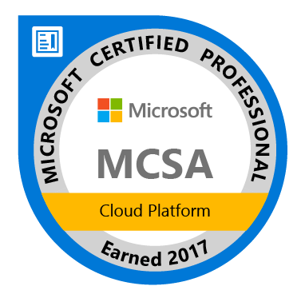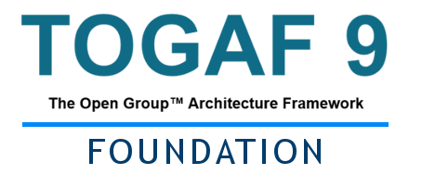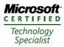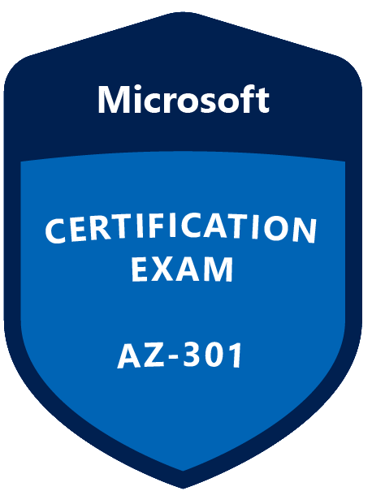
Bharath. P
E-Mail: bharathp1972@gmail.com / bhalak1210@gmail.com
Mobile No: +91 8610233490
PROFESSIONAL SNAPSHOT

➲ IT Management & Architecture Strategist offering excellence in planning, monitoring, executing and deploying modern IT technology by leveraging skills in infrastructure system set-up, support and management while executing large scale projects
Career Summary

- Senior IT Professional offering 19 years of extensive global multi-cultural and diversified experience in spearheading large scale IT Cloud/Collaboration projects; 4 years of experience on Cloud computing, 8+ years of experience in solution designing and 8 years of experience in Windows, VMware technologies.
- Design and build solutions in Microsoft Azure that are in-line with industry standards and best practices.
- Created migration strategy for cloud migration, handled different phases in cloud migration like discovery, assessment, design, migration and testing.
- Participated in customer meeting, handled application owner interview to understand CMO.
- Created scripts using PowerShell.
- Architecting migration strategies which involves cross forest migration.
- Created artifacts like High- & low-level design guide, implementation guide, requirement summary and analysis document.
- Worked and created solutions for global customers.
- Involved in requirements gathering and assessment for various projects.
- Designed Active Directory environment with integrated DNS which has multiple sites across the globe.
- Involved in Active Directory (Domain\Forest) and VMware migration projects.
- GPO design and implementation.
- Active Directory consolidation project.
- Configuration enclosure and HP blade servers.
- Maintenance of servers and service including print server, File server and DHCP servers.
- Installation and configurations of windows servers, ESX servers.
- Migration on physical server to virtual, P2V.

Cloud Projects

- Migration on-Prem workloads to azure: Created end to end solution to migrate On-prem workloads to Azure public cloud for various global customer.
- Extend On-Prem AD to Azure: Solution provided to extend on-premises Active Directory Domain and DNS to Microsoft Azure. Post migration to Azure the VMs use Domain controller/DNS server hosted in Azure for authentication and name resolution.
- Design VNET/Subnet in Azure: Created design to implement VNET/subnets in Microsoft Azure. Design is created in line with best practices that will offer maximum security, co- existence with on-premise infrastructure, easy to manage and accommodate future requirements.
- Azure AD Connect: Designed solution to sync on-premises Active directory with Azure Active Directory with Azure AD connect. Solution enables SSO and multifactor authentication.
- Azure MFA: Solution is developed by setting up NPS server and installed with NPS extension to connect with Azure MFA as a secondary authentication for VPN server.

- Designed a solution to host Health care Application in Azure public cloud
Solution is developed to host Health care Application in Azure by setting up domain controllers, WEB servers, Integration server, DB servers in Azure cloud and deployed WAF.
- Designed a solution to host Insurance Application in Azure public cloud
Solution is developed by setting up Application server, WEB servers, Integration server, DB servers in Azure cloud, deployed HUB and Spoke model (VNET), Vnet Peering and site to site with On-prem.
- Azure connectivity: Designed solution to setup site to site and Point to Site and Global VNET Peering.
- VNET Authorization/Express Route: Designed the solution to authorize the VNET in different subscription with Express Route to get connected to On-Premises.
- Designed a solution to connect On-prem server to the servers in Azure in a Non-Routed Address space
Solution is developed by setting up Azure Firewall in the Routed VNET which is connected Via Express Route. The Routed VNET and NON-Routed VNETs are peered. The UDR has been setup in Routed VNET to forward the packet to On-prem server.
- Azure Site Recovery: Solution is developed to setup ASR between Azure pair Regions.
- Azure File share integration with Active directory: Solution given and implemented Azure file creation and integration with Active directory in Azure public cloud.
- VM Automation: Created ARM template for VM deployment for the client requirement.
- DR Design: Designed a solution for DR between 2 Azure regions, implemented and done the DR Failover test successfully.
- Isolated VNET Setup: Design a solution to provide isolated VNet for their application testing using Azure Bastion.

Active Directory

- Designed Active Directory environment with integrated DNS which has multiple sites across the globe.
- Designed and Deployed Group Polices both at Domain and OU level.
- Designed and Implemented DHCP service with Backup DHCP
- Used ADMT (Active directory migration tool) to migrate objects such as users, servers, groups and computers between the forests.
- Migration of Application servers from multiple domains to single forest domains. Source domains are legacy and target are windows server 2012 environment. The ADMT is the tool used for this migration.
- Active Directory consolidation: Single forest with 60 child domains where 450 domain controllers installed to support Active directory. Active directory is consolidated to 120 domain controllers and each domain installed with two domain controllers.
- Active directory logical split: Solution has been provided to the client that the existing Active directory data has been analyzed and logically split for two entity. The required OUs and groups are created as part of the design with the user movement.
- Designed solution and provided support to implement Quest AD Monitoring tools in Active directory environment.

VMware

- The migration of Global catalogue server running on in ESX 2.5 to ESX 3.5 and in the meantime, need of increase the system drive and RAM Upgrade as part of the project.
- Having experience in implement, troubleshoot and configure VMware virtual machines.
- Installations of ESX servers and patching
- HA/DRS configurations.
- Migration of Physical server from On-prem to VMware using VMware convertor.

Scripting

- Having middle level experience in below mentioned scripts tools.
- Power shell

Cloud Implementation Experience

- Virtual Machines
- VM Automations using ARM template (Json)
- Point to Site
- Site to Site (Route based and Policy Based)
- Load Balancers
- Azure Firewall
- Virtual Networks
- Applicate Gateway/WEB Application Firewall
- Traffic Manager
- Log Analytics
- VPN Gateway setup
- VNET Peering
- Azure Synapse setup
- Azure Data Brick setup
- Azure data Factory
- Azure data lake setup
- Storage/Disk configuration and provisions
- App Service Environment
- App service plan
- Azure Site Recovery
- Network Security Configuration
- Backup
- Patching
- Alert Configurations
- Key vault setup
- ARM Template

Work Experience

- Hewlett Packard Ltd. – October 2007 to till date
Roles performed: Level 3 engineer-Windows/VMware

- Hewlett Packard Enterprise Services – October 2011 to 2017 September
Roles performed: Solution Design Engineer-Active Directory

- DXC Technology – October 2017 to till date
Roles performed: Azure Cloud Engineer/Architect

- Atheros Wireless Communication – Jun 2006 to September 2007
Role Performed: System Administrator (Windows)

- OMCOMPUTERS – February 2002- April 2006
Role Performed: System Administrator (Windows)

Certifications
- Microsoft Azure Certifications
AZ-301 -Microsoft Architect design
AZ-500 -Microsoft Security Technologies
70-534 -Architecting Microsoft Azure Solutions
70-533 - Implementing Microsoft Azure Infrastructure Solutions

- Microsoft® Certified Solutions Expert
Server Infrastructure

- Microsoft® Certified Solutions Associate
Windows Server 2012, Windows Server 2008, Cloud Platform (AZURE)

- Microsoft® Certified IT Professional
Server Administrator on Windows Server 2008

- Microsoft® Certified Technology Specialist
Administering and deploying system center 2012 Configuration manager
Windows Server 2008 R2, Server Virtualization
Windows Server Virtualization, Configuration
Windows Server 2008 Active Directory, Configuration
Windows Server 2008 Applications Infrastructure, Configuration
Windows Server 2008 Network Infrastructure, Configuration

- Other Certification
Cisco Certified Network Associate
ITIL V2: Exim ITIL Certified
TOGAF

EDUCATIONAL DETAILS

- Bachelor of computer Application (BCA) from Madurai Kamara jar University, Tamil Nadu, India.
- Diploma in Electrical and Electronics Engineering from Bhaktavatchalam Polytechnic, Tamil Nadu, India

