VPOS 7
Intergrade with Auto Count Accounting
(XLS Format)
Step 1:
VPOSEXP7.exe(Ver 7.0 (20150617)) > File> General setup
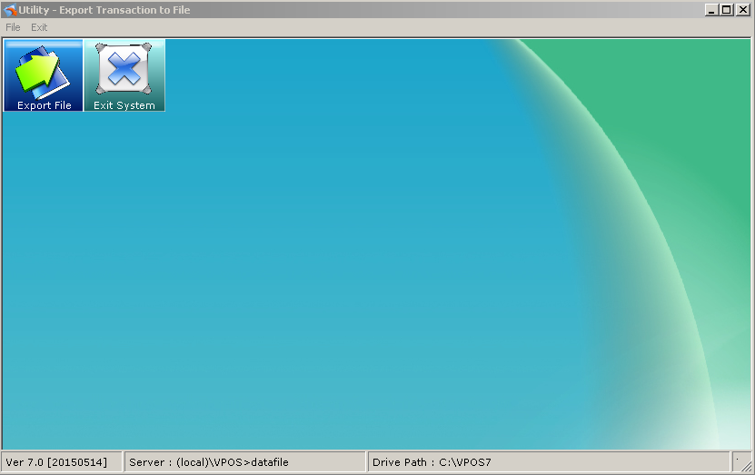
Step 2:
Network Type:[LAN] local area Network
Export Path : D:\VPOS7\PosExp (the location path to export.)
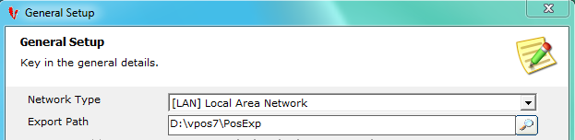
Step 3:
Click the Front POS tab,
[Front POS] Export Style:VPOS7 - [AC] auto Count Accounting (GST Version)
[Front POS] File Format : [XLS] – Example:XX XX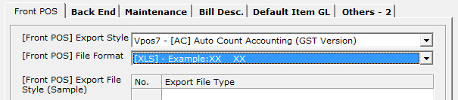
Step 4:
Click the Bill Desc. tab, key in all the bill type description.
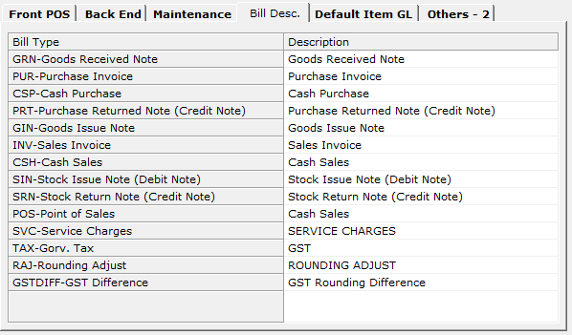

Step 5:
Click the Default Item GL, Follow by the accounting system GL Code.
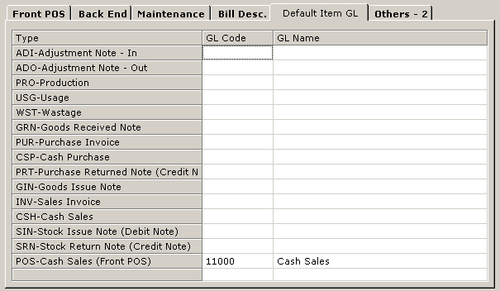

Step 6:
General Setup - > Others-2
Cash Sales Account : Cash sales GL CODE in accounting system