VPOS 7
Intergrade with
SQL Accounting System
(XML Format)
Step 1:
VPOSEXP7.exe( Ver 7.0 (20150617)) > File> General setup
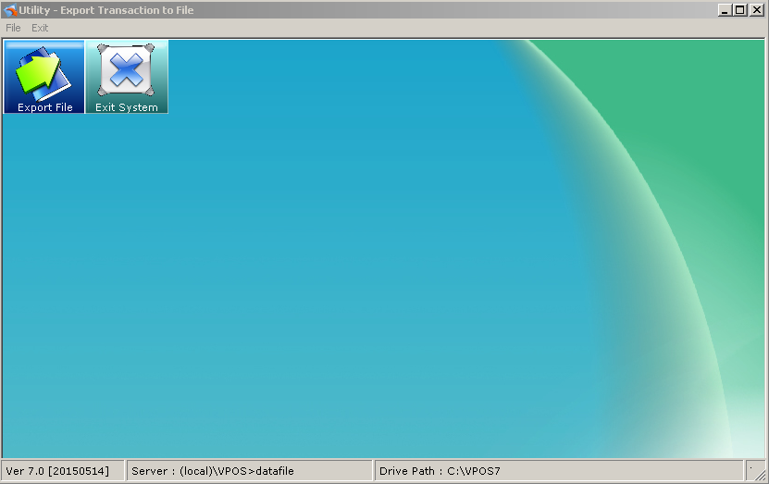
Step 2:
Network Type:[LAN] local area Network
Export Path : D:\VPOS7\PosExp (the location path to export.)
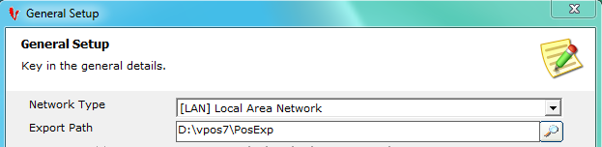
Step 3:
Click the Front POS tab,
[Front POS] Export Style:VPOS7 - [Q4] SQL Financial Accounting - XML Format [GST Version]
[Front POS] File Format : [XML] - Example: <>XX</>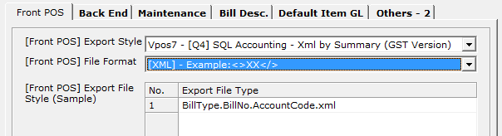
Step 4:
Click the Bill Desc. tab, key in all the bill type description.
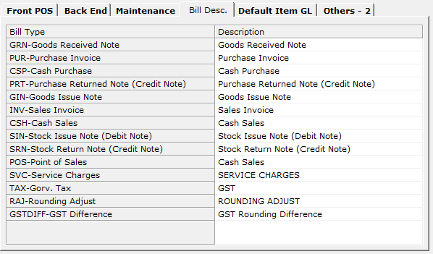

Step 5:
Click the Default Item GL, Follow by the accounting system GL Code.
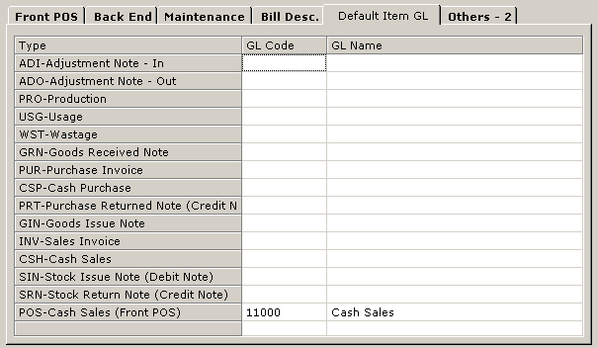

Step 6:
General Setup - > Others-2
GL export by Outlet : [ uncheck ]
** if [checked] each outlet follow by own running customer Trade Code.
Bill No. with Outlet Code:[ uncheck ]
** if [checked] Bill number export with outlet code, example:V001-100001(outletcode-billno)
Default Account Code : CASH
Discount Code : DISC
Service Charges Code : SVRCHARGE
Rounding Code : RDNSCENTS
GST DIFFERENCE CODE : Please follow the accounting system Code
POS – CN GL CODE : Please follow the accounting system Code
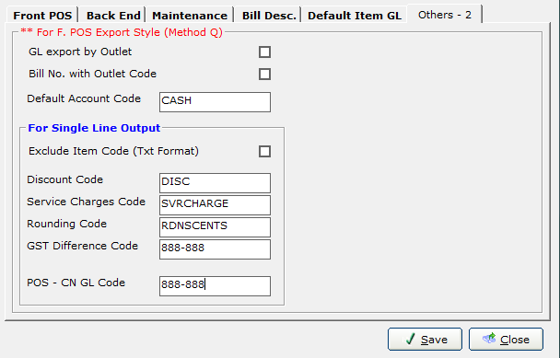

Step 7
* how to maintain GL code : File > GL Maintenance , create the code and name , according the accounting system.
