Recalculate tools
Step 1:
Open the latest Frontend.
1.1 FrontEnd Recalculate screen shoot.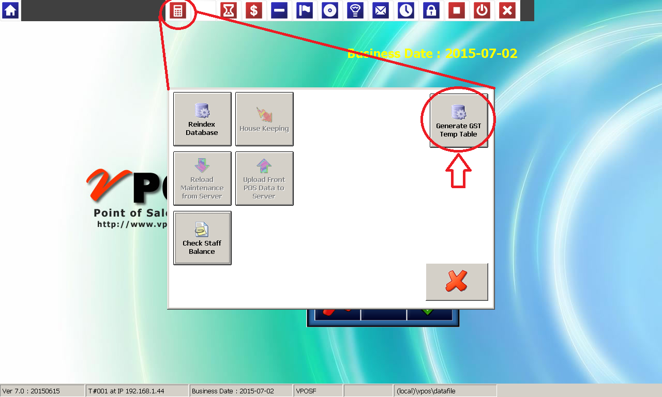
Step 2:
2.1 FrontEnd Recalculate screen shoot
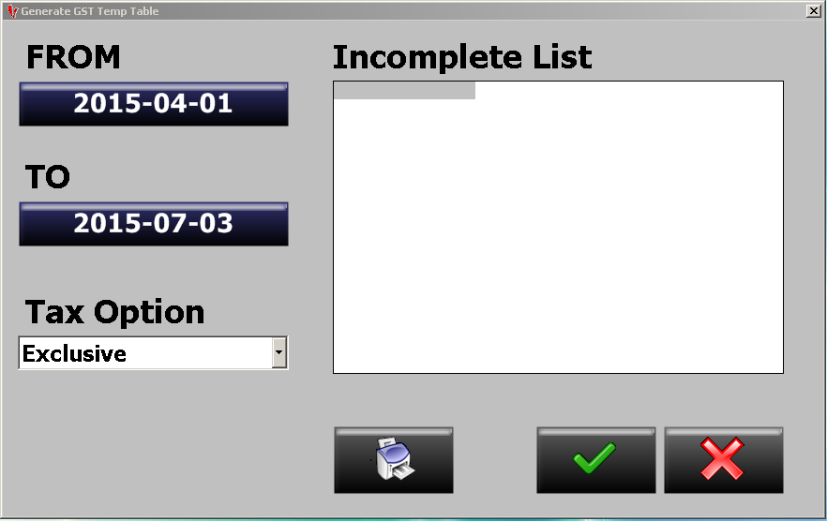
Filter date from and date to for recalculate.
Select the Tax Option: Exclusive or Inclusive.
Step 3:
Press the button to proceed.
Step 4:
If have PLU code missing and item does not mapping any classification, the item code will display in the incomplete list.
Step 5:
Press the Printer button to print report.

