VPOS 7
Intergrade with Million Accounting (GST Version)
Step 1:
VPOSEXP7.exe(Ver 7.0 (20150617)) > File> General setup
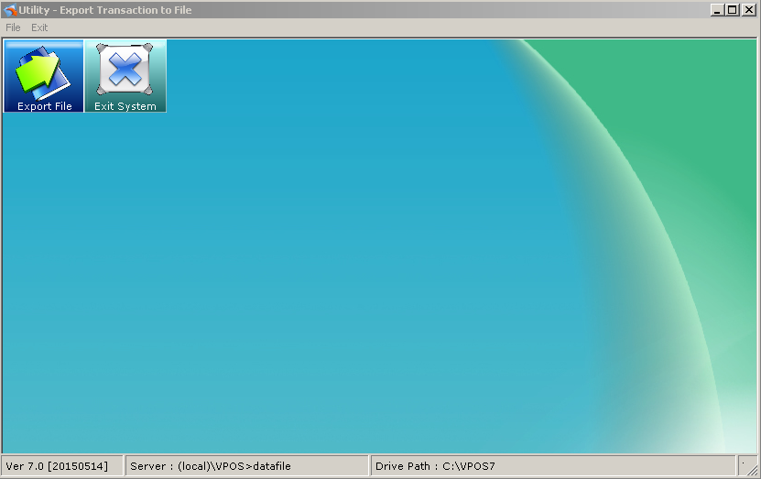
Step 2:
Network Type:[LAN] local area Network
Export Path : D:\VPOS7\PosExp (the location path to export.)
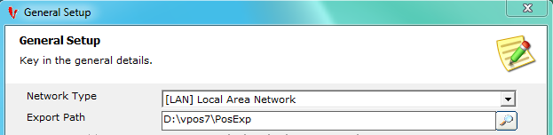
Step 3:
Click the Front POS tab,
[Front POS] Export Style:VPOS7 - [T] Million Accounting (GST Version)
[Front POS] Million Path: (C:\Milion)-Set The path where Million System Installed in which path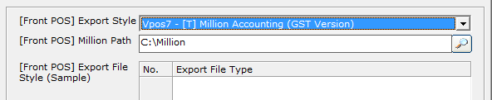

Step 4:
Click the Bill Desc. tab, key in all the bill type description.
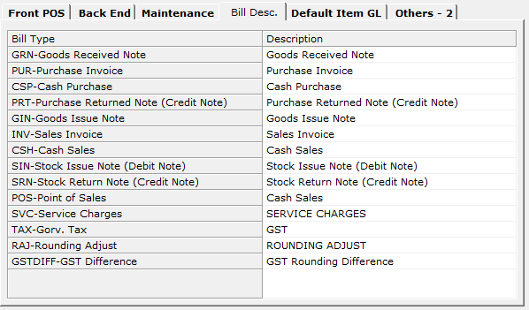

Step 5:
Click the Default Item GL, Follow by the accounting system GL Code.
