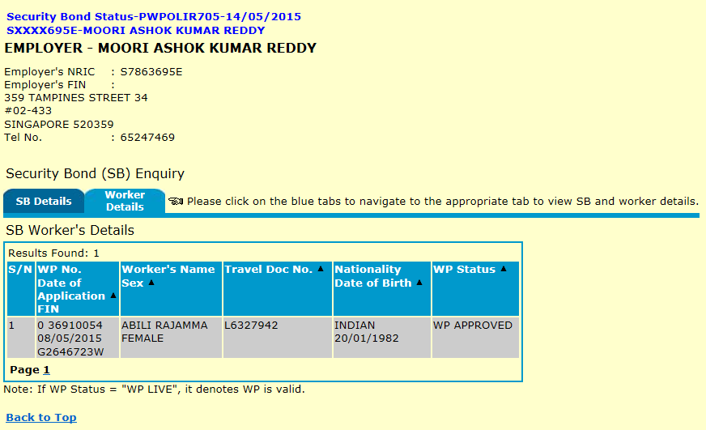

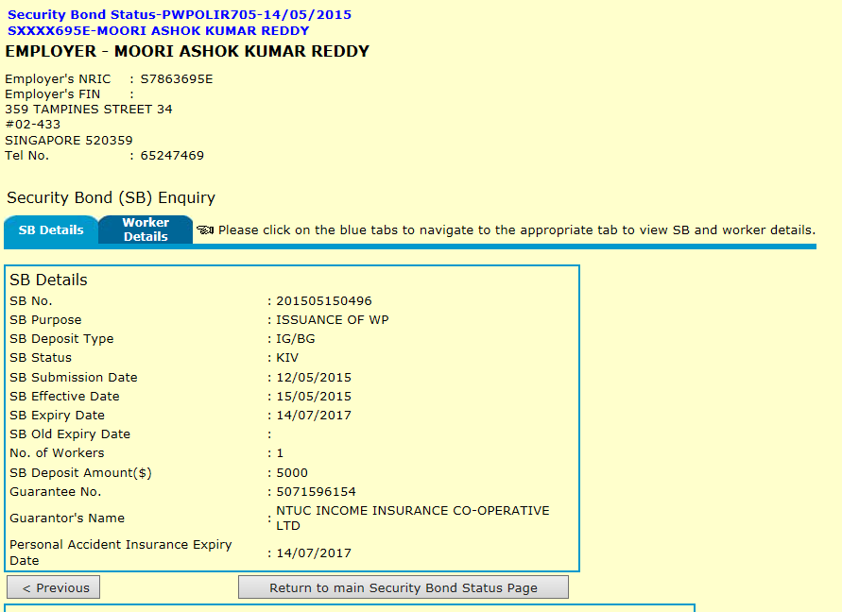

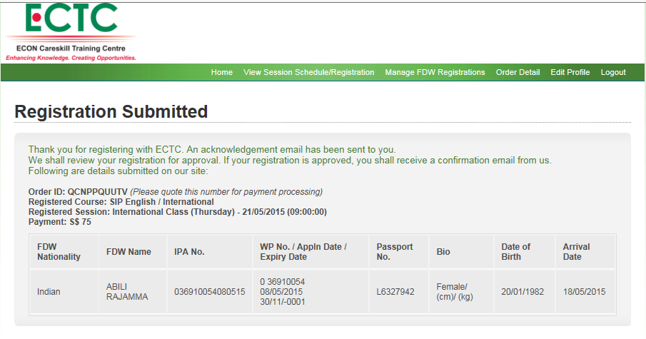

Registration Submitted
Thank you for registering with ECTC. An acknowledgement email has been sent to you.
We shall review your registration for approval. If your registration is approved, you shall receive a confirmation email from us.
Following are details submitted on our site:

Order ID: QCNPPQUUTV (Please quote this number for payment processing)
Registered Course: SIP English / International
Registered Session: International Class (Thursday) - 21/05/2015 (09:00:00)
Payment: S$ 75
FDW Nationality | FDW Name | IPA No. | WP No. / Appln Date / Expiry Date | Passport No. | Bio | Date of Birth | Arrival Date
Indian | ABILI RAJAMMA | 036910054080515 | 0 36910054  08/05/2015  30/11/-0001 | L6327942 | Female/ (cm)/ (kg) | 20/01/1982 | 18/05/2015

Issue Work Permit-PWPOLIR712-29/05/2015
SXXXX695E-MOORI ASHOK KUMAR REDDY

WORKER - ABILI RAJAMMA

  FIN | : | G2646723W
  Nationality | : | INDIAN
  Sex | : | FEMALE
  Date of Birth | : | 20/01/1982
  Age | : | 33
  WP No. | : | 0 36910054
  Date of Application | : | 08/05/2015

If any of the personal particulars above is incorrect, do not proceed. You should submit a clear copy of the worker's travel document to us using iSubmit (www.mom.gov.sg/isubmit). Select Request Type 4 and indicate the particulars to be amended under the Message section. You may then proceed to submit your issuance request after we have amended the particulars.

Request By
User | : | MOORI ASHOK KUMAR REDDY
Company | :
Submission Date/Time | :
Issuance Request Status | : | Draft

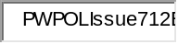
Employment Information
Date of Temporary WP | : | 19/05/2015 | Skill Level | : | UNSKILLED
Security Bond (SB) No. | : | 201505150496 | SB Expiry Date | : | 14/07/2017
Personal Accident Insurance Expiry Date : 14/07/2017
Worker's Occupation | : | 91101A-DOMESTIC WORKER
Employer's Name | : | MOORI ASHOK KUMAR REDDY
Employer's Address | : | 359 TAMPINES STREET 34  #02-433  SINGAPORE 520359
WP Expiry Date | : | 14/05/2017

Worker's Travel Document Information
(You should update us if there are changes to the worker's travel document Information.)

 | Current | New (if any)
Travel Document No. | L6327942 | 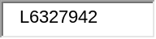
Travel Document Expiry Date | 23/01/2024 | (DD/MM/YYYY)

Compulsory Update of Worker's Details

Worker's Full Medical Examination Results
(If the worker is currently pregnant, do not proceed. You should fax the printout of this screen with your contact no. to 65320795. You may then proceed to submit your issuance request after we have contacted you.)
Certification by Singapore-registered Medical Doctor:
FIT FOR EMPLOYMENT IN THE ABOVE-STATED OCCUPATION
Date of Doctor's Certification in Medical Report | : | 23/05/2015 (DD/MM/YYYY)

Medical Insurance (MI) Details
Note:
Employers are required to purchase and maintain a minimum medical insurance coverage of $15,000 per year for each Work Permit holder for inpatient care and day surgery.
Name of Insurer | : | NTUC INCOME INSURANCE CO-OPERATIVE LTD
Policy No. | : | 5071596154 
Commencement Date | : | 15/05/2015 
Expiry Date | : | 14/07/2017 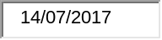

Card Delivery Details
To make the card delivery successful and secure
- You are encouraged to provide 3 authorised recipient(s) (e.g. company representative, employer, pass holder, etc.)
- Authorised recipient(s) must be present, in person, at the delivery address (e.g. your office, employment agency, home etc.)
- We will check his / her photo ID (e.g. NRIC, work pass card, travel document of the pass holder, etc.) upon delivery
- We cannot allow changes in delivery schedule / address / authorised recipient(s) due to the short turnaround time from pass issuance to card delivery
For more information on card delivery, please go to www.mom.gov.sg/card-delivery
I want the card to be delivered to: | 359 TAMPINES STREET 34  #02-433  SINGAPORE 520359
We need the authorised recipient(s)' mobile numbers for us to send SMS on the delivery date / time at least 1 working day before the delivery and also to call them before delivery. Please inform the recipient(s) if you have authorised them to receive the card.
Authorised  Recipient | Name  Mobile No.  Email | ID Type | ID No.
1 | MOORI ASHOK KUMAR REDDY  81188449  ashokvar@gmail.com | NRIC | S7863695E
2 | BOJJIREDDY SOUJANYA  93365499  ashoksowji@gmail.com | NRIC | S8477350F
3

Declaration
• | All the information and documents I have submitted for this Work Permit Issuance request are true and correct. I understand that if I make any false declarations, the Work Permit will be cancelled and I will be guilty of an offence.
• | I agree to give consent to WPD to verify my/my spouse's income with the Inland Revenue Authority of Singapore (IRAS) if the application for the Work Permit is earlier made via WPOL.
• | I need to pay the Foreign Worker Levy through GIRO and will send the GIRO Application Form to CPF Board, if required.
• | I will retain a copy of the worker's Medical Insurance (MI) Policy and produce it to MOM for verification at any time. If MOM requires the same information from the insurer providing the MI policy, I will have no objections for the insurer to release the information directly to MOM.

Payment of Issuance Fee and Overstaying Fine (if any)
Payment Details
Type of Payment for Worker |  | Amount (SGD)
 | 1. Issuance Fee | $30
 | Total Amount | $30
 | GST (if any) | $0

Note:
Please check all the information entered and the computed WP expiry date shown in the "Employment Information" section before submitting. Otherwise, a $60 fee will be charged if there is a need to re-print the Card.
To proceed, click <Pay & Submit> once.
Payment may take some time, so please do not open another window or start a new request while payment is in progress.
If payment is successful, a confirmation page will be displayed.
If you do not get a confirmation page, the payment may not be completed. Check this using "Retrieve Draft Request for Work Permit Issuance" function in the left hand menu and submit again.

Issue Work Permit-PWPOLIR714-29/05/2015
SXXXX695E-MOORI ASHOK KUMAR REDDY

WORKER - ABILI RAJAMMA

  FIN | : | G2646723W
  Nationality | : | INDIAN
  Sex | : | FEMALE
  Date of Birth | : | 20/01/1982
  Age | : | 33
  WP No. | : | 0 36910054
  Date of Application | : | 08/05/2015
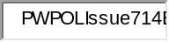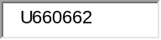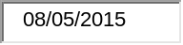
Your WP issuance request is completed!
 | Request made by
 | User | : | MOORI ASHOK KUMAR REDDY
 | Company | :
 | Submission Date/Time | : | 29 May 2015 11:41 AM
 | Issuance Request Status | : | APPROVED
 | WP Issuance Date | : | 29/05/2015
 | WP Expiry Date | : | 14/05/2017


Payment Details
Your payment is successful.
 | Receipt No | : MOM0001033773644
 | ePayment Ref. No. | : CC15052911404804
 | Payment Status | : PAID
 | Payment Mode | : eNETS
 | Bill Ref. No. | : EI0001671999

Type of Payment for Worker |  | Amount (SGD)
 | 1. Issuance Fee | $30
 | Total Amount | $30

Please click on the <Print Letter(s)> button below to view and print the:
• Notification Letter


The letter(s) will be displayed in a pop-up window. If this does not happen shortly, please click here .
If the printing fails, you can print via the "Check Status - Issuance Request" under "Issue" from the function side menu.
Note:
Employer can login to WP Online to find out whether the worker is eligible for renewal, six to eight weeks before the WP Expiry Date, if he/she wishes to renew the WP. Please note that WP renewal is subjected to prevailing conditions.

You should now book an appointment for the worker to report for Card registration at MOM Services Centre - Hall C within the next 7 days. Visit to the MOM Services Centre is strictly by appointment only.
Note:
To book an appointment for a group of workers, you can do so after you have submitted the issuance

We have improved the Issuance function to allow you to submit supporting documents, inform us where you want the Work Permit (WP) Card to be delivered to and also make an appointment for the worker to report for Card registration at MOM Services Centre - Hall C if required. These improvements aim to provide you with greater convenience and reduce the no. of trips you need to make to MOM.
- It will take you around 15 minutes to complete this request and it will be processed immediately upon submission.
- Before you proceed, make sure the worker is in Singapore and you have:
  - Updated the worker's residential address via our Online Foreign Worker Address System (OFWAS) at www.mom.gov.sg
  - A local address and contact details for us to deliver the WP Card
  - Completed and Clear scanned copies of
    - the worker's travel document, disembarkation / embarkation Card (i.e. the Immigration White Card (IMM27)), medical examination form
    - the WP application form
    - the security bond form (this is not the letter of guarantee your insurer or bank gave you. Get the security bond form from WPOL > Enquire > Security Bond Status)
(Note: You may be asked to upload more or fewer documents depending on what you have entered during online issuance.)
  - GIRO/Credit Card/eNets Debit information for online payment

- For change of employers of non-Malaysian workers, you must get the letter of consent from the current employer to transfer the worker to the new employer. Work Pass Division (WPD) will not be responsible for any disputes arising from this

