- Highlight
- Note
- Expand Highlight
- Expand Note
Module 10: Implementing Network Security
Contents:
Lesson 1: | Overview of Network Security
Lesson 2: | Implementing Firewalls
Lesson 3: | Network Access Protection
Lab: | Implementing Network Security

Module Overview
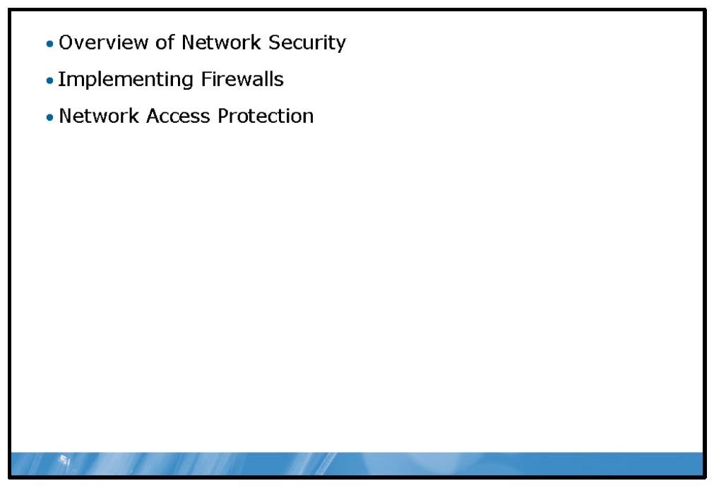
When you connect your computers to a network, you may expose them to additional security threats. It is important that you identify possible threats, and implement appropriate Windows® network security features to help to eliminate them.

Objectives
After completing this module, you will be able to:
• | Identify network-based security threats.
• | Implement Windows Firewall to secure Windows hosts.
• | Explain how to enforce corporate compliance.

Lesson 1: Overview of Network Security
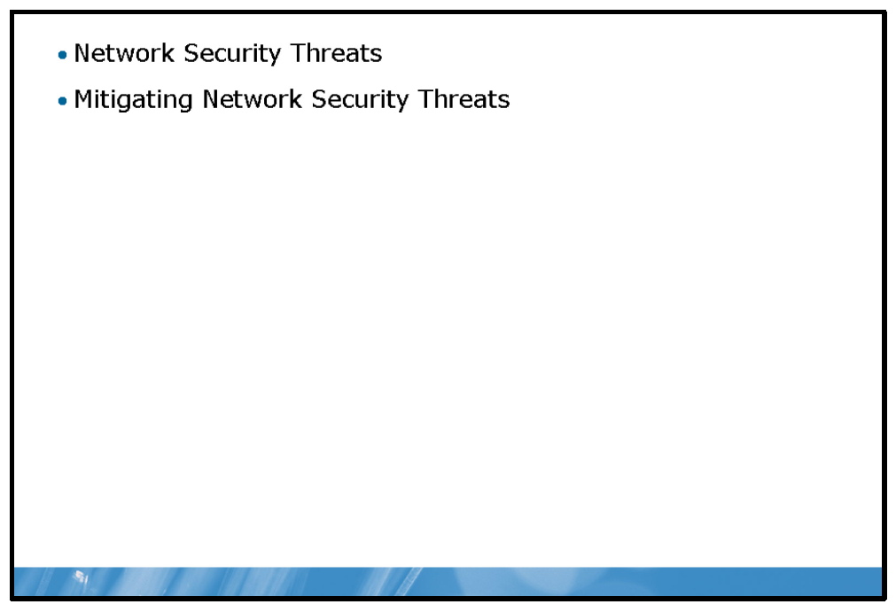
There are many network-based security threats. It is important to understand the nature of these threats and be able to implement appropriate security measures to mitigate them.

Objectives
After completing this lesson, you will be able to:
• | Describe the security threats that can appear on networks.
• | Describe common solutions to these threats.

Network Security Threats
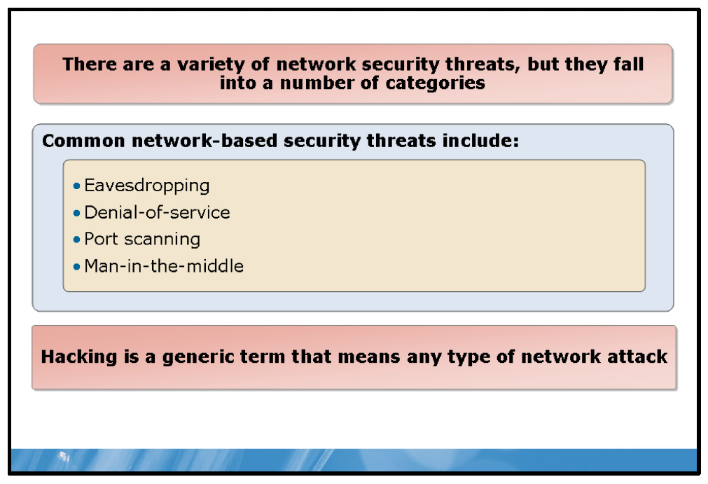

Key Points
There are a variety of network security threats, but they fall into a number of categories. Common network-based security threats include:
• | Eavesdropping. An eavesdropping attack occurs when a malicious person captures network packets being sent and received by workstations connected to your network. Eavesdropping attacks may result in sensitive data, such as passwords, being compromised which can lead to other, perhaps more damaging, attacks.  Note: Eavesdropping is also known as sniffing.
• | Denial-of-service. This attack is intended to limit the function of a network application, or make the application, or network resource, unavailable. There are numerous ways in which a malicious person can initiate a denial-of-service attack; often, however, the attacker is aware of vulnerabilities in the target application that they can exploit in order to render it unavailable.
• | Port scanning. Applications running on a Transmission Control Protocol/Internet Protocol (TCP/IP) host use TCP or User Datagram Protocol (UDP) ports to identify themselves. One way in which an attacker can exploit your network is to query hosts for the ports on which they listen for client requests; these ports are said to be open. Once an attacker can identify an open port, they can use other attack techniques to attempt to gain access to your network.
• | Man-in-the-middle. The malicious attacker uses a computer to impersonate a legitimate host on the network with which your computers are communicating. The attacker intercepts all of the communications intended for the destination host. The attacker may wish to view the data in transit between the two hosts, but can also modify the data in transit.
• | Hacking. This is a generic term that means any type of network attack.
Question: Has your network been the victim of a malicious attack? What type of attack was it?

Mitigating Network Security Threats
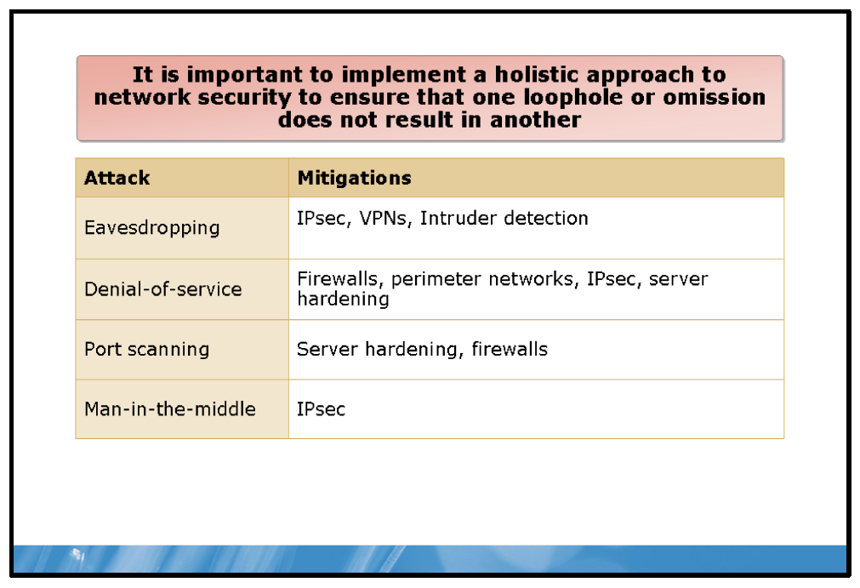

Key Points
One of the most important things to realize is that attackers look for access into your network using a variety of tools and techniques. Once they have found a way in, however minor and apparently innocuous, they can exploit that success, and take the attack further. For this reason, it is important to implement a holistic approach to network security to ensure that one loophole or omission does not result in another.
You can use any or all of the following defense mechanisms to help to protect your network from malicious attack.
• | Internet protocol security (IPsec). IPsec provides a way to authenticate IP-based communications between two hosts and, where desirable, encrypt that network traffic.
• | Firewalls. Firewalls allow or block network traffic based on the type of traffic.
• | Perimeter networks. A perimeter network is an isolated area on your network to and from which there is defined network traffic flow. When you need to make network services available on the Internet, it is inadvisable to connect the hosting servers directly to the Internet. By placing these servers in a perimeter network, you can make them available to Internet users without letting those users gain access to your corporate intranet.
• | Virtual private networks (VPNs). When your users must connect to your corporate intranet from the Internet, it is important that they do so as securely as possible. The Internet is a public network and data in transit across it is susceptible to eavesdropping or man-in-the-middle attacks. By authenticating and encrypting connections between your remote users and your corporate intranet through the use of a VPN you can mitigate these risks.
• | Server hardening. By only running the services you need, you can make your servers inherently more secure. To determine what services you require, you must establish a baseline of security among your servers. Because it is sometimes difficult to determine precisely which Windows Server® services are required to support the desired functionality, you can use tools such as the Security Configuration Wizard or the Microsoft® Baseline Security Analyzer to help you.
• | Intruder detection. While it is important to implement the preceding techniques to help to secure your network, it is also sensible to monitor your network for signs that it has been attacked. You can implement intruder detection systems to help you perform this task. You can implement intruder detection systems on devices at the perimeter of your network such as Internet-facing routers.

Lesson 2: Implementing Firewalls
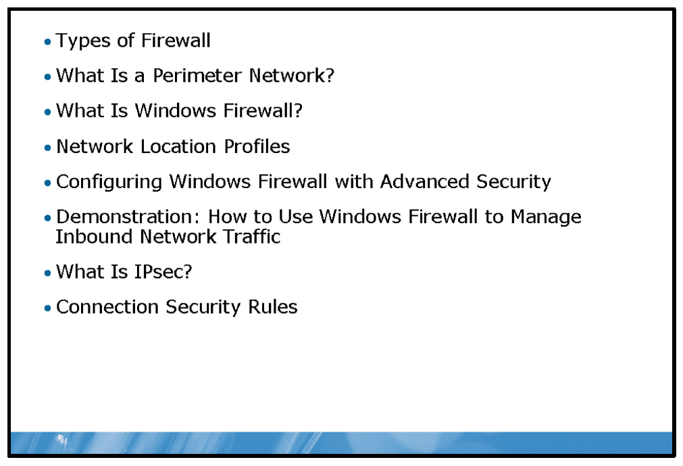
A firewall helps protect your computer against access attempts from unauthorized computers that are located on the Internet. You can implement firewalls using software, hardware, or a combination of both. Firewalls work on the principle of filtering network traffic based on the characteristics of that traffic, and then either allowing or blocking the traffic as determined by your configuration.

Objectives
After completing this lesson, you will be able to:
• | Describe common firewall solutions.
• | Design a perimeter network.
• | Describe Windows Firewall.
• | Describe network location profiles.
• | Describe configurable settings in Windows Firewall with Advanced Security management console snap-in.
• | Implement an inbound rule.
• | Describe IPsec.
• | Describe connection security rules.

Types of Firewall
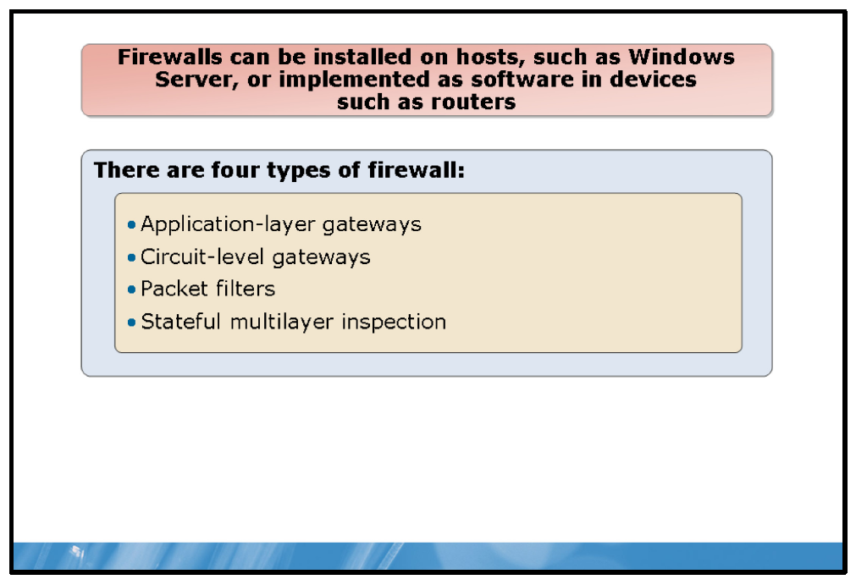

Key Points
There are four types of firewalls. These are:
• | Application-layer gateways. Operate at the application layer of the Open Systems Interconnection (OSI) model. Application-layer gateways proxy requests to or from your network and do not allow traffic for which you have not defined a proxy. In other words, a Hypertext Transfer Protocol (HTTP) proxy does not pass File Transfer Protocol (FTP) traffic. Application-layer gateways enable you to configure Network Address Translation (NAT) traversal filters that can support both IP address and port translation settings to support specific application layer protocols. This enables applications such as instant messaging, file transfer, and others to function through your firewall without you needing to open up multiple specific ports.
• | Circuit-level gateways. Operate at the session layer of the OSI model and monitor datagrams between communicating hosts to verify that requested sessions are legitimate. Circuit-level gateways monitor the TCP hand-shaking process – used to establish TCP sessions between hosts – to determine if the session is legitimate. Additionally, information passed from your network to remote hosts appears to originate from the circuit-level gateway. This is useful in hiding information about your network from remote hosts.
• | Packet filters. Operate at the network level of the OSI model and are often implemented as part of a router. Each packet is filtered and compared with an action list to determine the appropriate action to take with the packet. Actions include allowing or blocking the packet. Most consumer broadband routers provide this functionality.
• | Stateful multilayer inspection. These firewalls combine aspects of the other three firewall types providing a high level of security. A stateful multilayer inspection firewall examines data at all seven layers of the OSI model. Unlike other firewalls, stateful multilayer inspection firewalls not only inspect the packet header, but also inspect the packet payload. Each packet is examined and compared with example packets to determine the likelihood the packet contains malicious data.
You can install firewalls on hosts, such as Windows Server, or implement firewalls as software in devices such as routers.

What Is a Perimeter Network?
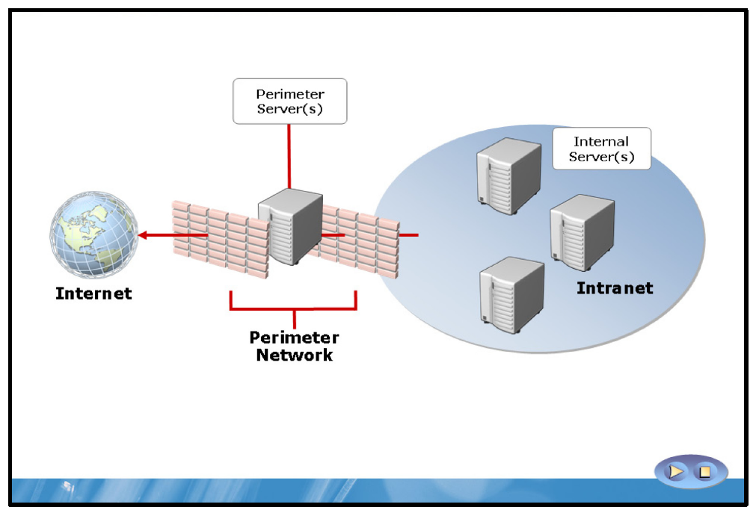

Key Points
In order to make your network applications available to users connected to the Internet, you must publish these applications. A common way of publishing these applications, while maintaining security, is to use servers placed in a perimeter network.
There are a number of different ways that you can configure your perimeter network, and these include:
• | Three-legged firewall. A single device or computer with multiple network interface cards, one of which is Internet-facing, another of which is connected to the perimeter network, and the remaining card being connected to the intranet. Software installed on the host is used to create the separation between the networks. The separation is achieved through filtering on the firewall device so that only specified traffic is passed between the interfaces designated as public, private, and perimeter. This solution works well for smaller networks; however, because the firewall device is connected directly to all three networks, security is compromised compared with other solutions.
• | Dual back-to-back firewalls. In this scenario, two firewalls are connected in sequence across three networks: the Internet, your perimeter network, and your corporate intranet. The network to which both firewalls are connected is the perimeter network. The firewalls are configured to allow only appropriate traffic to pass between their connected networks. This is a more complex and expensive solution because it requires additional hardware and software to configure; however, it provides for a more secure environment and is the configuration of choice for larger networks.
Through the combination of hardware and software, and with appropriate configuration, you should be able to create a perimeter network with the degree of network isolation that you require, while at the same time allowing for the necessary communication between devices located in each of the three networks.

Best Practice
Only deploy services that you specifically need in your perimeter network, and always publish services where possible, rather than physically deploy servers to the perimeter.
It is rare for an organization to operate without the need to connect its network infrastructure to the Internet. At the very least, most organizations use e-mail applications to conduct some elements of their core business.
Conduct an audit of the network services that you have within your organization and determine which services must be available to users from the Internet. Then consider how you want to make those services available. For example, if users require access to their e-mail while they work away from their office, consider the use of Web-based e-mail solutions because these are often easier to make securely available.
Note: Applications can be configured to use specific TCP ports; indeed, many applications are configurable to use only HTTP or HTTP Secure (HTTPS). This means that you can configure the Internet-facing firewall to allow only TCP port 80/443 inbound.

Typical Perimeter Applications
Although not an exhaustive list, the following table helps identify common applications that you might need to make available in your perimeter network.
Applications | Protocols | Comments
E-mail | Post Office Protocol 3 (POP3), Internet Message Access Protocol 4 (IMAP4), Simple Mail Transfer Protocol (SMTP), Microsoft Office Outlook® Web Access (HTTPS), Outlook Anywhere (HTTPS), Microsoft Exchange ActiveSync® (HTTPS) | Microsoft Exchange Server supports extensive publishing through the use of ForeFront® Threat Management Gateway (TMG). In addition, the Exchange Edge Transport server role enables SMTP relay functionality from the perimeter network.
Web server | HTTP, HTTPS | Place the Web servers directly in the perimeter network or publish them with ForeFront TMG.
Active Directory® Domain Services (AD DS) | Microsoft Lightweight Directory Access Protocol (LDAP) | It is inadvisable to place domain controllers in the perimeter network. If your edge application requires access to Active Directory domains, consider deploying Microsoft Active Directory Lightweight Directory Services (AD LDS) into the perimeter.
Web Conferencing | HTTPS, Session Initiation Protocol (SIP), Persistent Shared Object Model (PSOM), Real-time Transport Protocol (RTP), Real- time Control Protocol (RTCP) | Microsoft Office Communications server supports the  use of edge servers to extend conferencing to Internet participants. In addition, a ForeFront TMG server or other reverse-proxy is required to enable some conferencing features.
Instant Messaging | SIP | SIP is the industry standard protocol used for instant messaging.
Question: What services do you make available to users on the Internet?

What Is Windows Firewall?
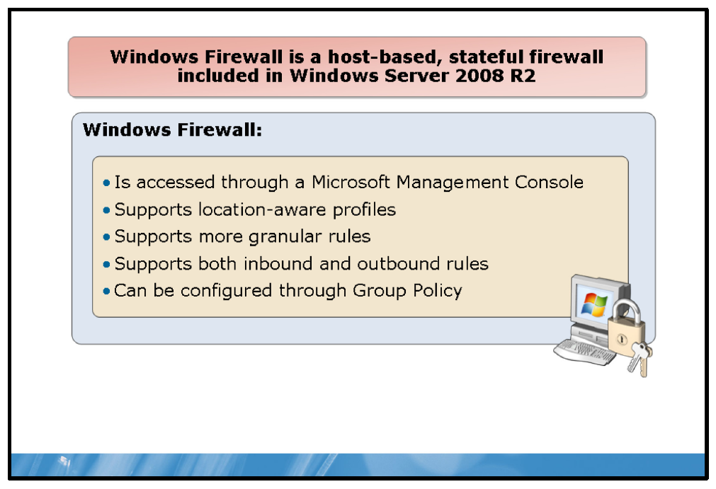

Key Points
Windows Firewall is a host-based, stateful firewall included in the Windows Server 2008 R2 operating system. Windows Firewall helps provide protection from malicious users and programs that rely on unsolicited incoming traffic to attack computers.
Microsoft first introduced Windows Firewall in the Windows XP with Service Pack 2 (SP2) operating system. Windows Server 2008 R2 provides significant improvements to Windows Firewall.
In Windows Server 2008 R2, Windows Firewall implements network traffic filtering in both directions—that is, inbound and outbound traffic. By default, Windows Firewall blocks all inbound traffic unless it either matches a configured rule, or is in response to a request from the local computer. By default, Windows Firewall allows all outbound traffic, unless it matches a configured rule. You can configure Windows Firewall by using several different management programs. The choice of which program to use depends on whether you wish to administer a single computer, or multiple computers. In addition, only some of the management programs give you access to the more advanced Windows Firewall configuration settings.
You access the new Windows Firewall with Advanced Security console from Control Panel by selecting Administrative Tools. You can also access the same configuration settings by using Group Policy. Windows Firewall with Advanced Security allows you to configure more advanced settings than you could by using the Windows Firewall Control Panel item.

Network Location Profiles
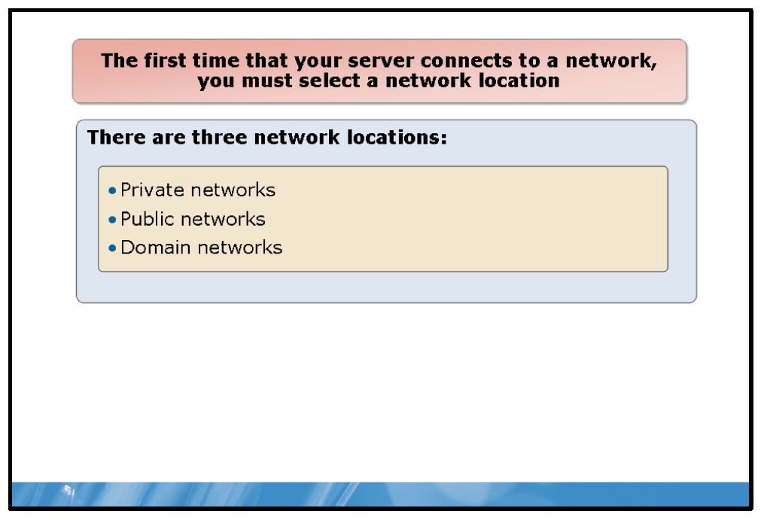

Key Points
The first time that your computer connects to a network, you must select a network location. This automatically sets appropriate firewall and security settings for that type of network. When you are connecting to networks in different locations, choosing a network location can help ensure that the computer is always set to an appropriate security level. There are three network locations:
• | Private networks. Private networks are networks at home or work where you know and trust the people and devices on the network. When private networks are selected, Network Discovery is turned on.
• | Public networks. Public networks are networks in public places. This location keeps the computer from being visible to other computers. When Public place is the selected network location, Network Discovery is turned off.
• | Domain networks. Domain networks are networks at a workplace that are attached to a domain. This option is used automatically for any network that allows communication with a domain controller. Network Discovery is on by default.
You can modify the firewall settings for each type of network location from the main Windows Firewall page. Click Turn Windows Firewall on or off, select the network location, and then make your selection. You can also choose to modify the following options:
• | Block all incoming connections, including those in the list of allowed programs
• | Notify me when Windows Firewall blocks a new problem  Note: Some settings may be managed by your system administrator depending on Group Policy configurations.
The Public networks location blocks certain programs and services from running to help protect the computer from unauthorized access. If you are connected to a Public network and Windows Firewall is turned on, some programs or services might ask you to allow them to communicate through the firewall so that they work properly.

Configuring Windows Firewall with Advanced Security
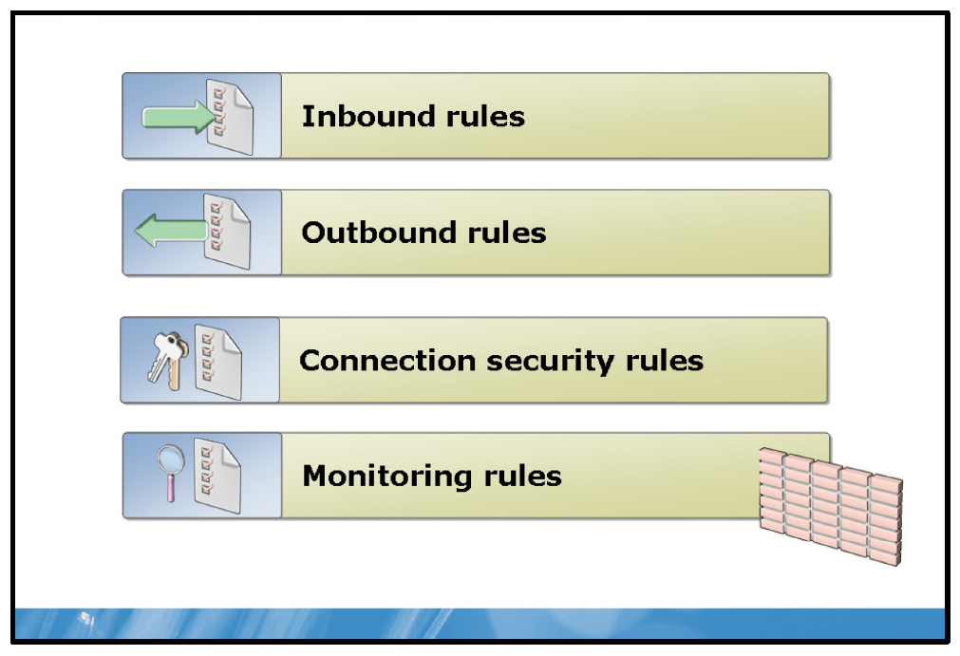

Key Points
Use the Windows Firewall with Advanced Security Properties page to configure basic firewall properties for domain, private, and public network profiles. A firewall profile is a way of grouping settings, including firewall rules and connection security rules. Use the IPsec Settings tab to configure the default values for IPsec configuration options. The options that you can configure for each of the three network profiles are:
• | Firewall State. You can turn the firewall on or off independently for each profile.
• | Inbound Connections. You can configure to block connections that do not match any active firewall rules, block all connections regardless of inbound rule specifications, or allow inbound connections that do not match an active firewall rule.
• | Outbound Connections. You can configure to allow connections that do not match any active firewall rules or block outbound connections that do not match an active firewall rule.
• | Settings. You can configure display notifications, unicast responses, local firewall rules, and local connection security rules.
• | Logging. You can configure and enable logging.

Windows Firewall with Advanced Security Rules
Rules are a collection of criteria that define which traffic you will allow, block, or secure with the firewall. You can configure different types of rules:
• | Inbound
• | Outbound
• | Connection Security

Inbound Rules
Inbound rules explicitly allow or block traffic that matches criteria in the rule. For example, you can configure a rule to allow traffic secured by IPsec for Remote Desktop through the firewall, but block the same traffic if it is not secured by IPsec.
When Windows is first installed, all unsolicited inbound traffic is blocked. To allow a certain type of unsolicited inbound traffic, you must create an inbound rule that describes that traffic. For example, if you want to run a Web server, then you must create a rule that allows unsolicited inbound network traffic on TCP port 80. You can configure the default action that Windows Firewall with Advanced Security takes whether connections are allowed or blocked when no inbound rule applies.

Outbound Rules
Windows Firewall allows all outbound traffic unless a rule blocks it. Outbound rules explicitly allow or deny traffic originating from the computer that matches the criteria in the rule. For example, you can configure a rule to explicitly block outbound traffic to a computer (by IP address) through the firewall, but allow the same traffic for other computers.

Inbound and Outbound Rule Types
There are four different types of inbound and outbound rules:
• | Program rules. Program rules can control connections for a program. Use this type of firewall rule to allow a connection based on the program that is trying to connect. These rules are useful when you are not sure of the port or other required settings since you only specify the path to the program executable (.exe) file.
• | Port rules. Port rules can control connections for a TCP or UDP port. Use this type of firewall rule to allow a connection based on the TCP or UDP port number over which the computer is trying to connect. You specify the protocol and individual or multiple local ports.
• | Predefined rules. Predefined rules can control connections for a Windows experience. Use this type of firewall rule to allow a connection by selecting one of the programs or experiences from the list. Network-aware programs that you install typically add their own entries to this list so that you can enable and disable them as a group.
• | Custom rules. Custom rules can be configured as needed. Use this type of firewall rule to allow a connection based on criteria not covered by the other types of firewall rules.

Connection Security Rules
Firewall rules and connection security rules are complementary, and both contribute to a defense-in-depth strategy to help protect your computer. Connection security rules secure traffic by using IPsec while it crosses the network. Use connection security rules to specify that connections between two computers must be authenticated or encrypted. Connection security rules specify how and when authentication occurs, but they do not allow connections. To allow a connection, create an inbound or outbound rule. After a connection security rule is in place, you can specify that inbound and outbound rules apply only to specific users or computers.
Note: Connection Security Rules are discussed in a separate topic.

Monitoring
Windows Firewall uses the monitoring interface to display information about current firewall rules, connection security rules, and security associations. The Monitoring overview page displays which profiles are active (domain, private, or public) and the settings for the active profiles.
Note: When you view the Windows Firewall with Advanced Security snap-in within the Group Policy Editor snap-in, the Monitoring node does not display. Also keep in mind, The Windows Firewall with Advanced Security events are available in Event Viewer.

Demonstration: How to Use Windows Firewall to Manage Inbound Network Traffic
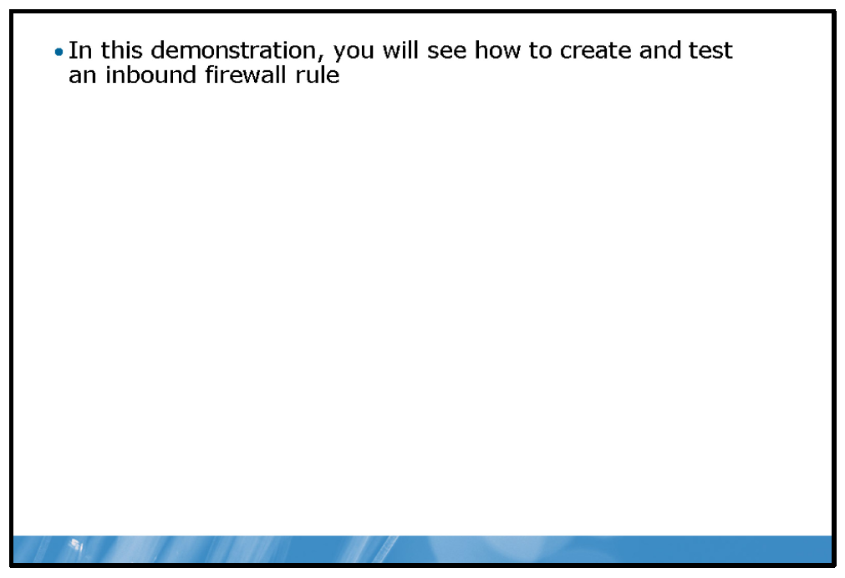

Key Points
In this demonstration, you will see how enable an inbound firewall rule.

Demonstration Steps:
1. | Verify the correct functionality of ping.
2. | Create a new firewall rule.
3. | Test the rule.
4. | Disable the rule.

What Is IPsec?
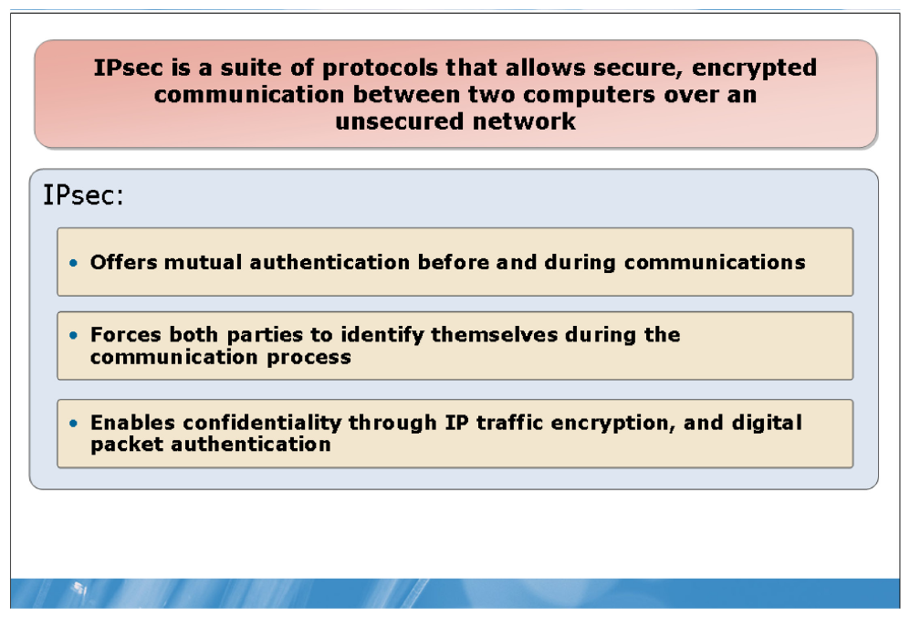

Key Points
IPsec is a framework of open standards for protecting communications over IP networks through cryptographic security services. IPsec supports:
• | Network-level peer authentication.
• | Data origin authentication.
• | Data integrity.
• | Data confidentiality.
• | Replay protection.
You typically use IPsec to attain confidentiality, integrity, and authentication in data transport across insecure channels. Though its original purpose was to secure traffic across public networks, its implementations are often used to increase the security of private networks, since organizations are not always sure if weaknesses in their own private networks are susceptible to exploitation.
IPsec provides the following benefits:
• | Offers mutual authentication before and during communications.
• | Forces both parties to identify themselves during the communication process.
• | Enables confidentiality through IP traffic encryption, and digital packet authentication.
IPsec operates in two modes:
• | Transport mode. This is the default mode for IPsec. In transport mode, IPsec only encrypts the IP payload; the IP header is not encrypted. Transport mode should be selected for end-to-end communications, such as that which occurs between a client and a server computer.
• | Tunnel mode. In tunnel mode, IPsec encrypts the IP header and the payload. Tunnel mode is most useful for communications between two networks when that communication takes place over an untrustworthy network, such as the Internet.

Connection Security Rules
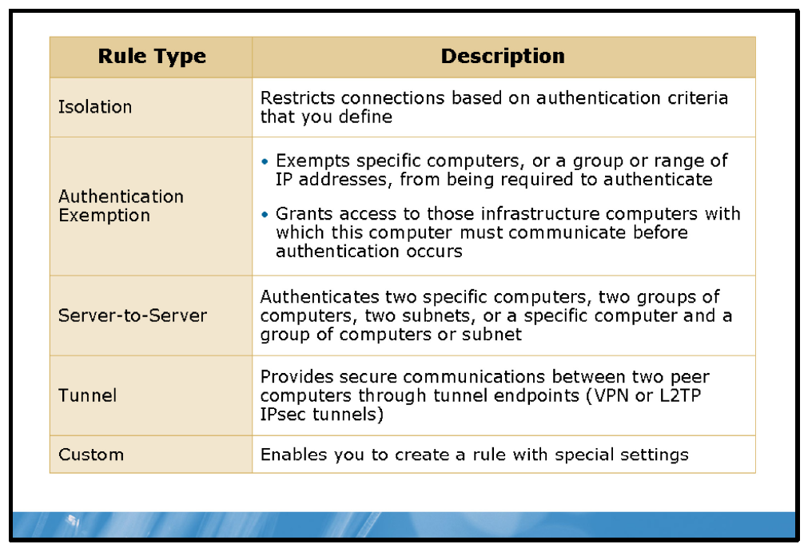

Key Points
In earlier Windows versions, managing IPsec policies and managing Windows Firewall were two separate processes achieved by using different management tools. Windows Server 2008 R2 unites IPsec and Windows Firewall so that you can manage both IPsec and Windows Firewall policies and rules through a single interface and set of command-line utilities.

IPsec Integration with Windows Firewall
The advantage of combining IPsec and Windows Firewall is that you can avoid overlapping possibly conflicting rules and policies, and you can streamline the process of securing your computer against unauthorized access.
You can configure IPsec with connection security rules in Windows Firewall with Advanced Security. These rules allow you to associate IPsec rules with Windows Firewall network profiles.
Firewall rules allow traffic through the firewall, but do not secure that traffic. To secure traffic with IPsec, you can create connection security rules; however, when you create a connection security rule, this does not allow the traffic through the Windows Firewall. You must create a firewall rule to do this, if the traffic is not allowed by the firewall’s default behavior. Connection security rules are not applied to programs and services; they are applied between the computers that make up the two endpoints.

What Are Connection Security Rules?
A connection security rule forces authentication between two peer computers before they can establish a connection and transmit secure information. Windows Firewall with Advanced Security uses IPsec to enforce these rules.
Use connection security rules to configure IPsec settings for specific connections between computers. Windows Firewall with Advanced Security uses the rules to evaluate network traffic, and then blocks or allows messages based on the criteria you establish in the rules. In some circumstances, Windows Firewall with Advanced Security blocks the communication. If you configure settings that require security for a connection (in either direction) and the two computers cannot authenticate each other, then the connection is blocked.
The configurable connection security rules are:
• | Isolation. An isolation rule isolates computers by restricting connections based on credentials such as domain membership or health status. Isolation rules allow you to implement an isolation strategy for servers or domains.
• | Authentication exemption. You can use an authentication exemption to designate connections that do not require authentication. You can designate computers by specific IP address, an IP address range, a subnet, or a predefined group such as a gateway.
• | Server to Server. A server-to-server rule protects connections between specific computers. This type of rule usually protects connections between servers. When you create the rule, you specify the network endpoints between which communications are protected. You then designate requirements and the authentication you want to use.
• | Tunnel. A tunnel rule allows you to protect connections between gateway computers. You typically use it when connecting across the Internet between two security gateways. You must specify the tunnel endpoints by IP address, and then specify the authentication method used.
• | Custom. Use a custom rule to authenticate connections between two endpoints when you cannot set up the authentication rules you need by using the other rules available in the New Connection Security Rule wizard.

Connection Security Rules Settings
When you enable and configure a connection security rule, you must define the following properties:
• | Requirements. You can select whether the rule requests authentication, requires inbound authentication, or requires both inbound and outbound authentication.
• | Authentication methods. You can select between a number of authentication methods; Kerberos, digital certificates, NTLMv2, and pre-shared key. You can also configure the rule to attempt a number of different methods in a preferred order.
• | Profile. Associate the rule with the appropriate network profile. You can select one or all of the following: domain, private, or public.
• | Exempt computers. For authentication exemption rules only, define the exempt computers by IP address, IP address range, or IP subnet.
• | Endpoints. For server-to-server rules only, define the IP addresses affected by the rule.
• | Tunnel endpoints. For tunnel rules only, define the tunnel endpoints affected by the rule.  Note: There is a significant difference between connection security rules and IPsec policies. An IPsec policy can filter traffic to the specific port level, while a connection security rule cannot—it only applies between computers, and not for specific types of traffic between those computers.

Lesson 3: Network Access Protection
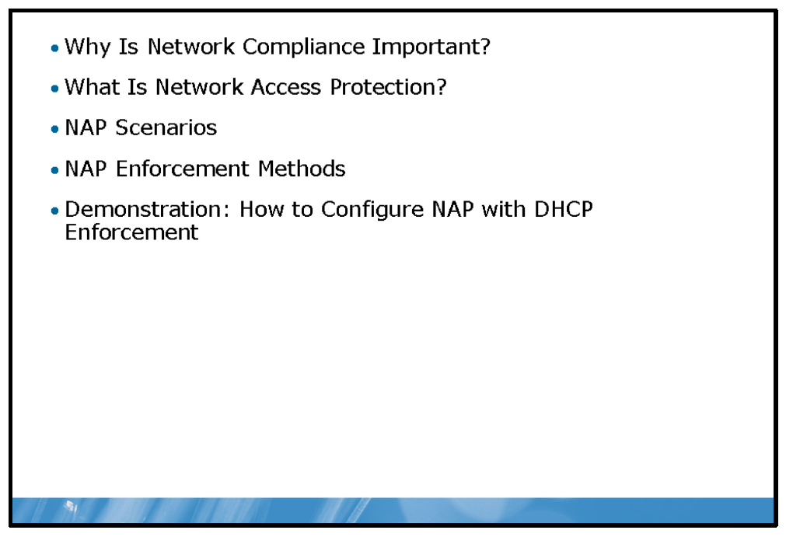
Network Access Protection (NAP) helps to ensure compliance with specific health policies for computers accessing your network. NAP helps you achieve and maintain a specific health policy. This lesson provides information about how NAP works, and how to configure NAP.

Objectives
After completing this lesson, you will be able to:
• | Explain why network compliance is important.
• | Describe NAP.
• | Describe the NAP scenarios.
• | Explain how NAP can control network access.
• | Configure NAP with DHCP.

Why Is Network Compliance Important?
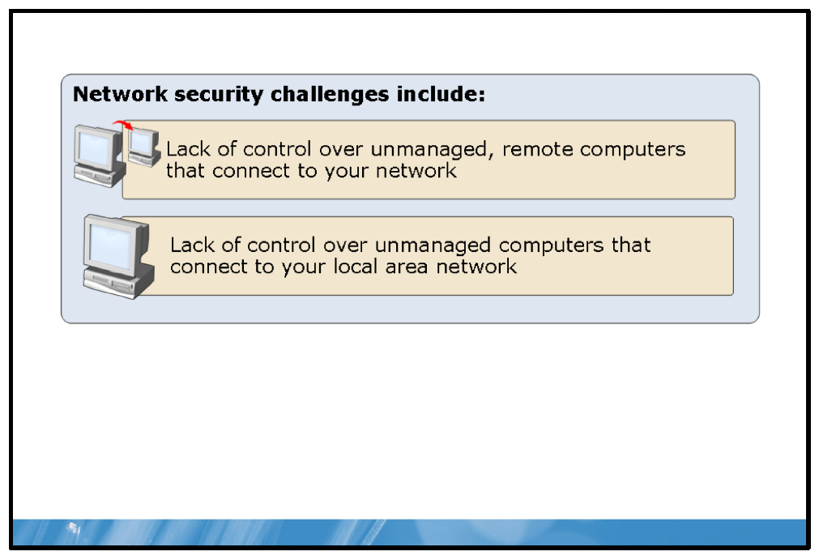

Key Points
If computers connect to your network without protection from viruses, malware, and other network-borne security threats, their security may be compromised which in turn could compromise the security of other computers on your network. It is important to ensure that all computers connecting to your network are up-to-date with security updates, are running antivirus and anti-malware software which is up-to-date, and have a suitably configured firewall running.
While it is relatively straightforward to ensure desktop computers that remain connected to only your corporate intranet are compliant with these requirements, it is less easy with roaming computers or computers that connect to your network from unmanaged networks such as those of a business partner or the home networks of your users.
NAP in the Windows Server 2008 R2 operating system provides a way for you to manage network compliance through the use of network health policies.

What Is Network Access Protection?
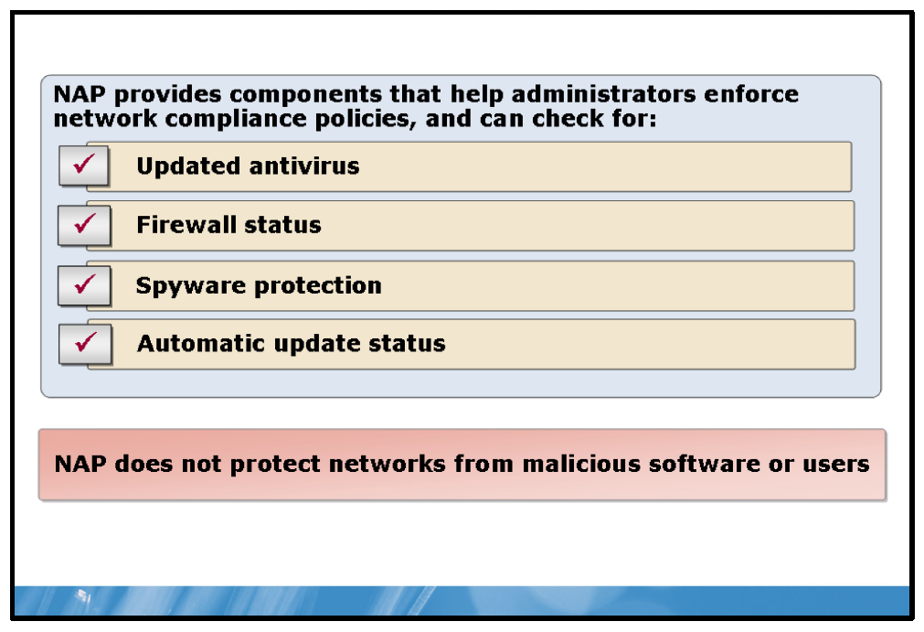

Key Points
NAP provides components to help you enforce health requirement policies for network access and communication. NAP allows you to create policies for validating computers that connect to your network, and to provide required updates or access to required health update resources while limiting the access or communication of noncompliant computers. You can customize your health maintenance solution to:
• | Monitor computers accessing your network for health policy compliance. The health policy may include checks for:
  • | Up-to-date antivirus patterns.
  • | Appropriate firewall status.
  • | Up-to-date malware protection.
  • | Windows Update settings.
• | Update computers with software updates to meet health policy requirements.
• | Limit access for computers that do not meet health policy requirements, to a restricted network.
Although NAP helps you automatically maintain the health of your network’s computers, which in turn helps maintain your network’s overall integrity, NAP does not protect your network from malicious users. For example, if a computer has all of the software and configuration settings that the health policy requires, then the computer is compliant and has unlimited network access; however, NAP does not prevent an authorized user with a compliant computer from uploading a malicious program to the network, or engaging in other inappropriate behavior.

NAP Functions
NAP has three important and distinct functions:
• | Health state validation. When a computer attempts to connect to the network, the NAP health policy server validates the computer’s health state against the health-requirement policies that you define. You also can define what to do if a computer is not compliant. In a monitoring-only environment, the NAP health policy server validates the health state of all computers, and then logs the compliance state of each computer for subsequent analysis. In a limited-access environment, computers that comply with the health-requirement policies have unlimited network access. Computers that do not comply with health-requirement policies may have their access limited to a restricted network.
• | Health policy compliance. You can help ensure compliance with health requirement policies by automatically updating noncompliant computers with missing software updates and configuration changes. You can do this by using management software, such as Microsoft System Center Configuration Manager 2007. In a monitoring-only environment, computers have network access before they are updated with required updates or configuration changes. In a limited access environment, noncompliant computers have limited access until the updates and configuration changes are complete. In both environments, computers that are compatible with NAP can become compliant automatically, and you can define exceptions for computers that are not NAP-compatible.
• | Limited access. You can protect your network by limiting noncompliant computers’ access. You can base limited network access on a specific time limit, or on what the noncompliant computer can access. In the latter case, you define a restricted network containing health update resources, and the limited access lasts until the noncompliant computer becomes compliant. You also can configure exceptions, so computers that are not compatible with NAP do not have their network access limited.

NAP Scenarios
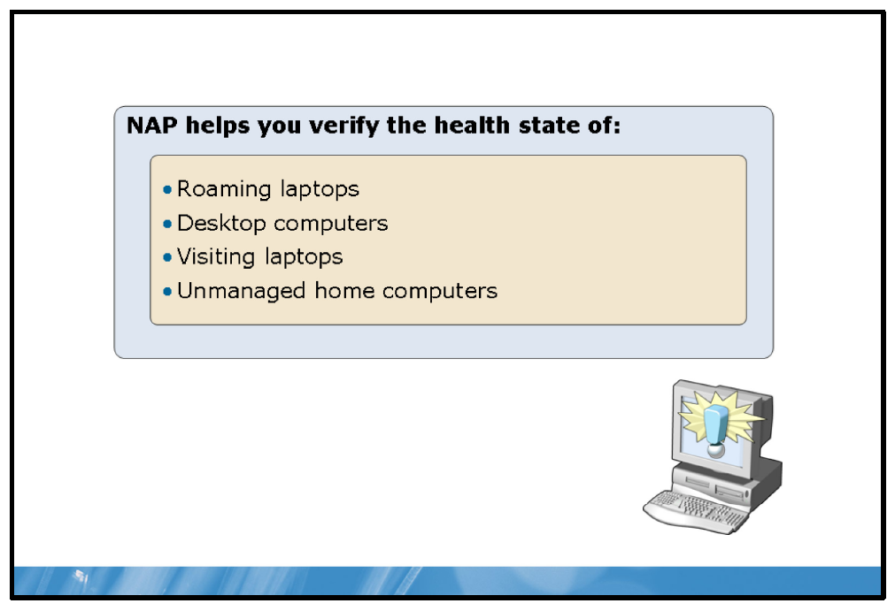

Key Points
NAP provides a solution for the common scenarios described in this section. Depending on your needs, you can configure a solution to address any or all of these scenarios for your network.

Roaming Laptops
Portability and flexibility are two primary laptop advantages, but these features also present a health threat. Users frequently connect their laptops to other networks. While laptops are away from your organization, they might not receive the most recent software updates or configuration changes.
Additionally, exposure to unprotected networks, such as the Internet, may introduce security-related threats to the laptops. NAP allows you to check any laptop’s health state when it reconnects to the organization’s network, whether through a virtual private network (VPN) connection, or the workplace network connection.

Desktop Computers
Although desktop computers usually do not leave the company building, they still can present a threat to your network. To minimize this threat, you must maintain these computers with the most recent updates and required software. Otherwise, these computers are at risk of infection from Web sites, e-mail, files from shared folders, and other publicly accessible resources. NAP allows you to automate health state checks to verify each desktop computer’s compliance with health-requirement policies. You can check log files to determine which computers do not comply. Additionally, using management software allows you to generate automatic reports, and to automatically update noncompliant computers. When you change health-requirement policies, computers can be provisioned automatically with the most recent updates.

Visiting Laptops
Organizations frequently need to allow consultants, business partners, and guests to connect to their private networks. The laptops that these visitors bring into your organization might not meet system health requirements, and can present health risks. NAP enables you to determine which visiting laptops are noncompliant, and limit their access to restricted networks. Typically, you would not require or provide any updates or configuration changes for visiting laptops. You can configure Internet access for visiting laptops, but not for other organizational computers that have limited access.

Unmanaged Home Computers
Unmanaged home computers that are not a member of the company’s Active Directory domain can connect to a managed company network through VPN. Unmanaged home computers provide an additional challenge, because you cannot physically access these computers. Lack of physical access makes enforcing compliance with health requirements—such as the use of antivirus software—more difficult. However, NAP enables you to verify the health state of a home computer every time it makes a VPN connection to the company network, and to limit its access to a restricted network until it meets system health requirements.

NAP Enforcement Methods
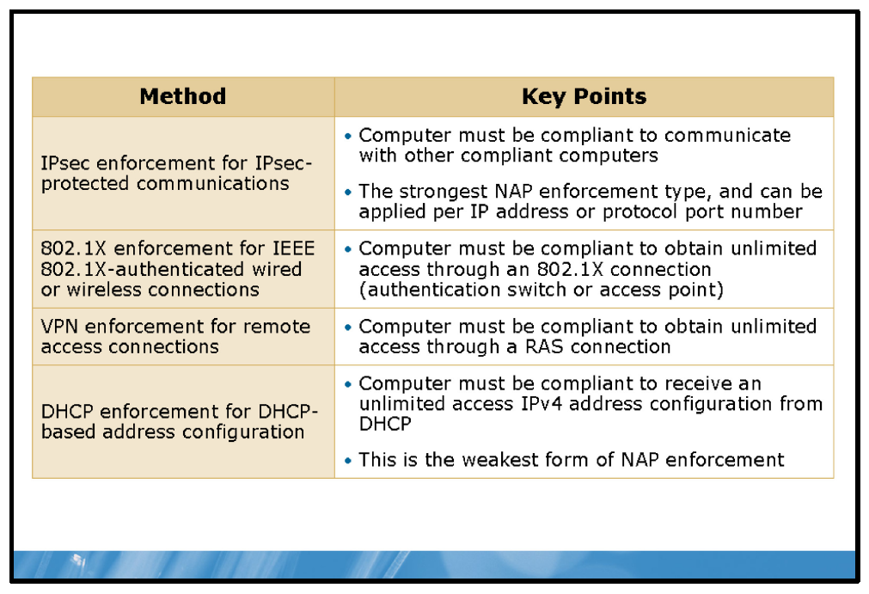

Key Points
Components of the NAP infrastructure—known as enforcement clients and enforcement servers—require health state validation, and enforce limited network access for noncompliant computers. The Windows 7 operating system, the Windows Vista® operating system, the Windows XP with SP3 operating system, the Windows Server 2008 operating system, and Windows Server 2008 R2 include NAP support for the following network access or communication methods:
• | IPsec-protected traffic. With IPsec enforcement, a computer must be compliant to initiate communications with other compliant computers.
• | Institute of Electrical and Electronics Engineers (IEEE) 802.1X-authenticated network connections. With IEEE 802.1X enforcement, a computer must be compliant to obtain unlimited network access through an IEEE 802.1X-authenticated network connection, such as to an authenticating Ethernet switch, or an IEEE 802.11 wireless access point (AP).
• | Remote access VPN connections. With VPN enforcement, a computer must be compliant to obtain unlimited network access through a remote access VPN connection.
• | Dynamic Host Configuration Protocol (DHCP) address configurations. With DHCP enforcement, a computer must be compliant to obtain unlimited access to Internet Protocol version 4 (IPv4) address configuration from a DHCP server. For noncompliant computers, network access is restricted with an IPv4 address configuration that limits access to the restricted network.
These network access or communication methods are known as NAP enforcement methods. You can use them separately or together to limit noncompliant computer access or communication. A server that is running Network Policy Server (NPS) in Windows Server 2008—the replacement for Internet Authentication Server (IAS) in Windows Server 2003—acts as a health policy server for all of these NAP enforcement methods.
Question: Which of the NAP enforcement types would best suit your company? Can you see your organization using multiple NAP enforcement types? If so, which ones?

Demonstration: How to Configure NAP with DHCP Enforcement
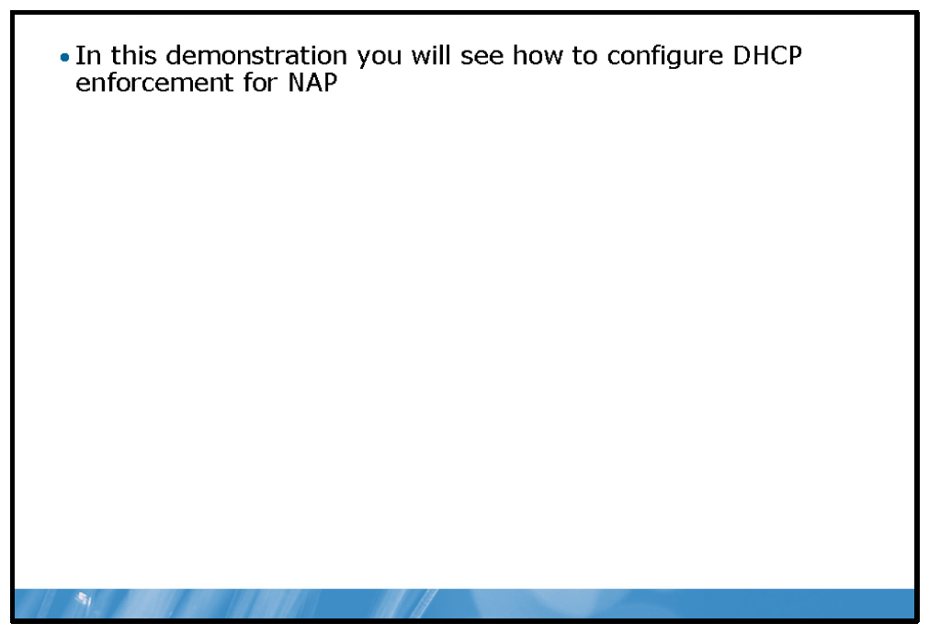

Key Points
In this demonstration, you will see how to enable an inbound firewall rule.

Demonstration Steps:
1. | Install the Network Policy Server role.
2. | Configure DHCP.
3. | Configure System health validators.
4. | Create health policies.
5. | Create network policies.
6. | Configure client settings.
7. | Test NAP.

Lab: Implementing Network Security
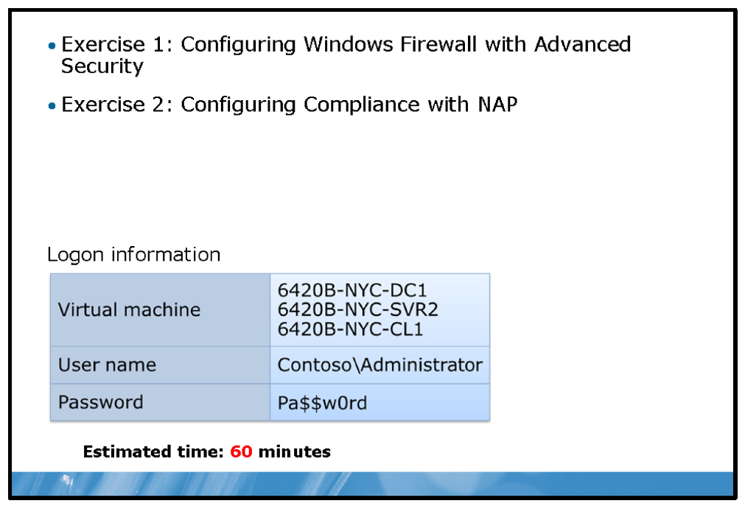

Lab Setup
For this lab, you will use the available virtual machine environment. Before you begin the lab, you must complete the following steps:
1. | On the host computer, click Start, point to Administrative Tools, and then click Hyper-V Manager.
2. | In Hyper-V™ Manager, click 6420B-NYC-DC1, and in the Actions pane, click Start.
3. | In the Actions pane, click Connect. Wait until the virtual machine starts.
4. | Log on using the following credentials:
  • | User name: Administrator
  • | Password: Pa$$w0rd
  • | Domain: Contoso
5. | Repeat these steps for 6420B-NYC-SVR2 and 6420B-NYC-CL1.

Lab Scenario
Ed Meadows has asked you to improve network security on domain-attached computers. He has supplied the requirements in an e-mail message. You must read the requirements and then implement them on a client computer.
E-Mail thread of correspondence with Ed Meadows:
Charlot | te Weiss
From: Sent: To: Subject: Charlott | Ed Meadows [Ed@contoso.com]  18 June 2010 13:14  Charlotte@contoso.com  Improving network security  e,
I’ve got some concerns about network security. I’d like to prevent attackers from using ping.exe on our network. As you know, by using ping.exe, malicious attackers can determine whether servers are online and may be able to exploit additional weaknesses on those servers with other tools.
Additionally, I want to make sure that only clients that are running antivirus software can connect to the network. Can you implement these changes?
Thanks
Ed

Exercise 1: Configuring Windows Firewall with Advanced Security

Scenario
You must implement a firewall rule that blocks inbound ICMPv4 traffic to prevent malicious attackers using ping.exe on the Contoso, Ltd network.
The main tasks for this exercise are as follows:
1. | Test network connectivity with Ping.
2. | Configure a new firewall rule.
3. | Test the rule.
4. | Disable the new rule.

Task 1: Test network connectivity with Ping
1. | Switch to the NYC-DC1 computer.
2. | On NYC-DC1, open a command prompt.
3. | Ping NYC-CL1.  Question: Are you successful?

Task 2: Configure a new firewall rule
1. | Switch to the NYC-CL1 computer.
2. | On NYC-CL1, open Windows Firewall with Advanced Security.
3. | Create a new Inbound Rule using the following information to complete the process:  Question: From the monitoring node, under Firewall, can you see the new rule?
  a. | Rule Type: Custom
  b. | Program: All Programs
  c. | Protocol type: ICMPv4
  d. | Scope: Default value
  e. | Action: Block the connection
  f. | Profile: Default value
  g. | Name: Contoso ICMPv4 Rule

Task 3: Test the rule
• | Switch back to the NYC-DC1 computer.  Question: Can you ping NYC-CL1?

Task 4: Disable the new rule
1. | Switch back to NYC-CL1.
2. | In Windows Firewall with Advanced Security, click Inbound Rules.
3. | Disable the Contoso ICMPv4 Rule.
4. | Close Windows Firewall with Advanced Security.
5. | Switch back to NYC-DC1.  Question: Can you ping NYC-CL1?
Results: After this exercise, you should have created and tested an inbound firewall rule.

Exercise 2: Configuring Compliance with NAP

Scenario
You must now implement NAP for DHCP enforcement to achieve the second objective of ensuring that client computers that connect to the network must be running antivirus software.
The main tasks for this exercise are as follows:
1. | Install the Network Policy Server role.
2. | Configure the DHCP Server role.
3. | Configure the System Health Validator.
4. | Disable unessential network policies.
5. | Create required health policies.
6. | Create the required network policies.
7. | Configure client NAP settings.
8. | Configure client to obtain and IPv4 address dynamically.
9. | Test NAP.

Task 1: Install the Network Policy Server role
1. | On NYC-SVR2, open Server Manager.
2. | Add the Network Policy and Access Services role.
3. | Install only the Network Policy Server role service.
4. | Close Server Manager.

Task 2: Configure the Dynamic Host Configuration Protocol (DHCP) Server role
1. | Open DHCP from Administrative Tools.
2. | View the Properties of the scope.
3. | On the Network Access Protection tab, select Enable for this scope.
4. | In the navigation pane, click Scope Options.
5. | Right-click Scope Options, and then click Configure Options.
6. | On the Advanced tab, in the User class list, select Default Network Access Protection Class.
7. | In the Available Options list, configure the 006 DNS Servers option with an IP address of 10.10.0.10.
8. | Configure the 015 DNS Domain Name String value with restricted.contoso.com.
9. | Close DHCP.

Task 3: Configure the System Health Validator
1. | On NYC-SVR2, open Network Policy Server from Administrative Tools.
2. | In the navigation pane, expand Network Access Protection, expand System Health Validators, expand Windows Security Health Validator, and then click Settings.
3. | In the Results pane, double-click Default Configuration.
4. | In the Windows Security Health Validator dialog box, clear all check boxes except An antivirus application is on, and then click OK.  Note: Configure only the settings for Windows 7/Windows Vista clients.

Task 4: Disable unessential network policies
1. | In the Network Policy Server console, in the navigation pane, expand Policies and then click Network Policies.
2. | In the Results pane, right click each of the two listed policies, and for each one, click Disable.

Task 5: Create required health policies
1. | In the navigation pane, click Health Policies.
2. | Create a new health policy with the following properties:
  • | Policy name: Healthy Client
  • | Client SHV checks: Client passes all SHV checks
  • | Health validator: Windows Security Health Validator.
3. | Create a new health policy with the following properties:
  • | Policy name: Un-Healthy Client
  • | Client SHV checks: Client fails one or more SHV checks
  • | Health validator: Windows Security Health Validator

Task 6: Create the required network policies
Note: Due to the relative complexity of this process, these steps are a duplicate of those in the Lab Answer Key.
1. | In the navigation pane, click Network Policies.
2. | Right-click Network Policies and then click New.
3. | In the New Network Policy wizard, on the Specify Network Policy Name and Connection Type page, in the Policy name box, type Healthy Unrestricted Client and click Next.
4. | On the Specify Conditions page, click Add.
5. | In the Select condition dialog box, click Health Policies and then click Add.
6. | In the Health Policies dialog box, in the Health policies list, click Healthy Client and then click OK.
7. | On the Specify Conditions page, click Next.
8. | On the Specify Access Permission page, click Next.
9. | On the Configure Authentication Methods page, clear all check boxes, select the Perform machine health check only check box and then click Next.
10. | On the Configure Constraints page, click Next.
11. | On the Configure Settings page, in the Settings list, click NAP Enforcement.
12. | In the Results pane, click Allow full network access and then click Next.
13. | On the Completing New Network Policy page, click Finish.
14. | Right-click Network Policies and then click New.
15. | In the New Network Policy wizard, on the Specify Network Policy Name and Connection Type page, in the Policy name box, type Un-healthy Restricted Client and click Next.
16. | On the Specify Conditions page, click Add.
17. | In the Select condition dialog box, click Health Policies and then click Add.
18. | In the Health Policies dialog box, in the Health policies list, click Un-Healthy Client and then click OK.
19. | On the Specify Conditions page, click Next.
20. | On the Specify Access Permission page, click Next.
21. | On the Configure Authentication Methods page, clear all check boxes, select the Perform machine health check only check box and then click Next.
22. | On the Configure Constraints page, click Next.
23. | On the Configure Settings page, in the Settings list, click NAP Enforcement.
24. | In the Results pane, click Allow limited access and then click Next.
25. | On the Completing New Network Policy page, click Finish.

Task 7: Configure client NAP settings
1. | Switch to the NYC-CL1 computer.
2. | Run napclcfg.msc.
3. | Enable the DHCP Quarantine Enforcement Client.
4. | Close napclcfg.msc.
5. | Run services.msc.
6. | Configure the Network Access Protection Agent for Automatic startup and then manually start it.
7. | Close services.msc.
8. | Run mmc.exe.
9. | Add the Group Policy Object Editor snap-in to the console using the defaults.
10. | In the console tree, expand Local Computer Policy/Computer Configuration  /Administrative Templates/Windows Components/Security Center.
11. | Double-click Turn on Security Center (Domain PCs only), click Enabled, and then click OK.
12. | Close the console.

Task 8: Configure client to obtain an IPv4 address dynamically
1. | Click Start, and in the Search box, type Network and in the Control Panel (28) list, click Network and Sharing Center.
2. | In Network and Sharing Center, in the left-pane, click Change adapter settings.
3. | Right-click Local Area Connection and then click Properties.
4. | Configure the adapter to:
  a. | Obtain an IP address automatically.
  b. | Obtain DNS server address automatically.  Note: Configure Internet Protocol Version 4 (TCP/IPv4).

Task 9: Test NAP
1. | On NYC-CL1, open a command prompt.
2. | Type ipconfig /release and press ENTER.
3. | Type ipconfig /renew and press ENTER.
4. | Type ipconfig /all and press ENTER.  Question: What is your Connection-specific DNS Suffix?  Question: What is your Quarantine State?
Results: After this exercise, you should have enabled NAP with DHCP enforcement.

To prepare for the next module
When you finish the lab, revert the virtual machines back to their initial state. To do this, complete the following steps:
1. | On the host computer, start Hyper-V Manager.
2. | Right-click 6420B-NYC-DC1 in the Virtual Machines list, and then click Revert.
3. | In the Revert Virtual Machine dialog box, click Revert.
4. | Repeat these steps for 6420B-NYC-SVR2 and 6420B-NYC-CL1.
5. | In the Virtual Machines pane, click 6420B-NYC-DC1, and then in the Actions pane, click Start.
6. | To connect to the virtual machine for the next module’s lab, click  6420B-NYC-DC1, and then in the Actions pane, click Connect.  Important: Start the 6420B-NYC-DC1 virtual machine first, and ensure that it is fully started before starting the other virtual machines.

Module Review and Takeaways
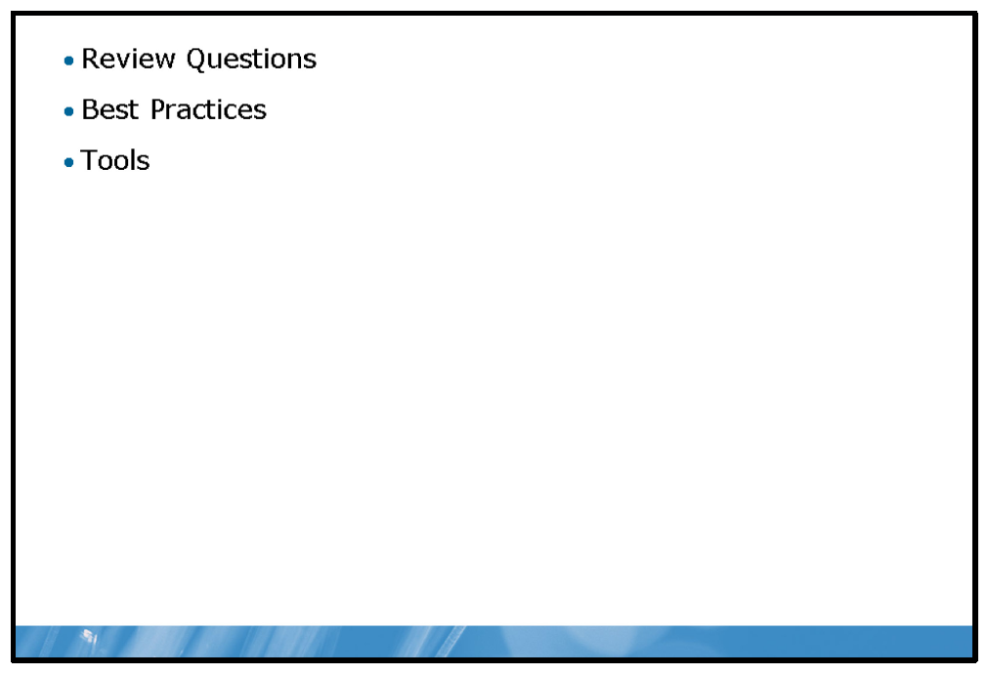

Review Questions
1. | Why is it important to publish services to the perimeter rather than connect servers directly to the Internet?
2. | If you wanted to ensure that only domain computers could communicate with other domain computers, how could you easily achieve this with Windows Firewall?
3. | You have implemented NAP in your organization, but are surprised when a computer from a visiting organization is responsible for a virus outbreak, despite meeting your organization’s health requirements. Should you be surprised?

Best Practices
• | Do not make it easy to connect to your network; if someone can plug a laptop into your network and access your intranet, you could face serious problems.
• | Install antivirus and anti-malware software.
• | Keep security software up-to-date.
• | Implement firewalls.
• | Publish services to your perimeter network.
• | Encrypt network communication.
• | Segment the network.
• | Require mutual authentication.
• | Restrict switch ports and wireless access points based on media access control (MAC) address or client certificates.

Tools
Tool | Use for | Where to find it
Server Manager |  | Start Menu
  • | Add roles
DHCP |  | Administrative Tools
  • | Manage DHCP server
Network Policy Server |  | Administrative Tools
  • | Manage NAP and network policies
mmc.exe |  | Command-line or Run
  • | Creating custom management tools by adding snap-ins
Ping.exe |  | Command-line
  • | Testing network connectivity
Windows Firewall with Advanced Security |  | Control Panel
  • | Managing inbound, outbound, and IPsec rules
Services.msc |  | Command-line or Run
  • | Manage services
Napclcfg.msc |  | Command-line or Run
  • | Manage NAP client settings

- Highlight
- Note
- Expand Highlight
- Expand Note
Module 11: Implementing Security Software
Contents:
Lesson 1: | Client Protection Features
Lesson 2: | E-Mail Protection
Lesson 3: | Server Protection
Lab: | Implementing Security Software

Module Overview
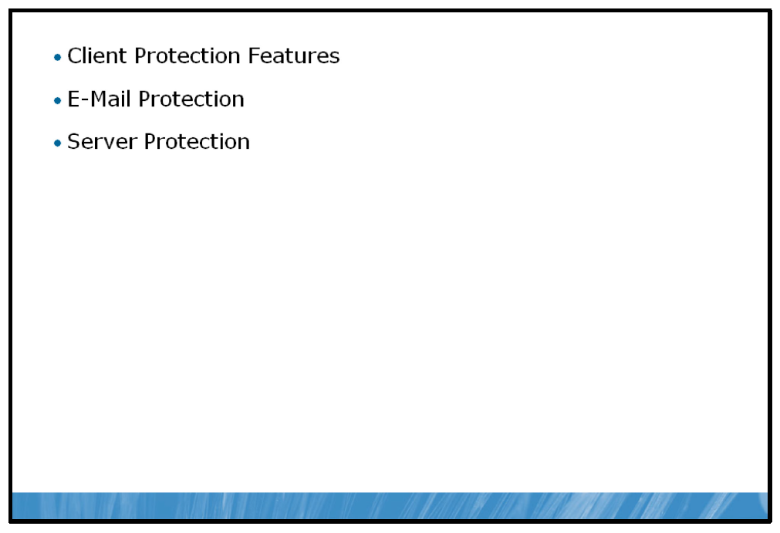
Computers are now, more than ever, interconnected. The Internet is accessible from almost anywhere a user takes a computer, and corporate networks are accessible from a user’s home through remote access. Communication among networks is continuous. Critical and private information is routinely sent out via e-mail, and the number of e-mail messages received by users continues to increase. Private corporate networks are now almost always connected in some way to the public Internet and a great deal of available server-oriented software requires, or at least recommends Internet access.
As the extent of connectivity increases, so to does the risk of some manner of compromise to the computer or network connected. Malicious code, unauthorized use and data theft are all risks that need to be accounted for and mitigated by an information technology (IT) administrator.

Objectives
After completing this module you will be able to:
• | Implement Windows Server® technologies and features to improve client security.
• | Describe security threats posed by e-mail and how to mitigate these threats.
• | Explain how to improve server security using Windows Server security analysis and hardening tools.

Lesson 1: Client Protection Features
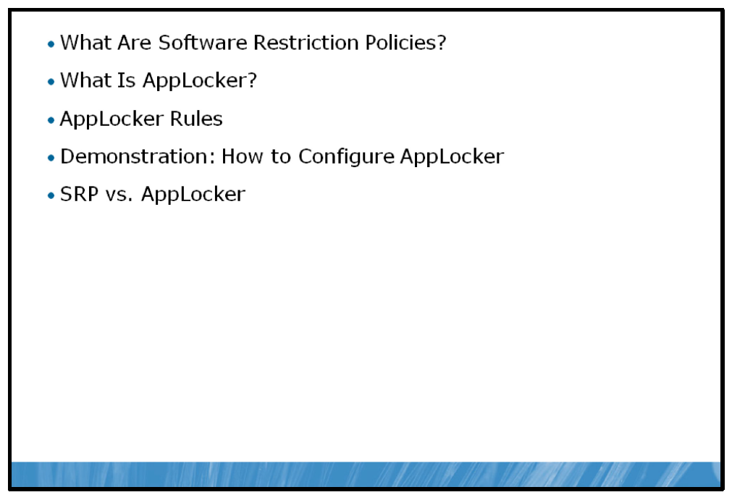
As client operating systems get more advanced and security threats increase, more mitigating features are being built into the operating system as a first line of defense. Building defenses into the operating system, however, is not meant to be the sole method used to secure your client infrastructure. Client protection features provide further methods to protect your client infrastructure, providing a safer infrastructure as a whole.
With the release of the Windows Server 2008 R2 operating system there are a few built-in technologies that have been modified and other new features added in order to help you to enhance the security of your desktop infrastructure, which is in constant communication with your network.
This lesson will introduce you to these technologies and explain how they can be used within your environment to help enhance the security and integrity of your client infrastructure.

Objectives
After completing this lesson you will be able to:
• | Describe Software Restriction Policies (SRPs).
• | Describe AppLocker™.
• | Describe how to use AppLocker rules.
• | Configure AppLocker.
• | Describe the differences between SRP and AppLocker.

What Are Software Restriction Policies?
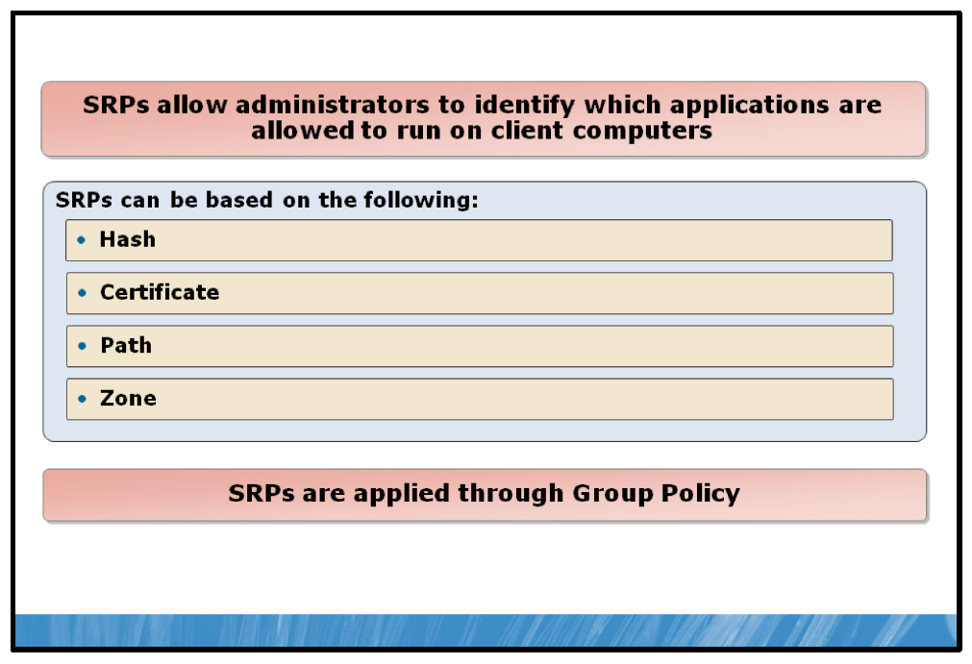

Key Points
One of the primary security concerns for client computers is the current applications available on each computer. In order to do their jobs, users need access to the applications that meet their specific needs. There is also the possibility, however, that unneeded or unwanted applications get installed on the client computers, whether unintentionally or for malicious or non-business purposes.
Introduced in the Windows® XP operating system and the Windows Server 2003 operating system, SRPs allow an administrator to identify and specify which applications are permitted to run on client computers. SRP settings are configured and deployed to clients using Group Policy. An SRP set is comprised of the following key components.

Rules
Rules govern how SRP responds to an application being run or installed. Rules are the key constructs within an SRP and a group of rules together determine how an SRP will respond to applications being executed. Rules can be based on one of the following criteria which apply to the primary executable file for the application in question.
• | Hash. A cryptographic fingerprint of the file.
• | Certificate. A software publisher certificate used to digitally sign a file.
• | Path. The local or Universal Naming Convention (UNC) path of where the file is stored.
• | Zone. The Internet Zone.

Security Levels
Each applied SRP is assigned a security level that governs the way the operating system reacts when the application that is defined in the rule is executed. The three available security levels are explained in the following points.
• | Disallowed. The software identified in the rule will not run, regardless of the access rights of the user.
• | Basic User. Allows the software identified in the rule to run as a standard, non-administrative user.
• | Unrestricted. Allows the software identified in the rule to run unrestricted by SRP.

Default Security Level
The way a system behaves in general is determined by the Default Security Level, which governs how the operating system reacts to applications without any SRP rules defined. The following three points outline a system default behavior, based on the Default Security Level applied in the SRP.
• | Disallowed. No applications will be allowed to run unless an SRP rule is created that allows each specific application or set of applications to run.
• | Basic User. All applications will run under the context of a basic user, regardless of the permissions of the user that is logged in unless an SRP rule is created to modify this behavior for a specific application or set of applications.
• | Unrestricted. All applications will run as if SRP was not enabled, unless specifically defined by an SRP rule.
Based on these three components, there are two primary ways to use SRPs.
• | If an administrator knows all of the software that should be allowed to run on clients, the Default Security Level could be set to Disallowed. All applications that should be allowed to run can be identified in SRP rules that would apply either the Basic User or Unrestricted security level to each individual application, depending on the security requirements.
• | If an administrator does not have a comprehensive list of the software that should be allowed to run on clients, the Default Security Level could be set to Unrestricted or Basic User, depending on security requirements. Any applications that should not be allowed to run could then be identified using SRP rules which would use a security level setting of Disallowed.
Software Restriction Policy settings can be found in Group Policy in the following location: Computer Configuration\Windows Settings\Security Settings\Software Restriction Policies.
Note: Software Restriction Policies are not enabled by default in Windows Server 2008 R2.

What Is AppLocker?
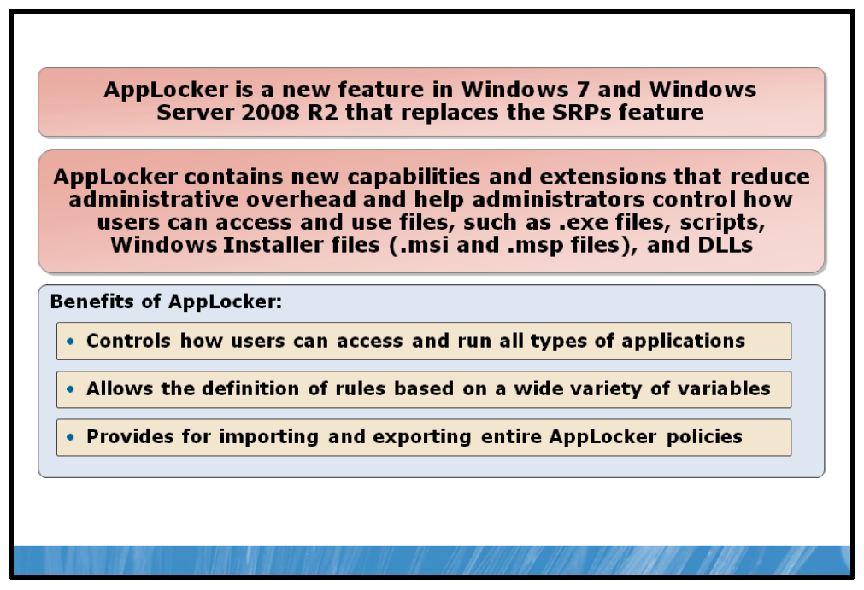

Key Points
Applocker (introduced in the Windows 7 operating system and Windows Server 2008 R2) provides a number of enhancements which improve upon the functionality previously provided by SRP. AppLocker provides administrators with a variety of methods for quickly and concisely determining the identity of applications that they may want to restrict or permit access to.
AppLocker is applied through Group Policy to computer objects within an organizational unit. As well, individual AppLocker rules can be applied to individual Active Directory® Domain Services (AD DS) users or groups.
AppLocker also contains options for monitoring or auditing the application of rules, both as rules are being enforced and in an audit-only scenario.
AppLocker can help organizations prevent unlicensed or malicious software from executing, and can selectively restrict ActiveX® controls from being installed. It can also reduce the total cost of ownership by ensuring that workstations are standardized across their enterprise and that users are running only the software and applications that are approved by the enterprise.
Specifically, the following scenarios provide examples of where AppLocker can be used to provide some level of application management.
• | Your organization implements a policy to standardize the applications used within each business group, so you need to determine the expected usage compared to the actual usage.
• | The security policy for application usage has changed, and you need to evaluate where and when those deployed applications are being accessed.
• | Your organization's security policy dictates the use of only licensed software, so you need to determine which applications are not licensed or prevent unauthorized users from running licensed software.
• | An application is no longer supported by your organization, so you need to prevent it from being used by everyone.
• | A new application or a new version of an application is deployed, and you need to allow certain groups to use it.
• | Specific software tools are not allowed within the organization, or only specific users have access to those tools.
• | A single user or small group of users needs to use a specific application that is denied for all others.
• | Some computers in your organization are shared by people who have different software usage needs.  AppLocker is available in the following editions of Windows:
• | Windows Server 2008 R2 Standard operating system
• | Windows Server 2008 R2 Enterprise operating system
• | Windows Server 2008 R2 Datacenter operating system
• | Windows Server 2008 R2 for Itanium-based Systems operating system
• | Windows 7 Ultimate operating system
• | Windows 7 Enterprise operating system  Note: Applocker is not enabled by default in Windows Server 2008 R2.

AppLocker Rules
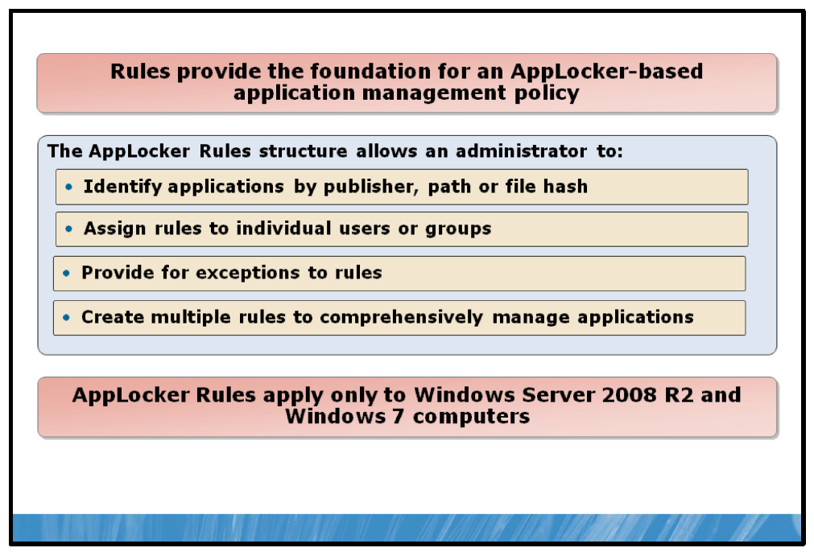

Key Points
Like SRP, AppLocker uses a rule-based implementation. Rules are the main component used to control application execution and provide the foundation for a secure application control environment.
AppLocker Rules are created in the Group Policy Editor interface and provide a number of easy to use wizards to configure and establish your AppLocker environment.

Default Rules
AppLocker contains a small set of default rules designed to ensure key operating systems. Specifically, the default rules enable the following:
• | All users to run files in the default Program Files directory.
• | All users to run all files signed by the Windows operating system.
• | Members of the built-in Administrators group to run all files.

Creating Rules
Rules are comprised of the following elements.
• | Permissions. The permissions setting determines how AppLocker will affect the application defined in the rule. There are two settings for permissions.
  • | Allow. Allow specifically allows the application to run.
  • | Deny. Deny specifically denies the application to run.
In addition, the Permissions area contains the option to specify users or groups to apply the rule to.
• | Conditions. The Conditions settings provide the details around the actual application definition for the rule. There are three conditions from which to select.
  • | Publisher. Publisher identifies the application based on a number of variables contained within the software publisher’s digital signature. This condition can only be used if the application you wish to identify has been digitally signed by its publisher.
  • | Path. Path allows you to specify a specific file or folder path where the application’s executable file resides. If a folder is selected, the rule being defined will apply to all files contained in the folder.
  • | File hash. File hash identifies the application’s executable file based on file hash of the executable. File hash is most commonly selected when the application selected has not been digitally signed by its publisher.
In addition, the Conditions section provides the option to add exceptions based on the condition used or another of the conditions. For example, a rule created using the Publisher may allow all applications that have been digitally signed the publisher “Microsoft”. In addition, an exception may be created based on a Path condition to restrict applications found in a specific folder.
• | Name. A descriptive name can be provided to allow for easy identification and sorting of multiple AppLocker rules.

Demonstration: How to Configure AppLocker
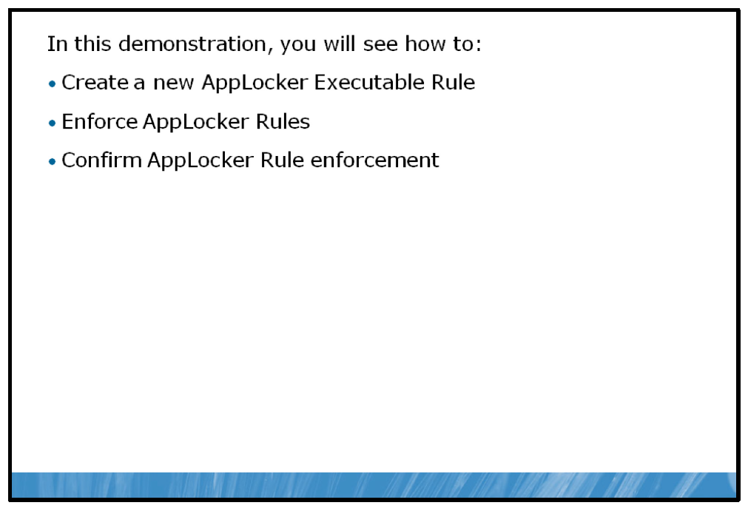

Key Points
In this demonstration you will see how to configure AppLocker.

Demonstration Steps:
1. | Create a new AppLocker Rule.
2. | Enable enforcement AppLocker Rules.
3. | Confirm the enforcement of an AppLocker Rule.

SRP vs. AppLocker
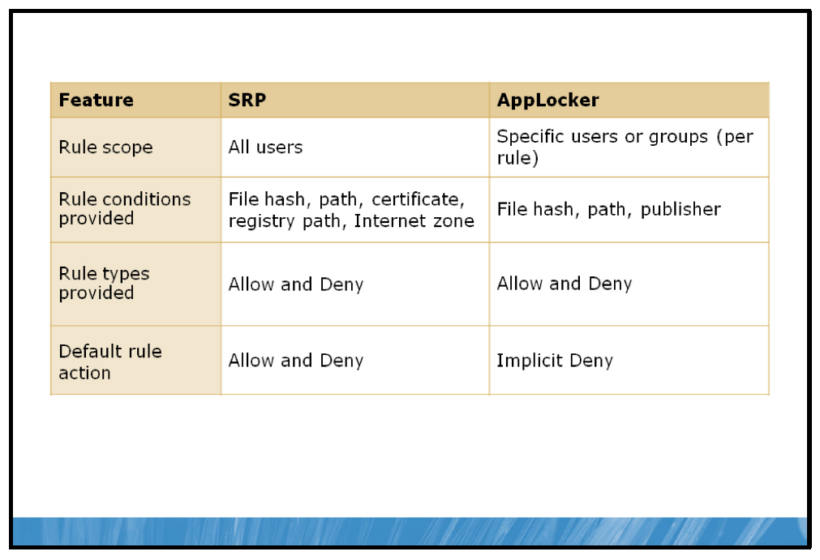

Key Points
While SRPs have been included in Windows Server 2008 R2 and Windows 7 for backwards compatibility purposes, AppLocker provides a number of enhancements over SRP. AppLocker is the recommended tool for providing application management when working within a Windows Server 2008 R2 and Windows 7 environment. AppLocker provides a more simplified and streamlined implementation and interface than SRP while also enabling a greater measure of control and flexibility when creating and implementing Rules.

AppLocker Benefits vs. SRP
When implementing SRPs in previous Windows versions, it was particularly difficult to create policies that were secure and remained functional after software updates were applied. This was due to the lack of granularity of certificate rules and the fragility of hash rules that became invalid when an application binary was updated. To address this issue, AppLocker enables you to create a rule that combines a certificate and a product name, file name, and file version. This simplifies your ability to specify that anything signed by a particular vendor for a specific product name can run.
Certificate rules in SRP allow you to trust all software signed by a specific publisher; however, AppLocker gives you much greater flexibility. When creating publisher rules, you can trust the publisher, and also drill down to the product level, the executable level, and even the version.
For example, with SRP, you can create a rule that affectively reads “Trust all content signed by Microsoft”. With AppLocker, you further refine the rule to specify: “Trust the Microsoft® Office 2007 Suite if it is signed by Microsoft and the version is greater than 12.0.0.0”.
The AppLocker enhancements over the SRP feature can be summarized as follows:
• | The ability to define rules based on attributes derived from a file’s digital signature, including the publisher, product name, file name, and file version. SRP supports certificate rules, but they are less granular and more difficult to define.
• | A more intuitive enforcement model; only a file that is specified in an AppLocker rule is allowed to run.
• | A new, more accessible user interface that is accessed through a new Microsoft Management Console (MMC) snap-in extension to the Group Policy Management Console snap-in.
• | An audit-only enforcement mode that allows administrators to determine which files will be prevented from running if the policy were in effect.
The following table outlines other key differences between AppLocker and SRPs.
Feature | SRP | AppLocker
Rule scope | Specific user or group (per Group Policy object [GPO]) | Specific users or groups (per rule)
Rule conditions provided | File hash, path, certificate, registry path, Internet zone | File hash, path, publisher
Rule types provided | Allow and Deny | Allow and Deny
Default Rule action | Allow and deny | Implicit Deny
Audit only mode | No | Yes
Wizard to create multiple rules at one time | No | Yes
Policy import or export | No | Yes
Rule collection | No | Yes
Windows PowerShell® support | No | Yes
Custom error messages | No | Yes

Implementing AppLocker and SRPs
Prior to Windows Server 2008 R2 and Windows 7, Windows operating systems were only able to use SRP rules. In Windows Server 2008 R2 and Windows 7, you can apply SRP or AppLocker rules, but not both. This allows you to upgrade an existing implementation to Windows 7 and still take advantage of the SRP rules defined in group policies.
However, if Windows Server 2008 R2 or Windows 7 have both AppLocker and SRP rules applied in a group policy, then only the AppLocker rules are enforced and the SRP rules are ignored.
When you add a single AppLocker rule in Windows Server 2008 R2 or Windows 7, all processing of SRP rules stops. Therefore, if you are replacing SRP rules with AppLocker rules, then you must implement all AppLocker rules that you require at one time. If you implement the AppLocker rules incrementally, then you will lose the functionality provided by SRP rules that have not yet been replaced with corresponding AppLocker rules.
Note: SRP is still the standard method to restrict software usage in versions of Windows prior to Windows Server 2008 and Windows 7.
Question: Why must AppLocker rules be defined in a GPO separate from SRP rules?

Lesson 2: E-Mail Protection
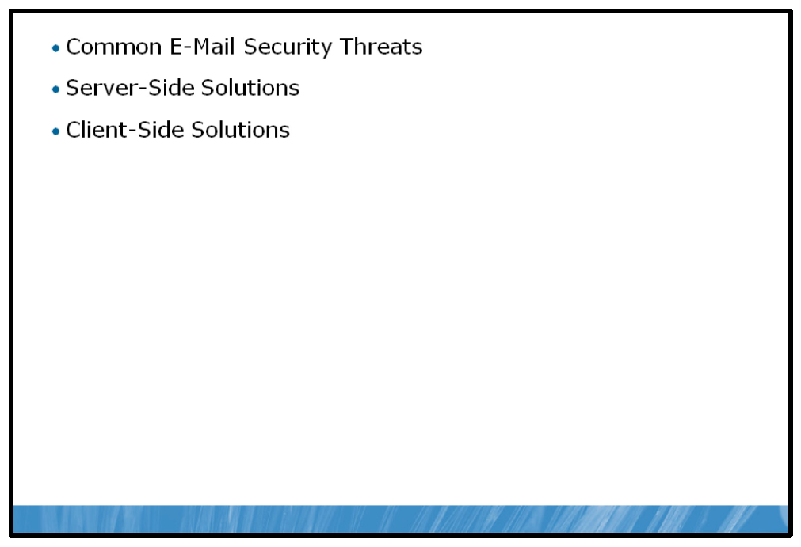
One of the major threats today is the introduction of malicious code into a corporate network. Malicious code can be extremely detrimental to the proper functionality of the corporate network and the creators of malicious code are becoming increasingly inventive in finding new ways to introduce this code into an environment.
One of the most common and effective methods of getting malicious code into an environment is through e-mail. Due to its widespread use, necessity for organizational functionality as well as the inherent trust of the delivery mechanism, e-mails carrying some form of malicious code continue to be a problem for IT administrators.
This lesson will introduce you to various methods for mitigating the threat of unsafe e-mail activity within a number of different areas in a corporate network environment.

Objectives:
After completing this lesson, you will be able to:
• | Describe common e-mail threats.
• | Describe the possible server solutions to these threats.
• | Describe possible client-based solutions.

Common E-Mail Security Threats
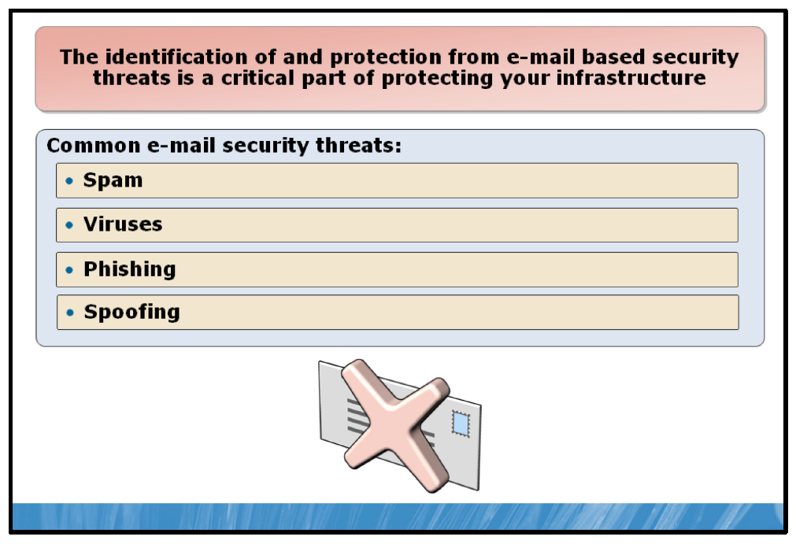

Key Points
A large amount of today’s e-mail messages are unwanted or unsolicited. Even as
e-mail filtering systems become more intelligent in the way they analyze and block these types of messages, the perpetrators of these illegitimate e-mails are coming up with new ways to get around the protection provided. The most common threats of e-mail today are:

Spam
Spam is usually an unsolicited e-mail that arrives in your inbox, typically sent as part of a bulk junk e-mail operation. E-mail addresses are harvested or collected in various methods, most commonly by extracting addresses from internet forums and postings. These addresses are then used to target users to purchase goods and services that may or may not be valid. Often spammers will include propaganda to make the e-mail look more valid than it actually is, and viruses are sometimes present in spam e-mails.

Phishing
One form of spam is called phishing. Phishing is an attempt to gather what is usually sensitive information from a user. The most common form of phishing is to request to harvest key security information and bank details from a user by diverting them to a falsified Web site. Over the years phishing attacks have increased. It is an easy way to gain access to reusable information without having to continually spam the user trying to get them to purchase goods or services. Windows Server 2008 R2, Windows 7, and Windows Internet Explorer® (IE) 8 (the default browser) includes a phishing filter which checks against
known falsified Web sites commonly trying to gather information from unsuspecting users.

Spoofing
Spoofing is another common threat wherein the sender attempts to mask or hide their identity as if they were someone else. Spoofing makes an e-mail from User A to User B allow User A to essentially identify themselves as anyone they would like to be, rather than simply being User A.

Viruses
A virus is a piece of malicious code that will copy itself and then expand in some way shape or form. Usually it sends itself out in a piece of spam or by taking control of other computers and trying to infect them as well. The term virus has become a catch-all term referring to traditional viruses, wherein there was not a reason other than to exploit code. But now the term includes malware, adware and spyware, and all programs which infect machines. Many viruses will perform malicious activity on an infected computer, such as data theft or disabling of essential applications.

Server-Side Solutions
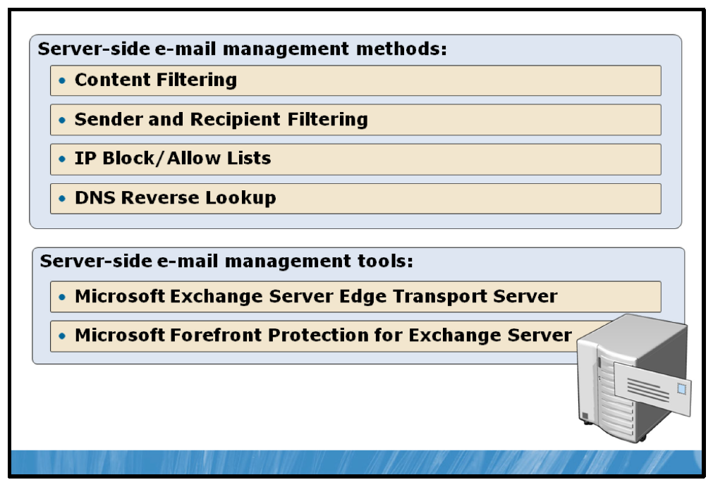

Key Points
To protect from the various levels of threats that exist within the confines of e-mail infrastructure, several methods and layers of protection are required to effectively keep the threat of e-mail-based attacks at an acceptable level.
In a server environment, several general methods exist that combine to decrease the threat of unwanted e-mail or e-mail server activity.

Content Filtering
Content filtering is a method commonly used to identify spam e-mail. Typically, either software installed on a server or a dedicated device is responsible for intercepting e-mail either to (most common) or from the e-mail server. The contents of the e-mail are then checked against an existing database or catalog of known spam-related terms or patterns. E-mail messages that appear to be spam are either deleted or sent to a quarantine area, preventing them from reaching their intended destination.

Sender and Recipient Filtering
Similar to content filtering, sender and recipient filtering selectively filters incoming or outgoing e-mail messages. With send and recipient filtering, however, the filtering process is dependent on a relatively static database of senders and/or recipients that can be filtered. There are two types of sender and recipient filtering.
• | Blocklist filtering identifies e-mail addresses that are known to be associated with unwanted activity. E-mails coming from blocklisted addresses are filtered and removed.
• | Allowlist filtering works in the reverse of blocklist filtering. When allowlist filtering is used, e-mail addresses contained in the allowlist database are identified as valid addresses. Allowlist filtering is most commonly used in conjunction with content filtering to prevent e-mails coming from valid senders being incorrectly identified as spam.

IP Block/Allow Lists
Using IP addresses is another way to identify the source of e-mail messages. E-mail servers can be configured to check against a database of IP addresses that are either known as valid or addresses that have been flagged as sources of spam-related activity. Similar to e-mail address filtering, IP-based blocklists and allowlists are often used in conjunction with more sophisticated content filtering to decrease the occurrence of false positives.

DNS Reverse Lookup
Another way e-mail is protected is by using reverse DNS lookup rules. If an e-mail destined for your organization comes from @contoso.com, the first thing most
e-mail servers do is to ensure it is a legitimate e-mail and do a reverse DNS lookup on the e-mail server hosting contoso.com. This is done by checking for the DNS PTR record to ensure to confirm the source of the e-mail. This ensures that the
e-mail is from a valid source. If there is no reverse e-mail server for contoso.com the e-mail will be discarded.
Sender Policy Framework (SPF) records work as an extension of DNS reverse lookups and can prevent sender e-mail address forgery. SPF records put the onus on the sending organization to register the IP addresses or alias for all e-mail servers that are allowed to send e-mail from the organization’s domain. Receiving e-mail servers can check the SPF records, and only accept e-mail from the authorized servers.

Microsoft Exchange Server Edge Transport Server
Edge Transport Servers are specifically configured Microsoft Exchange servers that handle all e-mail flow in and out of an organization’s core Exchange servers. An Edge Transport server is located in an organization’s perimeter network, acting as a gateway to the e-mail infrastructure of the private network. An Edge Transport server can perform content filtering, address filtering, and a number of other anti-spam-related functions that help protect against unwanted e-mail activity. Edge Transport servers identify and filter e-mail content prior to it entering the private corporate network, thereby decreasing and organizations’ risk and exposure to e-mail-related attacks and the issues that can arise from such attacks.

Microsoft Forefront Protection for Exchange Server
Microsoft Forefront® is a group of technologies that provide anti-malware protection in a Windows environment.
Microsoft Forefront Protection for Exchange Server is an edge-based solution, meaning that it is deployed into an organization’s perimeter network in the same way as a Microsoft Exchange Edge Transport server. Microsoft Forefront Protection for Exchange Server can also be deployed on Exchange Servers inside of the organization.
Microsoft Forefront Protection for Exchange Server is a comprehensive solution to edge-based e-mail security management. It provides anti-spam and e-mail filtering capabilities, anti-virus detection and filtering, and attachment blocking. It also provides the enforcement of policy-based e-mail management, allowing administrators to be very specific about the management of e-mail security in their environment.

Client-Side Solutions
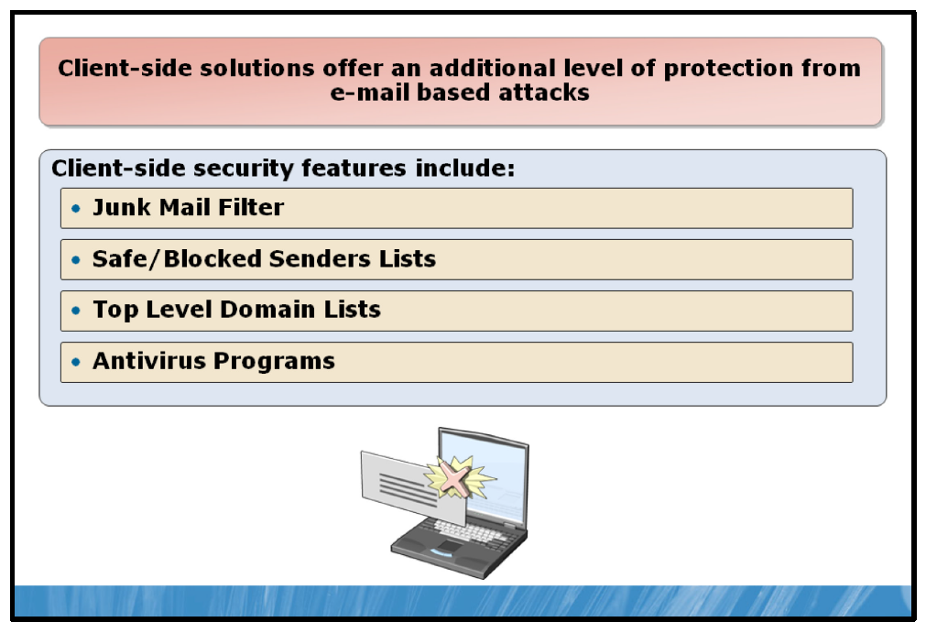

Key Points
While server-based solutions and tools deployed into an organization’s perimeter network provide the best defense against e-mail-based threats attempting to enter your network, no one solution will eliminate 100% of e-mail-based threats.
Client-side e-mail security management provides an additional level of protection from unwanted e-mail for your users.

Microsoft Office Outlook 2007 and 2010 Defenses
As well as antivirus programs and boundary defenses, Microsoft Office Outlook® 2007 and 2010 provide additional layers of security. Office Outlook 2007 and 2010 have junk filters built in which restrict potentially harmful attachments as well as images from being displayed. This junk filter is based on the concept of trusted senders as well as its own logic.
Office Outlook 2007 and 2010 maintain two lists of sender addresses for the purpose of filtering received e-mail content. Office Outlook 2007 and 2010 users can maintain these lists according to messages they receive and how they want those messages handled by Office Outlook 2007 and 2010.
• | Safe senders. Safe senders are addresses that have been identified as known and trusted senders of e-mail. Messages received from addresses located in the safe senders list are treated in a trusted manner and will be allowed to display images and other functions that might be considered potentially harmful if coming from an untrusted address.
• | Block senders. In contrast to the safe senders list, the blocked senders list contains a list of addresses that are known as unsafe. Messages from these addresses are filtered in order to prevent the potential for harmful activity.
Office Outlook 2007 and 2010 also allow a user to maintain a list of international top-level domains (TLDs) that are marked as unsafe or unwanted. For example, to block e-mail coming from addresses in Germany or Mexico, the TLDs .de and .mx would be added to the Blocked TLD list.
When an e-mail comes in, Office Outlook 2007 and 2010 check the validity of the e-mail and check the level of junk e-mail protection you have set. There are four levels of security:
• | No filtering. This setting will allow all e-mail to get in regardless of the sender and will not use Office Outlook 2007 and 2010’s built-in junk e-mail settings.
• | Low. This will perform a basic scan and analyze e-mail as it comes in, allowing most e-mail to pass through and end up in the inbox. It also takes into account the safe senders, safe recipients, blocked senders list and international settings which are configurable in Office Outlook 2007 and 2010. The safe senders and safe recipients list is a list of people you trust, no matter what kind of logic Office Outlook 2007 and 2010 might apply to the e-mail. These lists will ensure that the e-mail, provided it gets past the front line of defense, always ends up in your inbox. The blocked senders list is just that, any e-mail address or domain on the blocked senders list immediately gets treated as junk e-mail. The international setting allows blocking of top level domains as well as specific character encoding sets. For example, if you never intend on getting e-mail from anyone in Mexico, you can set the international setting to treat any e-mail from .mx as junk e-mail. Further, if you never expect anything in the Taiwanese character set, you can set that character set to be treated as junk.
• | High. High, similar to Low, filters e-mail, only on a more aggressive scale, letting less e-mail through to your inbox. High also takes into account all of the aforementioned lists.
• | Safe Lists Only. Safe Lists Only is the most extensive filtering possible, but can treat some potential “safe” e-mail as junk. Safe Lists Only will only allow e-mail from the safe senders and safe recipients lists mentioned above and treats all remaining e-mail as junk e-mail.

Antivirus Programs
Most antivirus programs integrate with e-mail programs like Microsoft Office Outlook and scan e-mail before you read it. It will also scan it while you read it and any attachments included in the e-mail will also be scanned. This provides a second layer of defense in case the perimeter-based servers have missed a potentially harmful e-mail.
This second level or layer of security also allows an end user or an IT department to put more rigorous checks in place on specific machines rather than at the global level. For example, the global policy might be to allow Microsoft Office Word, Microsoft Office Excel® and Microsoft Office PowerPoint® files through the firewall. However, at the second layer, the antivirus program will block the service staff of the company from receiving any attachments at all.

Lesson 3: Server Protection
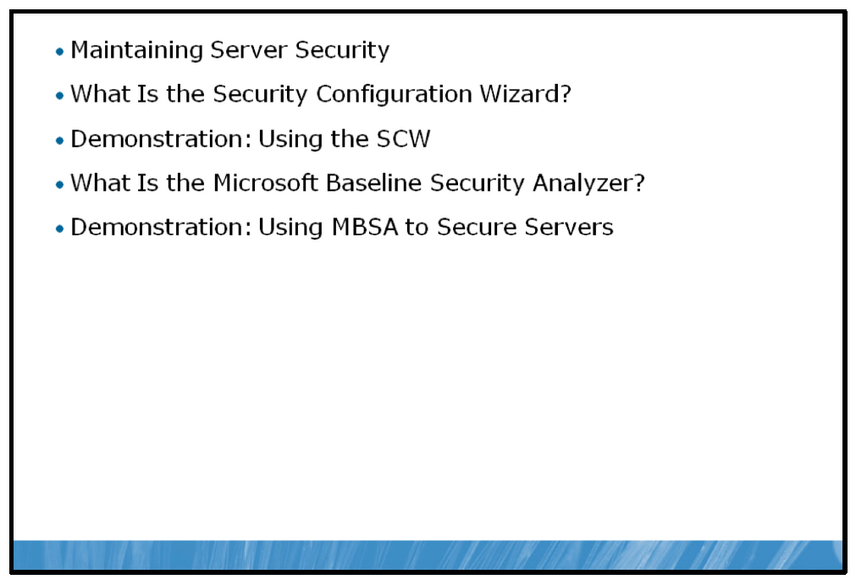
An organization’s servers represent the core of its network functionality. Servers typically host multiple business critical services within an organization. An infected file server may propagate a virus to remote workstations further crippling a network, whereas an infected e-mail server could potentially cut off external communications between your organization and your clients for an extended period of time. As a result, security measures implemented on the server infrastructure represent one of the most important aspects of maintaining overall network integrity and functionality.
This lesson introduced a number of ways to ensure that your servers are protected from circumstances that could leave them vulnerable to attack.

Objectives
After completing this lesson, you will be able to:
• | Describe how to maintain server security.
• | Describe the Security Configuration wizard (SCW).
• | Configure a Security Policy using the SCW.
• | Describe Microsoft Baseline Security Analyzer (MBSA).
• | Use the MBSA to help secure your servers.

Maintaining Server Security
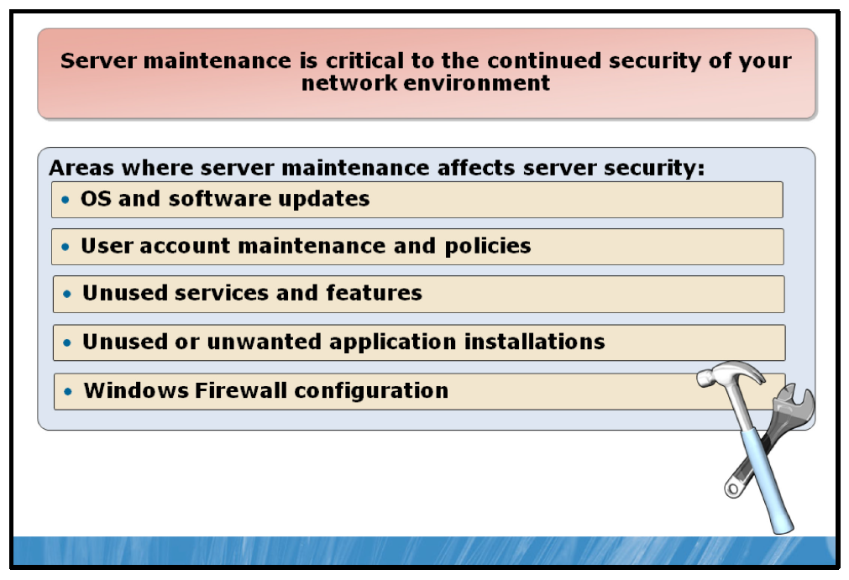

Key Points
Ensuring the security of your Windows Server 2008 R2 servers is an ongoing process that requires routine attention and maintenance to ensure that your servers are the least exposed to attack as possible. Several areas exist that should be considered when maintaining the security of your servers.

Maintaining Updates
Operating systems, including Windows Server 2008 R2 are constantly changing and evolving in response to customer demand for new features, newly identified security risks or other changes in the computing world. As well, applications installed on servers experience the same state of constant change for many of the same reasons. Due to this ever-changing state, operating systems and the applications that run on them are constantly being updated. While many update processes, such as Microsoft Update and Windows Server Update Services (WSUS) are primarily automated, these automated processes need to be routinely examined for proper operation.

User Account Security
The state of your server’s (and, if applicable, domain’s) account security is critical to ensuring the integrity of your server environment. Account passwords should be enforced by a password complexity policy and passwords should be regularly updated to prevent unauthorized account access. Unused accounts should be disabled or removed from the system. Accounts with elevated privileges, such as administrative accounts, should be closely monitored and used only for their intended purpose. For additional security, these accounts could be protected with an added measure of security, such as a smart card or a biometric authentication device.

Unused Services or Features
Disabling unused services and features within Windows Server 2008 R2 not only reduces the potential vulnerability of your server to attack, but also carries the added benefit of potentially increased performance.

Application Installation and Usage
Like unused services or features, unused applications can expose your server to security vulnerabilities as well as potential performance implications. In addition, carefully monitoring installed applications will ensure that malicious or unauthorized application installations are detected and removed.

Windows Firewall
Windows Firewall is your servers first line of defense against incoming network attacks. Leaving Windows Firewall enabled and ensuring that it is properly configured for your server leaves that layer of protection intact and provides you with a manageable and flexible way to protect against potential network vulnerabilities that may exist in other applications on your server.

What Is the Security Configuration Wizard?
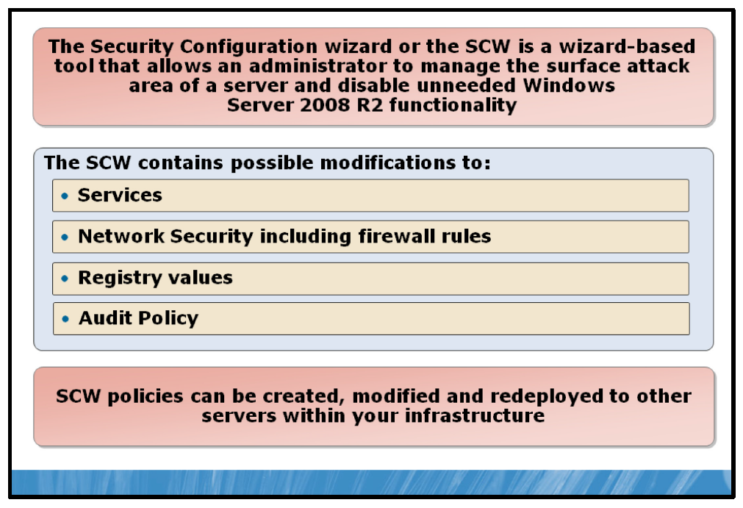

Key Points
The SCW can be used to enhance the security of a server by closing ports and disabling services not required for the server’s roles.
The SCW can be launched from the home page of Server Manager, in the Security Information section, or from the Administrative Tools folder. There is also a command-line version of the tool, scwcmd.exe.
The SCW is role-based in accordance with the new role-based configuration of Windows Server 2008 R2.
The SCW is typically run on a server prior to that server being deployed. This way, the attack surface of the server is reduced before it is deployed into the infrastructure and exposed to potential threats.
When the SCW is run, it scans the server and identifies the current state of the server relative to potential changes that may need to be made. SCW scans the following:
• | Roles that are installed on the server.
• | Roles likely being performed by the server.
• | Services installed on the server but not defined in the security configuration database.
• | IP addresses and subnets configured for the server.
The information discovered about the server is saved in an XML file. This server-specific file is called the configuration database.
The initial settings in the configuration database are called the baseline settings. After the server has been scanned and the configuration database has been created, you have the opportunity to modify the database, which will then be used to generate the security policy to configure services, firewall rules, registry settings, and audit policies. The security policy can then be applied to the server or to other servers playing similar roles. The SCW is a series wizard pages that presents these four security policy categories in separate sections:
• | Role-based service configuration
• | Network security
• | Registry settings
• | Audit policy

Role-Based Service Configuration
The outcome of this section is a set of policies that configure the startup state of services on the server. You want to ensure that only the services required by the server’s roles start and that other services do not start. To achieve this outcome, the SCW presents pages that display the server roles, client features, administration and other options detected on the scanned server. You can add or remove roles, features, and options to reflect the desired role configuration.

Network Security
The Network Security section produces the firewall settings of the security policy. Those settings will be applied by Windows Firewall with Advanced Security. Like the Role-Based Service Configuration section, the Network Security section displays a page of settings derived from the baseline settings in the configuration database. The settings in the Network Security section, however, are firewall rules rather than service startup modes.

Registry Settings
The Registry Settings section configures protocols used to communicate with other computers. These wizard pages determine Server Message Block (SMB) packet signing, Lightweight Directory Access Protocol (LDAP) signing, LAN Manager authentication levels, and storage of password LAN Manager hash values. Each of these settings is described on the appropriate page, and a link on each page takes you to a Security Configuration wizard Help page that details the setting.

Audit Policy
The Audit Policy section generates settings that manage the auditing of success and failure events and the file system objects that are audited. Additionally, the section enables you to incorporate a security template called SCWAudit.inf into the security policy.

Security Policies
When the SCW has completed the assessment of the server, it provides the opportunity to capture the settings in a security policy.
A security policy is the end result of the SCW run on a server. A security policy is an XML-based file that contains the settings obtained from the details provided during the SCW process. The policy contains potential changes to Windows settings from the following areas:
• | Services
• | Network security including firewall rules
• | Registry values
• | Audit policy
The saved policy can then be modified or deployed to servers by converting the policy to a GPO using the scwcmd.exe command-line tool and deploying the GPO using Group Policy.

Deploying a Security Policy Using Group Policy
You can apply a security policy created by the SCW to a server by using SCW itself, by using the Scwcmd.exe command, or by transforming the security policy into a GPO.
To transform a security policy into a GPO:
• | Log on as a domain administrator and run Scwcmd.exe with the transform command.
For example:
scwcmd transform /p:"Contoso DC Security.xml” /g:"Contoso DC Security GPO”
This command will create a GPO called Contoso DC Security GPO with settings imported from the Contoso DC Security.xml security policy file. The resulting GPO can then be linked to an appropriate scope—site, domain, or organizational unit (OU)—by using the Group Policy Management console. Be sure to type scwcmd.exe transform /? for help and guidance about this process.

Demonstration: Using the SCW
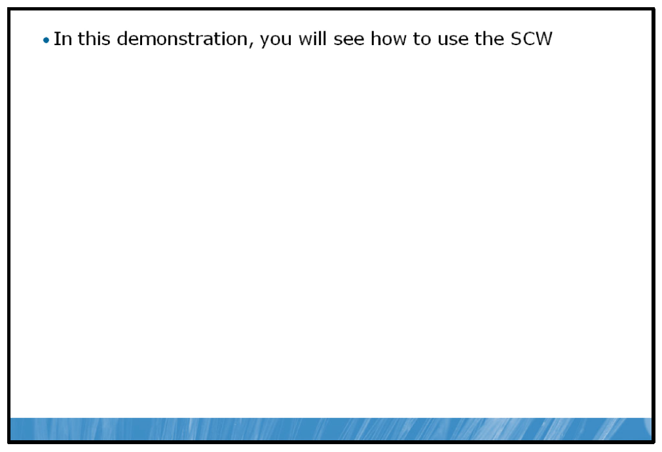

Key Points
In this demonstration you will see how to use the SCW to create a security policy.

Demonstration Step:
• | Use the SCW to create a security policy.

What Is the Microsoft Baseline Security Analyzer?
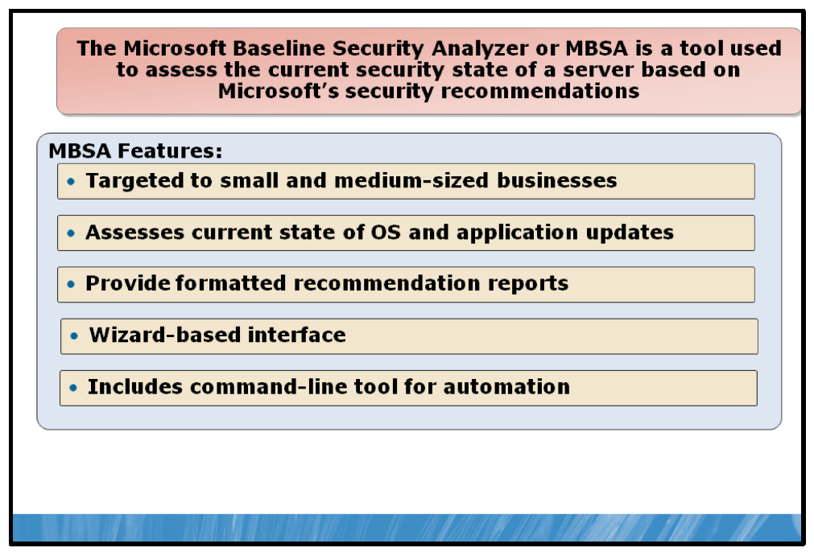

Key Points
MBSA is a software tool that analyzes the security state of an environment in accordance with Microsoft security recommendations. MBSA analyzes the current server state and documents any changes that will further secure the server and lock it down from attacks. Beginning in version 2.1, MBSA provides support for Windows Server 2008 R2.
MBSA uses Microsoft Update to check for the status of security updates and software updates for Microsoft applications such as Exchange and SQL Server as well as built-in applications like IE, Internet Information Server and offers guidance for the correction of detected inconsistencies.
In addition to the standard wizard-based interface, MBSA also provides a command-line interface (mbsacli.exe) which allows the MBSA to be run from within a script or as part of an automated task.
MBSA is designed for and geared towards small and medium businesses, but it can also be effectively used in a larger enterprise environment.

Demonstration: Using the MBSA to Secure Windows Servers
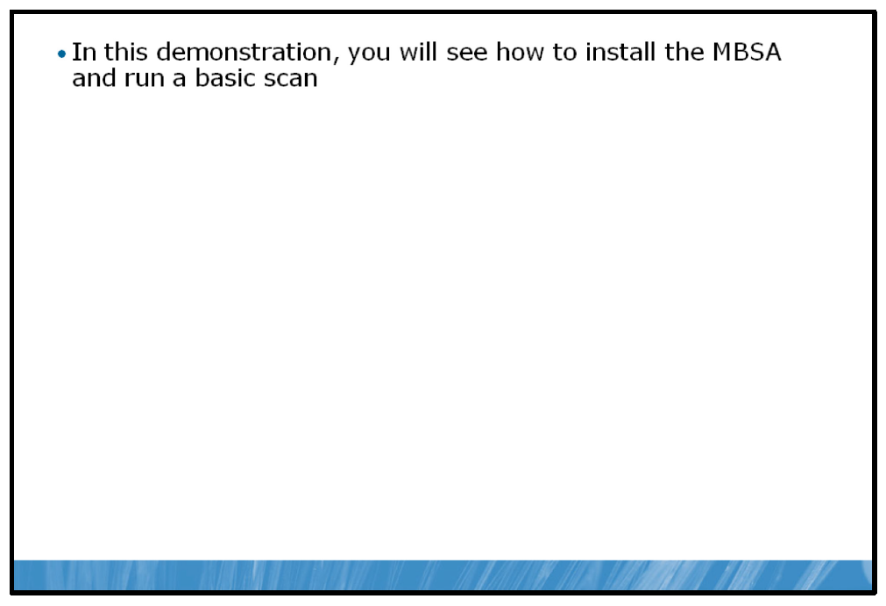

Key Points
In this demonstration you will see how to use MBSA to secure Windows Servers.

Demonstration Steps:
1. | Install the MBSA tool.
2. | Use MBSA to diagnose any problems with NYC-SVR2.

Lab: Implementing Security Software
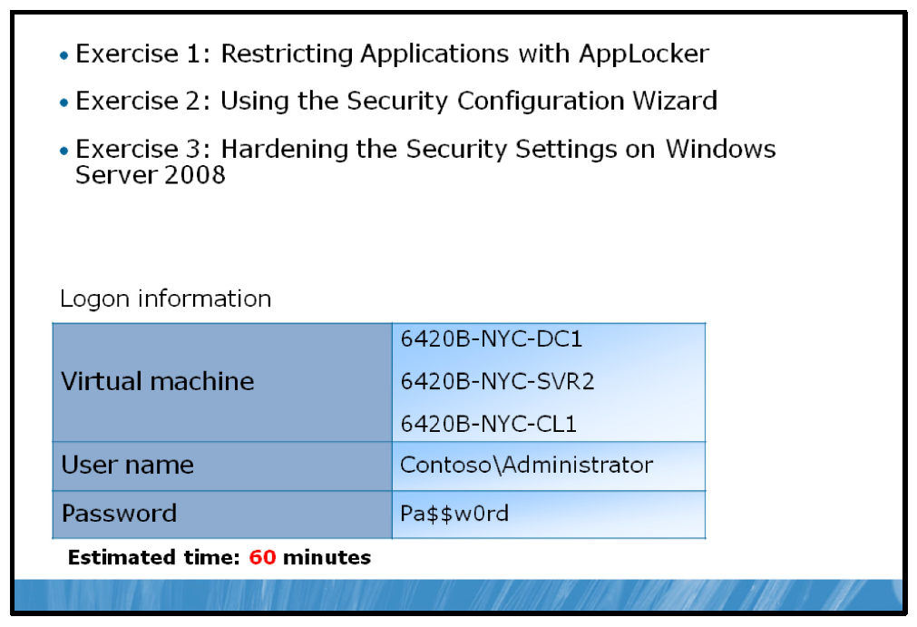

Lab Setup
For this lab, you will use the available virtual machine environment. Before you begin the lab, you must complete the following steps:
1. | On the host computer, click Start, point to Administrative Tools, and then click Hyper-V Manager.
2. | In Hyper-V™ Manager, click 6420B-NYC-DC1, and in the Actions pane, click Start.
3. | In the Actions pane, click Connect. Wait until the virtual machine starts.
4. | Log on using the following credentials:
  • | User name: Administrator
  • | Password: Pa$$w0rd
  • | Domain: Contoso
5. | Repeat these steps for 6420B-NYC-SVR2.
6. | In Hyper-V™ Manager, click 6420B-NYC-CL1, and in the Actions pane, click Start and then, in the Actions pane, click Connect. Do not log on to  NYC-CL1 until instructed to do so.

Exercise 1: Restricting Applications with AppLocker

Scenario
Microsoft Office 2007 has recently been installed in the Research Department at Contoso, Ltd on all client computers. Previously, WordPad was used for word processing tasks in the Research Department. To encourage users to use the new word processing capabilities of Office Word 2007, you have been asked to restrict users in the Research Department from running WordPad on their computers.
The main tasks for this exercise are as follows:
1. | Create a Group Policy object (GPO) to enforce the default AppLocker® Executable rules.
2. | Apply the GPO to the Contoso.com domain.
3. | Test the AppLocker rule.

Task 1: Create a Group Policy object (GPO) to enforce the default AppLocker Executable rules
1. | Switch to NYC-DC1.
2. | Open the Group Policy Management console and create a GPO entitled Wordpad Restriction Policy.
3. | Edit the new GPO with the following settings:
  • | Application Control Policy: Under Executable Rules create a new executable publisher rule for C:\Program Files\Windows NT  \Accessories\wordpad.exe that denies Everyone access to run any version of wordpad.exe.
  • | Configure Executable rules to be enforced.
  • | Configure the Application Identity service to run and set it to Automatic.

Task 2: Apply the GPO to the Contoso.com domain
• | Apply the WordPad Restriction Policy GPO to the Contoso.com domain container.

Task 3: Test the AppLocker rule
1. | Log on to NYC-CL1 as Contoso\Alan with the password of Pa$$w0rd.
2. | Refresh Group Policy by running gpudate /force from the command prompt.
3. | Try to run Start - All Programs - Accessories – WordPad.  Note: The AppLocker policy should restrict you from running this application. If the application runs, log off NYC-CL1 and log on again. Once the policy setting has applied, the application will be restricted.
Results: After this exercise, you will have restricted an application by using AppLocker.

Exercise 2: Using the Security Configuration Wizard

Scenario
You have been asked to use the Security Configuration wizard to create a security policy for domain controllers in the contoso.com domain based on the configuration of NYC-DC1. You will then convert the security policy into a GPO, which could then be deployed to all domain controllers by using Group Policy.
The main tasks for this exercise are as follows:
1. | Create a security policy.
2. | Transform a security policy into a GPO.

Task 1: Create a security policy
1. | On NYC-DC1, run the Security Configuration Wizard in the Administrative Tools folder.
2. | Carry through the steps of the wizard, accepting the defaults.
3. | Save the resultant Security Policy as DC Security Policy.xml.
4. | When prompted to apply the Security Policy, select Apply later.

Task 2: Transform a security policy into a GPO
1. | On NYC-DC1, use c:\windows\security\msscw\policies\scwcmd to transform DC-Security Policy.xml to a GPO named DC Security Policy GPO.
2. | In Group Policy Management console, examine the newly created DC Security Policy GPO.
Results: After this exercise, you will have used the Security Configuration wizard to create a security policy named DC Security Policy, and transformed the security policy to a Group Policy object named DC Security Policy.

Exercise 3: Hardening the Security Settings on Windows Server

Scenario
You have been asked to run MBSA on NYC-SVR2 to test for any areas requiring updates or maintenance.
The main tasks for this exercise are as follows:
1. | Install Microsoft® Baseline Security Analyzer (MBSA) on NYC-SVR2.
2. | Run the default MBSA scan.

Task 1: Install Microsoft Baseline Security Analyzer (MBSA) on NYC-SVR2
1. | Switch to NYC-SVR2.
2. | Open Windows Explorer and navigate to E:\Labfiles\MBSA.
3. | Run MBSASetup-x64-EN.msi using the defaults.

Task 2: Run the default MBSA scan
• | On NYC-SVR2, run the MBSA scan (ensuring to remove the check for updates checkmark).  Note: For demonstration and lab purposes you can change the automatic updates setting, however you will not be able to get updates as the classroom does not have internet connectivity.  Results: Your results should show several administrative vulnerabilities including the following: Automatic Updates Password Expiration Incomplete Updates Local Account Password Test File System Autologon Guest Account Restrict Anonymous Administrators Windows Firewall
Results: After this exercise, you will have used the MBSA to harden security settings.

To prepare for the next module
When you finish the lab, revert the virtual machines back to their initial state. To do this, complete the following steps:
1. | On the host computer, start Hyper-V Manager.
2. | Right-click 6420B-NYC-DC1 in the Virtual Machines list, and then click Revert.
3. | In the Revert Virtual Machine dialog box, click Revert.
4. | Repeat these steps for 6420B-NYC-SVR2 and 6420B-NYC-CL1.
5. | In the Virtual Machines pane, click 6420B-NYC-DC1, and then in the Actions pane, click Start.
6. | To connect to the virtual machine for the next module’s lab, click  6420B-NYC-DC1, and then in the Actions pane, click Connect.  Important: Start the 6420B-NYC-DC1 virtual machine first, and ensure that it is fully started before starting the other virtual machines.

Module Review and Takeaways
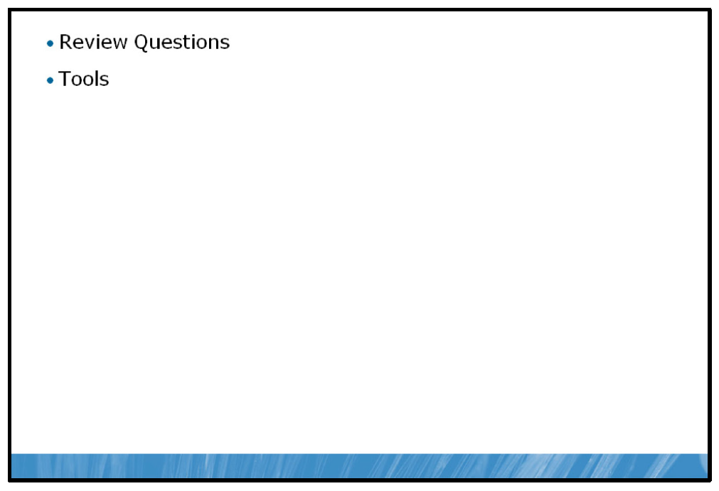

Review Questions
1. | What are the key differences between AppLocker and legacy Software Restriction Policies?
2. | Why are server-side e-mail security solutions typically more effective and easy to implement than client-side solutions?
3. | Why is maintaining software updates important to server security

Tools
Tool | Use for | Where to find it
Software Restriction Policies |  | Group Policy Management
  • | Managing software execution in legacy environments or in environments where Windows Server 2008 R2 and Windows 7 co-exist with legacy Windows operating systems
AppLocker |  | Group Policy Management
  • | Managing software execution in Windows Server 2008 R2 and Windows 7 environments
Microsoft Forefront Protection for Exchange Server |  | For more information see, Forefront Protection 2010 for Exchange Server http://www.microsoft.com /forefront/protection-for- exchange/en/us/default.aspx
  • | Provide antimalware protection for a Microsoft Exchange Server environment
Security Configuration wizard |  | Start Menu
  • | Generate and apply security policy templates to decrease the vulnerability of Windows Server 2008 R2
Microsoft Baseline Security Analyzer |  | For more information see, Microsoft Baseline Security Analyzer:  http://technet.microsoft.com/en- us/security/cc184924.aspx
  • | Analyze the security state of an environment in accordance with Microsoft security recommendations.

- Highlight
- Note
- Expand Highlight
- Expand Note
Module 12: Monitoring Server Performance
Contents:
Lesson 1: | Overview of Server Components
Lesson 2: | Performance Monitoring
Lab: | Monitoring Server Performance

Module Overview
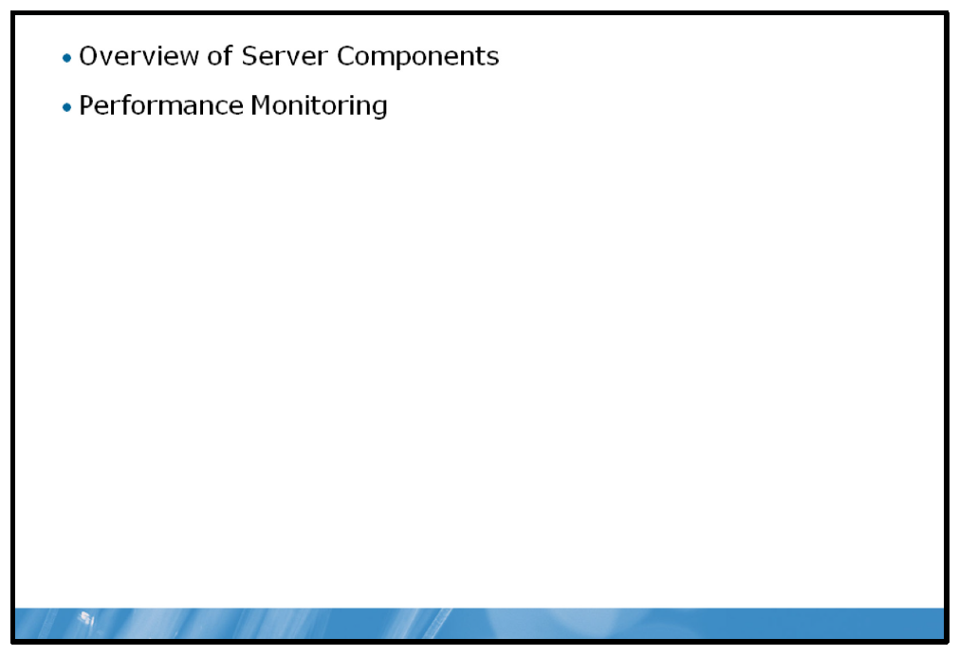
Monitoring the performance of servers is important for all organizations. Businesses require cost-effective solutions that provide value for money. You should monitor servers to ensure that they run efficiently and use available server capacity.
Many administrators require performance monitoring tools to identify components that require additional tuning and troubleshooting. By identifying components that require additional tuning, you can improve the efficiency of your servers.

Objectives
After completing this module, you will be able to:
• | Identify server components that are impacted through excessive workloads.
• | Measure system resource usage and identify component bottlenecks.

Lesson 1: Overview of Server Components
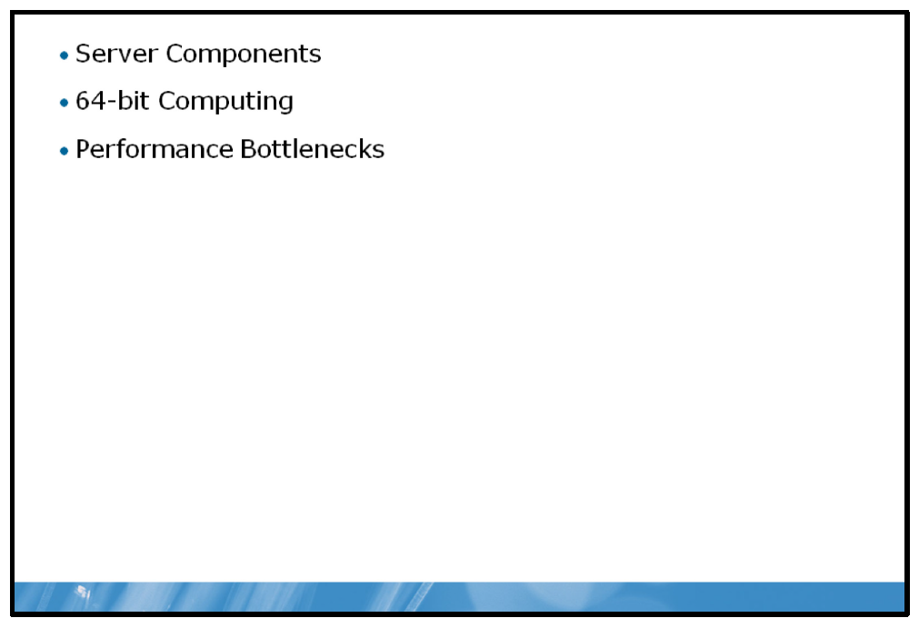
Before you can start to collect meaningful performance-related statistics, you must be able to identify the important server components that affect server performance most significantly. A bottlenecked server component can lead to significant performance problems. This lesson explores server components and explains how to identify server bottlenecks.

Objectives
After completing this lesson, you will be able to:
• | Describe the important server components.
• | Explain the benefits of 64-bit computing.
• | Describe performance bottlenecks.

Server Components
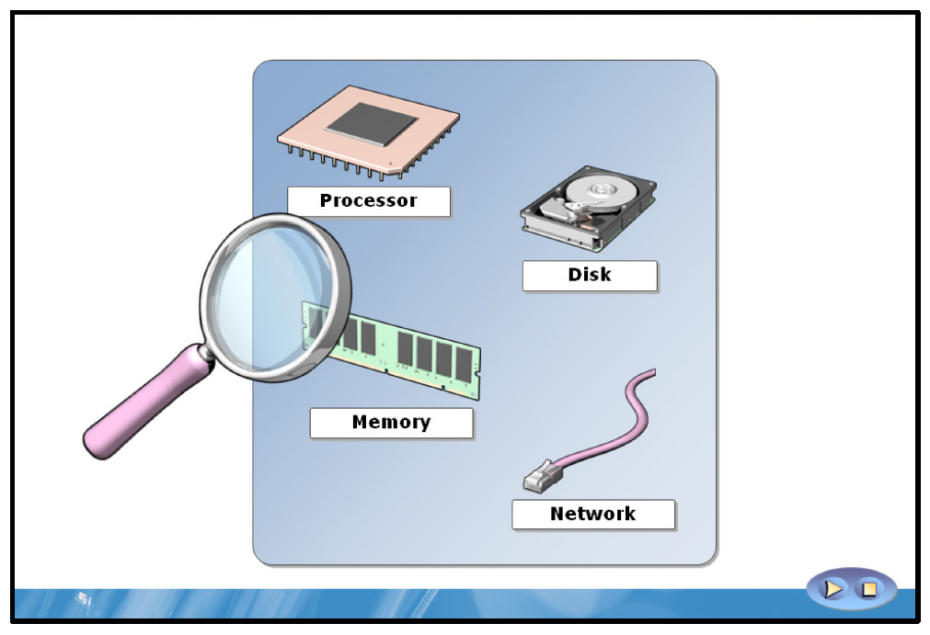

Key Points
The four main hardware components to monitor are processor, disk, memory and network. Understanding how these four key hardware components are utilized by the operating system and how they interact with one another is an important step along the road to understanding how to optimize server performance.
When monitoring performance, you should consider:
• | The measurement of all key components in your system.
• | The server role and workload to determine which hardware components are likely to restrict performance.
• | The ability to increase server performance by adding power or reducing the number of users who are accessing a server.

Processor
One important factor in determining the overall processor capacity of your server computer is processor speed. Processor speed is determined by the number of operations it can perform in a measured period of time. Servers with multiple processors, or processors with multiple cores, generally perform processor-intensive tasks with greater efficiency and are consequently faster than single processor or single-core processor servers.
Processor architecture is also important. 64-bit processors can access more memory and have a significant effect on performance. This is true especially when applications running on your server require a large amount of memory.

Disk
Hard disks are used to store programs and data. Consequently, the speed of the server is affected by the throughput of your disks, especially when the server is performing disk-intensive tasks. Disks have moving parts and it takes time to position the read/write heads over the appropriate sector on the disk to retrieve the requested information.
By selecting faster disks, and by using collections of disks to optimize access times, you can alleviate the potential for the disk subsystem to create a performance bottleneck.
It is also worth remembering that information on the disk is moved into memory before it can be used. If there is a surplus of memory, the Windows Server® operating system creates a file cache for items recently written to or read from the disks. Installing additional memory in a server can often improve the disk subsystem performance.

Memory
Programs and data are loaded from disk into memory before the program can manipulate the data. In servers that run multiple programs, or where datasets are very large, increasing the amount of memory installed can help improve server performance.
Windows Server uses a memory model in which excessive memory requests are not rejected, but handled by a process known as paging. During paging, data and programs in memory not currently being utilized by processes are moved into an area on the hard disk known as the paging file; this frees up physical memory to satisfy the excessive requests. However, because a disk is comparatively slow, paging has an effect on server performance. By adding more memory, and by using a 64-bit processor architecture that supports larger memory, you can reduce the need for paging.

Network
It is easy to underestimate the effect of a poorly performing network as it is not as easy to see or to measure as the other three server components. However, as so many of the programs and so much of the data that processes, and since application access is stored on network devices, it should not be surprising that the network is a critical component for performance monitoring.

64-bit Computing
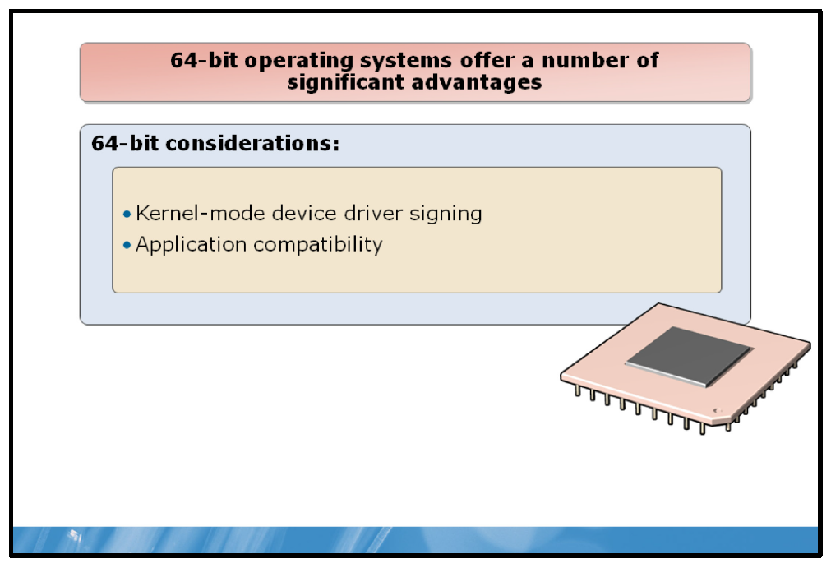

Key Points
The Windows Server 2008 R2 operating system is only available in 64-bit versions. 64-bit operating systems offer a number of significant advantages. For example, installing 64-bit operating systems offers the ability to scale up (increase processor cores and memory) more than is possible with a 32-bit operating system.

Device Driver Considerations
You must ensure that the kernel-mode drivers that you will use are all signed digitally; digital signatures for kernel-mode software are an important way to ensure security on computer systems. The mandatory kernel-mode, code signing policy applies to all kernel-mode software on systems running Windows Server 2008 R2.

Application Compatibility
In addition to ensuring that you have digitally signed drivers, you must consider application compatibility.
Windows Server 2008 R2 includes kernel and user mode application programming interface (API) changes that support virtualization, scalability, performance, power management, and networking enhancements. Consequently, applications designed to run on an earlier, 32-bit version of Windows Server may not run correctly on Windows Server 2008 R2.
You must verify the correct functionality of important applications before you deploy Windows Server 2008 R2, and where necessary, implement application fixes to ensure correct functionality.
Microsoft provides a number of application compatibility tools that can help you test, and where required, fix your applications so that they run correctly within the 64-bit Windows Server 2008 R2 environment.
Question: How many of the servers installed in your organization have 64-bit hardware but only 32-bit operating systems?

Performance Bottlenecks
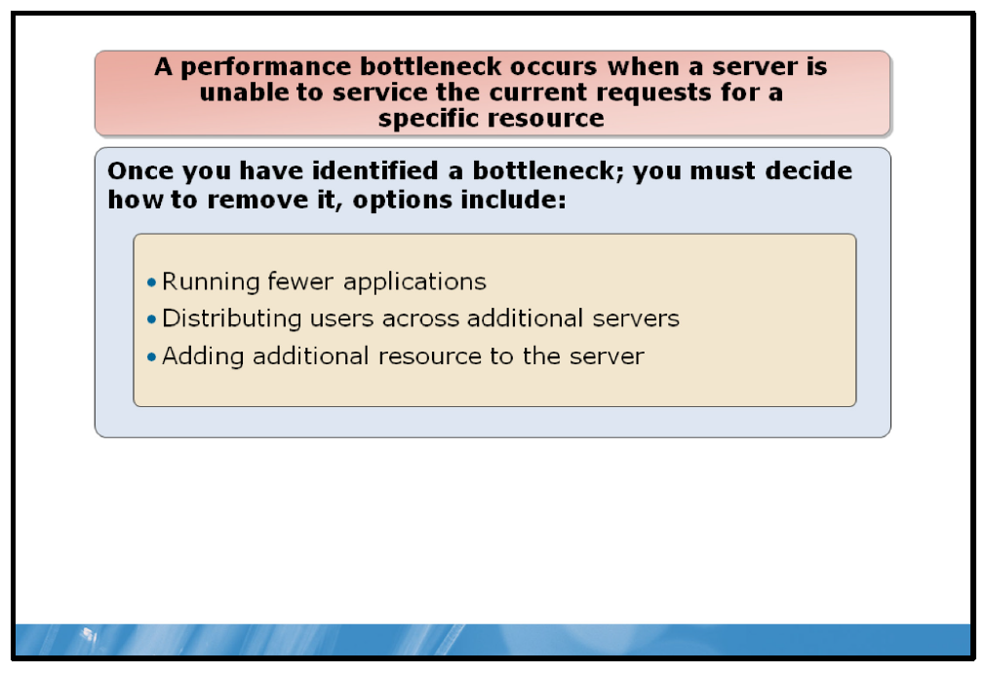

Key Points
A performance bottleneck occurs when a server is unable to service the current requests for a specific resource. The resource might be a server component, such as a disk, memory, processor, or network. Alternatively, the bottleneck might be caused by the shortage of a component within an application package.
By using performance monitoring tools on a regular basis, and comparing the results to your baseline and to historical data, you can identify server bottlenecks before they impact users.
Once you have identified a bottleneck, you must decide how to remove it. Option include:
• | Running fewer applications.
• | Distributing users across additional servers.
• | Adding additional resources to the server.
In severe circumstances, a server suffering from a severe resource shortage may stop processing user requests. However, if your server is experiencing a bottleneck but is still operating within acceptable limits, you might decide to defer any changes until the situation is resolved, or until you have an opportunity to take corrective action.

Lesson 2: Performance Monitoring
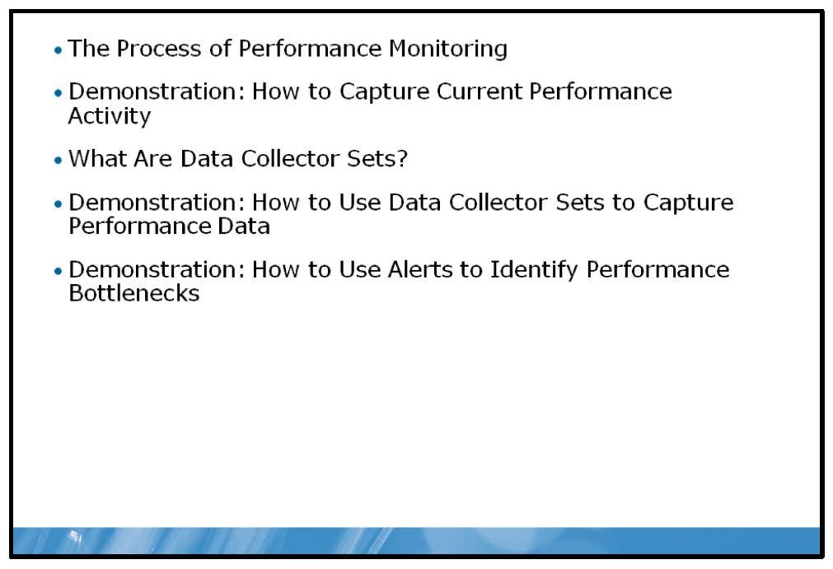
Windows Server provides a number of tools that enable you to gather and analyze performance-related statistics; it is important that you know what data to collect with these tools so that you can identify performance problems on your servers before they impact your users.

Objectives
After completing this lesson, you will be able to:
• | Describe the process of performance monitoring.
• | View real-time performance data.
• | Capture performance data for subsequent analysis.
• | Describe Data Collector Sets.
• | Identify server bottlenecks by using alerts.

The Process of Performance Monitoring
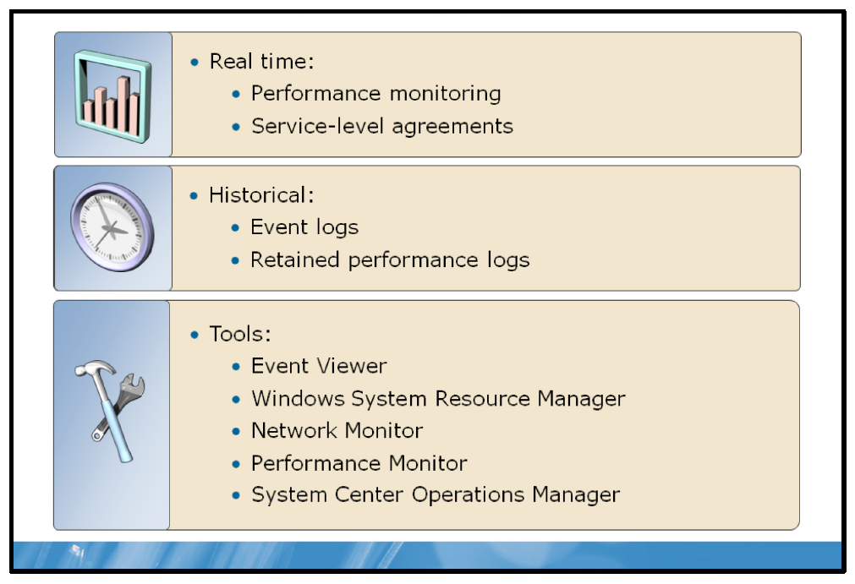

Key Points
There are several methods that you can use to collect performance data from servers in your organization. You should use each of these methods to suit your organization’s requirements.
Real-time monitoring of computers is useful when you want to determine the effect of performing a specific action or troubleshoot specific events. This type of monitoring can also help you to ensure that you are meeting service level agreements (SLAs).
Analyzing historical data can be useful for tracking trends over time, determining when to relocate resources, and deciding when to invest in new hardware to meet the changing requirements of your business. You should use historical performance data to assist you when you plan future server requirements.
If you intend to gather data for historical comparison, it is important to establish a performance baseline. To create a baseline, you must collect performance data over a period of time during which your server is under typical load. When you come to collect data in the future, you must ensure you collect statistics about the same resources as those you analyzed in your baseline. You can then compare resource usage against your baseline and see whether there are sufficient resources to satisfy user demands.
A range of tools is available to assist you in the monitoring of your server environment. These tools are described in the following table.
Tool | Description
Windows Server 2008 R2 Event Viewer | Windows Server 2008 R2 Event Viewer collects information that relates to server operations. This data can help you to identify performance issues on a server. You should search for specific events in the event log file to locate and identify problems.
Microsoft® Windows® System Resource | Using WSRM, you can control how CPU resources are allocated to applications, services, and processes. Managing these resources improves
Manager (WSRM) | system performance and reduces the chance that these applications, services, or processes will interfere with the rest of the system.  WSRM is a feature of Windows Server 2008 R2.
Microsoft Network Monitor | Network Monitor is a protocol analyzer. It enables you to capture, view, and analyze network data. You can use it to help troubleshoot problems with applications on the network.  You can download Network Monitor from the Microsoft Download Center Web site.
Microsoft Windows Performance Monitor | You can use Microsoft Windows Performance Monitor to examine how programs you run affect your computer’s performance, both in real-time and by collecting log data for later analysis. Windows Performance Monitor uses performance counters, event trace data, and configuration information, which can be combined into data collector sets.  Performance Monitor is built into Windows Server 2008 R2.
Microsoft System Center Operations Manager 2007 (Operations Manager) | Operations Manager enables you to build a complete picture of the past and current performance of your server infrastructure. Operations Manager can also automatically respond to events and address problems before they become an issue for you. Operations Manager requires time to configure and requires additional licenses.

Demonstration: How to Capture Current Performance Activity
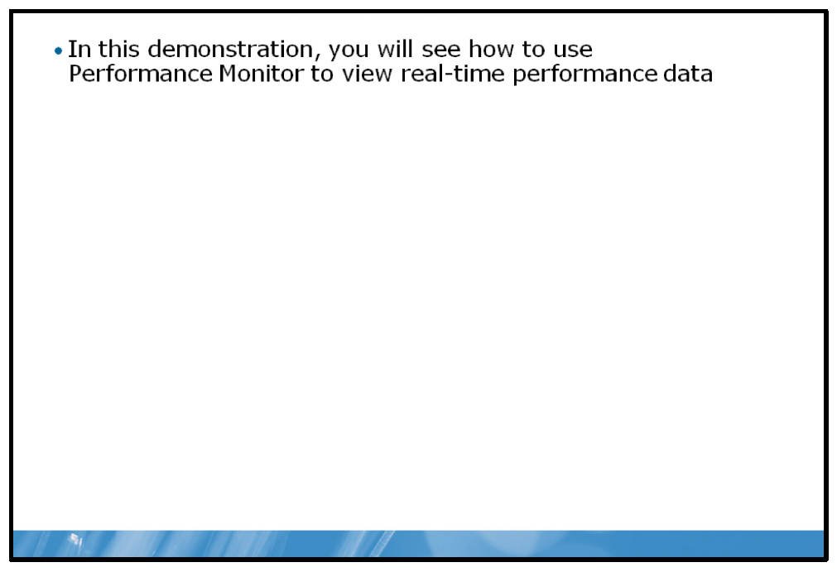

Key Points
There are many counters that you should research and consider monitoring to meet your specific requirements.
Windows Server 2008 R2 enables monitoring of operating system performance through performance objects and counters in the object. Windows Server 2008 R2 collects data from counters in various ways, including:
• | Real-time snapshot value
• | Total since last server restart
• | Average over specific time interval
• | Average of last x values
• | Number per second
• | Maximum value
• | Minimum value

Primary Processor Counters
CPU counters are a feature of the computer's CPU that stores the count of hardware-related events.
• | Processor>% Processor Time. Shows the percentage of elapsed time that this thread used the processor to execute instructions. An instruction is the basic unit of execution in a processor, and a thread is the object that executes instructions. Code executed to handle some hardware interrupts and trap conditions is included in this count.
• | Processor>Interrupts/sec. Shows the rate, in incidents per second, at which the processor received and serviced hardware interrupts.
• | System>Processor Queue Length. This counter is a rough indicator of the number of threads each processor is servicing. The processor queue length, sometimes called processor queue depth, reported by this counter is an instantaneous value that is representative only of a current snapshot of the processor, so it is necessary to observe this counter over a long period of time. Also, the System\Processor Queue Length counter is reporting a total queue length for all processors, not a length per processor.

Primary Memory Counters
The Memory performance object consists of counters that describe the behavior of physical and virtual memory on the computer. Physical memory is the amount of RAM on the computer. Virtual memory consists of space in physical memory and on disk. Many of the memory counters monitor paging, which is the movement of pages of code and data between disk and physical memory.
• | Memory>Pages/sec. Shows the number of hard page faults per second. A hard page fault occurs when the requested memory page cannot be located in RAM because it currently exists in the paging file. An increase in this counter indicates that more paging is occurring which in turn suggests a lack of physical memory.

Primary Disk Counters
The Physical Disk performance object consists of counters that monitor hard or fixed disk drives. Disks are used to store file, program, and paging data. They are read to retrieve these items, and are written to record changes to them. The values of physical disk counters are sums of the values of the logical disks (or partitions) into which they are divided.
• | Physical Disk>%Disk time. This counter shows how busy a particular disk is. A counter approaching 100% indicates that the disk is busy nearly all of the time and may suggest a performance bottleneck is imminent.
• | Physical Disk>Average Disk Queue Length. This counter shows how many disk requests are waiting to be serviced by the I/O manager in Windows Server at a given moment. The longer the queue, the less satisfactory the disk throughput is.

Primary Network Counters
Most workloads require access to production networks to ensure communication with other applications and services and to communicate with users. Network requirements include elements such as throughput—that is, the total amount of traffic that passes a given point on a network connection per unit of time.
Other network requirements include the presence of multiple network connections. Workloads might require access to several different networks that must remain secure. Examples include connections for:
• | Public network access.
• | Networks for performing backups and other maintenance tasks.
• | Dedicated remote-management connections.
• | Network adapter teaming for performance and failover.
• | Connections to the physical host server.
• | Connections to network-based storage arrays.
By monitoring the network performance counters, you can evaluate your network’s performance.
In this demonstration, you will see how to use Performance Monitor to view real-time performance data.

Demonstration Steps:
1. | View current activity in System Summary.
2. | Use Performance Monitor to view a chart on current activity.
3. | Use a Report to view the current activity.

What Are Data Collector Sets?
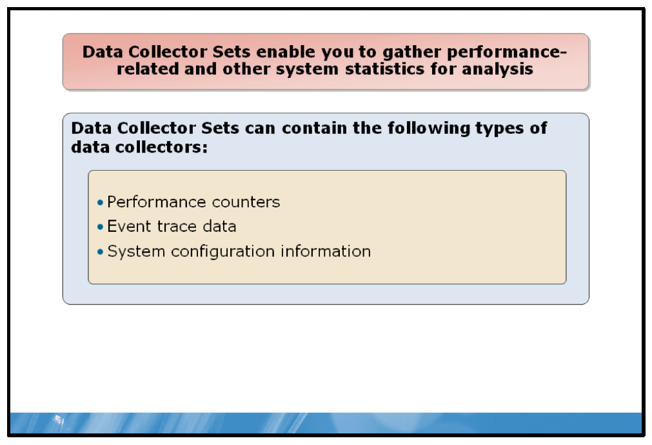

Key Points
A Data Collector Set is the foundation of Windows Server performance monitoring and reporting in Performance Monitor.
Data Collector Sets enable you to gather performance-related and other system statistics for analysis with other tools within Performance Monitor, or with third-party tools.
While it is useful to analyze current performance activity on a server computer, it is perhaps more useful to collect performance data over a period of time for subsequent analysis and comparison with previously gathered data. This data comparison enables you to make determinations about resource usage, to plan for growth, and to identify potential performance problems.
Data Collector Sets can contain the following types of data collectors:
• | Performance counters. Provides data about the server’s performance.
• | Event trace data. Provides information about system activities and events–often useful for troubleshooting.
• | System configuration information. Enables you to record the current state of registry keys and to record changes to those keys.
You can create a Data Collector Set from a template, from an existing set of data collectors in a Performance Monitor view, or by selecting individual data collectors and setting each individual option in the Data Collector Set properties.

Demonstration: How to Use Data Collector Sets to Capture Performance Data
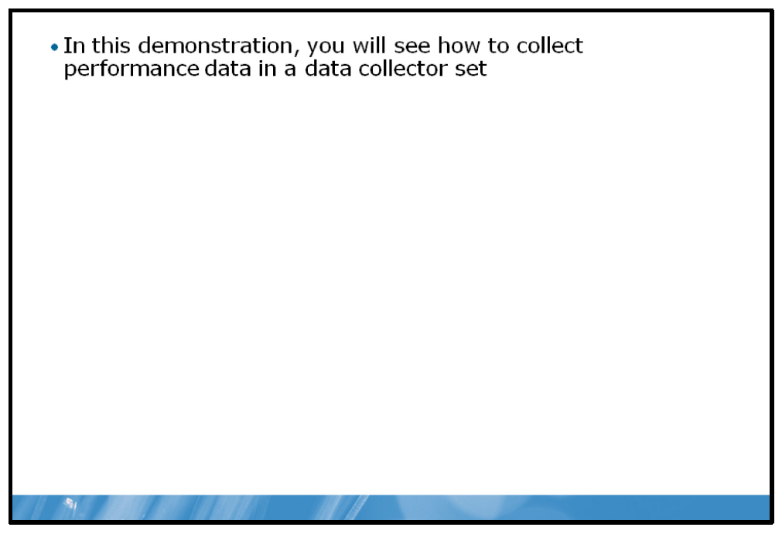

Key Points
In this demonstration, you will see how to collect performance data in a data collector set.

Demonstration Steps:
1. | Create a data collector set.
2. | Create a disk load on the server.
3. | Analyze the resulting data in a report.

Demonstration: How to Use Alerts to Identify Performance Bottlenecks
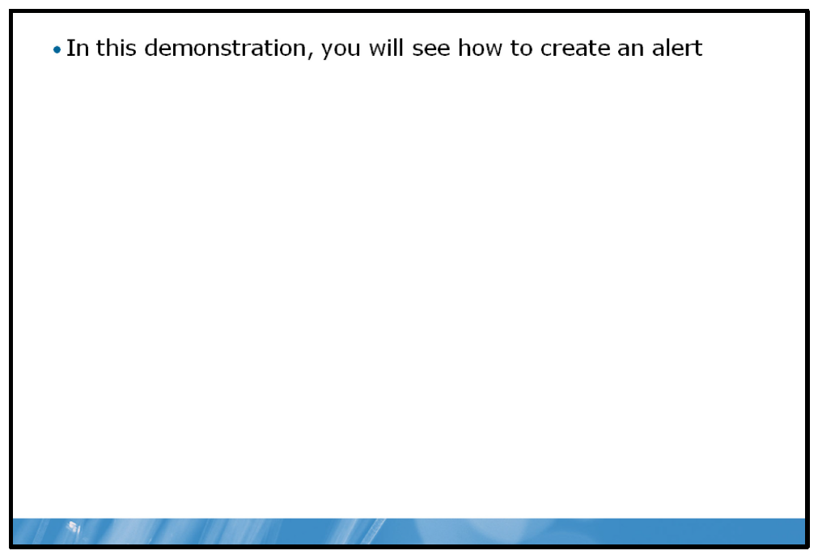

Key Points
You can use alerts in Performance Monitor to determine when a threshold has been exceeded and then to take appropriate action, such as run a program, generate an Event Log error, and start a data collector set.
In this demonstration, you will see how to create an alert.

Demonstration Steps:
1. | Create a data collector set with an alert counter.
2. | Generate a load on the server to exceed configured threshold.
3. | Examine event log for resulting event.

Lab: Monitoring Server Performance
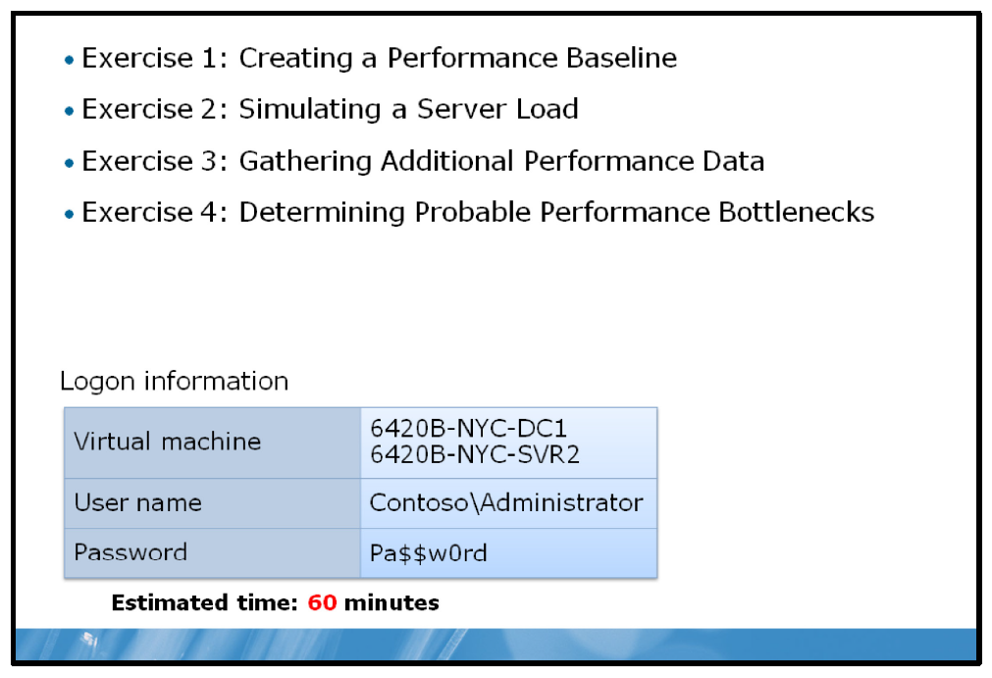

Lab Setup
For this lab, you will use the available virtual machine environment. Before you begin the lab, you must complete the following steps:
1. | On the host computer, click Start, point to Administrative Tools, and then click Hyper-V Manager.
2. | In Hyper-V™ Manager, click 6420B-NYC-DC1, and in the Actions pane, click Start.
3. | In the Actions pane, click Connect. Wait until the virtual machine starts.
4. | Log on using the following credentials:
  • | User name: Administrator
  • | Password: Pa$$w0rd
  • | Domain: Contoso
5. | Repeat these steps for 6420B-NYC-SVR2.

Lab Scenario
You have successfully deployed some new servers at the Contoso, Ltd branch offices. Before the system goes live, you decide to establish a performance baseline so that you can compare future workloads to the expected workload.

Exercise 1: Creating a Performance Baseline

Scenario
You load Performance Monitor on the server and create a baseline using typical performance counters.
The main tasks for this exercise are as follows:
1. | Create a Data Collector Set.
2. | Start the Data Collector Set.
3. | Create workload on the server.
4. | Analyze collected data.

Task 1: Create a Data Collector Set
1. | Switch to the NYC-SVR2 computer.
2. | Open Performance Monitor.
3. | Create a new user defined data collector set using the following information to complete the process:
  a. | Name: NYC-SVR2 Performance
  b. | Create: Create manually (Advanced)
  c. | Type of data: Performance counter
  d. | Select the following counters:
    • | Processor, %Processor Time
    • | Memory, Pages/sec
    • | PhysicalDisk, %Disk Time
    • | PhysicalDisk, Avg. Disk Queue Length
    • | System, Processor Queue Length
    • | Network Interface, Bytes Total/sec
  e. | Sample interval: 1 second
  f. | Where to store data: default value
4. | Save and close the data collector set.

Task 2: Start the Data Collector Set
• | In Performance Monitor, in the Results pane, right-click  NYC-SVR2 Performance, and then click Start.

Task 3: Create workload on the server
1. | Open a command prompt and run the following commands, pressing ENTER after each command:  Fsutil file createnew bigfile 104857600  Copy bigfile \\nyc-dc1\c$  Copy \\nyc-dc1\c$\bigfile bigfile2  Del bigfile*.*  Del \\nyc-dc1\c$\bigfile*.*
2. | Do not close the command prompt.

Task 4: Analyze collected data
1. | Switch to Performance Monitor.
2. | Stop the NYC-SVR2 Performance data collector set.
3. | In Performance Monitor, in the navigation pane, click Performance Monitor.
4. | On the toolbar, click View Log Data.
5. | In the Performance Monitor Properties dialog box, on the Source tab, click Log files and then click Add.
6. | In the Select Log File dialog box, double-click Admin.
7. | Double-click NYC-SVR2 Performance, double-click the  NYC-SVR2_date-000001 folder and then double-click DataCollector01.blg.
8. | Click the Data tab and then click Add.
9. | Select the following counters:
  • | Processor, %Processor Time
  • | Memory, Pages/sec
  • | PhysicalDisk, %Disk Time
  • | PhysicalDisk, Avg. Disk Queue Length
  • | System, Processor Queue Length
  • | Network Interface, Bytes Total/sec
10. | On the toolbar, click the down arrow and then click Report.
11. | Record the values listed in the report for analysis later.  Recorded values:
  • | Processor, %Processor Time
  • | Memory, Pages/sec
  • | PhysicalDisk, %Disk Time
  • | PhysicalDisk, Avg. Disk Queue Length
  • | System, Processor Queue Length
  • | Network Interface, Bytes Total/sec
Results: After this exercise, you should have established a baseline.

Exercise 2: Simulating a Server Load

Scenario
Having created the baseline, you now simulate a load to represent the system in live usage.
The main tasks for this exercise are as follows:
1. | Load a new program on the server.
2. | Configure the load on the server.

Task 1: Load a new program on the server
1. | On NYC-SVR2, switch to the command prompt.
2. | Change to the C:\Labfiles\StressTool folder.

Task 2: Configure the load on the server
• | On NYC-SVR2, run StressTool.exe 95.
Results: After this exercise, you should have introduced a load on your server.

Exercise 3: Gathering Additional Performance Data

Scenario
Users are complaining of poor server performance and you investigate by using the previously created data collector set.
The main task for this exercise is as follows:
1. | Start the data collector set again.

Task: Start the data collector set again
1. | Switch to Performance Monitor.
2. | Start the NYC-SVR2 Performance data collector set.
3. | Wait one minute for data to be captured.
Results: After this exercise, you should have captured additional performance data.

Exercise 4: Determining Probable Performance Bottlenecks

Scenario
You compare the results achieved under the new load with those collected when you first deployed the server.
The main tasks for this exercise are as follows:
1. | Stop the running program.
2. | View performance data.
3. | Analyze results and draw a conclusion.

Task 1: Stop the running program
• | At the command prompt, press CTRL+ C and then close the command prompt.

Task 2: View performance data
1. | Switch to Performance Monitor.
2. | Stop the data collector set.
3. | In Performance Monitor, in the navigation pane, click Performance Monitor.
4. | On the toolbar, click View log data.
5. | In the Performance Monitor Properties dialog box, on the Source tab, click Log files and then click Remove.
6. | Click Add.
7. | In the Select Log File dialog box, click Up One Level.
8. | Double-click the NYC-SVR2_date-000002 folder and then double-click DataCollector01.blg.
9. | Click the Data tab and then click OK.  Note: If you receive an error at this point, or the values in your report are zero, repeat steps 4-9.
Recorded values:
• | Processor, %Processor Time
• | Memory, Pages/sec
• | PhysicalDisk, %Disk Time
• | PhysicalDisk, Avg. Disk Queue Length
• | System, Processor Queue Length
• | Network Interface, Bytes Total/sec

Task 3: Analyze results and draw a conclusion
1. | Compared with your previous report, which values have changed?
2. | What would you recommend?
Results: After this exercise, you should have identified a potential bottleneck.

To prepare for the next module
When you finish the lab, revert the virtual machines back to their initial state. To do this, complete the following steps:
1. | On the host computer, start Hyper-V Manager.
2. | Right-click 6420B-NYC-DC1 in the Virtual Machines list, and then click Revert.
3. | In the Revert Virtual Machine dialog box, click Revert.
4. | Repeat these steps for 6420B-NYC-SVR2.
5. | In the Virtual Machines pane, click 6420B-NYC-DC1, and then in the Actions pane, click Start.
6. | To connect to the virtual machine for the next module’s lab, click  6420B-NYC-DC1, and then in the Actions pane, click Connect.  Important: Start the 6420B-NYC-DC1 virtual machine first, and ensure that it is fully started before starting the other virtual machines.

Module Review and Takeaways
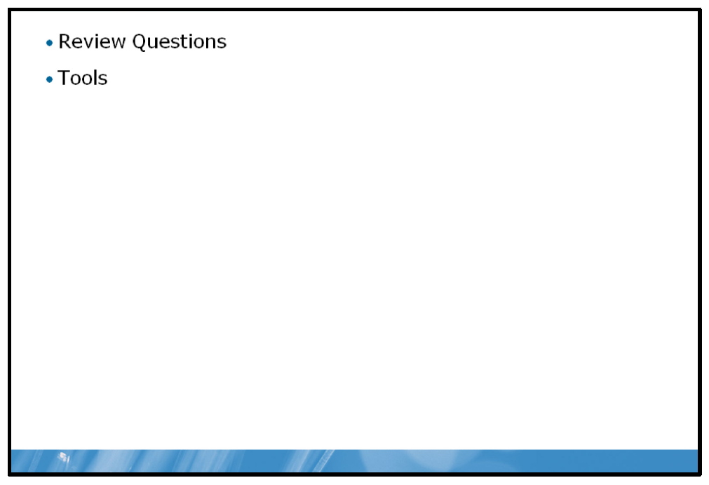

Review Questions
1. | In what ways does 64-bit computing potentially improve performance?
2. | What significant counters should you monitor in Windows Server Performance Monitor?

Tools
Tool | Use for | Where to find it
Fsutil.exe |  | Command line
  • | Configure and manage the file system
Performance Monitor |  | Start Menu
  • | Monitoring and analyzing real-time and logged performance data

- Highlight
- Note
- Expand Highlight
- Expand Note
Module 13: Maintaining Windows Server
Contents:
Lesson 1: | Troubleshooting Windows Server Startup
Lesson 2: | Server Availability and Data Recovery
Lesson 3: | Applying Updates to Windows Server
Lesson 4: | Troubleshooting Windows Server
Lab: | Maintaining Windows Server

Module Overview
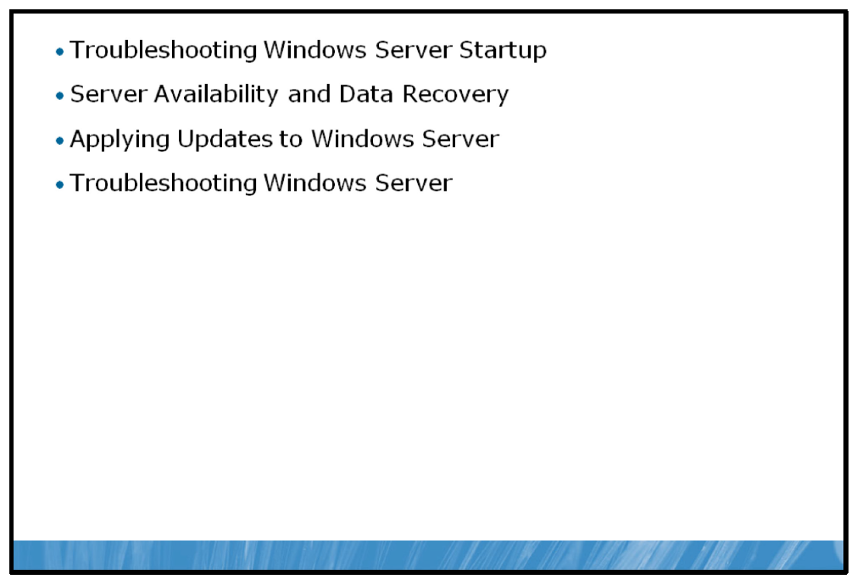
The Windows Server® 2008 R2 operating system provides a platform for organizations to build their technology infrastructure on. Windows Server is designed for the dynamic and efficient management of technology resources as well as providing effective solutions for business needs.
Windows Server’s roles are commonly very critical in an organization’s network infrastructure. It is critical to assure the Windows Servers are performing as efficiently as possible in their roles. To support Windows Server, you must maintain skills and knowledge to properly maintain an efficiently operating and continually available server infrastructure. You also must have the ability to troubleshoot issues within that infrastructure when they arise.

Objectives
After completing this module, you will be able to:
• | Troubleshoot the Windows Server boot process.
• | Implement high availability and recovery technologies to improve system availability.
• | Explain the importance of system updates.
• | Implement an appropriate troubleshooting methodology to resolve problems with Windows Server.

Lesson 1: Troubleshooting Windows Server Startup
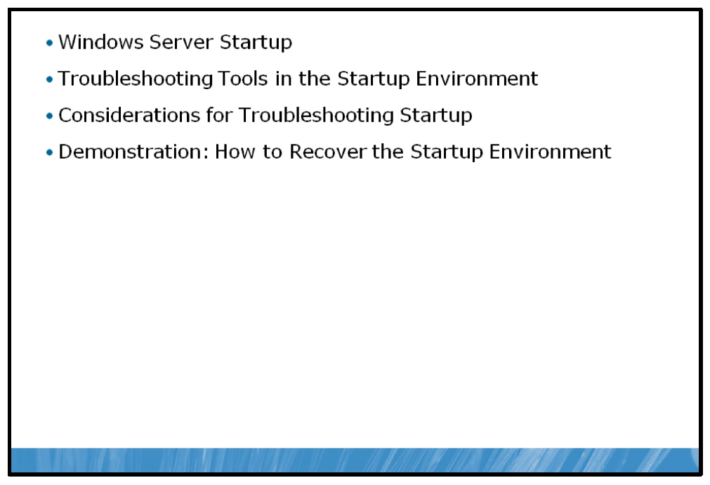
The Windows Server startup process ensures that all aspects of a Windows Server’s functionality are checked and initiated in a way that results in a stable and properly running server. Several issues can emerge in the startup process and the key to troubleshooting or, even better, avoiding these issues is the knowledge of how the Windows Server startup process works.
This lesson will introduce the details of the Windows Server startup process and give you the tools you need to identify and correct issues related to Windows Server startup.

Objectives
After completing this lesson, you will be able to:
• | Describe the Windows Server startup process.
• | Identify the startup troubleshooting tools.
• | Apply the considerations for troubleshooting the startup environment.
• | Recover the startup environment.

Windows Server Startup
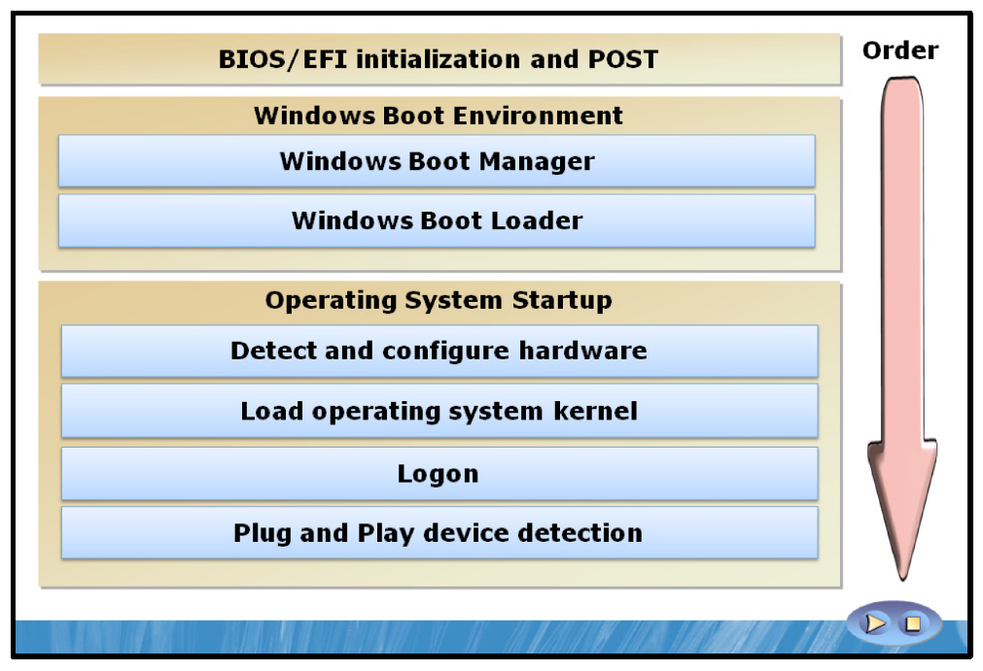

Key Points
The Windows Server boot process is made up of a number of steps involving components both inside and outside of the operating system environment. At first glance, startup seems to be one of the most basic features of an operating system. However, there's nothing simple or basic about startup processes and procedures.

The Windows Server Startup Process
Power On Self-Test (POST)
The Windows Server startup process consists of a number of steps, beginning with the initialization of system hardware through the computer’s basic input/output system (BIOS) or eXtensible Firmware Interface (EFI) firmware interface. This process is commonly referred to as POST. The POST process typically involves quick checks of system hardware components to confirm proper operation and functionality. Additionally, most BIOS or EFI systems provide for more intensive POST procedures in the event that troubleshooting needs to be performed on the POST process.
Boot Environment, Windows Boot Manager and Windows Boot Loader
Unlike earlier releases of Windows Server operating systems, Windows Server 2008 R2 doesn't use an initialization (.ini) file for the boot process. Rather, the operating system uses the Windows® Boot Manager to manage the operating system startup process.
This new boot environment dramatically changes the way the operating system starts and is designed to resolve issues related to the following:
• | Boot integrity
• | Operating system integrity
• | Firmware abstraction
The boot environment is loaded before the operating system, making the boot environment independent of the operating system. This process ensures that the boot environment can be used to confirm the integrity of the startup process and the operating system itself before actually starting the operating system by starting a boot loader.
A boot loader, in its most basic form, loads the initial files required to start an operating system. In a default installation of Windows Server 2008 R2, there is one boot loader reference stored in Windows Boot Manager called Windows Boot Loader, which launches the Windows Server 2008 R2 operating system. The Windows Boot Loader is stored in \Windows\System32\winload.exe and when started by Windows Boot Manager, it begins the initial load process of the operating system.
Within the boot environment, Windows Boot Manager controls the boot process using the information in the boot configuration data (BCD) store. Entries in the BCD store are loaded by Windows Boot Manager and contain configuration data about the various boot loaders installed on the system including the following:
• | Device where the boot loader is stored.
• | Path to the executable file of the boot loader.
• | Descriptive name of the boot loader.
• | Boot loader recovery options.
• | System root of boot loader files.
When multiple boot loaders are referenced in the BCD store, Windows Boot Manager will prompt the user at startup to choose which boot loader should be started. For example, a server may have Windows Server 2008 R2 installed on one partition and a client operating system like the Windows 7 operating system installed on another partition to allow the computer to start either of the operating systems, dependent on the needs of the user. This configuration is known as a multi-boot configuration.
Multi-boot configurations are often complicated and may require modification of the BCD store in order to accommodate changes made to the system. These changes can be made using a command-line tool called BCDEdit.
Note: To start BCDEdit, type BCDEdit.exe from the command prompt.
Certain aspects of the BCD store can also be modified within Windows Server 2008 R2. These settings can be accessed by opening the System applet in Control Panel, clicking Advanced System Settings, then clicking on the Advanced tab in the System Properties window and finally clicking Settings under Startup and Recovery.
Detect and Configure Hardware
Once Windows Boot Manager has started the Windows Boot Loader, the Windows Server 2008 R2 operating system begins to load. It starts by detecting hardware and loading the key device drivers required for initial operating system startup (hard disks, input devices such as keyboards and mice, system buses, and others).
Loading the Operating System Kernel
An operating system kernel is the most basic and fundamental portion of that operating system. The kernel controls system hardware and resources, managing them and making them available to applications running on the system.
Once the operating system kernel has loaded, the operating system is ready to begin interaction with the rest of the system software as well as user input, most commonly beginning with the logon.
Logon and Plug and Play Drivers
When a user logs on to a Windows Server 2008 R2 environment, the user’s credentials are processed and validated against the default security database, most commonly either the local security database or possibly Active Directory® Domain Services (AD DS). After the credentials have been validated, the user gains access to the operating system and applications, and any Plug and Play or user mode drivers load to complete the Windows Server 2008 R2 startup process.

Troubleshooting Tools in the Startup Environment
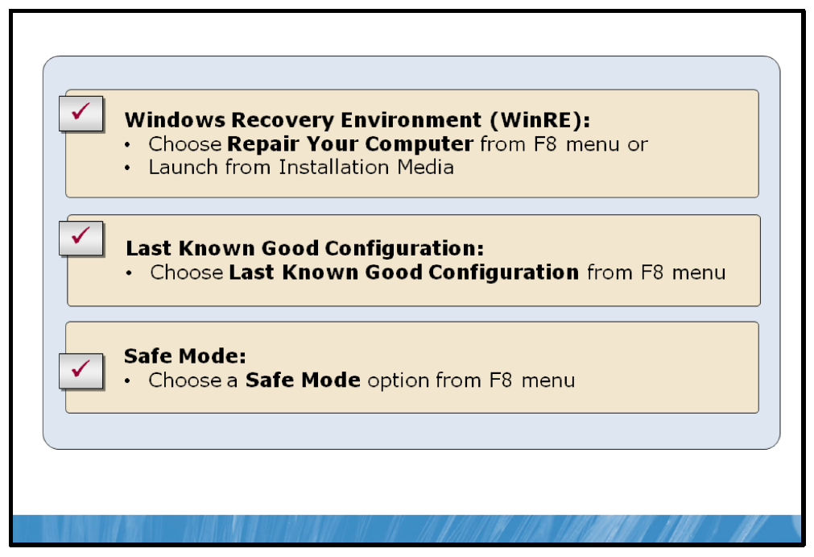

Key Points
During the Windows startup process, the failure or malfunction of any component involved can cause the startup process to fail or behave erratically. Events like hard disk failure, missing or corrupted files, third-party driver bugs or intentional or accidental damage of system files can interfere with the startup process. Windows Server 2008 R2 provides several tools to help troubleshoot and repair components involved in the startup process, allowing the operating system to startup correctly and efficiently.
Note: All three of these tools are available from the Windows Advanced Options Boot menu, which is accessible by pressing the F8 key prior to the Windows Server 2008 R2 startup splash screen.

Windows Recovery Environment (WinRE)
During the installation process, Windows Server 2008 R2 creates a special hidden partition on the system disk that contains a number of useful diagnostic and repair tools known collectively as the Windows Recovery Environment (WinRE). These tools are accessible prior to system startup manually through the F8 boot menu. Additionally, WinRE will start automatically if the system startup process failed to complete during the last boot.
Upon starting WinRE, you are presented with three options for recovery.
• | System Image Recovery allows you to restore the operating system from a backup created earlier using Windows Server Backup.
• | Windows Memory Diagnostic performs memory diagnostic tests that check the system’s random access memory (RAM).
• | Command Prompt opens a command prompt with administrative privileges that provides full access to the system’s file system and volumes.
Note: If a system loses electrical power during the boot process, WinRE will automatically launch the next time the system is booted.

Last Known Good Configuration
Using the Last Known Good Configuration restores a system’s configuration to the state is was in at the end of the last successful startup. Last Known Good Configuration makes a copy of configuration information stored in the registry each time the operating system startup process completes successfully and a user logs on to the system. Last Known Good Configuration stores the values for the following to registry hives, or groups of values.
• | HKLM\SYSTEM\CurrentControlSet\Control: This registry hive contains system configuration settings.
• | HKLM\SYSTEM\CurrentControlSet\Services: This registry hive contains settings that control driver and service configuration.
When you choose the Last Known Good Configuration option from the Windows Advanced Options menu, it marks the values in the two registry hives above as failed and replaces them with the copy taken after the last successful startup.

Safe Mode
The safe mode option allows the user to run system startup using a limited set of files, services and drivers. With this limited configuration, it makes failure from a malfunctioning driver or service less likely and allows you to troubleshoot from within the Windows graphical user interface (GUI) environment. On the Windows Advanced Options menu, several options exist for starting Windows in Safe mode.
• | Safe mode starts loading only a basic set of files, drivers and services, including mouse, keyboard, storage and basic video drivers. No networking services or drivers are started.
• | Safe Mode with Command Prompt loads the same service and driver set as Safe mode, but starts you at the command prompt rather than in the Windows GUI.
• | Safe Mode with Networking starts the same as Safe mode, but adds drivers and services necessary to provide network functionality.

Other Windows Advanced Options
In addition to the three tools discussed above for troubleshooting startup, the Windows Advanced Options menu provides other choices that can assist with troubleshooting Windows startup.
• | Enable Boot Logging starts the boot logging process, which records all startup events to a boot log.
• | Enable Low-Resolution Video sets the system resolution to 640 x 480 pixels, allowing you to reset your display resolution in the event that it was changed to a setting that rendered the system unusable.
• | Disable Driver Signature Enforcement disables the default behavior in Windows Server 2008 R2 that requires drivers loaded on startup to contain a valid digital signature.

Considerations for Troubleshooting Startup
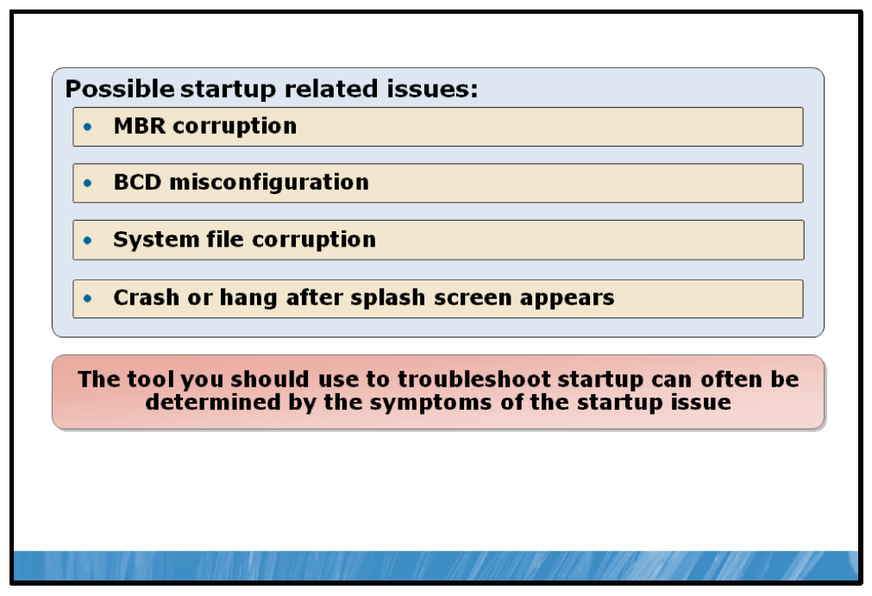

Key Points
When issues arise with the Windows startup process, resolving those issues and getting the system back to a bootable state as quickly as possible is your highest priority. It is important to consider which startup tool will best diagnose and solve the issue before you begin the troubleshooting process.
The following examples of common startup issues list conditions that prevent the startup process from completing successfully along with considerations for troubleshooting that specific problem and which tool or tools will best assist in correcting the problem.

Master Boot Record (MBR) Corruption
• | Symptoms. When a system’s MBR is corrupted or missing, the system will halt the startup process immediately following BIOS POST and a black screen or one of the following messages may appear: Invalid partition table, Error loading operating system or Missing operating system.
• | Causes. The MBR can become corrupt due to hard disk errors, disk corruption or intentional destruction of MBR data by a virus or malicious user.
• | Resolution. Launch WinRE, choose the Command Prompt option and execute bootrec/fixmbr. This command replaces the executable code in the MBR.

BCD Misconfiguration
• | Symptoms. After BIOS POST, you will see a message that begins Windows could not start because of a computer disk hardware configuration problem, Could not read from selected boot disk, or Check boot path and disk hardware.
• | Causes. The BCD has been deleted, become corrupt, or no longer refers to the proper boot volume, potentially because the addition of a partition has changed the name of the volume.
• | Resolution. Launch WinRE, choose the Command Prompt option, and then execute the bootrec/scanos and bootrec/rebuildbcd commands. These commands will scan each volume looking for Windows installations. When they discover an installation, they will ask you whether it should be added to the BCD as a boot option and what name should be displayed for the installation in the boot menu. For other kinds of BCD-related damage, you can also use Bcdedit.exe to perform tasks such as building a new BCD from scratch or cloning an existing good copy.

System File Corruption
• | Symptoms. System file (dynamic-link libraries (DLLs), drivers, executables) corruption typically will cause a message on a black screen after BIOS POST that says, Windows could not start because the following file is missing or corrupt, followed by the name of a file and a request to reinstall the file.
• | Causes. The volume on which a system file is located is corrupt or one or more system files have been deleted or become corrupt.
• | Resolution. Boot into the Windows Recovery Environment, choose the Command Prompt option, and then execute the chkdsk command. Chkdsk will attempt to repair volume corruption. If Chkdsk does not report any problems, obtain a backup copy of the system file in question and replace the file.

Crash or Hang After Splash Screen Appears
• | Symptoms. Issues that occur after the Windows splash screen appears, after the desktop appears or after you log in fall into this category and can manifest as a blue screen crash or an unresponsive system hang.
• | Causes. This type of problem is commonly caused by a device driver or potential corruption of registry information.
• | Resolution. The first and most straightforward method for attempting to restore a normal startup process would be to invoke the Last Known Good Configuration. This will load the appropriate registry information from a backup taken when the system last booted properly. This would allow for the review of recent changes to the operating system to attempt to discover what caused the crash or hang. If the problem is caused by a driver or service that existed on the system prior to when the Last Known Good Configuration was taken, another solution will need to be adopted. In this case, Safe mode may allow the system to boot properly at which point you can disable newly installed drivers or services in an effort to determine the cause of the problem.
Question: Which tool would you use to recover a system that fails to start properly immediately following the installation of a new network card?

Demonstration: How to Recover the Startup Environment
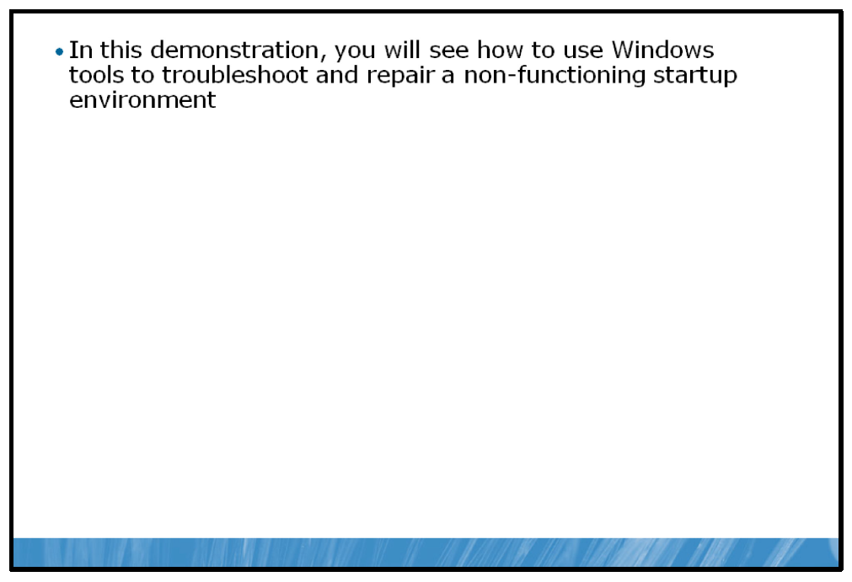

Key Points
In this demonstration, you will see how to recover a system from startup failure.

Demonstration Steps:
1. | Use the Windows Advanced Options Menu to launch an appropriate tool.
2. | Use the Command Prompt to launch various tools associated with troubleshooting the startup process.

Lesson 2: Server Availability and Data Recovery
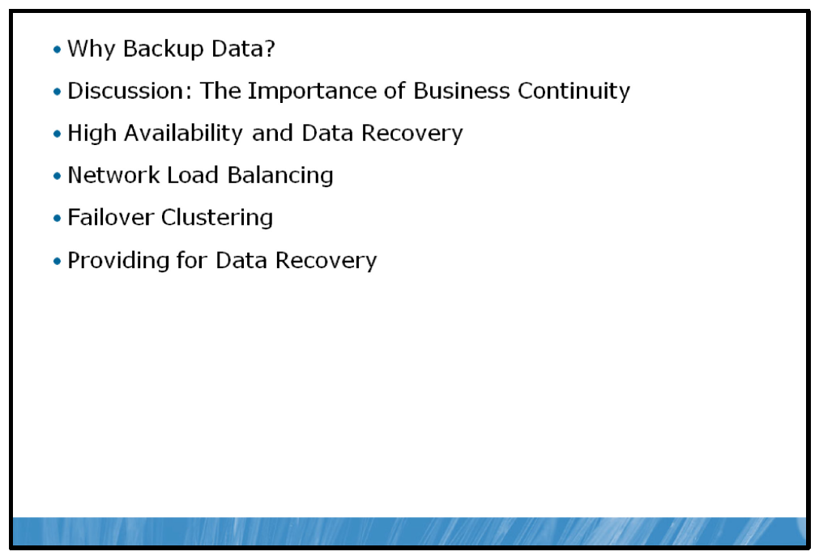
Organizations depend on constant and consistent access to their business information and applications. In this environment, a server is only useful when it is operating properly and it contains the correct data. A server that is experiencing intermittent failures, sporadically unavailable or one that contains inconsistent data or has lost data can cause large problems for an organization, often detrimentally affecting their line of business.
As someone responsible for the operation of your organization’s servers, you need to be aware of the variety of methods that Windows Server offers to allow for high availability, reliability and consistency as well as how to implement these methods.

Objectives
After completing this lesson, you will be able to:
• | Describe the need for backup.
• | Describe the requirement to provide for business continuity.
• | Differentiate between availability and recovery solutions.
• | Describe Network Load Balancing (NLB).
• | Describe failover clustering.
• | Implement a backup solution.

Why Backup Data?
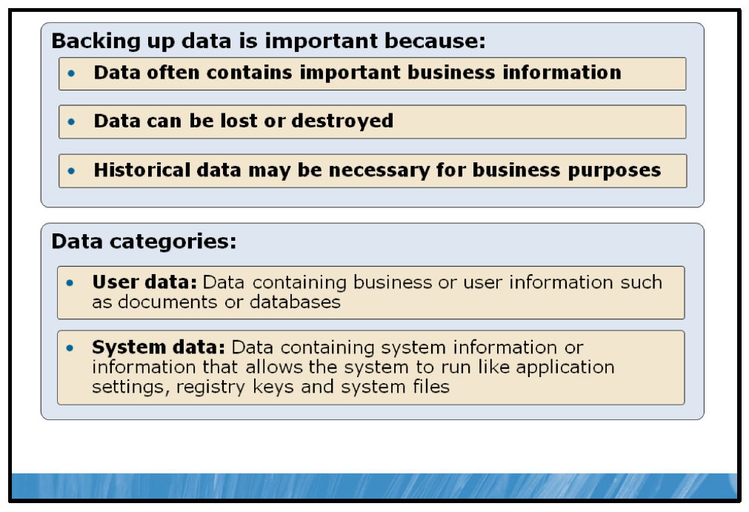

Key Points
Data is the most important digital commodity in the business world. Data hosted on an organization’s servers is most often critical to their line of business. Inventories, legal documents, and wage and employee information are just some of the important pieces of business information data that are frequently hosted on servers.
The retention or backup of this data is the first line of defense against any event or circumstance that could put the security, validity or the existence of that data at risk. Events that could lead to data loss include natural disasters like a flood, earthquake or lightning strike. Environmental issues such as fire, plumbing malfunctions or power surges can also contribute to the loss of data. Finally, malicious or accidental activity like hacking, file deletion, equipment theft or intentional damage often lead to data being lost.
Backing up your company’s data in Windows Server 2008 R2 is an important part of maintaining a reliable server environment. Not only business data, as discussed above, is at risk, but data contained in the operating system and server applications themselves need to be retained should the need to restore or recreate them arise.

User or Business Data
Most user or business-related data that is stored on a server is stored in a specifically allocated drive or folder structure, dedicated exclusively to storing that data. In this configuration, all of the business data is in one place, and can be backed up as a whole rather than backing up data from a variety of disparate locations on the server. The location and structure of this data will depend on the individual organization, and can vary from implementation to implementation.

System Data
System data, such as operating system and application data, however, is almost always stored in a consistent location on the operating system. While not always accessed or modified by employees directly like business data, system data is critical to the operation of a server. It is important that the Windows Server system volume, which holds the location of the Windows Server operating system files, be backed up as well to ensure that a server is recoverable from its backups in the case of a system failure.

Discussion: The Importance of Business Continuity
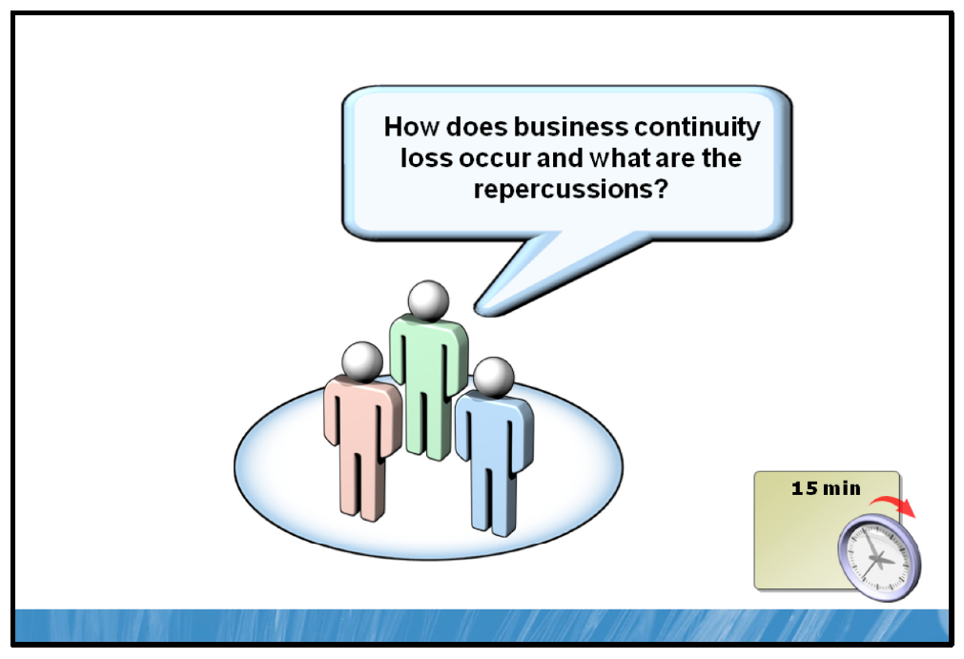

Key Points
Business continuity planning refers to the ongoing maintenance activity and infrastructure planning and implementation that allow an organization to carry on their line of business in the event of a disaster or system failure.
The ability for an organization’s server infrastructure to ensure business continuity at times of crisis is a very important aspect of server management and maintenance.
Question: What types of events could interfere with business continuity?
Question: What would the cost be to your organization if your server infrastructure was unavailable for an hour, a day, or a week?

High Availability and Data Recovery
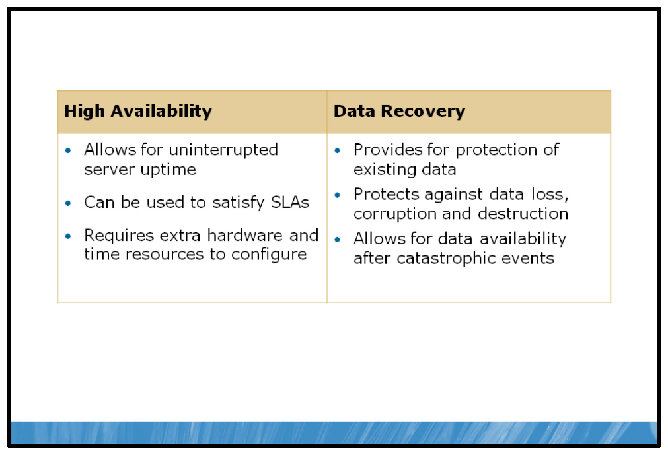

Key Points
Organizations have come to rely more and more on their information technology (IT) infrastructure to support their business needs. In many cases, an organization’s server infrastructure provides applications or contains data that is critical to business operations. As a result, the availability of those applications and the retention and safety of that data must be managed to ensure business continuity through high availability and data recovery.

High Availability
High availability refers to the ability of a server infrastructure to remain available and operable in the event of hardware, application or service outages within the server infrastructure itself.
Organizations that are required to meet service level agreements (SLAs) or that run applications critical to an organization’s daily business typically use high availability solutions to achieve required server uptimes. This uptime value is often referred to as the number of 9’s referred to in the percentage of that server’s total availability. It is not uncommon for companies to strive for five nines of uptime (99.999%), which equates to less than ten minutes per year of server downtime.
High availability typically involves multiple servers configured to perform the same role or provide similar services. If one of the servers experiences a hardware or software failure, the remaining servers continue to provide the services.
Windows Server 2008 R2 contains several features that assist you in maintaining high availability in your server infrastructure.

Fault Tolerant Hardware Support
Windows Server 2008 R2 supports fault tolerant hardware architecture supplied by many server hardware vendors that allows for the removal, addition or replacement of hardware components such as fans, power supplies, memory, hard disks, network cards and processors. This architecture allows a server to remain running and available while hardware upgrades occur or faulty hardware components are replaced.

Failover Clustering
Failover clustering allows for a group of servers to work together to provide a set of applications or services. Together, these servers provide a fault tolerant configuration that continues to provide its applications and services, even if one of the servers in the cluster fails or becomes unavailable.

Network Load Balancing (NLB)
NLB provides for the high availability of Transmission Control Protocol/Internet Protocol (TCP/IP) based network services. In a network load balancing configuration, each server is aware of the others in its group and when one server fails or becomes unavailable on the network, traffic is redirected among the other servers, ensuring continuity of the network services.

Data Recovery
Data recovery processes ensure that critical data is recoverable, should the data be lost, corrupted or destroyed. This typically involves the copying or backing up of data to a device separate from the server. These devices can be external hard disks or flash drives, tapes, or network locations. Often, these devices are stored in a different physical location than the server being backed up in the case that the location was physically destroyed or damaged by a disaster such as a fire or flood.
When data is lost, corrupted, or destroyed, the backed up data can then be restored to the original location on the server; or to a separate server until the original server has been restored or rebuilt.

Windows Server Backup
The built-in tool for backing up data in Windows Server 2008 R2 is Windows Server Backup. Windows Server Backup is a simple and easy to use backup and recovery tool. You can use Windows Server Backup to perform full, copy and incremental backups on both local and remote systems.
When you use Windows Server Backup, you need to have separate, dedicated media for storing backed up data. Windows Server Backup can use external and internal disks, DVDs, or shared folders for backup and restore locations. DVDs can be used only to restore full volumes of data, not individual files, folders or application data.
You can use Windows Server Backup for recovery in several ways. Rather than having to manually restore files from multiple backups if the files were stored in incremental backups, you can recover folders and files by choosing the date on which you backed up the version of the item(s) you want to restore. You can recover data to the same server hardware or to new server hardware that has no operating system.
Note: Backups taken with Windows Server Backup can also be restored from within the WinRE.
While Windows Server Backup provides built in data recovery in Windows Server 2008 R2, many third-party solutions can be leveraged to provide a robust, enterprise-level data recovery solution.
Question: Why would an organization need to implement both high availability and data recovery processes to ensure business continuity?

Network Load Balancing
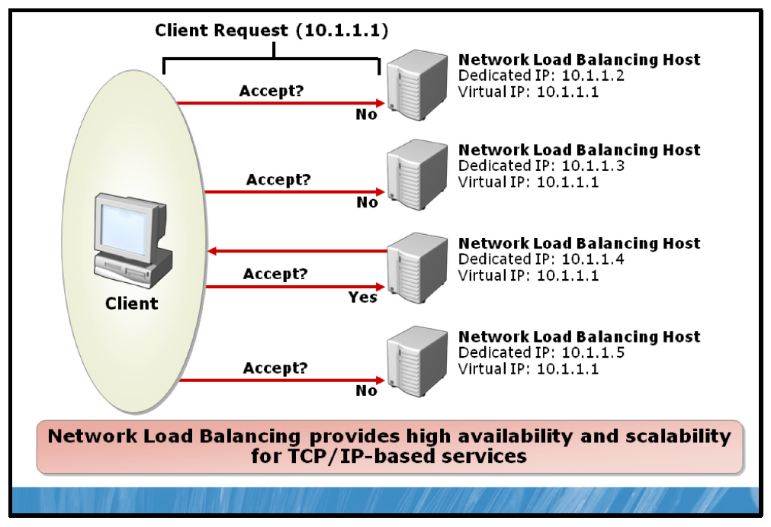

Key Points
NLB provides high availability and scalability for TCP/IP-based services, including Web servers, File Transfer Protocol (FTP) servers, other mission-critical servers and services. In an NLB configuration, multiple servers run independently, and do not share any resources. This group of servers is referred to as a cluster. Client requests are distributed among the servers, and in the event of a server failure, NLB detects the problem and distributes the load to another server. NLB allows you to increase network service performance and availability.

High Availability
NLB supports high availability by redirecting incoming network traffic to working cluster hosts if a host fails or is offline. Existing connections to an offline host are lost, but the Internet services remain available. In most cases, for example with Web servers, client software automatically retries the failed connections, and the clients experience a delay of only a few moments before receiving a response.
Many applications work with NLB. Generally, NLB can load balance any application or service that uses TCP/IP as its network protocol and is associated with a specific TCP or User Datagram Protocol (UDP) port.
Some examples are listed in the following table.
Protocol | Examples
Hypertext Transfer Protocol (HTTP) and HTTP Secure (HTTPS) | Microsoft® Internet Information Services (IIS): Port 80
FTP | Microsoft IIS: Port 20, port 21, and ports 1024-65535
Simple Mail Transfer Protocol (SMTP) | Microsoft Exchange Server: Port 25
Remote Desktop Protocol (RDP) | Terminal Services: Port 3389
Point-to-Point Tunneling Protocol (PPTP) & Internet Protocol Security (IPsec) | Virtual private network (VPN) servers: 1723 for PPTP

Performance
NLB supports server performance scaling by distributing incoming network traffic among one or more virtual IP addresses assigned to the NLB cluster. The hosts in the cluster concurrently respond to different client requests, even multiple requests from the same client. For example, a Web browser might obtain each of the multiple images in a single Web page from different hosts within an NLB cluster. This speeds up processing and shortens the response time to clients.

Scalability
NLB allows administrators to scale network services to meet client demand. New servers can be added to a load balancing cluster without modifying the applications or reconfiguring clients. The NLB cluster does not need to be taken offline to add new capacity, and members of the Load Balancing cluster do not need to be based on identical hardware.

Failover Clustering
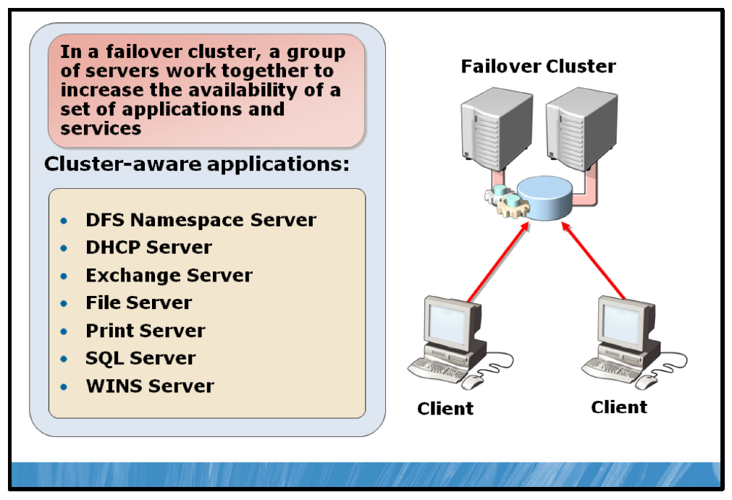

Key Points
Failover clustering is another technology in Windows Server 2008 R2 that provides for high availability. In a failover cluster, a group of servers, or a cluster, work together to increase the availability of a set of applications and services. Physical cables and software connect the clustered servers, referred to as nodes. If any of the cluster nodes fail, other nodes begin to provide service to clients (a process known as failover). With this method, system downtime is minimized and a high level of availability is provided.
Applications that are best suited for configuration in a failover cluster are applications that use a centralized set of data. Applications like Microsoft SQL Server®, Microsoft Exchange Server, and services like Dynamic Host Configuration Protocol (DHCP), file and print, and Dynamic Name System (DNS) use centralized data sets and are therefore ideal for being configured as a failover cluster.
Note: The failover cluster feature is only available in the Windows Server 2008 R2 Enterprise operating system and the Windows Server 2008 R2 Datacenter operating system.

Failover Clustering Benefits
Failover clustering provides several benefits for mission-critical server and application deployments, including:
• | Reduced downtime in the event of server failure.
• | Reduced downtime in the event of operating system failure.
• | Reduced downtime during periods of planned server maintenance.
Applications or services that are added to a failover cluster must be cluster-aware in order to take advantage of the full benefits provided by failover clustering. Cluster-aware refers to the application’s ability to register with the failover cluster in order to communicate with the cluster and take advantage of the cluster’s features. Applications and services that are cluster-aware include the following:
• | Distributed File System (DFS) Namespace Server
• | DHCP Server
• | Exchange Server
• | File Server
• | Print Server
• | SQL Server
• | Windows Internet Name Service (WINS) Server  Note: Exchange Server 2007 and Exchange Server 2010 provide failover clustering solutions that do not require a single data store. These versions of Exchange Server can use replication to maintain multiple copies of the mailbox databases.
Applications that do not support cluster events are called cluster-unaware. Some cluster-unaware applications can be configured as high availability resources and can be failed over. The following provisions apply:
• | IP-based protocols are used for cluster communications. The application must use an IP-based protocol for its network communications.
• | Nodes in the cluster access application data through shared storage devices. If the application isn't able to store its data in a configurable location, the application data is not available on failover.
• | Client applications experience a temporary loss of network connectivity when failover occurs. If client applications cannot retry and recover from this, they will cease to function normally.

Providing for Data Recovery
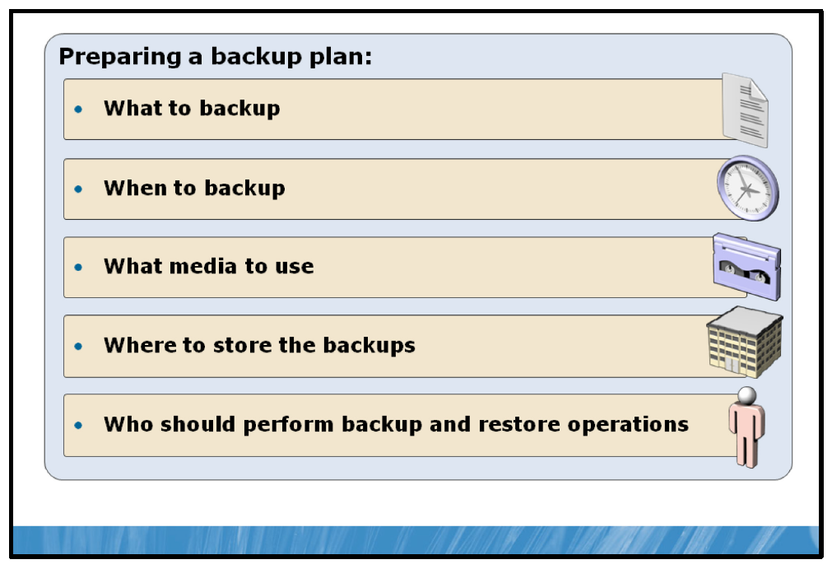

Key Points
Providing for data recovery involves implementing a plan that includes what to backup, how often to back it up, what media the backed up data will be stored on, where that media will be stored, and who can backup and restore the data.

What to Back Up
Deciding what to back up is one consideration when developing a backup plan. Business information loss may significantly disrupt business productivity. In most situations, a full data backup is desirable. The key question for the organization is what data is vital to the company? This data may consist of customer or client database information, payroll records, and product information.

When to Back Up
A few questions need to be answered when considering back up. Ask yourself, “When do I need to backup?”, “How often should backups be made?” and, “How long will my backup take and what time of day will the backup take place?” When asking how often backups occur, the answer depends on your business data and how frequently it changes. An organization’s sales history may only need to be backed up monthly, but the current sales database which is constantly being updated with sales information may need to be backed up multiple times per day. The second and third questions, regarding how long the backup will take and when the backup should be taken are dependent on each other. Often, data being backed up cannot be in use by users and applications during the backup process. A full backup of all servers in a datacenter may take 15-20 hours. If your business operates on a ten hour work day, that only leaves 14 hours to do your backup. Typically, the longer, full backup is done during off hours, perhaps on a weekend. Then, smaller backups of specific information or critical information are taken more often throughout the week.

What Media to Use
After the decision is made about what data to backup, the next step is to determine where to store the backup. Options for storage include external or internal hard drives, CDs, DVDs, universal serial bus (USB) flash drives, in some third-party backup systems, and tape devices.

Where to Store the Backups
To provide greater security, an organization should store these backups in an off-site location. This is helpful in a situation such as a fire where backup media stored onsite may be potentially destroyed.

Who Should Perform the Backup/Restore Operations
The final fundamental consideration is who should perform the backup, and perhaps more critically, restore operations. After you have implemented a backup strategy, you could automate the backup process; indeed, most backup solutions are automated. However, it might occasionally be necessary to perform ad hoc backup operations. You should consider carefully which users can perform this task.
When you need to restore data, it is important that the right data is restored, and to the correct location. For this reason, restore operations, aside from user-initiated single file operations, should only be conducted by skilled administrative personnel.
You can use the Windows Server built-in groups to assign the necessary backup and restore privileges, or you can create your own groups as needed.

Windows Server Backup
Windows Server Backup provides a means of administration, a Microsoft Management Console (MMC) snap-in administrative tool and the WBAdmin command (wbadmin.exe). Both the snap-in and the command-line tools allow you to perform manual or automated backups to an internal or external disk volume, a remote share, or optical media. Backing up to tape is no longer supported by Windows Server Backup.
Question: What would an appropriate backup plan look like for your organization or department?

Lesson 3: Applying Updates to Windows Server
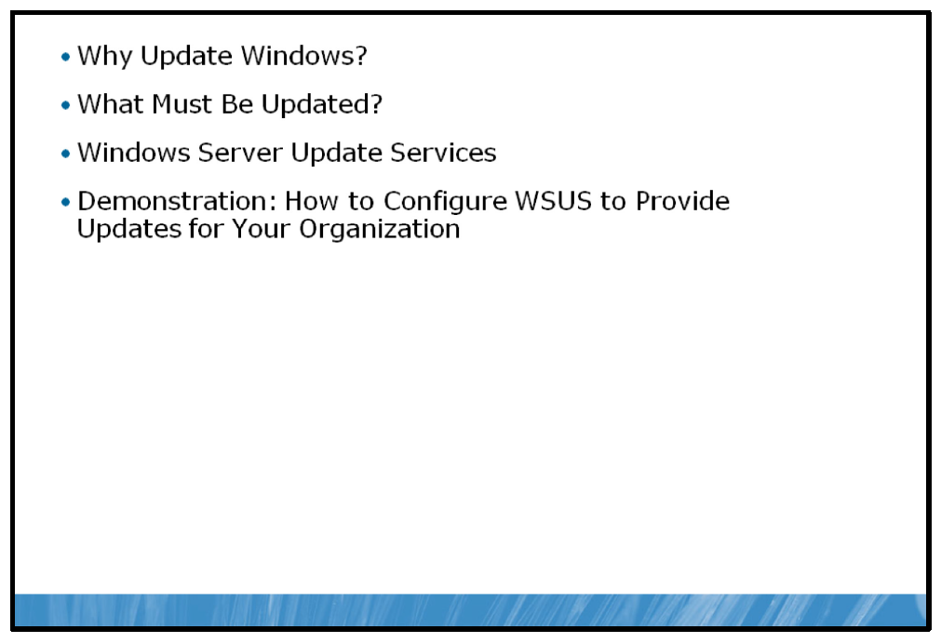
Windows Server 2008 R2 provides a full featured framework that allows it to maintain itself in a current and secure state through updates.

Objectives
After completing this lesson, you will be able to:
• | Describe the need to keep Windows Server up-to-date.
• | Describe what needs to be kept up-to-date.
• | Explain how Windows Server obtains updates using Windows Server Update Services (WSUS).
• | Implement WSUS.

Why Update Windows?
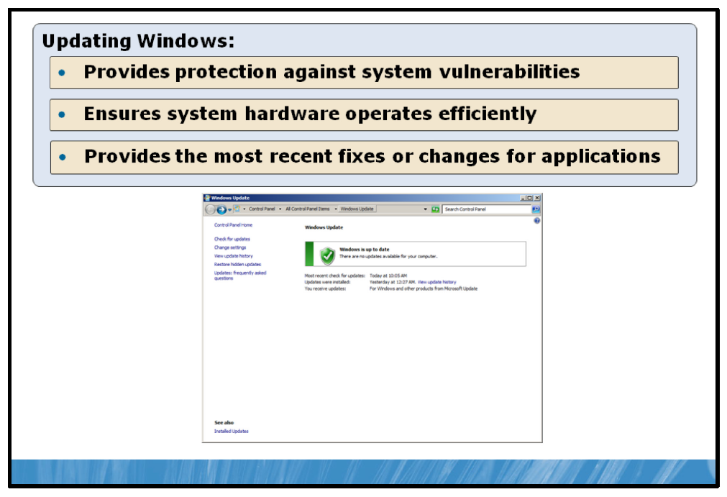

Key Points
Globally, computing happens in an ever changing environment. New technology emerges daily, while new ways to exploit technology seem to emerge hourly. As technology advances and security concerns appear, your server infrastructure needs to be both prepared and protected in order to perform efficiently.
The following questions can be asked of a static, non-updated server running Windows Server 2008 R2.
• | Does your server have a vulnerability to malicious code that takes advantage of potential weak spots identified in your server’s operating or application configuration?
• | When a new device is installed, how can you ensure that you have the most recent version of the driver installed?
• | How can you be sure you are running the latest and most compatible versions of your applications?
You need to update your Windows Servers to ensure that you can avoid the pitfalls associated with the points above, but manual configuration of a single server can be a time-consuming and tedious process, let alone the configuration of hundreds of servers.
The key source of Windows updates is the Microsoft Update Web site. Here, a catalog of updates is stored and available for download and installation to your computer.
Windows Server 2008 R2 contains a robust infrastructure for managing interaction with the Microsoft Update process, but it is up to you to ensure that the tools available are tailored to your environment and working in a way that ensures your infrastructure is secure and regularly updated.

What Must Be Updated?
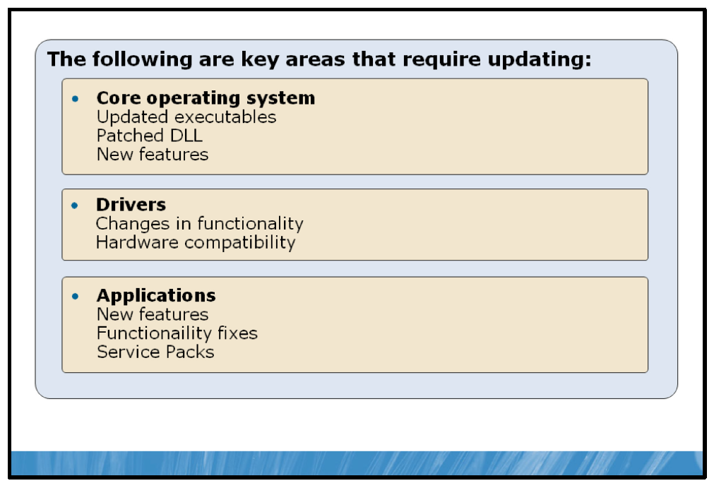

Key Points
Updates can be applied to a variety of areas within the Windows Server infrastructure:
• | Core Operating System. The core files of your server’s operating system must be kept up to date in order to correct possible security vulnerabilities and maintain the most recent set of features and functionality. New versions of executables, additional features, and updated .dll and data files are a few of the aspects of the core operating system that may be implemented as part of an update.
• | Drivers. Hardware devices on your servers need to have the most recent drivers installed to ensure that your system functions properly and that all of the components can work together as a cohesive whole without conflicts or interruption. The way that Windows interacts with your server and the attached hardware is governed primarily by the device drivers that Windows loads for the devices. Old, corrupt or incompatible drivers can cause a device to function improperly and could cause system instability or even failure.
• | Applications. Updates also need to be performed on applications as well. Service Packs, feature updates, and security fixes all ensure that your applications are able to consistently provide their associated services within your environment.
In addition to these three core areas, other aspects such as device firmware may also need to be periodically updated.

Windows Server Update Services
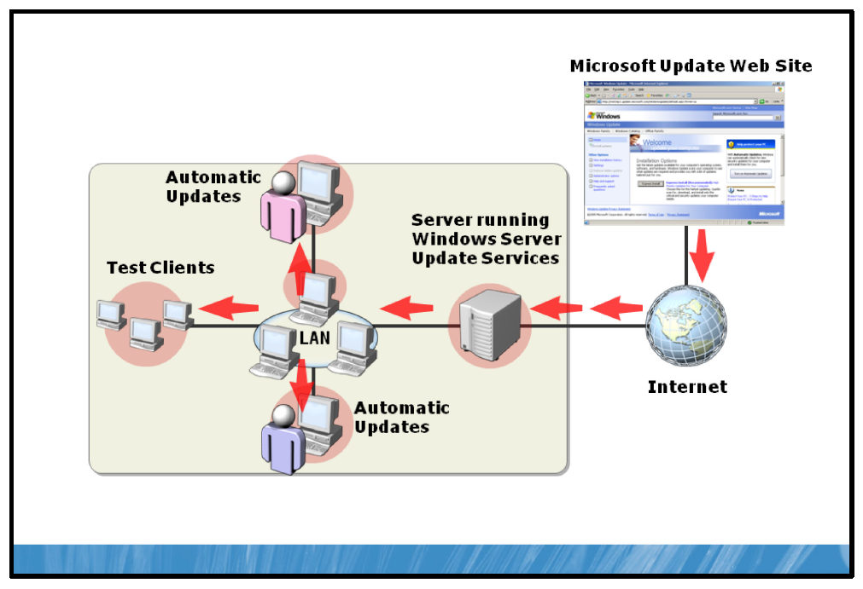

Key Points
WSUS enables network administrators to simplify and gain greater control over the process of applying updates to all computers in the network environment.
When WSUS is installed on a server, WSUS downloads all of the latest updates from the Microsoft Update servers on the Internet, and then all other computers on the network are configured to download their updates directly from the WSUS server.
In a typical WSUS implementation, instead of each computer downloading the same update files independently, only the WSUS server downloads the files from the Microsoft Update servers. The WSUS server downloads a copy of each available update and saves it in a local data store, making it available for access by all of the computers on the network. Because the WSUS server has to download only one copy of each update, the amount of bandwidth consumed by the update process is reduced drastically. WSUS also provides administrators with the opportunity to research, evaluate, and test updates before deploying them to the network clients.
A Windows Server Update Services server has several components and settings that are configurable to suit the needs of your environment.
• | Synchronization. This setting controls when WSUS will synchronize with Internet-based Microsoft Update servers to download new updates.
• | Products. This setting controls which products WSUS will download updates for. This includes Windows server and client operating systems, as well as many Microsoft applications and server products, such as Microsoft Office, SQL Server, Exchange Server, and many others.
• | Classifications. Microsoft updates come in several different classifications which identify the type and urgency of the update. This setting allows you to select which classifications WSUS will synchronize.
• | Languages. By default, WSUS synchronizes only updates in the language that you specified when installing Windows Server 2008 R2.
• | Approvals. This setting controls how updates are applied to clients and which classifications are set for automatic approval and subsequent install. By default, WSUS automatically approves all security, critical, and definition updates for servers. For clients, WSUS approves all security, critical, and definition updates, plus service packs.
• | Storage. WSUS downloads only the approved updates and stores them, in Cab format, in the C:\WSUS\WsusContent folder by default.
• | Server updates. By default, servers download the latest updates from the WSUS server and inform the administrator that they are ready to install. An administrator must install them manually using the Windows Update control panel applet.
• | Client updates. Clients connect to the WSUS server and download the latest updates for their respective operating systems, and then install them automatically according to the set schedule. If necessary, the Automatic Updates client restarts the computer when the update installations finish.
WSUS is managed with an MMC snap-in which allows you to configure settings, manage and view the status of updates as well as add new client computers or groups to the WSUS server.

Using Group Policy to Configure Windows Update Settings
WSUS clients are configured via group policy object (GPO) settings.
GROUP POLICY SETTING | FUNCTION
Configure Automatic Updates | Enables the Automatic Updates client, specifies whether the client should download and install updates with or without user intervention, and specifies the installation interval and time of day.
Specify intranet Microsoft update service location | Specifies the URL that Automatic Updates clients use to access the WSUS server on the local network.
Automatic Updates detection frequency | Specifies the interval at which Automatic Updates clients check the server for new updates.
Allow non-administrators to receive update notifications | Enables users without administrative privileges to receive notifications of impending update downloads or installations from the Automatic Updates client.
Allow Automatic Updates immediate installation | Specifies whether the Automatic Updates client should install updates that do not require a service interruption or system restart immediately.
No auto-restart with logged on users for scheduled automatic updates installations | Specifies whether the Automatic Updates client can trigger a system restart when a user is logged on to the system. When set to Disabled, the computer can restart automatically while a user is logged on to the computer.
Re-prompt for restart with scheduled installations | Specifies the time interval the Automatic Updates client should wait before restarting the computer after a user postponed a previous restart request.
Delay Restart for scheduled installations | Specifies the time interval the Automatic Updates client should wait before restarting the computer after an update installation.
Reschedule Automatic Updates scheduled installations | Specifies the time interval the Automatic Updates client should wait after system startup before initiating an update installation that did not occur because the computer was offline.

Demonstration: How to Configure WSUS to Provide Updates to Your Organization
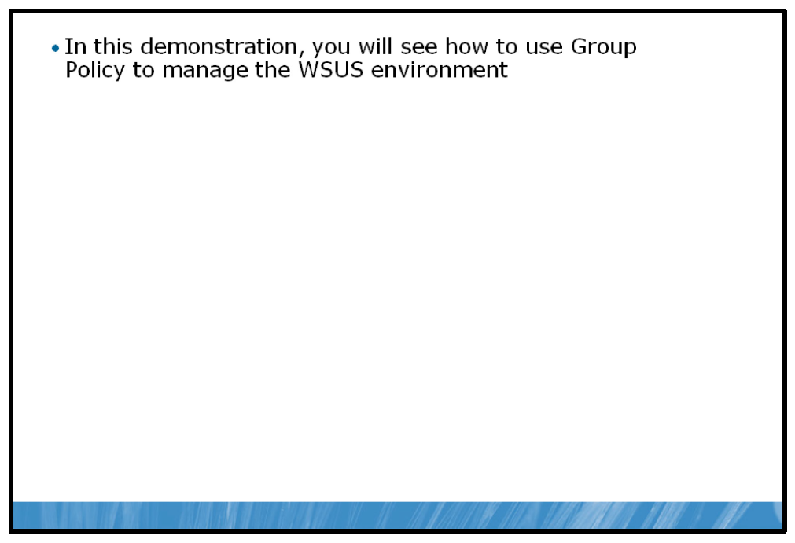

Key Points
In this demonstration, you will see how to configure WSUS.

Demonstration Steps:
1. | Open Group Policy Management Console.
2. | View Group Policy settings for WSUS.

Lesson 4: Troubleshooting Windows Server
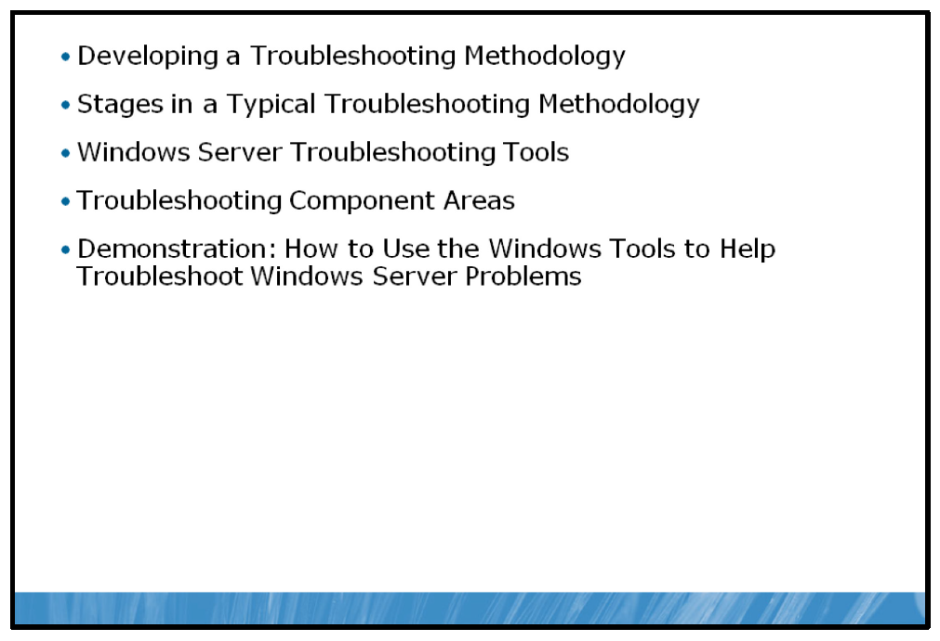
When a system failure or an event that affects system performance occurs, you need to be able to repair the problem or resolve the issue quickly and efficiently. With so many variables and possibilities in the modern network environment, the ability to determine the root cause quickly often depends on having a logical and comprehensive troubleshooting methodology. You also must understand the tools available to determine the root cause and make corrections to the environment if applicable.

Objectives
After completing this lesson, you will be able to:
• | Develop a troubleshooting methodology.
• | Describe troubleshooting stages.
• | Select troubleshooting tools.
• | Troubleshoot component areas.
• | Use Windows tools to troubleshoot problems.

Developing a Troubleshooting Methodology
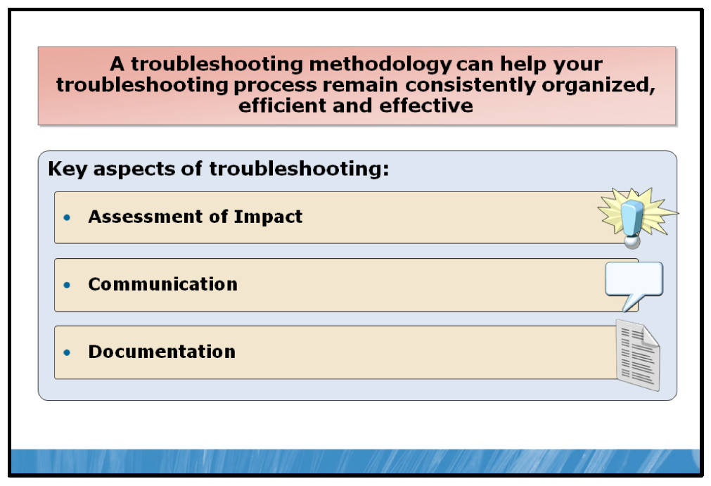

Key Points
Troubleshooting a problem, especially when dealing with technology, can be a multi-step process involving a large number of potential root causes and several attempts to resolve the issue before the actual root cause is determined. From gathering information to testing possible fixes to ensuring that fixes work properly and can be maintained, a troubleshooting methodology can help your troubleshooting process remain organized and efficient.
Key concepts and practices must be understood and observed throughout the troubleshooting process to ensure that the issue is resolved in the most effective way possible.

Assessment of Impact
Understanding how an issue affects your network environment and the operations of your organization is a very important part of the troubleshooting process. An issue that impacts critical services, such as point-of-sale operations in a busy retail store, may need to have a temporary partial fix or workaround implemented until the root cause of the issue can be determined and corrected.
As the troubleshooting process proceeds, the temporary fix may need to be reassessed to ensure that it is supporting the rest of the environment as effectively as possible. Finally, once the original issue has been determined and corrected, a method for replacing the temporary fix with the permanent solution needs to be determined and implemented in a way that has the least impact on your organization’s operations.

Communication
Almost every issue you troubleshoot is going to affect at least one person in your organization. Those affected need to know specifically how the issue will affect them going forward. In addition, they should be informed regarding the progress of the troubleshooting process, time estimates for resolution and process changes that may be required of them due to a temporary fix. When the issue has been corrected and the environment returned to a completely functioning state, they also need to be notified that the issue is resolved. All of these items fall under the category of communication.
Communication is one of the most critical components in the troubleshooting process and is often overlooked. Communication may consist of face-to-face conversation, phone calls, e-mails or the updating of a helpdesk ticket with troubleshooting progress.
If there are a number of people affected by an issue, your communication methods may need to be adjusted to ensure that the information is reaching those affected as efficiently as possible. For example, if an issue affects an entire department, you may establish one person from that department, often a manager, to communicate directly with. Any information regarding the troubleshooting process is then relayed by the manager to the others in the department. This ensures that you are able to focus on the troubleshooting process, and assigns responsibility to the manager for making sure that his staff members are aware of the status and progress of the troubleshooting process.

Documentation
Throughout the troubleshooting process, documentation must be maintained at all levels. Initial symptoms, affected people and systems, potential causes, as well as both failed and successful attempts to resolve the issue need to be recorded and appropriately documented to ensure that you make forward progress in the troubleshooting process.
Failing to document the troubleshooting process could result in overlooked symptoms, miscommunication or communication breakdown, failed solutions being attempted multiple times, or even the return to seemingly normal operation without knowing the specifics of the resolution or if a permanent fix was completed. Once an issue has been resolved, your proper documentation of the resolution and the steps taken to achieve that resolution can help you to expedite the troubleshooting process of similar issues.

Stages in a Typical Troubleshooting Methodology
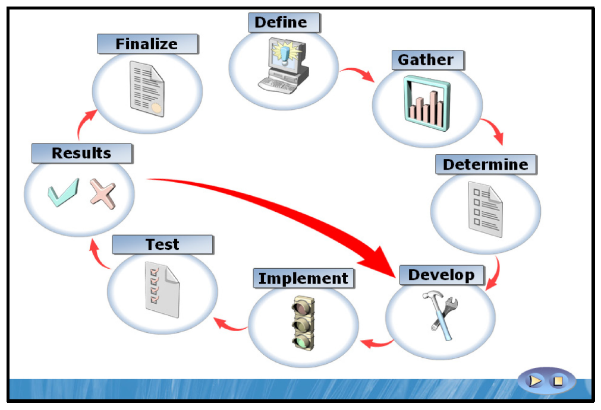

Key Points
In any troubleshooting methodology, especially one where multiple people may be involved in the troubleshooting process, it is important to have an established troubleshooting process. Using this process, the issue raised is taken through a number of stages, each bringing the issue closer to the final resolution.
1. | Define the issue. The first step in the troubleshooting process is to correctly define the issue. This means ensuring that you have obtained specific information regarding the symptoms observed by those experiencing the issue. This could consist of physical descriptions from end users (my screen went blank when I clicked the start button) or the observation of the issue yourself. Ensuring that you understand the scope and the facts of the issue is very important. Incorrect or incomplete information can lead to incorrect assumptions about troubleshooting information and could potentially result in the elimination of all assumed root causes without an actual resolution.
2. | Gather initial information. The next step in the process is to gather appropriate information about the issue. Typically, this gathering consists of actions like extended observation of the symptoms, running diagnostic tests on affected hardware and software or obtaining technical information from vendors or suppliers of affected items.
3. | Determine probable causes for the issue. Once the appropriate information has been gathered, a list of probable causes needs to be recorded and typically ranked, ensuring that the most probable causes are investigated first. As the troubleshooting process proceeds the causes are tested one by one, it may lead to the removal of causes other than the cause being tested. It also may lead to new causes being added to the list as a result of more information gathered during testing.
4. | Develop an action plan. Next, you should determine an action plan to test for the most probable cause or causes. This plan may involve one or more steps, and should be documented to ensure that it is carried out properly and that it can be repeated if necessary later in the troubleshooting process. Also, your development plan should allow for rollback after implementation in case the action plan does not resolve the issue.
5. | Implement the action plan. Once a plan has been established, the plan should be implemented and the process documented.
6. | Test the results of the action plan. After the implementation of the plan has been completed, you should test the environment to determine if the issue has been corrected. You should also check to ensure that related systems and users are not negatively impacted by the results of the action plan.
7. | Document the results of the action plan and repeat the action plan steps if necessary. The results of your action plan should then be documented. If the result of the action plan corrected the matter in a satisfactory manner, you should carry on to the last step of closing the issue and finalizing the documentation. If your action plan was unsuccessful, you should rollback the action plan steps. Then move on to the next probable cause on the list and begin the action plan steps for that cause, repeating the process until the cause is determined and resolution is achieved.
8. | Record issue as resolved and finalize documentation. Once you have determined the issue as resolved, any temporary fixes or workarounds should be removed and affected users should be informed of the resolution. In addition, the documentation of the resolution and steps taken in the troubleshooting process should be finalized and recorded in a manner that allows for later reference or cataloging. This may be through a helpdesk ticketing application, a Microsoft Office Word or Microsoft Office Excel® document, or simply a written record in a notebook.

Summary
When these steps are observed and carried out properly, your troubleshooting process will follow a logical and thorough methodology that will assist you in resolving an issue quickly and efficiently as well as equipping you with the ability to quickly resolve the issue should it occur again in your environment.

Windows Server Troubleshooting Tools
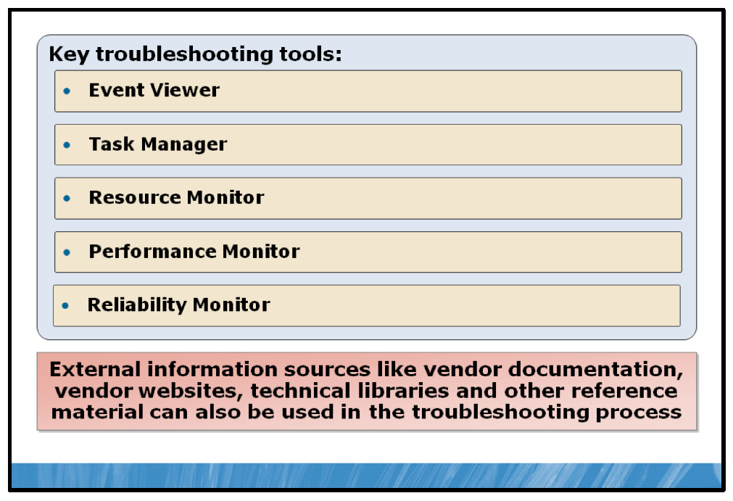

Key Points
When you are troubleshooting issues in Windows Server 2008 R2, detailed and correct information is your most valuable asset in determining and resolving the issue. The more information you have available to you regarding the issue, the more likely you are to be able to determine both the most probable cause and the most effective solution. Windows Server 2008 R2 contains several built-in tools that allow you to gather information about the server environment and identify potential issues.

Event Viewer
Windows Event Viewer provides access to the Windows 2008 event logs. Event logs provide information regarding system events that occur within Windows. These events include information, warning and error messages about Windows components and installed applications.
Event Viewer provides categorized lists of essential Windows log events (application, security, setup and system) as well as log groupings for individual installed applications and specific Windows component categories. Individual events provide detailed information regarding the type of event that occurred, when the event occurred, the source of the event as well as detailed technical information to assist in troubleshooting the event.
Additionally, Event Viewer allows you to consolidate logs from multiple computers onto a centralized computer using subscriptions. Finally, you can configure Event Viewer to perform an action based on a specific event or events occurring. This may include sending an e-mail message, launching an application or running a script or other maintenance action that could notify you or attempt to resolve a potential issue.
Note: Event Viewer can be accessed by clicking the Start button, clicking Administrative Tools and then clicking Event Viewer.

Task Manager
Windows Task Manager is the simplest and quickest way to monitor real-time resource usage and performance information in Windows Server 2008 R2. The Task Manager provides information about currently running applications, processes and services as well as a high-level performance view of three system resources: CPU, memory, and network. Within Task Manager, you can also see a list of currently logged-on users.
Note: To open the Task Manager, do one of the following:
1. | Press CTRL+SHIFT+ESC.
2. | Press CTRL+ALT+DEL, and then click Task Manager.
3. | Right-click the taskbar, and then click Task Manager.
4. | Click the Start button, and then in the Start Search box, type taskmgr.exe.

Resource Monitor
Resource Monitor provides features similar to Task Manager, but greatly enhanced. It provides a comprehensive view of the performance of each of the key system components (CPU, disk, network, and memory) in both a graphical and a detailed report form. Resource Monitor provides detailed information that allows you to troubleshoot resource or performance-based issues at a very specific level.
Note: To launch Resource Monitor, do one of the following.
1. | Open Task Manager, click the Performance tab, and then click Resource Monitor.
2. | Click Start, and then in the Start Search box, type perfmon /res, and then press ENTER.

Performance Monitor
Windows Performance monitor is an MMC snap-in that allows you to measure and compare the performance of a large number of system components. This information can be displayed graphically in real time or collected and reported on for a given time period. Windows accumulates the data for these components using objects called counters. A counter can track the information regarding a single component or aspect of the system within Performance Monitor.
In addition to the default counters, applications installed on a Windows Server such as Microsoft SQL Server or Microsoft Exchange Server may add their own counters to Performance Monitor, allowing you to monitor various aspects of those application installations.
Performance Monitor is capable of monitoring a specific set of counters over a period of time for monitoring purposes as well as the ability to view detailed reports of system performance and configuration.
Note: To launch Performance Monitor, do the following:
Click Start , click Administrative Tools, and then click Performance Monitor.

Reliability Monitor
Reliability Monitor provides an overview of system stability and the events and changes that impact the overall stability of a system. It tracks software installation and uninstallation, Windows failures, application failures, and hardware failures.
Reliability Monitor calculates a System Stability Index that reflects in graph form whether unexpected problems reduced the system's reliability. The accompanying System Stability Report provides details to help identify the specific changes that reduced reliability.
Note: To launch Reliability Monitor, do the following:
Click Start, in the Start Search box, type perfmon /rel, and then press ENTER.

External Sources
In addition to the troubleshooting tools included with Windows, external sources such as product manuals, vendor Web sites or community forums or discussion groups can be used to provide additional resources for the troubleshooting process.

Troubleshooting Component Areas
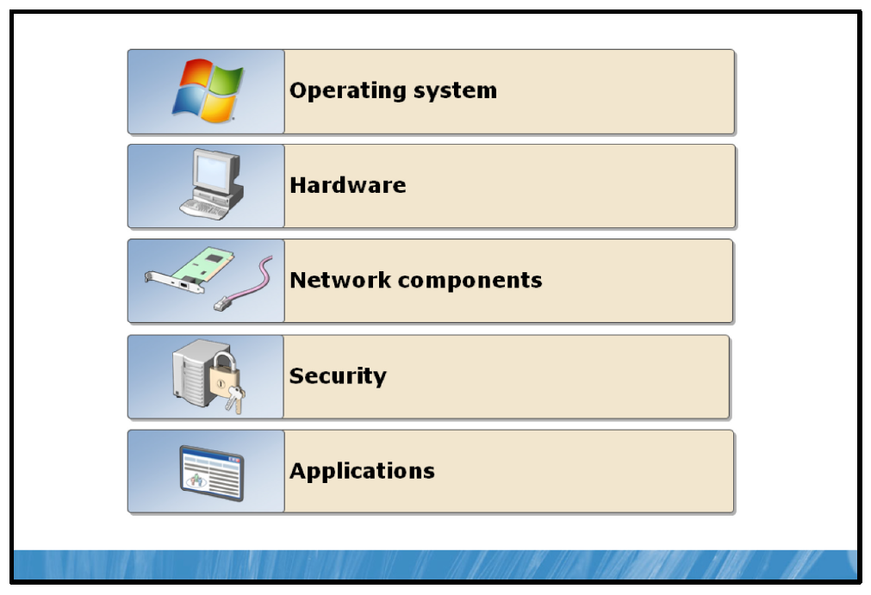

Key Points
Early in the troubleshooting process, you will attempt to determine the cause of the problem. Typically, the problem will be with some component of the computer and its associated hardware, software and environment in general. These elements can be classified into a number of system component categories. By attempting to determine which system component is causing a problem, you are using the subtractive approach to troubleshooting. For example, if the computer will not start, you might determine that the cause could be hardware related, such as a hard disk failure, or operating system related, such as a missing startup file. However, it is important to consider that a combination of components in different categories can cause some issues. The following sections look more closely at the main system components.

Operating System
Faults or corruptions in the system registry or with system services can result in operating system–related problems. The operating system controls user and application access to the computer hardware. The operating system is composed of device drivers, services, security components, applications, network components, and the configuration that links these components together. However, for troubleshooting purposes, you should consider the operating system as just the base elements—startup files, startup configuration components, and operating system services—and not the security, application, or network elements.
Operating system faults often manifest during the computer startup process. For example, if a user accidentally deletes a critical startup file, the operating system will be unable to start. If you install a new operating system service pack, or update, it might introduce unexpected problems. For this reason, it is important to test all service packs and updates before you deploy them.

Hardware
For the purposes of troubleshooting, hardware-related problems include problems with the physical computer, attached peripherals and devices, as well as device drivers related to these components. Computers are very reliable, but certain components are more prone to failure. Components with moving parts, such as disk drives and power supplies, tend to wear out. These problems are readily identifiable and easily fixed.
Other hardware-related issues can occur due to incompatible devices or device conflicts. To communicate with the rest of the computer, the operating system allocates each device a unique configuration.
Occasionally, the operating system is unable to allocate to all devices the necessary unique configuration; this may result in device failure or even cause the computer to fail to start at all.

Network Components
You can define any network configuration as a network component. For example, the TCP/IP configuration is a network component, so problems related to a computer’s IP address, subnet mask, and default gateway are all network component–related. Many network component problems with server computers can manifest at client computers, in the form of applications or operating system components operating in an unexpected way due to lack of network connectivity. Consequently, it can be difficult to determine precisely where a network component problem lies.

Security
When a user is unable to access a resource that the user should have access to, or conversely, when a user can access a resource they should be restricted from, there is typically a security-related issue.
Some security-related problems can manifest as network component problems. For example, problems with the firewall configuration might result in users being unable to access resources to which they should have access. Data encryption and authentication issues can also result in security problems.
Problems can also occur because of users having elevated administrative rights, or excessive permissions on important files or folders. For example, a user with Full Control of the Windows system folder may accidentally delete sensitive system files, resulting in an unstable or unusable operating system.

Applications
Application-related problems are those specifically related to the application programs installed and used by the users. Many of these problems result from misuse of the application by the user or from the user attempting to do something with the application that the application does not support. Adequate user training should minimize these sorts of problems.
If a user reports a problem with an application and misuse has not caused the problem, the problem’s cause might be a software error or bug. You can consult the application’s documentation to determine whether this is a known problem and whether service packs or hot fixes exist that will eliminate the problem.
Users that report performance problems with applications might have hardware-related problems rather than an application problem. The computer may require more memory, or the computer’s disk may be fragmented. You can determine whether a problem is hardware performance related because hardware performance problems typically affect more than one application.
Application incompatibility issues can also cause significant problems. A specific combination of applications running at the same time may cause operating system failures and data loss. You can avoid application incompatibility issues by deploying only applications that you have tested in combination together, and by restricting end users from installing additional applications.

Demonstration: How to Use Windows Tools to Help Troubleshoot Windows Server Problems
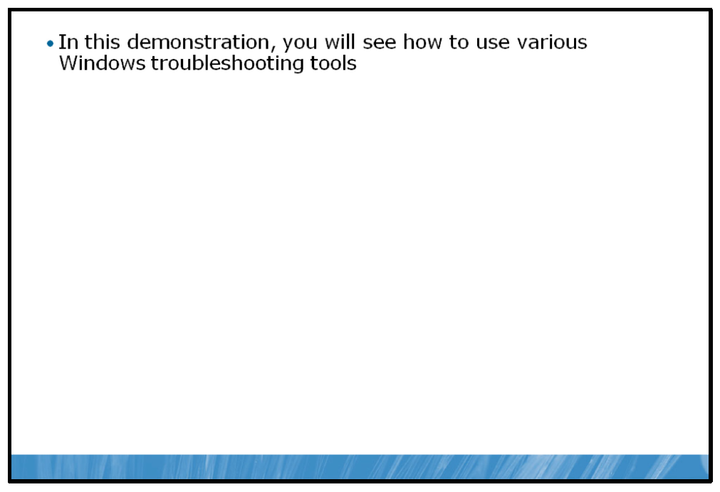

Key Points
In this demonstration, you will see how to use various Windows troubleshooting tools.

Demonstration Steps:
1. | Open and view Event Viewer.
2. | Open and view Task Manager.
3. | Open and view Resource Monitor.

Lab: Maintaining Windows Server
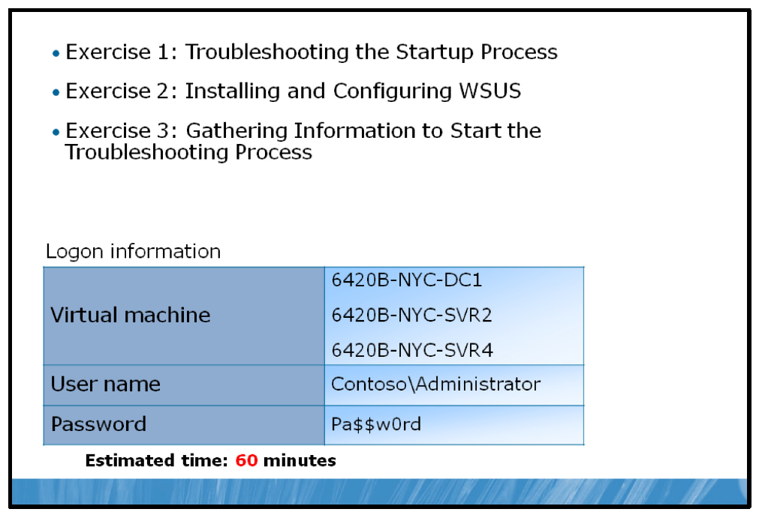

Key Points
After completing this lab, you will be able to:
• | Troubleshoot the Windows startup process.
• | Install and configure WSUS.
• | Gather information to start the troubleshooting process.

Lab Setup
For this lab, you will use the available virtual machine environment. Before you begin the lab, you must complete the following steps:
1. | On the host computer, click Start, point to Administrative Tools, and then click Hyper-V Manager.
2. | In Hyper-V™ Manager, click 6420B-NYC-DC1, and in the Actions pane, click Start.
3. | In the Actions pane, click Connect. Wait until the virtual machine starts.
4. | Log on using the following credentials:
  • | User name: Administrator
  • | Password: Pa$$w0rd
  • | Domain: Contoso
5. | Repeat these steps for 6420B-NYC-SVR2.
6. | Start 6420B-NYC-SVR4.

Lab Scenario
A number of troubleshooting tickets have been submitted to you to correct three separate issues that exist in the Contoso, Ltd company network environment.

Exercise 1: Troubleshooting the Startup Process

Scenario
A helpdesk Incident Record has been forwarded to you for resolution by the Contoso, Ltd helpdesk support team. Users in the New York office have reported being unable to access network resources on a specific server. You have been asked to review the Incident Record, resolve the issue and complete the Incident Record.The main tasks for this exercise are as follows:
1. | Read the supporting documentation.
2. | Complete the assessment information on the Incident Record.
3. | Resolve the issue and complete the Incident Record.

Supporting Documentation
Contoso Incident Record
Incident Reference Number: 501285
Called logged by Date of call  Time of call  User  Status | John Peoples  15th May  11:45  Daniel Roth  OPEN
Incident Details:
Call logged by IT helpdesk. Branch users cannot access shared files on NYC-SVR4.
1. | File shares not accessible over the network.
2. | Cannot connect to NYC-SVR4 with Remote Desktop Connection.
3. | Cannot ping NYC-SVR4 IP address.
4. | All other network resources in the branch location are functioning properly.

Preliminary Questions:
1. | Where is the best place to troubleshoot this problem from?
2. | What considerations should be made regarding NYC-SVR4 and the people and services that require the services provided by NYC-SVR4?

Assessment Questions:
1. | What is the error message displayed on NYC-SVR4?
2. | What could the possible causes of this error message be?
3. | What tool should you use to attempt to correct the problem causing the error message?
4. | How can you access these tools?

Resolution Questions:

Task 1: Read supporting documentation
1. | Read the attached Incident Record to determine possible troubleshooting methods.
2. | Answer the Preliminary Questions in the Incident Record.

Task 2: Investigate the issue on 6420B-NYC-SVR4
1. | Switch to the NYC-SVR4 computer.
2. | Observe the error message displayed on NYC-SVR4 and answer the Assessment Questions in the Incident Record.

Task 3: Resolve the issue on NYC-SVR4 and complete the Incident Record
1. | Attach the Windows Server 2008 R2 Installation DVD to NYC-SVR4 using these steps.
  a. | Switch to Hyper-V Manager, right click on 6420B-NYC-SVR4 and then click Settings.
  b. | In the Settings for 6420B-NYC-SVR4 dialog box, click DVD Drive in the Hardware Pane.
  c. | In the DVD Drive Pane, select Image file and then click Browse.
  d. | Navigate to C:\Program Files\Microsoft Learning\6420\Drives, click WServer2008R2_Eval.iso and then click Open.
  e. | In the Settings for 6420B-NYC-SVR4 dialog box, click OK.
2. | Switch to the NYC-SVR4 computer.
3. | On the 6420B-NYC-SVR4 on localhost – Virtual Machine Connection window toolbar, click Action and then click Reset.
4. | In the Reset Machine dialog box, click Reset.
5. | When Press Any Key to boot from DVD or CD is displayed, press ENTER.
6. | At the Install Windows dialog box, click Next and then click Repair your computer.
7. | In the System Recovery Options dialog box, select Use recovery tools that can help fix problems starting Windows and then click Next. Click Command Prompt.
8. | Use bcdedit to view the current BCD store.
9. | Use bootrec to scan for the operating system and to rebuild the BCD store with the newly found operating system entry. When prompted, add the rebuilt installation to the boot list.
10. | Restart the computer to ensure proper operation.
11. | Complete the Resolution Questions in the Incident Record.
12. | Revert the NYC-SVR4 virtual machine.
Results: After this exercise, you should have used Windows tools to troubleshoot the startup process.

Exercise 2: Installing and Configuring WSUS

Scenario
You have been forwarded a request to install and configure a WSUS server in Contoso, Ltd’s New York location and test the configuration by configuring a client machine to use the WSUS Server to receive automatic updates.
The main tasks for this exercise are as follows:
1. | Read the supporting documentation.
2. | Install prerequisites for WSUS on NYC-SVR2.
3. | Configure NYC-SVR2 as a WSUS Server.
4. | Use Group Policy to enable NYC-CL1 to obtain updates from the new WSUS server.
5. | Create a computer group, and add NYC-CL1 to the new group.
6. | Approve an update for Windows 7 clients.
7. | Install an update on the Windows 7 client.
8. | View WSUS reports.

Supporting Documentation
Contoso Add Request
Request Reference Number: 10527
Requested By  Date of Request Assigned to  Status | Nancy Anderson  17th May  You  OPEN
Request Details:
Configure WSUS for local distribution of updates for the New York office:
1. | Install prerequisite components on NYC-SVR2.
2. | Install WSUS on NYC-SVR2.
3. | Configure WSUS as detailed:
  • | Restore the WSUS backup from E:\Labfiles\WSUS\Backup.
4. | Configure test client NYC-CL1 to receive updates from the newly configured WSUS server.
5. | Test the configuration by installing updates on NYC-CL1.

Task 1: Read supporting documentation
• | Read the attached request form.

Task 2: Install prerequisite components on NYC-SVR2
1. | Install Internet Information Server by doing the following:  Note: There are a number of roles selected by default, no not de-select any of these roles.
  a. | Switch to NYC-SVR2.
  b. | Run Server Manager and add the Web Server (IIS) role with the following components enabled:
    • | ASP.NET
    • | Windows Authentication
    • | Dynamic Content Compression
    • | IIS 6.0 Metabase Compatibility  Note: When prompted, click Add Required Role Services.
2. | Close the Add Roles Wizard after installation is finished and then close Server Manager.
3. | Install Microsoft Report Viewer by doing the following.
  a. | Open Windows Explorer and browse to E:\Labfiles\WSUS\.
  b. | Run the Reportviewer.exe file, and install Report Viewer by using the installation wizard.

Task 3: Configure NYC-SRV2 as a WSUS server
1. | Browse to E:\Labfiles\WSUS.
2. | Run the file WSUS30-KB972455-x64.exe to start the Windows Server Update Services 3.0 SP2 Setup Wizard.
3. | Install WSUS.
4. | Use the location C:\WSUS for updates, Windows Internal Database as a WSUS database, and the existing IIS Default Web site.
5. | At the end of installation, the Windows Server Update Services Configuration Wizard appears. Do not run this wizard, click Cancel to close it. You will restore configuration data using a backup in the next steps.
6. | Click Start, type CMD.exe and then press ENTER.
7. | Type Net Stop MSSQL$Microsoft##SSEE, and then press ENTER.
8. | In Windows Explorer, browse to E:\LabFiles\WSUS\Backup.
9. | Click Organize, and then click Select All.
10. | Click Organize, and then click Copy.
11. | In the Address bar, click Computer.
12. | Browse to C:\WSUS\.
13. | Click Organize, and then click Paste.
14. | In the Confirm Folder Replace dialog box, select the check box next to Do this for all current items, and then click Yes.
15. | In the Copy File dialog box, select the check box next to Do this for the next 1 conflicts, and then click Copy and Replace.
16. | When the file copy is complete, at the command prompt, type Net Start MSSQL$Microsoft##SSEE, and then press ENTER.
17. | Click Start, point to Administrative Tools, and then click Internet Information Services (IIS) Manager.
18. | In the tree view, expand NYC-SVR2, and then click Application Pools.
19. | Right-click WsusPool, and then click Recycle.
20. | Close Internet Information Services (IIS) Manager.
21. | At the command prompt, type: cd "C:\Program Files\Update Services  \Tools", and then press ENTER.
22. | Type wsusutil reset, and then press ENTER.
23. | Close the command prompt.

Task 4: Use Group Policy to enable NYC-CL1 to obtain updates from the new WSUS server
1. | On NYC-DC1, open Group Policy Management.
2. | Create a new GPO linked to the Contoso.com domain named WSUS.
3. | Open the Group Policy Management Editor to edit the WSUS GPO.
4. | In the Group Policy Management Editor window, under Computer Configuration, expand Policies, expand Administrative Templates, expand Windows Components, and then click Windows Update.
5. | Enable Configure Automatic Updates.
6. | Enable Specify intranet Microsoft update service location.
  • | Set the intranet update service for detecting updates and the intranet statistics server to http://NYC-SVR2.
7. | Enable Automatic Updates detection frequency.
8. | Start 6420B-NYC-CL1 and log on as Contoso\Administrator with the password of Pa$$w0rd.
9. | On NYC-CL1, open a command prompt and type, wuauclt /a /r and then press ENTER.

Task 5: Create a computer group, and add NYC-CL1 to the new group
1. | On NYC-SVR2, open the Windows Server Update Services console.
2. | Expand NYC-SVR2, expand Computers, and then select All Computers. In the details pane, change the Status to Any. Click Refresh.
3. | In the Actions pane, click Add Computer Group, and name the group TestComputers.
4. | Change membership of the NYC-CL1.contoso.com computer object so that it is a part of the TestComputers group.

Task 6: Approve an update for Windows® 7 operating system clients
1. | In the Update Services window, in the console pane, expand Updates, and then click Security Updates.
2. | In the details pane, change the Approval filter to Any Except Declined, change the Status filter to Any, and then click Refresh. Notice all of the updates available.
3. | In the Security Updates pane, right-click Security Update for Windows 7 (KB981332), and then click Approve.  Note: Do not select the x64 versions of the updates specified.
4. | Approve the update for all computers.
5. | In the console pane, click Critical Updates.
6. | In the Critical Updates details pane, right-click Update for Windows 7 (KB976662), and then click Approve.
7. | Set a deadline for yesterday's date.  Note: Entering yesterday’s date will cause the update to be installed as soon as the client computers contact the server.

Task 7: Install an update on the Windows 7 operating system client
1. | On NYC-CL1, at the command prompt, run GPUpdate /force.
2. | Once the policy has finished updating, run wuauclt /detectnow.
3. | Open Windows Update to review recently installed updates.  Note: It may take several minutes for the Windows Update icon to appear.

Task 8: View WSUS reports
• | On NYC-SVR2, run a Computer Detailed Status report to view updates for NYC-CL1.
Results: At the end of this exercise, you will have configured WSUS to manage updates.

Exercise 3: Gathering Information to Start the Troubleshooting Process

Scenario
You have been asked to examine possible performance issues with NYC-SVR2.
You know that the server NYC-SVR2 experiences low network traffic and has limited disk activity, but the help desk is receiving many reports that the server is slow.
Later that week, the help desk receives reports that the server is running slow again. You know that the server NYC-SVR2 is not running processor-intensive applications.
The main tasks for this exercise are as follows:
1. | Examine the Performance Monitor logs for the first issue and answer the resolution questions for Part  A.
2. | Examine the Performance Monitor logs for the first issue and answer the resolution questions for Part  B.

Supporting Documentation
Contoso Incident Record PART A (Complete for Task 1)
Incident Reference Number: 501289
Called logged by Date of call  Time of call  User  Status | John Peoples  19th May  12:10  Daniel Roth  OPEN
Incident Details:
Call logged by IT helpdesk. Users report NYC-SVR2 is running slow. Performance Monitor logs are stored
in E:\Labfiles\Captures\6420B-NYC-SVR2-LAB13-EX3-PARTA.blg.
Resolution Questions:
1. | What do the Performance Logs for NYC-SVR2 indicate could be the source of the problem?
2. | Keeping in mind your answer from question 1, what steps (using a troubleshooting methodology) would you take to continue the troubleshooting process?  Contoso Incident Record PART B (Complete for Task 2)
Incident Reference Number: 501290
Called logged by Date of call  Time of call  User  Status | John Peoples  20th May  13:15  Daniel Roth  OPEN
Incident Details:
Call logged by IT helpdesk. Users report NYC-SVR2 is running slow, Performance Monitor logs are stored
in E:\Labfiles\Captures\6420B-NYC-SVR2-LAB13-EX3-PARTB.blg.
Resolution Questions:
1. | What do the Performance Logs for NYC-SVR2 indicate could be the source of the problem?
2. | Keeping in mind your answer from question 1, what steps (using a troubleshooting methodology) would you take to continue the troubleshooting process?

Task 1: Examine the Performance Monitor logs for the first issue and answer the resolution questions for Part A
1. | Switch to the NYC-SVR2 computer.
2. | Use Performance Monitor on NYC-SVR2 to review the data collector logs at E:\Labfiles\Captures\6420B-NYC-SVR2-LAB13-EX3-PARTA.blg on the server.
3. | Examine the following counters:
  • | Processor - % Processor Time (Instance 0)
  • | System - Processor Queue Length
  • | Process _ % Processor Time (All Instances)
4. | Complete the resolution questions in Part A of the Incident Record.
5. | Close Performance Monitor.

Task 2: Examine the Performance Monitor logs for the first issue and answer the resolution questions for Part B
1. | Switch to the NYC-SVR2 computer.
2. | Use Performance Monitor on NYC-SVR2 to review the data collector logs at E:\Labfiles\Captures\6420B-NYC-SVR2-LAB13-EX3-PARTB.blg on the server.
3. | Examine the following counters:
  • | PhysicalDisk - Avg. Disk Queue Length (Instance 0 C:)
  • | PhysicalDisk - Current Disk Queue Length (Instance 0 C:)
  • | PhysicalDisk - Disk Transfers/sec (Instance 0 C:)
  • | Process - IO Data Bytes/sec (All Instances)
4. | Complete the resolution questions in Part B of the Incident Record.
5. | Close Performance Monitor.
Results: After this exercise, you should have gathered information to start the troubleshooting process.

To prepare for the next module
When you finish the lab, shut down the virtual machines and revert them back to their initial state. To do this, complete the following steps:
1. | On the host computer, start Hyper-V Manager.
2. | Right-click 6420B-NYC-DC1 in the Virtual Machines list, and then click Revert.
3. | In the Revert Virtual Machine dialog box, click Revert.
4. | Repeat these steps for 6420B-NYC-SVR2 and 6420B-NYC-CL1.

Module Review and Takeaways
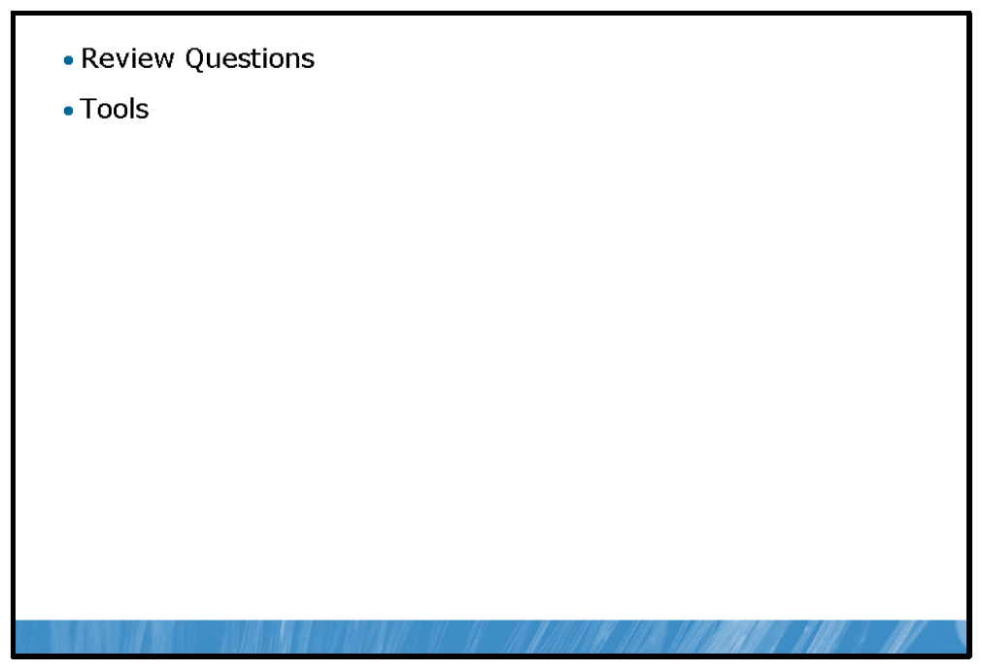

Review Questions
1. | What is the key functionality of a boot loader?
2. | How does fault tolerant hardware provide for high availability, provided the hardware is supported by Windows Server 2008 R2?
3. | What benefits does Performance Monitor offer over Resource Monitor?

Tools
Tool | Use for | Where to find it
BCDEdit |  | From the command line, type bcedit.
  • | Editing Windows Boot Configuration Data Store
WSUS |  | http://www.microsoft.com /downloads/details.aspx?  FamilyId=a206ae20-2695-436c-9578- 403a7d46e40&displaylang=en
  • | Managing Microsoft Updates in the enterprise
WinRE |  | Choose Repair Computer from the F8 Windows Advance Options boot menu, or choose Repair Computer when booting from  Windows 2008 installation media.
  • | Used to repair various aspects of a Windows Server.
Last Known Good Configuration |  | Choose Last Known Good Configuration from the F8 Windows Advance Options boot menu.
  • | Loads system registry settings saved from the last successful system startup.
Safe Mode |  | Choose one of the Safe Mode options from the F8 Windows Advanced Options boot menu.
  • | Loads Windows Server with a minimal set of drivers and services for troubleshooting purposes.
Windows Server Backup |  | Click Start, type Windows Server Backup into the Start Search field and press ENTER.
  • | Backup Windows Server computers.
Windows Update |  | Click Start, type Windows Update into the Start Search field and press ENTER.
  • | Updates operating system, device driver and Microsoft application components.
WSUS |  | http://technet.microsoft.com /en-us/wsus/default.aspx .
  • | Allows for centralized management of the Windows Update process.
Event Viewer |  | Click Start, click Administrative Tools and then click Event Viewer.
  • | View Windows logs.
Task Manager |  | Press CTRL+SHIFT+ESC.
  • | View basic real-time information regarding the Windows environment.
Resource Monitor |  | From Task Manager, click the Performance tab and then click the Resource Monitor button.
  • | View detailed real-time information regarding the Windows environment.
Performance Monitor |  | Click the Start button, click Administrative  Tools and then click Performance Monitor.
  • | View and collect real time and historical performance and configuration information regarding the Windows environment.
Reliability Monitor |  | Click the Start button, and then in the Start Search box, type perfmon /rel, and then press ENTER.
  • | View an overview of system events and relative system stability.

- Highlight
- Note
- Expand Highlight
- Expand Note
Module 14: Implementing Virtualization
Contents:
Lesson 1: | Overview of Virtualization Technologies
Lesson 2: | Implementing the Hyper-V Role
Lab: | Implementing Virtualization

Module Overview
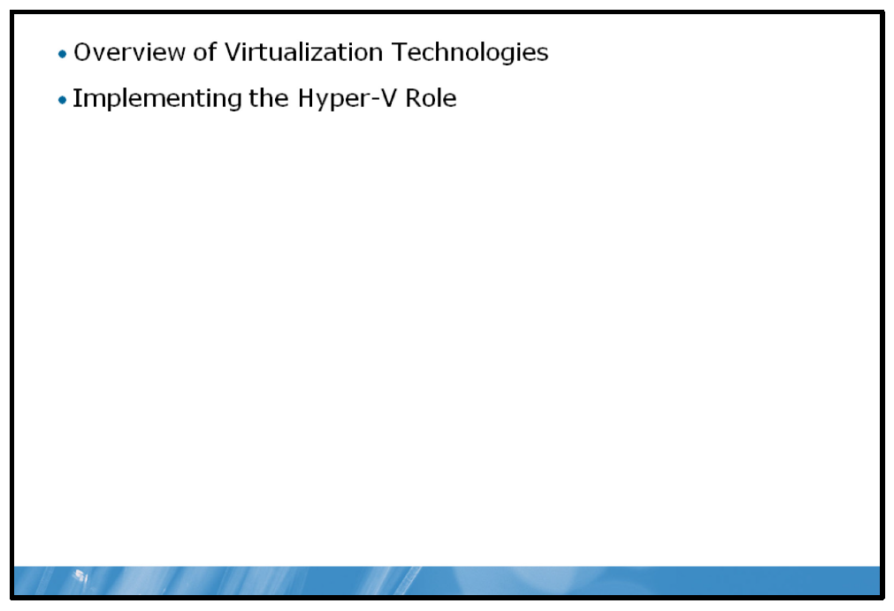
Almost all organizations are looking for ways to decrease the cost and complexity of providing an Information Technology (IT) infrastructure.
Virtualization has become a key component in developing an efficient and cost effective IT strategy. This module introduces virtualization, and it describes how virtualization relates to server, desktop, and application environments. This module also describes how to implement server virtualization by deploying and configuring the Hyper-V™ server role.

Objectives
After completing this module, you will be able to:
• | Describe the various virtualization technologies.
• | Implement server virtualization with Hyper-V.

Lesson 1: Overview of Virtualization Technologies
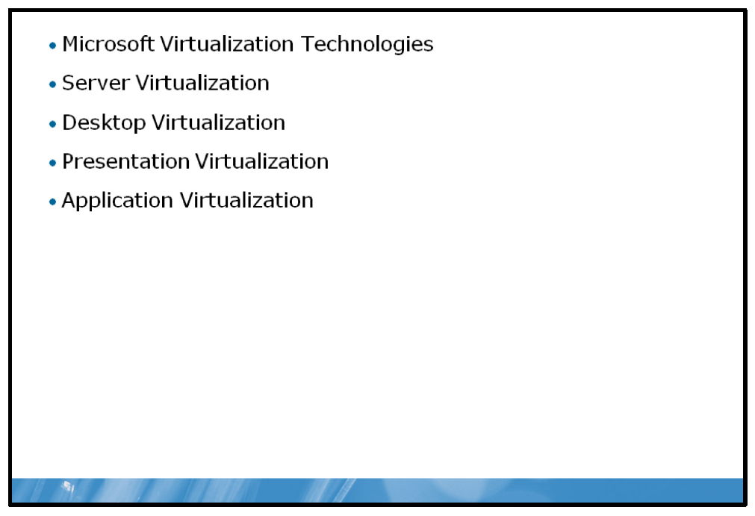
Microsoft provides a complete set of products that provide virtualization solutions in many scenarios. You can use these virtualization products in many different ways to make the IT infrastructure more efficient and effective. This lesson provides an overview of the Microsoft virtualization solutions, and details how you can use them to address many of today’s IT infrastructure issues.

Objectives
After completing this lesson, you will be able to:
• | Describe virtualization technologies.
• | Describe server virtualization.
• | Describe desktop virtualization.
• | Describe presentation virtualization.
• | Describe application virtualization.

Microsoft Virtualization Technologies
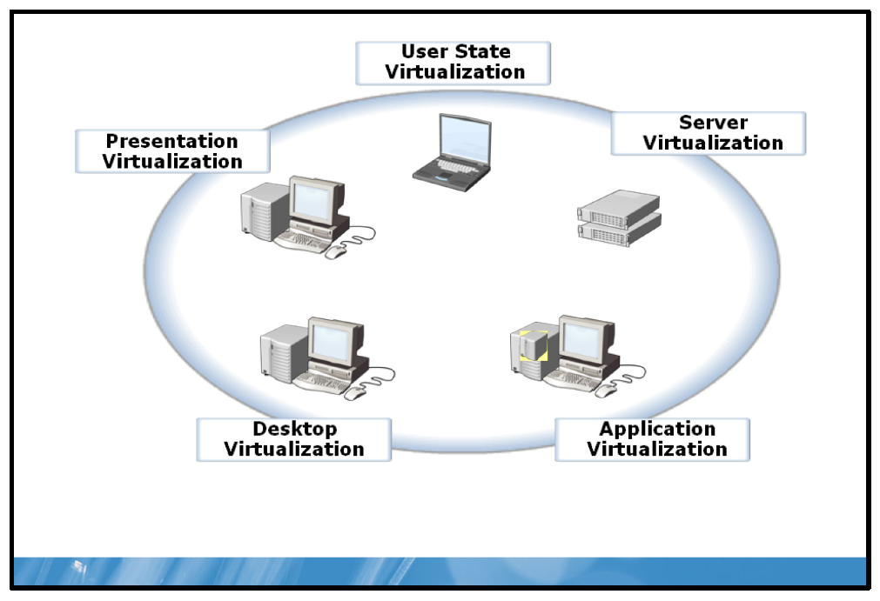

Key Points
Virtualization separates the application and operating system components that users work with from the actual physical components that provide the application or operating system services. For example, virtual machines provide all of the functionality of physical servers, but the operating system is not tied to any particular piece of hardware, and can be made available where it is most convenient. Applications traditionally have run on an operating system that is running on a particular piece of hardware. With application and presentation virtualization, those applications may be running on a centralized server or in a virtual environment that is completely portable to other operating systems or hardware devices.

Virtualization Solutions
Microsoft provides virtualization solutions that address most of the virtualization requirements for most organizations.
• | Server virtualization. Windows Server® 2008 Hyper-V and Microsoft® Virtual Server 2005 R2 enable server virtualization, so that you can run multiple virtual machines on a single physical server. This allows greater density of resource use (hardware, utilities, space) while allowing you to maintain operational isolation and security.
• | Desktop virtualization. Desktop virtualization is provided by running Microsoft Virtual PC on the Windows Vista® operating system, or Windows® Virtual PC and Windows XP Mode on the Windows 7 operating system. Desktop virtualization enables you to run multiple operating systems on a single workstation, and to run an incompatible legacy or line-of-business (LOB) application within a more-current desktop operating system. Microsoft provides a way to manage a complex desktop virtualization environment through Microsoft Enterprise Desktop Virtualization (MED-V). With MED-V, you can create and manage a centralized collection of Virtual PC images, and then deliver those images to client computers as required.
• | Presentation virtualization. Remote Desktop Services (RDS) in Windows Server 2008 R2 provides presentation virtualization. RDS replaces Terminal Services, which was available in previous Windows versions. Presentation virtualization enables you to run applications and maintain application storage on centralized servers, while providing users with a familiar application interface on their workstations. RDS provides the tools required to create a seamless environment for users so they can run applications locally or on a remote server with very minimal differences. Microsoft extends the concepts of presentation and desktop virtualization with Virtual Desktop Infrastructure (VDI). With VDI, you can host client virtual machines on a Hyper-V infrastructure and provide access to the virtual machine through RDS.
• | Application virtualization. Application virtualization enables you to run applications in a virtualized environment on a user’s desktop. With application virtualization, the application is isolated from the underlying operating system because the application is encapsulated in a virtual environment. When you deploy a complete application virtualization solution, you can use centralized servers to distribute the virtual applications. Microsoft Application Virtualization (App-V) is an example of an application virtualization platform.
• | User state virtualization. User state virtualization enables users to take advantage of separating their documents and profile information from a specific computer, which makes it easy to get working again on a new machine in case of a stolen or dropped laptop. Profile virtualization also makes it easy for users to move between computers, or to experience the same desktop environment when using one of the other virtualization technologies.
• | Virtualization management. One of the critical components in deploying virtualization is to be able to manage the solution, including both the physical and virtual components. The System Center suite of tools provides virtualization management. Tools like System Center Configuration Manager, System Center Operations Manager 2007, and System Center Virtual Machine Manager (VMM) provide a familiar set of tools for managing both the virtual environment and the physical layer that hosts the virtual environment.

Server Virtualization
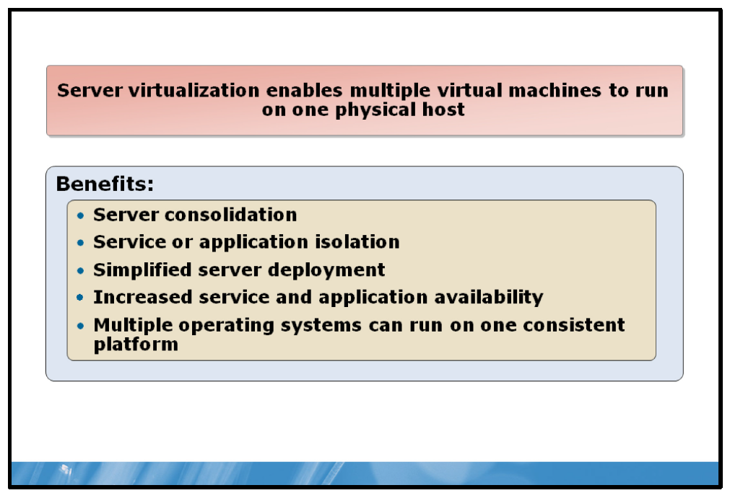

Key Points
Server virtualization enables you to configure one or more virtual machines that emulate a physical computer. Multiple virtual machines can run on one physical server, with all the virtual machines sharing the resources available on the physical server.
Microsoft provides three products for server virtualization:
• | Microsoft Virtual Server 2005 R2
• | Windows Server 2008 Hyper-V
• | Windows Server 2008 R2 Hyper-V  Note: Windows Server 2008 R2 Hyper-V uses the same underlying technology to enable server virtualization as Windows Server 2008, but it also provides some significant new features.

Benefits of Server Virtualization
Server virtualization provides many benefits, including:
• | Server consolidation. Many servers that organizations deploy are underutilized. By deploying multiple virtual machines on a much lower number of physical servers, you can increase the server resource utilization significantly while decreasing the number of physical servers. You can deploy many virtual machines on one physical server. In most organizations, this will result in a significant decrease in power and space consumption in the data centers.
• | Service or application isolation. Server virtualization enables you to run each service or application on an isolated operating system. This means that you can prevent one application from impacting another application when upgrades or changes are made. This is preferable to running multiple applications or services on a single operating system.
• | Simplified server deployment. By creating standard virtual machine builds, you can deploy new server builds more easily. Because you are deploying virtual machines rather than physical servers, you do not need to acquire new hardware or locate data center space and power, for each new server.  Note: You may need to invest in new server and storage hardware when first implementing server virtualization, but an important result of server virtualization is the decrease in the number of physical servers that your organization will need.
• | Increased service and application availability. Because the service or application no longer connects directly to a specific piece of hardware, it is much easier to ensure high availability and recoverability. With live migration in Windows Server 2008 R2, you can move a virtual machine to another physical server with little or no perceived outage.
• | Multiple operating systems can run on one consistent platform. With server virtualization, you can deploy multiple operating system technologies on a single hardware platform. For example, you can deploy the Windows Server 2003 operating system, the Windows Server 2008 operating system, and Linux on one Windows Server 2008 R2 Hyper-V host. Server virtualization also makes it much easier to replace hardware when it becomes obsolete or fails.

Desktop Virtualization
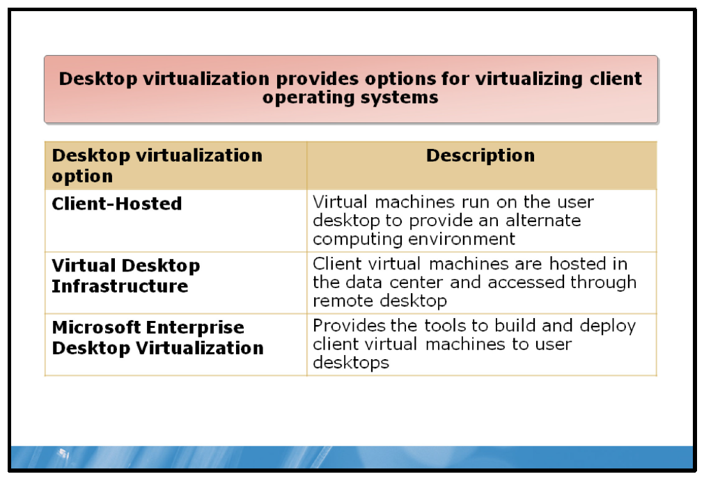

Key Points
Desktop virtualization provides new options for deploying client desktops by enabling several ways to virtualize the desktop. Traditionally, users have worked on a specific piece of hardware that is running a single operating system and all applications.

Client-Hosted Desktop Virtualization
Client-hosted desktop virtualization uses Microsoft Virtual PC on Windows Vista and Windows Virtual PC on Windows 7 to enable users to run multiple virtual machines on their Windows desktop. Client-hosted desktop virtualization creates a separate environment on the desktop, allowing incompatible legacy or LOB applications to operate within their native environment on top of a more-current desktop operating system.
In Windows 7, Microsoft provides a preconfigured Windows XP operating system virtual machine that can be run as a Windows Virtual PC virtual machine. Windows XP mode enables you to run applications seamlessly from a Windows 7 computer or from the Windows XP virtual machine.

VDI
VDI extends the concept of desktop virtualization by running client operating systems as virtual machines on servers in the data center. This means that the virtual client computers are not running on the user desktop, but on a centralized Hyper-V environment in the data center. Users can interact with the virtual machines by using regular computers or thin clients, and then establishing remote desktop connections to the virtual machines. In Windows Server 2008, VDI has been integrated with RDS to provide a consistent client experience.
VDI enables you to centralize a user’s desktop for easier management. With VDI, the user can get an individualized desktop experience with full administrative control over desktop and applications.

MED-V
The Microsoft Desktop Optimization Pack includes MED-V, which enhances the management of the virtual machines that deploy to user desktops. MED-V adds four additional components on top of Virtual PC to enable enterprise deployment of desktop virtualization.
• | Virtual image repository and delivery. Simplifies the process of creating, testing, delivering, and updating virtual images.
• | Centralized management and monitoring. Manages the life cycle of a virtual machine.
• | Usage policy and data transfer control. An endpoint agent enforces usage policies for the virtual machine
• | Seamless end-user experience.
Question: When would you use each of the desktop virtualization options?

Presentation Virtualization
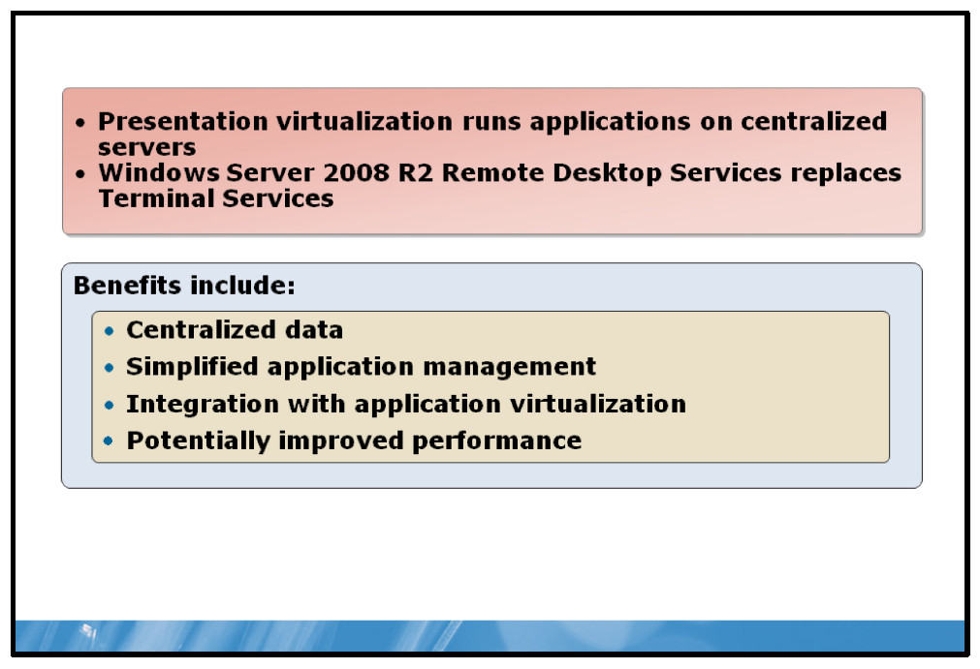

Key Points
Presentation virtualization runs applications on a central server, with only the application interface, mouse movements, and keystrokes sent across the network between the central server and the client computer. Presentation virtualization creates virtual sessions in which the executing applications project their user interfaces remotely.
Presentation virtualization was available for several Windows Server versions as Terminal Services. In Windows Server 2008 R2, the presentation virtualization feature is renamed to RDS.

Windows Server 2008 R2 RDS Features
Windows Server 2008 R2 provides several important features that optimize the deployment of presentation virtualization:
• | Remote Desktop RemoteApp. RemoteApp allows single applications to be accessible through Remote Desktop connections. With RemoteApp, an application’s user interface appears on the desktop as if that application were running locally. In fact, an application accessed via RemoteApp appears in the task bar like a local application, and you also can launch it like one: from the Start menu, through a shortcut, or by opening a file with the application extension.
• | Remote Desktop Web Access. Enables you to launch single applications and complete desktops from a Web browser.
• | Remote Desktop Gateway. Encapsulates Remote Desktop Protocol (RDP) traffic in Hypertext Transfer Protocol Secure (HTTPS). This gives users outside an organization’s firewall more secure access to internal applications without using a virtual private network (VPN).
• | Remote Desktop Connection Broker. Provides load balancing functionality for Terminal Services connections and enables a user to reconnect to an existing session in a load-balanced terminal server farm.
• | RemoteApp and Desktop Connection. This Control Panel client application allows users running Windows 7 to easily connect to RemoteApp programs and Remote Desktops.

Benefits of Presentation Virtualization
Running applications on a shared server like this offers several benefits, including:
• | You can centralize your data. This means that you can store it safely on a central server rather than on multiple desktop machines, which improves security because information is not spread across many different systems.
• | You can reduce the cost of managing applications significantly. Instead of updating each application on each individual desktop, for example, you must change only the single shared copy on the server. Presentation virtualization also allows using simpler desktop operating system images or specialized desktop devices, commonly called thin clients, both of which can lower management costs.
• | You can combine application virtualization with presentation virtualization to reduce the issues with incompatibilities between applications. You can install App-V applications on Remote Desktop Session Host servers and run multiple instances of potentially incompatible applications on the centralized server.
• | In some cases, presentation virtualization can improve performance. For example, if a client or server application needs to access large amounts of data from a central database, it may be quicker to run the application on a Remote Desktop Session Host that is located close to the data, rather than pull the data across a slow network connection to the client.

Application Virtualization
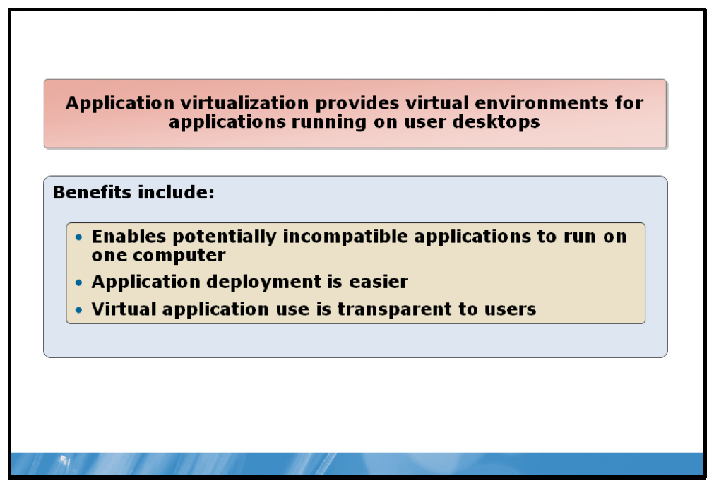

Key Points
You can use application virtualization to create virtual applications that you then can distribute to user desktops. Each virtual application includes its own registry entries, specific dynamic-link libraries (DLLs), and other resources. When you deploy a virtual application, it uses its own copy of these shared resources. Because the virtual application runs in an isolated environment, incompatible applications can share the same workstation.
App-V provides an application virtualization solution.

Benefits of App-V
App-V provides the following benefits:
• | App-V enables you to run potentially incompatible applications on the same client computer.  Applications commonly share various application or operating system components with other applications on the client computer. For example, one application might require a specific version of a DLL, while another application on that system might require a different version of the same DLL. Installing both applications may result in one of the applications overwriting the DLL that the other requires. With application virtualization, each application can have its own version of all required files and settings on the client computer.
• | Application virtualization can make application deployment significantly easier. When you create a virtual application, you create a single file that you can distribute to client computers. Since the applications are encapsulated in a virtual environment, you do not need to test new applications for conflicts with existing applications before you roll them out.
• | From the user’s perspective, a virtual application can be launched and run just like any other application. The user can start the virtual application from the Start menu, from a desktop icon, or by file extension association. The application appears in Task Manager. When the application is running, you can connect to printers, network connections, and other resources just like you can from any other application.
• | Virtual applications are easy to deploy and manage. You can stream a virtual application from a server, on demand, so the user can download it automatically the first time he needs to use it. If you must update an application, administrators can update the server version of the application, and the updated files then download the next time the client computer needs to run the application.

Lesson 2: Implementing the Hyper-V Role
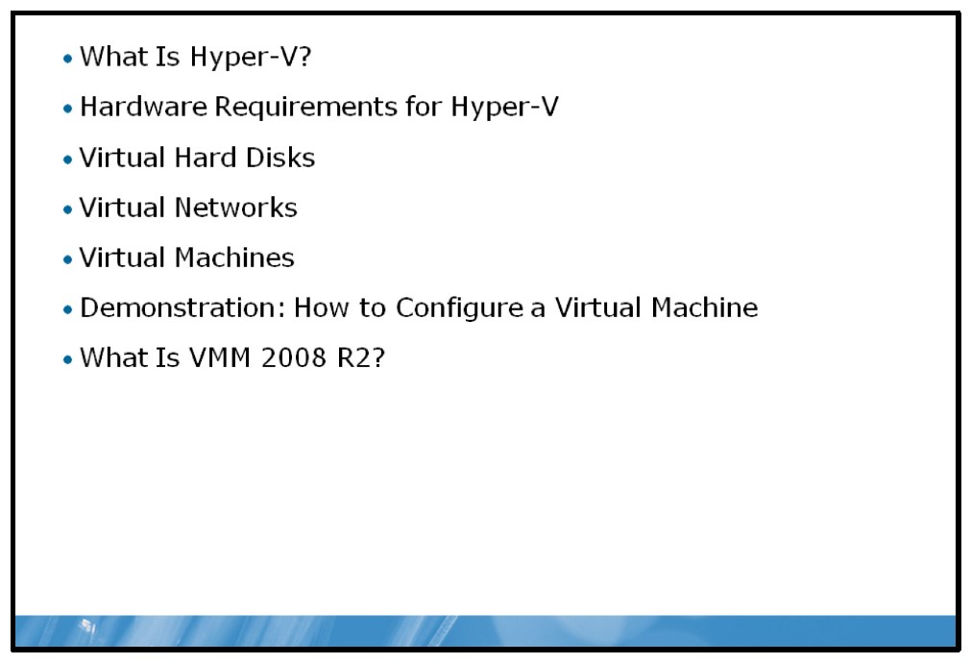
Server virtualization requires a host platform that enables you to run virtual machines. The current product from Microsoft that provides this platform is Windows Server 2008 R2 Hyper-V. This lesson explains how to deploy and configure the Hyper-V role.

Objectives
After completing this lesson, you will be able to:
• | Describe Hyper-V.
• | Describe the hardware prerequisites of Hyper-V.
• | Describe a virtual hard disk.
• | Describe a virtual network.
• | Describe a virtual machine.
• | Create a virtual machine.
• | Describe VMM 2008 R2.

What Is Hyper-V?
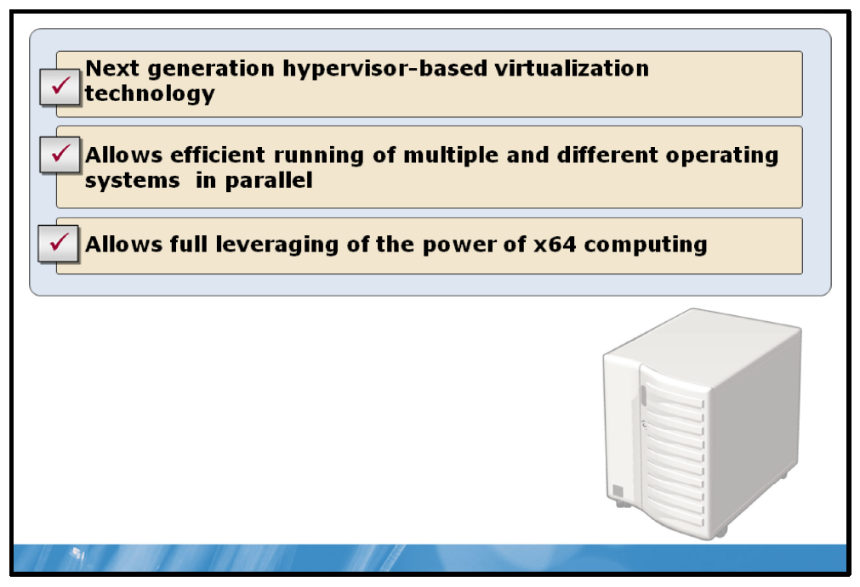

Key Points
The Hyper-V role in Windows Server 2008 and Windows Server 2008 R2 provides software infrastructure and basic management tools that you can use to create and manage a virtualized server computing environment.
Hyper-V is a hypervisor-based virtualization technology. The hypervisor is the processor-specific virtualization platform that allows multiple isolated operating systems to share a single hardware platform.
Hyper-V is a Type 1 hypervisor. A Type-1 hypervisor is a hypervisor that is considered a bare-metal hypervisor and runs directly on top of hardware. Type 1 hypervisors are often referred to as hardware virtualization engines. Hyper-V is designed using a 64-bit hypervisor. The hypervisor allows multiple virtual machines to access physical memory and CPU resources without conflicts. Also, it allows creation of 64-bit guest operating systems. In combination with virtualization-aware hardware that includes processors using Intel VT and AMD V technology, the Hyper-V hypervisor enables high performance and excellent scalability for guest operating systems.
Because the Hyper-V hypervisor takes advantage of Intel VT and AMD-V technology, more of the work of virtualizing multiple operating systems is performed by the processor hardware and less needs to be performed by the virtualization stack and hypervisor. The virtualization stack runs within the parent partition and has direct access to hardware devices. The parent partition then creates child partitions, which host the guest operating systems.
After the initial Windows Server 2008 R2 installation, the operating system can access the server hardware directly. After you add the Hyper-V role, a thin hypervisor layer between the operating system and the hardware resources is added. The currently installed operating system becomes the parent partition from where you can create and manage child partitions. Child partitions also do not have direct access to other hardware resources and are presented a virtual view of the resources, as virtual devices.
Drivers in the parent partition are used for accessing the server hardware. Child partitions use virtualized devices through virtual server client (VSC) drivers, which communicate through Virtual Machine Bus (VMBus) with Virtualization Service Providers (VSP) in the parent partition. Requests to the virtual devices are redirected either through the VMBus or through the hypervisor to the devices in the parent partition.
The VMBus manages the requests. The VMBus is a logical inter-partition communication channel. The parent partition hosts VSPs, which communicate over the VMBus to handle device access requests from child partitions. Child partitions host VSCs, which redirect device requests to VSPs in the parent partition through the VMBus.

Hardware Requirements for Hyper-V
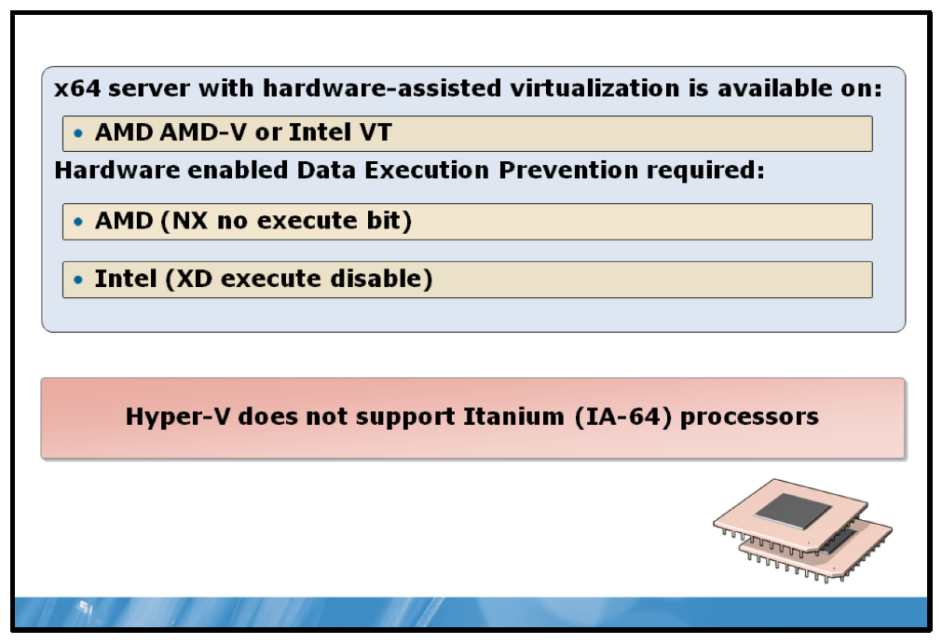

Key Points
Before you can run virtual machines in Windows Server 2008 R2 Hyper-V, you must ensure that you properly address and configure all hardware perquisites on the host computer. There are four requirements that you must meet before you can install the Hyper-V server role successfully: You must have:
• | An x64-based processor.
• | Hardware data execution prevention (DEP).
• | Hardware-assisted virtualization.
• | A basic input/output system (BIOS) that allows you to enable DEP and hardware-assisted virtualization.

DEP
You must have hardware-enforced DEP enabled by configuring either the Advanced Micro Devices (AMD) no execute bit (NX bit) or the Intel execute disable bit (XD bit).
Note: DEP provides operating system protection from applications executing code in a non-executable memory region; this helps to prevent malicious code from executing on your computer. Hardware-enforced DEP provides improved protection over that available in software-enforced DEP.

Hardware Virtualization
If you want to run Hyper-V, you must have servers that are capable of running AMD Virtualization (AMD-V) or Intel Virtualization Technology (Intel VT).
Note: Using hardware virtualization improves the performance of virtual machines over that offered by software virtualization engines, such as Microsoft Virtual Server. Virtualization is improved because the hardware, rather than the software, can handle certain critical, non-virtualizable guest operating system requests. Hardware virtualization reduces the load on the host operating system.
After modifying the BIOS to support hardware virtualization and DEP, you may have to turn off the server for the settings to take effect. Performing a restart may not enable the new settings. You must turn off the computer completely, and then restart it.
Note: A new feature of Windows Server 2008 R2 Hyper-V is support for AMD’s Rapid Virtualization Indexing (RVI) and Intel's Extended Page Tables. While Hyper-V does not require these two new features, it does provide performance improvements for processor capabilities. You can install Hyper-V safely on older hardware if it meets DEP and hardware virtualization requirements.

Virtual Hard Disks
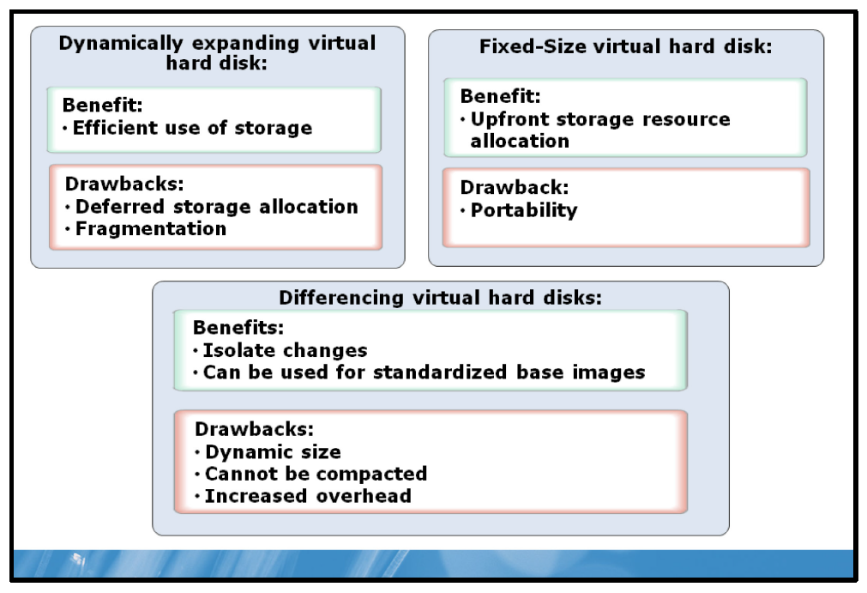

Key Points
A virtual hard disk provides storage for a virtual machine. Within the virtual machine, the virtual hard disk is represented as a physical disk, and the virtual machine uses it as if it were a physical disk. There are different types of virtual hard disks (VHDs) that have various advantages and disadvantages.

Dynamically Expanding VHDs
Dynamically expanding VHDs are virtual disks that start very small and then grow as you write data to them. Dynamically expanding VHDs are ideal for use in an environment where performance is not your primary consideration. Organizations typically use dynamically expanding disks in test and development environments. A dynamically expanding disk grows only to the space that you allocate to it when you create the VHD. Dynamically expanding disk performance has increased and has nearly the same performance levels as fixed-size disks.
One of the potential issues with using dynamically expanding VHDs is that you must manage storage utilization after deployment. If you have multiple dynamically expanding VHDs located in a single storage location that is less than the total maximum size of the VHDs, you must monitor the storage location to ensure that the VHDs do not expand to use up all available space.
Another potential issue with dynamically expanding virtual hard disks is that the VHD file may become fragmented on the host computer’s physical hard disk, which could affect the virtual disk’s performance.

Fixed-Size VHDs
Fixed-size VHDs are disks that use as much physical disk space as you specify when you create the disk. For example, if you create a 100 gigabyte (GB) fixed-size VHD, it will use 100 GB of physical disk space. The primary benefit with using fixed size disks is that all of the storage required for the disks is committed when you create the disks, thus reducing the likelihood that you will over commit your storage resources. One of the reasons for choosing fixed-size VHDs is that dynamically-expanding VHDs may not support some applications. For example, Microsoft does not support Microsoft Exchange Server 2010 or Exchange Server 2007 deployed on dynamically expanding VHDs.
One of the disadvantages of fixed-size disks is that the disks may take longer to move from one server to another.

Differencing VHDs
A differencing virtual hard disk is a virtual hard disk associated with another virtual hard disk in a parent-child relationship. The differencing disk is the child and the associated virtual disk is the parent. The parent disk can be any type of virtual hard disk. The differencing disk (the child) stores a record of all changes made to the parent disk and provides a way to save changes without altering the parent disk. In other words, by using differencing disks, you ensure that changes are made to the differencing disks and not to the original virtual hard disk. You can merge changes from the differencing disk to the original virtual hard disk, when appropriate.
• | The differencing hard disk expands dynamically as data intended for the parent disk is written to the differencing disk. You should write-protect or lock the parent disk. If another process modifies the parent disk, and does not recognize the differencing disk’s parent/child relationship, then all differencing disks related to the parent disk become invalid, and any data written to them is lost. By locking the parent disk, you can mount the disk on more than one virtual machine, similar to a read-only floppy disk or CD-ROM.
• | You cannot specify a size for a differencing disk. Differencing disks can grow as large as the parent disks to which they are associated. However, unlike dynamically expanding disks, differencing disks cannot be compacted directly. You can compact differencing disks only after merging the disk with a dynamically-expanding parent disk.
• | If you are using differencing disks, it is important to have a standardized naming convention for your virtual hard drives. It is not readily apparent from examining the virtual hard drive in Hyper-V manager whether it is a differencing drive or a parent disk.

Pass-Through Disks
Hyper-V also allows for the use of a pass-through disk type. When you configure a virtual machine to use a pass-through disk, the virtual machine will use an entire physical disk or volume on the host computer.
If you intend to use pass-through disks to support an operating system installation, you must store the guest configuration file in an alternate location. This is because the operating system’s installation will consume the entire pass-through disk. For example, you could locate the configuration file on another internal drive in the Hyper-V server itself, or if the host computer is part of a failover cluster, you can host the configuration file on a separate cluster that provides highly available file services. Be aware that you cannot dynamically expand pass-through disks.
Question: Describe a scenario in which you would use a dynamic disk?

Virtual Networks
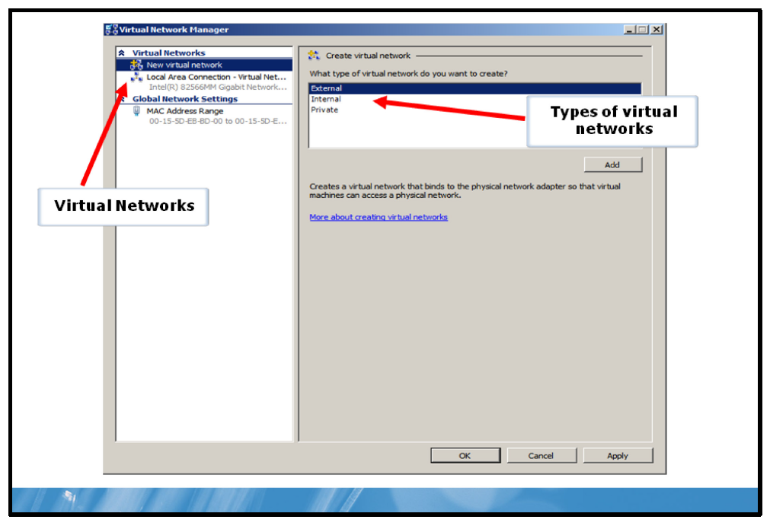

Key Points
Virtual Network Manager gives you the ability to create a mechanism for binding virtual machines to a physical network. Virtual Network Manager enables you to create and manage virtual networks. You can use Virtual Network Manager to add, remove, and modify the virtual networks. Virtual Network Manager is available from Hyper-V Manager.
When you create a virtual network, Hyper-V creates a virtual switch. The virtual switch routes traffic based on either the media access control (MAC) addresses or the virtual local area network (VLAN) Identifiers. The virtual switch modifies the MAC addresses of packets as it is used to route traffic with different MAC addresses than the physical network card MAC address. The advantage is that it can bind to any 802.3 compliant physical Ethernet network adapter.
You cannot connect a virtual network to a wireless network adapter. The virtual switch changes the MAC address of the source packet so that it does not match its own MAC address. As a result, you cannot provide wireless networking capabilities to virtual machines, because the 802.11 standard does not support the MAC address changes. You can attach only one virtual network to a specific physical network adapter at a time. You cannot attach multiple virtual networks to the same physical network adapter. When you create a virtual network:
• | Hyper-V creates a software-based switch.
• | You can associate only one Hyper-V virtual network with a single physical network adaptor.
• | It is bound to a physical network adapter and all other protocols are automatically unbound.
• | You can use it to control and secure network traffic that enters and leaves a virtual machine.
Windows Server 2008 R2 Hyper-V supports three types of virtual networks: external, internal, and private. When you create a virtual network through either the Hyper-V Manager or Windows Management Instrumentation (WMI), you also create a new software-based switch. There is no limit to how many virtual networks or ports for virtual machine connections that you can create. You can configure three types of virtual networks:
• | External. An external virtual network binds to a physical network adapter on the Hyper-V server so that the virtual machine can have access to a physical network. When you create a new external virtual network, Hyper-V creates a virtual network adapter on the parent partition unless you clear the option to Allow management operating system to share this network adapter. You would use an external connection when your virtual machine needs to access or be accessed on the corporate network or beyond the corporate environment.  Note: When you create an external virtual network, and clear the option to Allow management operating system to share this network adapter, the physical network adapter will be available only for virtual machines and will not be accessible by the host computer. This is a best practice if you want to isolate virtual machine network traffic from host network traffic. In this scenario, you must not clear this option on at least one network adapter or not create a virtual network that uses one of the physical network adapters to ensure that the host computer can communicate on the network.
• | Internal. When you create an internal virtual network, it allows the virtual machines to communicate with each other and with the Hyper-V server, but they cannot communicate with the physical network. This scenario is commonly used to simulate a networked environment with the base system. An internal network might be used in a training environment.
• | Private. The creation of a VPN enables the virtual machines to communicate with each other, but there is no association with any physical network adapter in the parent partition. This means that the virtual machines can communicate with each other but not with the host computer or with other computers on external networks. You can use private networks if you need to isolate virtual machines for security reasons. You may also have virtual machines that are being used for testing purposes and you do not want the virtual machines to inadvertently access the corporate network.
Question: Can you describe the steps you would use to isolate virtual machines from the physical network?

Virtual Machines
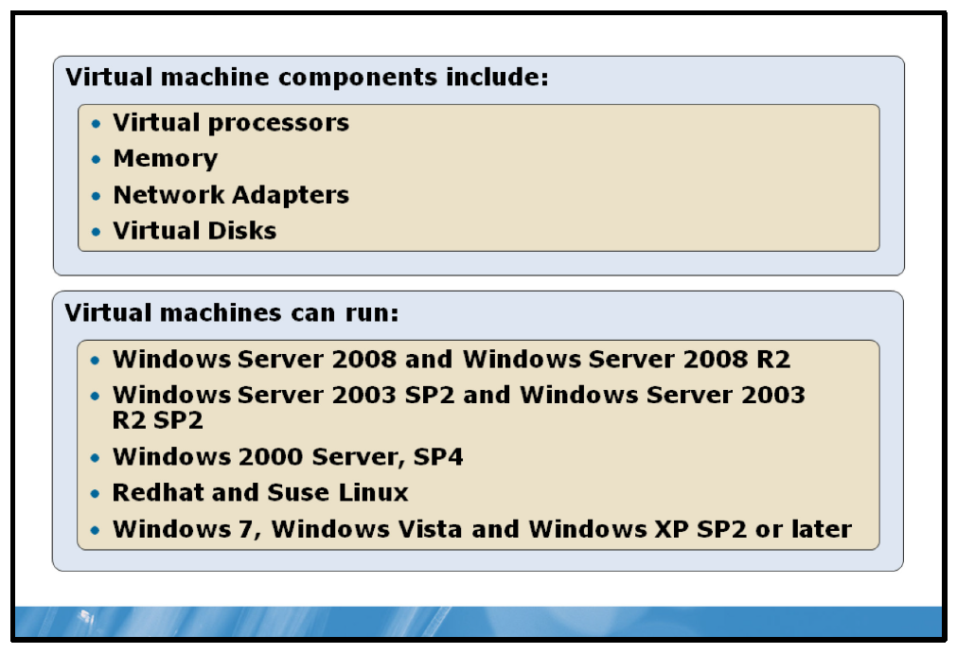

Key Points Virtual Machine Components
A virtual machine includes the following components:
• | Virtual processors. You can configure virtual machines with up to four virtual processors, depending on the operating system that is running in the virtual machine. The number of virtual processors that you can assign to a virtual machine is limited to the host computer’s number of processor cores, but you can assign more virtual processors in total between running virtual machines than there are processor cores on the host computer.
• | Memory. You can configure virtual machines with up to 64 GB of memory. The memory that you can assign to virtual machines is limited by the amount of random access memory (RAM) that the host computer has available. You cannot run virtual machines where the cumulative memory exceeds the amount of RAM available on the host computer.
• | Network adapters. The virtual machine uses network adapters to connect to the external network, to other virtual machines on the same host, or to the host computer. You can assign multiple virtual network adapters in virtual machines.
• | Virtual disks. Virtual disks are .vhd files that are available to the virtual machine as the system drive or for data storage. You have several options when configuring virtual disks. You also can create virtual machine snapshots, which creates Automatic VHD files with an .AVHD extension.

Supported Guest Operating Systems
The following operating systems are supported in virtual machines:
• | Windows Server 2008 and Windows Server 2008 R2. All server editions are supported except for the Windows Server 2008 R2 for Itanium-based Systems operating system edition. You can install both 64-bit and 32-bit versions and configure them with one, two, or four virtual processors.
• | The Windows Server 2003 Standard Edition operating system with Service Pack 2 (SP2) and the Windows Server 2003 R2 Standard Edition operating system with SP2. All server editions are supported except for the Windows Server 2003 Enterprise Edition for Itanium-based systems operating system. You can install both the 64-bit and 32-bit versions and configure them with one or two virtual processors.
• | The Microsoft Windows 2000 Server with SP4 operating system. Both Server and Advanced server editions are supported and you can configure them with only one processor.
• | Red Hat Enterprise Linux 5.2, 5.3 and 5.4. Both x86 and x64 editions are supported but you can configure them with only one processor. Linux Integration Components for Hyper-V are available and supported for these versions of Linux.
• | SUSE Linux Enterprise Server 10 with Service Pack 1 or 2, and SUSE Linux Enterprise Server 11. Both x86 and x64 editions are supported, but you can configure them with only one processor. Linux Integration Components for Hyper-V are available and supported for these versions of Linux.
• | Windows 7, Windows Vista, and Windows XP with SP2 or later. You can configure Windows 7 virtual machines with up to four processors. Additionally, you can configure Windows Vista and Windows XP SP3 with one or two processors and Windows XP SP2 with one processor.

Demonstration: How to Configure a Virtual Machine
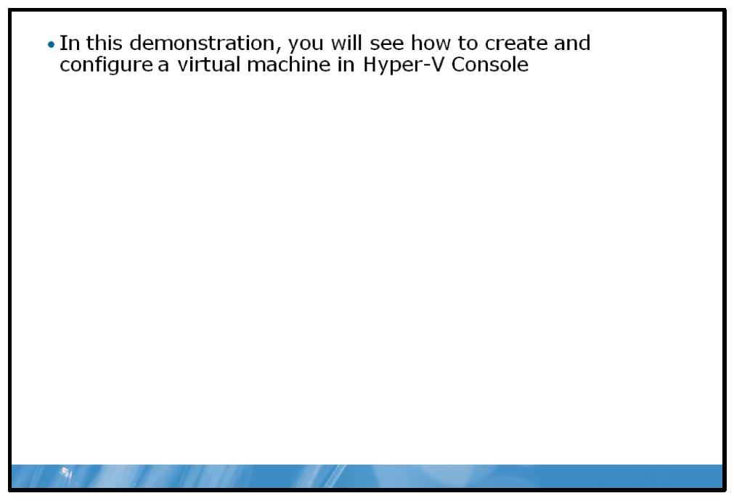

Key Points
You can install the Hyper-V role either on a full or Server Core installation of Windows Server 2008 R2. Installing the Hyper-V role on a full installation of Windows Server 2008 R2 installs all of the Hyper-V components. However, to install the Hyper-V role, you must be a member of the local Administrators group or your administrator must give you permissions.
After you install and configure the Hyper-V role on a server running Windows Server 2008 R2, you can manage the Hyper-V role and virtual machines by using the Hyper-V management tools. The management tools consist of the Hyper-V Manager, which is a Microsoft Management Console (MMC) snap-in, and Virtual Machine Connection, which provides you with direct access to a virtual machine through a network connection.
You also can manage the Hyper-V server role and connect to a virtual machine running in Hyper-V from remote computers. If you are running Windows Server 2008 or Windows Server 2008 R2, you can install the Hyper-V Tools feature. You also can manage Hyper-V from a client machine by installing the Remote Server Administration Tools management tools.
The Hyper-V Manager is the central graphical interface console that an administrator will use to manage small Hyper-V environments. You can use the Hyper-V Manager to administer several Hyper-V servers. In larger deployments, you should use the System Center VMM.
The Hyper-V Manager has three panes. The left pane shows the Hyper-V servers that you are managing currently. The center pane displays the virtual machines that you have installed on the selected Hyper-V server, as well as snapshots of highlighted virtual machines and their details. The right pane lists the actions available for managing a virtual server and virtual machines.

Managing Virtual Machines
You can configure virtual machines, create, and delete virtual machines, and export and import virtual machines.

Virtual Machine Snapshots
A virtual machine snapshot is a point-in-time capture of a virtual machine with all configurations and states present. You can create a snapshot while the virtual machine is running, is turned off, or is in a saved state. You can return, or revert, a virtual machine to a previous state. You return a virtual machine to a previous point-in-time by applying a snapshot. This will return the virtual machine to the state it was in when the snapshot was taken. As part of this snapshot application process, you have the option of taking a snapshot of the current state of the virtual machine before you revert to a previous version.

Import and Export
You can use the export functionality when you want to move a virtual machine to another host computer. You can export the virtual machine only when the virtual machine is turned off or in a saved state. To move the virtual machine to another host, copy the exported files to the new host, and then import the virtual machine. When importing a virtual machine, you have the option to copy a virtual machine. In that case, you will generate a new machine ID. If you are going to move a virtual machine, or if you are going to use a backup copy, then you should use the original virtual machine ID.

Virtual Machine State
You can manage the state of a virtual machine through this interface. You can Start, Turn Off, Shut Down, Save, Pause, Reset, or Rename the state of a virtual machine.

Managing Virtual Machine Configurations
You can access the virtual machine configurations by right-clicking the virtual machine, and then clicking Settings. In the virtual machine settings, you can configure the virtual machine hardware and management settings. You can manage an entire Hyper-V server role from a single interface, and you can manage multiple servers from the Hyper-V Manager.
In this demonstration, you will see how to create and configure a virtual machine in Hyper-V Console.

Demonstration Steps:
1. | Create a differencing disk.
2. | Create a virtual machine.
3. | Create and apply snapshots.

What Is VMM 2008 R2?
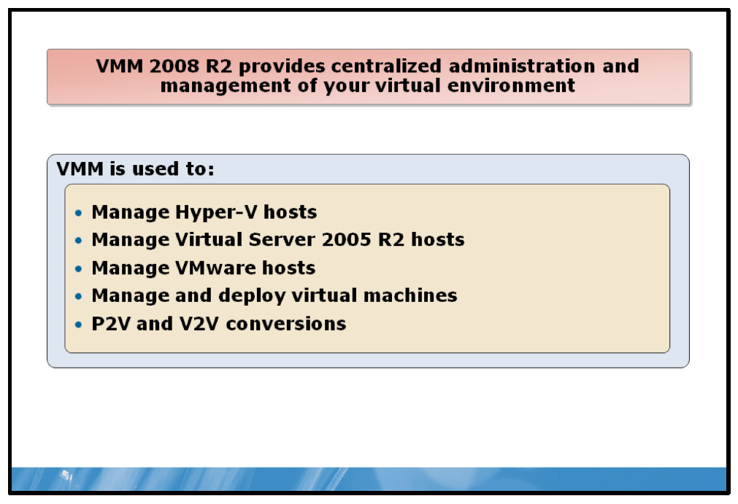

Key Points
VMM 2008 R2 enables you to administer and manage virtual environments from a central location. It also helps increase physical server utilization and enables the VMM administrator and authorized self-service end users to provision new virtual machines rapidly. It is a solution that solves many of the challenges found in a virtualized infrastructure.
You specifically can use Virtual Machine Manager to:
• | Manage Hyper-V hosts.
• | Manage Virtual Server 2005 R2 based hosts.
• | Manage VMware hosts.
• | Manage and deploy virtual machines.
• | Perform physical-to-virtual (P2V) and virtual-to-virtual (V2V) conversions.
• | Support Hyper-V.
VMM can integrate fully with your current Hyper-V environment, and it provides the same functionality as Hyper-V Manager, as well as numerous extended management features. VMM takes full advantage of Hyper-V benefits through a powerful, yet easy to use, console that streamlines many management tasks for virtual infrastructures. Additionally, administrators can manage virtualization host servers and their virtual resources through one unified console.
You can use VMM to manage virtualization in many business scenarios, including server consolidation, resource provisioning, business continuity enhancement, and performance and resource optimization.
Some key benefits that VMM offers include:
• | Maximizes data center resources through consolidation. A typical physical server in the data center operates at only 5 to 15 percent CPU capacity. VMM can help consolidate suitable server workloads onto a virtual machine host infrastructure, which frees up physical resources for repurposing or hardware retirement. By consolidating physical servers, you ensure that data center growth is less constrained by space, electrical, and cooling requirements.
• | Supports for Microsoft Virtual Server and VMware ESX. With this release, VMM now manages VMware ESX virtualized infrastructure in conjunction with the Virtual Center product. VMware versions that are supported are VMware ESX Server 3.0 or above, VMware ESX Server 3.5i, VMware VirtualCenter (VC) 2.5 (VMware Infrastructure 3 [VI3]), and VMware vSphere 4 (VI3 features only). Now administrators running multiple virtualization platforms can rely on one tool to manage virtually everything. Because of VMM compatibility with VMware VI3 (through Virtual Center), the VMM now supports features such as VMotion, and provides VMM-specific features such as Intelligent Placement to VMware servers.
• | Enables Performance and Resource Optimization (PRO). PRO provides the dynamic management of virtual resources though management packs that are PRO-enabled. Utilizing the deep monitoring capabilities of System Center Operations Manager 2007, PRO enables administrators to establish remedial actions that VMM will execute if a PRO identifies poor performance or pending failures in hardware, operating systems, or applications. As an open and extensible platform, PRO encourages partners to design custom management packs that promote compatibility of their products and solutions with PRO’s powerful management capabilities.
• | Converts machines by converting a physical machine to a virtual one can be a daunting undertaking--slow, problematic, and typically requiring you to halt the physical server. However, the enhanced P2V conversion in VMM means that P2V conversions will become routine. Similarly, VMM also provides a straightforward wizard that can convert VMware virtual machines to VHDs through a quick and easy V2V transfer process.
• | Provisions new machines quickly. VMM enables this efficiency by providing IT administrators with the ability to deploy virtual machines in a fraction of the time it would take to deploy a physical server. Through one console, VMM allows administrators to manage and monitor virtual machines and hosts to ensure they are meeting the needs of the corresponding business groups.
• | Minimizes deployment guesswork with Intelligent Placement. VMM does extensive data analysis on a number of factors before recommending which physical server should host a given virtual workload. This is especially critical when administrators are determining how to place several virtual workloads on the same host machine. With access to the historical data that Operations Manager 2007 provides, the Intelligent Placement process is able to factor past performance characteristics to ensure the best possible match between the virtual machine and its host hardware.
• | Delegates virtual machine management for Development and Test. This latest version of VMM features a thoroughly reworked and improved self-service Web portal, allowing administrators to delegate this provisioning role to authorized users while maintaining precise control over the management of virtual machines.
• | Organizes virtual machine components with the library. To keep a data center’s virtual house in order, VMM provides a centralized library to store the building blocks for various virtual machines, such as off-line machines and other virtualization components. With the library’s easy-to-use structured format, IT administrators can quickly locate and reuse specific components, thereby remaining highly productive and responsive to new server requests and modifications.
• | Provides a rich management and scripting environment with Windows PowerShell®. The entire VMM Administrator Console is built on the command-line and scripting environment, Windows PowerShell. This version of VMM adds additional PowerShell cmdlets and view script controls, which allow administrators to exploit customizing and automating operations at an unprecedented level.

Lab: Implementing Virtualization
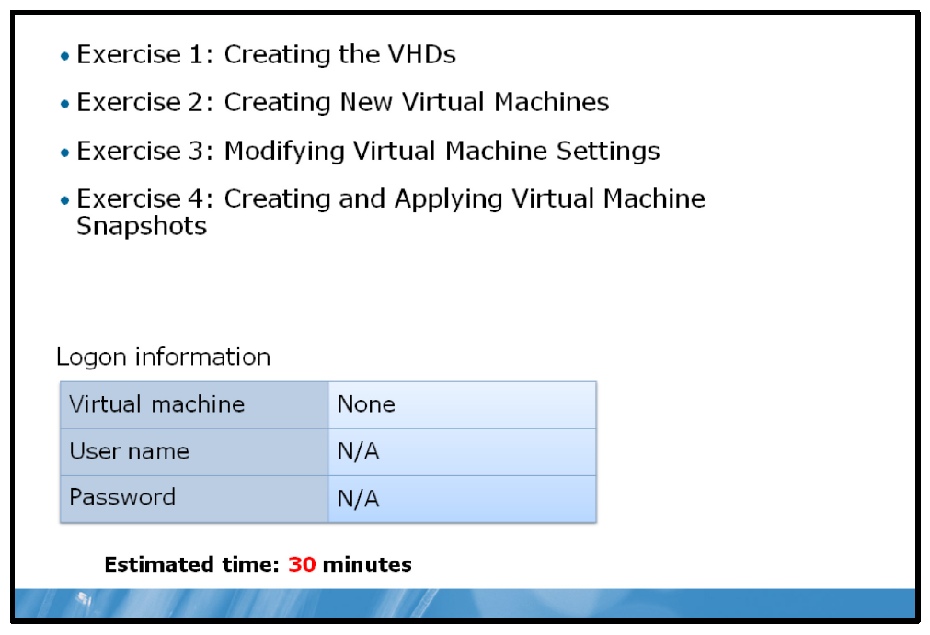

Lab Setup
For this lab, you will use the available host computer environment. Before you begin the lab, you must complete the following steps:
1. | Ensure that your host computer is running and that you are logged on.
2. | Ensure that no virtual machines are currently running.

Lab Scenario
Contoso, Ltd. has decided to introduce virtualization into their IT environment because they wish to reduce their hardware and power expenditures for the data center. The company has started deploying Hyper-V host computers running on Windows Server 2008 R2. You now need to create several virtual machines on the host computers.

Exercise 1: Creating the VHDs

Scenario
Contoso, Ltd. has deployed one Hyper-V host computer for testing purposes. For the initial deployment, your computer will host test virtual machines. Because Contoso, Ltd. will eventually use these virtual machines in production, it is important that they perform well. At this stage of the deployment, IT management has not decided which production servers to virtualize, but you should prepare at least two virtual machines that you can use for the initial proof-of-concept testing. On the first, deploy no operating system. On the second, you should deploy an initial server on this host computer that is running Windows Server 2008 R2.
The main tasks for this exercise are as follows:
1. | Create a dynamically expanding hard disk.
2. | Create a differencing hard disk.

Task 1: Create a dynamically expanding hard disk
• | On your host computer, in Hyper-V Manager, create a new virtual hard disk with the following configuration:
  • | Type: Dynamically expanding
  • | Name: NYC-Prod1.vhd
  • | Location: C:\Program Files\Microsoft Learning
  • | Maximum size: 32 GB

Task 2: Create a differencing hard disk
• | On your host computer, in Hyper-V Manager, create a new virtual hard disk with the following configuration:
  • | Type: Differencing
  • | Name: NYC-Test1.vhd
  • | Location: C:\Program Files\Microsoft Learning
  • | Parent drive: C:\Program Files\Microsoft Learning\base\drives  \WS08R2- SVR2.vhd
Results: After this exercise, you should have created the required VHDs.

Exercise 2: Creating New Virtual Machines

Scenario
Now that you have configured the VHDs, the next step is to create the virtual machines for the test and production environments.
The main tasks for this exercise are as follows:
1. | Create a new virtual machine for the production environment.
2. | Create a new virtual machine for the test environment.

Task 1: Create a new virtual machine for the production environment
• | On your host computer, in Hyper-V Manager, create a new virtual machine based on the following criteria:
  • | Name: NYC-PROD1
  • | Location: C:\Program Files\Microsoft Learning
  • | Memory: 1024 MB RAM
  • | Networking: Private Network
  • | Use an existing virtual disk, NYC-PROD1.vhd, that you created for production in Exercise 1.

Task 2: Create a new virtual machine for the test environment
• | On your host computer, in Hyper-V Manager, create a new virtual machine based on the following criteria:  Results: After this exercise, you should have created the two virtual machines required for testing purposes.
  • | Name: NYC-TEST1
  • | Location: C:\Program Files\Microsoft Learning
  • | Memory: 1024 MB RAM
  • | Networking: Private Network
  • | Use an existing virtual disk, NYC-TEST1.vhd, that you created for test in Exercise 1.

Exercise 3: Modifying Virtual Machine Settings

Scenario
The IT department has created the initial design for the production virtual machines. The design specifies that all virtual machines in production will need a separate data disk. Because the virtual machines will need a second disk for data, and performance is most important, you should create a small computer system interface (SCSI) adapter and use it to connect to the second disk. Additionally, you should configure the virtual machines with two processors and 2,048 megabyte (MB) of RAM.
The main task for this exercise is:
1. | Modify the virtual machine configuration for production.

Task: Modify the virtual machine configuration for production
1. | On your host computer, in Hyper-V Manager, create a new virtual hard disk with the following configuration:
  • | Type: Dynamically expanding
  • | Name: NYC-Prod1-Data.vhd
  • | Location: C:\Program Files\Microsoft Learning
  • | Maximum size: 64 GB
2. | Access the settings for the NYC-PROD1 virtual machine.
3. | Add the NYC-PROD1-Data.vhd virtual hard disk to a SCSI controller on the virtual machine.
4. | Change the RAM assigned to the virtual machine to 2048.
5. | Change the processors assigned to the virtual machine to 2.
Results: After this exercise, you should have modified the virtual machine settings.

Exercise 4: Creating and Applying Virtual Machine Snapshots

Scenario
In order to test applications on the test computers, you need to understand how snapshots work. In this exercise, you will configure and test snapshots using the test virtual machine.
The main tasks for this exercise are:
1. | Create a snapshot.
2. | Apply snapshots.

Task 1: Create a snapshot
1. | In Hyper-V Manager, ensure that the NYC-TEST1 virtual machine is turned off.
2. | Create a new snapshot of NYC-TEST1, and name it PRE-Test Snapshot.
3. | Start NYC-TEST1, and connect to it. Log on as Administrator using the password Pa$$w0rd.
4. | Close all open windows or dialog boxes.

Task 2: Apply snapshots
1. | On the virtual machine desktop, create a new text document called Snapshot1.txt.
2. | Create a new snapshot of NYC-TEST1, and name it Snapshot2.
3. | On the virtual machine desktop, create a new text document called Snapshot2.txt.
4. | Revert the virtual machine. On the virtual machine desktop, verify that the Snapshot2.txt file is no longer on the desktop.
5. | Apply the PRE-Test Snapshot. Verify that the virtual machine turns off. This is the state that the virtual machine was in when you created the snapshot.
6. | Apply Snapshot2, and start the virtual machine. Verify that the Snapshot1.txt file is on the desktop.
7. | Shutdown the virtual machine.
Results: After this exercise, you should have created snapshots and applied them to your virtual machines.

Module Review and Takeaways
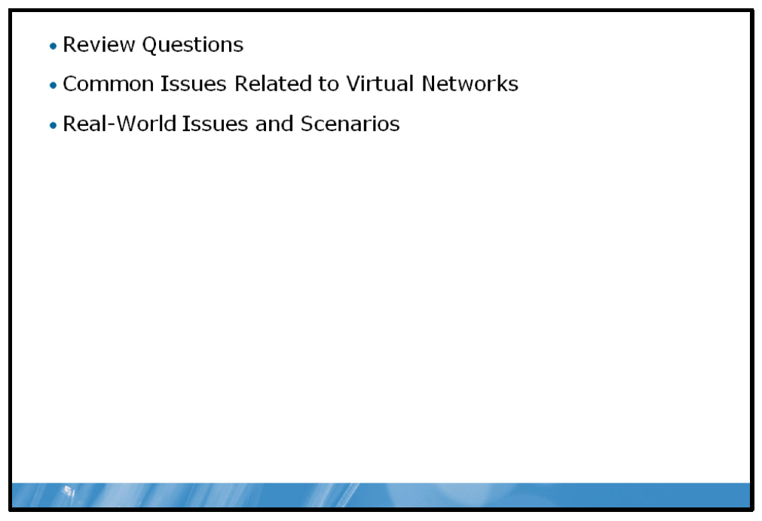

Review Questions
1. | Your organization is considering implementing server virtualization using Hyper-V. What is the primary consideration that you will need to consider when purchasing servers for this role?
2. | What are the hardware and BIOS prerequisites to install the Hyper-V Role?
3. | What are the differences between External, Internal, and Private virtual networks?
4. | Where is the option to change the location of the .VHD and virtual machines?
5. | What does it mean when the mouse pointer displays as a small dot in a virtual machine window?

Common Issues Related to Virtual Networks
Issue | Troubleshooting tip
The virtual machines on a host computer cannot communicate with each other. | Verify that they are using the same VLAN ID. If they are using a compatible VLAN, then verify the IP address configuration in the virtual machines.
You have copied a virtual hard disk file from one host to another. When you start the virtual machine,  the network settings have changed. | When you copy a virtual hard disk file from one host to another, the network configuration is not moved with the virtual machine. To retain the network configuration, you need to export and then import the virtual machine.
You have exported a virtual machine on one host, and imported the files on another host. The network adapter on the virtual machine is not connected. | When you import the virtual machine on a host, you need to ensure that the destination host computer has the same virtual networks configured as the source host computer. If the networks are not identical, the virtual network cannot be connected to the virtual machine.

Real-World Issues and Scenarios
1. | You are going to deploy Hyper-V on the Windows Server 2008 R2 servers. You have concerns about performance problems with so many virtual machines running on a server.
2. | You have concerns about the hardware requirements to deploy Hyper-V. Another department will create the virtual machines and then ship them to you for installation and configuration. When you import the virtual machine into Hyper-V and attempt to start the virtual machine, you receive an error that “Hyper-V launch failed; Either VMX not present or not enabled in BIOS”.
3. | Your organization is testing a custom application. The testers report that when they install the application on computers running an older version of the same application, they get errors. How could you address this issue?

Course Evaluation
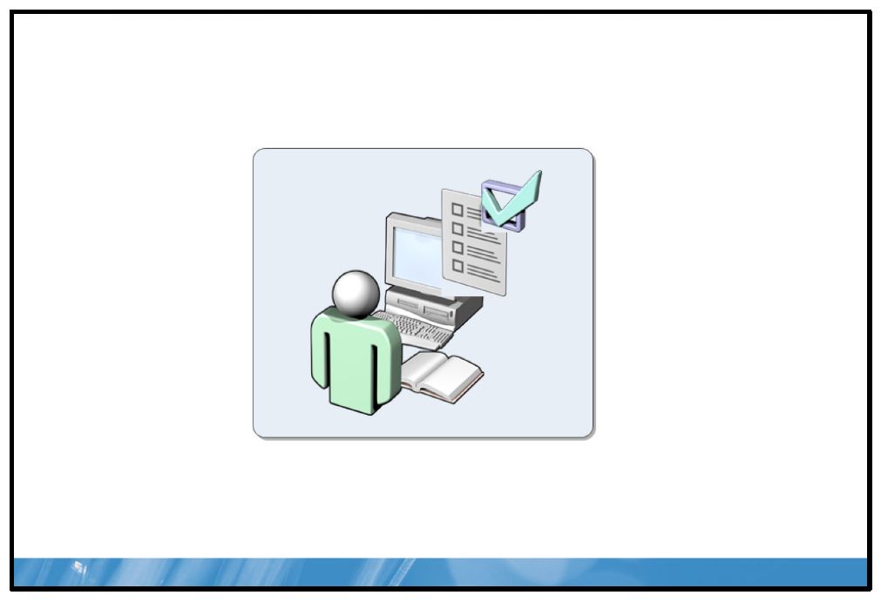
Your evaluation of this course will help Microsoft understand the quality of your learning experience.
Please work with your training provider to access the course evaluation form.
Microsoft will keep your answers to this survey private and confidential and will use your responses to improve your future learning experience. Your open and honest feedback is valuable and appreciated.

