- Highlight
- Note
- Expand Highlight
- Expand Note
Module 7: Implementing Active Directory Domain Services
Contents:
Lesson 1: | Introducing AD DS
Lesson 2: | Implementing AD DS
Lesson 3: | Managing Users, Groups, and Computers
Lesson 4: | Implementing Organizational Units
Lesson 5: | Implementing Group Policy
Lab: | Implementing AD DS

Module Overview
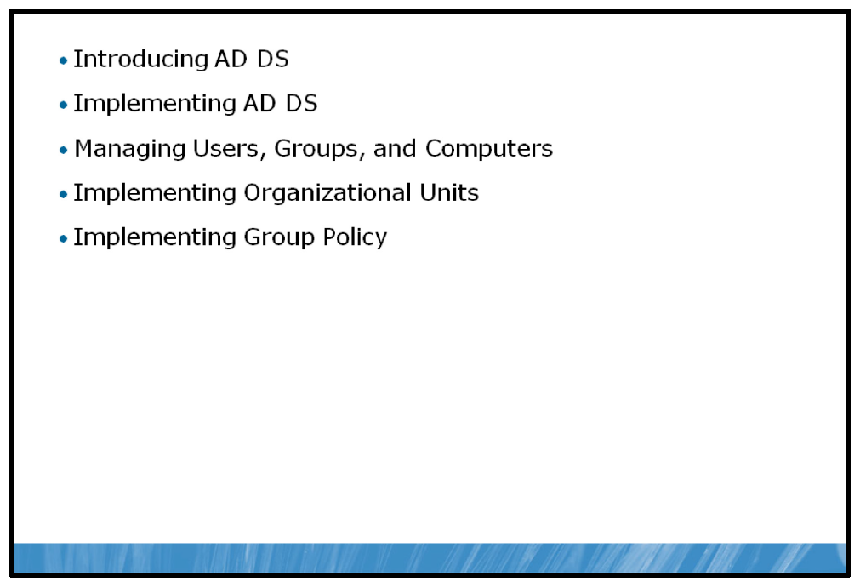
The Windows Server® 2008 R2 operating system Active Directory® Domain Services (AD DS) is a Microsoft® Windows®-based directory service. As a directory service, AD DS stores information about objects on a network and makes this information available to users and network administrators.

Objectives
After completing this module you will be able to:
• | Describe the fundamental features of AD DS.
• | Implement AD DS.
• | Manage objects in a domain.
• | Implement organizational units (OUs) for managing groups and objects.
• | Configure client computers centrally with group policy objects (GPOs).

Lesson 1: Introducing AD DS
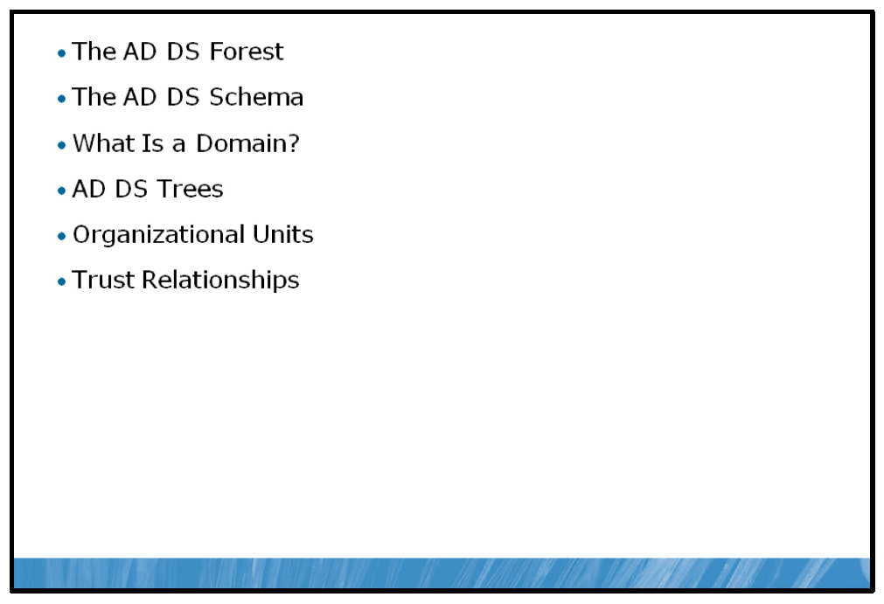
AD DS enables network users to access resources anywhere on the network using a single logon process and provides network administrators with an intuitive, hierarchical view of the network and a single point of administration for all network objects. Understanding the fundamental building blocks of AD DS enables you to make more informed decisions about implementing and configuring AD DS.

Objectives
After completing this lesson you will be able to:
• | Describe a forest.
• | Describe the schema.
• | Describe the domain.
• | Describe trees.
• | Describe OUs.
• | Describe trusts.

The AD DS Forest
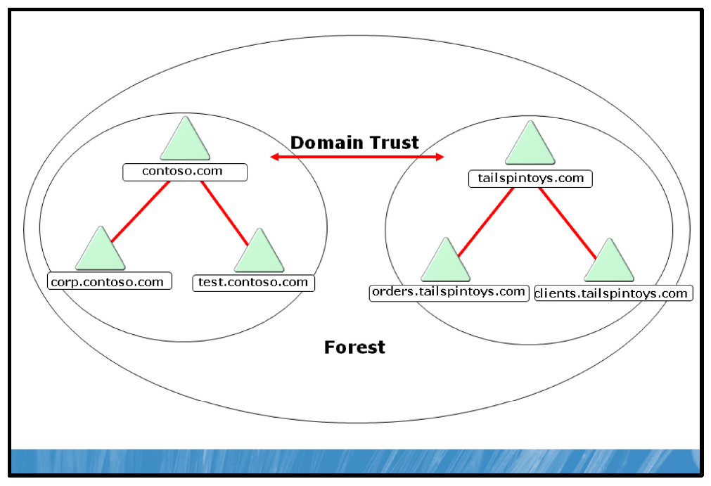

Key Points
In AD DS, a forest is the highest level of the logical structure hierarchy. An Active Directory forest represents a single, self-contained directory. A forest is a security boundary, which means that administrators in a forest have complete control over all access to information that is stored inside the forest and to the domain controllers that are used to implement the forest.
It is typical to implement a single forest within your organization unless you have some specific need for multiple forests. For example, if you want to create separate administrative areas for different parts of your organization, you must create multiple forests to represent those administrative areas.
If you implement multiple forests within your organization they will, by default, operate separately from each other as if they were the only directory service in your organization.
Note: You can integrate multiple forests by creating security relationships between them known as external or forest trust relationships.

Forest Wide Operations
AD DS is a multi-master directory service. This means that most changes to the directory can be made at any writable instance of the directory. That is, any writeable domain controller. Some changes, however, are single-master. This means they can only be made on one specific domain controller in the forest or domain, depending on the particular change. Domain controllers at which you can make these single-master changes are said to hold operations master roles. There are five operations master roles, two of which are forest-wide and the remaining three are domain-wide.
The two operations master roles assigned for the entire forest are:
• | Domain naming master. The job of the domain naming master is to ensure there are unique names throughout the entire forest. That is, it ensures that the fully-qualified name of each machine exists only once in the entire forest.
• | Schema master. The schema master tracks the schema of the forest and maintains changes to the underlying structure of the forest.
As these are key critical forest-wide roles, each forest must have only one schema master and domain naming master.

The AD DS Schema
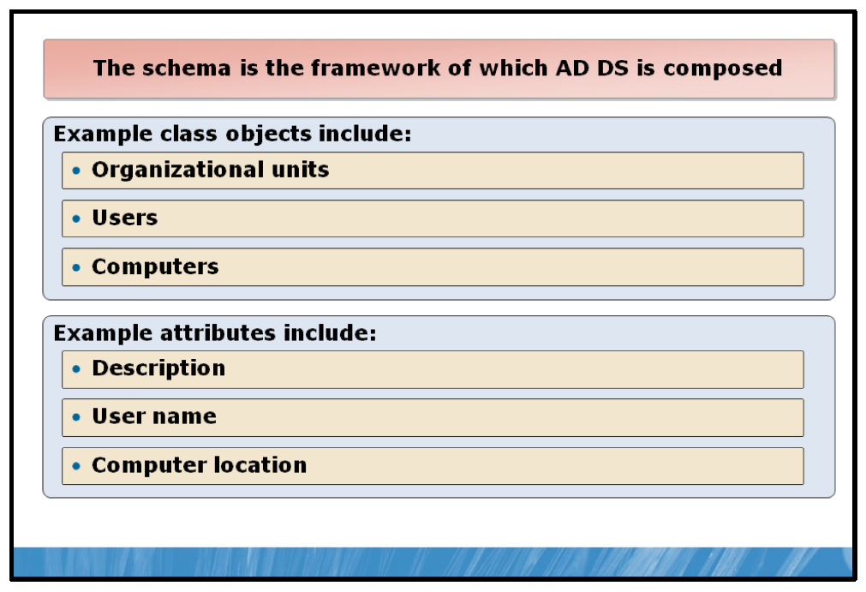

Key Points
The schema is the AD DS component that defines all objects and attributes that AD DS uses to store data.
AD DS stores and retrieves information from a wide variety of applications and services. So that it can store and replicate data from these various sources, AD DS standardizes how data is stored in the directory. By standardizing how data is stored, AD DS can retrieve, update, and replicate data while ensuring that the integrity of the data is maintained.
AD DS uses objects as units of storage. All objects are defined in the schema. Each time that the directory handles data, the directory queries the schema for an appropriate object definition. Based on the object definition in the schema, the directory creates the object and stores the data.
Object definitions control the types of data that the objects can store, as well as the syntax of the data. Using this information, the schema ensures that all objects conform to their standard definitions. As a result, AD DS can store, retrieve, and validate the data that it manages, regardless of the application that is the original source of the data. Only data that has an existing object definition in the schema can be stored in the directory. If a new type of data needs to be stored, a new object definition for the data must first be created in the schema.
In AD DS, the schema defines the following:
• | Objects that are used to store data in the directory.
• | Rules that define what types of objects you can create, what attributes must be defined when you create the object, and what attributes are optional.
• | Structure and the content of the directory itself.
The schema is a single master element of AD DS. This means that you must make changes to the schema at the domain controller that holds the schema operations master role.
The schema is replicated among all domain controllers in the forest. Any change that is made to the schema is replicated to every domain controller in the forest from the schema operations master role holder, typically the first domain controller in the forest.
Because the schema dictates how information is stored, and because any changes that are made to the schema affect every domain controller, changes to the schema should be made only when necessary — through a tightly controlled process — after you have performed testing to ensure that there will be no adverse effects on the rest of the forest.
Although you might not make any change to the schema directly, some applications make changes to the schema to support additional features. For example, when you install Microsoft Exchange Server 2010 into your AD DS forest, the installation program extends the schema to support new object types and attributes.

What Is a Domain?
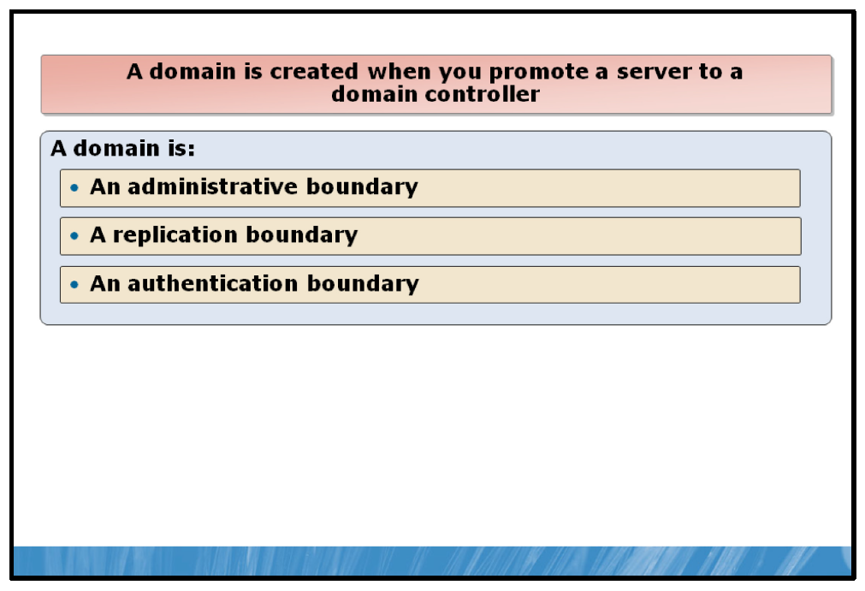

Key Points
A domain is an administrative boundary. All domains host an Administrator user account that has full administrative capabilities over all objects within the domain. Although the administrator can delegate administration on objects within the domain, the account retains full administrative control of all objects within the domain.
In earlier versions of Windows Server, domains were considered to provide complete administrative separation; indeed, one of the fundamental reasons for selecting a multidomain topology was to provide for this separation. However, in AD DS, the administrator account in the forest root domain also has full administrative control to all objects in the forest, rendering this domain-level administrative separation invalid.
A domain is a replication boundary. AD DS consists of three elements, or partitions; these are the schema, the configuration partition, and the domain partition. Generally, it is only the domain partition that changes frequently.
The domain partition contains objects that are likely to be updated often; these include users, computers, groups, and OUs. Consequently, AD DS replication consists primarily of the updates to objects defined within the domain partition. Only domain controllers in a particular domain receive domain partition updates from other domain controllers. Partitioning data enables organizations to replicate data only to where it is needed. In this way, the directory can scale globally over a network that has limited available bandwidth.
A domain is an authentication boundary. Each user account in a domain can be authenticated by domain controllers from that domain. Domains in a forest trust one another, and it is these trusts that enable a user from one domain to access resources held in another domain.

Domain Wide Operations
There are three operations master roles per domain. Initially assigned to the first domain controller in each domain, these are the following:
• | Relative identifier (RID) master. Whenever an object is created in AD DS, the domain controller where the object is created assigns the object a unique identifying number known as a security identity (SID). To ensure that no two domain controllers assign the same SID to two different objects, the RID master allocates blocks of SIDs to each domain controller within the domain.
• | Primary domain controller emulator. This role is the most important in as much as its temporary loss is noticed far more quickly than any other operations master role. It is responsible for a number of domain-wide functions, including:
  • | Updating account lockout status
  • | Single master for the creation and replication of GPO
  • | Time synchronization for the domain
• | Infrastructure master. This role is responsible for maintaining inter-domain object references. For example, when a group in one domain contains a member from another domain, the infrastructure master is responsible for maintaining the integrity of this reference.
These three roles must be unique in each domain, so each domain can have only one RID master, one primary domain controller (PDC) emulator, and one infrastructure master.

AD DS Trees
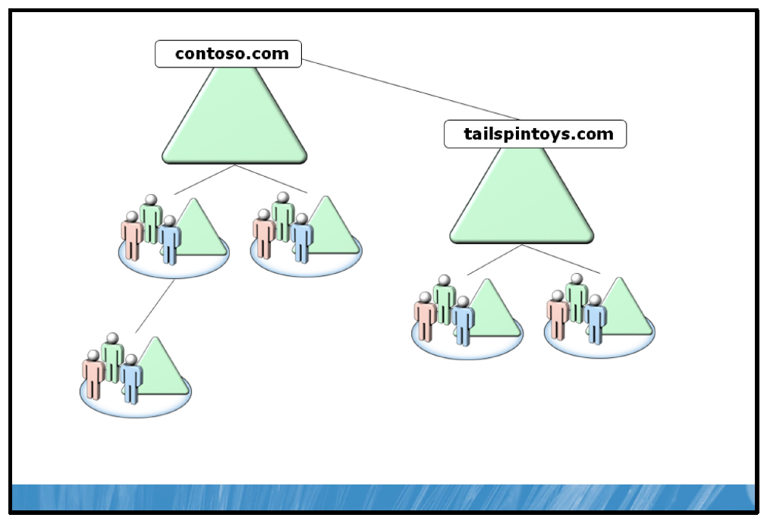

Key Points
If your AD DS consists of more than one domain, you must define the relationship between the domains. If the domains share a common root and a contiguous namespace, then they are logically part of the same Active Directory tree. A tree serves no administrative purpose. In other words, there is no tree administrator as there is a forest or domain administrator. A tree provides a logical, hierarchical grouping of domains that have parent/child relationships defined through their names. Your Active Directory tree maps to your Domain Name System (DNS) namespace.
Active Directory trees are created by the relationship between the domains within the forest. There is no intrinsic reason you should, or indeed, should not create multiple trees within your forest. However, keep in mind that a single tree, with its contiguous name space, is easier to manage, and easier for users to visualize.
Consider using multiple trees within a single forest if you have multiple name spaces to support. For example, if within your organization there are several distinct operating divisions with different public identities, you could create a different tree for each operating division. Bear in mind that with this scenario, there is no separation of administration because the forest root administrator still has complete control over all objects in the forest—in whichever tree they reside.

Organizational Units
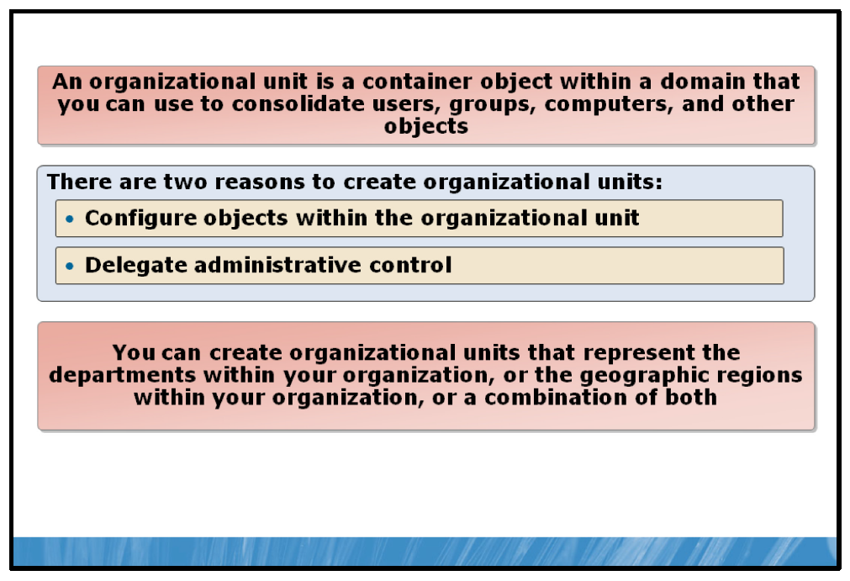

Key Points
An OU is a container object within a domain that you can use to consolidate users, groups, computers, and other objects. There are two reasons to create OUs:
• | Configure objects contained within the OU. You can assign GPOs to the OU, and the settings apply to all objects within the OU.
• | Delegate administrative control of objects within the OU. You can assign management permissions on an OU thereby delegating control of that OU to a user or group within AD DS other than the administrator.  Note: An OU is the smallest scope or unit to which you can assign Group Policy settings or delegate administrative authority.
You can use OUs to represent the hierarchical, logical structures within your organization. For example, you can create OUs that represent the departments within your organization, the geographic regions within your organization, and those that are a combination of both departmental and geographic regions. You can then manage the configuration and use of user, group, and computer accounts based on your organizational model.
Every AD DS domain contains a standard set of containers and OUs that are created when you install AD DS. These include the following:
• | Domain container, which serves as the root container to the hierarchy.
• | Built-in container, which holds the default service administrator accounts.
• | Users container, which is the default location for new user accounts and groups created in the domain.
• | Computers container, which is the default location for new computer accounts created in the domain.
• | Domain Controllers OU, which is the default location for the computer accounts for domain controllers computer accounts.

Trusts Relationships
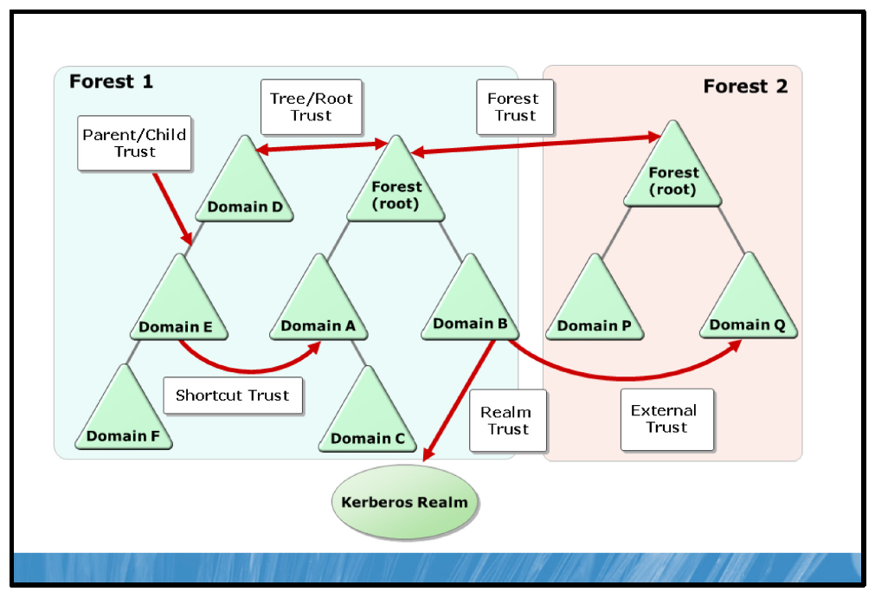

Key Points
A trust relationship enables one security entity to trust another security entity for the purposes of authentication. In the Windows Server 2008 R2 operating system, the security entity is the Windows domain.
The primary purpose of a trust relationship is to facilitate a user in one domain gaining access to a resource in another domain without needing to hold a user account in both domains.
In any trust relationship, there are two parties involved; the trusting entity, and the trusted entity. The trusting entity is the resource holding entity, while the trusted entity is the account holding entity. For example, if you lend someone your laptop computer, you trust them. You are the resource holding entity. It is your laptop; they are trusted as the account holding entity.

Types of Trusts
Trusts can be one-way or two-way.
A one-way trust means that although one entity trusts the other, the reciprocal is not true. For example, just because you lend Steve your laptop does not mean that Steve will necessarily lend you his car.
In a two-way trust, both entities trust one another.
Trusts can be transitive or nontransitive. In a transitive trust, A trusts B and B trusts C, then A also implicitly trusts C. For example, if you lend Steve your laptop, and Steve lends his car to Mary, then you might lend your cell phone to Mary.
Windows Server 2008 R2 supports a number of different trusts for use in different situations.
In a single forest, all domains trust one another with internal, two-way transitive trusts. In essence, this means that all domains trust all other domains. These trusts extend across trees within the forest. Aside from these automatically created trusts, you can configure additional trusts between domains within your forest, between your forest and other forests, and between your forest and other security entities, such as Kerberos realms or the Microsoft Windows NT® 4.0 operating system domains. The following table provides more information.
Trust  type | Transitivity | Direction | Description
External | Nontransitive | One-way or two-way | Use external trusts to provide access to resources that are located on a Windows NT Server 4.0 domain or a domain that is located in a separate forest that is not joined by a forest trust.
Realm | Transitive or nontransitive | One-way or two-way | Use realm trusts to form a trust relationship between a non-Windows Kerberos realm and a Windows Server 2008 operating system or a Windows  Server 2008 R2 domain.
Forest | Transitive | One-way or two-way | Use forest trusts to share resources between forests. If a forest trust is a two-way trust, authentication requests that are made in either forest can reach the other forest.
Shortcut | Transitive | One-way or two-way | Use shortcut trusts to improve user logon times between  two domains within a Windows Server 2008 or a Windows Server 2008 R2 forest. This is useful when two domains are separated by two domain trees.

Lesson 2: Implementing AD DS
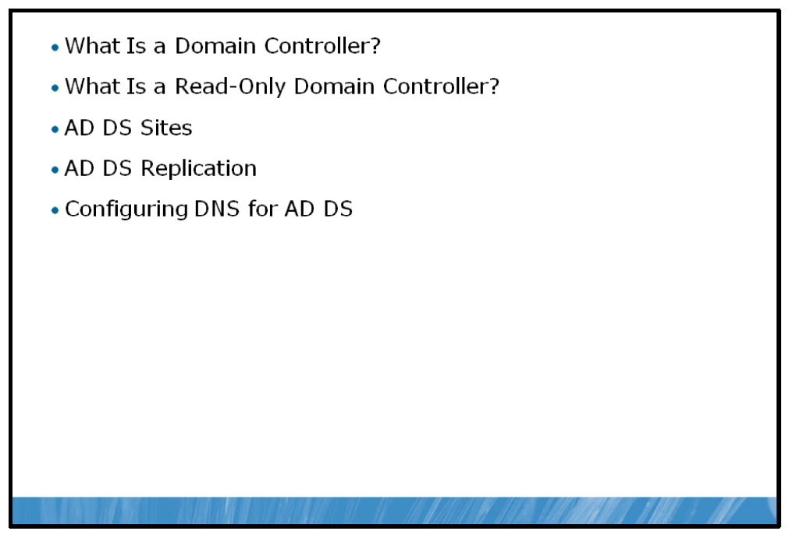
To implement AD DS you must deploy domain controllers. Understanding where and how to create domain controllers to optimize your network infrastructure is important to ensure that you optimize AD DS.

Objectives
After completing this lesson you will be able to:
• | Describe the role of a domain controller.
• | Describe when to use Read-Only domain controllers.
• | Describe AD DS sites.
• | Understand AD DS replication.
• | Configure DNS to support AD DS functions.

What Is a Domain Controller?
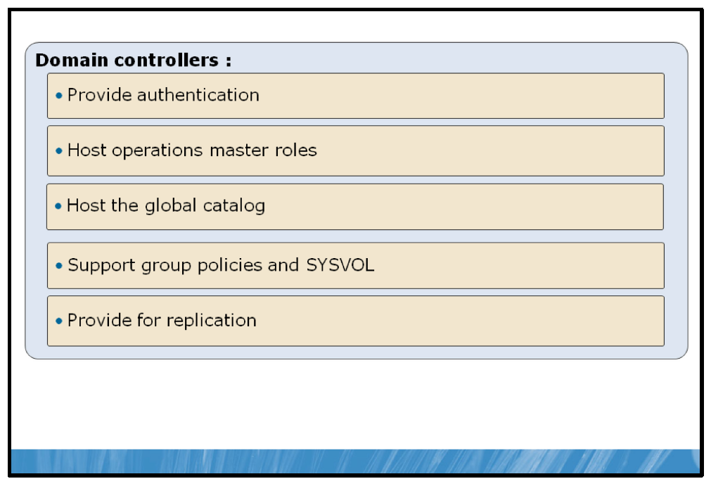

Key Points
You create a domain when you promote a Windows Server 2008 R2 server computer to a domain controller. Domain controllers host the AD DS.
Domain controllers provide the following functions on the network:
• | Provides authentication. Domain controllers store the domain accounts database, and provide authentication services.
• | Hosts operations master roles as an option. These roles were formerly known as Flexible Single Master Operations (FSMO) roles. There are five operations master roles, two forest-wide roles and three domain roles. You can transfer these roles as you require.
• | Hosts the global catalog as an option. You can designate any domain controller as a global catalog server.  Note: The global catalog is a distributed database that contains a searchable representation of every object from all domains in a multidomain forest. However, the global catalog does not contain all attributes for each object. Instead, the global catalog maintains a subset of attributes—those that are most likely to be useful in cross-domain searches.
• | Supports group policies and the System Volume (SYSVOL). Group policies consist of group policy containers, stored in AD DS, and group policy templates, stored in the SYSVOL folder in the file system of all domain controllers.
• | Provides replication. AD DS is a distributed directory service. Objects such as users, computers, OUs, and services are distributed across all domain controllers in the forest, and can be updated on any domain controller in the forest.
Note: You can deploy read-only domain controllers (RODCs) to branch offices where physical security might be less rigorous than elsewhere in your organization. For more information about using RODCs, visit the Microsoft TechNet Web site.
Note: Domain controllers in a forest share a common schema, a common global catalog, and a common forest root domain.

What Is a Read-Only Domain Controller?
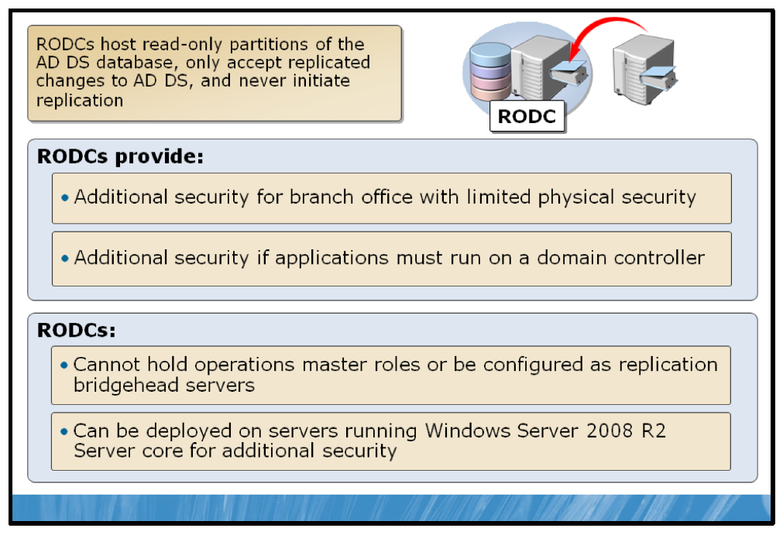

Key Points
An RODC is a new type of domain controller in Windows Server 2008 R2. With an RODC, organizations can easily deploy a domain controller in locations where physical security cannot be guaranteed. An RODC hosts a read-only replica of the database in AD DS for a given domain. The RODC is also capable of functioning as a global catalog server.
Beginning with Windows Server 2008, an organization can deploy an RODC to address scenarios with limited wide area network (WAN) bandwidth or poor physical security for computers. As a result, users in this situation can benefit from:
• | Improved security.
• | Faster logon times.
• | More efficient access to resources on the network.
RODC Feature | Explanation
Read-only Active Directory database | Except for account passwords, an RODC holds all of the Active Directory objects and attributes that a writable domain controller holds. However, changes cannot be made to the replica that is stored on the RODC. Changes must be made on a writable domain controller and replicated back to the RODC.
Unidirectional replication | Because no changes are written directly to the RODC, no changes originate at the RODC. Accordingly, writable domain controllers that are replication partners do not have to pull changes from the RODC. This reduces the workload of bridgehead servers in the hub and the effort required to monitor replication.
Credential caching | Credential caching is the storage of user or computer credentials. Credentials consist of a small set of approximately ten passwords that are associated with
 | security principals. By default, an RODC does not store user or computer credentials. The exceptions are the computer account of the RODC and a special krbtgt (Kerberos key distribution service center account) account that each RODC has. You must explicitly allow any other credential caching on an RODC.
Administrator role separation | You can delegate the local administrator role of an RODC to any domain user without granting that user any user rights for the domain or other domain controllers. This permits a local branch user to log on to an RODC and perform  maintenance work on the server, such as upgrading a driver. However, this does not give the branch user the right to log on to any other domain controller or perform any other administrative task in the domain.
Read-only Domain Name System | You can install the DNS Server service on an RODC. An RODC is able to replicate all application directory partitions that DNS uses, including ForestDNSZones and DomainDNSZones. If the DNS server is installed on an RODC, clients can query it for name resolution as they would query any other DNS server.
The following points help summarize the RODC role:
• | The domain controller that holds the PDC emulator operations master role for the domain must be running Windows Server 2008. This is necessary for creating the new krbtgt account for the RODC and for ongoing RODC operations.
• | The RODC needs to forward authentication requests to a global catalog server running Windows Server 2008 in the site that is closest to the site with the RODC. The Password Replication Policy is set on this domain controller to determine if credentials are replicated to the branch location for a forwarded request from the RODC.
• | The domain functional level must be Windows Server 2003 so that Kerberos constrained delegation is available. Constrained delegation is used for security calls that need to be impersonated under the context of the caller.
• | The forest functional level must be Windows Server 2003, so that linked-value replication is available. This provides a higher level of replication consistency.
• | You must run adprep /rodcprep one time in the forest. This will update the permissions on all of the DNS application directory partitions in the forest to facilitate replication between RODCs that are also DNS servers.
• | An RODC cannot hold operations master roles or function as a replication bridgehead server.
• | You can deploy an RODC on Server Core for additional security.

AD DS Sites
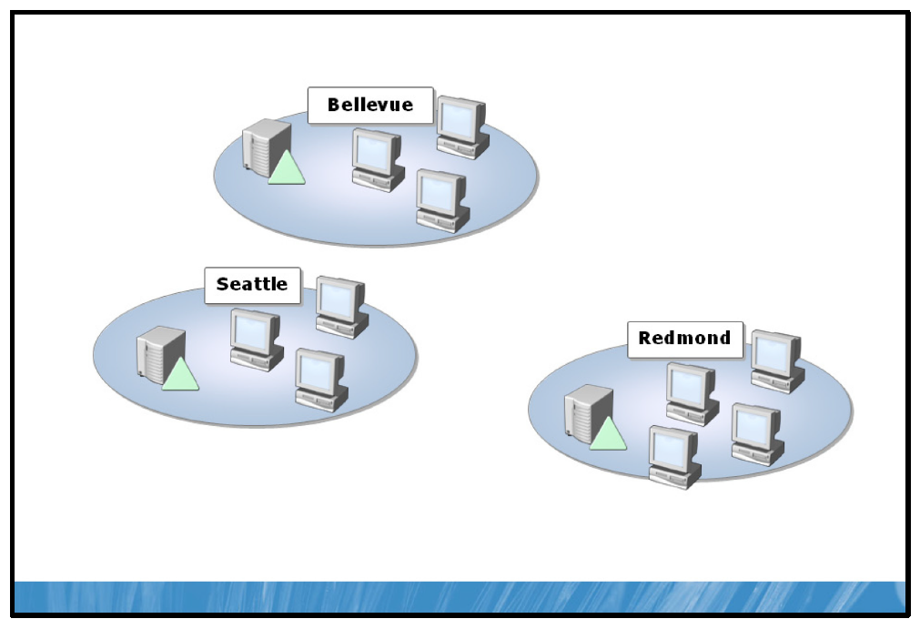

Key Points
A site is a logical representation of a geographical area in your network. A site represents a high-speed network boundary for your AD DS computers; that is, computers that can communicate with high speed and low latency can be grouped into a site; domain controllers within a site replicate AD DS data in an optimized way for this environment; this replication configuration is largely automatic.
Note: Sites are used by client computers to locate services such as domain controllers and global catalog servers. It is important that each site that you create has at least one domain controller and global catalog server.

AD DS Replication
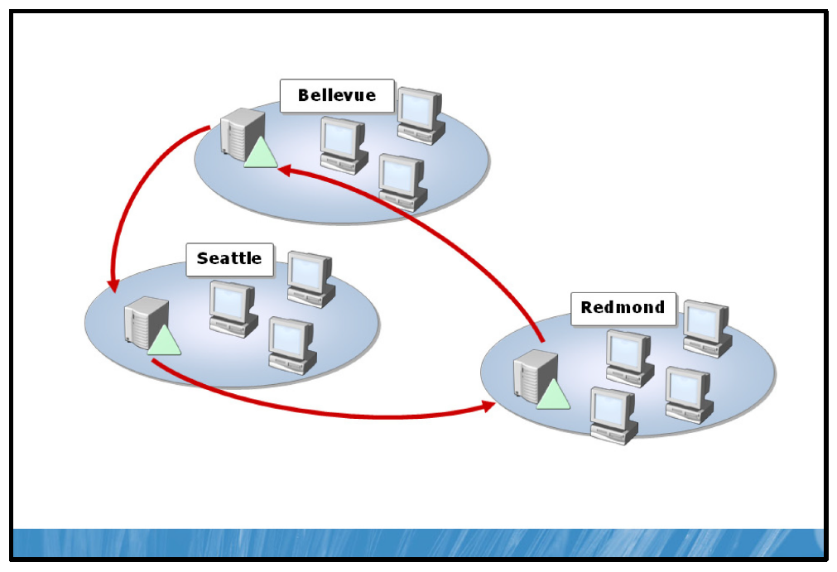

Key Points
AD DS replication is how changes to directory data are transferred between domain controllers in an AD DS forest. The AD DS replication model defines the mechanisms that allow directory updates to be transferred automatically between domain controllers to provide a seamless replication solution for the AD DS distributed directory service.
There are three partitions in AD DS and it is the domain partition that contains the data that changes most frequently and consequently makes up the bulk of AD DS replication data.

Active Directory Site Links
A site link is used to handle the replication between groups of sites. You can use the default site link provided in AD DS, or else create additional site links as your needs dictate. You can configure settings on site links to determine the schedule and availability of the replication path to help control replication. When two sites are connected by a site link, the replication system automatically creates connections between specific domain controllers in each site that are called bridgehead servers.

Configuring DNS for AD DS
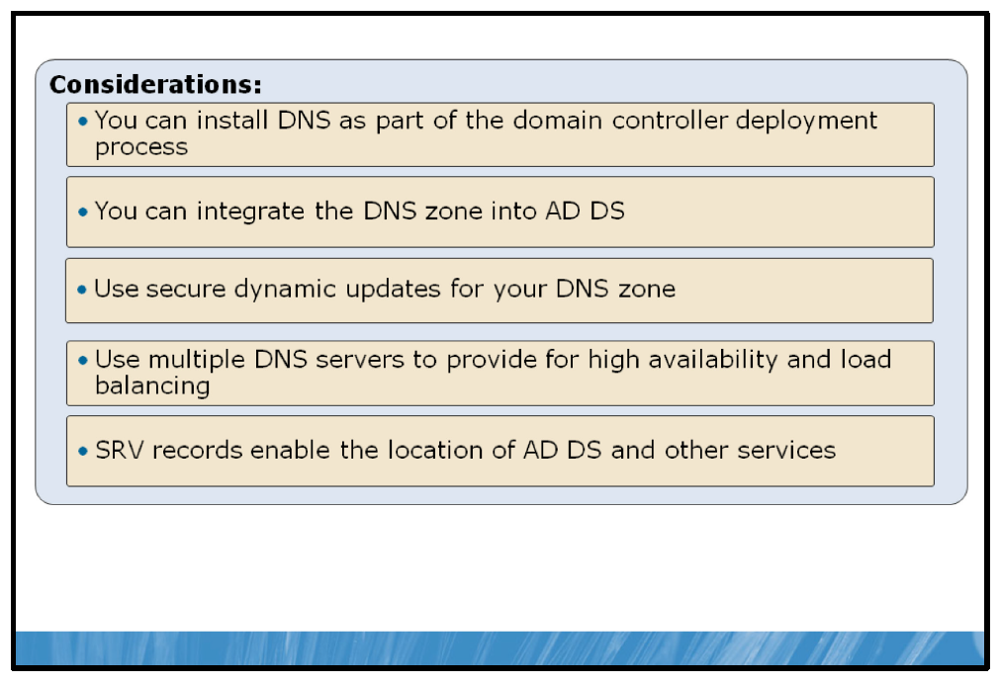

Key Points Installing DNS
AD DS requires DNS. The DNS server role is not installed on Windows Server 2008 R2 by default. Like other functionality, it is added in a role-based manner when a server is configured to perform the role.
You can install the DNS server role using the Add Role link in Server Manager. The DNS server role can also be added automatically by the Active Directory Domain Services Installation Wizard (dcpromo.exe). The domain controller options page of the wizard allows you to add the DNS server role.

Configuring DNS Zones
After installing a DNS server, you can begin adding zones to the server. You can select to store the zone data in AD DS if the DNS server is a domain controller. This creates an Active Directory integrated zone. If you deselect this option, the zone data is stored in a file, rather than in AD DS.

Dynamic Updates
When you create a zone, you are also prompted to specify whether dynamic updates are supported. Dynamic updates reduce the management overhead of a zone, because clients can add, delete, and update their own resource records.
Dynamic updates leave open the possibility that a resource record could be spoofed. For example, a computer could register a record named www, effectively redirecting traffic from your Web server to the incorrect address.
To eliminate the possibility of spoofing, Windows Server 2008 R2 DNS Server service supports secure dynamic updates. A client must authenticate prior to updating its resource records, so the DNS server knows whether the client is the same computer that has the permission to modify the resource record.

DNS Zone Transfers
An enterprise should strive to ensure that a zone can be resolved authoritatively by at least two DNS servers.
If the zone is AD DS integrated, you can simply add the DNS server role to another domain controller in the same domain as the first DNS server. Active Directory integrated zones, and the replication of the DNS zone by AD DS, are described in the next lesson.
If the zone is not AD DS integrated, you must add another DNS server and configure it to host a secondary zone. Remember that a secondary zone is a read-only copy of the primary zone.

SRV Records
A Service Locator (SRV) resource record resolves a query for a network service, allowing a client to locate a host that provides a specific service.
SRV records are used in these and many other scenarios:
• | When a domain controller needs to replicate changes from its partners
• | When a client computer needs to authenticate to AD DS
• | When a user changes his or her password
• | When an Microsoft Exchange server performs a directory lookup
• | When an administrator opens Active Directory Users and Computers
An SRV record follows the syntax shown below:
protocol.service.name TTL class type priority weight port target
An example of an SRV record is shown below:
_ldap._tcp.contoso.com 600 IN SRV 0 100 389 hqdc01.contoso.com
The components of the record are:
• | The protocol service name, such as the Lightweight Directory Access Protocol (LDAP) service offered by a domain controller.
• | The time-to-live value, in seconds.
• | The class (all records in a Windows DNS server will be IN or INternet).
• | The type: SRV.
• | The priority and weight, which help clients determine which host should be preferred.
• | The port on which the service is offered by the server. Port 389 is the standard port for LDAP on a Windows domain controller.
• | The target, or host of the service, which in this case is the domain controller named hqdc01.contoso.com.
When a client process is looking for a domain controller, it can query DNS for an LDAP service. The query returns both the SRV record and the A record for the server(s) that provide the requested service.

Lesson 3: Managing Users, Groups, and Computers
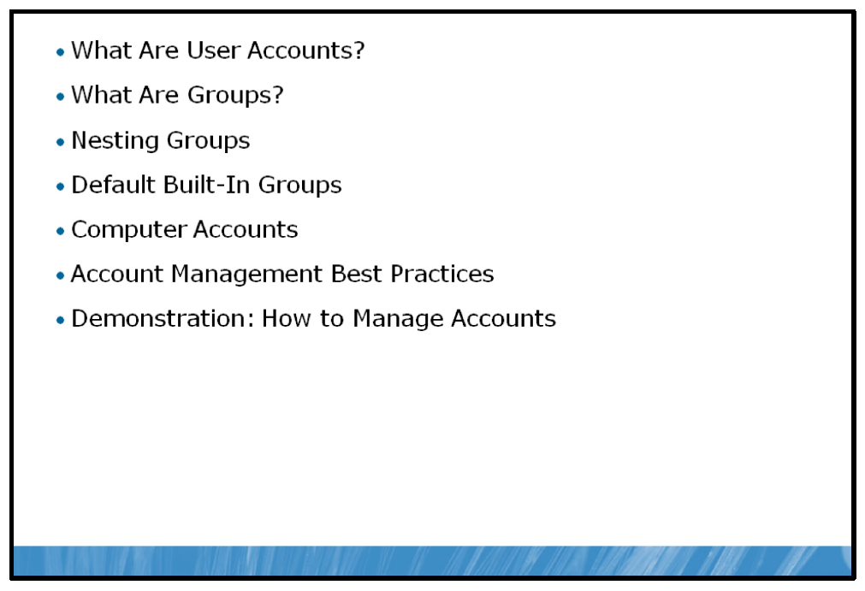
One of your functions as an AD DS administrator is to manage user, group, and computer accounts. These accounts are AD DS objects that individuals use to log on to the network and access resources. In this lesson, you will learn about modifying user, group, and computer accounts in an AD DS domain.

Objectives
After completing this lesson, you will be able to:
• | Describe user accounts.
• | Describe groups.
• | Understand when to nest groups.
• | List the default built-in groups.
• | Describe a computer account.
• | Provide best practices for user, group, and computer management.
• | Create and manage users, groups, and computer accounts.

What Are User Accounts?
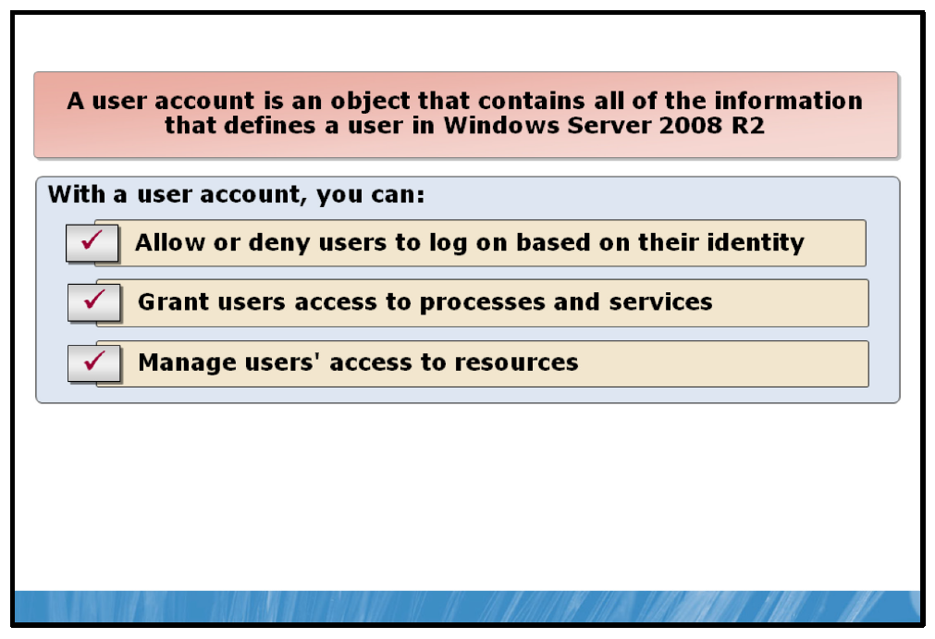

Key Points
In AD DS for Windows Server 2008, all users that require access to network resources must be configured with a user account. With this user account, users can be authenticated to the AD DS domain and granted access to network resources.
A user account is an object that contains all of the information that defines a user in Windows Server 2008 R2. The account can be either a local or a domain account. A user account includes the user name and password as well as group memberships. A user account also contains many other settings that you can configure based upon your organizational requirements.
With a user account, you can:
• | Allow or deny users to log on to a computer based on their user account identity.
• | Grant users access to processes and services for a specific security context.
• | Manage users' access to resources such as AD DS objects and their properties, shared folders, files, directories, and printer queues.
The Users container located in Active Directory Users and Computers displays the three built-in user accounts: Administrator, Guest, and HelpAssistant. These built-in user accounts are created automatically when you create the domain.
A user account enables a user to log on to computers and domains with an identity that can be authenticated by the domain.
To maximize security, you should avoid multiple users sharing one account. By avoiding multiple users on an account, each user who logs on to the network should have a unique user account and password.
When creating a user account, you must provide a user logon name. User logon names must be unique in the domain/forest in which the user account is created.

What Are Groups?
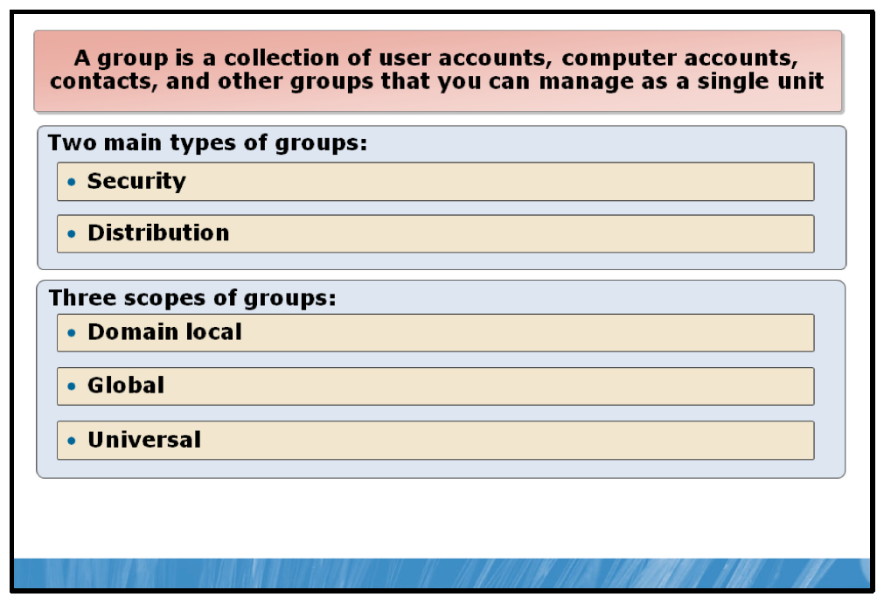

Key Points
A group is a collection of user accounts, computer accounts, contacts, and other groups that you can manage as a single unit. There are three common reasons for creating groups in AD DS. These are:
• | Granting permissions. Rather than assign a number of user accounts the same permissions on the same resource, you could create a group, add the users as members, and grant the group permissions on the resource.
• | Assigning rights. When a user requires administrative control of a resource, such as a server, it is better to add the user to a management group created for that purpose. Then, if the user changes job functions within your organization, you can remove them from the group. You can remove their assigned rights on the server without the need to change permissions.
• | Distributing e-mail. When your users want to send e-mail messages to multiple users, you can create specialized groups within the e-mail system to facilitate the process more efficiently.
Objects that belong to a particular group are referred to as group members.

Group Types
There are two types of groups in AD DS: distribution groups and security groups.
Security Groups
You create security groups to consolidate objects to which you want to assign permissions or rights. You can also use security groups for distribution purposes within an e-mail application, such as Exchange Server.
Distribution Groups
You can use distribution groups only with e-mail applications, such as Exchange Server, to send e-mail to multiple users. Distribution groups are not security-enabled and cannot be assigned permissions on resources or objects in AD DS. In smaller organizations, it is usually unnecessary to create distribution groups as security groups can be mail-enabled. However, in larger organizations, the separation of distribution and security groups enables you to separate the administration of the e-mail system and AD DS.

Group Scope
Any group, whether it is a security group or a distribution group, is characterized by a scope that identifies the extent to which the group is applied in the domain tree or forest. There are three group scopes:
• | Domain local. Domain local groups can contain members from any domain in the forest but can only be granted permissions and assigned rights on objects on the local domain. In other words, the group’s abilities are localized.
• | Global. Global groups can contain members only from the local domain, but can be granted permissions or assigned rights anywhere in the forest. In other words, the group’s abilities are global.
• | Universal. A universal group can contain members from anywhere in the forest and can be granted permissions and assigned rights anywhere in the forest. In other words, the group’s abilities and membership are universal. Another important characteristic of a universal group is that the membership list is maintained in the global catalog; consequently, you can only mail-enable universal groups in Exchange Server.
Question: Describe a situation where you would use a distribution group instead of a security group.

Nesting Groups
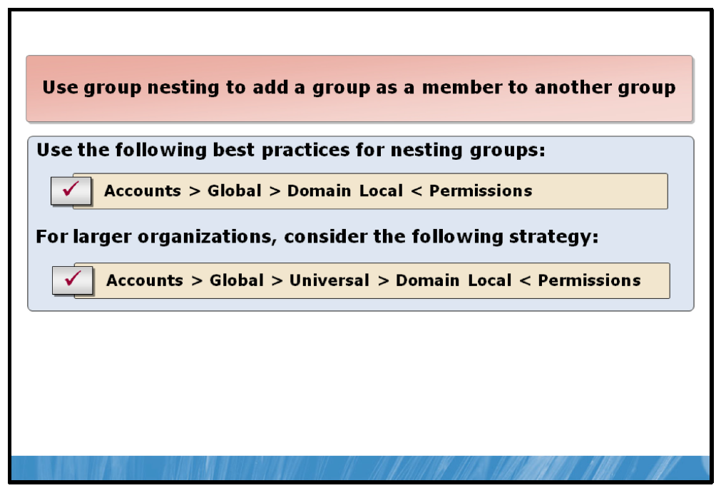

Key Points
When you use nesting, you add a group as a member of another group. You can use nesting to combine group management. Nesting increases the member accounts that are affected by a single action, and reduces replication traffic caused by the replication of changes in group membership.
The following are best practices for nesting groups:
1. | Add user accounts into global groups.
2. | Add global group to a domain local group.
3. | Assign permissions or rights to the domain local group.
You can remember the preceding process with this pneumonic:
Accounts > Global > Domain Local < Permissions (AGDLP).
For larger organizations that require an additional tier of groups, consider adding global groups to universal groups:
1. | Add user accounts into global groups.
2. | Add the global group to an appropriate universal group.
3. | Add the universal group to the domain local group.
4. | Assign permissions or rights to the domain local group.
You can remember the preceding process with this pneumonic:
Accounts > Global > Universal > Domain Local < Permissions (AGUDLP).

Default Built-In Groups
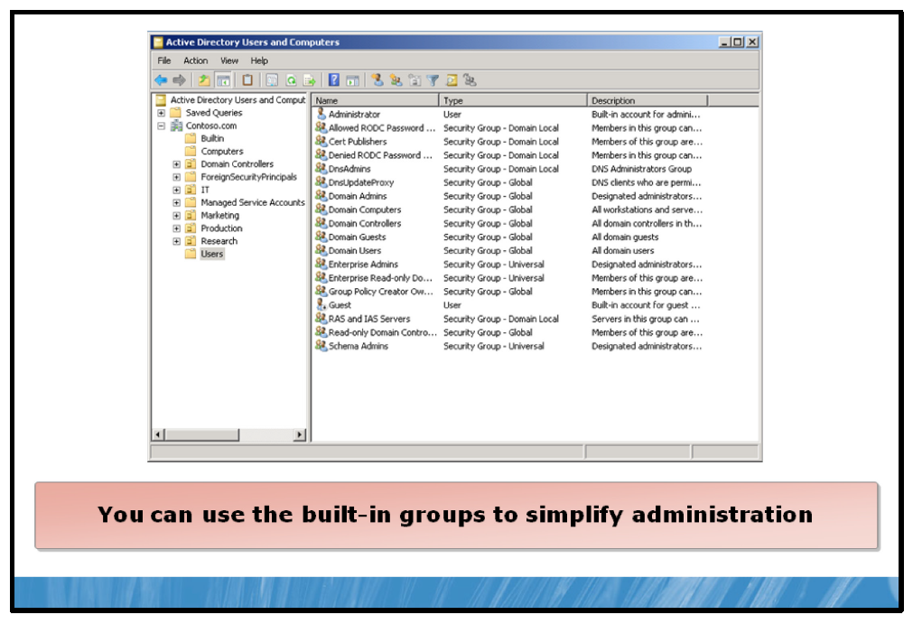

Key Points
In both domains and standalone workgroup-based computers, there are built-in groups. You can use the built-in groups to simplify administration. For example, adding user accounts to the built-in Domain Admins group enables the member user to perform administration on all domain computers.
Note: Bear in-mind that some of these built-in groups have powerful pre-assigned rights and privileges. Although it can be convenient to add users to built-in groups to achieve an administrative goal, you may be inadvertently assigning more rights and privileges than you intended.
In addition to built-in groups, there are system groups. These system groups do not have an explicitly maintained membership list, but rather have an implicit membership. For example, the group Authenticated Users contains anyone who is able to logon to the domain. You can use system groups to assign management permissions and rights or permissions on resources.
Note: Because these system groups do not have an explicit membership list, they are not displayed in Active Directory Users and Computers.
If the built-in and system groups are not sufficient for your needs, create additional groups as required.
The built-in groups are stored in the Users folder and the Builtin folder under the domain root.

Computer Accounts
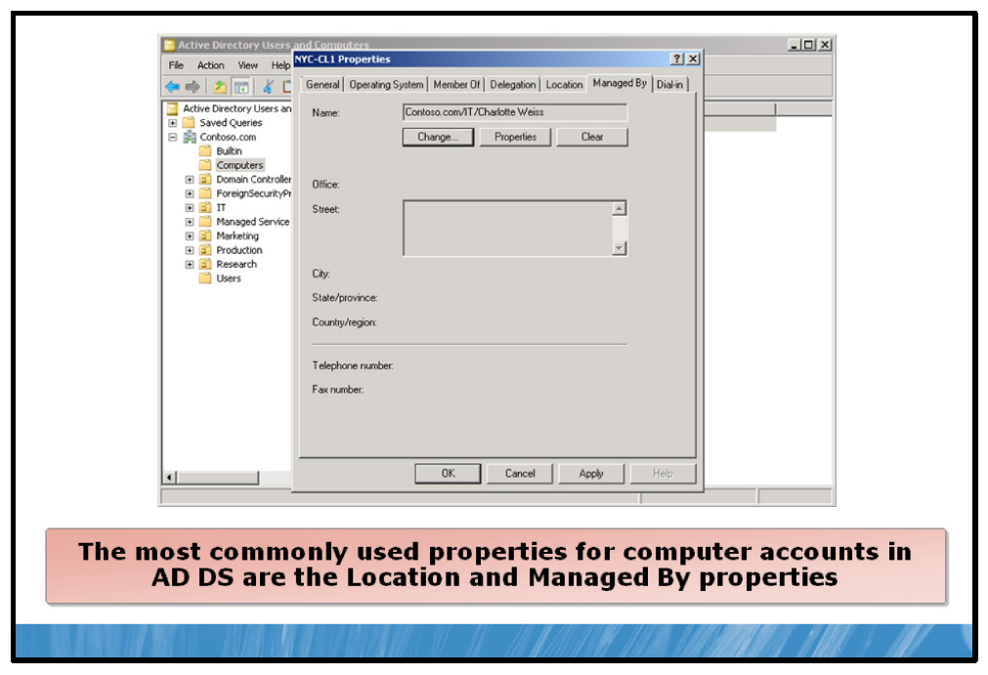

Key Points
In AD DS, computers are security principals, just like users. This means that computers must have accounts and passwords. To be fully authenticated by AD DS, a user must have a valid user account, and the user must also log on to the domain from a computer that has a valid computer account. All computers running Microsoft Windows NT® or later operating systems must have computer accounts in AD DS.
Computers access network resources to perform key tasks such as authenticating user log on, obtaining an IP address, and receiving security policies. To have full access to these network resources, computers must have valid accounts in AD DS. The two main functions of a computer account are performing security and management activities.
If you join a computer to a domain, the computer account is created in the Computers container by default. In most organizations, administrators move the computer accounts to department-specific OUs so that specific software and operating system configurations can be applied to the computers.
The most commonly used properties for computer accounts in AD DS are the Location and Managed By properties. To maintain computers, you must find the physical location of the computers.
• | The Location property can be used to document the computer’s physical location in your network.
• | The Managed By property lists the individual responsible for the computer. This information can be useful when you have a data center with servers for different departments and you need to perform maintenance on the server. You can call or send e-mail to the person who is responsible for the server before you perform maintenance on the server.

Account Management Best Practices
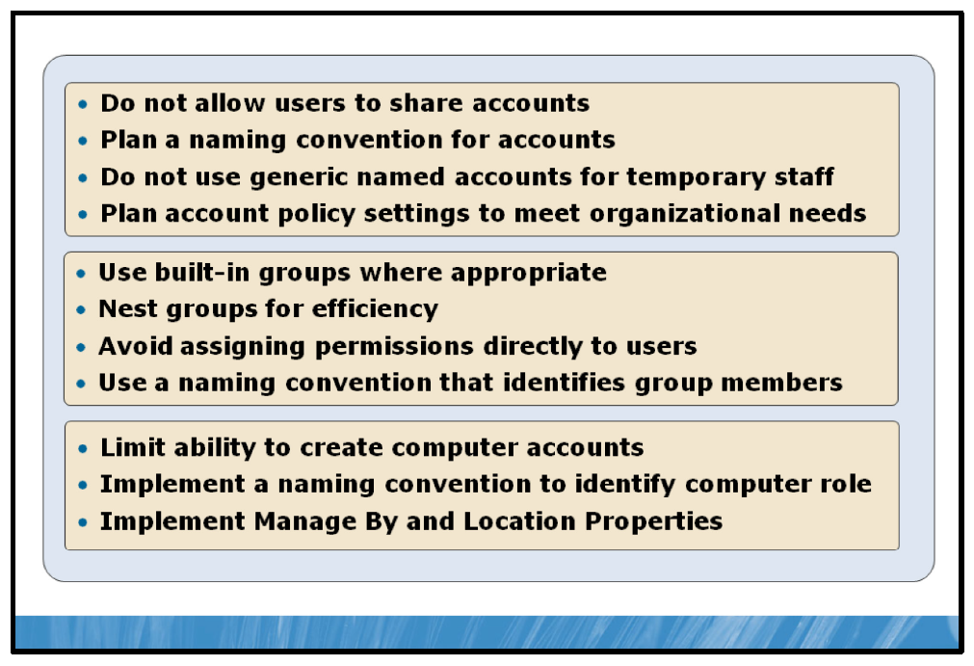

Key Points
Consider the following best practices to help to ensure that you manage accounts within your AD DS forest efficiently.

User Accounts
When planning and implementing user accounts, consider the following points:
• | Create a user account for all users who need to access your forest; do not allow users to share user accounts.
• | Implement a naming convention that yields simple-to-remember, unique user names. Bear in-mind that the more users you have, the more likely there are to be duplicates within your organization.
• | Create accounts for temporary or contract staff with the same naming convention that you use for other users. That is, do not use generic account names such as Temp1.
• | Plan the accounts policy carefully to ensure that it meets the security needs of your organization. The accounts policy includes password length, password complexity rules, and the maximum password age for user accounts.

Group Accounts
When planning and implementing groups, consider the following points:
• | Use the built-in and system groups where appropriate to simplify administration.
• | Nest groups to more efficiently control access to resources in larger organizations.
• | Avoid assigning permissions and rights directly to user accounts. Use groups to make on-going maintenance easier.
• | Use a group naming convention that identifies who belongs to a group or what rights a management group has. For example, the Sales global group obviously identifies users that are in the Sales department, while the Printer Managers local group contains users with printer management rights.

Computer Accounts
When planning computers, consider the following points:
• | Limit who has the ability to create computer accounts.
• | Implement a naming convention that helps you identify the role and location of a computer.
• | Implement the Manage by and Location properties of computer accounts so that they are easier to locate and manage.

Demonstration: How to Manage Accounts
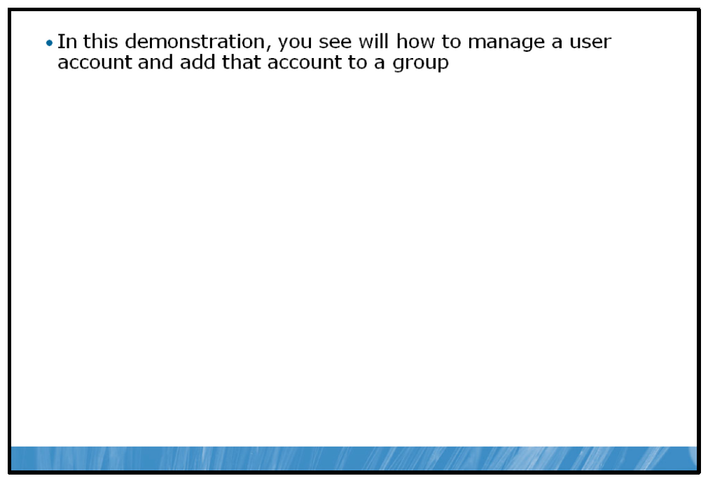

Key Points
You can manage user, group, and computer accounts by using either Active Directory Users and Computers or the Active Directory Administrative Center (ADAC).
In this demonstration you will see how to create an account using the ADAC. After creating the account, you will see how to make it a member of a group.

Demonstration Steps:
1. | Run Active Directory Administrative Center.
2. | Create a new user Claus Hansen.
3. | Add Claus to the Domain Admins group.

Lesson 4: Implementing Organizational Units
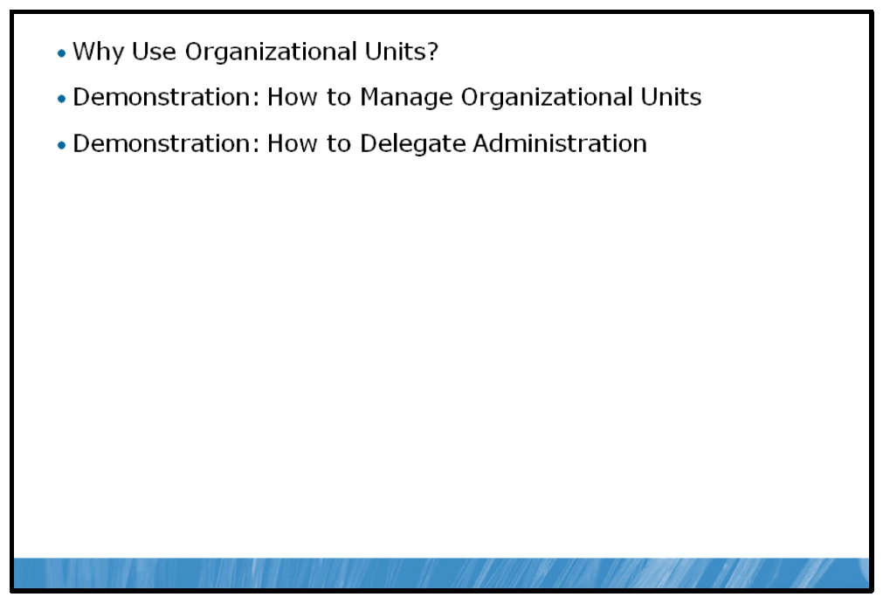
You can use OUs to collect users, groups, and computers together for administrative purposes. In this lesson, you will learn why and how to use OUs to help to administer your organization.

Objectives
After completing this lesson, you will be able to:
• | Describe why to use OUs.
• | Create and manage OUs.
• | Delegate permissions on OUs.

Why Use Organizational Units?
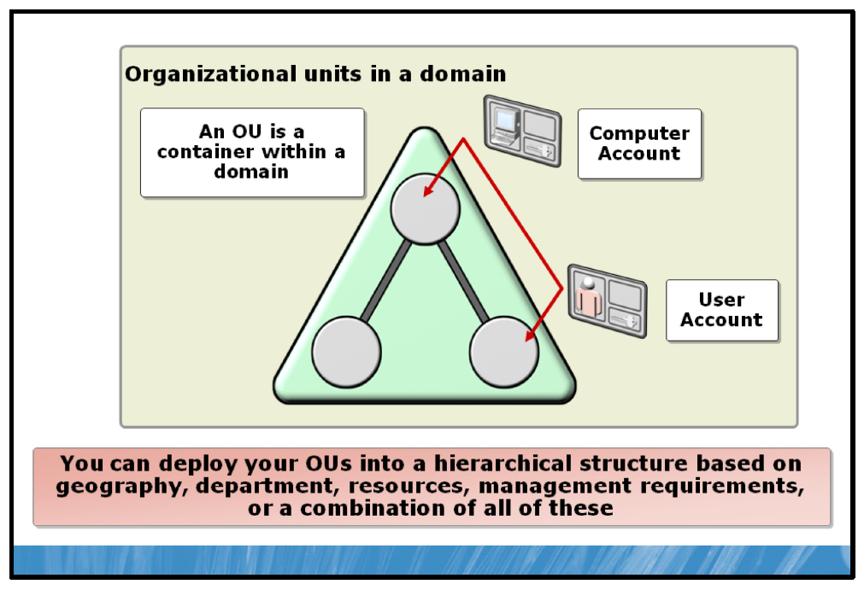

Key Points
An OU is an AD DS object that is contained in a domain. You can use OUs to organize hundreds of thousands of directory objects into manageable units. OUs are useful in grouping and organizing objects for administrative purposes, such as delegating administrative rights and assigning policies to a collection of objects as a single unit.
AD DS OUs are used to create a hierarchical structure within a domain. By creating an OU structure, you are grouping objects that you can administer as a unit.
An organizational hierarchy should logically represent an organizational structure. That organization could be based on geographic, functional, resource-based, or user classifications. Whatever the order, the hierarchy should make it possible to administer AD DS resources as flexibly and effectively as possible. For example, if all of the computers that are used by information technology (IT) administrators must be configured in a certain way, you can group all of the computers in an OU, and assign a policy to manage the computers in the OU.

OU Hierarchical Models
Organizations may deploy OU hierarchies by using several different models. The following are different OU models:
• | Geographic OUs. If the organization has multiple locations and network management is distributed geographically, you should use a location-based hierarchy. For example, you might decide to create OUs for New York, Toronto, and Miami in a single domain.
• | Departmental OUs. A Departmental OU is based only on the organization's business functions, without regard to geographical location or divisional barriers. This approach works well for small organizations with a single location.
• | Resource OUs. Resource OUs are designed to manage resource objects (non-users such as client computers, servers, or printers). This design is most useful when all resources of a given type are managed in the same manner. Resource-based OUs can simplify software installations or printer selections based on Group Policies.
• | Management-based OUs. Management-based OUs reflect the various administrative divisions within the organization by mirroring its structure in the OU structure. Responsibilities to manage users and groups, when they are placed into nested departmental OUs, can be delegated to managers of those departments.
The eventual OU design should represent how the business will be administered. Delegation of authority, separation of administrative duties, central versus distributed administration, and design flexibility are important factors you must consider when you design Group Policy and select the scenarios to use for your organization.
Question: Describe one scenario when you would use a domain to organize a network. Describe one scenario when you would use an OU to organize a network.

Demonstration: How to Manage Organizational Units
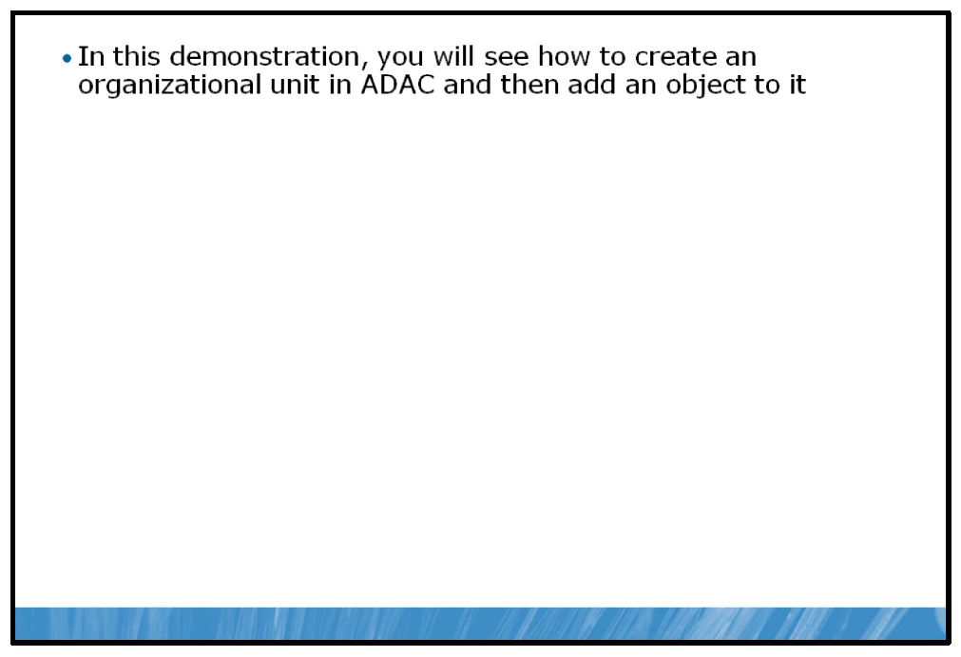

Key Points
In this demonstration, you will see how to create an organizational unit using the ADAC. After the creation of the organizational unit, you will see how to add objects to it.

Demonstration Steps:
1. | Run Active Directory Administration Center.
2. | Create a new organizational unit called Sales.
3. | Add Claus Hansen to the Sales organizational unit.
4. | Create a new computer called PRO-W7E-0001 in the Sales organizational unit.

Demonstration: How to Delegate Administration
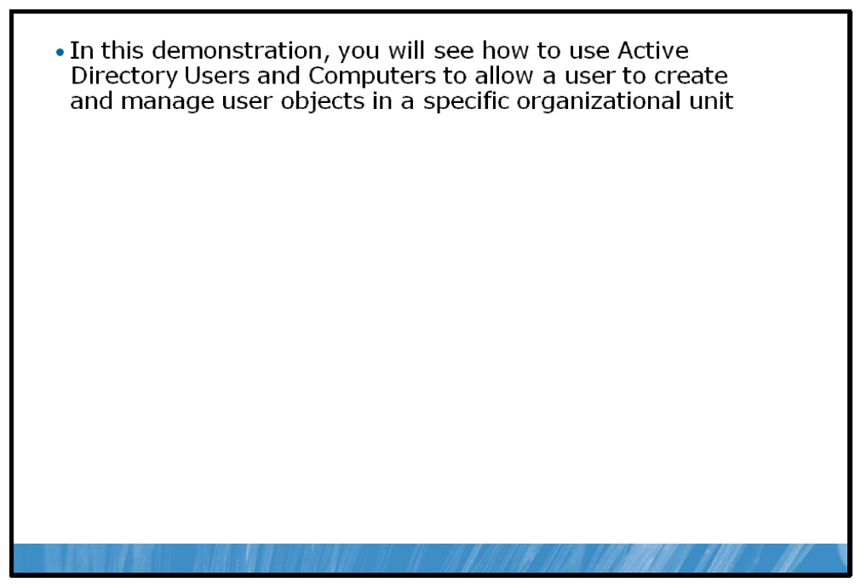

Key Points
In this demonstration you will see how to delegate control of an organizational unit to a user.

Demonstration Steps:
1. | Run Active Directory Users and Computers.
2. | Delegate control of the Sales organizational unit to Claus Hansen.

Lesson 5: Implementing Group Policy
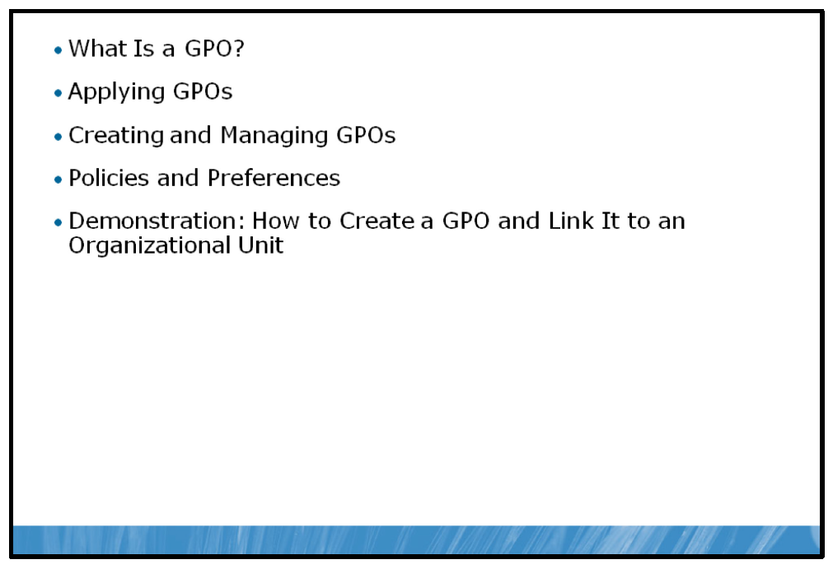
Once you have created users, groups, computer accounts, and an OU structure in your AD DS and reducing IT costs. With Group Policy forest, the next step is commonly implementing group policy. Group Policy and the AD DS infrastructure in Windows Server 2008 R2 enable IT administrators to automate user and computer management, thus simplifying administrative tasks and AD DS, administrators can efficiently implement security settings, enforce IT policies, and distribute software consistently across a given site, domain, or range of OUs.

Objectives
After completing this lesson, you will be able to:
• | Describe GPOs.
• | Understand local, site, domain, and organizational unit-linked policies.
• | Explain how to use GPO management tools.
• | Describe GPO Policies and Preferences.
• | Create a GPO and assign to an organizational units.

What Is a GPO?
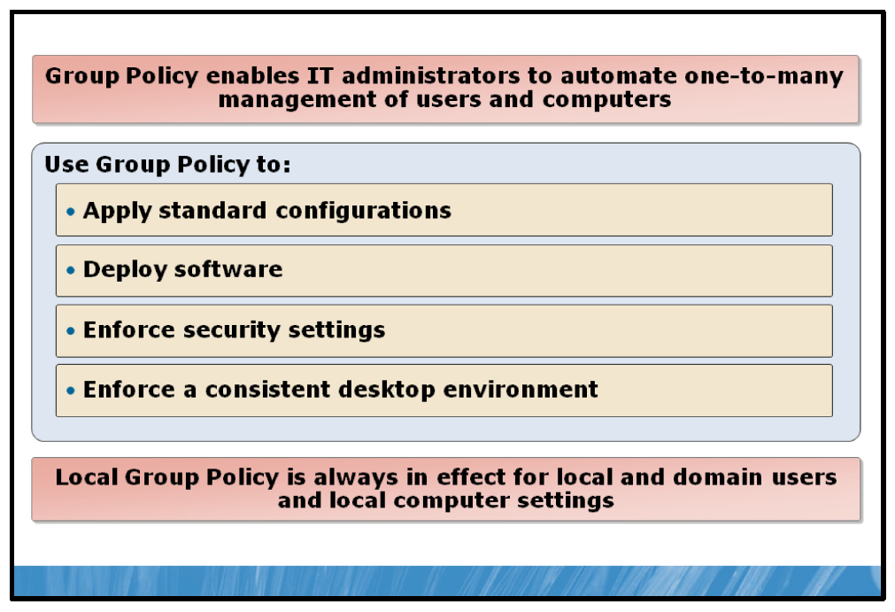

Key Points
Group Policy is a Microsoft technology that supports one-to-many management of computers and users in an AD DS environment. By editing Group Policy settings and targeting a GPO at the intended users or computers, you can centrally manage specific configuration parameters. In this way, you can manage potentially thousands of computers or users by changing a single GPO.
A GPO is the collection of settings that are applied to selected users and computers.
Group Policy can control many aspects of a target object’s environment, including: the registry, NTFS file system security, audit and security policy, software installation and restriction, desktop environment, logon/logoff scripts, and many other settings.
One GPO can be associated with multiple containers in AD DS, through linking. Conversely, multiple GPOs may link to one container.
Each computer running a Microsoft Windows operating system has a local GPO. In these objects, Group Policy settings are stored on individual computers, whether or not they are part of an AD DS environment or a networked environment.
Note: Local GPOs contain fewer settings than nonlocal GPOs, particularly under Security Settings and do not support all of the GPO settings of a domain Group Policy – such as Folder Redirection or Group Policy Software Installation.
Group Policy has thousands of configurable settings (approximately 2,400). These settings can affect nearly every area of the computing environment. You cannot apply all of the settings to all versions of Microsoft Windows operating systems. For example, many of the new settings that came with the Microsoft Windows XP Professional operating system, Service Pack (SP) 2, such as software restriction policies, only applied to that operating system. Equally, many of the hundreds of new settings only apply to the Windows 7 operating system and Windows Server 2008 R2. If a computer has a setting applied that it cannot process, it simply ignores it.

Applying GPOs
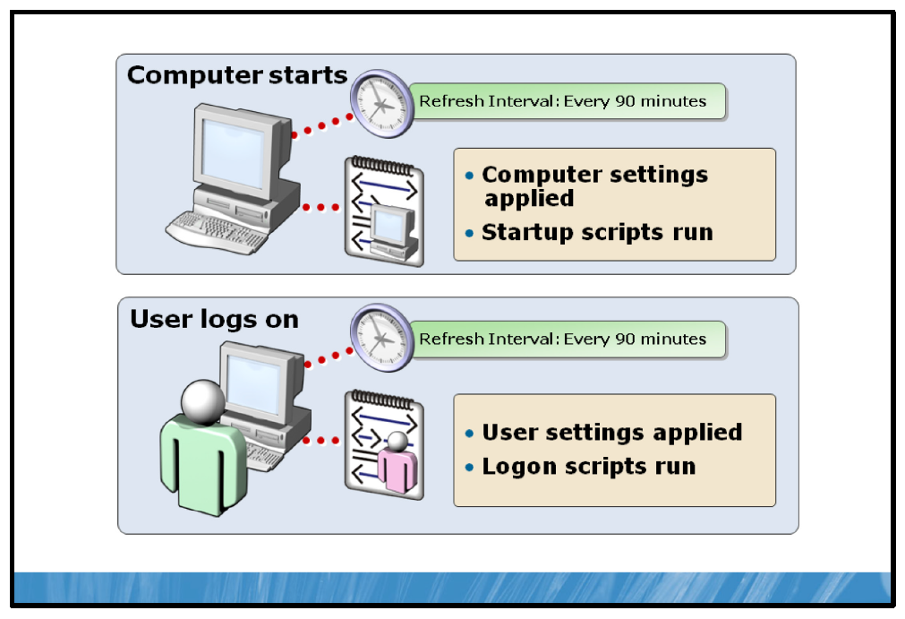

Key Points
Clients initiate Group Policy application by requesting GPOs from AD DS. When Group Policy is applied to a user or computer, the client component interprets the policy, and then makes the appropriate environment changes. These components are known as Group Policy client-side extensions. As GPOs are processed, a service on the domain controller passes the list of GPOs that must be processed to each Group Policy client-side extension. The extension then uses the list to process the appropriate policy, when applicable.
The site, domain, and organizational unit links from a GPO are used as the primary targeting principle for defining which computers and users should receive a GPO. Security filtering and Windows Management Instrumentation (WMI) filtering can be used to further reduce the set of computers and users to which the GPO will apply. The group policy engine uses the following logic in processing GPOs: If a GPO is linked to a domain, site, or organizational unit that applies to the user or computer, the group policy engine must then determine whether the GPO should be added to its GPO list for processing.
GPOs that apply to a user or computer do not all have the same precedence. Settings that are applied later can override settings that are applied earlier. Group Policy settings are processed in the following order:
• | Local GPO. Each computer has exactly one GPO that is stored locally. This processes for both computer and user group policy processing.
• | Site. Any GPOs that have been linked to the site that the computer belongs to are processed next. Processing is in the order that is specified by the administrator, on the Linked GPOs tab for the site in Group Policy Management Console (GPMC). The GPO with the lowest link order is processed last, and therefore has the highest precedence.
• | Domain. Processing of multiple domain-linked GPOs is in the order specified by the administrator, on the Linked GPOs tab for the domain in GPMC. The GPO with the lowest link order is processed last, and therefore has the highest precedence.
• | Organizational units. GPOs that are linked to the organizational unit that is highest in the AD DS hierarchy are processed first, and then GPOs that are linked to its child organizational unit are processed, and so on. Finally, the GPOs that are linked to the organizational unit that contain the user or computer are processed.
GPOs can also be filtered by WMI settings such as hardware or software settings, configurations or even applications that are installed.

Creating and Managing GPOs
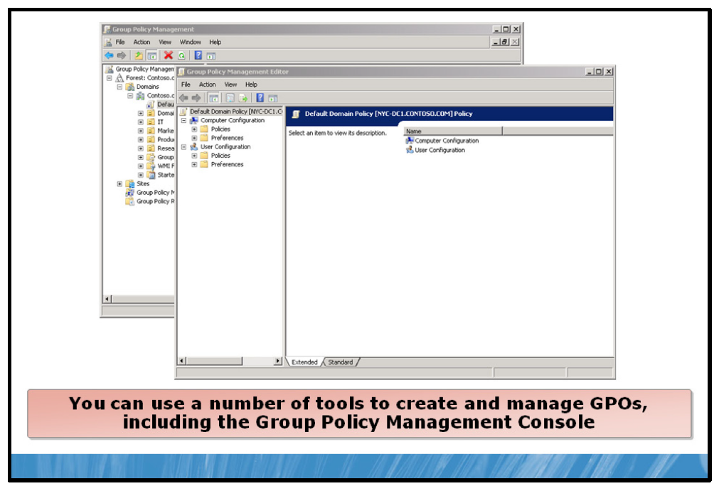

Key Points
You can create or manage GPOs in many ways. A GPO can be created from a template or by default using a graphical user interface (GUI) tool such as the GPMC. Once you have created the GPO you can link it to the appropriate container: site, domain, or OU.
GPMC provides mechanisms for backing up, restoring, migrating, and copying existing GPOs. This is very important for maintaining your Group Policy deployments in the event of error or disaster. It helps you avoid manually recreating lost or damaged GPOs, and having to again go through the planning, testing, and deployment phases. Part of your ongoing Group Policy operations plan should include regular backups of all GPOs.
GPMC also provides for copying and importing GPOs, both from the same domain and across domains.

Policies and Preferences
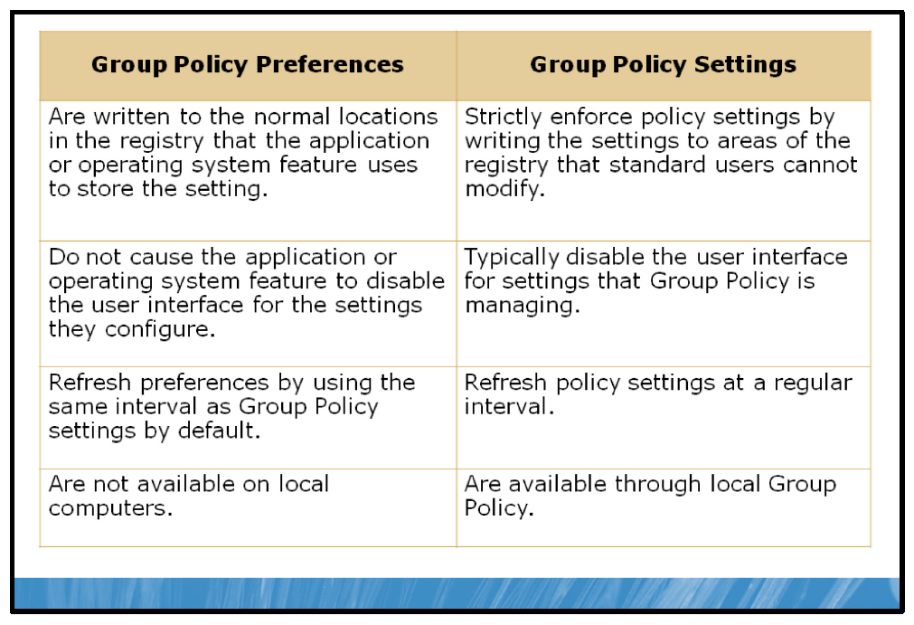

Key Points
Many common configuration settings were traditionally delivered through logon or startup scripts. This required writing, debugging, and storing the scripts in a central location, and then applying the scripts by using user settings or Group Policy. Group Policy preferences enable IT professionals to configure, deploy, and manage many common operating system and application settings that they previously were not able to manage using Group Policy.
Group Policy preferences are new for Windows Server 2008, and include more than 20 new Group Policy extensions that expand the range of configurable settings within a GPO. In contrast to policy settings, you allow users to change preferences after you deploy them.
The key difference between preferences and policy settings is enforcement. Group Policy strictly enforces policy settings. Organizations typically deploy two types of settings: managed and unmanaged. Managed settings are policy settings that you enforce. Unmanaged settings are preferences. In contrast to policy settings, you allow users to change preferences after you deploy them.
The following table describes the differences between policies and preferences:
Preferences | Policies
Preferences are not enforced. | Settings are enforced.
User interface is not disabled. | User interface is disabled.
Import individual registry settings or entire registry branches from a local or a remote computer. | Cannot create policy settings to manage files, folders, and so on.
Not available in local Group Policy. | Available in local Group Policy.
Supports non-Group Policy–aware | Requires Group Policy–aware applications.
applications.
Original settings are overwritten. | Original settings are not changed.
Removing the preference item does not restore the original setting. | Removing the policy setting restores the original settings.
Targeting is granular, with a user interface for each type of targeting item. | Filtering is based on WMI and requires writing WMI queries.
Supports targeting at the individual preference item level. | Supports filtering at a GPO level.
When choosing whether to deploy an item by using Group Policy settings or preferences, the most important factor is whether or not you want to enforce the setting. To configure a setting without enforcing it, use preferences. The next factor is whether the application or feature is Group Policy–aware. To enforce items for which no policy setting is available, you can deploy them as preference items and then disable the Apply Once And Do Not Reapply option in the configuration of the setting.

Demonstration: How to Create a GPO and Link It to an Organizational Unit
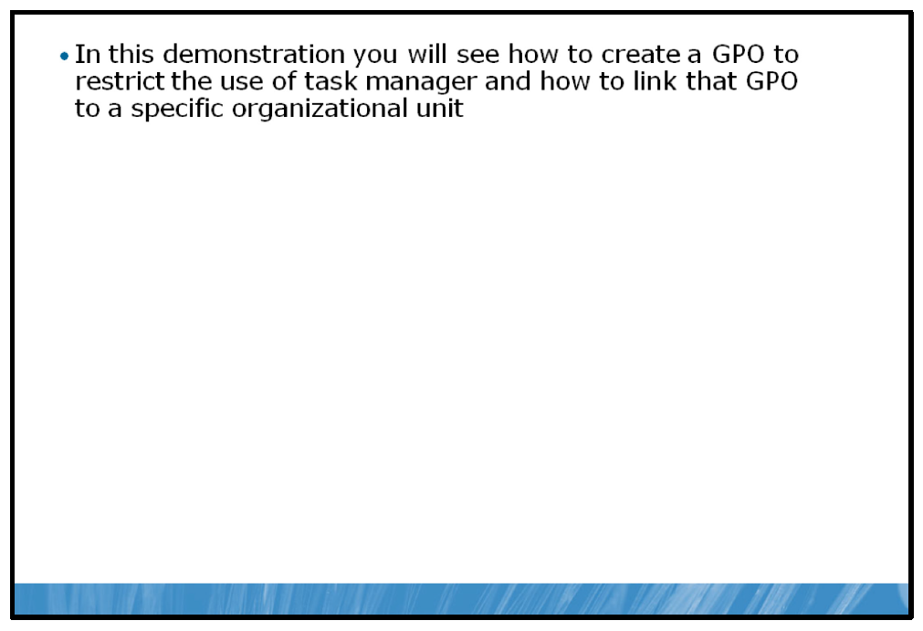

Key Points
In this demonstration you will see how to create a GPO using the GPMC. After the creation of the GPO you will link the GPO to Production OU and then log in as a production user. You will then see what happens when the GPO is not applied.

Demonstration Steps:
1. | Ensure the GPMC is installed.
2. | Create a new GPO.
3. | Restrict users from starting Task Manager when pressing CTRL+ALT+DEL.
4. | Link the GPO to the Sales OU.
5. | Log on as Claus Hansen to show the GPO is working.
6. | Log on as the Administrator to show the GPO is not applied.

Lab: Implementing AD DS
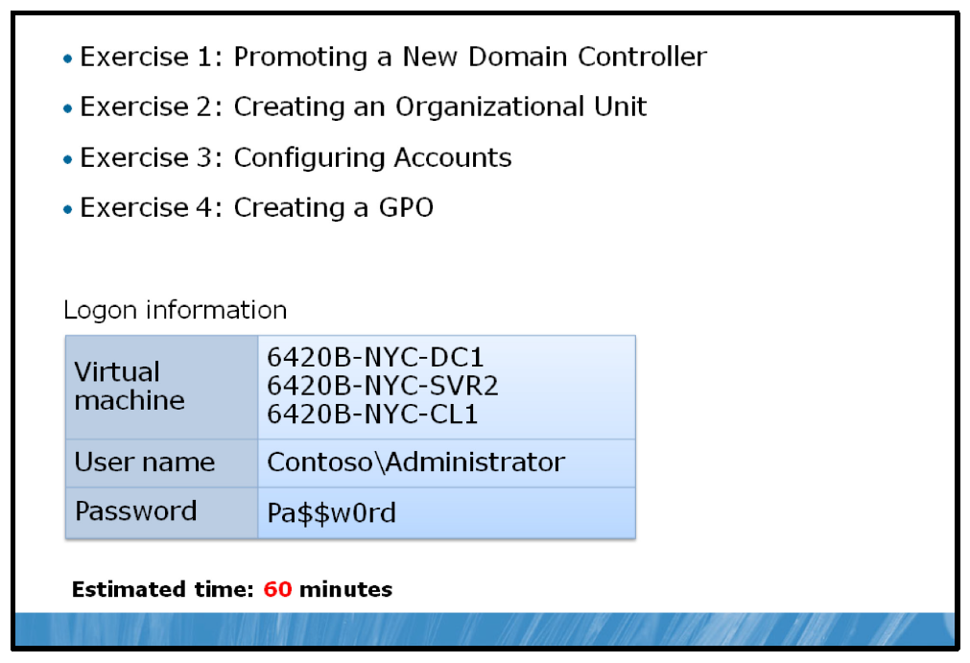

Lab Setup
For this lab, you will use the available virtual machine environment. Before you begin the lab, you must complete the following steps:
1. | On the host computer, click Start, point to Administrative Tools, and then click Hyper-V Manager.
2. | In Hyper-V™ Manager, click 6420B-NYC-DC1, and in the Actions pane, click Start.
3. | In the Actions pane, click Connect. Wait until the virtual machine starts.
4. | Log on using the following credentials:
  • | User name: Administrator
  • | Password: Pa$$w0rd
  • | Domain: Contoso
5. | Repeat these steps for 6420B-NYC-SVR2 and 6420B-NYC-CL1.

Lab Scenario
Contoso, Ltd. has created a new department ahead of a merger with the A Datum Corporation. Ed Meadows has asked you to create a new OU in AD DS to support this new department and populate it with the users, groups, and computers to support the new staff.

Exercise 1: Promoting a New Domain Controller

Scenario
Ed thinks that having more users will place additional load on the existing domain controller in New York. He has asked you to promote an existing member server as a new domain controller.
The main task for this exercise is as follows:
1. | Add an additional domain controller.

Task: Add an additional domain controller
1. | Switch to the NYC-SVR2 computer.
2. | Run dcpromo and wait while the AD DS binaries are installed.
3. | Complete the Active Directory Domain Services Installation Wizard using the following information:
  a. | Operating system compatibility: accept defaults
  b. | Choose a Deployment Configuration: Existing forest: Add a domain controller to an existing domain
  c. | Network credentials: accept defaults
  d. | Select a domain: Contoso.com (default)
  e. | Select a site: NewYork
  f. | Additional domain controller options: accept defaults
  g. | Acknowledge the DNS warning message.
  h. | Location for database, log files, and SYSVOL: accept defaults
  i. | Directory Services Restore Mode Administrator Password: Pa$$w0rd
  j. | Select the Reboot on completion check box.
Results: After this exercise, you will have promoted a new domain controller.

Exercise 2: Creating an Organizational Unit

Scenario
You must now create the required organizational unit for team members.
The main task for this exercise is as follows:
1. | Create an organizational unit.

Task: Create an organizational unit
1. | Once NYC-SVR2 has restarted, log on using the following credentials:
  • | User name: Administrator
  • | Password: Pa$$w0rd
  • | Domain: Contoso
2. | In Active Directory Users and Computers, in the Navigation pane, click Contoso.com.
3. | Create a new organizational unit in the Contoso.com domain called A Datum Merger Team.
Results: After this exercise, you will have created a new organizational list.

Exercise 3: Configuring Accounts

Scenario
Ed has asked that you create the necessary users accounts and groups, and move the users’ computer accounts into the OU. You need two groups, one for all team members and one for the manager, Tony Allen. You will then grant Tony Allen the ability to reset user passwords on all user accounts in the A Datum Corporation Merger Team OU.
The main tasks for this exercise are as follows:
1. | Add user accounts.
2. | Create groups.
3. | Add members to the groups.
4. | Move a computer account.
5. | Delegate control of the OU.

Task 1: Add user accounts
1. | In Active Directory Users and Computers, create the following user accounts in the A Datum Merger Team OU using the following information to complete the process:
  a. | Configure users’ first names and last names.
  b. | User logon name is first name.
  c. | Password is Pa$$w0rd.
  d. | Clear the User must change password at next logon option.
2. | Users to create are:
  a. | Christian Kemp
  b. | Tony Allen
  c. | Pia Lund
  d. | Soha Kamal
  e. | Oliver Cox

Task 2: Create groups
• | In the A Datum Merger Team OU, create the following Global Security groups:
  • | Mergers and Acquisitions
  • | Merger Team Management

Task 3: Add members to the groups
1. | Add all new users in the A Datum Merger Team OU to the Mergers and Acquisitions group.
2. | Add only Tony Allen to the Merger Team Management Group.

Task 4: Move a computer account
• | In Active Directory Users and Computers, in the Computers folder, move the NYC-CL1 computer to the A Datum Merger Team OU.

Task 5: Delegate control of the OU
• | Using the Delegation of Control Wizard, grant the Merger Team Management global security group the right to Reset user passwords and force password change at next logon on the A Datum Merger Team OU.
Results: After this exercise, you will have created the necessary users accounts and groups, and moved the users’ computer accounts into the OU.

Exercise 4: Creating a GPO

Scenario
You must now create a GPO and link it to the A Datum Merger Team OU. The GPO will launch a logon script for users in the new OU.
The main tasks for this exercise are as follows:
1. | Create a GPO.
2. | Link the GPO.
3. | Test the GPO.

Task 1: Create a GPO
1. | Open Group Policy Management.
2. | Create a new GPO called A Datum Merger Team GPO.
3. | Open the GPO for editing. Use the following steps to complete the process of creating a logon script for the team:
  a. | In the Group Policy Management Editor, expand User Configuration, expand Policies, expand Windows Settings, and then click Scripts (Logon/Logoff).
  b. | In the Results pane, double-click Logon.
  c. | In the Logon Properties dialog box, click Add.
  d. | In the Add a Script dialog box, click Browse.
  e. | In the Browse dialog box, right-click in the No items match your search box, click New, and then click Text Document.
  f. | Highlight the entire filename, including the file extension, and type logon.vbs and press ENTER.
  g. | In the Rename dialog box, click Yes.
  h. | Right-click logon.vbs and then click Edit.
  i. | In the Open File – Security Warning dialog box, click Open.
  j. | In notepad, type msgbox “Welcome to the A Datum Merger Team”.
  k. | Click File and then click Save.
  l. | Close Notepad.
  m. | In the Browse dialog box, click Open.
  n. | In the Add a Script box, click OK.
  o. | In the Logon Properties dialog box, click OK.
4. | Close Group Policy Management Editor.

Task 2: Link the GPO
• | Link the A Datum Merger Team GPO to the A Datum Merger Team organizational unit.

Task 3: Test the GPO
1. | Switch to NYC-CL1 and log off.
2. | Log on using the following credentials:
  • | User name: Tony
  • | Password: Pa$$w0rd
  • | Domain: Contoso
3. | Does the script run?
Results: After this exercise, you will have created a GPO and linked it to the A Datum Merger Team OU.

To prepare for the next module
When you finish the lab, revert the virtual machines back to their initial state. To do this, complete the following steps:
1. | On the host computer, start Hyper-V Manager.
2. | Right-click 6420B-NYC-DC1 in the Virtual Machines list, and then click Revert.
3. | In the Revert Virtual Machine dialog box, click Revert.
4. | Repeat these steps for 6420B-NYC-SVR2 and 6420B-NYC-CL1
5. | In the Virtual Machines pane, click 6420B-NYC-DC1, and then in the Actions pane, click Start.
6. | To connect to the virtual machine for the next module’s lab, click  6420B-NYC-DC1, and then in the Actions pane, click Connect.  Important: Start the 6420B-NYC-DC1 virtual machine first, and ensure that it is fully started before starting the other virtual machines.

Module Review and Takeaways
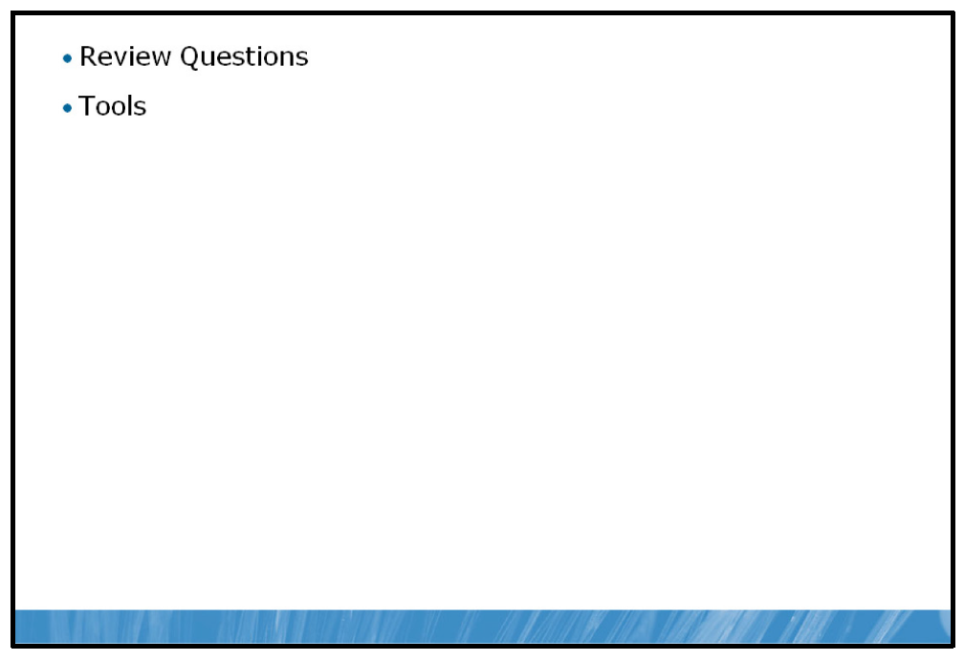

Review Questions
1. | For most organizations, how many AD DS forests are required?
2. | If you are installing an AD DS compatible e-mail application, what implications does this have for your AD DS schema?
3. | What kind of trusts are implemented between domains in a single forest?
4. | Why create organizational units?

Tools
Tool | Use for | Where to find it
Active Directory Users and Computers |  | Administrative Tools
  • | Managing objects within AD DS such as Users, groups, and computers
Active Directory Administrative Center |  | Administrative Tools
  • | Managing objects within AD DS such as Users, groups, and computers
Group Policy Management Console |  | Administrative Tools
  • | Creating, managing, and editing group policies

- Highlight
- Note
- Expand Highlight
- Expand Note
Module 8: Implementing IT Security Layers
Contents:
Lesson 1: | Overview of Defense-in-Depth
Lesson 2: | Physical Security
Lesson 3: | Internet Security
Lab: | Implementing IT Security Layers

Module Overview
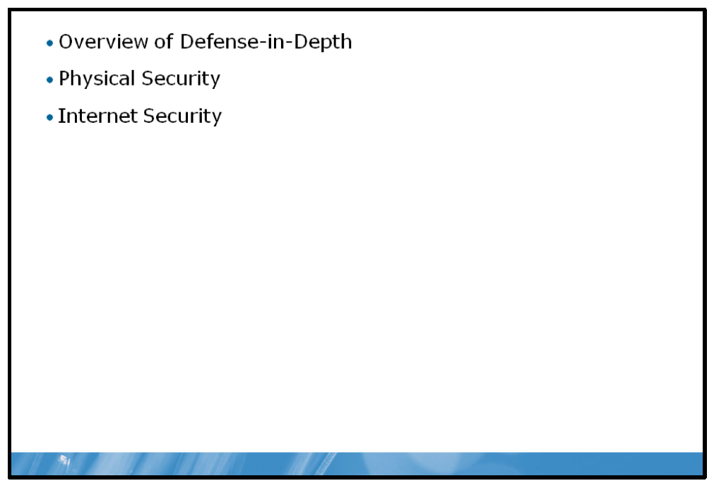
Security is an integral part of any computer network and must be considered from many perspectives. Data security for Web content and files accessed on network shares are common concerns. In addition to file and share permissions, you can also use data encryption to restrict data access.

Objectives
After completing this module, you will be able to:
• | Identify security threats at all levels and mitigate those threats.
• | Describe physical security risks and identify mitigations.
• | Identify Internet-based security threats and protect against them.

Lesson 1: Overview of Defense-in-Depth
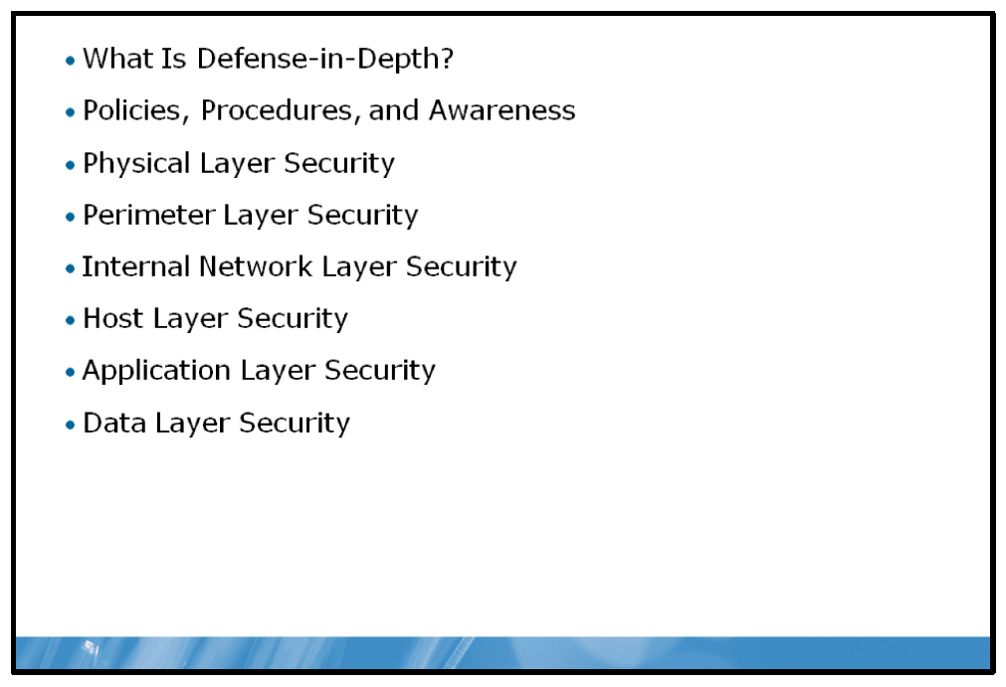
There are various ways to approach security design for computers. Defense-in-depth is one model for analyzing and implementing security for computer systems. The model uses layers to describe different areas of security.

Objectives
After completing this lesson, you will be able to:
• | Describe defense-in-depth.
• | Describe how policies, procedures, and awareness can help to implement defense-in-depth.
• | Describe physical security threats and mitigations.
• | Describe perimeter network security threats and mitigations.
• | Describe internal network security threats and mitigations.
• | Describe host-based security threats and mitigations.
• | Describe application-based security threats and mitigations.
• | Describe data-based security threats and mitigations.

What Is Defense-in-Depth?
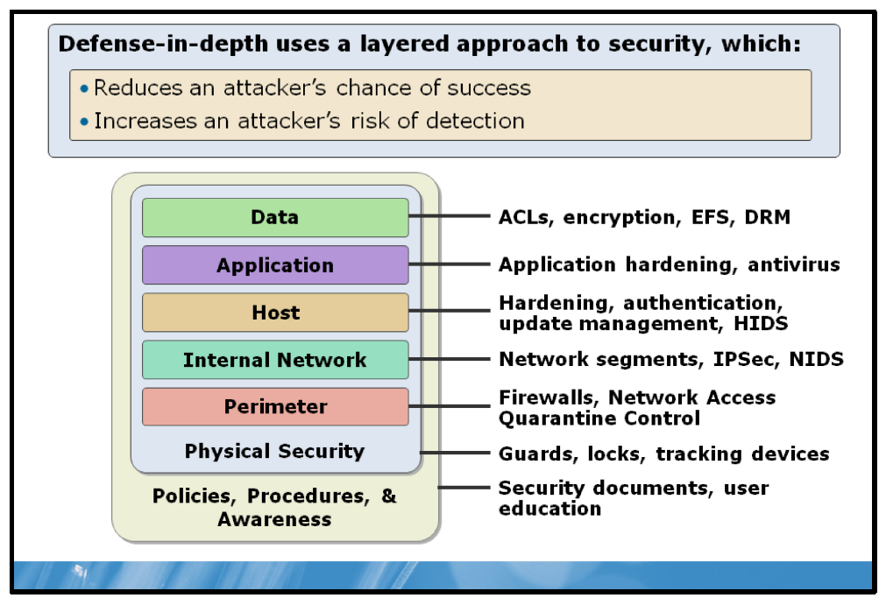

Key Points
When you park your car in a public place, you consider a number of factors before walking away from it. For example, where it is parked, whether the doors are locked, and whether you have left anything of value lying on the seat. You understand the risks associated with parking in a public place, and you can mitigate those risks. As with your car, you cannot properly implement security features on a computer network without first understanding the security risks posed to that network.
You can mitigate risks to your computer network by providing security at differing infrastructure layers. The term defense-in-depth is often used to describe the use of multiple security technologies at different points throughout your organization.

Policies, Procedures, and Awareness
Physical security measures need to operate within the context of organizational policies regarding security best practice. For example, enforcing a strong user password policy is not helpful if users write their passwords down and stick them to their computer screens. When establishing a security foundation for your organization’s network, it is a good idea to start with establishing appropriate policies and procedures and making users aware of them. Then you may progress to the other aspects of the defense-in-depth model.

Physical Security
If any unauthorized person can gain physical access to your computer, then most other security measures are of little consequence. Ensure that computers containing the most sensitive data, such as servers, are physically secure.

Perimeter
These days, no organization is an isolated enterprise. Organizations operate within a global community, and network resources must be available to service that global community. This might include building a Web site to describe your organization’s services, or making internal services such as Web conferencing and e-mail, accessible externally so that users can work from home or from satellite offices.
Perimeter networks mark the boundary between public and private networks. Providing specialist servers, such as a reverse proxy, in the perimeter network allows you to more securely provide corporate services across the public network.
Note: A reverse proxy enables you to publish services from the corporate intranet, such as e-mail or Web services, without placing the e-mail or Web servers in the perimeter.

Networks
Once you connect computers to a network, they are susceptible to a number of threats. These threats include eavesdropping, spoofing, denial of service, and replay attacks. This is especially relevant when communication takes place over public networks by users working from home, or from remote offices.
Note: Common network security threats, such as eavesdropping and spoofing, and their mitigations are discussed in course 6420B: Fundamentals of Windows
Server 2008, Module 10: Implementing Network Security.

Host
The next layer of defense is that used for the host computer. You must keep computers secure with the latest security updates.

Application
Applications are only as secure as your latest security update. You should consistently use Microsoft® Windows® Update to keep your applications up-to-date.

Data
The final layer of security is data security. To help ensure protection of your network, ensure proper use of file permissions, encryption, and backup.
Question: How many layers of the defense-in-depth model should be secured?

Policies, Procedures, and Awareness
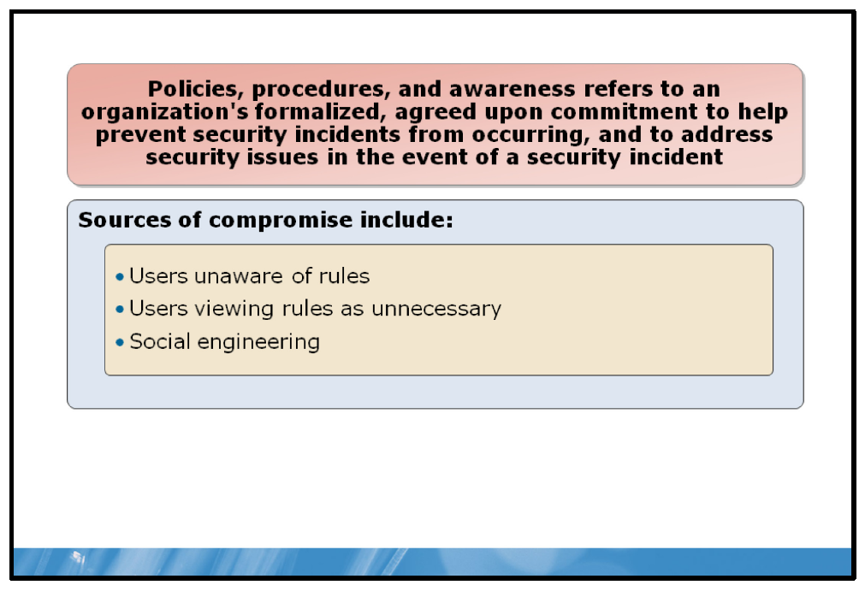

Key Points
Security is not only a technology-based solution. Organizations also implement policies, procedures, and awareness programs to help prevent security incidents. Security relies on staff and users following policies and procedures. For example, rules must be in place to determine under what circumstances a password can be reset and how that new password is communicated to the user. Without these rules, unauthorized password resets could unknowingly be performed that would allow an attacker to access your system.
Even when you implement rules to help prevent security problems, they can be circumvented. Some ways that policies and procedures are compromised include:
• | Users unaware of the rules. When users are unaware of the rules, they cannot be expected to follow them.
• | Users viewing rules as unnecessary. If the reason for rules is not adequately communicated to users, then some treat the rules as unnecessary.
• | Social engineering. Users and computer administrators are vulnerable to social engineering where they are convinced to break the rules. Sometimes this involves impersonating a legitimate user.

Mitigation
Consider the following to help to mitigate these threats:
• | Create specific rules that help prevent social engineering.
• | Educate users on rules and their relevance.
• | Implement compliance monitoring.
It is very important that you make users aware of your security rules, their relevance to the organization, and the ramifications or consequences of not abiding by those security rules.
Question: What are some examples of policies and procedures being compromised and affecting computer system security?

Physical Layer Security
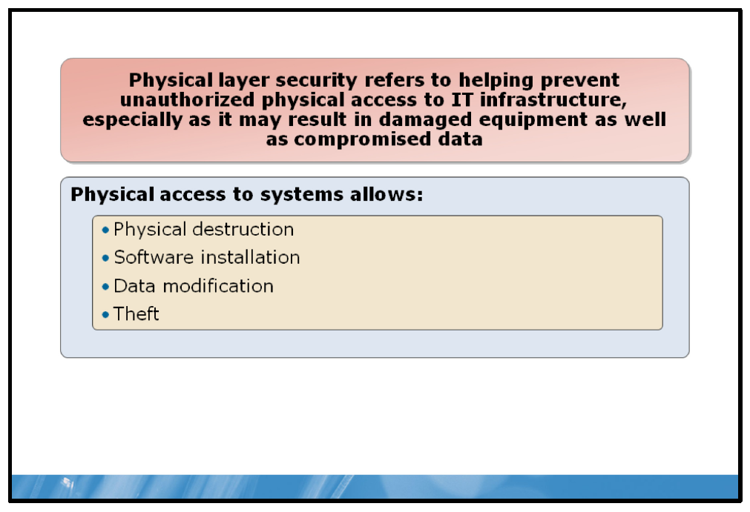

Key Points
This is one of the most commonly overlooked areas of securing computer systems. In general, anyone that has physical access to computer systems can:
• | Damage systems. This can be as simple as a server stored beside a desk that is accidentally knocked or has coffee spilled on it.
• | Install unauthorized software on systems. Unauthorized software can be used to attack systems; for example, there are utilities available to reset the administrator password on a Windows-based workstation or member server.
• | Modify data. After a system has been compromised, data can be modified. This could be done by a disgruntled employee to modify their own performance review.
• | Steal data. Data such as credit card information could be stolen after a system has been compromised.
• | Steal hardware. If laptops are left unsecured, they can be stolen. Even servers improperly secured can be stolen along with their data.

Mitigation
You must secure the network infrastructure including physical security. The problem is that while you want to make it difficult for non-authorized people to access your computers and infrastructure, you want to make it relatively straightforward for authorized employees.
Consider the following to help to mitigate physical security threats:
• | Restrict physical access by locking doors.
• | Monitor server room access.
• | Install fire suppression equipment.
Question: What are some examples of compromises when physical layer security is not in place?

Perimeter Layer Security
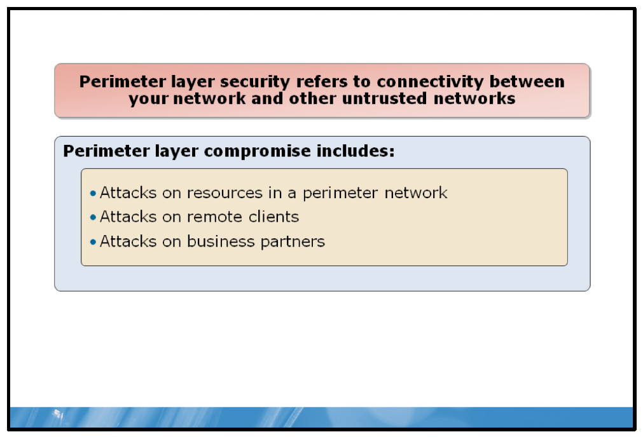

Key Points
Perimeter layer security refers to connectivity between your network and other untrusted networks. The most commonly considered untrusted network is the Internet. However, there are other untrusted networks that are a concern:
• | Remote access client. The client computers are accessing your network from a remote network over which you have little or no control. Yet, the clients have access to more data on your network than typical Internet hosts.
• | Business partners. You do not control the networks of business partners and cannot ensure that they have appropriate security controls in place. If a business partner is compromised, then the network links between your organization and the business partner pose a risk.

Mitigation
To keep your organization safe, create a private network and a perimeter network through the use of firewalls, intruder prevention and detection systems, and other components.
Consider the following to help to mitigate perimeter security threats:
• | Implement firewalls at network boundaries.
• | Implement network address translation (NAT).
• | Use virtual private networks (VPNs) and implement encryption.
Question: In what way could a business partner be a risk?

Internal Network Layer Security
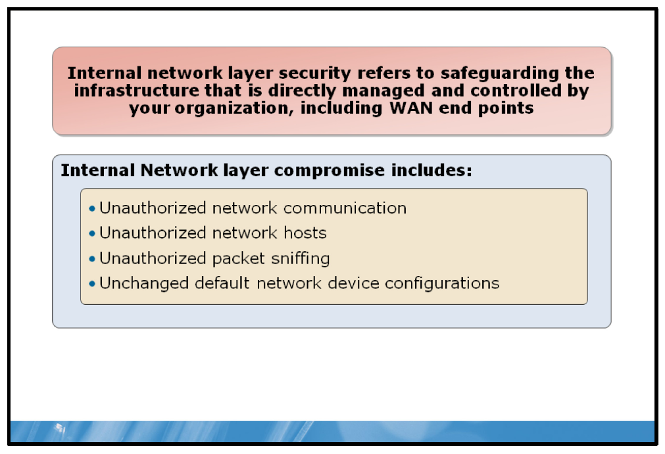

Key Points
Internal network layer security refers to events on the internally controlled network, including local area networks (LANs) and wide area networks (WANs). This layer is easier to secure because you have control of the devices on these networks.
The security risks to the internal network layer are:
• | Unauthorized network communication. Hosts may communicate with servers to which they have no need. This raises the risk of host-level exploits being performed. Restricting network communication to specific servers helps to prevent this.
• | Unauthorized network hosts. Frequently, security risks can be introduced to a network by unauthorized hosts connecting to the network. A common source of unauthorized hosts is visitors with laptops.
• | Unauthorized packet sniffing. The risk of unauthorized packet sniffing on modern wired networks is minimal because switches control packet delivery and ensure that packets are sent only to the specific destination. However, wireless networks are vulnerable, especially when only basic security measures, such as wired equivalent privacy (WEP), are used to help secure access.
• | Default configurations on network devices. Network devices, such as routers, have a default configuration that includes a default management username and password; failure to change these compromises your network security.  Note: Packet sniffing occurs when a malicious attacker connects a network data analyzer to the network to capture and examine network packets in transit; this can lead to additional attacks, depending upon the data captured. For example, if the attacker can capture username and password information in transit, they can exploit this to gain access to your computer network servers and data.

Mitigation
At the heart of many of these risks is the concept of authentication. If two computers can identify one another, then they can communication more securely. You can provide authentication services in a number of ways, such as digital certificates that are exchanged during initial communications. How you distribute and manage these certificates depends on your organization, but might include the use of a public key infrastructure (PKI) that you implement within your organization.
Note: You cannot always rely on authentication as some applications, such as network analysis, do not support authentication.
Besides authentication, consider using encryption to ensure that data is secure while it is in transit. You can encrypt communication to either the perimeter-based or edge servers from the public network with tunneling technologies, and communication between the edge servers and the internal network with Internet protocol security (IPsec).
In addition, Secure Socket Layer (SSL) can provide for secure and authenticated communications across networks, and is widely used on the Internet.
Consider the following to help to mitigate these threats:
• | Do not make it easy to connect to your network; if someone can plug a laptop into your network and access your intranet, you could face serious problems.
• | Encrypt network communication.
• | Segment the network.
• | Require mutual authentication.
• | Restrict switch ports and wireless access points based on media access control (MAC) address or client certificates.
Question: Why is wireless communication more at risk for packet sniffing than wired communication?

Host Layer Security
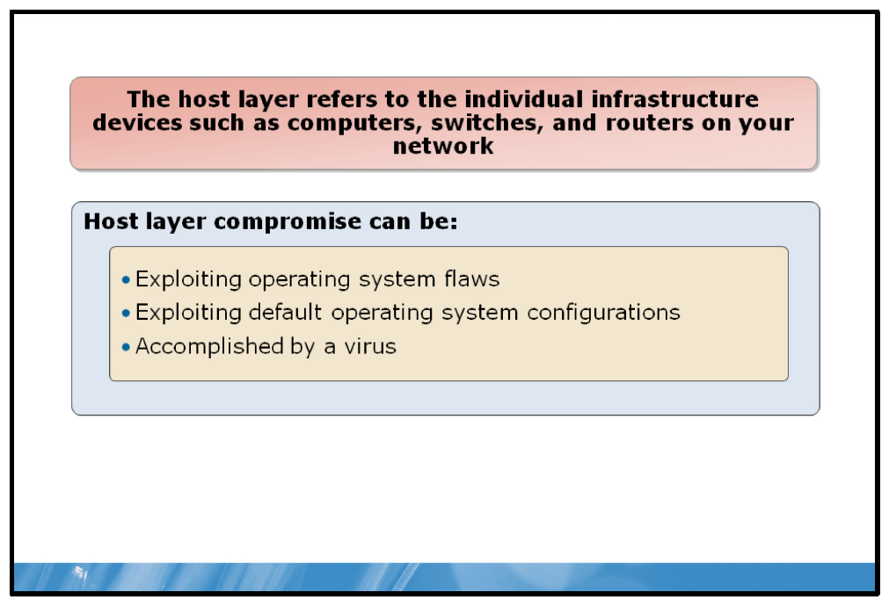

Key Points
The host layer refers to the individual computers on the network. This includes the operating system, but not application software. Operating system services, such as a Web server, are included in host layer security.
Host layer security can be compromised by:
• | Operating system vulnerabilities. An operating system is complex. Consequently, there are often vulnerabilities that hackers can exploit. These vulnerabilities enable attackers to install malicious software or control hosts.
• | Default operating system configurations. Operating systems and their services include default configurations. In some cases, the default configuration may not include a password or may include sample files with vulnerabilities. Attackers use their knowledge of default configurations to compromise systems.
• | Viruses are one mechanism used to attack hosts. The virus uses operating system flaws or default configurations to replicate itself.

Mitigation
Windows Update and Windows Server Update Services (WSUS) can help to keep your Windows computers up-to-date. In addition, you should consider using antivirus and malware protection. In the Windows 7 operating system, consider using Microsoft Forefront® Protection Manager and Windows Defender to guard against security threats to host computers.
Consider the following to help you to mitigate these threats:
• | Harden operating systems.
• | Monitor access attempts.
• | Implement antivirus and anti-spyware software.
• | Implement host-based firewalls.
Question: What is an example of host layer security being compromised?

Application Layer Security
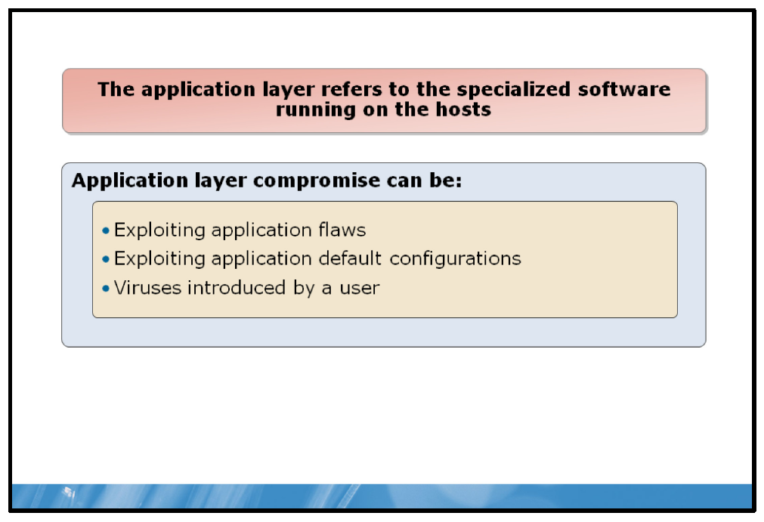

Key Points
The application layer refers to applications running on the hosts. This includes additional services, such as mail servers, and desktop applications, such as Microsoft Office. The risks to applications are similar to the risks to hosts and include:
• | Application vulnerabilities. Applications are complex programs that are likely to have vulnerabilities. Attackers can use these vulnerabilities to install malicious applications or remotely control a computer.
• | Default application configurations. Applications, such as databases, may have a default password or no password at all. Not securing the default configuration simplifies the work of attackers attempting to access a system.
• | Viruses introduced by users. In some cases, viruses are introduced by user actions rather than flaws. In other cases, an application is actually a Trojan horse that has malicious code embedded in what appears to be a useful application.

Mitigation
Consider the following to help you to mitigate these threats:
• | Run applications with the least privileges possible.
• | Install security updates.
• | Enable only required features and functionality.
Question: Give an example of malicious applications that may be installed by a user.

Data Layer Security
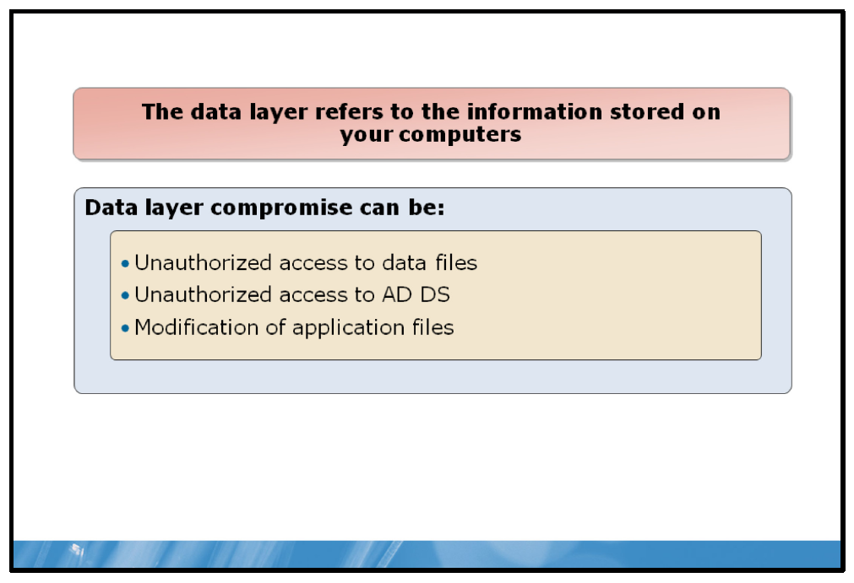

Key Points
The data layer refers to data stored on your computers. This includes data files, application files, databases, and Active Directory® Domain service (AD DS). When the data layer is compromised it can result in:
• | Unauthorized access to data files. Unauthorized access to data files may result in unintended users reading data. For example, the salaries of other staff. It may also result in data being modified and becoming inaccurate.
• | Unauthorized access to AD DS. This may result in user passwords being reset and attackers logging on by using the reset passwords.
• | Modification of application files. When application files are modified, they may perform unwanted tasks such as replicating data over the Internet where an attacker can access it.

Mitigation
This can take many forms, and might include using NTFS file system permissions and shared folder permissions to ensure that only authorized users can access files at a defined level of access. You might also be concerned with intellectual property rights and ensuring that your data is used appropriately. Finally, for data privacy, you can use both file and disk encryption technologies, such as the Encrypting File System (EFS) or Windows BitLocker® Drive Encryption.
Consider the following to help to mitigate data layer security threats:
• | Implement and configure suitable NTFS files system permissions.
• | Implement encryption.
• | Implement rights management.
Question: Give an example of a data layer compromise.

Lesson 2: Physical Security
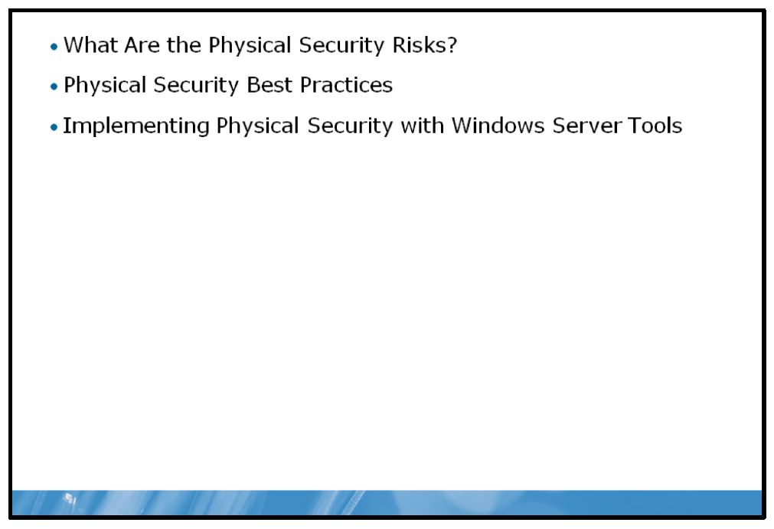
Physical security provides the first level of defense against the malicious attacker. Consequently, it is important to ensure that your network and the attached computers are physically secure. This lesson explores common physical security threats, their mitigations, and how Windows Server can help to provide physical security on your network.

Objectives
After completing this lesson, you will be able to:
• | Describe physical security risks.
• | Provide best practice for mitigating these risks.
• | Explain the Windows tools used to help provide physical security.

What Are the Physical Security Risks?
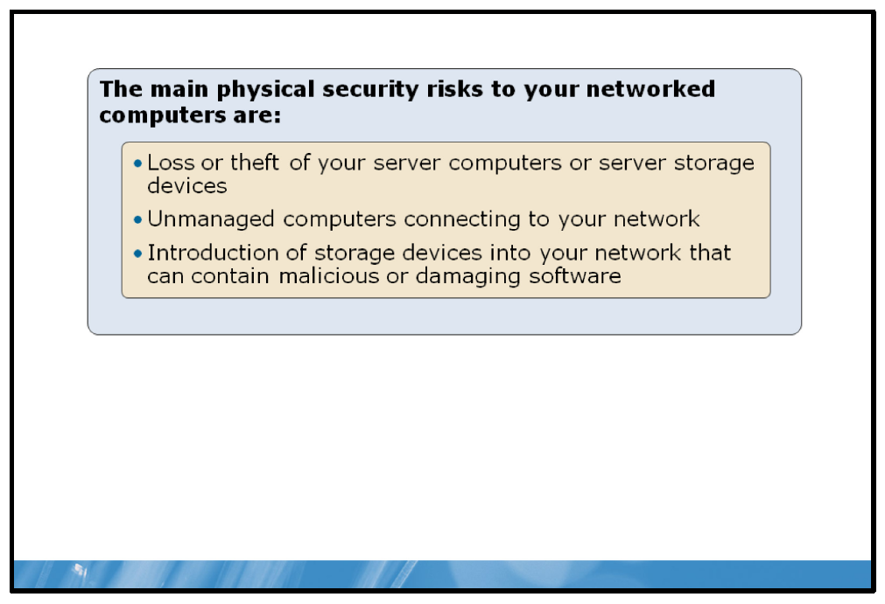

Key Points
Aside from physical damage to inappropriately located servers and potential resulting data loss, the main physical security risks to your networked computers are:
• | Data compromise arising from the loss or theft of your server computers or server storage devices.
• | Data compromise resulting from unmanaged computers connecting to your network.
• | Data compromise resulting from the introduction of storage devices into your network that can contain malicious or damaging software.

Physical Security Best Practices
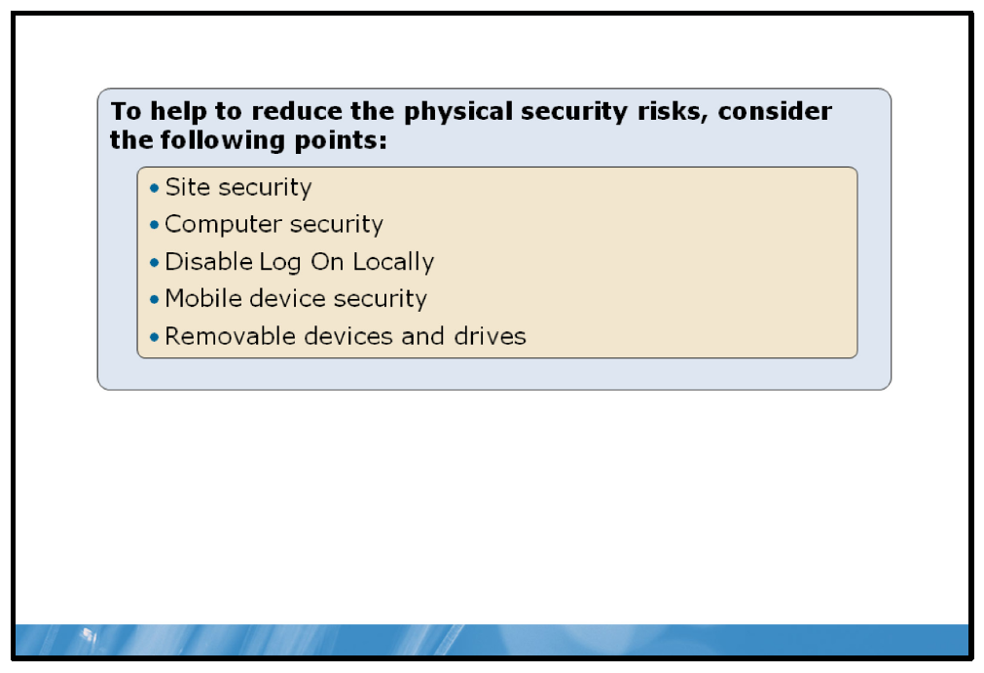

Key Points
To help to reduce the physical security risks, consider the following points:
• | Site security. Where possible, ensure that only authorized persons have access to the physical site where your computers are located. This is more difficult with branch offices, and also with certain commercial markets – such as retail.
• | Computer security. Ensure that server computers, or any computer that contains or has access to important data, are physically secure. Ideally, place servers and their storage devices in computer rooms that are protected by physical security mechanisms such as keypads. In high-security environments, consider implementing biometric security to ensure that only authorized persons can physically access your computers.
• | Disable Log On Locally. The ability to logon interactively at a computer is a right that is typically granted to all users for all computers in your forest with the exception of domain controllers.  Consider further restricting the right to Log on Locally where more security is required. If a user cannot logon, this diminishes their ability to perform actions on your network.
• | Mobile device security. Mobile devices, for example laptop computers and mobile phones, provide users with the convenience of being able to access the corporate network from anywhere. However, this raises the possibility that these devices might be lost or stolen. Ensure that you implement appropriate security on mobile devices so that in the event of their loss, data is not compromised. Consider implementing remote wipe technologies on mobile devices such as Windows Mobile handsets. Consider implementing EFS and BitLocker Drive Encryption on laptops.
• | Removable devices and drives. Consider very carefully whether the convenience of users being able to copy files to and from removable storage devices outweighs the security risk posed. If you decide that users will be allowed to use removable storage devices, consider implementing BitLocker-to-Go™ on these devices. This consideration will provide for data encryption on the device.

Implementing Physical Security with Windows Server Tools
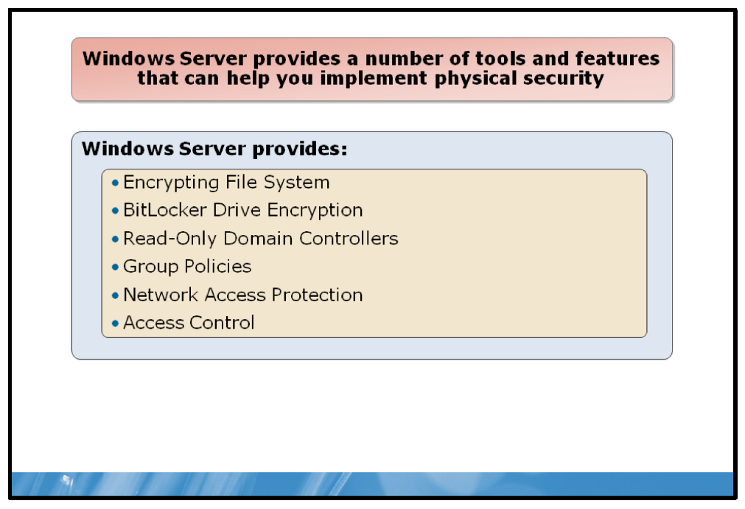

Key Points
Windows Server provides a number of tools and features that can help you implement physical security.

Encrypting File System
The EFS is the built-in file encryption tool for Windows file systems. A component of the NTFS file system, EFS enables transparent encryption and decryption of files by using advanced, standard cryptographic algorithms. Any individual or program that does not possess the appropriate cryptographic key cannot read the encrypted data. Encrypted files can be protected even from those who gain physical possession of the computer that the files reside on. Even persons who are otherwise authorized to access the computer and its file system cannot view the data.

BitLocker Drive Encryption
BitLocker provides protection for the computer operating system and data stored on the operating system volume by ensuring that data stored on a computer remains encrypted, even if the computer is tampered with when the operating system is not running. BitLocker provides a closely integrated solution in a Windows Server 2008 R2 operating system and Windows 7 to address the threats of data theft or exposure from lost, stolen, or inappropriately decommissioned personal computers.

Read-Only Domain Controllers (RODC)
RODC is a new type of domain controller in Windows Server 2008 R2. With an RODC, you can easily deploy a domain controller in locations where physical security cannot be guaranteed such as, a branch office. An RODC hosts a read-only replica of the database in AD DS for a given domain.
When an RODC services the logon request for a user on your network, that user’s credentials are cached at the server; only users’ accounts at the branch office are cached in this way. If the RODC is stolen, only this subset of your domain accounts is compromised making it easier and quicker for you to maintain user account security.
Note: By default, no user credentials are cached on the RODC. This is safer because in the event of the RODC being stolen, no user passwords are compromised. However, if the link between the head office, where the writable domain controllers exist, and the branch office fails, and caching is not enabled, users at the branch cannot logon until the link is reestablished.

Group Policies
If you allow users to add storage devices, such as universal serial bus (USB) memory sticks or external hard drives, to their network-attached computers, you may potentially introduce additional security risks. Windows Server can use group policy objects (GPOs) to enforce rules on network-attached computers that control or prohibit the addition of storage devices.

Network Access Protection
When you allow computers to connect to your network from unmanaged locations, such as users’ homes, or you allow computers from other organizations to connect to your network, you expose your network to security risks.
Your network is only as secure as the least secure computer attached to it. Many programs and tools exist to help you to secure your network-attached computers, such as antivirus or malware detection software. However, if the software on some of the connected computers is not up-to-date, or worse, not enabled or configured correctly, then these computers pose a security risk.
Computers that remain within your office environment and are always connected to the same network are relatively easy to keep configured and updated. Computers that connect to different networks, especially unmanaged networks, are less easy to control, for example, laptop computers that are connected to customer networks, or to public wireless fidelity (Wi-Fi) hotspots. In addition, unmanaged computers seeking to connect remotely to your network, such as users’ home computers, pose a challenge.
Network Access Protection (NAP) is a policy-enforcement platform that is built into the Windows 7, the Windows Vista® operating system, the Windows XP operating system with Service Pack 3 (SP3), and the Windows Server 2008 and Windows Server 2008 R2 operating systems. NAP allows you to more strongly protect network assets by enforcing compliance with system health requirements.
NAP provides the necessary software components to help ensure that computers connected or connecting to your network remain manageable, so they do not become a security risk to the network and other attached computers. This enables you to more confidently allow computers to connect to your network.

Access Control
Once computers have connected to your network and have access to your server data, you can protect the integrity of the data by configuring appropriate file permissions. Ensure that you only grant permissions where needed and grant the minimum permissions required. This is especially important in situations where users from outside your organization are connecting to your network.

Lesson 3: Internet Security
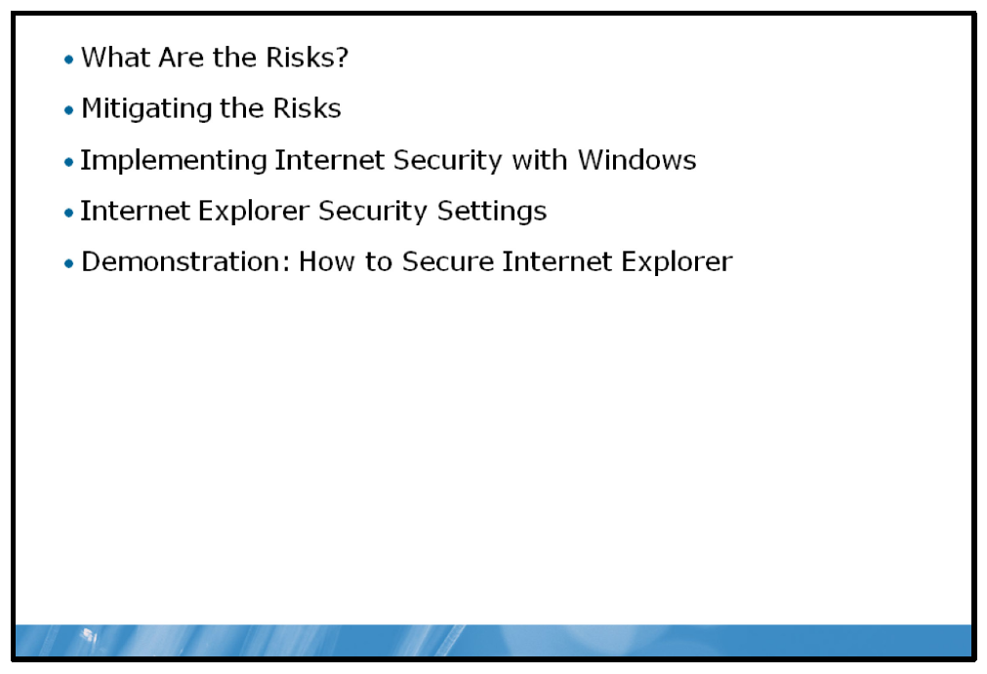
Internet access has become increasingly important in recent years, both for work productivity, and personal development and entertainment. As the demand for Internet connectivity grows, and users perform increasingly complex tasks on the Internet, there is an increase in related risks. This lesson explores the technologies and features available in Windows to help to protect your Windows-based computers while connected to the Internet.

Objectives
After completing this lesson, you will be able to:
• | Describe the risks posed by connecting to the Internet.
• | Describe possible mitigations to these risks.
• | Describe the Windows Server components and features that can help provide this Internet security.
• | Describe Windows Internet Explorer® (IE) security settings.
• | Configure IE security settings.

What Are the Risks?
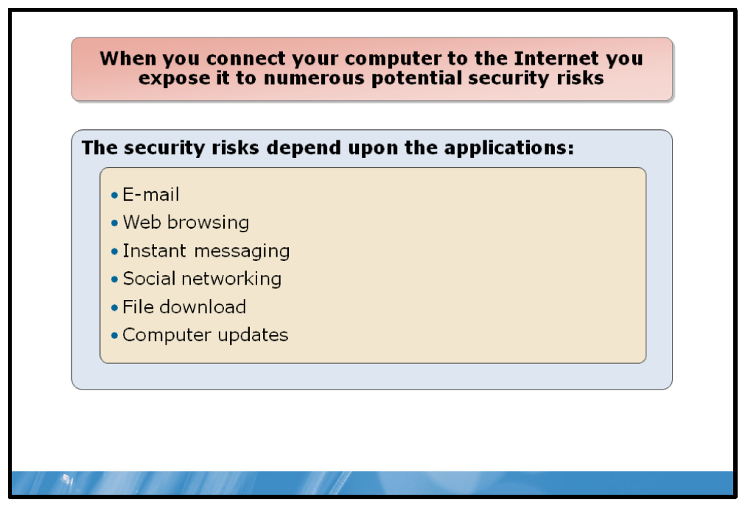

Key Points
When you connect your computer to any untrusted network, including the Internet, you expose it to numerous potential security risks. One way in which you can consider the security risks posed by the Internet is to consider the applications that you use when connected to the Internet. Common applications, and associated security risks, include:
• | E-mail. An e-mail message can contain a malicious payload; the message might contain:  It is also important to remember that almost all e-mail is sent in clear-text; that is, unencrypted. This means that if the message is intercepted, anyone can read and potentially modify the message contents. Additionally, most e-mail is transmitted between hosts that have no knowledge of one another. Consequently, most e-mail traffic is not authenticated making it more difficult to determine the true originator of a message.
  • | A malicious executable file that is attached to the message.
  • | A request for personal information.
  • | Inappropriate content.
  • | Embedded links to unsafe Web sites.
• | Web browsing. A Web site can hide numerous security risks including malicious programs. Common risks associated with Web sites include:  It is also important to be sure that you have navigated to the appropriate site rather than to a bogus site masquerading as a legitimate site.
  • | Plug-ins. These are applications designed to work with your browser to provide additional capabilities. For example, you can use plug-ins to enable your browser to view video files. They have the ability to expose security flaws in your browser.
  • | Active-X controls. These small programs are downloaded by your browser to enable it to perform a number of specialized tasks, including manipulating data files or viewing specific file types. Malicious Active-X controls can pose a security threat to your computer.
  • | Cross-site scripting. Enables malicious attackers to enable client-side scripts in Web pages that you computer is viewing, even when the Web site you are viewing is considered a safe source.
  • | Cookies. Cookies are used for authentication, session tracking, storage of Web site preferences, shopping cart contents, and many other potential uses. Because of the sensitive data stored in cookies, they have the potential to be misused by malicious individuals.
• | Instant Messaging (IM). This method of communicating with friends and colleagues is very popular. However, it has attracted the attention of malicious attackers. IM messages can contain links to unsafe Web sites or be used to initiate file transfers, remote control sessions, or share files and content on your computer.
• | Social networking. There are numerous social networking sites. These sites can pose the same security risks as any other Web site. However, it is important to remember that these sites exist as a way for you to share information, some of which may be personal information. Exercise caution when you share your personal information with others.
• | File download. Any file that you download from the Internet may come from an untrusted source and may contain harmful code. It is important that you only download files from trusted sources and that, where possible, files are digitally signed so that you can easily determine the files’ origin. This is especially relevant for device drivers as files of this type, if malicious, can have a far more detrimental effect on your computer.
• | Computer updates. It is common for software installed on your computer, including the operating system, to periodically check for and download updates. This is one way of ensuring that your computer is up-to-date, performs optimally, and remains secured through the application of security updates. However, software obtained from an untrusted source could use this update mechanism to download malicious code onto your computer. Ensure that you verify that the updates are safe.
In addition, simply connecting to the Internet exposes your computer to possible security risks. For example, if you connect to the Internet from your home or from the office, the chances are that the connection is reliable and reasonably secure. However, when you connect to the Internet from a location such as a wireless hotspot, you might expose your computer to additional security risks.
Also, bear in-mind that although the connection provided by the hotspot might, in itself, be secure, other computers that are connected to the network might be compromised by security flaws that might affect your computer. In addition, it is common for hotspots to provide an unsecured connection for easier wireless Internet access. However, under these circumstances, data that your computer sends and receives can be captured and accessed by third parties.

Mitigating the Risks
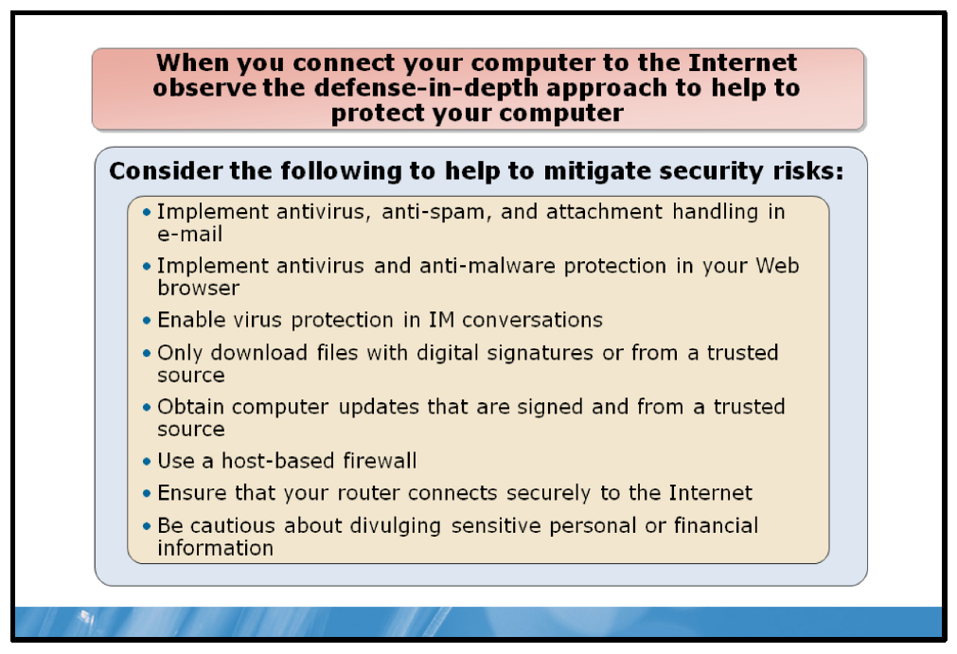

Key Points
You can help reduce the chances of your computer’s security being compromised if you observe the defense-in-depth approach when you connect your computer to the Internet.
When performing common tasks on the Internet, consider the following points to help mitigate security risks:
• | E-Mail. Implement e-mail software or use additional software with your e-mail software that supports the following important security features:
  • | Anti-spam control. Ensure that junk e-mail is either quarantined or deleted. Anti-spam software can identify spam messages using a variety of technologies.
  • | Antivirus control. Scan incoming and out-going messages for viruses. Ensure that you keep the virus software up-to-date to provide adequate protection against new and emerging threats.
  • | Attachment handling controls. Some e-mail software, such as Microsoft Office Outlook®, enables you to configure how attachments of specific types are handled. For example, you can configure the e-mail software to block attachments of a file type that can contain malicious code, also known as executable files.
• | Web browsing. A Web browser should provide the ability to select appropriate security settings based upon the trustworthiness of a Web site. For example, IE enables you to define security settings for different security zones, such as Internet, local intranet, trusted sites, and restricted sites. Security settings within the context of these zones include whether or not to download and run ActiveX® controls, scripting behavior, and how to handle signed or unsigned content.  It is also important to implement security software when you browse the Web. Suitable software should provide antivirus protection, protection against spyware, identity protection, and a link scanner that can help identify unsafe Web sites before you visit them.  Finally, be cautious when you shop online. Only use sites that you trust, that can provide a digital certificate to verify their identity, and that provide you with a redress should something go amiss with your order.
• | IM. Many security software packages provide protection against viruses in files that you might attempt to receive by an instant message. However, it is important that you are careful about the information that you divulge during an instant message conversation as these messages are often sent and received in clear text.
• | Social networking. It is important that you only divulge information through social networking sites that you are happy to see in the public domain. It is a good idea to limit the type of information that you share. For example, divulging details about your finances, combined with information about your address can give a malicious attacker sufficient information to steal your identity and commit fraud.
• | File download. You can limit your exposure to unsafe downloads by implementing antivirus software. Additionally, by only downloading files from trusted sources and files that provide a digital signature, you can help to reduce the security risk posed by downloads. Often, downloaded files may appear safe but actually contain code that can install additional software that harms your computer. Windows implements a security feature called User Account Control (UAC) that enables you to control unintended software installations.
• | Computer updates. To ensure that your computer updates are safe, only download updates from safe sources. Computers that are running either Windows 7 or Windows Server 2008 R2 obtain their updates from the Microsoft Web site or from a local server within your workplace organization running Windows Server Update Services (WSUS).
• | Connecting to the Internet. When you connect to the Internet, ensure that you have enabled a host-based firewall. Computers that are running either Windows 7 or Windows Server 2008 R2 implement the Windows Firewall with Advanced Security. When you first connect to a new network, such as a wireless hotspot, you must define whether the network is public or private. Windows Firewall with Advanced Security then adjusts the security settings based upon your selection.  In addition to a host-based firewall, it is also advisable to ensure that the router that connects to the Internet provides additional protection. Typical home-office asymmetric digital subscriber line (ADSL) routers provide NAT and firewall functionality.

Implementing Internet Security with Windows
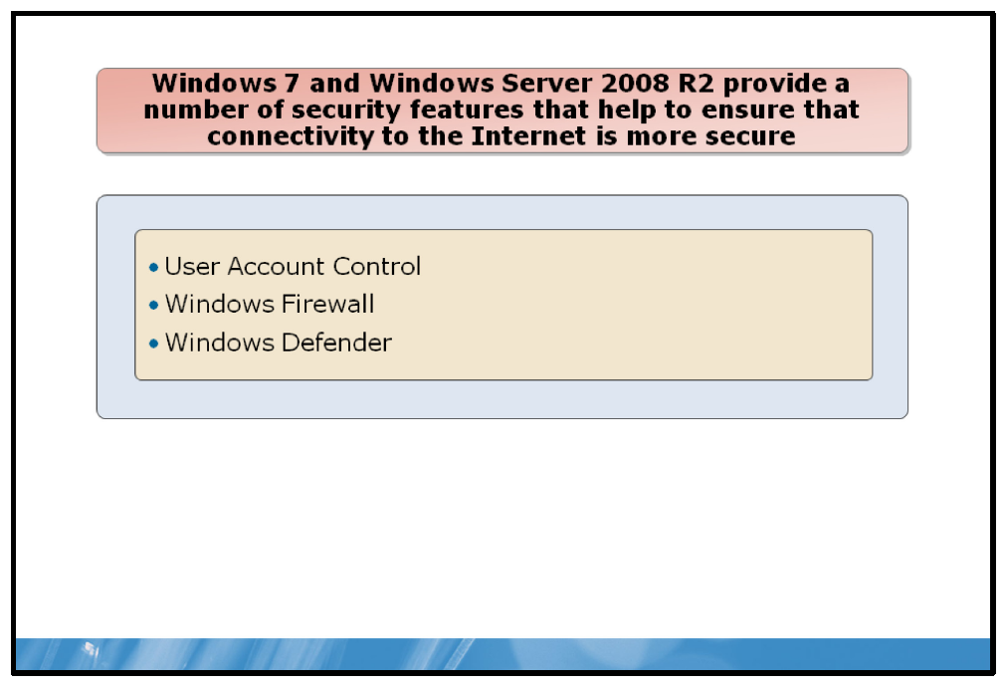

Key Points
Windows 7 and Windows Server 2008 R2 provide a number of security features that help to ensure that connectivity to the Internet is more secure.

UAC
UAC is a security feature that provides a way for each user to elevate their status from a standard user account to an administrator account without logging off, switching users, or using the Run As command.
UAC is a collection of features rather than just a prompt. These features, including File and Registry Redirection, Installer Detection, the UAC prompt, and the ActiveX Installer Service, enable Windows users to run with user accounts that are not members of the Administrators group. These accounts are generally referred to as standard users and are broadly described as running with least privilege.
When a change is made to your computer that requires administrator-level permissions, UAC notifies you as follows:
• | If you are an administrator, click Yes to continue.
• | If you are not an administrator, someone with an administrator account on the computer will have to enter his or her password for you to continue.
If you are a standard user, providing permission temporarily gives you administrator rights to complete the task and then your permissions are returned back to standard user when you are finished. This ensures that even if you are using an administrator account, changes cannot be made to your computer without your knowledge. This security can help prevent malicious software and spyware from being installed on or making changes to your computer.

Windows Firewall
Windows Firewall is a host-based, stateful firewall included in Windows Server 2008 R2. It drops incoming traffic that does not correspond to traffic sent in response to a request (solicited traffic) or unsolicited traffic that has been specified as allowed (accepted traffic). Windows Firewall helps provide protection from malicious users and programs that rely on unsolicited incoming traffic to attack computers. Windows Firewall can also drop outgoing traffic and is configured using the Windows Firewall with Advanced Security snap-in, which integrates rules for both firewall behavior and traffic protection with IPsec.

Windows Defender
Windows Defender in Windows 7 helps protect you from spyware and malicious software. Windows Defender is not antivirus software. Windows Defender offers three ways to help keep spyware from infecting the computer:
• | Real-time protection is the mechanism that actively monitors for malware and alerts you when potentially unwanted software attempts to install itself or to run on the computer. It also alerts you when programs attempt to change important Windows settings.
• | The SpyNet community helps you see how other people respond to software that has not yet been classified for risks. When you participate, your choices are added to the community ratings to help other people choose what to do.
• | Scanning options are used to scan for unwanted software on the computer, to schedule scans on a regular basis, and to automatically remove any malicious software that is detected during a scan.

Internet Explorer Security Settings
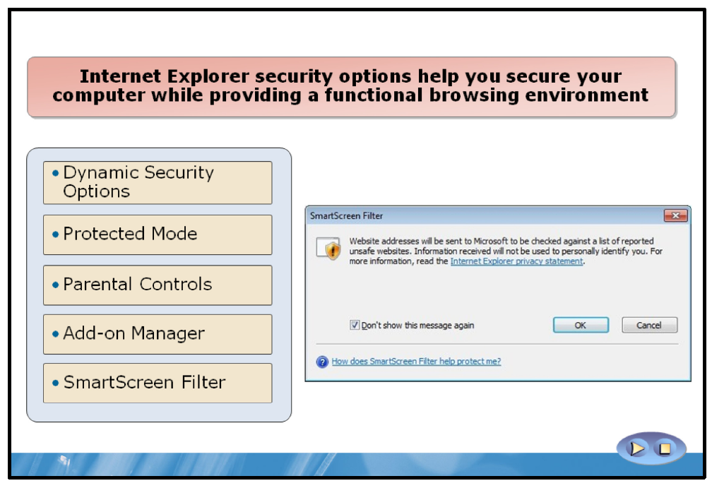

Key Points
IE security options help you secure your computer while providing a functional browsing environment. IE has new functionality that helps protect computers against malicious software, and helps protect users against data theft from fraudulent Web sites. In addition, IE comes with safe and easy add-on functionality that gives users full control over adding functionality to their online experiences, while at the same time avoiding inadvertent, unwanted software downloads.

Dynamic Security Options
The following table describes the most important Dynamic Security options that you can configure for IE.
Dynamic security  options | Use
ActiveX Opt-in | Disables nearly all pre-installed ActiveX controls to prevent potentially vulnerable controls from being exposed to attack. You can easily enable or disable ActiveX controls as needed through the Information Bar and the Add-on Manager.
Security Status Bar | Enhances Web site security and privacy settings awareness by displaying color- coded notifications next to the address bar. Internet Explorer changes the Address  Bar to green for Web sites bearing new High Assurance certificates, indicating that the site owner has completed extensive identity verification checks. Microsoft  Phishing Filter notifications, certificate names, and the gold padlock icon are now also adjacent to the address bar for better visibility. Certificate and privacy detail information can easily be displayed with a single click on the Security Status Bar.
SmartScreen® Filter | Protects you against phishing sites, warns you when visiting potential or known fraudulent sites, and blocks the site if required. The opt-in filter updates several times per hour with the latest security information from Microsoft, and several industry partners.
Cross-Domain Barriers | Limits scripts on Web pages from interacting with content from other domains or windows. This enhanced safeguard helps protect the computer against malicious software by limiting malicious Web sites from potentially manipulating flaws in other Web sites, or causing you to download undesired content or software.
Delete Browsing History | Allows you to clean up cached pages, passwords, form data, cookies, and history.
Address Bar Protection | Displays an address bar for every window—whether pop-up or standard—to help  block malicious sites from emulating trusted sites.
International Domain Name Anti-  Spoofing | Adds support for International Domain Names in Uniform Resource Locators (URLs), and notifies you when visually similar characters in the URL are not expressed in the same language. Thus it protects you against sites that could otherwise appear as known, trustworthy sites.
URL Handling Security | Redesigned URL parsing ensures consistent processing and minimizes possible exploitation. The new URL handler helps centralize critical data parsing, and increases data consistency.
Fix Settings for Me | Warns you with an Information Bar when current security settings may put you at risk, which can prevent you from browsing with unsafe settings. Within the Internet Options dialog box, certain items are highlighted in red when they are not safely configured. In addition, this option issues reminders that the settings remain unsafe. You can instantly reset Internet security settings to the Medium- High default level by clicking Fix Settings for Me in the Information Bar.
Add-ons Disabled Mode | Helps you troubleshoot difficulties in launching IE, or in reaching specific Web sites, by causing Internet Explorer to start in  No Add-ons mode, in which only critical system Add-ons are enabled.

Protected Mode
Protected mode in the Windows Vista security infrastructure is one of the important new IE security features. Protected mode provides IE with the rights needed to browse the Web, while simultaneously withholding rights needed to silently install programs or modify sensitive system data. In addition, Protected mode helps protect against malicious downloads by restricting the ability to write to any local machine zone resources other than temporary Internet files. Web-based software cannot write to any location other than the Temporary Internet Files folder without explicit user consent.
Running programs with limited user rights rather than administrator rights offers better protection against attacks, because Windows can restrict the malicious code from performing damaging actions. This additional defense helps ensure that scripted actions or automatic processes cannot download data to locations other than directories with lower rights, such as the Temporary Internet Files folder.
Although Protected mode does not protect against all forms of attack, it significantly reduces the ability of an attack to write, alter, or destroy data on the user's computer, or to install malicious code.

Parental Controls
To help keep children safer online, parents can control browsing behavior through the Parental Control settings built into Windows Vista. You can monitor a child's activities and remotely change the restriction levels. You can apply a restriction to many activities on the computer, such as playing games or browsing the Internet. You can also examine a child's browsing session afterwards; the child lacks the necessary permissions to remove their session history.
Note: | Parental Control settings are only available if the computer is not a member of a domain.

Add-on Manager
The Internet Explorer Add-on Manager is designed to give you greater control over IE add-ons.
Add-ons are a great way to introduce new functionality to your online experience. However, add-ons are also a great way of introducing malicious software to your computer. You can use the Add-on Manager to display:
• | Add-ons that have been used by IE.
• | Add-ons currently loaded in IE.
• | Add-ons that run without requiring permission.
• | Downloaded ActiveX controls.
You can then selectively enable or disable these add-ons, and delete any ActiveX controls.

SmartScreen Filter
Businesses put a lot of effort into protecting computer assets and resources. Phishing attacks, otherwise known as social engineering attacks, can evade those protections and result in users giving up personal information. The majority of phishing scams target individuals in an attempt to extort money or perform identity theft.
With the introduction of the SmartScreen Filter, Internet Explorer 8 builds on the Phishing Filter technology introduced in Internet Explorer 7. The Phishing Filter was designed to warn users when they attempt to visit known phishing sites. The SmartScreen Filter replaces the Phishing Filter and helps protect against phishing Web sites, other deceptive sites, and sites known to distribute malware.
The SmartScreen Filter improves upon the Phishing Filter by providing:
• | An improved user interface.
• | Faster performance.
• | New heuristics and enhanced telemetry.
• | Anti-malware support.
• | Improved Group Policy support.

Demonstration: How to Secure Internet Explorer
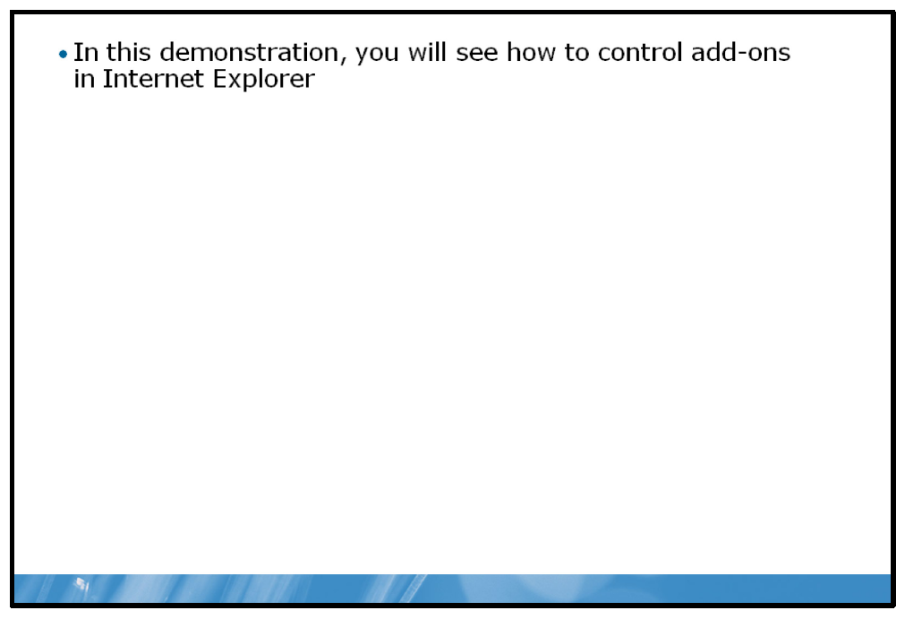

Key Points
In this demonstration, you will see how to disable an add-on.

Demonstration Steps:
1. | View a Web page that uses an ActiveX control.
2. | Disable the control.
3. | View the Web page again to verify the add-on is disabled.

Lab: Implementing IT Security Layers
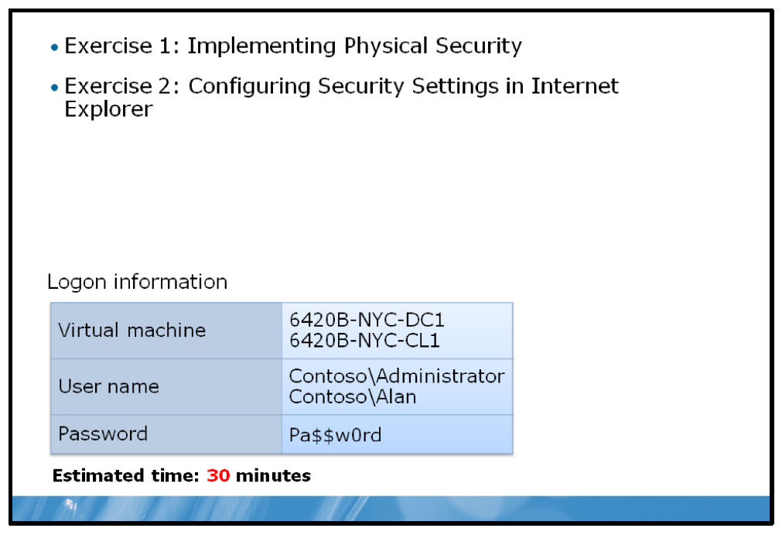

Lab Setup
For this lab, you will use the available virtual machine environment. Before you begin the lab, you must complete the following steps:
1. | On the host computer, click Start, point to Administrative Tools, and then click Hyper-V Manager.
2. | In Hyper-V™ Manager, click 6420B-NYC-DC1, and in the Actions pane, click Start.
3. | In the Actions pane, click Connect. Wait until the virtual machine starts.
4. | Log on using the following credentials:
  • | User name: Administrator
  • | Password: Pa$$w0rd
  • | Domain: Contoso
5. | Repeat these steps 2 and 3 for 6420B-NYC-CL1.
6. | Log on using the following credentials:
  • | User name: Alan
  • | Password: Pa$$w0rd
  • | Domain: Contoso

Lab Scenario
Alan Brewer has visited various Research department branch offices. On his return to the head office of Contoso, Ltd, he produced a list of security concerns and sent them by e-mail to Ed Meadows, your boss. Ed has tasked you with the resolution of these issues.

Exercise 1: Implementing Physical Security

Scenario
The security issues revolve around the fact that many of the branch offices cannot be physically secured. Once you have completed the incident record, make proposals about how best to address Alan’s concerns over physical security.
The main tasks for this exercise are as follows:
1. | Read the supporting documentation.
2. | Complete the Incident Record.

Supporting Documentation
Contoso Network Security Policy – Laptops
Document Reference Number: EM220109/1
Document Author Date | Ed Meadows  22nd January
Overview
This document defines the corporate policy regarding laptops and other portable computing devices within Contoso, Ltd.
Policies
1. | Any network device that is moved from the office of Contoso, Ltd. must be configured in such a way that loss of the device does not lead to a compromise of the stored data.
2. | Laptops can connect to other networks provided:
  a. | A suitable firewall is in place.
  b. | The computer is up-to-date with security updates.
  c. | Protection against viruses and malware is installed.
3. | Portable storage devices are permitted for use on laptops as long as their loss does not compromise the data stored on them.

E-mail thread of correspondence with Ed Meadows:
Charlotte Weiss
From: |  | Ed Meadows [Ed@contoso.com]
Sent: |  | 6 May 2010 12:01
To: |  | Charlotte@contoso.com
Subject: |  | RE: Branch offices security concerns
Attached: |  | Incident Record
Charlotte,
Please look at the attached incident record and review Alan’s concerns. Get a plan together for resolving these security concerns. Thanks,
Ed
 | ----- Original Message -----
 | From: | Alan Brewer [Alan@Contoso.com]
 | Sent: | 5 May 2010 11:45
 | To: | Ed@Contoso.com
 | Subject: | Branch offices security concerns
Ed,
I just got back from the branches. I’m pretty worried that, given the sensitive nature of the data we handle in Research, physical security is pretty lax compared with the head office. I have listed my main concerns below:
• | Laptops are used by research staff; they often take these home.
• | In some branches there is no dedicated room for the servers.
• | We often let external contract staff connect their own computers to our research networks.
• | I notice that some personnel bring music files on USB drives into the offices.
Regards, Alan

Task 1: Read the supporting documentation
1. | Read e-mail and the attached incident record with a view to determining the possible problem causes.
2. | Read the Contoso Network Security Policy – Laptops document with a view to determine if you must enforce any changes at the branch based on corporate policies.

Task 2: Complete the incident record
1. | Answer the questions in the incident record.
2. | Complete the Resolution section of the incident record.
  Contoso Incident Record
  Incident Reference Number: 501285
  Called logged by Date of call  Time of call  User | Ed Meadows  10th May  10:50  Alan Brewer
  Status | OPEN
  Incident Details
  Call logged by Information Technology (IT) manager following inquiries at branch offices concerning physical security problems raised by Research department manager, Alan Brewer. Reported concerns:
  1. | Laptops are used by research staff and they often take these home.
  2. | In some branches there is no dedicated room for the servers.
  3. | External contract staff can connect their own computers to the research networks.
  4. | Staff uses personal USB storage devices on work computers.
  Questions
  1. | What security policies apply to the branch office laptops as defined in the Contoso Network Security Policy – Laptops document?
  2. | What security concerns do you have about the branch offices?
  3. | How would you address the concerns you might have about laptop computer use?
  4. | How would you address the concerns you might have about the lack of dedicated server computer rooms?
  5. | How would you address the concerns you might have about contractor computer use?
  6. | How would you address the concerns you might have about removable storage devices?
  7. | Complete the resolution section below with a summary of your proposals.
  Resolution
Results: | After this exercise, you should have completed the incident record.

Exercise 2: Configuring Security Settings in Internet Explorer

Scenario
When Alan returned from the branch offices, he had a few problems with his laptop computer. You determined that these problems were related to his laptop’s Internet Explorer settings. You must verify the settings are appropriate.
The main tasks for this exercise are as follows:
1. | Verify current Internet Explorer security settings.
2. | Change the Intranet Zone security settings.
3. | Test the Security changes.
4. | Add the Web site to the Trusted Sites List.
5. | Test the Security Zone change.

Task 1: Verify current Internet Explorer security settings
1. | Switch to the NYC-CL1 computer.
2. | Open Internet Explorer.
3. | What is the current security level for the Local intranet zone?

Task 2: Change the Intranet Zone security settings
1. | Change the security settings for the Local intranet zone to High.
2. | Enable Protected Mode for the Local intranet zone.
3. | Close Internet Explorer.

Task 3: Test the security changes
Note: |  |  | If the Welcome to Internet Explorer 8 dialog box appears, click Ask me later.
 | 1. | Open Internet Explorer.
 | 2. | Navigate to http://nyc-dc1/intranet .
 | 3. | What is the security zone of this Web site?
 | 4. | On the Contoso Intranet Home page, click Current Projects.  Question: Did the web page load successfully?  Question: In Manage Add-ons, can you see the Tabular Data Control Add-on?
 | 5. | Close the Contoso Projects web page.

Task 4: Add the Web site to the Trusted Sites List
Question: What is the current security level for the Trusted sites zone?
• | Add the http://nyc-dc1 site to the Trusted sites list.

Task 5: Test the Security Zone change
1. | On the Contoso Intranet Home page, click Current Projects.  Question: Did the projects list populate?  Question: In Manage Add-ons, can you see a Tabular Data Control Add-on?
2. | Close Internet Explorer.
Results: | After this exercise, you should have modified Internet Explorer security settings.

To prepare for the next module
When you finish the lab, revert the virtual machines back to their initial state. To do this, complete the following steps:
1. | On the host computer, start Hyper-V Manager.
2. | Right-click 6420B-NYC-DC1 in the Virtual Machines list, and then click Revert.
3. | In the Revert Virtual Machine dialog box, click Revert.
4. | Repeat these steps for 6420B-NYC-CL1.
5. | In the Virtual Machines pane, click 6420B-NYC-DC1, and then in the Actions pane, click Start.
6. | To connect to the virtual machine for the next module’s lab, click  6420B-NYC-DC1, and then in the Actions pane, click Connect.  Important: Start the 6420B-NYC-DC1 virtual machine first, and ensure that it is fully started before starting the other virtual machines.

Module Review and Takeaways
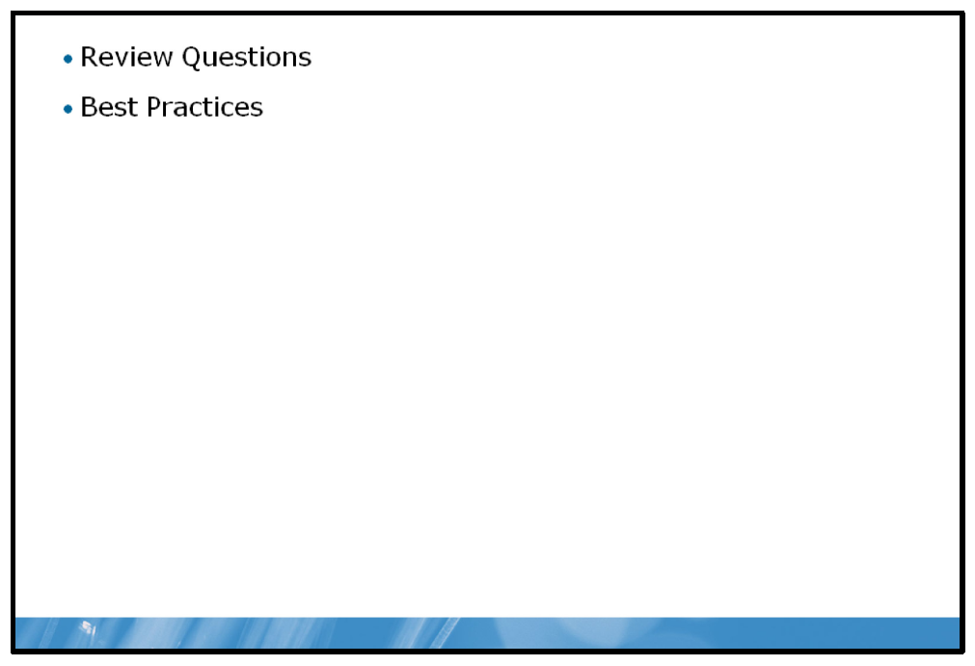

Review Questions
1. | Why is it important to educate your users about your organization’s acceptable use policy?
2. | How could you help to reduce the risk that your wireless network is the target of unauthorized packet sniffing?
3. | What are the risks associated with allowing your users to connect their laptops to Wi-Fi hotspots?

Best Practices for Implementing Defense-in-Depth
Supplement or modify the following best practices for your own work situations:
• | Create specific rules that help prevent social engineering and educate users on these rules and their relevance.
• | Restrict physical access to servers by locking doors and then monitor server room access.
• | Implement firewalls at network boundaries.
• | Implement NAT.
• | Use VPNs and implement network encryption.
• | Segment the network.
• | Require mutual authentication.
• | Restrict switch ports and wireless access points based on MAC address or client certificates.
• | Harden operating systems.
• | Monitor access attempts.
• | Implement antivirus and anti-spyware software.
• | Implement host-based firewalls.
• | Run applications with the least privileges possible.
• | Install security updates.
• | Enable only required features and functionality.
• | Implement and configure suitable NTFS file system permissions.
• | Implement file and/or volume encryption.
• | Implement rights management.

- Highlight
- Note
- Expand Highlight
- Expand Note
Module 9: Implementing Windows Server Security
Contents:
Lesson 1: | Overview of Windows Security
Lesson 2: | Securing Files and Folders
Lesson 3: | Implementing Encryption
Lab: | Implementing Windows Security

Module Overview
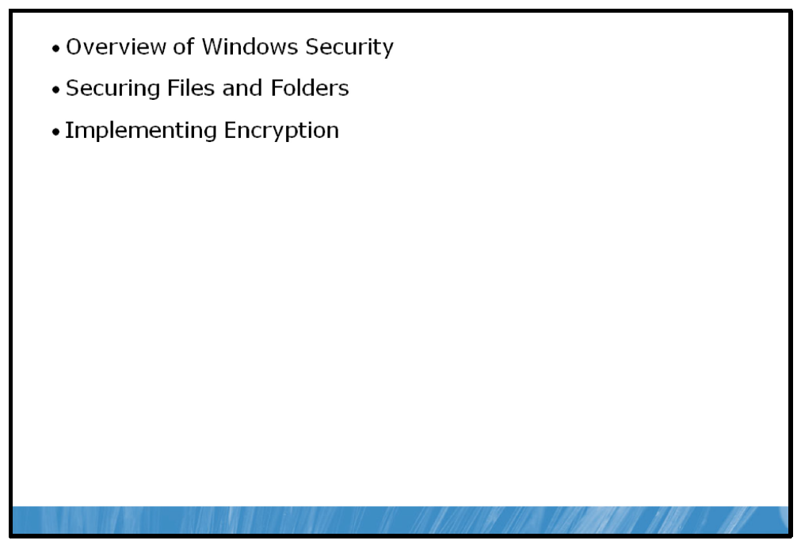
As organizations expand the availability of network data, applications, and systems, it becomes more challenging to ensure network infrastructure security. Security technologies in the Windows Server® 2008 R2 operating system enable organizations to provide better protection for their network resources and organizational assets in increasingly complex environments and business scenarios. This module reviews the tools and concepts available for implementing security within a Microsoft® Windows® infrastructure.

Objectives
After completing this module, you will be able to:
• | Describe the features in Windows Server 2008 R2 that help improve your network’s security.
• | Explain how to secure files and folders within a Windows Server environment.
• | Explain how to use the encryption features provided by Windows Server 2008 R2 to secure access to resources.

Lesson 1: Overview of Windows Security
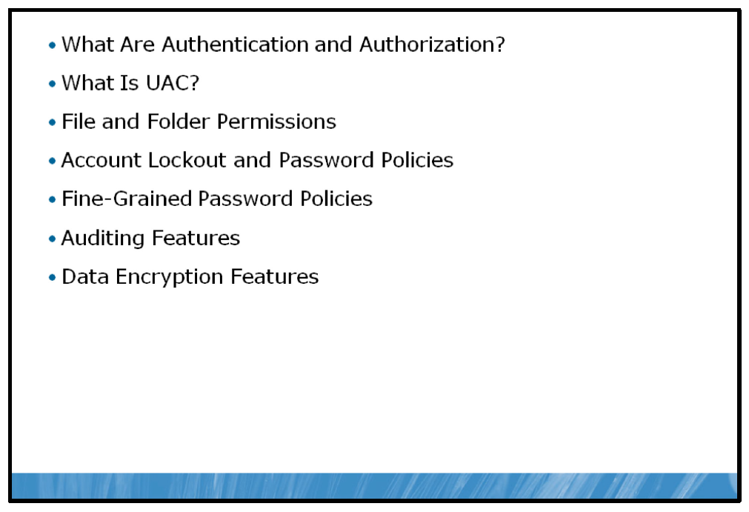
Windows Server 2008 R2 includes numerous features that provide different methods for implementing security. These features combine together to form the core of Windows Server 2008 R2’s security functionality. Understanding these features and their associated concepts as well as being familiar with their basic implementation is critical to maintaining a secure environment.

Objectives
After completing this lesson, you will be able to:
• | Describe authentication and authorization.
• | Describe User Account Control (UAC).
• | Describe file and shared folder permissions.
• | Describe account lockout and password policies.
• | Describe Fine-Grained Password Policies.
• | Describe auditing features.
• | Describe encryption.

What Are Authentication and Authorization?
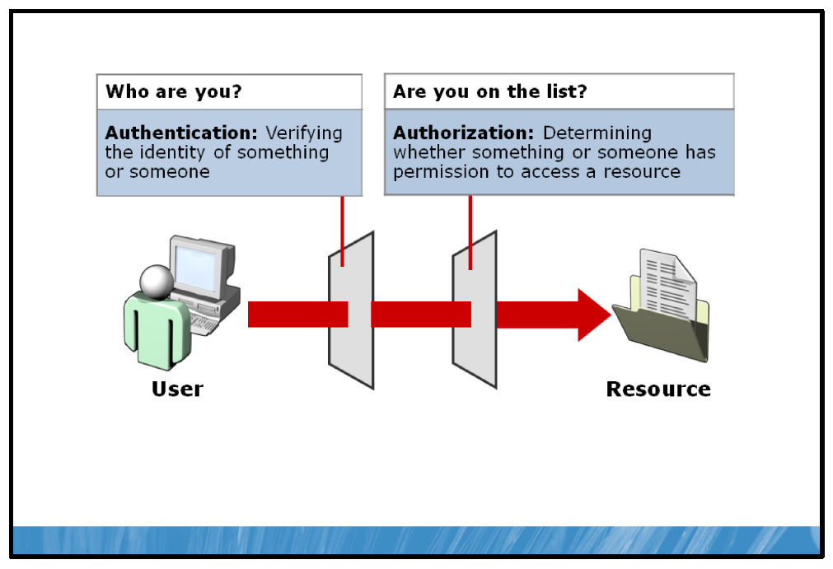

Key Points
Windows Server 2008 R2 security at the user level is centered around user accounts, which are typically identified by a username and verified with a password. The username and password combination allows a user to gain access to network resources as specified by the user account’s permissions. This process is typically broken down into two components: authentication and authorization.

Authentication
Authentication is the process of confirming that something is authentic. Authentication distinguishes legitimate users from uninvited guests, and is the most visible and fundamental concept in security. In private and public computer networks (including the Internet), the most common authentication method used to control access to resources involves verification of a user’s credentials; that is, a username and a password.
However, the username and password combination is only the most basic form of authentication. Other mechanisms and tools can also be used in the Windows Server 2008 R2 environment to add multiple layers to the authentication process to ensure that user’s identities on your network are legitimate and secure. Some of the key mechanisms available include:
• | Smart Cards. A smart card refers to a card-shaped device that contains specific digital information, in most cases used to specifically identify an individual. Smart cards can be used as an additional means of security when combined with a username and password. For example, an organization may issue smart cards to administrative users, requiring them to use a username and password as well as the smart card to log in when using accounts with elevated administrative permissions. This combination provides an extra measure of security for the usage of those accounts.
• | Biometrics. The term biometrics refers to the measuring of an unchanging physical or behavioral characteristic to uniquely identify a given person. Fingerprints are the most common form of implemented biometrics. Other possibilities include facial recognition, iris scanning, and voice recognition. Biometrics are most commonly used in conjunction with a username and password to provide an added measure of security in environments where highly sensitive data is involved. Biometrics can also be used as the sole means of authentication, and, due to the personal nature of authentication, are considered more secure than smart cards.
• | Public key infrastructure (PKI). PKI refers to the infrastructure required to use mathematically related digital “keys” in the process of encrypting and decrypting data. PKI will be covered in more detail later in this module.
• | Remote Authentication Dial-In User Service (RADIUS). Windows Server 2008 R2 contains support for RADIUS, a widely supported networking protocol that provides centralized management of authentication over multiple systems. RADIUS is most typically used to unify remote authentication to multiple, disparate systems. For example, an organization may use a virtual private network (VPN) server from Company A, be given access to network segments via routers from Company B and also be given access to Windows-based services and applications, all with one username and password.

Authorization
Authorization is the process of determining whether an identified user is permitted access to a resource and what the appropriate level of access is for that user. This could include authorization to read a file, authorization to modify file and folder properties, authorization to delete a file or folders, or a combination of these or many other permissions.
Authorization has two main components within Windows Server.
• | The initial definition of permissions for system resources by the owner of a specific resource or a system administrator
• | The subsequent checking of permission values by the system or application when a user attempts to access a system resource
It is important to note that it is possible to have authorization (access to resources) without first providing authentication (entering a username and password). This occurs many times in modern computing. For example, when you access a Web page on the Internet, you are accessing the resources on that Web server (pages, graphics, etc.) without providing any type of authentication to the Web server.

What Is UAC?
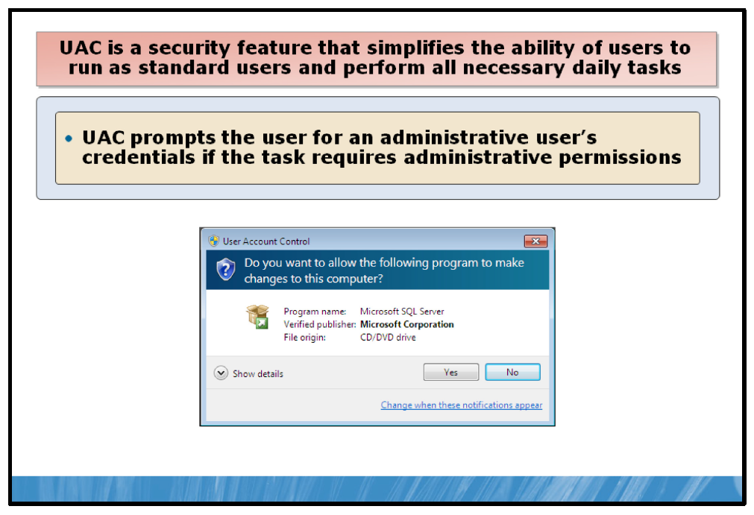

Key Points
Administrative accounts carry with them a large degree of security risk. When an administrative account is logged in, its privileges allow access to the entire Windows system, including the registry, system files and configuration settings. As long as an administrative account is logged in, the system is vulnerable to attack and has the potential to be compromised.
UAC provides a method by which all users can be aware of the way their account privileges are being used on the computer.

UAC in Windows Server 2008 R2
By default, both standard users and administrators access resources and run applications in the security context of a standard user.
The UAC prompt provides a way for a user to “elevate” his or her status from a standard user account to an administrator account without logging off or switching users, or using Run As… and creates a more secure environment for the running and installing of applications.
When an application requires administrator-level permission, UAC notifies you as follows:
• | If you are an administrator, you can click Yes to elevate your permission level and continue. This process of requesting approval is known as Admin Approval Mode.  Note: In Windows Server 2008 R2, the built-in Administrator account does not run in Admin Approval Mode. This results in no UAC prompts when using the local Administrator account.
• | If you are not an administrator, the username and password for an account that has administrative permissions needs to be entered. Providing administrative credentials temporarily gives you the administrative privileges required to complete the task. After the task is complete, your permissions are returned back to those of a standard user.
This process of notification and elevation of privileges makes it so that even if you are using an administrator account, changes cannot be made to your computer without you knowing about it, which can help prevent malicious software (malware) and spyware from being installed on or making changes to your computer.
UAC will allow certain system-level changes to occur without prompting, even when logged on as a local user:
• | Install updates from Windows Update.
• | Install drivers from Windows Update or those that are packaged with the operating system.
• | View Windows settings.
• | Pair Bluetooth devices with the computer.
• | Reset the network adapter and perform other network diagnostic and repair tasks.

Modifying UAC Behavior
The UAC notification experience can also be modified within the Windows Server 2008 R2 control panel to adjust the frequency and behavior of UAC prompts.
UAC can also be configured using Group Policy. The following Group Policy object (GPO) settings can be configured for UAC:
• | Administrator Approval Mode for the built-in Administrator account.
• | Behavior of the elevation prompt for administrators in Admin Approval Mode.
• | Behavior of the elevation prompt for standard users.
• | Detect application installations and prompt for elevation.
• | Only elevate executables that are signed and validated.
• | Only elevate UIAccess applications that are installed in secure locations.
• | Run all administrators in Admin Approval Mode.
• | Switch to the secure desktop when prompting for elevation.
• | Virtualize file and registry write failures to per-user locations.  Note: By default, UAC is not configured or enabled in Server Core installations of Windows Server 2008 R2.

File and Folder Permissions
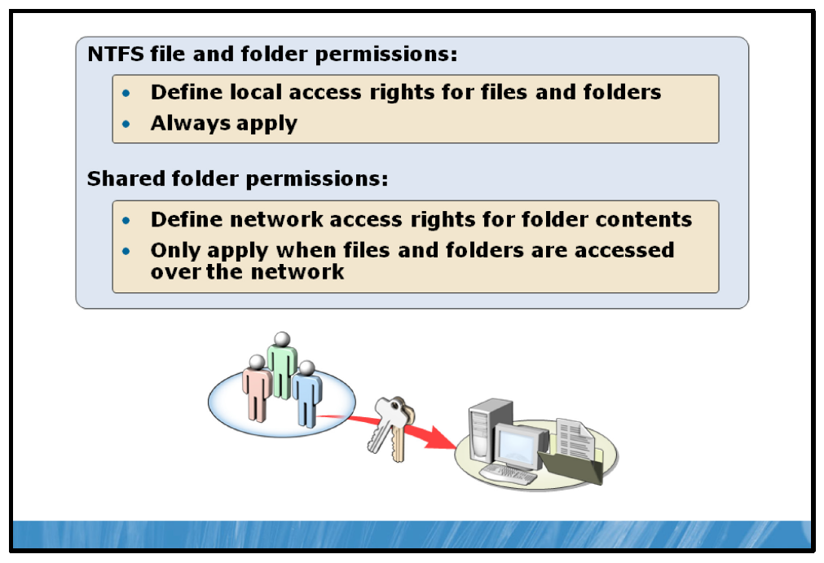

Key Points
The files and folders stored on a server can contain many different forms of data. As an administrator, you may not want all users on the network to be able to perform certain operations on specific files and folders. Once authenticated, a user in Windows Server 2008 R2 is given authorization to access such files and folders through file and folder permissions.
Two main categories of permissions exist in Windows Server 2008 R2.
• | NTFS file system file and folder permissions. NTFS permissions are assigned to files and folders on NTFS volumes and govern the access given to users who attempt to access the files. NTFS permissions are assignable to individual or sets of files and folders.
• | Shared folder permissions. When a local folder is shared or made accessible to the rest of the network, a separate set of permissions are assigned to the folder that control users accessing the files from a network location. Shared folder permissions are assignable only to a folder or group of folders, not to individual files.
• | Combined permissions. Shared folder permissions are combined with the NTFS file and folder permissions to provide a two-level set of permissions for that specific folder when accessed over the network.  Note: Both NTFS file and folder permissions and shared folder permissions have a variety of access levels that can be granted or denied to a specific user or group of users. These levels will be covered in detail later in this module.
Question: How do shared folder permissions affect access to local NTFS files and folders?

Account Lockout and Password Policies
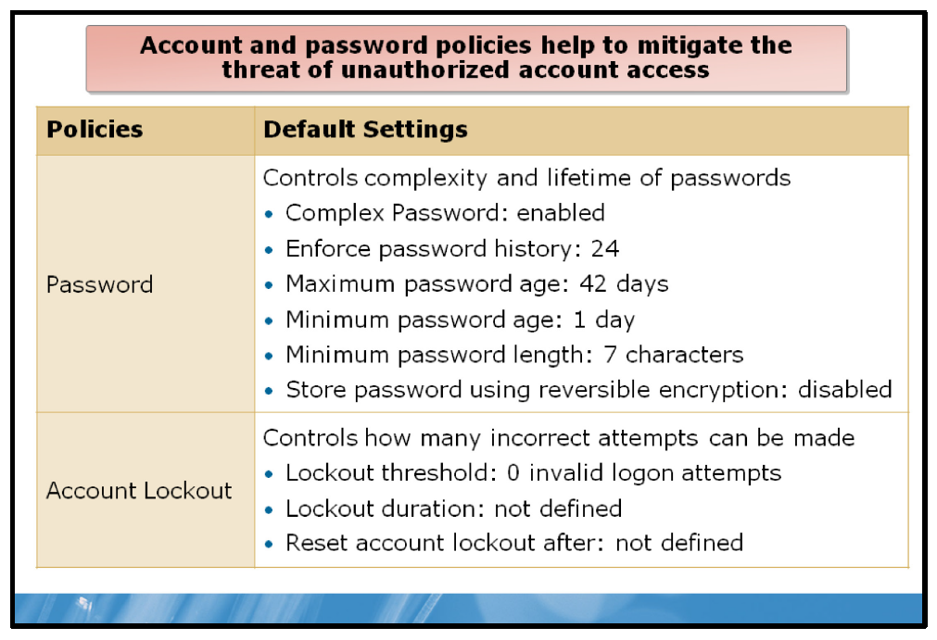

Key Points
The security provided by a password system depends on the passwords being kept secret at all times. Thus, a password is vulnerable to compromise whenever it is used, stored, or even known. In password-based authentication, this vulnerability presents a significant risk to system security.
You can help protect your system by customizing password policy settings, including requiring users to change their password regularly, specifying a minimum length for passwords, and requiring passwords to meet certain *complexity requirements.
A domain’s password policy settings are controlled by a number of GPO settings related to accounts and passwords.
You can help protect your computer or domain by customizing your password policy settings, including requiring users to change their password regularly, specifying a minimum length for passwords, and requiring passwords to meet certain complexity requirements.
Policy | What it does | Best practice
Password must meet complexity requirements | Requires that passwords: | Enable this setting. These complexity requirements can help ensure a strong password. Strong passwords are more difficult to crack than those containing simple letters or numbers.
  • | Be at least six characters long.
  • | Contain a combination of at least three of the following characters: uppercase letters, lowercase letters, numbers, symbols (punctuation marks).
  • | Do not contain the user's user name or screen name.
Enforce password history | Prevents users from creating a new password that is the same as their | Use a number that is greater than 1. Enforcing password history ensures
 | current password or a recently used password. To specify how many passwords are remembered, provide a value. For example, a value of 1 means that only the last password will be remembered, and a value of 5 means that the previous five passwords will be remembered. | that passwords that have been compromised are not used over and over.
Maximum password age | Sets the maximum number of days that a  password is valid. After this number of days, the user will have to change the password. | Set a maximum password age of 30- 70 days. Setting the number of days too high provides hackers with an extended window of opportunity to crack the password. Setting the number of days too low might be frustrating for users who have to change their passwords too frequently.
Minimum password age | Sets the minimum number of days that must pass before a password can be changed. | Set the minimum password age to at least  1 day. By doing so, you require that the user can only change their password once a day. This will help to enforce other settings. For example, if the past five passwords are remembered, this will ensure that at least five days must pass before the user can reuse their original password. If the minimum password age is set to 0, the user can change their password six times on the same day and begin reusing their original password on the same day.
Minimum password length | Specifies the fewest number of characters a password can have. | Set the length between eight and 12  characters (provided that they also meet complexity requirements). A longer password is more difficult to crack than a shorter password, assuming the password is not a word or common phrase.
Store passwords using reversible encryption | Stores the password using encryption that can be reversed in order for certain applications to verify the password. | Do not use this setting unless you use a program that requires it, enabling this setting decreases the security of stored passwords.
In addition, another group of GPO settings governing account lockout policies are available to control what actions are taken by the operating system if a user repeatedly fails to enter a valid password when logging on to the system. These are known as Account Lockout Policy settings.
Policy | What it does | Best practice
Account lockout | Specifies the number of failed | A setting between 3 and 5 will allow for
threshold | login attempts allowed before the account is locked out. For example, if the threshold is set to  3 the account will be locked out after a user enters incorrect login  information three times. | reasonable user error as well as limiting repeated login attempts for malicious purposes.
Account lockout duration | Allows you to specify a timeframe, in minutes, after which the account will automatically unlock and resume  normal operation. If you specify 0 the account will be locked out indefinitely until an administrator manually unlocks it. | Once the threshold has been reached and the account is locked out, the account should remain locked long enough to block or deter any potential attacks, but short enough not to interfere with productivity of legitimate users. A duration of 30 to 90 minutes should work well in most situations.
Reset account lockout counter after | Defines a timeframe for counting  the incorrect login attempts. If the policy is set for one hour and the account lockout threshold is set for three attempts, a user can enter the incorrect login information three times within one hour. If they enter the incorrect information twice, but get it correct the third time the counter will reset after one hour has elapsed (from the first incorrect entry) so that future failed attempts will again start counting at one. | Using a timeframe between 30 and 60 minutes is sufficient to deter automated attacks as well as manual attempts by an attacker to guess a password.
Note: Account Policy settings can be accessed by clicking on the Start button, clicking Run and typing secpol.msc into the Open dialog box.
Question: What would be the effect on a user’s account if they entered their password incorrectly fives times between 10:00AM and 10:25AM with the following settings applied to their account:
• | Account lockout threshold: 4
• | Account lockout duration: 60 minutes
• | Reset account lockout After: 30 minutes.

Fine-Grained Password Policies
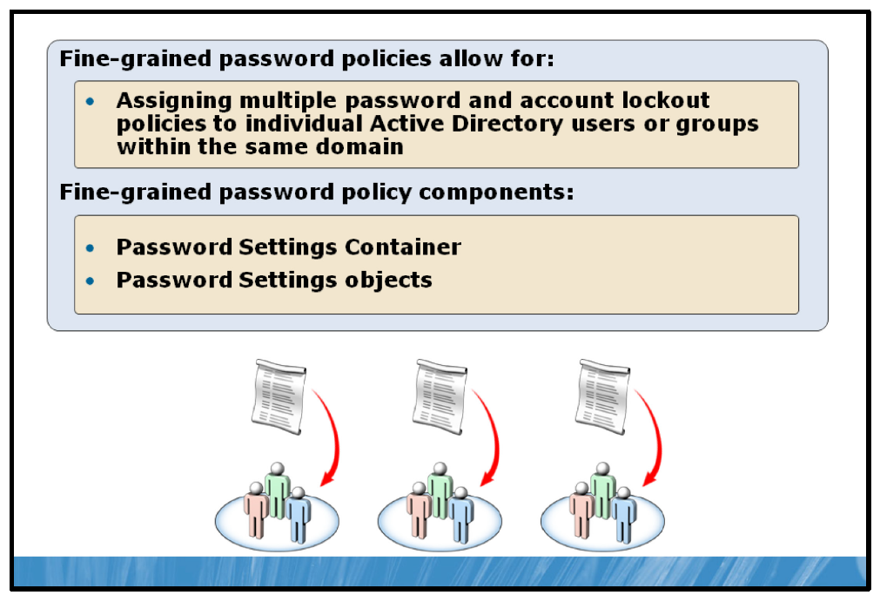

Key Points
In an Active Directory® Domain Services (AD DS) environment, standard password and account lockout policies are applied to the entire domain. This behavior may not be desired by organizations that require different password and account lockout policies for different users or groups.
Fine-grained password policies provide the solution to this issue. Fine-grained password policies allow an administrator to apply multiple, unique password policies to multiple users or groups within the same domain.
Individual fine-grained password policies are each stored within their own Active Directory object called a Password Settings object (PSO). All PSOs are stored within a parent container called a Password Settings Container (PSC). PSO stores policy information regarding password and account lockout policy settings are mentioned in the previous topic.
Passwords must meet the following complexity requirements:
• | Enforce password history
• | Maximum password age
• | Minimum password age
• | Minimum password length
• | Store passwords using reversible encryption
• | Account lockout duration
• | Account lockout threshold
• | Reset account lockout after
A PSO can be linked to one or more AD DS users or global security groups. Once linked, the setting defined within that PSO will apply to the linked users to groups.
Note: A PSO may not be linked to an Active Directory organizational unit (OU), only to AD DS users and groups.

Auditing Features
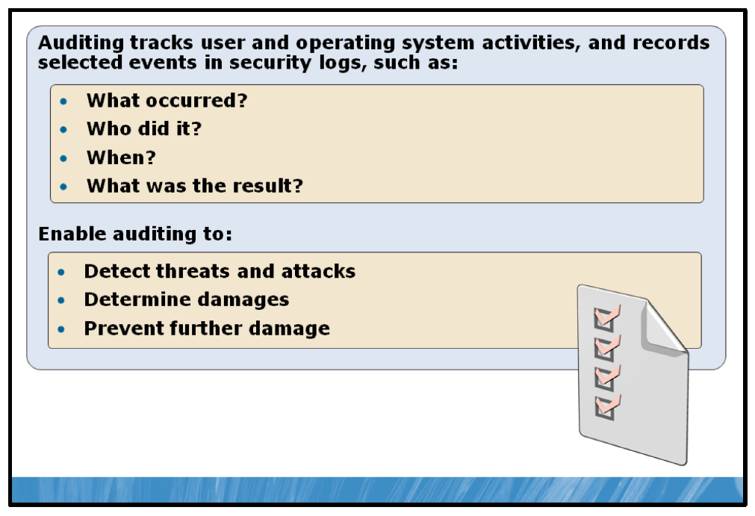

Key Points
Auditing is the process that tracks user activity by recording selected events in a security log. Auditing provides a recorded log of access and activity, allowing an administrator to determine whether or not resources are being accessed and utilized appropriately and according to policy. Auditing logs the following information regarding system activity:
• | What occurred?
• | Who did it?
• | When did the event occur?
• | What was the result?
The most common types of events to audit are:
• | Access to objects, such as files and folders.
• | Management of user and group accounts.
• | Users logging on and off the system.  Note: For example, you may want to monitor which users are accessing a specific document file and what type of operations they are performing on it (read, write, change permissions, etc.). When auditing is enabled within Windows for file and folder objects, you can configure auditing on the document file to record information for each time a user accesses the document in any way.

Data Encryption Features
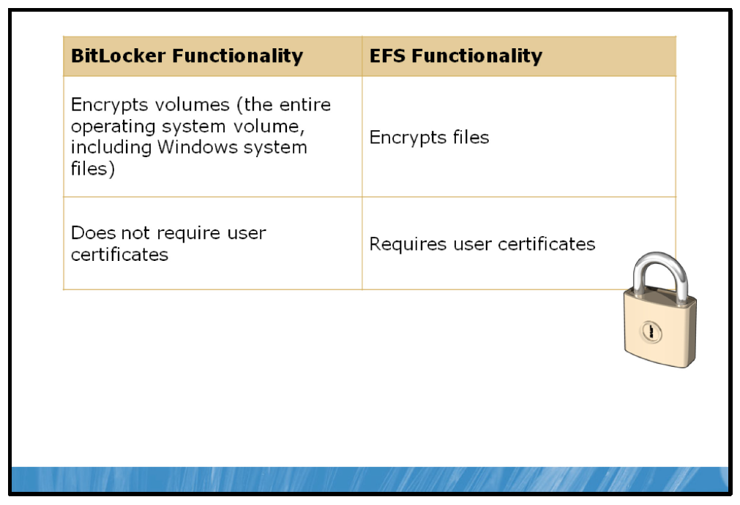

Key Points
Windows Server 2008 R2 provides features that provide both file and volume-level encryption.

Encrypting File System (EFS)
EFS provides core file level encryption for files and folders stored on NTFS volumes. EFS supports industry standard encryption algorithms and smart card–based encryption. By default, users generate self-signed encryption keys which allow for both the encryption and decryption of files or folders. Other users cannot view the contents of the files unless the key is made available to them.
EFS allows users to quickly and conveniently encrypt files or folders containing sensitive data, knowing the data will be secure regardless of file or folder permissions granted.
While EFS provides for the encryption of file contents, it does not encrypt file metadata such as file name, file size, file extension type or assigned permissions.

BitLocker
BitLocker® Drive Encryption is a system built into Windows Server 2008 R2 that provides for encryption of the entire operating system volumes as well as additional data volumes.
BitLocker-to-Go™ provides for the encryption of removable data drives like universal serial bus (USB) flash drives or portable hard drives.
Bitlocker utilizes keys for encryption in similar fashion to EFS, but provides for more options for key management. Users can store encryption keys on a removable USB drive, incorporate passkeys or incorporate a special hardware feature called Trusted Platform Module (TPM) to ensure that an encrypted volume only allows for decryption while attached to a specific system.
BitLocker’s features are designed to be simple to implement and allow for transparent file system access once fully configured.

Comparing BitLocker and EFS
The following table compares BitLocker and EFS encryption functionality:
BitLocker functionality | EFS functionality
Encrypts volumes (the entire operating system volume, including Windows system files and the hibernation file) | Encrypts files
Does not require user certificates | Requires user certificates
For example, EFS is used to protect individual files and folders that belong to a specific user, such as sensitive documents. The encryption process is commonly initiated by the user as well.
BitLocker, on the other hand, is used to encrypt entire volumes or hard disks and is useful for ensuring that the data on a disk in a server cannot be read in case it is removed and placed in another server.

Lesson 2: Securing Files and Folders
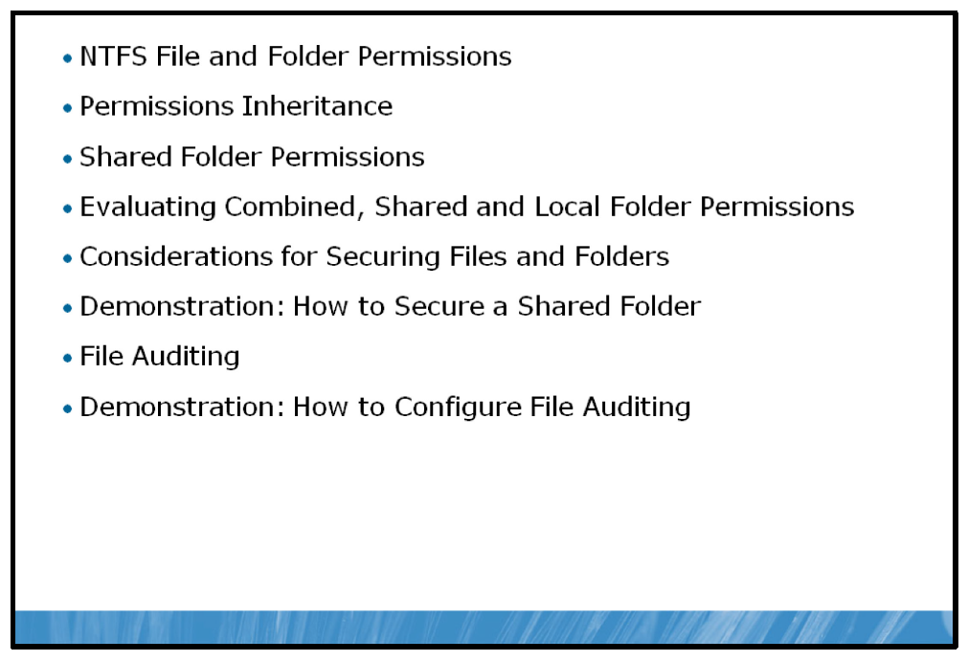
Ensuring data integrity and security is a fundamental aspect of a Windows Server 2008 R2 implementation. The assignment of proper permissions to users and groups for the resources they require access to is the first level of data security in a Windows Server environment.
This lesson covers the configuring of permissions, best practices for maintaining permissions functionality and auditing file and folder access to ensure that configured permissions are operating effectively.

Objectives
After completing this lesson, you will be able to:
• | Describe the available file and folder permissions on NTFS volumes.
• | Describe inheritance.
• | Describe shared folder permissions.
• | Explain how NTFS and shared folder permissions combine.
• | Implement best practice when sharing and securing files.
• | Secure shared files.
• | Describe file auditing.
• | Audit file access.

NTFS File and Folder Permissions
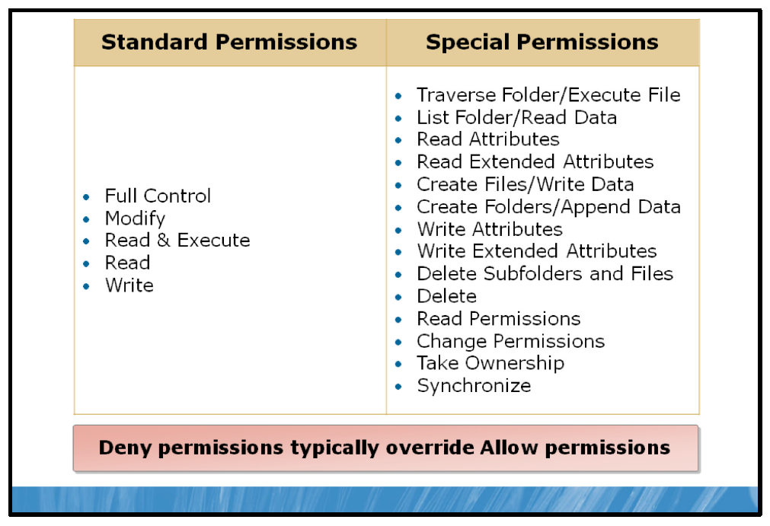

Key Points
NTFS file and folder permissions specify which users, groups, and computers can access files and folders on an NTFS volume. NTFS permissions also dictate what users, groups, and computers can do with the contents of the file or folder.
There are two types of NTFS permissions:
• | Standard. Standard permissions are the most commonly used permissions.
• | Special. Special permissions provide a finer degree of control for assigning access to files and folders; however, special permissions are more complex to manage than standard permissions.

Standard File and Folder Permissions
The following table lists the standard NTFS file and folder permissions. You can choose whether to allow or deny each of the permissions.
File permissions | Description
Full Control | This gives complete control of the file/folder and control of permissions.
Modify | This gives read and write access.
Read and Execute | Allows a file to be read and programs can be started.  Allows folder content to be seen and programs can be started.
Read | This give read only access.
Write | Allows file content to be changed and files can be deleted.  Allows folder content to be changed and files can be deleted.
Special permissions | Allows custom permissions configuration.
Note: Groups or users granted Full Control on a folder can delete any files in that folder regardless of the permissions protecting the file.
To modify NTFS permissions, you must be given the Full Control NTFS permission for a folder or file. The one exception is for file and folder owners. The owner of a file or folder can modify NTFS permissions even if they do not have any other current NTFS permissions. Administrators can always take ownership of files and folders to make modifications to NTFS permissions.

Special File and Folder Permissions
Special permissions give you a finer degree of control for assigning access to files and folders. However, special permissions are more complex to manage than standard permissions. The following table defines the special permissions that can be assigned for each file and folder:
File permissions | Description
Traverse Folder/Execute File | The Traverse Folder permission applies only to folders. This permission allows or denies the user from moving through folders to reach other files or folders, even  if the user has no permissions for the traversed folders. Traverse Folder takes effect only when the group or user is not granted the Bypass Traverse Checking user right. The Bypass Traverse Checking user right checks user rights in the Group Policy snap-in. By default, the Everyone group is given the Bypass Traverse Checking user right.  The Execute File permission allows or denies access to program files that are running.  If you set the Traverse Folder permission on a folder, the Execute File permission is not automatically set on all files in that folder.
List Folder/Read Data | The List Folder permission allows or denies the user from viewing file names and subfolder names in the folder. The List Folder permission applies only to folders and affects only the contents of that folder. This permission is not affected if the folder that you are setting the permission on is listed in the folder list. Also, this setting has no effect on viewing the file structure from the command-line interface.  The Read Data permission applies only to files and allows or denies the user from  viewing data in files.
Read Attributes | The Read Attributes permission allows or denies the user from viewing the attributes of a file or folder, such as read-only and hidden attributes. Attributes are defined by NTFS.
Read Extended Attributes | The Read Extended Attributes permission allows or denies the user from viewing the extended attributes of a file or folder. Extended attributes are defined by programs and can vary by program.
Create Files/Write Data | The Create Files permission applies only to folders and allows or denies the user from creating files in the folder.  The Write Data permission applies only to files and allows or denies the user from making changes to the file and overwriting existing content by NTFS.
Created Folders/Append Data | The Create Folders permission applies only to folders and allows or denies the user from creating folders in the folder.  The Append Data permission applies only to files and allows or denies the user from making changes to the end of the file but not from changing, deleting, or overwriting existing data.
Write Attributes | The Write Attributes permission allows or denies the user from changing the attributes of a file or folder, such as read-only or hidden. Attributes are defined by NTFS.  The Write Attributes permission does not imply that you can create or delete files or folders; it includes only the permission to make changes to the attributes of a file or folder. To allow or to deny Create or Delete operations, see Create Files/Write Data, Create Folders/Append Data, Delete Subfolders and Files, and Delete.
Write Extended Attributes | The Write Extended Attributes permission allows or denies the user from changing the extended attributes of a file or folder. Extended attributes are defined by programs and can vary by program.  The Write Extended Attributes permission does not imply that the user can create or delete files or folders; it includes only the permission to make changes to the attributes of a file or folder. To allow or to deny Create or Delete operations, view the Create Files/Write Data, Create Folders/Append Data, Delete Subfolders and Files, and Delete sections in this article.
Delete Subfolders and Files | The Delete Subfolders and Files permission applies only to folders and allows or denies the user from deleting subfolders and files, even if the Delete permission is not granted on the subfolder or file.
Delete | The Delete permission allows or denies the user from deleting the file or folder. If  you have not been assigned Delete permission on a file or folder, you can still delete the file or folder if you are granted Delete Subfolders and Files permissions on the parent folder.
Read Permissions | Read permissions allows or denies the user from reading permissions about the file or folder, such as Full Control, Read, and Write.
Change Permissions | Change Permissions allows or denies the user from changing permissions on the file or folder, such as Full Control, Read, and Write.
Take Ownership | The Take Ownership permission allows or denies the user from taking ownership of the file or folder. The owner of a file or folder can change permissions on it, regardless of any existing permissions that protect the file or folder.
Synchronize | The Synchronize permission allows or denies different threads to wait on the handle for the file or folder and synchronize with another thread that may signal  it. This permission applies only to multiple-threaded, multiple-process programs.
Note: When assigning both standard and special NTFS permissions, permissions set to Deny typically override permissions set to Allow.
To configure NTFS file and folder permissions, follow these steps:
1. | Right-click on the file or folder to which you want to assign permissions and click Properties.
2. | Click on the Security tab to view existing permissions.
3. | To modify standard permissions, click the Edit button.
4. | To modify special permissions, click the Advanced button.

Permissions Inheritance
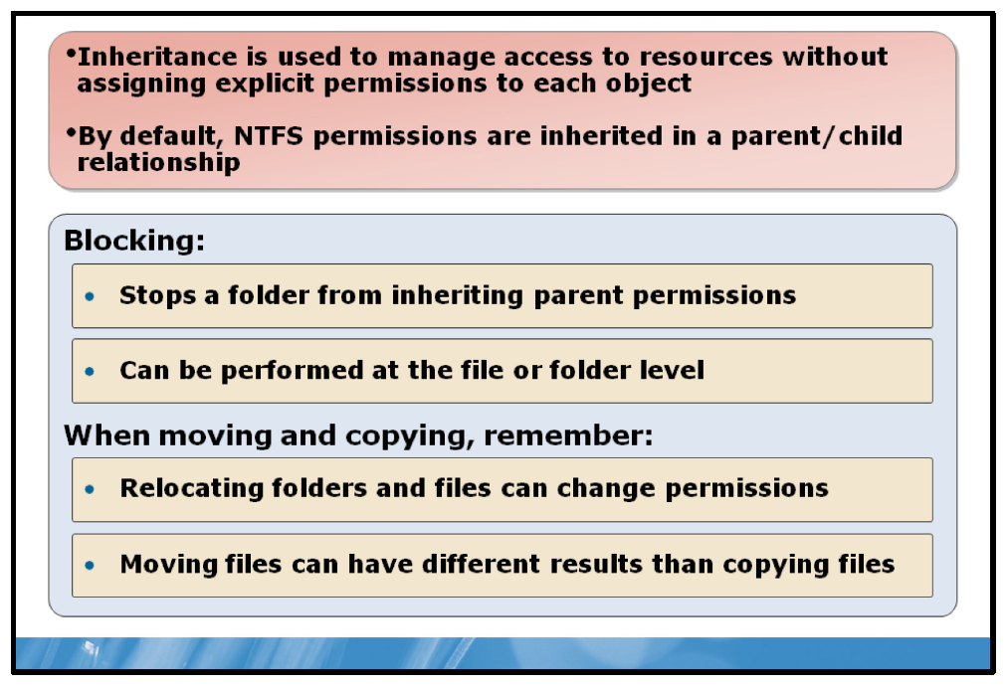

Key Points
By default, the permissions granted to a parent folder are inherited by its subfolders and files. Permissions can be inherited only from a direct parent and any files and folders contained within the parent folder will be assigned the same permissions as the parent folder, even if the parent folder’s permissions are modified. Permissions inherited in this manner are referred to as implicit permissions. A folder or file will always inherit its parent folder’s permissions unless inheritance is blocked.
When blocking inheritance, the folder for which you block permissions inheritance becomes the new parent folder, and the subfolders and files that are contained in it inherit the permissions assigned to it. A folder that has had inheritance blocked will retain its originally inherited permissions as its default permission set until those permissions are modified. Permissions can be inherited only from a direct parent. Permissions inherited in this manner are referred to as implicit permissions.
In addition to inherited or implicit permissions, permissions assigned to a file or folder that override that file or folder’s inherited permissions are called explicit permissions. Explicit permissions are specifically set for a given set of files and folders, and behave slightly different when being moved within an NTFS volume.
To block inheritance for a file or folder, perform the following steps:
1. | Right-click the file or folder to which you want to block inheritance, and then click Properties.
2. | Click the Security tab to view existing permissions.
3. | Click the Advanced button.
4. | In the Permissions window, click the Change Permissions button.
5. | In the Permissions window, uncheck Include inheritable permissions from this object’s parent.
6. | Click the Add or Remove button, depending on what permissions you want assigned to the blocked folder.

Copying vs. Moving Files
When you copy or move a file or folder, the permissions might change, depending on where you move the file or folder. You should understand the changes that the permissions undergo when they are copied or moved.

Copying a File
When you copy a file or folder from one folder to another folder, or from one partition to another partition, the following rules apply:
• | Within a single NTFS partition, the copy of the folder or file inherits the permissions of the destination folder.
• | To a different NTFS partition, the copy of the folder or file inherits the permissions of the destination folder.
• | To a non-NTFS partition, such as a file allocation table (FAT) partition, the copy of the folder or file loses its NTFS permissions, because non-NTFS partitions do not support NTFS permissions.

Moving a File
When you move a file or folder, the following rules apply:
• | Within the same NTFS partition, the folder or file keeps its original permissions. If the permissions of the new parent folder are changed later, the file or folder will inherit the new permissions.  Permissions explicitly applied to the folder will be retained. Permissions previously inherited will be lost.
• | To a different NTFS partition, the folder or file inherits the permissions of the destination folder. When you move a folder or file between partitions, the Windows Server 2008 operating system copies the folder or file to the new location and then deletes it from the old location.
• | To a non-NTFS partition, the folder or file loses its NTFS permissions, because non-NTFS partitions do not support NTFS permissions.

Shared Folder Permissions
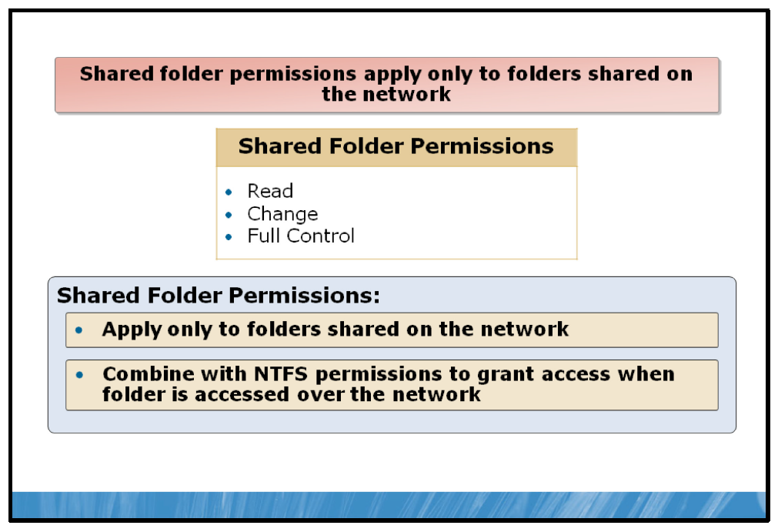

Key Points
When you share a folder, it is made available over the network. In order to ensure appropriate access to the files is granted, shared folder permissions must be applied.
Shared folder permissions apply only to users who connect to the folder over the network. They do not restrict access to users who access them locally on the computer where the folder is stored. You can grant shared folder permissions to user accounts, groups, and computer accounts.
By default, a shared folder is already protected by the NTFS permissions applied to that specific folder.
The following table lists the options available for shared folder permissions. You can choose whether to allow or deny each of the permissions.
File permissions | Description
Read | Read permission allows users to view folder and file names, and file data and the attributes of files. Users are also able to access the shared folder's subfolders, and run program files and scripts.
Change | Users that are granted the Change permission can perform all of the functions granted by the Read permissions as well as create and delete files and subfolders. Users are also able to change file attributes, change the data in files, and append data to files.
Full Control | Users that are granted the Full Control permission can perform all the tasks enabled by the Change permissions as well as take ownership of files, and change file permissions.
The shared folder permissions above are available through Windows Server 2008 R2’s Advanced Sharing properties, found in the folder’s Properties dialog box. A more simplified set of permissions (Read or Read/Write) can be assigned by right-clicking on the folder and selecting Share, which brings up the File Sharing dialog box.
Note: As with NTFS permissions, when assigning shared folder permissions, permissions set to Deny typically override permissions set to Allow.

Evaluating Combined, Shared and Local Permissions
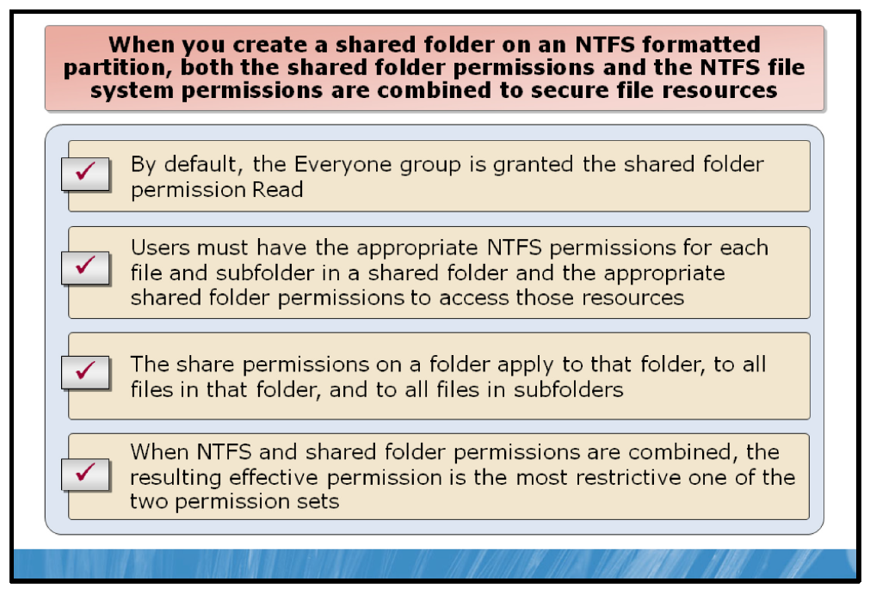

Key Points
When a shared folder is created on a partition formatted with the NTFS file system, both the shared folder permissions and the NTFS file system permissions are combined to protect file resources. NTFS file system permissions apply whether the resource is accessed locally or over a network, but they are filtered against the share folder permissions.
So, when accessing a shared folder over the network, a user must have the appropriate permissions granted on a shared folder to gain access to the files and folders within that folder. Once it has been determined that the user has been granted access through the shared folder permissions, the user’s access to the specific NTFS file(s) or folder(s) is checked against the user’s NTFS permissions. If both the shared folder permissions and the NTFS permissions allow the type of access that the user is attempting on the files, access is granted.
When you grant shared folder permissions on an NTFS volume, the following rules apply:
• | By default, the Everyone group is granted the shared folder permission Read.  Note: If the guest user account is enabled on your computer, the Everyone group includes anyone. According to best practice, remove the Everyone group from any permission lists and replace it with the Authenticated Users group.
• | Users must have the appropriate NTFS file system permissions for each file and subfolder in a shared folder in addition to the appropriate shared folder permissions to access those resources.
• | When NTFS file system permissions and shared folder permissions are combined, the resulting permission is the most restrictive one of the effective shared folder permissions or the effective NTFS file system permissions.
• | The share permissions on a folder apply to that folder, to all files in that folder, to subfolders, and to all files in those subfolders.
The following analogy can be helpful in understanding what happens when you combine NTFS and share permissions. When dealing with a shared folder, you must always go through the shared folder to access its files over the network. Therefore, you can think of the shared folder permissions as a filter that only allows users to perform actions on its contents that are acceptable to the share permissions. All NTFS permissions that are less restrictive than the share permissions are filtered out so that only the share permission remains.
For example, if the share permission is set to Read, then the most you can do when accessing the share over the network is read the contents, even if individual NTFS file permission is set to Full Control. If configuring the share permission to Modify, then you are allowed to read or modify the shared folder contents. If the NTFS permission is set to Full Control, then the share permissions filter the effective permission down to just Modify.

Considerations for Securing Files and Folders
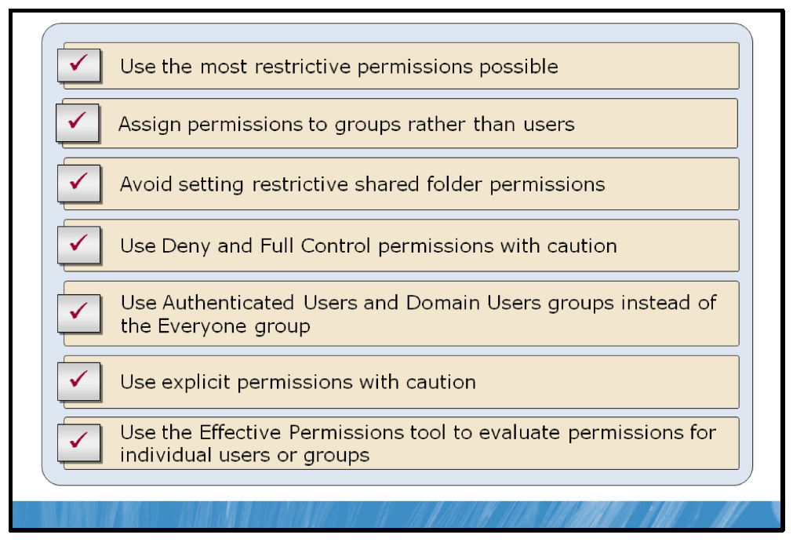

Key Points
When you are managing access to resources using NTFS file and folder permissions and shared folder permissions, consider the following best practices:
• | Use the most restrictive permissions possible. Do not grant more permissions for a file or folder than the users legitimately require. For example, if a user only has to read the files in a folder, grant Read permission for the folder to the user or group to which the user belongs.
• | Avoid assigning permissions to individual users. Use groups whenever possible. Because it is inefficient to maintain user accounts directly, avoid granting permissions to individual users.
• | Use restrictive shared folder permissions only when necessary. To avoid complicated combined permissions scenarios, use NTFS file and folder permissions to restrict or grant access as much as possible. NTFS file and folder permissions offer much more precise control over user access and always apply to file and folder security, whether being accessed locally or over the network.
• | Use Deny permissions with caution. Deny permissions always override Allow permissions and can result in users being mistakenly restricted access to files or folders.
• | Remember that Full Control lets users modify permissions. Assign Full Control permissions with caution, as any change in existing permissions could potentially affect security.
• | Use the Authenticated Users or the Domain Users group instead of the Everyone group (if present) from the shared folder’s permissions list. The Everyone group includes guest users. Using the Authenticated or Domain Users groups limits file or folder access to only authenticated users, and prevents users or viruses from accidentally deleting or damaging files.
• | Be conscious of explicitly set permissions and the effects of blocked inheritance. When assigning permissions to a parent folder, be aware that some subfolders and files might have inheritance blocked and explicit permissions specified. In this case, such subfolders and files will not inherit the parent folders permissions when changes are made.
• | You can use the Effective Permissions tool to evaluate the permissions assigned to a user or group for a specific file or folder. Effective Permissions allows you to select users or groups and then shows you the effective permissions for those users or groups according to all of the permissions set on the specific file or folder. You use the following steps to reach the Effective Permissions tool:
1. | Right-click on the file or folder you wish to evaluate and click Properties.
2. | In the Properties dialog box, click the Security tab and then click the Advanced button.
3. | In the Advanced Security Settings dialog box, click the Effective Permissions tab.

Demonstration: How to Secure a Shared Folder
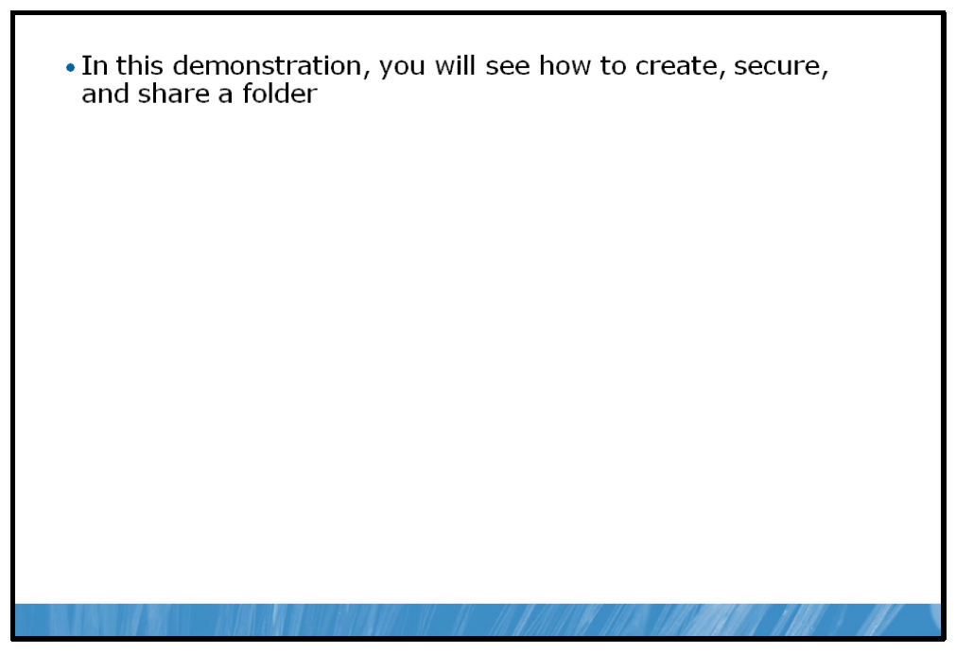
In this demonstration, you will see how to create a folder, secure it using NTFS permissions, share the folder and further secure it with shared folder permissions.

Demonstration Steps:
1. | Create a new folder.
2. | Assign NTFS permissions to the new folder.
3. | Share the new folder and assign shared folder permissions

File Auditing
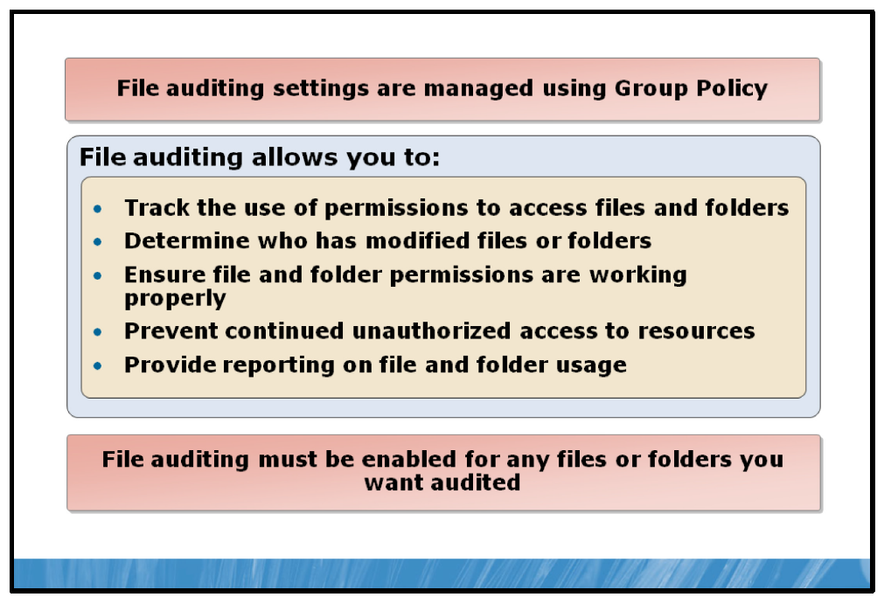

Key Points
Securing files and folders with permissions will only help protect data; they will not tell you who deleted important data or who was trying to access files and folders inappropriately. To track who accessed files and folders and what they did, you must configure auditing for file and folder access. Every comprehensive security strategy should include auditing.
Configuring file and folder auditing in Windows Server 2008 is a two part process:
1. | Enabling audit object policy in GPO in Group Policy. This setting can be reached by running secpol.msc from a command prompt or from the Run command on the Start menu. Once in Local Security Policy, expand Local Policy and click Audit Policy.
2. | Once Audit object access has been enabled in Local Security Policy, auditing must be enabled for any files and users you want to audit. These settings can be reached by navigating to the Properties window for the folder you want to audit, selecting the Security tab, clicking the Advanced button and selecting the Auditing tab in the Advanced Security Settings dialog box.  When enabling auditing on a specific folder, the same inheritance rules used by NTFS permissions and Shared folder permissions apply to the auditing properties. By default, files and folders will inherit their parent’s audit settings unless inheritance is blocked or explicitly specified.  Note: Unlike permissions, there is only one method of applying auditing properties; to allow them. There is no Deny option when configuring auditing properties.
Once configured, file and folder auditing events will be recorded to the Windows security log. This log can be viewed in Event Viewer, located in the Diagnostics section of Server Manager.

Demonstration: How to Configure File Auditing
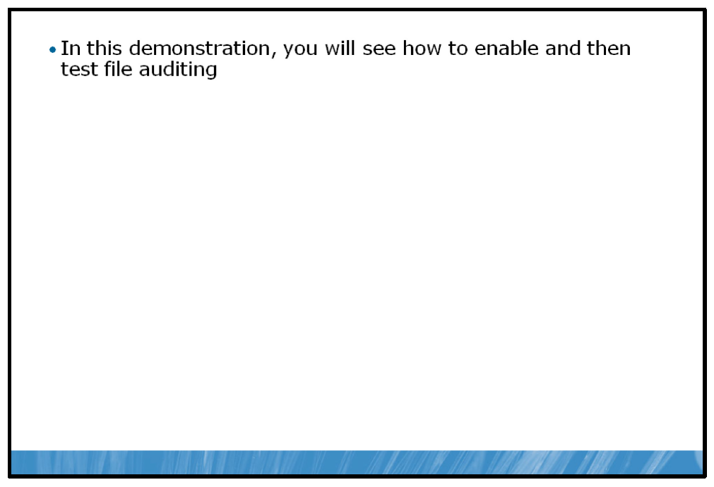
In this demonstration, you will see how to configure the Audit object access security policy to audit file access.

Demonstration Steps:
1. | Configure the object access auditing policy to audit file access.
2. | Create a new folder and enable auditing.
3. | Test the object access auditing policy.

Lesson 3: Implementing Encryption
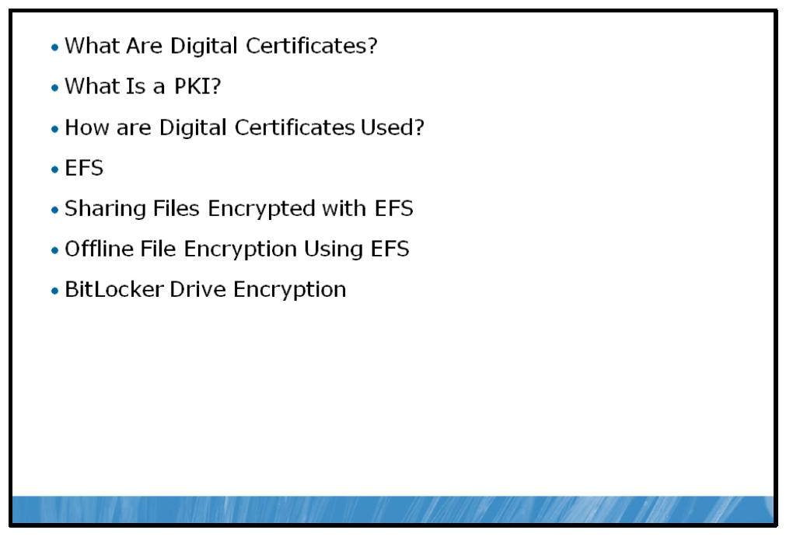
In this age of information interconnection, an organization’s network may consist of intranets, Internet sites, and extranets—all of which are potentially susceptible to access by unauthorized individuals who intend to maliciously view or alter an organization’s digital information assets. Therefore, it is important that you have some means of ensuring that your organization’s data and communications are secure. To make your communication secure, it is important for you to understand the fundamentals of the systems that make secure data possible.

Objectives
After completing this lesson, students will be able to:
• | Describe a digital certificate.
• | Describe a PKI.
• | Describe how digital certificates are used.
• | Describe how EFS helps to ensure file privacy.
• | Describe how to share files encrypted with EFS.
• | Describe how to encrypt Offline Files using EFS.
• | Describe how BitLocker protects entire drives.

What Are Digital Certificates?
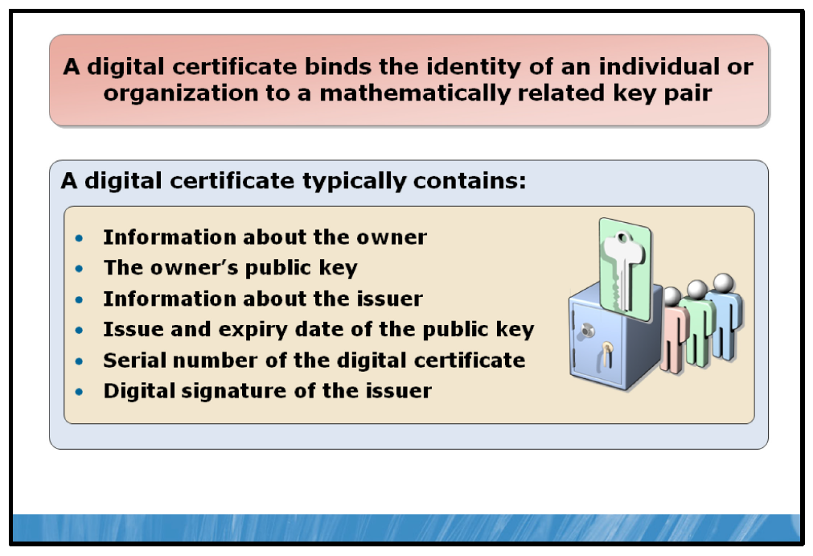

Key Points
A digital certificate is a physical digital entity that binds a person’s or organization’s identity to mathematically related private and public keys for the use of encrypting and decrypting data as well as verifying the authenticity of the user or organization in relation to the data being exchanged.
A digital certificate makes it possible to verify someone's claim that they have the right to use a given key, helping to prevent people from using phony keys to impersonate other users. Used in conjunction with encryption, digital certificates provide a more complete security solution, assuring the identity of all parties involved in a transaction.
A digital certificate generally contains information about the following:
• | A user, computer, or network device that holds the private key corresponding to the issued certificate. The user, computer, or network device is referred to as the owner or subject of the certificate.
• | A public key of the certificate's associated public and private key pair.
• | The issuer of the certificate, commonly known as a Certificate Authority (CA).
• | The issue and expiry dates of the public key associated with the certificate.
• | The serial number of the digital certificate.
• | The digital signature of the issuing CA.
• | The names of the encryption and/or digital signing algorithms supported by the certificate.
Also, a digital certificate may contain additional information, such as the encryption algorithms supported, the acceptable applications or uses for the certificate or other applicable information.

What Is a PKI?
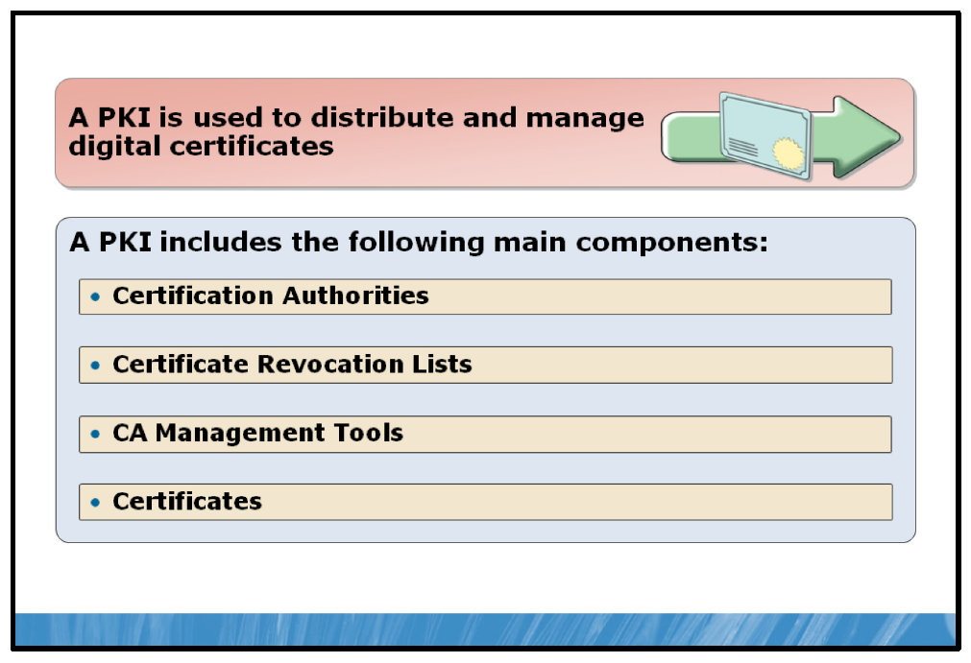

Key Points
A PKI enables the distribution and management of digital certificates to users and computers in a secure and trustworthy manner.
A PKI is a system of components that allow for the authentication and verification of authenticity of each party involved in digital communication through the use of public key cryptography.
A PKI consists of the following components:
• | CAs. CAs represent the people, processes and tools used to create digital certificates and securely bind the user’s identity to their public keys. Before issuing a digital certificate to a user, a CA will verify that user’s identity and the validity of their purpose for obtaining a digital certificate.  A CA will place their digital signature on a certificate, which both verifies that the certificate has come from a trusted source as well as acting like a tamper-proof seal on the certificate itself, preventing any attempts to tamper with the digital certificate.  CA’s also operate in a hierarchal manner, where CAs that issue certificates may use another, more widely trusted CA as its parent to maintain the level of trust necessary within a PKI environment.
• | Certification revocation lists (CRLs). CRLs contain a list of certificates that have been revoked or removed from a CA prior to the certificate’s expiry date.
• | Certificate and CA management tools. When a Windows Server 2008 R2 server is configured as a CA, a specific set of tools are available to create and manage certificates, manage CRLs and perform maintenance on different aspects of the PKI environment.
• | Certificates. Digital certificates are the primary item of circulation in a PKI. A PKI exists primarily for the proper management of these certificates.

How Are Digital Certificates Used?
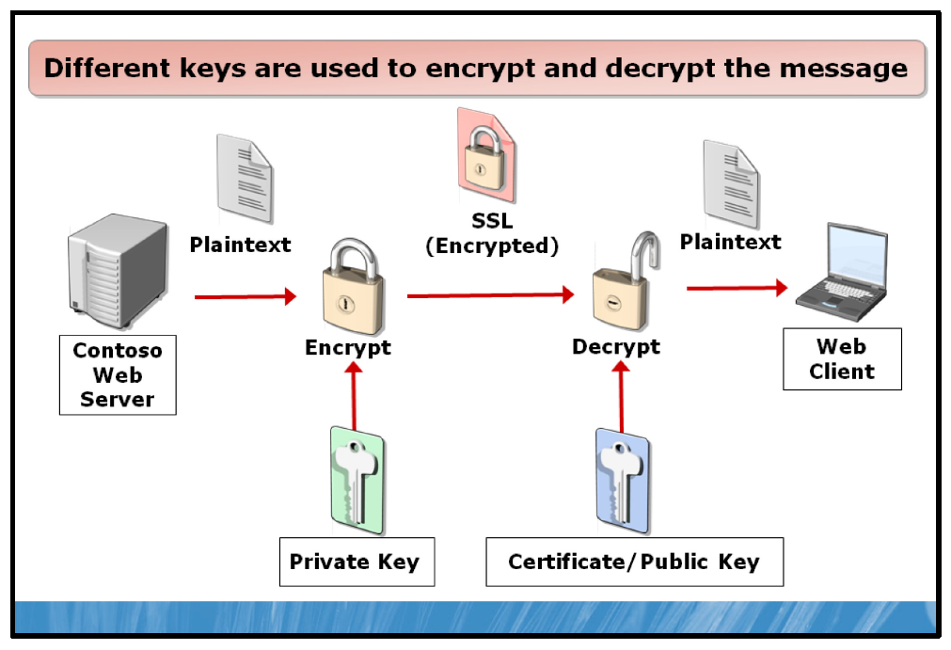

Key Points
In modern cryptography, data is encrypted and decrypted using a key which contains the information necessary for performing the encryption or decryption. A key is a piece of physical data, and may be protected by a password or attached to a smart card or even a Windows user’s account.
In the simplest form of data encryption, data is both encrypted and decrypted using the same key. This method of using the same key for both encryption and decryption is known as symmetric encryption.
Symmetric encryption works very well when the same user is both encrypting and decrypting the data. However, when the user encrypting the data is different than the user who is decrypting the data and especially if the encryption and decryption process must happen on different computers or networks, symmetric encryption becomes more problematic. In this case, the user encrypting the data must find some way to make the key available to the user decrypting the data. Anytime the key is exchanged between users, it becomes vulnerable to being intercepted and compromised.
The use of digital certificates introduces an alternative to the shortcomings of symmetric encryption. Data exchange using a digital certificate uses asymmetric encryption. When using asymmetric encryption, a pair of mathematically related keys is used to encrypt or decrypt data. One of the keys, commonly referred to as the private key, is held by an individual. A second key, the public key, is attached to the digital certificate, which can be digitally requested at any time. With this form of encryption, either the private or public key can be used to encrypt the data. Then, the opposite key is used to decrypt the data.
For example, in the above diagram, data at the Contoso Ltd’s Web server is encrypted using Contoso, Ltd’s private key and SSL encryption. The resultant encrypted data is sent out over the public Internet to the Web client who is accessing the information on the server. Since the data has encrypted using Contoso Ltd’s private key, the Web client can be assured that the information is coming from Contoso, Ltd’s and is genuine.
Alternatively, data sent from the client to the server, such as personal or financial information, is first encrypted using SSL and Contoso Ltd’s public key attached to the digital certificate. The user can be assured that encrypted information is safe in transit because only Contoso, Ltd’s private key can decrypt the data. It is critical for private keys to be secured in order to maintain the integrity of this exchange.
Digital certificates are used for a wide variety of purposes. Depending on the nature of the issuing CA, certain digital certificates may have a specific level of trust assigned to them. Public, Private and Self-signed certificates each have individual characteristics that make them suitable for specific implementations. The following points outline characteristics of Public, Private and Self-signed certificates:
• | Public CAs typically charge a fee for providing a digital certificate, but the certificate is universally trusted. Also, public certificates can be used in almost any situation a private certificate is used. Digital certificates used on the public Internet are most commonly issued by a public CA.
• | Private certificates allow an organization to manage their certificate issuing process and any number of certificates can be generated at no cost. This allows an organization with the requirement to issue many certificates for internal use to use a private CA and not incur the costs associated with a large number of public certificates. This gives an organization a great deal of control of certificate management, but requires additional administrative overhead. Private certificates may be used within an organization to facilitate secure e-mail or the encryption of individual’s data.
• | Self-signed certificates do not require the implementation of a stand alone CA. Rather, the application itself creates and signs the certificate. This decreases the administrative overhead of maintaining a private CA and the organization incurs no extra costs. The main drawback however, is that the self-signed certificate has a very limited valid scope; strictly within the application itself.
Question: In what situations would a public certificate signed by a trusted CA be requested or required?
Question: Why would a private certificate be used instead of a public certificate?
Question: Why would an organization choose to use self-signed certificates over private certificates?

EFS
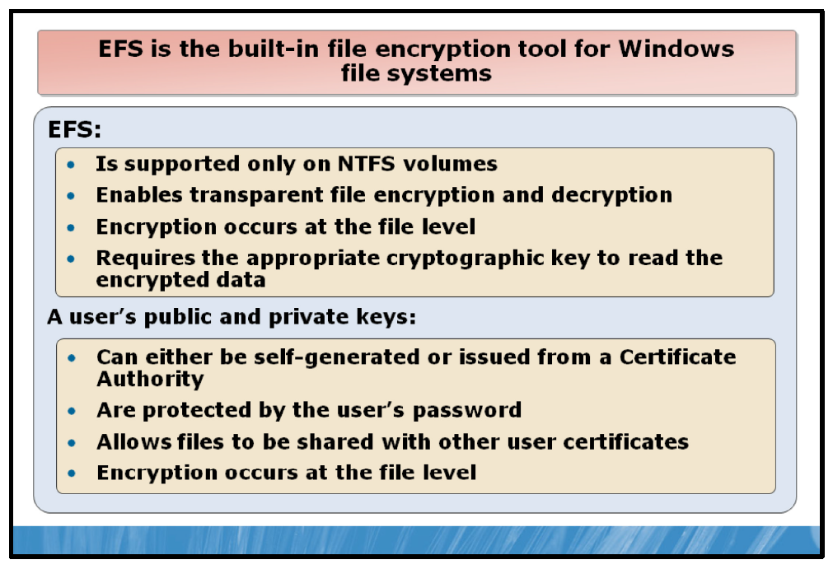

Key Points
EFS is the built-in file encryption tool for Windows file systems. A component of the NTFS file system, EFS enables transparent encryption and decryption of files by using advanced, standard cryptographic algorithms. Any individual or program that does not possess the appropriate cryptographic key cannot read the encrypted data. Encrypted files can be protected even from those who gain physical possession of the computer that the files reside on. Even persons who are otherwise authorized to access the computer and its file system cannot view the data.
Information technology (IT) professionals must understand that while encryption is a powerful addition to any defensive plan, other defensive strategies must be used because encryption is not the correct countermeasure for every threat. However, every defensive weapon, if used incorrectly, carries the potential for harm. EFS must be understood, implemented appropriately, and managed effectively to ensure that your experience, the experience of those to whom you provide support, and the data you want to protect are not compromised.
The following are important basic facts about EFS:
• | EFS encryption does not occur at the application level but rather at the file-system level; therefore, the encryption and decryption process is transparent to the user and to the application.  If a folder is marked for encryption, every file created in or moved to the folder will be encrypted. Applications do not have to understand EFS or manage EFS-encrypted files any differently than unencrypted files.
• | If a user attempts to open a file and possesses the key to do so, the file opens without additional effort on the user's part. If the user does not possess the key, he or she receives an "Access denied" error message.
• | File encryption uses a symmetric key that is encrypted with the user’s public key and stored in the file header. A certificate with the user’s public and private keys (known as asymmetric keys) is stored in the user’s profile.  This key pair is bound to a user identity (ID) and made available to the user who has possession of the user ID and password. The user’s private key must be available for the file to be decrypted.
• | If the private key is damaged or missing, even the user that encrypted the file cannot decrypt it. If a recovery agent exists, then the file may be recoverable. If key archival has been implemented, then the key may be recovered, and the file decrypted; otherwise, the file may be lost. This encryption system is commonly referred to as PKI.
• | The user’s certificate that contains his or her public and private keys can be archived (for example, exported to a floppy disk) and kept in a safe place to ensure recovery, if keys become damaged.
• | The user’s public and private keys are protected by the user's password. Any user who can obtain the user ID and password can log on as that user and decrypt that user's files.  Therefore, a strong password policy and strong user education must be a component of each organization's security practices to ensure the protection of EFS-encrypted files.
• | EFS-encrypted files do not remain encrypted during transport if saved to or opened from a folder on a remote server. The file is decrypted, traverses the network in plaintext, and if saved to a folder on the local drive that is marked for encryption, is encrypted locally. EFS-encrypted files can remain encrypted while traversing the network if they are being saved to a Web folder using WebDAV.
• | EFS is only supported on the NTFS file system. If a user moves or copies an encrypted file to a non-NTFS file system, like a floppy disk or USB flash drive formatted with the file allocation table 32-bit (FAT32) file system, the file will no longer be encrypted.  Note: When users encrypt files in remote shared folders, their keys are stored on the file server.

Managing EFS Certificates
EFS uses public key cryptography to allow the encryption of files. The keys are obtained from the user’s EFS certificate. Because the EFS certificates may also contain private key information, they must be managed correctly.
Users can make encrypted files accessible to other users’ EFS certificates. If you grant access to another user’s EFS certificate, that user can, in turn, make the file available to other user’s EFS certificates.
Note: EFS certificates are only issued to individual users, not to groups.

EFS in Windows Server 2008 R2
Windows Server 2008 R2 includes a number of new EFS features, including:
• | Support for Storing Private Keys on Smart Cards. Windows Server 2008 includes full support for storing users’ private keys on smart cards. If a user logs onto Windows with a smart card, EFS can also use the smart card for file encryption.  Administrators can also store their domain’s recovery keys on a smart card. Recovering files is then as simple as logging on to the affected machine, either locally or using Remote Desktop, and using the recovery smart card to access the files.
• | EFS Rekeying wizard. The EFS rekeying wizard allows users to choose an EFS certificate and then select and migrate existing files that will use the newly chosen EFS certificate.  They can also use the wizard to migrate users in existing installations from software certificates to smart cards. The wizard is also helpful in recovery situations because it is more efficient than decrypting and re-encrypting files.
• | New Group Policy Settings for EFS. You can use Group Policy to centrally control and configure EFS protection policies for the entire enterprise. A number of Group Policy options were added to help administrators define and implement EFS organizational policies.
• | Per-User Encryption of Offline Files. You can use EFS to encrypt offline copies of files from remote servers. When this option is enabled, each file in the offline cache is encrypted with a public key from the user who cached the file. Thus, only that user has access to the file, and even local administrators cannot read the file without access to the user's private keys.
• | Support for AES 256-Bit Encryption. EFS supports industry standard encryption algorithms including Advanced Encryption Standard (AES). AES uses a 256-bit symmetric encryption key and is the default EFS algorithm.

Sharing Files Encrypted with EFS
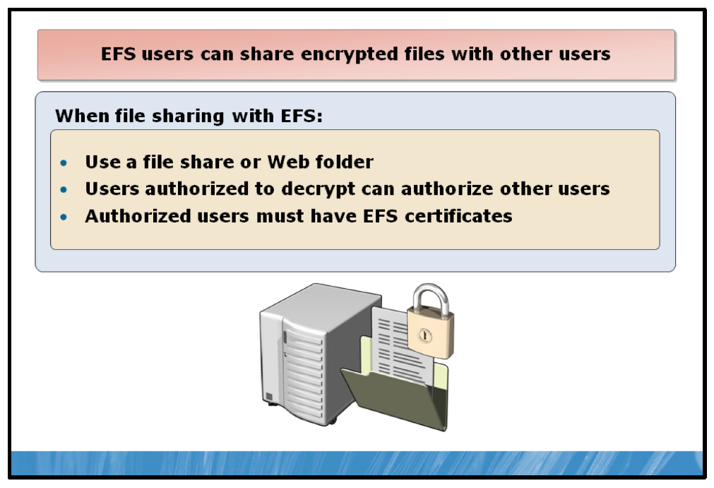

Key Points
EFS users can share encrypted files with other users on file shares and in Web folders. With this support, you can give individual users permission to access an encrypted file. The ability to add users is restricted to individual files. After a file has been encrypted, file sharing is enabled through the user interface. You must first encrypt a file and then save it before adding more users. Users can be added either from the local computer or from AD DS and Active Directory if the user has a valid certificate for EFS.
It is important that users electing to share encrypted files keep the following points in mind:
• | Shared EFS files are not file shares. If authorized users need to access shared EFS files over the network, a file share or Web folder is required. Alternatively, users can establish remote sessions with computers that store encrypted files by using Terminal Services.
• | Any user who is authorized to decrypt a file can authorize other users to access the file. Granting access is not limited to the file owner. Caution users to share files only with trusted accounts because those accounts can authorize other accounts. Removing the Write permission from a user or group of users can prevent this problem, but it also prevents the user or group from modifying the file.
• | EFS sharing requires that the users who will be authorized to access the encrypted file have EFS certificates. These certificates can be located in roaming profiles or in the user profiles on the computer on which the file to be shared is stored, or they can be stored in and retrieved from AD DS and Active Directory.
• | EFS sharing of an encrypted file often means that the file will be accessed across the network. It is best if Web folders are used for encrypted file storage whenever possible.
• | If a user chooses to remotely access an encrypted file stored on a file share and to authorize other users to access the file, the authorization process and requirements are the same as on the local computer. Additionally, EFS must impersonate the user to perform this operation, and all of the requirements for remote EFS operations on files stored on file shares apply.
• | If a user chooses to remotely access an encrypted file stored on a Web folder and to authorize other users to access the file, the file is automatically transmitted to the local computer in ciphertext. The authorization process takes place on the local computer with the same requirements as for encrypted files stored locally.
You can authorize individual users to access encrypted files. Perform the following steps to share an encrypted file with other users:
1. | In Windows Explorer, right-click the encrypted file and then click Properties.
2. | On the General tab, select Advanced.
3. | In the Advanced Attributes dialog box, under Compress or Encrypt Attributes, select Details.  Note: If you select an encrypted folder instead of an encrypted file, the Details button appears dimmed. You can add users to individual encrypted files but not to folders.
4. | In the Encryption Details dialog box, click Add.
5. | Add a user from the local computer or from AD DS.

Offline File Encryption Using EFS
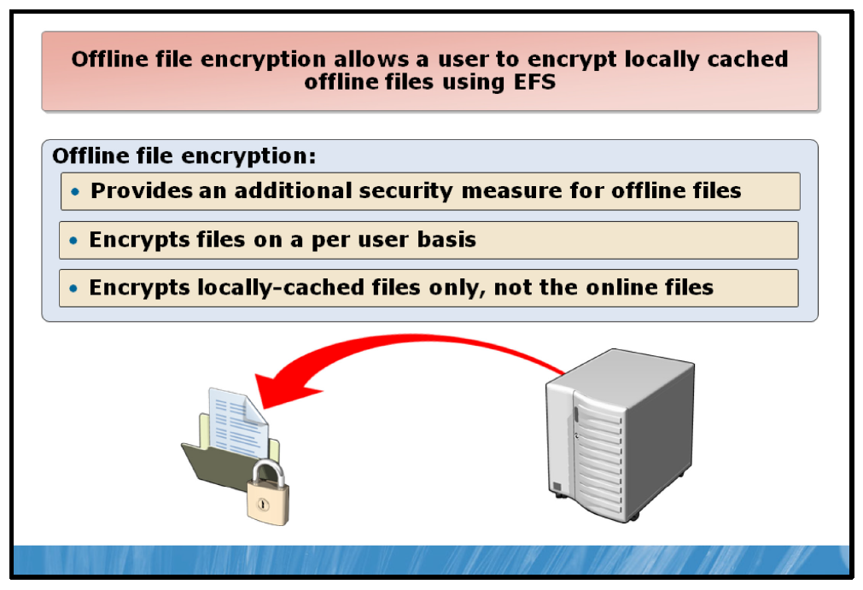

Key Points
Windows Server 2008 R2 supports the local caching of network files for use when the network connection may not be available. This feature is referred to as Offline Files. With Offline Files, users are able to have access to the files they need, regardless of the status of their connection to the network.
Offline files are capable of being encrypted using EFS. Encrypting offline files provides an additional level of security and ensures that the locally cached copies of network files are protected from unauthorized access, just as they would be if they were encrypted on the network share.
Windows Server 2008 R2 introduces the ability to encrypt offline files on a per user basis, improving upon the security of encrypted offline files in previous versions of Windows.
Note: Encrypting offline files does not encrypt the network version of the file; it only encrypts the local copy.

BitLocker Drive Encryption
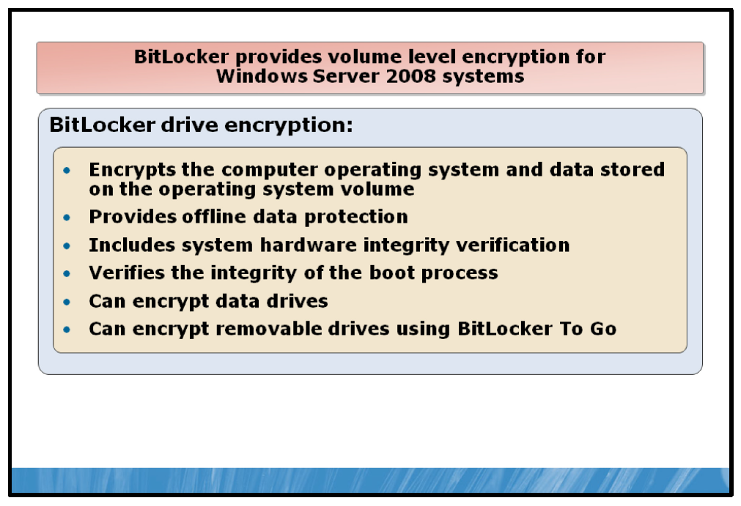

Key Points
Windows BitLocker Drive Encryption provides protection for the computer operating system and data stored on the operating system volume by ensuring that data stored on a computer remains encrypted, even if the computer is tampered with when the operating system is not running. BitLocker provides a closely integrated solution in Windows Server 2008 R2 to address the threats of data theft or exposure from lost, stolen, or inappropriately decommissioned personal computers.
Data on a lost or stolen computer can become vulnerable to unauthorized access when a user either runs a software attack tool against it or transfers the computer’s hard disk to a different computer. BitLocker helps mitigate unauthorized data access by enhancing Windows file and system protections. BitLocker also helps render data inaccessible when BitLocker-protected computers are decommissioned or recycled.
BitLocker Drive Encryption performs two functions that provide both offline data protection and system integrity verification:
• | Encrypts all data stored on the Windows operating system volume (and configured data volumes). This includes the Windows operating system, hibernation and paging files, applications, and data used by applications.  BitLocker also provides an umbrella protection for non-Microsoft applications, which benefits the applications automatically when they are installed on the encrypted volume.
• | Is configured by default to use a Trusted Platform Module (TPM) to help ensure the integrity of early startup components (components used in the earlier stages of the startup process), and "locks" any BitLocker-protected volumes so that they remain protected even if the computer is tampered with when the operating system is not running.

System Integrity Verification
BitLocker uses the TPM to verify the integrity of the startup process by:
• | Providing a method to check that early boot file integrity has been maintained, and to help ensure that there has been no adverse modification of those files, such as with boot sector viruses or root kits.
• | Enhancing protection to mitigate offline software-based attacks. Any alternative software that might start the system does not have access to the decryption keys for the Windows operating system volume.
• | Locking the system when tampered with. If any monitored files have been tampered with, the system does not start. This alerts the user to the tampering since the system fails to start as usual. In the event that system lockout occurs, BitLocker offers a simple recovery process.
In conjunction with the TPM, BitLocker verifies the integrity of early startup components, which helps prevent additional offline attacks, such as attempts to insert malicious code into those components. This functionality is important because the components in the earliest part of the startup process must be available unencrypted so that the computer can start.
As a result, an attacker can change the code in those early startup components and then gain access to the computer, even though the data on the disk was encrypted. Then, if the attacker gains access to confidential information such as the BitLocker keys or user passwords, BitLocker and other Windows security protections can be circumvented.
Additionally, BitLocker Drive Encryption technology in Windows Server 2008 R2 is extended from operating system drives and fixed data drives to include removable storage devices such as portable hard drives and USB flash drives.

Using BitLocker To Go with Removable Drives
When a laptop is lost or stolen, the loss of data typically has more impact than the loss of the computer asset. As more people use removable storage devices, they can lose data without losing a PC. BitLocker To Go provides enhanced protection against data theft and exposure by extending BitLocker drive encryption support to removable storage devices such as USB flash drives, and is manageable through Group Policy.
In Windows Server 2008 R2, users can encrypt their removable media by opening Windows Explorer, right-clicking the drive, and clicking Turn On BitLocker. They will then be asked to choose a method to unlock the drive. These options include:
• | Password. This is a combination of letters, symbols, and numbers the user will enter to unlock the drive.
• | Smart card. In most cases, a smart card is issued by your organization and a user enters a smart card PIN to unlock the drive.
After choosing the unlock methods, users will be asked to print or save their recovery password. This is a 48-digit password that can also be stored in AD DS and Active Directory and used if other unlock methods fail (for example, when a password is forgotten). Finally, users will be asked to confirm their unlock selections and to begin encryption.
When you insert a BitLocker-protected drive into your computer, Windows will automatically detect that the drive is encrypted and prompt you to unlock it.

Lab: Implementing Windows Security
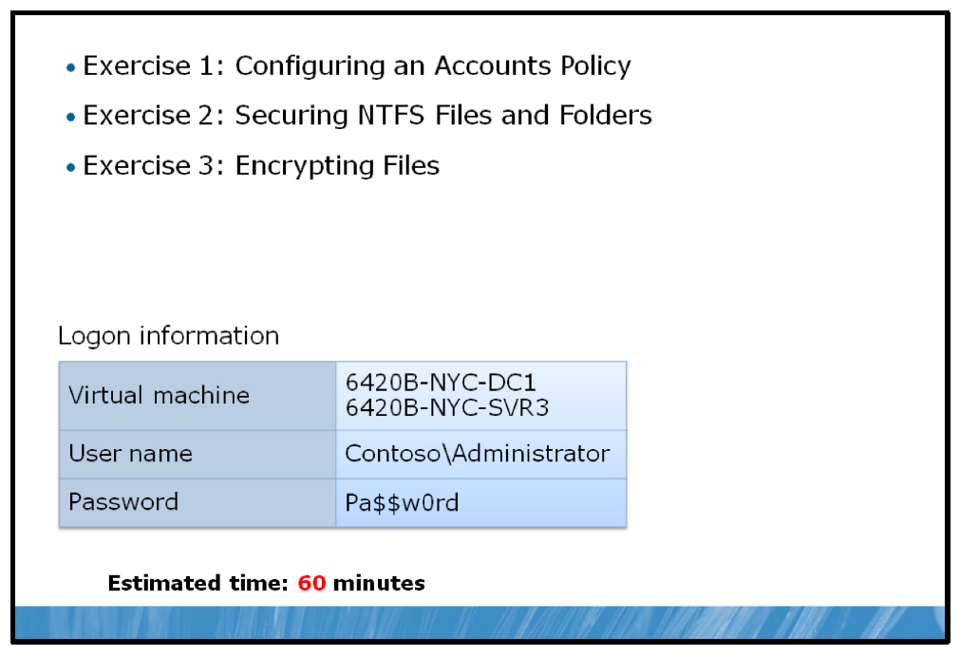

Lab Setup
For this lab, you will use the available virtual machine environment. Before you begin the lab, you must complete the following steps:
1. | On the host computer, click Start, point to Administrative Tools, and then click Hyper-V Manager.
2. | In Hyper-V™ Manager, click 6420B-NYC-DC1, and in the Actions pane, click Start.
3. | In the Actions pane, click Connect. Wait until the virtual machine starts.
4. | Log on using the following credentials:
  • | User name: Administrator
  • | Password: Pa$$w0rd
  • | Domain: Contoso
5. | Repeat these steps for 6420B-NYC-SVR3.

Exercise 1: Configuring an Accounts Policy

Scenario
You have been asked to implement a password policy in order to meet the requirements of new Contoso, Ltd company security policies.
Your supervisor has asked you to configure settings to comply with the following criteria, ensuring that best practices are used when settings are not specifically defined by company policy.

Best Practices
• | Passwords must be at least eight characters long.
• | Password must contain at least three of the four following character types: lowercase letters (a-z), uppercase letters (A-Z), numbers (0-9),  non-alphanumeric characters (example, ! @ # $).
• | Passwords must be changed every 60 days.
• | Users cannot use a password again until five other different passwords have been used.
• | Users should be locked out of the system after repeated failed logon attempts.
The main tasks for this exercise are as follows:
1. | Configure Password Policy settings according to company policy.
2. | Configure Account Lockout Policy settings according to company policy.

Task 1: Configure Password Policy settings
1. | On NYC-DC1, open the Group Policy Managment console.
2. | Edit the Default Domain Policy.
3. | Modify the Password policy settings, updating the appropriate settings with the information above.

Task 2: Configure Account Lockout Policy settings
• | Modify the Account Lockout Policy settings, updating the appropriate settings with the information above.
Results: After this exercise, you should have configured Password and Account Lockout settings in Account Policies.

Exercise 2: Securing NTFS Files and Folders

Scenario
The Research team at Contoso, Ltd has asked for a new folder to be created on NYC-SVR3 to store general research information as well as information regarding their projects and special classified information. They would like this folder and its contents to be fully accessible to the entire Research team, with the exception of the classified information, which should be unavailable to all members of the Research team with the exception of Max Stevens, the Research Manager, who should have full access to classified information. The Research team will access the files and folders exclusively over the network.
You have been asked by your supervisor to create a shared folder structure that satisfies the Research team’s request.
The main tasks for this exercise are as follows:
1. | Create the C:\Research folder structure.
2. | Assign appropriate NTFS file and folder permissions to the folder structure.
3. | Share the C:\Research folder on the network and set appropriate shared folder permissions.

Task 1: Create the C:\Research folder structure
1. | On NYC-SVR3, create a new folder called C:\Research.
2. | Create two subfolders in C:\Research named Classified and Projects.

Task 2: Assign appropriate NTFS file and folder permissions to the folder structure
1. | Block inheritance for the C:\Research folder.
2. | Assign the Contoso\Research group Full Control over the C:\Research folder.
3. | Block inheritance for the C:\Research\Classified folder.
4. | Assign only Contoso\Max Full Control over the C:\Research\Classified folder.

Task 3: Share the C:\Research folder on the network and set appropriate shared folder permissions
1. | Share the C:\Research folder on the network.
2. | Assign Full Control permissions for C:\Research to the Contoso\Research group.
Results: After this exercise, you should have secured NTFS and shared folders.

Exercise 3: Encrypting Files

Scenario
It has been requested by your supervisor that, on NYC-SVR3, specific files containing sensitive information in the Classified subfolder of the new Research shared folder be encrypted to prevent unauthorized access. You have been asked to test encryption on the Classified folder.
The main tasks for this exercise are as follows:
1. | Encrypt files and folders using EFS.
2. | Confirm that files are encrypted.
3. | Decrypt files and folders.

Task 1: Encrypt files and folders using Encrypting File System (EFS)
1. | If necessary, log on to NYC-SVR3 as Contoso\Administrator with the password of Pa$$w0rd.
2. | Create a test file called Personal.txt in the C:\Research\Classified folder.
3. | Encrypt the C:\Research\Classified folder and files within it.
4. | Log off of NYC-SVR3.

Task 2: Confirm that files are encrypted
1. | Log on to NYC-SVR3 as Contoso\Max with the password of Pa$$w0rd.
2. | Confirm that the Classified folder and files have been encrypted by attempting to open the Personal.txt file in the C:\Research\Classified folder. The encrypted file and folder names should also be listed in green text.
3. | Log off of NYC-SVR3.

Task 3: Decrypt files and folders
1. | Log on to NYC-SVR3 as Contoso\Administrator with the password of Pa$$w0rd.
2. | Decrypt the contents of C:\Research \Classified.
Results: After this exercise, you should have encrypted and decrypted files and folders using EFS.

To prepare for the next module
When you finish the lab, revert the virtual machines back to their initial state. To do this, complete the following steps:
1. | On the host computer, start Hyper-V Manager.
2. | Right-click 6420B-NYC-DC1 in the Virtual Machines list, and then click Revert.
3. | In the Revert Virtual Machine dialog box, click Revert.
4. | Repeat these steps for 6420B-NYC-SVR3.
5. | In the Virtual Machines pane, click 6420B-NYC-DC1, and then in the Actions pane, click Start.
6. | To connect to the virtual machine for the next module’s lab, click  6420B-NYC-DC1, and then in the Actions pane, click Connect.  Important: Start the 6420B-NYC-DC1 virtual machine first, and ensure that it is fully started before starting the other virtual machines.

Module Review and Takeaways
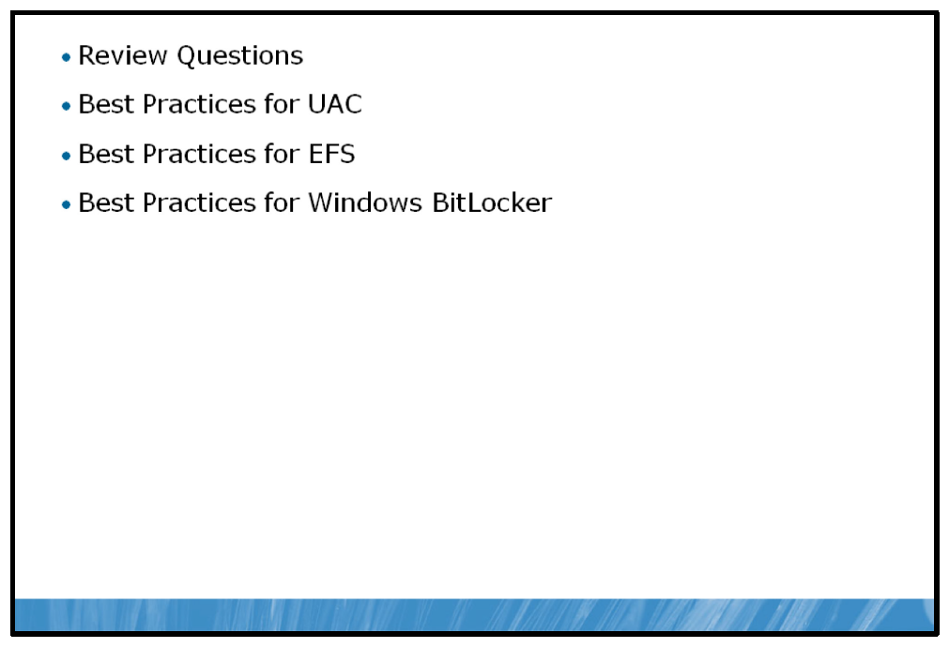

Review Questions
1. | What is the most efficient way to give several users access to a shared folder with the same permissions?
2. | What are some of the ways of protecting sensitive data in Windows Server 2008?

Best Practices for UAC
• | UAC Security Settings are configurable in the local Security Policy Manager (secpol.msc) or the Local Group Policy Editor (gpedit.msc). However, in most corporate environments, Group Policy is preferred because it can be centrally managed and controlled. There are nine GPO settings that can be configured for UAC.
• | Because the user experience can be configured with Group Policy, there can be different user experiences, depending on policy settings. The configuration choices made in your environment affect the prompts and dialog boxes that standard users, administrators, or both, can view.  For example, you may require administrative permissions to change the UAC setting to “Always notify me” or “Always notify me and wait for my response.” With this type of configuration, a yellow notification appears at the bottom of the User Account Control Settings page indicating the requirement.

Best Practices for EFS
The following is a list of standard best practices for EFS users:
• | Users should export their certificates and private keys to removable media and store the media securely when it is not in use. For the greatest possible security, the private key must be removed from the computer whenever the computer is not in use. This protects against attackers who physically obtain the computer and try to access the private key. When the encrypted files must be accessed, the private key can easily be imported from the removable media.
• | Encrypt the My Documents folder for all users (User_profile\My Documents). This makes sure that the personal folder, where most documents are stored, is encrypted by default.
• | Users should encrypt folders rather than individual files. Programs work on files in various ways. Encrypting files consistently at the folder level makes sure that files are not unexpectedly decrypted.
• | The private keys that are associated with recovery certificates are extremely sensitive. These keys must be generated either on a computer that is physically secured, or their certificates must be exported to a .pfx file, protected with a strong password, and saved on a disk that is stored in a physically secure location.

Best Practices for Windows BitLocker
Because BitLocker stores its own encryption and decryption key in a hardware device that is separate from the hard disk, you must have one of the following:
• | A computer with TPM.
• | A removable USB memory device, such as a USB flash drive. If your computer does not have TPM version 1.2 or higher, BitLocker stores its key on the memory device.
• | The most secure implementation of BitLocker leverages the enhanced security capabilities of TPM version 1.2.
• | On computers that do not have a TPM version 1.2, you can still use BitLocker to encrypt the Windows operating system volume. However, this implementation will require the user to insert a USB startup key to start the computer or resume from hibernation and does not provide the pre-startup system integrity verification offered by BitLocker that is working with a TPM.

