-A A A+
Terms and Conditions | FAQs | Help


Submission of Application for Visa Electronically (SAVE)

Logout

If you are unable to see the photo image, please click here for more details.
Step 5 of 6: Confirmation

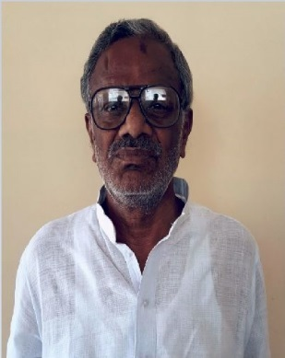

PARTICULARS OF APPLICANT
Name | : | KAKARLA VENKATA SESAIAH
Alias | :
Date Of Birth | : | 01/07/1956 | Sex | : | MALE
Marital Status | : | MARRIED
Nationality of Spouse | : | INDIAN
Spouse's NRIC No | :
Country of Birth | : | INDIA | State / Province of Birth | : | ANDHRA PRADESH
Nationality | : | INDIAN | PRC ID No | :
Race | : | INDIAN
Religion | : | HINDU
Religious Denomination | :
Type of Travel Document Held | : | INTERNATIONAL PASSPORT
Travel Document No | : | H2647220
Machine Readable Zone ID | :
Travel Document
Issue Date | : | 13/01/2009 | Expiry Date | : | 12/01/2019
Country of Issue | : | INDIA
Place of Issue | : | ANDHRA PRADESH
Address in Country of Origin
Country of Origin | : | INDIA
Division/Province/State of Origin | : | ANDHRA PRADESH
Prefecture of Origin | :
County/District of Origin | :
Address | : | H NO 4 97 DBN PALLI RAJAMPET KADAPA ANDHRA PRADESH INDIA PIN 516115

OTHER DETAILS OF APPLICANT
Occupation | : | BUSINESSMAN
Highest Academic / Professional Qualifications Attained | : | SECONDARY
Type Group | : | SOCIAL
Type Of Visa | : | MULTIPLE JOURNEY
Date of Intended Arrival in Singapore | : | 04/08/2017
How long do you intend to stay in Singapore? | : | MORE THAN 30 DAYS
If your intended stay in Singapore is more than 30 days, please state the reason for your intended length of stay and the duration | : | GOING TO STAY WITH OWN SON FAMILY. COMING TO SINGAPORE FOR GRAND DAUGHTER'S BIRTHDAY CELEBRATIONS.ALSO THEY WANTED TO PARTICIPATE AND ENJOY THE NATIONAL DAY CELEBRATIONS DECORATIONS AND EVENTS. WANTED TO SPEND SOME TIME WITH FAMILY MEMBER AND WITH FRIENDS.SITE SEEING AND DO SOME SHOPPING AS WELL.
Address in Singapore
Where will you be staying in Singapore? | : | RELATIVE'S PLACE
Block/House No | : | 573 | Floor No | : | 03 | Unit No | : | 3313
Street Name | : | ANG MO KIO AVE-3 |  |  |  | Postal Code | : | 560573
Building Name | : |  |  |  |  | Tel No | : | 90090529
Did you reside in other countries, other than your country of origin, for one year or more during the last 5 years? |  |  |  |  |  |  | : | NO

ANTECEDENT OF APPLICANT
Please choose in the box where appropriate against the following:
Have you ever been refused entry into or deported from any country, including Singapore? | : | NO
Have you ever been convicted in a court of law in any country, including Singapore? | : | NO
Have you ever been prohibited from entering Singapore? | : | NO
Have you ever entered Singapore using a different passport or name? | : | NO

MISCELLANEOUS
Remarks | : | I AM APPLYING VISAS FOR ONE OF CHILDHOOD FRIEND PARENTS.MY FRIEND NAME IS KAKARLA RAVIKIRAN. FIN NUMBER G6194805N. HE IS WORKING IN SINGAPORE FROM QUITE LONGTIME. I KNOW THEM FROM MY CHILDHOOD AS WELL AS WE ALL ARE FROM SAME PLACE IN INDIA.
Local Contact's Email Address | : | ASHOKVAR@GMAIL.COM

PARTICULARS OF LOCAL CONTACT
Applicant's Country of embarkation before arriving Singapore | : | INDIA
Relationship of Applicant to Local Contact | : | FRIEND
Name | : | MOORI ASHOK KUMAR REDDY
NRIC Number | : | S7863695E
I declare that I have a valid International Passport | : | YES
Local Contact's Passport Number | : | Z3504796
Local Contact's Passport Expiry Date | : | 13/03/2026

Address in Singapore
Block/House No | : | 359 | Floor No | : | 02 | Unit No | : | 433
Street Name | : | TAMPINES STREET 34 |  |  |  | Postal Code | : | 520359
Building Name | : |  |  |  |  | Contact No | : | 81188449

 | I declare that all information furnished by me in this application are true and correct.  I understand that if there is any discrepancy in the information declared, a resubmission with a new processing fee of $30/- is required.

Please confirm this submission by clicking on the 'Submit' button.



Click on the buttons or links once only.
Do not use the Back or Forward button on your browser as this may end your transaction.

If you encounter any problems with this e-service, please contact us at 6391 6100, or email ica_save_helpdesk@ica.gov.sg
This website is optimised for IE version 10.0, 11.0, Firefox 27.0, 28.0 and Safari 6.1, 7.0, Chrome 34.0, 35.0, Opera 19, 20

ICA Website • eCitizen
Privacy Statement | Terms of Use | © 2017 Government of Singapore

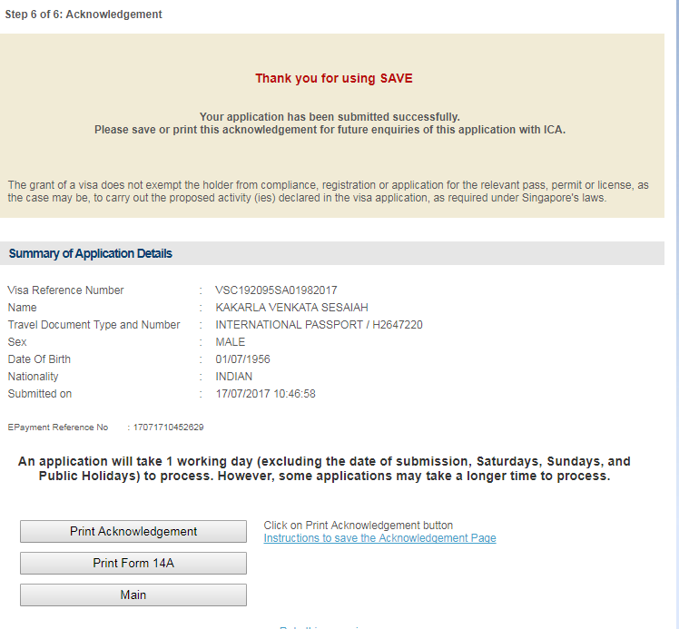

Thank you for using SAVE
Your application has been submitted successfully.
Please save or print this acknowledgement for future enquiries of this application with ICA.
The grant of a visa does not exempt the holder from compliance, registration or application for the relevant pass, permit or license, as the case may be, to carry out the proposed activity (ies) declared in the visa application, as required under Singapore's laws.

Summary of Application Details
Visa Reference Number | : | VSC192095SA01982017
Name | : | KAKARLA VENKATA SESAIAH
Travel Document Type and Number | : | INTERNATIONAL PASSPORT / H2647220
Sex | : | MALE
Date Of Birth | : | 01/07/1956
Nationality | : | INDIAN
Submitted on | : | 17/07/2017 10:46:58
EPayment Reference No | : | 17071710452629

An application will take 1 working day (excluding the date of submission, Saturdays, Sundays, and Public Holidays) to process. However, some applications may take a longer time to process.

-A A A+
Terms and Conditions | FAQs | Help

Submission of Application for Visa Electronically (SAVE)

Logout

If you are unable to see the photo image, please click here for more details.
Step 5 of 6: Confirmation

PARTICULARS OF APPLICANT
Name | : | KAKARLA PADMAVATHAMMA
Alias | :
Date Of Birth | : | 15/01/1954 | Sex | : | FEMALE
Marital Status | : | MARRIED
Nationality of Spouse | : | INDIAN
Spouse's NRIC No | :
Country of Birth | : | INDIA | State / Province of Birth | : | ANDHRA PRADESH
Nationality | : | INDIAN | PRC ID No | :
Race | : | INDIAN
Religion | : | HINDU
Religious Denomination | :
Type of Travel Document Held | : | INTERNATIONAL PASSPORT
Travel Document No | : | H2647225
Machine Readable Zone ID | :
Travel Document
Issue Date | : | 13/01/2009 | Expiry Date | : | 12/01/2019
Country of Issue | : | INDIA
Place of Issue | : | ANDHRA PRADESH
Address in Country of Origin
Country of Origin | : | INDIA
Division/Province/State of Origin | : | ANDHRA PRADESH
Prefecture of Origin | :
County/District of Origin | :
Address | : | H NO 4 97 DBN PALLI RAJAMPET KADAPA ANDHRA PRADESH INDIA PIN 516115

OTHER DETAILS OF APPLICANT
Occupation | : | HOUSEWIFE
Highest Academic / Professional Qualifications Attained | : | SECONDARY
Type Group | : | SOCIAL
Type Of Visa | : | MULTIPLE JOURNEY
Date of Intended Arrival in Singapore | : | 04/08/2017
How long do you intend to stay in Singapore? | : | MORE THAN 30 DAYS
If your intended stay in Singapore is more than 30 days, please state the reason for your intended length of stay and the duration | : | GOING TO STAY WITH OWN SON FAMILY. COMING TO SINGAPORE FOR GRAND DAUGHTER'S BIRTHDAY CELEBRATIONS.ALSO THEY WANTED TO PARTICIPATE AND ENJOY THE NATIONAL DAY CELEBRATIONS DECORATIONS AND EVENTS. WANTED TO SPEND SOME TIME WITH FAMILY MEMBER AND WITH FRIENDS.SITE SEEING AND DO SOME SHOPPING AS WELL.
Address in Singapore
Where will you be staying in Singapore? | : | RELATIVE'S PLACE
Block/House No | : | 573 | Floor No | : | 03 | Unit No | : | 3313
Street Name | : | ANG MO KIO AVE-3 |  |  |  | Postal Code | : | 560573
Building Name | : |  |  |  |  | Tel No | : | 90090529
Did you reside in other countries, other than your country of origin, for one year or more during the last 5 years? |  |  |  |  |  |  | : | NO

ANTECEDENT OF APPLICANT
Please choose in the box where appropriate against the following:
Have you ever been refused entry into or deported from any country, including Singapore? | : | NO
Have you ever been convicted in a court of law in any country, including Singapore? | : | NO
Have you ever been prohibited from entering Singapore? | : | NO
Have you ever entered Singapore using a different passport or name? | : | NO

MISCELLANEOUS
Remarks | : | I AM APPLYING VISAS FOR ONE OF CHILDHOOD FRIEND PARENTS.MY FRIEND NAME IS KAKARLA RAVIKIRAN. FIN NUMBER G6194805N. HE IS WORKING IN SINGAPORE FROM QUITE LONGTIME. I KNOW THEM FROM MY CHILDHOOD AS WELL AS WE ALL ARE FROM SAME PLACE IN INDIA.
Local Contact's Email Address | : | ASHOKVAR@GMAIL.COM

PARTICULARS OF LOCAL CONTACT
Applicant's Country of embarkation before arriving Singapore | : | INDIA
Relationship of Applicant to Local Contact | : | FRIEND
Name | : | MOORI ASHOK KUMAR REDDY
NRIC Number | : | S7863695E
I declare that I have a valid International Passport | : | YES
Local Contact's Passport Number | : | Z3504796
Local Contact's Passport Expiry Date | : | 13/03/2026

Address in Singapore
Block/House No | : | 359 | Floor No | : | 03 | Unit No | : | 433
Street Name | : | TAMPINES STREET 34 |  |  |  | Postal Code | : | 520359
Building Name | : | TAMPINES STREET 34 |  |  |  | Contact No | : | 81188449

I declare that all information furnished by me in this application are true and correct.
I understand that if there is any discrepancy in the information declared, a resubmission with a new processing fee of $30/- is required.

Please confirm this submission by clicking on the 'Submit' button.

Click on the buttons or links once only.
Do not use the Back or Forward button on your browser as this may end your transaction.

If you encounter any problems with this e-service, please contact us at 6391 6100, or email ica_save_helpdesk@ica.gov.sg
This website is optimised for IE version 10.0, 11.0, Firefox 27.0, 28.0 and Safari 6.1, 7.0, Chrome 34.0, 35.0, Opera 19, 20

ICA Website • eCitizen
Privacy Statement | Terms of Use | © 2017 Government of Singapore

-A A A+
Terms and Conditions | FAQs | Help

Submission of Application for Visa Electronically (SAVE)

Top of Form
Logout

Step 6 of 6: Acknowledgement

Thank you for using SAVE
Your application has been submitted successfully.
Please save or print this acknowledgement for future enquiries of this application with ICA.
The grant of a visa does not exempt the holder from compliance, registration or application for the relevant pass, permit or license, as the case may be, to carry out the proposed activity (ies) declared in the visa application, as required under Singapore's laws.

Summary of Application Details
Visa Reference Number | : | VSC192159SA01982017
Name | : | KAKARLA PADMAVATHAMMA
Travel Document Type and Number | : | INTERNATIONAL PASSPORT / H2647225
Sex | : | FEMALE
Date Of Birth | : | 15/01/1954
Nationality | : | INDIAN
Submitted on | : | 17/07/2017 11:12:02
EPayment Reference No | : | 17071711091118

An application will take 1 working day (excluding the date of submission, Saturdays, Sundays, and Public Holidays) to process. However, some applications may take a longer time to process.

Click on Print Acknowledgement button
Instructions to save the Acknowledgement Page
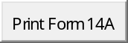

Rate this e-service

Bottom of Form

Click on the buttons or links once only.
Do not use the Back or Forward button on your browser as this may end your transaction.

If you encounter any problems with this e-service, please contact us at 6391 6100, or email ica_save_helpdesk@ica.gov.sg
This website is optimised for IE version 10.0, 11.0, Firefox 27.0, 28.0 and Safari 6.1, 7.0, Chrome 34.0, 35.0, Opera 19, 20

ICA Website • eCitizen
Privacy Statement | Terms of Use | © 2017 Government of Singapore

