EMEA DS SAN
Non-EERS Entitlement Review Process

Classification: | Internal
Department: | EMEA Distributed Storage Management
Author: | David Coles
Version: | 1.1

VERSION HISTORY

Version Number | Version Date | Revised By | Description
1.0 | 19/11/2009 | David Coles | Version 1.0
1.1 | 20/11/2009 | David Coles | Added Appendix A – Approved Users  Added Appendix B – List of applicable Hardware

Document Reviewers and Approvers:

Below please find the list of the individuals responsible for review or approve this document. An “X” indicates whether the individual is a reviewer only or a reviewer and approver. (Choose One)

Name | Position  (e.g., Client Manager, Project Manager) | Reviewer  (only) | Approver
David Coles | SAN BAU | X
Gary Battersby | EMEA SAN Manager |  | X

Table of Contents

Document Reviewers and Approvers: 2
Assumption(s) 4
Abstract 5
Centera Disk Arrays 6
SANScreen Application 7
Connectrix Manager Application 8
Hitachi Device Manager Application 9
Final Steps 10
Appendix A – List of Approved Users 11
Appendix B – List of applicable Equipment / Hardware 13

Assumption(s)

- The EMEA DS SAN team member responsible for obtaining these user lists / screenshots has a valid login to all the systems mentioned.
- The EMEA DS SAN team member responsible for obtaining these user lists / screenshots is aware of how to obtain a screenshot once logged into the application.
- The EMEA DS SAN team member responsible for obtaining these user lists / screenshots has a comprehensive list of all separate instances of the above mentioned applications
- The EMEA DS SAN team member responsible for obtaining these user lists / screenshots has a knowledge of all the varied ways in which these applications must be accessed

Abstract

Certain applications used by EMEA DS SAN team are not covered by EERS. A list follows:
- Centera Disk arrays
- SANScreen application
- Connectrix Manager Application
- HDS Device Manager Application
Accounts on the above are reviewed by the EMEA DS SAN Manager at the same time as the EERS entitlements are done. This is documented via VT and VCC, whereby a VT is raised to cover the necessary login and application interrogation activities (as required by the SAN Log review process).
The EMEA DS SAN team will access these applications and provide user lists (screenshots) and attach these lists into the appropriate VCC task. These lists are reviewed by the EMEA DS SAN Manager and approved / updated as necessary.
There now follows a detailed procedure for each of the above mentioned applications on how to obtain these user lists / screenshots.

Centera Disk Arrays

- RDC to UKCTIPRSA10 (or UKCTIDTRSA10)
- Launch Centera Viewer (D:\profiles\All Users\Desktop\Centera 3.1 SP3)
- Click “File”
- Click “Connect”
- Choose an instance
- Click “Connect”
- Enter Username and password
- Click “OK”
- Click “Yes” on the Security Alert window
- Click “Commands”
- Click “CLI”
- In “Command>” window at the bottom of the screen type “Show profile list”
- Take a screenshot of the output list
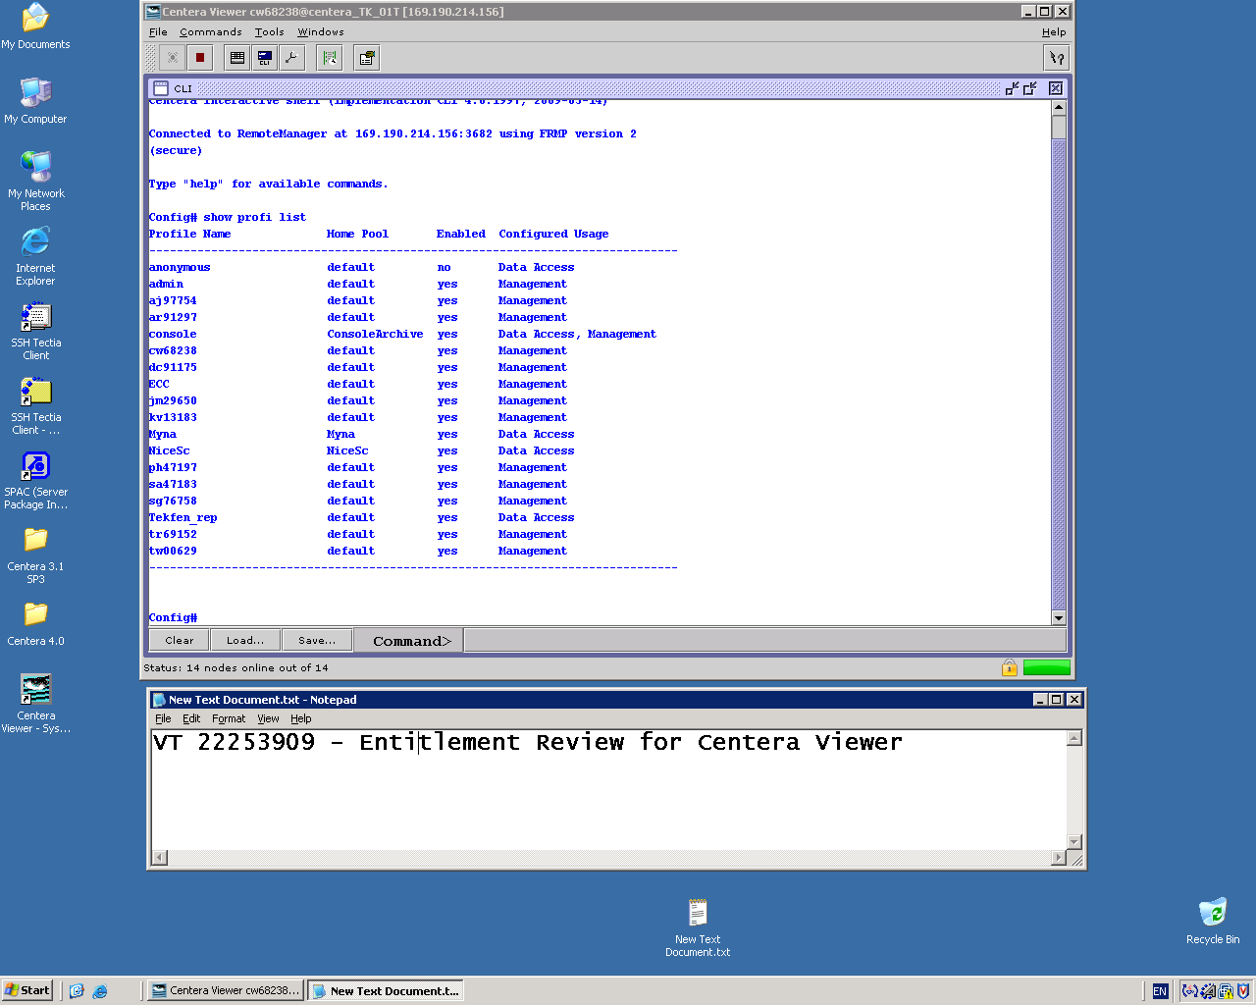
- Insert Screenshot in appropriate VCC task
- In “Command>” window at the bottom of the screen type “quit”
- Click “File”
- Click “Disconnect”
- Repeat steps 3-18 for every Centera Instance

SANScreen Application

- RDC to LDNCTISTEM001 (or LDNCTISTEM002)
- Launch Web browser
- Point browser at http://ukctiprsa48 for CGC instance, http://ukctiprsa50 for RDC instance
- Locate “Main Menu” on left hand side of screen
- Click menu entry “User Management”
- Enter username and password in appropriate boxes in SANScreen Login window
- Click “Sign in”
- Take a screenshot of the output list
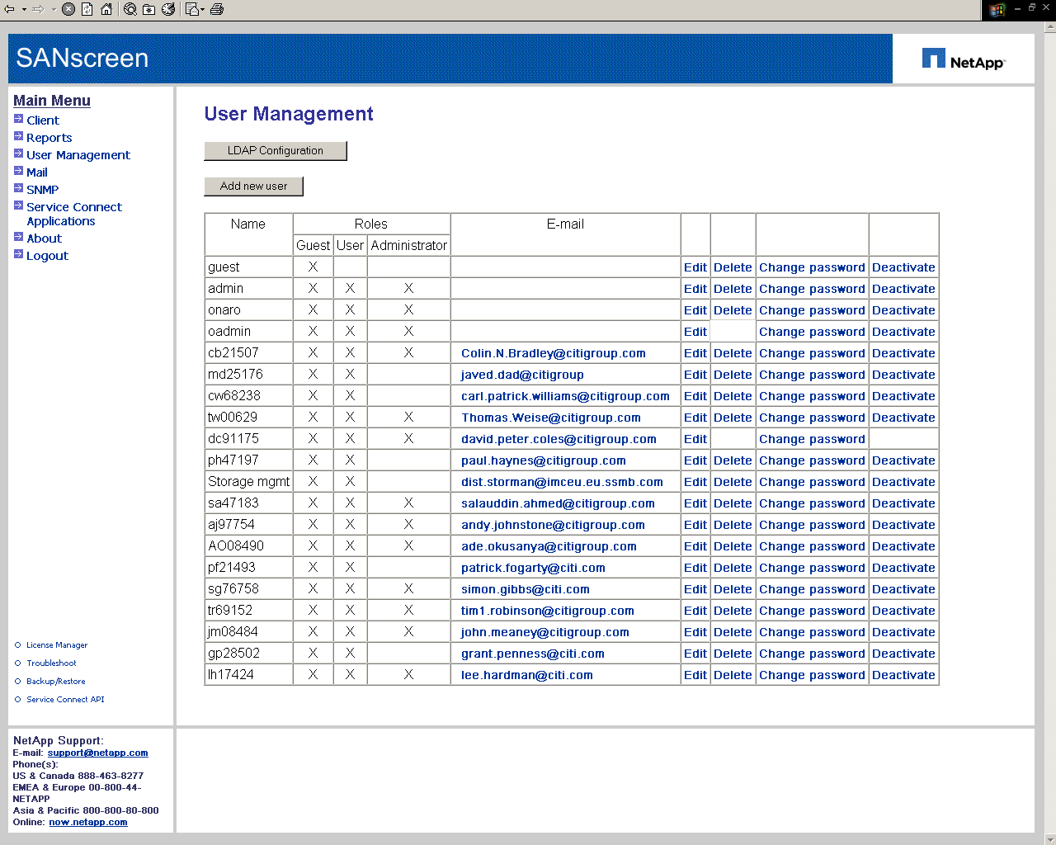
- Insert Screenshot in appropriate VCC task
- Return to SANcreen window
- Click “Logout” in “Main Menu”
- Repeat steps 4-11 for every SANScreen instance

Connectrix Manager Application

- Login to a UNIX SAN management host.
- Locate Connectrix Manager executable (/opt/emc/ConnectirxManager/ConnectrixManaget871Client/bin)
- Run executable “ConnectrixClient” – a login window appears
- Choose appropriate “Network address” – i.e. fabric
- Enter User ID and password into appropriate boxes
- Click “login”
- In “View All” window, click “SAN” – top left hand corner of window
- Click “Users” from drop-down list
- Take a screenshot of the output list in “Server Users” window
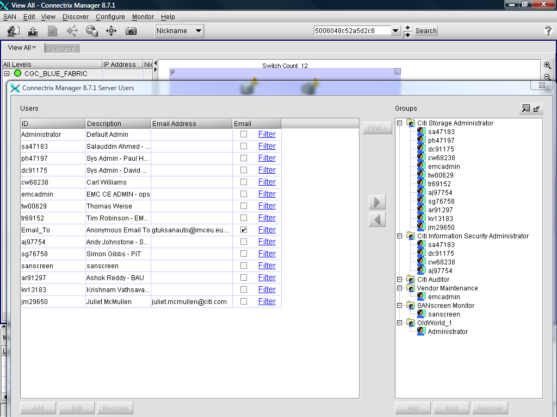
- Insert screenshot in appropriate VCC Task
- Click “OK” in “Server Users” window
- Right-Click arrow icon located in top left-hand corner of “View All” window
- Click “Quit”
- Repeat steps 3-14 for all for every Connectrix Manager Fabric

Hitachi Device Manager Application

- RDC to LDNCTISVHM001 for RDC, or FFTCTISVHM001DR for FDC
- Open a Web Browser
- Point Browser at https://localhost:23016/DeviceManager/
- Answer “Yes” or “OK” to the small number of popup windows that appear
- Type in User ID and Password into the appropriate boxes
- In extreme left hand panel, click “Administration”
- Click “Users and Permissions”
- Click “Users” in main window panel
- Take a screenshot of the output list
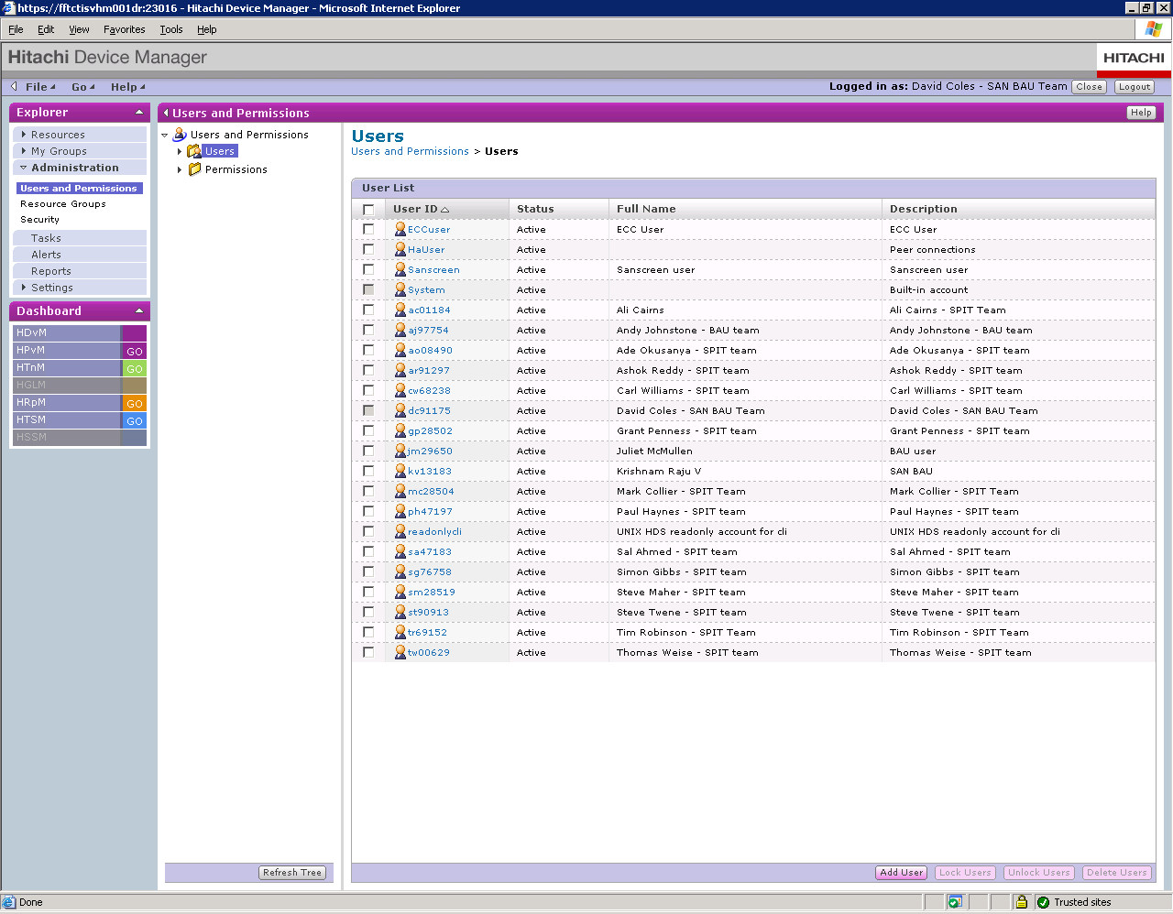
- Insert screenshot into appropriate VCC task
- Click “logout” button located in top right-hand corner of window
- Repeat steps 2-11 for every instance of Device Manager

Final Steps

Once all the screenshots have been uploaded into their associated VCC task:
- Inform EMEA DS SAN manager that the non-EERS applications are ready of review
- Send a list of all commands executed in order to obtain these screenshots to E-Mail Distribution list “*GT EMEA TI Distributed Storage Review”. Include the number of the VT that initiated this data collection exercise as justification for running these commands
- Await instruction from EMEA DS SAN manager
- If changes to any of the lists are required, amend as per EMEA DS SAN managers instructions
- Take a new screenshot of the amended output list
- Insert new screenshot into appropriate VCC task
- Inform EMEA DS SAN manager that applications are again ready for review
- Repeat steps 3-7 until approval for ALL screenshots obtained from EMEA DS SAN Manager

Appendix A – List of Approved Users

Centera Users
SOEID | Name | Team
aj97754 | Andy Johnstone | SAN BAU
ar91297 | Ashok Kumar Reddy | SAN BAU
dc91175 | David Coles | SAN BAU
jm29659 | Juliet McMullen | SAN BAU
kv13183 | Krishnam Raju Vathsavai | SAN BAU
tw00629 | Thomas Weise | SAN BAU
ph47197 | Paul Haynes | SAN PiT
cw68238 | Carl Williams | SAN PiT
sa47193 | Salauddin Ahmed | SAN PiT
sg76758 | Simon Gibbs | SAN PiT
tr69152 | Tim Robinson | SAN PiT

SANScreen Users
SOEID | Name | Team
aj97754 | Andy Johnstone | SAN BAU
ar91297 | Ashok Kumar Reddy | SAN BAU
dc91175 | David Coles | SAN BAU
jm29659 | Juliet McMullen | SAN BAU
kv13183 | Krishnam Raju Vathsavai | SAN BAU
tw00629 | Thomas Weise | SAN BAU
ph47197 | Paul Haynes | SAN PiT
cw68238 | Carl Williams | SAN PiT
sa47193 | Salauddin Ahmed | SAN PiT
sg76758 | Simon Gibbs | SAN PiT
tr69152 | Tim Robinson | SAN PiT
ao08490 | Ade Okusanya | SAN PiT
lh17424 | Lee Hardman | SAN PiT
cb21507 | Colin Bradley | SAN ENG
pf21493 | Pat Fogarty | SAN ENG

Connectrix Manager Users

SOEID | Name | Team
aj97754 | Andy Johnstone | SAN BAU
ar91297 | Ashok Kumar Reddy | SAN BAU
dc91175 | David Coles | SAN BAU
jm29659 | Juliet McMullen | SAN BAU
kv13183 | Krishnam Raju Vathsavai | SAN BAU
tw00629 | Thomas Weise | SAN BAU
ph47197 | Paul Haynes | SAN PiT
cw68238 | Carl Williams | SAN PiT
sa47193 | Salauddin Ahmed | SAN PiT
sg76758 | Simon Gibbs | SAN PiT
tr69152 | Tim Robinson | SAN PiT

Hitachi Device Manager Users Users

SOEID | Name | Team
aj97754 | Andy Johnstone | SAN BAU
ar91297 | Ashok Kumar Reddy | SAN BAU
dc91175 | David Coles | SAN BAU
jm29659 | Juliet McMullen | SAN BAU
kv13183 | Krishnam Raju Vathsavai | SAN BAU
tw00629 | Thomas Weise | SAN BAU
ph47197 | Paul Haynes | SAN PiT
cw68238 | Carl Williams | SAN PiT
sa47193 | Salauddin Ahmed | SAN PiT
sg76758 | Simon Gibbs | SAN PiT
tr69152 | Tim Robinson | SAN PiT
ao08490 | Ade Okusanya | SAN PiT
lh17424 | Lee Hardman | SAN PiT
mc28504 | Mark Collier | SAN PiT
ac01184 | Ali Cairns | SAN PiT
sm28519 | Steve Maher | SAN PiT
st90913 | Steve Twene | HDS

Appendix B – List of applicable Equipment / Hardware

Centera
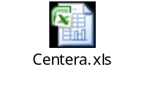
Connectrix Manager
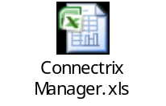
SANScreen
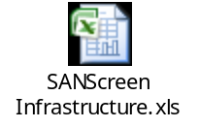
Hitachi Device Manager
