Personal
Ashok Experience
[Type the document subtitle]
Ashok Kumar Reddy
9/6/2015

[Type the abstract of the document here. The abstract is typically a short summary of the contents of the document. Type the abstract of the document here. The abstract is typically a short summary of the contents of the document.]

Contents
Main 1
Currently roles 1
Previous roles 5
Experience in Previous companies 6
Solution Middle East 6
Wipro/Satyam GE 6
Sankalp Webtech 7
Sybernet technologies 7
Personal 7
Goals/Achievements 8

Main
This is Ashok Kumar Reddy and currently working in Citibank under Global Emerging Technology team and also under Capacity and performance team

Currently roles

EMC SRM ViPR
EMC SRM Controller enables IT to create a web scale infrastructure leveraging existing storage investments. Vipr SRM is a comprehensive monitoring and reporting solution that helps IT visualize, analyze and optimize todays storage investments while providing a management framework that supports investments in software-defined storage.
With Vipr SRM, we can obtain detailed relationship and topology views from the applications, to the virtual or physical host, down to the LUN to identify service dependencies.
We can view performance trends across the data path and identify hosts competing for resource
Vipr srm helps us to analyze health, configurations and capacity growth. We can also track block, file and object capacity consumptions across the data centers
We can define service levels and track consumption by the disk technology, RAID type, array model, fast policy or Vmax3 service level objectives to understand where and how capacity is being consumes

SRM Vipr helps you to optimize capcity and improve productivity. Detailed capacity reporting improves planning to enhance purchasing processes and reduce costs and also which will improve the ROI
Within ViPR SRM, creating a custom performance report for a host or application is as simple as selecting the desired reports using the “push pin” capability to add them to a “My View” dashboard. Once created it can be saved, emailed or shared with anyone in the organization
ViPR SRM validates front-end and back-end configuration rules, design best practices and compliance to the EMC Support Matrix to ensure service levels are not impacted by configuration issues in VPLEX environments.

HPNA
HP Network Automation – Drive efficient change, automated configuration, security administrator and complicance, network fault, availability and performance with change, configuration, compliance and automated diagnostics.
HPNA software automates the complete operational lifecycle of network devices from provisioning to policy-based change management, complaince, and security administration.
HPNA provides a holistic, automated approach across the network management domain
benefits
- Reduce costs by automating time-consuming manual compliance and configuration tasks
- Pass audit and compliance requirements easily with proactive policy enforcement and audit compliance reports
- Improve network security by recognizing and fixing security vulnerabilities before they impact the network
- Increase network stability and uptime by preventing inconsistencies and minconfigurations
- Leverage process-powered automation to deliver application integrations and achieve full IT lifecycle workflow automations
- HPNA software goes beyond multivendor network configuration management to help you prevent errors before they occur and deliver measurable cost savings using process-driven network automation
- The end result is a resilient, maintainable and cost-effective network that is compliant with both company starndards and government regulations.
HP Network Automation provides process‑powered
automation. When combined with HP Operations
Orchestration software, HP Network Automation
takes workflow automation to a new level, letting you
automate IT workflows beyond traditional network
change and configuration management. Automation is
of little value if your devices are not supported. That is
why HP Network Automation supports an exhaustive
set of network devices from over 70 vendors, and
includes virtual devices, giving you comprehensive
network change and configuration management
- coverage for an extensive range of devices.
For customers with Cisco and HP Networking devices,
HP Network Automation offers unique capabilities for
unmatched change, configuration, and compliance
- management of those devices.
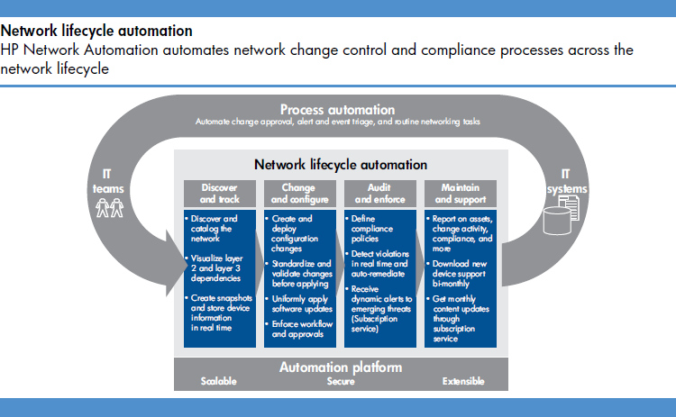

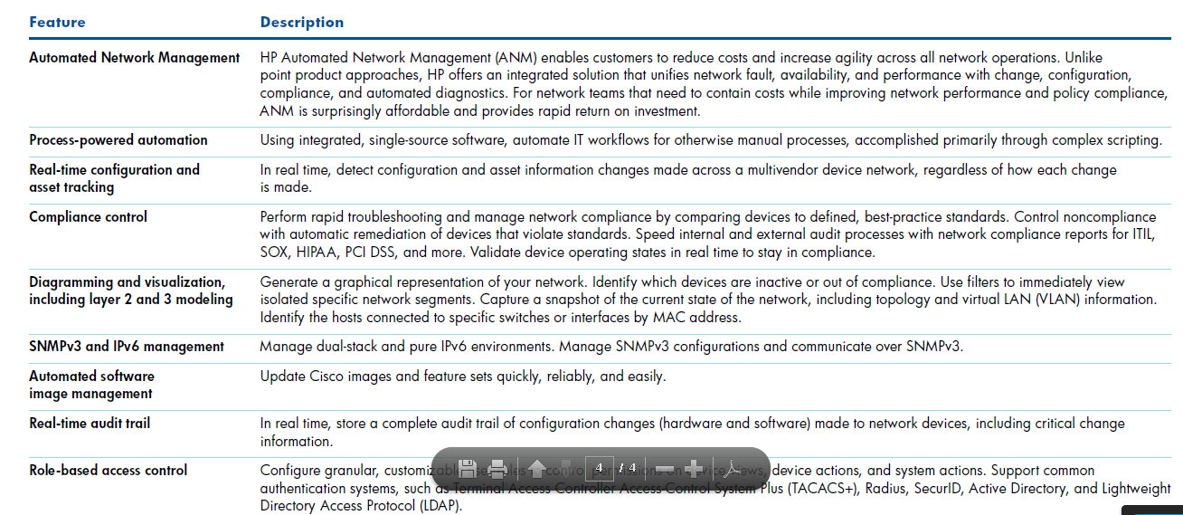

DRA
Formerly known as Symantec Disaster Recovery Advisor, Veritas Risk Advisor automatically detects and reports on risks (of data loss and application downtime) and sub-optimality in the IT infrastructure. It agentlessly scans systems across data centers and draws on a database of nearly 6,000 issues to help raise system availability & data protection, and supports optimization of the infrastructure for aspects such as performance and resource utilization, by providing prioritized guidance for remediating the identified issues.

Key Features
- Agent-less and automatic scan of high availability and disaster recovery infrastructure.
- Gap knowledge base with nearly 6,000 risk signatures out-of-the-box to detect potential risks.
- Automatically sends notification tickets to the system management console allowing proactive risk mitigation.
- Risk reporting that includes risk details and locations can be tuned to individual environments.
- Integration with customer preferred system management and ticketing consoles for management and operational ease.
- User-defined, granular role configurations for management interface view.
- Distributed architecture for enterprise scalability and performance.
- Optional module Veritas Risk Advisor – SAN Analyzer
Overview of Veritas Disaster Recovery Advisor (DRA):
- Detects HA/DR (high availability/disaster recovery) issues such as config drift, storage config, DB setup, optimization issues within and across multiple data centers
- 3000+ host and storage vulnerabilities. The vulnerability list set was assembled over 3 years of development and testing
- NO AGENTS, easy to install (1 hr), easy to maintain (automatically updated), and easy to use (takes 1 hr to learn).
- Installed on one Windows box, and from this box, DRA scans 1000s of servers (Unix, Linux, Windows) and 100,000s of storage devices throughout the multiple data centers.

Key Benefits
- Helps businesses meet critical RPO and RTO Service Level Agreements by reducing risks to business continuity.
- Holistic view of infrastructure takes account of dependencies to highlight risks in priority order.
- Ability to identify SAN-specific risks e.g. path/ HBA mis-configurations or single points of failure in fabric.
- Agent-less implementation makes it non-disruptive to production environment.
- Scan frequencies can be scheduled based on business needs, reducing data center intrusiveness.
- Gap knowledge base updates are automatic, requiring no manual intervention.
- Improves performance by highlighting underutilized storage space, unused copies of storage volumes, database entities and replication configuration changes.
- One management server scales to thousands of monitored servers across multiple data centers.
- Single, consolidated view of disaster recovery readiness with easy deployment, management and maintenance.

NEW - Symantec™ Disaster Recovery Advisor 6.4
Available from 2 March 2015.
Symantec is announcing Symantec™ Disaster Recovery Advisor 6.4. Symantec™ Disaster Recovery Advisor 6.4 (DRA) automatically detects and reports on risks (of data loss and application downtime) and sub-optimality in the IT infrastructure. DRA agentlessly scans systems across the data center and draws on a database of nearly 6,000 issues to help raise system availability and data protection, and supports optimization of the infrastructure for aspects such as performance and resource utilization by providing prioritized guidance for remediating the identified issues.
Note:This release includes the addition of annual subscription licensing.
What’s New:
New Platform Support
- IBM V7000
- EMC VPLEX
  - Support for EMC VPLEX 5.2 and above was added for environments which include ESX/ESXi servers using EMC CLARiiON and VNX storage systems
  - Data collection is performed by using the VPLEX Management Server.
- HP 3PAR
  - Support for HP 3PAR StoreServ Storage added
  - Data is collected Using 3PAR InForm CLI.
- Oracle GoldenGate
  - DRA collects information regarding Oracle GoldenGate by querying the Oracle GoldenGate Monitor Repository which is part of the Management Pack for Oracle GoldenGate
  - Oracle GoldenGate Director was the previous monitoring product and was replaced by Oracle GoldenGate Monitor. DRA supports integration only with Oracle GoldenGate Monitor.
Data Collection
- Support partial scan for Hitachi HiCommand
  - The ability to selectively scan Hitachi storage arrays has been added
  - After configuring a HiCommand Storage Proxy and performing Storage Array Discovery, users may click Edit Storage Scope to select which of the arrays managed by the HiCommand will be scanned
  - The default setting is “All storage arrays”
  - This capability was planned for 6.4 and we were able to include it in already in 6.3.2.
- HP 3PAR
  - Support for HP 3PAR StoreServ Storage added
  - Data is collected Using 3PAR InForm CLI.
- Oracle GoldenGate
  - DRA collects information regarding Oracle GoldenGate by querying the Oracle GoldenGate Monitor Repository which is part of the Management Pack for Oracle GoldenGate
  - Oracle GoldenGate Director was the previous monitoring product and was replaced by Oracle GoldenGate Monitor. DRA supports integration only with Oracle GoldenGate Monitor.
- Simplify the scan process - remove requirements
  - It is no longer a mandatory requirement to have the ‘inqraid’ tool installed on scanned Windows and AIX servers that use HDS storage volumes
  - DRA is able to identify storage volumes used by these hosts without running the ‘inqraid’ command
  - It is still recommended to use ‘inqraid’ if available.
- WebSphere, WebLogic and Tomcat - scanning improvements.
Application
- Database Views - Reduce requirements
  - First of all, note that System API (SAPI) has been renamed to DRA Database Views
  - In addition to the previous capability of automatic creation and management of the Oracle schema for the Database Views by DRA, a new method has been added to allow users to manually configure fixed Oracle schemas. This new method does not require granting the DBA (DB ADMIN) permission to DRA
  - Users may now control whether the creation of Database Views is performed as part of the data analysis and define a timeout for the views creation process
  - To learn more details about the methods available for creating the Database Views, review the User Guide and the Advanced Configuration - Database Views (new) screen
  - This feature was planned for version 6.4 and we were able to incorporate it into 6.3.2.
- Configuration Wizard Step 2 redesign
  - The Storage Scan Configuration User Interface was redesigned in order to simplify the management of storage array scanning, provide more visibility onto the scan scope and status and streamline the configuration workflow
  - The new design presents the scanned storage systems in the main view, as opposed to storage proxies in past release
  - For more information regarding the new Storage Scan Configuration UI, refer to the DRA 6.4 User Guide.
- Granular gap (risk signature) suppression
  - Ability to suppress gaps by Business Entity / Cluster / Host / Site.
- Support for DRA database on Oracle RAC
- Usability and Cosmetic improvements for the Ticket Details report
- Analytics
  - VMware risk analysis and platforms (focus on ESX Server, vSphere HA and VMware Virtual Network best practices)
  - VCS signature refresh.
Key Features:
- Scans IT infrastructure agentlessly on a scheduled basis
- Checks against a database of nearly 6,000 issues
- Takes holistic view of infrastructure taking account of dependencies
- Provides prioritized action list including remediation guidance
- Integrates with leading CMDB and ticketing systems.

ScaleIO
OK – now look at the vSAN/ScaleIO through that lens:
- First – at the top level of “what are they”, yes – vSAN and ScaleIO are similar. They are both distributed transactional software stacks, and ones that are “software only, bring your own hardware” models. They share many architectural models (internal “object” mechanics with replicated content for failure handling, read/write caching layer for localization of data using flash, a “client and server” layer in their stacks, distributed metadata internals)
- Like many EMC/VMware actions – when we see a customer need (in this case "I want a 'software only transactional stack'") we: SIMULTANEOUSLY attack it from:
  - Perspective 1: "Start by assuming you're using vSphere" viewpoint (led by VMware – still open of course – but VMware-centric, sometimes using some EMC intellectual property like Avamar in VDP or several other examples)
  - Perspective 2: "Start by assuming you’re using VMware, as well as several different hypervisors + physical environments, each with 'a bunch of different workloads'" (led by EMC – still open of course – but EMC-centric, sometimes using some VMware intellectual property).
- vSAN is focused on “Perspective 1” aka from the view point of start by assuming VMware:
  - It's designed to be "invisible" when you're using vSphere
  - It's deeply embedded in the VMkernel (so it’s harder to expose for external use but conversely vmkernel embedded gives some advantages)
  - It's management model is "you manage it via vCenter". See above.
  - It's designed for vSphere cluster “levels of scale” (in currently shipping vSphere 5.x releases – this maximum is 32 nodes)
- Scale IO is focused on on “Perspective 2” aka from the view point by assuming "all hypervisor/physical hosts"
  - It's designed to "run on" heterogenous infrastructure – and isn't invisible (it has it's own management model)
  - It's mostly OS agnostic (including running as a virtual machine for hypervisors). It's dependent on a OS level driver (for both client and server functions)
  - You manage it via the Scale IO management tools.
  - It's designed for "cloud scale" (tens to tens of thousands of nodes).
Over the fullness of time – perhaps intellectual property from one or the other will cross pollinate (we do that often). Perhaps over the fullness of time, everyone will use vSphere and vSAN will win everwhere. Conversely, perhaps, time will show that heterogeneous environments including Openstack on KVM/Xen and SCOM on Hyper-V and vCloud Suite + vSphere will continue to coexist.
One thing to point out – BOTH VMware and EMC have an open posture – working inside ecosystems beyond ourselves. We both contribute to OpenStack (nova integration for ESX, neutron for Nicira, vCAC with the whole kit and kaboodle, Cinder for EMC storage, Swift in ViPR) – and this is sincere. This openness is important. My point about the “two perspectives” originates from the model of how VMware and EMC independently tackle solutions – with a perspective of what is “assumed”.
- ScaleIO has a different design point – to provide highly scalable server-based storage for heterogeneous platforms, including multiple hypervisors and physical servers. ScaleIO has its own installation, configuration and management workflows which are typically driven by expert storage administrators.

The confusion between VMware Virtual SAN and ScaleIO is partially fueled by recent press articles, which claim full integration of ScaleIO into vSphere’s ESX kernel. This claim is not accurate. There are no plans to port the core ScaleIO product in the ESX kernel or integrate it with the rest of the vSphere stack.
EMC acquired ScaleIO last summer, in between disclosing plans to add ViPR software-defined storage at EMC World 2013 and VMware's launch of the VSAN beta at VMworld. ScaleIO and VMware both can turn commodity hardware into shared storage.
EMC labels both VMware Virtual SAN and ScaleIO as software-defined- storage. They are both block-based, distributed transactional software stacks with similar architectural models, according to EMC executives. And both have a connection with ViPR.
EMC executives admit the similarities but say ScaleIO scales better and supports more types of servers than VMware-specific VSAN.
"VSAN and ScaleIO are both software-defined storage that provide hyper-converged storage," said Erez Webman, ScaleIO founder and currently CTO and chief architect for EMC's ScaleIO/server storage software group. "When customers look for a solution that is VMware only, they can choose between VSAN and ScaleIO. I can see such environments, but most environments where heterogeneous (external) storage is a concern, I would see ScaleIO."
The products are even more connected now that ScaleIO is integrated into the ViPR controller that manages block, object and Hadoop Distributed File System (HDFS). The ViPR controller can also plug into VMware vSphere VSAN.
What separates the ScaleIO and VSAN is scalability, said David Goulden, CEO of EMC's Information Infrastructure.
"VSAN and ScaleIO are both block platforms," Goulden said Monday during a media question and answer session. "But they're for different workloads. VSAN is hyper-converged storage. Think of VSAN as an extension of (VMware) vSphere, it only runs when physically connected to vSphere. ScaleIO is aimed to scale. You can add thousands of nodes. VSAN is limited in size, it scales to 32 nodes.
"Just like you have multiple block physical arrays, you have multiple types of software-defined storage."
And EMC does not worry about having multiple types of overlapping storage. There is overlap between many of its platforms, such as its VNX, VMAX, Isilon and Atmos arrays and even its data protection applications. EMC's acquisition of DSSD this week will bring more flash to the vendor that already has hybrid and all-flash arrays plus server-side flash products.
"Different workloads have different requirements," Goulden said. "There's no way one size fits all."
Razor Technology, an enterprise systems integrator, has six ScaleIO installations among its customers, according to Razor distinguished engineer Oleg Lukyanov. One Razor customer is running more than 30 servers.
"Whenever you grow the system, you get immediate performance," Lukyanov said. "If you run out of performance and you need more IOPS, you just add more drives. I can take drives from virtual and physical systems and create a pool. It rebalances all the LUNs automatically in the background. This is very unusual for any system. The system is so simple."
Lukyanov said to get that kind of storage scalability, the choices are buy expensive traditional storage systems or build an iSCSI system. In either case, he said, management is not so simple.
"You have to manage all the storage that is allocated, track what is shared from where and which volume you pulled out of it and which servers are using the volumes," he said of traditional SANs. "The management overhead is high and it just kills any Capex in savings."
Adding more capacity to a ScaleIO configuration is not as complex, he said.
"You basically pick your server. You go back to ScaleIO and allocate a pool volume out of it. Done," Lukyanov said. "Then you can ask ScaleIO where the volume is and allocate to it. You don't need spreadsheets."

Previous roles

Experience in Previous companies

Solution Middle East

Wipro/Satyam GE

Sankalp Webtech

Sybernet technologies

Personal

Goals/Achievements

Certifications

Technologies worked

