Citigroup
Ashok’s Experience doc
Work experience
Ashok Kumar Reddy Moori
9/6/2015

[Type the abstract of the document here. The abstract is typically a short summary of the contents of the document. Type the abstract of the document here. The abstract is typically a short summary of the contents of the document.]

Contents
Main 3
Current roles:- 3
EMC SRM ViPR 3
XtremIO 5
HPNA 10
DRA 12
ScaleIO 12
Unisphere for Vmax 16
DCNM 17
Introduction to Cisco Data Center Network Manager 17
DCNM-SAN Server 17
DCNM-SAN Client 18
Device Manager 18
DCNM-SAN Web Client 19
Performance Manager 19
Authentication in DCNM-SAN Client 19
Cisco Traffic Analyzer 20
Network Monitoring 20
Performance Monitoring 20
ESRS 21
VMAX3 21
Supported VMAX3 Features 22
Key Feature Changes 23
Overview of TimeFinder Clones 24
Using clones with databases and file systems 24
Clone terminology 25
Clone creation 25
Key differences between TimeFinder/Clone and TimeFinder/Mirror 27
Migrations 27
Open Replicator Features: 30
Open Replicator Objectives: 30
Open Replicator Practical Considerations: 30
Open Replicator Limitations: 31
Applicable Environments 31
Throughput Observations: 31
HOT PULL 32
Hot Push 32
COLD PUSH 33
CopyOnWrite (COW) 33
Front-end Zero Detection 34
Donor Update 34
Previous roles 35
APAC 35
EMEA 35
Replication operations 35
Storage optimization and reclamation project 35
Lean effect 35
EMEA Capacity team leader 36
MOR Reports 36
Chargeback / Host Billing reports 36
Experience in Previous companies 36
Solution Middle East 37
Wipro/Satyam GE 37
Sankalp Webtech 38
Sybernet technologies 38
Certifications : - 39
MCSE 39
SUN Certified System Administrator For Solaris 8 39
CCNA 2.0 39
DHE 39
PGDCA 39
Technologies worked 39
Personal 41

Main
This is Ashok Kumar Reddy and currently working in Citibank under Global Emerging Technology team and also part of Capacity and performance team. Joined in Citi 2006. Having 10+ years of experience in Storage Area Networks. Worked in SAN Operations team, Projects team, Capacity Management & forecasting team, L2 & L3 teams, Capacity & performance teams
- Currently in Citi, SAN storage is divide into L2, L3, Emerging technology, Build , provisioning & migration teams.
- Work with the CATE engineering teams on any new implementation on SAN/NAS or CAS products.
- Involving in various Performance related issues (slow response, high resource utilization etc.)
- Attending New Project ‘Kick off’ meetings wherever Storage is a required stream.
- Work closely with the regional CTI and Client project managers to ensure requirements are properly identified, defined and solutions delivered.
- Technical knowledge and hands-on experience in VMAX, DMX, XtremIO, Clariion, HDS VSP/USPV, Centera & Cisco MDS/McData SAN directors using Solution Enabler, Hitachi Command Suite, Unisphere for Vmax, Storage Navigator, EMC Control Center, SAN Screen, Time Finder, Cisco CLI, Cisco Fabric Manager and Connetrix Manager software for day-to-day operations.
- Involved and handled some of the Major Projects like CEEMEA Migration, Rainbow, VMware Migration, Bronze/Archival storage migration project, Q2 Tech-Refresh, GDCS Migration, RAID-10 to RAID-5 Migration, Clariion Tech-Refresh, FC9000 Swat Out, Hong Kong COB implementation, Microcode upgrades for Symmetrix frames, Connectrix Manager Upgrades, etc...
- Manage user access requests. Monitor alerts and resolve false alerts.
- Disaster recovery preparation and clean-up: Preparation and clean-up work for teams executing disaster-recovery drills

Current roles:-

EMC SRM ViPR
SRM offers a wide variety of report types, including standard tables, graphs, and specialized reports such as map, topology, and mixed reports, which combine several reports on one page.
SRM supports
EMC VMax – discover the data through SE for the capacity and Unisphere for Vmax for performance reports.
EMC VNX/Clariion – discovered through Unishpere for VNX. |EMC VNX/Celera - discovered through Unishpere for VNX . |NetApps – Discovered through Netapp OnTAP. | Cisco MDS – Discovered through SNMP community. |Mcdata switches – discovered through connectrix. |XtremIO – through XMS servers, |XIV – through XIV GUI, |Hitachi – through HCS device manager. |VMWare – through Vcenter
SRM project is implemented in Citi is a new proper solution for storage monitoring, billing and reporting. As a part of this project the solution will be developed, certified, tested and deployed in all regions (NAM, LATAM, EMEA, APAC) to replace the legacy ECC & Sanscreen products.
Regularly generating/reviewing the reports like storage enterprise capacity dashboards, switch port inventor, disk capacity report, storage utilization MOR report, chargeback utilization report, file & block utilization report
Vipr SRM is a comprehensive monitoring and reporting solution that helps IT visualize, analyze and optimize today’s storage investments while providing a management framework
In Vipr SRM, we can obtain detailed relationship and topology views from the applications, to the virtual or physical host, down to the LUN to identify service dependencies.
We can view performance trends across the data path and identify hosts competing for resource
Vipr srm helps us to analyze health, configurations and capacity growth. We can also track block, file and object capacity consumptions across the data centers
We can define service levels and track consumption by the disk technology, RAID type, array model, and fast policy or Vmax3 service level objectives to understand where and how capacity is being consumes
SRM Vipr helps you to optimize capacity and improve productivity. Detailed capacity reporting improves planning to enhance purchasing processes and reduce costs and also which will improve the ROI
ViPR SRM validates front-end and back-end configuration rules, design best practices and compliance to the EMC Support Matrix to ensure service levels are not impacted by configuration issues in VPLEX environments.
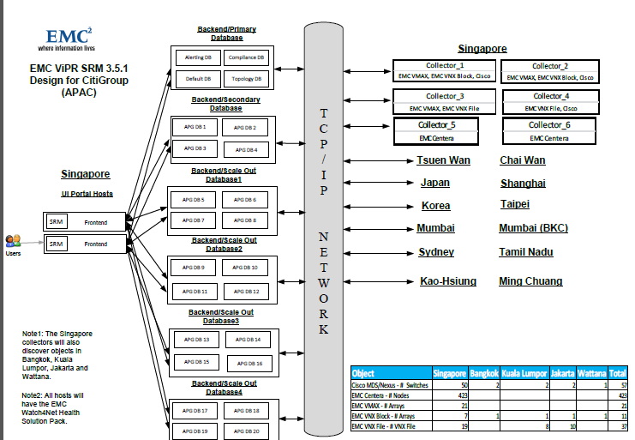

XtremIO
The XtremIO Storage Array is an all flash system, based on scale-out architecture. The system uses building blocks called X-Bricks which can be clustered together to grow performance and capacity as required. Currently single X-Brick systems are being certified. At this time the XtremIO array is being certified as restricted only for use with VDI deployments.
A transformational architecture is needed to fully take advantage of flash. EMC XtremIO was created from scratch to fully leverage flash and enable the data center of the future. It is uniquely designed to address the demands of virtualization for superior random I/O performance, rapid response times, scalability, flexibility, and administrator agility.
System | Raw Capacity | Read/Write IOPS | Read IOPS
Starter X-Brick | 5 TB | 150K | 250K
1 X-Brick | 10, 20, or 40 TB | 150K | 250K
2 X-Brick Cluster | 20, 40, or 80 TB | 300K | 500K
4 X-Brick Cluster | 40, 80, or 160 TB | 600K | 1M
6 X-Brick Cluster | 120 or 240 TB | 900K | 1.5M
8 X-Brick Cluster | 160 or 320 TB | 1.2M | 2M
Key features:
- Scales to more than 1,612 TB effective capacity per cluster
- Inherently load balances data for maximum performance without tuning
- Provides writeable snapshots with space efficiency and zero performance impact
- Delivers truly inline, always-on data deduplication to reduce capacity needs and TCO
- Enables operational and disaster recovery using native replication with EMC RecoverPoint
- Includes XtremIO Data Protection (XDP): more resilient and lower overhead than legacy RAID

Each X-brick is comprised of:
- One 2U Disk Array Enclosure (DAE), containing:
- 25 eMLC SSDs (standard X-Brick 10TB) or 13 eMLC SSDs (5TB Starter X-Brick)
- Two redundant power supply units (PSUs)
- Two redundant SAS interconnect modules
- Two 1U Battery Backup Units (BBUs)
- Two 1U Storage Controllers (redundant storage processors)
Each Storage Controller includes:
- Two redundant PSUs
- Two 8GB/s Fiber Channel (FC) ports
- Two 10Gbe iSCSI ports
- Two 40GB/s Infiniband ports
- One 1Gb/s management port

Thin Provisioning

XtremIO storage is natively thin provisioned using a small internal 8KB block size. All volumes in the system are thin provisioned, meaning that the system consumes capacity only when it is actually needed. XtremIO determines where to place the unique 8KB blocks physically inside the cluster after it calculates their fingerprint IDs. This means it never pre-allocates or thick provisions storage space before writing.

SAS Back-end

The XtremIO array utilizes 6 GB/s Serial Attached SCSI (SAS) backend, with 4 lanes each. The SAS backend connection can address 4 storage devices at the same time on a port.

The XtremIO includes 2 SAS backend ports per storage controller. Currently the XtremIO utilizes only one back-end SAS port for connectivity to the DAE per storage controller. Enabling all backend ports is scheduled for a future release.

High Availability

The Storage Controllers and DAE in the cluster are equipped with dual power supplies. The cluster also has dual Battery Backup Units.

Any information not committed to the SSD is kept in multiple locations, called Journals. Each software module has its own journal, which is not kept on the same Storage Controller (SC) and can be used to restore data in case of unexpected failure. These journals are kept on the storage controllers with battery backed up power supplies. In case of a problem with the Battery Backup Unit (BBU), the journal fails over to another SC. In case of global failure, the BBU ensure that all Journals are written to vault drives in the SC and the cluster is then turned off.

XtremIO Data Protection

An X-brick is preconfigured as a single redundancy group, which eliminates the need to select, configure, and tune RAID groups. XDP uses double parity RAID6-like data protection. Dedicated hot spares are not required for rebuild; instead it leverages the “hot” space concept, where any free space available in the array can be utilized for failed drive reconstructions. The cluster always reserves sufficient distributed capacity for performing a single rebuild even at 100% physical capacity utilization. When an SSD fails the cluster rebuilds it to restore redundancy, this rebuild reconstructs data from the failed SSD onto the remaining SSDs in the protection group. Capacity utilization on a given protection group should never exceed 95%, it is recommended to reserve the capacity of at least one SSD in case of a dual SSD failure scenario. The X-brick can recover from multiple SSD failures that do not occur simultaneously. A dual drive failure that occurs concurrently is not yet supported.

Inline Data Reduction

The always on inline deduplication feature enables the removal of redundancies from data before it is written to the flash media. As data enters the cluster, data reduction is performed in real-time and not as a post-processing operation. Data blocks are stored according to their content and not according to their user level address within the volumes. If host data is written over and over again, it will be de-duplicated and no additional writes to the SSDs will occur.

XtremIO Cluster Configurations

Description | One X-Brick
Max eMLC SSDs per Cluster | 25
X-Brick Storage Controllers | 2
Processors  Per Cluster | 4 x 8-core  2.1 GHz Xeon
Total Memory Per Cluster | 512 GB
Max 6Gbps  SAS Back-End Buses per Cluster | 4 x 4-Lane
Max 8Gbps  FC Front-End Ports per Cluster | 4
Max 10Gbps Ethernet iSCSI - Front-End Ports per Cluster | 4
# Infiniband Switches per Cluster | 0
X-Brick Cluster Rack Space | 6U
Battery Backup Unit (BBU) 2 x PS | 2
Usable Capacity | 7.58 TB
Max # defined initiators per cluster | 512
Max # defined initiators per initiator groups | 64
Max # defined volumes per cluster | 8192
Max volume size per cluster | 256TB**
Max # defined users per cluster | 50

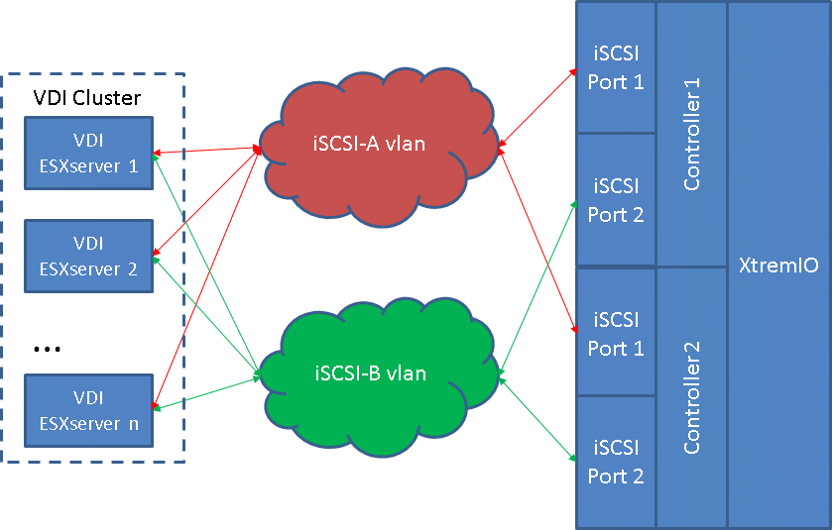

HPNA
HP Network Automation – Drive efficient change, automated configuration, security administrator and compliance, network fault, availability and performance with change, configuration, compliance and automated diagnostics.
HPNA software automates the complete operational lifecycle of network devices from provisioning to policy-based change management, compliance, and security administration.
HPNA provides a holistic, automated approach across the network management domain
Benefits
- Reduce costs by automating time-consuming manual compliance and configuration tasks
- Pass audit and compliance requirements easily with proactive policy enforcement and audit compliance reports
- Improve network security by recognizing and fixing security vulnerabilities before they impact the network
- Increase network stability and uptime by preventing inconsistencies and min configurations
- Leverage process-powered automation to deliver application integrations and achieve full IT lifecycle workflow automations
- HPNA software goes beyond multivendor network configuration management to help you prevent errors before they occur and deliver measurable cost savings using process-driven network automation
- The end result is a resilient, maintainable and cost-effective network that is compliant with both company standards and government regulations.
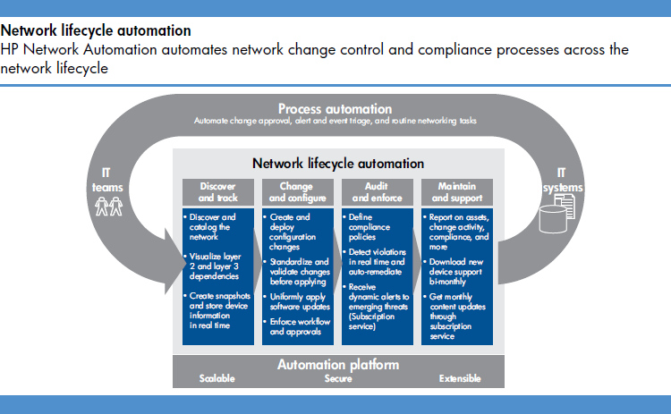

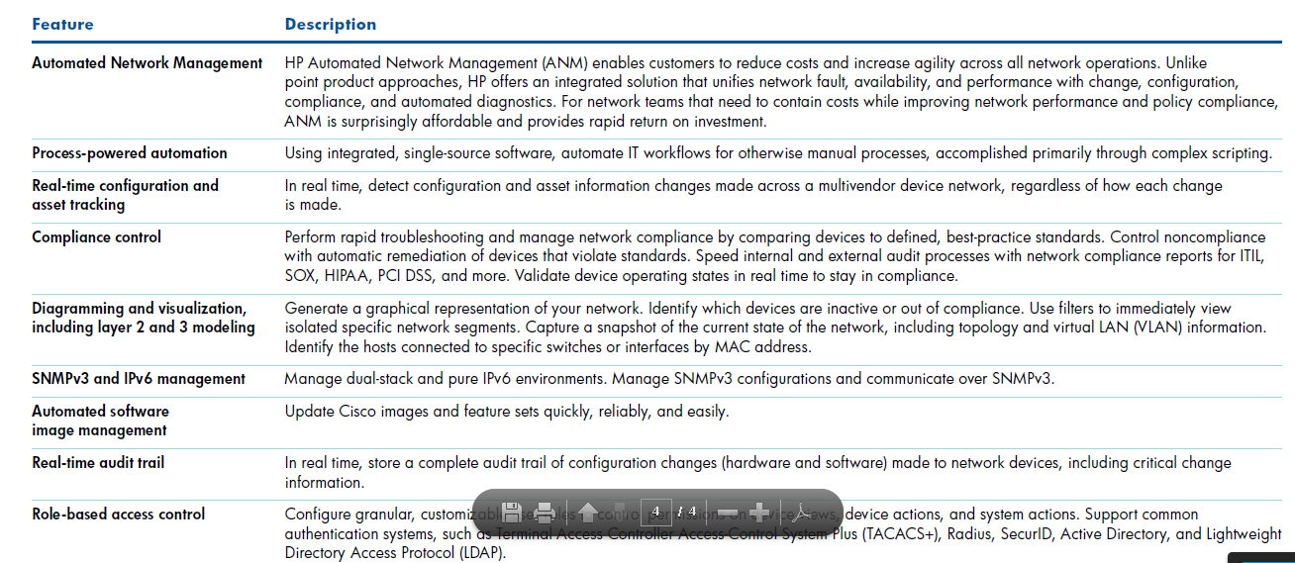

DRA
Formerly known as Symantec Disaster Recovery Advisor, Veritas Risk Advisor automatically detects and reports on risks (of data loss and application downtime) and sub-optimality in the IT infrastructure. It agentless scans systems across data centers and draws on a database of nearly 6,000 issues to help raise system availability & data protection, and supports optimization of the infrastructure for aspects such as performance and resource utilization, by providing prioritized guidance for remediating the identified issues.
Overview of Veritas Disaster Recovery Advisor (DRA):
- Detects HA/DR (high availability/disaster recovery) issues such as config drift, storage config, DB setup, optimization issues within and across multiple data centers
- Installed on one Windows box, and from this box, DRA scans 1000s of servers (Unix, Linux, and Windows) and 100,000s of storage devices throughout the multiple data centers.
- Helps businesses meet critical RPO and RTO Service Level Agreements by reducing risks to business continuity.
- Holistic view of infrastructure takes account of dependencies to highlight risks in priority order.
- Ability to identify SAN-specific risks e.g. path/ HBA mis-configurations or APOF in fabric.
- Agent-less implementation makes it non-disruptive to production environment.
- Scan frequencies can be scheduled based on business needs, reducing data center intrusiveness.
- Gap knowledge base updates are automatic, requiring no manual intervention.
- Improves performance by highlighting underutilized storage space, unused copies of storage volumes, database entities and replication configuration changes.
- One management server scales to thousands of monitored servers across multiple data centers.
- Single, consolidated view of disaster recovery readiness with easy deployment, management and maintenance.

ScaleIO

EMC ScaleIO is software that creates a SAN by aggregating servers local direct-attached storage (DAS) to form globally shared block storage accessible over IP. The lightweight ScaleIO software components are installed on the application hosts and inter-communicate via a standard LAN to handle the application I/O requests sent to ScaleIO block volumes. This decentralized block I/O flow combined with a distributed, sliced volume layout results in parallelism which allows it to scale too many nodes (servers).
A ScaleIO volume is a block device that is exposed to one or more hosts (much like a traditional SAN LUN). ScaleIO breaks each volume into a large number of 1MB data chunks which are spread across the servers and disks within the ScaleIO cluster. Each volume also has a corresponding mirror on different nodes and servers in the cluster. This layout goes a long way in eliminating hot spots across the cluster and allows for the scaling of the overall I/O performance of the system through the addition of nodes and or disks. Furthermore, this layout enables a single application that is accessing a single
Traditional storage systems typically combine system software with commodity hardware (which is comparable to application server hardware) to provide enterprise-grade resilience. ScaleIO provides similar enterprise-grade resilience by running the storage software directly on application servers. Designed for fault tolerance and high availability, ScaleIO handles all types of failures including failures of media, connectivity, nodes, software interruptions, and more.
The ScaleIO software features distributed auto-healing processes that can overcome media and node failures without requiring administrator involvement. Dynamic and elastic, ScaleIO enables administrators to add or remove nodes and capacity on the fly. The software immediately responds to changes by rebalancing the storage distribution to achieve a layout that optimally suits the new configuration. All performance and redistributions on ScaleIO can be monitored and observed on the ScaleIO dashboard which is a simple Java applet.
Because ScaleIO is hardware agnostic, the software works with various types of storage including magnetic disks, solid-state disks, and PCIe flash cards. It can be installed in an existing infrastructure as well as in green field configurations.
Based on the above statements, previous evaluation findings, and other factors, it has been determined that EMC ScaleIO will be certified for production use in Citigroup. The primary use case for ScaleIO will be in Virtualized environments (VMWare) along with support for Standalone/Physical environments.
- ScaleIO has a different design point – to provide highly scalable server-based storage for heterogeneous platforms, including multiple hypervisors and physical servers. ScaleIO has its own installation, configuration and management workflows which are typically driven by expert storage administrators.
- ScaleIO is a software-only solution that uses existing servers' local disks and LAN to create a virtual SAN that has all the benefits of external storage—but at a fraction of cost and complexity. ScaleIO utilizes the existing local internal storage and turns it into internal shared block storage. For many workloads, ScaleIO storage is comparable to, or better than external shared block storage.
- The lightweight ScaleIO software components are installed on the application servers and communicate via a standard LAN to handle the application I/O requests sent to ScaleIO block volumes. An extremely efficient decentralized block I/O flow, combined with a distributed, sliced volume layout, results in a massively parallel I/O system that can scale up to thousands of nodes.
- ScaleIO is designed and implemented with enterprise-grade resilience. Furthermore, the software features an efficient distributed self-healing process that overcomes media and node failures, without requiring administrator involvement.
- Dynamic and elastic, ScaleIO enables administrators to add or remove nodes and capacity on-the-fly. The software immediately responds to the changes, rebalancing the storage distribution and achieving a layout that optimally suits the new configuration.
- Because ScaleIO is hardware agnostic, the software works efficiently with various types of disks, including: magnetic (HDD) and solid-state (SSD) disks, flash PCI Express (PCIe) cards, networks, and hosts.
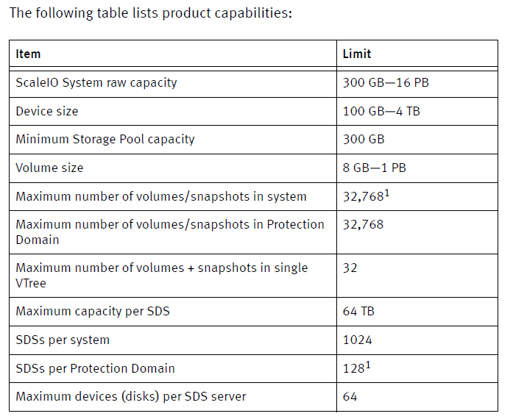
- ScaleIO is a software-only solution. The ScaleIO components are lightweight, highly available software components, installed on new or existing servers alongside your production applications (hypervisors, databases, web applications, etc.). The system can be installed directly on the servers, or over a virtual server system (hypervisor or virtual machines).
- This chapter provides a high-level description of building and using a ScaleIO virtual SAN.
- ScaleIO provides multiple management tools: CLI, GUI, REST, Open Stack, and a VMware plug-in.
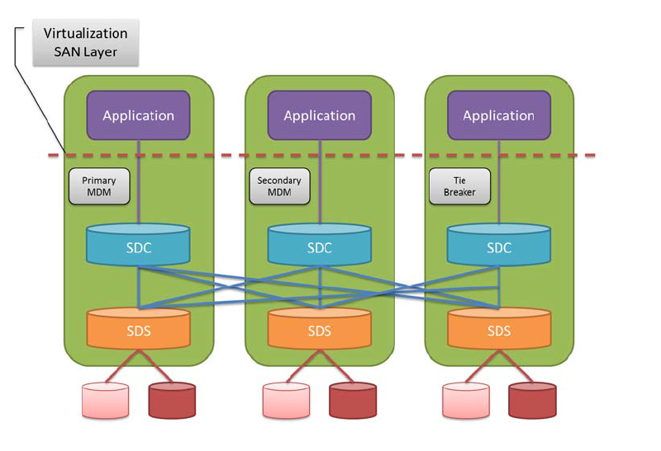
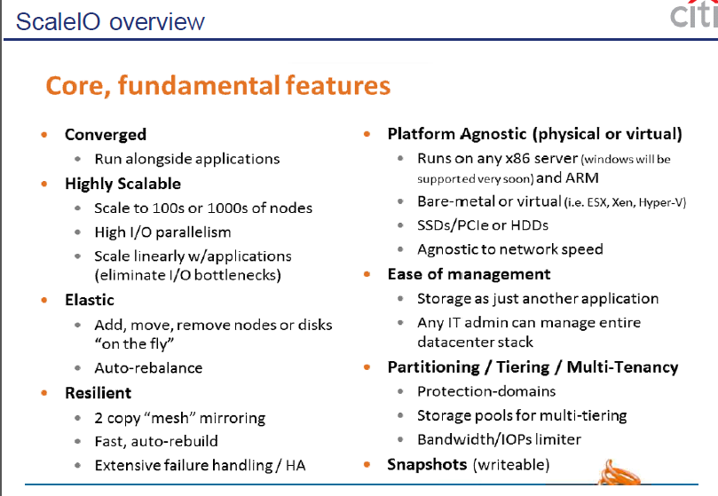
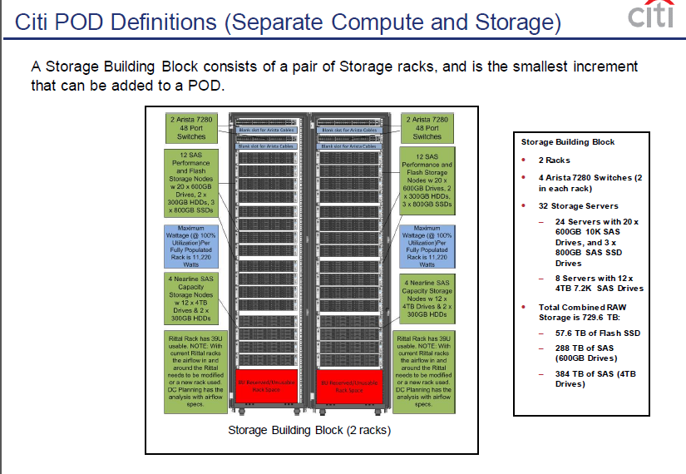

Unisphere for Vmax

Unisphere for VMAX (U4V) is a web browser based user interface designed to provide storage management for EMC Symmetrix products under a common framework and offers features such as provisioning, managing, and monitoring, alerting and performance analysis.
U4V provides a Performance Real Time view for examining high frequency data points, Historical View for all Symmetrix array Key Performance Indicators (KPI), and Diagnostic View for root cause analysis.
U4V allows data to be collected and stored for analysis and reports to be produced on workload, resource usage trends for service level management, diagnostics and capacity planning.
Unisphere for VMAX will primarily be used by Storage Area Network administrators to assist allocation decision making, performance monitoring and issue investigation on VMAX storage arrays
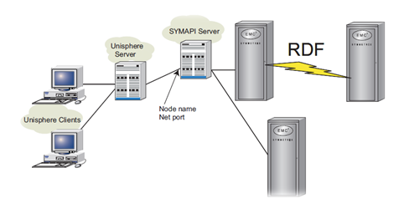
With Unisphere for VMAX 8.0.2 and above you are able to manually backup all the data currently on the database server, including Database Storage Analyzer, Workload Planner, performance, and infrastructure data. Database backups will enable you to recover from system crashes.
U4V uses STP data that is already being captured by the Service Processor in a VMAX array for EMC’s remote diagnostic and troubleshooting purposes.
Unisphere presents its data in Realtime, Diagnostic and Historical views.
• Real Time: Collects data between 2 and 5 seconds for a limited group of metrics – the data is available for
the previous hour.
• Diagnostic: Collects data every 10 minutes – data can be displayed for the last 1-24 hrs
• Historical: Collects Data every 15 minutes – data can be displayed for between 24hrs – 1yr (albeit with
reduced resolution for periods > a few days).

DCNM
DCNM Rollout At the beginning of January CATE released Data Centre Network Manager (DCNM) 5.2.1 which is the product to supersede Fabric Manager And NXOS 5.2.1 firmware for the Cisco switches. In order to upgrade the switches the management infrastructure needs to be upgraded as a prerequisite. – In parallel at that time we were encountering the issue on the Replication fabric (aka cloning issue) which the vendor recommended we move to NXOS 5.2.2, and more recently a VTM was identified which is resolved by the upgrade to NXOS 5.2.1. As above DCNM needed to be deployed as a prerequisite, which is what I have been working on for the last 4 weeks.
This is now deployed to a point I can hand this over to operations for use.
Cisco Prime DCNM is the global solution for the management of the Cisco DataCenter, including both LAN, SAN and unified networks. DCNM provides a comprehensive set of management features across the whole range of NX-OS platforms, and down to the Virtual Machines. These features include the discovery, inventory, configuration and change management, NX-OS software management, template-based provisioning, proactive monitoring, performance monitoring and capacity planning, topology views and troubleshooting tools. This session will explore those features and highlight some best practice methodology to get the most out of DCNM. A basic understanding of the underlying technologies is needed, together with some network management skills.

Introduction to Cisco Data Center Network Manager

Cisco Data Center Network Manager (DCNM) is a management system for the Cisco Unified Fabric. It enables you to provision, monitor, and troubleshoot the data center network infrastructure. It provides visibility and control of the unified data center so that you can optimize for the quality of service (QoS) required to meet service-level agreements.
Cisco DCNM increases overall data center infrastructure uptime and reliability, thereby improving business continuity. It provides a robust framework and comprehensive feature set that meets the routing, switching, and storage administration needs of data centers. Cisco DCNM streamlines the provisioning for the unified fabric and monitors the SAN and LAN components. Cisco DCNM provides a high level of visibility and control through a single web-based management console for Cisco Nexus, Cisco MDS, and Cisco Unified Computing System products.
Cisco DCNM also supports the installation of the Cisco DCNM for SAN and Cisco DCNM for LAN components with a single installer.

DCNM-SAN Server
DCNM-SAN Server is a platform for advanced MDS monitoring, troubleshooting, and configuration capabilities. DCNM-SAN Server provides centralized MDS management services and performance monitoring. SNMP operations are used to efficiently collect fabric information. The Cisco DCNM-SAN software, including the server components, requires about 60 MB of hard disk space on your workstation. Cisco DCNM-SAN Server runs on Windows 2000, Windows 2003, Windows 2008, Windows XP, Windows 7, Solaris 9 and 10, and Red Hat Enterprise Linux AS Release 5.
Each computer configured as a Cisco DCNM-SAN Server can monitor multiple Fibre Channel SAN fabrics. Up to 16 clients (by default) can connect to a single Cisco DCNM-SAN Server concurrently. The Cisco DCNM-SAN Clients can also connect directly to an MDS switch in fabrics that are not monitored by a Cisco DCNM-SAN Server, which ensures that you can manage any of your MDS devices from a single console.

DCNM-SAN Client
Cisco DCNM-SAN Client is a Java and SNMP-based network fabric and device management tool with a GUI that displays real-time views of your network fabric, including Cisco Nexus 5000 Series switches, Cisco MDS 9000 Family switches and third-party switches, hosts, and storage devices.
DCNM-SAN Client provides Fibre Channel troubleshooting tools, in addition to complete configuration and status monitoring capabilities for Cisco MDS 9000 Family switches and Cisco Nexus 5000 Series switches. You can use these health and configuration analysis tools on the MDS 9000 Family switch or Cisco Nexus 5000 Series switch to perform Fibre Channel ping and traceroute.
Fabric Manager Release 4.1(1b) and later releases provide a multilevel security system by adding a server admin role that allows access to limited features. The configuration capabilities of a server admin is limited to configuring FlexAttach and relevant data. Advanced mode option is available only for network administrators and provides all of the DCNM-SAN features, including security, IVR, iSCSI, and FICON.

Device Manager
Device Manager provides a graphical representation of a Cisco MDS 9000 Family switch chassis or Cisco Nexus 5000 Series switch chassis, including the installed switching modules, the supervisor modules, the status of each port within each module, the power supplies, and the fan assemblies.
The tables in the DCNM-SAN Information pane basically correspond to the dialog boxes that appear in Device Manager. However, while DCNM-SAN tables show values for one or more switches, a Device Manager dialog box shows values for a single switch. Device Manager also provides more detailed information for verifying or troubleshooting device-specific configuration than DCNM-SAN.
Device Manager provides two views: Device View and Summary View. Use Summary View to monitor interfaces on the switch. Use Device View to perform switch-level configurations including the following configurations:
•Configuring virtual Fibre Channel interfaces
•Configuring Fibre Channel over Ethernet (FCoE) features
•Configuring zones for multiple VSANs
•Managing ports, PortChannels, and trunking
•Managing SNMPv3 security access to switches
•Managing CLI security access to the switch
•Managing alarms, events, and notifications
•Saving and copying configuration files and software image
•Viewing hardware configuration
•Viewing chassis, module, port status, and statistics

DCNM-SAN Web Client
With DCNM-SAN Web Client you can monitor Cisco MDS switch events, performance, and inventory from a remote location using a web browser.
•Performance Manager Summary reports—The Performance Manager summary report provides a high-level view of your network performance. These reports list the average and peak throughput and provides hot-links to additional performance graphs and tables with additional statistics. Both tabular and graphical reports are available for all interconnections monitored by Performance Manager.
•Performance Manager drill-down reports—Performance Manager can analyze daily, weekly, monthly and yearly trends. You can also view the results for specific time intervals using the interactive zooming functionality. These reports are only available if you create a collection using Performance Manager and start the collector.
•Zero maintenance database for statistics storage—No maintenance is required to maintain Performance Manager's round-robin database, because its size does not increase over time. At prescribed intervals the oldest samples are averaged (rolled-up) and saved. A full two days of raw samples are saved for maximum resolution. Gradually the resolution is reduced as groups of the oldest samples are rolled up together.

Performance Manager
The primary purpose of DCNM-SAN is to manage the network. A key management capability is network performance monitoring. Performance Manager gathers network device statistics historically and provides this information graphically using a web browser. Performance Manager presents recent statistics in detail and older statistics in summary. Performance Manager also integrates with external tools such as Cisco Traffic Analyzer.
Performance Manager has three operational stages:
•Definition—The Flow Wizard sets up flows in the switches.
•Collection—The Web Server Performance Collection screen collects information on desired fabrics.
•Presentation—Generates web pages to present the collected data through DCNM-SAN Web Server.
Performance Manager can collect statistics for ISLs, hosts, storage elements, and configured flows. Flows are defined based on a host-to-storage (or storage-to-host) link. Performance Manager gathers statistics from across the fabric based on collection configuration files. These files determine which SAN elements and SAN links Performance Manager gathers statistics for. Based on this configuration, Performance Manager communicates with the appropriate devices (switches, hosts, or storage elements) and collects the appropriate information at fixed five-minute intervals.

Authentication in DCNM-SAN Client
Administrators launch DCNM-SAN Client and select the seed switch that is used to discover the fabric. The user name and password are passed to DCNM-SAN Server and are used to authenticate to the seed switch. If this user name and password are not a recognized SNMP user name and password, either DCNM-SAN Client or DCNM-SAN Server opens a CLI session to the switch (SSH or Telnet) and retries the user name and password pair. If the user name and password are recognized by the switch in either the local switch authentication database or through a remote AAA server, then the switch creates a temporary SNMP user name that is used by DCNM-SAN Client and DCNM-SAN Server.

Cisco Traffic Analyzer
Cisco Traffic Analyzer provides real-time analysis of SPAN traffic or analysis of captured traffic through a Web browser user interface. Traffic encapsulated by one or more Port Analyzer Adapter products can be analyzed concurrently with a single workstation running Cisco Traffic Analyzer, which is based on ntop, a public domain software enhanced by Cisco for Fibre Channel traffic analysis.
Cisco Traffic Analyzer monitors round-trip response times, SCSI I/Os per second, SCSI read or traffic throughput and frame counts, SCSI session status, and management task information. Additional statistics are also available on Fibre Channel frame sizes and network management protocols.

Network Monitoring
DCNM-SAN provides extensive SAN discovery, topology mapping, and information viewing capabilities. DCNM-SAN collects information on the fabric topology through SNMP queries to the switches connected to it. DCNM-SAN recreates a fabric topology, presents it in a customizable map, and provides inventory and configuration information in multiple viewing options such as fabric view, device view, summary view, and operation view.
Once DCNM-SAN is invoked, a SAN discovery process begins. Using information polled from a seed Cisco MDS 9000 Family switch, including Name Server registrations, Fibre Channel Generic Services (FC-GS), Fabric Shortest Path First (FSPF), and SCSI-3, DCNM-SAN automatically discovers all devices and interconnects on one or more fabrics. All available switches, host bus adapters (HBAs), and storage devices are discovered. The Cisco MDS 9000 Family switches use Fabric-Device Management Interface (FMDI) to retrieve the HBA model, serial number and firmware version, and host operating-system type and version discovery without host agents. DCNM-SAN gathers this information through SNMP queries to each switch. The device information discovered includes device names, software revision levels, vendor, ISLs, PortChannels, and VSANs.

Performance Monitoring
DCNM-SAN and Device Manager provide multiple tools for monitoring the performance of the overall fabric, SAN elements, and SAN links. These tools provide real-time statistics as well as historical performance monitoring.
Real-time performance statistics are a useful tool in dynamic troubleshooting and fault isolation within the fabric. Real-time statistics gather data on parts of the fabric in user-configurable intervals and display these results in DCNM-SAN and Device Manager.
Device Manager provides an easy tool for monitoring ports on the Cisco MDS 9000 Family switches. This tool gathers statistics at a configurable interval and displays the results in tables or charts. These statistics show the performance of the selected port in real-time and can be used for performance monitoring and troubleshooting. For a selected port, you can monitor any of a number of statistics including traffic in and out, errors, class 2 traffic, and FICON data. You can set the polling interval from ten seconds to one hour, and display the results based on a number of selectable options including absolute value, value per second, and minimum or maximum value per second.

ESRS
EMC’s Secure Remote Support Gateway product provides a secure, IP-based, distributed remote service support solution giving Citigroup control and visibility of remote support access.
Simplicity – The Gateway solution consolidates access points for EMC support by providing a uniform, standards-based architecture for remote access across EMC product lines. The benefits include the elimination of modems and modem lines, WWDS/CitiVPN/DialVPN connections, management of safeword tokens, Storage Operations controlled authorization of access for remote support events, and consolidated logging of remote access for audit review.
Improved Availability – Because the Gateway solution is built and supported by EMC, problems can be resolved faster because a single vendor will now own all the pieces. Also because fewer components are involved the risk of remote access malfunction from mis-configuration of a component is reduced.
Security – The Gateway solution fulfills CISS requirements for authentication, authorization and auditing.

TLS v1.0 tunneling with Advanced Encryption Standard (AES) 256-bit SHA-1 data encryption
o Bilateral authentication of digital certificate registration
o X.509 digital certificates generation
o ESRS IP Client authentication based on digital certificate at EMC
o EMC-issued RSA SecurID Authenticators for digital certificate registration
o EMC-issued RSA SecurID for user authentication Secure remote application path using IP and port-mapping
o Access is restricted to authenticated and authorized EMC personnel

VMAX3
The VMAX3 storage array provides block-based storage to host servers via a fibre channel SAN.
Engine
The VMAX3 engine comprises of two director boards which house the MMCSs, I/O modules for front-end ports, back-end ports, vault flash drives, and Infiniband ports for connection to the Virtual Matrix. There are a total of 11 I/O module slots numbered 0-10 from left to right on each director. Slots 0, 1, 6, and 7 are used for vault flash drives. Slots 2, 3, 8, and 9 are used for front-end connectivity (8Gbps FC, 16Gbps FC, 1Gbps Ethernet, or 10Gbps Ethernet). Citi currently only supports fibre channel for VMAX3 front-end connectivity1. Slots 4 and 5 are used for back-end connectivity to the disk drives. Slot 10 is used for the Infiniband connections to the Virtual Matrix if the storage array has more than one engine. The picture below depicts the components of a VMAX3 engine along with the logical port numbers for the front-end connections.
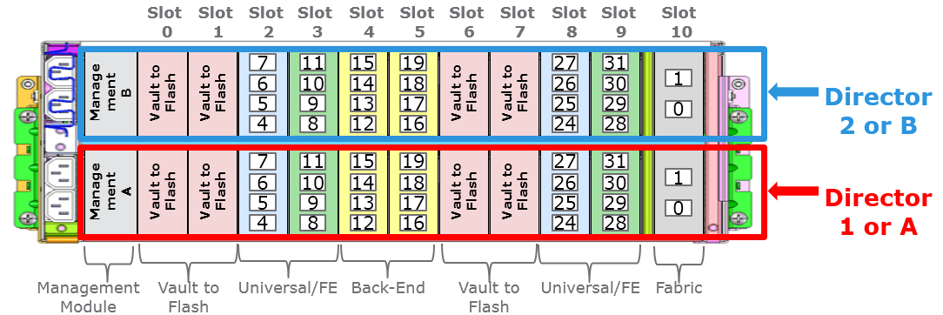
Fully Automated Storage Tiering (FAST) on VMAX3 is not user configurable. Disk groups, data volumes, thin pools, and storage resource pools (SRP) are configured by EMC in the factory or via a bin file change. Online changes to SRPs without re-initialization is currently not supported. A maximum of 2 SRPs can be configured on the VMAX3. Only one SRP should be configured containing all drives in the system for best utilization and efficiency. EMC will create a disk group for each drive type (technology, capacity, and speed) and RAID configuration. Each disk group will have one thin pool associated with it. EMC will also create the TDATs on the disk groups based on drive capacity and RAID type. Once the SRP is created, the usable capacity of the SRP is available to be provisioned to the host servers.
The new models, the 100K, 200K and 400K, can have 2, 4 and 8 dual-controller engines respectively.
- 100K - Xeon E5-2620-v2 2.1GHz 6-core; 24 cores/engine and 48 cores max,
- 200K - Xeon E5-2650-v2 2.6GHz 8-core; 32 cores/engine and 128 cores max,
- 400K - Xeon E5-2687-v2 2.7GHz 12-core; 48 cores/engine and 384 cores max.
Each engine has a Dynamic Virtual Matrix dual 56Gbit/s InfiniBand interconnect.

CSBE-15013-SG Citigroup Inc. 2015, All Rights Reserved. EMC VMAX3Solutions Guide, Version 0.8 Page 109 of 178

Supported VMAX3 Features
The table below lists the VMAX3 features and their current status in Citi. Feature | Item | Function | Citi Status
Virtual Provisioning | Native thin provisioning | All VMAX3 volumes are thin devices. | Supported
FAST | Fully automated storage provisioning | Distributes data across tiers of storage based SLO and activity on the volume | Supported
SRDF | Remote replication | Replicate data between storage arrays. Only 2-site replication supported. | Supported
SnapVX | Local replication | Provides local point-in-time copies of the data. | Supported
ZSR | Zero Space Reclamation | De-allocates zero space in LUNs and puts the reclaimed space back into the SRP. | Supported
Dynamic RDF groups are created on-the-fly with the symrdf command:
symrdf addgrp –label <rdfg name> -rdfg <src rdfg #> -sid <src SID> -dir <src dir:port> -remote_rdfg <tgt rdfg #> -remote_dir <tgt dir:port> -remote_sid <tgt SID> -nop
create dev count=10, size=34GB, emulation=FBA, config=RDF1+TDEV, remote_config=RDF2+TDEV, ra_group=1, sg=qtest-rdf1_sg, remote_sg=qtest-rdf2_sg;
symrdf createpair –sid 123 –rdfg 456 –sg localSG –type r1 –remote_sg remoteSG

Key Feature Changes
This is the initial release of EMC VMAX3 & Hypermax OS. Many of the features have been changed or simplified from previous generations the following are the key changes:
o Array set up
o FAST set up
o Service Level Objective Provisioning
o FAST SRDF - TBC
o SNAP VX

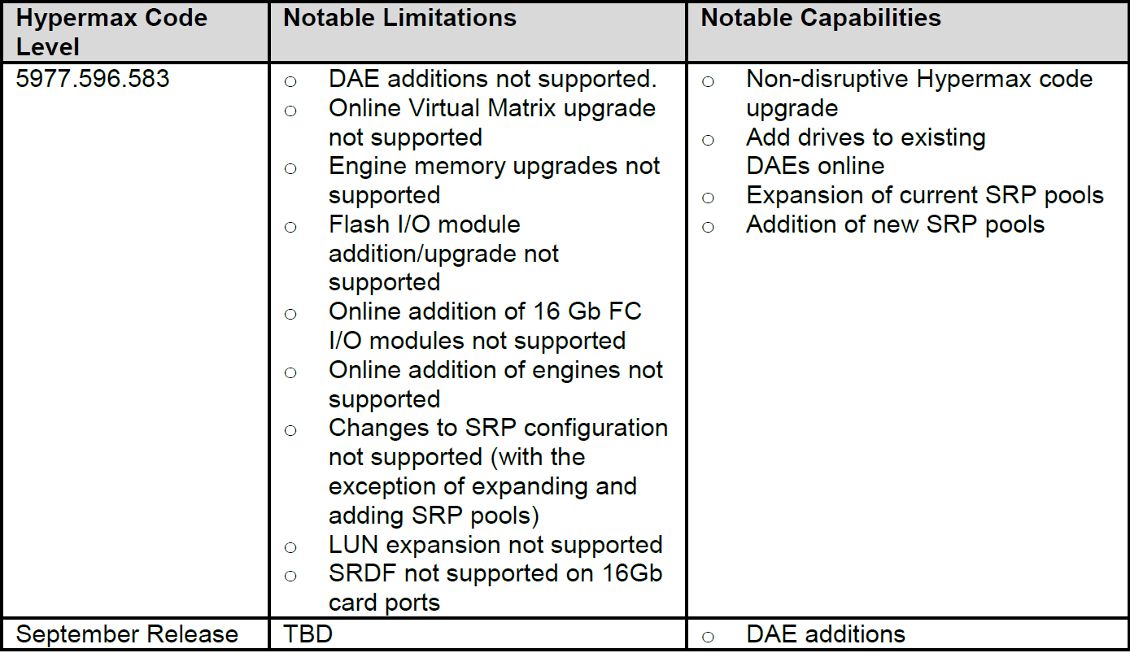
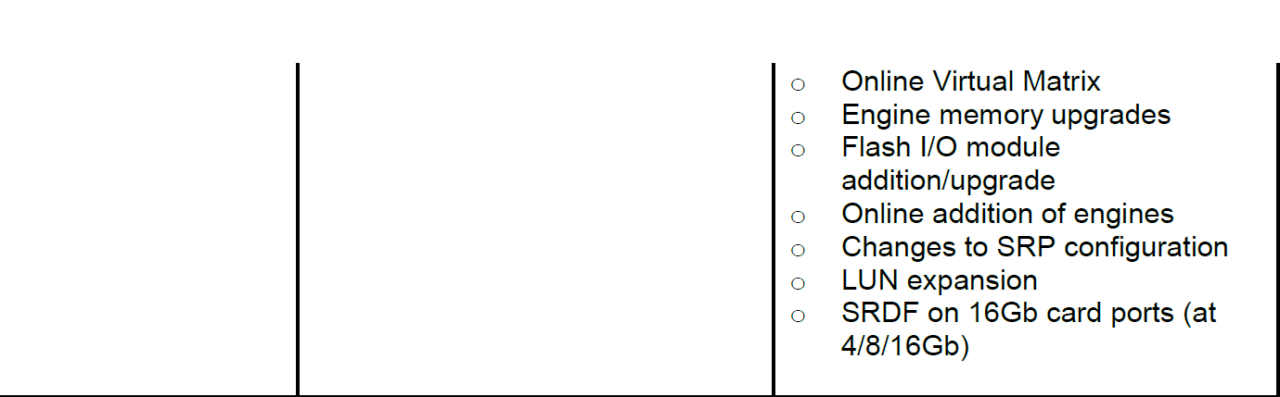

Overview of TimeFinder Clones
TimeFinder/Clone software for Symmetrix allows one to clone copies of data simultaneously
on one or more target devices from a single source device within the same Symmetrix. Data
can be copied to as many as 16 target devices (depending on configuration).
TimeFinder/Clone functionality is controlled via copy sessions, which pair the source and
target devices. Sessions are maintained on the Symmetrix array and can be queried to verify
the current state of the device pairs. A copy session must first be created to define and set
up the clone devices. The session is then activated, enabling the target devices to be
accessed by its host. When the clone is no longer needed, the session can be terminated.
TimeFinder/Clone operations are controlled from the host using the symclone commands
to create, activate and terminate the copy sessions.
Clones can be created in one of three modes:
PreCopy – Copying of data to the target clone begins as soon as the clone session
is created.
Copy – Copying of data to the target clone begins only when the clone is activated
CopyOnAccess – Copy of data to the target clone only occurs after activation and
when either data is written to the source or reads or writes take place to the target
device. This mode is not supported by GDSE.
TimeFinder/Mirror commands (symmir) can also be used to manipulate BCV-based clones.
On V-MAX, symmir always uses clone technology under the covers. As a consequence,
copies controlled by either symmir or symclone do not consume any mirror positions.
This document focuses on the “native” control of clones using the symclone command.
These can be used for a number of purposes:
1) To create a copy of production data for parallel batch runs. The copy can be quickly
re-synchronized with the master copy at the end of the run.
2) To create copies of production data for application test purposes.
3) To create multiple point-in-time copies of data at different points during a batch run
or during on-line day for potential restore back to the source (limited functionality).
4) To create rollback point-in-time copies for application development testing.
The symclone command can to be used to create point-in-time copies of data at the target
site of an SRDF/A environment prior to resyncing the SRDF/A link to ensure a consistent
copy of data at the DR site at all times. However, at the time of writing, it is recommended
that the symmir command still be used on V-MAX for this specific purpose, to provide
consistency with DMX processes and backwards compatibility with existing scripts used to
manager SRDF/A point-in-time copies.

Using clones with databases and file systems
If you take a point-in-time copy of an active file system or database, you have a copy of the
data that is equivalent to what you get when a server crashes with the file system or
database active. Hence, on mounting the file system and/or database you need to go
through fsck and/or DBMS recovery processes.
If you wish to avoid the fsck and/or DBMS recovery processes, you have several options:
a) Cease I/O (i.e. unmount filesystem and/or suspend database) prior to activating the
clone. This ensures that all data has been flushed down to disk and data set is
consistent.
b) Do not cease I/O or do not put database into backup mode, but activate the clone
with the –consistent flag (you will need a zero cost license for this). This ensures
that the database is consistent, but you still get a “server crash consistent” type
image i.e. you still need to go through fsck or DMBS recovery processes. Use of the
–consistent flag is covered in Section 5.3.1.
c) Put databases into backup mode and use –consistent with the activate
command. This will provide you with both a consistent copy of the data and avoids
the DMBS recovery step for databases. However, this will not help with the
filesystem fsck issues. Using of a sync command is a possibility here (not tested by
GDSE), but one also needs to close open files.

Clone terminology
The following terms relating to clone operations are used throughout the document. A table
showing the equivalence between TimeFinder/Clone (symclone) and the older, but perhaps
more familiar TimeFinder/Mirror (symmir) commands can be found in Appendix A.
Copy or Clone Session – A copy session pairs source and a target devices i.e. it defines
the relationship between the devices. Sessions are maintained on the Symmetrix Array.
Create – Creates the relationship between a source device and a clone target device. Also
starts copying of data for precopy mode clones. After creation, the target device is not
accessible by its host. Similar to an establish operation with symmir for precopy mode
clones.
Activate – Marks the point-in-time that the clone copy represents, and hence is similar to a
split operation with symmir. Also starts the copying of data for copy mode clones. After
activation, the target device is accessible to a host, and is no longer synchronized with its
source.
Establish – Creates and activates a clone session with a single command. Only available
with copy mode clones. Similar to an establish operation with symmir.
Recreate – Requests that only changed tracks since the last activate action are copied
across to the target device. Equivalent to an incremental establish with symmir.
Restore – Copies data from the target to the source. Can either be a full or incremental
restore. A restore operation can only be followed by a termination operation or a split
operation.
Split – Used to split a clone device pair that is in the Restored state. This command will
change the direction of the clone relationship (that is, the original source device will become
the source device for a future copy), which will enable you to use either the establish or
recreate command.
Terminate – Destroys the clone session relationship between source and target. Equivalent
to a cancel operation with symmir.
The symmir command should only be used in SRDF/A environments for the management
of R2 point-in-time copies prior to SRDF/A resyncs. The symclone command should be
used for any other

Clone creation
Clones should usually be created using the –precopy and –differential options.
-precopy ensures that the copying of data begins PRIOR to the activation of the clone and hence
offers the potential to take point-in-time copies of data without impacting performance of the
source or target at the time of activation.
-differential maintains changed track information and permits differential resynchronisation and
restores. Note that use of –differential limits the maximum number of copy sessions for a source
device to eight. However, this is a limit that is not likely to impact many requirements. Note that
differential status cannot be set after creation. –differential can only be used with –copy or –
precopy.
If you are planning never to use the clone for restore purposes, nor to resync it with the source,
but are simply using cloning to make a copy for test purposes, then the differential flag is not
required. The only benefit of not specifying –differential is that it extends the number of copy
sessions that a source volume can have from eight to sixteen.
A differential precopy clone session for multiple volumes can be created with the command
# symclone –f ./clone_pairfile –sid <SID> create –precopy –differential
# symclone –f clone_pairfile –sid <SID> activate –consistent
# symclone –f clone_pairfile –sid <SID> recreate –precopy
# symclone –f clone_pairfile–sid <SID> establish [–consistent]
Confirmation that precopy has completed one cycle can be obtained from the following
command:
# symclone –f ./clone_pairsfile –sid <SID> verify –precopy –cycled
Once one precopy cycle has completed, it is safe to activate the R2 clone.
# symclone –f ./clone_pairsfile –sid <SID> activate –nop [-consistent]
# symclone –f clone_pairfile –sid <SID> query –multi
# symclone list –sid <SID>
# symclone –f clone_pairfile –sid <SID> verify –copied –i 10
# symclone –f clone_pairfile –sid <SID> restore
# symclone –f clone_pairfile –sid <SID> terminate
stordaemon action storapid -cmd list_gks 314
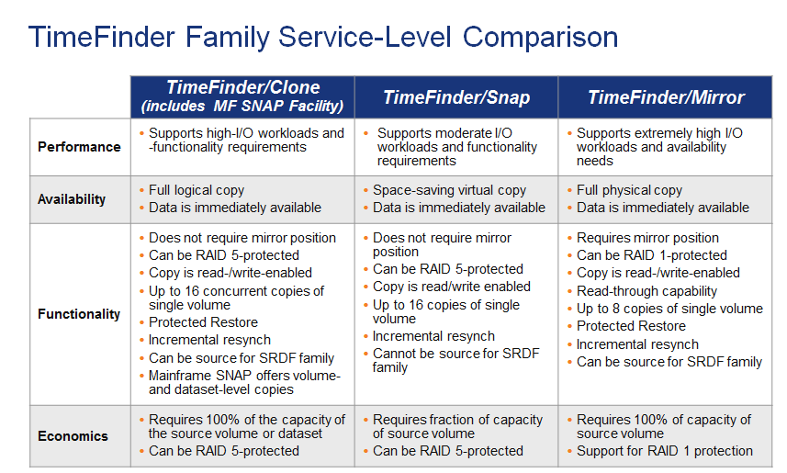
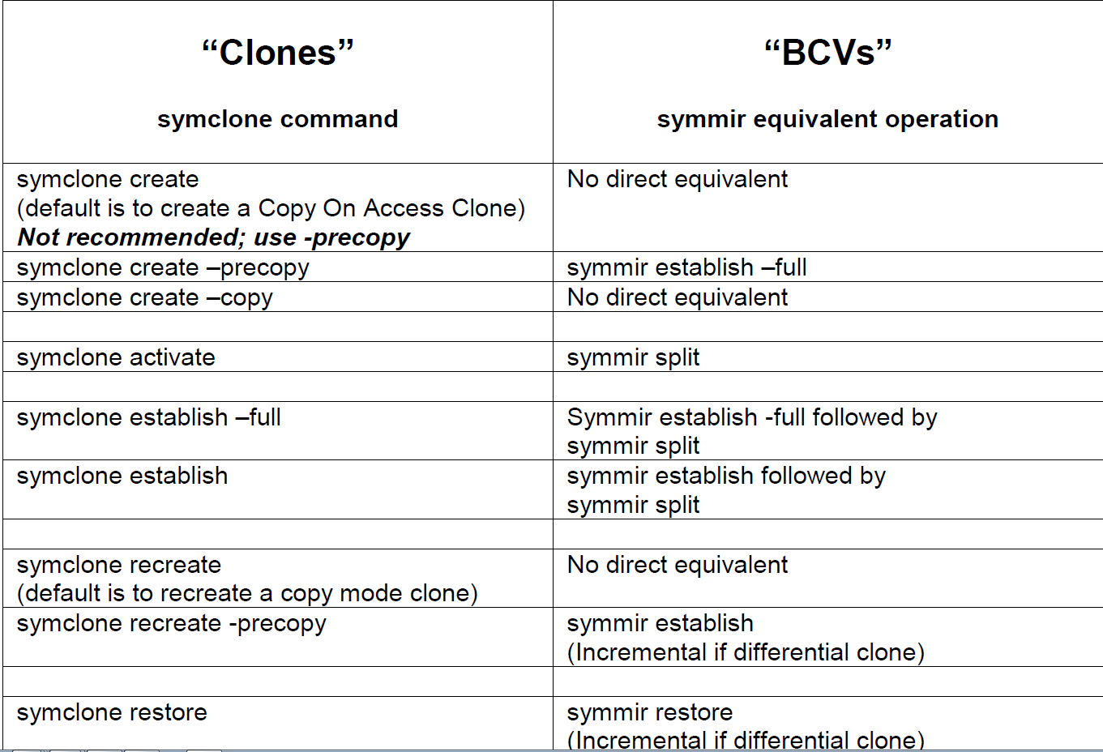

Key differences between TimeFinder/Clone and TimeFinder/Mirror
The following are the most important differences between Clones and BCV mirrors:
• Clones do not consume mirror positions. Hence, it is possible to:

o have many (up to 16) simultaneous clone targets from a single source
o have mirrored copy session targets in an SRDF environment
o have a copy session with a concurrent SRDF source

The above are not possible with TimeFinder/Mirror BCVs
• It is possible to use Standard devices as clone targets. These can also be R1 devices (for copy and precopy clones only). TimeFinder mirrors, on the other hand, cannot use standard devices as targets; BCV devices must be configured in the bin file, which is a major drawback.

The clone target can be accessed before the copying has completed (with however a performance impact on the source and target). This is not possible with TimeFinder Mirrors.

And the following Performance Metrics and data’s were analyzed

- Cache Read Hit %
- Cache Write Pending %
- FED Processor Utilization
- BED Processor Utilization
- Raid Group Busy %
- Total IOPS ( Read + Write )
- Total MBPS ( Read + Write
Parameter | Description
Total IOPS | This is a dynamic value , threshold cannot be defined
Cache Read Hit% | The amount of data read directly from Cache instead of disk
Cache Write Pending % | The amount of data waiting in cache to be de-staged to disk
Front-End Processor (FED) Load % | FED processors serve Host IO
Back-End Processor (BED) Load % | BED processors serve data transfer between the backend disk and cache
RAID Group Max Busy % | Physical Disk busy % in a given RAID Group as a single entity

Collection Period: 26th April – 3rd May 2011 @ 1 hour Interval
 | Parameter | Average Measured Value | Peak Measured Value | HDS Recommended Value
 | Total IOPS | 3000 | 4000 | N/A
 | Read Hit % | 70 | 85 | >30%
 | Cache Write Pending % | 30 | 40 | < 30%
 | Front-End Processor Load % | 30 | 45 | < 50%
 | Back-End Processor Load % | 18 | 25 | < 50%
 | RAID Group Max Busy % | 15 | 18 | < 50%

1.3 Quantify Issue
How many users are affected: 3 flexcube branches ( Slowakia/Hungary/Czech)
Which business group is affected:CTS ( TTS)
Are other teams looking at the issue (e.g. Database, Application teams):Database
What is the business impact of the issue: MEDIUM – cob data will not be consistent with prod

Impact | Description
HIGH | Production impact, Loss of Service, Trading Floor etc
MEDIUM | Batch Runs, Job Times, delayed response times but still at acceptable levels
LOW | Performance Review (how is this server performing?)

2. Problem Statement
Please summarise the problem as it is viewed by the SA team, ensuring that it clearly encompasses the issue as agreed by all other groups that you represent (Database, Application, Business etc):
Cloning processing is taking long time and breached agreed SLAs.

3.1 Data Collection - Questions
When was the issue first identified: today at 1:00
What has been done so far to resolve the issue: Clone disks has been checked on UNIX systems
Have these attempts made the issue worse/better: no change
Have these attempts been documented (please attach):yes
Have there been any infrastructure changes: This is first cloning process iteration after go-live
Have there been any recent hardware/software changes on the Application, Server, OS or Database: This is first cloning process iteration after go-live

3.1 Data Collection - Log Files (contact SAN team if assistance required)
Collect IOSTAT or similar for the period in which the issue is experienced (please attach):
Collect VMSTAT or similar for the period in which the issue is experienced (please attach):
Collect VXSTAT or similar for the period in which the issue is experienced (please attach):
Provide EMCgrab and/or HDS GetConfig from the affected server (please attach):

Migrations
The two most prominent forms of migrating data in the enterprise SAN environment are host-based and array-based architectures:
■ Host-based data migrations functions by a host reading data from a source storage array and writing that data to a target array via the SAN. During the copy operation, server resources are dedicated to managing the copying process, and the SAN must transfer the data for both the read and write operations. A sample of host-based data migration applications are EMC Softtek Replicator, Open Migrator and Veritas Volume Manager.
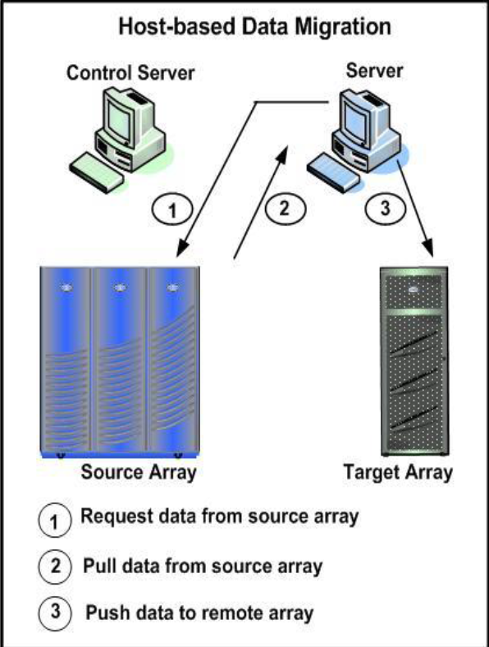
Array-based data migration transfers the data directly from the source devices in one array to the target devices in another array. The array manages the transport of the data through the SAN while continuing to support the foreground I/O access to the source devices. An example of array-based migration tool is EMC SRDF and Open Replicator.
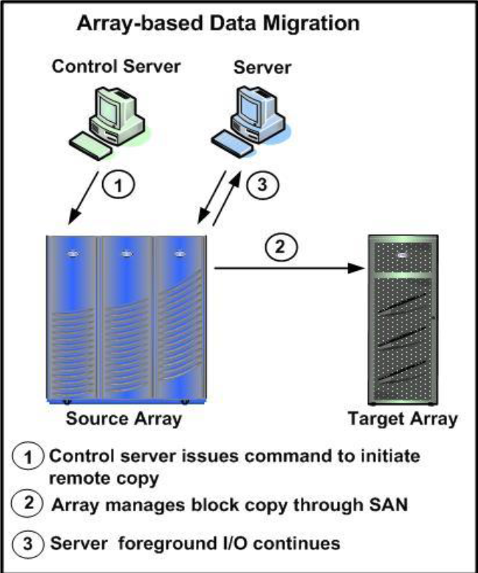
Open Replicator Terms/Definitions:
• Control device – Symmetrix array running the ORS software and acting as the host to direct I/O to and from the devices on the source array.

• Remote device - Partner to the control device, the remote device does not need any special software and simply responds to host I/O request.

• Session – Each ORS source volume is counted as a session.

• Push - Sends data from the source to the target storage array.

• Pull - Fetches data from the source storage array to the target array.

• Hot – Host is online (generating read & write requests) during the copy operation.

• Cold – Host is offline during the copy operation.

• Pace - Control the speed of the copy operation.

Open Replicator Features:
• Migrate data between EMC and other vendor arrays within the SAN infrastructure without interfering with host applications and ongoing business operations.
• Control and remote devices are agnostic to the protection type or number of members.

Open Replicator Objectives:
• Technology refreshes in upgrading storage arrays
• Storage tier alignment strategy to place data on the most cost effective storage configurations
• Distribute host IO load between frames
• Reduce capacity utilization with in a thin pool

Open Replicator Practical Considerations:
• In a push operation the remote (target) device capacity must be equal to or larger than the control (sources) device.

In a pull operation, the control (target) device should be equal to or larger than the remote (source) device.
• In a push operation the remote devices should be offline or inaccessible to changes until the copy process is complete.
• At the start of a hot push operation all tracks in the source device are labeled as protected. Protected tracks are copied to the remote device before modification (CopyOnWrite).
• In a cold pull operation, the source devices should be write-disabled at the array for the duration of the copy operation.
• In a hot pull operation, all tracks in the source device are labeled as protected. Protected tracks are copied from the source device to the target device before a host can access it (CopyOnAccess) and the protection is removed.
• Accumulation of I/O errors between the remote and control devices will cause a session to fail in a hot copy mode and temporarily stall the cold copy operation.

In a hot pull operation, all tracks in the source device are labeled as protected. Protected tracks are copied from the source device to the target device before a host can access it (CopyOnAccess) and the protection is removed.
• Accumulation of I/O errors between the remote and control devices will cause a session to fail in a hot copy mode and temporarily stall the cold copy operation.
• An offline push is capable of transferring data to multiple remote devices simultaneously.
• Access security to the ORS command set is provided through Solutions Enabler and the Symmetrix Microcode. View the Symmetrix and Solutions Enabler Solutions Guides security capabilities and configuration.

Open Replicator Limitations:
• Up to fifteen incremental ORS copy sessions can exist for a single Symmetrix device.
• Only one copy session can be active at a time. The number of individual sessions in the copy session is defined by the device file.
• An ORS copy session is between two or more arrays. Creating a session between devices on the same array is not supported.
• An offline push to multiple remote devices does not allow a remote device to be removed from the session.
• ORS can only use FBA devices via Fibre Channel directors.
• Only one remote device is allowed for an online push operation.
• Symmetrix supports 1024 concurrent push or pull sessions.

Applicable Environments
• Open Replicator with Solution Enabler v7.X
• Symmetrix array with Enginuity 5773 or 5876
• Clariion CX and VNX arrays

Throughput Observations:
• ORS transfers data in chunks equal to one track of 65,536 bytes (64KB) in size.
• The layout and protection scheme of the source device is the major factor in determining the transfer rate. The Symmetrix Raid-0+1 source device shows the highest throughput regardless of the protection scheme of the target device.
• In a cold push session, the I/O is distributed equivalently to each of the remote devices.

180 MB/s for a 4 GB SAN DMX - 4
• 300 MB/s for a 4 GB SAN VMAX Family arrays
• 300 MB/s for an 8 GB SAN VMAX Family arrays
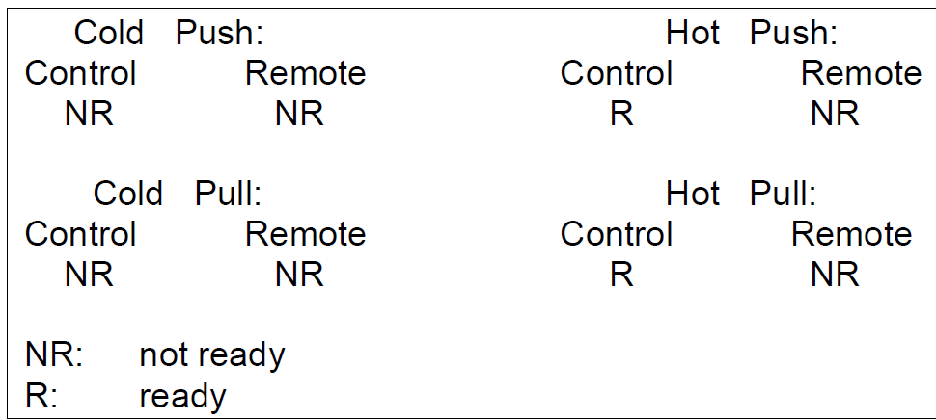

HOT PULL
919 | 00D8 | Raid 5 | <== | Raid 0+1 | 151 | 127
919 | 00B1 | Raid 0+1 | <== | Raid 0+1 | 159 | 127
Device File "or2w-1" created with two sessions:
# Control Devices Remote Devices:
#=======================================
symdev=919:00b1 symdev=127:0151
symdev=919:00d8 symdev=127:0159
1. ORS command syntax to initiate a hot pull session at the highest transfer rate:

• symrcopy create -copy -name s11pull -pull -hot -file or2w-1 (step 1 in Hot Pull diagram)
• symrcopy activate -file or2w-1
• symrcopy set pace 0 -file or2w-1 –nop (step 2 in Hot Pull diagram)

2. The “symrcopy –file <fdevice file> query” command is used to view the status of the pull sessions:

Hot Push

Device File "or2w-1" created with four sessions:
# Control Devices Remote Devices:
#=======================================
symdev=919:00b5 clardev=APM00040800355:0013
symdev=919:00d9 clardev=APM00040800355:0018
symdev=919:00b1 symdev=127:0151
symdev=919:00d8 symdev=127:0159
1. Create/Activate an ORS hot push session from the control devices to the remote devices (see step 1, in the hot push diagram above):

• symrcopy create -copy -name s11push -push -hot -file or2w-1 –nop

• symrcopy activate -file or2w-1

Set transfer pace to the highest level (see step 2, in hot push diagram above):
• symrcopy set pace 0 -file or2w-1 –nop

COLD PUSH
Device File: or2w-1
# Control Devices Remote Devices:
#=======================================
symdev=919:00b5 clardev=APM00040800355:0018
symdev=919:00b5 symdev=127:0151

1. Initiate a cold push from the Symm 919 to remote 1 and remote 2 simultaneously at the highest transfer rate:

• symrcopy create -copy -name s11push -push -cold -file or2w-1 –nop

• symrcopy activate -file or2w-1 –nop (see step 1, in cold push diagram above)

• symrcopy set pace 0 -file or2w-1 –nop (see step 2, in the cold push diagram above)

Termination of the cold push copy process:

• symrcopy terminate –file or2w-1

CopyOnWrite (COW)
Device File:
#Control Devices Remote Devices
#=======================================
symdev=919:00b5 clardev=APM00040800355:0013
symdev=919:00d9 clardev=APM00040800355:0018
symdev=919:00b1 symdev=127:0151
symdev=919:00d8 symdev=127:0159
1. Create and activate an ORS hot push session from the control array 919 to both remote arrays. Once the session is active, initiate the copy-on-write mode:

• symrcopy create -copy -name s11push -push -hot -file or2w-1 –nop

• symrcopy activate -file or2w-1 –nop (see step 1, in COW diagram)

• symrcopy set mode nocopy -file or2w-1 –nop (see step 2, in COW diagram)

symrcopy set mode copy -file or2w-1 –nop (step 2, in COW diagram)

• symrcopy set pace 0 -file or2w-1 –nop (step 3, in COW diagram)
Configure ORS to migrate from the DMX-3 (control frame to DMX-2 (remote frame):
Create Device File:
symdev=0919:00D9 symdev=0127:0159
Set Configuration:
symrcopy create -copy -name s11pull -push -hot -file s11oprep -nop
'Create' operation execution is in progress for the device list in
device file 's11oprep'. Please wait...
'Create' operation successfully executed for the device list
in device file 's11oprep'.
Start Migration:
symrcopy activate -file s11oprep -nop
'Activate' operation execution is in progress for the device list in
device file 's11oprep'. Please wait
'Activate' operation successfully executed for the device list
in device file 's11oprep'.
Set the Pace of Migration:
symrcopy set pace 0 -file s11oprep -nop
'Set Pace' operation execution is in progress for the device list in
device file 's11oprep'. Please wait...
'Set Pace' operation successfully executed for the device list
in device file 's11oprep'.
Monitor Status of Migration:
symrcopy query -file s11oprep -c 10 -i 60
Hot pull - retrieve the data from the remote array back to the control frame:
Unmount the filesystem to be restored:
umount /export/oprep_d9
Device file:
symdev=0919:00D9 symdev=0127:0159
Configure the migration:
symrcopy create -copy -name s11pull -pull -hot -file s11oprep -nop
'Create' operation execution is in progress for the device list in
device file 's11oprep'. Please wait...
'Create' operation successfully executed for the device list
in device file 's11oprep'.
Start migration:
symrcopy activate -file s11oprep –nop
'Activate' operation successfully executed for the device list
in device file 's11oprep'.
Set the Pace of Migration:
symrcopy set pace 0 -file s11oprep -nop
'Set Pace' operation execution is in progress for the device list in
device file 's11oprep'. Please wait...
'Set Pace' operation successfully executed for the device list
in device file 's11oprep'.
Monitor migration status:
symrcopy query -file s11oprep -c 10 -i 30

Front-end Zero Detection
ORS front-end zero detection is an option that can be used with thin devices on the control array. Front-end zero detection looks for incoming zero patterns from the remote device, and instead of writing the incoming data of all zeros to the thin device, the group on the thin device is de-allocated. Front-end zero detection is allowed for -pull operations only and is indicated by the -frontend_zero argument. The front-end zero detections commands are ignored for any standard control devices.
The following command example shows how to enable and disable front-end zero detection:
• symrcopy create -session_name rcopy_1 -pull -hot -frontend_zero –file dev_file_1
• symrcopy -session_name rcopy_1 set frontend_zero off

Donor Update
The donor update option protects against potential data loss due to a SAN failure or other connectivity issue during a hot pull operation. In donor updates, writes to the control device from the host are immediately copied to the remote device as well. Because the data is fully copied to both the remote device and the control device, if a failure occurs, the session can be safely terminated and created again to fully recover from any mid-copy failure.
The following command example shows how to enable the donor update option:
• symrcopy create -name rcopy_1 -pull -hot -donor_update –file dev_file_1
• symrcopy activate -session_name rcopy_1 symrcopy set donor_update off - session_name rcopy_1 - consistent

19.3 Example of the front-end zero and donor update options
# symrcopy -f tst-062912 create -pull -hot -frontend_zero -donor_update
Execute 'Create' operation for the 2 specified devices
in device file 'FLM-tst-062912' (y/[n]) ? y

Previous roles

APAC
I had joined in Citi in 2006 through Optimum Solutions as a contractor and I was supporting APAC Storage Operational Team Under KK ( Krishna Kumar Pazhore/Bhaskar Raju) and I was supporting SAN BAU allocations and supporting McData, DMX, clarion, Centera products

EMEA
Later in 2007, I moved to EMEA SAN Operations team and also I converted to Citi Permanent employee. Supporting EMEA Operations team and performing Day-to-Day Storage operations ( Incident management, problem management, ONcall support, Vendor management, performing Zonings, disk allocation, SAN reclaims. Supporting DMX, Vmax, HDS USPV, VSP/VSP-VM, Cisco, McData, Clariion, VNX Block, XIV, Centeras

Replication operations
Performing all kind of SAN Replication operations In SRDF/S and SRDF/A environments. Like Split, Establish, Restore, failover and failback operations on application/business requirements
Even Involving/performing Annual or Semi-annual COB/DR test and performing SAN operations as per the application requirement
Performing any activity using proper Change tickets to avoid the compliance issues
Regularly performing/involving RCSA/AUDITs and providing the evidences/justifications in quartly/semi-annually and annually.

Storage optimization and reclamation project
Regularly performing Storage optimization and reclamation projects and performing disk removals/reclaims in unused/decommissioned storage to save the cost

Lean effect
In 2014 lean transformation happened and divides the teams into L2 & L3 teams. So I will be under EMEA L3 team and performing all SAN L3 related activities

EMEA Capacity team leader
I was team-lead for the EMEA capacity team and Conducting and contributing the inputs to SAN capacity review meeting on weekly basis and minutes are storing in share point site .Keeping Storage and Switch inventory databases are up-to-date to generate the reports to Global Storage Management team. Regularly monitoring/reviewing the pool utilization and over subscription percentage and defining the guidelines for further allocations/restrictions. Regularly reviewing the SAN utilization reports in meetings and taking the actions accordingly. Regularly reviewing and updating the V-Max Capacity, V-Max pools capacity, HDS Capacity reports, thin provisioning summary, Centera capacity reports, DMX Capacity Report and Switch Utilization Reports.

MOR Reports
Generating and producing the MOR Report on a monthly basis to the Senior SAN management which contains the SAN utilization on Organization wise ( Corp, ICG, GCG, & Other). The reporting process contains both a number of manual tasks. The origins of the reporting data comprise several sources, which are generally databases from various business applications or command line output. This report is produced based on various data sources in Citigroup, mainly from the Host Billing report, CSI, SAN Screen, and some ECC data.

Chargeback / Host Billing reports
Generating and producing the Host Billing reports on a monthly basis. Host Billing scripts were written in 2011 according to the SAN configuration but now many changes in SAN environment. So every time we are struggling with many issues. Reporting sources are ECC, SANScreen, CICSO Device Manager, Connectrix Manager, HDS Device Manager, SYMCLI, HDS CLI & Clariion Navsecicli. Basically need to execute the scripts in each and every SAN environment and need to perform many manual tasks to generate the final files. Currently working on EMC SRM Vipr to produce and generate the chargeback & capacity reports automatically which saves a lot of manual hours

Experience in Previous companies
Over 5-6 years’ experience in System/Network Engineer and worked in various projects

Employer | Position | Period
Citi Group, Singapore | Global Storage Administrator(L3) | Nov 2007 - till the date
Optimum solutions, Singapore (Citi) | Senior Storage Specialist | Aug 2006 – Oct 2007
Solutions Middle East, Dubai | Sr.Systems&S Support Engineer | May 2003 - July 2006
WiproTechnologies,Hyderabad | Sr.Systems & Network Administrator | April 2000 - April 2003
Sankalp Web Tech,Hyderabad, | Network Administrator | Nov1999 – Mar 2000
SybernetTechnologies,Hyderabad | Customer Support Engineer | Jan 1998 - Oct 1999

Solution Middle East
Worked as a Senior Systems & Support Engineer in Solutions Middle East – Dubai and responsible for Systems/Storage Operations. This company is involved in Systems integration, facility Management & SAN Storage/Network Integration.
Almost worked more than 3 years and Worked from 2003 to 2006 . Later got a opertunity work in Citi. So I moved from Dubai to Singapore
This company having many clientages like Govt, private and hotels. Gathering the requirements and deliver the right product and will implement as per the requirement.
Design , setup, implementation & upgrade as per the customer requirement on Citrix Presentation servers 3.0 & Citrix Secure Gateway

OS Installation, Configuration and Troubleshooting of Midrange systems with Sun Solaris, MS Windows 2003, Windows XP, MS Windows 2000, Sun OS 2.8, Linux 7.6, Linux 9 & Linux AS.

Installation and supporting Captaris Rightfax application.
Installation and Configuration of Microsoft Exchange Server 2000 & Microsoft Exchange 2003 Mail servers.
Installation & Configuration of Apache Web server, Squid Proxy Server, BIND DNS server, Jabber Chat Server, Qmail server, SAMBA File & print Server, Squirrel Web mail server, PROFTP FTP server, Trend Micro, Sophos & Escan Antivirus.

Maintenance of Domain Registration & Hosting business for more than 100 Domains.

Designing WAN/LAN Diagrams, Preparing Documentation, Vendor Co-ordination and Customer support.
Design & implementation of Sonic Wall firewall, Established Site-to-Site VPN and Global VPN tunnels.

Installation and configuration of PUSS/PULL SMS Gateways and SMS client applications like Web2sms, Notification Server, Email2sms and Email Alerts in both SMS Gateway and GSM modem.
Installation, Configuration and Management of Cisco Routers, L2 & L3 Switches & WAN links

Wipro/Satyam GE
April 2000 to April 2003:- Worked as a Sr.Systems & Network Administrator for Wipro Info Tech Franchise and Supporting Wipro Technologies and Satyam GE Software Services Ltd. Leading a Team for Network and System Support in Systems, LAN and WAN areas. Satyam GE is an enterprise network and nearly established with 40 servers with directly attached Storage comprises of Solaris, Windows, Linux and managing with Veritas Volume Manger, & Netbackup. This company is basically focused in to Software development, CAD/CAM, Power Controls, Motors Designing and Embedded System. All the projects, which are undertaken, are GE Internal projects.
I worked 3 years under Wipro and Satyam GE through Wipro Infotech franchise and later got a opportunity work in Dubai. So I moved to Dubai
- Installing, troubleshooting the Hardware Sun Enterprise Servers, High end Compaq Prolient Servers, DELL PowerEdge series Servers and Wipro Acer Altos Servers
- SUN Solaris, Windows NT, 2000, LINUX installation, and administration
- Installed and configured Solaris 5.6,7 & 8 on ENTERPRISE 250 server, SUN Ultra 10, Sun Ultra 60 & SUN Ultra 80 workstation models with various hardware configuration.
- Installation, Troubleshooting, & Administration of LAN, WAN
- Administration of Sun Cluster
- Desktop support
- Backup & Recovery Administration
- Installation, Configuration and troubleshooting of Mail Front end software’s like Microsoft Outlook2000, MS Outlook 97, Outlook Express, and Netscape.
- Designed, installed, and supported network hardware, related software, including Cisco routers, switches, horizontal and vertical cabling, and service provider interfaces.
- Installation, Configuration and troubleshooting of Microsoft Exchange Server 5.5 Implementation of X.400 Connectors. Creation, moving and deletion of mailboxes.
- Installation, Configuration and troubleshooting of DNS server, WINS server, DHCP server and Terminal server.
- Configuring and Administration of Cisco 2500 & 3600 series Routers
- Installed, configured and maintained VOIP and VPN.
- Preparing and Maintaining Monthly ISO reports and submitting the reports to the Customer

Sankalp Webtech
Nov1999 to Mar 2000:- Worked as a Network Administrator in Sankalp Web Tech, Hyderabad. Doing Pre and post sales Technical Support of Systems and Network Equipment.
Worked here only 4 months and after finished my SUN certification I got a opportunity to move Wipro.
Responsibilities:-
- Implementation of LAN and WAN.
- Installing & Maintenance of Windows NT Server 4.0 ( Domain Server & Member Server)
- Installation & Maintenance of Microsoft Windows NT 4.0 Workstation, windows98, Windows 95 & windows workgroup 3.11
- Installation & Maintenance of Special Services like IIS, RAS, DHCP, and DNS & WINS.
- Installation of Application Software like Oracle 8.0, Oracle 7.3, Visual Basic 5.0 & 6.0, Visual C++, TC++, Visual FoxPro, AutoCAD 14, MS Office 97.
- Backup and Recovery of Hard drives by Using Stellar Software.

Sybernet technologies
Dec 1997 to Oct 1999:- Worked as a Customer Support Engineer in Sybernet Technologies Pre and post-Sale Tech support of Systems.
Worked here almost 2 years. After finished my Diploma I got a opportunity to work in this company. I had finished MCSE certification
Responsibilities:-
- Assembling & Maintenance of 486 & Pentium Machines
- Installation of Application Software like Oracle 7.3, Visual Basic 5.0, TC++, FoxPro, AutoCAD13, MS Office 95 & all software packages.
- Installation & Maintenance of Nt3.5 Server, workstation, Windows 95.
- Involved in troubleshooting & maintenance of Monitors, UNIX Terminals, & other PC Hardware. Also involved in installing various Operating Systems like Windows 95/NT.
- Installation & Maintenance of Peripherals like Dot Matrix Printers & Desk Jet Printers & Bubble jet printer.
- Maintenance of Networks, computer Hardware & Peripherals
- Setting up the Hardware & Software environment according to newly arrival software

Certifications : -

MCSE

SUN Certified System Administrator For Solaris 8

CCNA 2.0

DHE

PGDCA

Technologies worked
Solutions Architect with extensive experience in planning ,designing & implementing optimized Cloud Computing, Virtualized Data Center, Private Cloud with ITaaS/IaaS/PaaS , Storage Area Networking, Networked Storage, Data Migration and Project Management

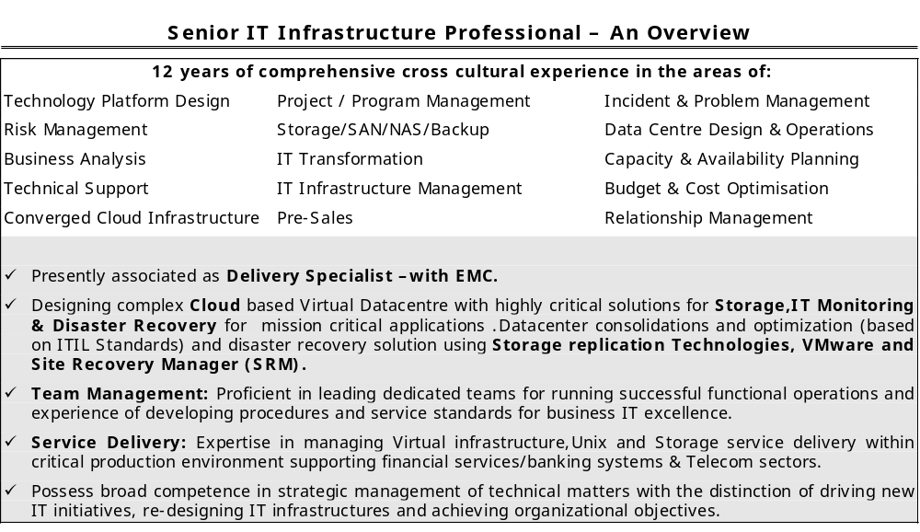

- Operating Systems: Solaris 8, 9,10 (SPARC & x86); IBM AIX 5.1,Redhat Linux,Windows 2003/2008
- Server Hardware: SUN Microsystems SPARC hardware; SUN Fire V880 , Sun StorEdge D240,3500, DELL: Power Edge 4300, 2550, 2500 2400, ,DECRU FC 520,UCS-B series
- SAN Directors/Switches: Mcdata , Brocade & Cisco MDS SAN Switches,Nexus 5000 series
- Software and Application : SRM,Powerpath,Replication Manager,Open Replicator, Cloud Tiering Appliance, VMware vCloud Director, VMware vCenter, IBM SCO ,Solaris Volume Manager , Veritas Net Backup,Symantec Enterprise Vault
- Storage : VMAX series,DMX series,VPLEX,Recover Point, VNX series,CX series,CX 3 series,CX4 series,VNX series,Atmos series,Centera series,Celerra series,IBM DS 4800,NS Series,Isilon,Netapp FAS Series,HDS VSP,USP V/VM,HDS AMS series, ,HP 3PAR
- Monitoring and Provisiong: EMC Control Centre, Navisphere Manager,Navicli,Symmcli,Connectrix Manager 7.0,8.6, SAN Manager , Fabric Manager ,Device Manager, EFCM,Veritas Command Central,HDS Device Manager,Symmetrix management console, Storage Resource Management (SRM)
- Performance : HDS Tuning Manager,ECC Performance Analyzer

Personal
I had completed Diploma in Electronics and Communication Engineering in Banagapalle, India from 1993 to 1996. I am unable to go to further studies because of the financial situations.
I am married and having 2 boys. Kids are 7 & 4 years old. Elder one is studying Primary One and Younger one is Nursery.

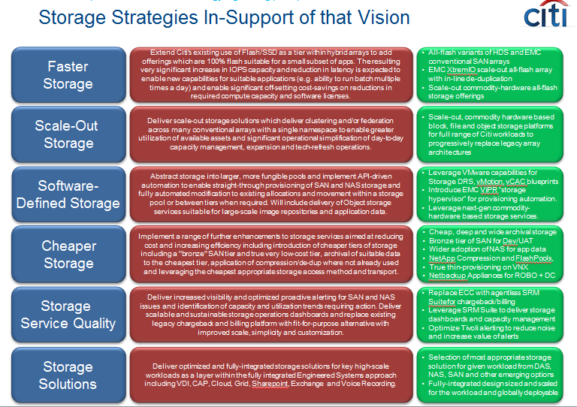

Capacity management

Streamline forecasting and troubleshooting of your virtual environment with EMC storage capacity planning
SolarWinds Storage Manager provides storage capacity planning capabilities for your EMC storage arrays that collect forecasting data. It also performs tracking and monitoring of historical performance to pinpoint hot spots, peak traffic hours, and potential failures.

- Automates storage capacity planning data collection in your physical and virtual infrastructure
- Provides simple ways to view storage growth rates, forecast when storage capacity will be exhausted, and predict costs
- Performs monitoring on historical performance to pinpoint hot spots, peak hours, and potential outages
- Reduces costs by facilitating tiered storage across your heterogeneous storage environment

Supports capacity monitoring, management, and planning for the following EMC platforms along with many platforms from other storage vendors:

- EMC Isilon
- EMC VNX™ and VNXe™, CLARiiON®
- EMC VMAX™ and VMAXe™, DMX™, Symmetrix®
- EMC Celerra®

Automate data collection for storage capacity planning to reduce errors and speed up the decision-making process
SolarWinds Storage Manager reduces the storage capacity planning complexity in your EMC environment. You no longer have to endure the headache of manual storage capacity and utilization tracking and monitoring. Storage Manager handles the entire data collection process in EMC arrays automatically. You’ll instantly get EMC storage capacity planning and management metrics like:

- Thin provisioning
- Used vs. usable vs. raw capacity
- Under-utilized volumes
- Free LUNs
- Volume overhead

Use simplified storage forecasting quickly and easily to forecast the quantity of storage you need to purchase and the right time to purchase it
SolarWinds Storage Manager’s storage capacity forecasting capability eliminates the need to spend hours monitoring and collecting data and building capacity planning and forecasting models from scratch to manage and plan capacity for your EMC SAN. Storage Manager handles all of the heavy lifting, helping you eliminate forecasting errors and spend your valuable time on other, more important tasks. In your EMC storage environment, Storage Manager helps you:

- Perform fast and exhaustive storage growth rate analysis
- Forecast when storage capacity will be exhausted
- Predict storage costs and budgetary requirements
- Reduce costs through support of tiered storage strategies

What is a storage capacity plan?
a storage capacity plan is a vital component of infrastructure management. It is a forecast of storage resources needed to support application and business requirements. Typically, storage capacity plans include growth parameters, key procedures for storage management and technology planning. Frequently this responsibility is overlooked due to tactical business pressures.

How is a storage capacity plan used?
A storage capacity plan is used to forecast storage consumption, provide adequate levels of service to applications and set budgets for storage acquisitions.

What is the business impact of developing and implementing a storage capacity plan?
A storage capacity plan reduces the risk of running out of storage resources and thereby improves cycle time and time-to-market. It also reduces waste by allowing organizations to better forecast storage needs and purchase only what is required for applications. This is important as storage technolgies, like many IT assets are constantly declining in value from an accounting perspective.

How is a storage capacity plan developed?
A storage capacity plan is developed by 1) establishing clear and measurable goals; 2) assessing the high level parameters of a business such as growth, expansion plans, geographic factors and economic trends; 3) assessing application service level and growth requirements; 4)observing historical trends and 5) forecasting storage requirements.

How to keep a storage capacity plan current?
Once a capacity plan is developed the implementation and ongoing management of the system is critical to extract business value and receive a payback for the investment required to create the plan and acquire and manage requisite tools. Automation, tools training, communication of results and taking action are all necessary components to realize value. This page has been created to assist in the development of best practices in implementing an ongoing capacity planning function.

Business Challenge: Storage Resource & Capacity Management
Definition
Maximize storage utilization processes to reduce waste and costs, reclaim lost or orphaned storage, and optimize efficiency.
Challenges
- Attaining end-to-end visibility to map applications to underlying server, switch, and storage infrastructure for all physical, logical, and virtual components
- Implementing proactive monitoring of the infrastructure across the entire data path to meet service level agreements
- Gaining global storage reporting capabilities or a tool to implement chargeback for storage services rendered
- Rectifying low storage utilization rates and out-of-date information
Symantec Solution: Storage Management
Standardize and automate the management of heterogeneous storage platforms to maximize storage utilization, increase IT responsiveness, and lower infrastructure and operational costs.
- Maximize storage utilization with enterprise-wide visibility
- Standardize on a single software infrastructure to improve service levels and reduce costs
- Provide global view of storage resources across geographically dispersed data center locations
- Reduce usage of storage resources by outdated, duplicate, and nonbusiness-related files

is that we waste a lot of capacity through design and mismanagement.
Some drivers of capacity demand, other than data growth, can be gleaned from numerous studies that show how up to 70% of the capacity of every flash device or disk drive we deploy is wasted by storing a mind-numbing number of copies of the same file, a lot of data that is never accessed or from data whose owner no longer exists in the company.
From a design standpoint, we waste a lot of capacity by adopting software-defined storage (SDS) strategies that require a minimum of three storage nodes with cross-replication of all data across all nodes, or by using antiquated file systems that claim space -- even that not used to store the bits of an object. Or we waste capacity simply by allocating storage in a very flawed manner. Witness the time-honored practice of allocating data storage capacity to a server administrator who requests it and then letting him or her decide whether to lay on a file system to put the space to work or just "disappear the capacity" (set it aside for an emergency, or rather, forget about it).

Data storage capacity isn't just a user problem
The data storage industry has delivered two things for years: miracles of technology and monuments to greed in the form of storage infrastructure products. From the 1980s until very recently, disk capacity has doubled approximately every 18 months while the cost of drives has fallen by half about every 12 months -- a technological miracle with economic benefits. But the price of an array -- a collection of commodity storage components in a commodity rack using something like a server motherboard as a controller -- has actually accelerated by as much as 120% per year.
A lot of this cost has to do with value-added software, which vendors have been affixing to their proprietary storage arrays to stand out in the marketplace and lock customers into their brand. SDS is predicated in part on the idea of returning arrays to their commodity state by abstracting all the value-added software into a free-standing software services layer that lives on a server. Vendors call this revolutionary, but I see it as a return to something akin to mainframe system managed storage (dfSMS) controlling a bunch of direct-attached storage devices.
Storage costs from 33 cents to 70 cents of every dollar spent on IT hardware today.
It remains to be seen whether this strategy will make storage any less costly to acquire, especially with respect to the SDS approaches advanced by leading server hypervisor vendors that are just as constricting and closed from an architectural perspective as the SAN and NAS systems they purport to replace. Because of the way storage is packaged and sold, the capital expense (Capex) is huge. Storage costs from 33 cents to 70 cents of every dollar spent on IT hardware today, and we are talking a lot of money even if we divide the cost of hardware, warranty and maintenance contracts, and software licenses by the number of years of service we hope to get from the investment.

Figuring out the true cost of ownership
But Capex (acquisition) costs are just part of the storage equation. To determine the cost of ownership, you need to look at operating expense (Opex), a number that is not nearly as available in most organizations. According to Gartner, annual Opex for storage is somewhere between four and five times annualized Capex.
Smarter storage from metadata, object stores
Opex includes backup and recovery, planned downtime, management and administration, and facility expenses (space, power and cooling). These numbers are probably buried in the books rather than noted as a clearly defined line item. However, we know that because we sometimes fail to manage storage infrastructure with great efficiency, real Opex can be pretty high.
Why don't we manage storage well? We tend to buy mostly Tier-1 storage, which is low-capacity, high-performance gear intended to make freshly minted applications shine on the day they are deployed -- whether they are critical applications or not. But I say that's wrong at the outset.
Traditionally, storage comes in different flavors for a reason. Some gear is optimized to store fast-accumulating data at sufficient speed to match the performance of demanding transaction systems. Other gear is designed to store large volumes of data that are routinely or occasionally updated or modified. Still other systems are designed for long-term mass storage of data with infrequent access and extremely low change rates. In well-managed environments, data moves from tier to tier according to a policy that has been automated using hierarchical storage management or archiving software. That is about the only way we can contain storage costs.
Unfortunately, to make tiering work, you need integrated infrastructure or at least a common management scheme. In some cases, vendors make it difficult to make their gear work with that of a competitor. Value-added software can be used to obfuscate efforts at common management, and with some arrays, proprietary file layout systems are deliberately implemented to preclude the sharing of data between heterogeneous platforms.
And the latter problem is not just associated with proprietary legacy arrays. Hypervisor vendors are implementing their own SDS stacks in ways that prohibit the sharing of their storage resource with data from workloads that have been virtualized using a competitor's hypervisor SDS model.
If you're wondering how "your" storage became "their" storage, you aren't alone. These proprietary barriers exacerbate our ability to automate data movement across storage tiers. It's a byproduct of the way in which SDS borrows from high-performance supercomputing hyper-clusters, which is where they seem to get many of their topology concepts. The impact of many SDS architectures is to build a flat storage infrastructure that is identically configured and deployed behind every virtual server. These form building blocks -- hyper-converged infrastructure nodes of server, storage and SDS middleware -- that can be rolled out of some inventory and deployed rapidly to respond to the demands of business managers and their changing business processes. Need another 50 seats of ERP? Roll out three more building blocks for adequate compute, network and storage capacities.
This may sound like the road to real agility until you realize that the infrastructure is inherently flat. There is no expensive-but-low-capacity storage tier to use with hot data. And there's no less-expensive, high-capacity storage tier for active but less frequently accessed data, and no cheap high-capacity storage tier for inactive and archival data. Failure to tier storage and manage data across tiers is a huge cost accelerator all on its own.

Considerations around SDS and data storage capacity
Software-defined storage allows you to consolidate storage services into a software layer on a server. This is a good thing, because it pulls them off array controllers where their functionality is isolated and benefits are confined to only one rig. It makes little sense to confine deduplication or thin provisioning to one stand of disk rather than extend it as a service across all storage platforms. To this extent, the SDS folks aren't pulling our collective leg.

How do you manage the demand for higher data storage capacity?
  - 1
  - 2
Next
What is misrepresented is that the consolidation of these value-added software functions in a server-side storage software stack is the panacea for storage management. It isn't.
In addition to storage services, storage management entails the management of the storage resource: the physical infrastructure, its operational status, and its allocation and de-allocation to workload. Just managing data replication services does little if mirroring does not work because a disk drive or flash device failed on a storage node and no one knows about it. Moreover, it contributes nothing to agility if storage cannot be mixed and matched behind those applications that need it to support changing workload demands.
You need to consider virtualizing your data storage capacity at the same time you centralize your storage services.
When you think about it, the only reason storage resource management isn't part of a hypervisor vendor's preferred SDS stack seems to be the relationships some vendors have with storage hardware vendors. If we virtualize the storage infrastructure, abstracting away not only the value-added software services but resource capacity management, the storage resource can become just as software-defined as storage services and be much more readily allocated, de-allocated and tiered.
Storage virtualization is nothing new. DataCore Software has been doing it for more than a decade, and IBM's SAN Volume Controller is making a push into this territory. But today's chief hypervisor players don't seem interested in creating sharable a storage resource that can be used with SDS to match data to the right kind of storage and services to optimize data use and storage costs.
If you are hoping SDS will tame the storage cost beast, software-defined storage, hyper-converged infrastructure, and old-fashioned proprietary storage arrays and fabrics are not a panacea. You need to consider virtualizing your data storage capacity at the same time you centralize your storage services. Only then can you preserve your tiering strategy and share capacity and services with all your data in an efficient way.

The benefits of compression and deduplication
For space reclamation and capacity optimization, deduplication is a powerful tool -- as long as you use the right method. In his Storage Decisions New York session, "Attack of the Killer Capacity," Taneja Group analyst Mike Matchett discussed the benefits of compression and deduplication, and how the two differ from each other.
"Not all deduplication is equal," Matchett said. "You can get different deduplication ratios, and it's worth testing out."
Inline deduplication reduces the number of copies of data before or while it is being written to a device. This has the benefit of allowing the backup to only have to support the final, necessary data, but can slow down the backup process.
Post-process dedupe, the alternative, does not eliminate the extraneous data until after it has been backed up. "So, if you're not aware of that, this can be done once you have the data landed," explained Matchett. "A scavenger process comes around behind and finds opportunities to deduplicate."
When it comes to compression, Matchett addressed the idea that compression and deduplication might be the "same thing." While he admitted that the two are technically similar, they perform different tasks. "But they work differently in practice, so compression looks at your file and makes it smaller and then you go and you can dedupe it," explained Matchett.
If you're looking for products that will aid capacity management, Matchett mentioned a number of vendors offering capacity management tools you might need, including ExtremeIO, Kaminario and RainStor. "You're going to do thin provisioning, dedupe and compression," said Matchett. "These are becoming sort of these basic check marks now for all kinds of storage that you're going to find."
Storage capacity management tools and products are often hyped as panaceas that will resolve all storage utilization issues and problems. And there is a lot of truth and outstanding value to those claims. On the other hand, these tools are not a total panacea because they fundamentally do not and cannot completely resolve all storage capacity utilization issues. To understand what storage capacity management tools can and cannot do requires a look at the operational problems they are attempting to solve
storage problem they attempt to solve is underutilized storage. Underutilized storage means an awful lot of money is thrown away on storage inefficiencies. Each Tier 1 storage TB wasted has an annual burdened cost (purchase price, maintenance, power, cooling, rack space, floor space, administrator time, etc.) of approximately $43,000. Whereas each Tier 2 storage TB wasted has an annual burdened cost of approximately $15,000.
The inefficiencies crop up as raw storage (all available unformatted physical storage) is formatted with a RAID set. Not all of the raw storage is formatted, configured or assigned to a LUN. Some is saved for spares, emergencies, or unanticipated demand which reduces raw capacity utilization.
Two more serious inefficiencies occur when sizable chunks of the allocated storage (configured capacity mapped to servers or virtual servers) is not claimed by those servers and not all of the claimed storage is presented as file systems and/or volumes to the applications and users. This wasted unused storage capacity is often referred to as "dark storage". It will typically go undetected by storage administrators because of the firewall between the storage and server administrators.
And one final trouble spot crops up when a server/virtual server or application is over-provisioned. Over provisioning occurs when the application administrator requires far more capacity then they will actually use.
Smarter storage from metadata, object stores
Capacity management tools will to varying degrees (depending on the vendor and the product) identify unformatted raw storage, unidentified unused dark storage, and over-provisioned storage. Some capacity management tools will also have sophisticated algorithms that predict future storage requirements based on historical trends of consumption and growth rates, while including policy based thresholds that notify admins when more storage must be acquired or allocated. Whereas others are not that sophisticated.
But no tool is all-knowing and all-seeing and any tool is only as good as the administrator operating it.
Capacity management tools cannot predict the unexpected. No matter how sophisticated a forecast algorithm, it is based on past performance. Stock prospectuses always state that past performance is not a guarantee of future performance. That applies to storage consumption as well. If there is a spike in users or demand such as occurs for Web-based applications, no capacity management tool is going to foresee that situation. All software tools utilize assumptions made by the software architects and writers. These assumptions are unlikely to apply to every situation.
Capacity management tools cannot prevent the fire drill that occurs when an application runs out of storage. If an application, server, or storage admin ignores or misses the alerts, alarms, and warnings generated by the capacity management tools (when thresholds are reached), there is not much the tool can do. The probability of increased server/virtual server and application downtime goes up as utilization goes up. In other words, capacity management tools are not a substitute for process and discipline; however, they make those processes and disciplines more effective.
Ultimately, capacity management tools are a delicate balancing act between increased storage utilization and increased risk of and actual downtime. In the end it doesn't matter where the storage administrator leans in this balance (more towards higher savings and higher risk or more towards lower savings and lower risk), a capacity management tool is an extremely valuable and important asset.

  - Inventory of processes: Providing a swim lane diagram approach breaking down processes into tasks, owners, interaction between owners and timeframe for each interaction and task. The organizational value of the process and amount of alignment with strategy and mission should be listed
  - Prioritized list of processes for change (based on value)
  - Identification of low-hanging fruit which can be low value but useful for political and funding benefits
  - Identify specific areas for change for each prioritized process
  - Identification and elimination of disconnects – gap analysis
  - Identification and elimination of duplicate work
  - Identification and elimination of unneeded work (not aligned with goals)
  - Identification and elimination of illogical work
  - Identification and insertion of missing steps
  - Case vs sequential approaches. Example: Should one person follow a storage provisioning request from start to finish or should multiple people handle parts of the request sequentially like an assembly line?
  - Parallel vs sequential: Determining if certain processes can be executed faster with more people
  - Value chain redesign: Determining if there are processes that are core competence of other organizations that may be integrated.
  - Self-service: Determining if requestors can self-fulfill parts of the request
  - Automation: Repeating steps with low environmental interaction, metrics gathering via workflow automation
  - Streamlining: Determining the appropriate sequence of steps

Folks, We need to ensure we ask each vendors project plan which should include POC project scope success criteria. Once we have that than we need to add on top of our success criteria…
Basically we need to provide them our requirement’s in terms of our pain points, some are listed here.
- User friendly Dash Boards,
- One Stop Global Views SAN/NAS (Federated Views)
- Simplified ways to identify the hot spots, will reduce time to deliver and reduce risk to our clients,
- Data enrichment options, Performance Tuning / workload distribution recommendations.
- Drill Down end to end views from SAN/NAS attached host to fabric / Network layer and then deep dive onto storage components,
- Reporting (Capacity, Trending, Performance) SAN/NAS Infra Level, Device Level (Host Disk Level, Pool Level, etc.).
- Client (SA’s, DBA’s &App Dev) Level Storage Dashboard (Include Performance & Capacity views) and recommendation if issues are at host level to reduce engagements with L2 & L3 teams, so L2 & L3 teams more focus on new technologies, training and quality of life.
- Storage Expert Level Dashboard for L2& L3 Run/support teams. (Include Performance & Capacity views) and recommendation if issues are at SAN/NAS Infra level.

Attached are few fabric related views, which I would like them to include.

Any Other NEW Innovative Ideas team members can come up will be welcomed here, Let’s bring the past experiences to Next Level and Think Outside of the box, how we can simplify our environment, reduce risk, reduce cost and foremost bring smile to our clients and SMT by delivering a Best in Class services to improve ROI for clients and Corp by demanding the very best and agile solutions from vendor partners…..
========================

