3-Tier FAST VP configurations should be used for non-SRDF “Silver” storage requirements in the range 220-320
usable TB. For smaller “Silver” requirements, non-FAST VP configurations should be used.

2-Tier FAST VP configurations should be used for non-SRDF “Gold” storage requirements for ~190TB (see
Appendix H for supported configurations and Best Practice for 2-Tier Gold FAST deployments).

FAST VP is not supported in Citi for use in conjunction with SRDF. At the time of writing, there are no plans to
support this combination.

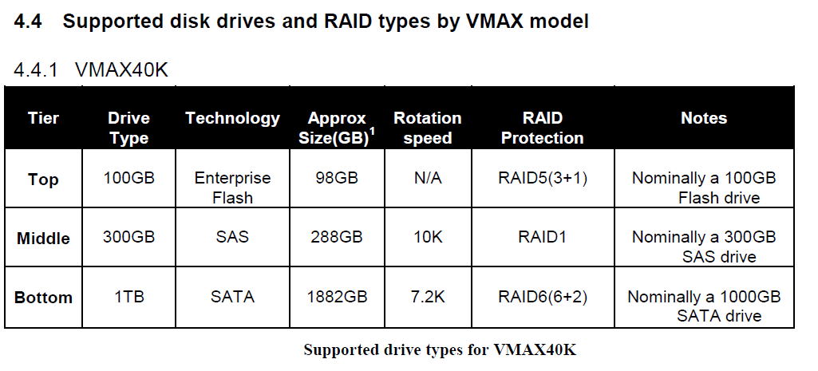

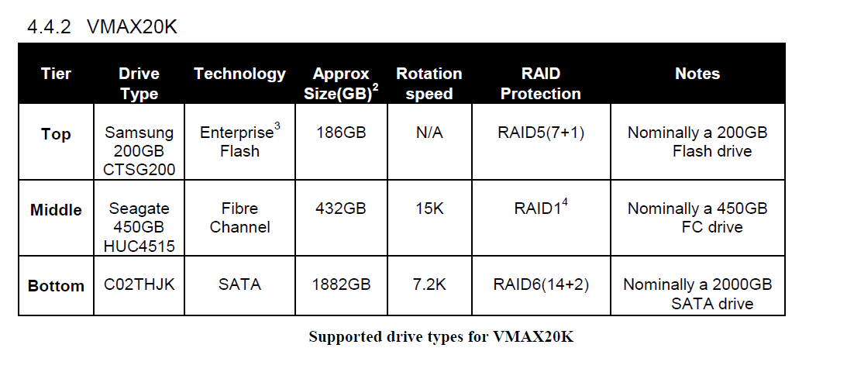

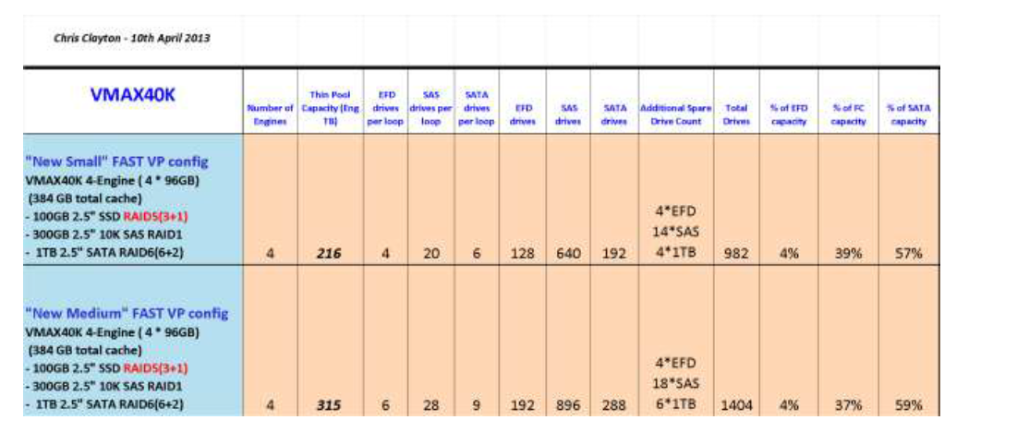

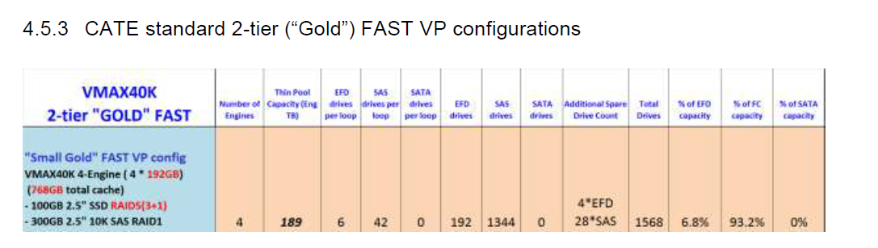

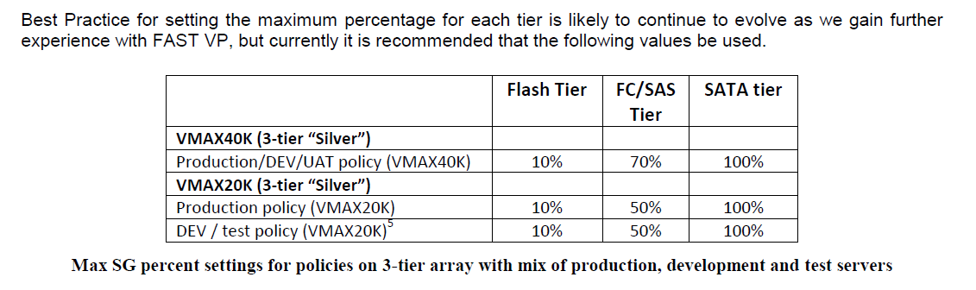
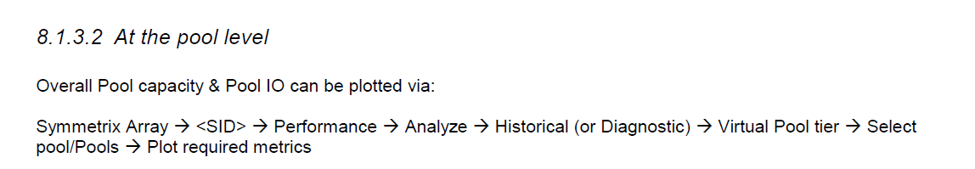
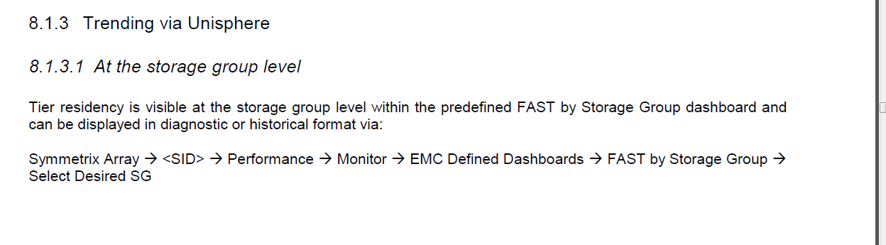

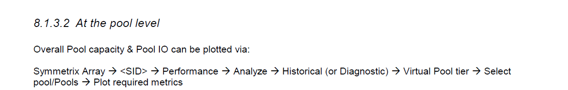

8.2 Monitoring data movement
With the CLI, data movement between tiers can most easily be detected at the Storage Group (SG) level by
repeated running of the command
# symfast -sid <SID> list -association -demand –sg <SG> -mb
and observing changes in tier residency. This reports to the nearest MB. The Growth column does NOT report
changes in tier residency, but the amount that usage of that tier can grow before the SG reaches the maximum
associated with the FAST VP policy associated with the SG.
For individual devices, use the command (described earlier)
# symcfg list -tdev -bound -detail -sg <SG> -sid <SID>
In
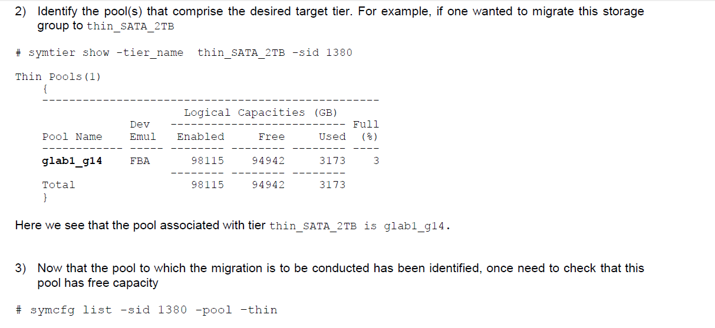

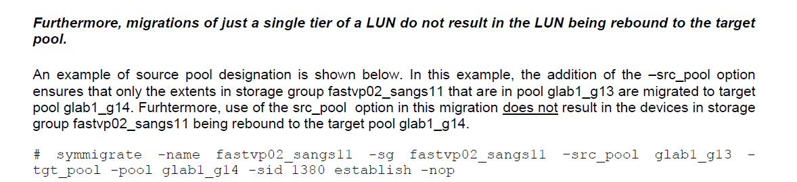
At the time of writing, Zero Space Reclamation (ZSR) does function on FAST VP devices that have some extents
currently being migrated.
In order to run ZSR on a storage group (SG) that is under FAST VP control, it is necessary to pin the devices in
the SG for the duration of the running of ZSR.
For example, if SG fastvp02_sangs11 contains devices 0331:033A
1) Pin the devices in this SG either by SG name or device range.
# symsg –sid 1380 -sg fastvp02_sangs11 pin
54
or
# symdev -sid 1380 -range 0331:033A pin –nop
2) Run zero space reclaim against these devices
# symconfigure -sid 1380 -cmd "free tdev 0331:033A start_cyl=0 end_cyl=last_cyl
type=zero;" commit –nop
3) Monitor the state of the reclaiming devices
# symcfg -sid 1380 -devs 0331:033A verify -tdev -bound -i 60
4) When the state of these devices has changed from reclaiming to bound, unpin the devices.
# symsg –sid 1380 -sg fastvp02_sangs11 unpin
or
# symdev -sid 1380 -range 0331:033A unpin –nop

