Step 4 of 6: Confirmation

Applicant's Particulars


Date of Birth | : | 25/03/2012 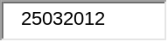
Sex | : | MALE 
Marital Status | : | SINGLE 
Name
Surname/Family Name | : | MOORI 
Given Name  (Including Middle Name) | : | LAKSHITH SAI KUMAR REDDY 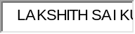
Alias (same sequence as shown in travel document, leave blank if not applicable)
Alias | :
Race | : | INDIAN 
Religion | : | HINDU 
Country Of Birth | : | INDIA 
State / Province of Birth | : | ANDHRA PRADESH 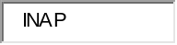
Nationality | : | INDIAN
Old Malaysian ID Type | :
Old Malaysian ID No. | :
New Malaysian ID Type | :
New Malaysian ID No. | :

Travel Document Details

Type of Travel Document Held | : | INTERNATIONAL PASSPORT 
Travel Document No. | : | K3144879 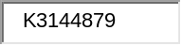
Travel Document Issue Date | : | 18/04/2012 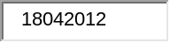
Travel Document Expiry Date | : | 17/04/2017 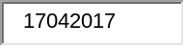
Country of Issue | : | INDIA
Place of Issue | : | ANDHRA PRADESH
FIN | : | G1166566M 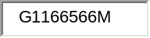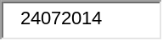

Residential Address

Address in Singapore
Block/House No. | : | 359 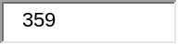 |  | Floor No. | : | 02 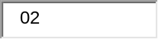 |  | Unit No. | : | 433 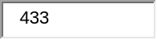
Street Name | : | TAMPINES STREET 34 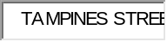 |  |  |  |  |  | Postal Code | : | 520359 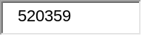
Building Name | :
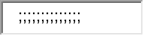

Contact Information

Email Address | : | ashoksowji@gmail.com 
Tel No. | : | 93365499 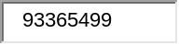

Marriage Details

Type of Application

Scheme | : | Child of Singapore Citizen/Singapore Permanent Resident 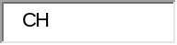

Antecedent

(a) Have you ever been refused entry into or deported from any country, including Singapore? | NO 
(b) Have you ever been convicted in a court of law in any country, including Singapore? | NO
(c) Have you ever been prohibited from entering Singapore? | NO
(d) Have you ever entered Singapore using a different passport or name? | NO
Remarks

Additional Remarks

Still pending for PR Allication status Permanent Residence Pending MOORI LAKSHITH SAI KUMAR REDDY PRS-2013-PRE-000060824 

Local Sponsor's Particulars

NRIC | : | S7863695E 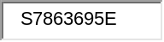
Sponsor Name | : | MOORI ASHOK KUMAR REDDY 
I am Applicant's | : | PARENT 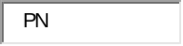
Contact Information
Email Address | : | ashokvar@gmail.com 
Tel No. | : | 81188449 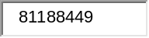

Application's Declaration

I hereby declare that all the particulars furnished by me in this application are true and correct.
I undertake not to misuse controlled drugs or take part in any political or other activities during my stay in Singapore which would make me an undesirable or prohibited immigrant under the Immigration Act.
I undertake to comply with the provisions of the Immigration Act and any regulations made thereunder or any statutory modification or re-enactment thereof for the time being in force in Singapore.
I undertake not to involve in any criminal offences in Singapore.
I undertake not to indulge in any activities that are inconsistent with the purpose for which the immigration passes have been issued.
I further undertake not to be engaged in any form of employment, business or occupation whilst in Singapore without a valid work pass issued under the Employment of Foreign Manpower Act (Cap. 91A).
I am aware that overstaying or working illegally in Singapore is a serious offence and on conviction, the penalties may include mandatory imprisonment and caning.
I understand that if the Controller of Immigration is satisfied that I or any member of my family breaches this undertaking or becomes an undesirable or prohibited immigrant, he will cancel my immigration pass and the passes of the members of the family, and we may be required to leave Singapore within 24 hours of such cancellation.
I understand that this application for and possession of a visa does not guarantee entry into Singapore and permission to entry is entirely discretionary at the point of entry.
I give my consent for your department to obtain and verify information from and with any source as you deem appropriate for the assessment of my application for immigration facilities
 I have read and understood the above declaration

Sponsor's Declaration

I hereby sponsor this application and certify that it is made for the purpose as stated by the applicant.
I shall be responsible for the cost of the applicant's repatriation and maintenance pending such repatriation, if necessary.
I consent and authorise the Immigration & Checkpoints Authority to obtain information and verify the financial information provided by me in respect of this application from or with the Inland Revenue Authority of Singapore and/or the Central Provident Fund Board of Singapore, and for them to disclose the information for the purpose of assessment of this application for the grant of a Visit Pass (Long-Term).
I declare that the statements made by the applicant and myself in this application are true and correct.

20 Jun 2014 03:19 PM Singapore

Your transaction has been completed.
You may wish to print out a copy of this confirmation for your reference.

Payment Details
From DBS/POSB Account POSB Savings
194-72842-5
Merchant Name ICA LTPass
Amount S$30.00
Transaction Description
DBS d2pay Reference 12763203296

For queries, please quote
Payment Reference 20140620151722914

Merchant Name IMMIGRATION AND CHECKPOINTS AUTHORITY
Merchant Reference Code JNX20140620151721213
NETS Reference Code 20140620151722914
Merchant Hostname https://ltpass.ica.gov.sg
Amount SGD 30.00

==============

e-VP
Electronic Visit Pass (Long-Term)
System
Step 2 of 2: Enquiry Result
Your Application for Visit Pass (long term) is receiving attention.

Application Summary
Reference No | : | VSC201406208919
FIN | : | G1166566M
Applicant Name | : | MOORI LAKSHITH SAI KUMAR REDDY
Travel Document No. | : | K3144879
Submitted On | : | 20/06/2014

SingPass ID: SXXXX695E
Logout

Name | : | MOORI ASHOK KUMAR REDDY
Enquiry Reference Number | : | EQ/2014/06/933071
Date and Time of Enquiry | : | 20-Jun-2014 03:07 PM

My Current Applications
No Record(s) Found.

Enquiry on Sponsored Applications
Type |  | Status |  | Name |  | Remarks
Permanent Residence |  | Pending |  | MOORI LAKSHITH SAI KUMAR REDDY |  | PRS-2013-PRE-000060824

Enquiry on Current Visa Applications

