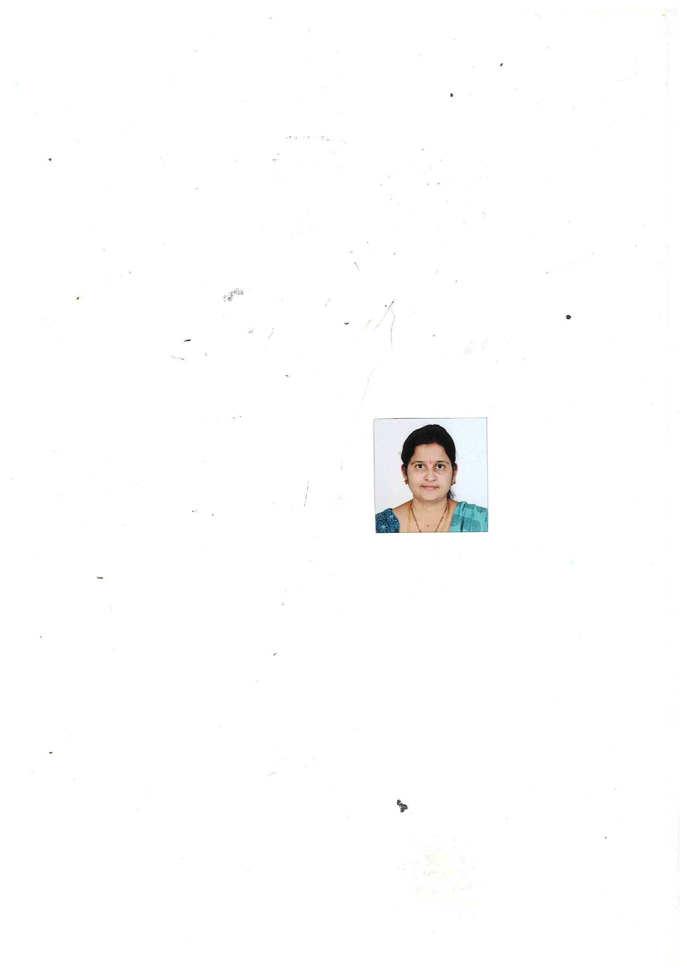
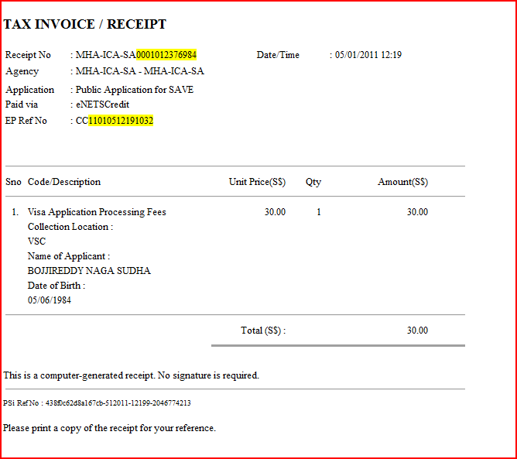

Step 3 of 3: Acknowledgement

Thank you for using SAVE
Your application has been submitted successfully.
Please print this acknowledgement page and click proceed to print the Form 14A.

Summary of Application Details
Visa Reference Number | : | VSC002829SA00052011
Name | : | BOJJIREDDY NAGA SUDHA
Travel Document Type and Number | : | INTERNATIONAL PASSPORT / J2815107
Sex | : | FEMALE
Date of Birth | : | 05/06/1984
Nationality | : | INDIAN
Submitted on | : | 05/01/2011 12:24:52
PSI Reference No | : | 438f0c62d8a167cb-512011-12199-2046774213
EPayment Reference No | : | CC11010512191032

This application will take 1 working day to process.

