Submission of Application for Visa Electronically (SAVE)

Logout

If you are unable to see the photo image, please click here for more details.
Step 5 of 6: Confirmation

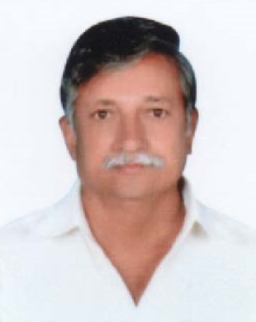

PARTICULARS OF APPLICANT
Name | : | MUPPALA GOPALA RAJU
Alias | :
Date Of Birth | : | 01/07/1953 | Sex | : | MALE
Marital Status | : | MARRIED
Nationality of Spouse | : | INDIAN
Spouse's NRIC No | :
Country of Birth | : | INDIA | State / Province of Birth | : | ANDHRA PRADESH
Nationality | : | INDIAN | PRC ID No | :
Race | : | INDIAN
Religion | : | HINDU
Religious Denomination | :
Type of Travel Document Held | : | INTERNATIONAL PASSPORT
Travel Document No | : | M8927618
Machine Readable Zone ID | :
Travel Document
Issue Date | : | 14/05/2015 | Expiry Date | : | 13/05/2025
Country of Issue | : | INDIA
Place of Issue | : | ANDHRA PRADESH
Address in Country of Origin
Country of Origin | : | INDIA
Division/Province/State of Origin | : | ANDHRA PRADESH
Prefecture of Origin | :
County/District of Origin | :
Address | : | RAILWAY KUDUR, YSR DISTRICT, 516101

OTHER DETAILS OF APPLICANT
Occupation | : | BUSINESSMAN
Highest Academic / Professional Qualifications Attained | : | UNIVERSITY
Type Group | : | SOCIAL
Type Of Visa | : | MULTIPLE JOURNEY
Date of Intended Arrival in Singapore | : | 05/10/2015
How long do you intend to stay in Singapore? | : | LESS THAN 30 DAYS
Purpose Of Visit | : | SEIGHT SEEING, SHOPPING, MEET FRIENDS AND RELATIVE
Address in Singapore
Where will you be staying in Singapore? | : | FRIEND'S PLACE
Block/House No | : | 359 | Floor No | : | 02 | Unit No | : | 433
Street Name | : | TAMPINES STREET 34 |  |  |  | Postal Code | : | 520359
Building Name | : |  |  |  |  | Tel No | : | 81188449
Did you reside in other countries, other than your country of origin, for one year or more during the last 5 years? |  |  |  |  |  |  | : | NO

ANTECEDENT OF APPLICANT
Please choose in the box where appropriate against the following:
Have you ever been refused entry into or deported from any country, including Singapore? | : | NO
Have you ever been convicted in a court of law in any country, including Singapore? | : | NO
Have you ever been prohibited from entering Singapore? | : | NO
Have you ever entered Singapore using a different passport or name? | : | NO

MISCELLANEOUS
Remarks | :
Email Address | : | ASHOKVAR@GMAIL.COM

PARTICULARS OF LOCAL CONTACT
Applicant's Country of embarkation before arriving Singapore | : | INDIA
Relationship of Applicant to Local Contact | : | FRIEND
Name | : | VATHSAVAI BHASKARA RAJU
NRIC Number | : | S7661457A
I declare that I have a valid International Passport | : | NO

Address in Singapore
Block/House No | : | 490B | Floor No | : | 09 | Unit No | : | 189
Street Name | : | TAMPINES STREET 45 |  |  |  | Postal Code | : | 521490
Building Name | : |  |  |  |  | Contact No | : | 81126939

I declare that the information furnished in respect of this application is true and correct. I understand that if there is any discrepancy in the information declared, a resubmission with a new processing fee of $30/- is required.
Please confirm this submission by clicking on the 'Submit' button.

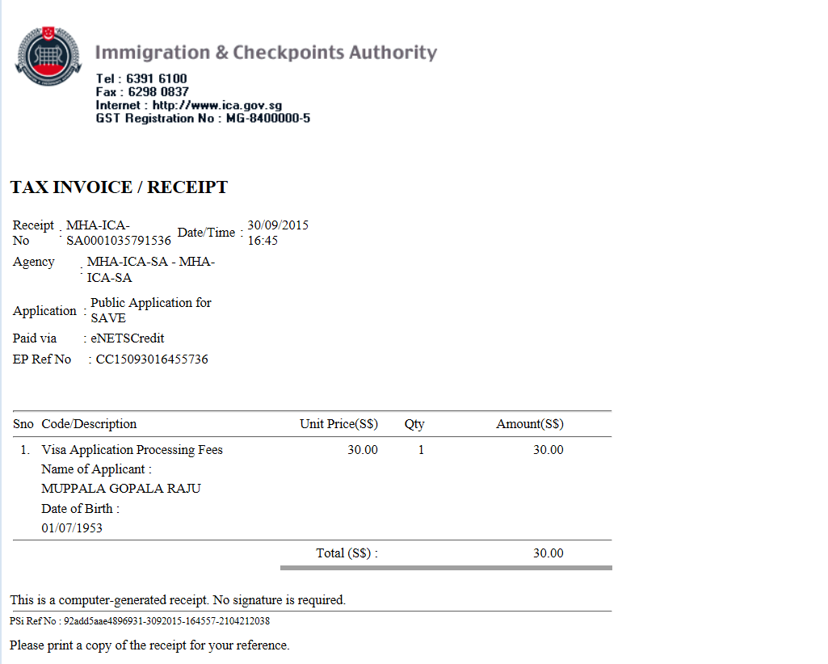

Thank you for using SAVE
Your application has been submitted successfully.
Please save or print this acknowledgement for future enquiries of this application with ICA.
The grant of a visa does not exempt the holder from compliance, registration or application for the relevant pass, permit or license, as the case may be, to carry out the proposed activity (ies) declared in the visa application, as required under Singapore's laws.

Summary of Application Details
Visa Reference Number | : | VSC352389SA02732015
Name | : | MUPPALA GOPALA RAJU
Travel Document Type and Number | : | INTERNATIONAL PASSPORT / M8927618
Sex | : | MALE
Date Of Birth | : | 01/07/1953
Nationality | : | INDIAN
Submitted on | : | 30/09/2015 16:46:56
PSI Reference No | : | 92add5aae4896931-3092015-164557-2104212038
EPayment Reference No | : | CC15093016455736

An application will take 1 working day (excluding the date of submission, Saturdays, Sundays, and Public Holidays) to process. However, some applications may take a longer time to process.

Submission of Application for Visa Electronically (SAVE)
Logout

If you are unable to see the photo image, please click here for more details.
Step 5 of 6: Confirmation



PARTICULARS OF APPLICANT
Name | : | ADDEPALLI VENKATESWARA BABU
Alias | :
Date Of Birth | : | 10/06/1978 | Sex | : | MALE
Marital Status | : | MARRIED
Nationality of Spouse | : | INDIAN
Spouse's NRIC No | :
Country of Birth | : | INDIA | State / Province of Birth | : | ANDHRA PRADESH
Nationality | : | INDIAN | PRC ID No | :
Race | : | INDIAN
Religion | : | HINDU
Religious Denomination | :
Type of Travel Document Held | : | INTERNATIONAL PASSPORT
Travel Document No | : | N3062588
Machine Readable Zone ID | :
Travel Document
Issue Date | : | 11/09/2015 | Expiry Date | : | 10/09/2025
Country of Issue | : | INDIA
Place of Issue | : | ANDHRA PRADESH
Address in Country of Origin
Country of Origin | : | INDIA
Division/Province/State of Origin | : | ANDHRA PRADESH
Prefecture of Origin | :
County/District of Origin | :
Address | : | OBULAVARIPALLE , YSR DISTRICT, 516105

OTHER DETAILS OF APPLICANT
Occupation | : | BUSINESSMAN
Highest Academic / Professional Qualifications Attained | : | UNIVERSITY
Type Group | : | SOCIAL
Type Of Visa | : | MULTIPLE JOURNEY
Date of Intended Arrival in Singapore | : | 05/10/2015
How long do you intend to stay in Singapore? | : | LESS THAN 30 DAYS
Purpose Of Visit | : | SEIGHT SEEING, SHOPPING, MEETING FRIENDS
Address in Singapore
Where will you be staying in Singapore? | : | FRIEND'S PLACE
Block/House No | : | 359 | Floor No | : | 02 | Unit No | : | 433
Street Name | : | TAMPINES STREET 34 |  |  |  | Postal Code | : | 520359
Building Name | : |  |  |  |  | Tel No | : | 81188449
Did you reside in other countries, other than your country of origin, for one year or more during the last 5 years? |  |  |  |  |  |  | : | NO

ANTECEDENT OF APPLICANT
Please choose in the box where appropriate against the following:
Have you ever been refused entry into or deported from any country, including Singapore? | : | NO
Have you ever been convicted in a court of law in any country, including Singapore? | : | NO
Have you ever been prohibited from entering Singapore? | : | NO
Have you ever entered Singapore using a different passport or name? | : | NO

MISCELLANEOUS
Remarks | :
Email Address | : | ASHOKVAR@GMAIL.COM

PARTICULARS OF LOCAL CONTACT
Applicant's Country of embarkation before arriving Singapore | : | INDIA
Relationship of Applicant to Local Contact | : | FRIEND
Name | : | VATHSAVAI BHASKARA RAJU
NRIC Number | : | S7661457A
I declare that I have a valid International Passport | : | NO

Address in Singapore
Block/House No | : | 490B | Floor No | : | 09 | Unit No | : | 189
Street Name | : | TAMPINES STREET 45 |  |  |  | Postal Code | : | 521490
Building Name | : |  |  |  |  | Contact No | : | 81126939

I declare that the information furnished in respect of this application is true and correct. I understand that if there is any discrepancy in the information declared, a resubmission with a new processing fee of $30/- is required.
Please confirm this submission by clicking on the 'Submit' button.

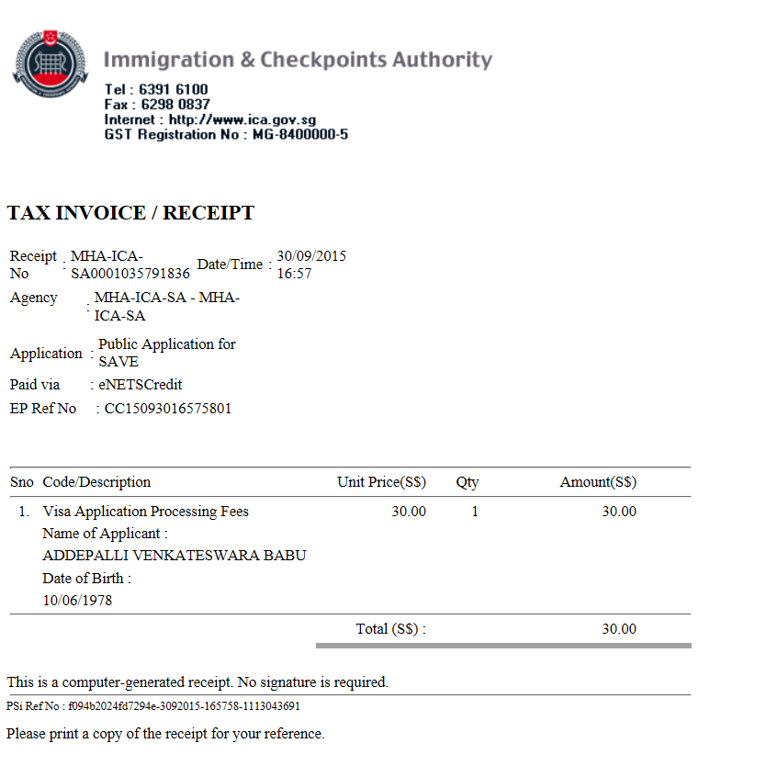

Thank you for using SAVE
Your application has been submitted successfully.
Please save or print this acknowledgement for future enquiries of this application with ICA.
The grant of a visa does not exempt the holder from compliance, registration or application for the relevant pass, permit or license, as the case may be, to carry out the proposed activity (ies) declared in the visa application, as required under Singapore's laws.

Summary of Application Details
Visa Reference Number | : | VSC352409SA02732015
Name | : | ADDEPALLI VENKATESWARA BABU
Travel Document Type and Number | : | INTERNATIONAL PASSPORT / N3062588
Sex | : | MALE
Date Of Birth | : | 10/06/1978
Nationality | : | INDIAN
Submitted on | : | 30/09/2015 16:58:51
PSI Reference No | : | f094b2024fd7294e-3092015-165758-1113043691
EPayment Reference No | : | CC15093016575801

An application will take 1 working day (excluding the date of submission, Saturdays, Sundays, and Public Holidays) to process. However, some applications may take a longer time to process.

