Submission of Application for Visa Electronically (SAVE)

Logout

If you are unable to see the photo image, please click here for more details.
Step 5 of 6: Confirmation

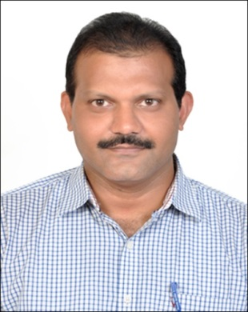

PARTICULARS OF APPLICANT
Name | : | BASIREDDY HARI PRASAD REDDY
Alias | :
Date Of Birth | : | 05/08/1970 | Sex | : | MALE
Marital Status | : | MARRIED
Nationality of Spouse | : | INDIAN
Spouse's NRIC No | :
Country of Birth | : | INDIA | State / Province of Birth | : | ANDHRA PRADESH
Nationality | : | INDIAN | PRC ID No | :
Race | : | INDIAN
Religion | : | HINDU
Religious Denomination | :
Type of Travel Document Held | : | INTERNATIONAL PASSPORT
Travel Document No | : | J0243944
Machine Readable Zone ID | :
Travel Document
Issue Date | : | 05/08/2010 | Expiry Date | : | 04/08/2020
Country of Issue | : | INDIA
Place of Issue | : | ANDHRA PRADESH
Address in Country of Origin
Country of Origin | : | INDIA
Division/Province/State of Origin | : | ANDHRA PRADESH
Prefecture of Origin | :
County/District of Origin | :
Address | : | H NO 1-5-39/2, SRI LAHSHMI HOSPITAL, NEW TOWN, MAHABUBNAGAR - 509001. AP

OTHER DETAILS OF APPLICANT
Occupation | : | PROFESSIONAL
Highest Academic / Professional Qualifications Attained | : | POST GRADUATE
Type Group | : | SOCIAL
Type Of Visa | : | MULTIPLE JOURNEY
Date of Intended Arrival in Singapore | : | 13/10/2015
How long do you intend to stay in Singapore? | : | LESS THAN 30 DAYS
Purpose Of Visit | : | SHOPPING, SEIGHT SEEING AND TO MEET RELATIVES
Address in Singapore
Where will you be staying in Singapore? | : | FRIEND'S PLACE
Block/House No | : | 359 | Floor No | : | 02 | Unit No | : | 433
Street Name | : | TAMPINES STREET 34 |  |  |  | Postal Code | : | 520359
Building Name | : |  |  |  |  | Tel No | : | 81188449
Did you reside in other countries, other than your country of origin, for one year or more during the last 5 years? |  |  |  |  |  |  | : | NO

ANTECEDENT OF APPLICANT
Please choose in the box where appropriate against the following:
Have you ever been refused entry into or deported from any country, including Singapore? | : | NO
Have you ever been convicted in a court of law in any country, including Singapore? | : | NO
Have you ever been prohibited from entering Singapore? | : | NO
Have you ever entered Singapore using a different passport or name? | : | NO

MISCELLANEOUS
Remarks | :
Email Address | : | ASHOKSOWJI@GMAIL.COM

PARTICULARS OF LOCAL CONTACT
Applicant's Country of embarkation before arriving Singapore | : | INDIA
Relationship of Applicant to Local Contact | : | FRIEND
Name | : | MOORI ASHOK KUMAR REDDY
NRIC Number | : | S7863695E
I declare that I have a valid International Passport | : | YES
Local Contact's Passport Number | : | S7863695E
Local Contact's Passport Expiry Date | : | 14/09/2016

Address in Singapore
Block/House No | : | 359 | Floor No | : | 02 | Unit No | : | 433
Street Name | : | TAMPINES STREET 34 |  |  |  | Postal Code | : | 520359
Building Name | : |  |  |  |  | Contact No | : | 81188449

I declare that the information furnished in respect of this application is true and correct. I understand that if there is any discrepancy in the information declared, a resubmission with a new processing fee of $30/- is required.
Please confirm this submission by clicking on the 'Submit' button.

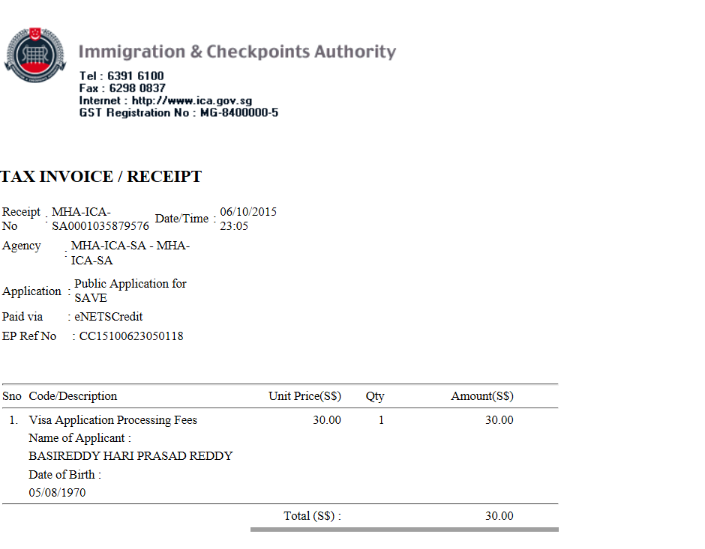

Submission of Application for Visa Electronically (SAVE)

Logout

Step 6 of 6: Acknowledgement

Thank you for using SAVE
Your application has been submitted successfully.
Please save or print this acknowledgement for future enquiries of this application with ICA.
The grant of a visa does not exempt the holder from compliance, registration or application for the relevant pass, permit or license, as the case may be, to carry out the proposed activity (ies) declared in the visa application, as required under Singapore's laws.

Summary of Application Details
Visa Reference Number | : | VSC359770SA02792015
Name | : | BASIREDDY HARI PRASAD REDDY
Travel Document Type and Number | : | INTERNATIONAL PASSPORT / J0243944
Sex | : | MALE
Date Of Birth | : | 05/08/1970
Nationality | : | INDIAN
Submitted on | : | 06/10/2015 23:05:53
PSI Reference No | : | d476fe7c8ed37c8a-6102015-2350-1354757681
EPayment Reference No | : | CC15100623050118

An application will take 1 working day (excluding the date of submission, Saturdays, Sundays, and Public Holidays) to process. However, some applications may take a longer time to process.

Submission of Application for Visa Electronically (SAVE)
Logout

If you are unable to see the photo image, please click here for more details.
Step 5 of 6: Confirmation

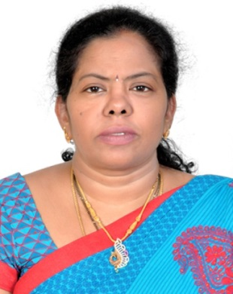

PARTICULARS OF APPLICANT
Name | : | BASIREDDY PADMA
Alias | :
Date Of Birth | : | 22/05/1968 | Sex | : | FEMALE
Marital Status | : | MARRIED
Nationality of Spouse | : | INDIAN
Spouse's NRIC No | :
Country of Birth | : | INDIA | State / Province of Birth | : | ANDHRA PRADESH
Nationality | : | INDIAN | PRC ID No | :
Race | : | INDIAN
Religion | : | HINDU
Religious Denomination | :
Type of Travel Document Held | : | INTERNATIONAL PASSPORT
Travel Document No | : | J2197530
Machine Readable Zone ID | :
Travel Document
Issue Date | : | 15/11/2010 | Expiry Date | : | 14/11/2020
Country of Issue | : | INDIA
Place of Issue | : | ANDHRA PRADESH
Address in Country of Origin
Country of Origin | : | INDIA
Division/Province/State of Origin | : | ANDHRA PRADESH
Prefecture of Origin | :
County/District of Origin | :
Address | : | H NO 1-5-39/2, SRI LAKSHMI HOSPITAL, NEW TOWN, MAHABOOBNAGAR - 519001

OTHER DETAILS OF APPLICANT
Occupation | : | PROFESSIONAL
Highest Academic / Professional Qualifications Attained | : | POST GRADUATE
Type Group | : | SOCIAL
Type Of Visa | : | MULTIPLE JOURNEY
Date of Intended Arrival in Singapore | : | 13/10/2015
How long do you intend to stay in Singapore? | : | LESS THAN 30 DAYS
Purpose Of Visit | : | SHOPPING, SEIGHT SEEING AND TO MEET RELATIVES
Address in Singapore
Where will you be staying in Singapore? | : | FRIEND'S PLACE
Block/House No | : | 359 | Floor No | : | 02 | Unit No | : | 433
Street Name | : | TAMPINES STREET 34 |  |  |  | Postal Code | : | 520359
Building Name | : |  |  |  |  | Tel No | : | 81188449
Did you reside in other countries, other than your country of origin, for one year or more during the last 5 years? |  |  |  |  |  |  | : | NO

ANTECEDENT OF APPLICANT
Please choose in the box where appropriate against the following:
Have you ever been refused entry into or deported from any country, including Singapore? | : | NO
Have you ever been convicted in a court of law in any country, including Singapore? | : | NO
Have you ever been prohibited from entering Singapore? | : | NO
Have you ever entered Singapore using a different passport or name? | : | NO

MISCELLANEOUS
Remarks | :
Email Address | : | ASHOKSOWJI@GMAIL.COM

PARTICULARS OF LOCAL CONTACT
Applicant's Country of embarkation before arriving Singapore | : | INDIA
Relationship of Applicant to Local Contact | : | FRIEND
Name | : | MOORI ASHOK KUMAR REDDY
NRIC Number | : | S7863695E
I declare that I have a valid International Passport | : | YES
Local Contact's Passport Number | : | F8249316
Local Contact's Passport Expiry Date | : | 14/09/2016

Address in Singapore
Block/House No | : | 359 | Floor No | : | 02 | Unit No | : | 433
Street Name | : | TAMPINES STREET 34 |  |  |  | Postal Code | : | 520359
Building Name | : |  |  |  |  | Contact No | : | 81188449

I declare that the information furnished in respect of this application is true and correct. I understand that if there is any discrepancy in the information declared, a resubmission with a new processing fee of $30/- is required.
Please confirm this submission by clicking on the 'Submit' button.

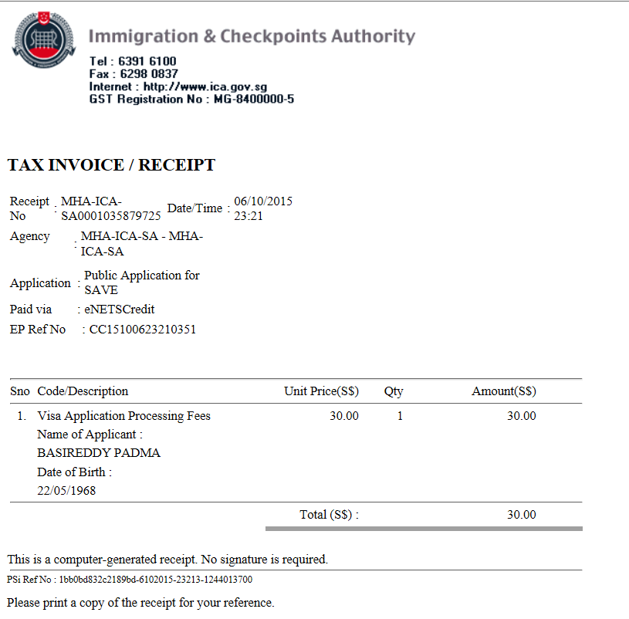

Submission of Application for Visa Electronically (SAVE)
Logout

Step 6 of 6: Acknowledgement

Thank you for using SAVE
Your application has been submitted successfully.
Please save or print this acknowledgement for future enquiries of this application with ICA.
The grant of a visa does not exempt the holder from compliance, registration or application for the relevant pass, permit or license, as the case may be, to carry out the proposed activity (ies) declared in the visa application, as required under Singapore's laws.

Summary of Application Details
Visa Reference Number | : | VSC359784SA02792015
Name | : | BASIREDDY PADMA
Travel Document Type and Number | : | INTERNATIONAL PASSPORT / J2197530
Sex | : | FEMALE
Date Of Birth | : | 22/05/1968
Nationality | : | INDIAN
Submitted on | : | 06/10/2015 23:21:54
PSI Reference No | : | 1bb0bd832c2189bd-6102015-23213-1244013700
EPayment Reference No | : | CC15100623210351

An application will take 1 working day (excluding the date of submission, Saturdays, Sundays, and Public Holidays) to process. However, some applications may take a longer time to process.

Submission of Application for Visa Electronically (SAVE)
Logout

If you are unable to see the photo image, please click here for more details.
Step 5 of 6: Confirmation

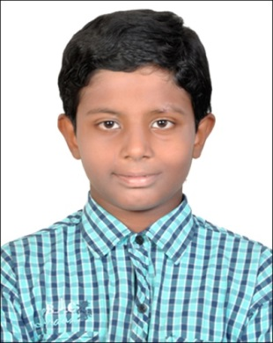

PARTICULARS OF APPLICANT
Name | : | BASIREDDY RISHITH REDDY
Alias | :
Date Of Birth | : | 12/08/2005 | Sex | : | MALE
Marital Status | : | SINGLE
Nationality of Spouse | :
Spouse's NRIC No | :
Country of Birth | : | INDIA | State / Province of Birth | : | ANDHRA PRADESH
Nationality | : | INDIAN | PRC ID No | :
Race | : | INDIAN
Religion | : | HINDU
Religious Denomination | :
Type of Travel Document Held | : | INTERNATIONAL PASSPORT
Travel Document No | : | N3061708
Machine Readable Zone ID | :
Travel Document
Issue Date | : | 10/09/2015 | Expiry Date | : | 09/09/2020
Country of Issue | : | INDIA
Place of Issue | : | ANDHRA PRADESH
Address in Country of Origin
Country of Origin | : | INDIA
Division/Province/State of Origin | : | ANDHRA PRADESH
Prefecture of Origin | :
County/District of Origin | :
Address | : | H NO 1-5-39/2, SRI LAKSHMI HOSPITAL, NEW TOWN, MAHABUBNAGAR - 519001

OTHER DETAILS OF APPLICANT
Occupation | : | STUDENT
Highest Academic / Professional Qualifications Attained | : | PRIMARY
Type Group | : | SOCIAL
Type Of Visa | : | MULTIPLE JOURNEY
Date of Intended Arrival in Singapore | : | 13/10/2015
How long do you intend to stay in Singapore? | : | LESS THAN 30 DAYS
Purpose Of Visit | : | SEIGHT SEEING AND TO MEET RELATIVES
Address in Singapore
Where will you be staying in Singapore? | : | FRIEND'S PLACE
Block/House No | : | 359 | Floor No | : | 02 | Unit No | : | 433
Street Name | : | TAMPINES STREET 34 |  |  |  | Postal Code | : | 520359
Building Name | : |  |  |  |  | Tel No | : | 81188449
Did you reside in other countries, other than your country of origin, for one year or more during the last 5 years? |  |  |  |  |  |  | : | NO

ANTECEDENT OF APPLICANT
Please choose in the box where appropriate against the following:
Have you ever been refused entry into or deported from any country, including Singapore? | : | NO
Have you ever been convicted in a court of law in any country, including Singapore? | : | NO
Have you ever been prohibited from entering Singapore? | : | NO
Have you ever entered Singapore using a different passport or name? | : | NO

MISCELLANEOUS
Remarks | :
Email Address | : | ASHOKSOWJI@GMAIL.COM

PARTICULARS OF LOCAL CONTACT
Applicant's Country of embarkation before arriving Singapore | : | INDIA
Relationship of Applicant to Local Contact | : | FRIEND
Name | : | MOORI ASHOK KUMAR REDDY
NRIC Number | : | S7863695E
I declare that I have a valid International Passport | : | YES
Local Contact's Passport Number | : | F8249316
Local Contact's Passport Expiry Date | : | 14/09/2016

Address in Singapore
Block/House No | : | 359 | Floor No | : | 02 | Unit No | : | 433
Street Name | : | TAMPINES STREET 34 |  |  |  | Postal Code | : | 520359
Building Name | : |  |  |  |  | Contact No | : | 81188449

I declare that the information furnished in respect of this application is true and correct. I understand that if there is any discrepancy in the information declared, a resubmission with a new processing fee of $30/- is required.
Please confirm this submission by clicking on the 'Submit' button.

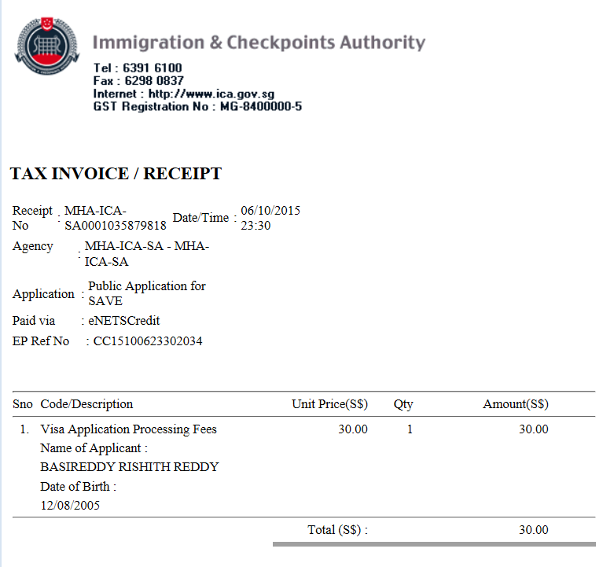

Submission of Application for Visa Electronically (SAVE)
Logout

Step 6 of 6: Acknowledgement

Thank you for using SAVE
Your application has been submitted successfully.
Please save or print this acknowledgement for future enquiries of this application with ICA.
The grant of a visa does not exempt the holder from compliance, registration or application for the relevant pass, permit or license, as the case may be, to carry out the proposed activity (ies) declared in the visa application, as required under Singapore's laws.

Summary of Application Details
Visa Reference Number | : | VSC359794SA02792015
Name | : | BASIREDDY RISHITH REDDY
Travel Document Type and Number | : | INTERNATIONAL PASSPORT / N3061708
Sex | : | MALE
Date Of Birth | : | 12/08/2005
Nationality | : | INDIAN
Submitted on | : | 06/10/2015 23:30:53
PSI Reference No | : | f572dc0dd8338354-6102015-233020-314331966
EPayment Reference No | : | CC15100623302034

An application will take 1 working day (excluding the date of submission, Saturdays, Sundays, and Public Holidays) to process. However, some applications may take a longer time to process

Submission of Application for Visa Electronically (SAVE)
Logout

If you are unable to see the photo image, please click here for more details.
Step 5 of 6: Confirmation

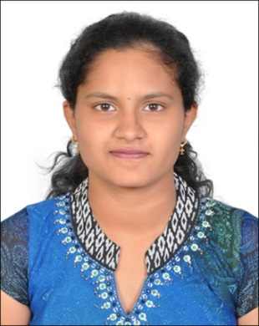

PARTICULARS OF APPLICANT
Name | : | BASIREDDY LAHARI
Alias | :
Date Of Birth | : | 16/10/1997 | Sex | : | FEMALE
Marital Status | : | SINGLE
Nationality of Spouse | :
Spouse's NRIC No | :
Country of Birth | : | INDIA | State / Province of Birth | : | ANDHRA PRADESH
Nationality | : | INDIAN | PRC ID No | :
Race | : | INDIAN
Religion | : | HINDU
Religious Denomination | :
Type of Travel Document Held | : | INTERNATIONAL PASSPORT
Travel Document No | : | N3098962
Machine Readable Zone ID | :
Travel Document
Issue Date | : | 16/09/2015 | Expiry Date | : | 15/09/2025
Country of Issue | : | INDIA
Place of Issue | : | ANDHRA PRADESH
Address in Country of Origin
Country of Origin | : | INDIA
Division/Province/State of Origin | : | ANDHRA PRADESH
Prefecture of Origin | :
County/District of Origin | :
Address | : | H NO 1-5-39/2, SRI LAKSHMI HOSPITAL, NEW TOWN, MAHABUBNAGAR - 519001

OTHER DETAILS OF APPLICANT
Occupation | : | STUDENT
Highest Academic / Professional Qualifications Attained | : | UNIVERSITY
Type Group | : | SOCIAL
Type Of Visa | : | MULTIPLE JOURNEY
Date of Intended Arrival in Singapore | : | 13/10/2015
How long do you intend to stay in Singapore? | : | LESS THAN 30 DAYS
Purpose Of Visit | : | SEIGHT SEEING AND TO MEET RELATIVES AND FRIENDS
Address in Singapore
Where will you be staying in Singapore? | : | FRIEND'S PLACE
Block/House No | : | 359 | Floor No | : | 02 | Unit No | : | 433
Street Name | : | TAMPINES STREET 34 |  |  |  | Postal Code | : | 520359
Building Name | : |  |  |  |  | Tel No | : | 81188449
Did you reside in other countries, other than your country of origin, for one year or more during the last 5 years? |  |  |  |  |  |  | : | NO

ANTECEDENT OF APPLICANT
Please choose in the box where appropriate against the following:
Have you ever been refused entry into or deported from any country, including Singapore? | : | NO
Have you ever been convicted in a court of law in any country, including Singapore? | : | NO
Have you ever been prohibited from entering Singapore? | : | NO
Have you ever entered Singapore using a different passport or name? | : | NO

MISCELLANEOUS
Remarks | :
Email Address | : | ASHOKVAR@GMAIL.COM

PARTICULARS OF LOCAL CONTACT
Applicant's Country of embarkation before arriving Singapore | : | INDIA
Relationship of Applicant to Local Contact | : | FRIEND
Name | : | MOORI ASHOK KUMAR REDDY
NRIC Number | : | S7863695E
I declare that I have a valid International Passport | : | YES
Local Contact's Passport Number | : | F8249316
Local Contact's Passport Expiry Date | : | 14/09/2016

Address in Singapore
Block/House No | : | 359 | Floor No | : | 02 | Unit No | : | 433
Street Name | : | TAMPINES STREET 34 |  |  |  | Postal Code | : | 520359
Building Name | : |  |  |  |  | Contact No | : | 81188449

I declare that the information furnished in respect of this application is true and correct. I understand that if there is any discrepancy in the information declared, a resubmission with a new processing fee of $30/- is required.
Please confirm this submission by clicking on the 'Submit' button.

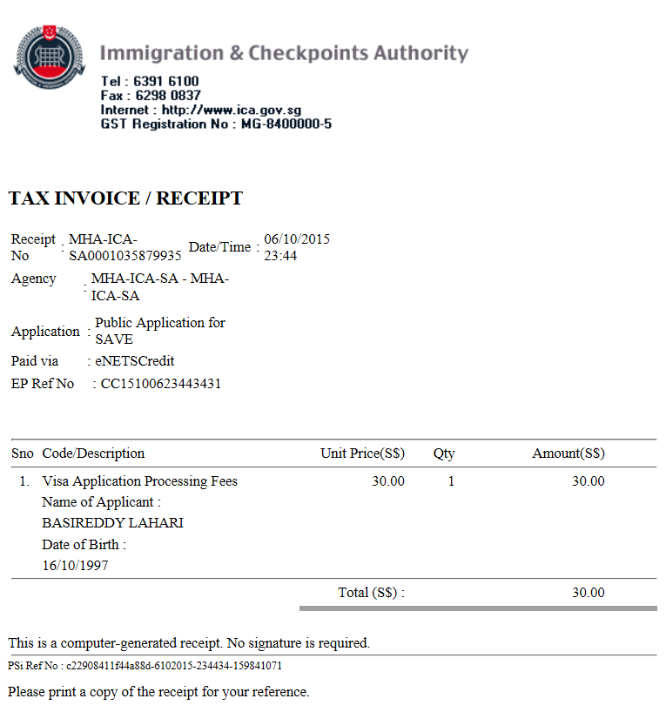

Submission of Application for Visa Electronically (SAVE)
Logout

Step 6 of 6: Acknowledgement

Thank you for using SAVE
Your application has been submitted successfully.
Please save or print this acknowledgement for future enquiries of this application with ICA.
The grant of a visa does not exempt the holder from compliance, registration or application for the relevant pass, permit or license, as the case may be, to carry out the proposed activity (ies) declared in the visa application, as required under Singapore's laws.

Summary of Application Details
Visa Reference Number | : | VSC359804SA02792015
Name | : | BASIREDDY LAHARI
Travel Document Type and Number | : | INTERNATIONAL PASSPORT / N3098962
Sex | : | FEMALE
Date Of Birth | : | 16/10/1997
Nationality | : | INDIAN
Submitted on | : | 06/10/2015 23:45:13
PSI Reference No | : | c22908411f44a88d-6102015-234434-159841071
EPayment Reference No | : | CC15100623443431

An application will take 1 working day (excluding the date of submission, Saturdays, Sundays, and Public Holidays) to process. However, some applications may take a longer time to process.

