GNAST DESIGN and CONFIGURATION GUIDE

For

EMC Unisphere for VMAX v8

CSBE Storage and Backup Engineering

Template Version: 2.0.7

Document Version#: 0.6

April 27, 2014



Disclaimer
If printed, content is valid only for the day it was printed. Always refer to the online document for the current version. If the user elects to maintain copies of this procedure, it is their responsibility to verify the currency of the document by checking it against the online version. This document must be promptly removed from use when obsolete.

Table of Contents
1 Document Purpose 5
2 Owner of Standard 5
3 Intended Audience 5
4 Principles 5
4.1 Revision History 5
4.2 Key Feature Changes 6
5 Assembly/Solution Description 6
6 Scope 6
6.1 Technology 6
6.2 Applicability 7
7 Components 7
7.1 List of Components 7
7.2 Operational Tools 7
8 Assembly/Solution Architecture 7
8.1 Unisphere for VMAX Architecture 7
8.2 Unisphere for VMAX Product Components 8
8.2.1 U4V Server 8
8.2.2 SYMAPI Server 9
8.2.3 Client Requirements 9
9 Installation & Configuration Instructions 10
9.1.1 Solutions Enabler Installation/Upgrade on Unisphere for VMAX Server 10
9.1.2 Testing Unisphere for VMAX server has access to remote SYMAPI server 13
9.1.3 Unisphere for VMAX Installation/Upgrade 14
10 Configuration Assurance 17
11 Scalability & Capacity 17
12 Availability Management 18
13 Regional or Merger Partner Consideration 18
14 Global Standard 18
14.1 Configuration of Unisphere for VMAX Security Model 18
14.1.1 Overview 18
14.1.2 Authorization: Restricting Activity Using Unisphere for VMAX 19
14.1.3 Group Based User Authorization Mapping 20
14.1.4 Symauth Configuration for Unisphere AD groups 21
14.1.5 Propagation of SYMAUTH roles changes 22
14.1.6 Authentication: Setting Up Centralized AD over LDAP 22
14.1.7 User Access to Unisphere for VMAX: 27
14.2 Log in message/Banner 28
14.3 Limiting/Filtering array discovery in U4V 29
14.4 McAfee Virus Scan – Addition of processes to Low Risk Process Policy 32
14.5 Web Server Certificates 32
14.6 Registering arrays for Data Collection 37
14.7 Unisphere Backup 38
14.7.1 Server backup 38
14.7.2 Unisphere performance database backup 39
14.8 Configure Idle User Timeout Session 40
14.9 Remove authorization via local directory 40
15 Relevant Links 41
16 Glossary/Definition 41
17 Appendix B: Unisphere usage 42
17.1 Rules on Poling & Array loading 42
17.2 Alerts 43
17.2.1 Default Alerts 43
17.2.2 U4V System Runtime Checks/Alerts 44
17.2.3 Target Enginuity level 44
17.3 Performance Thresholds and Alerts 45
17.3.1 Overview 45
17.3.2 Recommended Thresholds 46
17.4 Notification 47
17.4.1 Optional Email Notification 47
17.5 Reports 49
17.5.1 Dashboard Reports 49
17.5.2 Customized reports 50
17.6 Export button 51
17.7 Export/Importing Performance Settings 52
18 Appendix C – Version Tracker 53

Disclaimer
If printed, content is valid only for the day it was printed. Always refer to the online document for the current version. If the user elects to maintain copies of this procedure, it is their responsibility to verify the currency of the document by checking it against the online version. This document must be promptly removed from use when obsolete.
Note: The purpose of this template is to provide a standard document structure for completing designs with detailed instructions on how to install and configure secure technology standards within Citi’s global environment. This document follows the official standard GNAST design framework, and applies to all current GNAST technology standards/products inclusive of hardware and software.
This template also allows usage of the Secure Build Configuration Checklist (SBCC) into one GNAST Configuration Template.

In some sections, this template can be used as a “pointer” to more widely used guides and SBCC documents (i.e. SBCC). In other cases, it might make sense to use this template and expand as needed.

Document Purpose
This document provides detailed installation and configuration instructions for use by all operational and regional engineering teams for EMC Unisphere for VMAX deployment within Citi’s global environment, to ensure adherence to configuration, support, and management standards as well as compliance to Citigroup Information Security Standards.

Owner of Standard
GNAST (Global Network Architecture and Standards Team) is the owner of this standard and the related documents. CATE (Citi Architecture & Technology Engineering) is the custodial organization. CitiNetwork & CitiStorage Platform Engineering technologists will drive and generate content.

Intended Audience
The intended audience is CitiNetwork & CitiStorage Engineering, Global and Regional Operations and Engineering personnel responsible for designing, building, supporting, and managing Citi corporate network environments.

Principles

Revision History
Update the document history each time a draft is issued for review.

Version | Description | Date | Author/Organization
0.6 | U4V version 8.0.2 Draft | 04-27-2015 | Quang Le

Key Feature Changes
This is the initial production release of the EMC Unisphere for VMAX.

Assembly/Solution Description
Unisphere for VMAX (U4V) is a web browser based user interface designed to provide storage management for EMC Symmetrix products under a common framework and offers features such as provisioning, managing, monitoring, alerting and performance analysis.

U4V provides a Performance Real Time view for examining high frequency data points, Historical View for all Symmetrix array Key Performance Indicators (KPI), and Diagnostic View for root cause analysis.
U4V allows data to be collected and stored for analysis and reports to be produced on workload, resource usage trends for service level management, diagnostics and capacity planning.

Scope
Unisphere for VMAX will primarily be used by Storage Area Network administrators to assist allocation decision making, performance monitoring and issue investigation on VMAX storage arrays

Technology
Web GUI for EMC VMAX/Symmetrix storage arrays

Applicability
CTI GLOBAL DCIS-Storage SAN teams

Components

List of Components
The following tables list the required components and versions for the deployment of Unisphere for VMAX

Component Name | Capability Description
Unisphere for VMAX | V8.0.2 and above is the certified for deployment
Solutions Enabler | V8.0.2 and above is certified for deployment with U4V 8.0.2
Unisphere for VMAX server | Unisphere for VMAX software should only be installed on these O.S. types for this certification:  Windows 2008R2/2012 (SOE Built)

GNAST Bill of Material (BoM) NOTE: Restricted access: https://catecollaboration.citigroup.net/domains/networks/bom/default.aspx

Operational Tools
The following tools listed in the table will have each U4V instance integrated.

Name | Capability Description | Result
Solutions Enabler | Array communication
EMC SRM | Performance reporting

Assembly/Solution Architecture

Unisphere for VMAX Architecture

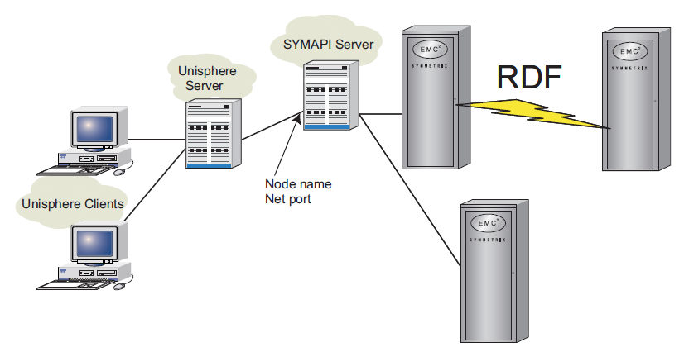

Unisphere for VMAX Product Components

U4V Server

Unisphere for VMAX server should be run on a VMware virtual machine with:
- Windows Server 2008 R2 Standard Edition (64-bit), 2012 or 2012R2

- Disk & Memory – The space required will depend on the amount of devices/arrays – EMC Advise the following scaling based on number of arrays/volume count:

Maximum Volume count | Maximum managed storage system count | Minimum Processor Specification | Minimum Available memory | Minimum available disk space
0-64K | 10 | 2 Core 1.8GHz | 12GB | 100GB
64-128K | 20 | 2 Core 1.8GHz | 16GB | 140GB
128-256K | 20 | 2 Core 1.8GHz | 20GB | 180GB
Memory: The above stated is the minimal dedicated amount of memory (not shared memory) required to run Unisphere for VMAX with performance option this is in addition to OS requirement.
Disk: The above stated is the minimal dedicated disk recommended to run Unisphere for VMAX this is in addition to OS requirement.

- Solutions Enabler will need to be installed as a prerequisite for Unisphere.

Interoperability with other applications
Due to the large memory requirements of Unisphere for VMAX, it is mandatory that no other applications (over and above standard build items) be installed on the same server.

SYMAPI Server

The Solutions Enabler configuration guide should be referenced for the setup and configuration of the physical SYMAPI server.

Unisphere for VMAX will interact with a SYMAPI server using the Solutions Enabler application that is set up in a Client /Server configuration. The SYMAPI server will have physical connectivity to the storage array via Fibre channel.

Restrictions:
- U4V server can only connect to a single SYMAPI server.

- U4V must only be used to collect performance data from Symmetrix that are local to the SYMAPI server. Data collection over RDF links to a remote Symmetrix is prohibited.

Typically existing Linux servers running Solutions Enabler (SE) should be used where possible to collect the STP data. In relation to U4V & SE a maximum of 256,000 devices can be collected by a single STP daemon i.e. a single SE server.
- An SE server can collect STP data on a defined subset of the arrays that it can see

- The primary or secondary SE server can manage (via CLI) all of the Symmetrix visible to both the primary or secondary SE server
As SE servers are deployed in redundant pairs. Each SE server in the pair could act as a separate SYMAPI server for multiple U4V instances.

Client Requirements
Browser | Version | Memory
Internet Explorer | 9.0 11.0 | 600MB
Chrome | 21.0.1180 or later | 600MB

- Flash player 11.2
- Appropriate version of Java SE Runtime Environment 7 (JRE)

Installation & Configuration Instructions
The following sections of this document discuss the installation and configuration steps for Unisphere for VMAX and assume the correct hardware has been deployed.

Solutions Enabler Installation/Upgrade on Unisphere for VMAX Server
Solutions Enabler Installation on the Unisphere for VMAX Server is a pre-requisite for U4V.
The provision of this package should be via TPM. It will also detect and upgrade the previous version automatically.

This is an “interactive” install package, so that regional deployment differences can be accommodated and hence screenshots are provided below.

TPM Package Name: CITI_WIN_SolutionsEnabler_802_00
- Request the SA to push the package from TPM
  - Note: TMP will not install the program, but drop the binaries on the VM for the SA/Storage admin to carry out movement (if required) and installation.

- Run the installation package and follow the installation instructions
  - Install to appropriate location (typically default)

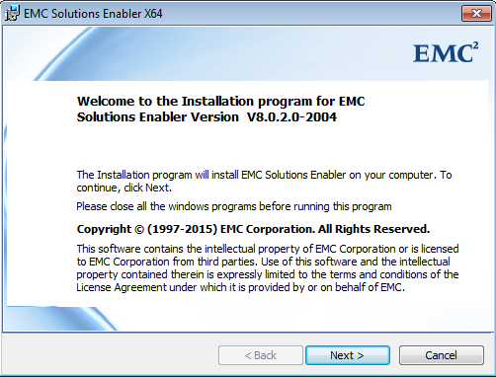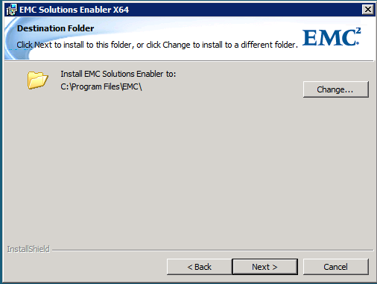

- Select Typical Set up
- Select all Stordaemon Services allowed and Accept default lockbox password (Server_Name@Smas-1)
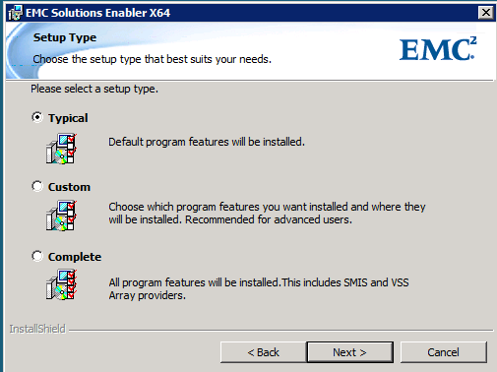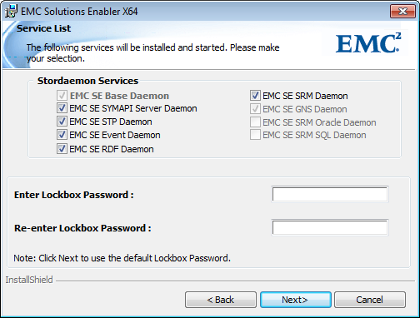

- Confirm default selection and proceed with the installation

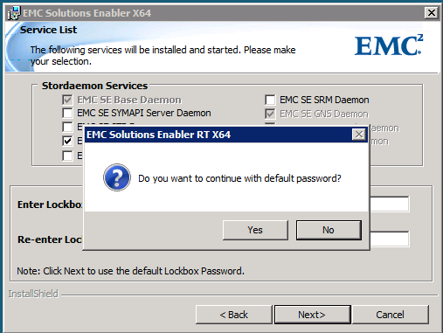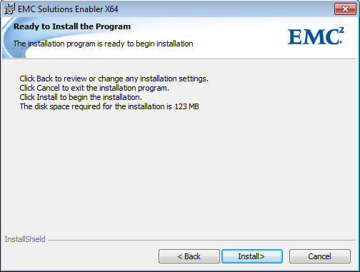

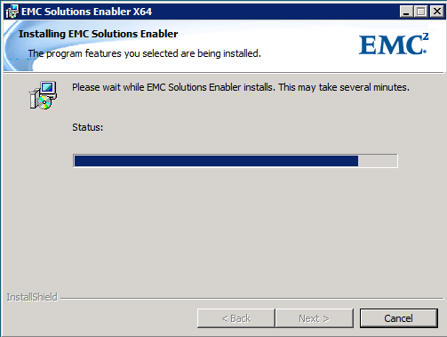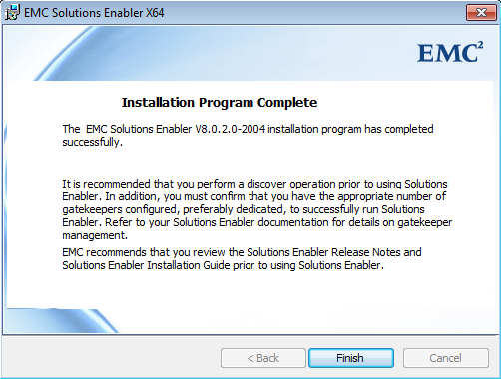

Post install activities – SYMAPI Server

SSL Negotiation
Unisphere for VMAX server and remote SYMAPI server should be configured to utilize SECURE. SSL sessions.

From remote SYMAPI server, ensure the configuration file options is set as per the default:
storsrvd:security level = SECURE

Note: If this is leveraging an existing SE deployment and there are other clients that need to utilize unsecured SSL sessions, the security level may be set accordingly to accommodate both Secure and Non Secure.

storsrvd:security level = ANY

Nethost file configuration
To allow the Unisphere for VMAX server to connect to the remote SYMAPI server.

On the remote SYMAPI server, edit
/var/symapi/config/nethost

Add
<Unisphere for VMAX server name> * or <IP address> *

For example:
u4vserver.domain.nsroot.net *
111.222.333.444 *
It is recommended to restart the storsrvd service once any changes have been made to the options or nethost files

Post install activities – U4V Server

SSL negotiation
Unisphere for VMAX server and remote SYMAPI server should be configured to utilize SECURE SSL sessions.

From U4V server, edit the netcnfg file “<installpath>\emc\symapi\config\netcnfg” with the details of the SYMAPI server for example:

SYMAPI_SERVER - TCPIP symapi.domain.net 111.222.333.444 2707 SECURE

Restart SMAS service for the changes to take effect

Configure CLI path and System variables
On the U4V server request the system administrator to add in the path of the Solutions Enabler command line directory into the System path Variable:
<installpath>\EMC\SYMCLI\bin;
For example:
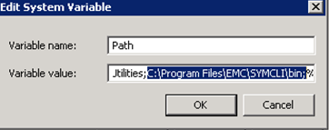

Add in new variables in System Variables:
Variable Name | Variable Value
SYMCLI_CONNECT | SYMAPI_SERVER
SYMCLI_CONNECT_TYPE | REMOTE

For example
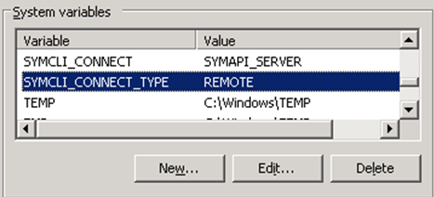:

Testing Unisphere for VMAX server has access to remote SYMAPI server
Post install and upgrades:
Before trying to use Unisphere for VMAX, it is recommended that you confirm that the remote SYMAPI server is accessible from the U4V server using a command line test on the server.

Use the command ‘symcli –def’ to confirm if the Symmetrix command line is configured correctly:
C:\Users\cw68238>symcli -def

Symmetrix Command Line Interface (SYMCLI) Version V8.0.2.0 (Edit Level: 1953)
built with SYMAPI Version V8.0.2.0 (Edit Level: 1953)

Current settings of the SYMCLI environmental variables:

SYMCLI_CONNECT : SYMAPI_SERVER
SYMCLI_CONNECT_TYPE : REMOTE

If the command is not recognized or environmental variables are not set correctly as display above, check system path and parameters and confirm they are configured correctly.

Verify that you can run a symcli command (via the remote SYMAPI server). For example:
C:\Users\cw68238>symcfg discover

This operation may take up to a few minutes. Please be patient...

C:\Users\cw68238>symcfg list

S Y M M E T R I X

Mcode Cache Num Phys Num Symm
SymmID Attachment Model Version Size (MB) Devices Devices

000192604261 Local VMAX-1 5876 120320 6 3021
000195700524 Remote VMAX40K 5876 36864 0 1496

If this fails, check the storsrvd.log file in /var/symapi/log on the remote SYMAPI server for clues as to why the connection was rejected.

Unisphere for VMAX Installation/Upgrade
Installation of this package should be via TPM. It will also detect and upgrade the previous version automatically.

This is an “interactive” install package and hence screenshots are provided below.
TPM Package Name: CITI_WIN_X64_UNIVMAX_8026_00

- Request the SA to push the package from TPM
  - Note: Installation location can be set as required before pushing from TPM

- If this is an upgrade, take a screen shot of the LDAP binding information. The LDAP binding will need to re-entered after the upgrade.
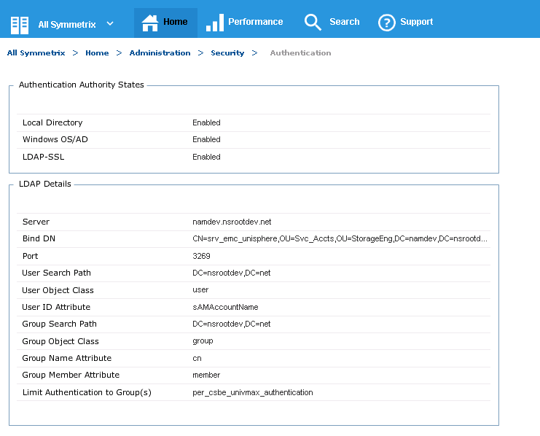

- Run the installation package and follow the installation instructions
  - Select Next
  - Install to appropriate location (typically default)
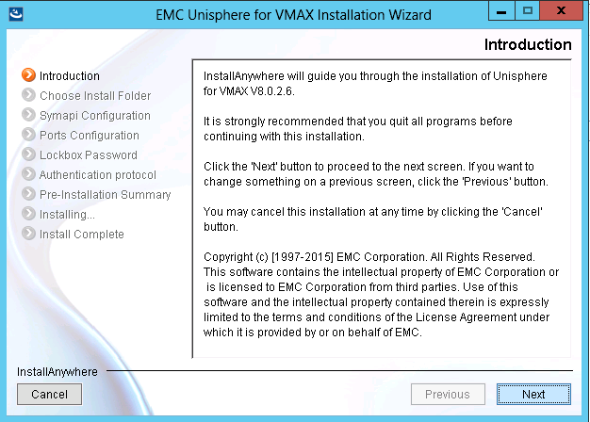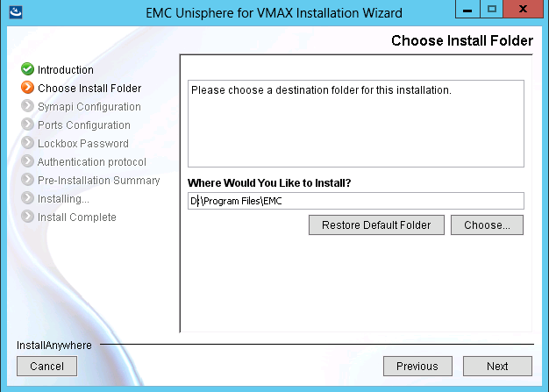

- You should select the “Remote” connection type, providing the fully qualified name of the remote SYMAPI server that you will be using, leaving the net port as 2707 default. > Next
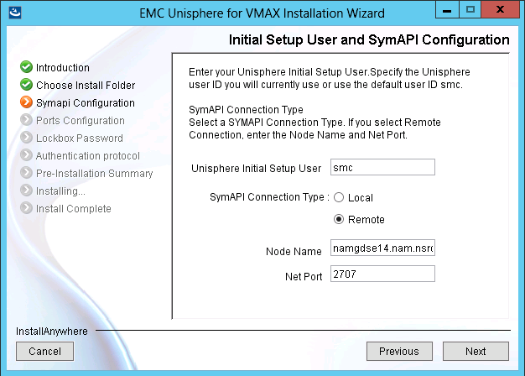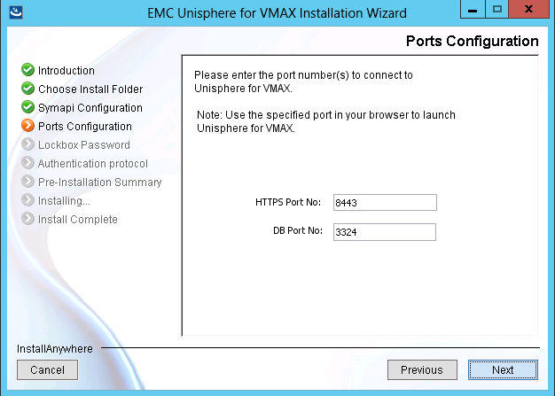

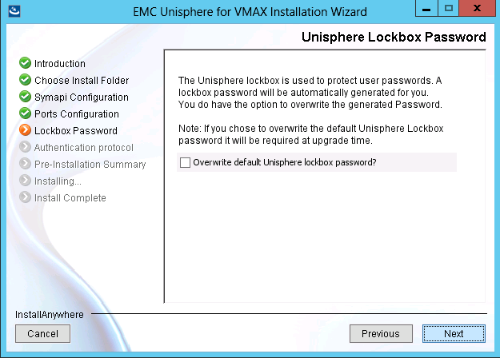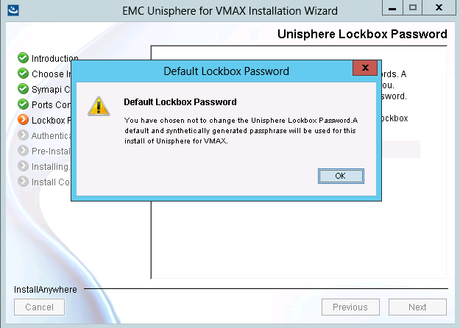
- Leave the checkbox unchecked for Certificate-based Client Authentication

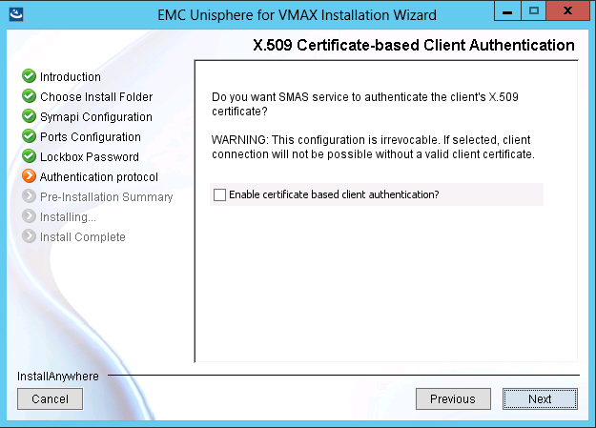

- Run the installation, and select ‘Done’ on completion
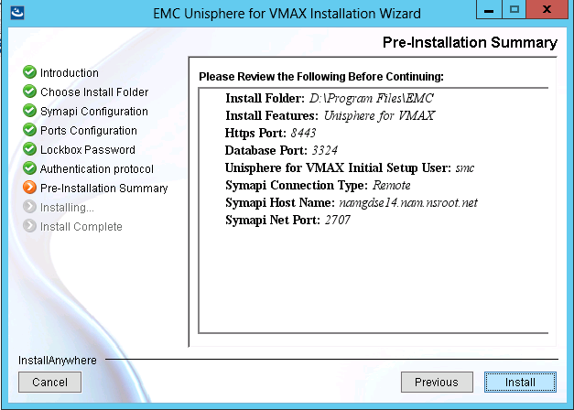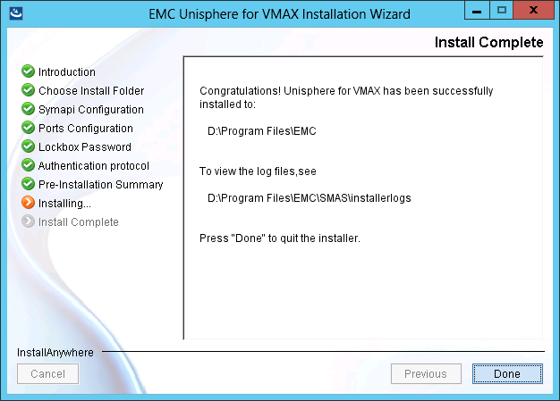

- LDAP authentication will need to setup again since the upgrade does not preserve these setting from the previous version.

Configuration Assurance
Not applicable to Unisphere for VMAX – Array Configuration assurance is carried out using HPNA via the symapi server.

Scalability & Capacity

Unisphere for VMAX does have some scalability limits due to:
- The potentially large amount of data that it needs to collect, store and manipulate.

- For each U4V instance, EMC only support visibility + data collection of a maximum of 256,000 devices, EMC provide a guideline limit of up to 20 Symmetrix arrays per U4V instance – with caveats on CPU, Memory and Disk.

The current hard limit is 256,000 devices per U4V server pair, and hence the maximum number of Symmetrix systems that can be managed may be less than 20 (or potentially more depending on device count per array).

The 256,000 device count per U4V server pair includes ANY array/devices the symapi server can see (locally or remotely) – Not just the devices on the arrays registered for data collection.

In larger estates it is highly likely the SYMAPI server will discover/have access to more arrays than a single U4V server will be configured to monitor – in this scenario certain arrays may need to be excluded from U4V in order to ensure the setup does not exceed the products limitation and impact data collection and general usage – please see the related appendix for further details on how to apply a filter for U4V.

The following table can be used to estimate how many U4V and SYMAPI servers will be needed. It assumes that each VMAX arrays no more than an average of 10000 volumes. Of course if the average device amount increases then the amount of arrays will decrease.

A minimum of 2 SE servers is assumed for all sites for CLI management.

 |  |  |  | EACH UNISPHERE VM
Maximum Volume count | Maximum managed storage system count | Number of Symapi servers | Number of Unisphere VM’s | Minimum Processor Specification | Minimum Available memory | Minimum available disk space
0-64K | 6 | 2 | 1 | 2 Core 1.8GHz | 12GB | 100GB
64-128K | 12 | 2 | 1 | 2 Core 1.8GHz | 16GB | 140GB
128-256K | 24 | 2 | 1 | 2 Core 1.8GHz | 20GB | 180GB
Deployments of more than 256K devices will typically consist of multiple symapi and Unisphere for VMAX virtual machines, potentially with a mix of the above specifications depending on the amount devices.

CTI should validate deployments larger than the above table with CATE and their local EMC account team.
Memory: The above stated is the minimal dedicated amount of memory (not shared memory) required to run Unisphere for VMAX with performance option this is in addition to OS requirement.
Disk: The above stated is the minimal dedicated disk recommended to run Unisphere for VMAX this is in addition to OS requirement.

Availability Management
Unisphere for VMAX is not considered sufficiently vital to warrant clustering.
To protect against loss of a server (unlikely as U4V will be running within a VM), regular backups of the database should be taken (see section Backup Unisphere Database). If necessary, these can be restored to another server, assuming the backup is accessible.

Regional or Merger Partner Consideration
n/a

Global Standard

Configuration of Unisphere for VMAX Security Model

Overview
The following table & Diagram summarizes the security configuration that has been adopted in Citi relating to Unisphere deployments.
Requirement | Implementation for Unisphere for VMAX
Centralized Authentication | User Authentication via LDAP using Active Directory as the source
Restricting activity when in Unisphere for VMAX | Authorization based on AD Group\User mapped to symauth roles
User access to U4V | Users will utilize desktop web browser for access (rather than direct RDP to a server)

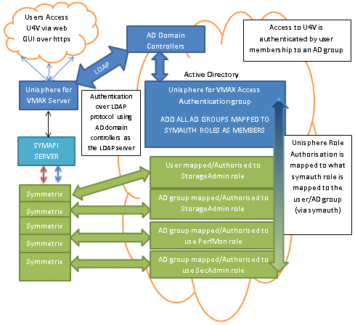

Authorization: Restricting Activity Using Unisphere for VMAX
The use of symauth feature as a user-based access control mechanism to a Symmetrix is mandatory when using Unisphere for VMAX.

Setup of symauth is covered in the CSBE Solutions Enabler 8.X Solutions Guide, as is audit logging, and is covered here in reference to U4V set up only.

Symauth meets Citi audit requirements since all user changes are logged with fmt=symaud and reviewed accordingly, if audit logging is correctly set up as per the above Solutions Guide.
Available roles can be assigned as per symauth:
- Monitor - Performs read-only operations on a Symmetrix array excluding the ability to read the audit log or Access Control definitions.
- StorageAdmin - Performs all management operations (active or control) on a Symmetrix array or on individual components within an array in addition to all monitor operations.

- Admin - Performs all operations on a Symmetrix array, including security operations, in addition to all monitor and StorageAdmin operations.
- SecurityAdmin - Performs security operations (symaudit, symacl, symauth) on a Symmetrix array in addition to all monitor operations.
- Auditor - Grants the ability to view, but not modify, security settings for a Symmetrix array (including reading the audit log, symacl list, and symauth) in addition to all monitor operations.
- PerfMonitor - Includes Monitor role permissions and grants additional privileges within the performance component of Unisphere for VMAX application to setup various alerts and update thresholds to monitor Symmetrix performance.
‘PerfMonitor’ is a role that limits access to managing performance related activities on Symmetrix systems specifically via Unisphere for VMAX. Where applicable the role should be assigned in order to limit certain users/AD groups to performance monitoring related and read-only operations, but not operational configuration via U4V.

The permissions Unisphere for VMAX users gain will be based on the SYMAUTH roles they or their AD groups are mapped to on each array.

An example of how to set up the group based mapping is provided in the following section

Most SAN administration team members will already be assigned to at least the ‘StorageAdmin’ role in order to carry out day to day CLI manipulation.

Note: The ‘Administrator’ role should not be assigned for providing rights for standard storage administration activities. It is possible to assign more than one role to a user (directly or indirectly via AD Group membership) in U4V and the combined privilege will be granted to the user.

Group Based User Authorization Mapping
Background
The symauth provides user-based authorization that assigns a user or group to a role to limit the management operations they can perform on a Symmetrix array.

From the 7.6 release of Solutions Enabler CATE have provided instruction on using group based authentication based on Kerberos groups. However U4V cannot utilize these groups for authentication, and there have continued to be issues with U4V using the native AD authentication option.

Using AD based authentication U4V cannot:
- Look up and pass user group information to symauth.
- Use AD group based symauth rules – therefore CTI would still need to maintain individual rules for each user
- Look up and pass nested AD group information
- Enforce a group based restriction for user access to U4V

To work-around the restrictions found with U4V using native AD, U4V does allow authentication via LDAP where you specify the authentication source. This has successfully been tested utilizing the AD domain controllers as the authentication source.

Symauth Configuration for Unisphere AD groups
Solutions Enabler represents user or group identity as a string that comprises of the User/Group Name and the authentication source. Although Symauth entries for U4V will be based on active directory groups, the authentication source however will NOT be specified as ‘D:’ (Windows Domain).
The Authentication source will need to be specified as ‘L:’ (LDAP)

New active directory groups can be requested and membership edited via Citi Marketplace (search for Active Directory) or you can utilize existing AD groups if they contain the appropriate users.
Once the AD groups have been set up (or you have identified the existing groups you wish to use) appropriate symauth rules will need to be applied, for example:

# symauth –sid 1234 –f filename commit

Where the contents of example file is
Add group L:namdev.nsrootdev.net\per_csbe_unispherevmax_admins to role StorageAdmin;
Add group L:namdev.nsrootdev.net\per_csbe_unispherevmax_users to role PerfMonitor;

Therefore In this example:
- Authentication source LDAP: (Using Active Directory Domain controllers) namdev.nsrootdev.net \ (Windows AD group) ‘per_csbe_unispherevmax_admin’ is mapped to the StorageAdmin role

- Authentication source LDAP: (Using Active Directory Domain controllers) namdev.nsrootdev.net \ (Windows AD group) ‘per_csbe_unispherevmax_users’ is mapped to the PerfMonitor role
Once applied you can check/confim the entry - Symauth list below has also been edited to just show these entries relevant to U4V.
# symauth -sid 4261 list –users -v
Role name : StorageAdmin
Group name : L:namdev.nsrootdev.net\per_csbe_unispherevmax_admins

Role name : PerfMonitor
Group name : L:namdev.nsrootdev.net\per_csbe_unispherevmax_users

Propagation of SYMAUTH roles changes
If changes are made to a user‘s symauth role outside of U4V (e.g. a change to the membership of an AD group that is used to define which users have a specific role), then the change will not immediately be visible to U4V.

This is because it can take some time for the authorization rule to update on SFS and be sent back to SE and U4V. Authorization rules are only immediately recognized within the process in which they were created. So if you were to create a rule through U4V, then that rule would be immediately enforced for that instance. It will take a few minutes to propagate to other instances of U4V/SE.

The bottom line is that you may have to wait several minutes (depending on the size of your environment, although there is no way to determine exact time) for the change to be visible to and used by U4V.

Authentication: Setting Up Centralized AD over LDAP

Prerequisites:
- A Windows AD group will need to be set up to restrict access to U4V application to only the members of the AD groups that will be nested within it.
  - The Nested groups will be the ones that have been mapped to symauth roles (Reference previous section on symauth group set up).

- A Functional ID/service account will need to be set up to carry out the user look up for authentication queries controlling access to Unisphere for VMAX.

FID/Service account and active directory groups can be requested and membership edited via Citi Marketplace (search for Active Directory), alternatively an existing FID could be leveraged. e.g. DCNM/HPNA

- The default U4V ‘smc’ account has been given admin role on the arrays via symauth to allow initial set up.

Process:
To set up the Authentication:
- Access Unisphere for VMAX via URL https://<UnisphereforVmax-server-name>:8443
Login into U4V with the initial default ‘smc’ account.

- Select Home ‘Administration’ ‘Security’ ‘Authentication’ which will display a summary of the current configuration.
- Select Edit and the Authentication Wizard will launch.
- Select LDAP-SSL

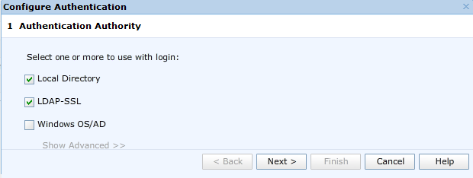

- Click Next
- LDAP-SSL configuration window will open Input details.
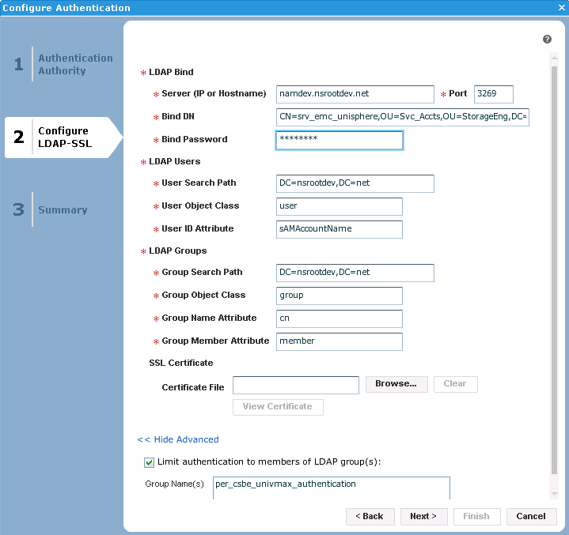

- Click Next once complete

Please see the table below providing further reference of the input details.

Configuration Item | Description | Citi entry
Server | IP address or hostname of the server to use for authentication | AD Domain  xxxxxx.nsroot.net  Example: eur.nsroot.net
Port | Port number of the LDAP/S service  (Global Catalogue) | 3269
Administration Bind DN | Distinguished Name of the service account used to perform operations, such as searching users and groups | Request this information from AD operations if this is not known.  CN=”FID sAMAccountName”,OU=”XXX”,OU=”YYY”,DC=”ZZZ”,DC=nsrootdev,DC=net  Example: CN=srv_emc_unisphere,OU=Svc_Accts,OU=StorageEng,DC=namdev,DC=nsrootdev,DC=net  OR  sAMAccountName@domain  Example  srv_account@xxxxxx.nsroot.net  srv_emc_unisphere,@namdev.nsrootdev.net
Bind Password | Password of the service account | Password that has been set for service account
User Search Path | Distinguished name of the node at which to begin user searches | DC=nsrootdev,DC=net
User Object Class | Object class identifying users in the LDAP hierarchy | User
User ID Attribute | Attribute identifying the user login ID within the user object | cn
Group Search Path | Distinguished name of the node at which to begin group searches | OU=XXXX,OU=YYYY, DC=nsrootdev,DC=net  Example: OU=Svc_Accts,OU=StorageEng, DC=nsrootdev,DC=net
Group Object Path | Object class identifying groups in the LDAP hierarchy | Group
Group Name Attribute | Attribute identifying the group name | Cn
Group Member Attribute | Attribute indicating group membership for a user within the group object | Member
Limit Authentication to members of LDAP group | Specifies to limit authentication to only members of a specified group | This is the AD group created for containing the nested groups NOT the groups mapped to symauth rules  e.g. per_univmax_authentication

If any settings are incorrect you will get an error banner, click close and you will return to the previous configuration page

If all settings are entered correctly a summary will be displayed
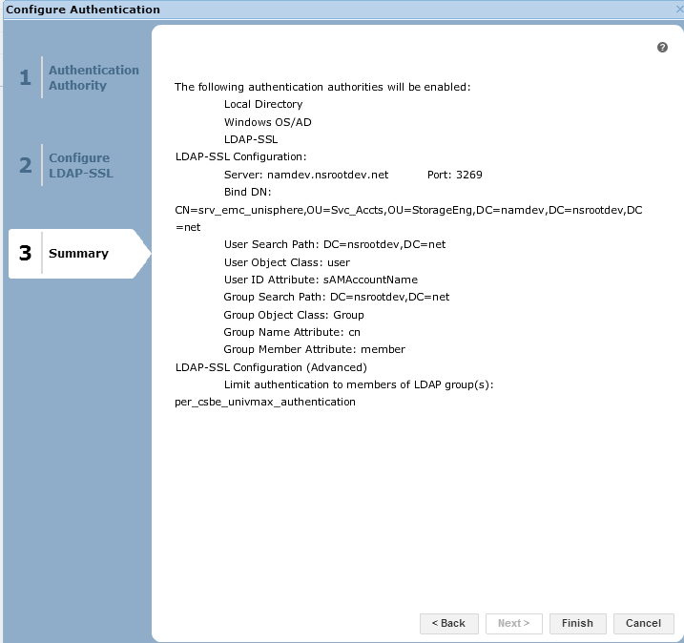
- Click Finish

Confirmation box will appear – click close
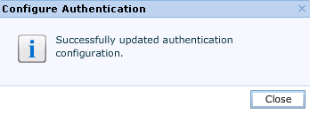

The Authentication Summary will update once you apply the change:
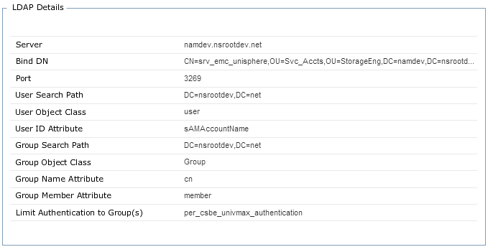

For initial setup, Local Directory should be left enabled as a temporary measure until all setup is complete. Remove “Local directory” only when there is a user set as “Administrator” or “SecurityAdmin” in symauth and the user has confirmed authentication access via LDAP.

If you disable Local access prematurely, you may lock yourself out of Unisphere for VMAX. You have been warned.

User Access to Unisphere for VMAX:
U4V is not limited to only being accessible via the window management workstation it resides on. Users do not need to RDP to a specific server before launching a browser on the server and logging on or have need to have access to the server.
Users will continue to access U4V from their desktop web browser after set up is complete
Access Unisphere for VMAX via URL
https://<UnisphereforVmax-server-name>:8443

- Enter JUST your SOE ID & Password
- Click Login

Log in message/Banner
The login message should be set accordingly:

You are authorized to use this System for approved business purposes only. Use for any other purpose is prohibited. Authorized and unauthorized activities may be monitored. All Data residing on this system remains the property of Citi.

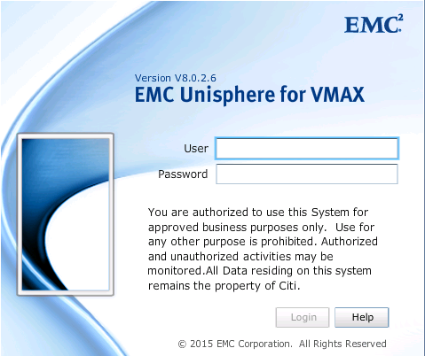

This is configured Home Administration Preferences Client session log in message
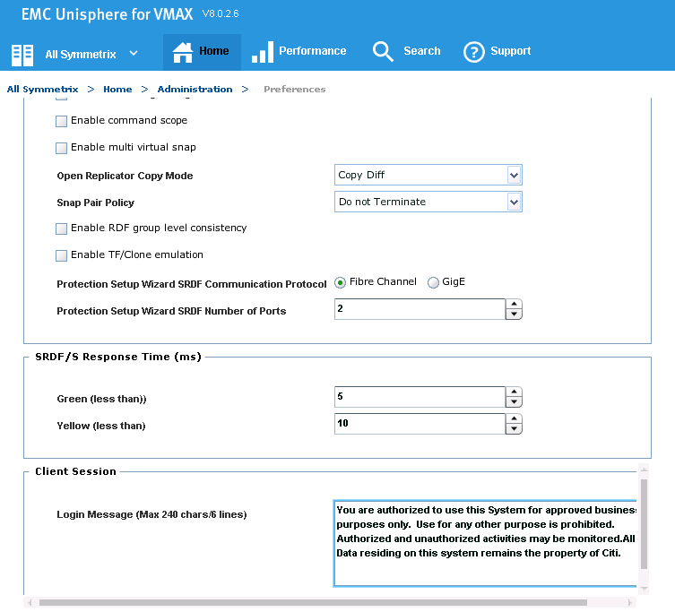

Limiting/Filtering array discovery in U4V
As highlighted in earlier sections, U4V scalability is limited to a maximum of 256,000 devices – Within larger estates a SYMAPI server may well see 40+ arrays.

By default U4V will discover whatever the SYMAPI server has discovered, which includes local and remote arrays, and is not limited to only arrays the arrays that are registered in U4V for collection.

In previous U4V versions, within some of the larger regional data centers, there have been incidents where U4V has not collected data for the arrays registered, with the cause being attributed to the U4V instances having more than the recommended devices allowed.

– In order to stay within the device limit U4V can be configured to exclude specified arrays from its discovery. The update requires making a change to an xml file on the U4V server, and example is shown below

It is recommended to limit U4V to only discover/monitor/view
- Arrays Registered for Data collection
- Local Arrays ONLY
  - Remote arrays should be excluded to eliminate un-needed traffic on RDF links

All Arrays visible on the SYMAPI server are visible on U4V instance
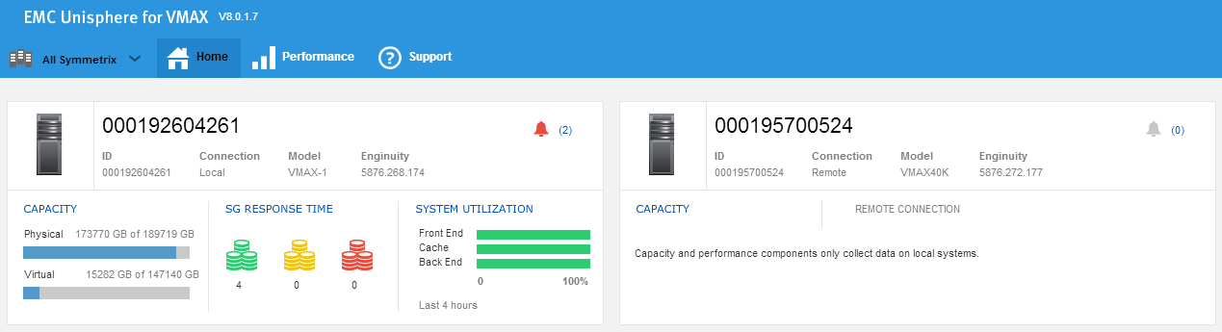

- Remove the deploy# folders in <Install Dir>\EMC\SMAS\jboss\domain. However, DO NOT delete the main “deploy” folder. When Unisphere starts, it will recreate the deploy0, deploy1, ... folders based on the “deploy” folder.

- Locate and open the ejb-jar.xml file.
Note: you will require appropriate rights to carry out changes to this file.

<Install Dir>/EMC/SMAS/jboss/domain/deploy/domain-symm.ear/domain-symm-ejb.jar/META-INF/
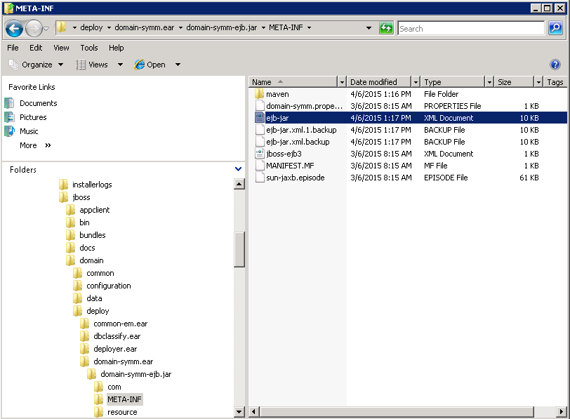

- In the ejb-jar.xml file locate the section as shown below
<!-- Comma-separated symm-id collection -->
<env-entry>
<env-entry-name>filterSymms</env-entry-name>
<env-entry-type>java.lang.String</env-entry-type>
<env-entry-value></env-entry-value>
</env-entry>
- Update the file to include all SYM IDs to be filtered OUT, depicted in the example below. The example depicts one SYM IDs that will be excluded, multiple entries should be comma separated.
<!-- Comma-separated symm-id collection -->
<env-entry>
<env-entry-name>filterSymms</env-entry-name>
<env-entry-type>java.lang.String</env-entry-type>
<env-entry-value>000195700524</env-entry-value>
</env-entry>

- Save the changes, Close the file
- Stop & start the SMAS services
Specified array should then no longer be visible to U4V.
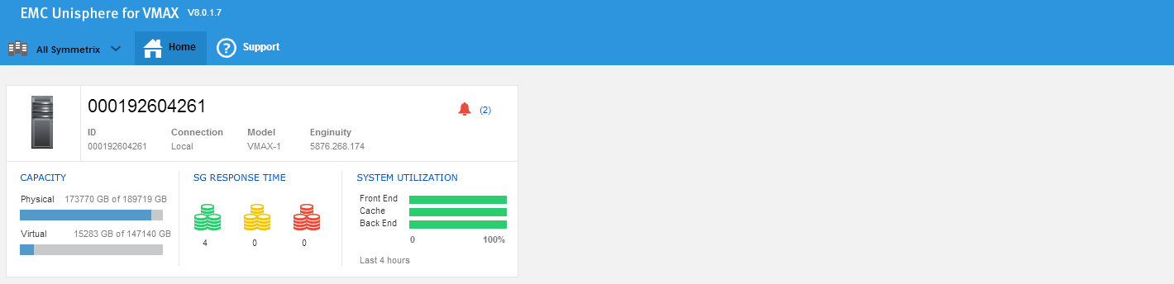

An RPQ was submitted by Peter Kemp (EMEA TC) to support the use of this exclusion workaround – This was rejected however EMC have advised they will support Citi – If any support issues are raised by the use of this exclusion, please inform the author of this document.

McAfee Virus Scan – Addition of processes to Low Risk Process Policy
EMC recommend the exclusion of postgres and stp directories and files from antivirus scan to avoid performance database corruption.

As confirmed with EMC (SR 68912574) – the stp directory exclusion is only applicable when Unisphere is deployed in Local configuration hence why it is not included.

Host & Security Engineering (HSE) team advise that Citi’s best practice is to avoid scanning on the processes rather than excluding files from virus scanning.
Therefore ‘pg_ctl.exe’ and ‘postgres.exe’ processes needs to be added into the ‘Low Risk Processes’ (LRP) policy whereby the antivirus will ignore files accessed by the ‘postgres.exe’ process, which will avoid virus scanning on the database files.

In order to request the processes are moved in to the low risk process policy the CTI teams carrying out the production deployments/upgrade will need to raise a ResolveIT Ticket to the HSE team.

- From the CATE website download a copy of the Security Deviation Request Form zip file – Which includes the SDRF, SMT and TISO email approval

- Raise a ResolveIT Ticket to: CTI GL AD APPLICATIONS-Information Assurance Ops (IAO) detailing the requirement to move the pg_ctl.exe and ‘postgres.exe’ processes in to the low risk process policy for the specific deployments.
  - Reference/Attach the approved SDRF form
Please note the following advice from the BISO:
“Deviations tied to a CTC version ID are good for the life of the product as long as the CTC Product ID is ‘Recommended or Restricted’, and the CTC Version ID is ‘Aging or Current’. Otherwise, deviations are good for one year and are the responsibility of the BISO and Application owner to file for an extension prior to expiration. ”

Web Server Certificates
When you first try to connect to the Unisphere for VMAX via web browser the error message for security certificate as shown below:
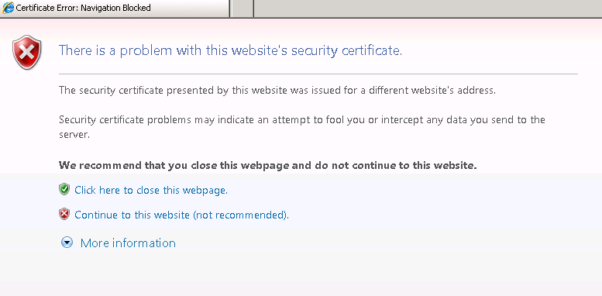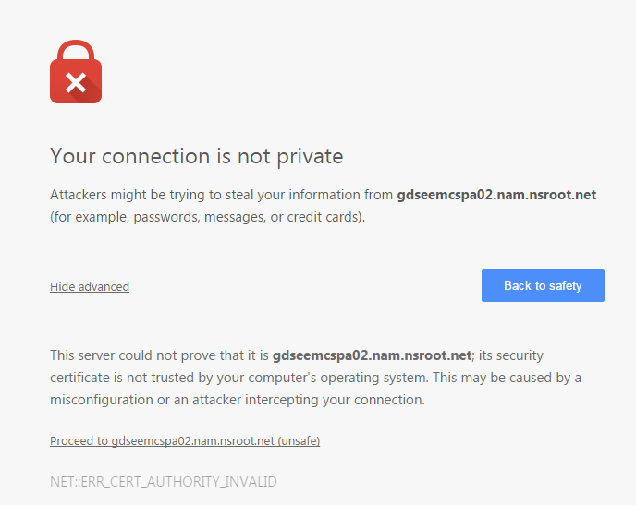
As a workaround you can click ‘Continue to this Website’ to access Unisphere.

During CIVA testing for U4V 1.5 it was advised it is required to apply a valid CA-signed digital certificate instead of using the self-signed certificate from U4V.

High level steps on how to replace the certificate for U4V are:
- Retrieve Keystore password
- Generate CSR
- Request signed certificate from CA
- Retrieve Server and CA certificate
- Import CA certificate chain into the U4V server keystore
- Import CA-signed certificate into the U4V server keystore
- Verify the certificate chain for the keystore

Step 1: Retrieve Keystore password
- Open <install_directory>\emc\smas\jboss\domain\configuration\domain.xml.init
- Search for ‘password=’
- The keystore password is displayed inside quotation marks in clear text
For example

Step2:Generate CSR
<install_directory>\emc\smas\jre\bin\keytool –certreq –alias tomcat –keyalg RSA –file tomcatcert.csr –keystore keystore
You will be prompted for the keystore password, once input a csr file will be generated.

Step 3: Request signed certificate from CA

Submit request from Citi Market Place (CMP) by searching for ‘Venafi MS-PKI On Demand Device Certificate - 163513 - Create/Revoke Certificate’
https://cmp.nj.ssmb.com/marketplace/control/product/~productId=47119_29952_GLOBAL

Complete the questionnaire according to your local requirements, adding the CSR generated in the previous step.

Also refer to: CMP instructions for SSL Cert request & MSPKI_-_SSL_Guide
NOTE: If required, certificate revocation can also be requested via marketplace –against the same market place product

Step 4: Retrieve CA signed certificate (Requester will be sent this via email)
CA signed certificate will be sent directly to the requestor

From the email - Please copy everything between the ---- delimiters, including the delimiter lines themselves and save to a file for use.
-----BEGIN CERTIFICATE-----
and include everything through
-----END CERTIFICATE -----

And to obtain the environment appropriate Device, Policy and Root CA chains, please visit the CATE MS PKI Sharepoint site (linked within the email) and select from the right sidebar. It is important to obtain all intermediate and root CA certificates for the signed certificate.

Step 5: Import CA certificate chain to the keystore
It is required to import all certificates in the certificate chain starting with the root certificate, intermediate certificates (in descending order from the root certificate), and then the CA signed certificate last.
- Copy the root, intermediate, and the signed certificate to the <InstallDirectory>\SMAS\jboss\standalone\configuration\ directory.
- Go to the following directory from command prompt:
cd <InstallDirectory>\SMAS\jboss\standalone\configuration\

- Run the following command to import the root CA certificate in trusted chain:
<install_directory>\emc\smas\jre\bin\keytool –import –alias root -trustcacerts –file <root certificate filename> –keystore keystore
Example:

# keytool -import -alias root -trustcacerts -file CitiInternalRootCAUntrusted_b64.cer -keystore keystore

- When prompted, enter the keystore password previously retrieved (step 1).

- Import the intermediate certifcates in the chain in descending order from the root certificate:

Example:
# keytool -import -alias intermiediate1 -trustcacerts -file CitiInternalPolicyCAUntrusted_b64.cer -keystore keystore

# keytool -import -alias intermiediate2 -trustcacerts -file CitiInternalDeviceCAUntrusted_b64.cer -keystore keystore

Step 6: Import the CA-signed certificate into the keystore
- From the U4V server, stop the SMAS service
C:\>net stop “EMC Symmetrix Management Application Server”
- Go to the following directory from command prompt:
cd <InstallDirectory>\SMAS\jboss\standalone\configuration\

- Run the following command on the command prompt:
<install_directory>\jre\bin\keytool -import –alias tomcat -trustcacerts -file <signed CA certificate filename> –keystore keystore

Example:

# keytool -import -alias tomcat -trustcacerts -file icl-unisp-vm01.cer -keystore keystore

- When prompted, enter the keystore password previously created (step1).
- Start the SMAS service

- On next attempted launch, you can install the Citi/CA signed certificate
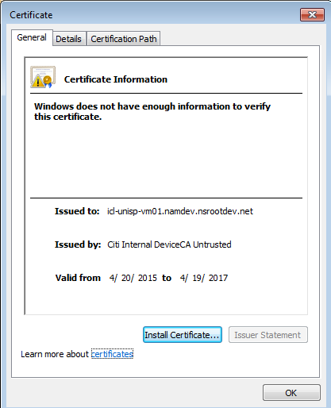

Step 7: Verify the certificate chain for the keystore
Issue the following command to list the certificates for the keystore:

<install_directory>\jre\bin\keytool -list -keystore keystore

Sample Output:

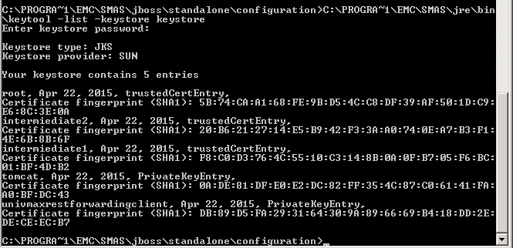

Notice that there is also a private key entry named univmaxrestforwardingclient in the keystore. If that private key entry is not in the keystore, issue the following command to create it in the keystore:

<install_directory>\jre\bin\service.bat generatekeystore <keystore password>

Registering arrays for Data Collection
The Performance component of Unisphere for VMAX only collects performance data after you register your Symmetrix systems. Note that ONLY local Symmetrix systems can be registered for Performance data collection.
Ensure that you have completed configuration of symauth to give the right privileges to set up data collection.

Login into Unisphere for VMAX using an AD account/Group with symauth roles ‘PerfMonitor’ or ‘StorageAdmin’ assigned on the Symmetrix array from which data is to be collected.

Once logged in, follow the below to register a Symmetrix system for performance data collection:
- Select the Symmetrix system
- Click ‘Performance’ ‘Settings’ ‘Systems Registrations’ to open the Systems Registrations view.
- Click Register to open the Register dialog box. The Symmetrix ID automatically populates the Select Symmetrix list.
- Select both the type of performance data to collect, ‘Real Time’ and ‘Diagnostic’.
- Set Diagnostic Interval to 10 Minutes (Minimum)
- Click OK.
View the system registrations by selecting ‘Performance’ ‘Settings’ ‘System Registrations’. Click on the ‘View Details’ button from bottom left panel to view further details or make changes (e.g. enable/disable Real time collections) to the system registrations on the Symmetrix array.
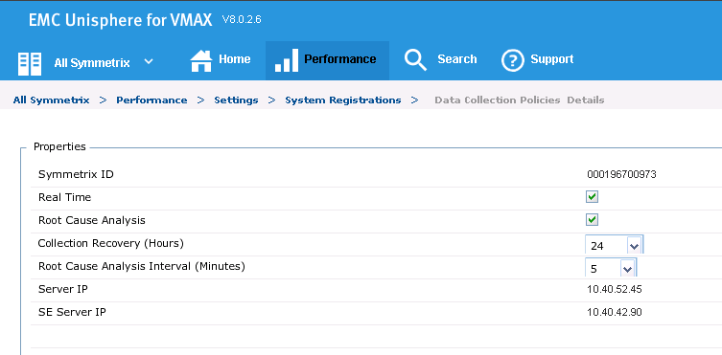

Unisphere Backup

Server backup
With Unisphere for VMAX 8.0.2 and above you are able to manually backup all the data currently on the database server, including Database Storage Analyzer, Workload Planner, performance, and infrastructure data. Database backups will enable you to recover from system crashes.

Noting that you can only restore the database to the same Unisphere for VMAX version and same operating system. For example, a V8.0.2 database on Windows, can only be restored to a V8.0.2 on Windows

At the point of testing the 8.0.2 GUI does not include a restore button! This was flagged to EMC who acknowledged this was missing – but have provided instructions for restore if this function is used (CTI should contact CATE If this function is needed) – this section will be updated once the GUI has the required function.

Unisphere performance database backup
Unisphere for VMAX performance database should be backed up regularly to protect against accidental corruption. On Symmetrix arrays with many devices, the disk space required eventually may be high.

To backup U4V performance database,
- Select Performance Settings Databases to open the Databases view.
- Select a database from the list and click ‘Backup’ to open the Database Backup wizard.
- Select the Symmetrix system.
- Enter a backup File Name. The file name will be started with Symmetrix system ID and timestamp of backup taken follow by the file name as defined here. For example:
  - 000192604261_201402020543_test_backup.dat”
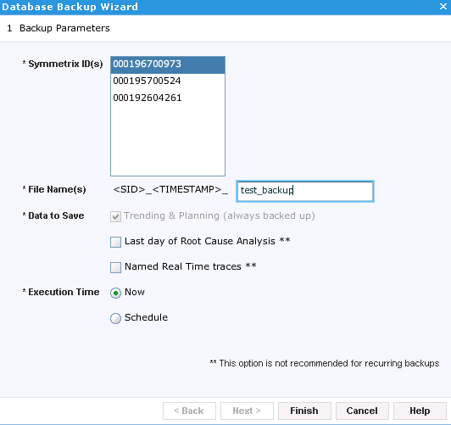
- Optional: Select any of the following Data to Save:
- Historical
- *Last day of Diagnostics
- *Named Real Time Traces

- Set the “Execution Time”:
  - If ‘Now’ – Click Finish.
  - If selecting ‘Schedule’ - Click ‘Next’. Select the ‘Start Date and time’. Select ‘Yes’ to configure for recurring database backup and select the day to run on weekly basis.
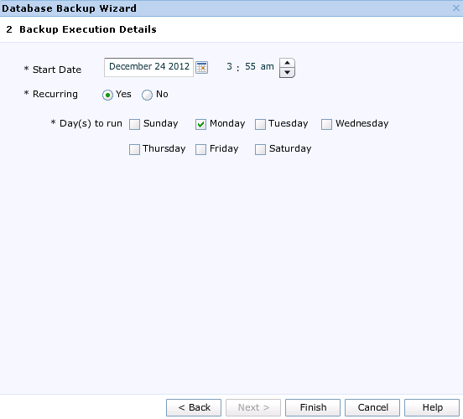
- Click Finish.
The backup will be written to the directory <InstallDirectory>\Program Files\EMC\SMAS\backup\SPA

Configure Idle User Timeout Session
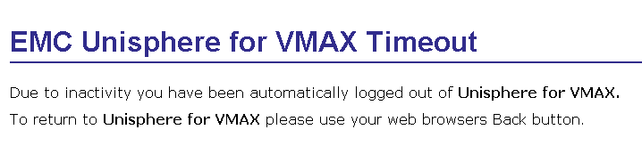
By default, the Unisphere for VMAX initiate automatic logout for user session after 480 minutes (8 hours).
Edit the web.xml file - Changing the setting from so users will be automatically logout after inactive session for more than 30 minutes.
Web.xml located in
<installdrive>\Program Files\EMC\SMAS\jboss\domain\deploy0\smc0.ear\smc.war\WEB-INF
Edit the parameter from 480 to 30
<param-name>sageIdleUserTimeoutInMinutes</param-name>
<param-value>30</param-value>
Restart SMAS service from the U4V server to take effective for this setting.

Remove authorization via local directory
Once setup has been completed and tested and you are 100% satisfied it works, local directory account assess must be disabled.

Users with appropriate Administrator or SecurityAdmin rights will need to login into U4V.
Select ‘Administration’ from the right bottom common tasks panel and select ‘Authentication’ Unselect ‘Local Directory’ from the list

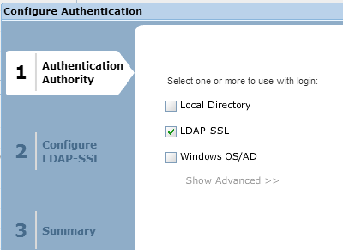

Relevant Links
Document/Web Site | Location
Unisphere for VMAX 8.0.2 vendor documentation | http://support.emc.com
SDRF | https://catecollaboration.citigroup.net/domains/platstor/gdse/products/techstdshmpgs/symmetrix.aspx
MSPKI_SSL Guide | https://catecollaboration.citigroup.net/domains/security/isp_standards/dpstds/Microsoft%20PKI/Releases/MSPKI%20-%20SSL%20Guide/MSPKI_-_SSL_Guide.docx
CMP Instructions for SSL cert request | https://catecollaboration.citigroup.net/domains/security/isp_standards/dpstds/venaficms/Requirements/CITI_AutomationDirector_CMP_Instructions.docx

Glossary/Definition

Term or Acronym | Explanation or Definition
CATE | Citi Architecture & Technology Engineering
GNAST | Global Network Architecture and Standards Team
NMS | Network Management System
HPNA | Hewlett Packard Network Automation
U4V | Unisphere for VMAX
SE | Solutions Enabler
Symmetrix | Legacy Array Family – now interchangeable with ‘VMAX’
VMAX | Array Family Type

Appendix B: Unisphere usage
This section covers some guidance and optional configuration items CTI can consider for use, no attempt has been made to provide/rewrite a user guide as the product comes with its own online help, and generally the product is fairly intuitive.

Rules on Poling & Array loading
U4V uses STP data that is already being captured by the Service Processor in a VMAX array for EMC’s remote diagnostic and troubleshooting purposes.

From previous issues encountered a potential risk comes from the frequency at which Unisphere polls an array for data, since requests are sent as in-band SCSI commands to a single FA (Front-end Adapter) on the VMAX which is also servicing IO to hosts. If the polling frequency is set too low, or particular types of data gathering modes are used, the load on the FA can increase to the point where host IO performance starts to degrade
Five key rules of the road to ensure that this does not happen are as follows:
- Unisphere should be configured to poll via the least busy FA on the array.
This can be identified using SPA heat maps/metrics (if SPA is already being used on the array in-question) or Unisphere itself if upgrading or following a suitable time period when used for the first time against the array.
U4V EMC Dashboards ‘ALL FE Directors’ or ‘Heat map’ can be used or metrics can be directly generated from the Analyze >Historical (or Diagnostic) Pane >Select FA’s>Plot charts against %Busy / Host IO per sec / Host MB per Sec.

- Use dedicated gatekeeper devices on the arrays for Unisphere – do not share them with any other role/function

- Use minimum 10 minute granularity for diagnostic data – this is sufficient for workload analysis and anything configured to poll more frequently than this introduces a greater load on the FA. – See Setting up Data Collection

- Where possible - one U4V session/user should be interacting with each array at any one time to again minimize querying load on the array FA.

Alerts
Unisphere for VMAX can be configured to monitor Symmetrix systems for specific events, error conditions and breaches of thresholds. When U4V has been enabled to capture the specified event, error or threshold breach it will display a reactive ‘alert’.

An alert in U4V can be considered to be a visible representation of an entry in the audit log or Symevent file – the U4V Alert is not the same as an alert from an event monitoring system.

Default Alerts
As part of solutions enabler configuration a number of essential events/alerts are already captured and forwarded to Citi Event Monitoring systems (see Solutions Enabler Guide for Further details) – Some of the same events included as part of the recommended solutions enabler configuration are also enabled as default in U4V.
These pertain to various Pool & FAST Policy Utilization levels, providing Normal, Warning, Critical & Fatal alerts based on % Utilization.

The default threshold alerts provided in U4V cannot be disabled or edited.
When a condition occurs triggering the alert, they are logged/displayed in the System Alerts Pane.
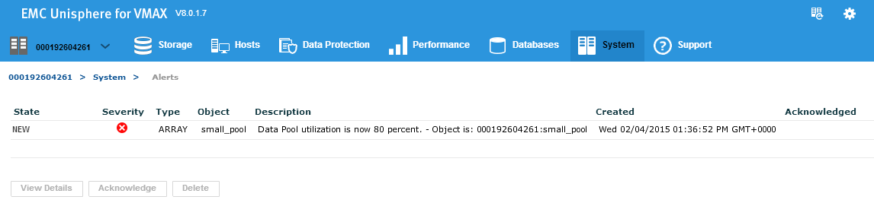
They can be acknowledged and/or deleted which will reduce/clear the alert count on the Home screen adjacent to the array.

U4V System Runtime Checks/Alerts
Unisphere for VMAX performs the following runtime checks. If a check returns a result outside the expected range, Unisphere for VMAX will raise the appropriate alert.
Checks are run on 10 minute intervals and alerts are raised on 24 hour intervals from the time the server was last started.
The checks and alerting is provided by default and cannot be disabled or edited.
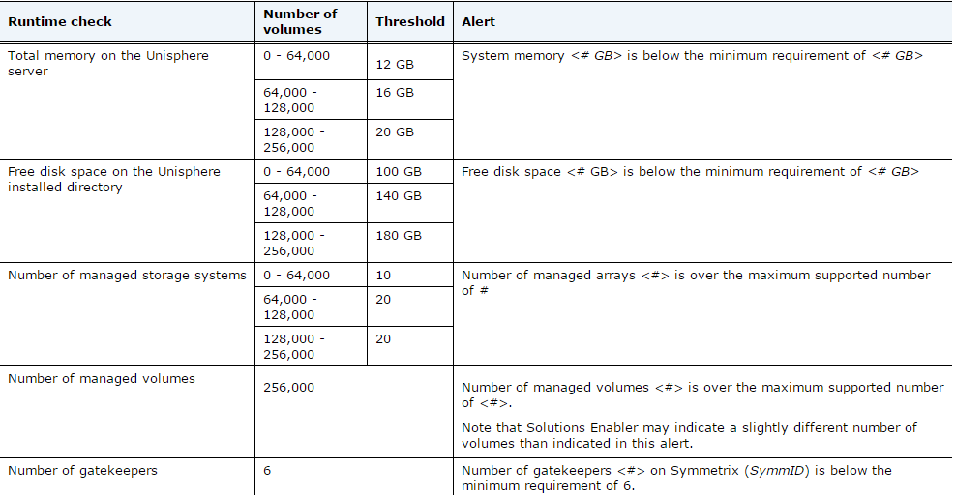

Target Enginuity level
By default U4V will log an alert if the symmetrix are not at EMC’s target Enginuity level. It is unlikely Citi would be at the same Enginuity levels as the latest vendor release – to avoid unneeded alert entries we would recommend this alert is disabled.
Home Administration Alert Settings Alert Policies Select the Target Enginuity Warning listed against each array discovered, click Disable
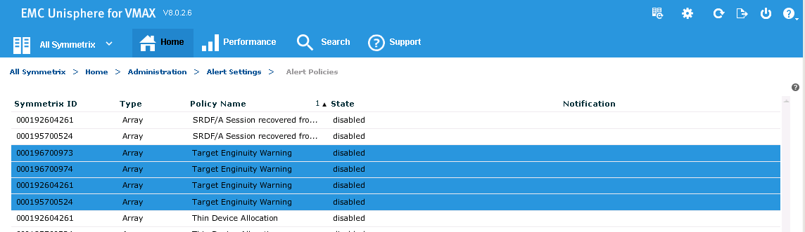

Performance Thresholds and Alerts

Overview
U4V provides the ability to create performance thresholds. There are many default system values for these thresholds which can be edited or new ones can be created.

The threshold values can be viewed from the charts in the Analysis or Diagnostic view.

And if enabled, U4V Alerts can be generated against threshold breaches

To view, edit or create new performance thresholds and alerts select Home Administration Alert Settings Performance Thresholds and Alerts to view and manage thresholds and alerts.
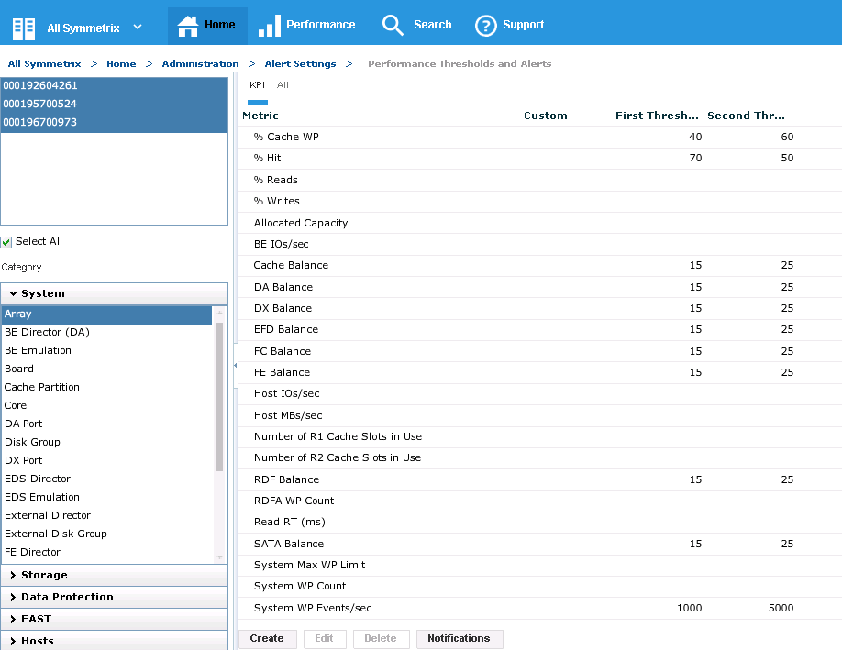

Click the ‘Create’ button from bottom left to create performance thresholds and alerts. Select the Symm ID, Category, Instance, and Metric to set the thresholds on, and enter the value for first/second threshold. Alerts can be enabled based on severity and occurrence.
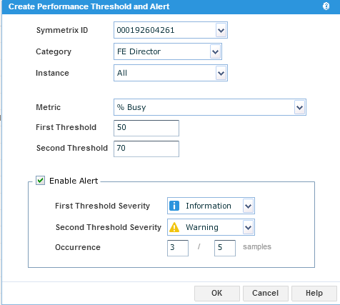

Thresholds can be seen from the chart in View too. Click on the menu bar on the chart in select ‘Display Thresholds’. Threshold values will then be displayed in the chart.

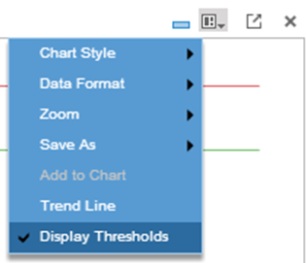
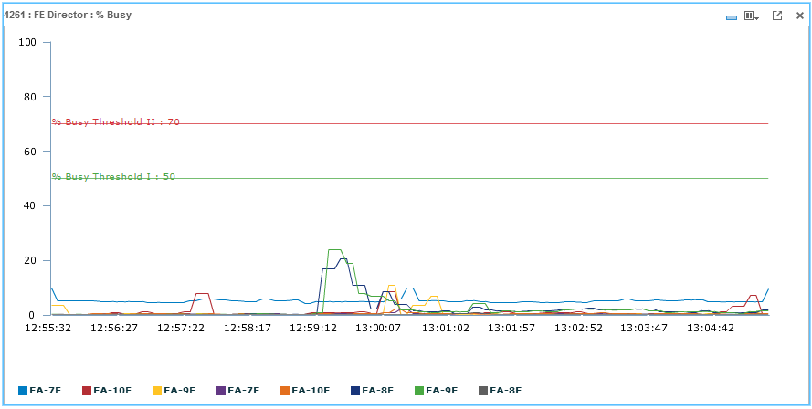

Recommended Thresholds

The following metrics were formulated with EMC performance engineering and are recommended as the basic performance related threshold alerts that should be set.
Any defaults thresholds can be edited.

 | UNISPHERE ALERT RECOMMENDATIONS FROM PERFORMANCE PERSPECTIVE
 | Threshold 1 | Data Points | Per Interval | Threshold 2 | Data Points | Per Interval
SWP | 50 | 2 | 6 | 80 | 1 | 1
%Busy DA | 70 | 3 | 6 | 80 | 3 | 6
%Busy FA | 70 | 3 | 6 | 90 | 3 | 6
%Busy Port 1 | 80 | 3 | 6 | 95 | 3 | 6
%Busy Port 0 | 80 | 3 | 6 | 95 | 3 | 6
 | Warning |  |  | Critical

Notification
As previously highlighted the alerts that are captured and displayed in Unisphere for VMAX are not the same as an alert in an event monitoring system.

However the ‘Notification’ feature in U4V can provide Email, Syslog and SNMP Notifications against the alerts U4V receives.

Citi’s strategic target is to move to a single platform for monitor, alerting and notification – hence why these are currently included as optional.

Optional Email Notification
It is acknowledged and understood that the receipt of U4V notifications via email would not likely be a welcome addition to the volume of emails the operations teams already receive.
We have included it as an option for the case that certain operations teams or even individuals did wish to receive set up and receive U4V notifications via email (even on a short term basis for a specific issue), as a supplementary addition to any existing alerting. Or just to be able to receive emailed reports.

Prerequisites

The appropriate email DL needs to be set up with an external address – e.g. Uniphere-Alerts@citi.com this can be requested via CMP.

Confirmation of the appropriate mail-hub

Once the DL has been set up you will need to configure the email server in Administration Alert Setting Notifications Config Email Server
Enter the DL details in the Sender field, and enter appropriate mail-hub in the IP address/Host field, leave the port as 25 Click Ok
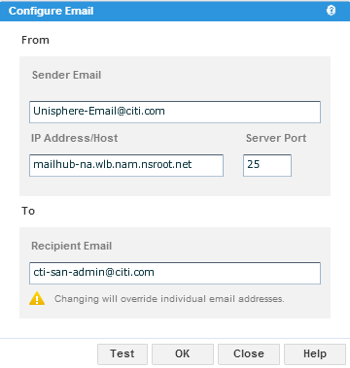

Once configured you are able to select the level of Alerts that you wish to receive an email notification against.
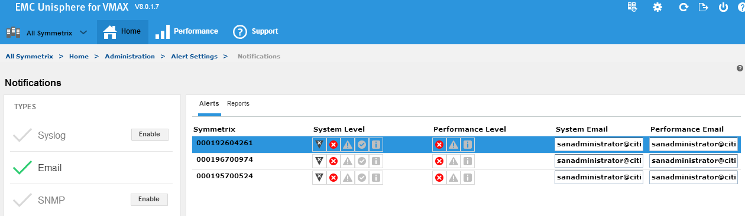

Reports

Dashboard Reports
The easiest way to set up a report is to use the report buttons at the bottom of the Performance Monitor pane.

Once the dashboard or template is displayed, select either ‘Save As, giving you the option to save the displayed data as a PDF to a user specified location or ‘Schedule the report’ up to 7 days ahead and set to reoccur, save locally and if configured email.
Note scheduled/reoccurring reports will be saved to Install Drive:\Program Files\EMC\SMAS\report\SPA\querydata

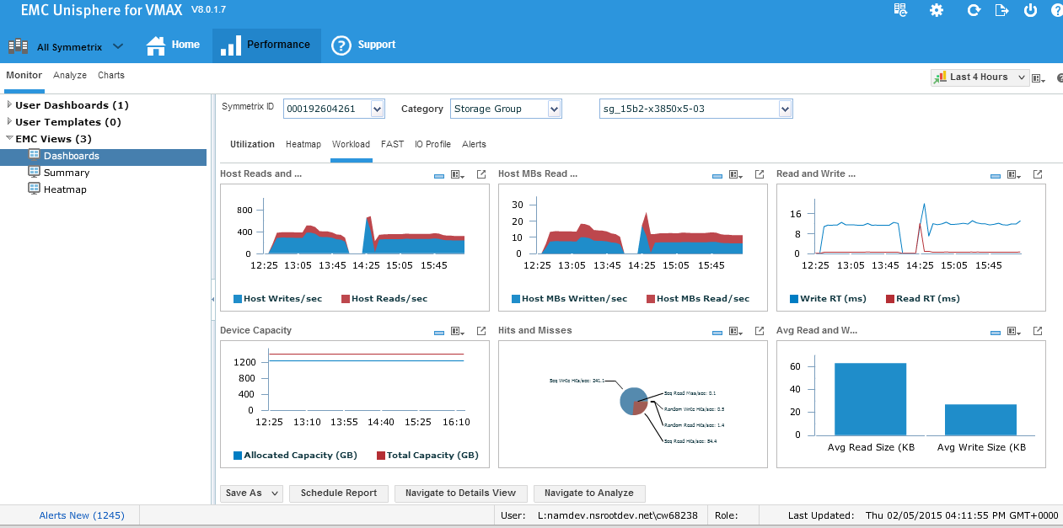

Dashboard Report Example
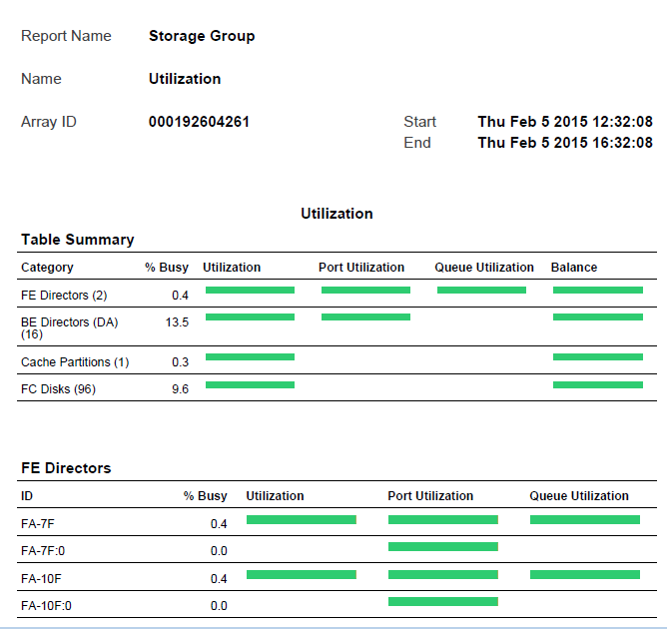

Customized reports
Alternatively customized reports can be created and provided as CSV, XML, BTP
Go to Performance’ ‘Settings’ ‘Reports’ to create report.

Add required queries to the report – the wizard will prompt for Categories, Format, and then you select the metrics required

Created/Scheduled reports will be visible in the summary

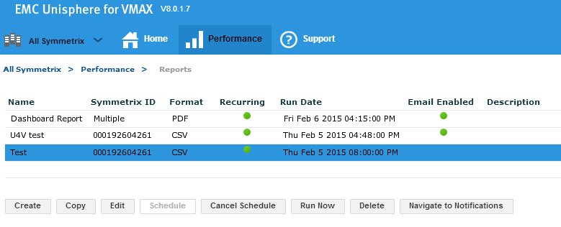

- Reports ran on demand will be saved to user specified location.
- Scheduled reports will save to:
Scheduled XML, CSV, and BTP reports are saved to this location:
install_dir\SMAS\report\SPA\querydata
- Scheduled UPV reports are saved to this location:
SMAS\backup\SPA
Example CSV
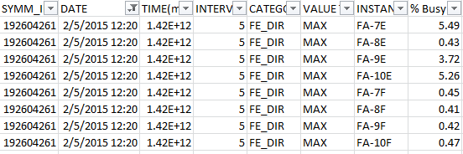

Export button
U4V has an excellent export feature that will allow most tables/charts & data to be exported to various formats.

On the pane where you have the metric you wish to export - click the export button



A wizard launches, where you specify the Item you wish to export, and depending on what you are exporting options are provided as to what data to export and what format

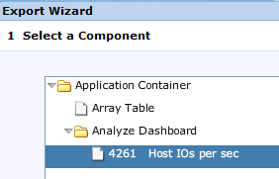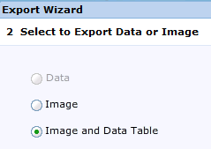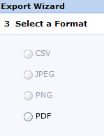

Exported Data is saved locally to your desktop in the chosen format

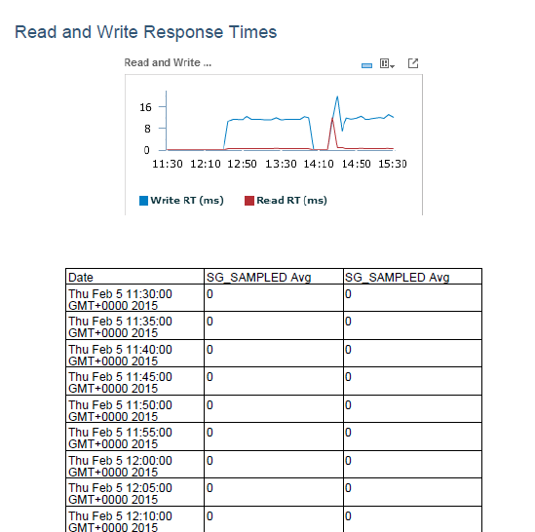

Export/Importing Performance Settings
The following settings can be exported and imported to assist the implementation process for multiple instances and as a pre-upgrade step:
- The Performance metrics (KPIs) definitions with their default (not instance-specific) settings
- The user template dashboards
To export Performance settings:
- Select a Symmetrix system
- Select any category (Databases, Metrics, Reports, etc.) under ‘Performance’ ‘Settings’
- Select ‘Export Settings’ from the Common Tasks panel to open the Export Settings dialog box
- Select the settings to export: Metrics Definitions, User Templates, or both.
- Enter and confirm a file password.

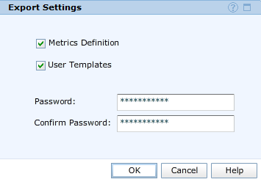

- Click OK. The Save Settings confirmation appears. Select preferred location to save the settings.
To import Performance settings to an alternative U4V instance:

- Select ‘Import Settings’ from the Common Tasks panel to open the Import Settings dialog box
- Select the settings to import: Metrics Definitions, User Templates, or both.
- Enter the file password (which was set during the export process). Click OK
- The Select File dialog box opens. Open the settings file from your preferred location

Appendix C – Version Tracker
Version | Changes Since the Last Version
0.1 | New certification draft
0.2 | 0.1 Re-written

“Historical” is always selected and cannot be unselected
The two * options are not recommended for recurring backups

