Recommendations for Addressing Storage Tech Refresh and New Capacity (BAU and Project)

Utilization of Installed has been reported since 2012 by the 3 Storage groups (NAS, SAN and Mainframe).
This document is intended to address how Tech Refresh and New Capacity storage should be treated for the purpose of calculating Utilization of Installed. Note that there is no impact to Utilization of Allocated.
Recommendations:
- Tech Refresh
  - Tech Refresh Capacity will be excluded from Installed for the calculation of Utilization of Installed.
    - The total Tech Refresh Capacity will be reported as a separate quantity
    - Where new frames have larger capacity than Tech Refresh source(s), the increment will be considered New Capacity.
  - Tech Refresh Used is to be counted once with the method selected by the Storage team:
    - NAS will report either Source or Target volume depending on production status
    - SAN will report both Source and Target
      - A minor increase in utilization occurs when a volume is dually Used on source and target frames in a given month during migration. Dual Used is typically less than a month.
- Mainframe will report Used as reported at start of the frame migration
      - Migration typically takes 1 -3 months.
- New Capacity (BAU and Project)
  - NAS to exclude for 3 months
  - SAN to exclude until 10% of capacity has been allocated but not longer than 6 months
    - Note: Due to complexity in measuring % Allocated for a portion of the frame where New Capacity and Tech Refresh Target share same frame, the entire frame will be excluded until 10% has been allocated to customers.
  - Mainframe will include Day 1 upon initiation and availability
- SAN and Mainframe recommendations are based on current tools and a desire to minimize reporting effort. If resources and practices are changed, a standard 3 month delay would be recommended.
Timing: These reporting changes for Tech Refresh and New Capacity are to be implemented at the beginning of November with October data by SAN and Mainframe. NAS will implement with November data and be in the MOR published early December.

The following material was briefly reviewed. Paul Stemmler has requested a number of follow-ups and meetings to discuss the material.
To be addressed by Capacity Management:
- All 3 teams expressed a desire to report on Usable, rather than Raw. This should be given serious consideration as it would align with Chargeback and exclude non-usable.
This would exclude: Configuration loss, RAID overhead, Storage OS disks, Spares; WAFL (Write Anywhere File Logger) for NAS; Delta Set Enhancement (replication capacity for out of cache condition) for Mainframe.
It would include: any performance reserve, e.g. CATE defined, and Snapshot Reserve (for rapid restore).
  - For historical reporting we will need to continue to report a legacy Installed Capacity, or a conversion factor to apply to historical values.

NAS proposal
Tech Refresh Capacity is to be identified, i.e. #TB
- Where new capacity added is greater than the Tech Refresh source(s), it is to be treated as New Capacity BAU
- Tech Refresh Capacity is to excluded from calculation of “% Utilized of Installed” but will but will be reported as a separate item.
Used will be included in calculation of %Utilized from Tech Refresh Source or Target:
- Tech refresh migration team manage the migrating volumes and record the volumes as either “in progress” or “completed”.
- For volumes “in progress”, the source usage is reported.
- For volumes “completed”, the target usage is reported.
- Once the target is passed for production, the source raw installed is removed from the report and replaced with the target raw installed.

New Capacity, i.e. (BAU and Project) is to be excluded from calculation of “% Utilized of Installed” for a period of 3 months after install. It is recognized that after the 3 months the NAS Server is likely to have below average utilization for a significant period.

NAS Specific reporting issues not being addressed:

- Snapshot Reserve is reserved up front and is a fixed size (standard of 20% to cover 2 week window), but usage is variable dependent on rate of data change - this should be considered Overhead and excluded.
- Currently included are system volumes and spares – should be excluded

- Raw multiplier is used to convert from Usable to Raw.

- A Reserve (unused) of 10% for CIFS and 25% for VMware is mandated by CATE and is therefore not usable. Tony has advised that this is a management decision to use or not and should be included.

- Utilization of the VMware environment is currently calculated based on Used of virtual (overcommitted allocated) rather than physical storage.

--------------------------------------------------------
Proposed Calculation of “usable storage” for NetApp is:
((([total of data disks] - [10% for performance]) - [10% WAFL]) - [20% snapshot reserve]) = [Total usable]
This calculation already assumes spares and parity disks have been removed.

Configuration - Breakout by percent of Delivered Capacity (100%) to Usable
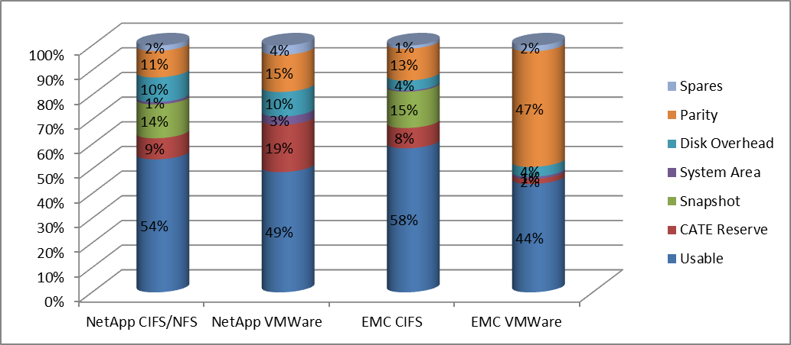
Snapshot and CATE Reserve are Citi management choices to provide 14 day fast restore capability and insure against performance and out of capacity conditions.
Type | Raw Installed (TB) | Spares | Parity | Disk Overhead | CATE Reserve | Total Available | System Area | Snapshot | Usable
NetApp CIFS/NFS | 179.4 | 3.8 | 19.2 | 17.9 | 15.4 | 123.0 | 1.7 | 24.6 | 96.7
NetApp VMWare | 51.3 | 1.9 | 7.7 | 5.1 | 9.8 | 26.7 | 1.7 | 0.0 | 25.0
EMC CIFS/NFS | 166.6 | 2.1 | 21.5 | 6.7 | 13.7 | 122.7 | 0.8 | 24.5 | 97.3
EMC VMWare | 89.7 | 2.1 | 42.0 | 3.6 | 1.8 | 40.2 | 0.8 | 0.0 | 39.4

Notes:
NetApp WAFL included in Disk Overhead
EMC Vmware is RAID-1(Mirror) configuration
NetApp CIFS/NFS and EMC CIFS based on current maximum cluster size.
NetApp and EMC VMware configurations related to same numbers of VMs.

De-Duplication is a weekly batch process that occurs once files are resident, and therefor requires disk space before compression until compression occurs.

SAN proposal

Tech Refresh Capacity is to be identified, i.e. #TB
- Where new capacity added is greater than the Tech Refresh source(s) it is to be treated as New Capacity BAU
- Tech Refresh Capacity is to excluded (subtract Source capacity) from calculation of “% Utilized of Installed” but will but will be reported as a separate item.
Used will be included in calculation of %Utilized from Tech Refresh Source and Target:
- Tech Refresh Used may be co-resident in both source and target for a variable period, typically less than a month. Overall the volume is not significant.
  - Dual Used source storage is deleted after disconnect from server (Gary Battersby).

New Capacity, i.e. (BAU and Project) is to be excluded from calculation of “% Utilized of Installed” until %Allocated reaches 10% or is installed 6 months. (This is based on experience if less than 10% Allocated it was brought in for specific reason, in general new frames allocation rate is very low first 3 months. Other case may be Tech Refresh related other case Dedicated Project).
Note: Due to complexity in measuring % Allocated for a portion of the frame where New Capacity and Tech Refresh Target share same frame, the entire frame will be excluded until 10% has been allocated to customers.

SAN Specific reporting issues not being addressed:

- Installed Disk currently reporting the Configured Raw value, rather than vendor advertised capacity
  - This is the Storage Admin’s view of capacity after configuration.
  - Includes Allocated Raw (to server) and Unallocated Raw
- Configured Usable excludes parity, spares and SFS (OS) volumes and is the quantity visible to Server SA’s
  - EMC and HDS frames typically see a 33% reduction in capacity value vs. Configured Raw
  - IBM XIV frames typically see a >50% reduction in capacity value vs. Configured Raw
- Performance constrained frames e.g. EMC 20K are allocating are maintaining a reserve
--------------------------------------------------------
Desire to change the metric to report on Configured Usable rather than Configured Raw (Installed Disk)
Installed (TB)
Definition
The total Raw storage after Meta data reserve, disk format reserve, vault reserve, RAID, hot spare reserve, & etc.
Current calculation:
Install (TB) = All Configured Raw (TB) - Configured Raw on TR-Source (TB) - Configured Raw w/ very Low Allocation (<10%) - Arrays unable to be discovered by ECC agents
Using Aug, 2013 data as one example, following arrays been excluded
1) Frames with low allocation rate <10% are:
* 17 recent new BAU: 15 VMAX40k, 1 HDS R700, & 1 VNX7500
* 5 Tech Refresh Source
* 2 Tech Refresh Target
* 7 Dedicate to Exchange, DMZ, GRAMS
2) Frames not discovered on FMO report:
* 2 Centera
* 1 VMAX-1 TR target
* 1 Clarrion TR SRC
* 1 Clarrion Exchange
Proposed calculation:
Install (TB) = Configured Raw (TB) excluding any on TR-SRC frame
= SUM [Physical Device Total ] on ECC “Array Summary by Tier & Pool” Report (filter out TR-SRC)
* Please note, the TR-SRC install (TB) will submit in different field.

Average Utilization (%)
Definition
The amount SAN storage is used by host out of total Allocated Storage.
*Please note: this is different than “% Utilized of Installed”, which is defined as the amount storage used by host out of total Installed Storage.
Current calculation:
For Thick storage, host used on Thick storage is retrieved via ECC host agent,
Utilization (%) on Thick = Aggregate total storage used by host on both file system and DB (RAW)
Total Allocated storage on host (RAW)
For Thin storage, but host used is retrieved via ECC Array agent since it is more accurate than host agent sum-up,
Utilization (%) on Thin = SUM [Virtual Device Used by Host (RAW)] ___
SUM [Virtual Device Allocated to Host (RAW)]
Proposed calculation:
To get most fare/accurate %util, we should exclude frames failed to be discovered, and frames with very low allocation rate, which are recently new install or dedicated to TR/Exchange/special projects

Utilization (%) on Thick = Aggregate total storage used by host on both file system and DB (RAW)
Proposed new Install on thick (Raw)

Utilization (%) on Thin = SUM [Virtual Device Used by Host (RAW)] ___
Proposed new Install on Thin (Raw)

Configuration - Breakout by percent of Delivered Capacity (100%) to Usable
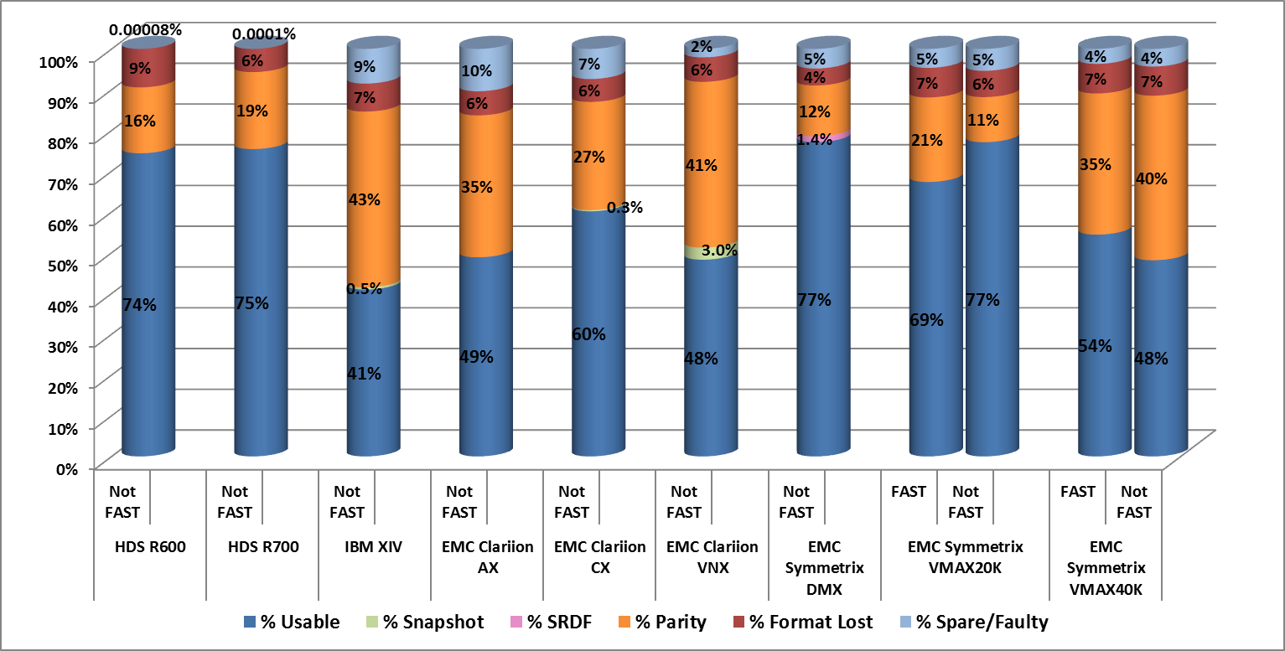

Array Config | IsFast | Market Size (GB) | Formatted Raw (GB) |  | Format Lost | Pool Phyical Total (GB) | Spare |  | Parity |  |  | SDRF Over  head |  |  | Snapshot/  others Overhead | Sum of  Config  Usable (GB)
HDS R600 | Not FAST | 1,111,824 | 1,006,824 |  | 105,000 | 1,006,824 | 1 |  | 179,795 |  |  | - |  |  | - | 827,029
HDS R700 | Not FAST | 3,579,200 | 3,375,451 |  | 203,749 | 3,375,447 | 4 |  | 676,394 |  |  | - |  |  | - | 2,699,069
IBM XIV | Not FAST | 3,960,000 | 3,688,037 |  | 271,963 | 3,351,141 | 336,896 |  | 1,708,915 |  |  | - |  |  | 20,480 | 1,621,747
EMC Clariion AX | Not FAST | 1,214,292 | 1,142,957 |  | 71,889 | 1,016,643 | 126,314 |  | 422,996 |  |  | - |  |  | - | 593,647
EMC Clariion CX | Not FAST | 1,285,772 | 1,214,037 |  | 72,472 | 1,119,107 | 94,930 |  | 341,868 |  |  | - |  |  | 3,368 | 773,871
EMC Clariion VNX | Not FAST | 8,966,450 | 8,431,278 |  | 538,580 | 8,244,806 | 186,472 |  | 3,649,114 |  |  | - |  |  | 265,240 | 4,330,452
EMC Symmetrix DMX | Not FAST | 3,464,258 | 3,319,957 |  | 144,301 | 3,153,391 | 166,565 |  | 432,052 |  |  | 49,387 |  |  | - | 2,671,980
EMC Symmetrix VMAX20K | FAST | 8,692,000 | 8,050,779 |  | 641,221 | 7,633,195 | 411,714 | 1,835,419 |  |  | - |  |  |  | - | 5,957,300
 | Not FAST | 9,203,300 |  | 8,621,984 | 595,454 | 8,126,733 | 495,251 | 1,018,498 |  |  | 1,649 |  |  | - |  | 7,106,598
EMC Symmetrix VMAX40K | FAST | 10,297,984 |  | 9,550,363 | 747,621 | 9,172,699 | 377,664 | 3,568,121 |  | - |  |  | - |  |  | 5,604,583
 | Not FAST | 660,000 |  | 612,800 | 47,200 | 584,210 | 28,590 | 266,541 |  | - |  |  | - |  |  | 317,669

Mainframe proposal

Tech Refresh Capacity is to be identified, i.e. #TB
- Where new capacity added is greater than the Tech Refresh source(s) it is to be treated as New Capacity BAU
- Tech Refresh Capacity is to excluded from calculation of “% Utilized of Installed” but will but will be reported as a separate item.
Used will be included in calculation of %Utilized from Tech Refresh Source or Target:
- Reported Tech Refresh disk Used will be frozen from beginning of Tech Refresh migrations for the frame to completion, typically 1-3 months.

New Capacity, i.e. (BAU and Project) is to be included in “% Utilized of Installed” as soon as initiated and available.

Mainframe Specific reporting issues not being addressed:

- Currently including in installed what does not show up in MVS numbers (20-25% of Installed):
  - RAID (12.5%)
  - MVS disk configuration loss
  - Dynamic Sparing
  - DSE (Delta Series Enhancement - Replication capacity in case where out of cache)
- Desire to report on usable which is visible from MVS rather than Installed Raw
note: Billing is currently done in Usable , not Raw.

--------------------------------------------------------
Desire to change the metric to report on Installed/Configured rather than Delivered (currently referenced as Installed) capacities. Calculate the utilization against the Installed (configured) capacity.

Delivered Capacity (MF)-Currently referred to as Installed
- Advertised Capacity Delivered by the Vendor.
  - Number of HDA’s * size of HDA.
  - Includes:
    - RAID protection.
    - Dynamic Spares.
    - Delta set extension devices.
    - Configuration overhead.
    - Any/all un-configured capacity.

Recommended Installed Capacity (MF) -also referred to as Configured-
- Capacity as seen by the operating system.
Configured Device Type’s. - available for allocation of data.
  - Not inclusive of:
    - RAID protection.
    - Dynamic Spares.
    - Delta set extension devices.
    - Configuration overhead.
Example:
Frame-id XYZ123 is delivered with 30 300gb drives or 9TB and has 4 additional 300gb dynamic spare disks 1.2TB for a total deliver capacity of 10.2tb.
- The frame is configured as RAID5(7+1) leaving 7.8TB available to create z/OS volumes.
- The 7.8TB is configured as 864 3390-9’s (or 864*8.5gb=7.34TB).
- The Delivered capacity is 10.2tb, Installed capacity is 7.3tb, overhead(lose) is 2.9tb.
- To achieve 60% of the Delivered capacity, we have to exceed 6.1tb or 79% of the installed/Configured capacity.

Configuration - Breakout by percent of Delivered Capacity (100%) to Usable

