For the VMAX
- Get the latest copy of the file with conventions – SAN EMEA Final Disk capacity inventory V7_Dec14.xls and rename it SAN EMEA Final Disk capacity inventory V7_Jan15.xls.
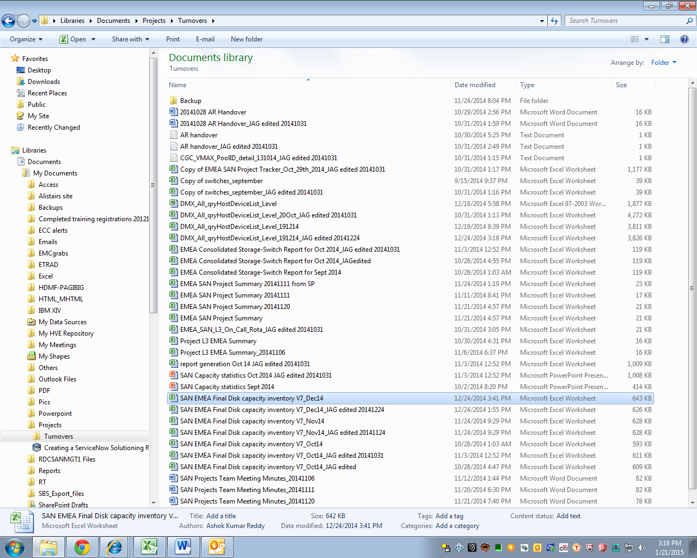
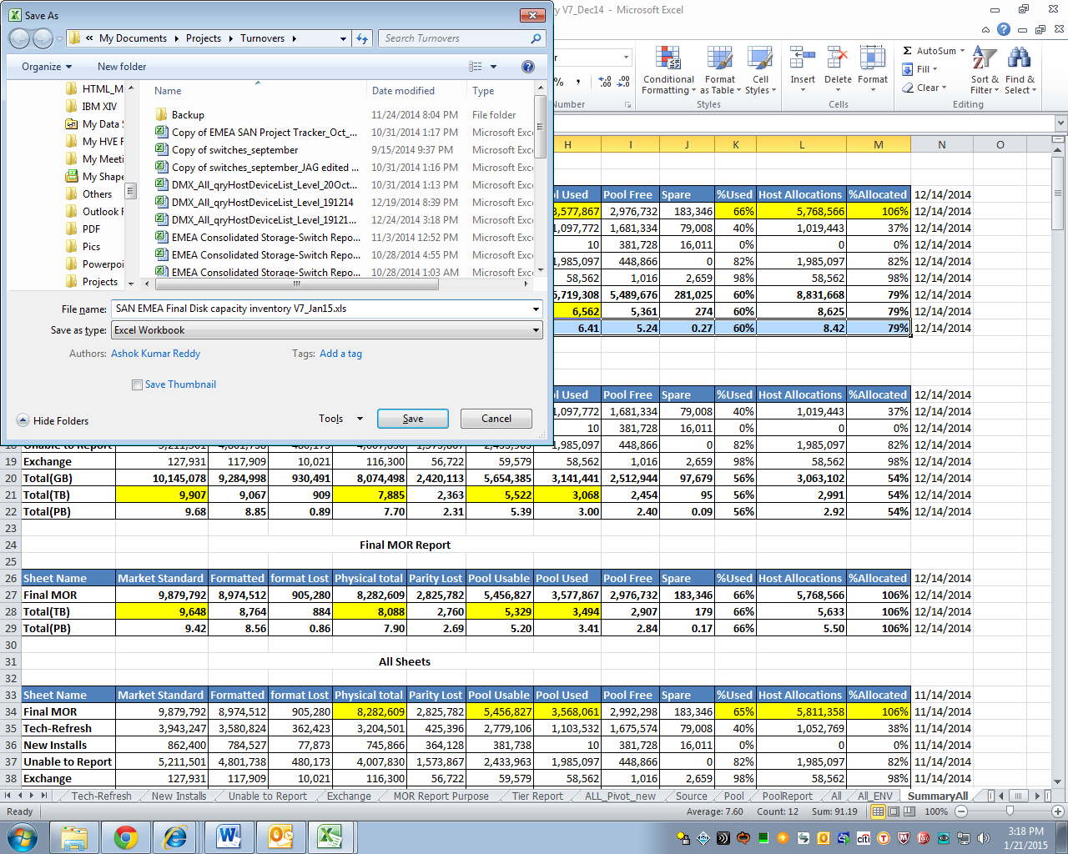

- Open the file. Go to the Pool tab.
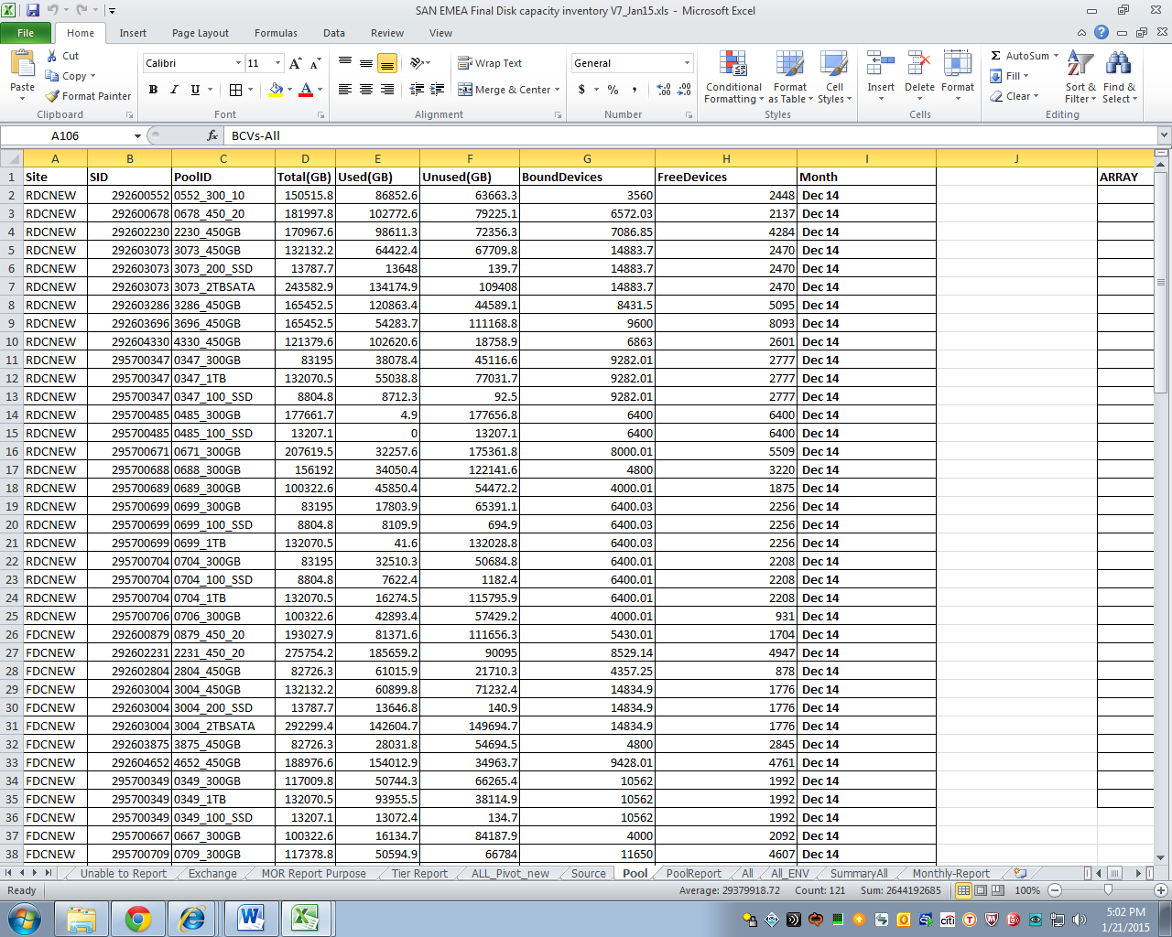
- Go to T:\Capacity Reporting\VMAX\2015\2015-01-16\Data.
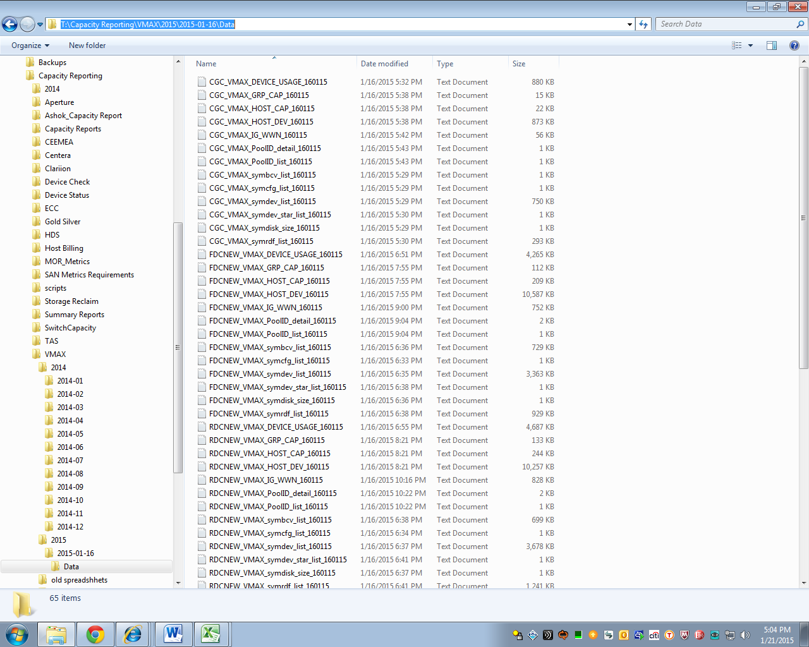

- With reference to the SAN EMEA Final Disk capacity inventory V7_Jan15.xls (column A, rows 1 to 54) and note the chronological arrangement such as RDCNEW, FDCNEW, ZDCBLW, ZDCCOLT, CGC.
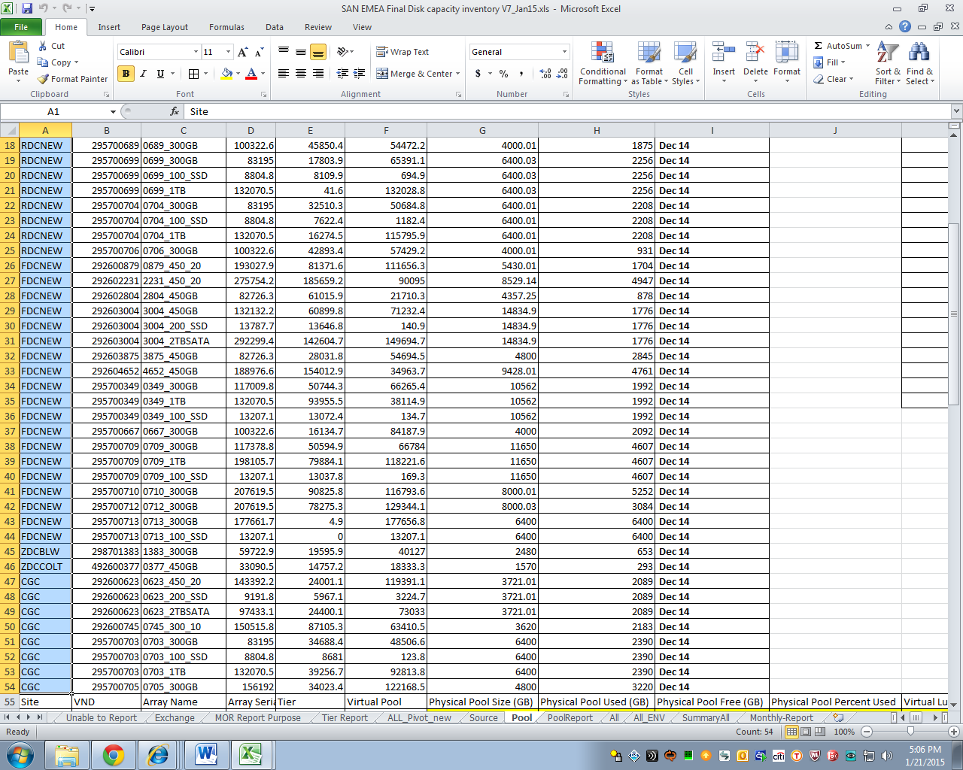

- With reference to T:\Capacity Reporting\VMAX\2015\2015-01-16\Data and the former step, open the files one by one starting with the same chronological order with file naming conventions:
RDCNEW_VMAX_PoolID_detail_160115
FDCNEW_VMAX_PoolID_detail_160115
ZDCBLW_VMAX_PoolID_detail_191114
ZDCCOLT_VMAX_PoolID_detail_191114
CGC_VMAX_PoolID_detail_160115
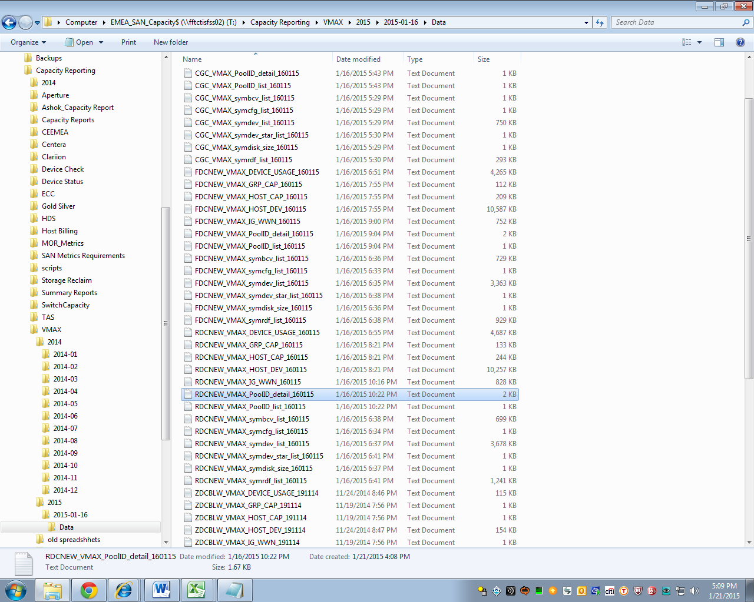

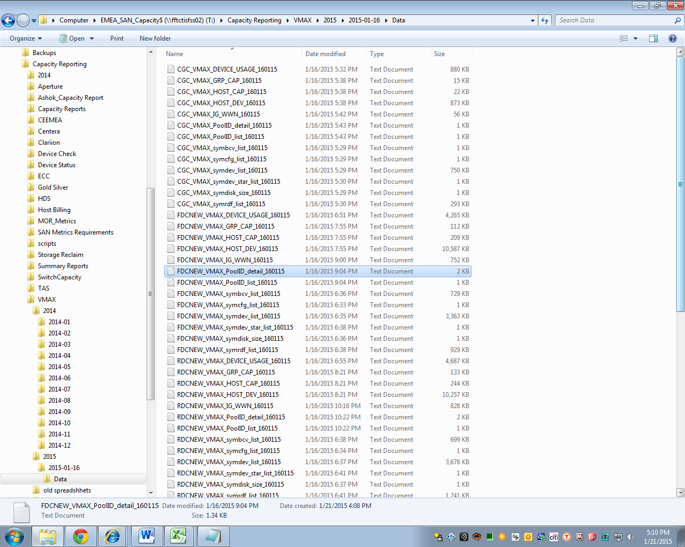

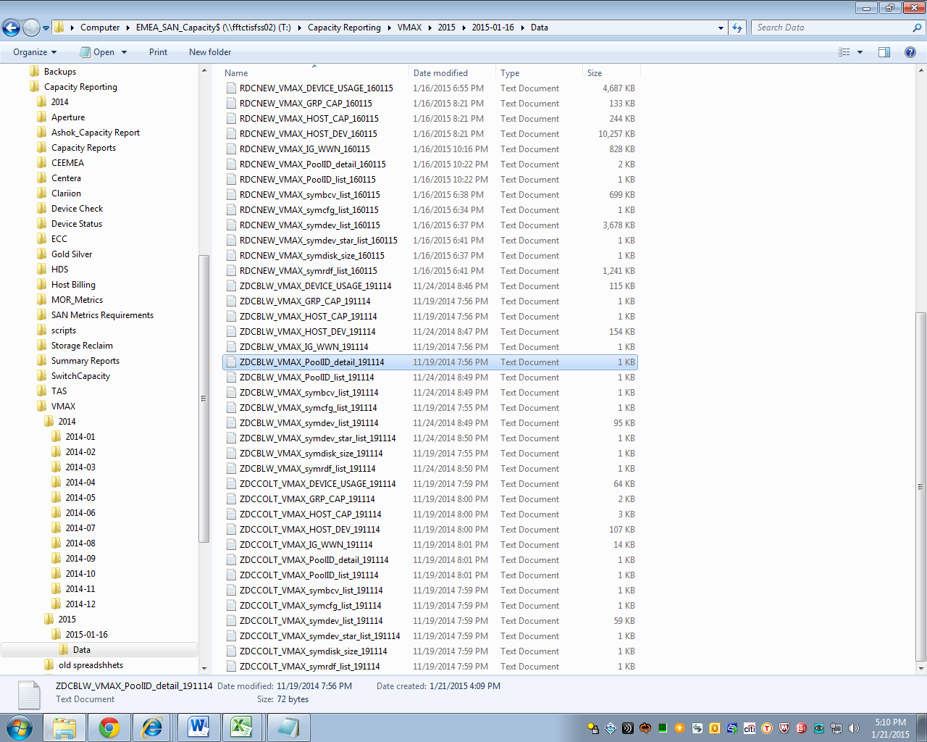
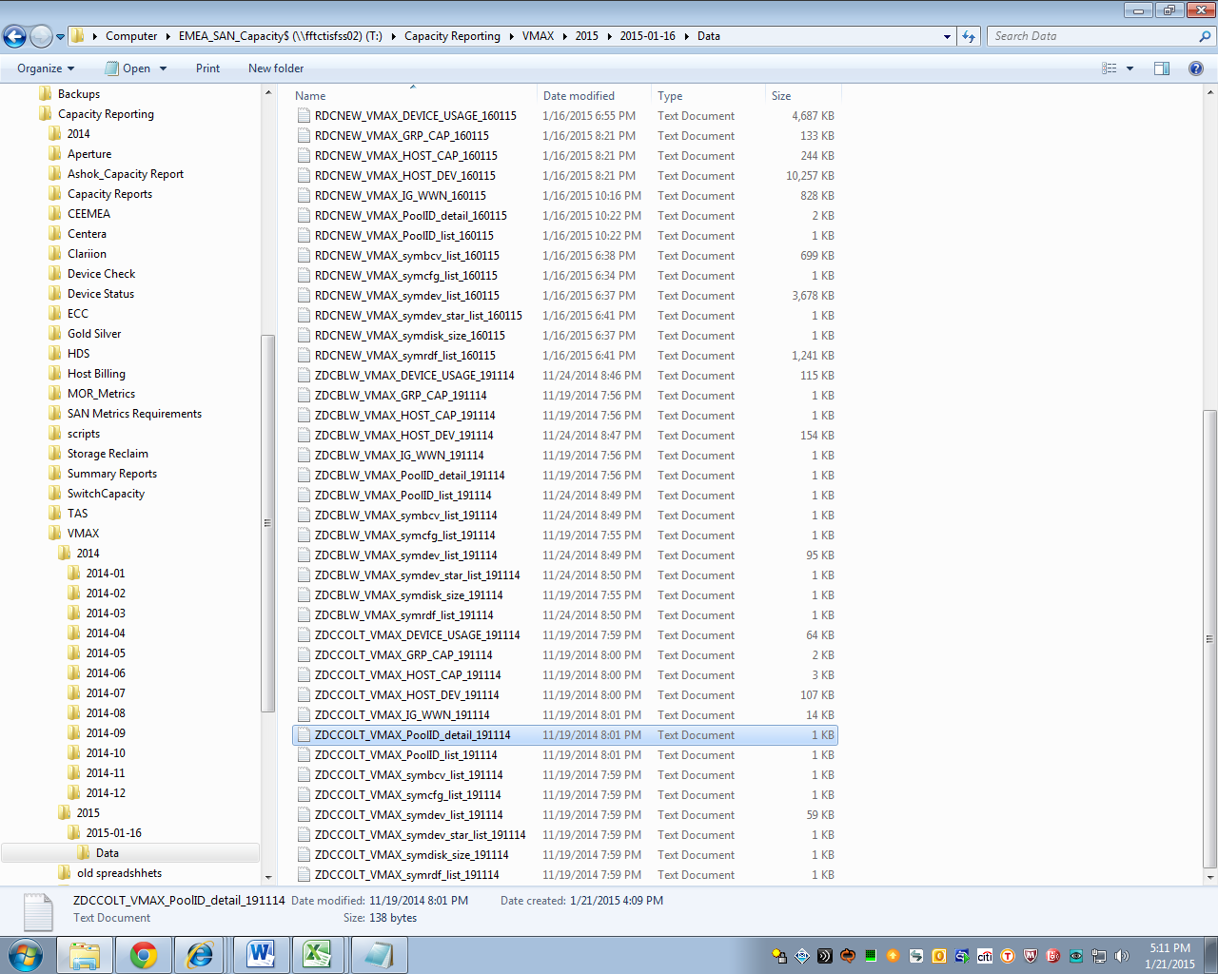
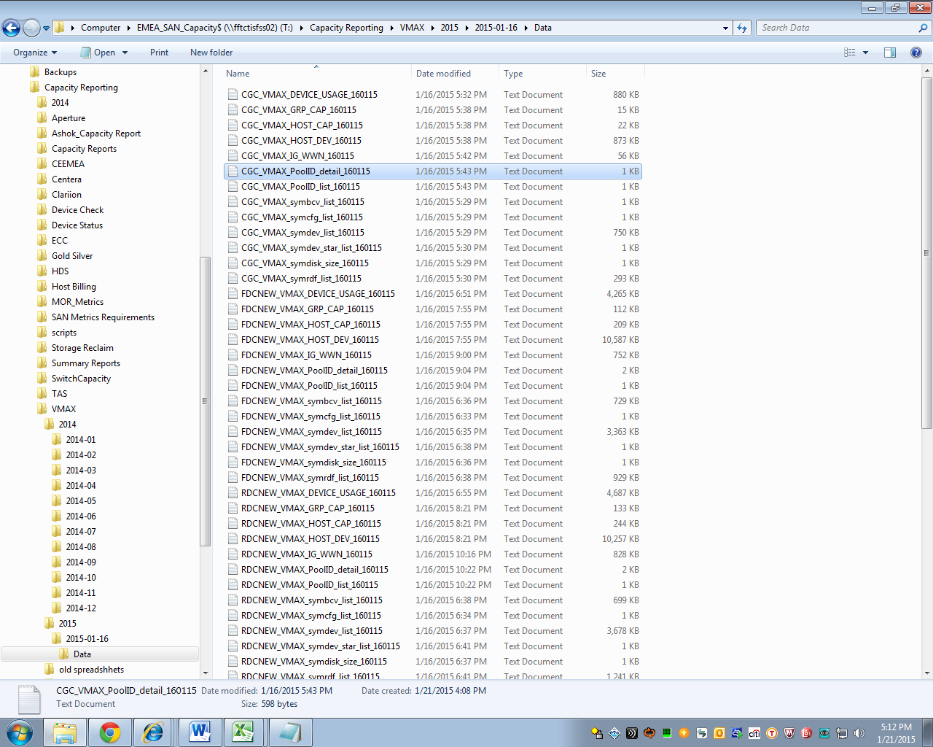

- Open the text file.
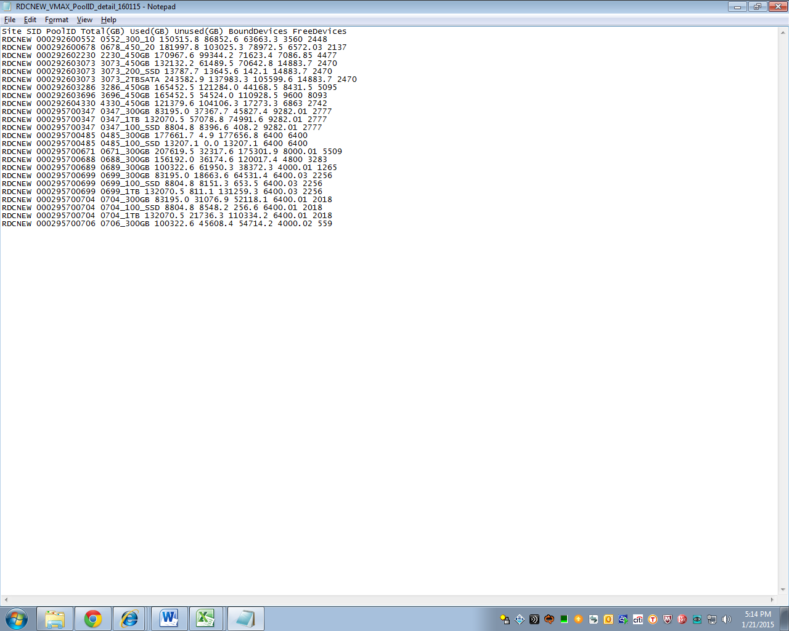

- Highlight all (except the top row). Copy.
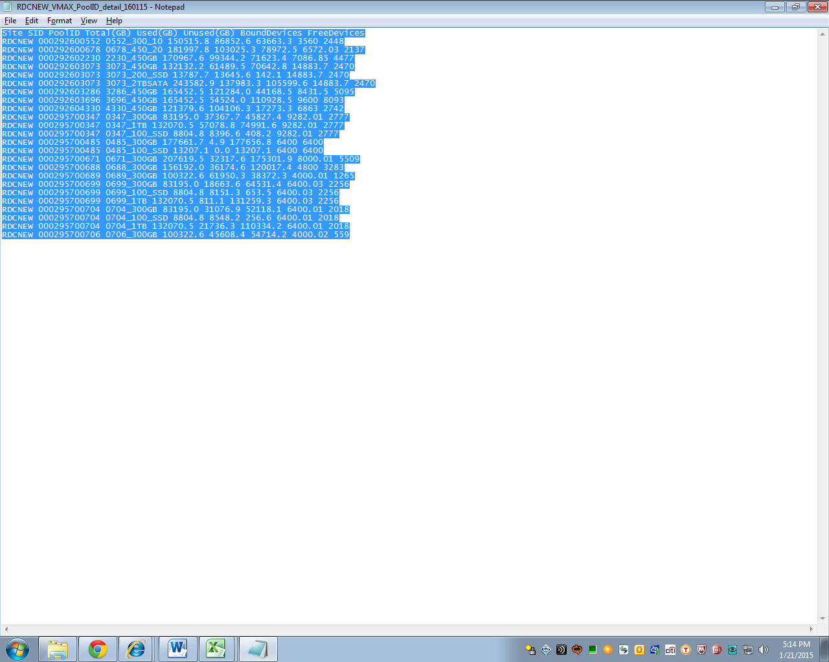

- Paste in the spreadsheet. Take note of the area that it is being contained and maintained (rows and columns).
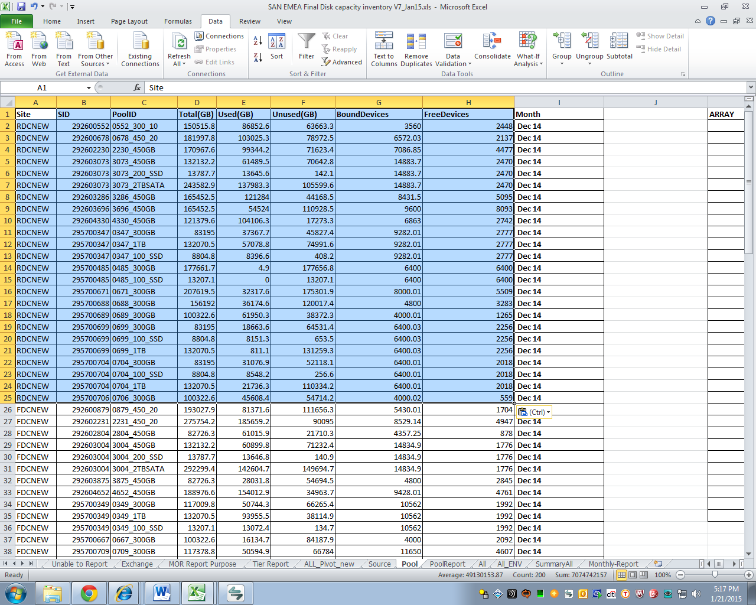

- Repeat with the other remaining 4 text files.
- Make sure that the Month columns on ALL tables depicts the current month and year (Jan15 for this example).
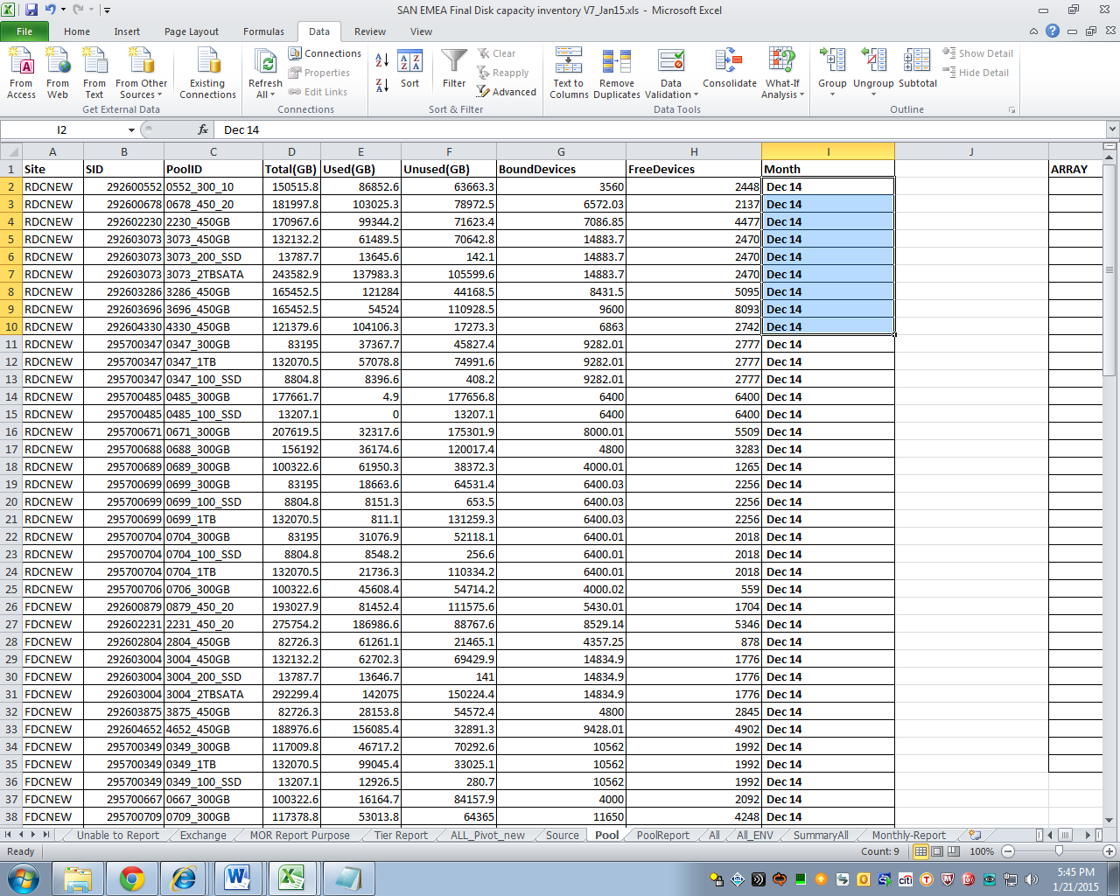
For the DMX
- Go to T:\Capacity Reporting\Gold Silver\Reports\2015\2015-01-16\DMX
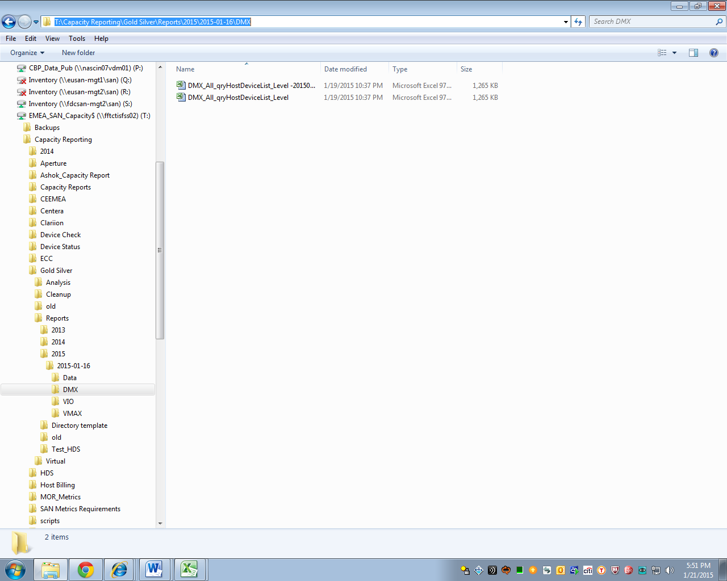

- Create a local copy to apply maintenance to the file and also not to touch the original file. Open.
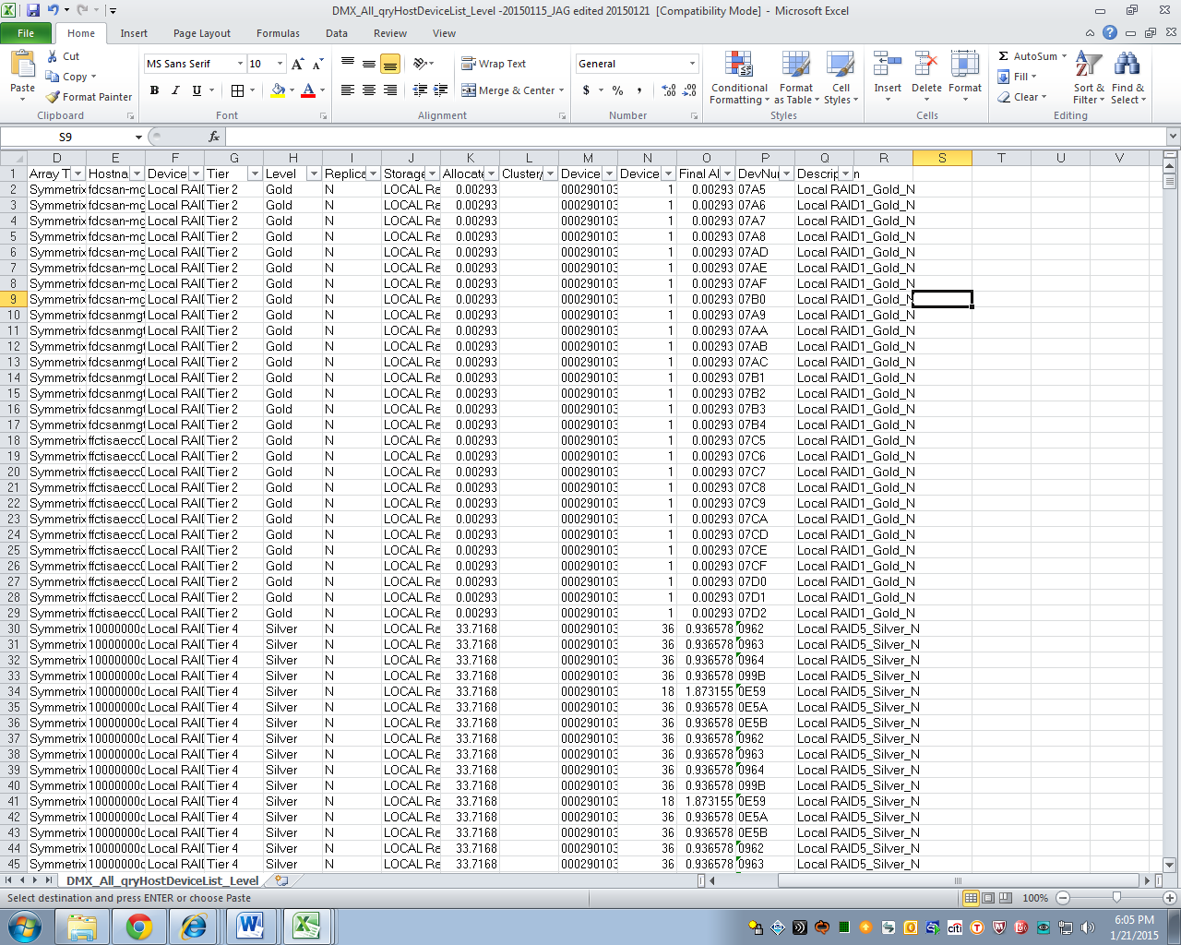

- Open the former local version which has entries for columns R to X.
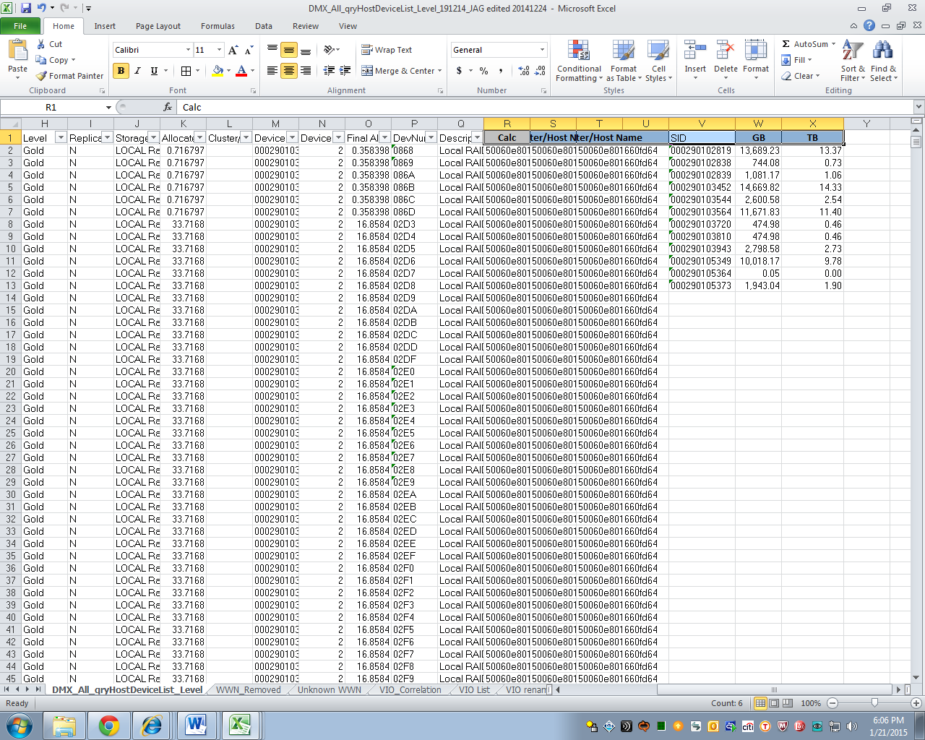

- Copy the functions in cells R2 to U2 from the old to the new. Make sure that the reference of the functions is that of the new file and not the old one so if possible copy from the function area and not on a per cell basis.
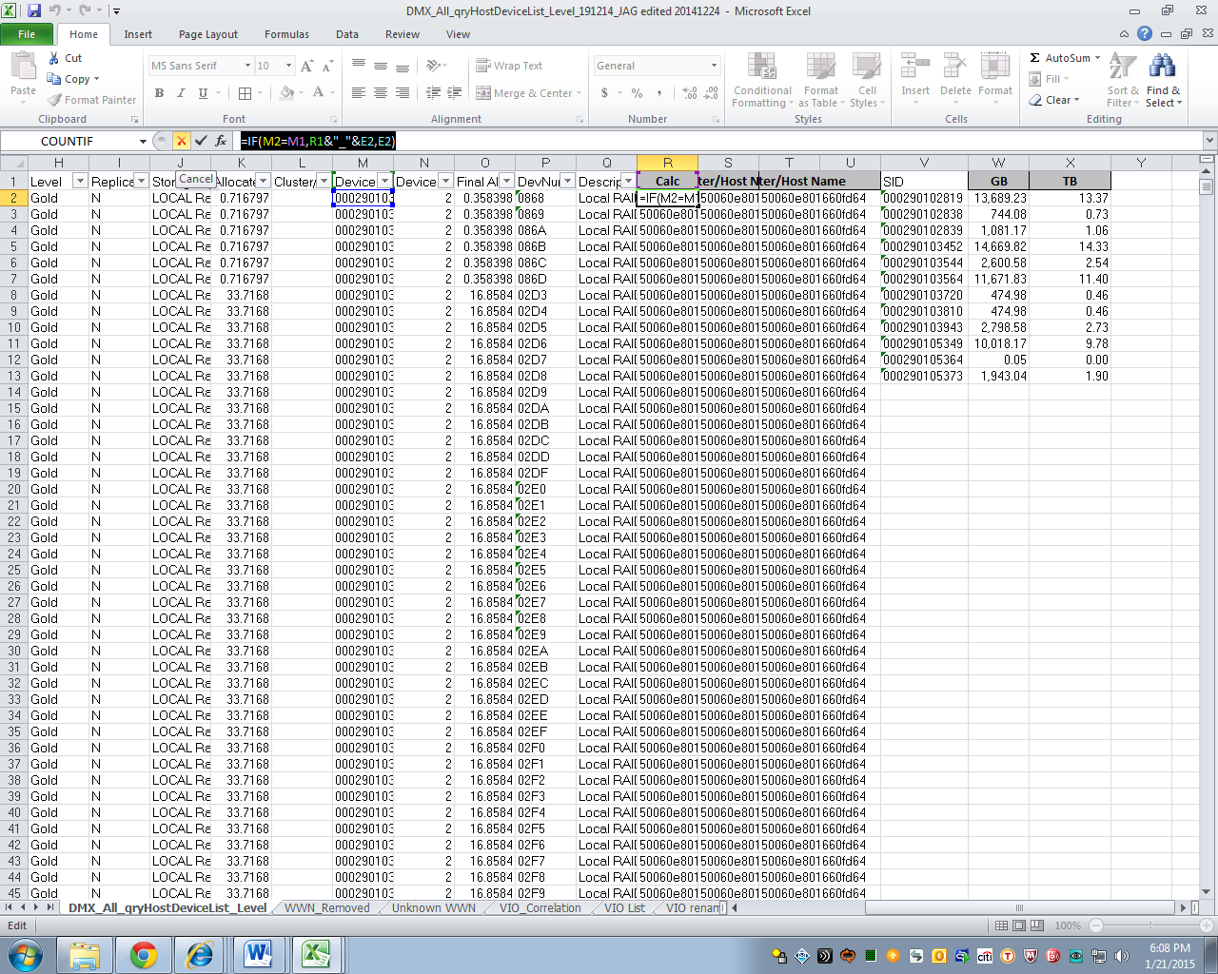

- Copy V2 to V13 (or whichever is still existing).
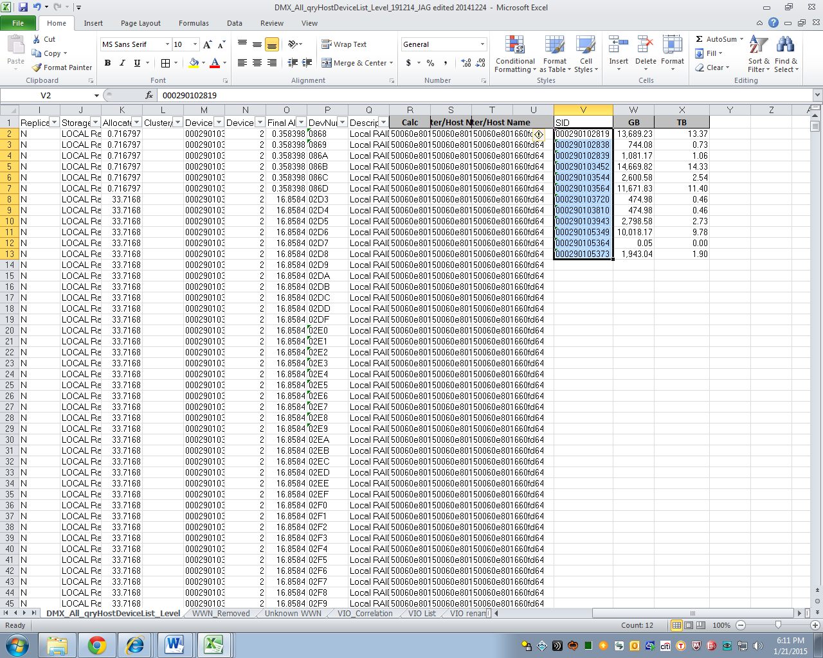

- Copy functions in rows W2 and X2. Copy down.
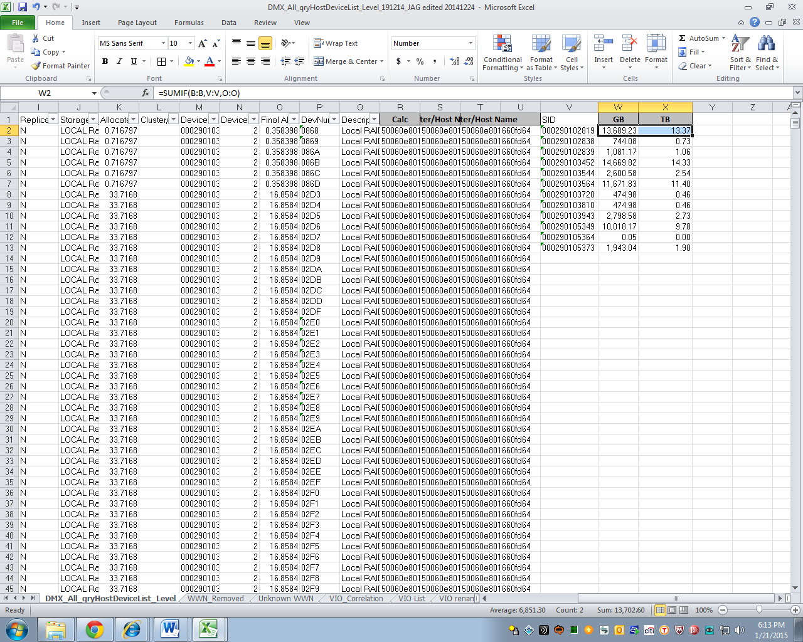
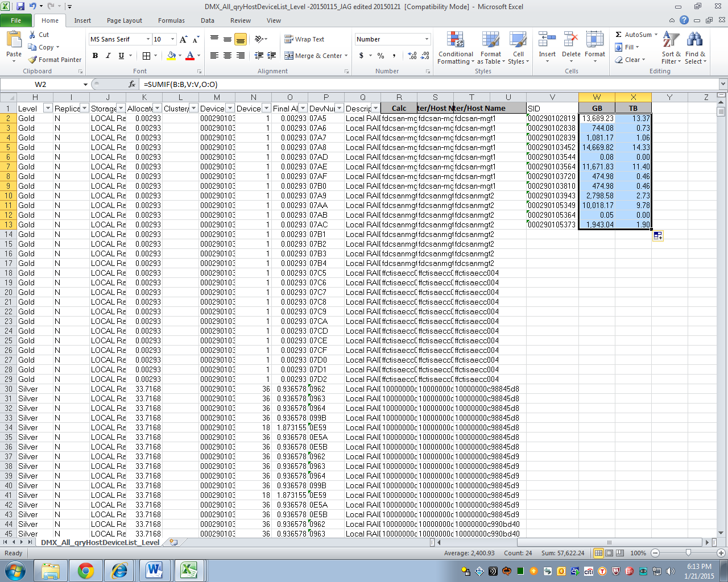

- Copy the info in column W of the DMX file to the SAN EMEA file using the SAN EMEA chronological order. Use Paste – Values Only.
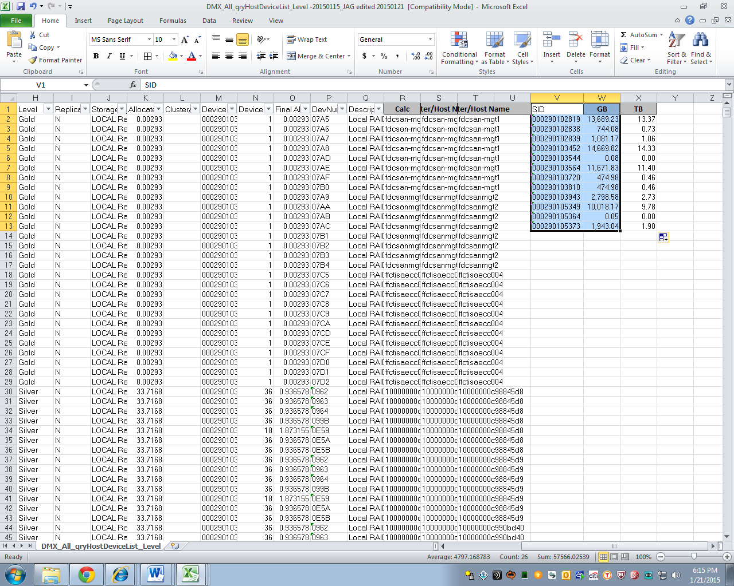
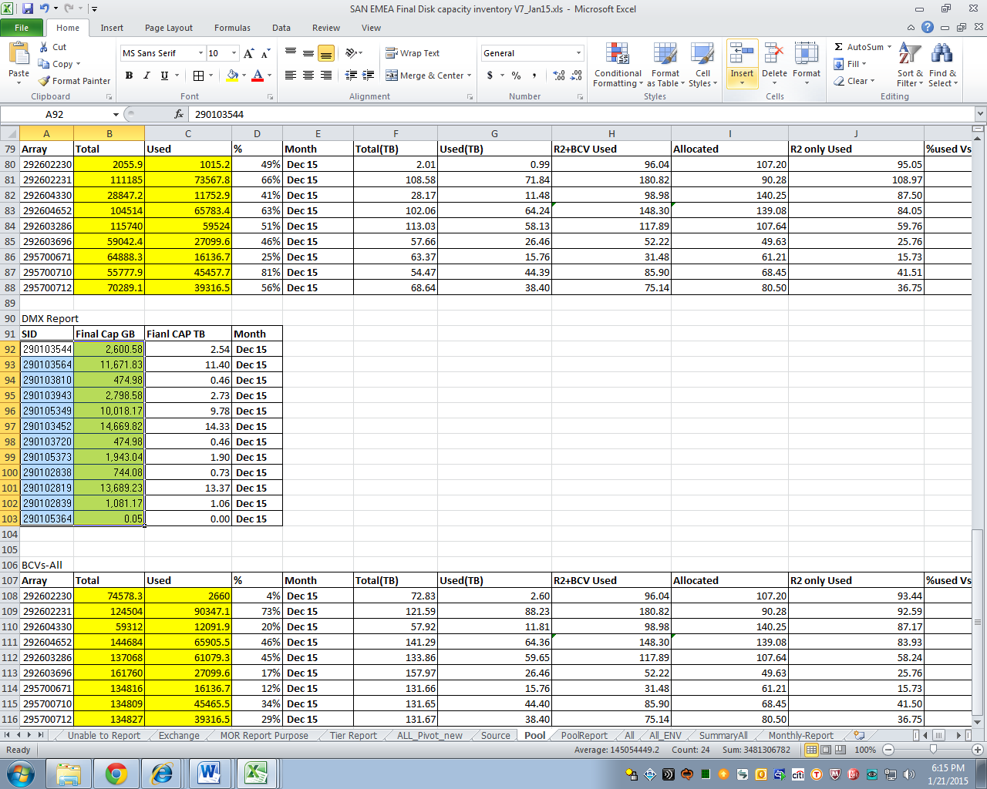
BCV’s
- Login to fgcctisanla01p through Tectia using your credentials. Once in type in bash.
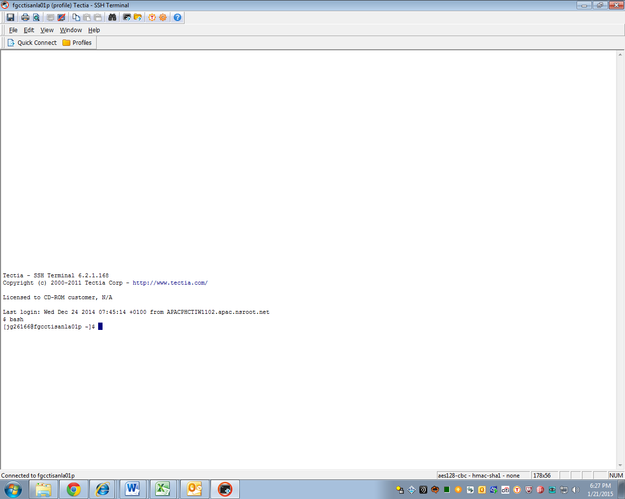

- Issue command cd /var/opt/san/vmax
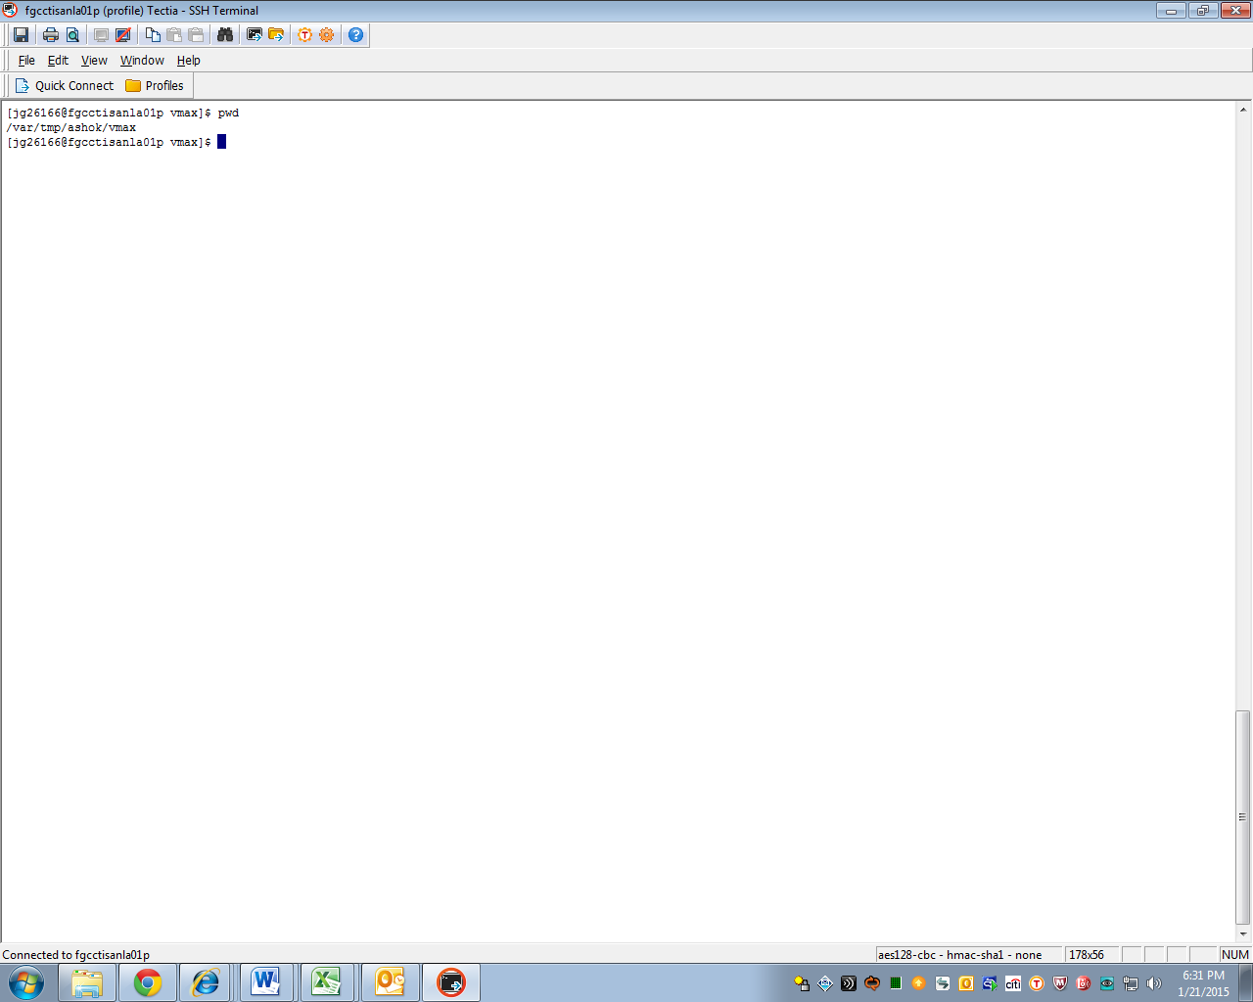

- Issue ls command.
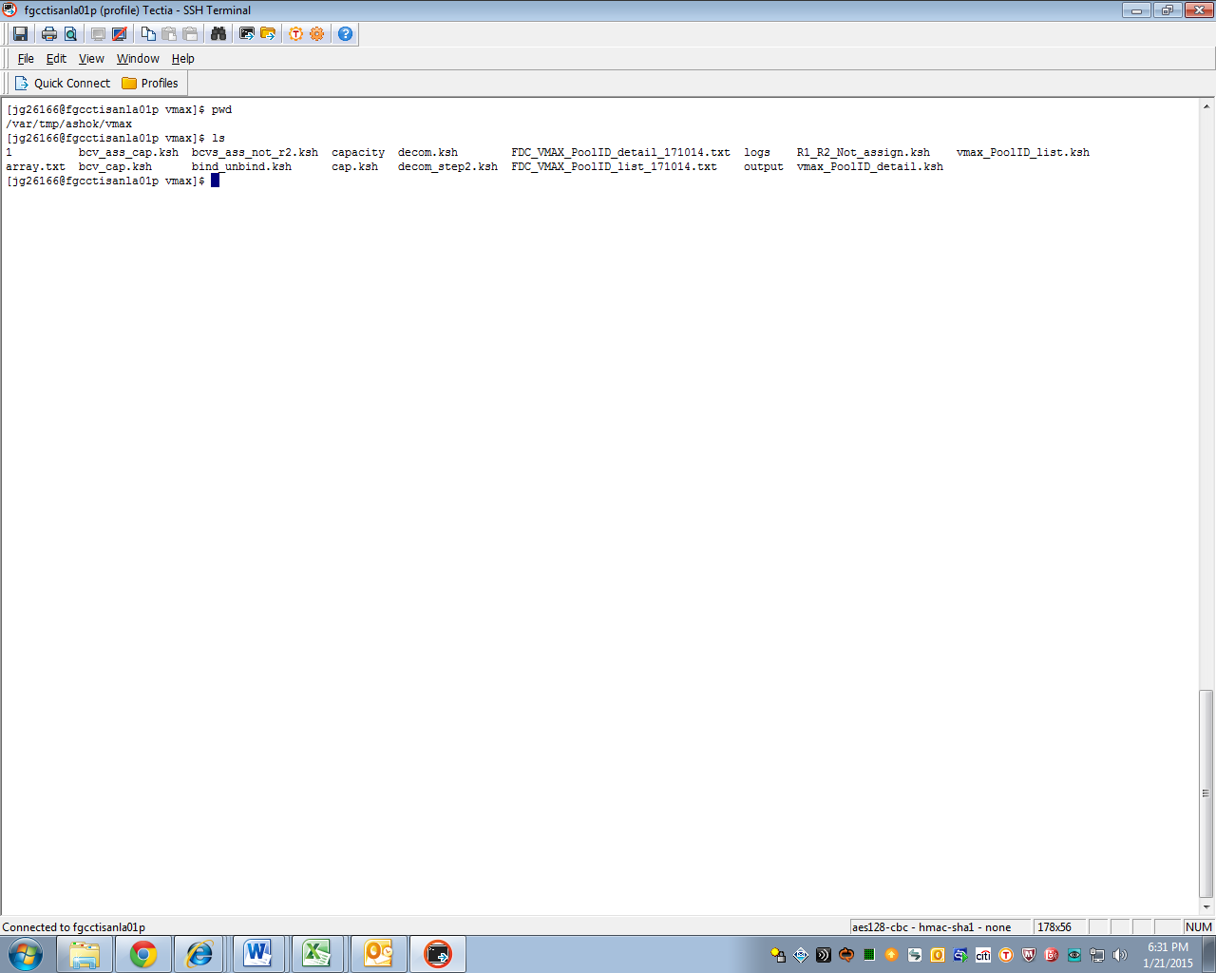

- Issue command -> export PATH=$PATH:/usr/bin:/usr/storapi/bin:usr/storapi/storbin:.:/opt/EMCpower/bin:/etc/emc/bin:/etc:/usr/local/bin:/usr/symcli/bin:/usr/kerberos/bin:/bin:/usr/bin:/sbin:/usr/sbin:/usr/local/bin:/usr/X11R6/bin:/etc/opt/emcpower/bin
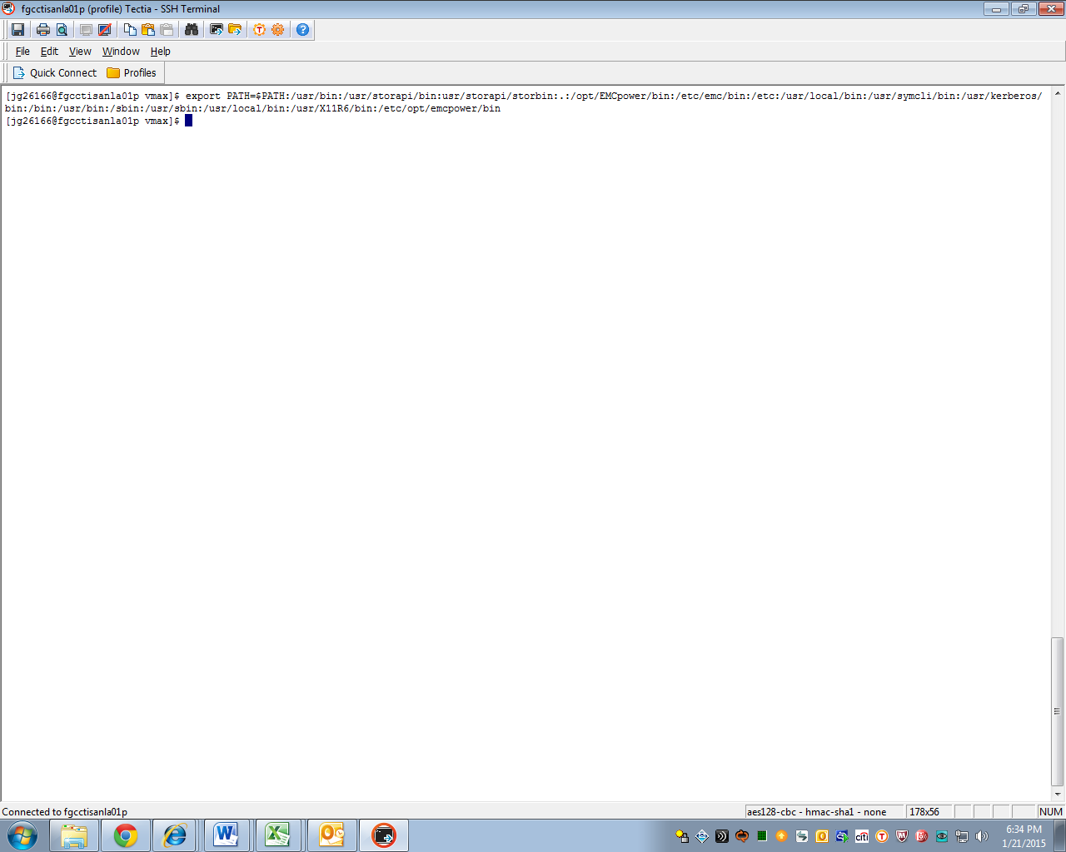

- Issue command -> sh ./bcv_cap.ksh
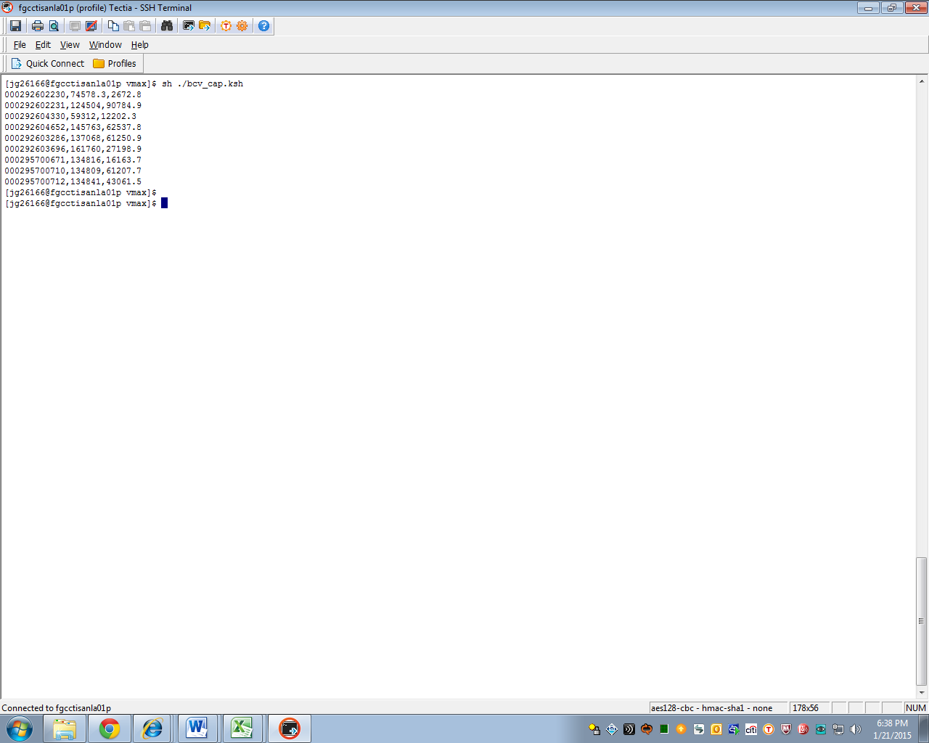

- Copy the information UNDER BCVs-All
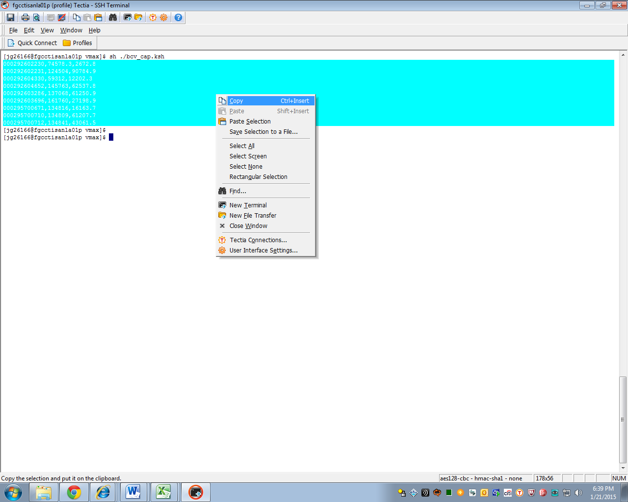

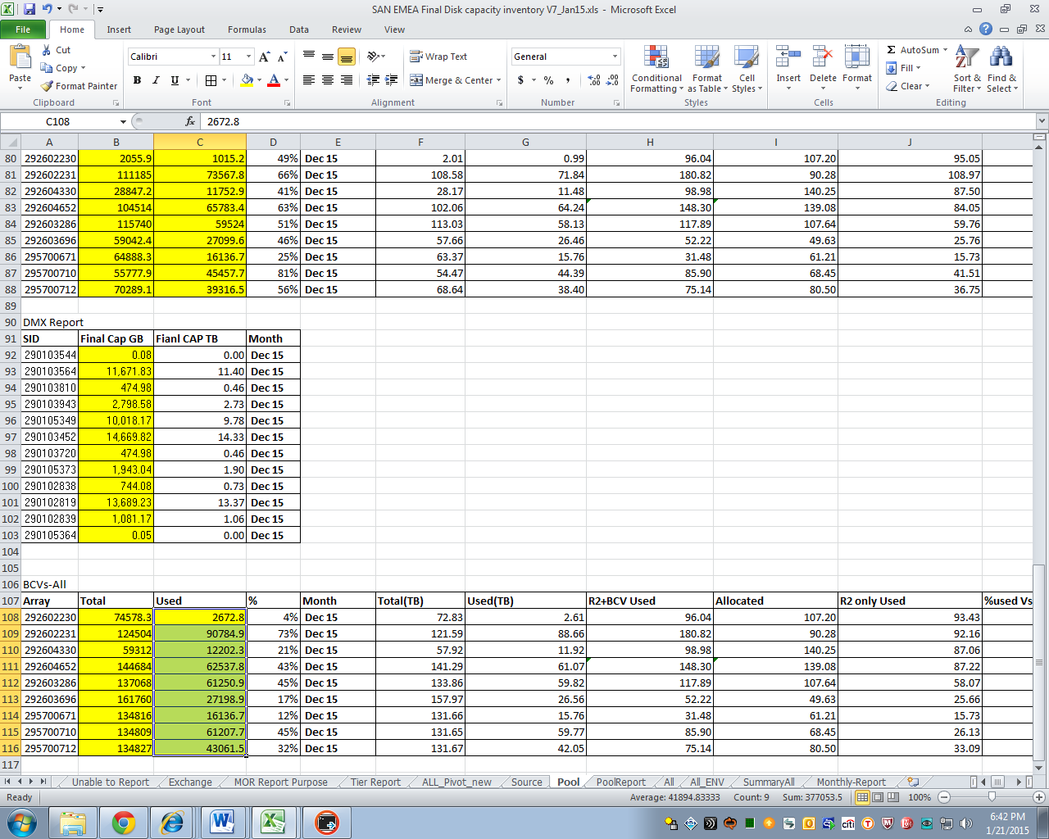

- Repeat step 5 and 6 for command -> sh ./bcv_ass.ksh. Information should be copied to BCVs – Only Association.
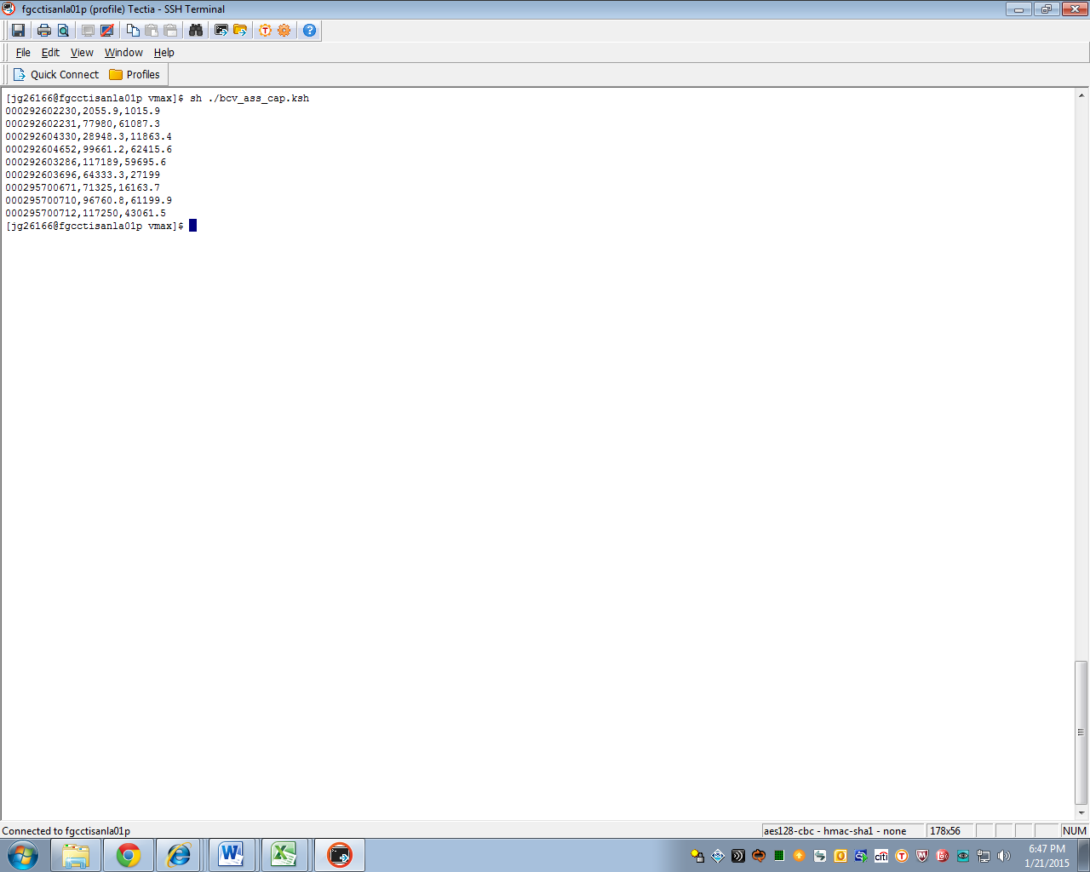

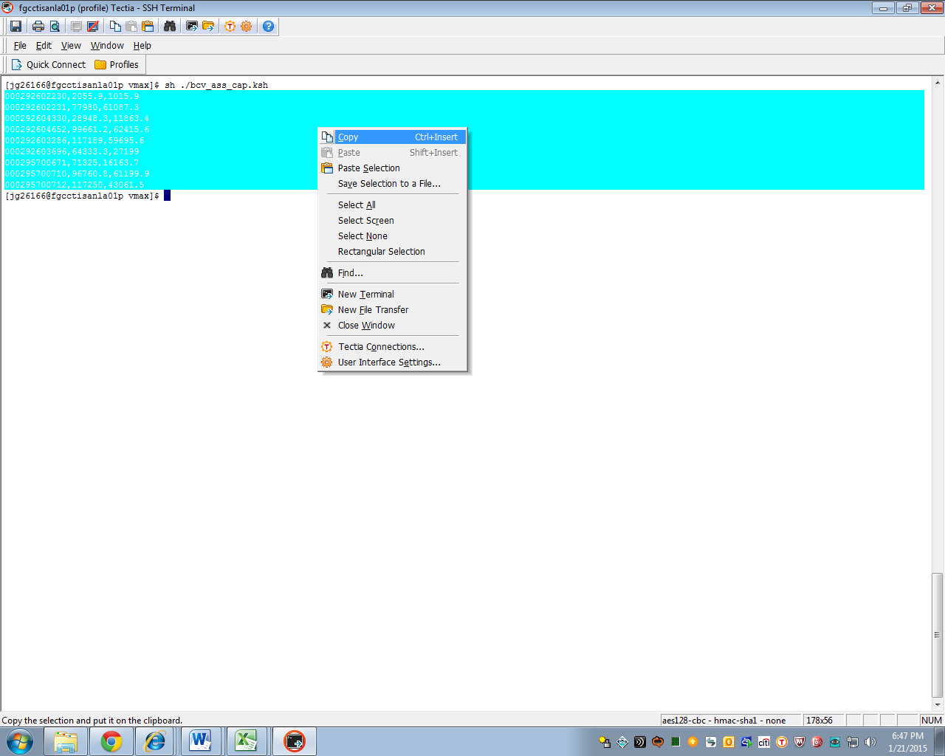
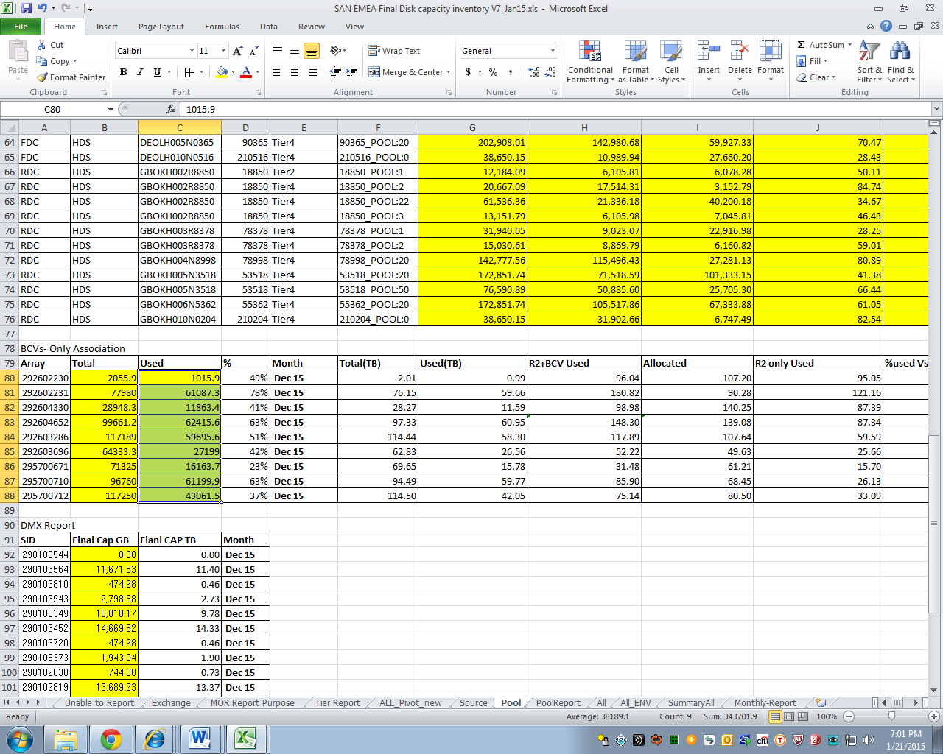

- For columns K1 to R34, please refer to the latest VMAX report (Source tab), the one used for the capacity meetings, for the figures.
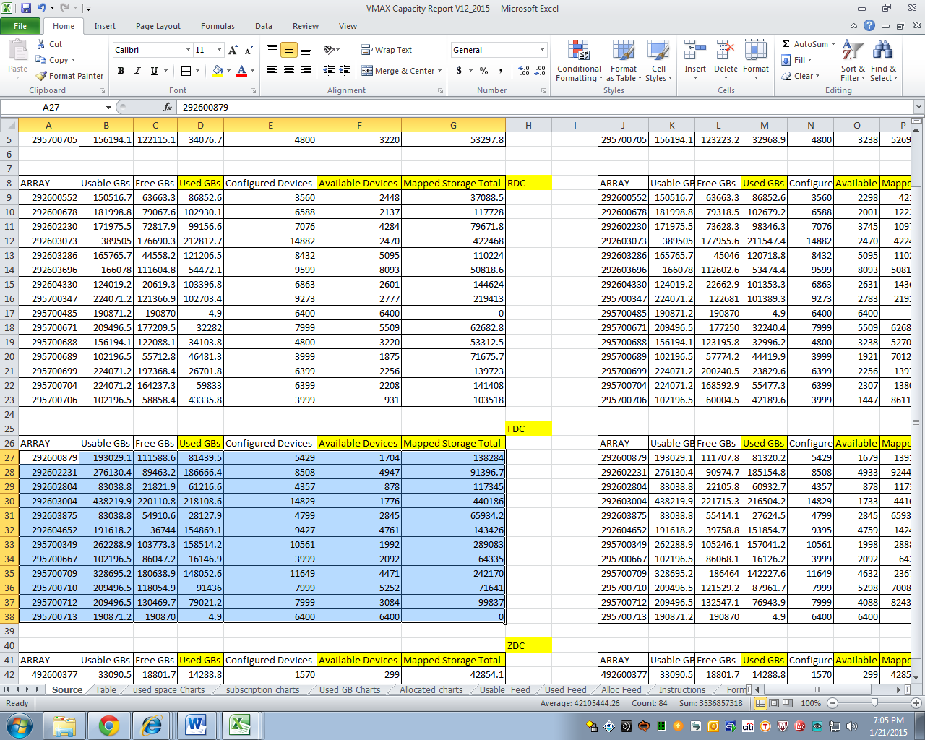
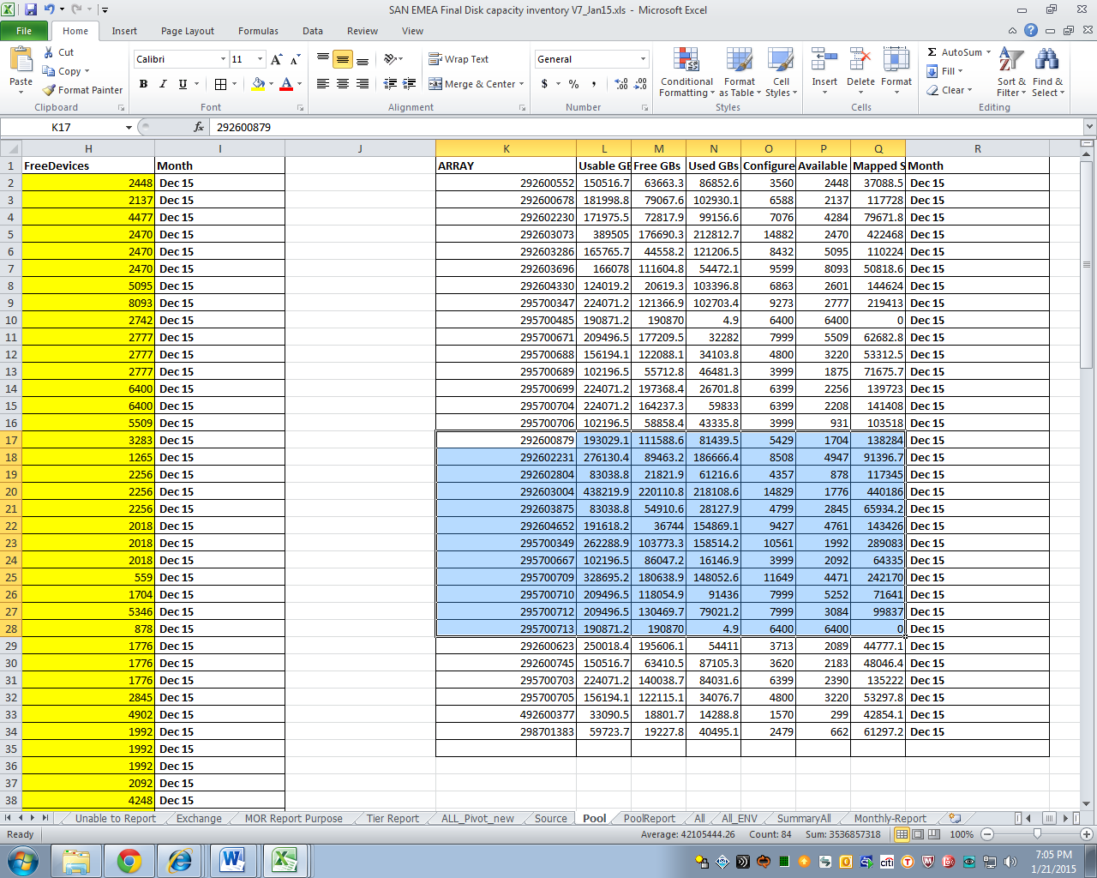
- On the Pool Report tab, go to the unoccupied row.
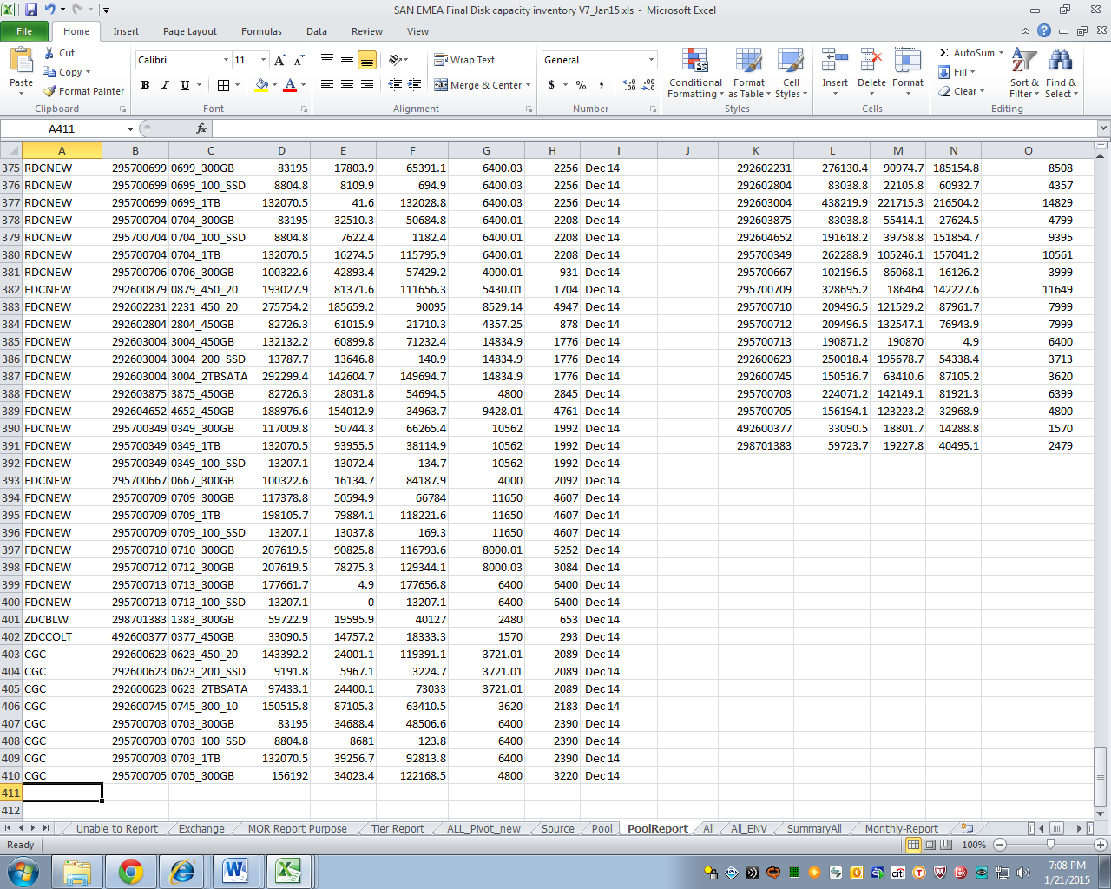
- Copy cells A2 to I54 of Pool tab to cell A411 of Pool Report tab. Cell destinations in the Pool Report tab should adjust accordingly as new information comes in. Paste Values only. This would serve as backup information as the Pool tab gets updated on a monthly basis.
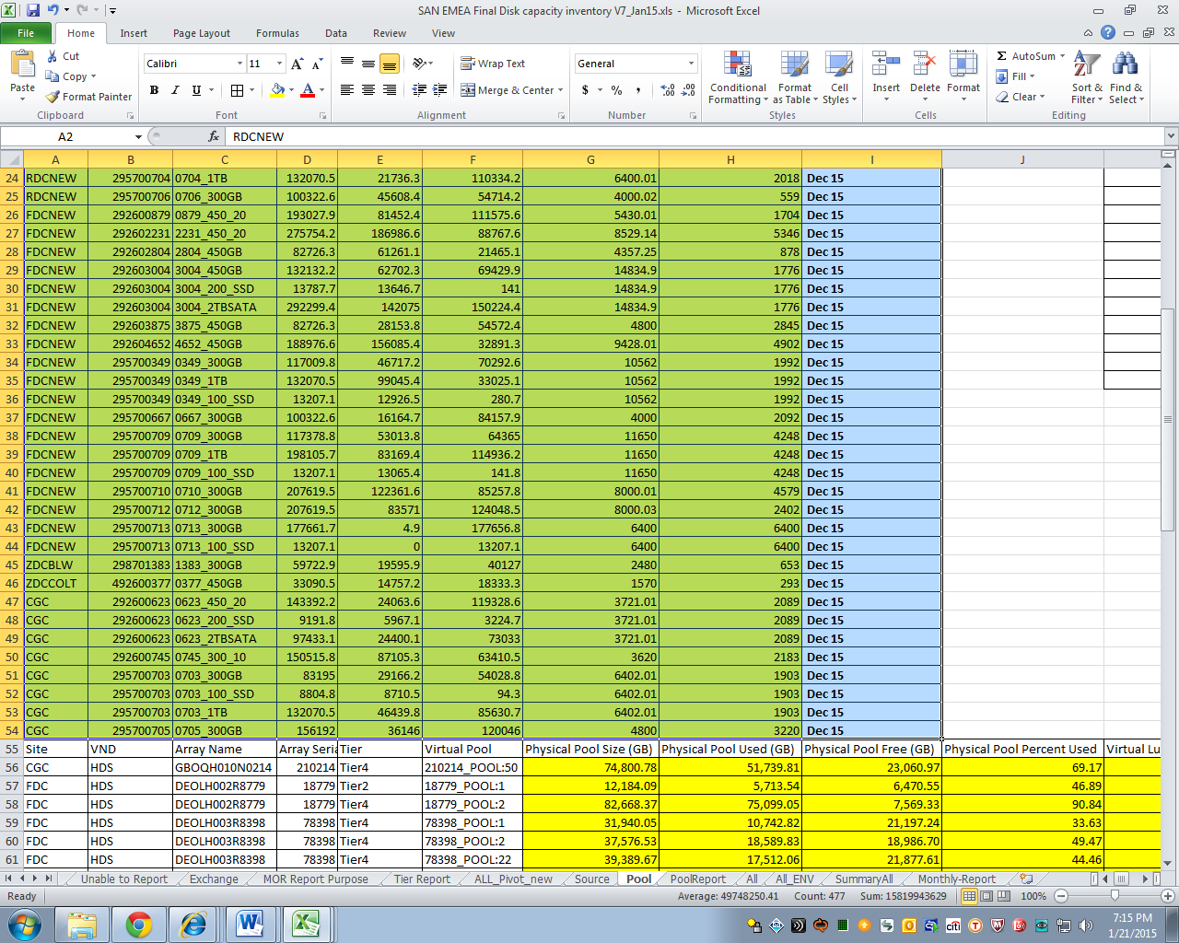
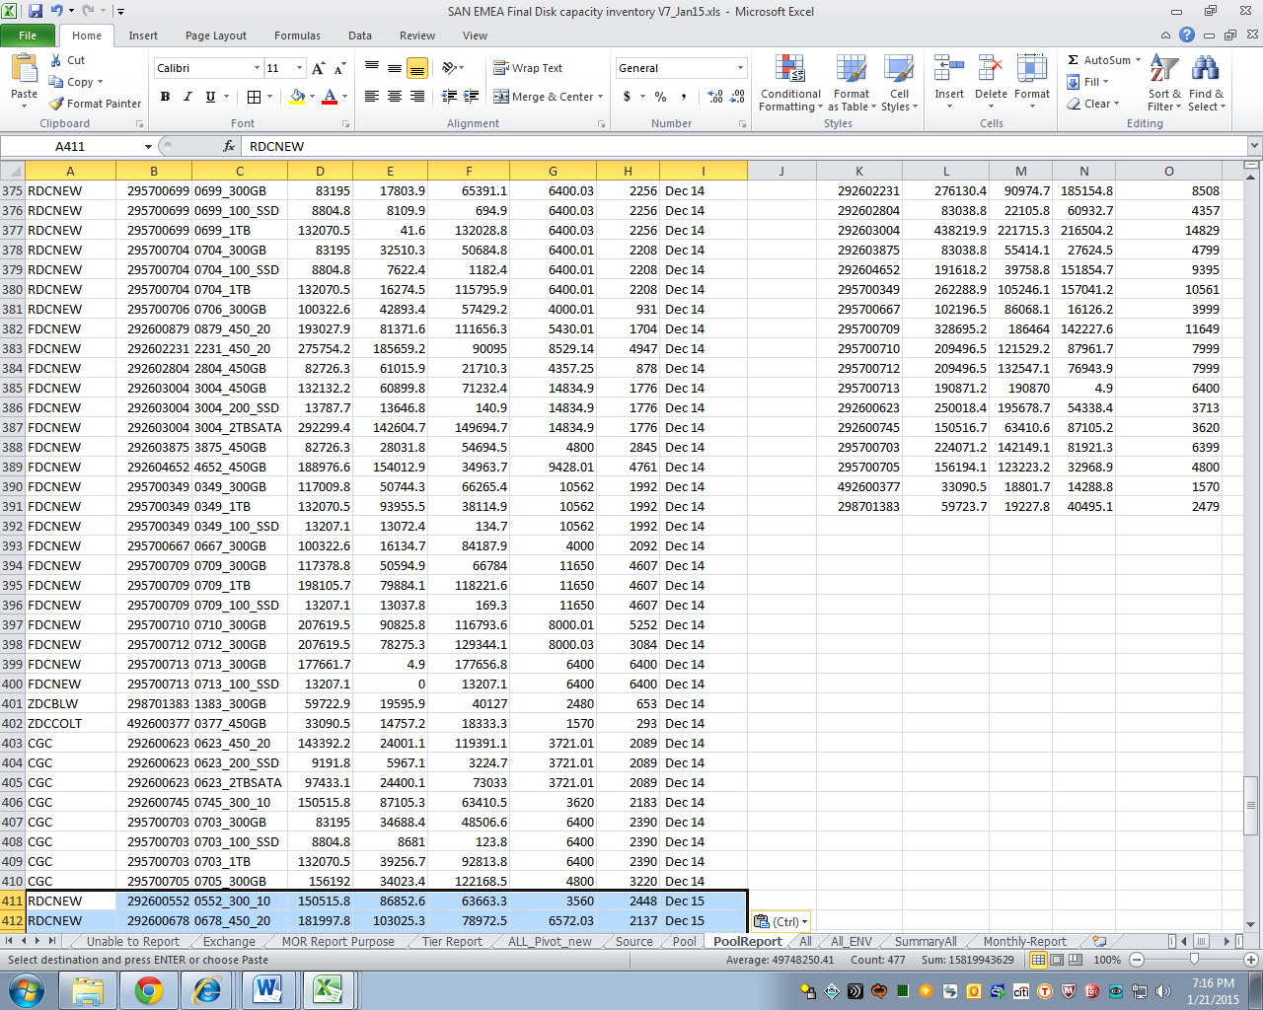
- Copy K1 to R34 of the Pool tab to K411 of the Pool Report tab.
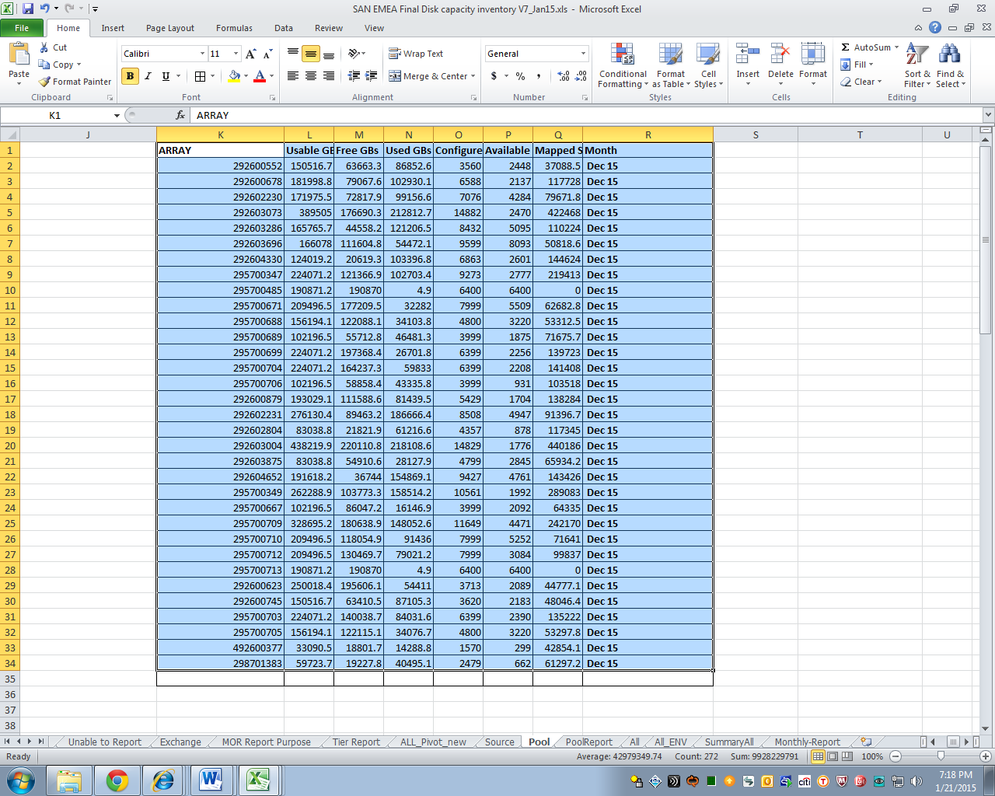
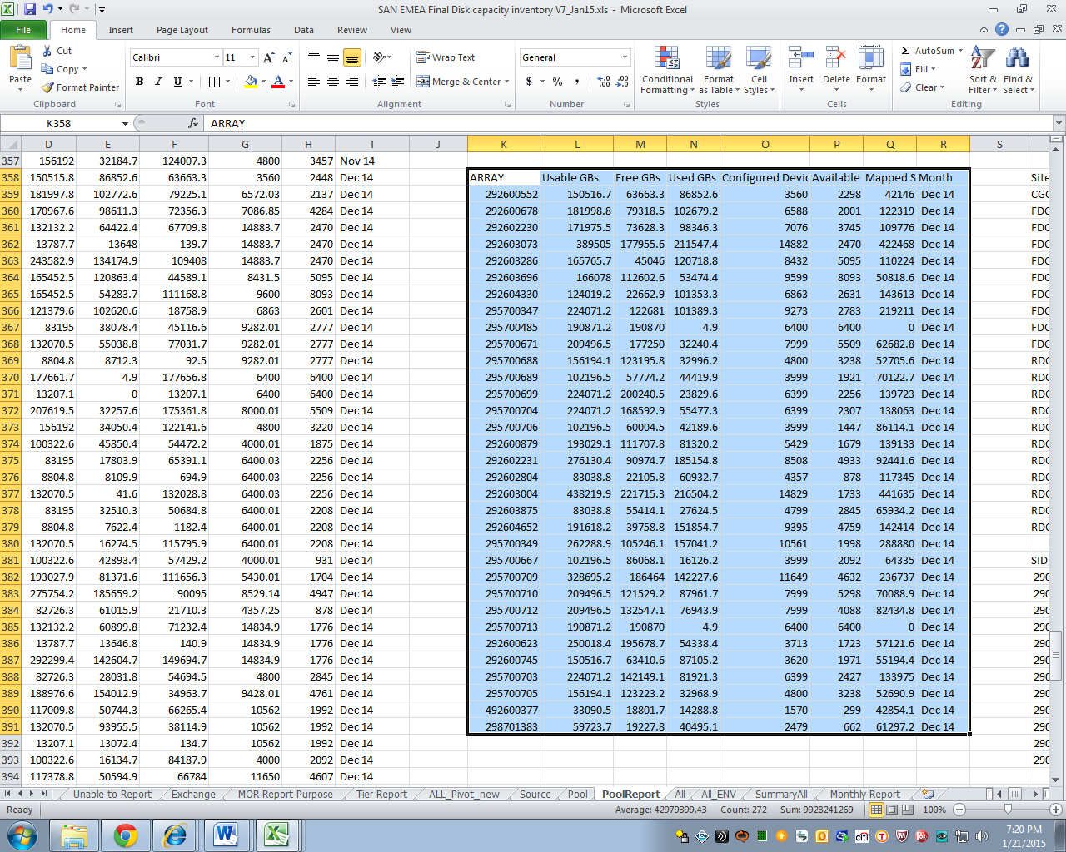
- Copy A55 to T76 of the pool tab to T411 of the Pool Report tab.
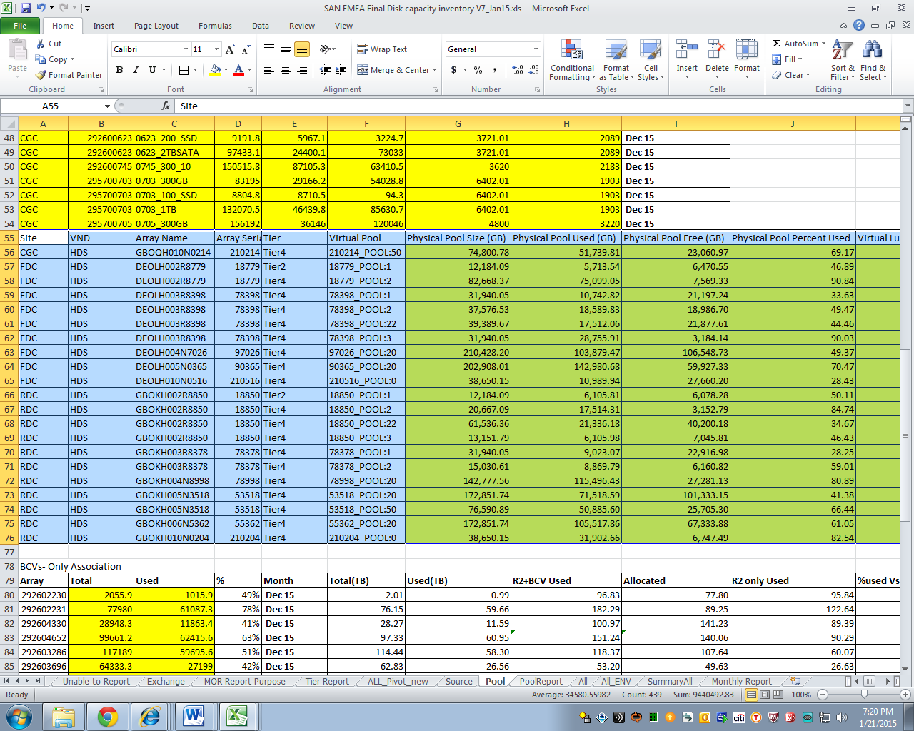
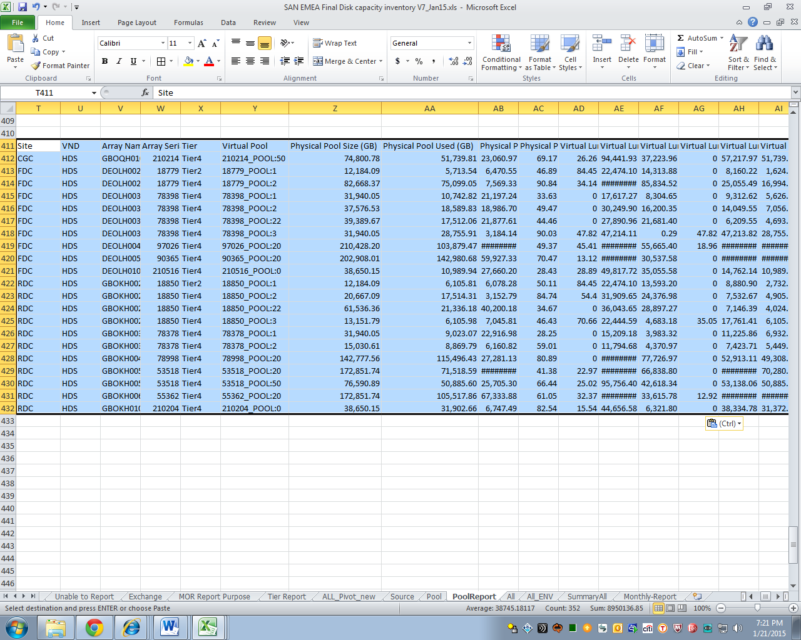
- Copy A91 to D103 of the Pool tab to T434 of the Pool Report tab.
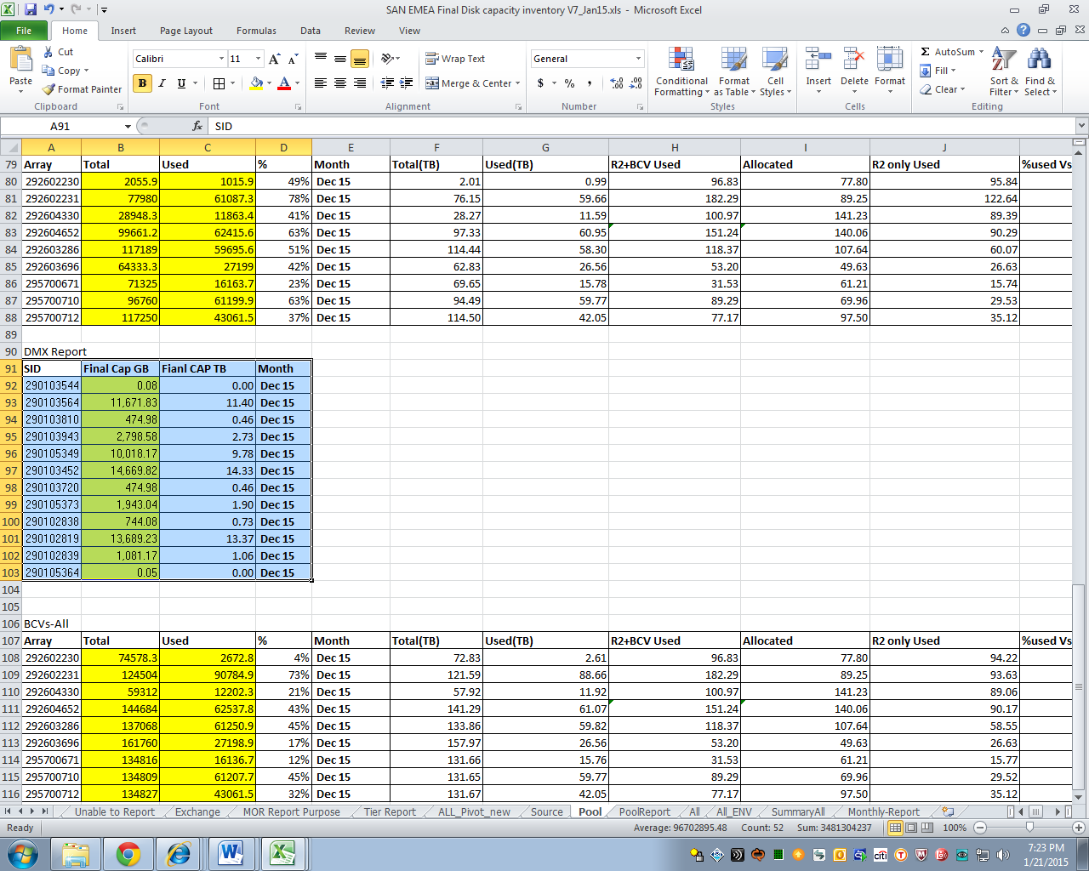
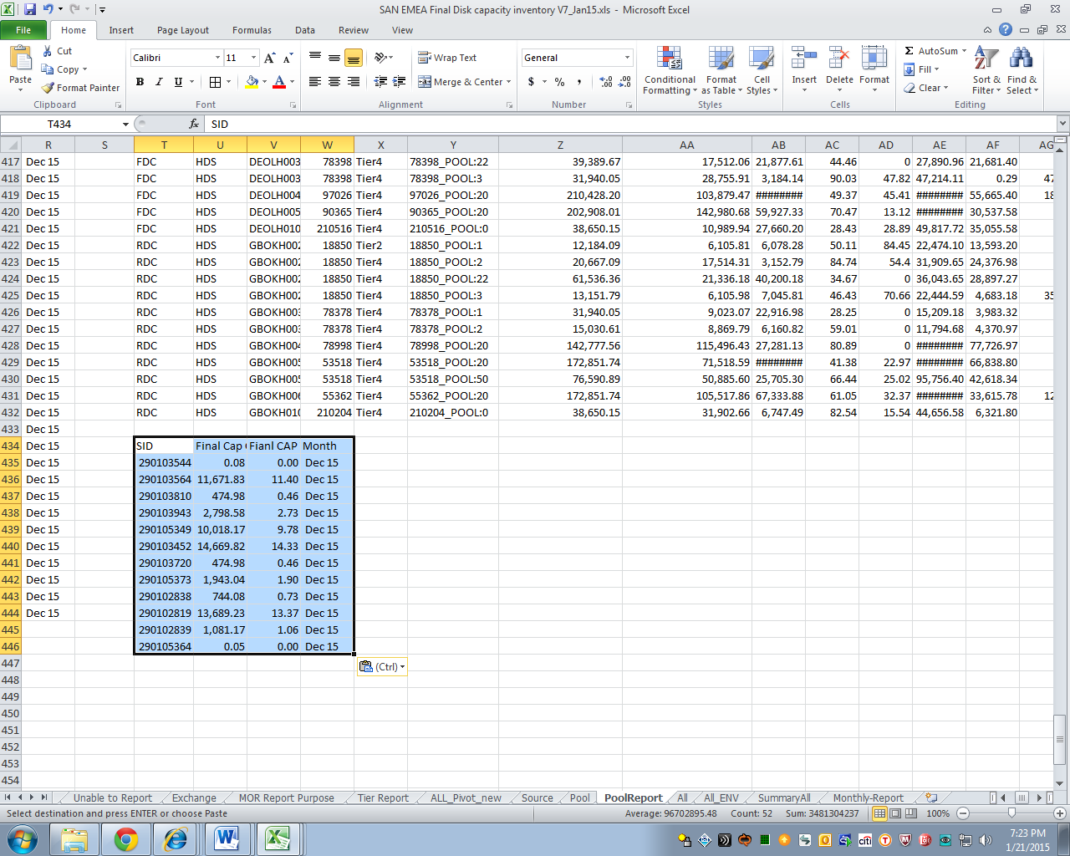
- Copy A78 to L88 of the Pool tab to Y434 of the Pool Report tab.
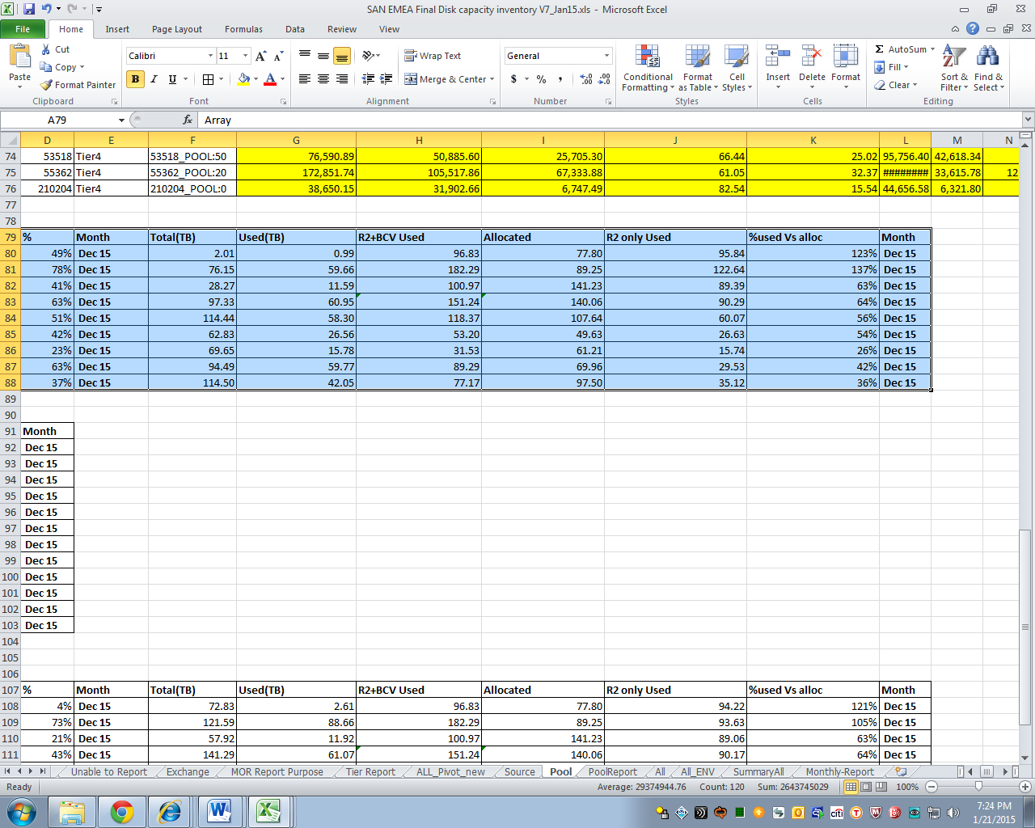
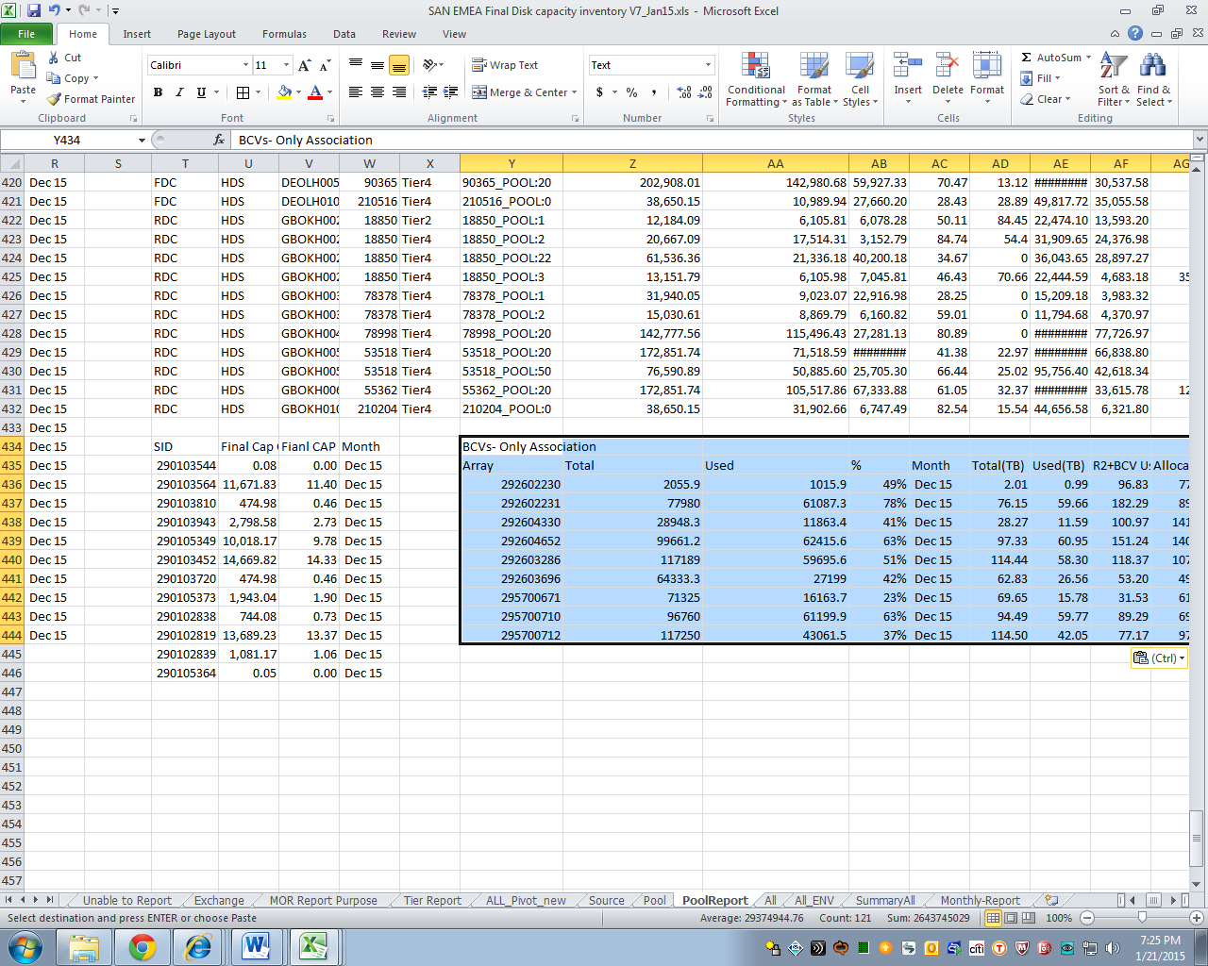
- Copy A106 to L116 of the Pool tab to Y446 of the Pool Report tab.
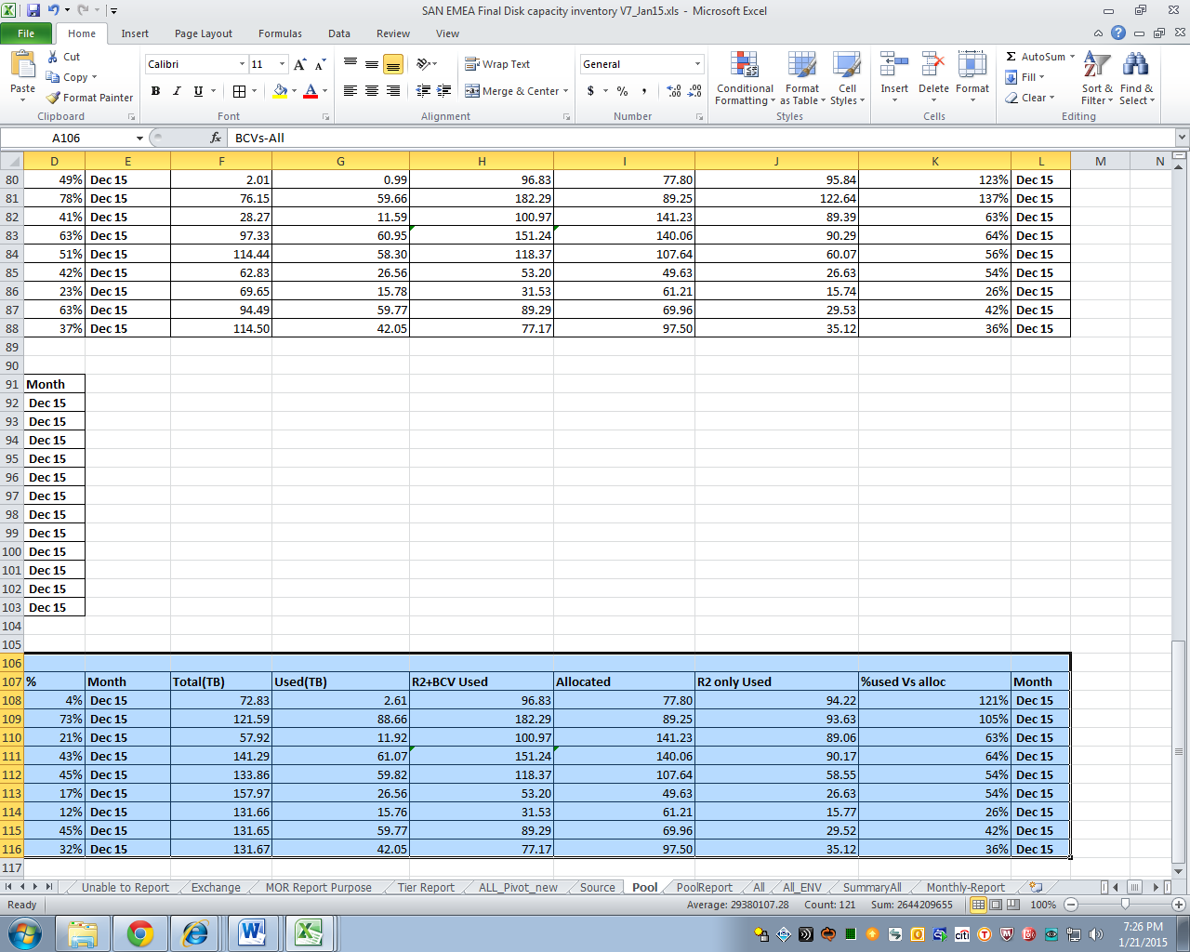
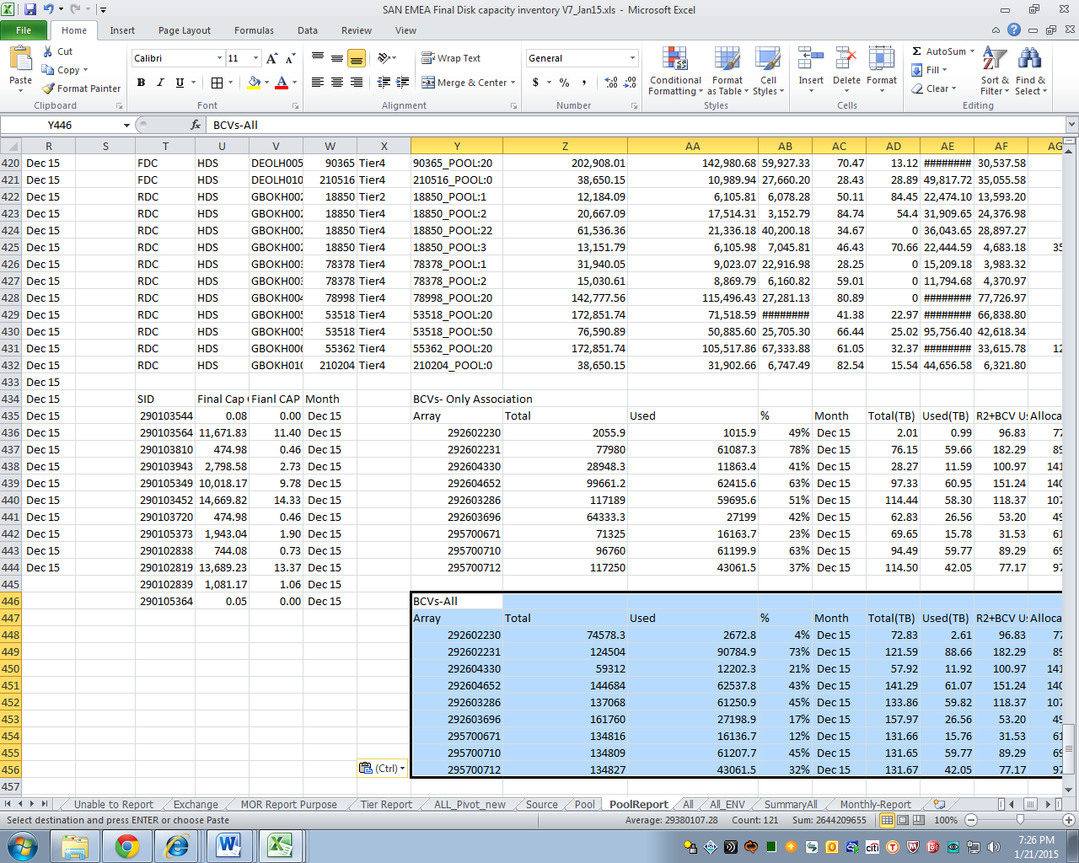
- Go to the first tab of the file (Summary tab). Refresh all tabs with pivot tables:
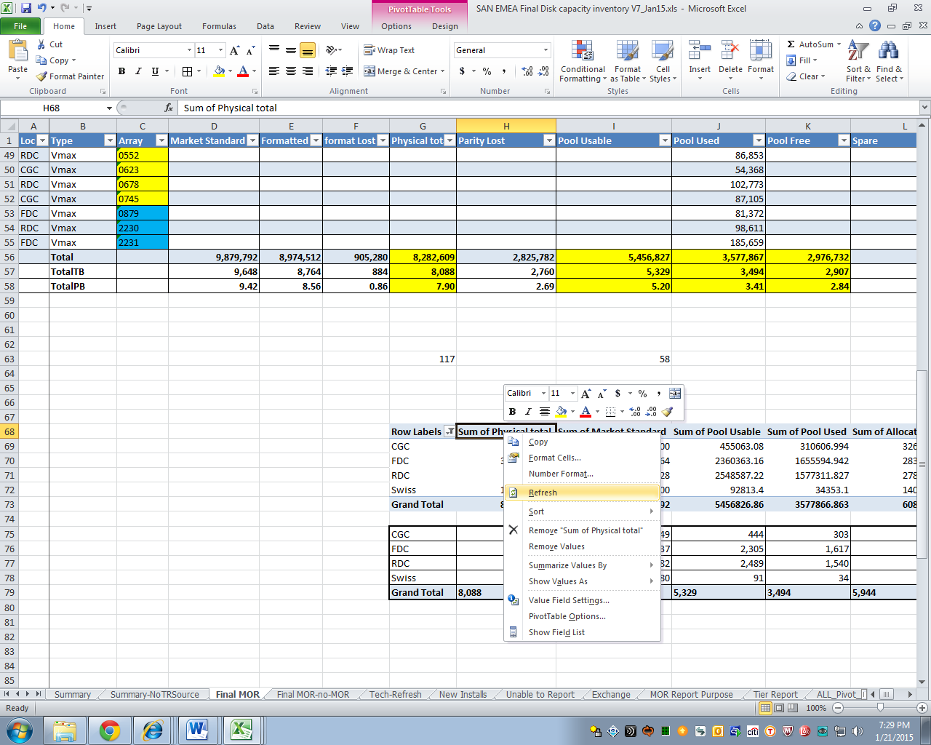
- In the Summary All tab (2nd to the last tab), highlights rows 1 to 30. Copy.
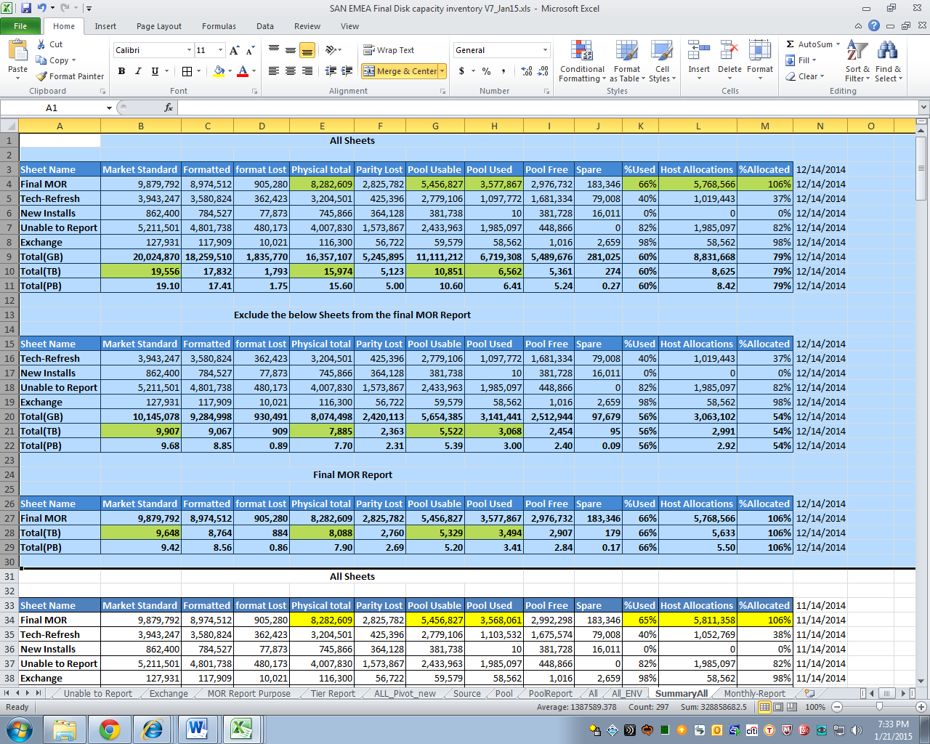
- Insert Copied Cells on row 1.
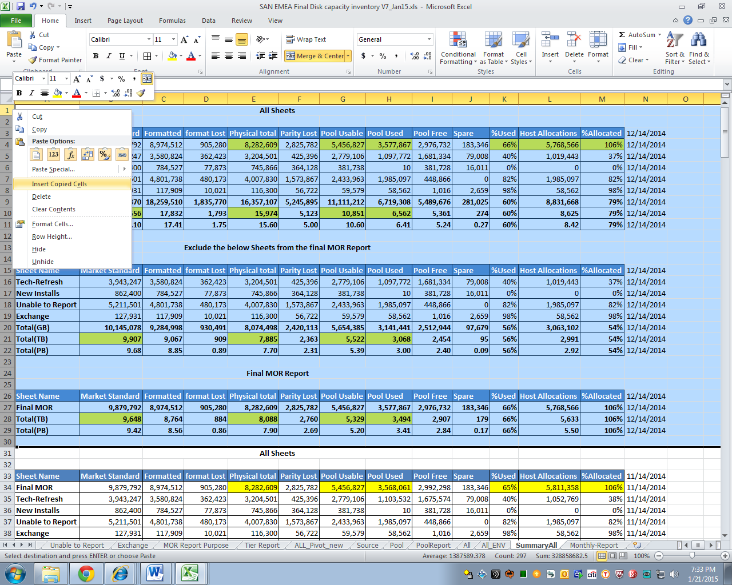
- On column N, change to the current month’s (and year’s) 14th.
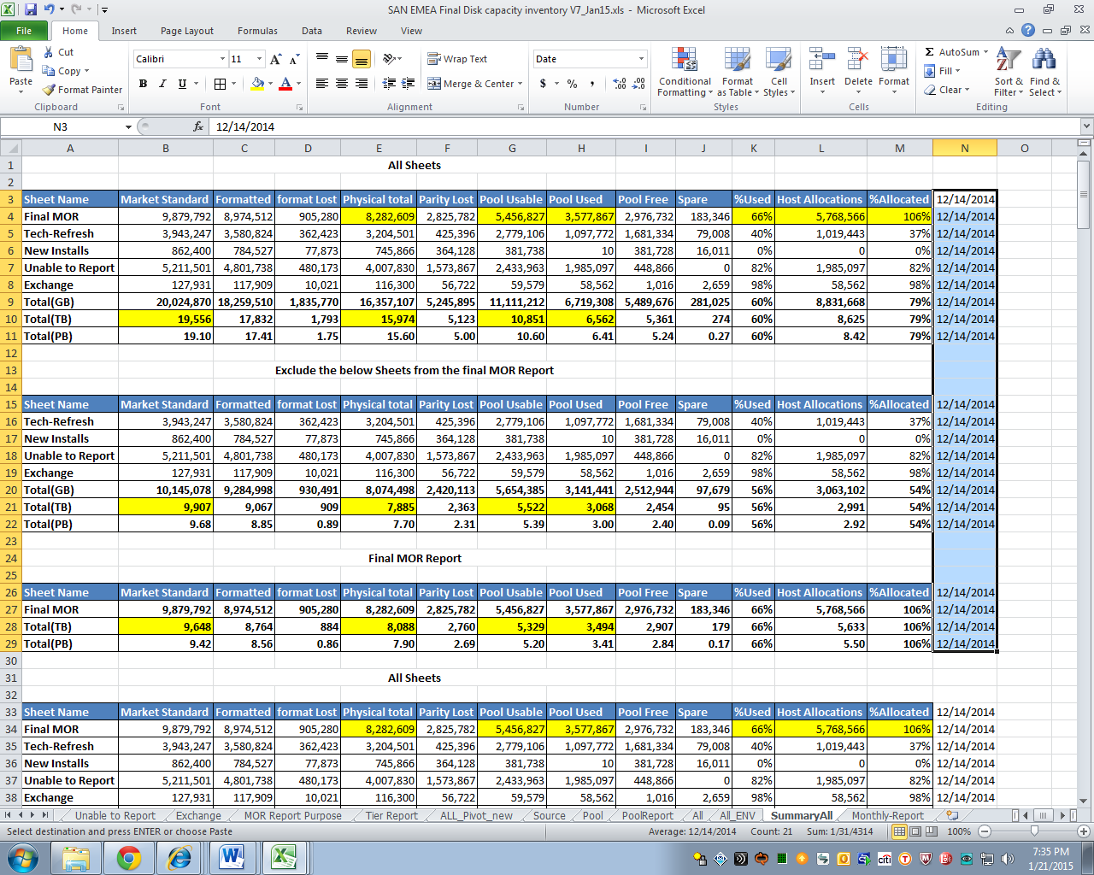
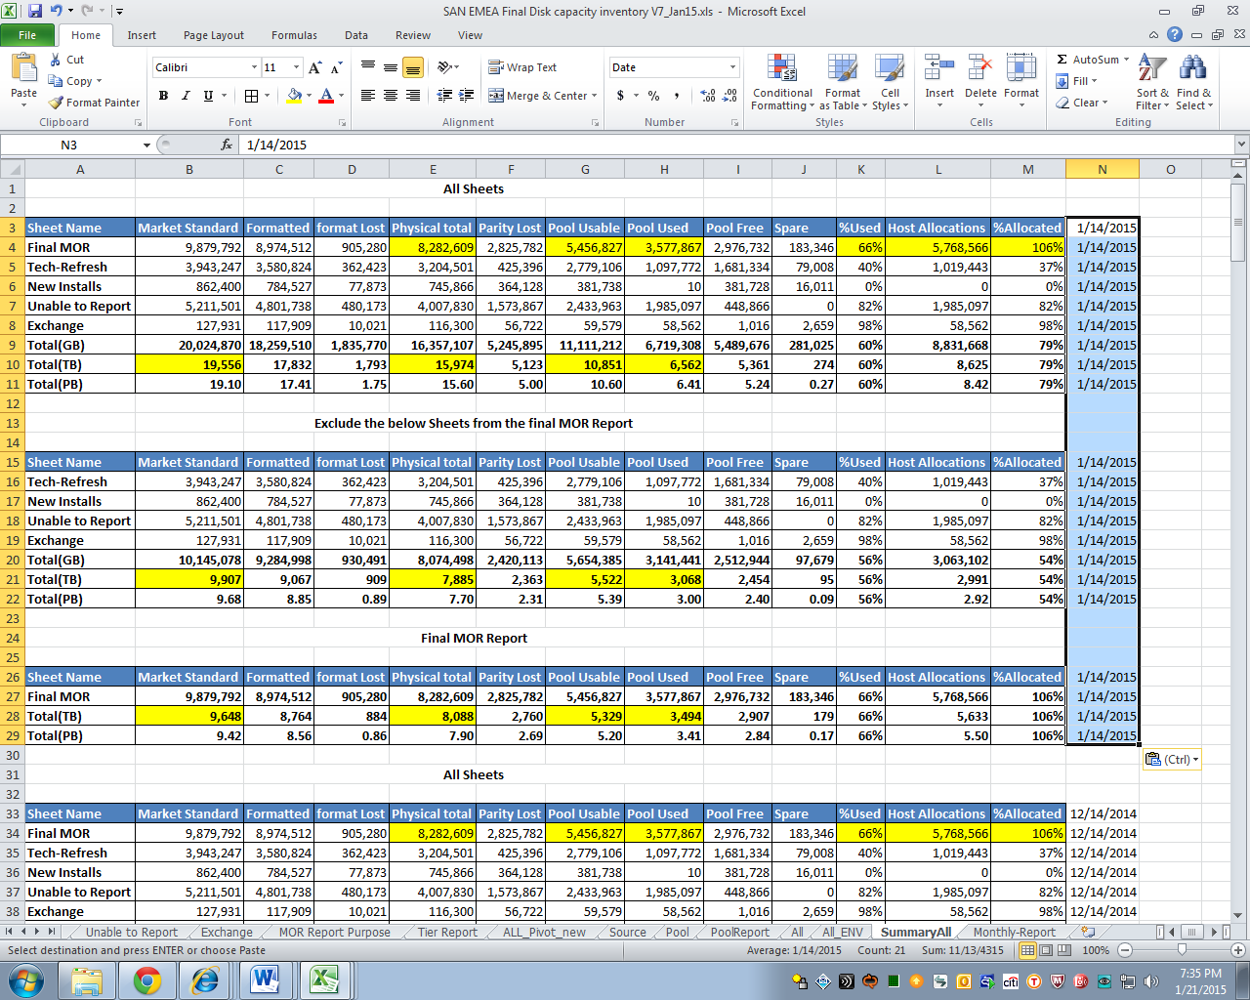
- On the Summary tab, copy all data from A1 to A1 of the Summary All tab. Paste Values Only.
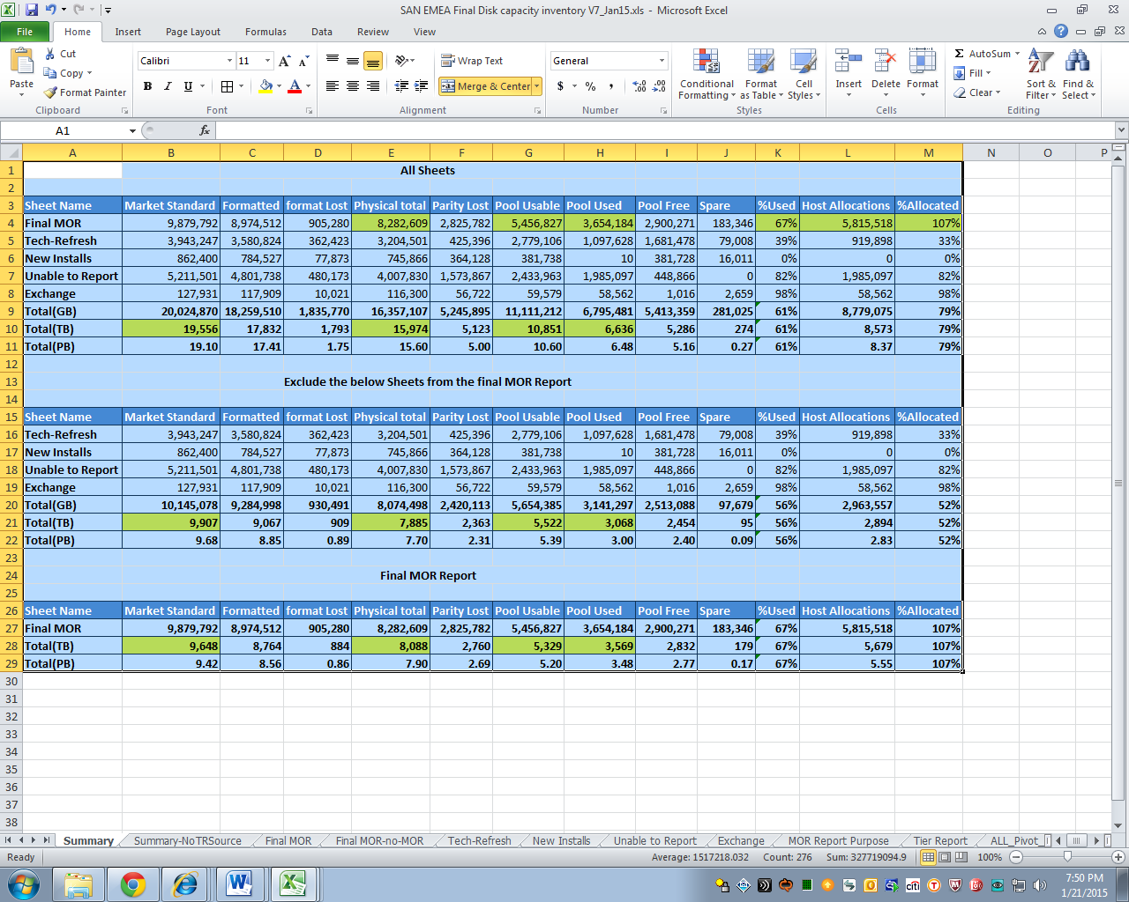
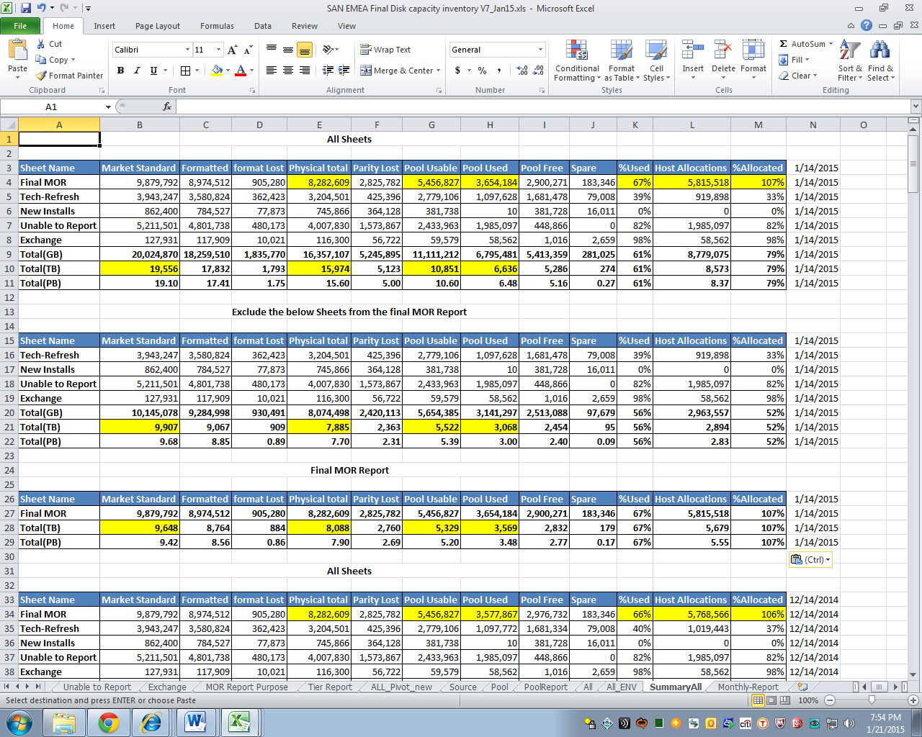
- Repeat step 33.
- On the Monthly Report tab (last tab). Copy the last entry (in this example row 13) to the row below (row 14). This gets adjusted accordingly as new information are added.
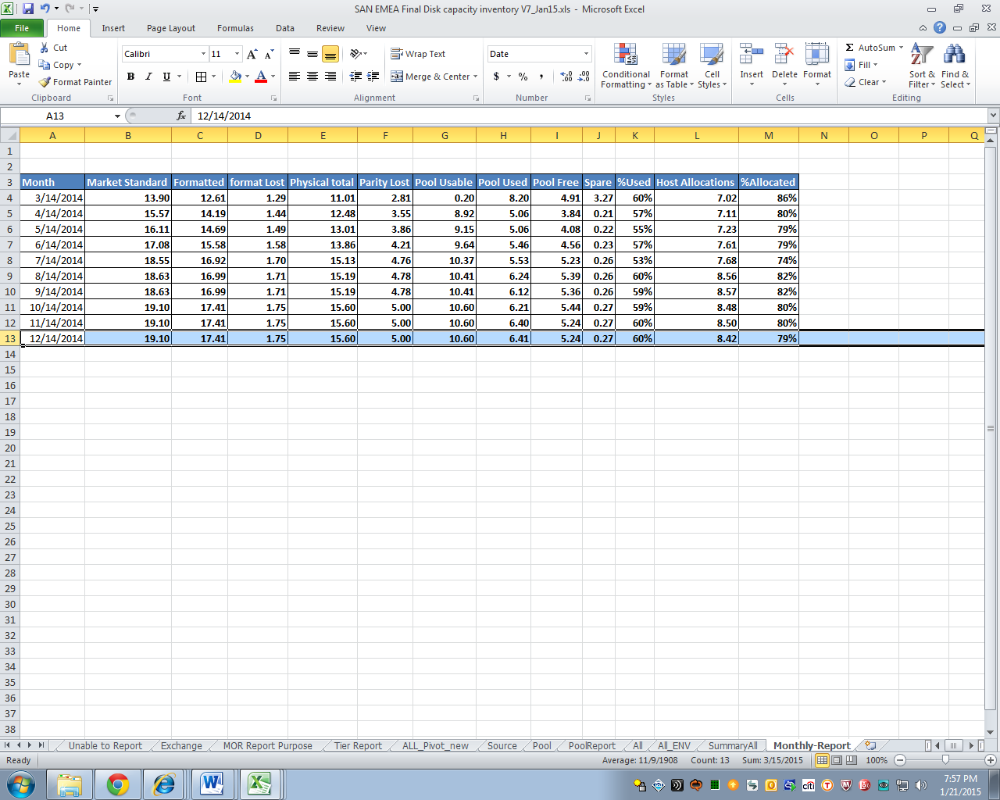
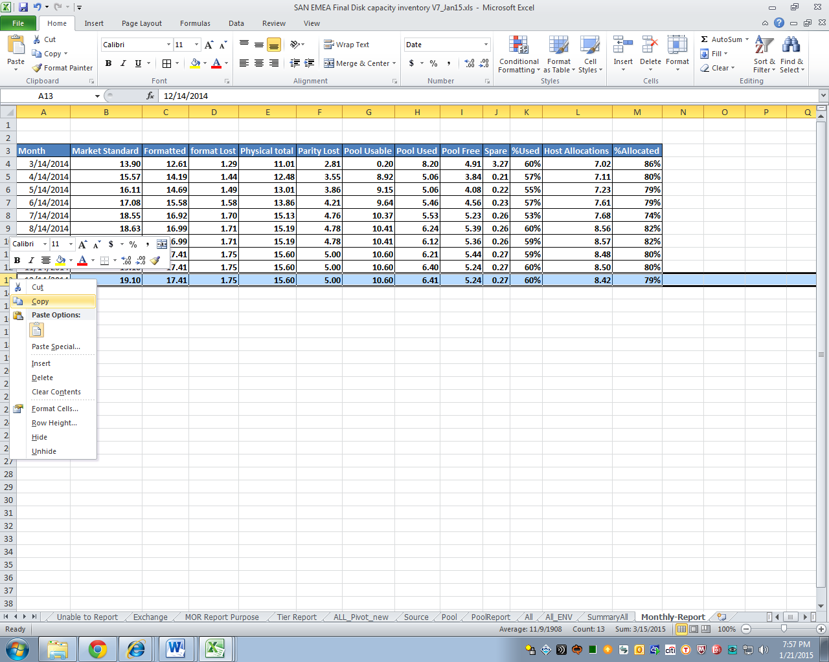
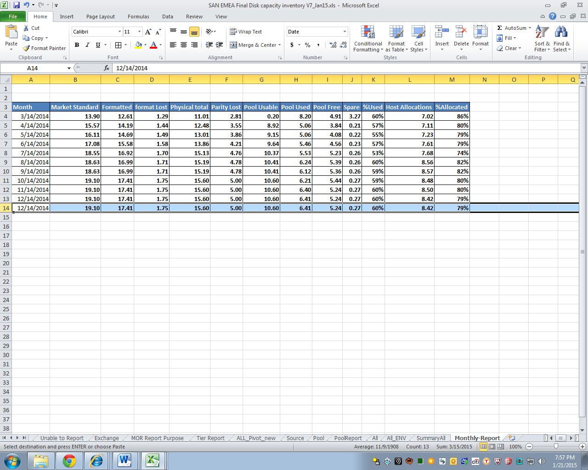
- On the Summary All tab, highlight and copy cells B11 to M11 to B14 to M14 of the Monthly Report tab.
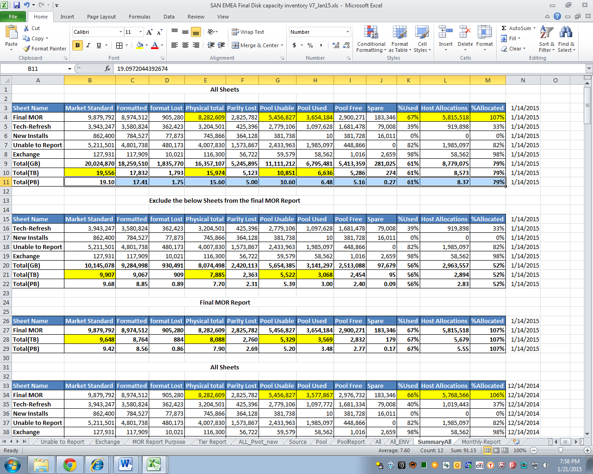
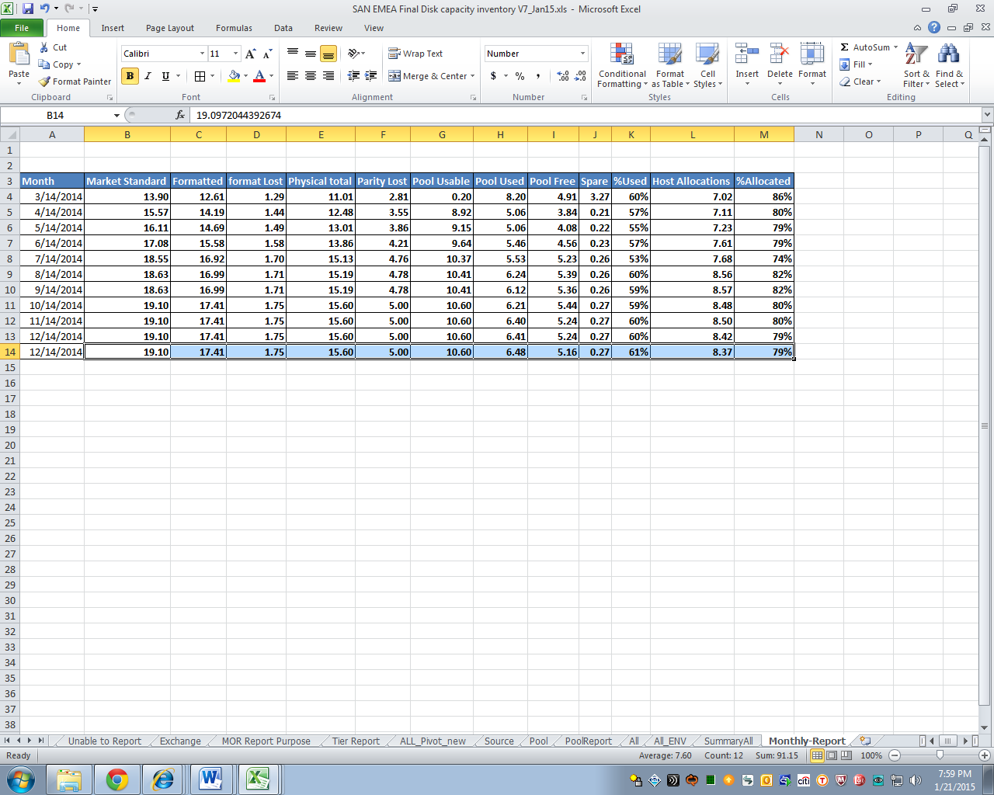
- Make sure to update the date of the latest information on cell A14 to the latest date.
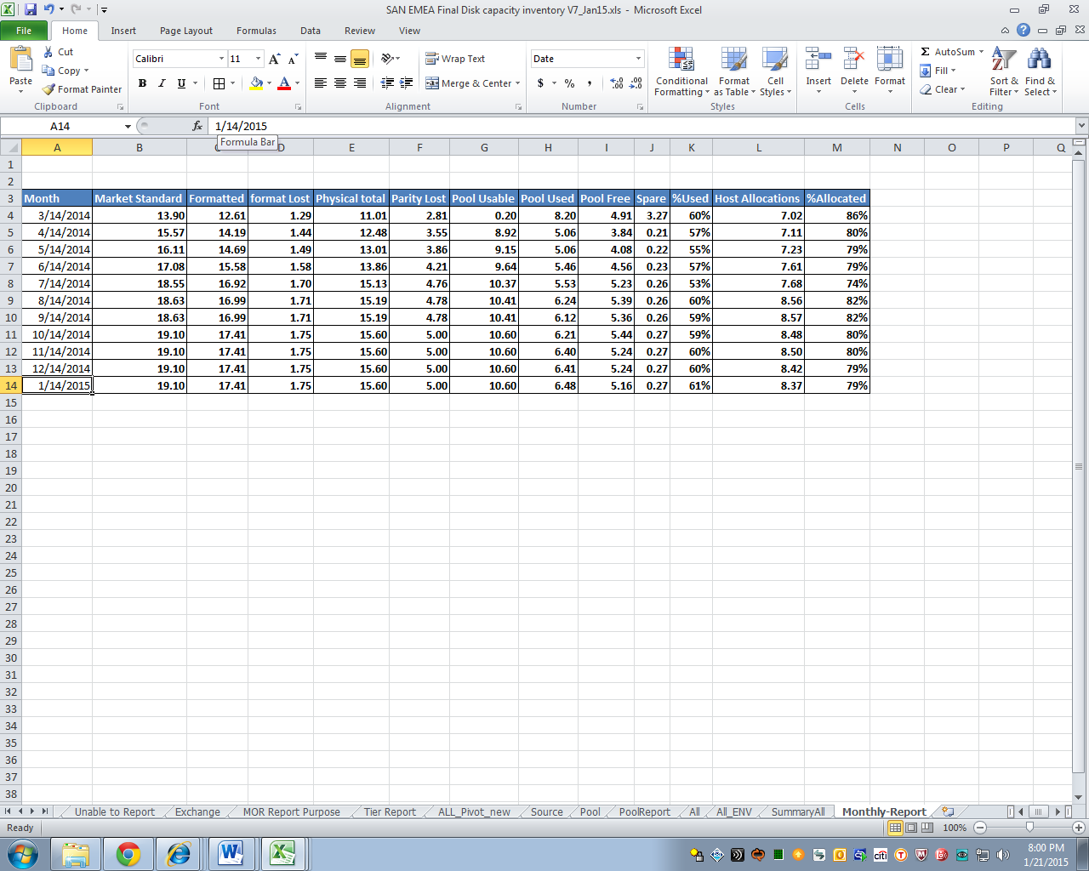
- Repeat step 33.
- Don’t forget to save and make sure to work on a new copy as soon as you open the former month’s version to have a backup.

