EMEA SAN MOR REPORT PROCEDURE

Global Distributed Storage Engineering

DRAFT

Version Control

Version | Date | Author | Reviewed | Comments
0.1 | 15/09/2011 | Adam Radage |  | Draft
0.2 | 28/05/2011 | Adam Radage |  | Updated
0.3 | 16/07/2012 | Adam Radage |  | Updated
0.4 | 03/08/2012 | Adam Radage/Ali Cairns |  | Updated & Tested

Contents

Version Control 2
Contents 3
1 Introduction 5
1.1 Overview 5
1.2 Purpose 5
1.3 Audience 5
2 Reporting Infrastructure and Process Overview 6
2.1 Overview 6
2.2 EMEA Datacenters 6
2.3 Report Sources 6
2.4 Report Frequency 7
2.5 Report Recipients 7
2.6 Report location 7
3 ECC Data gathering process 7
3.1 RDC, FDC & CGC EMC ControlCenter Environments 7
3.2 Pre-Process Data Generation Tasks 8
4 MOR Data Gathering Process 13
4.1 HostSector Data 13
4.2 Source Data 16
4.2.1 Vmax – 16
4.2.2 HDS - 16
4.2.3 DMX – 17
4.3 New Sheets 17
4.4 VMAX data 17
4.5 HDS data 22
4.6 DMX data 25
4.7 DMX Volume Group/File System Usage 27
5 Report Generation 28
5.1 Merging the data 28
5.2 Adjusting for Thin Storage 29
5.3 Optimisation 29
5.4 Building the MOR Report 30
5.5 SANScreen & Switch Report 33
5.6 RAID5 % Value 34
5.7 Tech Refresh 35
5.8 FTE 36
5.9 Comments 36
5.10 Report Submission 36
6 MOR Detail Report 36

- Introduction

Overview
The EMEA DS SAN team has been tasked to produce reports for a number of audiences. These reports vary greatly in detail, as does the source data and the procedures required to gather and process the information. The various audiences rely on these reports for their own purposes and consequently the reports’ reliability is highly important to them.

Purpose
This document provides an overview of the reporting scope, frequency and various data collecting and processing procedures, the tools and connectivity required and the types of sources from which the information is gathered.

Audience

The audiences include the EMEA Host Billing Team, the EMEA Business Office Team and Global Storage Management among others.

- Reporting Infrastructure and Process Overview

Overview

This document provides the procedure mainly for the MOR Report that is required by the Global storage Management. It also sets out other related reports that the parts of the MOR report may require.

The reporting process contains both a number of manual tasks, some of which require a number of different steps. The origins of the reporting data comprise several sources, which are generally databases from various business applications or command line output. These are described in a later section.

EMEA Datacenters

The datacenters in EMEA are as follows:

- RDC
- CGC
- FDC
- IXE (now obsolete)
- EDC (Meerbuch)
- Welle
- Poland (Senatorska & Golesowska)
- Russia (Moscow)
- Turkey (Tekfen & Yilmaz)
- Switzerland (Reitergasse & COLT)

Report Sources

The report sources are as follows:

    - ECC
    - SANScreen
    - CICSO Device Manager
    - Connectrix Manager
    - HDS Device Manager
    - SYMCLI
    - HDS CLI
    - Clariion Navsecicli

Report Frequency

The reports need to be generated on a monthly basis, and to be submitted by the 27th day of the month.

Report Recipients

Once the MOR report has been uploaded to the sharepoint site (see below), the following need to be informed that the latest report is now available:

- *GT EMEA TI MOR
- ‘GMOR@globalconsumer.collaborationtools.consumer.citigroup.net’
For the MOR Detail Report, email it to the following:

- Bachant, John [CCC-OT_IT]; Mahmood, Afzal [CCC-OT_IT]; Krishnakumar, Pazhore [CCC-OT_IT]; Borromeo, Raymond [CCC-OT_IT]; Zhou, Angela [CCC-OT_IT];

Report location

The MOR report should be uploaded to the appropriate date directory in the following sharepoint:

- https://globalconsumer.collaborationtools.consumer.citigroup.net/sites/EMEA_DOI/san/Shared%20Documents/Forms/AllItems.aspx?RootFolder=%2fsites%2fEMEA%5fDOI%2fsan%2fShared%20Documents%2fEMEA%20SAN%20MOR%20Metrics&FolderCTID=&View=%7b0758BE2F%2dC431%2d4175%2dB6E9%2d07D7557279F5%7d (Product Support - EMEA DS Storage and Backups > Product Support - EMEA DS SAN > Shared Documents > EMEA SAN MOR Metrics)

ECC Data gathering process

RDC, FDC & CGC EMC ControlCenter Environments

There are three Access databases that are dynamically linked to the three ECC repositories:

    - RDC_Capacity_Reports.mdb
    - FDC_Capacity_Reports.mdb
    - CGC_Capacity_Reports.mdb
A fourth database is linked to the three databases and merges the data from all four sources:

    - All_Capacity_Reports.accdb
A number of common tables are held within the following database which all four databases link to:
    - Core_Tables.mdb
This database possesses tables containing Tier levels, arrays SAN & site names. The site names are required to prevent array data being presented twice. The three ECC environments may each possess array data, and remote arrays data may not be comprehensive. The ‘Location’ table in the Core_Table.mdb database is used in the queries to ensure the arrays are presented with the correct site name.

Pre-Process Data Generation Tasks

Before this report can be generated it is essential that all the source data has been updated and the latest data exported to Excel spreadsheets.

Perform the following steps:

- Go to ‘T:\Capacity Reporting’ and open ‘RDC_Capacity_Reports.mdb’. The following window will appear:

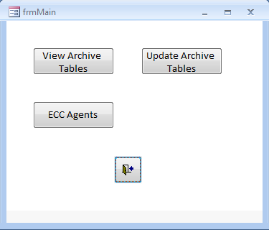

- Click on ‘Update Archive Tables’. The following window will appear:
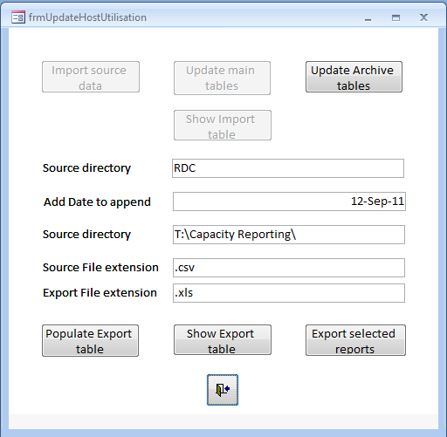

- Important: Update the date in the ‘Add Date to append’ textbox.
- Click the ‘Update Archive tables’ button
- When prompted by the following window, type in ‘sts’ into the password window:

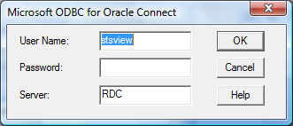

- Click through all the ‘Complete’ windows that appear. Finally Update Complete will come.

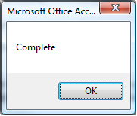

- Once complete, click on the ‘Show Export table’ button and the following window will appear:
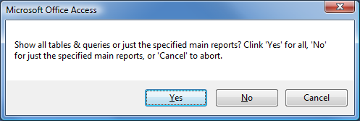

- Click ‘Yes’ to view all tables and queries. Click ‘No’ to view just the common queries that are used for report generation. Unless a new or specific query or table is to be required, then click ‘No’. The following window will appear:

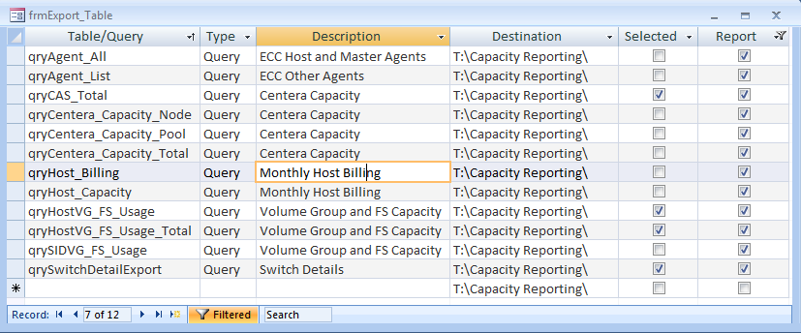

- The list shows all the ‘favourite’ queries. Click the ‘Selected’ option for all reports to be generated. Select the following:

    - qryCAS_Total Centera Capacity
    - qryCentera_Capacity_Node Centera Capacity
    - qryCentera_Capacity_Pool Centera Capacity
    - qryCentera_Capacity_Total Centera Capacity
    - qryHostVG_FS_Usage MOR Report/VG_FS Report
    - qryHostVG_FS_Usage_Total MOR Report/ VG_FS Report
    - qrySwitchDetailExport MOR Report/Switch Report

- Close the window and click on the ‘Export selected reports’ button
- These reports will be output to ‘T:\Capacity Reporting’
- Go to ‘T:\Capacity Reporting’ and open ‘FDC_Capacity_Reports.mdb’
- Run through the steps 2 to 7 above, but select the following reports when the ‘Show Export table’ button is clicked:

    - qryHostVG_FS_Usage MOR Report/VG_FS Report
    - qryHostVG_FS_Usage_Total MOR Report/ VG_FS Report
    - qrySwitchDetailExport MOR Report/Switch Report

- Close the window and click on the ‘Export selected reports’ button
- These reports will be output to ‘T:\Capacity Reporting’
- Go to ‘T:\Capacity Reporting’ and open ‘CGC_Capacity_Reports.mdb’
- Run through the steps 2 to 7 above, but select the following reports when the ‘Show Export table’ button is clicked:

    - qryHostVG_FS_Usage MOR Report/VG_FS Report
    - qryHostVG_FS_Usage_Total MOR Report/ VG_FS Report
    - qrySwitchDetailExport MOR Report/Switch Report

- Close the window and click on the ‘Export selected reports’ button
- These reports will be output to ‘T:\Capacity Reporting’
- Go to ‘T:\Capacity Reporting’ and open ‘All_Capacity_Reports.accdb’. The following window will appear:

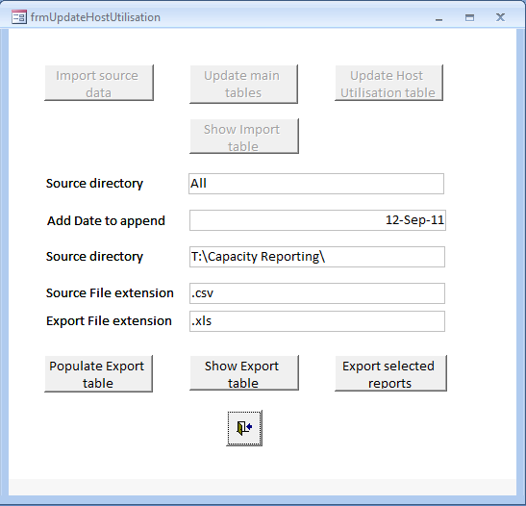

- Click the ‘Show Export table’ button and select the following:

  - qrySymmetrix_Capacity_Latest_TB Weekly SAN Metrics Requirements
  - qrySymmetrix_Capacity_Latest_TB_Tier_Crosstab Capacity by Tier
  - qry_Array_Summary MOR/Smart Reports
  - qry_Host_List Storage Productivity

- Note: This will connect with all three ECC repositories. And will request each password (‘sts’). Normally one will fail to connect, in which case, open the STSVIEW_STS_ARRAY_RDC, STSVIEW_STS_ARRAY_FDC & STSVIEW_STS_ARRAY_CGC in turn to establish the connection, and then try the Export again.

- These reports will be output to ‘T:\Capacity Reporting’.

- Move the below files into E:\Capacity Reporting\MOR_Metrics\Reports\YYYY\YYYY-MM\ECC DB folder

- RDC_qryCAS_Total
- RDC_qryCentera_Capacity_Node
- RDC_qryCentera_Capacity_Pool
- RDC_qryCentera_Capacity_Total
- <SITE>_qryHostVG_FS_Usage
- <SITE>_qryHostVG_FS_Usage_Total
  - <SITE>_qrySwitchDetailExport
  - All_qrySymmetrix_Capacity_Latest_TB
  - All_qrySymmetrix_Capacity_Latest_TB_Tier_Crosstab
  - All_qry_Array_Summary
  - All_qry_Host_List

MOR Data Gathering Process

HostSector Data
- Download the latest CSI_Data Report from the following location, though it is normally the previous month’s date:
https://catecollaboration.citigroup.net/entarch/eagovernanceinternal/Open%20Access%20Library/Forms/AllItems.aspx?RootFolder=%2Fentarch%2Feagovernanceinternal%2FOpen%20Access%20Library%2FReports&View=%7bC67A3ABC%2d7229%2d49C6%2dA744%2d92784CF68B2D%7d
- It will be under the current year directory and is normally named: ‘CSI_Metrics_File_<yyyymm>.zip’.
- Save it to the E:\Capacity Reporting\MOR_Metrics\Reports\<Year>/<year-Month>/Data folder and save a compressed copy.
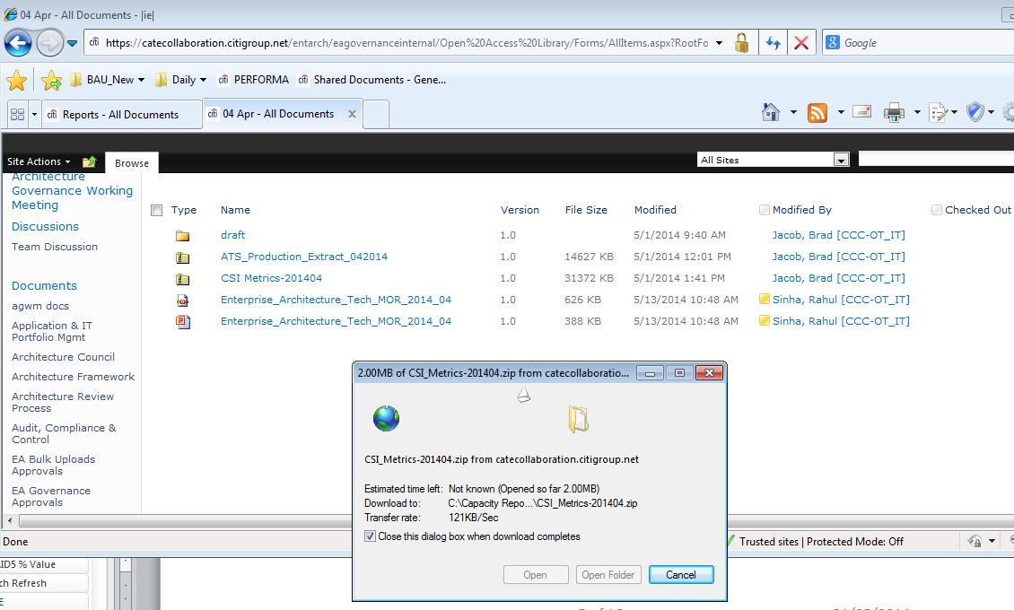
- Open the new file and copy the ‘Details’ sheet to the ‘HostSector’ spreadsheet, found in the E:\Capacity Reporting\MOR_Metrics\Reports\<Year>/<year-Month>/Data” folder.
- Remove all columns except:
- Sector Sort
- Sector
- Level2
- Applicationfamily
- Applicationtype
- Productid
- App Id
- App Name
- Move the data in the ‘Details’ sheet over to the ‘CSI’ sheet in the spreadsheet and overwrite.
- Download the latest TAS report, called ‘Server_Appid_inv_Emea_Ecc.csv’, from the following location:
- http://wem.nam.nsroot.net/ReportCenter/Public/CTIReports/Forms/AllItems.aspx?RootFolder=%2fReportCenter%2fPublic%2fCTIReports%2fdatafeeds&FolderCTID=0x012000D240FA796BF4AD438EE32AF583409EFA

- Save to the following location and create a compressed copy:
‘‘T:\Capacity Reporting\MOR_Metrics\<Year>/<year-Month>/Data
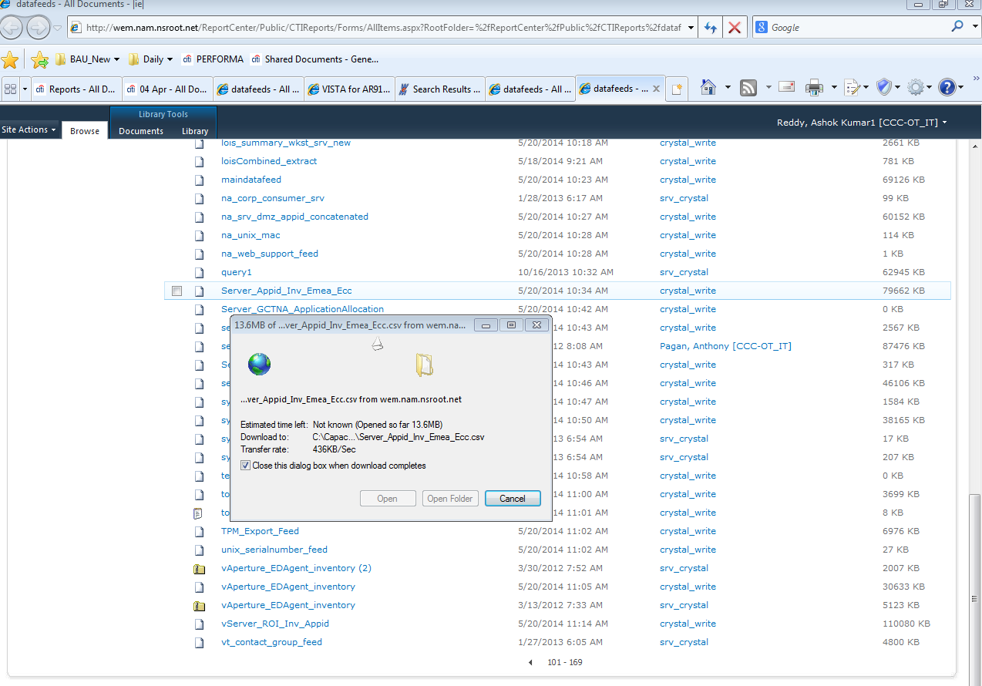
- Import it into the Server_Appid_inv_Emea_Ecc.csv’ (open new excel file and go to Data menu and select "from text " and select the appid_inv_emea_ecc.csv file . while import select seperate as "|" and complete the import ) spreadsheet at the same location and removing all columns except:
- Systemname
- Systemtype
- AppID
- AppName
- Region
- City
- Building
- Filter Region and select only EMEA and copy the records to TAS_IMPORT Sheet
- Copy the following fields into the ‘TAS’ sheet of the HostSector.xls’ spreadsheet:
- Systemname – copy to Column A
- AppID – Copy to Column B
- Copy the following fields from the ‘CSI’ sheet to the ‘TAS’ sheet in the ‘HostSector’ spreadsheet:
- Sector Sort - copy to Column F.
- App Id - copy to Column E.
- Ensure all formulae are copy down in columns C (=VLOOKUP(B2,E:G,3,FALSE) ) and G (=VLOOKUP(F2,I:K,3,FALSE) )
- In the HostSector sheet filter the data where Organisation is Other
- If the New Organisation has now been resolved then copy by value the new data from column C to column B
- Copy the values from E1:E6 –I1:I6 and paste as a values at the end and change the current month

Source Data

Vmax –
- Open the latest qryHost_Device_Utilisation_Latest_<yyyy_mm_dd>.xlsx report, or generate from the VMAX.mdb database. Ensure the Host Utilisation Tables Update has been run before exporting the report otherwise the output will be empty.

T:\Capacity Reporting\Gold Silver\Reports\<yyyy>\<yyyy-mm-dd\Vmax
- Copy the following fields from the report (qryHost_Device_Utilisation_Latest_<yyyy_mm_dd>.xlsx ) into the VMAX_MOR sheet of the DMX_HDS_vmax_Source<Month><year>.xls spreadsheet
- SID
- Cluster Group
- Hostname
- Device
- Device Capacity (MB)
- Allocated Capacity (MB)

HDS -
- Open the latest All_qryHostDeviceList_All_Level_<yyyy_mm_dd>.xlsx report, or generate from the HDS.mdb database. Ensure the Host Utilisation Tables Update has been run before exporting the report otherwise the output will be empty.

T:\Capacity Reporting\Gold Silver\Reports\<yyyy>\<yyyy-mm-dd\HDS
- Cluster name missing. So need to follow the below steps
  - Sort by by ‘Device’, then ‘Hostname’.
  - Add the three 'Calculation' fields to columns T, U and V. Use the formulae from a previous report. It is important to have sorted by Device then Hostname before adding the three Calculation fields:
  - Copy and ‘Paste by Value’ the ‘Cluster/Host Name’ from column ‘V’ to column ‘L’.

M | T | U | V
Device | Calc | Cluster/Host Name | Cluster/Host Name
18779_00:3C:17 | =IF(M2=M1,T1&"_"&E2,E2) | =IF(M2=M3,"",T2) | =IF(U2="",V3,U2)
18779_00:3C:17 | =IF(M3=M2,T2&"_"&E3,E3) | =IF(M3=M4,"",T3) | =IF(U3="",V4,U3)

- copy following fields from the Report All_qryHostDevicelist_All_Level.xls file to the ‘HDS_MOR’ sheet in the DMX_HDS Source_vmax_<Month><year>.xls spreadsheet
- Hostname
- Allocated GB
- Cluster/Host Name
- Device
- Consumed Capacity (GB)

DMX –
- Open the DMX_All_qryHostDeviceList_Level_<yyyy_mm_dd>.xlsx report, or generate from the DMX.mdb database. Ensure the Host Utilisation Tables Update has been run before exporting the report otherwise the output will be empty.

T:\Capacity Reporting\Gold Silver\Reports\<yyyy>\<yyyy-mm-dd\DMX

- Cluster name missing. So need to follow the below steps
- Sort by by ‘Device’, then ‘Hostname’.
- Add the three 'Calculation' fields to columns R, S and T . Use the formulae from a previous report. It is important to have sorted by Device then Hostname before adding the three Calculation fields:
- Copy and ‘Paste by Value’ the ‘Cluster/Host Name’ from column ‘T’ to column ‘L’.

M | R | S | T
Device | Calc | Cluster/Host Name | Cluster/Host Name
18779_00:3C:17 | =IF(M2=M1,R1&"_"&E2,E2) | =IF(M2=M3,"",R2) | =IF(S2="",T3,S2)
18779_00:3C:17 | =IF(M3=M2,R2&"_"&E3,E3) | =IF(M3=M4,"",R3) | =IF(S3="",T4,S3)

- copy following fields from the Report All_qryHostDevicelist_All_Level.xls file to the ‘DMX_MOR’ sheet in the DMX_HDS Source_vmax_<Month><year>.xls spreadsheet
- Hostname
- Allocated GB
- Cluster/Host Name
- Device

New Sheets
- Copy last month’s MOR report, called ‘EMEA SAN Data Input.xlsx’, to the new dated directory, in:
T:\CapacityReporting\MOR_Metrics\Reports\<yyyy>\<yyyy-mm-dd\
- Copy the following files from the previous month’s MOR data to a new subfolder called ‘data’ in the new MOR directory:
- VMAX.xls
- HDS.xls
- DMX.xls

VMAX data
- Open DMX_HDS Source_vmax_<Month><year>.xls sheet
- Open the VMAX.xls spreadsheet
- Go to Vmax_unique sheet ( and delete all the records except first record in Column A to H)
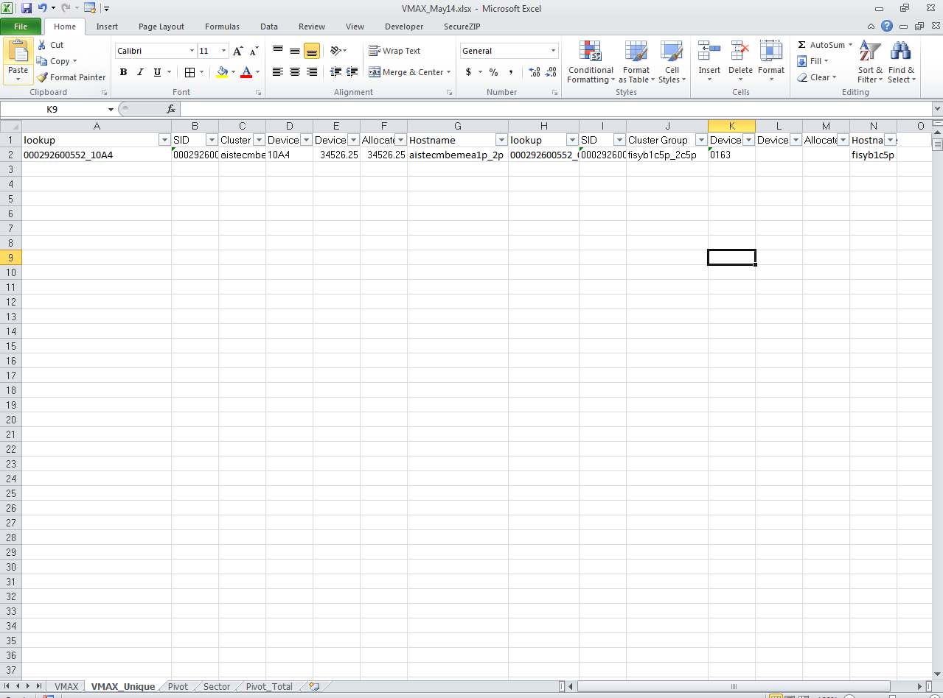
- Copy the following fields from the report (DMX_HDS Source_vmax_<Month><year>.xls ) into the VMAX sheet of the VMAX.xls spreadsheet
- SID
- Cluster Group
- Hostname
- Device
- Device Capacity (MB)
- Allocated Capacity (MB)
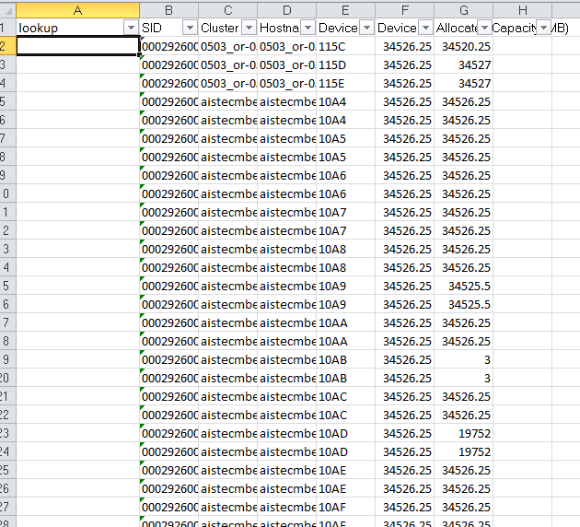

- Ensure the formulae (=B2 & "_" &E2 ) in column A are copied down
- Copy the following fields over to the ‘VMAX_Unique’ sheet
- SID
- Cluster Group
- Device
- Device Capacity (MB)
- Allocated Capacity (MB)
- Remove duplicates from columns B to F for to remove the Duplicate Entries
- As we found some Devices has having 2 entries in allocated Capacity. So need to perform again Remove Duplicate action. Need to highlight B to F and go to Data and select REMOVE DUPLICATE and uncheck F Column(Allocated Capacity ) ) and perform the action.
- Ensure the formulae in columns A (=B2 & "_" & D2 ) and G (=VLOOKUP($A2,VMAX!A:D,4,FALSE)) are copied down in the VMAX_Unique sheet:
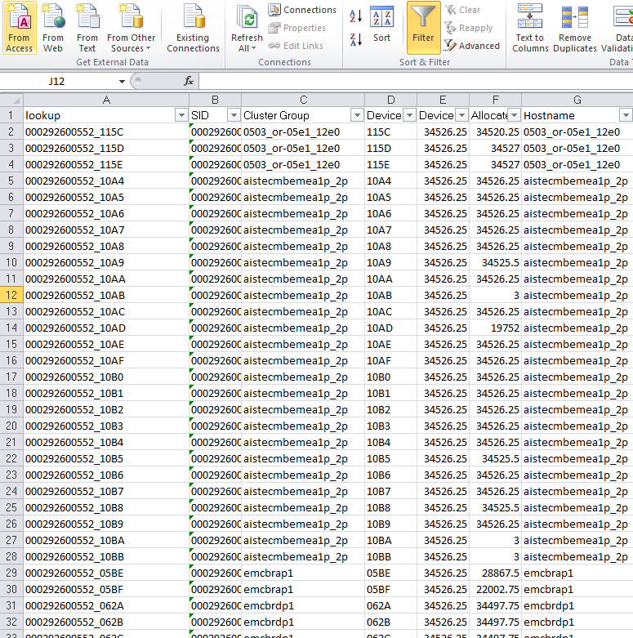
- Check any blanks in A means delete the blank Rows and make sure, no blanks in Column ‘A’.
- Check the data, if any entries have Device Capacity and Allocated as blank then that is okay. If there is data in only one of these fields then delete these records.
- Copy the data in the HostSector sheet from the HostSector.xls spreadsheet to the Sector sheet in the VMAX.xls spreadsheet. Paste by value to remove any formulae.
- Update the Pivot table in the Pivot sheet by right-clicking on it and selecting ‘Refresh’.
- Select all hostnames where the ‘Organisation’ and ‘New Organisation’ fields are ‘#N/A’.
- Add these hosts to the HostSector sheet in the HostSector.xls spreadsheet and copy down the formulae in column C. Copy by value the results in column C to column B.
- In the HostSector sheet of HostSector.xls, if any are ‘Other’ in ‘New Organisation’, look at hostnames of similar name and determine, if possible, whether the Sector name can be resolved. If so, then change Organisation in column B of the Sector sheet. (Skip)
- In the HostSector sheet of HostSector.xls , ensure all the Sectors in Organisation against the New Organisation, where The New Organisation Sector is not ‘Other’. (SKIP )
- Copy the three columns by value over to the VMAX sector spreadsheet
- Refresh the Pivot table again, and the #NA entries should have been resolved.
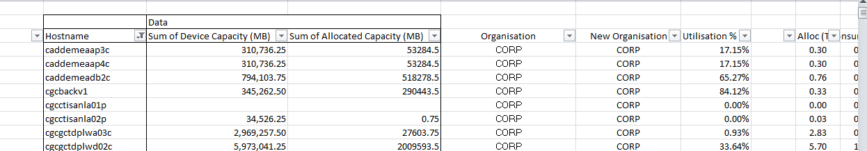

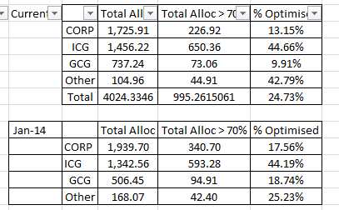
- Refresh to two Pivot tables in the ‘Pivot_Total’ sheet
- Change the month in cell B11.
- Insert 7 blank rows between the latest and last month’s data
- Copy the latest data down by value.
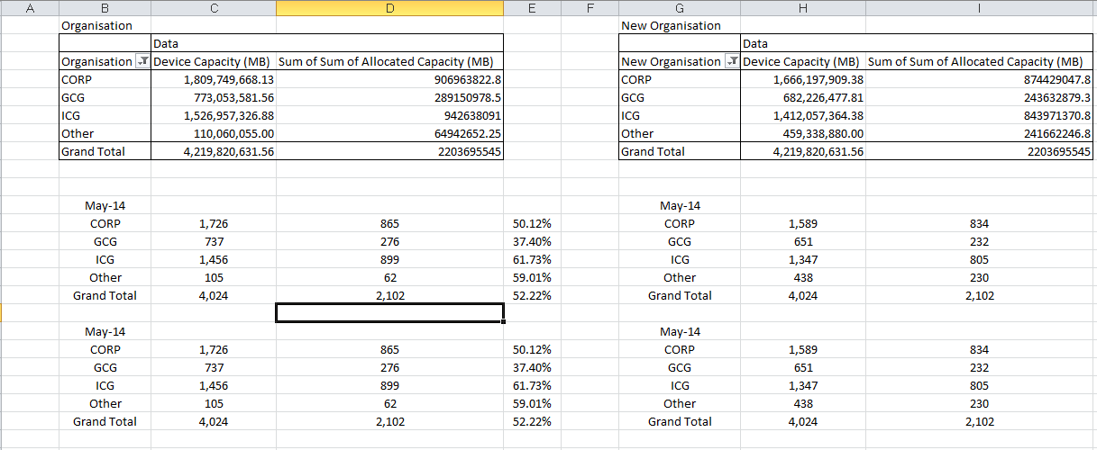

HDS data
- Open DMX_HDS Source_vmax_<Month><year>.xls sheet
- Open the HDS.xls spreadsheet
- open recent DMX_HDS Source_vmax_<Month><year>.xls file copy following fields from HDS_MOR sheet to the ‘HDS’ sheet in the HDS.xls spreadsheet
- Hostname
- Allocated GB
- Cluster/Host Name
- Device
- Consumed Capacity (GB)
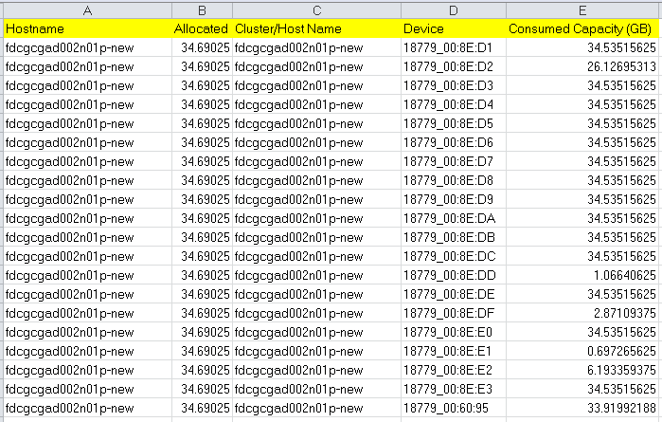
- Copy the following fields from HDS sheet over to the ‘HDS_Unique’ sheet and
- Cluster/Host Name
- Device
- Consumed Capacity (GB)
- Allocated GB
- Remove any lpfc0/lpfc1 using copy ( ?lpfc? ) and replace ( ) with blank in cluster/Hostname
- Remove duplicates from columns B to E.
- ensure the formulae in columns A (=IF(ISERROR(FIND("_",B2,1)),B2,LEFT(B2,FIND("_",B2,1)-1)) )are copied down
you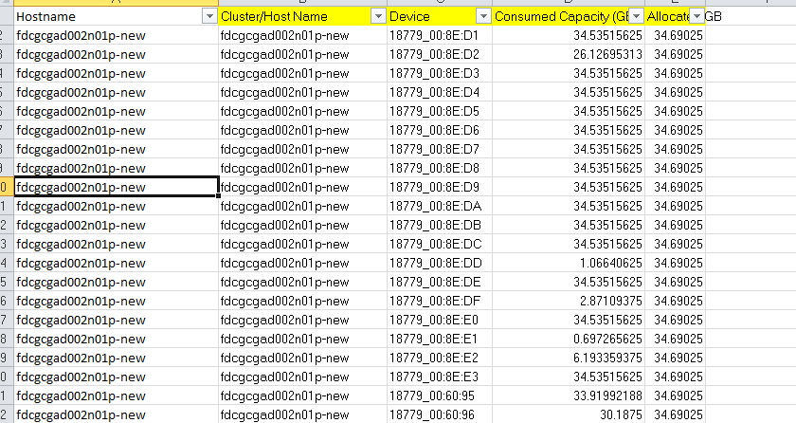

- Check any blanks in A means delete the blank Rows and make sure, no blanks in Column ‘A’.
- Copy the HostSector sheet from the HostSector.xls spreadsheet are copied the Sector sheet in the HDS.xls spreadsheet. Paste by value to remove any formulae.
- Update the Pivot table in the pivot sheet by right-clicking on it and selecting ‘Refresh’.
- Select all hostnames where the ‘Organisation’ and ‘New Organisation’ fields are ‘#N/A’.
- Add these hosts to the HostSector sheet in the HostSector.xls spreadsheet and copy down the formulae in column C. Copy by value the results in column C to column B.
- If any are ‘Other’ in ‘New Organisation’, look at hostnames of similar name and determine, if possible, whether the Sector name can be resolved. If so, then change Sector in Organisation in column B.(skip)
- Ensure all the Sectors in Organisation against the New Organisation, where The New Organisation Sector is not ‘Other’.(skip)
- Copy the three columns by value over to the HDS spreadsheet
- Refresh the Pivot table again, and the #NA entries should have been resolved.
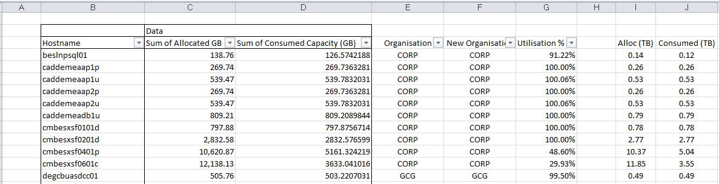

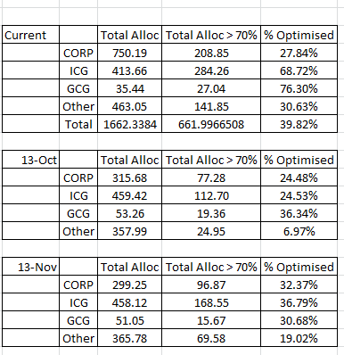

- Refresh to two Pivot tables in the ‘Pivot_Total’ sheet
- Change the month in cell B11.
- Copy and insert last month’s data above itself
- Copy the latest data by value over this
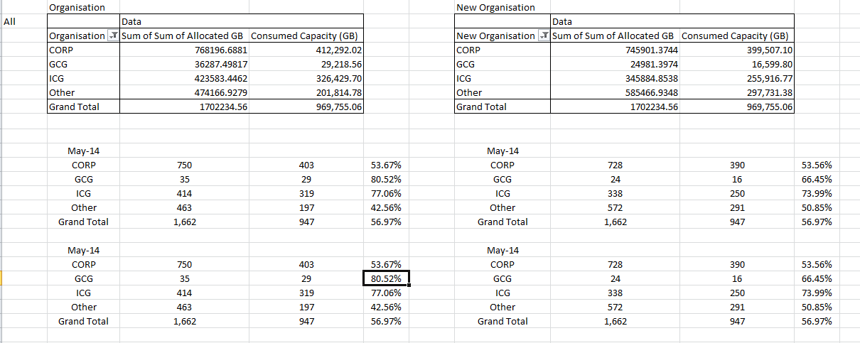

DMX data
- Open DMX_HDS Source_vmax_<Month><year>.xls and go to DMX_MOR sheet
- Open the DMX.xls spreadsheet
- open recent DMX_HDS Source_vmax_<Month><year>.xls file copy following fields from DMX_MOR sheet to the ‘DMX’ sheet in the DMX.xls spreadsheet
- Hostname
- Allocated GB
- Cluster/Host Name
- Device
- Copy the following fields over to the ‘DMX_Unique’ sheet and ensure the formulae in columns A are copied down:
- Cluster/Host Name
- Device
- Allocated GB
- Remove duplicates from columns B to D.
- Ensure the formulae in Column A
- (=IF(ISERROR(FIND("_",B2,1)),B2,LEFT(B2,FIND("_",B2,1)-1)) ) are copied down
- Check any blanks in A means delete the blank Rows and make sure, no blanks in Column ‘A’.
- Copy the data in the HostSector sheet from the HostSector.xls spreadsheet to the Sector sheet in the DMX.xls spreadsheet. Paste by value to remove any formulae.
- Update the Pivot table in the Pivot sheet by right-clicking on it and selecting ‘Refresh’.
- Select all hostnames where the ‘Organisation’ or ‘New Organisation’ fields are ‘#N/A’.
- Add these hosts to the HostSector sheet in the HostSector.xls spreadsheet and copy down the formulae in column C. Copy by value the results in column C to column B.
- If any are ‘Other’ in ‘New Organisation’, look at hostnames of similar name and determine, if possible, whether the Sector name can be resolved. If so, then change Sector in Organisation in column B. (Skip)
- Ensure all the Sectors in Organisation match against the New Organisation, where The New Organisation Sector is not ‘Other’. (skip)
- Copy the three columns by value over to the DMX spreadsheet
- Refresh the Pivot table again, and the #NA entries should have been resolved.
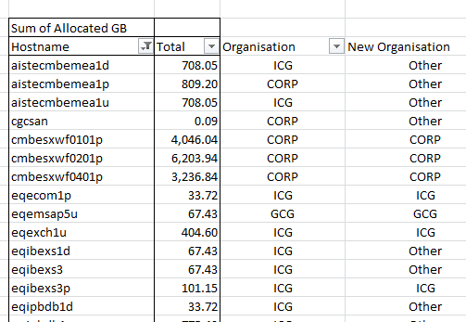

- Refresh to two Pivot tables in the ‘Pivot_Total’ sheet
- Update the date in cell C13
- Append last month’s data to the end of the tables below then overwrite with the latest data by pasting by value.
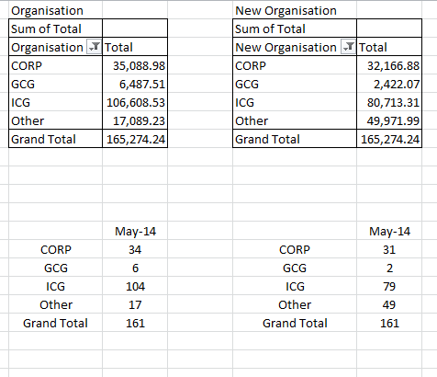

DMX Volume Group/File System Usage
- Copy a new VG_FS_<mmmyyyy> sheet of DMX.xls from the previous month’s sheet and rename with new month
- Generate the following reports from the three Capacity Reports databases that link to the three ControlCenter repositories: (Ref EMEA BO SAN Metrics Procedure v0.4 and follow from step 3.1)
- CGC_qryHostVG_FS_Usage .xls from CGC_Capacity_Reports.mdb
- RDC_qryHostVG_FS_Usage .xls from RDC_Capacity_Reports.mdb
- FDC_qryHostVG_FS_Usage .xls from FDC_Capacity_Reports.mdb
These are located in T:\Capacity Reporting folder or StorageReclaims
- Source data is present in ECC DB folder under VG_FS_xxx.xls file
- In each report select the current date then merge the following fields from the three reports into the new VG_FS_<mmmyyyy> sheet of DMX.xls repositories: and delete all other Columns except following.
- Date
- Site
- SAN
- HOST_NAME
- Total Allocated (GB)
- Total Accessible (GB)
- Total in FS (GB)
- Total Used in FS(GB)
- Remove all entries that have no data for ‘Total Used in FS (GB)’. (Note: only full valid entries can be used to establish the overall percentage of usage for each sector).
- Copy the formulae in columns I, J and K to the bottom of the data set.
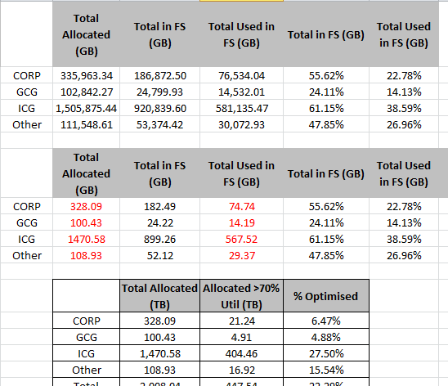

Report Generation

Merging the data
- In the DMX.xls spreadsheet, copy the last ‘Summary_<mmmyyyy> sheet over to a new sheet with the latest date
- Copy the Organisation data in the Pivot_Total sheets for VMAX, HDS and DMX to this sheet and paste by value into the appropriate ‘Measured’ cells for each array type and sector. Note, for DMX this will only be the ‘Total Alloc’ field, whereas for the VMAX and HDS, it will also be the ‘Total Used’ and ‘% Utilised’ fields.
- Update the Poland, Clariion and Centera values from the ‘SAN_Metrics Template.xls’ from the SAN Metrics Requirements report (see this separate report generation process). ( skip)
- Update the Clarion values in row 50 with the Totals in the Configured Used (TB) and Raw Used (TB) values in the ‘Clariion_Pivot_Summary’ sheet of the SAN Metrics Template.xls spreadsheet. (skip)
- Update both of the Centera values in row 51 with the Allocated Capacity (TB) value in the ‘Centera’ sheet of the SAN Metrics Template.xls spreadsheet. (skip)
- For DMX Usage, in sheet VG_FS_<mmmyyyy>, copy the values in columns M and O, rows 8 to 11, over to the DMX ECC Data columns in sheet ‘Summary_<mmmyyyy>. These will update the formulae in the ‘Measured’ Total Used column for DMX.
- open SAN EMEA final disk capacity inventory_xxxx.xls file and go to final MOR sheet
- find the Total TB in Column N (Host Allocation) and paste into K69 Column in Summary_<mmmyyyy> sheet of DMX.xls.
- find the Total TB in Column J (Pool Used) and paste into L69 Column in Summary_<mmmyyyy> sheet of DMX.xls
- Change the month in column I56 and I64
- Copy paste by value from I64 :P69 to r:w
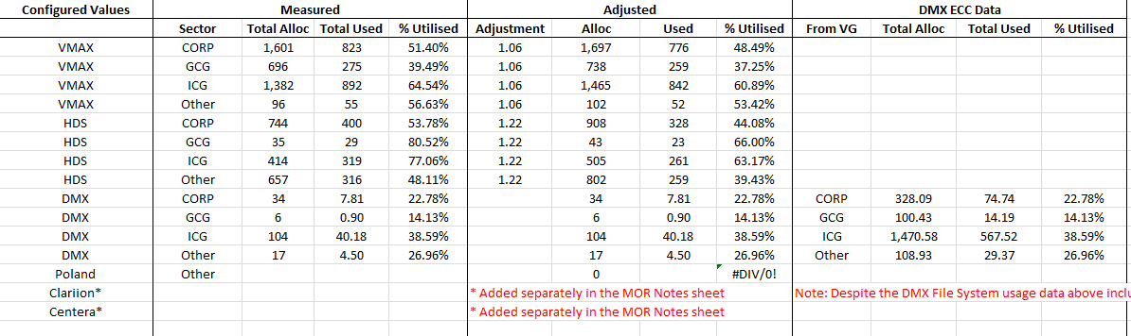

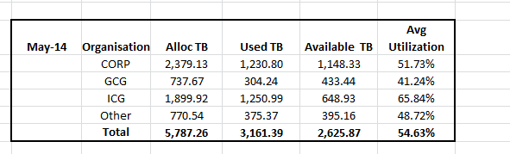

Adjusting for Thin Storage ( skip)
- Open the new Thin_Adjustments.xls spreadsheet.
- Open the Thin Provisioning Summary_v3.xls sheet from the following:
https://globalconsumer.collaborationtools.consumer.citigroup.net/sites/EMEA_DOI/san/Shared%20Documents/Forms/AllItems.aspx?RootFolder=%2fsites%2fEMEA%5fDOI%2fsan%2fShared%20Documents%2fEMEA%20SAN%20Capacity%20Reports&FolderCTID=&View=%7b0758BE2F%2dC431%2d4175%2dB6E9%2d07D7557279F5%7d

- Copy the data over to the Thin_Adjustments.xls spreadsheet.
- Take the new adjustment values for VMAX and HDS and update the Adjustment values for HDS and VMAX in the Summary_<mmmyyyy> sheet of DMX.xls.

Optimisation
- Copy the Optimisation data from columns N to Q from VMAX.xlsx Pivot sheet to the DMX.xls ‘Optimised_<yyyy> sheet
- Copy the Optimisation data from columns N to Q from HD.xls Pivot sheet to the DMX.xls ‘Optimised_<yyyy> sheet
- Copy the Optimisation data from columns M to P, rows 15 to 18 from DMX.xlx ‘VG_FS_<mmmyyyy> sheet to the DMX.xls ‘Optimised_<yyyy>’ sheet
- Update the columns I to O in the ‘Optimised_<yyyy>’ sheet to include this month’s data
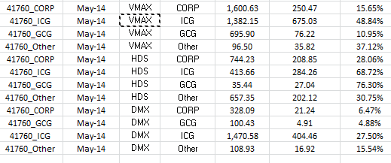

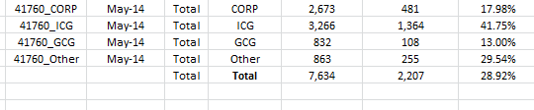

Building the MOR Report

- Copy last month’s MOR report called ‘EMEA SAN Data Input.xlsx’ to this months directory.
- Find the Final MOR Values section the latest data in the ‘DMX.xls’ spreadsheet (sheet ‘Summary_<mmmyyyy>’) in the table occupying columns I64 to N69.
- Copy this table then paste by value into columns C to H, at the bottom where the previous Summary Tables are in the ‘Notes’ sheet in the MOR report.
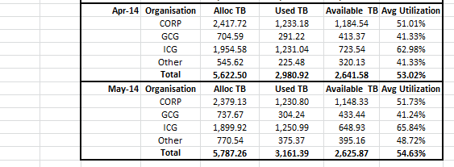
- Add the raw Clariion and Centera values to columns L to N at the bottom ( copy and paste the previous month data ) (Always Zero Value)
- Add the latest data to the ‘Data Tables’ above the Summary Tables, in a single line for the month.
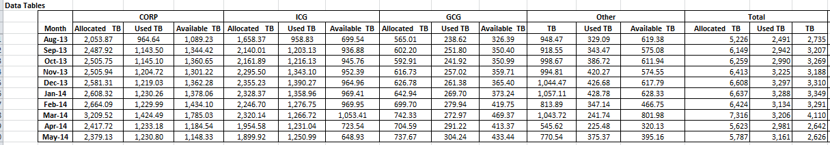
- Ensure the formulae in columns O to R in the ‘Data Tables’ are copied down.
- Create a new line in the Calculated Tables by copying last month’s data.
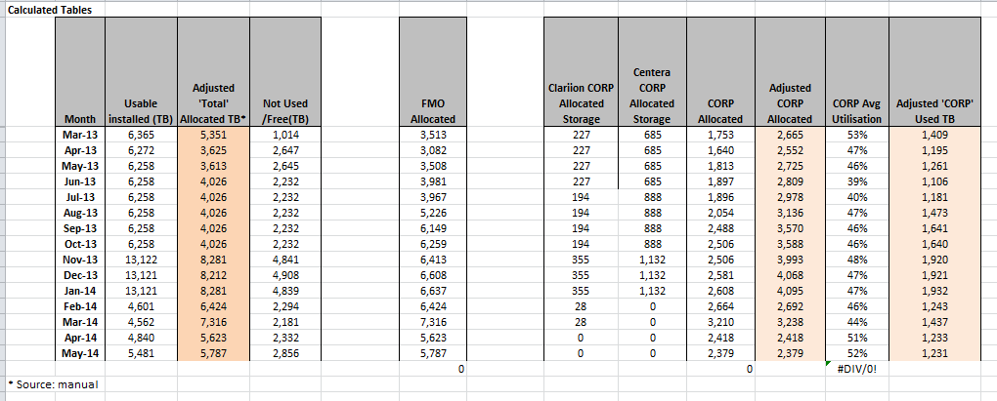

- Copy this months Centera and CLARiiON figures into Columns I and J of the Calculated Tables. ( Skip )
- Update the ‘EMEA SAN CIOC’ sheet ( from SAN EMEA FINAL DISK CAPACITY INVENTORY_XXXX.XLS MOR Report Purpose sheet). This will update the Calculated Tables in the ‘Notes’ sheet
- Obtain Raw Installed TB, Usable Installed TB, Used TB (Usable), Subsystems Frames/Filers (Usable) (columns D, E,F & H) in the ‘EMEA SAN CIOC’ sheet from the from SAN EMEA FINAL DISK CAPACITY INVENTORY_XXXX.XLS MOR Report Purpose sheet).
- Obtain Tech Refresh (Raw), Tech Refresh Subsystems Frames/Filers (Raw) (columns I & J) in the ‘EMEA SAN CIOC’ sheet from the from SAN EMEA FINAL DISK CAPACITY INVENTORY_XXXX.XLS Tech Refresh sheet) Column K and O.
- Obtain SAN Switch Capacity (#ports), Used Ports, SAN Switch Count (Column L,M& P) from EMEA Consolidated Storage-Switch Report for MMMM 2014.XLS sheet name SAN Switch Capacity Summary.
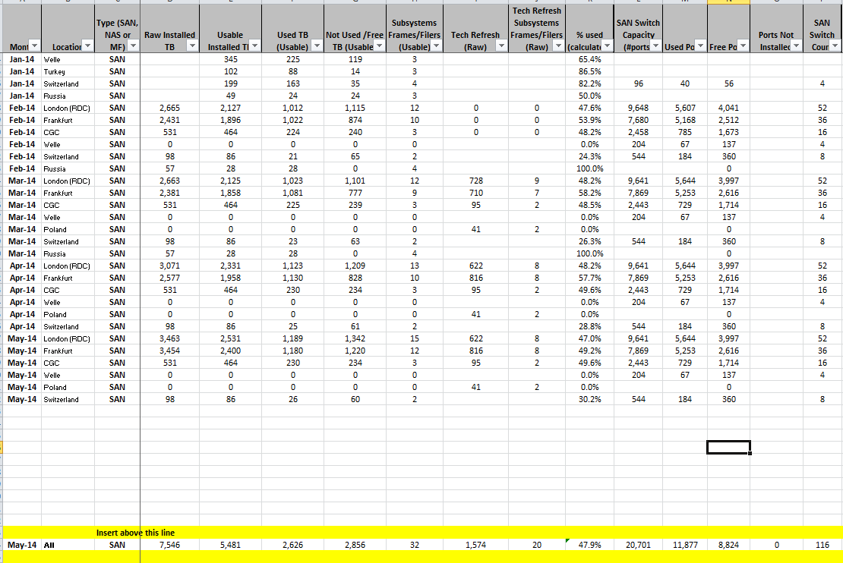
- The Calculated Tables should now be populated in the ‘Notes’ sheet. Change the date in the Latest tables found in columns C to H, then copy the data to a blank area of the ‘SAN’ sheet.
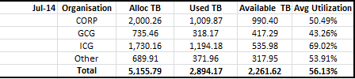
- Populate the main table with the data for each business sector.
- Check the Totals in the main table match the totals pasted from the Notes sheet.
- Update the Installed TB value in row 31 in the ‘SAN’ sheet with the value in the EMEA SAN CIOC sheet (between the yellow lines).
- Copy the Optimised data from the ‘Optimised_<yyyy>’ sheet in the DMX.xls spreadsheet to a blank area of the ‘SAN’ sheet in the ‘EMEA SAN Data Input.xlsx’ spreadsheet. Populate the %Optimised values for each business sector.
- Copy the Virtualised data from columns B to E, rows 27 to 31, in the ‘Summary_<mmmyyyy>’ sheet in the DMX.xls spreadsheet to ‘SAN’ sheet in the ‘EMEA SAN Data Input.xlsx’ spreadsheet.
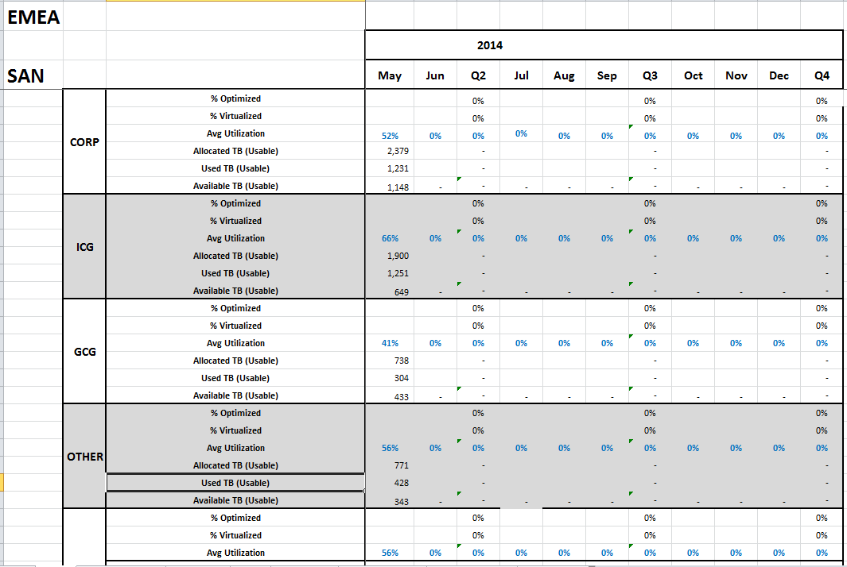

SANScreen & Switch Report ( skip)

- Log onto each SANScreen instance and generate the Switch Summary Report from the Reports tab.
- Save the output to the following directory:
- T:\Capacity Reporting\SwitchCapacity\<yyyy>\<yyyy-mm>\<yyyy-mm-dd>
- Add each output to the following summary report spreadsheets found in the ‘T:\Capacity Reporting\SwitchCapacity’ directory:
- CGCReports_Pivots.xls
- RDGCReports_Pivots.xls
- FDCReports_Pivots.xls
- Update the ‘Pivot’ sheet pivot table in these spreadsheets and copy data over to the ‘Report’ sheet by value
- Refresh the pivot table in the ‘Summary’ sheet
- Use the summary data to update the ’EMEA SAN CIOC’ sheet in the EMEA_SAN Input.xlsx spreadsheet for these locations:
- Frankfurt (from FDC)
- London (RDC) (from RDC)
- CGC (from CGC)
- IX Europe (from FDC)
- Meerbusch (from FDC)
- Obtain the CISCO Switch information for the for these locations:
- Welle
- Switzerland
- Obtain the CISCO Switch information for the for these locations:
- 10.154.174.65.csv
- 10.154.174.66.csv
- 10.154.174.74.csv
- 169.168.69.161.csv
- 169.168.69.162.csv
- For each of the above, access via an Internet browser and log on using normal AD user/password.
- Generate a report using the SAN Health Template and export a ‘.csv’ file, saving in the ‘T:\Capacity Reporting\SwitchCapacity\<yyyy>\<yyyy-mm>\<yyyy-mm-dd>’ directory .
- Go to the ‘CISCO_Switch_Capacity.xlsm’ file in the ‘T:\Capacity Reporting\SwitchCapacity ‘ directory and update with the new data in the ‘Data’ sheet.
- Go to the ‘Pivot_Site’ sheet and refresh ther pivot table, then copy down the formulae in the calculated fields.
- Collect the data for these locations and update the ‘EMEA SAN CIOC’ sheet in the ‘EMEA SAN Data Input/xlsx’ spreadsheet:
- Welle
- Switzerland
- In the ‘EMEA SAN CIOC’ sheet in the ‘EMEA SAN Data Input/xlsx’ spreadsheet, copy the previous month’s switch data for these locations:
- Senatorska
- Goleszowska

RAID5 % Value (skip)

- Update the EMEA_SAN_Replication_RAID5_working.xls spreadsheet, found in the ‘C:\Capacity Reporting\ Summary Reports\Replication_RAID5’ folder, using the information from the SAN Metrics Requirements Template spreadsheet.
- Take the Total Raw Allocated value which excludes the Centera arrays, in column AO and add to row 40 in the SAN sheet of the EMEA SAN Data Input.xlsx spreadsheet.

Tech Refresh ( skip)

- Copy the last ‘Tech Refresh.xls spreadsheet to the new directory in the MOR directory structure.
- Open the new spreadsheet.
- Obtain a list of hostnames from the DMX, VMAX, HDS (rdchds04 only) and HDS (all excluding rdchds04) sheets from the latest EMEA SAN Inventory.xls Host Billing report and populate the Source sheet in the Tech Refresh spreadsheet under the appropriate columns.
- Remove duplicates for each set of data.
- Copy the DMX and the HDS (not rdchds04) hostnames from the Source sheet to column C of the ‘VMAX compare’ sheet.
- Copy the VMAX hostnames from the source sheet to column G of the ‘VMAX Compare’ sheet.
- Ensure that all the formulae in column D are copied down for each DMX and HDS hostname in the ‘VMAX compare’ sheet.
- Copy column D and paste by value to column I.
- Remove duplicates and all NA# entries from column I.
- Open the VMAX.mdb database, found in the ‘C:\Capacity Reporting\VMAX folder’.
- Open the ‘Tech_Refresh’ table, found in the ‘Tables’ Custom Group of the Navigation Pane.
- Delete all current entries in this table and add to the matching entries in column I of the ‘VMAX Compare’ in the Tech_Refresh.xls spreadsheet.
- Close the table and Export the following query, using the GUI:

- qryTech_Refresh_Group_Total

- Move the exported report to the new directory in the MOR directory structure.
- Copy the DMX hostnames only from the Source sheet to column C of the ‘RDC04 compare’ sheet.
- Copy the HDS (rdchds04 only) hostnames from the source sheet to column G of the ‘RDC04 Compare’ sheet.
- Ensure that all the formulae in column D are copied down for each DMX hostname in the ‘RDC04 compare’ sheet.
- Copy column D and paste by value to column I.
- Remove duplicates and all NA# entries from column I.
- Open the HDS_WWN_CLI.mdb database, found in the ‘C:\Capacity Reporting\HDS folder’.
- Open the ‘Tech_Refresh’ table, found in the ‘Tables’ Custom Group of the Navigation Pane.
- Delete all current entries in this table and add to the matching entries in column I of the ‘RDC04 Compare’ in the Tech_Refresh.xls spreadsheet.
- Close the table and Export the following query, using the GUI:

- qryTechRefresh_Total

- Move the exported report to the new directory in the MOR directory structure.
- Open the two Tech Refresh reports and copy the values over to the ‘RDC04 Compare’ sheet of the Tech_Refresh.xls spreadsheet.
- Open the EMEA SAN Data Input.xlsx spreadsheet and add the Tech Refresh detail for each Site to the ‘EMEA SAN CIOC’ sheet, under the latest month’s entries.
- Add the total Tech Refresh amount to the current month’s Tech Refresh cell (row 35) in the ‘SAN’ sheet’.

FTE

- Update the FTE value (obtain from Nigel), obtained from the EMEA SAN Manager in row 36 of the ‘SAN’ sheet of the ‘EMEA SAN Data Input.xlsx’ spreadsheet.

Comments

- Refresh pivot tables in Pivottables sheet.
- Add comments on installations and allocations in the Comments sheet, using

Report Submission

- Email to the following groups with the email subject ‘Data Input-EMEA’:
- *GT EMEA TI MOR
- 'GMOR@globalconsumer.collaborationtools.consumer.citigroup.net'
- Upload to the following sharepoint:
- https://globalconsumer.collaborationtools.consumer.citigroup.net/sites/EMEA_DOI/san/Shared%20Documents/Forms/AllItems.aspx?RootFolder=%2fsites%2fEMEA%5fDOI%2fsan%2fShared%20Documents%2fEMEA%20SAN%20MOR%20Metrics&FolderCTID=&View=%7b0758BE2F%2dC431%2d4175%2dB6E9%2d07D7557279F5%7d

GCG allocation Report

1 ) open GCG_alloc_xxx.xls under Data folder
2) rename to latest month
3) Open vmax, hds and dmx files under data folder
4) go to Pivot sheet and filter the organisation to gcg
5)

