Software Defined Storage at Citigroup
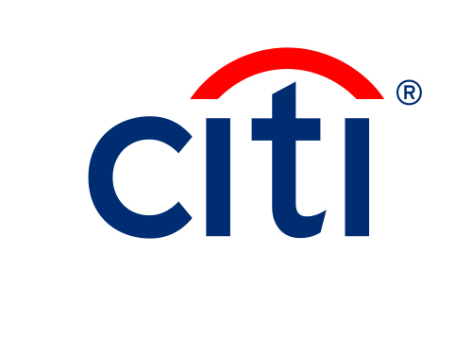

  - <Sub-title>

Abstract:
TBD.

Citigroup
As a global bank operating in more than 100 countries, Citigroup has a global private networking infrastructure interconnecting data centers located across the world. This IT infrastructure is shared by the various Citi businesses, such as corporate, consumer, and private banking, and trading services. The various organizations at Citi make up a large user base of both end-users and developers with a diverse set of technology and region-specific application requirements, which need to be supported by Citi’s shared IT infrastructure. Different regions, for example, have to comply with country-specific regulations and, as such, demand different IT deployment and security compliance rules.

Data Center Challenges
After a successful consolidation and realignment effort to reduce the number of data centers, Citi’s focus now is on building out and optimizing its data center infrastructure to accommodate the increasing usage and growth of compute and storage resources. In Citi’s current IT environment there are a number of challenges that need to be addressed to effectively support the increasing IT service needs by the various lines of business. Complexities arise as a result of the increasing scale of IT operations, the new instant and always-on service demands from end-users, and management of spending and usage of IT resources. In addition, new distributed processing and storage solutions, such as big data and grid computing, demand implementation and support of new scale-out workloads, effectively demanding a ‘cloud-like’ elastic compute and storage infrastructure.
- Scale: the large number of end-user applications and the emergence of new distributed software applications have been driving the need for build-out of compute and storage infrastructure. To keep up with the increasing rate of change a high level of automation is needed, eliminating the need for manual procedures and in-person approval processes. Different deployment models and technologies need to be considered to keep up with the increasing IT demands in a cost-effective way.
- Business Resiliency: With the increasing use and reliance on business applications, effective end-to-end troubleshooting of performance problems and outages is becoming increasingly important. While there are many vendor and technology solutions for monitoring and troubleshooting specific technology domains, there are few cross-domain monitoring and troubleshooting solutions today. New products and solutions are needed to provide end-to-end monitoring and trouble shooting capabilities, covering the compute, storage, and networking.
- IT Agility: The increasing use of business applications is driving the need for provisioning resources and delivering IT services to end-users in faster, more cost effective, ways. In order to achieve this goal, at Citi a first level of devops process automation was implemented a few years ago. In order to address the increasing needs for agile IT resource provisioning, the existing automation infrastructure at Citi is being enhanced to provide advanced self-serve resource provisioning capabilities via an internal cloud service, covering development, test, and production resources.
- Asset Utilization: To manage the build-out of server and storage resources, ensuring desired levels of utilization of the existing IT infrastructure is key. Although server virtualization has enabled flexible deployment of compute resources, there is often still a static fixed relationship between physical and virtual server infrastructure and specific workloads (e.g., designated servers for development). In order to optimize server asset utilization, there is a need to be able to repurpose physical and virtual server resources as part of elastic on-demand compute services.

Storage Challenges
<description of Citi storage challenges>

Storage Technology Trends
The storage industry is currently undergoing a seismic shift similar to the server/compute industry a decade ago with the introduction of server hypervisor virtualization. In addition, similar to SDN (Software Defined Networking) and commodity white box switching recently introduced in networking, concepts like Software Defined Storage (SDS) and commodity hardware are being introduced to storage as well. Finally, scale-out architectures, pioneered by web 2.0 companies, are now also being adopted by enterprises as part of their next-generation storage solutions.

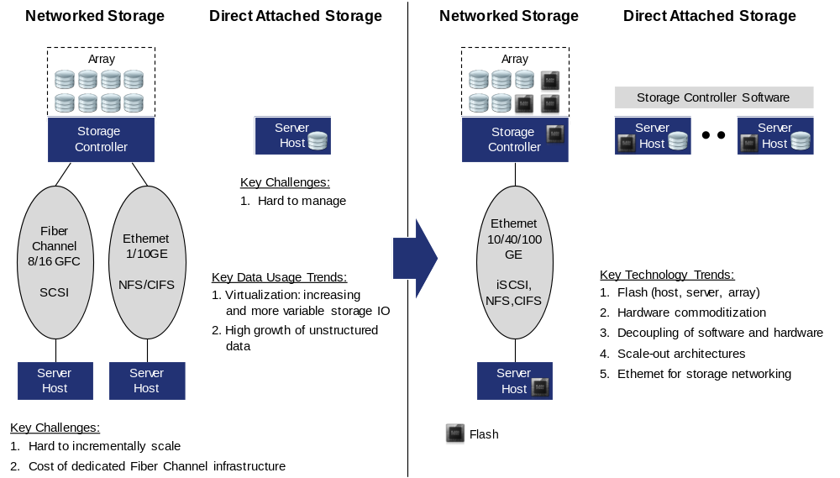
Figure 1 – Storage Technology Trends.

Flash Storage
Flash is a new technology that enables storing data in ‘solid state’ microchips instead of spinning magnetic disks used in traditional hard disk drives (HDD). Key benefits of flash-based storage are the high I/O and low power consumption. Different grades of flash are available; more expensive enterprise-grade SLC/eMLC flash and cheaper, but also less reliable, consumer grade MLC flash. Flash is being used in different form factors. It is used in Solid State Drives (SSDs) for high performance persistent storage and used as cache for accelerating data read/write operations. As indicated in Figure 1, flash is deployed for local storage cache and as high-speed storage drives in servers and storage arrays. With the cost of flash technology continuing to come down, flash has become a cost effective alternative to traditional spinning magnetic disk storage for high performance storage deployment use cases. In addition, increasingly enterprise grade flash storage solutions are being offered using a combination of advanced storage software with lower cost MLC flash, providing additional cost improvements.

Hardware Commoditization
Similar to server/compute and networking hardware, there has been a continuing decline of price levels for spinning magnetic disk and flash storage. Net result has been that with each new generation of centralized storage array solution, more storage capacity can be offered at lower cost points. In addition, with the introduction of new distributed storage solutions based on commodity server hardware, even more storage CAPEX savings can be achieved.

Decoupling of Software and Hardware
Traditional centralized storage solutions include storage controller(s) with software that is tightly integrated with hardware (e.g., array appliance). New distributed storage have started to emerge where storage controller software can run independently, as a virtualized instance on hypervisor or on commodity (server) hardware, providing flexibility in deployment options. With the commoditization of storage and compute hardware, the value of the new generation storage solutions is, in effect, shifting to the storage controller software.

Scale-Out Storage
In order to deal with the enormous growing amounts of data, web 2.0 companies were early adopters of scale storage architectures, which allowed them to incrementally scale their storage infrastructure in a seamless and cost effective way. Scale out storage architectures are distributed systems made up by commodity server/storage nodes with cluster-based software for inter-node communication and synchronization. Key characteristic and benefit of this type of architecture is that it can scale to a large number of nodes and that additional server/storage nodes can be added to increase scale and capacity without any downtime. In addition, a distributed architecture can provide increased resiliency (i.e., eliminating single point of failures) and effectively address distributed geographic data locality requirement (e.g., as a result of country-specific compliance regulations).
With the increasing storage capacity requirements, scale out architectures are becoming an attractive storage solution for large enterprises as well. With the adoption of distributed scale-out storage architectures, the role of networking for storage is becoming increasingly important. Not only reliable and high performance connectivity needs to be provided between end-user compute and the storage infrastructure, reliable networking is also needed to interconnect the distributed server/storage nodes.

Ethernet for Storage Networking
Fiber channel technology traditionally has been the technology of choice for implementing dedicated storage network connectivity, especially for block storage access with high bandwidth and stringent I/O requirements. With the increasing bandwidth (i.e., 10, 40, and 100Gb), Ethernet is becoming a viable alternative to Fiber Channel for supporting storage connectivity. Considering the increase in file-based storage access (e.g., NFS, CIFS) and the adoption of HTTP-based object storage, Ethernet/IP-based networking is becoming an increasingly important transport option for storage networking.
Ethernet network architectures are evolving as well, which benefit storage networking. One of them is the two-tier ’leaf-spine’ architecture, which is becoming a widely deployed data center network design. This type of architecture collapses the various network layers into an aggregation (spine) and access (leaf) layer, which is made possible by the increasing port density and speeds supported on new fixed and modular switches offered by various vendors today. In addition, access (Top-of-Rack) switches are connected to multiple upstream aggregation switches, which enable traffic flows to traverse multiple parallel links to reach end-point destinations.
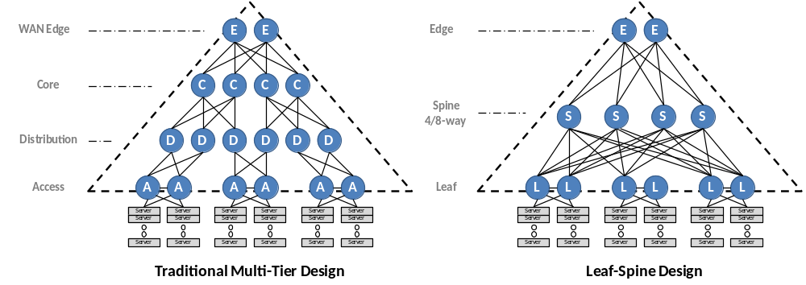
Figure 2 - Comparison of Data Center Network Architectures.
By leveraging multiple forwarding paths highly reliable network connectivity can be achieved. In addition, by collapsing multiple aggregation layers end-points (e.g., servers, storage nodes) are only a limited and fixed number of network hops away from each other, ensuring low and predictable latency across the network fabric (Figure 2). The latter is a key requirement for storage networking.

Citi’s Storage Technology Strategy
Tbd

Use Cases

Phased Deployment

Conclusions

