Global Storage Analytics PErformance Analysis PCM

Approval List:
Title: | Name: | Signature: | Date:
Document Owner | Kery Hines
GSM Approver | Al Mahmood

Distribution List
Global Storage Analytics Team

Note: If printed, content is valid only for the day it was printed. Always refer to the on-line document for the current version. If the user elects to maintain copies of this procedure, it is their responsibility to verify the currency of the document by checking it against the online version. This document must be promptly removed from use when obsolete.
- PURPOSE
This procedure establishes the necessary steps and guidelines for performing (high level) realtime and historical SAN/NAS performance ananlytics. The document assumes use by a subject matter expert (SME) and is not designed as a teaching tool.
- Revision history
Date | Rev. No. | Change | Author | Section
01/13/2015 | 1.0 | New Procedure Drafted | Kery Hines

- Persons affected
  - Any Citi business or group experiencing performance issues on CTI managed SAN or NAS storage.
- Policy
The policy of Global Storage Analytics is to ensure:
  - Address realtime performance issue
  - Configure tool to monitor/proactivity address both performance and capacity issues on CTI SAN/NAS storage arrays (or commodity hardware such as Scale I/O)
- definitions

- Responsibilities
  - Global Storage Analytics
  - Vendor

Analytics Tools
  - EMC
    - ViPR SRM (still in deployment/development phase)

Servers: Login using <soeid>/<local password>
http://nammsrmfe1.nam.nsroot.net:58080/APG/#
http://namusrmfe1.nam.nsroot.net:58080/APG/#

Sample of ViPR SRM main dashboard screen.
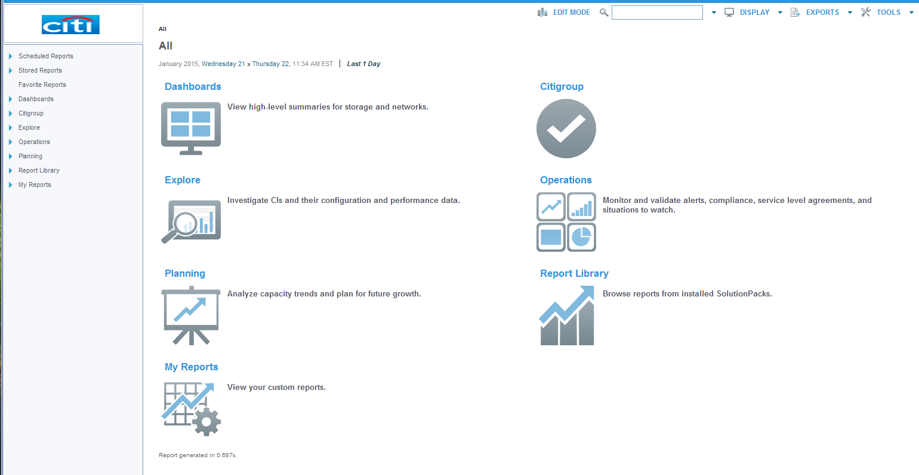

    - Unisphere for VMAX

Servers: Login using <soeid>/<AD soeid password>
390G – NAMEEMC01, 02
GTDC – NAMGEMC01, 02, 03
MWDC – NAMMEMC01, 02, 04, 05, 06, 07
O’Fallon – NAMMECM03
Rutherford – NAMREMC01, 02
SWDC – NAMUEMC01, 02, 03, 04, 05, 06. 07
Jardines – LACPEMC01
QRDC – LACQEMC01

Default sceens setup for quick analysis…

Real time last hour (heatmap, IOPS, cache write pending, response time)
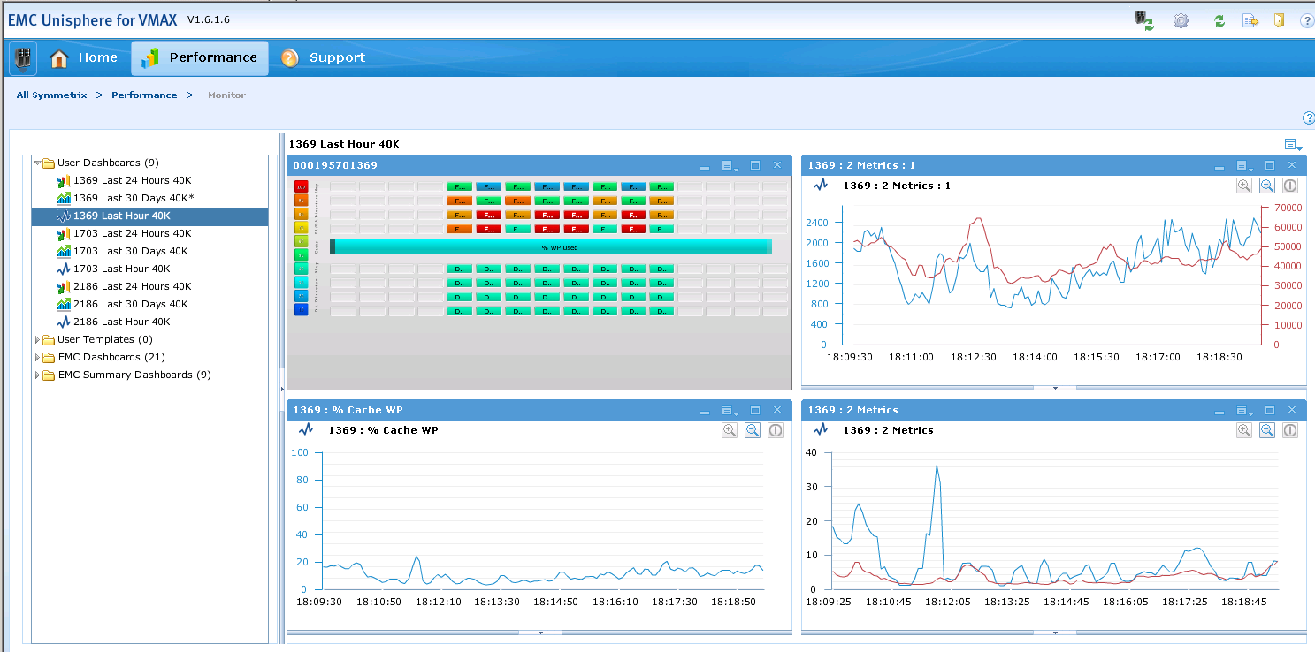

Diagnostic Last 24 Hours (heatmap, IOPS, cache write pending, response time)
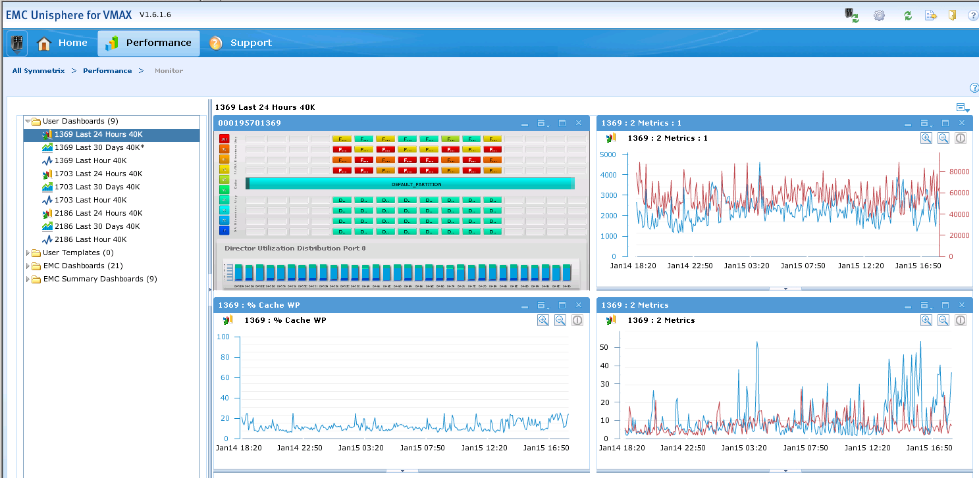

Historical last 30 days (heatmap, cache write pending, front end port bust %, backend busy %)
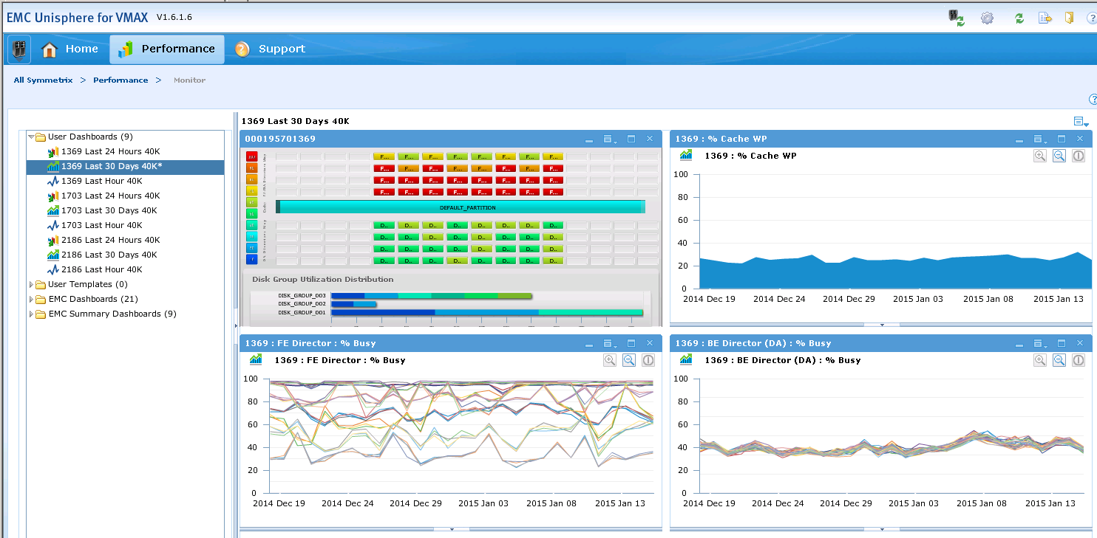

    - Unisphere for VNX

  - HDS
    - Tuning Manager Expert Assistance (TMEA)

There are two pieces. An online version of TMEA (still in development) and a detailed report that is emailed once a week by the TMEA team to Citi. Samples of both are below.

TMEA online…
The following URL and account information is provided for regional and global access
https://tmea-emea.hds.com/tmea/

Accounts for Accessing TMEA
These accounts are to be used by all Citi SAN staff. The passwords should be changed according to normal account policies.
• Global Account (All Regions) citiglobal (pass=start123)
• NAM (and LATAM) citinam (pass=start123)
• EMEA citiemea (pass=start123)
• APAC citiapac (pass=start123)

TMEA online screenshot sample
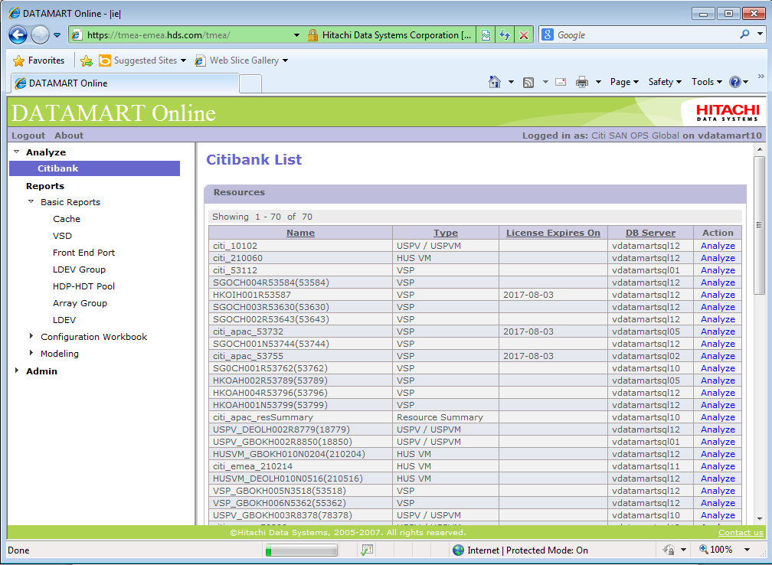
TMEA detail report generation screenshot sample
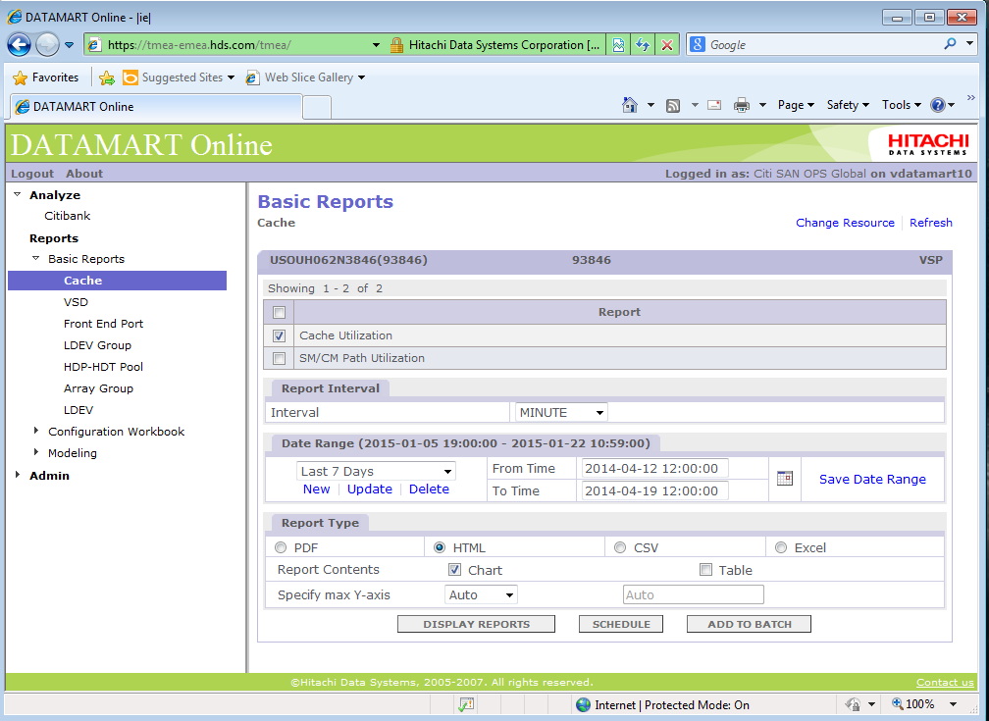

Sample of emailed report.
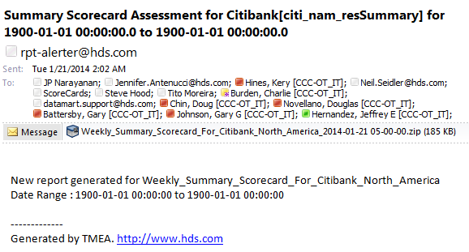

TMEA VSP Summary report
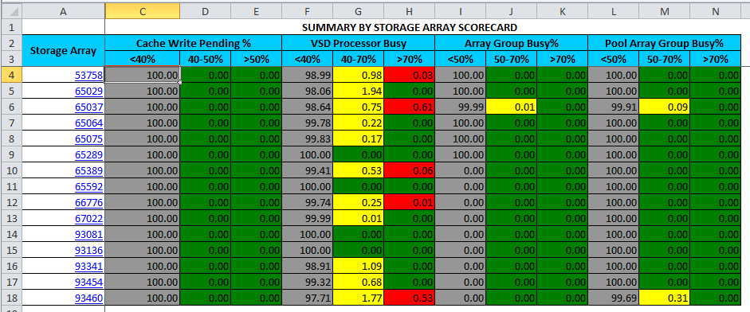

TMEA VSP Server Summary
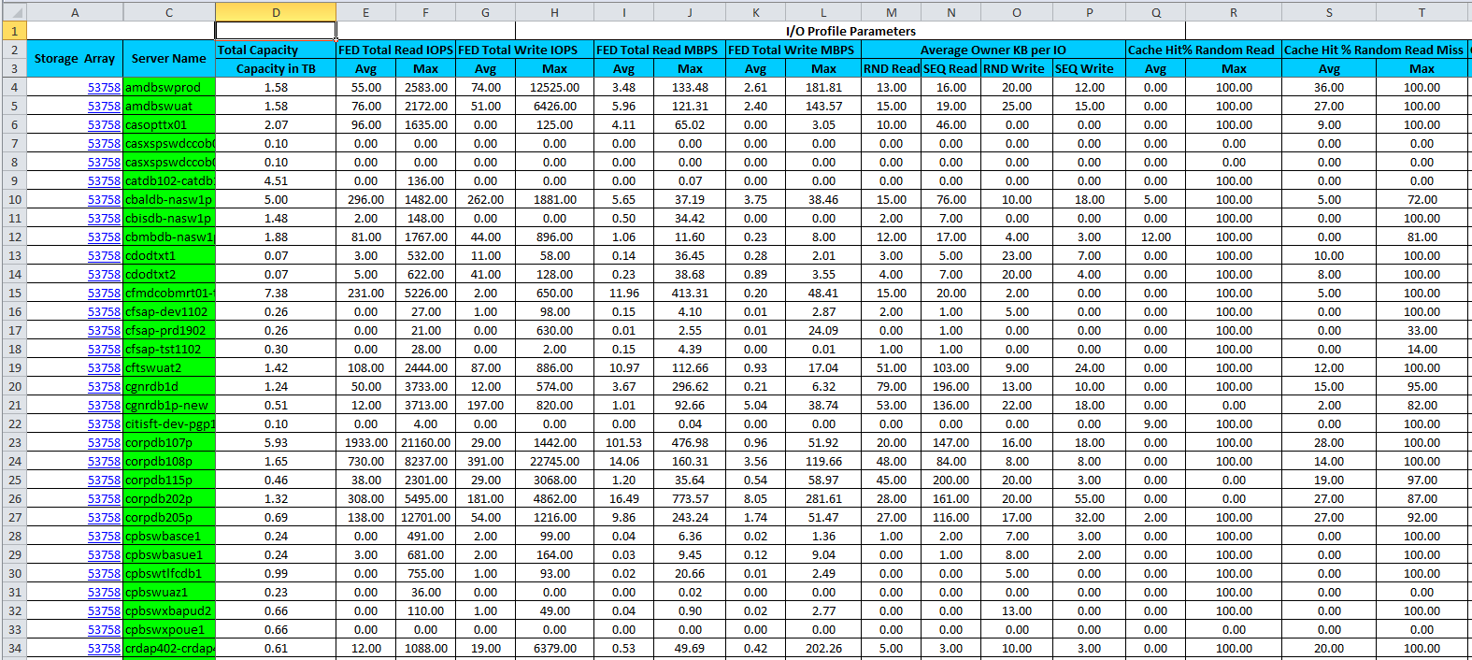

    - Hitachi Tuning Manager (HTnM)

Servers: Login using <soeid>/<AD soeid password>
390G – NAMEHDS03
GTDC – NAMGHDS03
MWDC – NAMMHDS03
Rutherford – NAMRHDS03
SWDC – NAMUHDS03

Sample HTnM screenshot
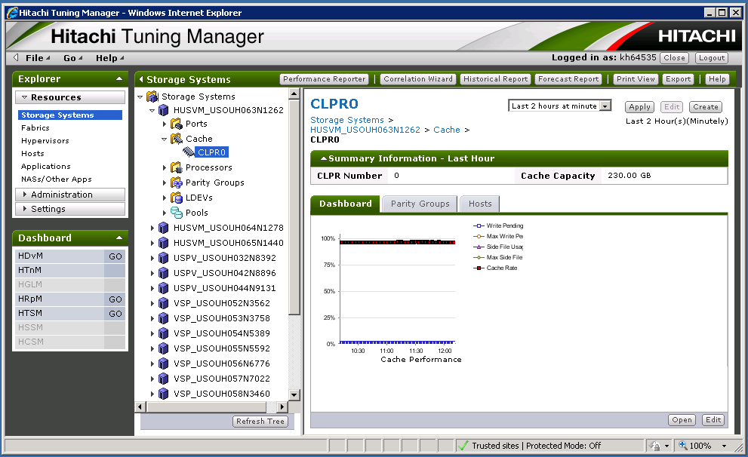

    - Hitachi Performance Reporter

Performance reporter is launched from HTnM main screen to perform a more detailed analysis using HTnM data.

Sample Performance Reporter selection screen
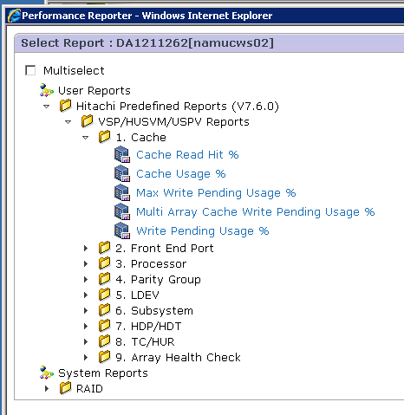

Performance Reporter detailed graph sample
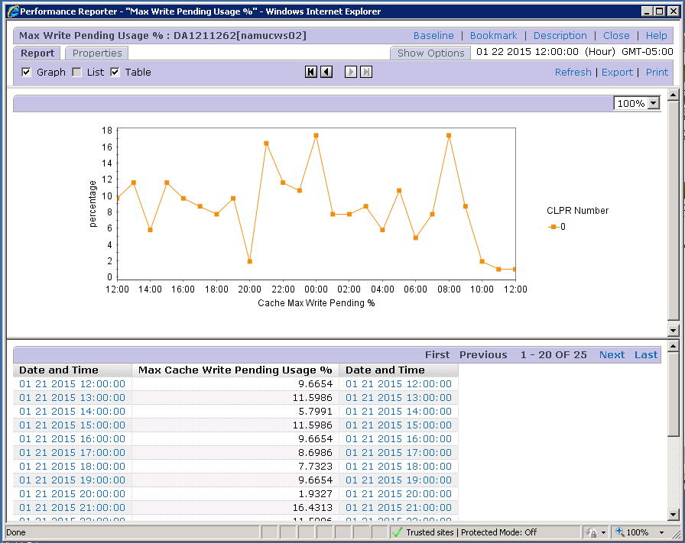

  - IBM
    - IBM XiV GUI and TOP

Servers: Login using <soeid>/<AD soeid password>
MWDC – NAMMIBM01
SWDC – NAMUIBM01

Sample from XiV GUI statistics screen
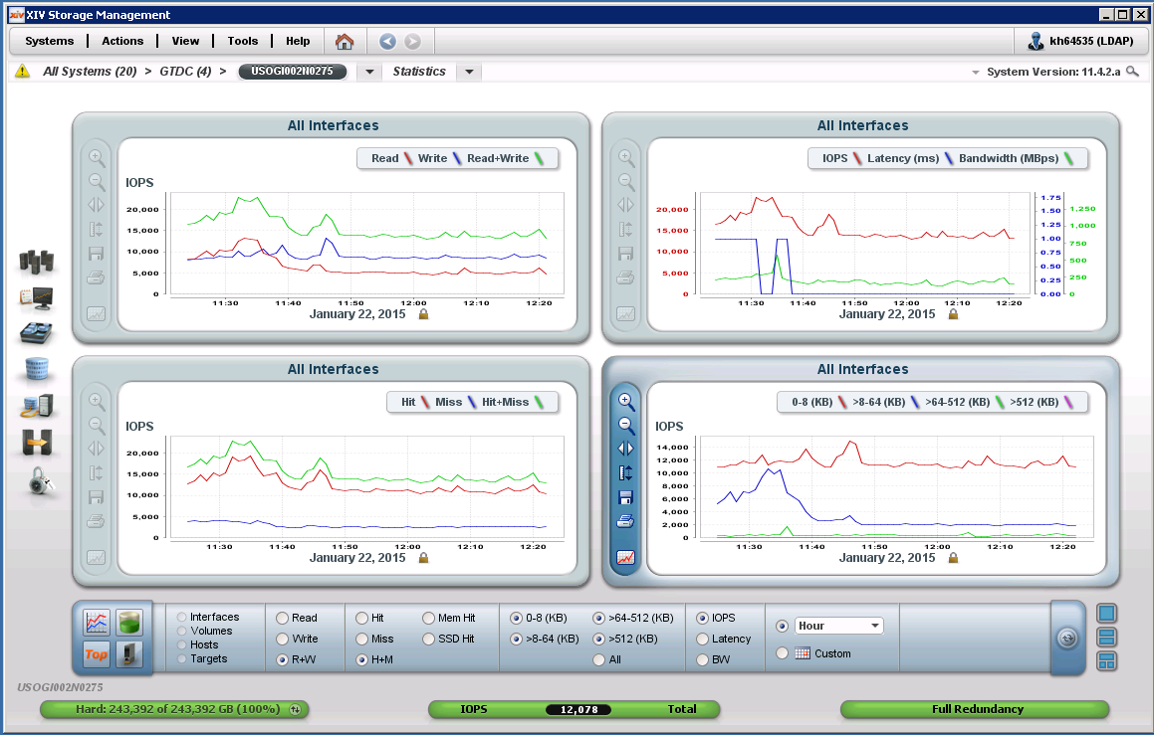

Sample from XiV Top
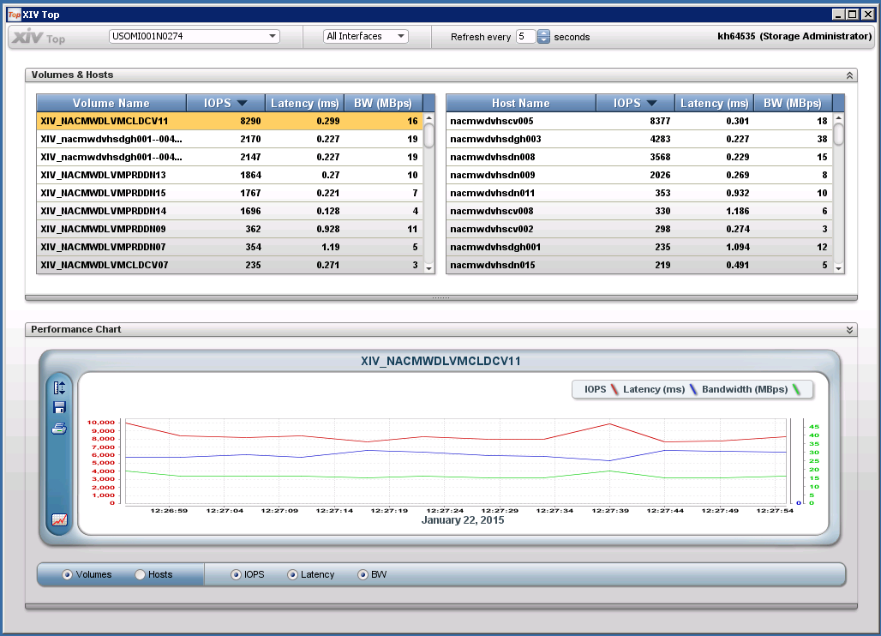

    - IBM Performance report extracts

IBM stats are collected once a day by a local script and stored on server NAMMIBM01 in directory D:\XiV_Daily_Perf_Stats\

Sample of Performance stats collected
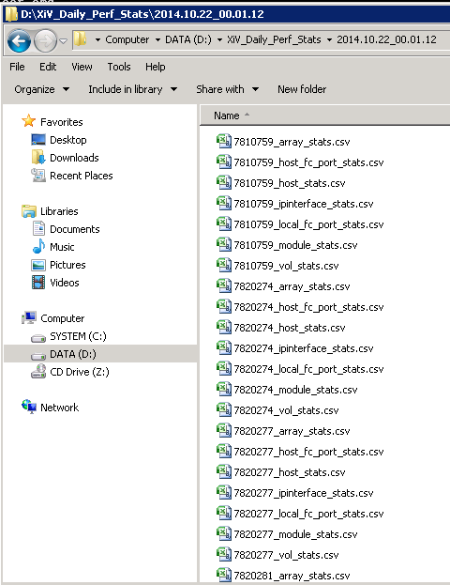

  - Cisco
    - Data Center Network Manager (DCNM)

Servers: Login using <soeid>/<AD soeid password>
390G – NAMECISCOA02, B02
GTDC – NAMGCISCOA03, B03
MWDC – NAMMCISCOA03, B03
Rutherford – NAMRCISCOA02, B02
SWDC – NAMUCISCOA02, B02
Jardines – NAMMCISCOA04, B04
Monterrey – NAMGCISCOA04, B04
QRDC – LACQCISCOA01 B01

Sample DCNM Web Interface performace dashboard
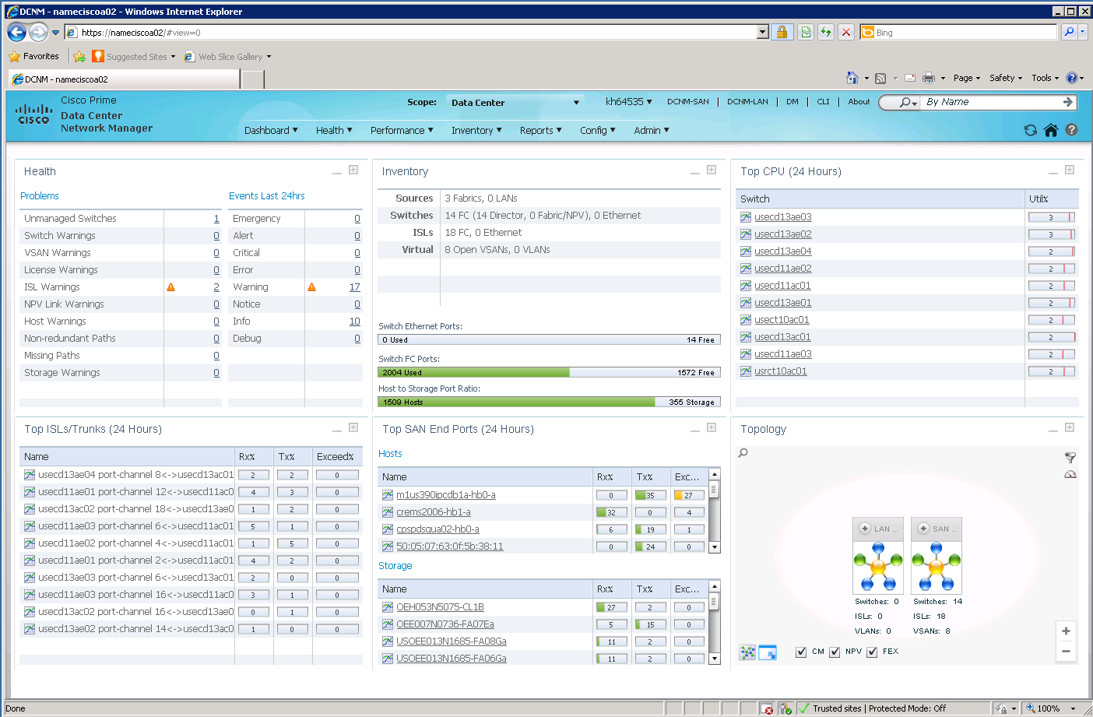

Sample DCNM web interface end device performance detail
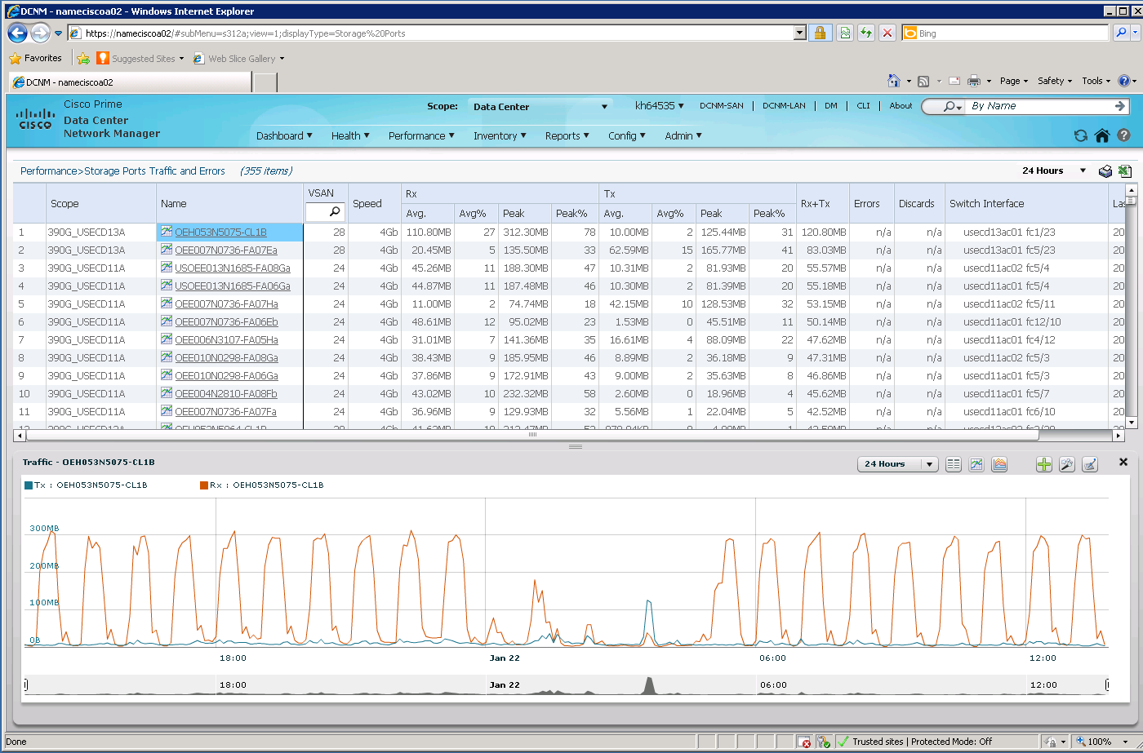

    - Cisco Fabric Manager and Device Manager

Sample DCNM Fabric Manager with Device Manager real-time summary screen open
