GNAST DESIGN and CONFIGURATION STANDARD

For

EMC XtremIO

CATE Storage & Backup Engineering

Template Version: 2.0.8

Document Version#: 1.0

December 18, 2014



Disclaimer
If printed, content is valid only for the day it was printed. Always refer to the online document for the current version. If the user elects to maintain copies of this procedure, it is their responsibility to verify the currency of the document by checking it against the online version. This document must be promptly removed from use when obsolete.

Table of Contents
1 Document Purpose 4
2 Owner of Standard 4
3 Intended Audience 4
4 Principles 4
4.1 Revision History 4
4.2 Key Feature Changes 5
5 Assembly/Solution Description 5
6 Scope 5
6.1 Technology 5
6.2 Applicability 5
7 Components 5
7.1 List of Components 5
7.2 Operational Tools 6
8 Assembly/Solution Architecture 6
9 Installation & Configuration Instructions 6
10 Configuration Assurance 7
11 Scalability & Capacity 7
12 Availability Management 7
13 Regional or Merger Partner Consideration 7
14 Global Standard 8
15 Relevant Links 9
16 Glossary/Definition 9
17 Appendix 9
17.1 Best Practices 9

Disclaimer
If printed, content is valid only for the day it was printed. Always refer to the online document for the current version. If the user elects to maintain copies of this procedure, it is their responsibility to verify the currency of the document by checking it against the online version. This document must be promptly removed from use when obsolete.
Note: The purpose of this template is to provide a standard document structure for completing designs with detailed instructions on how to install and configure secure technology standards within Citi’s global environment. This document follows the official standard GNAST design framework, and applies to all current GNAST technology standards/products inclusive of hardware and software.
This template also allows usage of the Secure Build Configuration Checklist (SBCC) into one GNAST Configuration Template.

In some sections, this template can be used as a “pointer” to more widely used standards and SBCC documents (i.e. SBCC). In other cases, it might make sense to use this template and expand as needed.

Document Purpose
This document provides detailed installation and configuration instructions for use by all operational and regional engineering teams for EMC XtremIO deployments within Citi’s global environment, to ensure adherence to configuration, support, and management standards as well as compliance to Citigroup Information Security Standards.

Owner of Standard
GNAST (Global Network Architecture and Standards Team) is the owner of this standard and the related documents. CATE (Citi Architecture & Technology Engineering) is the custodial organization. CitiNetwork & CitiStorage Platform Engineering technologists will drive and generate content.

Intended Audience
The intended audience is CitiNetwork & CitiStorage Engineering, Global and Regional Operations and Engineering personnel responsible for designing, building, supporting, and managing Citi corporate storage environments.

Principles

Revision History
Update the document history each time a draft is issued for review.

Document Version:
A first generation document that hasn’t been ratified before is a 0.0 (less than 1.0) during its revision cycle. When adopted it is a 1.0 version. Subsequent generations follow the same method of incrementing the decimal portion of the version number until ratified, and then increment the integer.

Document Version | Description | Date | Author/Organization
0.1 | Initial GNAST Standard | 12-Jan-2015 | Jeff Hernandez/CATE
1.0 | Ratified XtremIO Standard | 27-Jan-2015 | Jeff Hernandez/CATE

Key Feature Changes
3.0.1 BASH Vulnerability fix

Assembly/Solution Description
The XtremIO Storage Array is an all flash system, based on scale-out architecture. The system uses building blocks called X-Bricks which can be clustered together to grow performance and capacity as required. Currently single X-Brick systems are being certified and NDU expansion is not yet supported by EMC. At this time the XtremIO array is being certified as restricted only for use with VDI deployments.

This document should serve as a guide when configuring XtremIO storage arrays in Citi’s storage environment for block-based storage utilizing IP Fabrics. The information compiled in this document has been tested and certified by CATE Storage and Backup Engineering.

Scope
This solution has been certified for global VDI deployments.

Technology
The XtremIO Storage Array is an all flash system, based on scale-out architecture. The system uses building blocks called X-Bricks which can be clustered together to grow performance and capacity as required. Currently single X-Brick systems are being certified and NDU expansion is not yet supported by EMC.

Each X-brick is comprised of:
- One 2U Disk Array Enclosure (DAE), containing:
- 25 eMLC SSDs (standard X-Brick 10TB) or 13 eMLC SSDs (5TB Starter X-Brick)
- Two redundant power supply units (PSUs)
- Two redundant SAS interconnect modules
- Two 1U Battery Backup Units (BBUs)
- Two 1U Storage Controllers (redundant storage processors)
Each Storage Controller includes:
- Two redundant PSUs
- Two 8GB/s Fiber Channel (FC) ports
- Two 10Gbe iSCSI ports
- Two 40GB/s Infiniband ports
- One 1Gb/s management port

Front View

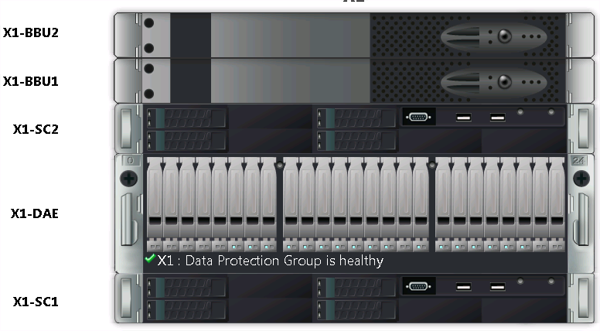

Rear View

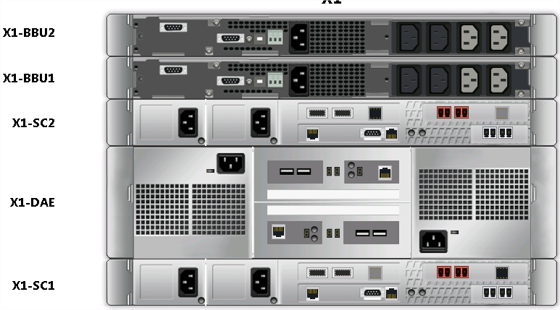

XtremIO System & Software Features

Thin Provisioning

XtremIO storage is natively thin provisioned using a small internal 8KB block size. All volumes in the system are thin provisioned, meaning that the system consumes capacity only when it is actually needed. XtremIO determines where to place the unique 8KB blocks physically inside the cluster after it calculates their fingerprint IDs. This means it never pre-allocates or thick provisions storage space before writing.

SAS Back-end

The XtremIO array utilizes 6 GB/s Serial Attached SCSI (SAS) backend, with 4 lanes each. The SAS backend connection can address 4 storage devices at the same time on a port.

The XtremIO includes 2 SAS backend ports per storage controller. Currently the XtremIO utilizes only one back-end SAS port for connectivity to the DAE per storage controller. Enabling all backend ports is scheduled for a future release.

High Availability

The Storage Controllers and DAE in the cluster are equipped with dual power supplies. The cluster also has dual Battery Backup Units.

Any information not committed to the SSD is kept in multiple locations, called Journals. Each software module has its own journal, which is not kept on the same Storage Controller (SC) and can be used to restore data in case of unexpected failure. These journals are kept on the storage controllers with battery backed up power supplies. In case of a problem with the Battery Backup Unit (BBU), the journal fails over to another SC. In case of global failure, the BBU ensure that all Journals are written to vault drives in the SC and the cluster is then turned off.

XtremIO Data Protection

An X-brick is preconfigured as a single redundancy group, which eliminates the need to select, configure, and tune RAID groups. XDP uses double parity RAID6-like data protection. Dedicated hot spares are not required for rebuild; instead it leverages the “hot” space concept, where any free space available in the array can be utilized for failed drive reconstructions. The cluster always reserves sufficient distributed capacity for performing a single rebuild even at 100% physical capacity utilization. When an SSD fails the cluster rebuilds it to restore redundancy, this rebuild reconstructs data from the failed SSD onto the remaining SSDs in the protection group. Capacity utilization on a given protection group should never exceed 95%, it is recommended to reserve the capacity of at least one SSD in case of a dual SSD failure scenario. The X-brick can recover from multiple SSD failures that do not occur simultaneously. A dual drive failure that occurs concurrently is not yet supported.

Inline Data Reduction

The always on inline deduplication feature enables the removal of redundancies from data before it is written to the flash media. As data enters the cluster, data reduction is performed in real-time and not as a post-processing operation. Data blocks are stored according to their content and not according to their user level address within the volumes. If host data is written over and over again, it will be de-duplicated and no additional writes to the SSDs will occur.

System Feature Matrix

Feature | Item | Function | Citi Status
XtremIO RTU OE | XtremIO Right to use | Licensed per X-brick cluster | Supported
XtremIO Mgmt | XtremIO Management license | Licensed per X-brick cluster | Supported
XIOS | XtremIO Operating System | XIOS runs on storage controllers and manages system functions | Supported
XMS | XtremIO Management Server | Virtual management server with web-based interface and CLI used to manage X-brick cluster. (Physical XMS server is not supported) | Supported
Thin Provisioning | Native thin provisioning | All volumes have thin provisioning enabled | Supported
Inline Data Reduction | In-line de-duplication | Always on deduplication | Supported
Local Protection | Snapshots | Block storage snapshots | Restricted
Remote Protection | None | Array to array block storage replication | Not Supported
Reporting | SRM | Centralized reporting – SRM (formerly Watch4Net) | Supported
Monitoring | SNMP Alerting | Centralized Enterprise Monitoring | Supported
Audit Log | Syslog Forwarding | Ability to forward audit log for SEMS reconciliation | Supported
Vendor remote support | ESRS for XtremIO | Monitors XtremIO and notifies vendor of error events | Supported
Path Management | NMP, MPIO, MPxIO, DMP, Powerpath | Host Multi-Pathing – ESX NMP is only certified use case at this time | Supported
Host/Array Connectivity | iSCSI 10GbE | Supported connectivity protocol | Supported
Host/Array Connectivity | FC 8Gb | Restricted connectivity protocol | Restricted

XtremIO Cluster Configurations

Description | One X-Brick
Max eMLC SSDs per Cluster | 25
X-Brick Storage Controllers | 2
Processors  Per Cluster | 4 x 8-core  2.1 GHz Xeon
Total Memory Per Cluster | 512 GB
Max 6Gbps  SAS Back-End Buses per Cluster | 4 x 4-Lane
Max 8Gbps  FC Front-End Ports per Cluster | 4
Max 10Gbps Ethernet iSCSI - Front-End Ports per Cluster | 4
# Infiniband Switches per Cluster | 0
X-Brick Cluster Rack Space | 6U
Battery Backup Unit (BBU) 2 x PS | 2
Usable Capacity | 7.58 TB
Max # defined initiators per cluster | 512
Max # defined initiators per initiator groups | 64
Max # defined volumes per cluster | 8192
Max volume size per cluster | 256TB**
Max # defined users per cluster | 50

** Thin provisioning of more than 130TB can be approved via RPQ

XtremIO Disk Array Enclosure

Description | 25 x 2.5” Drive DAE
Drive Types Supported | 2.5” SSD / 400Gb eMLC Flash
Enclosure Height (Rack Units) | 2U
Controller Interface | 6 Gb SAS

XtremIO Power & Weight Specifications

Description | Power Consumption | Heat Dissipation | IEC C14 Connections | 30A AC Circuits Single Phase | Weight
Single X-brick | 750VA | 2,559 BTU | 4 | 2 | 562.5 lb (255.1kg)

XtremIO Connectivity

Connection per Storage Controller | Ports | IP Address | Speed
Management | 1 | 1 | 1Gb
IPMI | 1 | 1 | 1Gb
iSCSI | 2 | 2 | 10GbE

Each X-brick has two storage controllers with each one having 2 x 10GbE LC iSCSI connections and a single 1 Gb Cat6 management connection. One iSCSI port per controller should be connected to a switch port on VLAN A and the other connected to a switch port on VLAN B for redundancy. The 1Gb MGMT1 connections on each controller require one IP address for management.

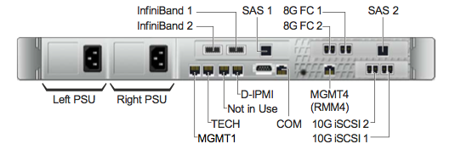

Note: Due to IPMI being identified as a security vulnerability the IP addresses for IPMI must be changed to dedicated internal access by EMC on initial install. This will require a change in cabling where the IPMI ports have a cross connection between storage controllers within the X-brick as in the example below.

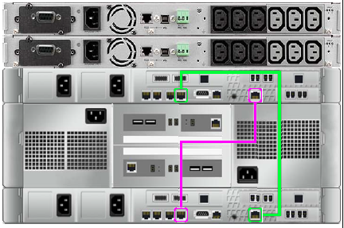

Prerequisites for a new XtremIO Environment

The following items are required in order to implement an XtremIO storage array according to CSBE standards:

- A virtual XtremIO management server (XMS) which EMC provides as a virtual appliance for ESX. This server will run the GUI and XMCLI interface for XtremIO storage management application.
- Management IPs on the GRN for the XtremIO storage controllers and XMS management connections.
- Citi standard monitoring infrastructure environment.
- Citi standard SEMS environment.
- Appropriate physical floor space, cooling, power, and redundant storage IP fabric connectivity.
- 10GBe network connectivity is required between the XtremIO storage and host ports for iSCSI environments.

Required Licensing for Array

A new X-brick installation will include the following licenses

- XtremIO Right to Use
- XtremIO Management License

Applicability

This solution is applicable to VDI deployments.

Components
See Data Center tab on GNAST BOM

Operational Tools

Component Name | Capability Description
Tivoli NetCool | Fault Management
EMC SRM | Capacity & Performance Monitoring
EMC ESRS | Remote vendor support
HP Network Automation | Configuration Management - Manual only at this time

Assembly/Solution Architecture

Design Overview

This section explains the general design for the implementation of an EMC XtremIO for block-based storage, utilizing IP fabric for host and storage connectivity. The diagram below depicts an overview of the infrastructure implemented for a standard Citi deployment, highlighting data and management communication.

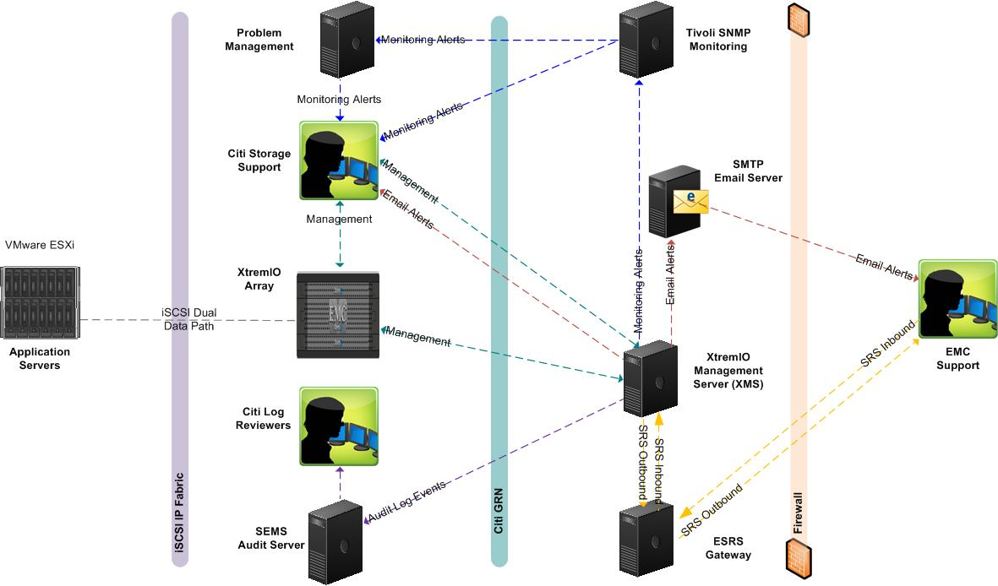

Array Management

The XtremIO storage array is managed via a stand-alone Linux-based virtual appliance, called the XtremIO Management Server (XMS), which can be accessed by typing the XMS management IP address in a browser (recommended). Each XtremIO cluster requires its own XMS host which can be a physical or virtual server; a virtual server is required at Citi. Please refer to the XMS Management Server section of this guide for further details.

Enterprise Monitoring and Alerting

SNMP alerting should be configured by Citi Storage team to send appropriate SNMP traps to the Enterprise Monitoring System. The monitoring infrastructure can then filter the alerts to generate notifications or problem tickets as appropriate. Please refer to the Availability Management section of this guide for further details.

Email Alerting

Email alerting should be configured by Citi Storage Integration team to send notifications to the appropriate Citi Storage Support team. Please refer to the Availability Management section of this guide for further details.

Audit Logs

Audit logs should be configured by Citi Storage Integration personnel in order to forward XMS syslog notifications to the appropriate Citi SEMS environment to meet compliance requirements. Please refer to the Audit Logging section of this guide for further details.

Performance

The XMS dashboard provides storage system performance statistics in real time as well as a 7 day history. These may be leveraged to improve performance and assist in determining where issues may be occurring. Please refer to Performance Monitoring using XMS for configuration information.

Remote Vendor Support

Email Alerting

Email home should be configured by EMC certified engineer to use Citi’s SMTP server to send the alerts to EMC support. Please refer to the Call Home and Email Alerting section for details.

EMC Secure Remote Support (ESRS)

XtremIO utilizes the ESRS Gateway for remote support activities. EMC support will connect to any XtremIO cluster via the ESRS Gateway for remote troubleshooting and problem resolution. Please refer to the Remote Support section for details.

Host Connectivity

XtremIO has been certified for host connectivity via iSCSI. It is recommended that hosts be configured with redundant 10GbE network adapters connected via redundant IP fabric top of rack switches, with paths to both storage controllers of the X-brick. Dual non-routed vlans should be configured for path redundancy. The X-brick supports fiber channel connectivity to redundant SANs; however, this configuration is currently restricted within Citi. Below is a diagram of the logical iSCSI layout.

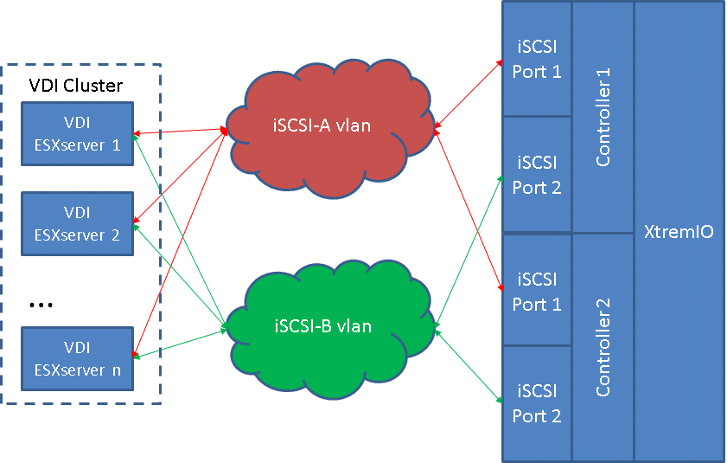

IP Fabric and iSCSI Guidelines

The following guidelines should be followed when connecting a host to the XtremIO array.

- The XtremIO storage system and hosts should be connected to two iSCSI VLANs for redundancy. These will be Layer 2 non-routed VLANs.
- iSCSI connections will be 10GbE SFP from host and storage. Jumbo frames should be enabled on the VLAN as well as the iSCSI array ports. The recommended MTU setting is 8800 across compute NICs, network switch, and iSCSI storage ports.
- Each iSCSI LUN will be presented out of each XtremIO iSCSI portal resulting in each LUN being seen 4 times by the ESX servers, twice per iSCSI VLAN.
- To easily differentiate IP connections it is recommended to configure
- Odd IP addresses on controller 1
- Even IP addresses on controller 2
- ESX native multi-pathing must be configured on the host side for proper round robin access to the target iSCSI ports on the X-bricks. For further details see VMware VDI 2.0 Storage Design Document.

iSCSI Portal Tables

As part of the implementation of the XtremIO, the iSCSI ports on the storage controllers must be configured for communication with the host iSCSI initiators. This requires setting up iSCSI portal tables via XMS.

- Go to Menu Bar > Select Administration > iSCSI Network Configuration

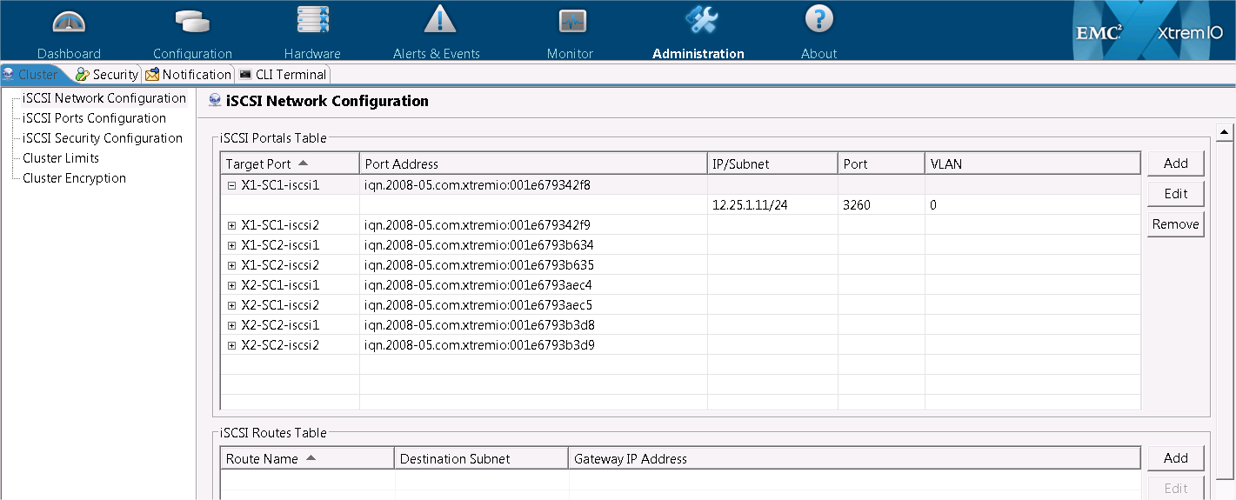

- Click Add > Select target port > Enter Non-routed VLAN information/Subnet bits. Port defaults to 3260 and VLAN to 0.

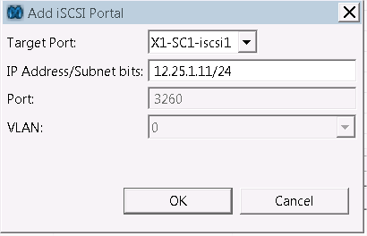

Note: For a given storage controller, one iSCSI port must be configured for VLAN A and the second iSCSI port for VLAN B. VLAN tagging on the XtremIO is not currently supported therefore verifying the port configuration and cabling is recommended.

iSCSI Ports Configuration

The XtremIO iSCSI ports on the storage controllers should be configured with Jumbo Frames enabled. The same MTU of 8800 must be set on compute NICs, iSCSI storage ports, and network switch.

- Go to Menu Bar > Select Administration > iSCSI Ports Configuration>

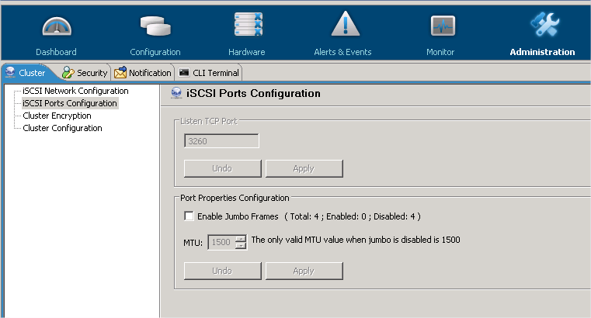

- Go to Menu Bar > Select Administration > iSCSI Ports Configuration>
- Select Enable Jumbo Frames check box and change MTU to 8800 > Apply
Note: The warning message below will appear and host connectivity could be impacted. It is recommended to do this during initial installation and before device is in production or during green zone.

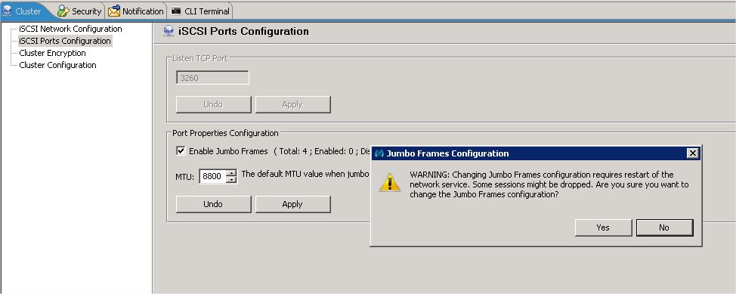

Snapshots

Snapshots are now supported in the current release. This functionality is restricted at this time and will be released in a future Solutions Guide.

XMS Management Server

The XMS will be installed from an EMC provided OVA package for each X-brick cluster. It should be deployed on a production vSphere cluster within the same data center that is not running on XtremIO storage. The specifications for XMS are as follows:

Operating System | Memory | CPU | Disk
Linux CentOS 6.2 | 8 GB vRAM | 2 vCPUs | 900 GB (Thin Provisioned)

It is recommended to manage and monitor the XtremIO storage array through the XtremIO storage management application installed on a Windows management server or desktop. XMS is preinstalled with the CLI and GUI. It must have network access to management and IPMI addresses on all the X-brick storage controllers and be located within the same data center.

The XMS GUI is initially installed via internet browser (e.g. Microsoft Internet Explorer) and a subsequent Java client will be the primary method for access. This client software communicates with the XMS using standard TCP/IP protocols and can be used in any location that allows the client to access the XMS. The full java client must be installed on the Windows management server or desktop as Java Web Start is required.

XMS Installation Procedure

Installation Steps
- Open up a browser and type in XMS IP address:

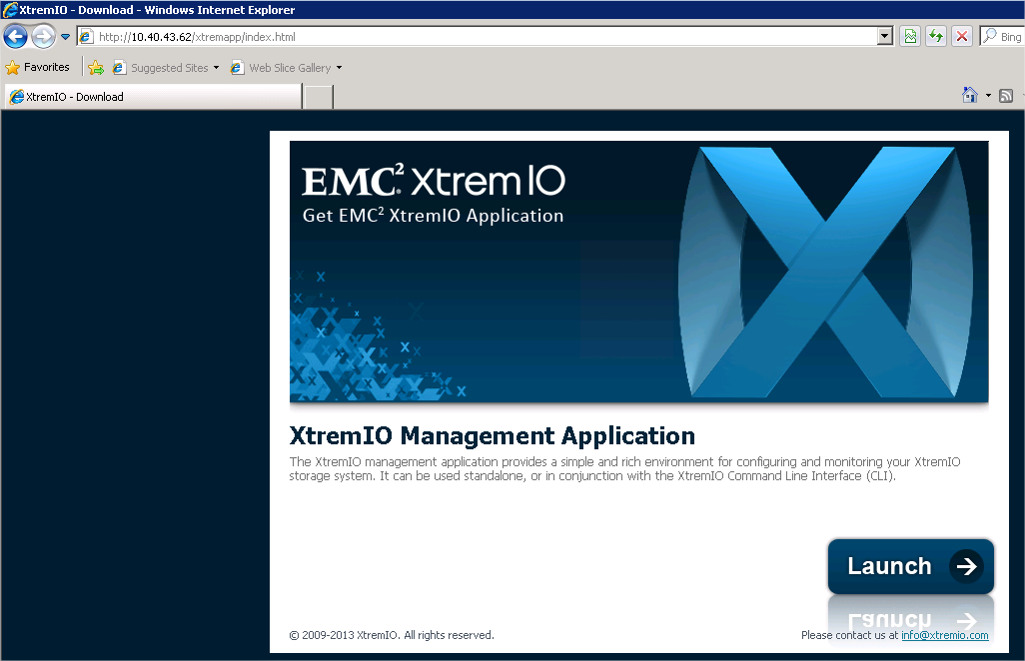

Note: Adding this URL to restricted sites may be required depending on your security settings

- Select launch and check the accept risk box to run application

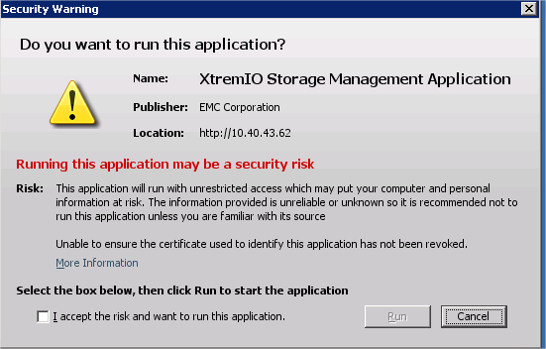

- Login screen will appear and allow you to enter the credentials

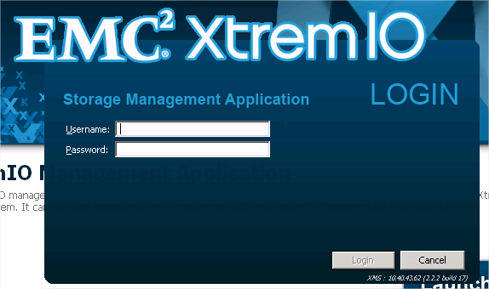

- Once login is verified the dashboard will appear

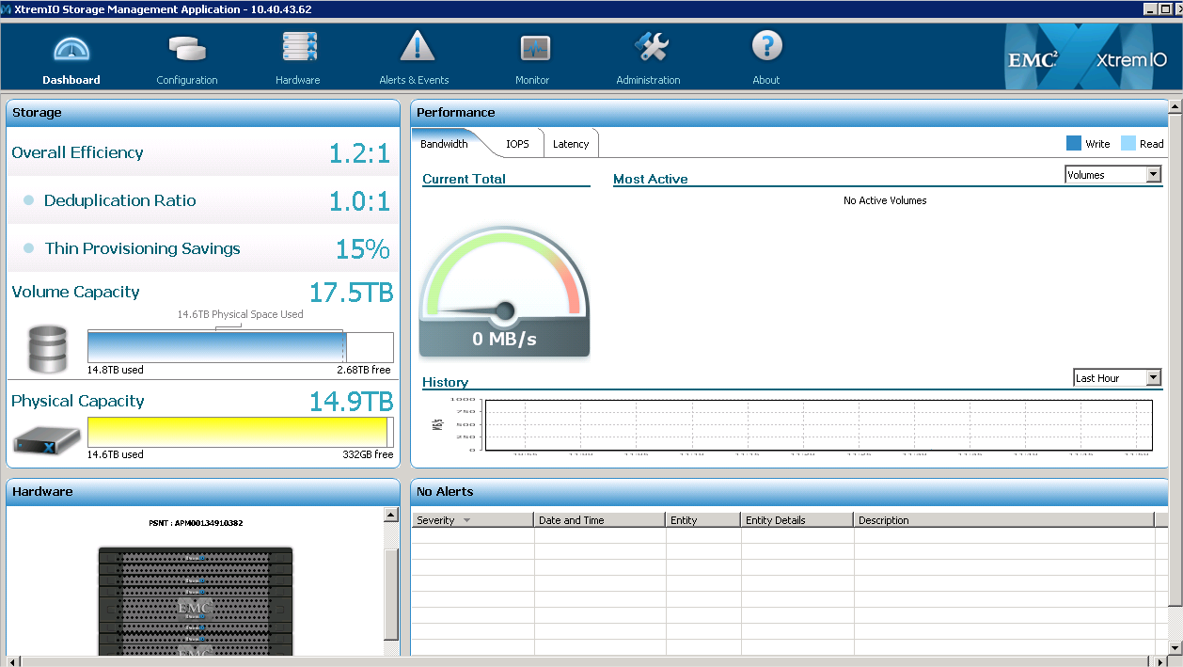

Note: A shortcut on the desktop will be created for future access

Installation & Configuration Instructions
- Physical installation of array into enterprise class data center
- Request cabling for XtremIO connectivity
- Assign relevant naming standards to XMS and storage controller IP addresses
- Request management IP’s for storage controllers and XMS connectivity as well as IP’s for 10GbE iSCSI connections.
- Request installation of XMS virtual appliance on production ESX cluster within same DC
- Coordinate with EMC to upgrade XtremIO cluster to latest Citi approved Service Pack and disable IPMI access.
- Configure XtremIO for e-mail home to EMC and Citi Storage Support
- Work with EMC to setup XMS for remote support via ESRS Gateway
- Enable IPtables on XMS and Storage Controller for limiting access.
- Configure and enable Citi enterprise monitoring
- Configure and enable Citi audit log forwarding.

Configuration Assurance

Refer to the following file found on the EMC XtremIO Standard Homepage for HPNA. At this time configuration assurance is done manually until further integration is completed.
- XtremIO SBCC (Standard build checklist)

Scalability & Capacity
XtremIO is certified for VDI 2.0 Pod implementations and are single X-bricks configurations only. The ability to upgrade from a single X-brick to multiple is not available from EMC at this time.

Monitoring XtremIO Capacity with XMS Dashboard

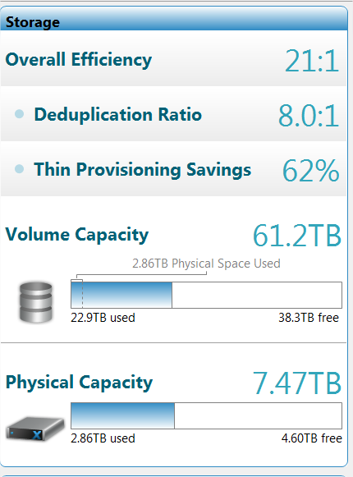

Term | Definition
Overall Efficiency | The disk space saved by the XtremIO array – Calculated as volume capacity / physical space used
Deduplication Ratio | Real-time inline data reduction ratio – Calculated as Volume Capacity used / Physical Space Used
Thin Provisioning Savings | % of volume capacity not in use – Free Volume Capacity / Allocated Volume Capacity
Volume Capacity | Total disk space defined by the volumes – Displays physical space used compared to logical space used
Physical Capacity | Total physical capacity available to all LUNs in cluster - Displays Used versus Free

Storage Capacity Alerting

The cluster is monitored using the Sys Ud Ssd Space parameter which represents Physical Capacity used on the array. This event activates when the physical capacity free reaches <10%. The system begins triggering a minor alert which must be confirmed manually before it clears. When the free space drops to 1% the alert changes to major and triggers another alert for forwarding. It is required to update the alert definitions for Sys Ud Ssd Space Limited so that the initial 90% alert will have a Major severity versus the default of Minor. Alerts are visible using the Alerts & Events option in the XMS Menu Bar under the Alerts or Events tab.

- Go to Alerts & Events>Select small triangle icon on right side for Display Alert Definitions

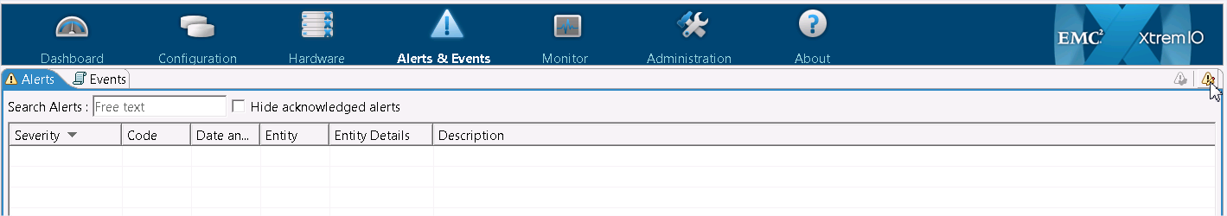

- Sort by Alert Name column>Double click Sys Ud Ssd Space Limited alert

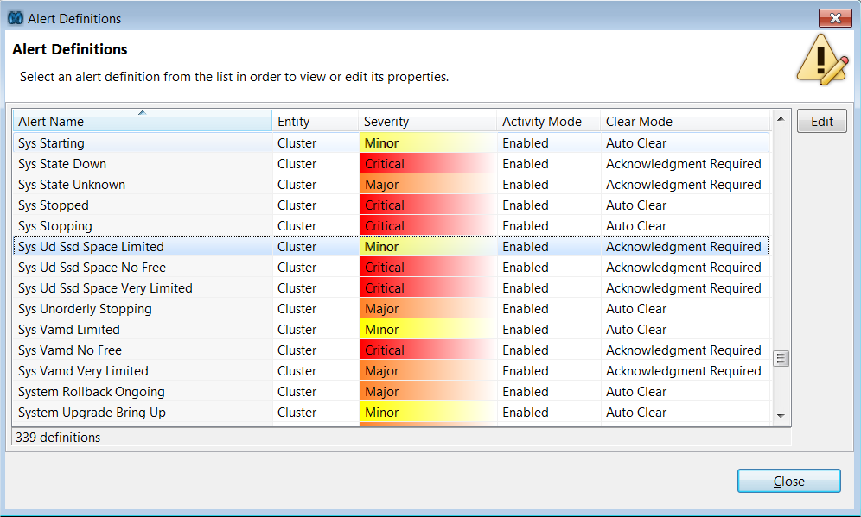

- Edit the alert definition by changing severity from Minor to Major and confirm Activity Mode: Enabled> Select OK
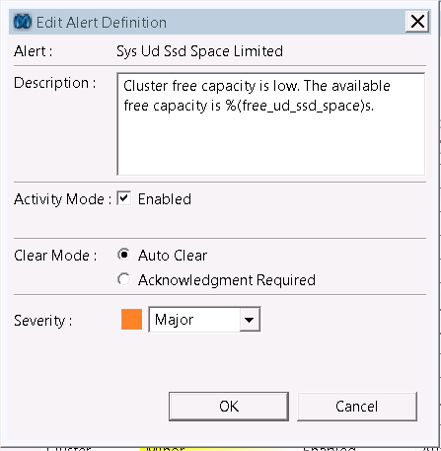

VAAI Thin Provision Limit

The additional ability to alert on total array capacity is available using the VAAI TP Limit. This setting provides a percentage to be set on the cluster configuration that will trigger once that percentage of physically used capacity is reached. Configuring this option can be done using the following steps.

- Go to Administration > Cluster Limits

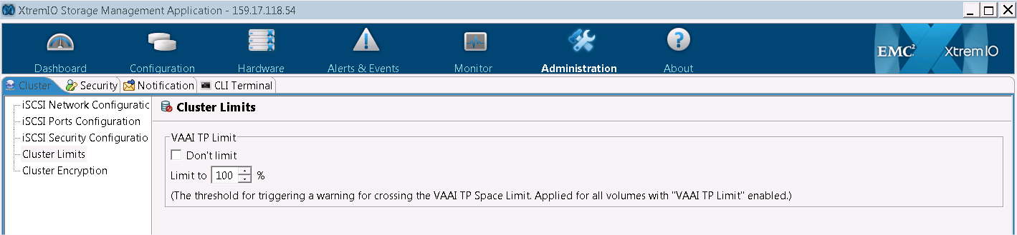

- Confirm Don’t Limit is unchecked > Enter 85% in the Limit to section > Apply

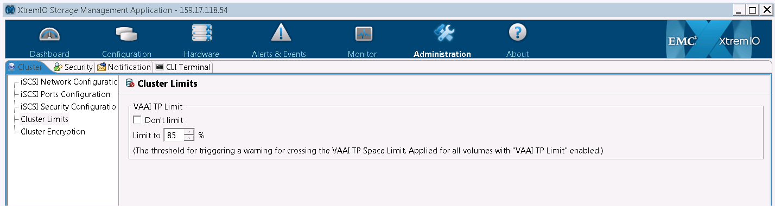

- A minor alert similar to below will generate once the threshold is met.
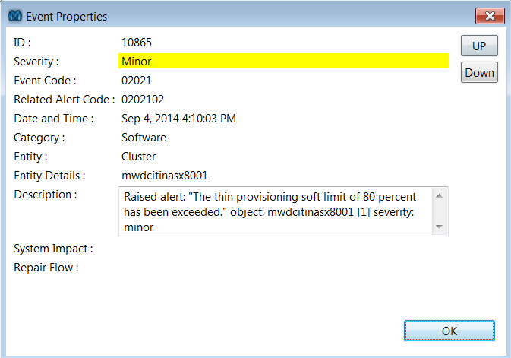

Alerts will generate an SNMP trap to be sent to the Enterprise Monitoring System. Below is the information on the thresholds and their settings.

Threshold Type | Threshold Range | Default | Alert Severity | Alert Acknowledge
TP Soft Limit | Custom | 100%/  85% is recommended | Minor | Manual acknowledgment required
Built-in | 90% | 90% | Major(Manual update required) | Manual acknowledgment required
Built-in | 99% | 99% | Critical | Manual acknowledgment required

Allowing total allocation to exceed 90% of total capacity puts you at risk of running out of space and impacting all applications using LUNs on the XtremIO storage array.

Capacity Monitoring with SRM

With the current XtremIO release and SRM, multiple XtremIO systems can be discovered using the XtremIO SolutionPack. This feature allows for a variety of capacity and performance metrics to be viewed in one dashboard. At the time of this publishing SRM is going through certification at Citi and more details on capacity reporting will be available in a future update to this document.

LUN Migration

With the current XtremIO release, LUN migration is not available. If LUN migration is required, host based methods will need to be utilized.

Availability Management

SNMP and Email Alerting

The XtremIO SNMP alerts should be configured to send to an Enterprise Monitoring trap host. The received traps are then filtered and (as appropriate) will create a problem ticket or generate an SMS / Paging alert.

Adding an Array to the Monitoring System

Tivoli monitoring and alerting service is provided by Citi’s ESM team. The ESM team can be contacted at *ESM Distributed Event Delivery for instructions on requesting the systems to be monitored. Once the request has been submitted, the ESM team should provide the Tivoli server that will be used to send the XtremIO SNMP traps to.

It should also be requested to the monitoring team to have the X-bricks setup in the ping scanning list i.e. if a ping of the array does not respond then this should be configured to generate an alert.

SNMP alerting with Tivoli NetCool

When there is an alert event, the array will send an SNMP alert to the trap host configured in the system. In order for the trap host to create a problem ticket or send out SMS/ Paging alert, it is important to check that a valid entry exists for each of the storage controllers in Aperture.

Notes
- Resiliency at the Tivoli NetCool (trap host) level is not available at this time. i.e. if the configured SNMP trap host server is down, all SNMP alerts sent by the storage system will not be received by the Tivoli NetCool environment

Adding an SNMP Recipient and SNMP Properties

The following steps should be taken to configure SNMP alerting on the XtremIO:

- Add recipient and properties for SNMP alerting.

  - From the menu bar select Administration icon, then in the left pane select SNMP Configuration.
  - Check the Send SNMP Notification box
  - Select Add to open Recipient Dialog Box, type in the recipient IP address then click OK to confirm and close dialog box.
  - Select the SNMP version (V1 or V2C) V1 is recommended within Citi.
  - Type in Community field (Default is public read only)
  - Type in Trap port field (Default is 162)

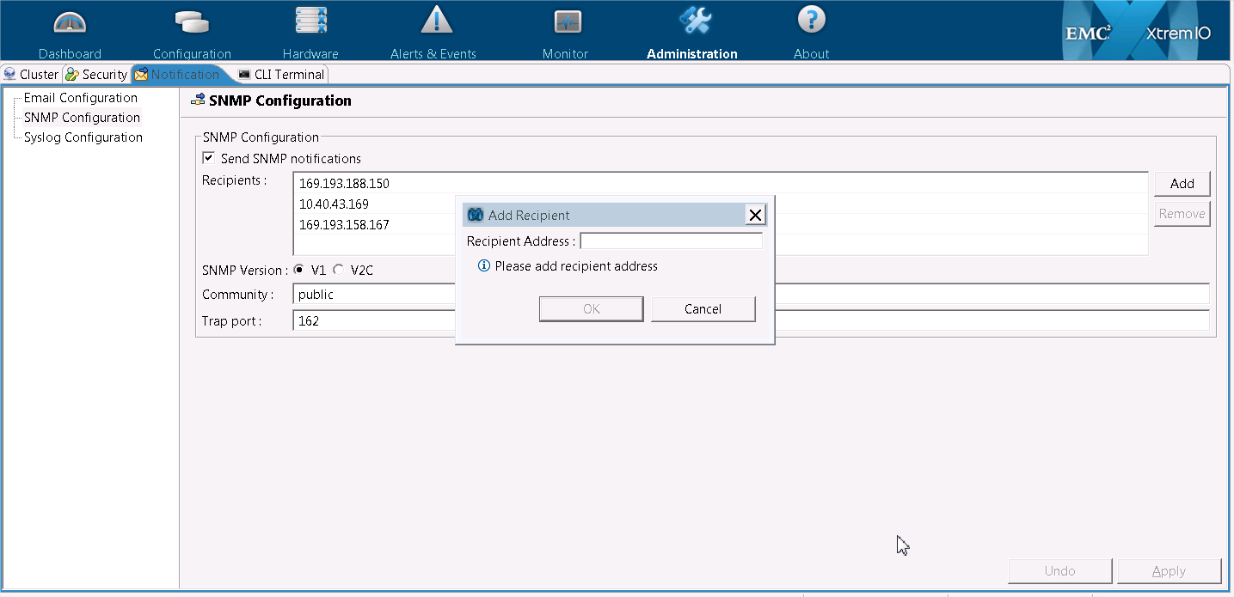

  - Click Apply to Save Changes

  - From menu bar, select Alerts & Events>Events Tab> Display Event Handlers icon on upper right corner.

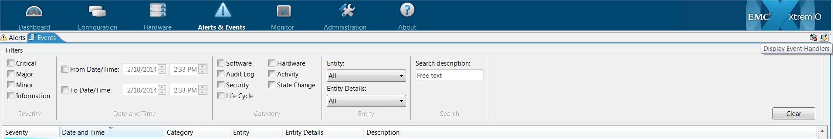

  - Select Add

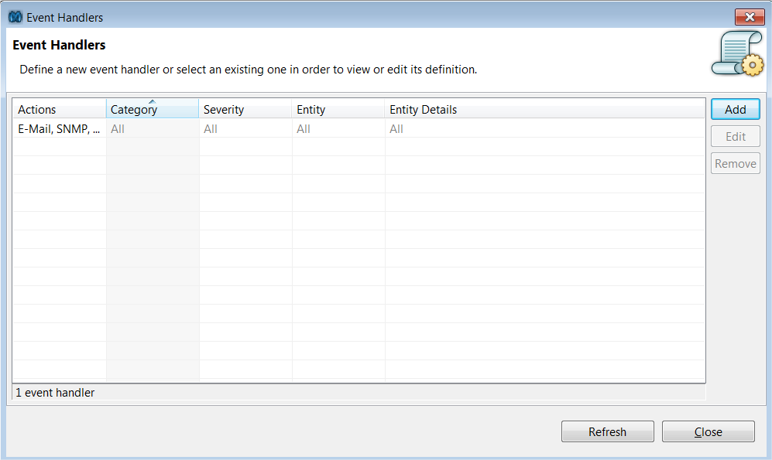

  - Select the Category, Severity, and Entity from the drop down then select Send e-mail and Send SNMP trap select OK. All severity levels should be selected in order to receive Major and Critical events.

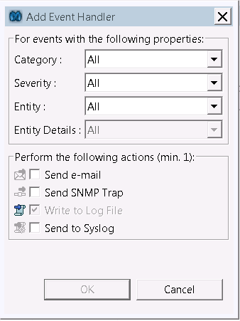

Note: There is currently not a Send Test Event option within XMS, enabling all properties and then creating a test user account can trigger a test alert to be sent to Tivoli NetCool console.

SNMP MIB

The below table describes the SNMP trap variables that are generated by the XtremIO and examples of relevant information from a triggered event.

OID/ Trap# | Trap Variable Name | Sample Alert Data
1 | xioEventType | Create
2 | xioEventThreshold | alert_def_sys_stopping
3 | xioEventObject | X2-SC1 [3]
4 | xioEventSeverity | Major
5 | xioEventState | Outstanding
6 | xioEventDesc | Raised alert of type alert_def_disconnected_from_node_mgr: object: X2-SC1 [3] severity: major
7 | xioEventXmsTime | Fri Feb 21 20:01:48 2014

XtremIO Severity | Netcool Severity | ESM Action
Information | 1 | No Ticket, Event will be cleared in 24 hrs in Netcool
Minor | 3 | No Ticket, possible e-mail alert if configured in SMRDB
Major | 5 | Ticket or email or both based on user config in SMRDB
Critical | 5 | Ticket or email or both based on user config in SMRDB

The various events are being reviewed within Citi to determine where there should be changes to the default severity. This is then used by the ESM team to create a rule file that maps an eventID to the Citi severity level. If a trap is received that is not defined in the rule file, the severity of the trap will be set to informational and will not be processed by any automation within Netcool.

In order for the ESM team to complete the SNMP alerting setup, they also require the MIB file for the array. The MIB file is available on the CSBE XtremIO Product page.

Call Home and Email Alerting

Email home should be configured on the storage array for remote alerting. The template should be setup to also send an email to Citi’s support team responsible for monitoring the XtremIO environment each time the device emails home to EMC. Citi’s SMTP server should be specified to send out the email home alerts under the SMTP Information.

Notes
- It is only possible to configure a single SMTP Server IP Address (DNS names are not supported). When selecting a mail relay host, ensure that a Virtual IP (VIP) address is used for the SMTP Server to provide resiliency.
- Do not use an SMTP server that is using storage on the array you are configuring.

Remote Support (EMC ESRS)

ESRS supports access to the XMS both outbound and inbound. Since the XMS is a virtual appliance on the Citi GRN the access to as well as from XMS and the storage controllers must be restricted. In order to facilitate this restriction ACL with IPTables must be used to enable access controls on XMS and storage controllers. Once alerts are received by EMC support from XMS they will have the ability to initiate access remotely to XMS for proper troubleshooting..

Please reference the ESRS Solutions Guide for more details.

Dossier Collection

In many troubleshooting scenarios the need to collect a dossier will be required. The dossier is a collection of logs from the XMS and storage controllers that EMC support will review. The way to obtain a dossier is via the CLI with the create-debug-info command. An example of using this command is below:

xmcli (jh53740)> create-debug-info
The process may take a while. Please do not interrupt.
...........................................................................................................................................................................................................................................
............................................................................................................................................
Successfully collected dossier on X2-SC2
Successfully collected dossier on X1-SC2
Successfully collected dossier on X1-SC1
Successfully collected dossier on X2-SC1
Successfully collected dossier on xms
Created /var/www/xtremapp/DebugInfo/b2-xtremio1_2014_08_07_1025.tar.gz

Debug info collected and may be accessed via https://10.40.43.62/xtremapp/DebugInfo/b2-xtremio1_2014_08_07_1025.tar.gz

Once the collection is complete you can copy the URL into a browser and download the tar file.

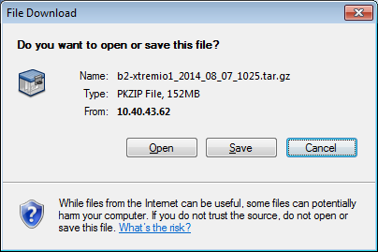

Event Monitor

For Audit Log Reconciliation, it is required that central event monitoring be configured for all arrays. Within XMS the ability to forward syslog events to a remote server can be configured as follows.

- Go to Menu Bar > Select Administration > Notifications tab > Syslog Configuration

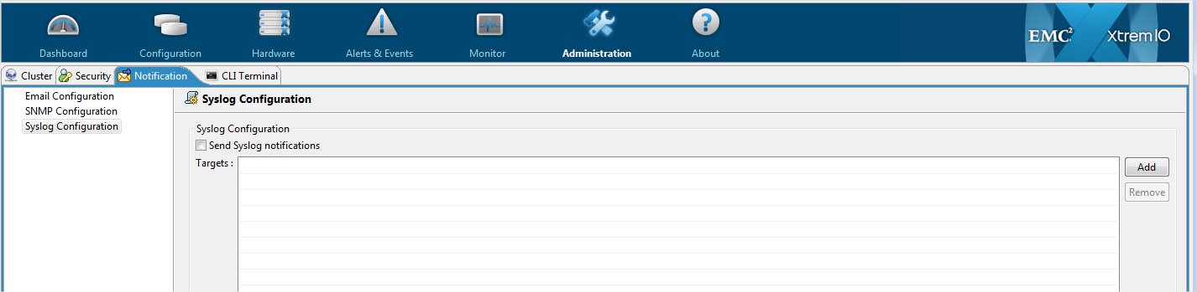

- Select Add > Type in hostname of Syslog server and click OK

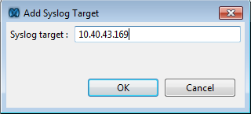

- Select check box for Send Syslog notifications then click Apply

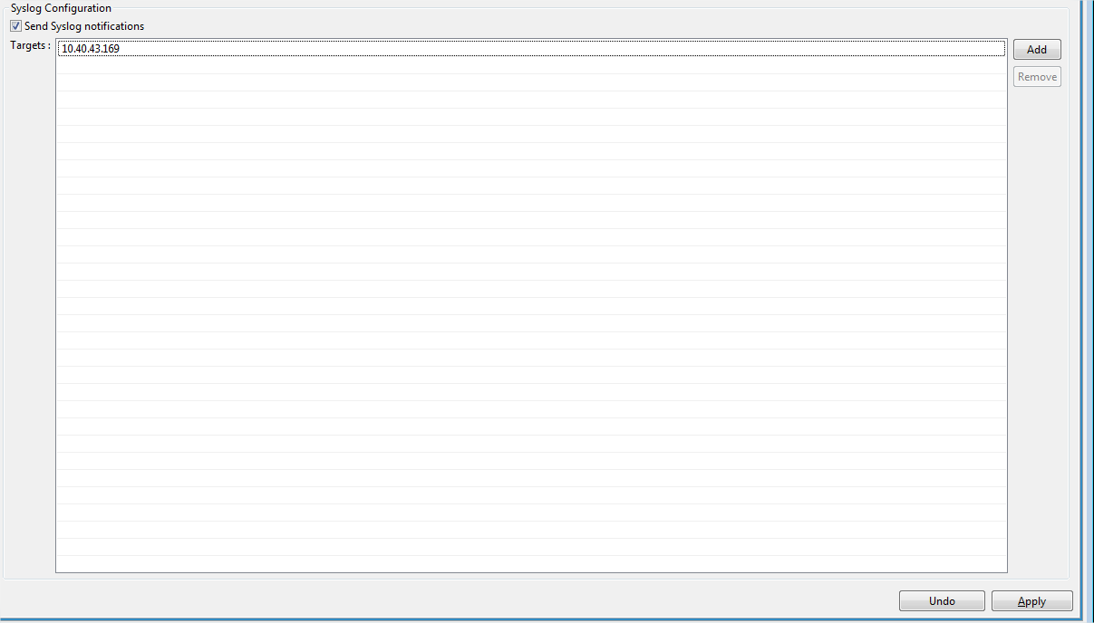

Performance Monitoring using XMS

XMS gathers real time performance statistics at the Block Size, Initiator Groups, and Volumes level in the Dashboard view. Bandwidth, IOPS, and Latency metrics for Reads and Writes are updated on a 5 second interval in the Performance pane. The ability to select statistics from the following time frames is available: Last Hour, Last 6 Hours, Last 24 Hours, Last 3 days, Last Week.

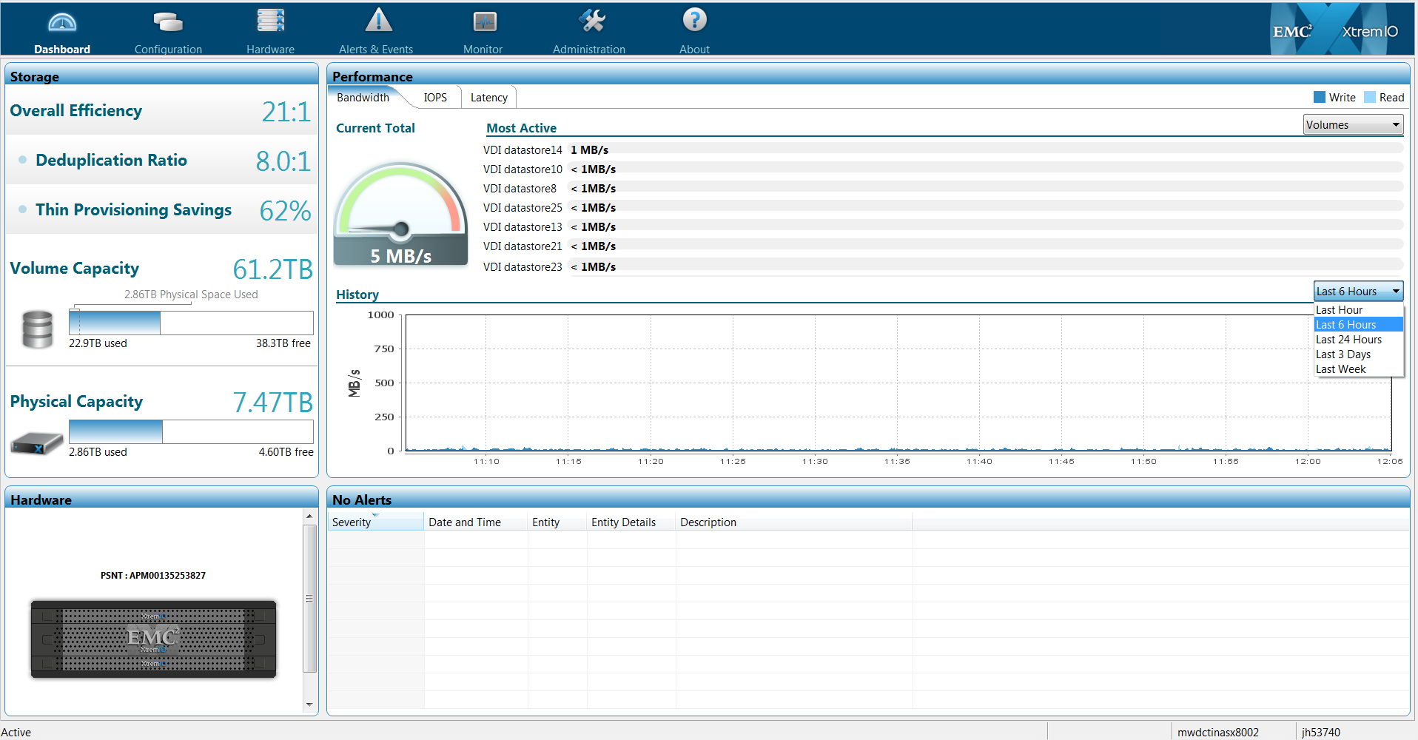

Exporting Performance History

In the current release, performance history is only kept for 7 days. The performance history can be exported via the CLI with the export-performance-history command. An example of the using this export is below.

xmcli (admin)> export-performance-history
Exported performance history can be accessed via http://x.x.x.x/xtremapp/performance_history.csv
xmcli (admin)>

Once the export is complete you can copy the URL into a browser and download the CSV file.

Advanced Real Time Monitors

In order to view specific components in real time there is the ability to create a custom monitor for a particular monitor type.

- Go to Menu Bar > Select Monitor > New to add new monitor

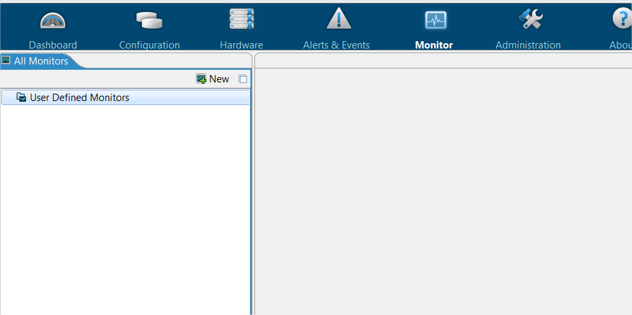

- Type in a Monitor name and select a monitor type from the list

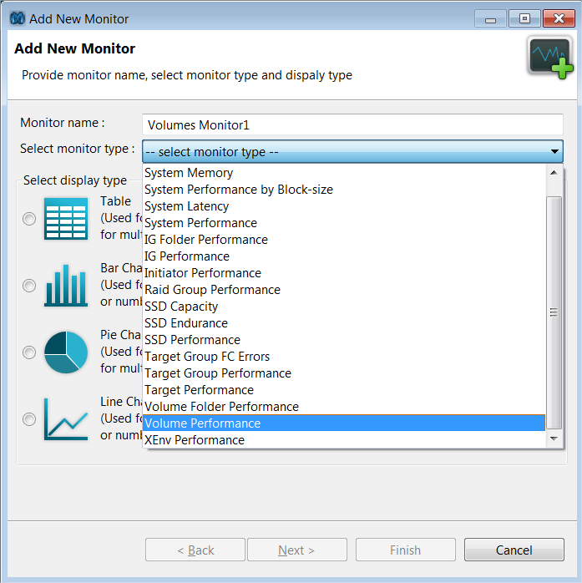

- Select the elements to include and properties to monitor then Next

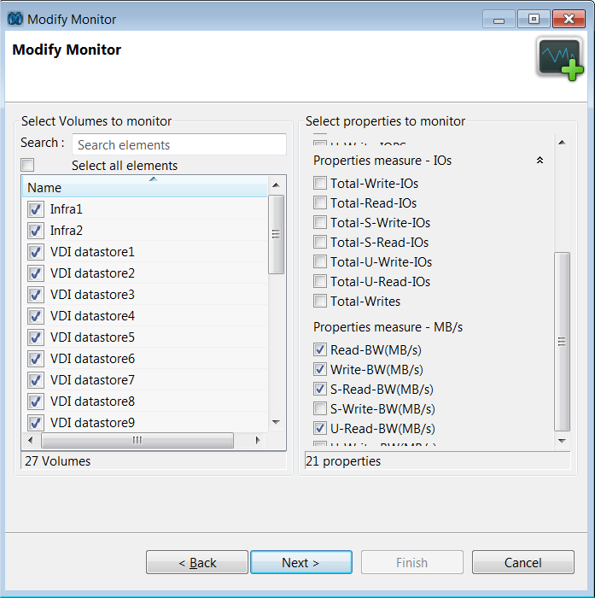

- Review monitor parameters and hit Finish

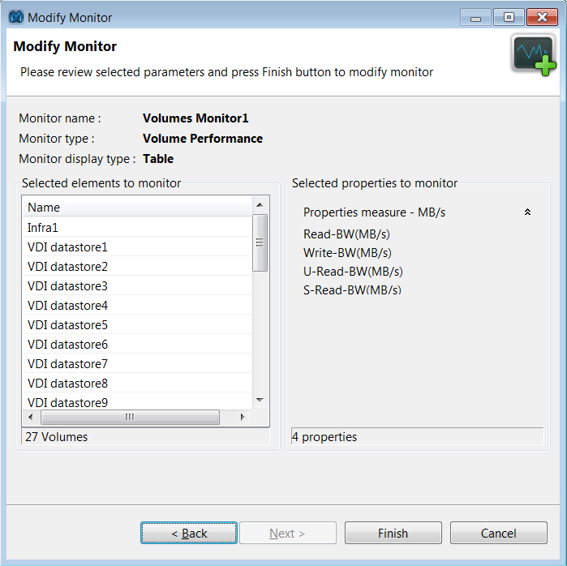

- The monitor will be available in the main viewing pane on the right.

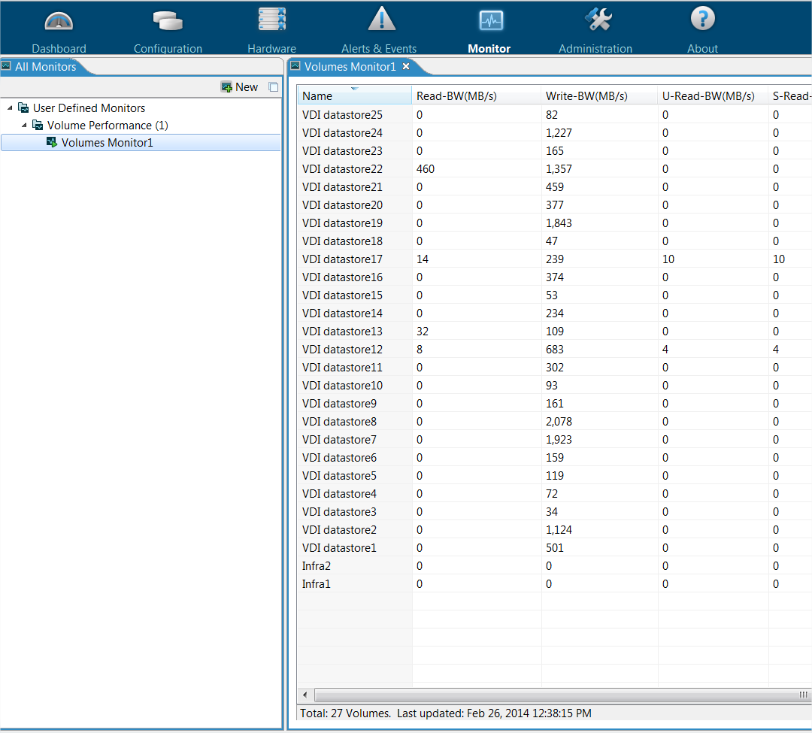

Regional or Merger Partner Consideration
Not Applicable – there are no regional considerations associated with this network design/configuration and it is not related to a company merger or acquisition.

Global Standard

Security Standards

Citi Information Security Standards (“CISS”) are available from Information Security Services (“ISS”) website.

Citi’s SAN, NAS and Backup infrastructure stores and processes information across the full range of information security classifications.

For data classified as Public or Internal, no specific provision is required for data encryption either in-flight or at-rest.

For Confidential and Confidential PII support, all new applications are required to encrypt confidential PII data in transit (refer to Encryption Requirements Section of CISS). For Restricted or Authentication data, encryption of data is required both in-flight and at-rest.

The recommended approach for Restricted, Authentication and new applications storing Confidential or Confidential PII data would be to encrypt the data within the application prior to transmission over the network. This approach has the benefit of also meeting the requirement in all these cases for persistent encryption when non-Citi managed storage infrastructure is used. At the time of writing this document there are no tested or approved solutions at the storage infrastructure layer to encrypt data in-flight or to encrypt the data at rest, meaning that where required, this functionality needs to be applied by the application.

This classification, by definition, infers a “Medium Risk” status on all Citi’s SAN, NAS and Backup infrastructure.

Audit Logging

Syslog forwarding for the EMC XtremIO environment should be integrated with Citi’s Secure Event Monitoring System (SEMS) for Audit Log Reconciliation. SEMS is used to centrally collect all security events. Custom reports can then be generated from the events collected by SEMS and sent to the log review teams for reconciliation. For details on configuring syslog forwarding go to the Event Monitor section.

Data Security

The recycling or reusing of LUNs from one host/application to another is prohibited. The recycling of LUNs compromises the data written by the initial host/application.

It is recommended that all LUNs must be deleted when no longer required by the host to which it was initially presented.

It is also recommended that the host SA should follow guidelines consistent with the data erasure of a physical drive prior to deleting the LUN.

Disk Sanitization

Disk sanitization is the process of physically obliterating data on disks in a manner that precludes recovery of that data by any known recovery methods.

Disk sanitization is a requirement mandated by CITMP IS Policy.

As there is currently no feature available within the XMS/XIOS that enables overwriting the contents of a disk, it is recommended to follow an approved process in accordance with Global Data Center Secure Media Disposal policies to
degauss the disks
use EMC Data Erasure for XtremIO service to securely erase or dispose of the disks (compliance with Global Data Center Secure Media Disposal policies should be verified and approved by an appropriate Information Security Officer)

NOTE: Current CITMP limitations restricting movement of electronic media warrant that all disk sanitization be completed without the transportation of disks.

Disposal of failed disks

All failed disks within every CTI data center are subject to stringent sanitization or degaussing procedures. As such, all failed media should be processed in accordance with Global Data Center Secure Media Disposal policies.

Information Ownership

The head of Distributed Engineering has information ownership of Storage products and all related engineering documents. Storage products are available in the Citi Technology Catalogue. All security and technology best practices for Storage products are the responsibility of CATE Storage and Backup Engineering and can be referenced from the CSBE website.

Role Based Access Controls (RBAC)

The following roles are defined for users and groups in XMS.

XtremIO Role | Privileges
Administrator | Full privileges for storage and security tasks.
Configuration | Full privileges for storage tasks.  No privileges for security tasks.
Read-Only | Read-only privileges for storage and monitor tasks.  No privileges for security tasks.

Roles defined for use in Citi

With the current XtremIO release LDAPS/Active Directory integration is required for user authentication.

For everyday administration, Citi administrators should perform one of the following roles:
- Configuration
- Read-Only

This section breaks down the responsibilities and corresponding XMS role.

Citi Role | Description | XMS Role
Storage Engineer | The role of the administrator is to  - Setup and make configuration changes to storage array  - Create / manage user accounts (including role association) | Administrator
Storage Administrator | The role of the Storage Administrator is to  - Make configuration changes to the storage system. | Configuration
Storage Monitor | The storage monitor will only be given read-only access to the storage system for troubleshooting and reporting purposes | Read-Only
System Administrator | A system account should be maintained in the unexpected event of being unable to manage the system using the above roles.  The system account should be used to create the initial Administrator accounts and then should be immediately uploaded to a certified password storage system to ensure that these accounts are not used for system administration.  Should there be a need to use the system account; the requester should use an auditable and traceable Change Management system to request the use of the account. | Administrator (admin acct)

Adding a Domain User

User Accounts

XMS should be setup to authenticate users with Citi’s Active Directory (AD) for the following reasons:
- Central management of user accounts
- Enforces user account and password policies as defined in AD
- Assign XMS roles to AD groups instead of having to map roles to each individual user.
- Provides segregation of duties for Storage Operations to assign user management functions including entitlement reviews to ISA.

XMS LDAP User Authentication

XMS has the ability to integrate with AD to authenticate users. To setup XMS AD user authentication, the ISA will need to do the following:

- XMS will need a functional ID and an associated password to be created in AD which it will use to bind to the directory. For further information on AD LDAP, please refer to the CATE Microsoft Active Directory site.

- AD Groups should be created for each of the XMS roles needed to manage the cluster: Read-Only, Configuration, and Administrator.

- Once the groups have been created in AD, users should be assigned membership to the AD group with their corresponding role.

- This is a one-time configuration setting. Once this setting is made, all user management tasks will be done on AD, not XMS. To configure AD user authentication in XMS, do the following:
  - Log into XMS using the default admin account.
  - Go to Menu Bar > Administration > Security Tab > LDAPs Configuration
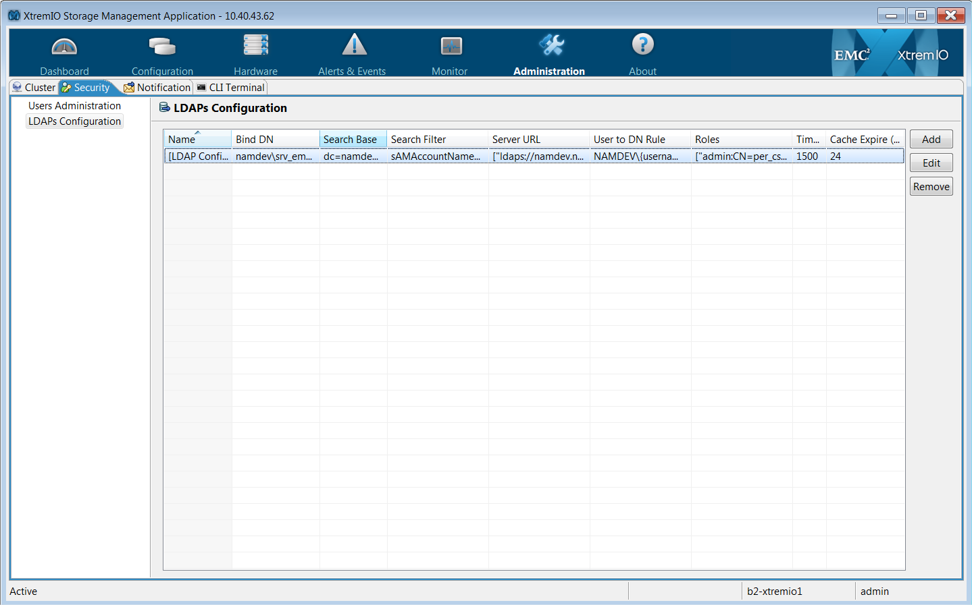
  - Select add from right side and enter the AD settings. All of this information should be provided by CATE Directory Engineering through the request process. Cache expiration should be lowered to 1 hour.
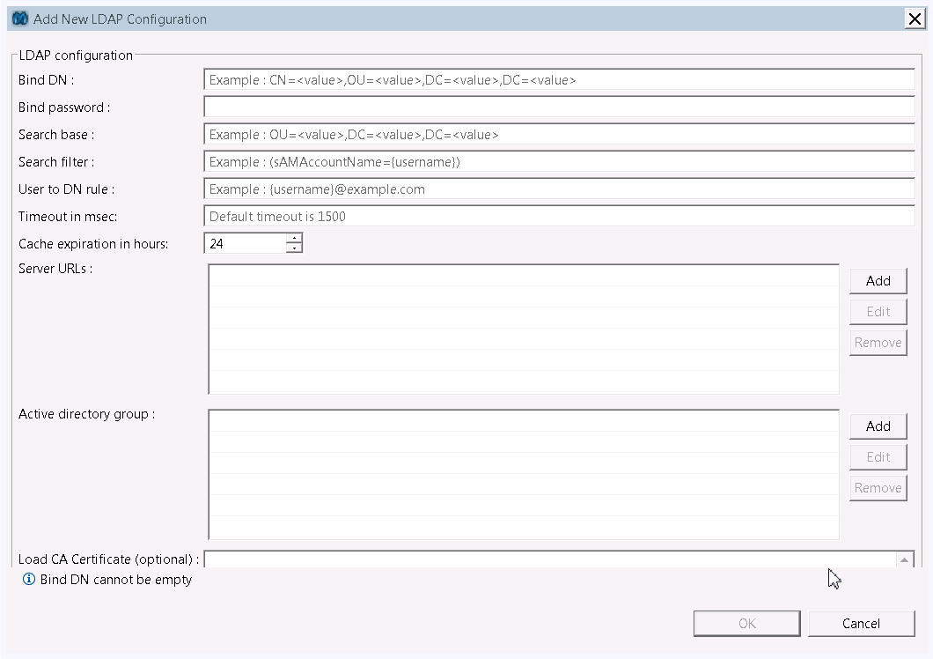
  - Add server URLs,

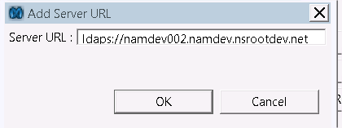
  - Add active directory group information
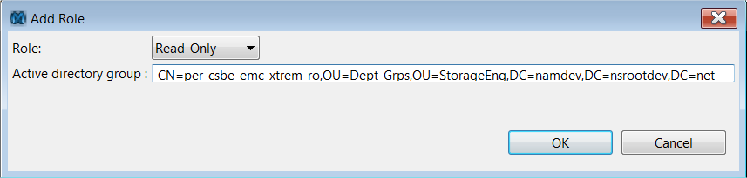
  - Load CA Certificate – A Citigroup LDAP certificate should be pasted in PEM format in this field. This certificate can be found at the following URL
https://digitalcertificate7.citigroup.com/cda-cgi/clientcgi?action=start

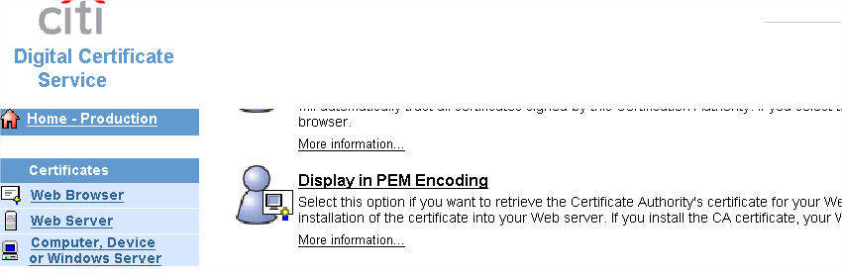

The output displayed after this option is selected is the PEM Encoding. Cut from -----BEGIN CERTIFICATE----- statement to the ----END CERTIFICATE----- statement with no extra spaces or lines then paste in the certificate field.

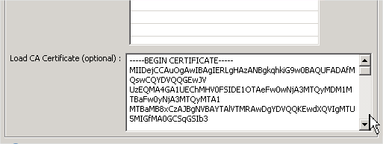
  - Select Ok to enable settings

Once the AD settings have been configured and successful connection to the replicated SSO LDAP infrastructure has been established, users can login with their AD credentials. For cross-domain access an additional LDAP configuration must be entered following the same steps as documented above. An example login screen is provided below:
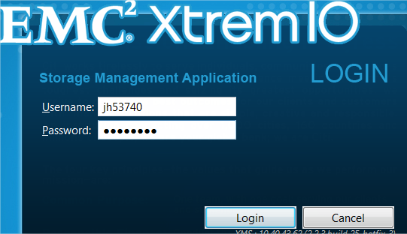

Functional IDs

With the current XtremIO release there are local accounts that provide specific privileges for EMC personnel to manage the device. These functional IDs must be managed by the storage operations teams and need to have passwords changed when appropriate. They should not be used by operational teams as a means of accessing the system, unless AD is inaccessible.

Once AD integration is configured, only the default Administrator account should be available for limited use in specific support cases.

User | Purpose | Role | Interactive | Privileged Access | Password Expiration
root | Administrative user created for Storage Controller & XMS (SSH access only) | Admin | Yes | Yes | Yes (PAR)
admin | XMCLI & GUI built-in administrative user for emergency access | Admin (cannot manage tech user account) | Yes | Yes | None (dual key control)
tech | XMCLI & GUI built-in administrative user for EMC support | Admin | Yes | Yes | None (dual key control)
xinstall | User for initial configuration/ installation on XMS used by EMC support | Admin | Yes | Yes | None
xmsupload | User created for uploading SW images to XMS for install and upgrade | User | Yes | Yes | None
xmsadmin | Built in administrative user for direct access to XMCLI used by EMC support | User | Yes | Yes | None

Root ID Access

With the current Service Pack release, root access will be required in certain troubleshooting scenarios on both XMS and the storage controllers. The following are some examples of cases where root access will be required:

- Collecting traces on live cluster for problem investigation.
- Troubleshooting cluster connectivity issues
- Some FRU replacement procedures
- Manually collect cluster logs in case dossier can’t collect the logs directly or there is a need for additional debug logs which are not collected by dossier.
- SSH from XMS to Storage Controllers
- Managing ACL rules with IPTables

Access Control List (ACL) with IPTables

With EMC support requiring access to XMS for ESRS capability there must be an ACL implemented for limiting access from the XMS and storage controllers to any other devices on the Citi GRN. IPTables is the internal firewall software on XMS and the storage controllers that will create the ACL to limit SSH access. This is an important compensating control for restricting outbound connections from XtremIO cluster components.

Warning: EMC has recently enabled specific ACL rules on the XMS and storage controllers without any manual entries required. Any additional changes to the IPTables ACL must be reviewed and approved by CATE and EMC support before implementing.

Environment Setup

To validate the environment is setup after Hotfix is applied use the following command:

xmcli (admin)> show-clusters-info
Cluster-Name Index State Conn-State Activation-Time Start-Time SW-Version PSNT
b2-xtremio1 1 active connected Mon Dec 9 17:19:47 2013 Tue Aug 5 12:36:00 2014 2.4.1-12_hotfix_1.4
Encryption-Mode Encryption-Supported Mode-Switch-St
atus Mode-Switch-New-Mode SSH-Firewall-Mode
APM00134910382 disabled No none
disabled locked

Under SSH-Firewall-Mode you should see locked instead of unlocked.

Required entries in ACL

SSH is used to communicate with XMS and the storage controllers. Based on this requirement SSH should only be allowed as follows:

Source | Target | Purpose | Ports
Storage management host | XMS | SSH access to XMS for management | SSH - 22
ESRS gateway | XMS | SSH access to XMS for EMC troubleshooting | SSH - 22
XMS | Storage Controller | SSH access from XMS to storage controllers for troubleshooting. No SSH access to any other targets. | SSH - 22
Storage controllers | None | No SSH access to any other targets | SSH - 22

Sample IPTables Entries

The following is a sample of the IPTables ACL that is enabled when the Hotfix is applied to the XtremIO cluster. These rules limit SSH access on XMS and storage controllers.

XMS rules
[root@csbe-vxms1 ~]# iptables -L
Chain INPUT (policy DROP)
target prot opt source destination
ACCEPT all -- anywhere anywhere
ACCEPT all -- anywhere anywhere state RELATED,ESTABLISHED
ACCEPT tcp -- anywhere anywhere tcp dpt:ssh
ACCEPT udp -- anywhere anywhere udp dpt:ntp
ACCEPT tcp -- anywhere anywhere tcp dpt:http
ACCEPT tcp -- anywhere anywhere tcp dpt:https
ACCEPT udp -- anywhere anywhere udp dpt:bootpc
ACCEPT icmp -- anywhere anywhere icmp echo-request

Chain FORWARD (policy ACCEPT)
target prot opt source destination

Chain OUTPUT (policy ACCEPT)
target prot opt source destination
ACCEPT tcp -- anywhere anywhere tcp dpt:ssh state RELATED,ESTABLISHED
ACCEPT tcp -- anywhere xtremio-1.nam.nsroot.net tcp dpt:ssh tcp
ACCEPT tcp -- anywhere xtremio-3.nam.nsroot.net tcp dpt:ssh tcp
ACCEPT tcp -- anywhere xtremio-5.nam.nsroot.net tcp dpt:ssh tcp
ACCEPT tcp -- anywhere xtremio-7.nam.nsroot.net tcp dpt:ssh tcp
DROP tcp -- anywhere anywhere tcp dpt:ssh state NEW

SC1 rules
[root@b2-xtremio1-x1-n1 ~]# iptables -L
Chain INPUT (policy DROP)
target prot opt source destination
ACCEPT all -- anywhere anywhere
ACCEPT all -- anywhere anywhere
ACCEPT tcp -- anywhere anywhere tcp dpt:vce
ACCEPT all -- anywhere anywhere state RELATED,ESTABLISHED
ACCEPT tcp -- anywhere anywhere tcp dpt:ssh
ACCEPT icmp -- anywhere anywhere icmp echo-request
ACCEPT udp -- anywhere anywhere udp dpt:bootpc
iscsi all -- anywhere anywhere
iscsi all -- anywhere anywhere

Chain FORWARD (policy ACCEPT)
target prot opt source destination

Chain OUTPUT (policy ACCEPT)
target prot opt source destination
ACCEPT tcp -- anywhere anywhere state ESTABLISHED /* XIO_LOCK_OUT_CON */
DROP tcp -- anywhere anywhere state NEW /* XIO_LOCK_OUT_CON */

Chain iscsi (2 references)
target prot opt source destination
ACCEPT tcp -- anywhere anywhere tcp dpt:iscsi-target

SC2 rules
[root@b2-xtremio1-x1-n2 ~]# iptables -L
Chain INPUT (policy DROP)
target prot opt source destination
ACCEPT all -- anywhere anywhere
ACCEPT all -- anywhere anywhere
ACCEPT tcp -- anywhere anywhere tcp dpt:vce
ACCEPT all -- anywhere anywhere state RELATED,ESTABLISHED
ACCEPT tcp -- anywhere anywhere tcp dpt:ssh
ACCEPT icmp -- anywhere anywhere icmp echo-request
ACCEPT udp -- anywhere anywhere udp dpt:bootpc
iscsi all -- anywhere anywhere
iscsi all -- anywhere anywhere

Chain FORWARD (policy ACCEPT)
target prot opt source destination

Chain OUTPUT (policy ACCEPT)
target prot opt source destination
ACCEPT tcp -- anywhere anywhere state ESTABLISHED /* XIO_LOCK_OUT_CON */
DROP tcp -- anywhere anywhere state NEW /* XIO_LOCK_OUT_CON */

Chain iscsi (2 references)
target prot opt source destination
ACCEPT tcp -- anywhere anywhere tcp dpt:iscsi-target

Important: After IPTables configuration changes are applied on XMS and storage controllers it is critical to validate access to and from each device.

Relevant Links
XtremIO Product Page

Glossary/Definition

Term or Acronym | Explanation or Definition
CATE | Citi Architecture & Technology Engineering
GNAST | Global Network Architecture and Standards Team
XMS | XtremIO Management Server
ESRS | EMC Secure Remote Support

Appendix A: Storage Controller Failover

XtremIO Health Check & SC Failover Simulation

- Upload the “Health Check” script to XMS
“Health Check” script should be uploaded to /images/scripts as user xmsupload/xmsupload
Requires “tech” account to execute
Running health Check script on an XIO with IPMI set to Dedicated.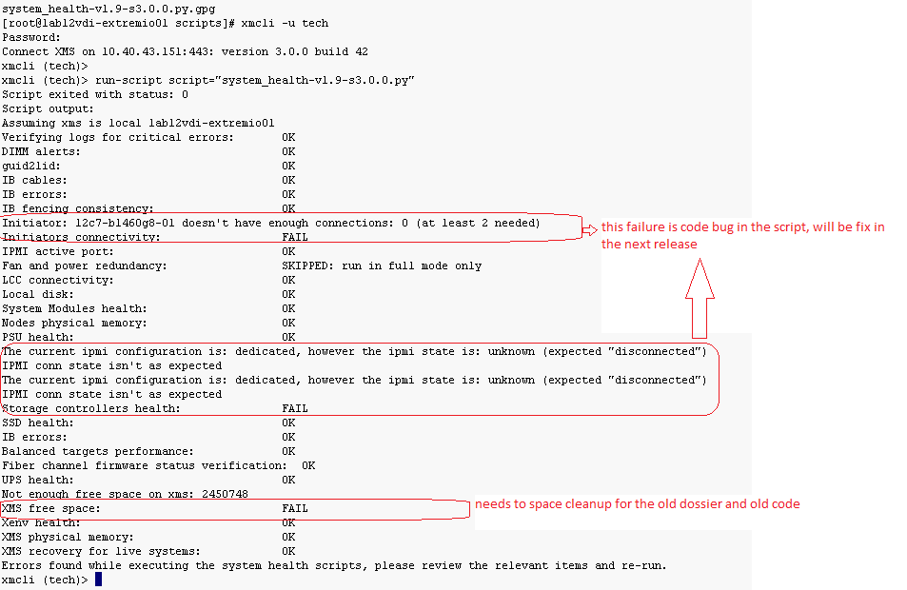
Note: XMS free space: 3GB space is required
- Before Testing: Disable SYR Notification to stop alerting:
#modify-syr-notifier disable

- Run the health check script
xmcli (tech)> run-script script="system_health-v1.9-s3.0.0.py"
IPMI is set to management:
Initiator Fail error is a code bug in the health check script will be fixed in the next release.
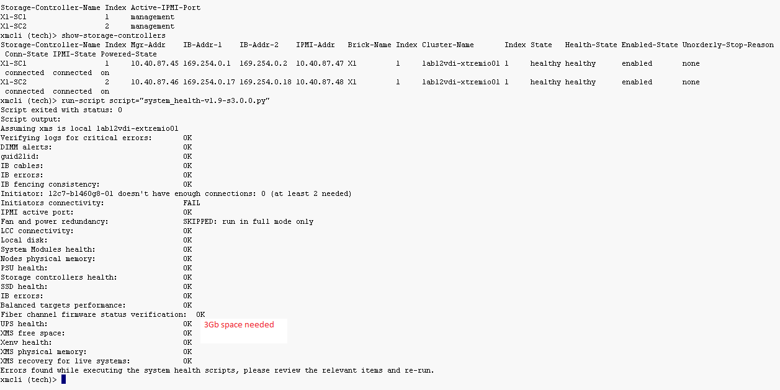
- Check ESX path
Note: All 4 iSCSI ports should be UP before starting the failover. The ESX hosts should have 4 Active paths before and after test.
2 active paths with a single SC after deactivated.
Check ESX paths before and after each deactivate/activate action as well as check for pending alerts.
Verify no Alerts in the array by running: # show-alerts

Command verification before De-Activating Storage Controllers
xmcli (tech)> show-alerts
xmcli (tech)> show-initiators-performance frequency=5
Initiator-Name Index Write-BW(MB/s) Write-IOPS Read-BW(MB/s) Read-IOPS BW(MB/s) IOPS Total-Write-IOs Total-Read-IOs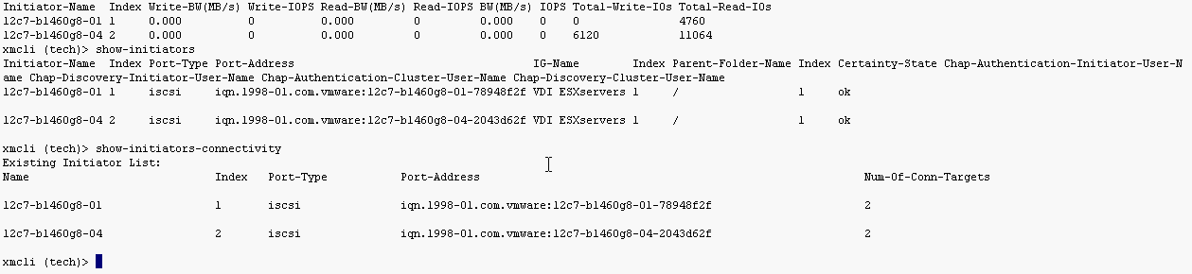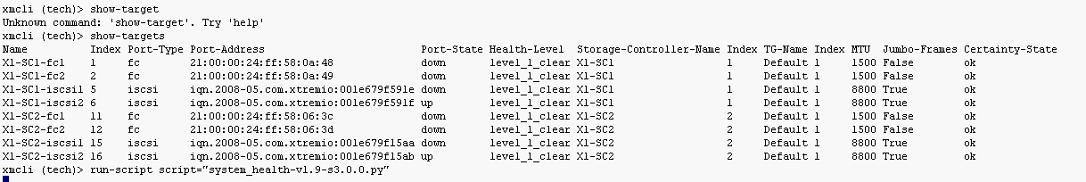
- De-activating Storage Controller:
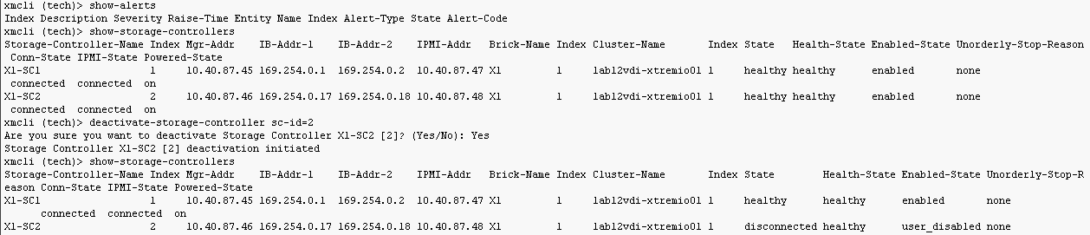
Verify XENVS are stabilized meta data load before Activating Storage Controllers
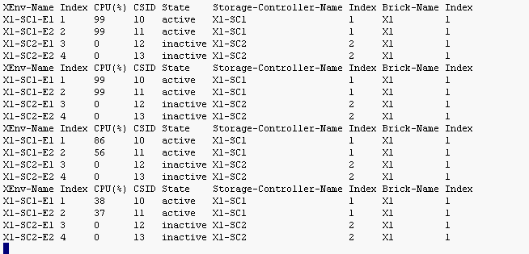
GUI Alerts View
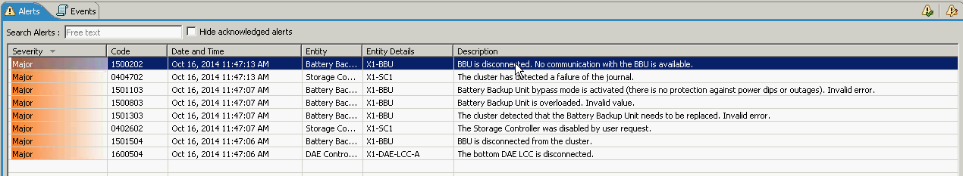
XMCLI Alert Show
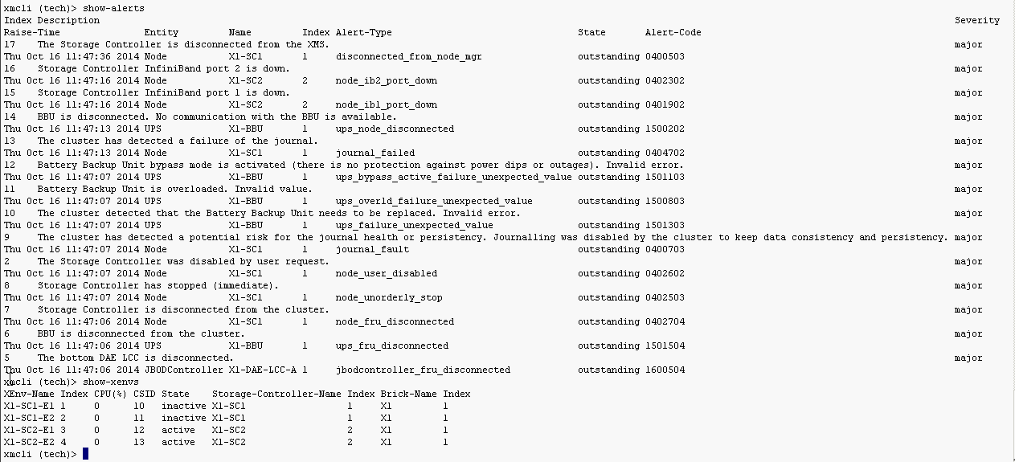
Note: After SC failover kicks off – should take about 10 minutes for surviving SC to normalize.

- Activating Storage Controllers after verifying Host path and Cluster/storage controllers had failover completely and meta data is stabilized.

Appendix B: Upgrade Procedures

As part of the upgrade from 3.0.0-42 to 3.0.1-11 a larger XMS server is required. This is the primary change with the newer software release. The following are the high level steps for upgrading the XtremIO cluster.

- Verify all host paths are active with ESX team
- EMC will run health check script and collect dossier
- Download new OVA file for deployment.
- Copy any configuration data from existing XMS server (Ex. IP, /etc/shadow, etc…)
- Shutdown existing XMS server
- VM team deploys the new XMS from OVA file. (2 vCPU, 8GB vRAM, 900GB storage)
- Upload 3.0.0-42 and 3.0.1-11 software files to new XMS
- EMC support will run XMS install for 3.0.0-42
- EMC support runs XMS recovery (XMS restore)
- EMC support reconfigures Timezone and NTP servers
- EMC support reconfigures call home and edits ESRS Service Link to add new IP address
- EMC will disable the SYR, SNMP, Email notifications
- EMC will run test-cluster-upgradability and the health check script to verify no issues exist
- EMC will run upgrade-cluster command to initiate the upgrade to 3.0.1 (Single X-brick should be 45 mins to an hour in duration)
- EMC will run various commands and health check script to verify no issues exist
- Create-debug-info will be run and dossier should be uploaded

Best Practices

Thin Provisioning

XtremIO provides array-based thin provisioning. Volumes are a collection of logical devices (LUNs) which are created for allocation to host initiator groups. The concept of managing pools or the need to configure RAID groups is not applicable.

Note: Thin provisioning of more than 130TB must be approved via EMC RPQ.

Volume (LUN) Creation

When creating a volume, the following inputs are required
- Volume Name – The volume naming convention below is recommended:
  - Data Volume: vm_esxclustername_dsXX(XX will be numbers…01, 02, 03, etc.)
- Size
- Volume Type (Normal 512 LBs should be used)

- Go to Menu Bar > Select Configuration > Under Volumes Tab > Click Add
Provide Volume Name, Size, Type, and leave Small IO, Unaligned IO, and VAAI TP Alerts Disabled > Next

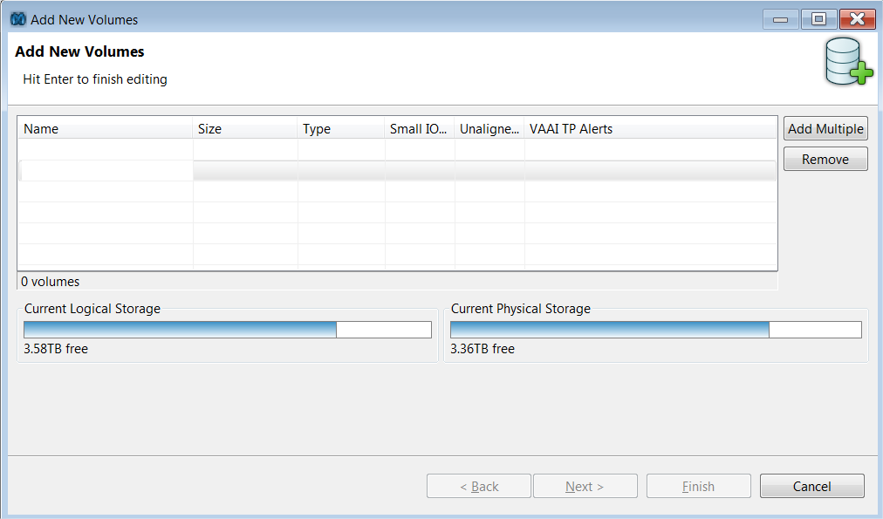

With the VDI use case, alerting at the volume level is not recommended at this time due to increased number of warnings that will be received on the VMware virtual center console for each ESX host.

- Volume folders can be created to logically group objects for simpler management > Create new folder or click Finish
- Folder name - Providing a relevant name is recommended (Ex. VDI Volumes)
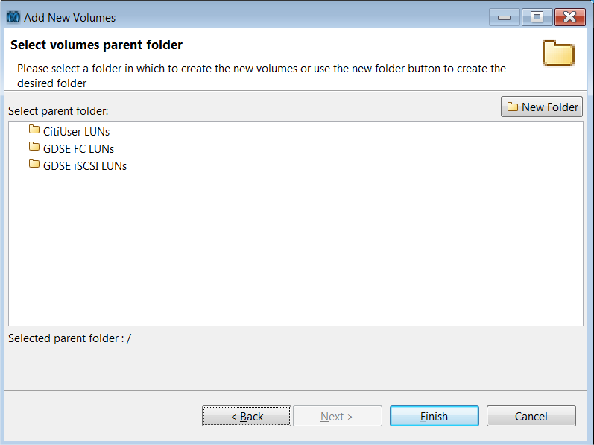

Initiator Groups

XtremIO uses the term “Initiators” to refer to ports that have access to volumes. These can be an iSCSI NIC or FC HBA. Initiators can be assigned to an Initiator Group (IG) for ease of management. The initiators within an IG share access to one or more of the X-brick volumes using LUN mapping. IQN’s for iSCSI initiators should be obtained from ESX server administrators.

Adding Initiators

- Go to Menu Bar > Select Configuration > Under Initiator Groups Tab > Click Add

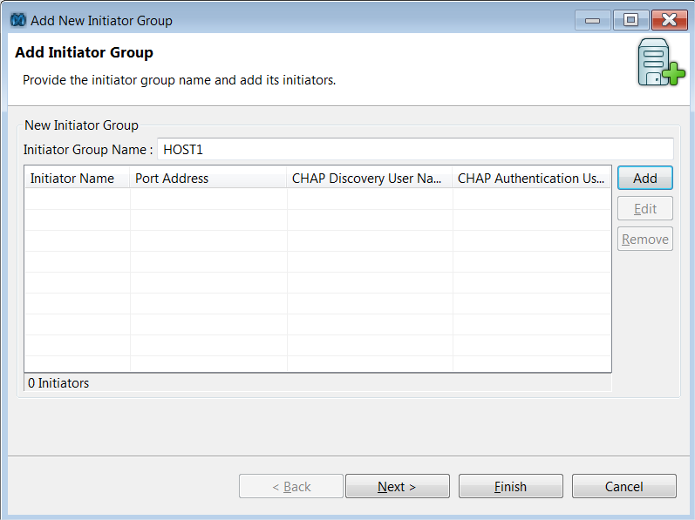

- Provide Initiator Group Name > Add > Type relevant Initiator Name and Port Address (Provided by ESX SA) > OK
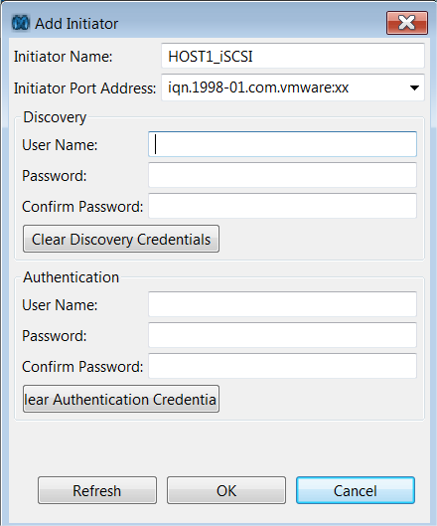

- Initiator Group folders can also be created to logically group objects for simpler management > Create New Folder with relevant name or Click Finish
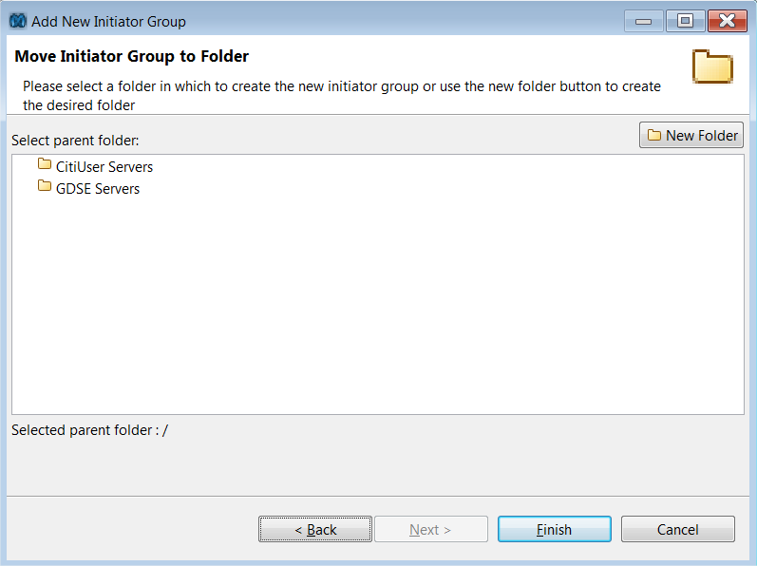

LUN Mapping

In order to allow initiators in an initiator group to access a volume’s disk space, you must map the volume to the initiator group.

- Select Volume you want to map from Volumes tab and Initiators that needs to access this volume from Initiator Groups tab

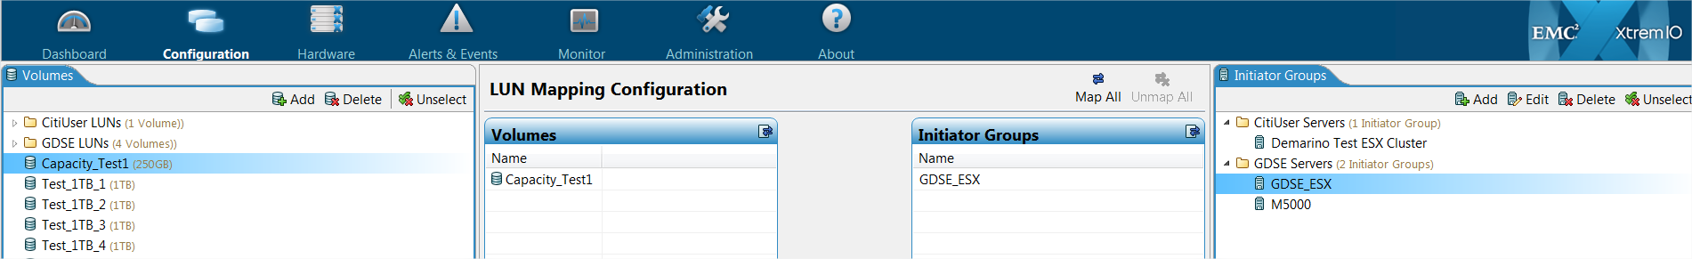

- Select Map All > Blue line appears between Volume and IG > Click Apply to enable

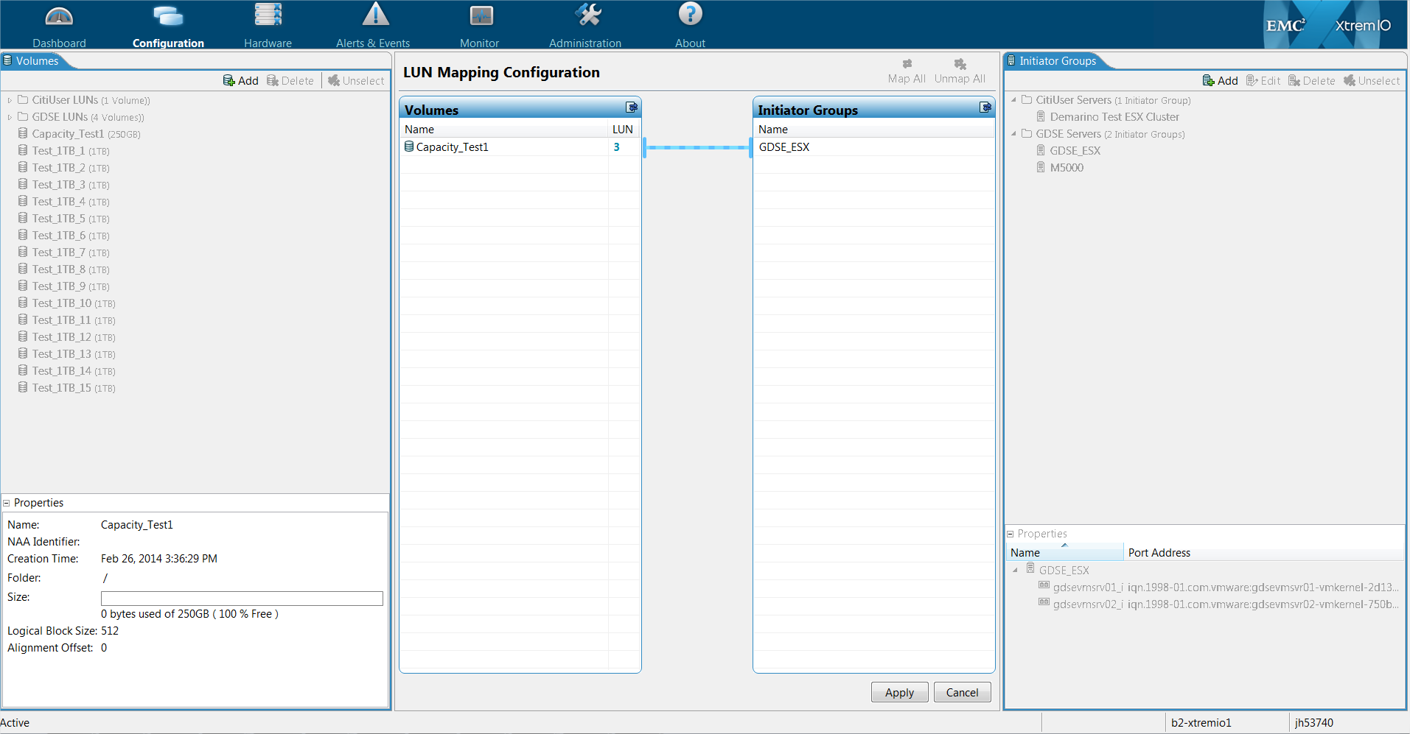

LUN Expansion and Shrinking

With the current XtremIO release, the ability to expand LUNs is available without having to unmap the volume. Shrinking a LUN is not supported at this time. LUN expansion is restricted at this time due to standard sized LUNs being utilized with the VDI use case.

LUN Sizing Guidelines

While it is possible for the LUN size to be as large as 256TB per X-brick, thin provisioning of more than 130TB is not recommended and must be approved via EMC RPQ. Host OS and application limits need to be taken into consideration when determining LUN size.

Local Protection

The XtremIO Storage Controllers are clustered so as to protect from the failure of a single storage controller (SC). In the case of an SC failure, the LUNs will continue to be available via the surviving SC. Each storage controller also has built in redundancy with dual power supplies, mirrored write cache as well as multiple paths connecting to the disk subsystem.

Remote Protection

At the time of writing, replication at the storage array level is not available for EMC XtremIO. With the current VDI use case, array based replication is not required.

System/data owners should ensure that any requirement for replication for COB purposes is addressed at the host or application level. For details on certified replication approaches please consult with the application and platform owners.

Further information is also available in the Open Systems Data Replication Playbook

Backup Standards

All data is accessed via the hosts to which LUNs are allocated. With the current VDI use case for XtremIO, backups are not taken of this environment.

This includes a secondary BBU (1U) as part of the standard build for single X-bricks at Citi.
A 20TB X-Brick with 800Gb eMLC SSDs is now available but is not certified at this time.
When configuring a new array, it is suggested to check with ESM team if a solution with failover/load-balancing is available for the trap host (not available at time of documentation)

