GNAST
REQUIREMENTS, TEST PLAN & TEST RESULTS

For

EMC XtremIO

CATE Storage & Backup Engineering

Template Version: 3.4
MSO2007 Version

Document Version#: 1.0

January 27, 2015



Disclaimer
If printed, content is valid only for the day it was printed. Always refer to the online document for the current version. If the user elects to maintain copies of this procedure, it is their responsibility to verify the currency of the document by checking it against the online version. This document must be promptly removed from use when obsolete.

1. Document Purpose 5
2. Owner of Standard 5
3. Intended Audience 5
4. Principles 5
4.1. Revision History 5
4.2. Key Feature Changes 8
4.3. Citi Production Configuration Standards Attestation 8
4.4. Key Features Tested 8
4.4.1. Items in scope for this project 8
4.4.2. Out of scope 8
5. Summary of Testing Issues 9
5.1. EMC Known problems and limitations 9
5.2. Issues identified during testing 9
5.2.1. Fixed problems 10
6. Requirements Overview 10
6.1. Software Requirements 10
6.1.1. Array Management Test Plan/Results 10
6.1.2. XMS Test Plan/Results 10
6.2. Alerting and Monitoring Test Plan/Results 11
6.3. Vendor Remote Access 11
6.4. System/Functional Requirements 11
6.4.1. XtremIO Storage Platform Hardware Tests 11
6.4.2. Volume (LUN) Provisioning 13
6.4.3. Thin Provisioning 14
6.4.4. iSCSI Path Failover Test 14
6.4.5. De-duplication 15
6.4.6. Smarts 15
6.4.7. Hewlett Packard Network Automation 15
6.4.8. InfoVista 16
6.5. Technical Requirements 16
6.6. Business/User Requirements 16
6.7. Integration/Compatibility Requirements 16
6.8. XtremIO Performance Tests 17
6.8.1. Test Environment 17
6.8.2. Test I/O Workloads 17
6.8.3. Results 18
6.8.4. Performance Observations 20
6.8.5. Workload Recommendations 20
6.9. Security Configuration Test Plan/Results 20
6.9.1. Audit Logging (SEMS) 20
6.9.2. XMS LDAPS Security Tests 21
6.10. Capacity/Stress Test Requirements 21
6.10.1. Zero-Space Reclaim with Thin Provisioning 21
6.10.2. Test steps 21
6.10.3. Results 21
6.10.4. Observations 21
6.11. Continuity of Business Requirements 21
6.12. XMS & Storage Controller BASH Vulnerability Tests 22
6.13. Configuration Assurance Requirements 22
6.14. User Provisioning Requirements 22
6.15. Backup & Restore Requirements 22
7. Test Scope 22
7.1.1. Hardware 23
• See items under section 6.8.1 23
7.1.2. Software 23
• See items under section 6.1 23
7.1.3. Test Equipment 23
• See items under section 6.8.1 23
7.1.4. Network Layout/Topology 23
7.1.5. Parameter/Communication Protocol 25
8. Testing & Results 25
8.1. Hardware Test 25
See items under section 6.8.1 26
8.2. Software Test 26
See items under section 6.1 26
8.3. System/Functional Test 26
See items under section 6.4 26
8.4. Technical Test 26
See items under section 6.4 26
8.5. Business/Unit Test 27
8.6. Integration/Compatibility Test 27
8.7. Performance Test 27
See items under section 6.8 27
8.8. Security Test 27
See items under section 6.9 28
8.9. Capacity/Stress Test 28
See items under section 6.10 28
8.10. Continuity of Business Test 28
8.11. Backup & Restore Test 28
9. Glossary/Definition 29
10. Appendices 29
10.1. Appendix A: LDAPS Management 29
10.1.1. AD Integration 29
10.2. Appendix B: Central Event Monitoring 31
10.2.1. SEMS Sample Report 31
10.3. Appendix C: SRM Discovery 32
10.4. Appendix D: iSCSI Path Failover 32
10.5. Appendix E: ESRS Management 35
10.5.1. Access Control List (ACL) with IPTables 35
10.6. External References 36
10.7. Bill of Material 36
10.8. Configuration & Results Log 36

Note: The purpose of this template is to provide a standard document structure for completing requirements, developing the test plan and capturing the test results for technology standards/products. This document follows the official standard GNAST design framework, and applies to all current GNAST technology standards/products inclusive of hardware and software.

Document Purpose
This document provides the requirements, test plan, and test results, for EMC XtremIO.

Owner of Standard
GNAST (Global Network Architecture and Standards Team) is the owner of this standard and the related documents. CATE (Citi Architecture & Technology Engineering) is the custodial organization. CitiNetwork & CitiStorage Platform Engineering technologists will drive and generate content.

Intended Audience
The intended audience is CitiNetwork & CitiStorage Engineering, Global and Regional Operations and Engineering personnel responsible for designing, building, supporting, and managing Citi corporate storage environments.

Principles

Revision History

GNAST Template Revision History

Version | Description | Date | Author/ Contact Information
2.1 | Details/link added to section 7.12 (System and Network Management Test) around Network Services requirements. | 17-12-2008 | James Rosario
2.2 | CATE Network Engineering header / logo added | 2-1-2009 | James Rosario
2.3 | Saving template as MSO2007 document following meeting with Citi MSO support organization meeting regarding document corruptions seen by CNE team. Fixed header and footer. | 24-Apr-2009 | Bret Cashen
2.4 | Inserted new section, which is now 4.3 Citi Production Configuration Standards Attestation and previous section 4.3, is now 4.4. This modification is to resolve, CBNA Sev1-67826 Corrective Action Plan. | 13-May-2011 | Bret Cashen
2.5 | Link added to section 7.12 (System and Network Management Test) pointing to new Network Life-Cycle Certification Support (NLCS) site. | 28-July-2011 | James Rosario
2.6 | Moved section 7.1.2 System and Network Management Test up under section 5.3.1. Deleted section 5.12. System and Network Management Requirements | 15-Aug-2011 | James Rosario
2.7 | Updated section 5.3.1 (System and Network Management Test) adding appropriate Net Serv stakeholder | 7-Nov-11 | James Rosario
2.8 | Updated section 5.3.1 (System and Network Management Test) adding additional link and noting email evidence is now required from Net Serv team confirming all NMS requirements have been met | 24-May-12 | James Rosario
2.9 | Updated section 5.3.1 (System and Network Management Test) updating new TPM for Smarts, InfoVista | 4-Jan-13 | James Rosario
3.0 | Updated header with CitiNetwork & CitiStorage Platform Engineering  Updated section 5.3.1, 5.3.3 replacing AlterPoint reference with Hewlett Packard Network Automation  Updated Test result check boxes so TPM can double click and use radio button. | 16-Jan-13 | James Rosario
3.1 | Updated section 5.3.1 with new guidance, requirements | 21-Nov-13 | James Rosario
3.2 | Updated section 5.3.1 (System and Network Management Test) with new NMS / PLC Certification Process link. | 8-Apr-14 | James Rosario
3.3 | Updated all test sections with Not Applicable checkbox option. | 19-May-14 | James Rosario
3.4 | Added 3 new sections as per TDLC requirements:  Vulnerability Threat Management (VTM) Requirements  Configuration Assurance Requirements  User Provisioning Requirements | 19-Nov-14 | James Rosario

Update the document history each time a draft is issued for review.

Document Version:
A first generation document that hasn’t been ratified before is a 0.0 (less than 1.0) during its revision cycle. When adopted it is a 1.0 version. Subsequent generations follow the same method of incrementing the decimal portion of the version number until ratified, and then increment the integer.

Version | Description | Date | Author/ Contact Information
0.1 | Initial Draft | 20-01-2015 | Jeff Hernandez
1.0 | Initial GNAST Standard | 27-Jan-2015 | Jeff Hernandez

Key Feature Changes
No changes, Initial Standard

Citi Production Configuration Standards Attestation
Has the solution you are certifying been tested against Citi’s production configuration standards?
If your test plan and results fully complies with a current Citi Production Configuration Standard, outline which of those configuration guides/standards it does here and update the GNAST Online Certification Request Form for your certification with the attestation.
- Configuration Standard “GNAST Design and Configuration EMC XtremIO” – Complies.

Key Features Tested

Items in scope for this project
The following items are deemed in scope for this project and were assessed due to their potential impact on the XtremIO for block standard build and operational best practices:

- Non-disruptive upgrade
- XMS management and CLI
- Thin provisioning
- Inline de-duplication
- iSCSI connectivity
- Local monitoring
- Remote monitoring and access
- Performance management and reporting
- LDAPS integration
- GNU BASH Remote Code Execution Vulnerability Fix
- Audit logging

Out of scope
CATE Storage Engineering will be leveraging vendor testing to validate the fixes for all other bugs addressed with this release of software.

Other components / features considered out of scope for this particular project include:

- Snapshots
- Remote replication
- Application protection
- VSI Support
This is a snapshot of mandatory and required key features tested.
Feature | Testing |  |  |  |  | Notes
Feature | Light | Medium | Heavy | Vendor | Out of Scope | Notes
NDU to 3.0.1-11
Thin Provisioning |  |  |  |  |  | Native
De-Duplication |  |  |  |  |  | In-line De-Duplication
Local Protection  Snapshots |  |  |  |  |  | Redirect on Write Snapshots
Remote
Protection
Local Management |  |  |  |  |  | Domain Management  RBAC
Audit Logging and Review |  |  |  |  |  | Central Event Monitoring, SEMS
Reporting |  |  |  |  |  | SRM
Local Monitoring |  |  |  |  |  | SNMP Alerting  Capacity alerting
Remote Monitoring and Access |  |  |  |  |  | SMTP  ESRS Gateway
Performance Management |  |  |  |  |  | XMS, XMCLI
Management and CLI |  |  |  |  |  | XMS, XMCLI
Host Connectivity FC  Current Platforms |  |  |  |  |  | SAN Stacks for Current Platforms
Host Connectivity  iSCSI, FCoE |  |  |  |  |  | 10GbE Connectivity iSCSI

Summary of Testing Issues

EMC Known problems and limitations

For a full list of EMC known problems and limitations please refer to the EMC XtremIO Storage Array Software Version 3.0.1-11 Release Notes document available from EMC Powerlink.

Issues identified during testing

The following issues were identified during testing
- Multiple SSD failures that occur simultaneously are not supported. A single SSD failure must completely rebuild before a second failure can occur.
- Upgrading an existing X-brick cluster with additional X-bricks is not supported.

Fixed problems
For a full list of issues fixed in 3.0.1-11 please refer to the EMC XtremIO Storage Array Software Version 3.0.1-11 Release Notes document available from EMC Powerlink.

Requirements Overview
This test plan will test basic functionality of the XtremIO running 3.0.1-11. Since the XtremIO is a scale-out architecture, both x-Bricks will be tested for the certification of the XtremIO Next Gen storage arrays.

The following components were used for these tests:
- XtremIO installed and configured as a block-level system.
- XtremIO was connected to the corporate IP network for management.
- XtremIO management server(XMS) for managing XtremIO cluster
- Dual non routed VLANs for 10GbE iSCSI attachment
- Dual SAN fabrics with 8GB connectivity
- Each host NIC & HBA is accessible to both storage controllers

For a description of the environment used for performance testing, please refer to XtremIO Performance Tests section.

Software Requirements

The following software was used for the functionality tests:
- XMS 3.0.1-11
- XMCLI 3.0.1-11

Array Management Test Plan/Results
Item | Test | Results | Pass / Fail | Notes
1 | Verify that the XMS can manage the X-brick cluster. | XMS version 3.0.1-11 can manage X-brick cluster. XMS version must be the same as storage controllers. When cluster is installed or upgraded, XMS and SCs must have the same version. | Pass | Refer to CSBE XtremIO Product Page for the latest certified Service Pack.

XMS Test Plan/Results

All tests in this section were done on Windows 2008 R2 and Win7 Desktop .

Item | Test | Results | Pass / Fail | Notes
1 | Install and launch XMS from management server | Entered XMS IP in browser and downloaded JNLP file. Full Java version required due to java webstart. Installed successfully | Pass
2 | Verify that upgrade installation of the X-brick cluster updates XMS and the cluster can be managed. | XMS upgraded successfully. Entered XMS IP in browser and downloaded new JNLP file. | Pass

Alerting and Monitoring Test Plan/Results

Item | Test | Results | Pass / Fail | Notes
1 | Verify that email home is sending alerts to the vendor. | EMC successfully setup and tested email-home functionality | Pass
2 | Verify Performance Monitoring functionality. | XMS was able to gather statistics real-time as well as historical data. | Pass | GUI and XMCLI with export-performance-history command
3 | Verify SRM discovery | SRM 3.5 is able to discover XtremIO arrays | Pass | XtremIO is discovered under Solution Pack for XtremIO. Refer to Appendix C: SRM Discovery for more details
4 | Verify that Tivoli Alerting works with XMS | SNMP alerts were being sent out for errors on the system and received by Tivoli | Pass | Worked with Tivoli team to create ruleset and filter traps.

Vendor Remote Access

Item | Test | Results | Pass / Fail | Notes
1 | Verify that EMC can access the XtremIO via ESRS for troubleshooting. | The vendor was able to access the XtremIO remotely via ESRS | Pass | Refer to Appendix E: ESRS Management for more details
2 | Implement ACL with IPTables for limiting leap frog from XMS and storage controllers | Implemented IPTables commands and enabled ACL on XMS and SCs | Pass | Refer to Appendix E: ESRS Management for more details

System/Functional Requirements

XtremIO Storage Platform Hardware Tests

Citi and EMC collectively provided a standard hardware test plan that was used for certification of XtremIO storage platform. The final test plan is provided below:

Item | Citi Requested Test | Expected Result | Pass | Notes
1 | Power-off PSU #1 for SC1 | Fault on XMS, No effect on hosts, recharge of power supply should occur. | Pass | Powered off X1-SC1 PSU1. Command show-storage-controllers-psus displayed PSU1 off.  Power was restored and PSU displayed on.
2 | Power off Battery Backup Unit #1 | Fault on XMS, No effect on hosts, battery begins drain. | Pass | Powered off BBU1. Command show-bbus displayed failed then disconnected. Power was restored and BBU displayed connected then started recharge.
3 | Storage controller failure – disconnect all power | Fault on XMS, host should not be affected. |  | Powered off X1-SC1. Command show-xenvs displayed state for X1-SC1 as inactive, show-storage-controllers displayed X1-SC1 as disconnected. Host was not impacted. Restored power and X1-SC1 shows active and healthy again.
4 | Pull SC1 IB port 1 and replace | Faults on SC1 and enclosures connected to IB 1 | Pass | Pulled X1-SC1-IB1 cable, show-storage-controllers-infiniband-ports displayed state as down. No impact to host or X-brick cluster. Reconnected and port shows up.
5 | Pull both IB ports for X1-SC2 and replace | X1-SC2 will fail and display error | Pass | Pulled X1-SC2-IB1/IB2 cable, show-storage-controllers-infiniband-ports displayed Rate-In-Gbps as 0. Show-storage-controllers displays state for X1-SC2 as disconnected. No impact to host or X-brick cluster. Reconnected and port shows 40GB/s and X1-SC2 as healthy.
6 | Pull DAE LCC A and replace | A fault should be appear but connectivity to disks should not be lost due to redundant loop | Pass | Pulled X1-DAE-LCC A, show-daes-controllers displayed State as disconnected. Show-xenvs displays X1-SC1 as inactive. No impact to host or X-brick cluster. Reconnected and port shows active and X1-SC1 as healthy.
7 | Pull single SSD | A fault should appear on the drive but no data loss should occur. Rebuild of parity and no capacity change. | Pass | Pulled SSD from X1 slot 0, show-slots displays empty and none for drive info. Show-ssds displays slot 0 as failed_in_rg and disconnected. Show-data-protection-groups has degraded state for X1-DPG 1. Show-data-protection-groups-performance shows high utilization due to rebuild. Rebuild took about 1hr and 45mins. Once rebuild completed DPG has normal state and performance is zero. No impact to host or X-brick cluster.
8 | Pull 2 x SSDs | Rebuild of parity should occur. | Partial Pass | Per EMC, dual SSD failure must happen in sequential fashion, one SSD must fail and rebuild before the second SSD can fail and rebuild. Simultaneous failure is not supported. This scenario was tested successfully show-ssds displays both SSDs as revoked_from_rg. Once rebuild completes for 2nd SSD the DPG displays state of normal. No impact to host or X-brick cluster.
9 | Replace SSDs | Install both SSDs that were removed previously and add to DPG. | Pass | Installed SSD in X1 -slot 0 and slot1. Added the first SSD via GUI back to DPG. Took 5 mins to complete, then added the second SSD. Show-ssds displays drive as in_rg.
10 | Pull out network connections from storage system and replace | Connectivity to SC's through the management server should be lost | Pass | Pulled mgmt. network connections from both storage controllers. Show-clusters displays state as active but Conn-State is unknown. No impact to host or X-brick cluster.
11 | Add a new DAE to an existing array | This upgrade is not possible with the current release. | Fail | Currently the ability to upgrade an existing XtremIO cluster is not available. Adding another X-brick to the cluster will be available in 3.0 release
12 | Unplug power to Infiniband switch – one PSU at a time | Fault should appear but connectivity to disks should not be lost due to redundant switch | Pass | Removed power from IB-SW1. Show-infiniband-switches displays state as disconnected. Restored power and state displays healthy. No impact to host or X-brick cluster.
13 | Remove power cable from one of the DAE's PSU. Replug power cable once the results have been recorded. | The other PSU module should increase its fan speed and the DAE should remain operational. LED on PSU should turn amber. When power cable gets replugged, the PSU should resume normal operation. | Pass | Pulled power to X1-DAE-PSU 2, show-daes-psus displayed State as off. No impact to host or X-brick cluster. Reconnected and state shows on.
14 | Shutdown XMS | Cluster should continue to function, XMS/XMCLI inaccessible. | Pass | XMS was powered off and host access to luns was validated successfully.
15 | Shutdown power to the entire storage array forcing a shutdown. Verify that no data loss occurs as a result of the power loss and the system fully recovers after power is restored to the system. | The storage array should switch to the standby power supplies for power and should remain powered up until all cache is flushed to the journal drives. No data loss should occur. | Pass | All power removed from X-brick, show-storage-controllers displays Powered-State as disconnected and show-clusters displays unknown and disconnected. All control data is written to journal before BBUs drain to 0% and orderly shutdown is initiated. Power was restored and cluster re-initialized then BBUs recharged.
16 | Dual SC failure | Take down 1 SC from each X-brick in multiple X-bricks setup. | Pass | Removed power to X1-SC1 and X2-SC2, show-xenvs displays each SC as inactive in the cluster and show-storage-controllers displays each SC as disconnected. Restored power to both SCs and state displays active and connected. No impact to host or X-brick cluster.

Volume (LUN) Provisioning
Item | Test | Results | Pass / Fail | Notes
1 | Discover host connected to the array. | iSCSI and FC connectivity host discovery of array was successful | Pass
2 | Create Volumes (LUN) | Volumes (Luns) created successfully | Pass
3 | Create Initiator Groups | Initiator groups created successfully | Pass
4 | Apply volume (LUN) mapping | Volume (LUN) mapping applied successfully | Pass
5 | Host volume (LUN) access | Host can access the volumes (LUN) successfully | Pass
6 | Unmap volumes (LUN) from initiator group. | Volumes (LUN) unmapped from IG successfully. | Pass
7 | Delete Volumes (LUN) | Volumes (LUN) deleted successfully | Pass

Thin Provisioning
Item | Test | Results | Pass / Fail | Notes
1 | Create thin LUN | 2.34TB Thin LUN created successfully. | Pass | LUN details in XMS:  User Capacity: 2.34 TB  Used Capacity: 0 bytes
2 | Map thin LUN to initiator group. | Thin LUN mapped to IG and host was able to discover the LUN. | Pass
3 | Verify that thin friendly file systems do not take up all the allocated capacity. | Performed format of a 2.34TB VMFS5 LUN on ESX 5.0 server. The consumed capacity of the thin LUN after the format was 19.3MB. | Pass
4 | Verify XMS can gather performance statistics on thin LUNs | Performance statistics were gathered and reported by XMS in real time. | Pass
5 | Unmap LUN from initiator. | LUN removed successfully. | Pass
6 | Delete LUN | LUN deleted successfully. | Pass
7 | Verify logical volume capacity is updated and zero physical space is reclaimed. | Logical LUN capacity was updated successfully and zero physical space was reclaimed from array. | Pass | For detailed test results, see Zero-Space Reclaim with Thin Provisioning

iSCSI Path Failover Test

Item | Test | Results | Pass / Fail | Notes
1 | Verify that iSCSI paths perform proper failover with ESX NMP accessing XtremIO LUNS. | Active paths to XIO LUNs failed and recovered successfully. | Pass | Round Robin must be set on ESX host.

De-duplication

Item | Test | Results | Pass / Fail | Notes
1 | In line de-duplication is enabled by default | De-duplication occurred in-line at an array level. | Pass
2 | Jurassic pilot environment with 290 VDIs consuming various physical capacity | Optimal de-dupe ratio obtained for active pilot VDIs was 5.5:1 | Pass

Smarts
Test Details/Action | Capture evidence to show discovery and event management of Device Under Test by EMC Smarts Fault Management platform.
Expected Results
Actual Results
Email evidence Net Serv has signed off on PLC evidence (embed email)
Additional comments | Not applicable - storage arrays do not integrate with SMARTS

Pass Fail CONDITIONAL Pass Not Applicable (with detail)

Hewlett Packard Network Automation
Test Details/Action | Capture evidence to show discovery and event management of Device Under Test by Hewlett Packard Network Automation Configuration and Device inventory Tool
Expected Results
Actual Results
Email evidence Net Serv has signed off on PLC evidence (embed email)
Additional comments | HPNA automation is pending completion and a standard configuration assurance checklist is available on the product page below for manual validation. https://catecollaboration.citigroup.net/domains/platstor/gdse/products/techstdshmpgs/emcxtremio.aspx

Pass Fail CONDITIONAL Pass Not Applicable (with detail)

InfoVista
Test Details/Action | Capture evidence to show discovery and event management of Device Under Test by InfoVista Performance Management Tool
Expected Results
Actual Results
Email evidence Net Serv has signed off on PLC evidence (embed email)
Additional comments | Not applicable - storage arrays do not integrate with InfoVista

Pass Fail CONDITIONAL Pass Not Applicable (with detail)

Technical Requirements
  - See items under section 4.4

Business/User Requirements
- Not applicable - No Specific Business Unit testing required

Integration/Compatibility Requirements
  - See items under section 6.2

XtremIO Performance Tests
A mixture of I/O workloads was run against the configuration to gather relative performance metrics. The intent of this testing is to gauge any relative change in the performance metrics for the single server used in this testing. Because of the limited workload and server connectivity on the storage frame, these results should not be considered applicable for determining production storage array performance capabilities nor for determining the expected performance of any single server. Many additional factors could affect the actual performance of a single server attached to a storage array.

Test Environment
SOE Management Station Configuration:
- Server Model: VMware Guest
- OS: Windows 2008 R2

Load Generator Server
- Server Model: Oracle M5000
- OS: SunOS 5.10 Generic_150400-02
- HBA: 2 x LPe11002-E-8Gb, 2 x LPe12002-8Gb, 4 x LP16002-8Gb
- Switch Ports : Cisco MDS 9500 8GB full duplex

XtremIO Configuration:
- 2 - X-bricks
- 2 - Storage Controllers (SC) per X-brick/256GB memory per SC
- 4 x 8-core 2.1GHz Xeon per X-brick
- Release 2.2.3-25 SP3
- 50 x 400Gb eMLC per X-brick - 14.9TB usable

Vdbench Configuration:
- Vdbench version 503rc11
- Raw volume access

Vdbench was utilized for generating a variety of I/O workloads. For random workloads a parameter file was created on the M5000 to drive I/O against 15 x 873 GB raw volumes using 24 threads which seemed to be the optimal setting for these test scenarios. These tests lasted about 5 minutes per workload test. Also, before beginning the testing a sequential write workload was completed to fill capacity on all LDEVs. Below is a summary of the workloads that were tested for each configuration.

Test I/O Workloads
Workload | Block Size | Type | Tested Configuration
100% Read | 4 Kb | Random, 0% cache hit | XDP
50% Read 50% Write | 4 Kb | Random, 0% cache hit | XDP
100% Read | 8 Kb | Random, 0% cache hit | XDP
50% Read 50% Write | 8 Kb | Random, 0% cache hit | XDP
OLTP2HW –  Mixed: 80% WD 1, 20% WD 2 | 8 Kb  64Kb | WD1 Random = 66% read/34% write, 22% read cache hit  WD2 Sequential = 25 % read/75% write | XDP

Results

The following are the results from Vdbench running the test workload defined above.

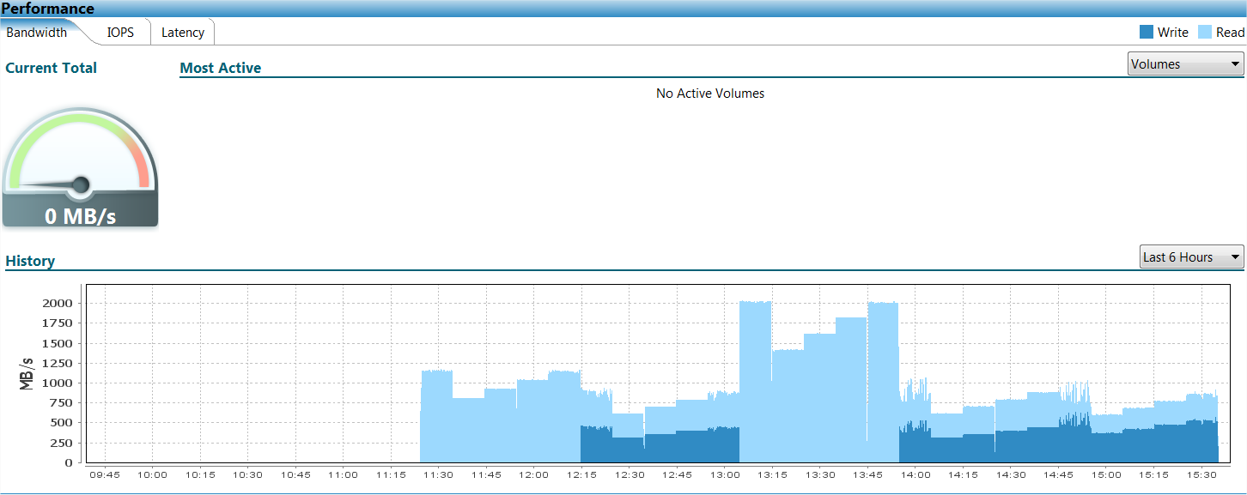

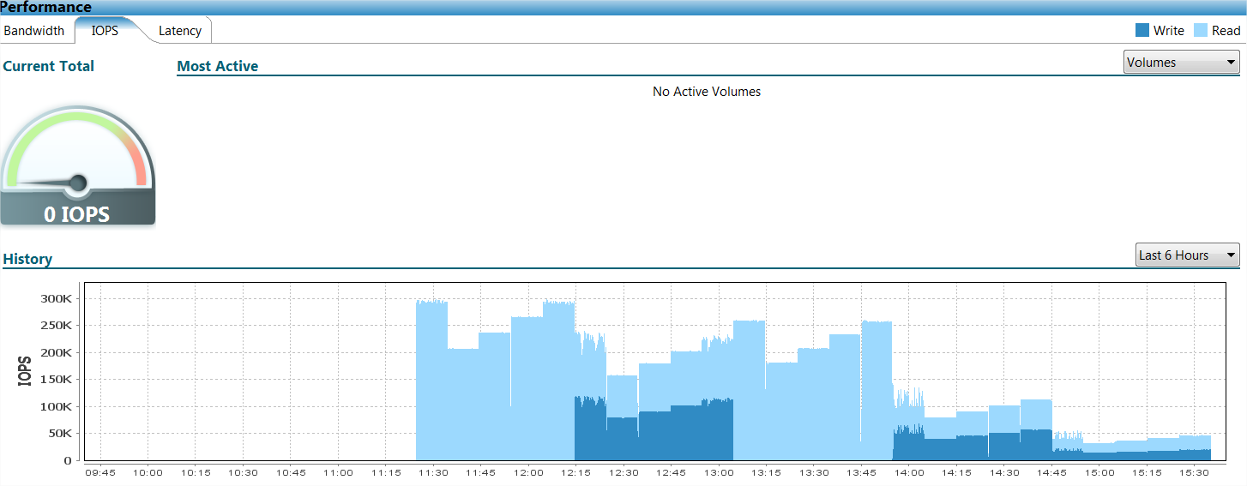

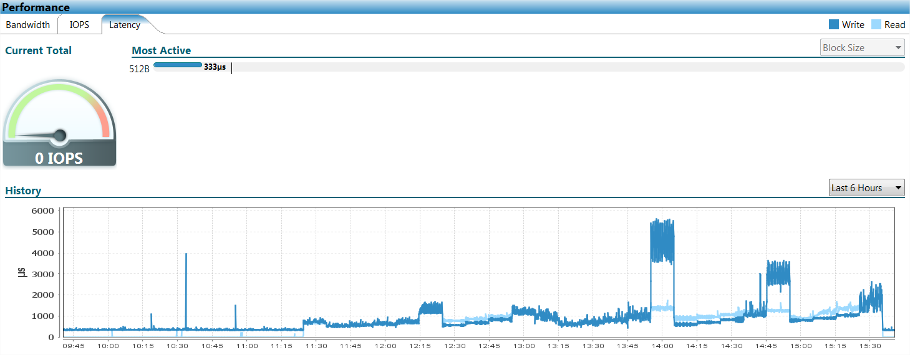

Performance Observations

- Vdbench response time varied due to host queuing and with a single host in this benchmarking test the risk was more prevalent.
- The 4kb random read, 4kb random read/write, and 8kb random read workloads performed well on the XtremIO array.
- The 8kb random read/write and the OLTP2HW mixed workload showed much lower IOPS, throughput, and response time.

Workload Recommendations

Based on the above results, the use case recommendation for XtremIO is small block workloads such as VDI. Larger block size mixed workloads such as database or ETL environments are not recommended on this platform at this time.

Security Configuration Test Plan/Results

Audit Logging (SEMS)
Verify that the XMS can use the existing SEMS solution.

Item | Test | Results | Pass / Fail | Notes
1 | Ensure audit logs can be picked up by SEMS | SEMS (Arcsight) is able to receive syslog from XMS for audit review. | Pass | Refer to Appendix B: Central Event Monitoring for sample audit report generated from audit logs
2 | Ensure all user initiated changes are logged | User initiated changes are logged | Pass
3 | Verify with SEMS team that the audit log entries are being captured and parsed correctly. | SEMS team is able to receive events from XMS syslog notifications | Pass | Refer to Appendix B: Central Event Monitoring for sample audit report generated from audit logs

XMS LDAPS Security Tests
The tests in this section are related to the configuration and management of LDAPS in the XtremIO environment.

Item | Test | Results | Pass / Fail | Notes
1 | Initialize LDAPS configuration on XMS. | LDAPS security initialized on XMS. | Pass
2 | Connect XMS to Active Directory for user authentication. | XMS was successfully configured to connect to the test AD environment and users were successfully able to log in respective to the role assigned to the AD group. | Pass | Refer to Appendix A: LDAPS Management for more details
3 | Verify that AD users can only perform actions respective to their defined roles in XMS. | AD users can only perform actions based on their roles | Pass | Available Roles: Administrator, Configuration, Read-only
4 | Test multi-domain management on XMS (Global Catalog Server) | Not tested | N/A | Refer to Appendix A: LDAPS Management for more details

Capacity/Stress Test Requirements

Zero-Space Reclaim with Thin Provisioning
The purpose of these tests is to determine that Zero-Space in thin LUNs gets reclaimed after ESX UNMAP command is run.

Test steps
- Created multiple 2.34TB thin LUNs and allocated them to ESX 5.0 cluster.
- Configured all LUNs as datastore and VMFS5 format
- Loaded VDI VMs on the datastores
- Deleted data from datastore
- In ESX shell navigate to datastore (/vmfs/volumes/…
- Run “vmkfstool -y 50” (unmaps 50% of free space)
- View volume and array capacity utilization.

Results

The volume capacity and physical utilization from the XtremIO array decreased based on the unmap command being run. Large 1MB writes were encountered due to the UNMAP command, this triggered higher throughput and response time to the ESX hosts connected to the XtremIO array.

Observations

From the results above the reclaim process does provide the ability to reclaim space with 0’s written to it; however, it is important to note that the performance impact experienced should be considered when scheduling these reclaim commands in a production environment.

Continuity of Business Requirements
- Not applicable

XMS & Storage Controller BASH Vulnerability Tests
As part of the 3.0.1-11 Service Pack the GNU Bash CVE-2014-6271 Remote Code Execution Vulnerability has been resolved. This fix is enabled after non-disruptive upgrade completes from 3.0.0-42 to 3.0.1-11 and resolves VTM 45102.

Validation of XIO 3.0.0-42 show vulnerability exists in red below.

[root@mwdcitinasx8002x bin]# bash --version
GNU bash, version 4.1.2(1)-release (x86_64-redhat-linux-gnu)
Copyright (C) 2009 Free Software Foundation, Inc.
License GPLv3+: GNU GPL version 3 or later <http://gnu.org/licenses/gpl.html>

This is free software; you are free to change and redistribute it.
There is NO WARRANTY, to the extent permitted by law.
[root@mwdcitinasx8002x bin]# env 'x=() { :;}; echo vulnerable' 'BASH_FUNC_x()=() { :;}; echo vulnerable' bash -c "echo test"
vulnerable
bash: BASH_FUNC_x(): line 0: syntax error near unexpected token `)'
bash: BASH_FUNC_x(): line 0: `BASH_FUNC_x() () { :;}; echo vulnerable'
bash: error importing function definition for `BASH_FUNC_x'
test

https://access.redhat.com/articles/1200223

Validation of XIO 3.0.1-11 shows vulnerability does not exist below.

[root@b2-xtremio1-vxms ~]# /bin/bash --version
GNU bash, version 4.1.2(1)-release (x86_64-redhat-linux-gnu)
Copyright (C) 2009 Free Software Foundation, Inc.
License GPLv3+: GNU GPL version 3 or later <http://gnu.org/licenses/gpl.html>

This is free software; you are free to change and redistribute it.
There is NO WARRANTY, to the extent permitted by law.
[root@b2-xtremio1-vxms ~]# env 'x=() { :;}; echo vulnerable' 'BASH_FUNC_x()=() { :;}; echo vulnerable' bash -c "echo test"
bash: warning: x: ignoring function definition attempt
bash: error importing function definition for `BASH_FUNC_x'
test

Configuration Assurance Requirements
Infrastructure Product Category (IPC) Classification: C

See SBCC link on product page:
https://catecollaboration.citigroup.net/domains/platstor/gdse/products/techstdshmpgs/emcxtremio.aspx

User Provisioning Requirements
- Not applicable

Backup & Restore Requirements
- Not applicable

Test Scope
  - See items under section 4.4

Hardware

See items under section 6.8.1

Software

See items under section 6.1

Test Equipment

See items under section 6.8.1

Network Layout/Topology
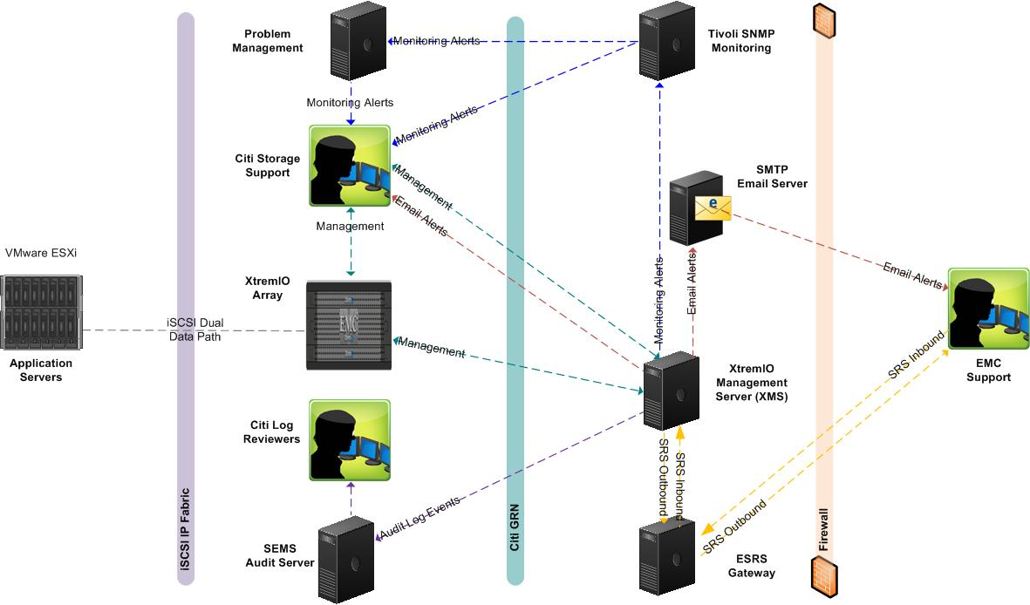
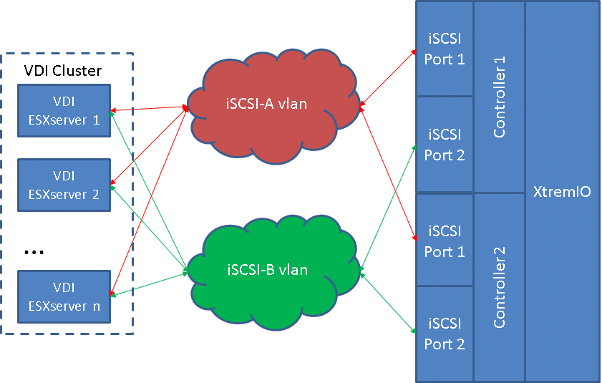

Parameter/Communication Protocol
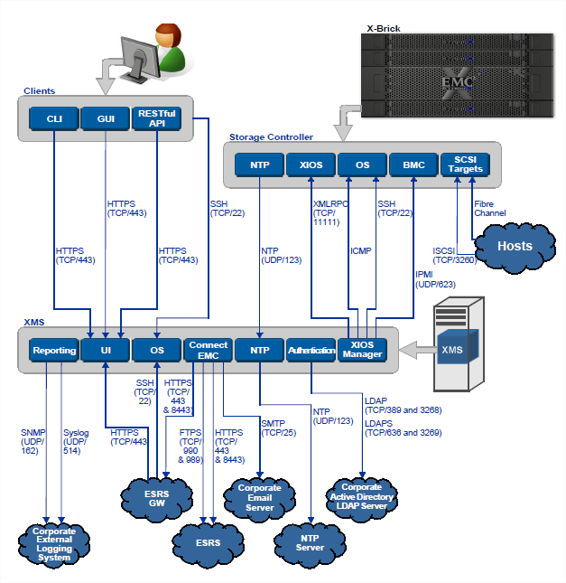

Testing & Results
Provide test specifications and document test results in this section. Expand the table to accommodate as many cases as required to fully test the technology standard/solution.
Only check the “Conditional Pass” box to indicate that there were issues or complexities not related to a problem with the hardware, software, or solution being tested, or were not considered sufficiently serious to mark the test as failed. For all items marked as “Conditional Pass”, enter the reason in the “additional comments” field and highlight the text in red.

Hardware Test
The purpose of this test is to verify that:
Test Details/Action
Expected Results
Actual Results
Additional comments | See items under section 6.8.1

Pass Fail CONDITIONAL Pass Not Applicable

Software Test
The purpose of this test is to verify that:
Test Details/Action
Expected Results
Actual Results
Additional comments | See items under section 6.1

Pass Fail CONDITIONAL Pass Not Applicable

System/Functional Test
The purpose of this test is to verify that:
Test Details/Action
Expected Results
Actual Results
Additional comments | See items under section 6.4

Pass Fail CONDITIONAL Pass Not Applicable

Technical Test
The purpose of this test is to verify that:
Test Details/Action
Expected Results
Actual Results
Additional comments | See items under section 6.4

Pass Fail CONDITIONAL Pass Not Applicable

Business/Unit Test
The purpose of this test is to verify that:
Test Details/Action
Expected Results
Actual Results
Additional comments | Not applicable - No Specific Business Unit testing required

Pass Fail CONDITIONAL Pass Not Applicable

Integration/Compatibility Test
The purpose of this test is to verify that:
Test Details/Action
Expected Results
Actual Results
Additional comments | See items under section 6.2

Pass Fail CONDITIONAL Pass Not Applicable

Performance Test
The purpose of this test is to verify that:
Test Details/Action
Expected Results
Actual Results
Additional comments | See items under section 6.8

Pass Fail CONDITIONAL Pass Not Applicable

Security Test
The purpose of this test is to verify that:
Test Details/Action
Expected Results
Actual Results
Additional comments | See items under section 6.9

Pass Fail CONDITIONAL Pass Not Applicable

Capacity/Stress Test
The purpose of this test is to verify that:
Test Details/Action
Expected Results
Actual Results
Additional comments | See items under section 6.10

Pass Fail CONDITIONAL Pass Not Applicable

Continuity of Business Test
The purpose of this test is to verify that:
Test Details/Action
Expected Results
Actual Results
Additional comments | Not applicable - Current deployments are for VDI and COB plan is to install new system.

Pass Fail CONDITIONAL Pass Not Applicable

Backup & Restore Test
The purpose of this test is to verify that:
Test Details/Action
Expected Results
Actual Results
Additional comments | Not applicable - Current deployments are for VDI and backup/restore is not a requirement.

Pass Fail CONDITIONAL Pass Not Applicable

Glossary/Definition

Term or Acronym | Explanation or Definition
CATE | Citi Architecture & Technology Engineering
GNAST | Global Network Architecture and Standards Team
XMS | XtremIO Management System

Appendices

Appendix A: LDAPS Management

This section describes the test results of LDAPS management on XMS for single AD domain integration.

AD Integration

XMS allows for setting up authentication with Citi’s Active Directory environment. This allows the ability to assign XMS roles to AD groups instead of having to map roles to each user..

The test was carried out with the development AD environment and the following AD users for each role were verified:
- xtrem_adm
- xtrem_cfg
- xtrem_ro

Multiple domain authentication is supported by adding another LDAP configuration.

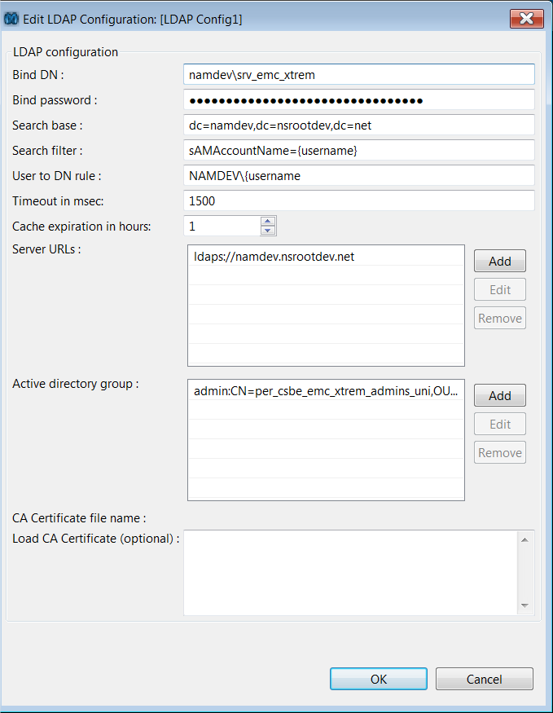

Appendix B: Central Event Monitoring

SEMS Sample Report

XMS events were visible in the Alerts & Events section of the GUI or with show-events via XMCLI.

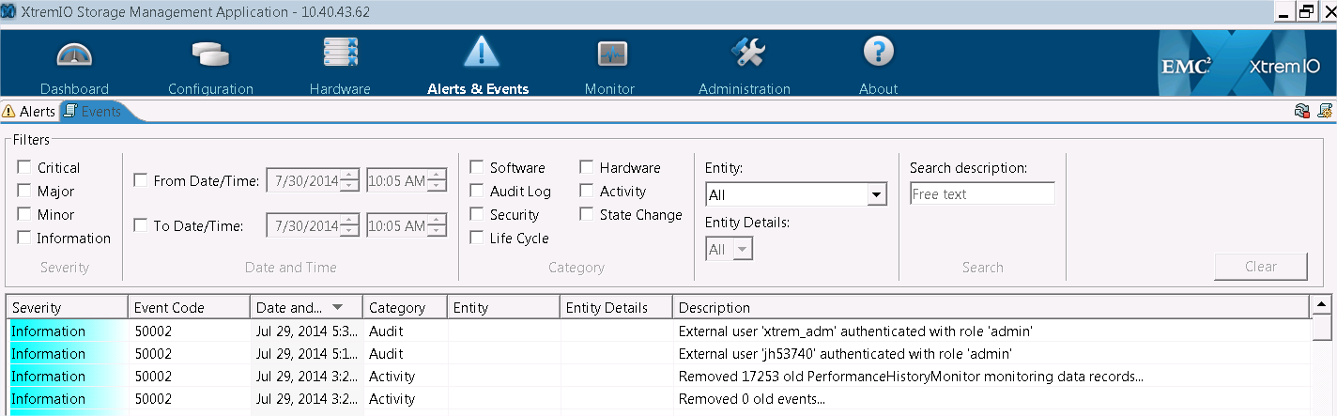

It was confirmed with the SEMS team that audit logs were being captured.

At the time of publishing, the SEMS team was in the review phase of validating the XMS syslog format. An include list of events will be developed once this initial review is complete. As such it was not possible to include a sample of the audit report that is generated by SEMS team for regular reporting on audit events.

The initial audit report generated from ArcSight will intentionally have some empty column fields. These fields are populated by the Log review team during log review process. For more info on these fields, please refer to the Log review team.

Appendix C: SRM Discovery

Below is a sample screenshot of how XtremIO is discovered in SRM 3.5.

Capacity, de-dupe ratio, and thin provision savings were displayed for multiple arrays.

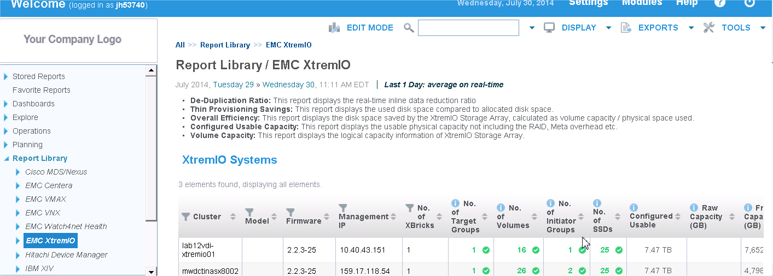

At the time of this writing SRM 3.5 was still in the certification process and full reporting integration with XtremIO is under review.

Appendix D: iSCSI Path Failover

iSCSI failover was verified with ESX server accessing XtremIO LUNs.

Started copy of powered off vm files to XtremIO iSCSI volume - 8 paths show active
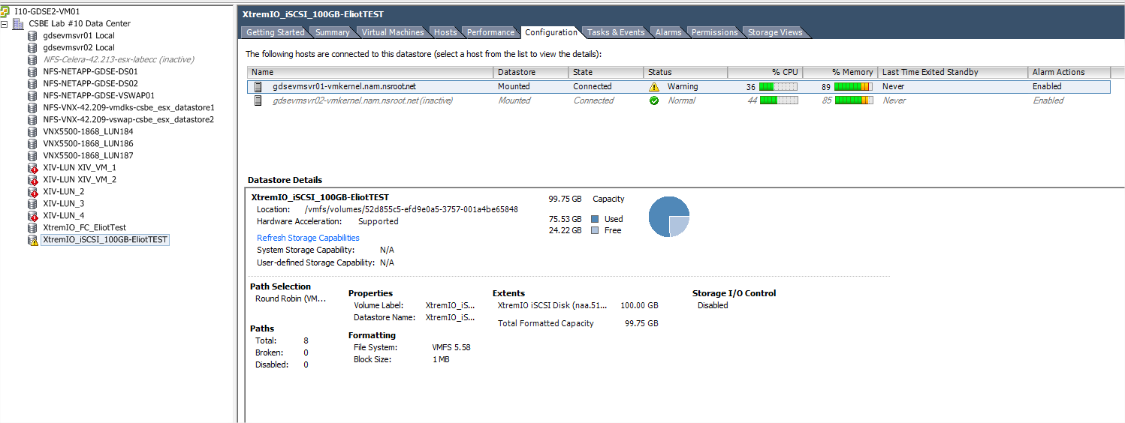
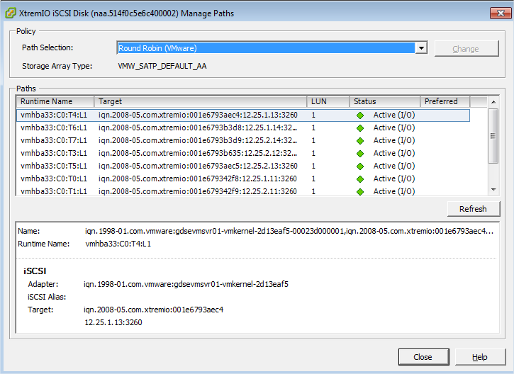

After removing both iSCSI Portals from XMS (X1-SC1-iscsi1 – 12.25.1.11/24 & X1-SC1-iscsi2 – 12.25.2.11/24) 2 dead paths show broken

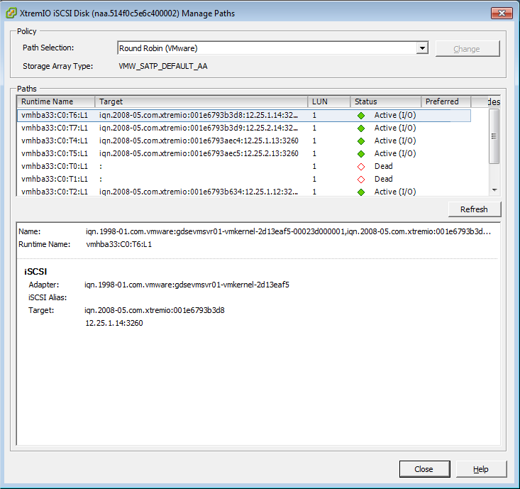

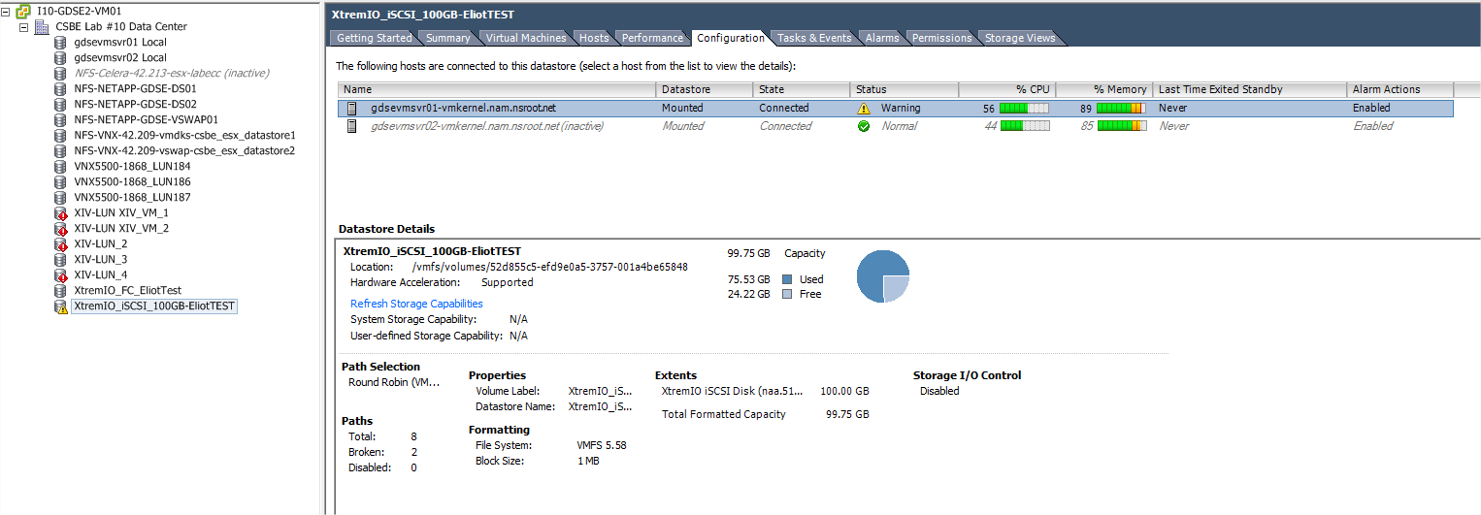

After iSCSI Portals are recreated from XMS, all paths automatically become active
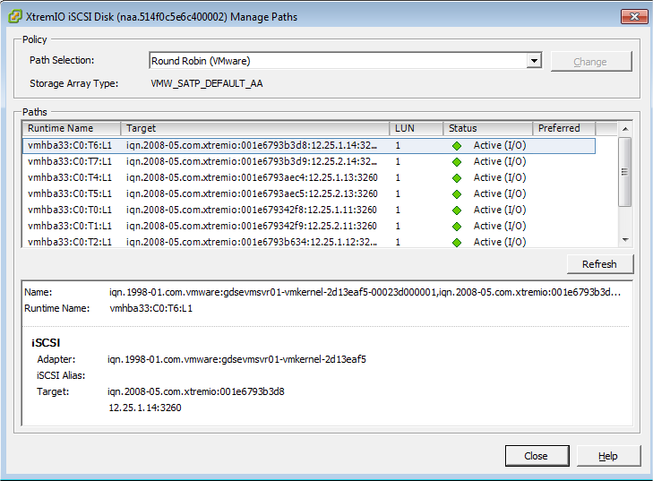
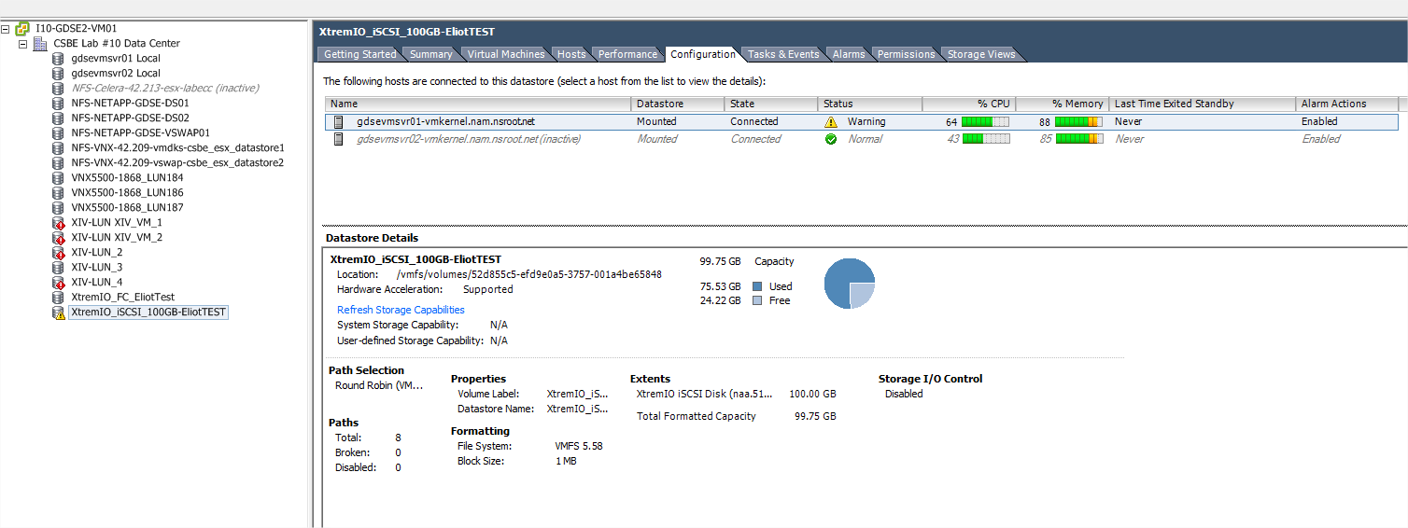

Appendix E: ESRS Management

The XtremIO was integrated with version 2.24 of ESRS. The below lab frames have been deployed and remote connectivity tested successfully (APM00134910382, APM00141803339):

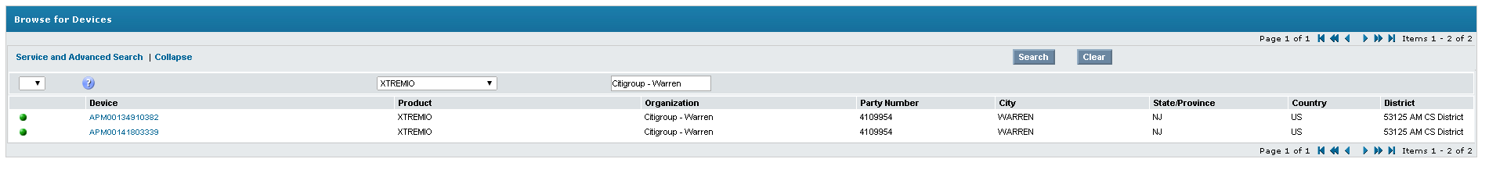

Access Control List (ACL) with IPTables

With EMC support requiring access to XMS for ESRS capability ACL using IPTables was tested for limiting access from the XMS and storage controllers to any other devices on the Citi GRN. EMC has integrated ACL using IPTables in 3.0.1-11 without the need to make any manual entries. The following rules were validated once the Hotfix was applied.

Source | Target | Purpose | Ports
Storage management host | XMS | SSH access to XMS for management | SSH - 22
ESRS gateway | XMS | SSH access to XMS for EMC troubleshooting | SSH - 22
XMS | Storage Controller | SSH access from XMS to storage controllers for troubleshooting. No SSH access to any other targets. | SSH - 22
Storage controllers | None | No SSH access to any other targets | SSH - 22

External References

Document | URL
EMC XtremIO Product Page | https://www.emc.com/storage/xtremio/overview.htm
EMC XtremIO 3.0.1-11 Release Notes | https://support.emc.com (requires EMC login)
EMC XtremIO 3.0.1-11 User Guide | https://support.emc.com (requires EMC login)
EMC Web Site | http://www.emc.com/

Bill of Material

 | Qty | Product ID | Description
 |  |  | XtremIO Single Xbrick - 48 Months
 |  | Hardware
 | 1 | X02-D25-400F | XtremIO -25x400GB Flash Drives OE SW-FLD
 | 1 | X02-KITS-FD | XtremIO SINGLE BRICK CONFIG KIT (FIELD)
 | 1 | X02-VRACK-FD | XtremIO VIRTUAL RACK (FIELD)
 | 2 | X02-UPS-220FP | XtremIO - UPS 220V - FLD - Secondary
 | 1 | X02-CTRL-TAGF | XtremIO - STORAGE CONTROLLER/W TAG - FLD
 | 1 | X02-CTRL-F | XtremIO - STORAGE CONTROLLER - FLD
 |  | Software
 | 1 | X02-RTU | XtremIO Right to Use- OE
 | 1 | X02-MNGT-01 | XtremIO-MGMT LICENSE QTY 1
 |  | Maintenance
 | 1 | M-PREHWX-001 | PREMIUM HARDWARE SUPPORT
 | 1 | M-PRESWX-001 | PREMIUM SOFTWARE SUPPORT

Configuration & Results Log
Provided in Section 6 and Section 10.

Less than 4 hours of testing – validate functionality / proof of concept testing
Between 4 and 8 hours of testing – validate functionality and devise best practices
More than 8 hours of testing – validate functionality, determine use cases, identify operational issues and devise best practices
Vendor to provide test plans executed in QA or to test on behalf of Citi
Functionality will not be tested or recommended for production use as a result of this project.

