Software Tools Quick Reference
  - EMC
    - ViPR SRM (still in deployment/development phase)

Servers: Login using <soeid>/<local password>
http://nammsrmfe1.nam.nsroot.net:58080/APG/#
http://namusrmfe1.nam.nsroot.net:58080/APG/#

Sample of ViPR SRM main dashboard screen.
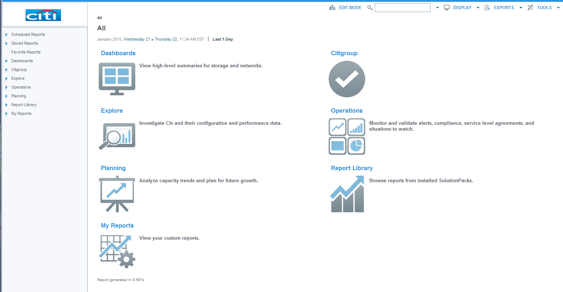

    - Unisphere for VMAX

Servers: Login using <soeid>/<AD soeid password>
390G – NAMEEMC01, 02
GTDC – NAMGEMC01, 02, 03
MWDC – NAMMEMC01, 02, 04, 05, 06, 07
O’Fallon – NAMMECM03
Rutherford – NAMREMC01, 02
SWDC – NAMUEMC01, 02, 03, 04, 05, 06. 07
Jardines – LACPEMC01
QRDC – LACQEMC01

Default sceens setup for quick analysis…

Real time last hour (heatmap, IOPS, cache write pending, response time)
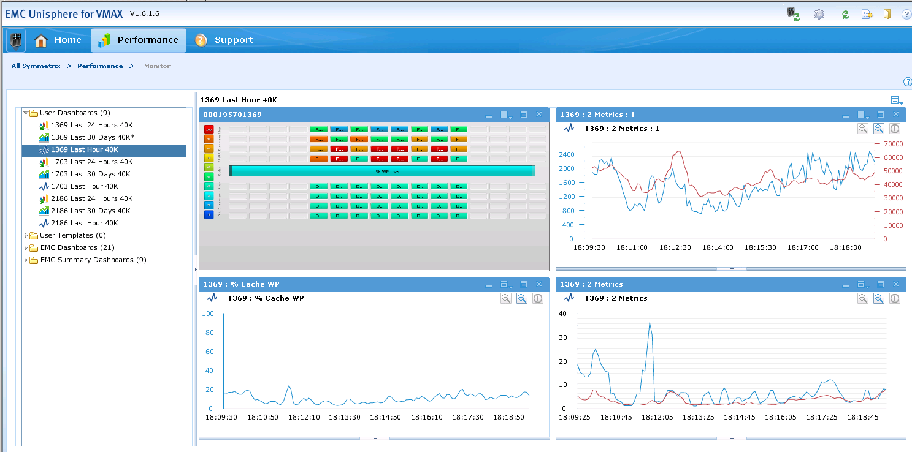

Diagnostic Last 24 Hours (heatmap, IOPS, cache write pending, response time)
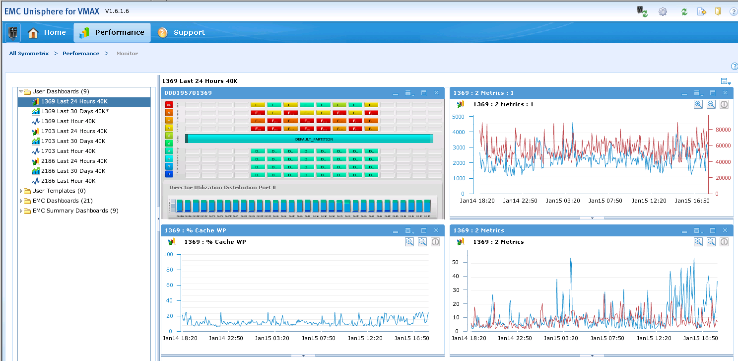

Historical last 30 days (heatmap, cache write pending, front end port bust %, backend busy %)
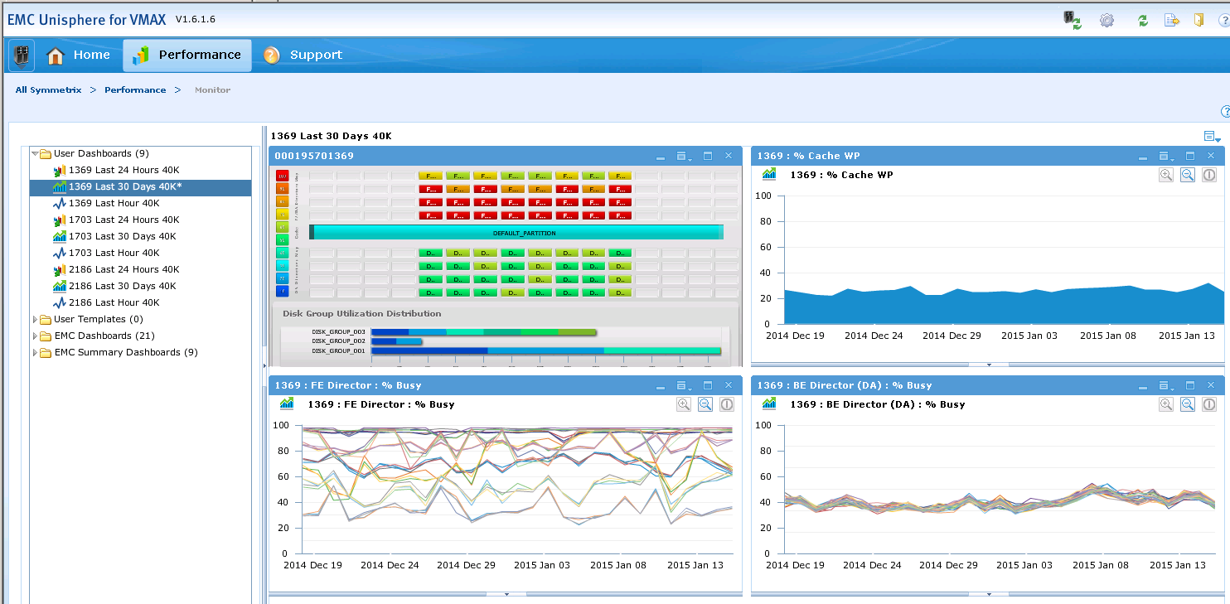

    - Unisphere for VNX

  - HDS
    - Hitachi Command Suite (HCS)

Servers: Login using <soeid>/<AD soeid password>
390G – NAMEHDS03
GTDC – NAMGHDS03
MWDC – NAMMHDS03
Rutherford – NAMRHDS03
SWDC – NAMUHDS03

Sample HCS screenshot
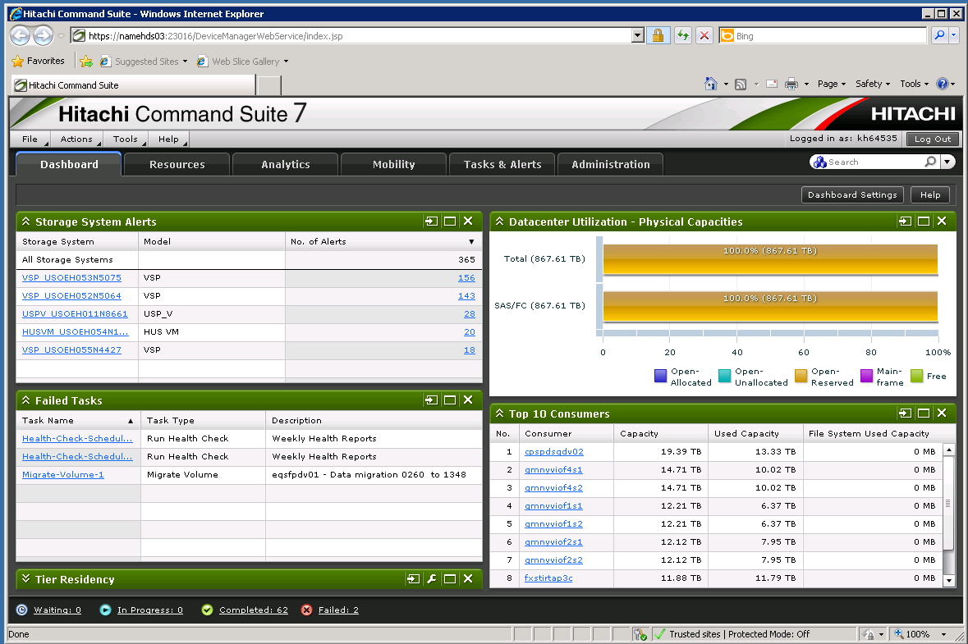

  - IBM
    - IBM XiV GUI and TOP

Servers: Login using <soeid>/<AD soeid password>
MWDC – NAMMIBM01
SWDC – NAMUIBM01

Sample from XiV GUI statistics screen
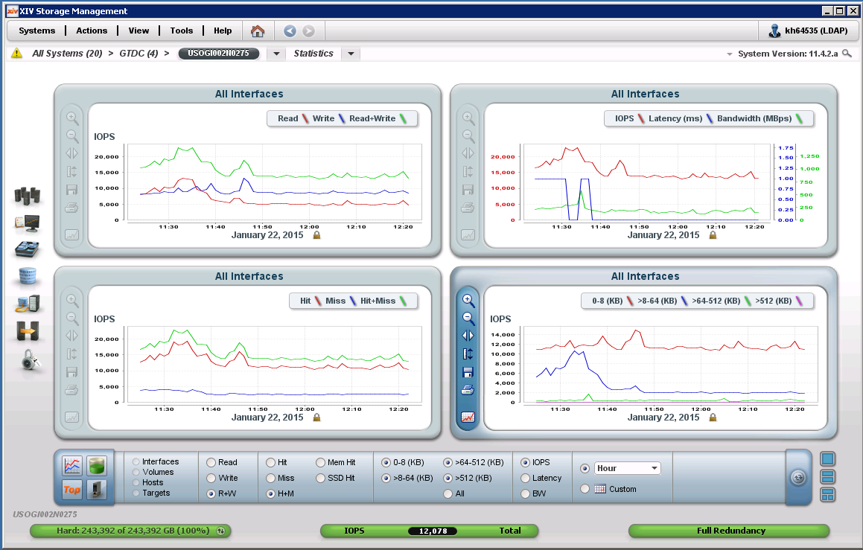

Sample from XiV Top
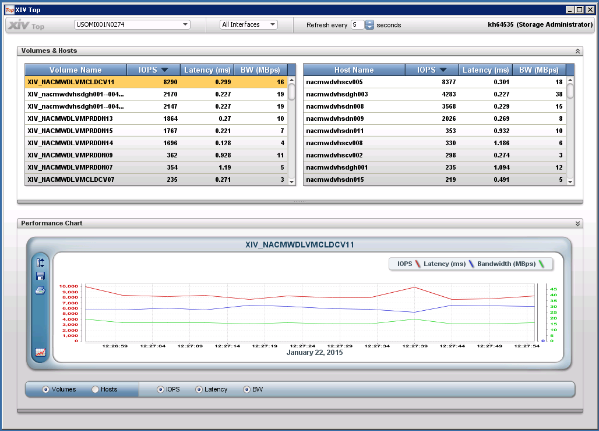

  - Cisco
    - Data Center Network Manager (DCNM)

Servers: Login using <soeid>/<AD soeid password>
390G – NAMECISCOA02, B02
GTDC – NAMGCISCOA03, B03
MWDC – NAMMCISCOA03, B03
Rutherford – NAMRCISCOA02, B02
SWDC – NAMUCISCOA02, B02
Jardines – NAMMCISCOA04, B04
Monterrey – NAMGCISCOA04, B04
QRDC – LACQCISCOA01 B01

Sample DCNM Web Interface performace dashboard
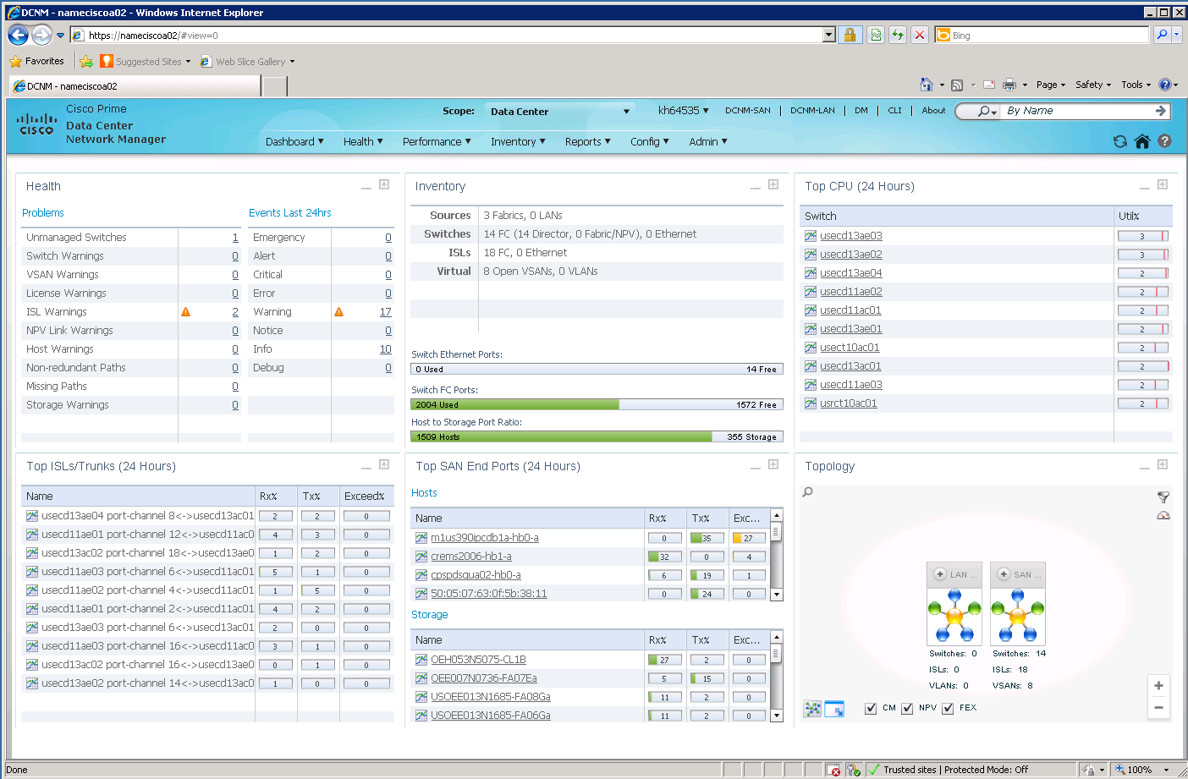

Sample DCNM web interface end device performance detail
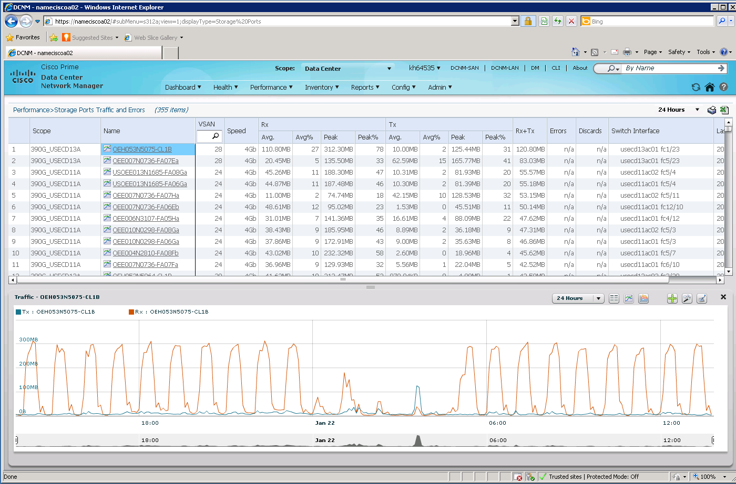

    - Cisco Fabric Manager and Device Manager

Sample DCNM Fabric Manager with Device Manager real-time summary screen open
