Possible Party Venues
- Lakeside Park
- Maplewood Community Center
- Pine Ridge Beach
- Cherry Hill Park
- Camp Redwood
- River Hills Golf Course
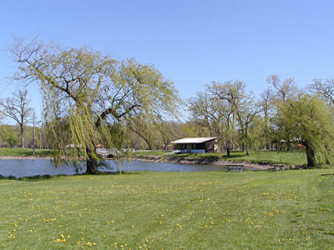
1: Lakeside Park
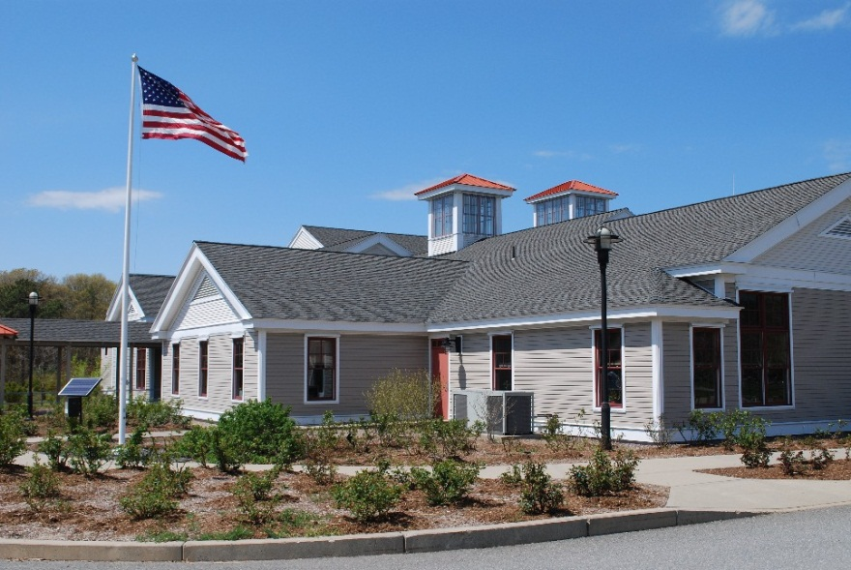
2: Maplewood Community Center
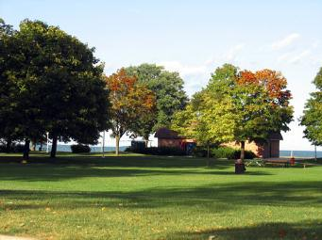
3: Pine Ridge Beach
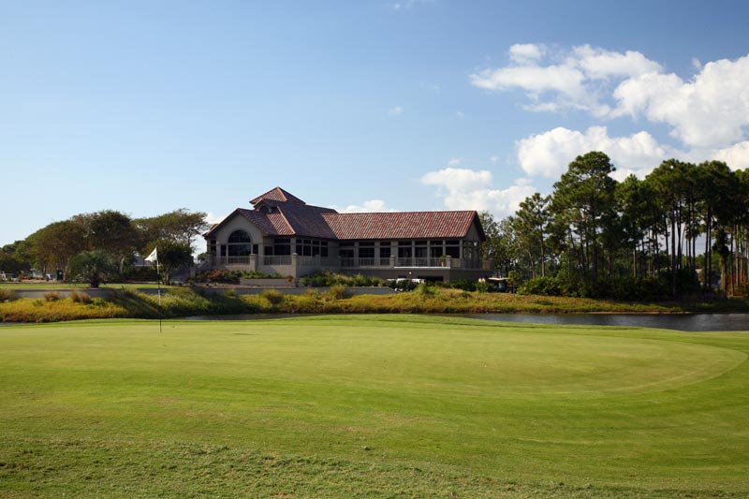
4: River Hills Golf Course

Committee Members
Name | Role | Phone
Carol Westfeld | Marketing | x3321
Marty Edwards | Fundraising | x4736
Farrah Smithwick | Food | x7390
Angela Martin | Prizes | x8132

