GNAST Design and Standard for

SAN automated configuration assurance

Tools and Automation

Template Version: 2.4
MSO2007 version

Document Version#: 1.2

Fed 20, 2015



Disclaimer
If printed, content is valid only for the day it was printed. Always refer to the online document for the current version. If the user elects to maintain copies of this procedure, it is their responsibility to verify the currency of the document by checking it against the online version. This document must be promptly removed from use when obsolete.

Table of Contents
GNAST Design and Standard for 1
SAN automated configuration assurance 1
Tools and Automation 1
1 Document Purpose 4
2 Intended Audience 4
3 Principles 4
3.1 Revision History 4
3.2 Key Feature Changes 5
4 Assembly/Solution Description 5
5 Scope 5
5.1 Technology 5
5.2 Applicability 5
6 Components 5
6.1 List of Components 5
7 Assembly/Solution Architecture 6
8 Installation & Configuration Instructions 6
9 Configuration Assurance 7
9.1 Device inventory view 7
9.2 Tracking violations 8
9.3 Managed devices 14
10 Scalability & Capacity 15
11 Availability Management 15
12 Troubleshooting and support 15
12.1 Device missing from HPNA 15
12.2 New policy/SBCC violations 16
12.3 Device access, commands and evidence 17
12.3.1 VMAX 17
12.3.2 HDS 20
12.3.3 Cisco MDS 23
12.3.4 XIV 24
12.3.5 VNX SP 27
12.4 Device feed 29
12.5 Build and support lifecycle process 30
12.5.1 HPNA access 30
12.5.2 Device policy verification 31
12.5.2.1 Check if device in HPNA 31
12.5.2.2 Check Policies 34
12.5.2.3 Test after remediation 38
12.5.2.4 Miscellaneous 39
12.6 HPNA support 39
13 Relevant Links 39
14 Glossary 40
15 Appendix 40
15.1 Best Practices 40

Note: The purpose of this template is to provide a standard document structure for completing designs with detailed instructions on how to install and configure secure technology standards within Citi’s global environment. This document follows the official standard GNAST design framework, and applies to all current GNAST technology standards/products inclusive of hardware and software.

Document Purpose
Objective of this document is to replace current SAN SBCC configuration assurance tool written in Perl which has false positive flaw with robust SAN SBCC configuration assurance vendor / CATE engineering supported tool define. Implement automated configuration assurance for SAN appliances via HP Network Automation (HPNA) and using Cititools as the reporting platform.

Remediation of Issue# 562459/ 570895 CAP
CTI SAN, working with CATE, will strengthen the existing automated scripts and configuration process to address the weaknesses identified by the Internal Audit team. Once a CATE-certified automated configuration assurance (ACA) solution is developed, CTI will implement this new solution in all Regions and the existing CTI developed scripts will be retired from the Global SAN environment.

Intended Audience
The intended audience is SAN engineering, integration and operation teams.
HPNA support team.

Principles

Revision History
Document Version:
A first generation document that hasn’t been ratified before is a 0.0 (less than 1.0) during its revision cycle. When adopted it is a 1.0 version. Subsequent generations follow the same method of incrementing the decimal portion of the version number until ratified, and then increment the integer.

Version | Description | Date | Author
0.1 | Initial import to standard document | 25-Jun-2014 | Nicolas Robin
1.0 | Final Document | 25-Jun-2014 | Nicolas Robin
1.1 | Adding SAN build team process | 8-Jan-2015 | Nicolas Robin
1.2 | Updated SAN build team review process | 20-Feb-2015 | Nicolas Robin

Key Feature Changes
updated the SAN build team review process to include Cititools (chapter 12.5)

Assembly/Solution Description
Perform automated configuration assurance on the SAN environment.

Scope
Cisco MDS
Hitachi Data Systems HDS SAN
EMC Symmetrix VMAX
EMC Clariion
IBM XIV

Notes:
- Brocade is out of scope as this implementation target date is Q4 2014 and Brocade final replacement will occur in H1 2015.
- Same status for DMX
- Same status for USP-Vs.

Technology

Applicability
CTI, global

Components

List of Components
Component Name | Capability Description
Base Components
HPNA

Assembly/Solution Architecture
Refer to the HP Network Automation standard document

Installation & Configuration Instructions
HPNA installation instructions: refer to the GNAST Standard - HPNA backend Automation install.
In addition,

On each hpna1, hpna2 and hpna-uat set, specifically, on hpnagtapp5p, hpnamwdc05c, hpnagtapp1u”

Upload New drivers:
EMCSymmetrixConfigFiles, EMCVNXSPConfigFiles, HDS-SANConfigFiles, IBMXIVConfigFiles

Create new groups
dynamic emc vnx sp – filter on driver EMCVNXSPConfigFiles
dynamic emc symmetrix – filter on driver EMCSymmetrixConfigFiles
dynamic hds san – filter on driver HDS-SANConfigfiles
dynamic ibm xiv – filter on driver IBMXIVConfigFiles
dynamic cisco mds – filter on existing driver Cisco MDS switches 9000 series

add new password rules
ibm xiv
emc vnx sp
emc symmetrix
hds san
cisco mds na latam
cisco mds emea

replace/populate folders
/opt/app/hds
/opt/app/vnx

Add id_rsa.pem key under admin -> server admin as below:

Configuration Assurance

Device inventory view

Go to Cititools -> reports -> HPNA device summary: Filter “NI Device Type” on “SAN” and select the summary by Region and Device Family - https://cititools-dev.nam.nsroot.net/NSPortal/Report/HPNADeviceSummary

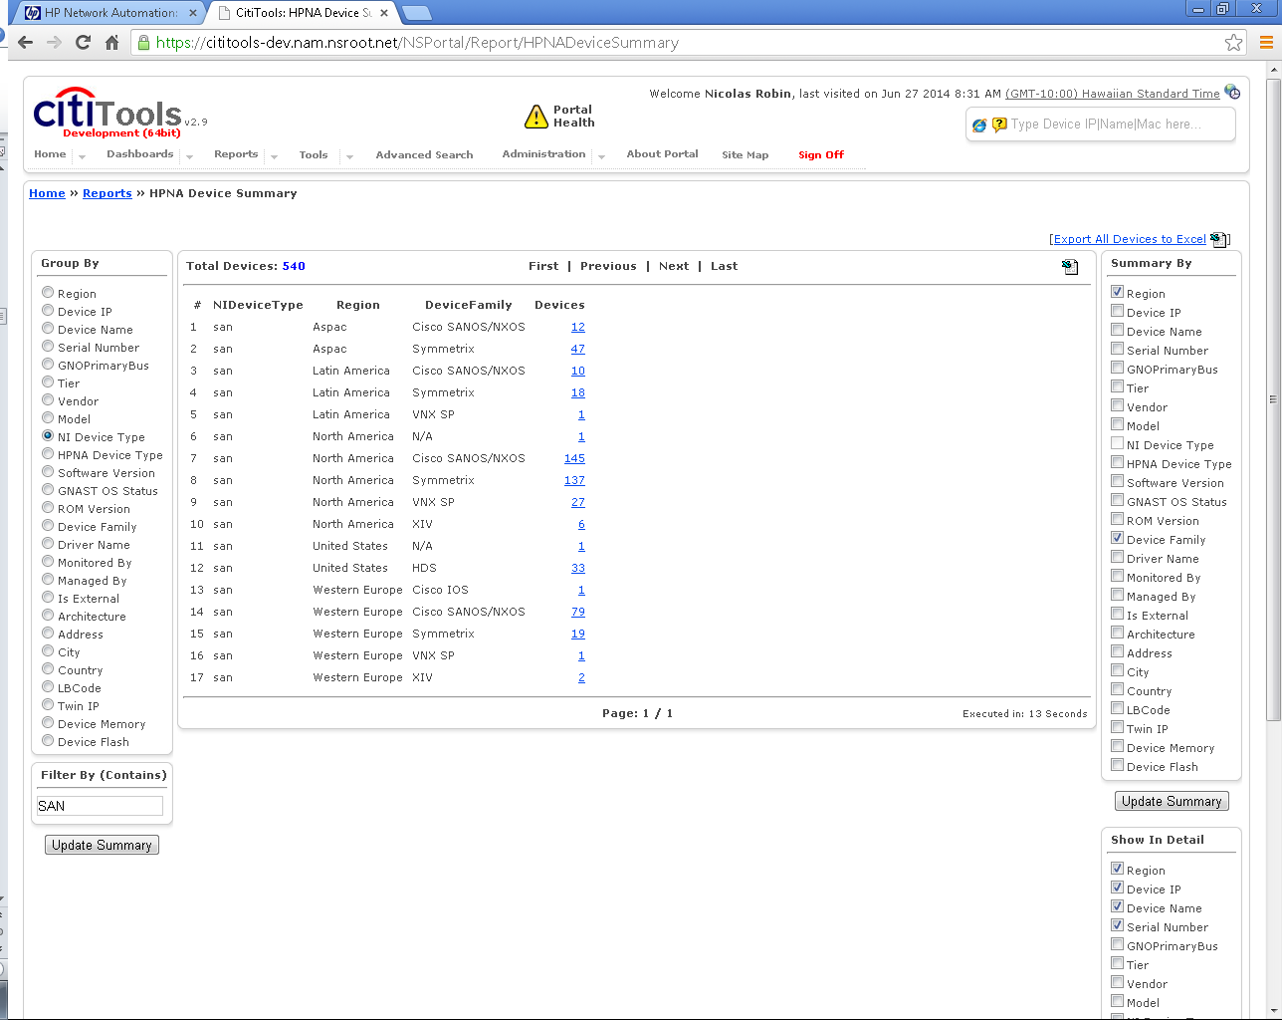

Tracking violations
SAN and NAS CTI users of Cititools need to belong to the TACACS group “HPNA-RO” group to be able to use the exception tracking tool. If you cannot access the URL above, an error message will be displaying, including instructions on how to obtain such an access.

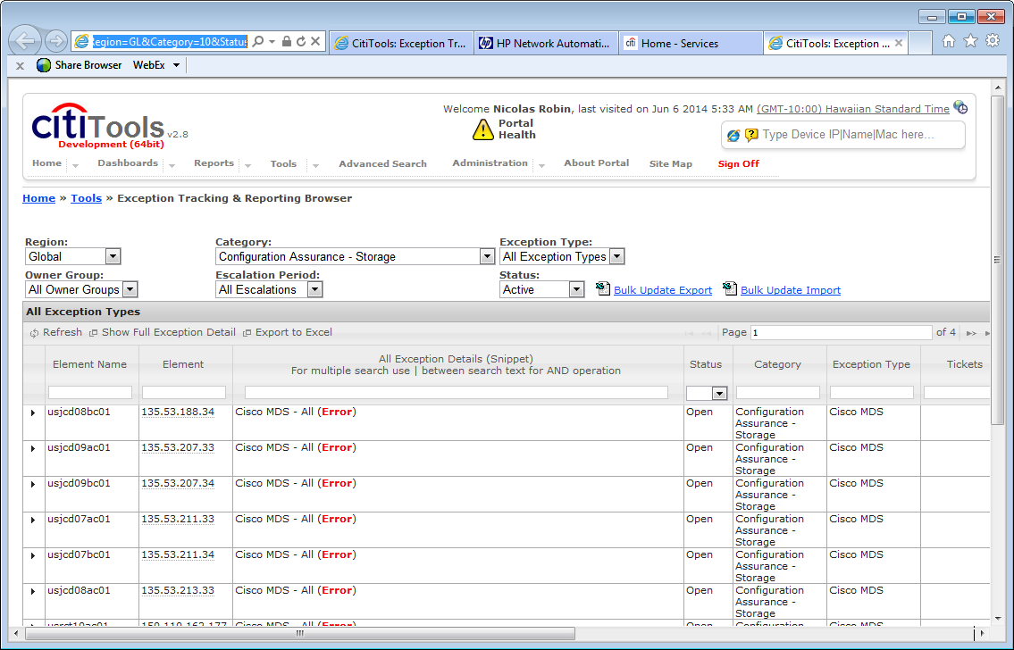

To view storage specific violations, set the category to “Configuration Assurance – Storage” and Exception type to the specific product (Cisco MDS, EMC Symmetrix, etc.)

To view the detail of the violation, go to the bottom of the page and click on “show full exception detail”.

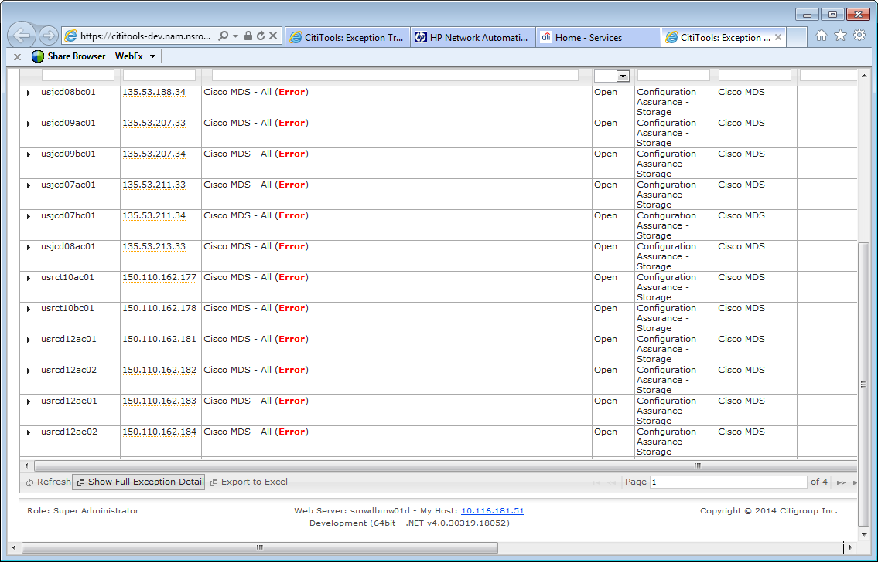

To filter on a specific region, go to the right side of the table (you first have to go to the bottom of the page then move the cursor) until you find Region

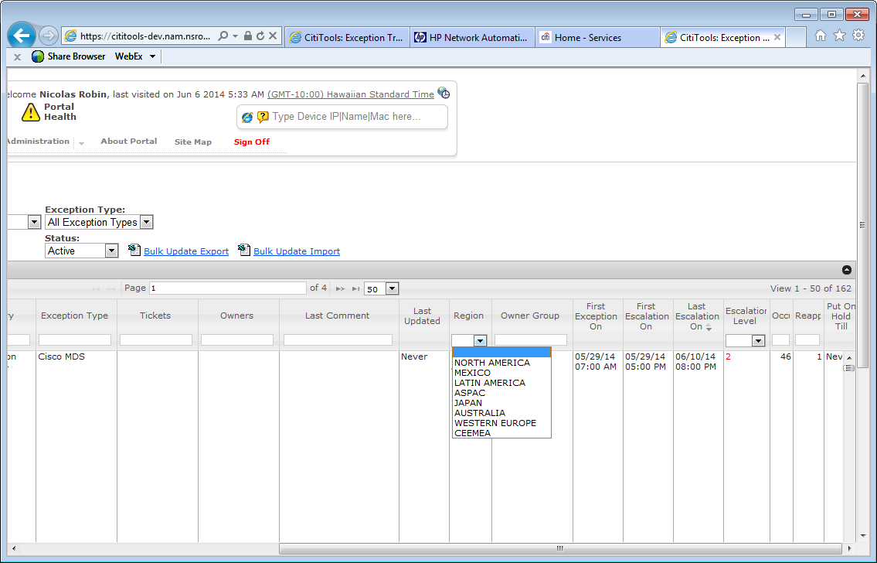

Each violation can (this is not mandatory) be edit in in a couple of ways. All involve expanding the violation by clicking on the arrow on the left
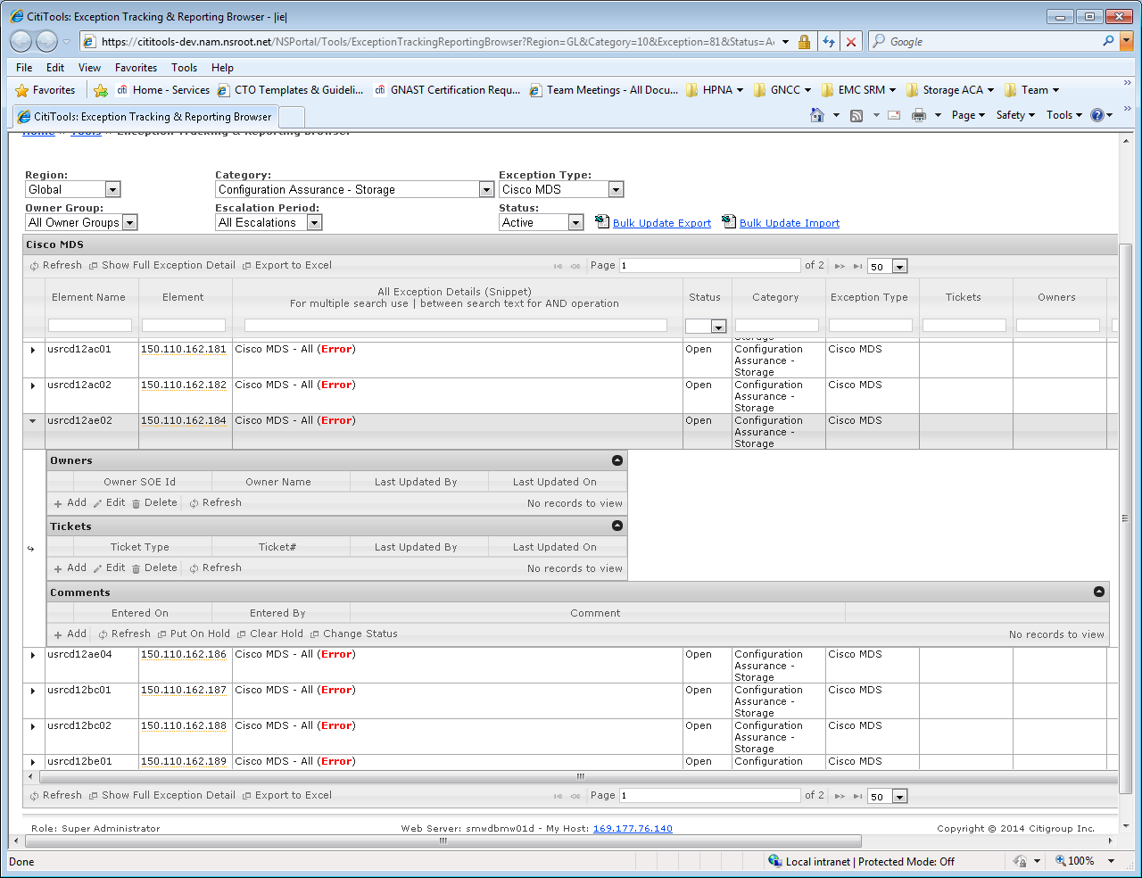
You can add/edit an owner and a ticket, add a comment and put on hold (if it is an exception to the rule, you can set the alert on hold and it will no longer be listed in the active violations).
All such activities are logged to a violation and will stay with it.

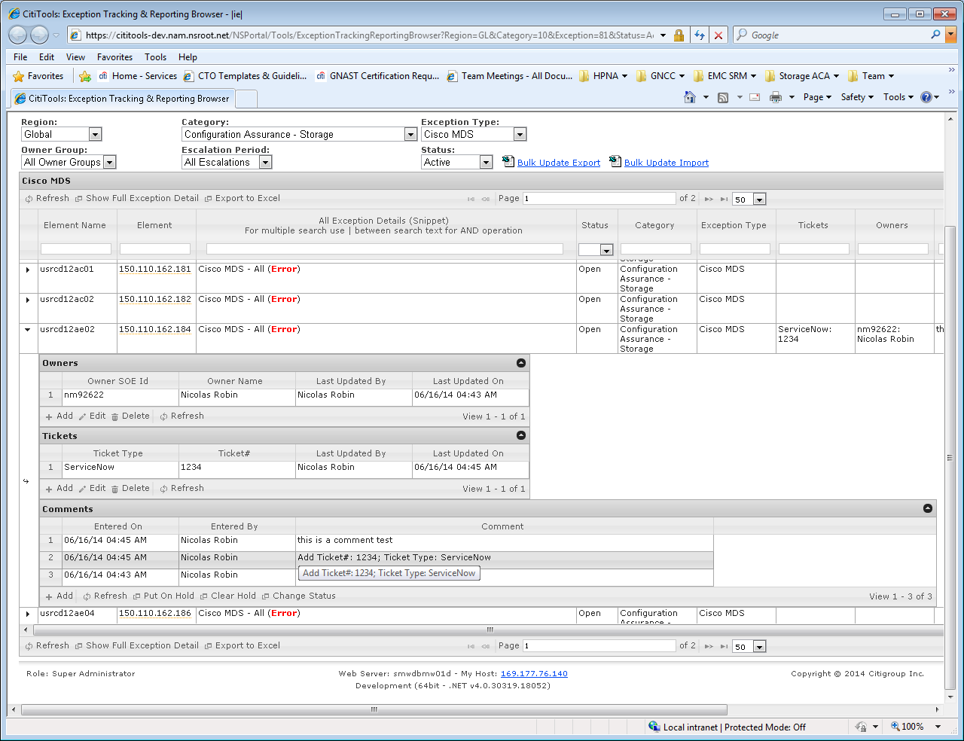

Note if a violation is remediated then occurs again within 3 months, the same violation will get opened.
All SAN device families have a single policy with multiple rules.
A policy is a list of checks called “rules” against a list of devices (scope).
In the storage pace, each device family has a single policy, with each SBCC check having its own rule. The advantage of this is all the device SBCC issues are listed under one entry.
A violation is the association of a policy with a device failing one or more rules in that policy.

You can view “on hold” violations by setting the “status” field to “on hold”.

If a device has a rule violation as below
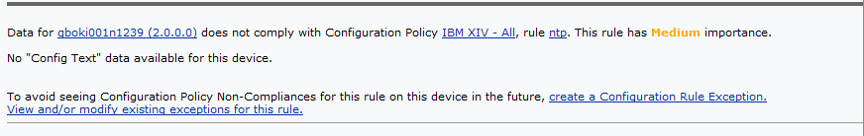

It means this device data could not be collected by HPNA – either Aperture has an issue (here it is the case, as the IP 2.0.0.0 is clearly incorrect) -> to check first aperture (search based on the name). If Aperture look fine, verify the access for HPNA has been setup correct. If so, contact HPNA support to investigate the issue: *cti us hpna support.

Note the Exception type “Storage Aperture or Access” list issues with the Aperture data as well as access failures to devices.

Managed devices

The HPNA device summary page in cititools lists all types of devices managed in HPNA.
To view Cisco MDS devices, select the device family “Cisco SANOS/NXOS”.
To view HDS devices, select the device family “HDS”.
To view XIV devices, select the device family “XIV”.
To view VNX SP devices, select the device family “VNX SP”.
To view VMAX devices, select the device family “Symmetrix”.

URL: https://cititools.nam.nsroot.net/NSPortal/Report/HPNADeviceSummary (production)
https://cititools-dev.nam.nsroot.net/NSPortal/Report/HPNADeviceSummary (development)

For instance, VNX SP devices view:

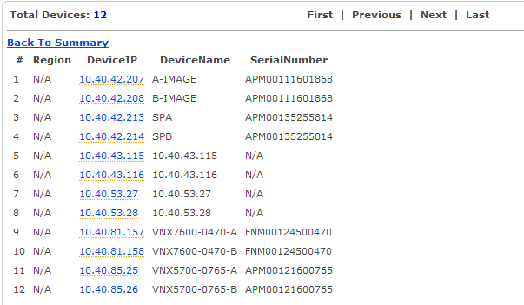

Scalability & Capacity
HPNA has over 10000 spare license compared to the few thousands storage devices.
The collection script (backup_storage.pl) is running in 10 minutes multitasking.

Availability Management
Part of the HP Network Automation standard

Troubleshooting and support

Device missing from HPNA

Devices are added from Aperture. If it is not present in HPNA, it likely means the device entry in Aperture is not matching the appropriate filter described in the device feed chapter below.

Please make sure the device is correctly entered in Aperture (specifically the IP) and verify it maps to the filter from the device specific feed. If it does and the device is not in HPNA, contact HPNA support.

New policy/SBCC violations

Every day a check is performed on Cititools that generates an email for each



One email is sent per escalation and device type. I.e. you can potentially have one email for XIV escalation level 1, one for XIV escalation level 2, one for IBM XIV escalation 1,… Emails are global, i.e. there is no NA XIV email or ASPAC XIV email. Only new escalations and alerts would be listed.
The first column lists the region, IP and hostname. The email does not currently contain the country. On Symmetrix, the IP is a fake IP and the hostname is the SID.

Email recipients are configurable via a cititools web front-end (go to Cititools -> Tools -> Exception Tracking & Reporting -> Exception Editor), as well as the escalation duration:

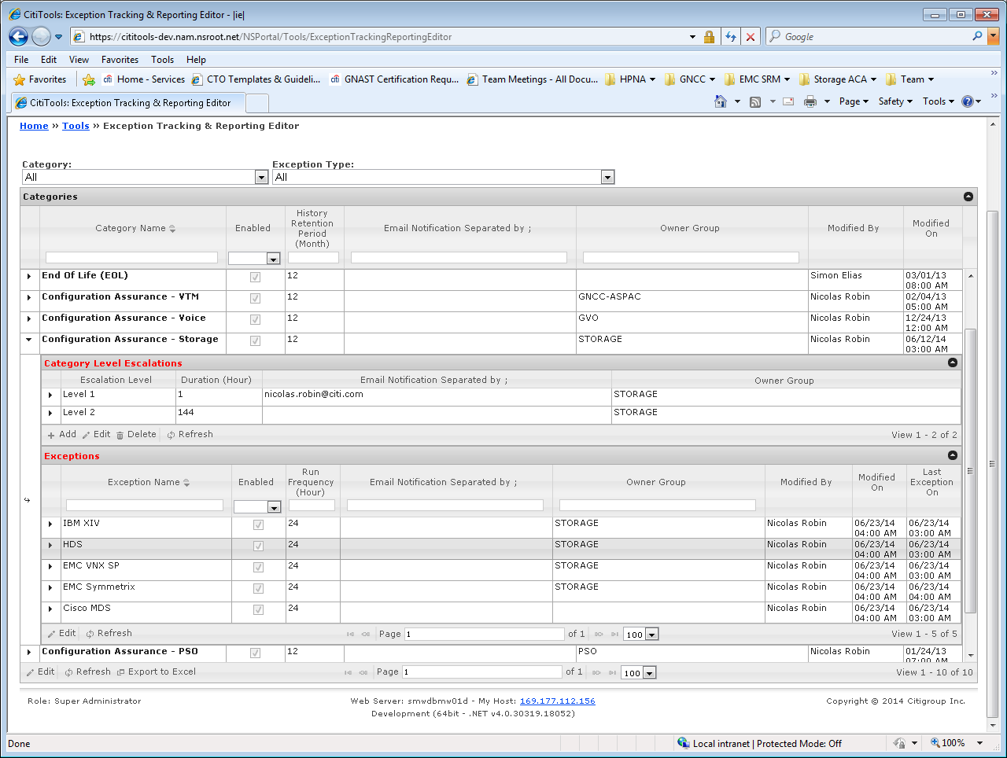

This shows every 24 hours the checks for new violations and escalated violations is performed, and the level 1 escalation (new violation) is emailed (in the instance above) to Nicolas.robin@citi.com. The email recipient is the only entry needing amendment in production. If you get an access error, follow the described procedure on the web error page to get access.

Device access, commands and evidence

VMAX
HPNA connects to each SE via sym_cli running from the HPNA server.

The package /net/stealth/export1/home1.localhost/sw/Linux/hpna_client-0.4-1.x86_64.rpm has to be installed on each SE by the local Unix SAs. It creates a Unix local “hpnaro” account. This accounts needs to belong to the “monitor” role and permissioned to access the gns and api daemons.

Successful package installation:
# rpm -ivh /net/stealth/export1/home1.localhost/sw/Linux/hpna_client-0.3-1.x86_64.rpm
Preparing... ########################################### [100%]
1:hpna_client ########################################### [100%]
[Dev root @ namaltswapp01d /opt/app/hpna]
#

On each VMAX, the commands called are:
symcfg list -v
symcfg list -FA all -v
symauth list
symauth -sid $array list -users -by_role
symdist list -v
symcfg -sid $array list -memory
symtier list -vp
symfast list -control_parms
symfast list -state
symcfg list -pool -thin
symacl list -accgroup
symdisk list -isspare
symdisk list -dskgrp_summary

The whole SBCC has been converted in HPNA rules

Inventory in development, https://cititools-dev.nam.nsroot.net/NSPortal/Report/HPNADeviceSummary -> select device family “symmetrix” on the left side, and on the right select region and click “update summary:

Rules defined for VMAX:
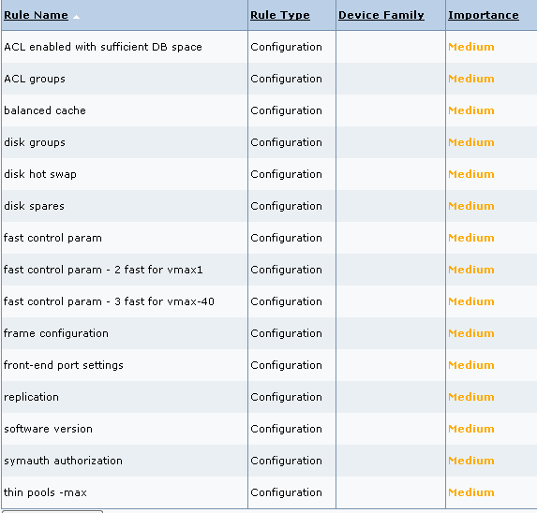

To view the policy and rule definition, go to cititools -> configuration assurance policy catalog. Filter the first column “Name” on “EMC Symmetrix – all”:

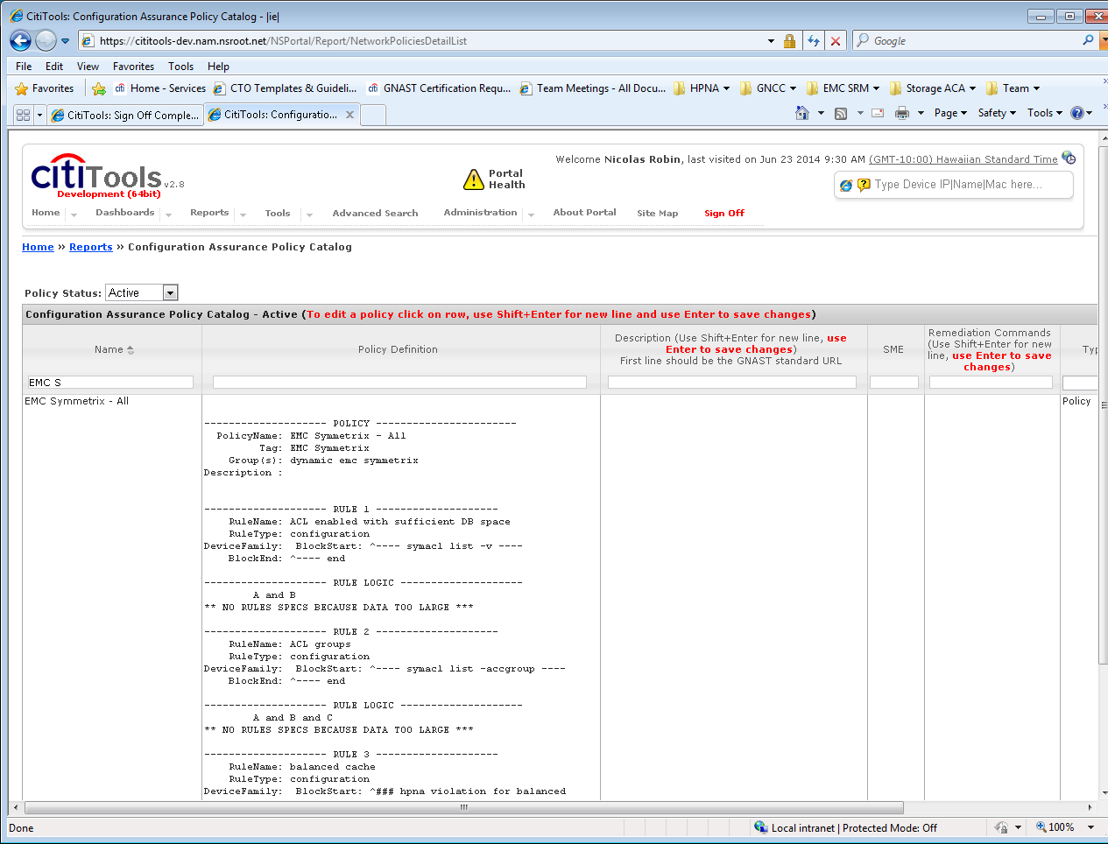

Quantity of VMAX from Aperture:

EMCSymmetrixConfigFiles 2
EMCSymmetrixConfigFiles aspac 47
EMCSymmetrixConfigFiles latin america 18
EMCSymmetrixConfigFiles north america 136
EMCSymmetrixConfigFiles western europe 19

HDS
HPNA connects to the hicommand servers via the hicommandcli.

Ldap user “hpna_mds” for NA, “emea_cisco_hpna” for emea, undefined for ASPAC.

User needs to belong to the read only group “storage administrator”.
The commands called are:
"getstoragearray",
"getstoragearray subtarget=port",
"getstoragearray subtarget=replicationinfo",
"getstoragearray subtarget=hoststoragedomain"

Only the microcode, host modes and FED port have been implemented in HPNA. Other data are not or only partially available via the hicommandcli. CATE is submitting an enhancement request for HDS to provide one way to provide access to all the data listed in the SBCC, whether hicommandcli, raidcom or a web API.

In development, https://cititools-dev.nam.nsroot.net/NSPortal/Report/HPNADeviceSummary -> select device family “hds” on the left side, and on the right select region and click “update summary:

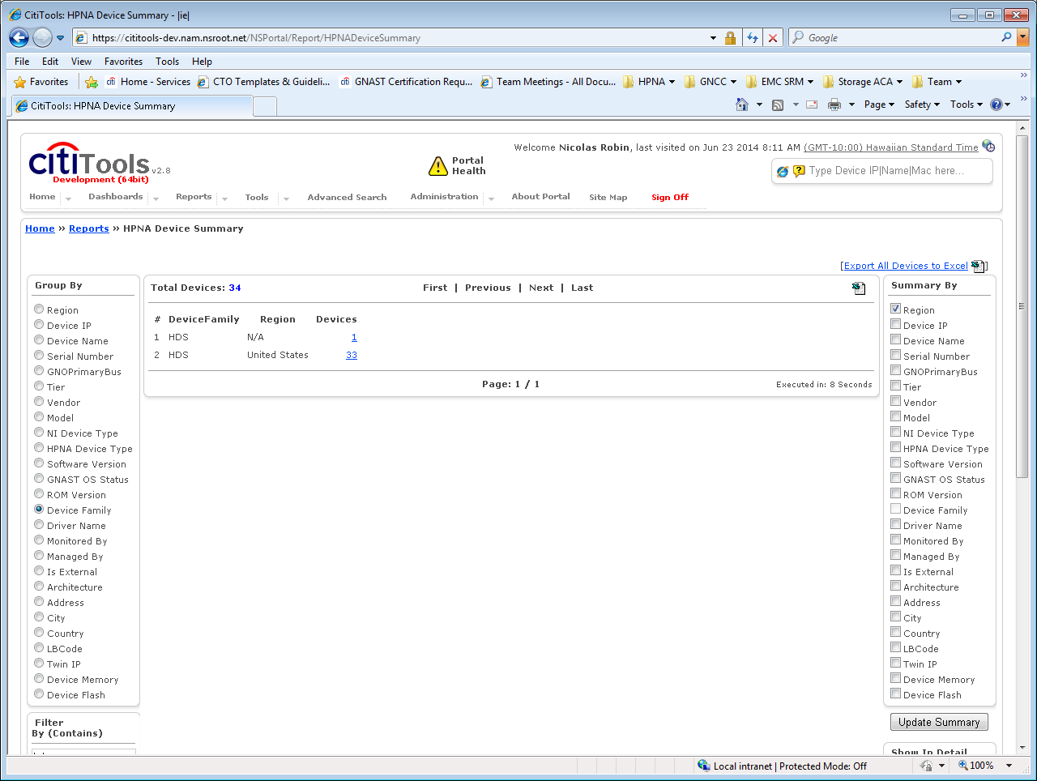

To view the policy and rule definition, go to cititools -> configuration assurance policy catalog. Filter the first column “Name” on “HDS – All”

List of rules:

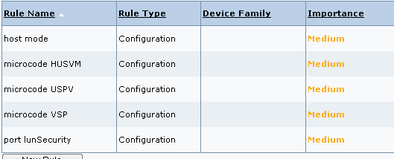

Cisco MDS
HPNA connects directly to the Cisco MDS switches. The ID being used to connect to the switches needs to be assigned the MDS facility role in AD.

Ldap user “hpna_mds” for NA, “emea_cisco_hpna” for emea, undefined for ASPAC.

The command called is “show run”.
The whole SBCC is converted in HPNA policies.

Inventory in development, https://cititools-dev.nam.nsroot.net/NSPortal/Report/HPNADeviceSummary -> select device family “SANOS” on the left side, and on the right select region and click “update summary:

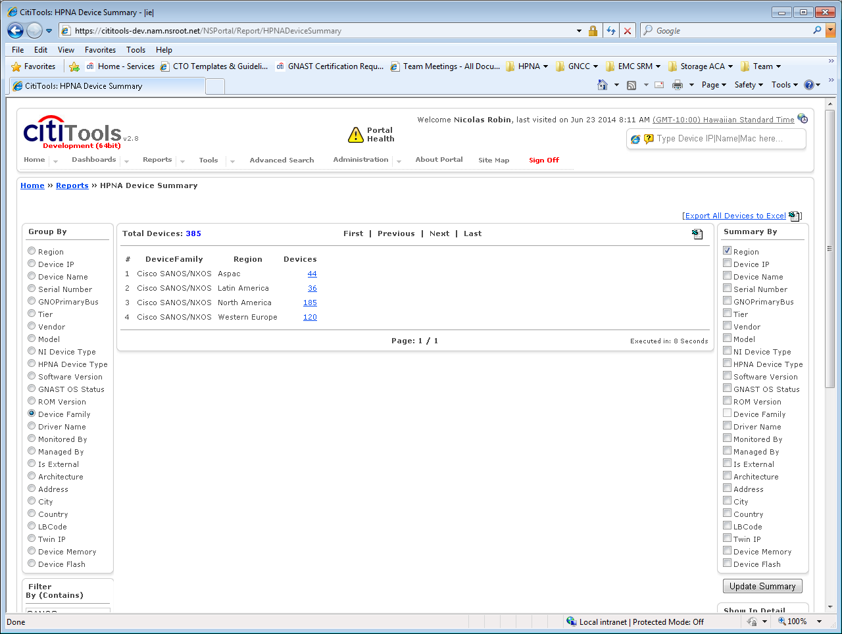

Rules defined in HPNA:
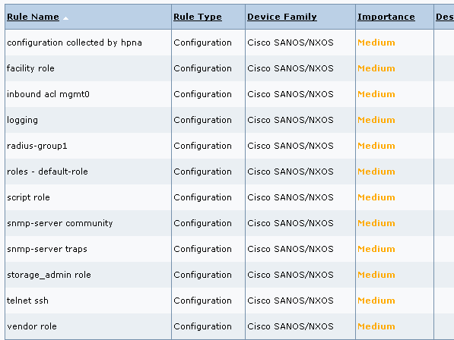

To view the policy and rule definition, go to cititools -> configuration assurance policy catalog. Filter the first column “Name” on “cisco MDS – All”

XIV
HPNA collects the XIV data via the xiv_cli
The commands called are:
‘version_get’,
'access_list',
'ldap_list_servers',
'ldap_config_get',
'dest_list',
'destgroup_list',
'rule_list',
'user_list',
'user_group_list',
'service_list',
'host_list',
'config_get',
'event_threshold_list',
'smsgw_list',
'smtpgw_list ',
'vol_default_ssd_caching_get',
'ipinterface_list',
'support_center_list'

The access account needs to belong to the read only role.

Ldap user “hpna_mds” for NA, “emea_cisco_hpna” for emea, undefined for ASPAC.

The following commands are currently not RO commands and will not be checked for now – IBM will release in Q3 2014 the code that will allow these commands to be called with a RO account:
ldap_list_servers
ldap_config_get
vol_default_ssd_caching_get
support_center_list

Note the “Pool Filling Alert” is a capacity check, not a security check, therefore needs to be performed by SRM or other capacity planning tool. Reason being: can we afford to wait 24 hours before alerting on such issue? HPNA is not a real time monitoring tool.

Inventory in development, https://cititools-dev.nam.nsroot.net/NSPortal/Report/HPNADeviceSummary -> select device family “XIV” on the left side, and on the right select region and click “update summary:
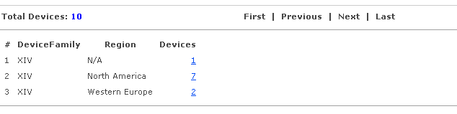
PS: N/A is a lab device.

To view the policy and rule definition, go to cititools -> configuration assurance policy catalog. Filter the first column “Name” on “IBM XIV – All”

List of rules:
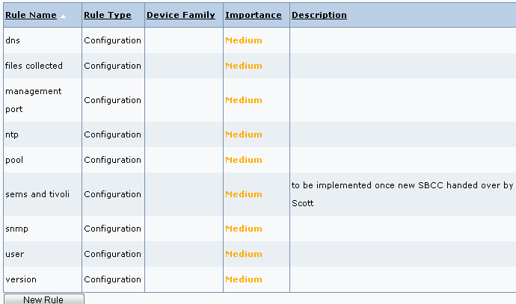

VNX SP
HPNA collect the VNX SP data via naviseccli. The MSAD account used should be permissioned to the monitor group.

Ldap or local user “hpna_mds” for NA, “emea_cisco_hpna” for emea, undefined for ASPAC.

The IP ACL needs to have the following IPs added:
Prod: 194.41.66.139
COB 194.41.66.139
UAT 194.41.66.139
Dev 194.41.67.92

The commands called are:
‘getall’,
'getsp',
'getsptime',
'networkadmin -get -all',
'arrayname',
'ntp -list -all',
'getcache -wst',
'getcache -mirror',
'getcache -wsz',
'getcache -rsza -rszb',
'getcache -page',
'getcache -high',
'getcache -low',
'security -ldap -listserver',
'security -list',
'environment -list -all',
'eventmonitor -portal -list',
'analyzer -status',
'analyzer -get',
'storagepool -list',
'getdisk -state',
'ndu -list -name -isactive',
'faults -list',
‘getagent’

The commands not being collected due to non Admin permission are: ntp –list –all, security –ldap –listserver, security –list. An enhancement has been submitted to EMC but not ETA has been provided at this time.

All the SBCC is implemented except the ones relying on the commands above, as well as the storage pool test (pending SME clarification).

------------
Collection for these 5 categories of devices will run once a day for all these devices, midnight GMT for EMEA devices, 6am GMT for the Americas, noon GMT for ASPAC devices.

Inventory in HPNA development, https://cititools-dev.nam.nsroot.net/NSPortal/Report/HPNADeviceSummary -> select device family “SANOS” on the left side, and on the right select region and click “update summary:

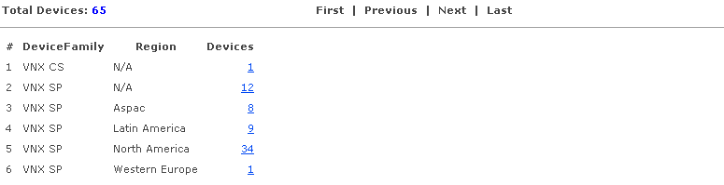

To view the policy and rule definition, go to cititools -> configuration assurance policy catalog. Filter the first column “Name” on “EMC VNX SP - All”

List of rules:
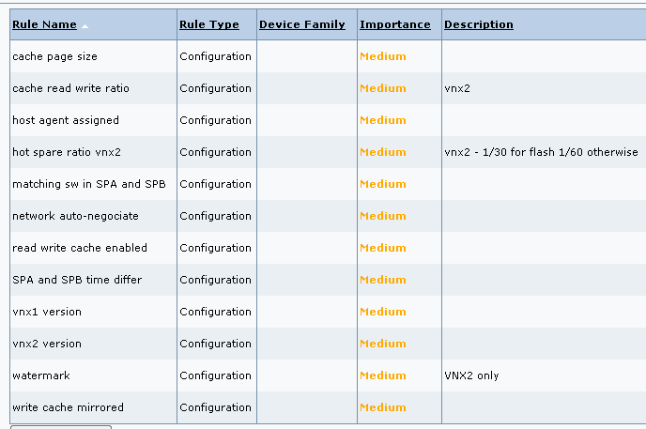

Device feed

Currently the device feed is coming from Aperture and a seedfile. Aperture takes precedence over the seedfile.
Only EMCSE are listed in the seedfile. All other devices come from Aperture.

Seedfile format and sample:

#<ip>,<type>,<region>,<country>,<lbcode>
172.31.254.35,xiv,north america,united states,gtdc
172.31.254.74,xiv,north america,united states,swdc
172.31.254.77,xiv,north america,united states,mwdc

Daily feed – access via Aperture backend replication DB.

Build and support lifecycle process

- When you contact DC to add a new device, add to the request to set the status to “pre-production”
- Setup the device
- Check the device is in HPNA and its SBCC/policy (once the device has been added to Aperture)
- Add HPNA policy evidence to the SN change
- Contact DC to update status from pre-production to production

HPNA access

To access HPNA, you need a Cisco Secure TACACS account:
https://cmp.nj.ssmb.com/marketplace/control/product/~productId=43736_66523_GLOBAL#
select the group “HPNA-RO”
The TACACS password is your 4 digit safeword pin followed by “7” (and NOT 8 as during remote access)

HPNA URL:
https://hpna2.nam.nsroot.net:8443 (prod)
https://hpna-dev.nam.nsroot.net:8443 (dev – the one we will work from)
Dev and prod both use same TACACS and have the same devices.

Device policy verification

Check if device in HPNA

Go to https://hpna2.nam.nsroot.net:8443
Login with your tacacs account (cf 12.5.1 chapter).

Search for the device based on the IP or hostname (top left)
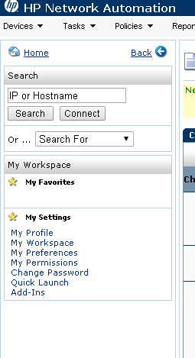

Important:
- For XIV and VNX, only the highest management IP is in HPNA => that’s 1 out of the 3 XIV IP and 1 of the VNX SPA and SPB. The other IPs are NOT in HPNA.
- VMAX do not have a real IP for the most parts (192.168… for a lot of them) -> the VMAX IPs are only used for HPNA purpose and do not exists – the serial number is the HPNA hostname, so you want to search on the serial number, e.g. 192601795

IF your device is not found, it most likely means the filter used against Aperture is not capturing it.
I.e. Aperture entry is likely wrong and needs to be updated.
HPNA specifically relies on the following fields:
name, status, business, IP, model, serial number and manufacturer -> you want to check Aperture if these fields are correct.

If aperture data is accurate and the device is not present, contact HPNA support: *cti us hpna support / SN queue - CTI GL AD APPL-NSDM HPNA SUPPORT

If Data Center is not updating in a timely manner the Aperture data, escalate (CCing your mgmt. as well as the DC mgmt.) after their SLA for update request expired.

- Current Aperture feed filter criteria:
- Hicommand servers: name first 3 letters are "nam", 4th letter is anything, then name finished by "hds03", and the ip_address has to be defined.
- HDS arrays: model contains 'VSP' or ‘HUS*VM' or 'USPV'
- XVI: highest mgmt IP for each device, name 3rd letter "o", 5th letter "i", manufacturer "IBM", ip_address defined
- EMC SE: static list maintained in HPNA (no available filter listing these in Aperture) – if list changes, *cti us hpna support needs to be notified:
162.124.213.25,emcse,north america,united states,390g
168.72.74.99,emcse,north america,united states,gtdc
144.215.204.26,emcse,north america,united states,mwdc
150.110.173.54,emcse,north america,united states,nj7
169.177.75.33,emcse,north america,united states,swdc
169.192.70.9,emcse,north america,united states,7137
144.215.21.55,emcse,north america,united states,qrdc
10.207.92.36,emcse,north america,united states,1747j
135.53.211.168,emcse,north america,united states,ah84
10.110.37.88 ,emcse,north america,united states,cons

- VNX SP: manufacturer "EMC”, name does not contain "nas", model contains "VNX", last 4 characters of name and serial number match, ip_address defined
- VMAX: manufacturer "EMC, serial number starts by "ck" or "hk", name 3rd character is not "m", model contains "V-MAX"
- DMX: manufacturer "EMC, serial number starts by "ck" or "hk", name 3rd character is not "m", model contains "DMX"
- Cisco MDS: manufacturer CISCO, model contains "MDS"
- For all the above, the business field must contain "CTI" or "Citigroup Technology Infrastructure".
- filter is not case sensitive
- MDS IP comes from Aperture OR is derived from DNS (nslookup using the nsroot.net sub-domains, e.g. nam.nsroot.net, eur.nsroot.net)

Check Policies
If the device is in HPNA:
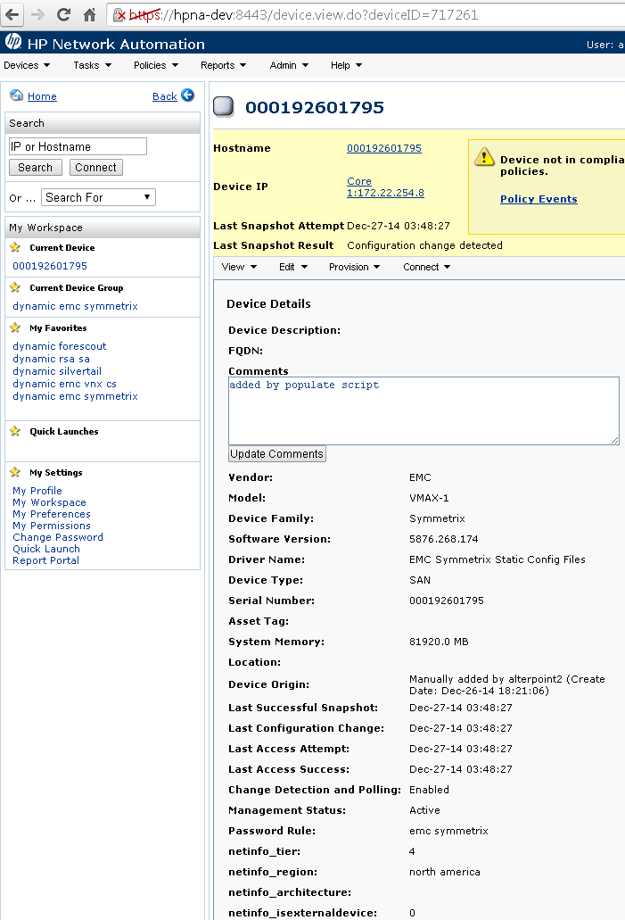

Go to View -> Device Detail -> Policies
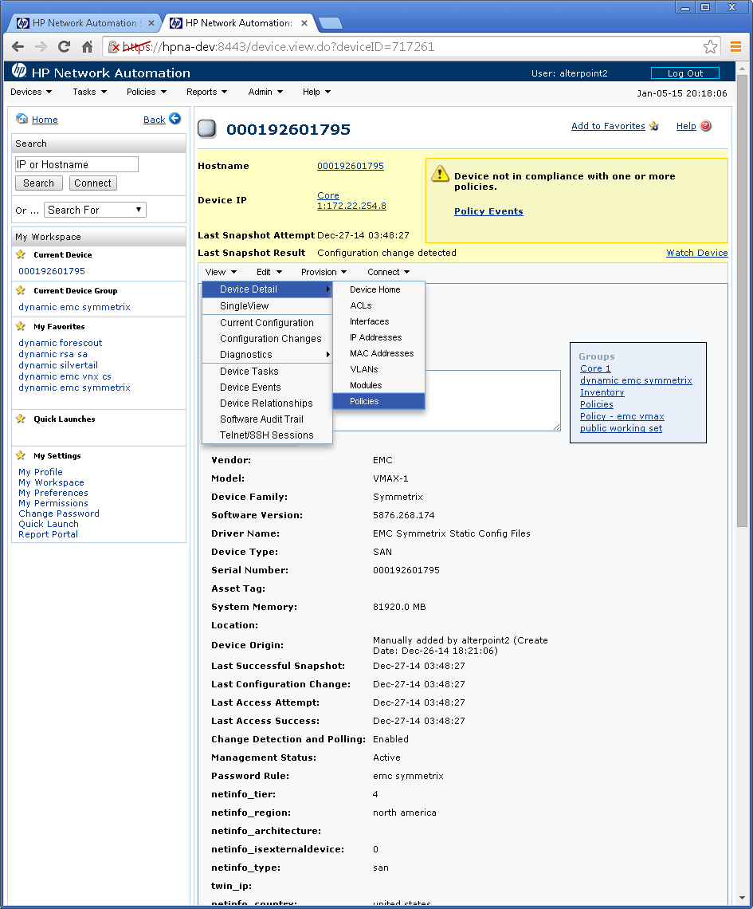

This will list all the rules a device is checked against, and will display a fail for any rule failing:

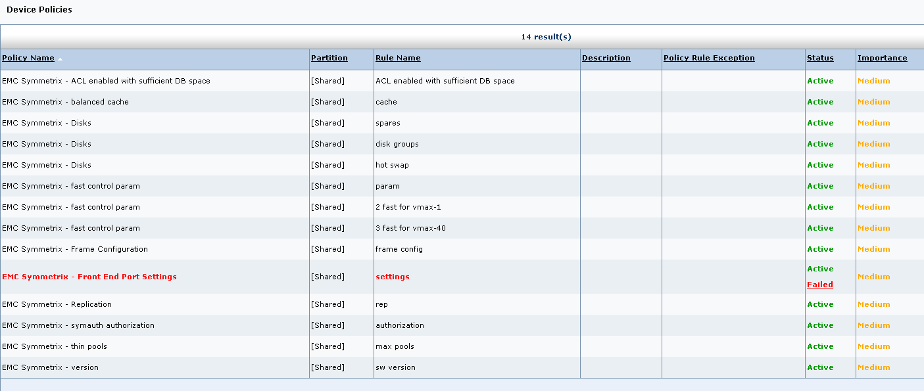
Each failure is basically one of the two following: something that should be present in the command output is missing, or something should not be present in the command output.

This screen above would be your evidence to upload in SN for the handover to production.

*IF* there are violations, you need to go to Cititools to investigate the violations:
https://cititools.nam.nsroot.net/NSPortal/Report/DevicesViolatedAPPolicies

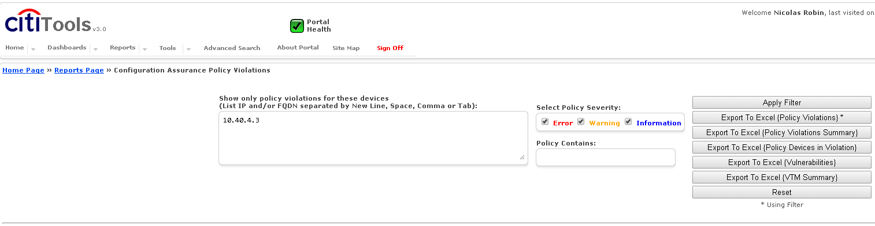

Enter the SAN IP in the IP filter above to view the violations

Example:
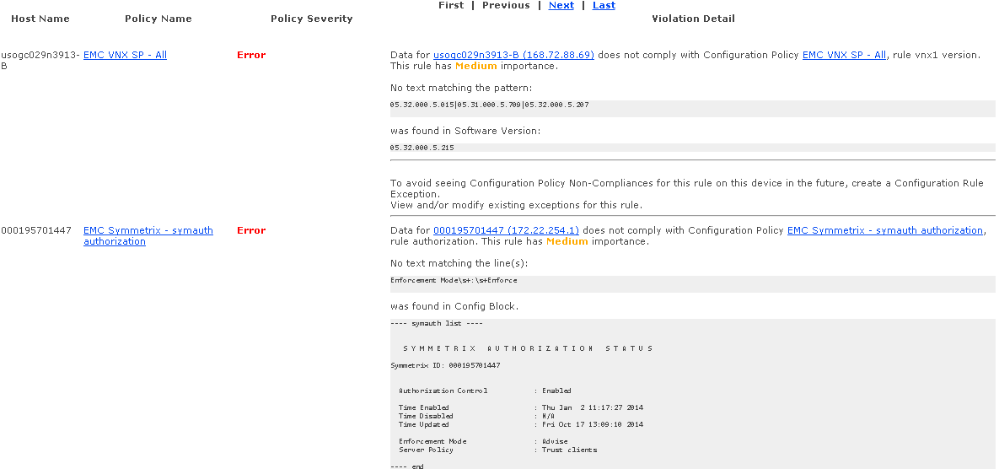

Most policies use regular expression, so you might see “\s+” or other such expressions. Follows a quick cheat:
+ means one or more, * means zero or more
\s+ means one or more space/tab combinations
\s* means zero or more space/tab combinations
\S+ means anything except space/tab one or more times
^ is beginning of a line
$ is end of a line

Review each violation. A violation is (1) either a genuine issue on the SAN or (2) the policy is incorrect.

For the latter, If you find a policy that generates a false positive, either the policy is not in sync with the SBCC or the policy and the SBCC are wrong – either way, contact the CATE TPM CCing the CATE manager and build team about the issue. The TPMs own the SBCC and the policies.
When uploading the handover evidence to SN, indicate the policy is a false positive and that the TPM is working on it, so that does not stop from moving the device to production.

Test after remediation

If there is a genuine violation that you remediate, to check it, click on edit -> take snapshot
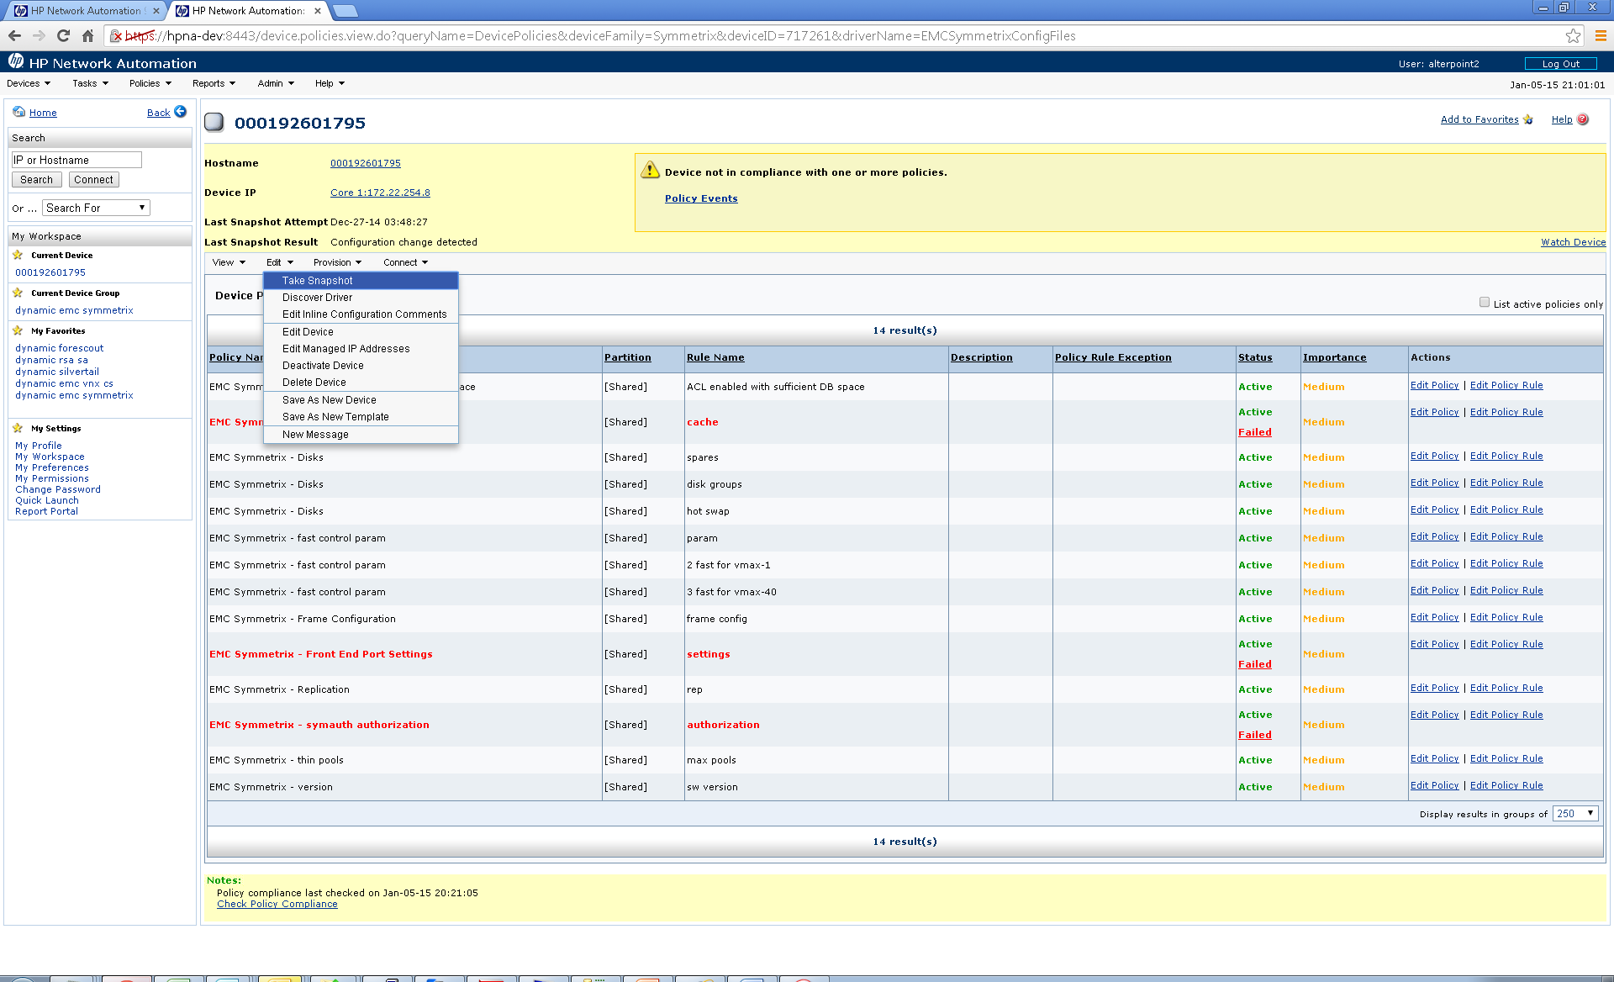
Then click “save” – save really means “run”

This will trigger a data collection which should take 1-3 mn. If successful, it will say so, if it fails, it will try to indicate the reason of the failure.

Important: to collect data, the hpna account has to be setup. For a VMAX and HDS, the EMC SE or Hicommand IP has to be discovered first (part of the daily Aperture sync): if HPNA does not know what EMCSE a VMAX is associated with, the data collection will fail. If we have a VMAX in HPNA that never got discovered (i.e. there is no “model”), it means either Aperture data is incorrect or HPNA is not accessing the EMC SE that has this VMAX “local”.

Miscellaneous

HPNA collect the Aperture status: if Aperture is “production” or “contingency”, it displays “operational”, else it displays the Aperture status. E.g. emdsfdc1a-jd-11 is “pre-production”.

The netinfo_nataddress field contains the EMCSE (for VMAX/DMX) or Hicommand (for HDS) IPs.
netinfo_swcoverage contains the Aperture monitoring field, e.g. “Tivoli – emea”

HPNA support

HPNA support team contact:

*cti us hpna support

SN queue - CTI GL AD APPL-NSDM HPNA SUPPORT

Relevant Links

Cititools production: https://cititools.nam.nsroot.net
Cititools development: https://cititools-dev.nam.nsroot.net

Glossary

Term or Acronym | Explanation or Definition
CATE | Citi Architecture & Technology Engineering
GNAST | Global Network Architecture and Standards Team
NMS | Network Management System

Appendix

Best Practices

