David Ring

Virtualization & Storage

Menu
Skip to content
- Home
- About
- Vblock
- VMAX
- VNX
- VNXe
- XtremIO
- RecoverPoint
- Cisco
- VMware
HomeVMAX

VMAX

EMC VMAX3 – Adding Gatekeeper RDM Volumes To VMware MGMT VM
July 6, 2015 David Ring Vblock, VMAX, VMware EMC, Gatekeeper, PowerCLI, RDM, VMAX3, VMWARE
VMAX3: Creating the RDM Volumes and Associated Masking View
This is an example Masking View for a two node ESXi cluster on which the VMAX management virtual machine shall reside:
1. Create a Port Group with the VMAX FA ports that the ESXi hosts have been zoned to:
symaccess -sid 123 -name MGMT_VM_PG -type port create
symaccess -sid 123 -name MGMT_VM_PG -type port -dirport 1d:24,2d:31,3D:28,4d:27 add
2. Create the Initiator Group containing the ESXi hosts WWNS:
symaccess -sid 123 -name MGMT_VM_IG -type initiator create -consistent_lun
symaccess -sid 123 -name MGMT_VM_IG -type initiator -wwn 21000024ff5CXXF8 add
symaccess -sid 123 -name MGMT_VM_IG -type initiator -wwn 21000024ff5CXXF9 add
symaccess -sid 123 -name MGMT_VM_IG -type initiator -wwn 21000024ff55XX4C add
symaccess -sid 123 -name MGMT_VM_IG -type initiator -wwn 21000024ff55XX4D add
3. Create the Storage Group for the Gatekeeper RDM Volumes:
symsg -sid 123 create MGMT_VM_SG -slo optimized -srp SRP_1
Listing the SRP:
symcfg list -srp
4. Create the Gatekeeper volumes (10 Gatekeeper volumes in this example) and add to the MGMT_VM_SG:
symconfigure -sid 123 -cmd “create dev count=10, emulation=FBA, sg=MGMT_VM_SG, size=3 CYL, config=tdev”; preview -nop
symconfigure -sid 123 -cmd “create dev count=10, emulation=FBA, sg=MGMT_VM_SG, size=3 CYL, config=tdev”; prepare -nop
symconfigure -sid 123 -cmd “create dev count=10, emulation=FBA, sg=MGMT_VM_SG, size=3 CYL, config=tdev”; commit -nop
5. Create the Masking View:
symaccess -sid 123 create view -name MGMT_VM_MV -sg MGMT_VM_SG -pg MGMT_VM_PG -ig MGMT_VM_IG
View Configuration Details
Confirm that the HOSTS are logged into the correct VMAX ports:
symaccess -sid 123 list logins -wwn 21000024ff5CXXF8
symaccess -sid 123 list logins -wwn 21000024ff5CXXF9
symaccess -sid 123 list logins -wwn 21000024ff55XX4C
symaccess -sid 123 list logins -wwn 21000024ff55XX4D
Verify that the HBA is a member of the correct Initiator Group:
symaccess -sid 123 list -type initiator -wwn 21000024ff5CXXF8
symaccess -sid 123 list -type initiator -wwn 21000024ff5CXXF9
symaccess -sid 123 list -type initiator -wwn 21000024ff55XX4C
symaccess -sid 123 list -type initiator -wwn 21000024ff55XX4D
Storage Group details:
symaccess -sid 123 list -type storage -name AMP_SG -v
symaccess -sid 123 show AMP_SG -type storage
Port Group details:
symaccess -sid 123 list -type port -name AMP_PG -v
symaccess -sid 123 show AMP_PG -type port
Initiator Group details:
symaccess -sid 123 list -type initiator -name AMP_IG -v
symaccess -sid 123 show AMP_IG -type initiator
Masking View details:
symaccess -sid 123 list view -name AMP_MV
symaccess -sid 123 list view -name AMP_MV -detail
Gatekeeper details:
symdev -sid 340 list -cap 3 -captype cyl
symaccess -sid 123 list assignment -dev 049:052
If you need to remove the devs from the SG:
symaccess -sid 123 -name AMP_SG -type storage remove devs 049:052
####################################################################
Script to Automate Adding RDM Disk’s:
PowerCLI Script: Automate Adding RDM Disk’s
Here is a script which scans for the Host LUN ID and then attributes the $LUN_# parameter
to the ‘ConsoleDeviceName’. This greatly simplifies the process of adding large quantities of RDM Disk’s.
There are 4 parameters used in the script. The following 3 shall be prompted for:
“Your-ESXi-Hostname” $VMhostname
“Your-VM-Name” $VM
“Your-VMFS-DS-Name” $Datastore
Please edit the runtime name as required, the script default is :
“vmhba0:C0:T0:L#”
The following example script will automatically create 10 RDM Disks on a Virtual Machine and place the pointer files
in a VMFS Datastore based on the parameters provided.
#####################################################################
Write-Host “Please edit the runtime name in the script if required before proceeding, the default is:” -ForegroundColor Red
Write-Host “vmhba0:C0:T0:L#” -ForegroundColor Green
Write-Host “Please enter the ESXi/Vcenter Host IP Address:” -ForegroundColor Yellow -NoNewline
$VMHost = Read-Host
Write-Host “Please enter the ESXi/Vcenter Username:” -ForegroundColor Yellow -NoNewline
$User = Read-Host
Write-Host “Please enter the ESXi/Vcenter Password:” -ForegroundColor Yellow -NoNewline
$Pass = Read-Host
Connect-VIServer -Server $VMHost -User $User -Password $Pass
##########################################
$VMhostname = ‘*’
ForEach ($VMhostname in (Get-VMHost -name $VMhostname)| sort)
{
Write-Host $VMhostname
}
Write-Host “Please enter the ESXi Hostname where your target VM resides:” -ForegroundColor Yellow -NoNewline
$VMhostname = Read-Host
######################################
$Datastore = ‘*’
ForEach ($Datastore in (Get-Datastore -name $Datastore)| sort)
{
Write-Host $Datastore
}
Write-Host “From the list provided – Please enter the VMFS datastore where the RDM pointer files will reside:” -ForegroundColor Yellow -NoNewline
$Datastore = Read-Host
######################################
$VM = ‘*’
ForEach ($VM in (Get-VM -name $VM)| sort)
{
Write-Host $VM
}
Write-Host “From the list provided – Please enter the VM Name where the RDM volumes shall be created on:” -ForegroundColor Yellow -NoNewline
$VM = Read-Host
##############
Write-Host “ESXi Hostname you have chosen: ” -ForegroundColor Yellow
Write-Host “$VMhostname” -ForegroundColor Green
Write-Host “VMFS you have chosen: ” -ForegroundColor Yellow
Write-Host “$Datastore” -ForegroundColor Green
Write-Host “Vitual Machine you have chosen: ” -ForegroundColor Yellow
Write-Host “$VM” -ForegroundColor Green
################
## ACLX T0:L0 ##
################
$LUN_0 = Get-SCSILun -VMhost $VMhostname -LunType Disk | Where-Object {$_.runtimename -like “vmhba0:C0:T0:L0”} | Select ConsoleDeviceName,runtimename
$LUN_0 = $LUN_0 | Select ConsoleDeviceName
$LUN_0 = $LUN_0 -replace “@{ConsoleDeviceName=”, “”
$LUN_0 = $LUN_0 -replace “}”, “”
$LUN_0
New-HardDisk -VM $VM -DiskType RawPhysical -DeviceName $LUN_0 -DataStore $Datastore
#####################
## Gatekeepers x10 ##
#####################
$LUN_1 = Get-SCSILun -VMhost $VMhostname -LunType Disk | Where-Object {$_.runtimename -like “vmhba0:C0:T0:L1”} | Select ConsoleDeviceName,runtimename
$LUN_1 = $LUN_1 | Select ConsoleDeviceName
$LUN_1 = $LUN_1 -replace “@{ConsoleDeviceName=”, “”
$LUN_1 = $LUN_1 -replace “}”, “”
$LUN_1
New-HardDisk -VM $VM -DiskType RawPhysical -DeviceName $LUN_1 -DataStore $Datastore
$LUN_2 = Get-SCSILun -VMhost $VMhostname -LunType Disk | Where-Object {$_.runtimename -like “vmhba0:C0:T0:L2”} | Select ConsoleDeviceName,runtimename
$LUN_2 = $LUN_2 | Select ConsoleDeviceName
$LUN_2 = $LUN_2 -replace “@{ConsoleDeviceName=”, “”
$LUN_2 = $LUN_2 -replace “}”, “”
$LUN_2
New-HardDisk -VM $VM -DiskType RawPhysical -DeviceName $LUN_2 -DataStore $Datastore
$LUN_3 = Get-SCSILun -VMhost $VMhostname -LunType Disk | Where-Object {$_.runtimename -like “vmhba0:C0:T0:L3”} | Select ConsoleDeviceName,runtimename
$LUN_3 = $LUN_3 | Select ConsoleDeviceName
$LUN_3 = $LUN_3 -replace “@{ConsoleDeviceName=”, “”
$LUN_3 = $LUN_3 -replace “}”, “”
$LUN_3
New-HardDisk -VM $VM -DiskType RawPhysical -DeviceName $LUN_3 -DataStore $Datastore
$LUN_4 = Get-SCSILun -VMhost $VMhostname -LunType Disk | Where-Object {$_.runtimename -like “vmhba0:C0:T0:L4”} | Select ConsoleDeviceName,runtimename
$LUN_4 = $LUN_4 | Select ConsoleDeviceName
$LUN_4 = $LUN_4 -replace “@{ConsoleDeviceName=”, “”
$LUN_4 = $LUN_4 -replace “}”, “”
$LUN_4
New-HardDisk -VM $VM -DiskType RawPhysical -DeviceName $LUN_4 -DataStore $Datastore
$LUN_5 = Get-SCSILun -VMhost $VMhostname -LunType Disk | Where-Object {$_.runtimename -like “vmhba0:C0:T0:L5”} | Select ConsoleDeviceName,runtimename
$LUN_5 = $LUN_5 | Select ConsoleDeviceName
$LUN_5 = $LUN_5 -replace “@{ConsoleDeviceName=”, “”
$LUN_5 = $LUN_5 -replace “}”, “”
$LUN_5
New-HardDisk -VM $VM -DiskType RawPhysical -DeviceName $LUN_5 -DataStore $Datastore
$LUN_6 = Get-SCSILun -VMhost $VMhostname -LunType Disk | Where-Object {$_.runtimename -like “vmhba0:C0:T0:L6”} | Select ConsoleDeviceName,runtimename
$LUN_6 = $LUN_6 | Select ConsoleDeviceName
$LUN_6 = $LUN_6 -replace “@{ConsoleDeviceName=”, “”
$LUN_6 = $LUN_6 -replace “}”, “”
$LUN_6
New-HardDisk -VM $VM -DiskType RawPhysical -DeviceName $LUN_6 -DataStore $Datastore
$LUN_7 = Get-SCSILun -VMhost $VMhostname -LunType Disk | Where-Object {$_.runtimename -like “vmhba0:C0:T0:L7”} | Select ConsoleDeviceName,runtimename
$LUN_7 = $LUN_7 | Select ConsoleDeviceName
$LUN_7 = $LUN_7 -replace “@{ConsoleDeviceName=”, “”
$LUN_7 = $LUN_7 -replace “}”, “”
$LUN_7
New-HardDisk -VM $VM -DiskType RawPhysical -DeviceName $LUN_7 -DataStore $Datastore
$LUN_8 = Get-SCSILun -VMhost $VMhostname -LunType Disk | Where-Object {$_.runtimename -like “vmhba0:C0:T0:L8”} | Select ConsoleDeviceName,runtimename
$LUN_8 = $LUN_8 | Select ConsoleDeviceName
$LUN_8 = $LUN_8 -replace “@{ConsoleDeviceName=”, “”
$LUN_8 = $LUN_8 -replace “}”, “”
$LUN_8
New-HardDisk -VM $VM -DiskType RawPhysical -DeviceName $LUN_8 -DataStore $Datastore
$LUN_9 = Get-SCSILun -VMhost $VMhostname -LunType Disk | Where-Object {$_.runtimename -like “vmhba0:C0:T0:L9”} | Select ConsoleDeviceName,runtimename
$LUN_9 = $LUN_9 | Select ConsoleDeviceName
$LUN_9 = $LUN_9 -replace “@{ConsoleDeviceName=”, “”
$LUN_9 = $LUN_9 -replace “}”, “”
$LUN_9
New-HardDisk -VM $VM -DiskType RawPhysical -DeviceName $LUN_9 -DataStore $Datastore
$LUN_10 = Get-SCSILun -VMhost $VMhostname -LunType Disk | Where-Object {$_.runtimename -like “vmhba0:C0:T0:L10”} | Select ConsoleDeviceName,runtimename
$LUN_10 = $LUN_10 | Select ConsoleDeviceName
$LUN_10 = $LUN_10 -replace “@{ConsoleDeviceName=”, “”
$LUN_10 = $LUN_10 -replace “}”, “”
$LUN_10
New-HardDisk -VM $VM -DiskType RawPhysical -DeviceName $LUN_10 -DataStore $Datastore
##############
### VERIFY ###
##############
##Finding RDMs Using PowerCLI:##
# Detailed #
# Get-VM | Get-HardDisk -DiskType “RawPhysical” | Select Parent,Name,DiskType,ScsiCanonicalName,DeviceName,CapacityGB | fl
# Brief #
# Get-ScsiLun -VMHost $VMhostname -LunType disk
# NAA #
# Get-ScsiLun -VMHost $VMhostname -LunType disk | select CanonicalName
### Get IP Address for ViClient to check GUI ###
# Get-VMHost -Name $VMhostname | Get-VMHostNetworkAdapter
Leave a comment

EMC VMAX3 – CLI Cheat Sheet
June 24, 2015June 25, 2015 David Ring VMAX cli, EMC, SLO, SNAPVX, SRP, SYMCLI, VMAX, VMAX3
Guest post by the VMAX Guru – Paul Martin @rawstorage
VMAX3 CLI Cheat Sheet
Disclaimer, this is not a comprehensive how to, just a toe in the ocean of VMAX3, there is always more and there is always why. The information here is not a substitute for the product guides which have been consolidated into a single downloadable PDF documentation set please download and refer to the documentation set for full feature descriptions.
https://support.emc.com/docu59402_Solutions-Enabler-8.0.3-Documentation-Set.pdf
Also see the new features paper for more details on VMAX3 and features in general
https://www.emc.com/collateral/technical-documentation/h13578-vmax3-family-new-features-wp.pdf
FAST with SLO
One of the major changes with V3 is the way we provision storage. FAST has been enhanced to work on a more granular level (128KB track level) and we have abstracted a lot of the internals so that the end user need not be so concerned about the mechanics of the array they can simply provision capacity and set a performance expectation which the array will work to achieve.
In VMAX3 FAST is always on and the majority of the configuration is pre-configured, available SLO are dictated by the disks available in the array and Storage Resource Pools are defined in the bin file.
Provisioning storage on a VMAX3 is easier that on previous Symm/VMAX arrays, we are no longer required to create meta devices to support larger devices and the SLO model makes provisioning intuitive and easy. From the command line it’s pretty much a three step process:
1. Create your storage group and assign your SLO and workload (optional), if no SLO or workload is specified FAST will still manage everything but your SLO will be optimized. The storage can represent your applications devices as a whole and can be used in SRDF and Timefinder meaning if you design storage with application==storagegroup snapshot/srdf design becomes simpler later on too. VMAX3 supports 64K storage groups so there is no reason not to configure 1 per app.
symsg –sid 007 create myapp_sg –slo gold –workload oltp
2. Create and add your devices, here I am creating 5 x 2048 GB devices and adding to my storage group. Note I can just create 2048 GB devices, no meta is created. At present we can create devs up to 16TB soon to be increased further.
symconfigure -sid 007 -cmd "create dev count =5 config=tdev, emulation=fba size=2048 GB sg=myapp_sg;" preview
3. Present to the host via a masking view, no change from VMAX here.
symaccess –sid 007 create view –name myapp_mv –sg myapp_sg –pg myapp_pg –ig myapp_ig
Here I will highlight a few of the key commands to gather information about the configuration and interaction with the SRP and SLO.
NOTE:- Monitoring and Alerting of FAST SLO is built into Unisphere for VMAX. SLO compliance is reported at every level when looking at storage group components in Unisphere.
Viewing SRP Configured On The Array
Most VMAX3 arrays will only have a single SRP however it is possible to have multiple, if you are using FAST.X or ProtectPoint you may have an additional SRP in the config, the following command shows you what is available:
symcfg list –srp
Note the default SRP is set to be usable by RDFA DSE, this is normal. There is no need to configure a separate pool for DSE in VMAX3, we can reserve and cap some space from the default SRP for this purpose.
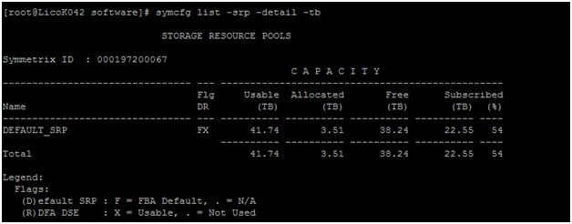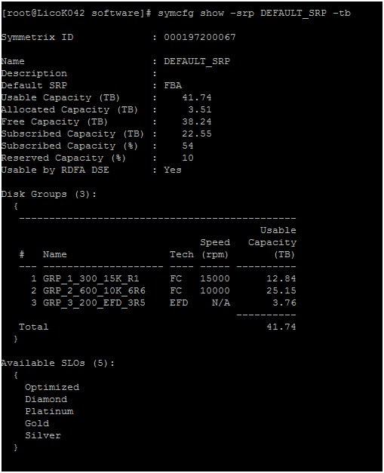
Viewing the Available SLO
symcfg list -slo
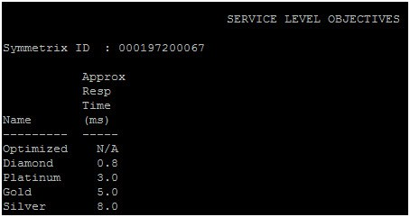
To get a more detailed look at the SLO’s and the workloads that can be associated with storage groups you can run the following command. The output shows the approximate response time for each.
symcfg list –slo –detail –by_resptime –all
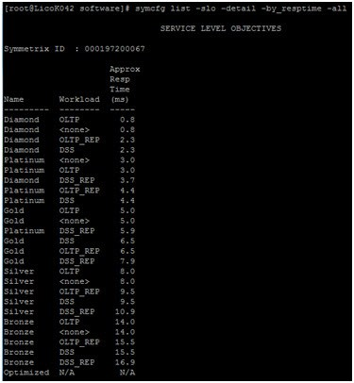
SRP Capacity Consumption
In order to get an idea of how your storage is being consumed from the command line you can run the CMD:
symsg list –srp –demand –type slo
this will show you how your SRP is being consumed by each of the SLO, it will also list how much is consumed by DSE and Snapshot, remember this capacity all comes from your SRP so it’s worth keeping an eye on.
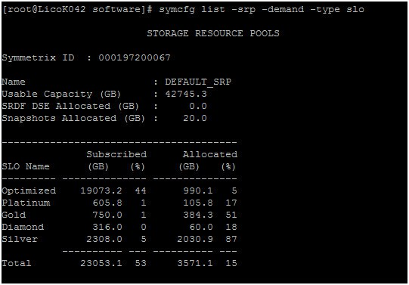
Listing SLO associations by Storage Group
The previous command gives us a good idea at a high level, but if we want to see from a storage group level which storage groups are associated with each SLO we have a command for that too:
Symsg list –by_SLO –detail
this shows each storage group and whether or not it is associated with an SLO, we also get some detail about the number of devices but we don’t see much regarding the capacity.
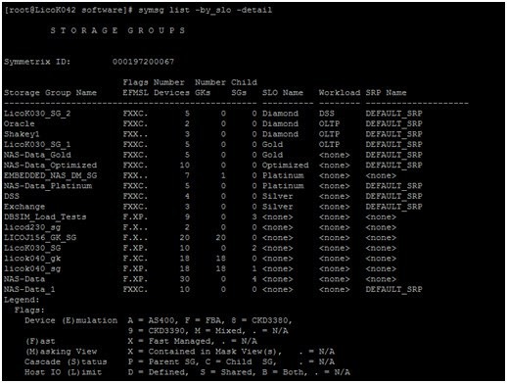
Additionally you can see consumption on an individual device level on the application storage group.
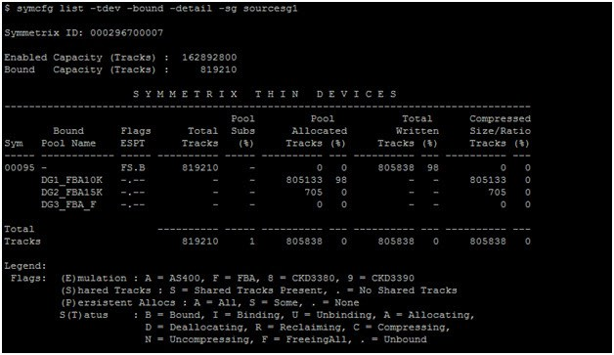
You can see the full breakdown of your SRP including drive pools and which SLO you have available as well as TDAT information. The output below shows all the thin devices (TDEVS) bound to the SRP and how much space they are each consuming.
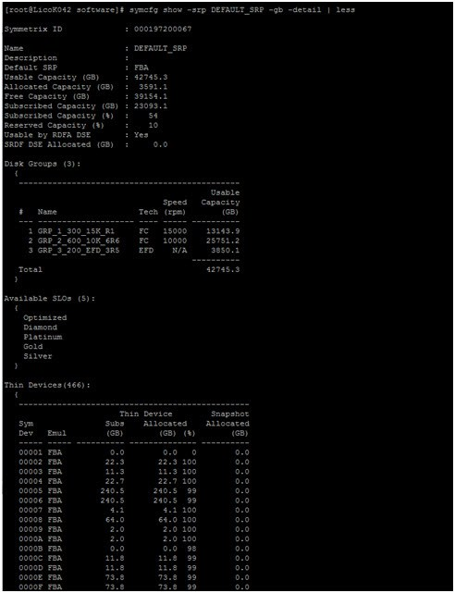
Changing SLO On Existing Storage Groups
Changing Service Level Objective to Platinum and Workload to OLTP_REP for a storage group test:
symsg –sg test -sid 123 set –slo Platinum -wl OLTP_REP
Solutions Enabler 8.X also allows for moving devices between groups non-disruptively
• Moving devices between child storage groups of a parent storage group when the masking view uses the parent group.
• Moving devices between storage groups when a view is on each storage group and both the initiator group (IG) and the port group (PG) elements are common to the views (initiators and ports from the source group must be present in the target).
• Moving devices from a storage group with no masking view or service level to one in a masking view. This is useful as you can now create devices and automatically add to storage group from CLI, so a staging group may exist. Command is:
symsg –test –sid 123 –sg staging_sg move dev 345 gold_sg
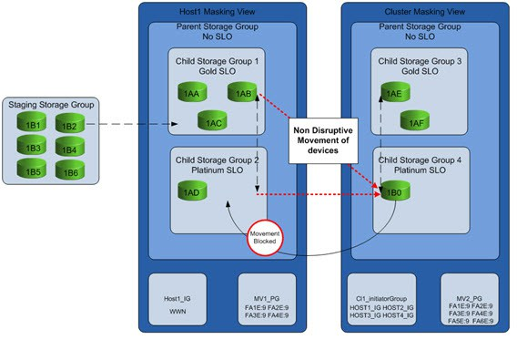
SnapVX – Space efficient Targetless Snapshots
I’m not going to go into the full details of SnapVX and what makes it revolutionary in the VMAX3, we have a very good technote that already covers this in detail. Needless to say, taking snapshots on VMAX3 is quicker, more efficient and easier than it has been on any previous generations. See the technote for full details.
Like most features in the VMAX to access the functionality simply put the word sym in front of the feature name. SnapVX is controlled with the symsnapvx command set. Really the only command you should need is symsnapvx –h, this will get you the full set of options. I’ll highlight a few of the main commands here.
Creating Snapshots
SnapVX is simplest when your storage has been designed with an application per storage group, you can still use device groups or files if you want but VMAX3 supports 64K storage groups, that is enough for one per application in most environments and means only managing a single entity for each application for provisioning as well as local replication and remote replication. You can snap multiple applications together using a cascaded storage group containing all of the child storage groups for each application. SnapVX snapshots are consistent by design so no need to specify any additional flags to obtain a point in time image of a live system.
To create a snapshot simply grab the storagegroup name which contains all the devices for your application and execute the establish command, the example below will create a snapshot hourly snapshot and will automatically terminate the same snapshot 24 hours after it was created:
symsnapvx –sg test–snapshotname hourlysnapshot establish –ttl –delta 1 –nop
You could run the command above in a cron job or batch file every hour and snapvx will create a new generation each time (gen 0).
Listing SnapVX Snapshots And Capacity Consumed
In order to see which storage groups are consuming the most space we can run the following cmd:
symcfg list –srp –demand –type sg
The output lists the storage groups showing their subscribed capacity (how much potential space they can consume) as well as their actual allocated capacity. A Particulary useful output here is the SnapShot Allocated (GB) Column, if you are in a bind for space you can quickly identify which storage group has consumed the most snapshot space and terminate some snapshots to return space to the SRP.
Note your storage group will only show up in this command output if it is FAST managed. Although everything in VMAX3 is under fast control it is possible to create storage groups that are not FAST managed for various use cases. A storage group is FAST managed if you explicitly specify the SRP and or assign an SLO. Shown below SourceSG1 has a large capacity of snapshot allocated storage.
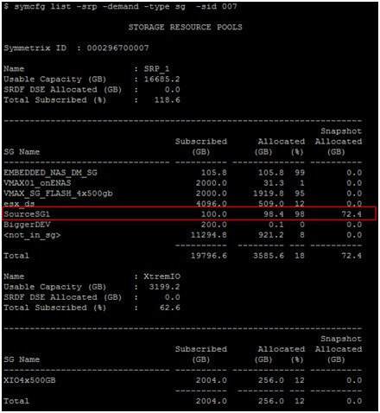
To find out more about your snaps you can run the following cmd:
symsnapvx –sid –sg groupname list –detail
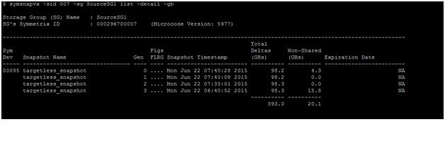
If I want to link off and access a snap I can use a storage group which I have pre-created with the same number of devices as the source/target devices can be same size or larger..
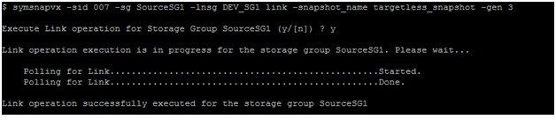
For deeper dive and more on the internals please see the Technote on EMC.com
https://www.emc.com/collateral/technical-documentation/h13697-emc-vmax3-local-replication.pdf
Useful Commands For Everyday Use!:
This information is at your finger tips with symcli -v
SYMCLI BASE Commands:
symapierr- Used to translate SYMAPI error code numbers into SYMAPI error messages.
symaudit – List records from a Symmetrix audit log file.
symbcv – Perform BCV support operations on Symmetrix BCV devices.
symcfg – Discover or display Symmetrix configuration information. Refresh the host’s Symmetrix database file or remove Symmetrix info from the file. Can also be used to view or release a ‘hanging’ Symmetrix exclusive lock.
symchg – Monitor changes to Symmetrix devices or to logical objects stored on Symmetrix devices.
symcli – Provides the version number and a brief description of the commands included in the Symmetrix Command Line
symdev – Perform operations on a device given the device’s Symmetrix name. Can also be used to view Symmetrix device locks.
symdg- Perform operations on a device group (dg).
symdisk – Display information about the disks within a Symmetrix.
symdrv – List DRV devices on a Symmetrix.
symevent – Monitor or inspect the history of events within a Symmetrix.
symhost – Display host configuration information and performance statistics.
syminq – Issues a SCSI Inquiry command on one or all devices. Interface.
symipsec – Administers IPSec encryption on Gigabit Ethernet connections.
symlabel – Perform label support operations on a Symmetrix device.
symlmf – Registers SYMAPI license keys.
sympd- Perform operations on a device given the device’s physical name.
symsg- Perform operations on a storage device group (sg).
symstat – Display statistics information about a Symmetrix, a Director, a device group, or a device.
symreturn- Used for supplying return codes in pre-action and post-action script files.
SYMCLI CONTROL Commands:
symaccess- Administer Symmetrix Access Logix. (Mapping and Masking of devices)
symacl – Administer Symmetrix access control information.
symauth – Administer Symmetrix user authorization information.
symcg- Perform operations on an composite group (cg).
symchksum- Administer checksum checks when an Oracle database writes data files on Symmetrix devices.
symclone – Perform Clone control operations on a device group or on a device within the device group.
symconfigure – Perform modifications on the Symmetrix configuration.
symconnect – Setup or Modify Symmetrix Connection Security functionality.
symfast – Administer Symmetrix FAST (Fully Automated Storage Tiering) policies, associations, and the FAST Controller.
symmask – Setup or Modify Symmetrix Device Masking functionality.(Older Symmetrix Pre 5977)
symmaskdb- Backup, Restore, Initialize or Show the contents of the device masking database. (Older Symmetrix Pre 5977)
symmigrate – Migrates the physical disk space associated with a Symmetrix device to a different data protection scheme, or to disks with different performance characteristics. (VMAX 10K/20K/40K)
symmir – Perform BCV control operations on a device group or on a device within the device group.
symoptmz – Perform Symmetrix Optimizer control operations.
symqos – Perform Quality of Service operations on Symmetrix Devices.
symrcopy – Perform Symmetrix Rcopy control operations on devices in a device file.
symrdf – Perform RDF control operations on a device group or on a device within the device group.
symrecover – Perform automated SRDF session recovery operations.
symreplicate – Perform automated, consistent replication of data given a pre-configured RDF/Timefinder setup.
symsan – List ports and LUNs visible on the SAN
symsnap – Perform Symmetrix Snap control operations on a device group or on devices in a device file.
symsnapvx- Perform Symmetrix Snapvx control operations.
symstar – Perform SRDF STAR management operations.
symtier – Create and manage storage tiers within a Symmetrix.
symtw- Manage time windows for the Optimizer, FAST and FAST VP controller within a Symmetrix. (VMAX 10K/20K/40K)
SYMCLI SRM(Mapping) Commands symhostfs- Display information about a host File, Directory, or host File System.
symioctl – Send IO control commands to a specified application.
symlv- Display information about a volume in Logical Volume Group (vg).
sympart – Display partition information about a host device.
symrdb – Display information about a third-party Relational Database.
symrslv – Display detailed Logical to Physical mapping information about a logical object stored on Symmetrix devices.
symvg- Display information about a Logical Volume Group (vg).
1 Comment

VCE VISION – VMAX Config Notes (EMC SMI-S)
June 19, 2015June 22, 2015 David Ring Vblock, VMAX SMI-S, Vblock, Vision, VMAX
The following are some configuration notes for configuring the ‘VMAX Management HOST’ for communication with ‘VCE Vision’ via SMI-S. Before proceeding ensure you have presented and configured the ‘VMAX Management HOST’ with gatekeeper volumes from the VMAX to allow for in-band communication over Fibre Channel. EMC SMI-S provider is included as part of ‘Solutions Enabler with SMIS’ install package which can be downloaded from ‘support.emc.com’.
Begin by installing SMI-S Provider, ensuring you select the ‘Array provider’ (Windows does not require Host provider) and chose the option for SMISPROVIDER_COMPONENT:
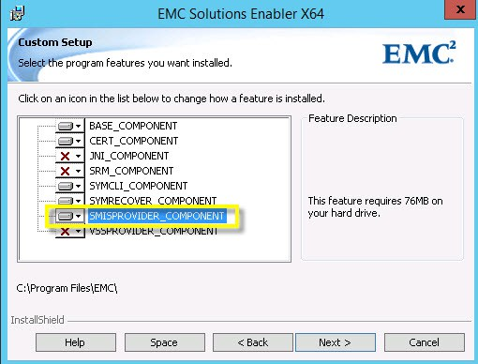
From the windows services.msc console check that both the ‘ECOM’ and ‘storsrvd’ services are set to automatic and in a running state:
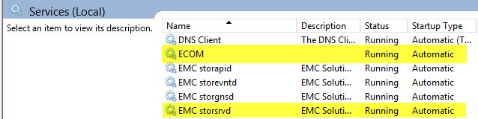
Check that EMC storsrvd daemon is installed and running from a Windows cmd prompt using stordaemon.exe:
stordaemon install storsrvd -autostart
stordaemon start storsrvd
stordaemon.exe list
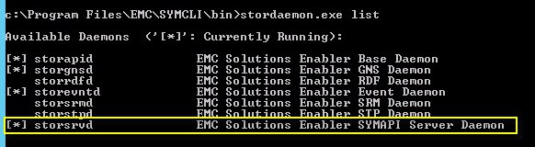
Or using the SC (service control) command you can query/start/config the ECOM and storsrvd services:
sc query ECOM.exe
sc query storsrvd
sc start ECOM.exe
sc start storsrvd
sc config ECOM.exe start=auto
sc config storsrvd start=auto
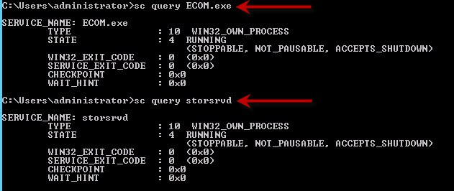
Run netstat -a and check the host is listening on ports 5988 5989:
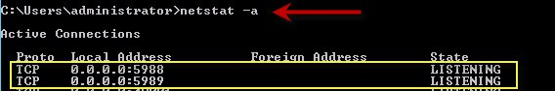
UPDATE ENVIRONMENT VARIABLES:
Add the SYMCLI installation directory path (DRIVE:\Program Files\EMC\ECIM\ECOM\BIN) to the list of system paths:
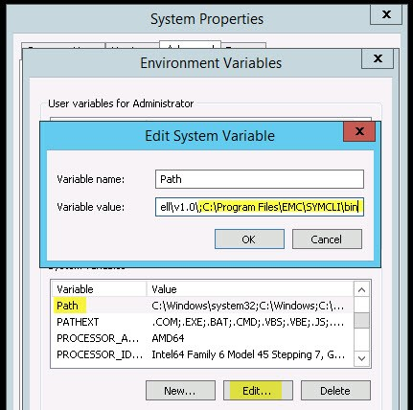
Or use the windows CLI to add the SYMCLI and ECOM directories to the PATH environment variable:
setx /M PATH "%PATH%;C:\Program Files\EMC\SYMCLI\bin;C:\Program Files\EMC\ECIM\ECOM\bin"
Perform a Symcfg Discover followed by Symcfg List to ensure communication is present between the VMAX and the VMAX management server.
If experiencing issues such as the ECOM service failing to start it is worth rebooting the mgmt server at this stage.
ECOM SERVER: ADD A NEW SMI-S Provider User For Vision
Provided all the validations are successful then proceed to login to the ECOM server and create the user you would like to use for Vision connectivity:
Open https://localhost:5989/ecomconfig
Login with default credentials of: admin / #1Password
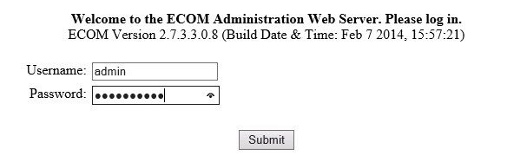
Select the option to add a new user and create the Vision user with administrator role and scope local:
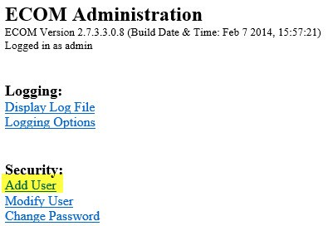
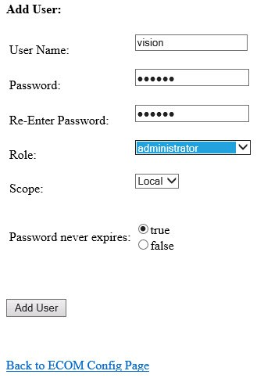
Windows Firewall
If the Windows firewall is enabled then rules will need to be created to allow ECOM ports TCP 5988&5989 and SLP port UDP 427. For example using the windows command line netsh to create rules for SLP and ECOM:
netsh advfirewall firewall add rule name="SLP" dir=in protocol=UDP localport=427 action=allow
netsh advfirewall firewall add rule name="ECOM" dir=in protocol=TCP localport=5988-5989 action=allow
netsh advfirewall firewall show rule name=SLP
netsh advfirewall firewall show rule name=ECOM
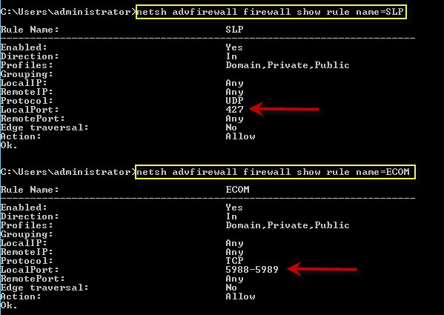
Confirm VMAX Connectivity VIA SMI-S (TestSMIProvider)
Open a Windows cmd prompt session as admin user, if the environment variable has not been set then you will need to ‘cd’ to c:\Program Files\EMC\ECIM\ECOM\BIN. Type TestSMIProvider.exe at the prompt, from here chose all defaults except for the Vision user and password created through the ECOM console:
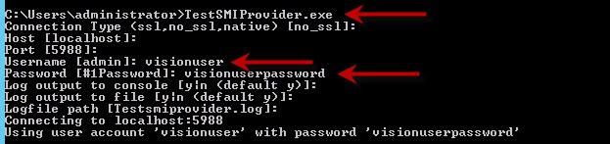
At the prompt type ‘dv’ to confirm connectivity between the VMAX and SMI-S:
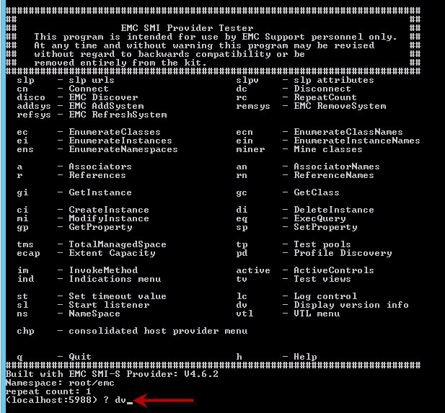
For any troubleshooting please refer to: ‘C:\Program Files\EMC\ECIM\ECOM\log’
Note: When configuring Vision please ensure to use the ‘VMAX Management HOST’ IP address for all VMAX entries in the Vblock.xml configuration file.
Leave a comment

EMC VMAX³ – Front-End FC WWPN’s & Zoning Considerations
March 20, 2015July 13, 2015 David Ring VMAX EMC VMAX³, fabric, Front-End, VMAX, VMAX3, wwn, WWPN, Zoning
Please begin by downloading the attached PDF here.
As you can see this is a fully compiled listing of all 256 possible FC WWPN’s available on a VMAX³ system. A 100K system can cater for a maximum of 64 FC Front-end connections, a 200K has a possible 128 ports, while the flagship 400K can have up to 256 FC Front-end connections.
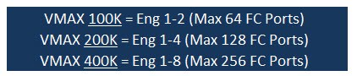
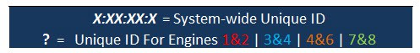
Note: for demonstration purposes I am using X’s and a ? to explain the unique identifiers of a VMAX³ system. Please refer to the .pdf listing to help understand the concept.
X:XX:XX:X = System-wide Unique ID – as you will see from the provided WWPN listing this value is the unique identifier per VMAX³ system (a follow-on post focusing on decoding VMAX³ WWN’s shall explain this further). On a per VMAX³ system the X:XX:XX:X value will remain the same for all FC WWPN’s associated with that VMAX³ system.
There is a notable change from the previous VMAX usage of WWPN’s; there is now a unique identifier labeled as ? this uniquely identifies a pair of engines:
? = Unique ID For Engines 1&2 | 3&4 | 4&6 | 7&8
On previous VMAX generations all the X’s and ? were consistent across all FC Port WWPN’s with only the last 2 hex values of a WWPN acting as the unique port identifier, with the VMAX³ the unique port identifier is now the last three hex values. With VMAX³ the key point to note is the ? value remains the same throughout directors 1-4 then increments by one hex value for the next four directors, for example if C:04 is the unique ID for Director1 Port4 then for Director5 Port4 the C changes to D and remains at this value for directors 5-8 etc; so given this information and referring to the list provided:
Director1 Port4 has a value of 50:00:09:75:58:01:EC:04
Director5 Port4 has a value of 50:00:09:75:58:01:ED:04
Director9 Port4 has a value of 50:00:09:75:58:01:EE:04
Director13 Port4 has a value of 50:00:09:75:58:01:EF:04
There are two choices of FC Font-end I/O Modules to choose from:
• 8 Gbps four-port FC-module (Glacier) Non-Bifurcated, operational at speeds of 2/4/8Gbps, Populated left to right (Slots 2,3,8,9).
• 16 Gbps four-port FC-module(Rainfall) Bifurcated(meaning that the 8 lanes of PCIe are split into 2 connections of 4 lanes each), operational at speeds of 4/8/16Gbps, Populated right to left (Slots 9,8,3,2).
VMAX3 uses PCIe 3.0 thus allowing for maximum available port speeds.
Dual Fabric:One approach for cabling is to connect Even director ports to Fabric-A & Odd director ports connect to Fabric-B. Engine-1 Example:
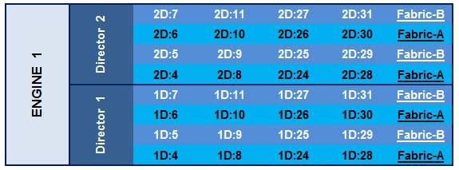
When using this approach in a single engine system the I/O ports from each director evenly span both SAN fabrics.
HOST or Cluster FA Port Usage: in order to ensure a balanced approach is maintained, connect a Host or cluster to 2xDirectors in a Single Engine system or 4xDirectors in a VMAX with greater than 1xEngine.
Single Engine example:Zoning a Host evenly across 2 directors and across both fabrics using ports 1D:4, 1D:31, 2D:28 & 2D:7:
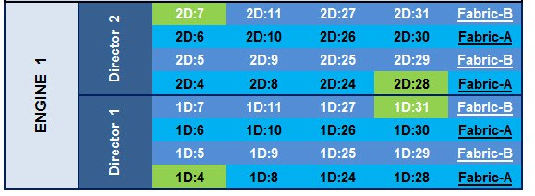
Two Engine example: Zoning a Host or Cluster evenly across 4 directors and across both fabrics using ports 1D:4, 2D:31, 3D:28 & 4D:7, this will spread load for performance and ensure fabric redundancy :
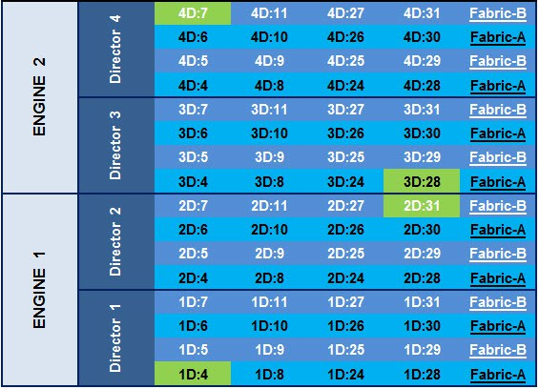
These examples are a guideline for evenly balancing port utilization across all available director ports. See below for additional reading.
VMAX³ ACLX GK: The first physical FA port on the array will have the show ACLX flag set; thus any host attached to that port will be shown the ACLX device as LUN 000.
Hopefully these considerations and lists may assist you with planning (or automating) your zoning scripts for VMAX³ systems.
SYMCLI List all FA WWN’s: symcfg -sid xxx list -fa all -port -detail
Useful References:
VMAX3 Family New Features – A Detailed Review of Open Systems White Paper
http://www.emc.com/collateral/technical-documentation/h13578-vmax3-family-new-features-wp.pdf
VMAX3 Reliability, Availability, and Serviceability Tech Notes
http://www.emc.com/collateral/technical-documentation/h13807-emc-vmax3-reliability-availability-and-serviceability-tech-note.pdf
5 Comments

VMAX VG2/8 – Masking View & Cisco Zoning Script
December 8, 2014April 23, 2015 David Ring VMAX Cisco, masking view, VMAX, VNX VG, Zoning
This post will cover the Masking and Zoning scripts for a VG when using Cisco MDS fabric switches. This post will not cover the creation or rules around the Control volumes, please reference the latest EMC publications for guidelines around quantity and size of the control volumes. The following example configuration applies to ‘VNX File OE 7.1’.
Note: Please reference EMC documentation for precise instructions as this is an example only config for deploying a ‘VNX VG’ with a VMAX.
The following is a list of the celerra control volumes and sizes required for the NAS installation:
• 2 x 12394 cylinders (11.62 GB)
• 3 x 2216 cylinders (2.03 GB)
• 1 x 69912 cylinders (64 GB)
• 1 x 2 cylinder volume for the gatekeeper device
VG Control Volumes and their respective HLU ID’s:
• The two ‘11.62 GB’ control LUNs map to HLU 0 and 1.
• The three ‘2.03 GB’ control LUNs map to HLU 2, 3, and 4.
• The ’64 GB’ control LUN maps to HLU 5.
• 1 x ‘2 cyl’ gatekeeper LUN maps to 0F.
Listing the Control Volumes in order to gather their HEX values:
symdev -sid XXX list -emulation celerra
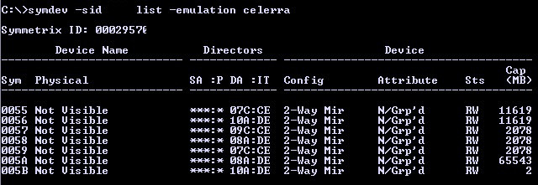
Add -v for a more detailed report:
symdev list -emulation celerra -v
In this example configuration we are using the F:1 ports on Engines 4&5:
#### List the Celerra LUN/ACLX MAPPING TO F1 FA ports: ####
symcfg -sid xxx -dir 7f -p 1 list -addr -avail
symcfg -sid xxx -dir 8f -p 1 list -addr -avail
symcfg -sid xxx -dir 9f -p 1 list -addr -avail
symcfg -sid xxx -dir 10f -p 1 list -addr -avail
1. MASKING VIEW CONFIG
Create the initiator group:
symaccess -sid XXX -name VG_IG -type initiator create -consistent_lun
If you have identified the Xblade WWPN’s from the fabric switches then you may add now, else you can wait until they are displayed by the Control Station during the NAS install:
symaccess -sid XXX -name VG_IG -type initiator -wwn 50060160…… add
symaccess -sid XXX -name VG_IG -type initiator -wwn 50060160…… add
symaccess -sid XXX -name VG_IG -type initiator -wwn 50060160…… add
symaccess -sid XXX -name VG_IG -type initiator -wwn 50060160…… add
Create the port group using the VMAX FA Ports 7f:1,8f:1,9f:1,10f:1:
symaccess -sid XXX -name VG_PG -type port create
symaccess -sid XXX -name VG_PG -type port -dirport 7f:1,8f:1,9f:1,10f:1 add
Note: Ensure the ACLX volume is mapped to these FA ports 7f:1,8f:1,9f:1,10f:1 as 0E.
symdev -sid XXX list -aclx -v provides detailed information for the ACLX volume.
See here for further ACLX details: EMC VMAX – Access Control Logix (ACLX) Gatekeeper Mapping
Create the Storage Group:
Add the Control Devices as listed above (Do not add the gatekeeper volume at this stage to the SG).
symaccess -sid XXX -name VG_SG -type storage create
symaccess -sid XXX -name VG_SG -type storage add devs 0055-005A
Create Masking View:
symaccess -sid XXX create view -name VG_MV -sg VG_SG -pg VG_PG -ig VG_IG -celerra
symaccess -sid XXX show view VG_MV
Now add 1 x 2 cyl Gatekeeper with a HLU value of 0F:
symaccess -sid XXX -name VG_SG -type storage add devs 005B -lun 0f -celerra
Verify the configuration:
symaccess -sid XXX show view VG_MV
symaccess -sid XXX list logins
2. Cisco MDS Zoning
It is good practice to isolate the file traffic on its own dedicated VSAN. In this example VSAN’s 20-Fabric-‘A’ and 21-Fabric-‘B’ are used specifically for the NAS traffic between the VG & VMAX.
Fabric A Zoning
## Collect Interface details: ##
show interface description | grep VMAX40K
fc2/15 VMAX40K_7f1
fc3/19 VMAX40K_9f1
show interface description | grep XBlade
fc1/17 XBlade 2-00/00
fc4/29 XBlade 3-00/00
## VMAX WWNs: ##
show flogi database interface fc 2/15
7f1: 50:00:09:75:00:xx:xx:59
show flogi database interface fc 3/19
9f1: 50:00:09:75:00:xx:xx:61
## XBLADE WWNs: ##
show flogi database interface fc 1/17
XBlade 2: 50:06:01:60:xx:xx:xx:xx
show flogi database interface fc 4/29
XBlade 3: 50:06:01:68:xx:xx:xx:xx
## Configure: ##
conf t
interface fc2/15, fc3/19, fc1/17, fc4/29
no shut
vsan database
vsan 20 name NAS_WORKLOAD_VSAN_A
vsan 20 interface fc2/15, fc3/19, fc1/17, fc4/29
fcdomain domain 1 static vsan 20
fcdomain priority 2 vsan 20
fcdomain restart vsan 20
fcalias name XBlade2-00-00 vsan 20
member pwwn 50:06:01:60:xx:xx:xx:xx
fcalias name XBlade3-00-00 vsan 20
member pwwn 50:06:01:68:xx:xx:xx:xx
fcalias name VMAX40K_7f1 vsan 20
member pwwn 50:00:09:75:00:xx:xx:59
fcalias name VMAX40K_9f1 vsan 20
member pwwn 50:00:09:75:00:xx:xx:61
zone name XBlade2-00-00_to_VMAX-7f-1 vsan 20
member fcalias VMAX40K_7f1
member fcalias XBlade2-00-00
zone name XBlade3-00-00_to_VMAX-9f-1 vsan 20
member fcalias XBlade3-00-00
member fcalias VMAX40K_9f1
zoneset name zs_vsan20 vsan 20
zone name XBlade2-00-00_to_VMAX-7f-1
zone name XBlade3-00-00_to_VMAX-9f-1
zoneset activate name zs_vsan20 vsan 20
zone commit vsan 20
Copy Run Start
show zoneset active vsan 20
Fabric B Zoning
show interface description | grep VMAX40K
fc2/15 VMAX40K_10f1
fc3/19 VMAX40K_8f1
show interface description | grep XBlade
fc1/17 XBlade 2-00/00
fc4/29 XBlade 3-00/00
## VMAX WWNs: ##
show flogi database interface fc 2/15
10f1: 50:00:09:75:00:xx:xx:65
show flogi database interface fc 3/19
8f1: 50:00:09:75:00:xx:xx:5d
## XBLADE WWNs: ##
show flogi database interface fc 1/17
XBlade 2: 50:06:01:61:xx:xx:xx:xx
show flogi database interface fc 4/29
XBlade 3: 50:06:01:69:xx:xx:xx:xx
## Configure: ##
conf t
interface fc2/15, fc3/19, fc1/17, fc4/29
no shut
conf t
vsan database
vsan 21 name NAS_WORKLOAD_VSAN_B
vsan 21 interface fc2/15, fc3/19, fc1/17, fc4/29
fcdomain domain 2 static vsan 21
fcdomain priority 2 vsan 21
fcdomain restart vsan 21
fcalias name XBlade2-00-01 vsan 21
member pwwn 50:06:01:61:xx:xx:xx:xx
fcalias name XBlade3-00-01 vsan 21
member pwwn 50:06:01:69:xx:xx:xx:xx
fcalias name VMAX40K_10f1 vsan 21
member pwwn 50:00:09:75:00:xx:xx:65
fcalias name VMAX40K_8f1 vsan 21
member pwwn 50:00:09:75:00:xx:xx:5d
zone name XBlade2-00-01_to_VMAX-10f-1 vsan 21
member fcalias XBlade2-00-01
member fcalias VMAX40K_10f1
zone name XBlade3-00-01_to_VMAX-8f-1 vsan 21
member fcalias XBlade3-00-01
member fcalias VMAX40K_8f1
zoneset name zs_vsan21 vsan 21
zone name XBlade2-00-01_to_VMAX-10f-1
zone name XBlade3-00-01_to_VMAX-8f-1
zoneset activate name zs_vsan21 vsan 21
zone commit vsan 21
copy run start
show zoneset active vsan 21
NEXT: INSTALL NAS ON CONTROL STATION 0
====================================SUMMARY===================================
Congratulations!! Install for VNX software to release 7.1.76-4 succeeded.
Status: Success
Actual Time Spent: 40 minutes
Total Number of attempts: 1
Log File: /nas/log/install.7.1.76-4.Dec-02-11:54.log
=====================================END=======================================
3. Perform Checks
Verify NAS Services are running:
Login to the Control Station as ‘nasadmin’ and issue the cmd /nas/sbin/getreason from the CS console. The reason code output should be as follows (see detailed list of Reason Codes below):
10 - slot_0 primary control station
11 - slot_1 secondary control station
5 - slot_2 contacted
5 - slot_3 contacted
Check the status of the DATA Movers and view which slot is active:
nas_server -info -all
Confirm the VMAX is connected to the VG:
nas_storage -check -all
nas_storage -list
List detailed information of the config:
/nas/bin/nas_storage –info –all
Code Levels:
List the datamovers: nas_server -list
Check the DART code installed on the Data Movers: server_version ALL
Check the NAS code installed on the Control Station: nas_version
Network Configuration:
Control Station: /sbin/ifconfig (eth3 is the mgmt interface)
Data Movers: server_ifconfig server_2 -all
Date & Time:
Control Station: date
Data Movers: server_date ALL
List the disk table to ensure all of the Control Volumes have been presented to both Data Movers:
nas_disk -list
Check the File Systems:
df -h
Confirm the EMC NAS version installed and the model name:
/nasmcd/bin/nas_version
/nas/sbin/model
Check IP & DNS info on the CS:
nas_cs -info
Log Files:
Log file location: /var/log/messages
Example of NAS services starting successfully:
grep -A10 “Starting NAS services” /var/log/messages*
Output:
Dec 8 19:07:27 emcnas_i0 S95nas: Starting NAS services
Dec 8 19:07:46 emcnas_i0 EMCServer: nas_mcd: MCD will monitor CS IPMI connection.
Dec 8 19:08:46 emcnas_i0 EMCServer: nas_mcd: slot 0 missed 10 heartbeats from slot 1.
Dec 8 19:08:50 emcnas_i0 EMCServer: nas_mcd: Install Manager is running on slot 0, skipping slot 1 reboot
Dec 8 19:08:50 emcnas_i0 EMCServer: nas_mcd: Slot 0 becomes primary due to timeout
Dec 8 19:08:52 emcnas_i0 mcd_helper: All NBS devices are up
Dec 8 19:09:08 emcnas_i0 kernel: kjournald starting. Commit interval 5 seconds
Check the Data Mover Logs:
server_log server_2
Complete a Health Check:
/nas/bin/nas_checkup
Failing over a Control Station:
Failover:
/nas/sbin/./cs_standby -failover
Takeover:
/nasmcd/sbin/./cs_standby -takeover
Or reboot:
nas_cs –reboot
Determine the failover status of the Blades (Datamovers):
/nas/bin/nas_server -info –all
Initiate a manual failover of server_2 to the standby Datamover:
server_standby server_2 -activate mover
List the status of the Datamover’s:
nas_server -list
Review the information for server_2:
nas_server -info server_2
Shutdown Datamover (blade):
/nas/bin/server_cpu server_2 -halt now
Power on the Datamover (blade):
/nasmcd/sbin/t2reset pwron -s 2
Restore the original primary Datamover:
server_standby server_2 -restore mover
VG Shutdown:
Shutdown Control Stations and DATA Movers:
/nasmcd/sbin/nas_halt -f now
List of Reason Codes:
0 – Reset (or unknown state)
1 – DOS boot phase, BIOS check, boot sequence
2 – SIB POST failures (that is, hardware failures)
3 – DART is loaded on Data Mover, DOS boot and execution of boot.bat, boot.cfg.
4 – DART is ready on Data Mover, running, and MAC threads started.
5 – DART is in contact with Control Station box monitor.
6 – Control Station is ready, but is not running NAS service.
7 – DART is in panic state.
9 – DART reboot is pending or in halted state.
10 – Primary Control Station reason code
11 – Secondary Control Station reason code
13 – DART panicked and completed memory dump (single Data Mover configurations only, same as code 7, but done with dump)
14 – This reason code can be set for the Blade for any of the following:
• Data Mover enclosure-ID was not found at boot time
• Data Mover’s local network interface MAC address is different from MAC address in configuration file
• Data Mover’s serial number is different from serial number in configuration file
• Data Mover was PXE booted with install configuration
• SLIC IO Module configuration mismatch (Foxglove systems)
15 – Data Mover is flashing firmware. DART is flashing BIOS and/or POST firmware. Data Mover cannot be reset.
17 – Data Mover Hardware fault detected
18 – DM Memory Test Failure. BIOS detected memory error
19 – DM POST Test Failure. General POST error
20 – DM POST NVRAM test failure. Invalid NVRAM content error (checksum, WWN, etc.)
21 – DM POST invalid peer Data Mover type
22 – DM POST invalid Data Mover part number
23 – DM POST Fibre Channel test failure. Error in blade Fibre connection (controller, Fibre discovery, etc.)
24 – DM POST network test failure. Error in Ethernet controller
25 – DM T2NET Error. Unable to get blade reason code due to management switch problems.
Leave a comment

EMC VMAX – Identify Failed Drive Location
September 22, 2014September 22, 2014 David Ring VMAX DISK, DRIVE, FAILED, IDENTIFY, LOCATION, VMAX
In order to understand this Post fully, I would advise you read “EMC VMAX – 20/40K Back-End Connectivity” first.
Having completed a VMAX ‘Health Check’ through ‘Unisphere’ it has been highlighted that a drive has failed:
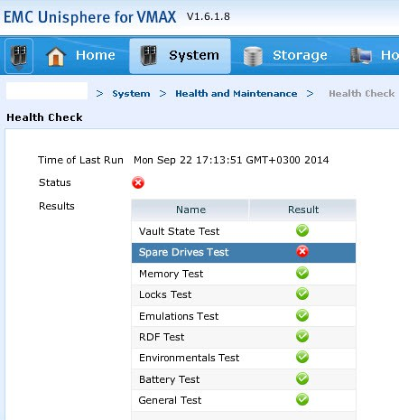
Running the command symdisk list -failed will display the details of the failed disk (-v for more detail):
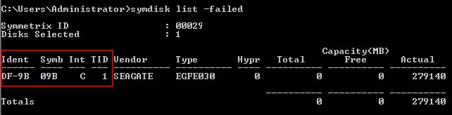
You can also check if the failed disk has been spared out by issuing the command symdisk list -isspare:
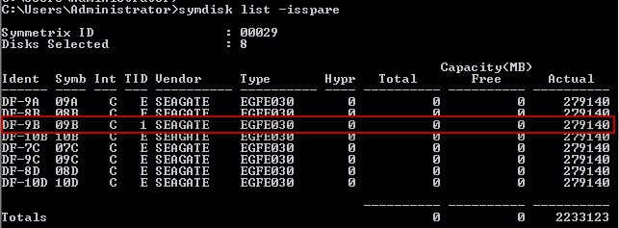
Determining the Drive Location based on the information provided:
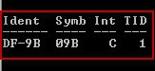
‘Ident/Symb’ = ‘9B’ identifies the Director and the MOD that the drive is connected to at the Back-End. Thus we can gather at this stage that the drive is connected to Director 9 (Engine5).
On both directors of Engine5(9&10) there are two Back-End IO modules (MOD0 & MOD1) per director, MOD0 has connections A0,A1,B0,B1 and MOD1 has connections C0,C1,D0,D1. MOD0 on both the even and odd directors connect to DAE’s 9,13,10,14 with MOD1 on both directors connecting to DAE’s 11,15,12,16. The 8 Redundant Loops on Engine5 connect up as follows:
DAE9=LOOP0 (A0)
DAE10=LOOP2 (B0)
DAE11=LOOP4 (C0)
DAE12=LOOP6 (D0)
DAE13=LOOP1 (A1)
DAE14=LOOP3 (B1)
DAE15=LOOP5 (C1)
DAE16=LOOP7 (D1)
‘Int’ = ‘C’ stands for interface, this is the port used on the MOD.
C = Port 0
D = Port 1
Thus far we can determine that the Drive is located on LOOP2 (9B 0).
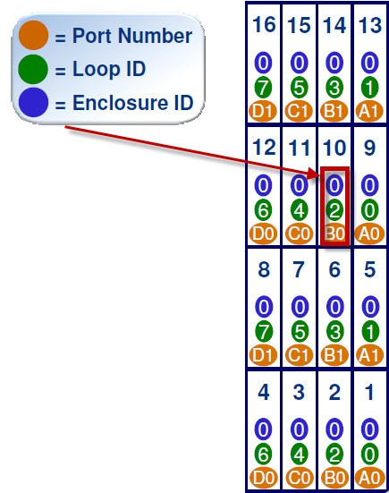
‘TID’ = ‘1’ refers to the target ID, or the disk location on the Loop.
From all this information we can determine that the location of the Failed drive (‘9B 0 1’) is ‘Drive Bay-1A, DAE-10, Disk-01’:
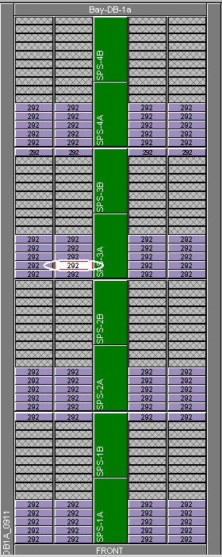
If you have access to SymmWin then you can Toggle the disk LED: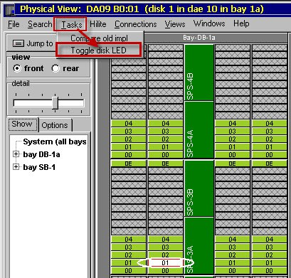
Leave a comment

EMC VMAX – Disk Group & Pool Expansion
September 17, 2014September 24, 2014 David Ring VMAX Disk Group, EMC, Expansion, HYPER, POOL, TDAT, VMAX
In order to expand a VMAX Thin Pool we must first create the additional Data Devices (TDATs) on the underlying physical Disk Group. This example outlines how to calculate and create those TDAT devices and then expand the Thin Pool with the newly created TDATs.
Scenario:
A Disk Group that consisted of 64 X 600GB disk drives has been increased to 128 X 600GB Drives. EMC will be required to create and apply an upgrade BIN in order to expand the existing DG to 128 Disks, once this has been completed we can then proceed with the TDAT configuration.
After gathering the details with respect to the existing Hyper and TDAT sizes, then we can do a quick calculation in order to determine the count and size of the TDATs required (In this case the configuration is a simple replica of the existing configuration).
Calculating the Hyper Size
If we take the scenario above where a 64 Drive DG has been doubled to 128 Drives, with each of the first 64 drives in the DG having 8 Hypers per disk in a RAID 5 (3+1) configuration.
Listing the existing TDATs within Disk Group 1:
symdev list -disk_group 1 -datadev
From the output of this command we can see that the TDAT size is 206130MB, from this we can calculate the Hyper size used:
206130/3
=68710 MB Hyper Size
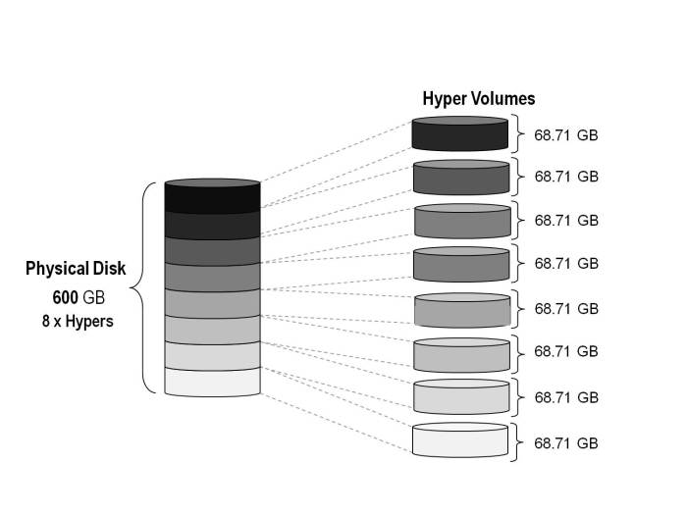
Calculating the number of TDATs Required
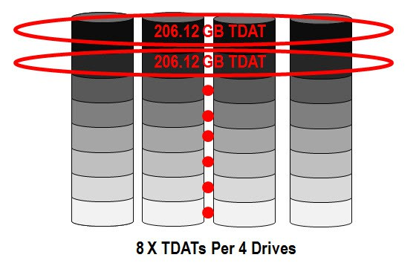
From the image above you can gather that for each set of 4 Drives (Raid5 3+1) we require a total of 8 x TDATs.
8 Hypers * 64 Disks
=512 Hypers
=512/4 (R5 3+1)
=128 TDATs
Creating the New TDATs
Creating the new 128 x TDATs required on the newly added 64 Disks:
symconfigure –sid xxx –cmd “create dev count=128, config=Raid-5, data_member_count=3, attribute=datadev, emulation=FBA, size=206130 mb, disk_group=1;” Preview -nop
symconfigure –sid xxx –cmd “create dev count=128, config=Raid-5, data_member_count=3, attribute=datadev, emulation=FBA, size=206130 mb, disk_group=1;” Commit -nop
New TDAT Range Returned = 1177:11F6
List the new TDAT range created:
symdev list -datadev -disk_group 1 -nonpooled
Adding the new TDATs to the Thin Pool
Adding and enabling the new TDATs to the existing pool and thus essentially doubling the capacity of the Pool:
symconfigure -sid xxx -cmd “add dev 1177:11F6 to pool ‘Pool-Name’ type=thin, member_state=enable;” Preview -nop
symconfigure -sid xxx -cmd “add dev 1177:11F6 to pool ‘Pool-Name’ type=thin, member_state=enable;” Commit -nop
Rebalance the Pool
This command will rebalance the allocated extents in the Thin Pool nondisruptively across all of the enabled data devices in the pool. Automated pool rebalancing should be run whenever new data devices are added to a pool.
symconfigure -sid xxx -cmd “start balancing on pool ‘Pool-Name’ type=thin;” commit -nop
Check on the rebalancing progress:
symcfg -sid xxx -pool ‘Pool-Name’ verify -poolState -balancing
Display a detailed report of the expanded Pool
symcfg show -pool ‘Pool-Name’ -thin -detail -all -mb | more
The pool now consists of 256 TDATs (or 1024 Hypers!)
4 Comments

Post navigation
← Older posts

EMC Symmetrix VMAX – Masking Views for VMware ESX Boot & Shared Cluster VMFS Volumes
March 13, 2013February 10, 2015 David Ring Vblock, VMAX EMC, esx, ESXi, initiator group, masking view, port group, storage group, Symmetrix, Vblock, VMAX
This script is a result of having to create quite a large number of dedicated Masking views for VMware ESX 5.x server boot volumes and Masking Views for shared vmfs datastore clusters. In this example I will create two dedicated ESX server MV’s and one Cluster Masking View consisting of the two ESX Hosts sharing a VMFS datastore.
Each VMware ESX server boots from a SAN-attached boot volume presented from the VMAX array. As an example the boot LUNs are 20GB devices which are configured from a dedicated RAID5 3+1 disk group:
symconfigure -sid xxx -cmd “create dev count=2, config=Raid-5, data_member_count=3, emulation=FBA, size=20GB, disk_group=1;” COMMIT
List the newly created devices:
symdev -sid xxx list -disk_group 1
If you wish to confirm that a device has not already been assigned to a host:
symaccess -sid xx list assignment -dev xxx
Or if you need to check a series of devices:
symaccess -sid xxx list assignment -dev xxx:xxx
“symaccess” command performs all Auto-provisioning functions. Using the symaccess command we will create a port group, initiator group and a storage group for each VMware ESX host and combine these newly created groups into a Masking View.
Port Group Configuration
1. Create the Port Group that will be used for the two hosts:
symaccess -sid xxx -name ESX-Cluster-PG -type port create
2. Add FA ports to the port group; in this example we will add ports from Directors 8&9 From Engines 4&5 8e:0,9e:0:
symaccess -sid xxx -name ESX-Cluster-PG -type port -dirport 8e:0,9e:0 add
Note on Port Groups: Where possible to achieve best performance and availability hosts should be mapped to two or more Front-End ports on directors. If you have multiple engines then spread across engines and directors – Rule 17 (20/40K). Please see post: EMC VMAX 10K Zoning with Cisco MDS Switches
Check that the Host HBAs are logging in:
symaccess -sid xxx list logins -dirport 8e:0
symaccess -sid xxx list logins -dirport 9e:0
Host ESX01 Masking View Configuration
1. Create the Initiator Group for ESX01:
symaccess -sid xxx -name ESX01_ig -type initiator create -consistent_lun
2. Add the ESX Initiator HBA WWNs to the Initiator Group:
symaccess -sid xxx -name ESX01_ig -type initiator -wwn wwn_A add
symaccess -sid xxx -name ESX01_ig -type initiator -wwn wwn_B add
3. Create the Storage Group for the first ESX host Boot volume:
symaccess –sid xxx -name ESX01_sg -type storage create
4. Add the Symmetrix boot volume device to the Storage Group:
symaccess -sid xxx -name ESX01_sg -type storage add devs ####
5. Create the Masking View:
symaccess -sid xxx create view -name ESX01_mv -sg ESX01_sg -pg ESX-Cluster-PG -ig ESX01_ig
Host ESX02 Masking View Configuration
1. symaccess -sid xxx -name ESX02_ig -type initiator create -consistent_lun
2. symaccess -sid xxx -name ESX02_ig -type initiator -wwn wwn_A add
symaccess -sid xxx -name ESX02_ig -type initiator -wwn wwn_B add
3. symaccess -sid xxx -name ESX02_sg -type storage create
4. symaccess -sid xxx -name ESX02_sg -type storage add devs ####
5. symaccess -sid xxx create view -name ESX02_mv -sg ESX02_sg -pg ESX-Cluster-PG -ig ESX02_ig
Configuration of Cluster1 (ESX01,ESX02) with shared VMFS Datastore
1. We begin by cascading the cluster hosts into a single Initiator Group:
symaccess -sid xxx -name Cluster1_IG -type initiator create -consistent_lun
symaccess -sid xxx -name Cluster1_IG -type initiator -ig ESX01_ig add
symaccess -sid xxx -name Cluster1_IG -type initiator -ig ESX02_ig add
2. Create the Storage Group containing the shared Datastore(s):
symaccess -sid xxx -name Cluster1_SG -type storage create
4. Add the Symmetrix shared Datastore(s) device(s):
symaccess -sid xxx -name Cluster1_SG -type storage add devs ####(:####)
5. The Port Group contains the director Front-End ports zoned to the ESX Hosts (As per the PG created above):
symaccess -sid xxx -name ESX-Cluster-PG -type port create
symaccess -sid xxx -name ESX-Cluster-PG -type port -dirport 8e:0,9e:0 add
6. The Masking View for the entire ESX cluster:
symaccess -sid xxx create view -name Cluster1_MV -sg Cluster1_SG -pg ESX-Cluster-PG -ig Cluster1_IG
View Configuration Details
To view the configuration of the groups PG,IG,SG and MV (use -v for more detail):
symaccess -sid xxx list -type storage|port|initiator -v
symaccess -sid xxx list -type storage|port|initiator -name group_name
symaccess -sid xxx show group_name -type storage|port|initiator
symaccess -sid xxx list view -v
symaccess -sid xxx list view -name view_name
symaccess -sid xxx list view -name view_name -detail
symaccess -sid xxx list assignment -dev DevID
Examples:
symaccess -sid xxx list -type port (Lists all exisiting port group names)
symaccess -sid xxx show ESX-Cluster-PG -type port
symaccess -sid xxx list -type port -dirport 8e:0 (Lists all port groups that a particular director port belongs to)
symaccess -sid xxx show -type initiator Cluster1_IG -detail
symaccess -sid xxx list logins -wwn xxxx (Verify that wwn xxx is logged in to the FAs)
symaccess -sid xxx list -type initiator -wwn xxxx(Verify that the HBA is a member of the correct Initiator Group)
symaccess -sid xxx show Cluster1_SG -type storage
symaccess -sid xxx show view Cluster1_MV
symaccess -sid xxx list assignment -dev XXXX (Shows the masking details of devices)
Verify BOOT|DATA LUN Assignment to FA Port(s) (LUN To PORT GROUP Assignment):
symaccess -sid xxx list assignment -devs ####
symaccess -sid xxx list assignment -devs ####:####
Backup Masking View to File
The masking information can then be backed up to a file using the following command:
symaccess -sid xxx backup -file backupFileName
The backup file can then be used to retrieve and restore group and masking information.
The SYMAPI database file can be found in the Solutions enabler directory: for example “D:\Program Files\EMC\SYMAPI\db\symapi_db.bin” if you wish to confirm the SE install location quickly then issue the following registry query cmd:
reg.exe query “HKEY_LOCAL_MACHINE\SOFTWARE\EMC\EMC Solutions Enabler” /v InstallPath
Note: On the VMAX Service Processor the masking information is automatically backed up every 24 hours by the Scheduler. The file (accessDB.bin) is saved to O:\EMC\S/N\public\user\backup.
Restore Masking View from File
To restore the masking information to Symmetrix enter the following command:
symaccess -sid xxx restore -file backupFileName
4 Comments

Search for: 

@DavidCRing
My Tweets

Top Posts & Pages
- EMC RecoverPoint Architecture and Basic Concepts
- EMC VMAX - Removal Of A TDEV
- EMC VMAX3 - CLI Cheat Sheet

Categories
Categories 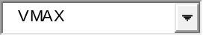

Archives
Archives 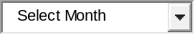

David Ring
- Vblock – Advanced Management Pod Second Generation (AMP-2) August 6, 2015 David Ring
- EMC VNXe – Shutdown Procedure July 21, 2015 David Ring
- EMC XtremIO – 4.0 Maximums July 14, 2015 David Ring
Blog at WordPress.com. | The Big Brother Theme.
David Ring
Blog at WordPress.com. The Big Brother Theme.
Follow

Follow “David Ring”

Get every new post delivered to your Inbox.
Join 1,305 other followers
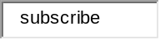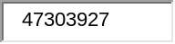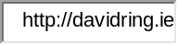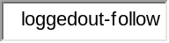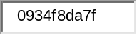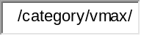


Build a website with WordPress.com

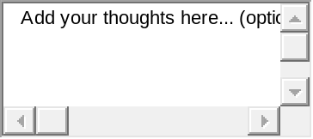Post to 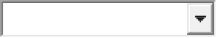
Cancel 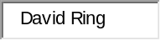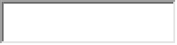
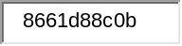

<img src="http://pixel.wp.com/b.gif?v=noscript" style="height:0px;width:0px;overflow:hidden" alt="" />

