GNAST CONFIGURATION GUIDE

For

Storage Resource Manager 3.5.1

Network Service

Template Version: 2.0.5

Document Version#: 1.0

October 08, 2014



Disclaimer
If printed, content is valid only for the day it was printed. Always refer to the online document for the current version. If the user elects to maintain copies of this procedure, it is their responsibility to verify the currency of the document by checking it against the online version. This document must be promptly removed from use when obsolete.

Table of Contents
1 Document Purpose 5
2 Owner of Standard 5
3 Intended Audience 5
4 Principles 5
4.1 Revision History 5
4.2 Key Feature Changes and Bug Fixes 6
4.3 Known Issues 6
5 References 7
6 Scope 8
7 Installation & Configuration Instructions 8
7.1 SRM 3.5.1 New Installation 8
7.2 Pre-Requisites 8
7.3 Installation Sequence 10
7.4 SRM 3.5.1 Installing a Backend 10
7.4.1 SRM Software Installation 10
7.4.2 Additional software 11
7.4.3 Post Backend Installation Configuration 11
7.5 Installing an Additional Backend 12
7.5.1 Additional software 14
7.5.2 Post Backend Installation Configuration 14
7.6 SRM 3.5.1 Installing a Frontend 16
7.6.1 Frontend Base Installation 16
7.6.2 Additional software 17
7.6.3 Post Base Installation Configuration 17
7.7 SRM 3.5.1 Installing a Collector 22
7.7.1 Linux Collector Base installation 22
7.7.2 Additional software 23
7.7.3 Post Base Installation Configuration 23
7.7.4 Windows(Centera) Collector Base installation 24
7.7.5 Additional Software 24
7.7.6 Post Base Installation Configuration 24
Final Configuration 29
7.7.7 Registering components 29
7.7.8 Installing SRM Licenses 29
7.7.9 Including Citi Banner Message 29
7.7.10 Including Citi Logo 29
7.7.11 Web Server Certificates 29
7.7.12 Webservice Certificate 30
7.7.13 Configuring AD Group Authentication and Role Authorization 30
7.8 Deploying Solutions Packs 31
7.8.1 EMC M&R Health 31
7.8.2 EMC VMAX Solutions Pack 31
7.8.3 EMC VNX Solutions Pack 32
7.8.4 EMC XTremIO Solutions Pack 34
7.8.5 EMC Centera Solutions Pack 34
7.8.6 Hitachi Device Manager Solutions Pack 35
7.8.7 IBM XIV Solutions Pack 36
7.8.8 NetApp Filer Solutions Pack 37
7.8.9 Cisco MDS/Nexus Switch Solutions Pack 37
7.8.10 Physical Hosts Solutions Pack 38
7.8.11 VMware vCenter Solutions Pack 38
7.8.12 Oracle Database Solutions Pack 39
7.8.13 Microsoft SQL Server Solutions Pack 40
7.9 Physical Host Monitoring 40
7.9.1 Linux 41
7.9.2 Solaris 41
7.9.3 AIX 42
8 Configuration Assurance 42
9 Global Standard 42
10 Glossary/Definition 43
11 Appendix 44
11.1 Appendix A – Pre-Requisites for SRM Solution Packs 44
11.2 Appendix C - Solutions Enabler Proxy Connection 46
11.3 Appendix D - Configuring Roles in SRM 48
11.4 Appendix E – Linux ACL configuration 50
11.5 Appendix F - Configuring Users in SRM 51
11.6 Appendix G - Integrating with Active Directory for Authentication 51
11.7 Appendix H - Integrating with Active Directory for Authorization 53
11.8 Appendix I - Modifying the Webservice Password 54
11.9 Appendix J - Including Citi Banner Message 55
11.10 Appendix K - Changing the MySQL Password 56
11.11 Appendix L - Installing the Licenses 58
11.12 Appendix M - ELMS license reference 58
11.13 Appendix N – Citi Logo 58
11.14 Sudo Compiling and Automation 58
11.14.1 Solaris compiling 58
11.14.2 AIX compiling 59
11.14.3 Automation 59

Disclaimer
If printed, content is valid only for the day it was printed. Always refer to the online document for the current version. If the user elects to maintain copies of this procedure, it is their responsibility to verify the currency of the document by checking it against the online version. This document must be promptly removed from use when obsolete.

Note: The purpose of this template is to develop the basis for the eventual convergence of various existing GNAST Configuration Guides and Templates as well as the current Secure Build Configuration Checklist (SBCC) into one GNAST Configuration Template. This is a work in progress.

In most cases, this template can be used as a “pointer” to more widely used configuration guides and SBCC documents. In other cases, it might make sense to use this template and expand as needed.

Document Purpose
This document provides detailed installation and configuration instructions for use by all operational and regional engineering teams for Storage Resource Manager deployment within Citi global environment, to ensure adherence to configuration, support, and management standards as well as compliance to Citigroup Information Security Standards.

Owner of Standard
GNAST (Global Network Architecture and Standards Team) is the owner of this standard and the related documents. CATE (Citi Architecture & Technology Engineering) is the custodial organization. CitiNetwork & CitiStorage Platform Engineering technologists will drive and generate content.

Intended Audience
The intended audience is CitiNetwork & CitiStorage Engineering, Global and Regional Operations and Engineering personnel responsible for designing, building, supporting, and managing Citi corporate network environments.

Principles

Revision History

Document Version:
A first generation document that hasn’t been ratified before is a 0.0 (less than 1.0) during its revision cycle. When adopted it is a 1.0 version. Subsequent generations follow the same method of incrementing the decimal portion of the version number until ratified, then increment the integer.

Version | Description | Date | Author/Organization
0.9 | Initial GNAST Standard | 05-22-2014 | Ali Shakir/Colin Bradley
0.10 | Multiple sections update | 5-28-2014 | Bin Zhou
1.0 | Final Document, Updated after dry run | 06-05-2014 | Colin Bradley
1.1 | Updated to reflect certification of 3.5.1 |  | Colin Bradley

Key Feature Changes and Bug Fixes
The following issues have been addressed in the 3.5.1 certification:

 | Description | Fix Type
 | Civa Finding H1 - Unsupported / Legacy System | Java(TM) SE Runtime Environment (build 1.7.0_51-b13)
 | Civa M1 - Sensitive information obtained | Configuration Change
 | Property Store Database enforcing HTTP | Bug Fix Jira ticket 5519- 5522
 | Topology database not being populated | Bug Fix Jira 1829
 | Windows Discovery Requires admin priv | Enhancement
 | Unable to encrypt server.xml passwords | Enhancement
 | VMAX requires StorageAdmin privilege | Enhancement in SE 7.6.2.8 to support non-admin discovery
 | Winrm URLPrefix=”wsciti” | Enhancement
 | No timeout on discovery scripts for ssh | BugG Fix Jira ticket 5536
 | Chargeback Report inaccurate | Bug Fix
 | XTremIO historical Performance Chart rescaling issue | Fix to modify report provided by EMC
 | VNX Heatmap does not select any data | Fix to modify report provided by EMC
 | Oracle XMLDB dependency | Enhancement
 | Windows 2003 collector stops | Bug Fix Ticket EMP-1423.

Known Issues
The following table lists the known issues in this release.

 | XtremIO Discovery Issue with AD accounts | Fix scheduled to be in future XIO firmware release. Temporary workaround with local accounts available.
 | There is an issue with the XtremIO Performance dashboard whereby changing the time range over which to display the performance metrics does not take effect in the dashboard display. | EMC has provided a workaround. Please refer to the Test Plan results Document.
 | XIV Collector potential for collections to timeout if there are connectivity issues with the XIV management IP addresses. | A product enhancement has been raised with EMC. No ETA.
 | XIV Discovery issue with AD accounts | Fix scheduled to be in future XIV firmware release. CATE has provided a temporary workaround
 | HDS Performance Metrics not being displayed | CATE are investigating the use of the HDS Device Manager agent to collect these metrics.
 | LDAP integration issue with SRM Roles. | SRM fixed planned for SRM 4.0 release
 | NetApp discovery requires admin level privileges | No planned fix. CATE and EMC are investigating a number of different options for gathering the data securely.
 | Possible infinite wait for ssh script-engine | EMC Engineering ticket is opened to address this Trac-11452.
 | Windows host winRM message encryption over HTTP is not supported | Expected to be fixed in 4.0 release
 | Property Store Database enforcing HTTP from Cisco MDS solution pack | EMC SR#65645170
 | SRM has feature to simulate/test user access and this allows an SRM security admin to commit actions on behalf of another user. This feature cannot be disabled | Expected to be fixed in 4.0 release

References
Document Name | Location | Owner
GNAST Requirements Test Plan Results - EMC SRM | https://catecollaboration.citigroup.net/domains/networks/tools/emcstorageresourcemgmt/GNAST%20Requirements%20Test%20Plan%20Results%20-%20EMC%20SRM.doc | CATE
EMC ViPR SRM Data Collection Impact | https://catecollaboration.citigroup.net/domains/networks/tools/emcstorageresourcemgmt/EMC%20ViPR%20SRM%20Data%20Collection%20Impact%20-V5.1.pdf | EMC
ViPR SRM 3.5.1 Release Notes | https://catecollaboration.citigroup.net/domains/networks/tools/emcstorageresourcemgmt/docu55067_ViPR-SRM-3.5-SP1-Release-Notes.pdf | EMC
Cisco Solutions Pack Metrics | https://catecollaboration.citigroup.net/domains/networks/tools/emcstorageresourcemgmt/Field%20Mapper%20Cisco.vsd | CATE
HDS Solutions Pack Metrics | https://catecollaboration.citigroup.net/domains/networks/tools/emcstorageresourcemgmt/hiCommandFieldMapper.vsd
Isilion Solutions Pack Metrics | https://catecollaboration.citigroup.net/domains/networks/tools/emcstorageresourcemgmt/Field%20Mapper%20Isilion.vsd | CATE
VMAX Solutions Pack Metrics | https://catecollaboration.citigroup.net/domains/networks/tools/emcstorageresourcemgmt/Field%20Mapper%20VMAX.vsd | CATE
VMware Solutions Pack Metrics | https://catecollaboration.citigroup.net/domains/networks/tools/emcstorageresourcemgmt/Field%20Mapper%20VMware.vsd | CATE
VNX Block Solutions Pack Metrics | https://catecollaboration.citigroup.net/domains/networks/tools/emcstorageresourcemgmt/Field%20Mapper%20VNX.vsd | CATE
VNX File Solutions Pack Metrics | https://catecollaboration.citigroup.net/domains/networks/tools/emcstorageresourcemgmt/Field%20Mapper%20VNX%20File.vsd | CATE

Scope
Storage Resource Manager (SRM) will be deployed in the Citi Regional Data Centers across the globe. SRM Front-End and Back-End components will be deployed in SWDC and MWDC as well as in EMEA and ASPAC. SRM collectors will be deployed in all regional data centers including SWDC, MWDC, GTDC, QRDC, 390 Greenwich, Rutherford, and Ofallon.

Installation & Configuration Instructions
The SRM application has 3 distinct components, the installation and configuration of which are covered in this section. These components are:

- Backend
- Collector
- Frontend

For simplicity this section will provide instruction on a net new SRM installation and also instruction on the installation and configuration of any one of the items bulleted above.

SRM 3.5.1 New Installation

Pre-Requisites
Prior to beginning the installation the following pre-requisites need to be met:

- Prepare a spreadsheet or checklist that lists all server name/IP address for Frontend, Backend, Linux collector and Windows collector.
- SRM licenses
  - Note: Please see Appendix B for acquiring SRM license from EMC
- Active Directory
  - Non-Interactive Functional ID with basic privileges.
  - Certificate .crt and .pem files from the AD/LDAP server.
  - Active Directory groups for each distinct role in SRM (**Note please refer to Known Issues)
- All servers must be SOE build with proper OS loaded.
CATE is supporting SRM 3.5.1 on the following operating systems:
  - Linux RHEL 6.x 64-bit
  - Windows Server 2008 R2 (For Centera Collector Only)

- Windows Group Policy Object (GPO)
- An OU “SRMServers” should be created under OU “Servers” if it doesn’t exist.
- All SRM Windows servers are member of “SRMServers”
- GPO similar to the following already exists and linked to linked to “SRMServers:
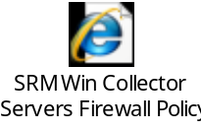
**Note: Please see Appendix A for Pre-Requisites for SRM Solution Packs
- Host Discovery - Pre-Reqs
Unix SRMhost package must be deployed to monitored host.

- Individual Solution Pack pre-requisites are included in the Appendices.
  - EMC VMAX
  - EMC VNX
  - EMC Centera
  - IBM XIV
  - Hi-Comand HDS
  - EMC XTremIO
  - Cisco MDS
  - Oracle Database

Installation Sequence
Recommending the following the following installation sequence:

  - Primary Backend
  - Additional Backend/DBs
  - Frontend
  - Collector(Linux and/or Windows)

SRM 3.5.1 Installing a Backend
Please follow this procedure for SRM Backend Base installation.

APG-Backend(s) | JDBC-Drivers | MySQL
Sun-JRE | License-Manager | Module-Manager
MySQL-Maintenance-Tool | Webservice-Gateway
Table 1: Components Installed

SRM Software Installation

- Ensure you have root privileges on the server
- Download ViPR_SRM_3.5.1_Linux_x86_64.tgz from xxx to /tmp on the target host.
- Change the permissions of the setup file:
  - chmod +x EMC_MnR_6.4.1_Linux_64-bit_Setup_File.sh
- From the directory where the setup file is located run the install:
  - ./EMC_MnR_6.4.1_Linux_64-bit_Setup_File.sh
- You will be presented with licensing agreement. Please hit the space bar until you receive the message below and answer y to accept.
  - Do you accept EULA [y/N] ? y
- Accept the default install directory by hitting return.
  - Enter the new or current installation directory [/opt/APG]:
- Confirm the installation directory by entering y and return.
  - Install in /opt/APG [Y/n] ?
- Accept the creation of the default user account by hitting return. The default user is “apg”.
  - Enter the user account we should create and use [apg]:
- Hit return to accept the service scripts directory.
  - Enter the service scripts directory [/etc/init.d]:
- You will be presented with a choice of what type of installation you wish to carry out. This will depend on the architecture design of the deployment and the purpose of the server in that architecture. See below.
  - Proceed with [b]ackend, [c]ollector, [D]efault, [f]rontend, or [m]inimal installation?

- Select b – for backend.
- Start the core services:
  - /opt/APG/bin/manage-modules service start all
- Validate that the services have started
  - /opt/APG/bin/manage-modules service status all

Additional software

HPNA client package

- Install hpna_client-0.3-1.x86_64.rpm

Post Backend Installation Configuration

/etc/security/limits.conf
- Update or add, if the following entries do not present in /etc/security/limits.conf

apg hard nofile 65534
apg soft nofile 65534
apg hard nproc 65534
apg soft nproc 65534

- Save the change and exit.

Linux ACL
- Refer to Appendix C for configuring the ACL list

HPNA client
- Create sudoer configuration for hpnaro
- cd /etc/sudoers.d
- visudo –f hpnaro-sudo
- type the following and then save:
- hpnaro ALL=(root) NOPASSWD:/sbin/iptables –L

File permission change
- As required by Citi information Security Standards the permissions on the following files needs to be changed to 600: <chmod 600 <filename>>

/opt/APG/Tools/Webservice-Gateway/Default/conf/module.properties
/opt/APG/Backends/APG-Backend/Default/conf/mysql.xml
/opt/APG/Tools/Topology/Default/conf/topology-refresh-config.xml
/opt/APG/Tools/MySQL-Maintenance-Tool/Default/conf/mysql-root-apg.xml
/opt/APG/Tools/MySQL-Maintenance-Tool/Default/conf/mysql-root-mysql.xml
/opt/APG/Tools/MySQL-Maintenance-Tool/Default/conf/mysql.xml

Webservice-Gateway Password
- As required by Citi information Security Standards the Webservice-Gateway password needs to be changed and encrypted.
- /opt/APG/bin/crypt-password.sh “Welcome1”
- Edit /opt/APG/Tools/Webservice-Gateway/Default/conf/users
- Replace “changeme” with appropriate encrypted password

Granting DB access
- The following steps assume “watch4net” is the root password for MySQL. Use appropriate value to replace watch4net during deployment. Also replace FEServer with actual frontend server FQDN
- Execute /opt/APG/bin/mysql-client.sh
- Input the following info: username: root, database: apg, password: watch4net
- At mysql> prompt
mysql> GRANT ALL PRIVILEGES ON apg.* to 'apg'@'FEServer' identified by 'watch4net';
mysql> GRANT ALL PRIVILEGES ON master.* to 'apg'@'FEServer' identified by 'watch4net';
mysql> GRANT ALL PRIVILEGES ON topology.* to 'apg'@'FEServer' identified by 'watch4net';
mysql> GRANT ALL PRIVILEGES ON events.* to 'apg'@'FEServer'' identified by 'watch4net';
mysql> GRANT ALL PRIVILEGES ON compliance.* to 'apg'@'FEServer' identified by 'watch4net';
mysql> flush privileges;

Changing the MYSQL database passwords
In line with Citigroup Security policies the SRM MYSQL database password must be changed and encrypted on all servers in the SRM infrastructure. This must be done on each backend database in the SRM environment.

**NOTE: The database will be unavailable for the time period while the passwords are being updated.

Appendix K Changing the MySQL Password

Installing an Additional Backend
- Ensure you have root privileges on the server
- Download ViPR_SRM_3.5.1_Linux_x86_64.tgz from xxx to /tmp on the target host.
- Change the permissions of the setup file:
  - chmod +x EMC_MnR_6.4.1_Linux_64-bit_Setup_File.sh
- From the directory where the setup file is located run the install:
  - ./EMC_MnR_6.4.1_Linux_64-bit_Setup_File.sh
- You will be presented with licensing agreement. Please hit the space bar until you receive the message below and answer y to accept.
  - Do you accept EULA [y/N] ? y
- Accept the default install directory by hitting return.
  - Enter the new or current installation directory [/opt/APG]:
- Confirm the installation directory by entering y and return.
  - Install in /opt/APG [Y/n] ?
- Accept the creation of the default user account by hitting return. The default user is “apg”.
  - Enter the user account we should create and use [apg]:
- Hit return to accept the service scripts directory.
  - Enter the service scripts directory [/etc/init.d]:
- You will be presented with a choice of what type of installation you wish to carry out. This will depend on the architecture design of the deployment and the purpose of the server in that architecture. See below.
  - Proceed with [b]ackend, [c]ollector, [D]efault, [f]rontend, or [m]inimal installation?

- Select m – for minimal.
- Install the mysql and task-scheduler modules by running the following commands:
  - /opt/APG/bin/manage-modules install myssql Default
  - /opt/APG/bin/manage-modules install task-scheduler Default
- Configure MySQL:
  - Start the MySQL service
    - /opt/APG/bin/manage-modules service start mysql Default
  - Create four new databases with names apg1, apg2, apg3 and apg4 by running the following command 4 times.
    - /opt/APG/bin/mysql-command-runner.sh –c /opt/APG/Tools/MySQL_Maintenance-Tool/Default/conf/mysql-root-mysql.xml –Q “create database apg1”;
**Note replace apg1, with apg2, apg3 and apg4 for each iteration of he command.
- Register the new apg databases to the APG backend server by running the following command for each of the apg databases. (Answer yes to each of the questions):
  - /opt/APG/bin/manage-modules.sh install backend apg[1..n]
- Install the maintenance tool for each new backend by running the following command for each apg database. (Responding with yes to the questions).
- /opt/APG/bin/manage-modules.sh install mysql-maintenance-tool apg[1..n]
- To allow remote access to the MySQL database run the following command for each host in this ViPR SRM installation:
    - /opt/APG/bin/mysql-command-runner.sh –c /opt/APGTolls/MySQL-Maintenance-Tool/Default/conf/mysql-root-mysql.xml –Q “GRANT ALL PRIVILEGES ON *.* TO apg@< HOST NAME> IDENTIFIED BY PASSWORD ‘watch4net’”
- Reconfigure the JDBS connections of the new backends: 6.
  - Find all of the XML files in the /opt/APG/Backends/APG-Backend/apg[1..n] folders that contains JDBS connection URLs.
    - For example …localhost:53306/apg
  - Update the URLs to include the correct APG database numbers.
    - For example …localhost:53306/apg[1..n]
  - To complete this step with a script (for Linux), run the following command:

find /opt/APG/Backends/APG-Backend/apg[1..n] -name '*.xml' | xargs sed -i "s|jdbc:mysql://localhost:53306/apg|\\0[1..n]|"

- The Telnet interface port for each new apg database must be different. The default port is 2001. To change the port numbers, edit the following files and set the port numbers to 2[1..n]01
  - /opt/APG/Backends/APG-Backend/apg[1..n]/conf/telnetinterface.xml
- The socket interface port for each new apg database must be different. The default port is 2000.
  - To change the port numbers, edit the following file and set the port numbers to 2[1..n]00
/opt/APG/Backends/APG-Backend/apg[1..n]/conf/socketinterface.xml

- Point the MySQL maintenance tools to the new local databases by editing the 9. following files and replacing “apg” with the correct names (like apg1).
  - /opt/APG/Tools/MySQL-Maintenance-Tool/apg[1..n]/conf/mysql.xml
  - /opt/APG/Tools/MySQL-Maintenance-Tool/apg[1..n]/conf/mysql-root-apg.xml
- To complete this step with a script (for Linux):
  - find /opt/APG/Tools/MySQL-Maintenance-Tool/apg[1..n] -name '*.xml' | xargs sed -i "s|jdbc:mysql://localhost:53306/apg|\\0[1..n]|"
- Start the backend:
  - /opt/APG/bin/manage-modules service start all

Additional software

HPNA client package

- Install hpna_client-0.3-1.x86_64.rpm

Post Backend Installation Configuration

/etc/security/limits.conf
- Update or add, if the following entries do not present in /etc/security/limits.conf

apg hard nofile 65534
apg soft nofile 65534
apg hard nproc 65534
apg soft nproc 65534

- Save the change and exit.

Linux ACL
- Refer to Appendix C for configuring the ACL list

HPNA client
- Create sudoer configuration for hpnaro
- cd /etc/sudoers.d
- visudo –f hpnaro-sudo
- type the following and then save:
- hpnaro ALL=(root) NOPASSWD:/sbin/iptables –L

File permission change
- As required by Citi information Security Standards the permissions on the following files needs to be changed to 600: <chmod 600 <filename>>

/opt/APG/Tools/Webservice-Gateway/Default/conf/module.properties
/opt/APG/Backends/APG-Backend/Default/conf/mysql.xml
/opt/APG/Tools/Topology/Default/conf/topology-refresh-config.xml
/opt/APG/Tools/MySQL-Maintenance-Tool/Default/conf/mysql-root-apg.xml
/opt/APG/Tools/MySQL-Maintenance-Tool/Default/conf/mysql-root-mysql.xml
/opt/APG/Tools/MySQL-Maintenance-Tool/Default/conf/mysql.xml

Webservice-Gateway Password
- As required by Citi information Security Standards the Webservice-Gateway password needs to be changed and encrypted.
- /opt/APG/bin/crypt-password.sh “Welcome1”
- Edit /opt/APG/Tools/Webservice-Gateway/Default/conf/users
- Replace “changeme” with appropriate encrypted password

Changing the MYSQL database passwords
In line with Citigroup Security policies the SRM MYSQL database password must be changed and encrypted on all servers in the SRM infrastructure. This must be done on each backend database in the SRM environment.

**NOTE: The database will be unavailable for the time period while the passwords are being updated.

Appendix K Changing the MySQL Password

SRM 3.5.1 Installing a Frontend
Please follow this procedure for SRM Frontend Base installation.

The following components will be installed.

APG-Diagnostic-Tools | APG-Frontend | APG-Property-Store
APG-Web-Service | Administration-Tool | Alerting-Frontend
Centralized-Management | Compliance-Frontend | Device-Discovery
Formulas | Frontend-Search | Frontend-Report-Generator
JDBC-Drivers | License-Manager | Maps-Service
MIB-Browser | Module-Manager | SolutionPack modules
Sun-JRE | Task-Scheduler | Tomcat
WebApps-Resources | Webservice-Gateway
Table 3: Components Installed

Frontend Base Installation

- Ensure you have root privileges on the server
- Download ViPR_SRM_3.5.1_Linux_x86_64.tgz from xxx to /tmp on the target host.
- Change the permissions of the setup file:
  - chmod +x EMC_MnR_6.4.1_Linux_64-bit_Setup_File.sh
- From the directory where the setup file is located run the install:
  - ./EMC_MnR_6.4.1_Linux_64-bit_Setup_File.sh
- You will be presented with licensing agreement. Please hit the space bar until you receive the message below and answer y to accept.
  - Do you accept EULA [y/N] ? y
- Accept the default install directory by hitting return.
  - Enter the new or current installation directory [/opt/APG]:
- Confirm the installation directory by entering y and return.
  - Install in /opt/APG [Y/n] ?
- Accept the creation of the default user account by hitting return. The default user is “apg”.
  - Enter the user account we should create and use [apg]:
- Hit return to accept the service scripts directory.
  - Enter the service scripts directory [/etc/init.d]:
- You will be presented with a choice of what type of installation you wish to carry out. This will depend on the architecture design of the deployment and the purpose of the server in that architecture. See below.
  - Proceed with [b]ackend, [c]ollector, [D]efault, [f]rontend, or [m]inimal installation?

- Select f – for frontend.
- Start the core services:
  - /opt/APG/bin/manage-modules service start all
- Validate that the services have started
  - /opt/APG/bin/manage-modules service status all

Additional software

HPNA client package

- Install hpna_client-0.3-1.x86_64.rpm

Post Base Installation Configuration

/etc/security/limits.conf
- Update or add, if the following entries do not present in /etc/security/limits.conf

apg hard nofile 65534
apg soft nofile 65534
apg hard nproc 65534
apg soft nproc 65534

- Save the change and exit.

Linux ACL
- Refer to Appendix E for configuring the ACL list

HPNA client
- Create sudoer configuration for hpnaro
  - cd /etc/sudoers.d
  - visudo –f hpnaro-sudo
  - type the following and then save:
  - hpnaro ALL=(root) NOPASSWD:/sbin/iptables –L

File permission change
- As required by Citi information Security Standards the permissions on the following files needs to be changed to 600: <chmod 600 <filename>>

/opt/APG/Tools/Webservice-Gateway/Default/conf/module.properties
/opt/APG/Web-Servers/Tomcat/Default/conf/server.xml
/opt/APG/Tools/Frontend-Search/Default/conf/frontend-search.xml
/opt/APG/Web-Servers/Tomcat/Default/conf/Catalina/localhost/alerting-frontend.xml

Server.xml
- Edit /opt/APG/Web-Servers/Tomcat/Default/conf/server.xml file.
Ensure you take a backup of the file before editing.

- SSL
Make the following edits to the server.xml file, to disable unsecured communications via http. Include the GREEN highlighted items.

<!—
<Connector port="58080" protocol="HTTP/1.1"
connectionTimeout="20000"
compression="off" compressableMimeType="text/"
redirectPort="58443" URIEncoding="UTF-8" /> -->

- Make the following edits to the server.xml file, to enable secured communications via https. Remove items in RED and include items in GREEN.

<!--
<Connector port="58443" protocol="HTTP/1.1" SSLEnabled="true"
maxThreads="150" scheme="https" secure="true"
keystoreFile="conf/keystore" keystorePass="changeit"
compression="off" compressableMimeType="text/" ciphers=" TLS_RSA_WITH_AES_128_CBC_SHA,TLS_DHE_RSA_WITH_AES_128_CBC_SHA,TLS_DHE_DSS_WITH_AES_128_CBC_SHA,SSL_RSA_WITH_RC4_128_SHA "
clientAuth="false" sslProtocol="TLS" URIEncoding="UTF-8" /> -->
- Database
- Replace the localhost from the following blocks with PRIMARY Backend server name.

<!-- Defines the connection to the master database for MySQL. -->
url="jdbc:mysql://PrimaryBE:53306/master?autoReconnect=true"
APG timeseries database
url="jdbc:mysql:// PrimaryBE:53306/apg?autoReconnect=true"
<!-- Defines the connection to the topology database for MySQL. -->
url="jdbc:mysql:// PrimaryBE:53306/ topology?autoReconnect=true "
<!-- Defines the connections to the APG Event database for MySQL. -->
url="jdbc:mysql:// PrimaryBE:53306/events?autoReconnect=true" />
<!-- Defines the connections to the APG Compliance database for MySQL. -->
url="jdbc:mysql:// PrimaryBE:53306/compliance?autoReconnect=true&amp;tinyInt1isBit=false" />

APG.xml
- Edit /opt/APG/Web-Servers/Tomcat/Default/conf/Catalina/localhost/APG.xml
Ensure you take a backup of the file before editing.

Replace “localhost” with PRIMARY Backend server name, Add additional lines with proper server name if additional Database(s) are deployed.

Under Resource name="mgmt/APG-DB"
url="https://PRIMARYBE:48443/Backends/APG-Backend/Default
Encrypted Password
Replace “changeme” with appropriate encrypted password

alerting-frontend.xml
- Edit /opt/APG/Web-Servers/Tomcat/Default/conf/Catalina/localhost/alerting-frontend.xml
Ensure you take a backup of the file before editing.

Under <!-- Alerting Properties --> Replace locahost with Primary Backend server name
Append additional timeseries DBs, if they are deployed, after APG-DB.

frontend-search.xml
- Edit /opt/APG/Tools/Frontend-Search/Default/conf/frontend-search.xml
Ensure you take a backup of the file before editing.

Under <master>
Replace localhost with PRIMARY Backend
url="jdbc:mysql://PRIMARYBE:53306/master?autoReconnect=true"
Replace “watch4net” with appropriate encrypted password
Under <apgr>
Replace localhost with PRIMARY Backend
url="jdbc:mysql:// PRIMARYBE:53306/apg?autoReconnect=true"
Replace “watch4net” with appropriate encrypted password
Repeat and append this procedure for additional timeseries DB deployed.

report-generation-config.xml
- Edit /opt/APG/Tools/Frontend-Report-Generator/Default/conf/report-generation-config.xml
Ensure you take a backup of the file before editing.

Under <master>
Replace localhost with PRIMARY Backend
url="jdbc:mysql:// PRIMARYBE:53306/master?autoReconnect=true"
Replace “watch4net” with appropriate encrypted password
Under <database>
Replace localhost with PRIMARY Backend
url="jdbc:mysql://PRIMARYBE:53306/apg?autoReconnect=true"
Replace “watch4net” with appropriate encrypted password
repeat and append this procedure if additional DBs are deployed
Under <topology>
Replace localhost with PRIMARY Backend
url="jdbc:mysql:// PRIMARYBE:53306/topology?autoReconnect=true"
Replace “watch4net” with appropriate encrypted password
Under <alerting>
Replace localhost with PRIMARY Backend
url="service:jmx:rmi:///jndi/rmi:// PRIMARYBE:52569/jmxrmi"
Replace “changeme” with appropriate encrypted password

master-accessor-service-conf.xml
- Edit /opt/APG/Tools/Administration-Tool/Default/conf/master-accessor-service-conf.xml
Ensure you take a backup of the file before editing.

Under <master-database>
Replace localhost with PRIMARY Backend
url="jdbc:mysql:// PRIMARYBE:53306/master?autoReconnect=true"
Replace “watch4net” with appropriate encrypted password

maps-service.properties
- Edit /opt/APG/Tools/Maps-Service/Default/conf/maps-service.properties
Ensure you take a backup of the file before editing.

Under “Base URL”
Replace localhost with PRIMARY Backend
topoSvc.baseFeedUrl=http:// PRIMARYBE:58083/topology/
Under “URL for SPARQL endpoint”
Replace localhost with PRIMARY Backend
topoSvc.endpointUrl=http:// PRIMARYBE:58083/topology/repository/sparql

APG-WS.xml
**NOTE: Only if additional DBs are deployed.
Ensure you take a backup of the file before editing.

- Edit /opt/APG/Web-Servers/Tomcat/Default/conf/Catalina/localhost/APG-WS.xml
  - Append additional timeseries database if additional databases are deployed.

centralized-management.xml
**NOTE: Only if additional DBs are deployed.
- Edit /opt/APG/Web-Servers/Tomcat/Default/conf/Catalina/localhost/centralized-management.xml
Ensure you take a backup of the file before editing.
  - Append additional timeseries database if additional databases are deployed.

Webservice-Gateway Password
- As required by Citi information Security Standards the Webservice-Gateway password needs to be changed and encrypted.
**NOTE the crypt-password utility is only available on the backend servers.
- /opt/APG/bin/crypt-password.sh “Welcome1”
- Edit /opt/APG/Tools/Webservice-Gateway/Default/conf/users
- Replace “changeme” with appropriate encrypted password

Web.xml
- The following 2 files require 2 edits listed below:

/opt/APG/Web-Servers/Tomcat/Default/webapps/APG/WEB-INF/web.xml
/opt/APG/Web-Servers/Tomcat/Default/webapps/centralized-management/WEB-INF/web.xml

- Ensure you take a backup of the files before editing:

    - Replace: <session-timeout>240</session-timeout>
    - with <session-timeout>30</session-timeout>

  - To comply with Citi Security standards please make the following edit to both Web.xml files.
    - Search for “error-page” and insert the following highlighted section.

<error-page>
<error-code>403</error-code>
<location>/info/403</location>
</error-page>
<error-page>
<error-code>404</error-code>
<location>/info/404</location>
</error-page>
<error-page>
<error-code>500</error-code>
<location>/info/500</location>
</error-page>

Restart all services
- All configurations file edits are completed. The services must be restarted before you can successfully access SRM console.
  - /opt/APG/bin/manage–modules.sh service restart all

SRM 3.5.1 Installing a Collector
Please follow this procedure for SRM Linux Collector and/or Windows (Centera) Collector.

APG-Diagnostic-Tools | Device-Discovery | Generic-RSC
Generic-SNMP | JDBC-Drivers | License-Manager
Module-Manager | Sun-JRE | Tomcat
Topology-Mapping-Service | WebApps-Resources | Webservice-Gateway
Table 2: Components Installed

Linux Collector Base installation
- Ensure you have root privileges on the server
- Download ViPR_SRM_3.5.1_Linux_x86_64.tgz from xxx to /tmp on the target host.
- Change the permissions of the setup file:
  - chmod +x EMC_MnR_6.4.1_Linux_64-bit_Setup_File.sh
- From the directory where the setup file is located run the install:
  - ./EMC_MnR_6.4.1_Linux_64-bit_Setup_File.sh
- You will be presented with licensing agreement. Please hit the space bar until you receive the message below and answer y to accept.
  - Do you accept EULA [y/N] ? y
- Accept the default install directory by hitting return.
  - Enter the new or current installation directory [/opt/APG]:
- Confirm the installation directory by entering y and return.
  - Install in /opt/APG [Y/n] ?
- Accept the creation of the default user account by hitting return. The default user is “apg”.
  - Enter the user account we should create and use [apg]:
- Hit return to accept the service scripts directory.
  - Enter the service scripts directory [/etc/init.d]:
- You will be presented with a choice of what type of installation you wish to carry out. This will depend on the architecture design of the deployment and the purpose of the server in that architecture. See below.
  - Proceed with [b]ackend, [c]ollector, [D]efault, [f]rontend, or [m]inimal installation?

- Select c – for collector.
- Start the core services:
  - /opt/APG/bin/manage-modules service start all
- Validate that the services have started
  - /opt/APG/bin/manage-modules service status all

Additional software

HPNA client package

- Install hpna_client-0.3-1.x86_64.rpm

Post Base Installation Configuration

/etc/security/limits.conf
- Update or add, if the following entries do not present in /etc/security/limits.conf

apg hard nofile 65534
apg soft nofile 65534
apg hard nproc 65534
apg soft nproc 65534

- Save the change and exit.

Linux ACL
- Refer to Appendix E for configuring the ACL list

HPNA client
- Create sudoer configuration for hpnaro

- cd /etc/sudoers.d
- visudo –f hpnaro-sudo
- type the following and then save:
- hpnaro ALL=(root) NOPASSWD:/sbin/iptables –L

File permission change
- As required by Citi information Security Standards the permissions on the following files needs to be changed to 600: <chmod 600 <filename>>

/opt/APG/Tools/Webservice-Gateway/Default/conf/module.properties

Webservice-Gateway Password
- As required by Citi information Security Standards the Webservice-Gateway password needs to be changed and encrypted.

**NOTE the crypt-password utility is only available on the backend servers.
- /opt/APG/bin/crypt-password.sh “Welcome1”
- Edit /opt/APG/Tools/Webservice-Gateway/Default/conf/users
- Replace “changeme” with appropriate encrypted password

Windows(Centera) Collector Base installation
- Ensure you have administrator privileges on the server
- Download ViPR_SRM_3.5.1_Win64.zip from xxx to a temp location on the target host.
- Extract the binaries from the zip file.
- Double click EMC_MnR_6.4.1_Windows_64-bit_Setup_File.exe to begin the installation.
- Click “Next” on the Welcome screen to proceed to the licensing screen.
- Click I Agree on the licensing screen.
- Change Install Location to c:\apps_srv\APG, Click “Next”.
- From Choose Component window, select “Collector Modules”, click install
- After installation completes, start the services:
  - <SRM_Root>\APG\bin\manage-modules.cmd service start all
- Validate that the services have started:
  - <SRM_Root>\APG\bin\manage-modules.cmd service status all

Additional Software

CenteraView 4.2
*Note: if Centera viewer has already been installed as a pre-requisite then skip this step.
- Download CenteraView 4.2 from distribution server and install.

Tectia ssh
- Applying tpm package CITI_WIN_TECTIASSHSERVER_638_00.

Post Base Installation Configuration

Windows Host Firewall
- Creating firewall “SRMWebserviceGW” block rule
- Gpedit.msc->computer Configuration -> Windows Settings -> Security Settings -> Windows Firewall with Advanced Security-> Windows Firewall with Advanced Security -> Inbound Rules
- From right Pane, right click and select “New Rule”
- Select Rule Type “Port”
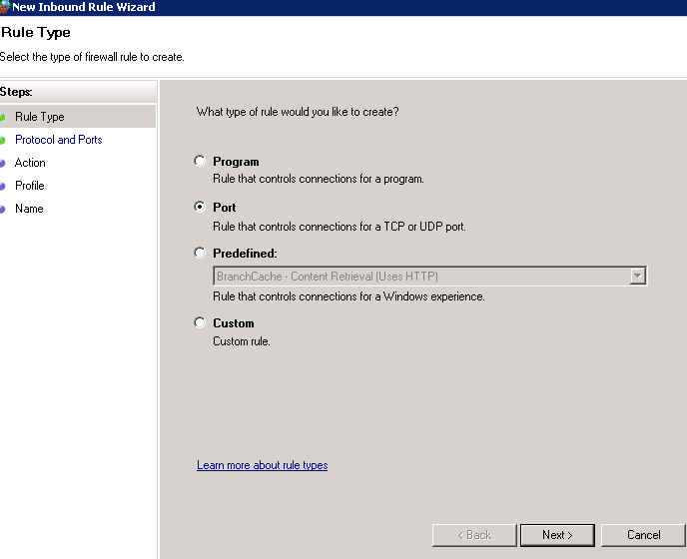
- From Protocol and Port, leave TCP in place and type 48443 in local ports
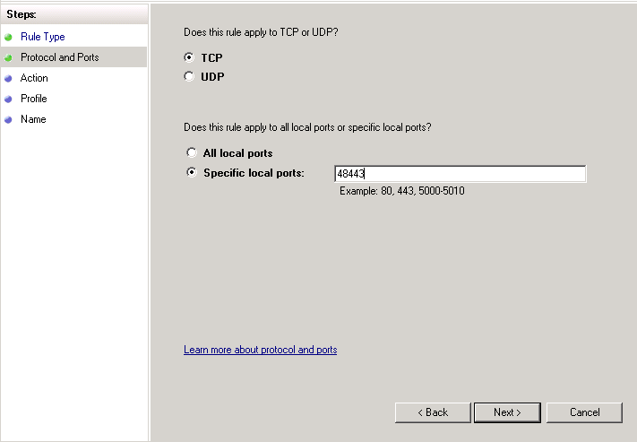
- Select Block the connection from Action windowrom Action window
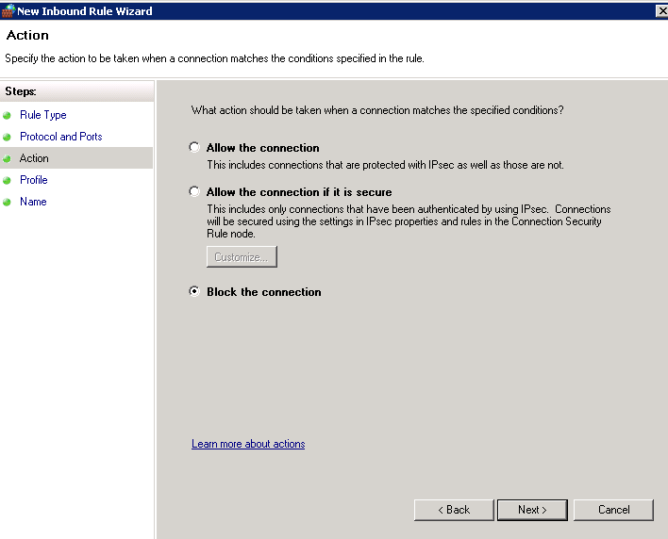
- From Profile window, leave the default as all checked
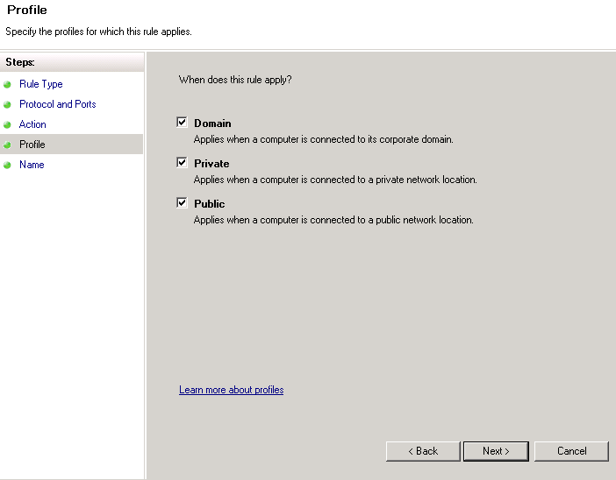
- From Name window, type SRMWebserviceGW-block, then click Finish
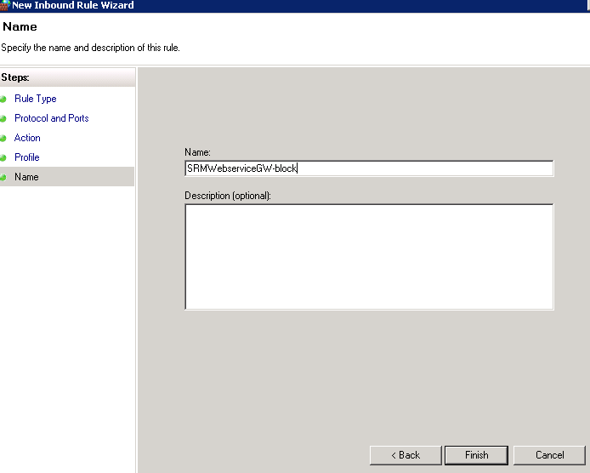
- Double click the rule you just created to bring up the property sheet and select Scope tab
- Select These IP addresses from “Remote IP address” box and click Add button
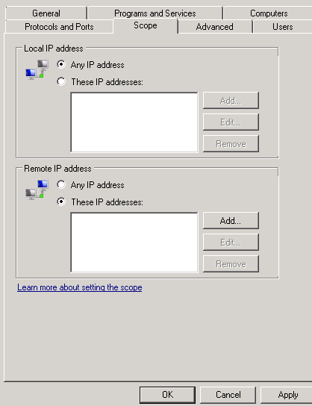
- From IP address window, select “This IP address range”,
put 1.1.1.1 in “From” box
put FE IP address -1 in “To” box and click OK.
For example, if FE IP address is 10.40.41.210 and we need to block all IP addresses other than the FE and we then put 10.40.41.209
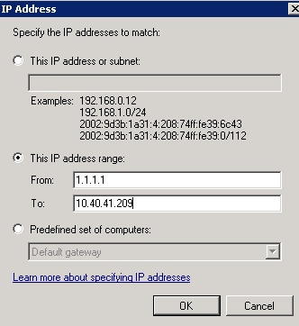
- Click Add button again to enter FE IP address +1 into “From” box and 255.255.255.255 into “To” box
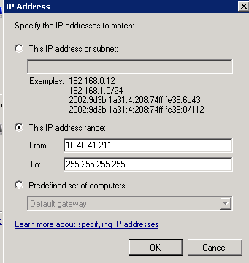
- Click Apply from next window and then OK.
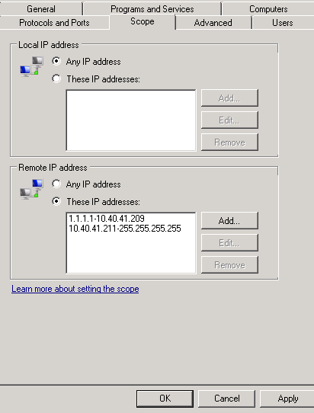

Tectia SSH

- Launch Server Manager and then Configuration Local Users and Groups Groups
- Select and open “Srv_SeInteractiveLogonRight”
- Add nam\alterpoint_svc, apply

Webservice-Gateway Password
- As required by Citi information Security Standards the Webservice-Gateway password needs to be changed and encrypted.
**NOTE the crypt-password utility is only available on the backend servers.
  - Edit “c:\apps_srv\APG\Tools\Webservice-Gateway\Default\users
  - Replace “changeme” with appropriate encrypted password value

Final Configuration
Log on to the SRM Console to complete the install configuration.

Registering components
You MUST register all SRM components including Frontend server, Backend server and all collectors at this step.
- Navigate to Administration
- Navigate to Cenntralized management
- Select Configuration
- For each server in the environment, that is not listed. You must register the server.

Installing SRM Licenses
You should have, at this stage a copy of the SRM licenses provided by EMC. If not you will need to request these before continuing.

Get License - Appendix M for obtaining Licenses

Apply License – Appendix L Installing the Licenses

Including Citi Banner Message
To comply with Citi Information Security Standards (CISS) we are required to present the user with a banner text when they attempt to login in the system. The following procedure details how to configure banner text for SRM.

Appendix J Including Citi Banner Message

Including Citi Logo
Please refer to Appendix N – Citi Logo.

Web Server Certificates
We are required to install valid SSL certificate from a Citi approved certificate authority (CA).

- Request a certificate from CA and Digital Certificate Service (DCS) via marketplace.
  - What action do you require?
    - New
  - From which certificate Authority do require the certificate?
    - <Dev/QA/UAT or Production>
  - What type of certificate do you require?
    - <Web Server SSL>
  - Provide a description of Device, hardware or Application
    - Enter as appropriate – e.g SRM - Reporting Web
GUI for SAN and NAS.
  - Provide a DNS Name (FQDN).
    - <Type in the host name that will be displayed in the certificate>
  - IP address
    - Server IP address
  - CSI ID
    - <Unisphere for VMAX CSI ID>

Also refer to: GIDA - How to guide - Request Certificates

Webservice Certificate
Frontend webservice certificate must be imported into all collector servers’ keystore in order for collectors to properly communicate with frontend webservice.

Configuring AD Group Authentication and Role Authorization
Please refer to the following sections below.
**NOTE: The procedures for each need to be carried out on each front-end host.
**NOTE: The local admin role will be unavailable after integration with AD.

Appendix G - Integrating with Active Directory for Authentication
Appendix H - Integrating with Active Directory for Authorization

Deploying Solutions Packs
At this point the base installation should be completed and we can begin to deploy the Solutions Packs.
For new installs EMC will provide an architecture/design document that will detail which SRM components are installed on each server. The purpose of this section is to detail the process of deploying the individual Solutions Packs.

**Note: Please see Appendix A for the Software Pre-Requisites for SRM Solution Packs

**Note: Given the range of reporting requirements within Citi it is expected that the majority if not all the reports will be developed in conjunction with the vendor to the point at which Citi develops the skills in-house to take over the development of the reports
**Note: Backend-Server-Name is for primary Backend Server if multiple backend servers are installed.

EMC M&R Health

EMC Watch4net Health Solutions Pack is required for each server including Linux and Windows.

- Login to SRM using SRM Administrators account.
- Navigate to “Modules” → “Centralized Management”.
- Navigate to “Solutions Pack Center”
- Under Application, Scroll to and Select “EMC Watch4net Health” Solutions Pack.
- Click “Install”
- You will be required to Select Components to Install
  - Data Collection: <Collector_Server_Name>
  - Reports: <FrontEnd_Server_Name>
The server name selected will be specific to your install.
- Click “Install”
- Wait until installation completes and click “Ok” to finish
- Repeat step 3-8 for all additional SRM servers that do not have EMC Watch4net Health Solutions Pack installed.

EMC VMAX Solutions Pack

The VMAX Solutions Pack requires a connection to Solutions Enabler and also to UniSphere for VMAX. It is recommended to avoid discrepancies with the collection of metrics, that the VMAX collector is configured to access the Solution Enabler Server(s) being used by the UniSphere for VMAX element manager.

Please review Appendix B for details on the SYMAPI Configuration.

- Login to SRM using SRM Administrators account.
- Navigate to “Modules” → “Centralized Management”.
- Navigate to “Solutions Pack Center”
- Scroll to and Select “EMC VMAX” Solutions Pack.
- Click “Install”
- You will be required to Select Components to Install
  - Alert Consolidation: <Backend_Server_Name>
  - Pre-Configured Alerts: < Backend_Server_Name>
  - Data Collection: <Collector_Server_Name>
  - Reports: <FrontEnd_Server_Name>
The server name selected will be specific to your install.
- Click “Install”
- On the Solutions Pack Configuration screen fill in the following data:
- Data Collection
  - Activate The Failover Filter: Yes (tick Mark)
  - Hostname or IP address to send data to: <Backend_Server_Name>
  - Network port to send data to: 2020
- Enable alerting on data collected: Yes (tick mark)
- Alerting on data Collection
  - Alerting Backend hostname or IP address: <Backend_Server_Name>
  - Alerting Backend data port: 2010
- Property Store configuration
  - WebService hostname or IP address: <Frontend_Server_Name>
  - WebService port number: 58443
  - WebService username: Frontend LDAP funcational ID
  - WebService password: <password>
- Enable Topology Backend on data collected: Yes (tick mark)
- Topology Service
  - Topology Service hostname or IP address: <Backend_SeverName>
  - Please Select the Gateway: <backend_Server_Name:48443>
- Configure UniSphere for VMAX Performance collection
  - Unisphere hostname or IP address: <UniSphere Hostname>
  - Unisphere network port: 8443
  - Username:
  - Password:
- UniSphere polling period: 7200
- Solutions Enabler bin directory: Accept Default
- Connection type: Remote
- SYMAPI Connection name: <As configured inNetHost file>
- VMAX
  - Array Full Serial Number: <include leading zeros.>
- Click “Configure”

EMC VNX Solutions Pack
- Login to SRM using SRM Administrators account.
- Navigate to “Modules” → “Centralized Management”.
- Navigate to “Solutions Pack Center”
- Scroll to and Select “EMC VNX” Solutions Pack.
- Click “Install”
- You will be required to Select Components to Install
  - Alert Consolidation: <Backend_Server_Name>
  - Pre-Configured Alerts: < Backend_Server_Name>
  - Data Collection: <Collector_Server_Name>
  - Events: < Backend_Server_Name>
  - Reports: <FrontEnd_Server_Name>
The server name selected will be specific to your install.
- Click “Install”
- Data Collection
  - Activate The Failover Filter: Yes (tick Mark)
  - Hostname or IP address to send data to: <Backend_Server_Name>
  - Network port to send data to: 2020
- Enable alerting on data collected: Yes (tick mark)
- Alerting on data Collection
  - Alerting Backend hostname or IP address: <Backend_Server_Name>
  - Alerting Backend data port: 2010
- Property Store configuration
  - WebService hostname or IP address: <Frontend_Server_Name>
  - WebService port number: 58443
  - WebService username: Frontend LDAP functional Id
  - WebService password: <password>
- Enable Topology Backend on data collected: Yes (tick mark)
- Topology Service
  - Topology Service hostname or IP address: <Backend_SeverName>
  - Please Select the Gateway: <backend_Server_Name:48443>
- Event server hostname or IP address: <Backend_Server_Name>
- Event server port number: 52001
- Alert consolidation server hostname or IP address: <Backend_Server_Name>
- Alert consolidation server port number: 2040
- Naviseccli Path: default
- VNX
- VNX Type: <Select Type>
- Unique friendly name for the VNX system: <System Alias>
- SP A IP: IP address of SPA A>
- SP B IP: <IP address of SP B>
- Use Naviseccli security file: <default>
- User Scope: LDAP
- Navisecli Username
- Navisecli Password
- Primary Control Station: <IP address of primary control Station>
- Secondary Control Station: <IP address of secondary control Station>
- VNX File Username:
- VNX File Password:
- Click Configure

EMC XTremIO Solutions Pack
- Login to SRM using SRM Administrators account.
- Navigate to “Modules” → “Centralized Management”.
- Navigate to “Solutions Pack Center”
- Scroll to and Select “EMC XTremIO” Solutions Pack.
- Click “Install”
- You will be required to Select Components to Install
  - Alert Consolidation: <Backend_Server_Name>
  - Data Collection: <Collector_Server_Name>
  - Reports: <FrontEnd_Server_Name>
The server name selected will be specific to your install.
- Click “Install”
- Data Collection
  - Activate The Failover Filter: Yes (tick Mark)
  - Hostname or IP address to send data to: <Backend_Server_Name>
  - Network port to send data to: 2020
- Enable alerting on data collected: Yes (tick mark)
- Alerting on data Collection
  - Alerting Backend hostname or IP address: <Backend_Server_Name>
  - Alerting Backend data port: 2010
- Property Store configuration
  - WebService hostname or IP address: <Frontend_Server_Name>
  - WebService port number: 58443
  - WebService username: <admin>
  - WebService password: <password>
- Enable Topology Backend on data collected: Yes (tick mark)
- Topology Service
  - Topology Service hostname or IP address: <Backend_SeverName>
  - Please Select the Gateway: <backend_Server_Name:48443>
- XtremIO
  - Management IP address or hostname: www.xxx.yyy.zzz
  - XTremeIO Username: Alias
  - XTremIO Password:
  - TimeZone of the XtremIO System
- Click Configure

EMC Centera Solutions Pack
- Login to SRM using SRM Administrators account.
- Navigate to “Modules” → “Centralized Management”.
- Navigate to “Solutions Pack Center”
- Scroll to and Select “EMC Centera” Solutions Pack.
- Click “Install”
- You will be required to Select Components to Install
  - EMC Centera Collector: <Collector_Server_Name>
  - Reports: < Frontend_Server_Name>
- Data Collection
  - Activate The Failover Filter: Yes (tick Mark)
  - Hostname or IP address to send data to: <Backend_Server_Name>
  - Network port to send data to: 2020
- Enable alerting on data collected: Yes (tick mark)
- Alerting on data Collection
  - Alerting Backend hostname or IP address: <Backend_Server_Name>
  - Alerting Backend data port: 2010
- Centera Configuration
  - Hostname or IP address of the management Node: <Hostname of management node>
  - Centera Friendly Name: < Centera Alias>
  - Centera Username (monitor role):
  - Password:
- Path to the Centera Viewer jar file (CenteraViewer.jar): <Leave Default if appropriate>
- Click Configure

Windows(Centera) Collector Service Account
All SRM Services must run using predefined AD functional account.
After Centera SolutionPack has been installed, you need to ensure the target Windows server has all SRM services meet above requirement.
The following procedure uses namdev\srmsvc account as an example. Substitute the proper account name during actual change.
Log on target Windows collector server.

Stop all SRM services
Open a command prompt “Run as administrator”
Execute command: C:\apps_srv\APG\bin\manage-modules.cmd service stop all
Open services
- Select and open “APGCollectorManagerEmccentera” service.
- Select “This account” radio button and input the actual FID.
For example, namdev\srmsvc
Note: you can click Browse button for validation
- Type correct password for this service account and repeat for confirmation.
- Click OK to close the window.

You must repeat above 1-4 steps for all SRM services started with APG.

Start all SRM services
After all services have been updated, execute command: C:\apps_srv\APG\bin\manage-modules.cmd service start all
Execute command: C:\apps_srv\APG\bin\manage-modules.cmd service status all to ensure all services are in “running” state.

Hitachi Device Manager Solutions Pack
- Login to SRM using SRM Administrators account.
- Navigate to “Modules” → “Centralized Management”.
- Navigate to “Solutions Pack Center”
- Scroll to and Select “Hitachi Device Manager” Solutions Pack.
- Click “Install”
- You will be required to Select Components to Install
  - Data Collection: <Collector_Server_Name>
  - Reports: <FrontEnd_Server_Name>
The server name selected will be specific to your install.
- Click “Install”
- Data Collection
  - Activate The Failover Filter: Yes (tick Mark)
  - Hostname or IP address to send data to: <Backend_Server_Name>
  - Network port to send data to: 2020
- Enable alerting on data collected: Yes (tick mark)
- Alerting on data Collection
  - Alerting Backend hostname or IP address: <Backend_Server_Name>
  - Alerting Backend data port: 2010
- Hitachi Device Manager
  - Hitachi Device Manager: <IP Address Hitachi Device Manager>
  - Username:
  - Password:
  - Enable Secure SSL: Yes
  - CIMOM port (leave empty if set to default 5988/5989):

IBM XIV Solutions Pack
- Login to SRM using SRM Administrators account.
- Navigate to “Modules” → “Centralized Management”.
- Navigate to “Solutions Pack Center”
- Scroll to and Select “IBM XIV” Solutions Pack.
- Click “Install”
- You will be required to Select Components to Install
  - Data Collection: <Collector_Server_Name>
  - Reports: <FrontEnd_Server_Name>
The server name selected will be specific to your install.
- Click “Install”
- Data Collection
  - Activate The Failover Filter: Yes (tick Mark)
  - Hostname or IP address to send data to: <Backend_Server_Name>
  - Network port to send data to: 2020
- Enable alerting on data collected: Yes (tick mark)
- Alerting on data Collection
  - Alerting Backend hostname or IP address: <Backend_Server_Name>
  - Alerting Backend data port: 2010
- Array Information
  - Management IP Address or hostname #1:
  - Management IP Address or hostname #2:
  - Management IP Address or hostname #3:
  - CIMOM Network Port:
  - Username:
  - Password:

NetApp Filer Solutions Pack

- Login to SRM using SRM Administrators account.
- Navigate to “Modules” → “Centralized Management”.
- Navigate to “Solutions Pack Center”
- Scroll to and Select “IBM XIV” Solutions Pack.
- Click “Install”
- You will be required to Select Components to Install
  - Data Collection: <Collector_Server_Name>
  - Reports: <FrontEnd_Server_Name>
The server name selected will be specific to your install.
- Click “Install”
- Data Collection
  - Activate The Failover Filter: Yes (tick Mark)
  - Hostname or IP address to send data to: <Backend_Server_Name>
  - Network port to send data to: 2020
- Enable alerting on data collected: Yes (tick mark)
- Alerting on data Collection
  - Alerting Backend hostname or IP address: <Backend_Server_Name>
  - Alerting Backend data port: 2010
- NetApp Configuration
  - NetApp Filer Mode: <Select Mode>
  - Hostname: <HostName of NetApp Filer>
  - IP Address: IP address of NetApp Filer
  - Port Number: 22
  - Username:
  - Password:

Cisco MDS/Nexus Switch Solutions Pack
- Login to SRM using SRM Administrators account.
- Navigate to “Modules” → “Centralized Management”.
- Navigate to “Solutions Pack Center”
- Scroll to and Select “Cisco MDS/Nexus” Solutions Pack.
- Click “Install”
- You will be required to Select Components to Install
  - Alert Consolidation: <Backend_Server_Name>
  - Pre-Configured Alerts: < Backend_Server_Name>
  - Data Collection: <Collector_Server_Name>
  - SNMP Masks: < Frontend_Server_Name>
  - Reports: <FrontEnd_Server_Name>
The server name selected will be specific to your install.
- Click “Install”
- Data Collection
  - Activate The Failover Filter: Yes (tick Mark)
  - Hostname or IP address to send data to: <Backend_Server_Name>
  - Network port to send data to: 2020
- Enable alerting on data collected: Yes (tick mark)
- Alerting on data Collection
  - Alerting Backend hostname or IP address: <Backend_Server_Name>
  - Alerting Backend data port: 2010
- Property Store configuration
  - WebService hostname or IP address: <Frontend_Server_Name>
  - WebService port number: 58443
  - WebService username: Frontend LDAP funcational ID
  - WebService password: <password>
- Enable Topology Backend on data collected: Yes (tick mark)
- Topology Service
  - Topology Service hostname or IP address: <Backend_SeverName>
  - Please Select the Gateway: <backend_Server_Name:48443>
- Event server hostname or IP address: <Backend_Server_Name>
- Event server port number: 52001
- Alert consolidation server hostname or IP address: <Backend_Server_Name>
- Alert consolidation server port number: 2040

Physical Hosts Solutions Pack
- Login to SRM using SRM Administrators account.
- Navigate to “Modules” → “Centralized Management”.
- Navigate to “Solutions Pack Center”
- Under Infrastructure, Scroll to and Select “Physical Hosts” Solutions Pack.
- Click “Install”
- You will be required to Select Components to Install
  - Alert Consolidation: <Backend_Server_Name>
  - Pre-Configured Alerts: < Backend_Server_Name>
  - Reports: <FrontEnd_Server_Name>
  - Scripts: <Collector_Server_Name>
The server name selected will be specific to your install.
- At Scripts v1.0.1 window, leave it as default and click “Install”
- Wait until installation completes, click “Ok” to finish
- Click “OK” again if you see next informational window.

VMware vCenter Solutions Pack
- Login to SRM using SRM Administrators account.
- Navigate to “Modules” → “Centralized Management”.
- Navigate to “Solutions Pack Center”
- Under Infrastructure, Scroll to and Select “VMware vCenter” Solutions Pack.
- Click “Install”
- You will be required to Select Components to Install
  - Alert Consolidation: <Backend_Server_Name>
  - Pre-Configured Alerts: < Backend_Server_Name>
  - Data collection: < Collector _Server_Name>
  - Events: < Backend_Server_Name >
  - Reports: <FrontEnd_Server_Name>
  - Scripts: <Collector_Server_Name>
The server name selected will be specific to your install.
Click “Next”
- At Alert Consolidation Window, Click “Next”
- At Pre-configured alerts Window, Click “Next”
- At Data collection window
Hostname: < Backend_Server_Name>
Alerting Backend hostname: < Backend_Server_Name>
Topology Service hostname: < Backend_Server_Name>
Use defined VMware vCenter hostname/IP, login credential to complete VMware vCenter Configuration settings.
Click “Next”
- At Reports window leave it as default and click “Next”
- At Scripts window, click “Install”
- Wait until installation completes, click “Ok” to finish
- Click “OK” again if you see next informational window.

Oracle Database Solutions Pack
- Login to SRM using SRM Administrators account.
- Navigate to “Modules” → “Centralized Management”.
- Navigate to “Solutions Pack Center”
- Under Application, Scroll and Select “Oracle Database”
- From Summary window click “Install”
- You will be required to Select Components to Install
  - Data collection: < Collector _Server_Name>
  - Reports: <FrontEnd_Server_Name>
Click “Next”
- From Data collection window,
Activate The Failover Filter: Yes (tick Mark)
Under Data collection,
Hostname or IP address to send data to: <Backend_Server_Name>
Under Alerting on data Collection
Alerting Backend hostname or IP address: <Backend_Server_Name>
Under Oracle database configuration
Leave “Simple” as configuration mode
Hostname: Oracle database server
Database port: proper port number
Database service name: proper service name
Type in credential for SRM user configured on target database
- Click “Install”.
- Wait until installation completes, click “Ok” to finish
- Click “OK” again if you see next informational window.

Microsoft SQL Server Solutions Pack
- Login to SRM using SRM Administrators account.
- Navigate to “Modules” → “Centralized Management”.
- Navigate to “Solutions Pack Center”
- Under Application, Scroll and Select “Microsoft SQL Server”
- From Summary window click “Install”
- You will be required to Select Components to Install
  - Data collection: < Collector _Server_Name>
  - Reports: <FrontEnd_Server_Name>
Click “Next”
- From Data collection window,
Activate The Failover Filter: Yes (tick Mark)
Under Data collection,
Hostname or IP address to send data to: <Backend_Server_Name>
Under Alerting on data Collection
Alerting Backend hostname or IP address: <Backend_Server_Name>
Under Microsoft SQL Server configuration
Input data with appropriate value
- Click “Next”.
- Acceptp default and click “Install”.
- Wait until installation completes, click “Ok” to finish
- Click “OK” again if you see next informational window

Physical Host Monitoring
SRM collector is capable of collecting data from the following host platform:
Linux, Solaris, AIX, Windows Server 2012R2, Windows Server 2012, Windows Server 2008R2 and Windows Server 2003.
Even though it is “Agentless” data collection, there are some prerequisite that must be met in order for SRM collector to properly communicate with hosts and collect data.
Prerequisite:
- Unix
- FID
LDAP functional ID “srmadmin” is required. Citi automation will create a local user account srmadmin with default home directory /opt/AGP/srmadmin if the FID doesn’t exist.
If FID already exists, automation will create the home directory, if it doesn’t exist already, according to the user account setting.
- Citi automation package SRMhost
Package SRMhost must be deployed on target host.
This package provides:
  - customized sudo function to corresponding OS platform, exception Linux where sudo is preinstalled.
  - Sudoer apg locks down all sudo command required by user srmadmin
  - ssh IP authorization list.
- Key pair
A default public srmadmin.pub is included in SRMhost package. After initial communication is established, a formal public key is can be used to replace the default public/private key pair.
- Windows
- Appropriate Citi WMF package, WMF 2.0, 3.0 or 4.0, has to be deployed for corresponding Windows platform
Documents from Citi Windows Security engineering provide background and package details
- winRM non-admin user privilege
configuration must go through for using non-admin privilege on each Windows.
Account name “srmsvc” is used as Windows winRM sample account name throughout this document for descriptive purpose.
Recording “SID” value for user “srmsvc” for use later.

Linux
Note: list of sudo command:
/home/srmadmin/inq,/opt/APG/sbin/srmacl.sh,/sbin/powermt,/usr/sbin/dmidecode,/usr/sbin/vgs,/sbin/vgs,/usr/sbin/lvdisplay,/sbin/lvdisplay,/usr/sbin/pvs,/sbin/pvs,/sbin/multipath -l
Package covers for both Redhat Linux 5.x and 6.x
Package installation
- Login as root
- Fetch SRMhost package “SRMhost-0-1.x86_64.rpm”
- Install by running rpm –ivh SRMhost-0-1.x86_64.rpm
- Proceed with installation by answering all questions positively.
Package removal
- Login as root
- rpm –e SRMhost-0-1.x86_64
- Respond positively to the prompted questions.

Solaris
Note: list of sudo command:
Cmnd_Alias PRIV_CMDS = /opt/APG/srmadmin/inq,/opt/APG/sbin/srmacl.sh,/usr/sbin/vxdisk -q -e list
Cmnd_Alias NONPRIV_CMDS = /usr/bin/mpstat,/usr/bin/sar
srmadmin ALL=(root) NOPASSWD:PRIV_CMDS
srmadmin ALL=() NOPASSWD:NONPRIV_CMDS
Package is built on Solaris 10 platform.
Package installation
- Login as root
- Fetch SRMhost package “SRMhost.pkg”
- Execute: pkgadd –d SRMhost.pkg
- Respond positively to the prompted questions.

Package removal
- Login as root
- Execute: pkgrm SRMhost
- Respond positively to the prompted questions.

AIX
Note: list of sudo command:
inq,/opt/APG/sbin/srmacl.sh,/usr/sbin/swap -l,/sbin/powermt,/usr/sbin/sar,/usr/sbin/kdb
Package is built on AIX 6.1 platform
The installation package is built as a release for testing package due to unavailability of test platform.

Configuration Assurance
HPNA is used for Configuration Assurance and checks for:
- Firewall rule
- Server configuration.
- SRM Server Component configuration
Policy | Description (If Needed). Policies that are defined but yet to be implemented must be clearly noted
i.e. L2 – CatOS - set errdisable-timeout enable udld
i.e. Riverbed - aaa and tacacs-server configuration - LATAM and NA
i.e. Routing - CSPAN and TIER 2 - ip flow-(cache or export) commands

Global Standard
Mandatory Security and Management Commands

Use this area to complete all manadatory security and management commands needed to meet CISS standards and Operational requirements. If the product has a GUI interface, include screen shots of the configuration steps.

E.g. Cisco IOS Banner and Windows Security screen shot

banner login ^
********************************************************************************************************************************************************************
* *
* You are authorized to use this System for approved business purposes only. *
* *
* Use for any other purpose is prohibited. All transactional records, reports, *
* e-mail, software, and other data generated by or residing upon this System *
* are the property of the Company and may be used by the Company for any purpose. *
* Authorized and unauthorized activities may be monitored.
*
* *
* CONTACT GLOBAL NETWORK CONTROL CENTER FOR ANY PROBLEMS @ xxx-xxx-xxxx *
* *
* *
* *
********************************************************************************************************************************************************************
^

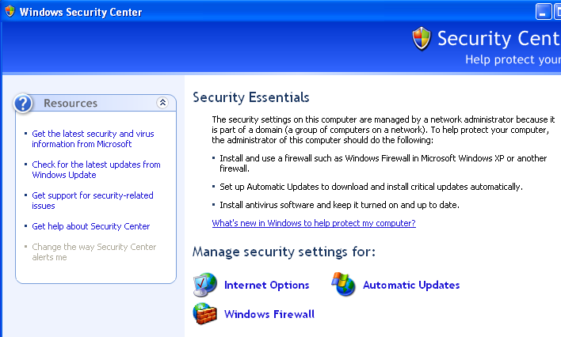

Optioanl Management Commands:

Include additional management commands that are not mandatory but might be of benefit to the Operational and Engineering teams.

Glossary/Definition

Term or Acronym | Explanation or Definition
CATE | Citi Architecture & Technology Engineering
GNAST | Global Network Architecture and Standards Team
NMS | Network Management System

Appendix

Appendix A – Pre-Requisites for SRM Solution Packs

Citigroup have certified a number of Solutions Packs. In order for these Solutions Packs to be installed and function correctly there are pre-requisites which need to be met. The following sections outline the pre-reqs for each individual Solution Pack.

EMC VMAX Solutions Pack
The software pre-requisites for the VMAX Solutions pack are:
- UniSphere for VMAX version v2.0 minimum
- Solutions Enabler v7.6.2.25 minimum
- Symauth privileges “Monitor” for the VMAX Collector
- UniSphere Functional Account for Performance Collection.

EMC VNX Solutions Pack
The software pre-requisites for the VNX Solutions pack are:
- Navisphere CLI 7.32.x minimum

Hi-Command Solutions Pack
The software pre-requisites for the VNX Solutions pack are:
- HiCommand Device Manager 7.3 minimum

IBM XIV Solutions Pack
Requires CATE script to be added to Cron job on XIV management host to enable successful discovery.
Please refer to the SRM sections of the following docs for more information.
https://catecollaboration.citigroup.net/domains/platstor/gdse/products/platforms/IBM%20XIV/CSBE-14020-SG.pdf
https://catecollaboration.citigroup.net/domains/platstor/gdse/products/platforms/IBM%20XIV/CSBE-14020-RN.pdf

NetApp Filer Solutions Pack
No specific software required.

EMC Centera Solutions Pack
The software pre-requisites for the Centera Solutions pack are:
- Centera viewer CLI (v4.2, v4.3)

EMC XTremIO
No specific software required.

Cisco
No specific software required.

Oracle Database
The followings must be configured on Oracle database instance if it isn’t automated:

create user watch4net identified by securepassword default
tablespace users temporary tablespace temp;
grant create session to watch4net;
grant select on V_$SYSSTAT to watch4net;
grant select on v_$filestat to watch4net;
grant select on v_$database to watch4net;
grant select on dba_data_files to watch4net;
grant select on dba_extents to watch4net;
grant select on dba_free_space to watch4net;
grant select on v_$parameter to watch4net;
grant select on v_$sgainfo to watch4net;
grant select on v_$rowcache to watch4net;
grant select on v_$librarycache to watch4net;
grant select on v_$latch to watch4net;
grant select on v_$rollstat to watch4net;
grant select on v_$dispatcher to watch4net;
grant select on v_$instance to watch4net;
grant select on v_$sesstat to watch4net;
grant select on v_$statname to watch4net;
grant select on v_$session to watch4net;
grant select on v_$sess_io to watch4net;
grant select on v_$asm_disk to watch4net;
grant select on v_$asm_diskgroup to watch4net;
grant select on v_$logfile to watch4net;
grant select on v_$log to watch4net;
grant select on sys.dba_tablespaces to watch4net;

Appendix B – Obtaining License File for SRM

Citi has a global Enterprise License agreement in place with EMC. Watch4Net licenses can be obtained from EMC by following the process below:
- Raise a Service Request (SR) through EMC Powerlink support portal. If you do not have access to Powerlink, please speak to your local EMC Sales representative and they can assist you.
- The SR will need to contain the following information
  - Citi Site ID:
  - Sales Order: <Enterprise license Agreement> will be sufficient
  - Product:
  - Host/OS:
  - Vesion:
  - Product to Enable: SRM Suite
  - EMC Sales Rep:
- You will also need to provide the output from the following command:
  - C:\APG\bin\manage-licenses.cmd host-id
- The SLA for EMC to send the permanent licenses through is 24-48hrs.
In the interim the product can be installed and temporary licenses issued. These can be obtained from the local EMC sales representative.

Appendix C - Solutions Enabler Proxy Connection
The following section details how to setup a Solutions Enabler Proxy Connection.

**NOTE: the Solutions Enabler Server must be at the same or higher version of Solutions Enabler for the proxy connection to work.

- Install Solutions Enabler on the host VM which will be used as the VMAX collector.
- For Windows this will be installed in the following directory:

C:\Program Files\EMC

- Edit the C:\Program Files\EMC\SYMAPI\config\netcnfg file to reflect each Solutions Enabler server which you are connecting to, see below where I am making a connection to two separate SE servers:

SYMAPI_SERVER - TCPIP namgdse04 10.40.42.12 2707 -
SYMAPI_SERVER2 - TCPIP namgdse14 10.40.42.90 2707 -

- The alias of the SYMAPI server in the netcnfg file is the name which you will use when 0discovering the arrays i.e.
- On the server you are making the connection to i.e. the Solutions Enabler server which has discovered the arrays you need to update the following file:

/var/symapi/config/nethost

10.40.54.94 *
10.40.43.178 *

**NOTE: If the collector server is moved and the IP address changes you will need to update the nethost file on the Solutions Enabler server to reflect the updated IP address.

- You will need to include a line entry for the VMAX collector server as above
- You will need to permission the VMAX collector server via Symauth.
- Create a command file called adduser.cmd on the Solutions Enabler Server
- Add the following entry

assign user H:<your host name here>\apg to role Monitor;

- After the command file is created execute the command file with the symauth command:

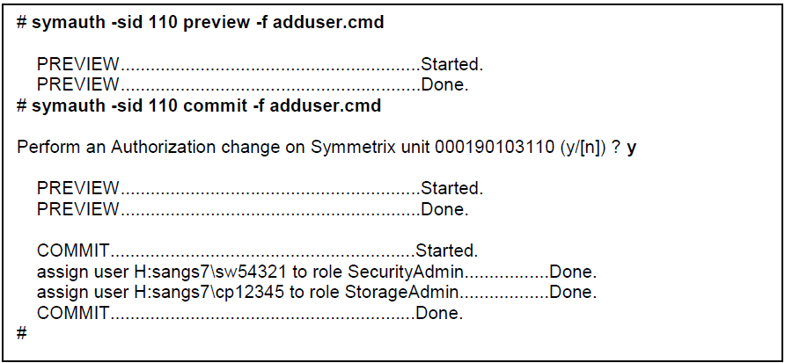

- Validate the user has been added.



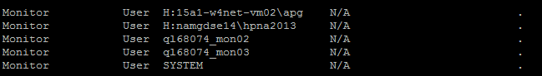

Appendix D - Configuring Roles in SRM
At the time of writing it is unknown the number of distinct SRM roles that will be required. At a minimum it is believed that the following roles will be configured:

- User Administrator Role
- SRM Administrators Role
- SRM Users Role

The function of each of these roles is described in the table below:

Role Name | Role Purpose
User Administrator | For the configuration and management of Roles and Users within SRM. This role will not have any privileged access to the application to either view, modify or create reports. It will also not have access to view, modify or discover devices.
SRM Administrators | The SRM Administrators role will have full read/write access to the SRM application, to enable the deployment of Solutions Packs and the discovery of devices. The SRM administrator’s role will also allow the creation, modification and deletion of reports and dashboards.
SRM Users | The SRM User will be allowed to view, modify and create reports. They will be have restricted write access to reports only in their profile.

In production these Roles will each be mapped to a distinct AD/LDAP group, the method to perform this mapping is detailed later in the document.
The following procedure will take you through the creation of these roles.

User Administrator
- As administrator (admin) login to SRM.
- Navigate to Administration.
- Select “Roles” from the left-hand tree
- Under “Roles Management”, Select Standard Mode -> This brings you into Advanced Mode.
- Click “New Role”
- Under Main Properties Fill in the following sections.
  - Name: User Administrator
  - Description: <Copy the text as detailed in the Table above>
  - Master Filter: Everything
  - Parent Role: Default
  - Disabled: unchecked
- Members
  - For SRM 3.5.1 you will be required to associate the SOE ID of the people performing the user management role to this role.
- External Members
  - Bind an external group to this role: Add the Distinguished Name of the AD/LDAP group to this role. Further instruction is given further in this document.
- Template Access
  - Default Access for All Templates: No Access
- Modules & Restrictions Access
  - APG FrontEnd – Click down arrow
    - “Edit Mode” Button display: No
- Click Save
- Select User Administrator
- Under Role and User Management
  - Select Roles and Users for all Roles
  - Do not Select Users for User Administrator
- Click Save
SRM Administrators

- As administrator (Admin) login to SRM.
- Navigate to Administration.
- Select “Roles” from the left-hand tree
- Click “New Role”
- Under Main Properties Fill in the following sections.
  - Name: SRM Administrator
  - Description: <Copy the text as detailed in the Table above>
  - Master Filter: Everything
- Members
  - For SRM 3.5.1 you will be required to associate the SOE ID of the people performing the user management role to this role.
- External Members
  - Bind an external group to this role: Add the Distinguished Name of the AD/LDAP group to this role. Further instruction is given further in this document.
- Template Access
  - Default Access for All Templates: Read/Write
- Modules & Restrictions Access
  - Everything should be set to Yes
- Click Save
SRM Users

- As administrator (Admin) login to SRM.
- Navigate to Administration.
- Select “Roles” from the left-hand tree
- Click “New Role”
- Under Main Properties Fill in the following sections.
  - Name: SRM Users
  - Description: <Copy the text as detailed in the Table above>
  - Master Filter: Everything
- Members
  - For SRM 3.5.1 you will be required to associate the SOE ID of the people performing the user management role to this role.
- External Members
  - Bind an external group to this role: Add the Distinguished Name of the AD/LDAP group to this role. Further instruction is given further in this document.
- Template Access
  - Default Access for All Templates: Read Only
- Modules & Restrictions Access
  - APG Frontend set to Yes
  - Everything else set to no
- Click Save

Appendix E – Linux ACL configuration
The following are steps for configuring a SRM Linux firewall. Replace FE/BE/Collector with actual server IPs and repeat it for all SRM servers.
Assuming login with root privilege, execute
iptables –F
iptables -P INPUT ACCEPT
iptables -P FORWARD DROP
iptables -P OUTPUT ACCEPT
iptables -A INPUT -i lo -j ACCEPT
iptables -A INPUT -s FE -j ACCEPT
iptables -A INPUT -s BE -j ACCEPT
iptables -A INPUT -s Collector -j ACCEPT
#Note: repeat for all servers
iptables -A INPUT -p tcp --dport 48443 -j DROP
iptables -A INPUT -p tcp --dport 2001 -j DROP
iptables -A INPUT -p tcp --dport 2000 -j DROP
iptables -A INPUT -p tcp --dport 2010 -j DROP
iptables -A INPUT -p tcp --dport 2008 -j DROP
iptables -A INPUT -p tcp --dport 8888 -j DROP
iptables -A INPUT -p tcp --dport 8189 -j DROP
iptables -A INPUT -p tcp --dport 53306 -j DROP
iptables -A INPUT -p tcp --dport 53307 -j DROP
/sbin/service iptables save

Appendix F - Configuring Users in SRM
**Note: There is a known issue with SRM when using it in conjunction with AD/LDAP for authorization. You are required to create a user locally in SRM and assign it the equivalent role privileges as the AD/LDAP group the user is a member.

- Login to SRM as admin.
- Navigate to Administration.
- Select “Users” from the left hand tree menu.
- Select “New User”.
- Under the “User Data” tab, fill in the following fields:
  - User Login: <SOEID>
  - Title
  - First Name
  - Last Name
  - Email Address
- Under the “User Status”:
  - User Status: Normal User
  - Profile: Default Profile
  - User Roles: <Assign the user the appropriate role>
- Click Save

Appendix G - Integrating with Active Directory for Authentication
The following section details the necessary steps required in order for SRM to integrate Active Directory (AD) for user authentication and also to disable local authentication.

Pre-Requisites
You will require the following prior to editing the server.xml file.
- A non-interactive Functional ID with basic user privileges
  - This is the connectionName and is the username used by SRM to authenticate with AD/LDAP
  - A connectionPassword is also required for the user specified connectionNAme
- Primary and alternate LDAP URLs.
- Certificate (.crt) file and a .pem file from the AD/LDAP server, for handshaking betweeb the SRM Front-End (LDAP Client) and the LDAP Server.

Configuration Steps
- The connectionName will be provided by the CTI Operational AD team.
- Login to the SRM server and navigate to the following file
  - /opt/APG/Web-Servers/Tomcat/Default/conf/server.xml
- Make a copy of this file and call the copy, server.xml.orig.
- Open the server.xml, you may need to change the permissions on the file in order to edit it.
- Locate the section of the file shown below:
<!-- Microsoft Active Directory -->
<!-- you can optionally switch to port 3268 if running multi DC non-GC -->
<!--
<Realm className="org.apache.catalina.realm.JNDIRealm"
connectionURL="ldap://your-ldap-server1:389"
alternateURL="ldap://your-ldap-server2:389"
connectionName="cn=your-username,OU=yourService Accounts,DC=nam,DC=nsrootdev,DC=net"
connectionPassword="your-password"
userSearch="(sAMAccountName={0})"
userBase="OU=User Accounts,DC=nam,DC=nsrootdev,DC=net"
referrals="follow"
derefAliases="always"
userSubtree="true" />
-->

- There are a couple of things that need to be edited in this section.
  - Remove the yellow highlighted comment marks. <!-- -->
  - Edit the connection URL and enter the full FQDN in place of the placeholder “your-ldap-server1.636”. 636 is the TCP port over which SSL communication can take place
  - Modify ldap:// to ldaps://, this allows communication over SSL.
  - Under the ConnectionName enter the string which is provided by the CTI AD Operations team.

connectionName="CN=srv_emc_watch4net,OU=Svc_Accts,OU=StorageEng,DC=namdev,DC=nsrootdev,DC=net"

  - You must also edit the UserBase string which would be:

userBase="DC=namdev,DC=nsrootdev,DC=net"

  - If will need to remove the ability to use a local account to login to W4N then comment (comments shown highlighted) out the following section.

<!-- Single sign on based on APG master database -->
<!-- Comment the following section if you are using LDAP or CAS authentication -->
<!-- <Realm className="org.apache.catalina.realm.DataSourceRealm"
dataSourceName="jdbc/master" roleNameCol="rolename"
userCredCol="password" userNameCol="username"
userRoleTable="users" userTable="users" />
-->

- You will also need to install the certificate using the keytool.exe utility (password for this is “changeit”)
- Navigate to /opt/APG/Java/Sun-JRE/6.0u45/ (the version of Java will change depending on the version of SRM being installed)
- Issue the command

  - ./Keytool –importcert –alias (alias-of-your-choosing) –file (the file where the cacert is located)
- Proceed to the next section

Appendix H - Integrating with Active Directory for Authorization
**NOTE: Due to a known issue with the SRM AD group/SRM Role integration you are still required at present to create a user in SRM and assign it the same role as granted to the Users AD group.

SRM has the ability to bind AD/LDAP groups to roles within SRM. These groups, within SRM, are known as external members.
In the production environment there will be at least 3 different AD/LDAP groups. Each group will be assigned to a particular role within SRM. The method to map these AD/LDAP groups to the SRM roles is outlined in the procedure below.
- Ensure that the AD/LDAP groups have been created.
- Obtain the Distinguished Name (DN) of the group you are mapping. An example of this format is shown below:
  - CN=per_csbe_unispherevmax_admins,OU=Dept_Grps,OU=StorageEng,DC=namdev,DC=nsrootdev,DC=net,namdev
- Edit the server.xml file on each front-end server in your infrastructure to include the roleBase parameter. See Below
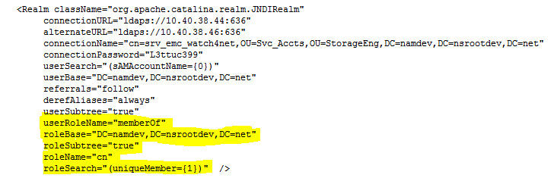
- Save the changes to the server.xml file and restart tomcat on each server:
  - /opt/APG/bin/manage-modules service restart tomcat
- Logon to SRM console as global administrator.
- Click Administration.
- Create or edit a role.
- Select the External Members tab.
- Enter the DN of the role and click the “Add to this role” button
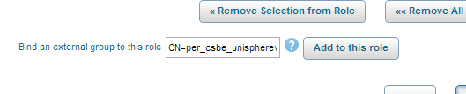
- Click Save
- Test by logging into SRM console with a user who exists in that AD/LDAP group.
- Restart Tomcat

Appendix I - Modifying the Webservice Password
On Linux:
- Select a new password, for the purposes of this document the password will be “changeme”
- Enter the following command to encrypt the password. This utility uses AES-128 encryption to transform clear text passwords into long alphanumeric strings
  - /opt/APG/bin/crypt-password.sh changeme
- You will receive an alphanumeric string as below:
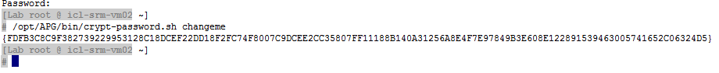
- Edit the file /opt/APG/Tools/Webservice-Gateway/Default/conf/users, with the encrypted password, see below:
  - admin:change
becomes
  - admin: C8C9F382739229953128C18DCEF2891539463005741652C0..
- Restart the Web Service Gateway.
  - /opt/APG/bin/manage-modules service restart webservice-gateway
- Repeat this process for each server in the SRM environment, the same encrypted password string can be used on each.

On Windows:

- The process remains the same as above, except for the following two items.
- On Windows the location of the user file is:
  - <APG_ROOT>\Tools\Webservice-Gateway\Default\conf\users
- On Windows the service can be restarted using the services screen.
On the SRM Console:
- Logon to the SRM Console.
- Navigate to Centralized Management
- Select Configuration

- Update the password for each of the servers in the environment
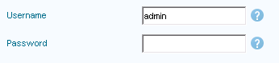
- Click Save.
- On the left hand tree panel navigate to the Central Configuration Repository.
- Update the Web-Service Gateway password.
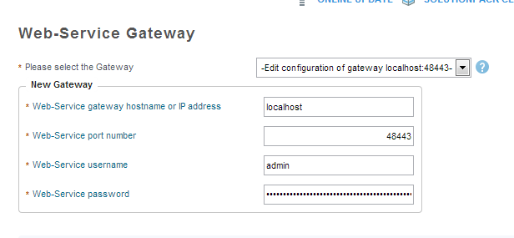

Appendix J - Including Citi Banner Message

- Login to SRM as admin
- Navigate to Administration
- Select Portal from the left-hand tree.
- Under the tab Frontend Status, include the following Welcome Message.
  - “You are authorized to use this System for approved business purposes only. Use for any other purpose is prohibited. All transactional records, reports, e-mail, software, and other data generated by or residing upon this System, to the extent permitted by local law, are the property of Citigroup Inc. or one of its subsidiaries or their affiliates (individually or collectively Citigroup) and may be used by Citigroup for any purpose authorized and permissible in your country of work. Activities on this System are monitored to the extent permitted by local law”
- Click Save

Appendix K - Changing the MySQL Password

- Log on to the SRM Backend Server where the database is located.
- Stop the following SRM services on the database server:
/opt/APG/bin/manage-modules.sh service stop tomcat
/opt/APG/bin/manage-modules.sh service stop backend
/opt/APG/bin/manage-modules.sh service stop task-scheduler
- Connect to the database using the following command:
  - /opt/APG/bin/mysql-client.sh
- You will connect to the APG database using root privileges, as below:
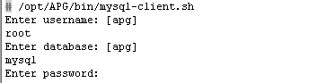
The default password is “watch4net”

- List the existing usernames and password as below:
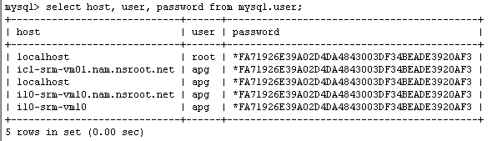
- Update the passwords for the two users “apg” and “root” with the following commands;
  - update mysql.user set password=PASSWORD(‘Welcome1’) where User='apg';
  - update mysql.user set password=PASSWORD(‘Welcome1’) where User='apg';
The password shown is used for demonstration only. Please select a unique password in line with Citi policies.
- Once the password has been set you can validate that the alphanumeric password has changed, see below:
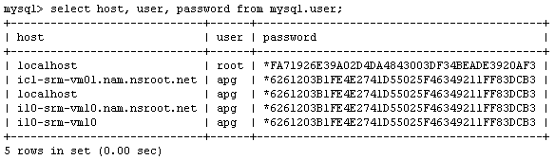
- Run the following commands to update the permissions:
  - GRANT ALL PRIVILEGES ON apg.* TO 'apg'@'localhost' IDENTIFIED BY 'NEW_PASSWORD';
  - GRANT ALL PRIVILEGES ON apg.* TO 'apg'@'server.domain.net' IDENTIFIEDBY 'NEW_PASSWORD'
  - GRANT ALL PRIVILEGES ON apg.* TO 'apg'@'192.168.1.1' IDENTIFIED BY 'NEW_PASSWORD';
FLUSH PRIVILEGES;
Replace either the FQDN or the IP address to match all those used in your network.
- After the password has been successfully updated type Exit to leave the mysql command line.
- Use the crypt-password.sh utility to encrypt the new password before updating the configuration files:
  - /opt/APG/bin/crypt-password.sh Welcome1
- After the password has been changed you must update the APG configuration files (shown below) to reflect the new password. Please ensure you have a copy of the configuration file before making any edits.

Component | Configuration File
Frontend Server / Tomcat | /opt/APG/Web-Servers/Tomcat/Default/conf/server.xml
Frontend Server / Tomcat | /opt/APG/Tools/Frontend-Search/Default/conf/frontend-search.xml
Frontend Server / Tomcat | /opt/APG/Web-Servers/Tomcat/Default/conf/Catalina/localhost/alerting-frontend.xml
Backend Server | /opt/APG/Backends/APG-Backend/Default/conf/mysql.xml
Backend Server | /opt/APG/Tools/Topology/Default/conf/topology-refresh-config.xml
Backend Server | /opt/APG/Tools/MySQL-Maintenance-Tool/Default/conf/mysql-root-apg.xml
Backend Server | /opt/APG/Tools/MySQL-Maintenance-Tool/Default/conf/mysql-root-mysql.xml
Backend Server | /opt/APG/Tools/MySQL-Maintenance-Tool/Default/conf/mysql.xml

**NOTE: it is not required to encrypt the AD connection password, as this is a non-interactive account.

- To change the database passwords in the server.xml file you are required to do the following:
- Update the passwords with the encrypted passwords.
- Navigate to the /Web-Servers/Tomcat/Default/conf/ directory and edit the unix-service.properties file.
- Add a new line where the rest of jvm.param lines are:

jvm.param.<N>=-Djavax.sql.DataSource.Factory=com.watch4net.apg.v2.gui.tomcat.W4NDataSourceFactory
- Note: Change the <N> to the next number as in seen in file.
- Save the changed properties file.

- Start the services
  - /opt/APG/bin/manage-modules.sh service update tomcat
  - /opt/APG/bin/manage-modules.sh service start backend
  - /opt/APG/bin/manage-modules.sh service start task-scheduler
- Restart the services on other servers in the infrastructure where configuration files have been modified.
  - /opt/APG/bin/manage-modules.sh service restart all

Appendix L - Installing the Licenses
- Launch a browser IE and Chrome are both supported.
- Type:
  - http://<yourserver_alias.xxx.nsroot.net:58080>/APG
- Click Sign In
- Navigate to “Administration”.
- Navigate to “Centralized Management → License Management”.
- In the “Licenses Listing” window, select “Upload”.
- Choose the license file provided by EMC (supports the upload of multiple license files in .zip format).
- Click OK.
- When the license upload has completed Click Ok.
- Click “Synchronize” to add the licenses to the remote servers in the SRM environment.

Appendix M - ELMS license reference
This document is a reference for how to obtain an ELMS license. You need to determine the license requirement and download the license file. Consult to EMC if need to
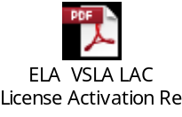

Appendix N – Citi Logo
- Login to SRM as admin
- Navigate to Administration
- Select Portal from the left-hand tree.
- Select the Default Display tab
- Upload a New Logo
- Click Save

Sudo Compiling and Automation

Solaris compiling
- Download OS image(Solaris 10):
sol-10-u11-ga-sparc-dvd.iso
- Mount CD image
mount -F hsfs -o ro `lofiadm -a /tmp/sol-10-u11-ga-sparc-dvd.iso` /mnt
assuming mount point /mnt is available and image is in /tmp
- SUNW packages with dependencies(possible SUNW gcc)
SUNWhea, SUNWlibm, SUNWdfbh, SUNWbtool, SUNWsprot, SUNWtoo
- Downloading csw gcc solaris packages 4.9.0(csw is the only source supporting Solaris gcc package).
pkgadd -d http://get.opencsw.org/now
/opt/csw/bin/pkgutil -U
/opt/csw/bin/pkgutil -a vim
/opt/csw/bin/pkgutil -y -i vim
- Downloading sudo source file(version 1.8.11).
sudo-1.8.11.tar.gz
- Extract sudo source to a working folder, for example, /var/tmp/src
- Ensure using gcc
export CC=/opt/csw/gcc4/bin/gcc
- Compiling
From sudo source folder, say /var/tmp/src
#./configure --prefix=/opt/APG/sudo --sysconfdir=/opt/APG/etc/
prefix is the target installation folder
sysconfdir is the target sudo configuration folder
#make
#make install
#make clean
- Verification of sudo function

AIX compiling
- Download and add the following packages:
http://www.bullfreeware.com/
bash-4.2-9.aix6.1.ppc.rpm
libiconv-1.14-1.aix6.1.ppc.rpm
gcc-4.4.5-1.aix6.1.ppc.rpm
mpfr-3.1.2-1.aix6.1.ppc.rpm
gettext-0.17-8.aix6.1.ppc.rpm
gmp-5.1.3-1.aix6.1.ppc.rpm
info-5.0-2.aix6.1.ppc.rpm
- Export CC=/opt/freeware/bin/gcc
- ./configure --prefix=/opt/APG/sudo --sysconfdir=/opt/APG/etc
- Make
- Make install
- Make clean

Automation
Unix host ssh passwordless authentication is recommended. Therefore, SRM collector authorization must be configured on each monitored Unix host for security purpose.
Assuming public key “srmadmin.pub” already exists in folder /etc/ssh2/keys/srmadmin, script “srmacl.sh” deployed into FID srmadmin home directory by SRM unix host package provides.
The script is executed using srmadmin user account and provides the following functions:
-h: help information
-v: version information
-l: list the current authorization list
-a: add a new IP address(SRM collector) into the authorization list
Syntax: srmacl.sh –a keyname IPaddress
-d: delete an IP address from authorization list
Syntax: srmacl.sh –d IPaddress
-u: update an IP entry within the authorization list
Syntax: srmacl.sh –u IPaddress(source) IPaddress(target)
-k: upload a new public key file
Syntax: srmacl.sh –k keyfile

