GNAST DESIGN/STANDARD
For

Storage Resource Manager

Network Services

Template Version: 2.4
MSO2007 version

Document Version#: 1.0

May 13, 2014



Disclaimer
If printed, content is valid only for the day it was printed. Always refer to the online document for the current version. If the user elects to maintain copies of this procedure, it is their responsibility to verify the currency of the document by checking it against the online version. This document must be promptly removed from use when obsolete.
Table of Contents
GNAST DESIGN/STANDARD 1
Storage Resource Manager 1
Network Services 1
1 Document Purpose 4
2 Owner of Standard 4
3 Intended Audience 4
4 Principles 4
4.1 Revision History 4
4.2 Key Feature Changes 4
5 Assembly/Solution Description 5
6 Scope 6
6.1 Technology 6
6.2 Applicability 6
7 Components 6
7.1 List of Components 6
7.2 Operational Tools 7
8 Assembly/Solution Architecture 7
9 Installation & Configuration Instructions 14
10 Configuration Assurance 14
11 Scalability & Capacity 14
12 Availability Management 15
13 Regional or Merger Partner Consideration 15
14 Relevant Links 15
15 Glossary 15
16 Appendix 15
16.1 Best Practices 15

Note: The purpose of this template is to provide a standard document structure for completing designs with detailed instructions on how to install and configure secure technology standards within Citi’s global environment. This document follows the official standard GNAST design framework, and applies to all current GNAST technology standards/products inclusive of hardware and software.

Document Purpose
This document provides detailed installation and configuration instructions for use by all operational and regional engineering teams for Storage Resource Manager deployment within Citi Global environment, to ensure adherence to designs, configuration, support, and management standards as well as compliance to Citigroup Information Security Standards.

Owner of Standard
GNAST (Global Network Architecture and Standards Team) is the owner of this document. CATE (Citi Architecture & Technology Engineering) is the custodial organization. CATE Network Engineering technologists will drive and generate content.

Intended Audience
The intended audience is Networks Engineering, Global and Regional Operations and Engineering personnel responsible for designing, building, supporting, and managing Citi corporate network environments.

Principles

Revision History

Version | Description | Date | Author
0.1 | Initial GNAST Standard | 05-10-2014 | Ali Shakir
1.0 | Final GNAST document | 05-13-2014 | Ali Shakir

Key Feature Changes
N/A

Assembly/Solution Description

Storage Resource Management Suite is a comprehensive storage resource management solution that enables users to visualize storage relationships, analyze capacity growth, and provide insight to optimize resources.

Visualize
Provides relationship and topology views from virtual or physical hosts down to the logical unit number (LUN) to identify application to storage dependencies.

Analyze
Provides dashboards and reports that track storage consumption. Provide views that help understand capacity.

Optimize
Display historical workloads and response times to help determine whether you’ve selected the right storage tier. Enable creation of charge-back reports to align application requirements with costs

The following highlight the benefits of SRM for Storage engineer and Storage Operations:

- Storage capacity reporting for multivendor storage environments (VNX, VMAX, Centera, XIV, HDS, NetApp, Cisco, Brocade)
- Relationship and topology views for the Storage Infrastructure
- View Performance trends across data paths to help identify hosts competing for resources.
- Collected metrics provide understanding of storage usage to help derive impact of storage change on applications
- Track block and file capacity consumption with reports to help understand who is using capacity, how much they are using, and when more will be required
- Track storage consumption by Disk Technology: RAID, ARRAY, FAST Policy to better understand how capacity is being consumed
- Empowers Storage Administrators with vast metrics to improve Capacity Planning and reduce overall cost
- Near-real metrics collection in conjunction with historical data provide a troubleshooting tool to solve complex storage problems

SRM application is comprised of several vendor components. These components provide specialized services for various aspects of Storage collection and reporting. The SRM suite communicates with the various components of the Storage Infrastructure including the SAN Switches and Element Managers.

Vendor Components include:
- SRM Frontend
- SRM Backend/Database
- SRM Collectors
- SRM Solution Packs

Citi Storage Components:
- SAN Fabric Switches
- Storage Array Element Managers
- NAS Filers
- SAN Hosts

Scope
.
Storage Resource Manager (SRM) will be deployed in the Citi Regional Data Centers across the globe. SRM Front-End and Back-End components will be deployed in SWDC and MWDC as well as in EMEA and ASPAC. SRM collectors will be deployed in all regional data centers including SWDC, MWDC, GTDC, QRDC, 390 Greenwich, Rutherford, and Ofallon.

Technology
Latest Storage Rosource Manager (SRM) version is 3.5.

Applicability
Application is global in the monitoring network devices.

Components
.

List of Components
Component Name | Capability Description
Base Components
SRM Front-End | Web Front End
SRM Back-End | Data Receiver from Collectors
SRM Database | MySQL Database
SRM Collector | Data Collectors
SRM Solution Packs | Collectors/Reports/Dashboard/Views for Specific Environment
SRM OS/Platforms
VMWARE | All Components are certified to run in a virtual environment.
RHEL 6 | SRM FE/BE/DB/Collectors
Windows 2008 R2 | SRM Centera Collector
Optional Components
(Operational Requirements)
Authentication/Authorization | LDAP/AD Integration

GNAST Bill of Material (BoM) NOTE: Restricted access: https://catecollaboration.citigroup.net/domains/networks/bom/default.aspx

Operational Tools

Name | Capability Description | Result
SMARTS | N/A
Hewlett Packard Network Automation | N/A
InfoVista | N/A
Other | N/A

Assembly/Solution Architecture

Storage Resource Management solution provides the components to collect the data from the Storage Infrastructure and provides the reporting capabilities to utilize the data collected. The following are the components that comprise the solution.

SRM Front-End:
- Interface to users
SRM Back-End:
- Target for data from SRM Collectors
SRM Database:
- MySQL database
- Co-located with BE
SRM Collectors:
- Distributed throughout the environment
- Extract data (heterogeneous, multi-vendor) from element managers and objects
SRM Solution Packs:
- A set of collectors, reports & dashboard views for a particular target environment
- SolutionPacks are available for VMAX, VNX, Cisco, NetApp, VMware, XIV, HDS, Linux, Windows, Brocade, Oracle, etc.

The SRM Suite utilizes the “Solution Packs” to provide the intelligence to understand the technology being targeted for collection. For example the VMAX “Solution Pack” includes the metrics that need to collected from a VMAX array, the method used to collect the metrics, as well as the reports and views that Engineers and Support could use to understand and troubleshoot the VMAX arrays. Below diagram provides further clarity about how the various components interact.

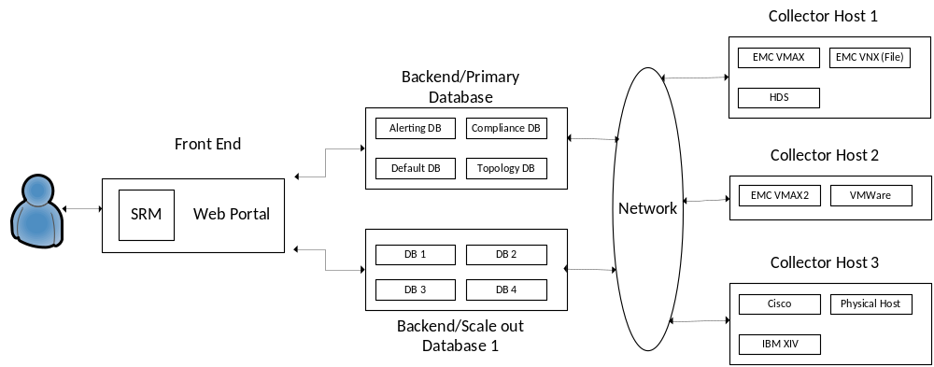
Collector
The Collector component is the engine that polls the devices to gather the metrics. The collector must reside as close to the device being polled as possible because of the large set of metrics collected for each technology. For example below is an example of the metrics collected from Cisco devices:

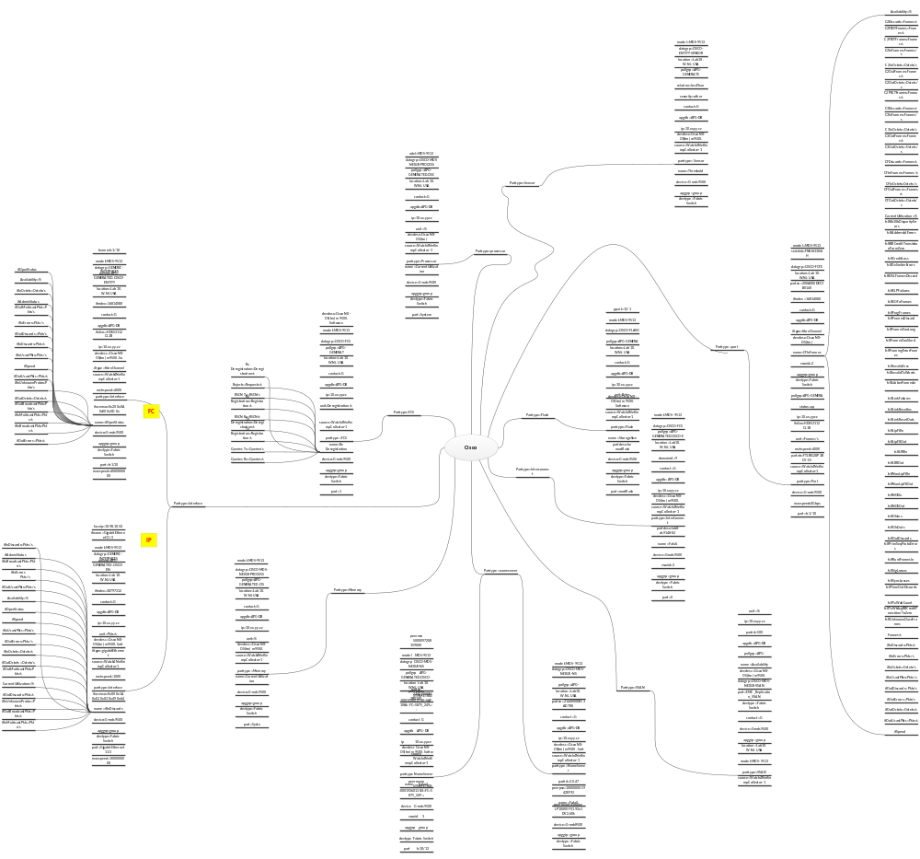

Due to this requirement the SRM Collectors will be deployed in all of the regional datacenters. Multiple Collectors can be installed on one Virtual Machine and collectors can be scaled out as necessary. As an example to collect the ~564,000+ metrics needed for SWDC the following depicts the deployment of collectors for SWDC.
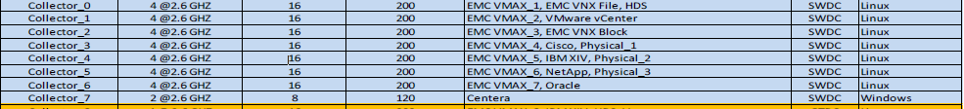

For details regarding EMC sizing best practices please go to Appendix A.
For details regarding metrics per datacenter please go to Appendix B.

Polling frequency varies per collector type due to the varied number of metrics that are collected for the various technologies being instrumented for. The polling frequency varies from 20 min for the largest Solution Pack by metrics collected, VMAX, to 5 min for the majority of Solution Packs. This limitation makes SRM not a viable solution for real-time monitoring.
For data collection the SRM suite attempts to leverage the data being collected by the Element Managers for Block storage components. This eliminates the duplication of data collection and helps limit the traffic generated by SRM across the LAN/WAN circuits. For File storage components the collection method requires communicating directly to the arrays. The same is true for Hosts and Network components, SRM directly communicates with the devices.

For details regarding data collection method for each technology please go to Appendix C.

Back-End
Once the data is collected by the SRM collectors, it is delivered to the SRM Back-end (BE). The primary function of the Back-end it to be a traffic cop for the data being delivered by all the collectors as well as the query manager when data is requested from SRM. In this way the Back-end manages where the data is stored and accessed.

Like the collector, the BE can be scaled out to as needed, however the first BE installed is called the Primary BE and is unique. It is a single point of failure for the SRM Suite. The Primary BE server contains 3 key services that are only running on the Primary BE:
Alerting DB – This is the service that forwards alerts from SRM to any external destination configured
Compliance DB – Configuration Assurance service for Storage environment
Topology DB – Provides mapping for Host to LUNS
The scale out BE’s do not contain these service, they only contain the services for reading/writing to the Persistent Datastore (DB). The BE and DB are required to be co-located since the BE must be able to communicate with the DB to complete its role.
In addition the BE deals with calculation and retention of the data. The data received from the SRM Collectors are only raw values. The BE does simple but useful kinds of aggregates that are computed from the raw values, such as the average value, minimum, maximum, sum, etc... The data is then pushed to the DB for persistent storage.

The Back-End also contains a special component called the Arbiter. This is load balancer like service that requires two components to work correctly, the Arbiter and the Balancer Connector. The Arbiter runs its own Collector Manager and is the main component responsible for maintaining a dynamic list of BE’s, called the balancing list. This list is provided to all the connected Balancer Connectors. The Balancer Connector resides on the SRM Collectors. It’s role is to regularly ask the connected Arbiter for the up to date balancing list. The Arbiter then utilizes this list to determine which BE to connect to for sending its collecting data.

Database

The Database is the persistence storage engine for the SRM Suite. The SRM Database is a MySQL DB with a non-relational schema.

For details regarding the database schema and tables please see Appendix D.
.
Front-End

The Front-End component is the entry point for all users of SRM. The Front-End is accessed via a Web-Portal, where the user is required to enter their SOEID and Windows password. SRM has been integrated with Microsoft Active Directory (AD) for authentication and authorization. Roles created in SRM FE will map to AD groups providing the appropriate access level to the end users. Citi Marketplace will be the place to request access to SRM. Once authenticated the User has access to the SRM UI. At a minimum the User will be able to view the dashboards and reports in the Report Library. At a maximum the User will have full read/write access to SRM.

The specific functions which can be carried out on the Front-End are:
- User/Role management
- Creation, Modification and deleting Reports
- Creation, Modification and deleting Dashboards
- Scheduling reports
- Deploying of Solutions Packs (incl. Solution Pack components e.g. Collectors)
- Upgrading and Patching of SRM components.
- Configuring of Data Enrichment parameters.
- Read access to component logfiles e.g. Collector, Backend, Audit etc.
- SRM Management functions e.g. Stop/Start Collector Services, Edit Discovery info
- License Management
- Alert Management

The Front-End also provides an overview of the health of the SRM environment for system administrators and highlights key performance metrics of the different servers in that SRM environment.

Citi Deployment
SRM will be deployed with “segmented” infrastructures. There are latency and performance requirements that require SRM to be deployed as segmented infrastructures, details provided in Scalability and Capacity section. Segmented deployments will be isolated from each other therefore each deployment will only provide visibility to its collected data. For example, to troubleshoot a problem in QRDC, a user will have to access the SWDC SRM Front-End to access QRDC data.

Below visualizes the “Segmented” SRM Infrastructure:

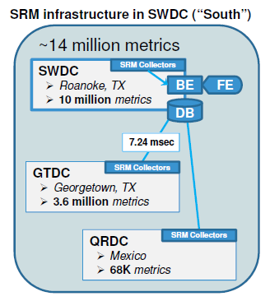
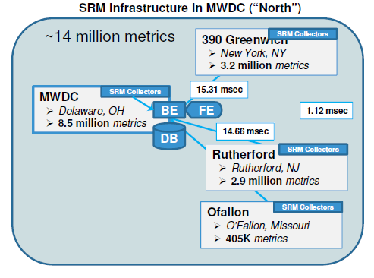
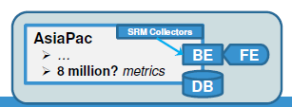
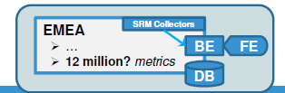

To fulfill the CTI requirement to provide chargeback reports with a global perspective, a second SRM infrastructure will be deployment with global scope. This infrastructure will collect metrics from each segmented SRM infrastructure and allow for reports with a global perspective. This will be achieved by having each SRM Collector send data to the local “segmented” SRM and the “global” SRM. Due to the performance limitation of SRM, the “Global” SRM will incur performance degradation. The “Global” SRM should not be used for troubleshooting regional issues or adhoc reporting.

Below visualizes the “Global” SRM infrastructure:
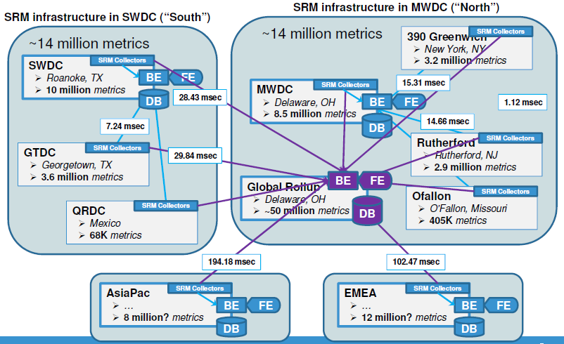
Alerting

SRM Suite is not designed as a real-time fault management solution. SRM does not have the capability to conduct root-cause analysis to provide “intelligent” alerting. In addition, due to the large set of metrics to be collected, there are some Solution Packs that have polling frequency of over 15 min, which would result in a significant delay in problem detection. However the framework to create alerts and develop complex alerting is in the product. The current version only provides a few alerts “out of the box” and requires manual configuration to develop alerts. EMC recommendation is to utilize the Element Managers within the storage infrastructure for alerting and SRM can act as a pass-through for events if desired. There is some effort by EMC to develop more robust alerting in future versions. Root-Cause Analysis will not be part of the SRM solution.

Device Management

SRM Suite currently does not currently provide any automation capabilities for device management. No integration is currently available with any Citi CMDB’s (NetInfo, Aperture). Therefore the addition/deletion of devices into SRM will be a manual process. CTI will be able to utilize csv file imports to provide some level of bulk import.

Installation & Configuration Instructions
Configuration Guide – SRM 3.0

Configuration Assurance
HPNA will provide configuration validation for SRM Linux Server
- IP Table configured
- Validate critical files exist on server
Windows Server will be require manual configuration assurance
- Validate Windows Firewall

Scalability & Capacity
SRM has latency and performance limitations that result in 2 SRM deployments; “Segmented” and “Global”.

SRM Latency Requirements:
- SRM Front-End and SRM Back-End Cannot exceed 5 ms response time
Ex. MWDC BE/DB cannot connect to FE in SWDC
- Backend and Collector Cannot exceed 300ms response time
- Collectors must be deployed local to targeted devices
- Disk response time should not exceed 10 ms
EMC is recommending SAN storage for FE/BE/DB and NAS storage for Collectors
- Maximum metrics per DB is 1 million therefore new database is required when 1 million metrics is breached.

Performance Limitations:
- EMC does not have published limitation for FE performance; however EMC has stated that once the database size exceeds ~20 million metrics, there is incremental degradation in FE performance.

Availability Management
No Disaster Recovery solution is required.

Due to the latency sensitivity of SRM component interactions and disk response time, a COB infrastructure would be a challenge to implement. A COB environment would also incur a significant cost escalation to the SRM infrastructure.

Regional or Merger Partner Consideration
If applicable, describe regional of merger partner specifications to be considered.
(Remove this note and type below)

Relevant Links

Glossary

Term or Acronym | Explanation or Definition
CATE | Citi Architecture & Technology Engineering
GNAST | Global Network Architecture and Standards Team
FE | SRM Frontend
BE | SRM Backend
DB | SRM Database
AD | Microsoft Active Directory

Appendix

Best Practices

Appendix A – EMC Sizing best practice

Scale Level | Storage Arrays/LUNs | NAS/File Systems | Hosts/Host Devices | Switches/Ports | ESXs/VMs | Estimated Metric Count (in Millions) | Deployment Type | VM Count
Minimal | 3/32,300 | 3/3,460 | 40/2,500 | 7/780 | 26/520 | 1 | All-in-One | 1
0 | 14/132,000 | 14/14,643 | 330/21,120 | 29/3,300 | 110/2,200 | 4 | SRM 4-VM vApp | 4
1 | 29/264,000 | 29/29,286 | 660/42,240 | 57/6,600 | 220/4,400 | 8 | SRM 4-VM vApp, 1 Additional Backend, 1 Additional Collector | 6
2 | 43/396,000 | 43/43,930 | 990/63,360 | 86/9,900 | 330/6,600 | 12 | SRM 4-VM vApp, 2 Additional Backend, 2 Additional Collector | 8
3 | 57/528,000 | 57/58,573 | 1,320/84,480 | 114/13,200 | 440/8,800 | 16 | SRM 4-VM vApp, 3 Additional Backend, 3 Additional Collector | 10
4 | 72/660,000 | 72/73,216 | 1,650/105,600 | 143/16,500 | 550/11,000 | 20 | SRM 4-VM vApp, 4 Additional Backend, 4 Additional Collector | 12

Appendix B – Metrics by Data Center

390 Greenwich
Total Metrics Count | 3.2 million

GTDC
Total Metrics Count | 3.6 million

MWDC
Total Metrics Count | 8.5 million

Ofallon
Total Metrics Count | 405 K

Rutherford
Total Metrics Count | 2.9 million

SWDC
Total Metrics Count | 10 million

QRDC
Total Metrics Count | 68 K

ASPAC (Not properly tallied yet)
Total Metrics Count | ~8 million

EMEA (Not properly tallied yet)
Total Metrics Count | ~12 million

Appendix C – Data Collection Method
BLOCK
VMAX/DMX – SRM utilizes Solution Enabler and Unisphere for VMAX to gather the data for VMAX arrays
VNX - SRM communicates to VNX array using NavisecCLI
HDS – The SRM XML collector communicates with the Hitachi Device Manager via CIM/WBEM service, using SOAP like communication to gather data for HDS Arrays
IBM XIV- SRM Collector communicates with IBM XIV using the CIM agent
FILE
VNX - SRM collector communicates to the Celerra control station via SSH and via XMLAPI
Centera – SRM collector communicates to Centera using the Centera Viewer CLI
NetApp – SRM collector utilizes SSH and executes commands to the NetApp CLI.
HOST
Windows (SAN attached) – SRM collector communicates to the windows server via WinRM
Linux/AIX/Solaris (SAN Attached) – SRM collector connects to the linux server via SSH and then executes remote shell commands
ESX Host (SAN Attached) – SRM collector connects to VCenter and uses VMware vSphere Web Services SDK and SOAP are used to access the data
NETWORK
Brocade – SRM collector utilizes SNMP to collect data
Cisco - SRM collector utilizes SNMP to collect data
Note: SNMP V3 is supported.
APPLICATION
ORACLE – SRM collector will utilize JDBC client to communicate with Oracle
Note: Only ORACLE instances utilizing SAN Storage are in scope

.

Note: There are some concerns with elevated privileges required to gather data from several technology components. CATE has undergone rigorous testing to validate if the elevated privileges are actually required. EMC is currently reviewing their requirements and may implement downgraded privileges for Citi installations.

Appendix D – Database Info and Schema

The data variable table contains the variable id (i.e. the internal variable identifier), the variable
name (i.e. the external unique identifier for the variable), and the storage group (the retention group the variable belongs to). The data property contains the properties associated to a variable. Each property is identified by a name and a value. The performance tables contain the performance data for every stored aggregate and for raw values. The raw values are stored in a specific table called data 0 which contains the internal variable identifier, the timestamp and the corresponding value. The raw values timestamps are unpredictable since they directly depend on the data sources polling rate. The aggregated values are stored in tables called data <aggregate period, in seconds. These tables contain the internal value identifier, the aggregate timestamp (which is always predictable since it is a multiple of the aggregate period), the average value, the minimum raw value, the maximum raw value, the sum, the last raw value, the number of raw values used to calculate these aggregates and the timestamp of the last raw value.

