GNAST
REQUIREMENTS, TEST PLAN & TEST RESULTS

For

EMC SRM 3.5.1.0

Network Services

Template Version: 3.0

Document Version#: 1.0

Oct. 03, 2014



Disclaimer
If printed, content is valid only for the day it was printed. Always refer to the online document for the current version. If the user elects to maintain copies of this procedure, it is their responsibility to verify the currency of the document by checking it against the online version. This document must be promptly removed from use when obsolete.

1. Document Purpose 4
2. Owner of Standard 4
3. Intended Audience 4
4. Principles 4
4.1. Revision History 4
4.2. Key Feature Changes 5
4.3. Citi Production Configuration Standards Attestation 5
4.4. Key Features Tested 6
5. Requirements Overview 6
5.1. Hardware Requirements 8
5.2. Software Requirements 8
5.3. System/Functional Requirements 8
5.3.1. System and Network Management Test 8
5.3.2. Smarts 8
5.3.3. Hewlett Packard Network Automation 9
5.3.4. InfoVista 9
5.3.5. Other 10
5.4. Technical Requirements 10
5.5. Business/User Requirements 11
5.6. Integration/Compatibility Requirements 11
5.7. Performance Requirements 11
5.8. Security Requirements 11
5.9. Capacity/Stress Test Requirements 11
5.10. Continuity of Business Requirements 11
5.11. Backup & Restore Requirements 11
6. Test Scope 12
6.1.1. Hardware 12
6.1.2. Software 13
6.1.3. Test Equipment 13
6.1.4. Network Layout/Topology 14
6.1.5. Parameter, Communication Protocol, Port 14
6.1.6. Network Addressing 15
7. Testing & Results 16
7.1. Hardware Test 16
7.2. Software Test 17
7.3. System/Functional Test 17
7.4. Technical Test 19
7.5. Business/Unit Test 39
7.6. Integration/Compatibility Test 41
7.7. Performance Test 41
7.8. Security Test 42
7.9. Capacity/Stress Test 43
7.10. Continuity of Business Test 44
7.11. Backup & Restore Test 44
8. Glossary/Definition 44
9. Appendix 45
9.1. External References 45
9.2. Bill of Material 45
9.3. Configuration & Results Log 45
9.4. VNX Heat Map Does not Select Any Data - Workaround 46
9.5. XTremIO Performance Dashboard Display – Workaround 49
9.6. Cisco SNMP Discovery HTTP is not enforced in Property Store – Workaround 50

Note: The purpose of this template is to provide a standard document structure for completing requirements, developing the test plan and capturing the test results for technology standards/products. This document follows the official standard GNAST design framework, and applies to all current GNAST technology standards/products inclusive of hardware and software.

Document Purpose
This document provides the requirements, test plan, and test results, for
EMC Storage Resource Manager(SRM) 3.5SP1

Owner of Standard
GNAST (Global Network Architecture and Standards Team) is the owner of this standard and the related documents. CATE (Citi Architecture & Technology Engineering) is the custodial organization. CitiNetwork & CitiStorage Platform Engineering technologists will drive and generate content.

Intended Audience
The intended audience is CitiNetwork & CitiStorage Engineering, Global and Regional Operations and Engineering personnel responsible for designing, building, supporting, and managing Citi corporate network environments.

Principles

Revision History

GNAST Template Revision History

Version | Description | Date | Author/ Contact Information
3.0 | Updated section 5.3.1 with new guidance, requirements | 21-Nov-13 | James Rosario

Update the document history each time a draft is issued for review.

Version | Description | Date | Author/ Contact Information
0.1 | Initial Draft | 17-Mar-14 | Bin Zhou
1.0 | Final Document | 19-May-14 | Ali Shakir
1.1 | Update for 3.5.1 | 03-Oct-14 | Bin Zhou/Colin Bradley

Key Feature Changes
The following list identifies key changes since the last version/release

Item | Description
N/A | Initial document

Citi Production Configuration Standards Attestation
. The following points highlight known issues, issues which were identified during testing and collectors that require elevated privileges:
- NetApp Filer Collector – This is not certified at this time. CATE and EMC engineering are exploring alternative methods of collection which do not require elvated privileges.
- HDS Performance Metrics – HDS performance metrics require the HDS Device Manager agent to be run on a server which has a command device attached. This method of collection is being evaluated by CATE.
- SRM provides authentication via Active Directory however for the capability to save custom reports a local account is necessary. (EMC state fix in 4.0)
- VMAX Collector device metrics – The VMAX collector requires the SMI-S agent in order to collect device level performance metrics. At this time the SMI-S agent is not a CATE certified component. SMI-S agent will be certified as part of the Solutions Enabler 8.0 effort in Q4. CATE with CTI will re-evaulate the requirement for device level metrics at that time.
- Windows host – Physical host SolutionPacks doesn’t support message encryption over HTTP which is a Citi standard winRM configuration. This has prevent SRM collector from accessing all windows hosts, including 2003, 2008R2, 2012 via winRM. EMC is working towards the solution. CATE will certify this feature when solution is available.

Key Features Tested
This is a snapshot of mandatory and required key features tested with pass/fail /outcome. (To be completed after section 7)
Feature | Mandatory/Optional | Test Result (Pass/Fail)
Please include key features specific to the technology standard/product. The Following are examples only:
- SRM suite installation and functionalites | Mandatory | Pass
- License manager | Mandatory | Pass
- SRM services | Mandatory | Pass
- Cisco MDS switch discovery and report | Mandatory | Conditional Pass
- VMAX Discovery and reporting | Mandatory | Pass
- VNX discovery and reporting | Mandatory | Conditional Pass
- XtremIO Discovery and reporting | Mandatory | Conditional Pass
- HDS Discovery and reporting | Mandatory | Pass
- IBM XIV Discovery and reporting | Mandatory | Conditional Pass
- NetApp Filer Discovery and reporting | Mandatory | Pass
- Centera Discovery and reporting | Mandatory | Pass
- Physical Host (Linux) Discovery and reporting | Mandatory | Pass
- Physical Host (Solaris) Discovery and reporting | Mandatory | Pass
- Physical Host (AIX) Discovery and reporting | Mandatory | Conditional Pass
- Physical Host (Windows) Discovery and reporting | Mandatory | Fail
- Oracle Database discovery and reporting | Mandatory | Pass
- MSSQL Database discovery and reporting | Optional | Pass
- VMWare vCenter discovery and reporting | Mandatory | Pass
- Topology map | Mandatory | Pass
- Charge back report | Mandatory | Conditional Pass
- Portal Login using SSL | Mandatory | Pass
- Linux ACL to secure open ports | Mandatory | Pass
- Windows Firewall to secure open port | Mandatory | Conditional Pass
- SRM service on Windows collector utilizing FID | Mandatory | Pass

Requirements Overview
Storage Resource Manager suite is a comprehensive storage resource management and reporting solution that enables users to visualize storage relationships, analyse capacity growth, and provide insight to optimize resources
The following include required functionality provided within SRM:
- Performance Reporting for Storage including SAN and NAS
- Storage Infrastructure Discovery
SRM collects metrics for:
- EMC VMAX
- EMC VNX block
- EMC VNX file
- EMC Centera
- Hitachi HDS
- IBM XIV
- NetApp
- Cisco MDS switch (Fabric Switches)
- Unix physical host connected to SAN
- Windows physical host connected to SAN
- Storage data VM hosts and ESX servers
- Replicate SANscreen(OCI) functionality
End to End Path mapping and monitoring
- Replicate EMC ControlCenter functionality
Performance/Capacity of EMC Storage Arrays
- SAN attached Oracle Database Utilization
Oracle database monitored for capacity and utilization
The following are not in scope for this release:
- Load Testing and data validation for Storage Reporting
- Automated Device Management
No integration with Citi databases for device add/delete/modify automation. This will be considered for future release
- Storage Alerting from SRM
This capability to generate alerts is part of SRM however it requires manual configuration therefore will not be included in this release. SRM 3.0 does not include any “out of the box” alerts.
- No Disaster Recovery Infrastructure
.

Hardware Requirements
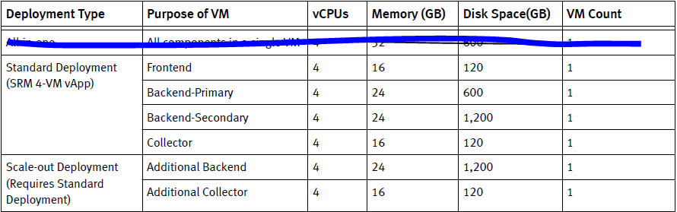

Software Requirements
EMC SRM suite: 3.5.1.0

OS platform
SOE Linux 6.x: FrontEnd, BackEnd, Collectors besides Centera Collector
SOE Windows Server 2008R2: Centera Collector
MySQL database 5.5.30: This is part of SRM installation

Additional software required for collectors:
VMAX: EMC Solution Enabler 7.6.2.24 or above
SNMP for SAN Switches
SSH for Linux Hosts/VNX File/HDS
WinRM for Windows Hosts
Navisec CLI for VNX
CIM Agent for IBM XIV
CIMOM for HDS
Centera: Centera Viewer 4.2

Required for client
Chrome browser 26.0.1410.64. (IE8 no topology support)

System/Functional Requirements

System and Network Management Test
N/A (SRM is a management tool)

You must provide email evidence showing all requirements has been met and that CitiNetwork Services team has signed off confirming their approval. Embed email evidence to 5.3.x section below. GNAST approval will not be issued without this evidence.

Smarts
Test Details/Action | N/A
Expected Results
Actual Results
Email evidence Net Serv has signed off on PLC evidence (embed email)
Additional comments | No performance or threshold alarming is considered from this certification. Server health will be monitored using host monitoring tool. Therefore, SMARTS isn’t required as part of this certification.

Pass Fail CONDITIONAL Pass

Hewlett Packard Network Automation
Test Details/Action | Windows collector  - Installing Tectia SSH TPM package  - Configure hpna id for ssh  - Collecting Windows host firewall registry  Linux SRM components  - Installing hpnaro rpm package  - Configure sudo for iptables -L  - Collecting iptables and SRM configuration files
Expected Results | Files are collected successfully.
Actual Results | All files have been collected from hpna successfully
Email evidence Net Serv has signed off on PLC evidence (embed email)
Additional comments | 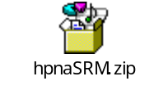

Pass Fail CONDITIONAL Pass

InfoVista
Test Details/Action | N/A
Expected Results
Actual Results
Email evidence Net Serv has signed off on PLC evidence (embed email)
Additional comments | N/A.

Pass Fail CONDITIONAL Pass

Other
Test Details/Action | N/A
Expected Results
Actual Results
Email evidence Net Serv has signed off on PLC evidence (embed email)
Additional comments | N/A

Pass Fail CONDITIONAL Pass

Technical Requirements

- Discovery/Collection of storage infrastructure components
  - EMC VMAX
  - EMC VNX block
  - EMC VNX file
  - EMC Centera
  - EMC XtremIO
  - Hitachi HDS
  - IBM XIV
  - NetApp
  - Cisco MDS fabric switch
  - Physical host with SAN storage
  - VMWare vCenter
  - Oracle database
  - Microsoft SQL Server
The following SRM Collector require elevated id privileges to function:
- VNX File Collector
- NetApp Filer Collector
- VMAX Collector
- Linux Host Collector
- Solaris Host Collector
- AIX Host Collector

Business/User Requirements

- Storage infrastructure components discovery and reporting– All SAN and NAS.
- Fabric discovery and reporting
- SAN attached Host discovery and reporting
- SAN attached Oracle Database Discovery and reporting
- Relationship Map for Storage Infrastructure
- Charge Back Reporting

Integration/Compatibility Requirements
No Integration with any Citi Databases for Device Management
No Integration with other management tools for Alerting

Performance Requirements
No Performance Requirements

Security Requirements
LDAP/AD integration,
Segregation of user administration and users.
FID password encryption
Linux firewall to block TCP:48443 request sourced from any IP address that is not SRM host.

Capacity/Stress Test Requirements
No Capacity/Stress Test Requriements.

Continuity of Business Requirements
No COB for SRM Suite

Backup & Restore Requirements
Citi standard backup/restore procedure is required.
The following data are required for backup:
- MySQL database
- Conf directory of all components

Test Scope
- Software Installation and verification
Standard installation with proper configuration and customization.
Verification to ensure communication, data access and funcationalites among components.
- Discovery
SAN Storage
- VMAX
- VNX
- HDS
- XIV
- XtremIO
NAS Storage
- NetApp
- VNX
CAS Storage
- Centera
Fabric switch
- Cisco MDS switch
Virtualized environment
- vCenter
- VM host
Physical host
- Linux
- Solaris
- AIX
- Windows
Database
- Oracle
- Microsoft SQL Server

- Topology
- Show topology map for supported storage type.
- SolutionPack report verification
- Ensure objects and associated reports are created properly.
- Security
- SRM portal with SSL
- Firewall protected for intercommunication within SRM infrastructure

Hardware
N/A

.

Software
The following is a list of software for SRM base installation as well as additional software that must be installed locally on collector in order for collector to communicate with target device.
Vendor Part /Version | Description | Build | Product O/S | Feature Set | Image Filename
EMC | SRM 3.5SP1 FrontEnd | 3.5.1.0 | Linux 6.5
EMC | SRM 3.5SP1 BackEnd | 3.5.1.0 | Linux 6.5
EMC | SRM 3.5SP1 Collector | 3.5.1.0 | Linux 6.5
EMC | SRM 3.5SP1 Collector | 3.5.1.0 | Windows 2008R2
EMC | Solutions Enabler | 7.6.1.0, 7.6,2.24 | Linux 6.5
EMC | Navisphere | 7.30.15.0.44 | Linux 6.5
EMC | Centera | 4.2 | Windows 2008R2

Test Equipment

Target test devices available are listed below:

- VMAX SAN Storage
- VNX block/Filer
- Centera
- IBM XIV
- HDS
- NetApp
- Cisco MDS switches
- VMWare vCenter
- Linux host(physical)
- Windows host(vm)
- Oracle server(vm)

Network Layout/Topology
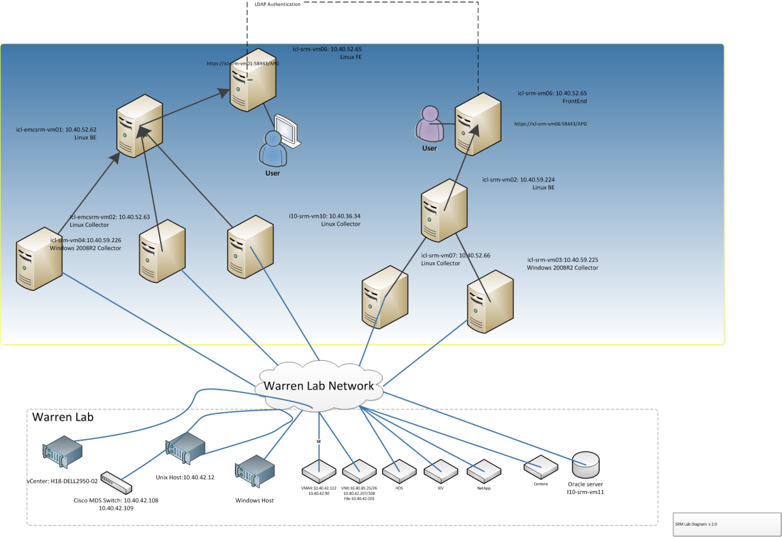

Parameter, Communication Protocol, Port
The following protocol and port number are used by SRM to communicate among different components, monitored devices including various storage types.
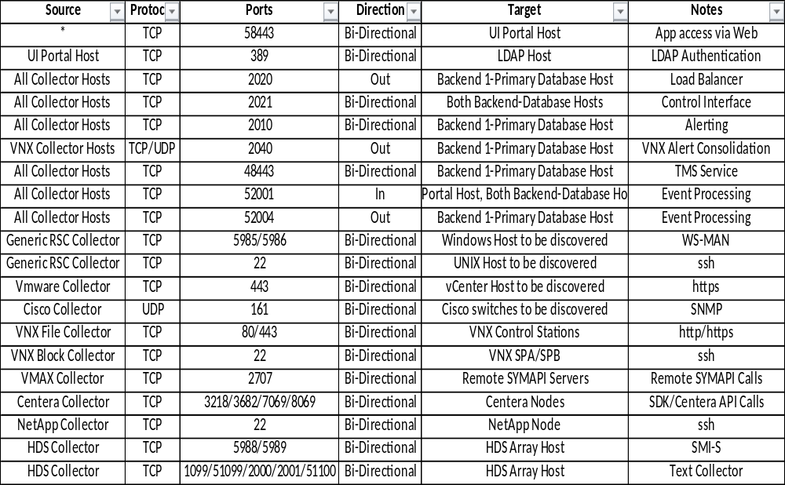

Network Addressing

SRM Test Lab Configuration
Host Name | IP Address | Role | Platform | Domain
icl-srm-vm06.nam.nsroot.net | 10.40.52.65 | FE | Linux 6.5 | CIVA
icl-srm-vm02.nam.nsroot.net | 10.40.59.224 | BE | Linux 6.5 | CIVA
icl-srm-vm07.nam.nsroot.net | 10.40.52.66 | Collector | Linux 6.5 | CIVA
icl-srm-vm03.nam.nsroot.net | 10.40.59.225 | Collector | Windows 2008R2 | CIVA
i10-srm-vm10.nam.nsroot.net | 10.40.36.34 | Collector | Linux 6.5 | CIVA
icl-srm-vm01.nam.nsroot.net | 10.40.59.223 | FE | Linux 6.5 | LAB
icl-emcsrm-vm01 | 10.40.52.61 | FE,BE | Linux 6.4 | LAB
icl-emcsrm-vm02 | 10.40.52.63 | Collector | Linux 6.4 | LAB
icl-srm-vm04.nam.nsroot.net | 10.40.59.226 | Collector | Windows 2008R2 | LAB
icl-srm-vm05.nam.nsroot.net | 10.40.52.64 | BE | Linux 6.5 | LAB

Monitored Device Configuration
Solution Type | Category | Hostname/IP, Connection name
VMAX | SAN | 10.40.53.32
VNX | SAN | 10.40.81.157, 10.40.81.158
VNX | NAS | 10.40.81.156
VNX | NAS | 10.40.85.23
Centera | NAS | 10.40.42.52
IBM XIV | SAN | 10.40.53.41, 10.40.53.42
Hitachi HDS | SAN | 10.40.59.50
NetApp | NAS | 10.40.60.73
Unisphere |  | 10.40.52.45
Cisco switch | SAN switch | 10.40.42.108, 10.40.42.109
vCenter | Vmware | 10.40.57.31
Physcial host | Linux Server | 10.40.42.12
Physcial host | Windows Server 2008R2 | 10.40.43.53
Physcial host | Windows Server 2012 | 10.40.43.51
Physcial host | Windows Server 2012R2 | 10.40.43.53
Microsoft SQL Server | Database | 10.40.36.71
Oracle Server | Database | 10.40.36.34

Testing & Results
Provide test specifications and document test results in this section. Expand the table to accommodate as many cases as required to fully test the technology standard/solution.
Only check the “Conditional Pass” box to indicate that there were issues or complexities not related to a problem with the hardware, software, or solution being tested, or were not considered sufficiently serious to mark the test as failed. For all items marked as “Conditional Pass”, enter the reason in the “additional comments” field and highlight the text in red.

Hardware Test
The purpose of this test is to verify that:
Test Details/Action | N/A
Expected Results
Actual Results
Additional comments | No hardware is used or involved in this test

Pass Fail CONDITIONAL Pass

Software Test
The purpose of this test is to verify that: Software installation and functionalities
Test Details/Action | - Package installation according to standard instruction instructions  - Customization
Expected Results | User is able to log into Portal
Actual Results | Login https://icl-srm-vm01:58443/APG with AD credential  admin user is able to log in  admin is able to perform user and administration functions  all registered servers show with status
Additional comments | 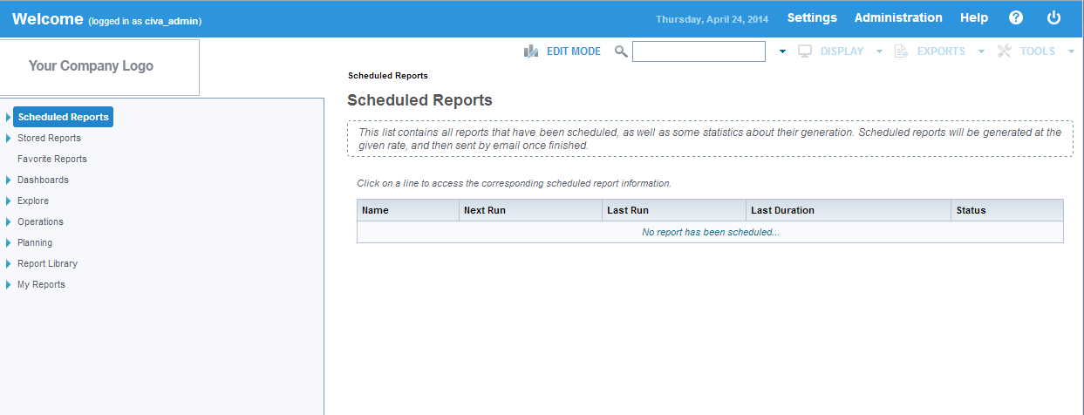  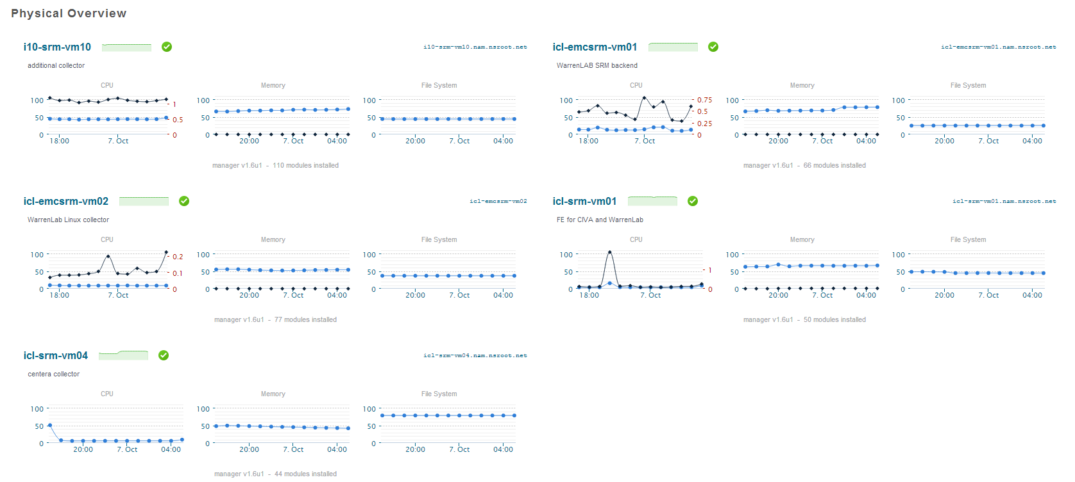

Pass Fail CONDITIONAL Pass

System/Functional Test
The purpose of this test is to verify that: License Mananager
Test Details/Action | - License can be loaded and synchronized across all components
Expected Results | All components are synchronized with current valid license
Actual Results | All components are synchronized with current valid license
Additional comments | 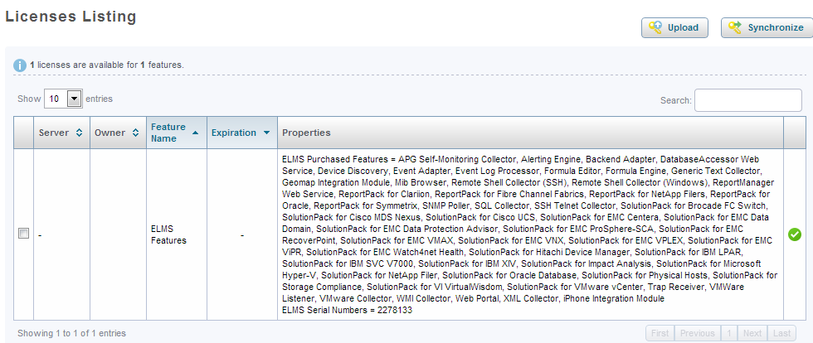

Pass Fail CONDITIONAL Pass

The purpose of this test is to verify that: Services are running on all components
Test Details/Action | - Verify services are running properly from FE, BE and collectos
Expected Results | All services are running OK
Actual Results | All services are running OK
Additional comments | FE:  # /opt/APG/bin/manage-modules.sh service status all  * Checking 'maps-service Default'... [ running ]  * Checking 'webservice-gateway Default'... [ running ]  * Checking 'collector-manager emc-watch4net-health'... [ running ]  * Checking 'tomcat Default'... [ running ]  * Checking 'task-scheduler Default'... [ running ]  BE”  /opt/APG/bin/manage-modules.sh service status all  * Checking 'topology-mapping-service Default'... [ running ]  * Checking 'topology-service Default'... [ running ]  * Checking 'webservice-gateway Default'... [ running ]  * Checking 'mysql Default'... [ running ]  * Checking 'alerting-backend Default'... [ running ]  * Checking 'backend Default'... [ running ]  * Checking 'collector-manager Generic-RSC'... [ running ]  * Checking 'collector-manager Load-Balancer'... [ running ]  * Checking 'collector-manager emc-watch4net-health'... [ running ]  * Checking 'event-processing-manager Alert-Consolidation'... [ running ]  * Checking 'event-processing-manager emc-vnx'... [ running ]  * Checking 'event-processing-manager vmware-vcenter'... [ running ]  * Checking 'task-scheduler Default'... [ running ]  Collector:  # /opt/APG/bin/manage-modules.sh service status all  * Checking 'topology-mapping-service Default'... [ running ]  * Checking 'webservice-gateway Default'... [ running ]  * Checking 'collector-manager Generic-RSC'... [ running ]  * Checking 'collector-manager Generic-SNMP'... [ running ]  * Checking 'collector-manager emc-watch4net-health'... [ running ]  * Checking 'collector-manager hitachi-device-manager'... [ running ]  * Checking 'collector-manager ibm-xiv'... [ running ]  * Checking 'collector-manager netapp-filer'... [ running ]  * Checking 'collector-manager oracle-database'... [ running ]  Windows Collector:  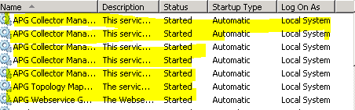

Pass Fail CONDITIONAL Pass

Technical Test
The purpose of this test is to verify that: Cisco MDS switch discovery and report
Test Details/Action | - Configuring discovery source and Cisco MDS switch credential  - Capability discovery  - Assigning collector  - Configuration sync to collector
Expected Results | Devices are discovered with predefined capability on specified collector  Reports are available
Actual Results | Devices are discovered with predefined capability on specified collector  Reports are available
Additional comments | One bug noticed  Frontend https url must be manually configured in file PTF-ViPR-Tagging.xml  For example: https://icl-srm-vm01.nam.nsroot.net:58443/APG-WS/wsapi/db  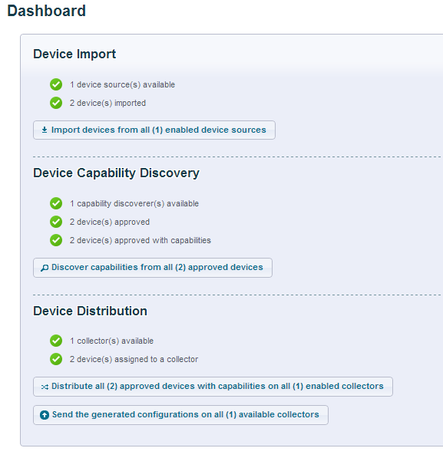  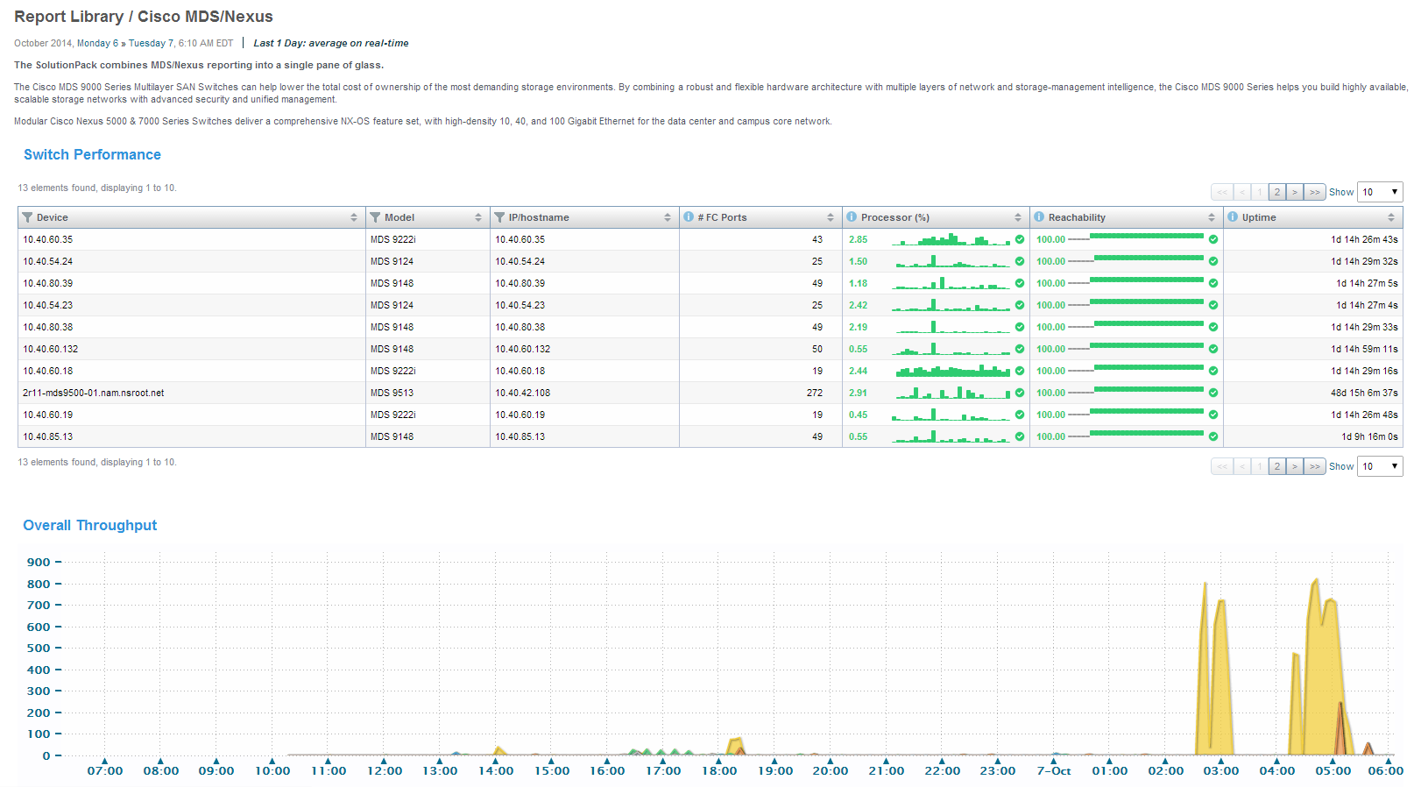

Pass Fail CONDITIONAL Pass

- Generic SNMP Collector (Cisco) – There remains an issue with the Property Store enforcing HTTP when the Generic SNMP Collector is reconfigured. EMC engineering will fix this in a future release – Bin to provide comment. Please see the Appendices

The purpose of this test is to verify that: VMAX Discovery and reporting
Test Details/Action | - Install and Configure VMAX solutionPack if it’s not installed  - Force discovery and data collection
Expected Results | VMAX device from Explore with data
Actual Results | VMAX device from Explore with data
Additional comments | 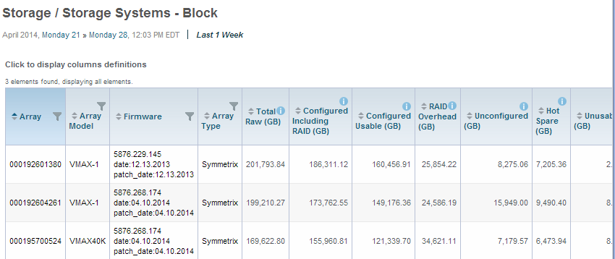

Pass Fail CONDITIONAL Pass

- VMAX Collector Errors – CATE has observed that on occasion the following Error message is seen in the VAMX Collector Logs:
WARNING -- [2014-09-16 03:15:50 EDT] -- XMLCollector::a(): Invalid raw value for variable VMAX-Collector000192604261StoragePoolglab261_13RemoveMeZero. Dropping...
“RemoveMeZero” variables are used in many areas to aid handling of some blank values. This error can be safely ignored.

The purpose of this test is to verify that: VNX discovery and reporting
Test Details/Action | - Install naviseccli package on Linux collector  - Install VNX SolutionPack if it isn’t installed  - Configure VNX SolutionPack for unified storage array
Expected Results | Block and File instances/reports in EMC VNX under Report Library
Actual Results | Two block type array and one file type array shown in the reportpack
Additional comments | 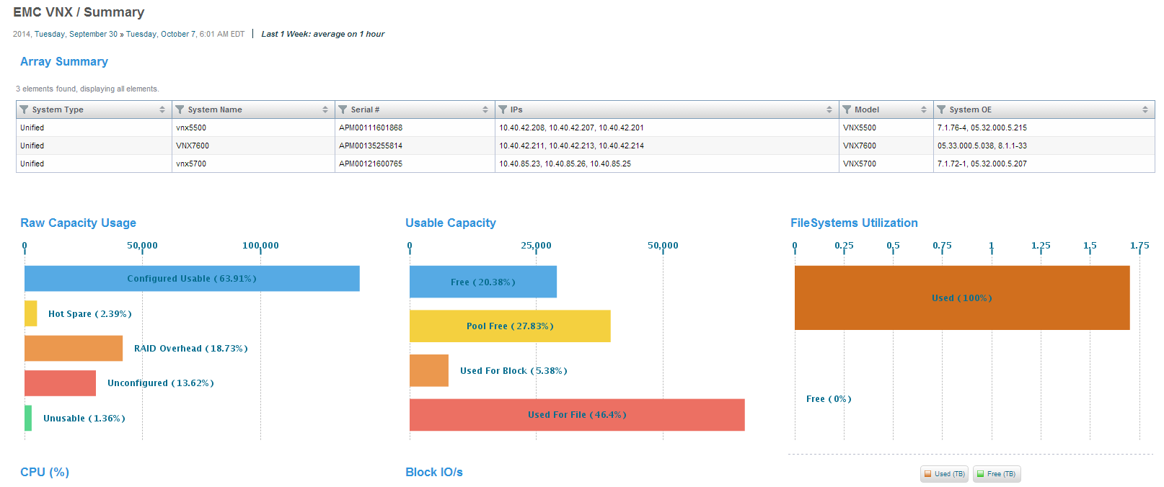  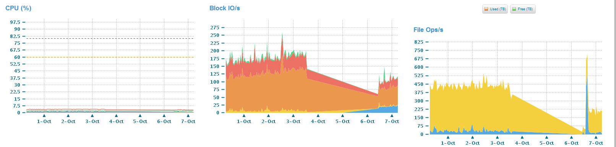

Pass Fail CONDITIONAL Pass

- VNX Array Workload Distribution does not select any data – this was a code bug introduced in SRM 3.5.1. A workaround has been provided by EMC. Please see Appendices

The purpose of this test is to verify that: HDS Discovery and reporting
Test Details/Action | - Install HDS SolutionPack on Linux collector if it isn’t installed already  - Configure and discover HDS
Expected Results | HDS instance and reports are available under Report Library
Actual Results | HDS instance and reports are available under Report Library
Additional comments | 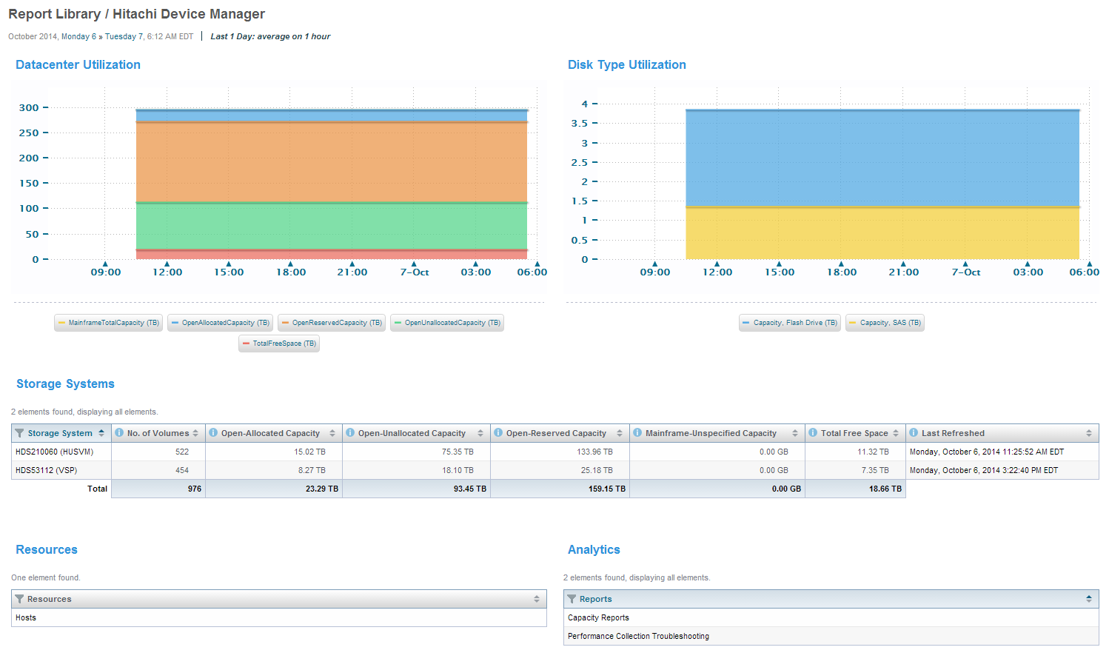

Pass Fail CONDITIONAL Pass

The purpose of this test is to verify that: IBM XIV Discovery and reporting
Test Details/Action | - Install IBM XIV SolutionPack on Linux collector if it isn’t installed already  - Configure and discover XIV
Expected Results | XIV instance and reports are available under Report Library
Actual Results | XIV instance and reports are available under Report Library
Additional comments | 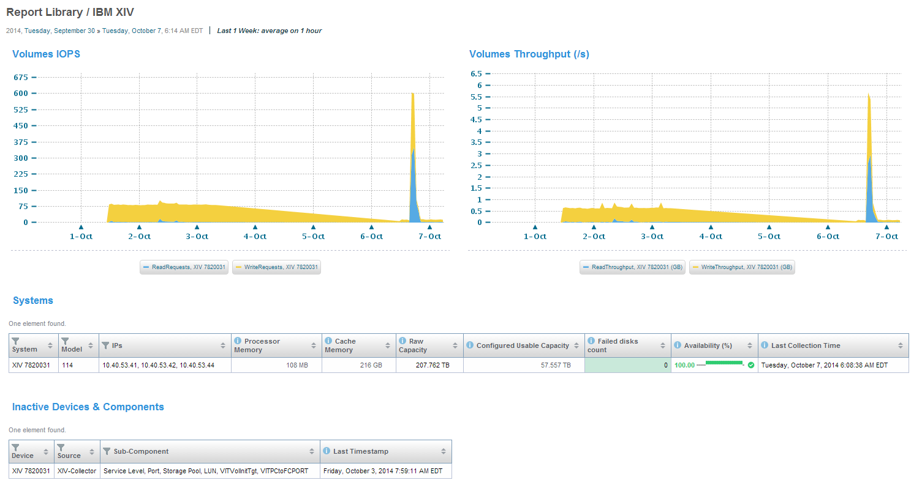

Pass Fail CONDITIONAL Pass

- XIV Collector – Due to an issue with the IBM XIV firmware and using an AD account to discover the XIV it is required that a simple cron job run on the XIV management server to enable caching of the AD account credentials. IBM will fix this in a future release of firmware in 2015. Details of the CATE workaround are found in: https://catecollaboration.citigroup.net/domains/platstor/gdse/products/platforms/IBM%20XIV/CSBE-14020-RN.pdf
- XIV Collector – CATE has observed that during the XIV collection each collection command is sent individually to 1 of the 3 management IP addresses. If the 1st IP is available the command will execute successfully. If it is unavailable a timeout will occur and the 2nd IP address will receive the command. However when the next command is issued it yet again is sent to the failed 1st IP address and a timeout will again occur. We have requested an enhancement to EMC to change this behavior as it is possible that as a result of the timeouts not all the collection commands will be issued in the collection window.

The purpose of this test is to verify that: NetApp Filer Discovery and reporting
Test Details/Action | - Install NetApp Filer SolutionPack on Linux collector if it isn’t installed already  - Configure and discover NetApp
Expected Results | NetApp Filer instance and reports are available under Report Library
Actual Results | NetApp Filer instance and reports are available under Report Library
Additional comments | 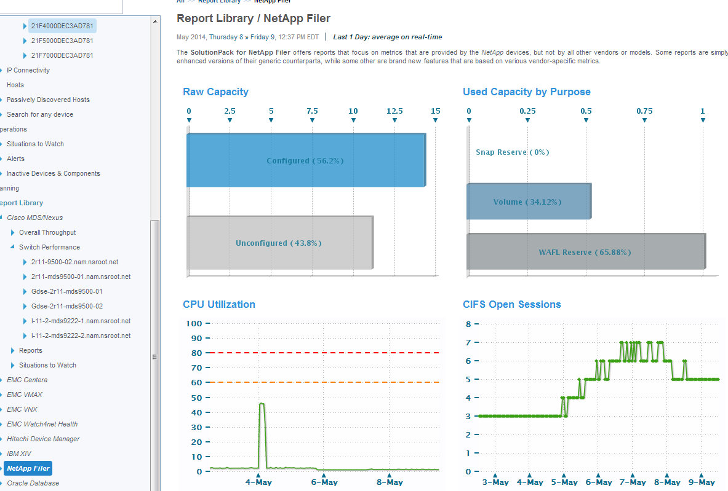

Pass Fail CONDITIONAL Pass

**NOTE: This NetApp discovery has been carried out using the default EMC method. This method uses commands which could be used to modify settings on the NetApp filer and as such this presents a security issue for Citi. NetApp discovery with this method will not at this time be certified. Alternative methods are being explored.

The purpose of this test is to verify that: Centera Discovery and reporting
Test Details/Action | - Install Centera SolutionPack on Windows collector if it isn’t installed already  - Configure and discover Centera
Expected Results | Centera instance and reports are available under Report Library
Actual Results | Centera instance and reports are available under Report Library
Additional comments | 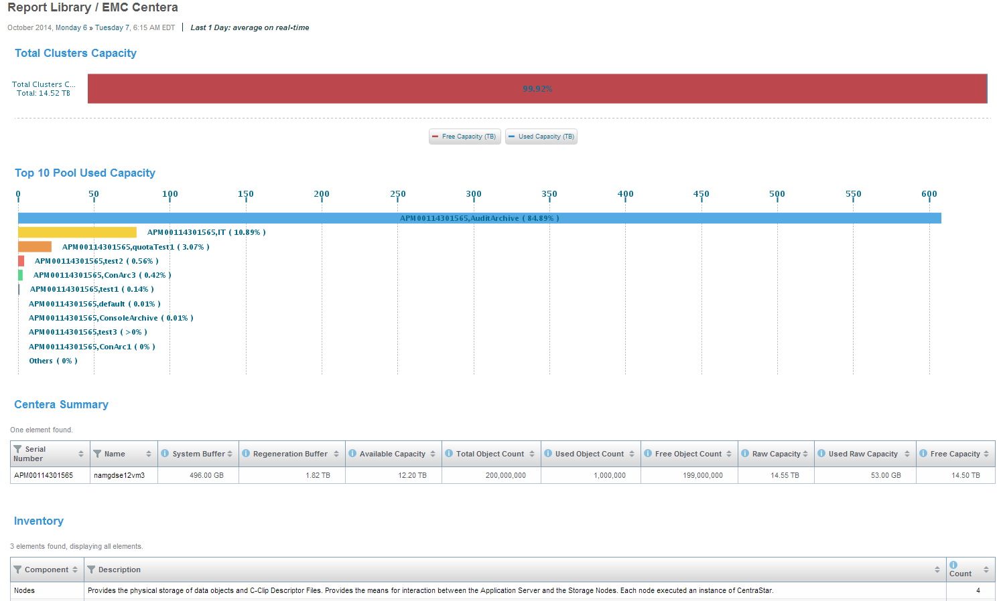

Pass Fail CONDITIONAL Pass

- Centera Collection Errors – CATE has observed that on occasion the following Error message is seen in the Centera Collector Logs:
WARNING -- [2014-09-10 19:10:27 EDT] -- PatternExtraction::extract(): Couldn't extract pattern (?s).*Total Raw Capacity:\s*(\S+)\s(\S+).*Used Raw Capacity:\s*(\S+)\s(\S+).*Free Raw Capacity:\s*(\S+)\s(\S+).*System Resources:\s*(\S+)\s(\S+).*Offline Capacity:\s*(\S+)\s(\S+).*Spare Capacity:\s*(\S+)\s(\S+).*Used Capacity:\s*(\S+)\s(\S+).*Metadata:\s*(\S+)\s(\S+).*Protected User Data:\s*(\S+)\s(\S+).*Used Object Count:\s*(\S+)\s(\S+).* for entry ' Centera interactive shell (Implementation CLI 4.2.2189, 2011-07-12) Could not connect srv_emc_srm [10.40.42.52:3682] Disconnected.
This is an intermittent problem in connecting to the Centera viewer (port 3682), And can be safely ignored.
The purpose of this test is to verify that: Physical Host (Linux) Discovery and reporting
Test Details/Action | - Install Physical Host SolutionPack if it isn’t installed already  - Configure FID, key pair, sudo  - Configure and discover Linux host
Expected Results | Linux Host instance and reports are available under Report Library
Actual Results | Linux Host instance and reports are available under Report Library
Additional comments | 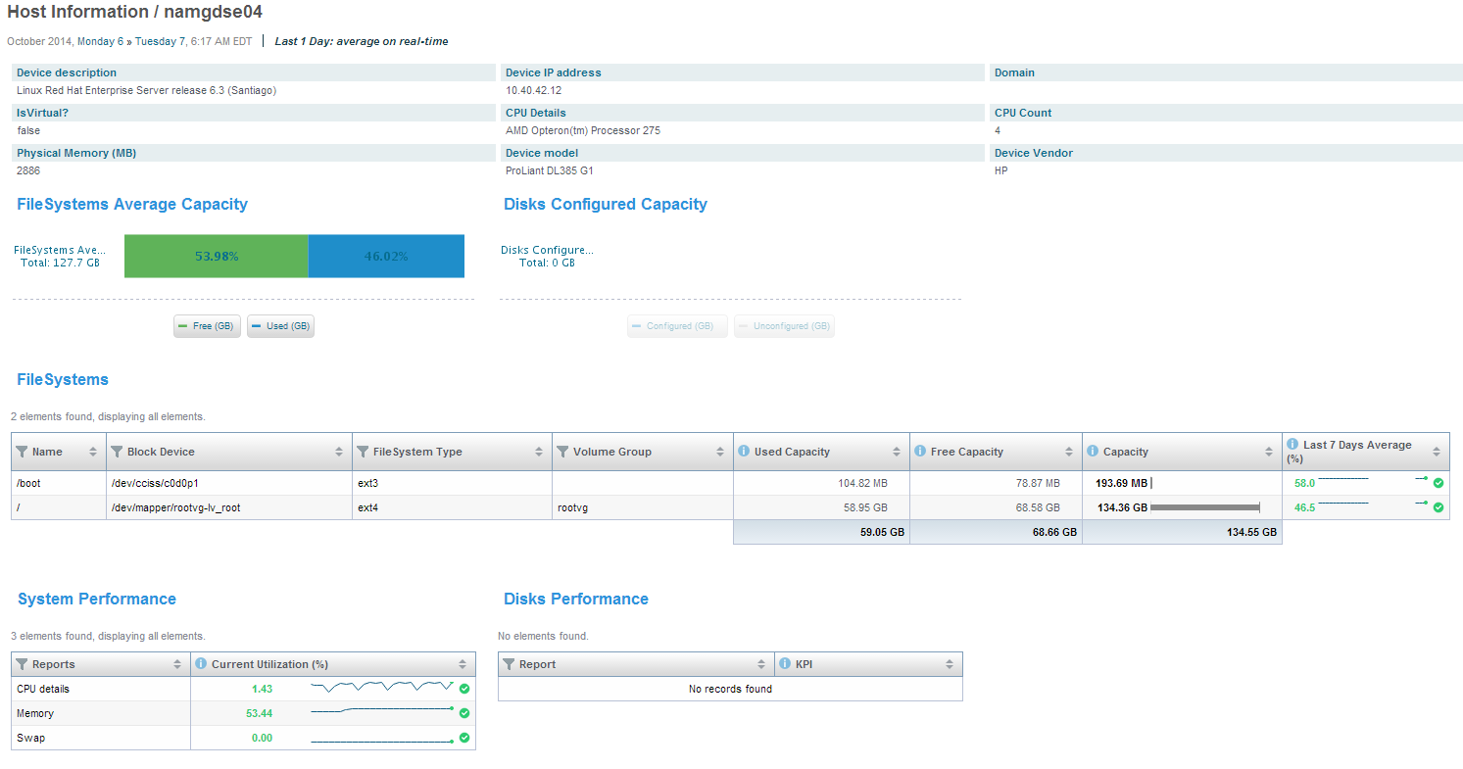

Pass Fail CONDITIONAL Pass

- Generic-SSH Collector – Possible Infinite wait for ssh script-engine. EMC Engineering ticket is opened to address this Trac-11452. No ETA.
The purpose of this test is to verify that: Physical Host (Solaris) Discovery and reporting
Test Details/Action | - Install Physical Host SolutionPack if it isn’t installed already  - Configure FID, key pair, sudo  - Configure and discover Solaris host
Expected Results | Solaris Host instance and reports are available under Report Library
Actual Results | Solaris Host instance and reports are available under Report Library
Additional comments | 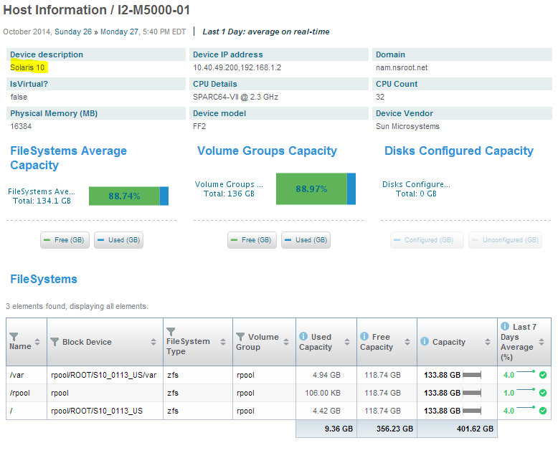  Note: sudo is required for this test. The customized sudo package is made available

Pass Fail CONDITIONAL Pass

The purpose of this test is to verify that: Physical Host (AIX) Discovery and reporting
Test Details/Action | - Install Physical Host SolutionPack if it isn’t installed already  - Configure FID, key pair, sudo  - Configure and discover AIX host
Expected Results | AIX Host instance and reports are available under Report Library
Actual Results | AIX Host instance and reports are available under Report Library
Additional comments | Note: sudo is required for this test. The test was performed from the only available test server. It is marked as conditional pass for this reason

Pass Fail CONDITIONAL Pass

The purpose of this test is to verify that: Physical Host (Windows) Discovery and reporting
Test Details/Action | - Install Physical Host SolutionPack if it isn’t installed already  - Ensure Citi WMF package is installed on hosts  - Ensure WinRM using URLPrefix wsciti, port 50080, http  - Configure collector using custom port 50080  - discover Windows host
Expected Results | Windows Host instance and reports are available under Report Library
Actual Results | Windows host can be discovered only with AllowUnencrypted=false
Additional comments | SRM Physical host solutionpack doesn’

Pass Fail CONDITIONAL Pass

The purpose of this test is to verify that: Oracle Database discovery and reporting
Test Details/Action | - Install Oracle SolutionPack if it isn’t installed already  - Configure and discover Oracle
Expected Results | Oracle Database reports shown under report libraray
Actual Results | Oracle Database reports shown under report libraray  Due to unavailability of Oracle Database server with SAN, the report doesn’t contain data for SAN
Additional comments | XML DB is not a Citi certified standard  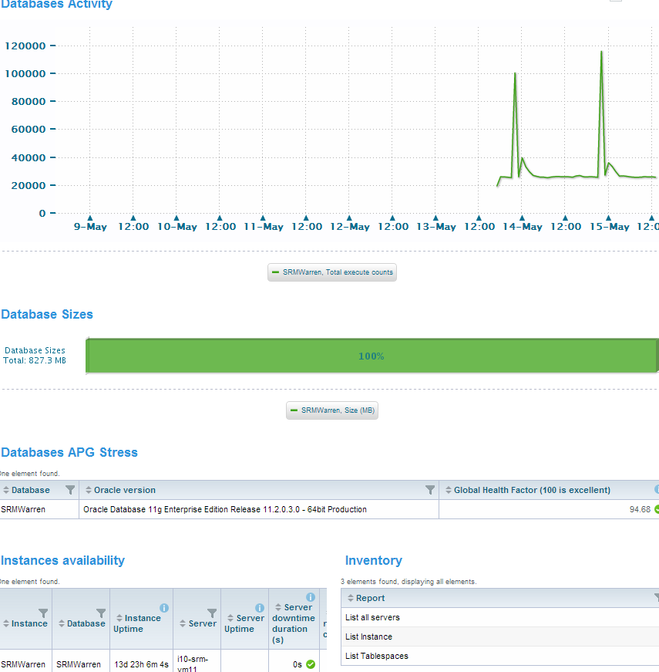

Pass Fail CONDITIONAL Pass

The purpose of this test is to verify that: VMWare vCenter discovery and reporting
Test Details/Action | - Install vCenter SolutionPack if it isn’t installed already  - Configure and discover vCenter
Expected Results | vCenter reports shown under report libraray  vmhosts are discovered
Actual Results | vCenter reports shown under report libraray  vmhosts are discovered
Additional comments | 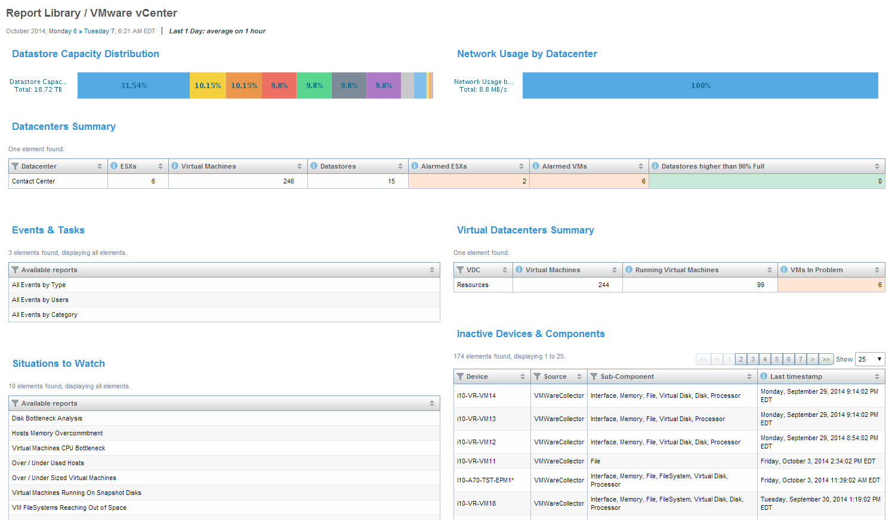  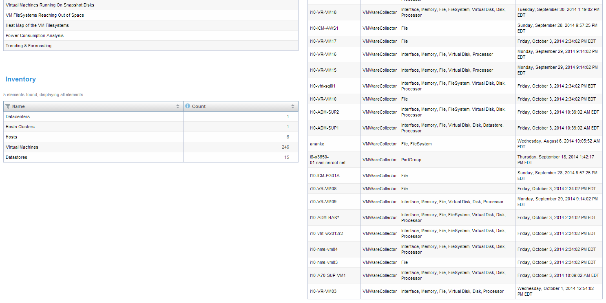

Pass Fail CONDITIONAL Pass

The purpose of this test is to verify that: Microsoft SQL Server discovery and reporting
Test Details/Action | - Install Microsoft SQL Server SolutionPack if it isn’t installed already  - discover Microsoft SQL Server
Expected Results | Microsoft SQL Server instance and reports are available under Report Library
Actual Results | Microsoft SQL Server instance and reports are available under Report Library
Additional comments | 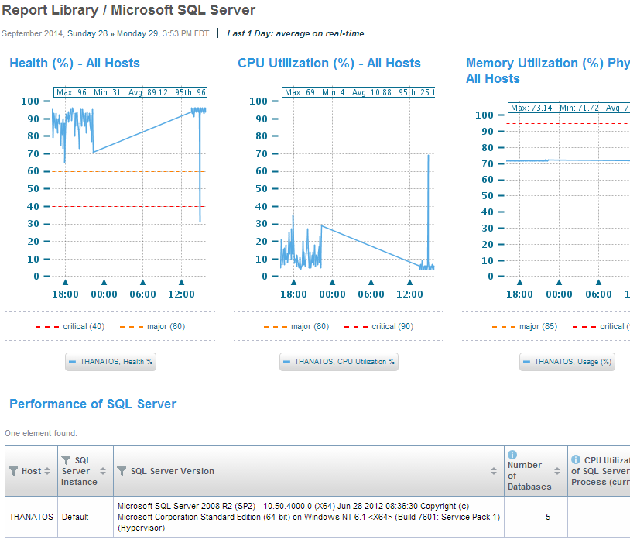

Pass Fail CONDITIONAL Pass

The purpose of this test is to verify that: XtremIO storage discovery and reporting
Test Details/Action | - Install XtremIO SolutionPack if it isn’t installed already  - Configure and discover XtremIO
Expected Results | XtremIO reports shown under report libraray
Actual Results | XtremIO reports shown under report libraray
Additional comments | 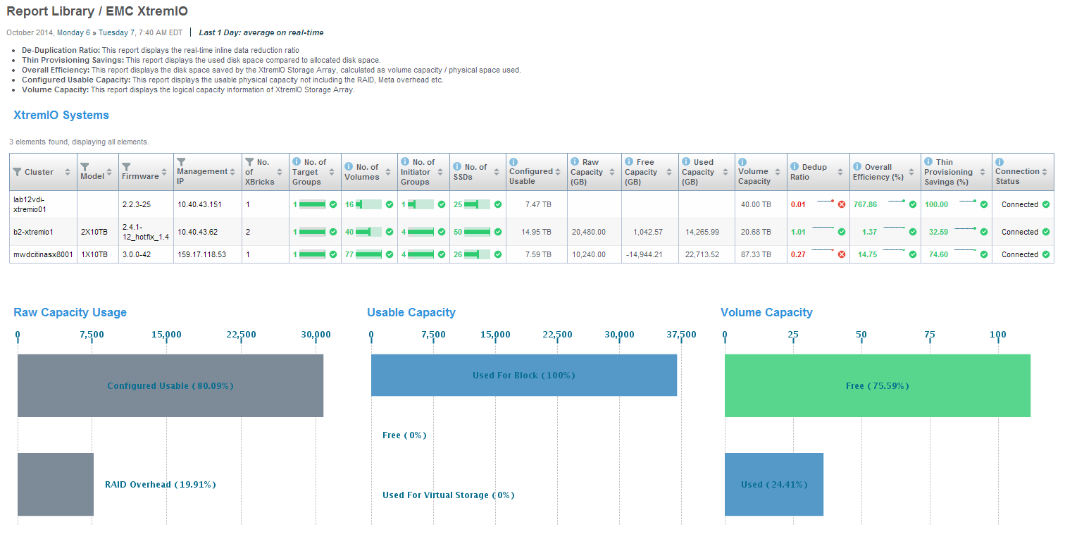  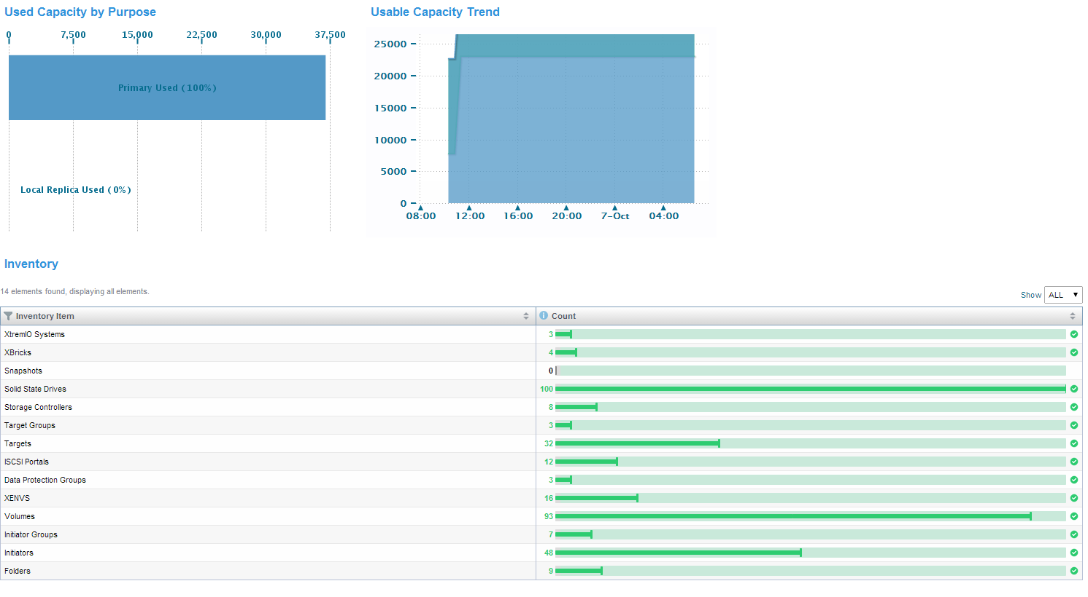  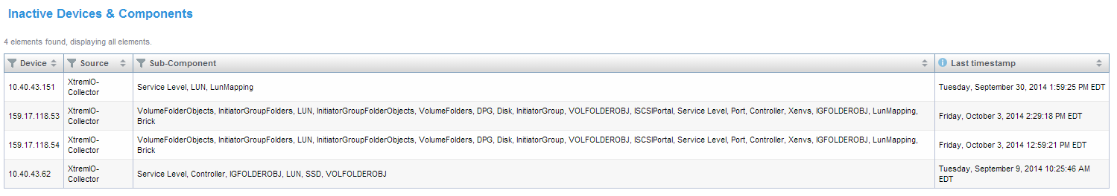

Pass Fail CONDITIONAL Pass

- XTremIO Collector – Due to an issue with the XtremIO firmware it is not possible to use an AD account to discover the XIO. Discovering the XIO with and AD account causes the XMS service to crash, therefore you are unable to manage the XIO. The workaround is to create a local read-only account and discover the XIO with this local account.
- XTremIO Performance Dashboard – There is an issue with the XtremIO Performance dashboard whereby changing the time range over which to display the performance metrics does not take effect in the dashboard display. EMC have provided a workaround for this. Please see the Appendices.
The purpose of this test is to verify that: Topology map
Test Details/Action | - Topology map availabile from Storage, host, passive discovered host, physical discovered host
Expected Results | - Topology map availabile from Storage , host, passive discovered host, physical discovered host
Actual Results | - Topology map availabile from Storage, host, passive discovered host, physical discovered host
Additional comments | 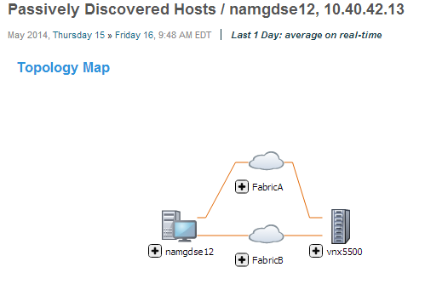  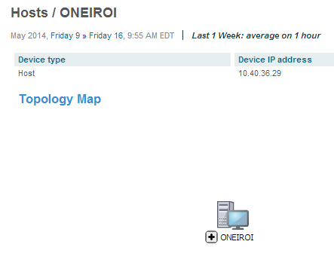  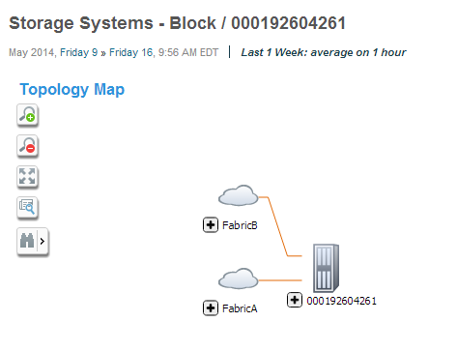  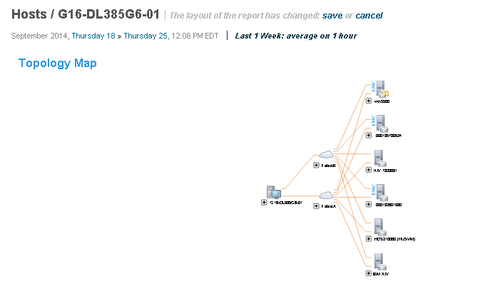
Pass Fail CONDITIONAL Pass

Business/Unit Test
The purpose of this test is to verify that: Charge back report
Test Details/Action | - Based on discovered device and solution the chargeback reports apply to all applicable hosts  - Explore to Storage, Chargeback by Host
Expected Results | Visible category and count for charge back.
Actual Results | Visible category and count for charge back.
Additional comments
Additional comments | 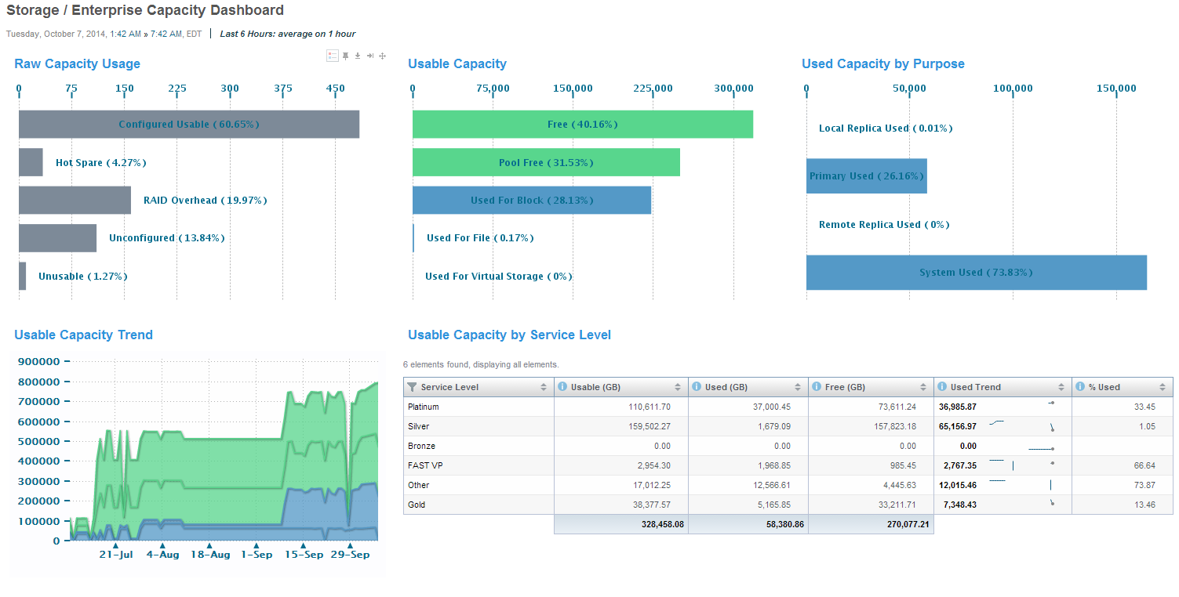  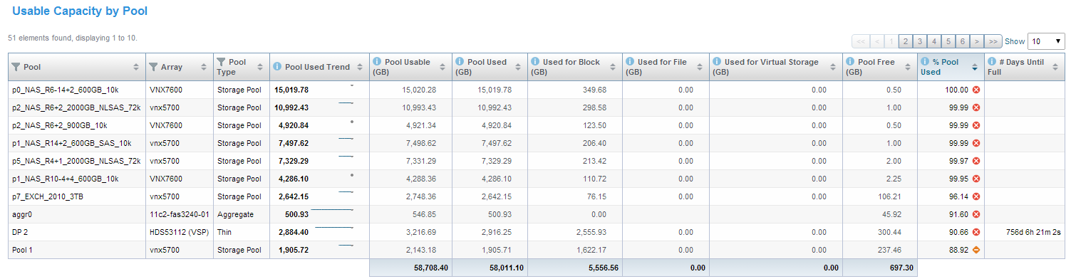  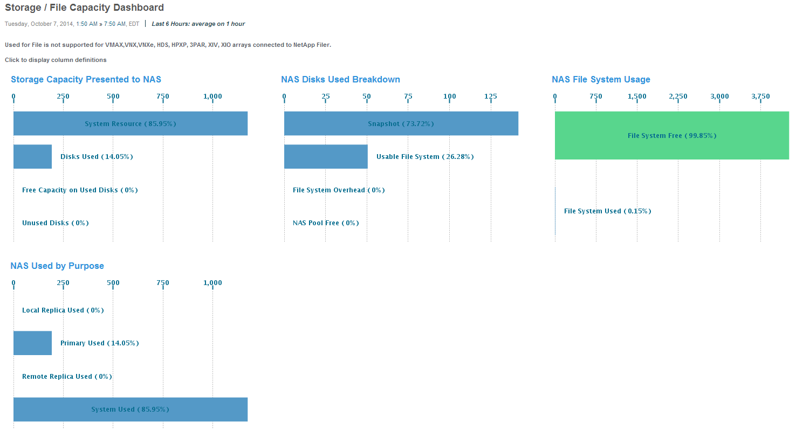  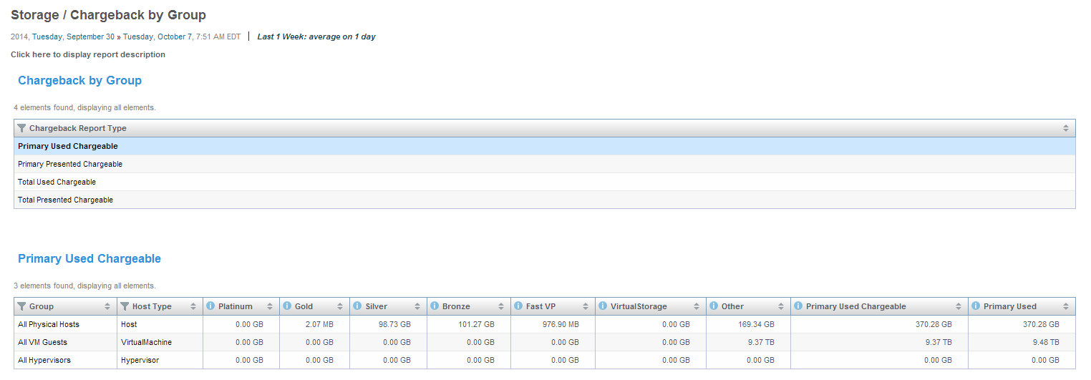  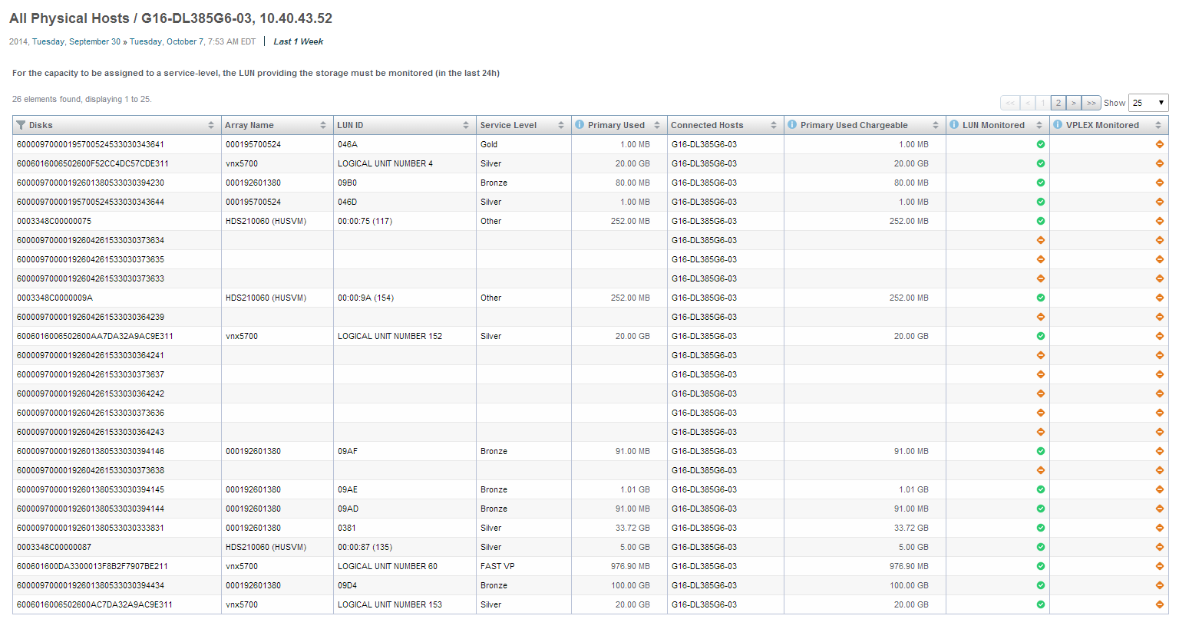  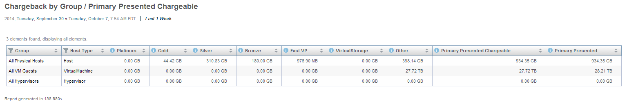  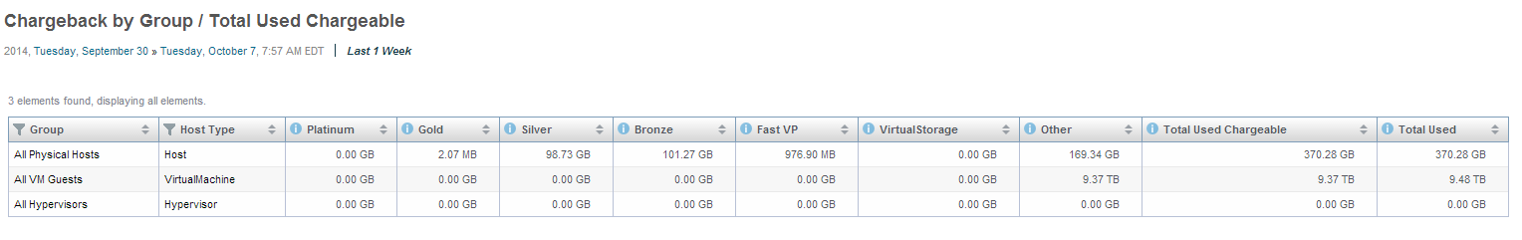  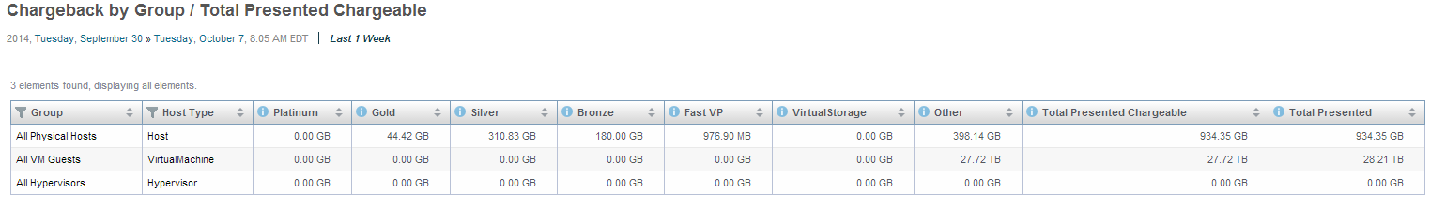

Pass Fail CONDITIONAL Pass

Integration/Compatibility Test
The purpose of this test is to verify that: N/A
Test Details/Action | N/A
Expected Results
Actual Results
Additional comments | N/A

Pass Fail CONDITIONAL Pass

Performance Test
The purpose of this test is to verify that: Cisco MDS switch data collection at set interval
Test Details/Action | - Default 5 minute(300) polling group for performance data  - Verify available data point are at expected interval
Expected Results | Data point time stamp interval is close to 5 minutes
Actual Results | Time stamps are randomly longer than configured value
Additional comments | Generic snmp collector is sending large amount of requests to target switch. Depending on device and network condition as well as the load on collector, following requests are skipped. This results into data gaps for short polling groups.  Polling group configured 10 minutes or more is expected to be working properly.

Pass Fail CONDITIONAL Pass
The purpose of this test is to verify that: Unix physical host performance impact at set interval
Test Details/Action | - Default 5 minute(300) polling group for performance data  - Verify available data point are at expected interval
Expected Results | Noticeable performance overhead increase
Actual Results | Performance overhead on target Unix host is negligible
Additional comments | .

Pass Fail CONDITIONAL Pass

Security Test
The purpose of this test is to verify that: Portal Login using SSL
Test Details/Action | - Tomcat server is configured with SSL and approved Citi cipher standard  - User login  - Verify no impact from functionalities
Expected Results | User functions are normal after using ssl
Actual Results | User functions are normal when login using https
Additional comments

Pass Fail CONDITIONAL Pass

The purpose of this test is to verify that: Linux ACL to secure open ports
Test Details/Action | - Configure and apply Linux firewall using iptables and restrict access to open ports, including 48443, only from specified SRM component IP as source addresses.  - Firewall rules applied to all Linux components  - Inspect component status as normal  - Using telnet and web browser to access 48443 from any IP other than listed IPs, failed
Expected Results | SRM infrastructure works properly. Request to open port from IP outside IP list is rejected
Actual Results | SRM infrastructure works properly. Request to open port from IP outside IP list is rejected
Additional comments | IPTables is not a certified configuration on SOE Linux

Pass Fail CONDITIONAL Pass

The purpose of this test is to verify that: Windows Firewall to secure open port
Test Details/Action | - Apply GPO from domain controller to enable Windows host firewall.  - Configure block rules from local group policy only allow frontend IP accessing port 48443  - Enable rule  - Using telnet and web browser to access 48443 from any IP other than frontend IP and failed  - SRM works as normal
Expected Results | SRM infrastructure works properly. Request to port 48443 from any IP address other than FrontEnd IP list is rejected
Actual Results | SRM infrastructure works properly. Request to port 48443 from any IP address other than FrontEnd IP list is rejected
Additional comments | Windows Firewall is not a certified configuraiton for Windows SOE  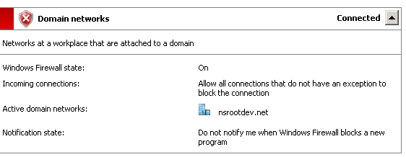

Pass Fail CONDITIONAL Pass

The purpose of this test is to verify that: SRM service on Windows collector utilizing FID
Test Details/Action | - Stop all SRM services  - Changing SRM services “log on” from localsystem to functional account, srm_svc, namdev srm functional account.  - Starting all services and monitoring service status
Expected Results | All services start and run properly without error
Actual Results | Services except gateway service failed to start
Additional comments | EMC does not support SRM service running as account other than localsystem

Pass Fail CONDITIONAL Pass

Capacity/Stress Test
The purpose of this test is to verify that:
Test Details/Action | N/A
Expected Results
Actual Results
Additional comments | This will have to be validated in deployment phase

Pass Fail CONDITIONAL Pass

Continuity of Business Test
The purpose of this test is to verify that:
Test Details/Action | N/A
Expected Results
Actual Results
Additional comments | Not required

Pass Fail CONDITIONAL Pass

Backup & Restore Test
The purpose of this test is to verify that:
Test Details/Action | N/A
Expected Results
Actual Results
Additional comments | This would be a BAU task

Pass Fail CONDITIONAL Pass

Glossary/Definition

Term or Acronym | Explanation or Definition
CATE | Citi Architecture & Technology Engineering
GNAST | Global Network Architecture and Standards Team
NMS | Network Management System
FE | SRM Front-End
BE | FRM Back-End

Appendix

External References
- Vendor resource
- CATE SRM Document

Bill of Material
For Bill of Material (BoM) include a list of all hardware, software, and components. DO NOT list price, discount level.

Configuration & Results Log
Where applicable, insert detailed log files captured from console sessions. All logging sessions must be time-stamped.

VNX Heat Map Does not Select Any Data - Workaround
Below are the steps to fix the report at 3.5 SP1.
- Navigate to All>>Operations>>Workload Distribution>>Array Workload Distribution>>VNX
- Click on Edit Mode
- Click on 'Report Details: Tree Map' tab
a) In the 'Size' field, set the filter to name=='TotalThroughput'
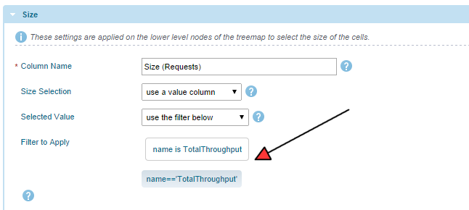

b) In the 'Color' field, set the Column Name to "Color (Bandwidth Mb/s)" (replace the word Throughput with Bandwidth). Also, expand the Value Settings section and set Scaling Mode to "none"

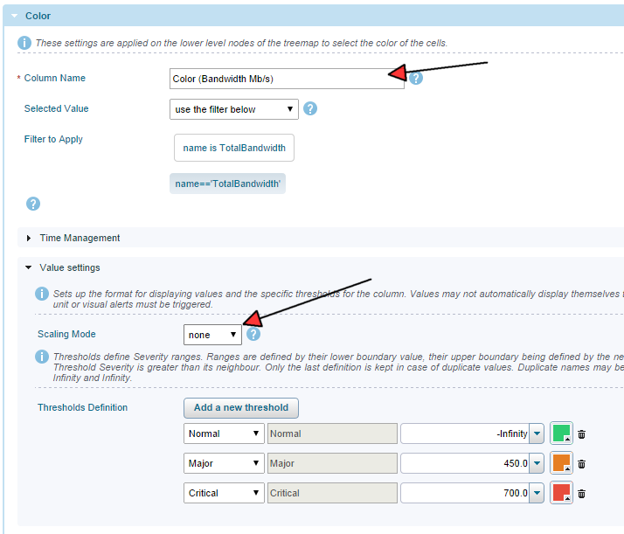
c) Click Save
4) Move down one node in the tree to All>>Operations>>Workload Distribution>>Array Workload Distribution>>VNX>>List of Array. Repeat steps 3a-c on this node
5) Move down one node in the tree to All>>Operations>>Workload Distribution>>Array Workload Distribution>>VNX>>List of Array>>Storage Processor. Repeat steps 3a-c on this node
6) Move down to the following node: All>>Operations>>Workload Distribution>>Array Workload Distribution>>VNX>>List of Array>>Storage Processor>>Array Port Performance Details/Metrics>>Mixed Report>>Ports
a) Click on "Report Details: Table" tab
b) Expand the Value: Requests (IOPS) section
c) Set the filter to name=='WriteThroughput' | name=='ReadThroughput'
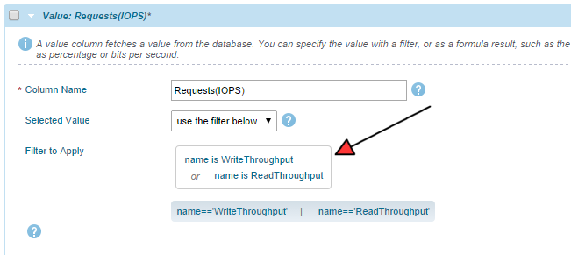
d) Expand the Value: Throughput (Mb/s) section
e) Rename the column to Bandwidth (Mb/s)
f) Set the filter to name==ReadBandwidth or WriteBandwidth
g) Expand the Value Settings section and set Scaling Mode to "none"

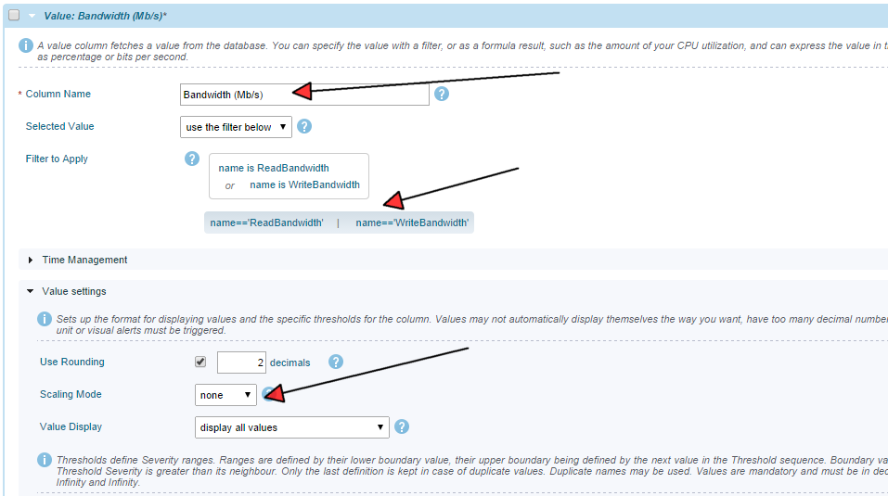
h) Click Save

XTremIO Performance Dashboard Display – Workaround
This workaround has been provided by EMC. EMC are considering changing this behavior in a future release, however they do not for some reason see the inability ti rescale the time range of these dashboards as an issue.
The nodes highlighted in the below screen shot is actually hidden in the tree, but only made to show in the report (Right side). The Display > Time Range Quick Switch works only for the node which is not hidden and is currently selected. For example, in the below screen shot, I made it visible, Selected it, and then changed it to Last Quarter. It changed as expected.

To hide to many subnode under the XtremIO System, we have purposefully hidden these Capacity Summary and its node. If they want this to be changed then they can edit the report and make each of the node under Capacity Summary as “Always show this node” as shown in the second screenshot below.

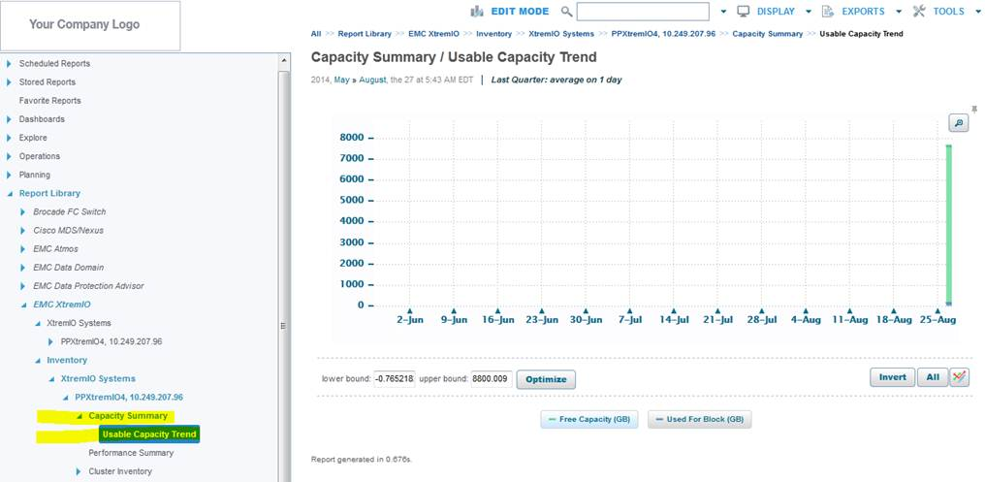

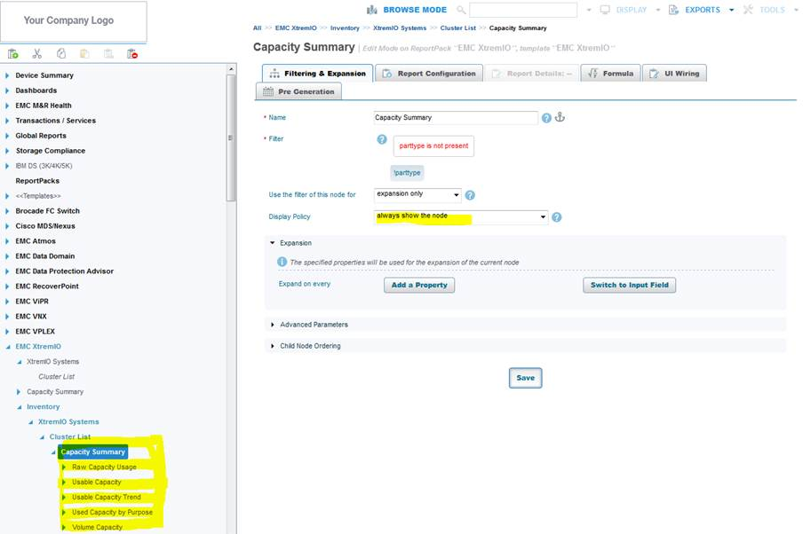

Cisco SNMP Discovery HTTP is not enforced in Property Store – Workaround
Awating screenshot from CB(me:)

