EMC ViPR SRM
Operational Runbook

Abstract
This is an operational runbook for
the global rollout of ViPR SRM at Citi.

March 2015

Contents
Discovery Activity Requirements (by platform) 3
Network Latency Requirements 3
Network Firewall Ports 3
EMC VMAX 4
EMC VNX 5
EMC XtremIO 5
EMC Centera 6
HDS 6
IBM XIV 7
NetApp 7
Cisco Switches 8
VMware (vCenter) 9
Daily Health-checks 10
Initial login report 10
Troubleshooting 10
Discovery or Reporting? 10
Discovery – Verifying collector status via logs 14
Viewing the “collection-0-0.log file with “tail” view or the file in its entirety 15

Discovery Activity Requirements (by platform)

Network Latency Requirements

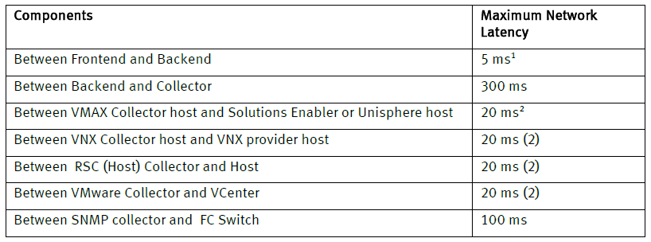
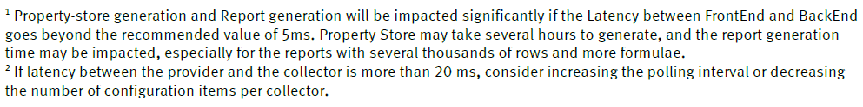

Network Firewall Ports
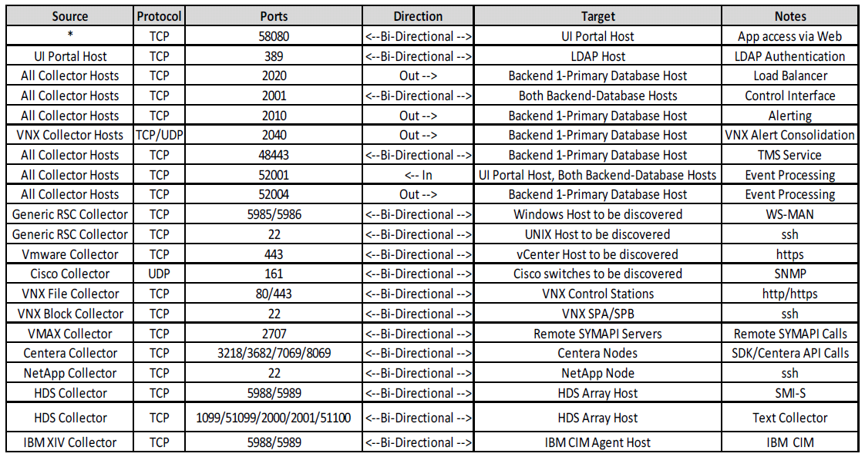

EMC VMAX
Supported Models
- DMX-3 series
- DMX-4 and DMX-4 950 series
- VMAX series
- VMAX SE series
Prerequisites
- Solutions Enabler 7.6.2.8 and later
- Unisphere for VMAX 1.6.2 and later (must be setup to collect performance data)
- SMI-S Provider 4.6.2 and later (required for LUN-level performance metrics)
- Symmetrix communications occur via Gatekeeper devices.
  - Option 1 (Remote Mode) – Assign 2 additional gatekeepers to existing SYMAPI server. SRM will utilize the existing SYMAPI server to communicate with the Symmetrix devices via SYMCLI. No additional software will need to be installed on the SYMAPI server. In the event that the SYMAPI server uses a “nethost” file, ensure the collector hostname or IP address is included (e.g. “vm-29810564 *”).
  - Option 2 (Local Mode) – Assign 2 additional gatekeepers to existing SYMAPI server. Install the VMAX Collector on the SYMAPI server (or a unique server if desired).
- If using ACLs, SRM will run SYMCLI commands as user “srmadmin”.
- Symmetrix Authorization (symauth) requirements are as follows:
  - For Solutions Enabler 7.6.2.25 and higher, only the Monitor role is required for the “srmadmin” user.
  - For versions of Solutions Enabler lower than 7.6.2.25, Admin or Storage Admin is required for the “srmadmin” user.
- The “srmadmin” user requires permission to access the storapid daemon in the “daemon_users” file.
- For Symmetrix Access Control (symacl, if enabled), the user “srmadmin” must be added to an Access Group which has the Access Type “BASE” and “VLOGIX” for all devices.
Pre-discovery Checklist
- Verify Prerequisites, and confirm with Citi “owners” that they want the target to be discovered (e.g. that it is not scheduled to be decommissioned).
- Array Serial Number
- Unisphere hostname or IP address
- Unisphere network port (if not the default 8443)
- Unisphere credentials (Username/Password)
- SYMCLI credentials (if using ACLs)
- Logon to the VMAX collector host as “srmadmin” (or use powerbroker to become “srmadmin”) and issue the following commands to verify SYMAPI connectivity:
  - /opt/emc/SYMCLI/bin/symcfg list
  - /opt/emc/SYMCLI/bin/symcfg list –sid <SID> list -v

EMC VNX
Supported Models
- CLARiiON, VNX and VNX2 models: Flare Code 4.30; 5.31 or higher
- Celerra, VNX andVNX2 models: DART 5.6 and 6.0; VNX OE for File 7.0 or later
- Second generation VNXe modules (as of VNXe 3200): VNXe OE 3.0 (Block and File)
- Note: First generation VNXe models (e.g. VNXe 3100, VNXe 3150 and VNXe 3300) are not supported.
Prerequisites
- Naviseccli (the version should match the Flare code level)
- Performance Statistics need to be enabled on SP-A and SP-B.
- If CIFS and NFS statistics are required, the server_stats service must be enabled.
- A user account (service account) with an Operator role or higher privileges (Block & File accounts).
Pre-discovery checklist
- Verify Prerequisites, and confirm with Citi “owners” that they want the target to be discovered (e.g. that it is not scheduled to be decommissioned).
- Array Serial Number
- IP address for SP-A & SP-B. (Verify the correct IP addresses by using “nslookup” and issue a ping command to the target array from the specified collector host.)
- Credentials

EMC XtremIO
Supported Models
- XtremIO 2.4 and higher
Prerequisites
- A non-admin account with read-only privileges.
Pre-discovery Checklist
- Verify Prerequisites, and confirm with Citi “owners” that they want the target to be discovered (e.g. that it is not scheduled to be decommissioned).
- Unique friendly name for the XtremIO array
- Management Hostname or IP Address
- Credentials

EMC Centera
Supported Models
- EMC Centera
Prerequisites
- Collector must be installed on Windows 2008 or higher.
- Centera 4.3 must be installed on Collector server.
- User account (service account) with the following privileges:
  - The only required roles are “Accesscontrol” and “Monitor”.
  - The “Granted Rights” only need to be set to “Read”.
Pre-discovery Checklist
- Verify Prerequisites, and confirm with Citi “owners” that they want the target to be discovered (e.g. that it is not scheduled to be decommissioned).
- Hostname or IP Address of a node with the management role
- Credentials

HDS
Supported Models
- AMS200 and AMS2100
- USP and USP_V
- HDS9970V
- HUS-VM
- VSP
Prerequisites
- Hitachi Command (“HiCommand”) Suite 7.4.1 or higher (full license; core license is not sufficient)
- CIM/WBEM features must be enabled in Hitachi Device manager
- User account with non-privileged rights to view all.
Pre-discovery Checklist
- Verify Prerequisites, and confirm with Citi “owners” that they want the target to be discovered (e.g. that it is not scheduled to be decommissioned).
- Hostname or IP Address of the Hitachi Device Manager
- Credentials
- SMI-S port

IBM XIV
Supported Models
- IBM XIV
Prerequisites
- The XIV CIM Agent must be running (for v10.1.0 and higher, it is pre-installed & enabled on the admin module)
- A user account with a minimum privilege of Read Only
Pre-discovery Checklist
- Verify Prerequisites, and confirm with Citi “owners” that they want the target to be discovered (e.g. that it is not scheduled to be decommissioned).
- Management hostname or IP Address #1, #2 & #3
- CIMOM Network Port
- Credentials

NetApp
Supported Models
- NetApp Filer 7-mode on Ontap V7 or higher
- NetApp Filer Cluster-mode on Ontap v8 or higher (Note: The cluster management IP must be provided during C-Mode filer discovery)
Prerequisites
- SRM utilizes NetApp CLI via SSH to communicate with NetApp. SSH v2 must be enabled.
- NetApp 7-Mode – SSH connection with the following roles:
  - login-ssh, cli-stats*, cli-snap*, cli-aggr*, cli-ifconfig, cli-qtree, cli-storage, cli-maxfiles, cli-echo, cli-vol*, cli-disk*, cli-lun, cli-fcp, cli-environment, cli-nfs*, cli-cifs* , cli-df, cli-sysconfig, cli-ifconfig, cli-version
- NetApp C-Mode – SSH connection with the following roles:
  - access level 'read only' for the following commands: volume, df, lun, storage, statistics, network, vserver, cluster, sleep
  - access level 'all' for the commands: set, system
Pre-discovery Checklist
- Verify Prerequisites, and confirm with Citi “owners” that they want the target to be discovered (e.g. that it is not scheduled to be decommissioned).
- NetApp Filer Mode (7-Mode or C-Mode)
- Hostname and IP Address (Verify the correct IP addresses by using “nslookup” and issue a ping command to the target array from the specified collector host.)
- Credentials

Cisco Switches
Supported Models
- Cisco MDS (9xxx)
- Cisco ONS (1520x)
- Cisco Nexus (5548, 1000v)
Prerequisites
- The following MIBs are supported:
  - CISCO-FLASH-MIB
  - CISCO-NS-MIB
  - CISCO-DM-MIB
  - CISCO-ENTITY-SENSOR-MIB
  - ENTITY-MIB
  - CISCO-FC-FE-MIB
  - IF-MIB
  - CISCO-ENTITY-FRU-CONTROL-MIB
  - CISCO-VSAN-MIB
  - CISCO-ZS-MIB
  - CISCO-SYSTEM-EXT-MIB
  - SNMPv2-MIB
  - CISCO-FCS-MIB
  - CISCO-FEATURE-CONTROL-MIB
- SNMP must be enabled/configured. SRM supports v1, v2c and v3 (SHA auth & AES128 privacy only).
- The SNMP community name needs a minimum role of network-operator. (Note: If the community string used for switch discovery is assigned to a role that has a VSAN policy set to deny, there is a possibility of a supervisor card fail-over and switch reboot.)
- All switches in the Cisco fabric must have the same SNMP credentials.
Pre-discovery Checklist
- Verify Prerequisites, and confirm with Citi “owners” that they want the target to be discovered (e.g. that it is not scheduled to be decommissioned).
- For SNMP v1/v2, a read-only Community String.
- For SNMP v3:
  - SNMP User Name
  - Authentication Protocol (MD5 od SHA)
  - Authentication Password
  - Encryption Protocol (AES or DES)
  - Encryption Password
  - V3 Context Name
  - V3 Context Engine ID

VMware (vCenter)
Supported Models
- VMware vCenter Server and ESX(i) must be 4.1 or higher (Note: 5.1 or higher is recommended)
- VMware ESX 4.1, 5.0 and 5.1
Prerequisites
- vCenter User Account – Read Only Account with Browse Datastore and all Storage View privileges
- If PowerPath/VE is running and metrics are required, PP/VE 5.8 or higher is required
Pre-discovery Checklist
- Confirm prerequisites
- vCenter Hostname or IP Address
- Credentials

Daily Health-checks

Initial login report

- Explore -> Storage -> Storage Systems (Look at last discovered time)
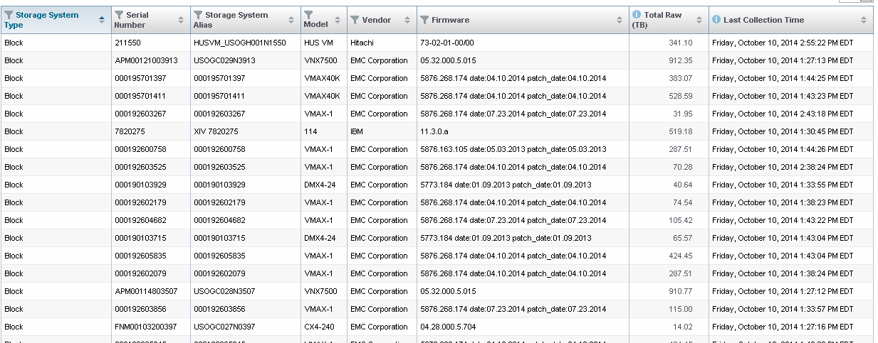
- Explore -> Switches (Look for obvious mistakes or missing data)
    - For switches, make sure Availability is all green boxes (One gray underscore is OK)
    - Go to Admin->SNMP Discovery, look for messages in the dashboard
    - If all look good, check SNMP Collectors

- M&R Health Reports

Troubleshooting

Discovery or Reporting?

In certain scenarios, data may be missing from tables of a report. There is a possibility that the data is not being sent to the report from the collector or there is an issue with the report filters itself.

Determining a data collection issue or a report issue:
- Validate the data is coming into the report first but not being displayed by identifying the report in question. Shown below:

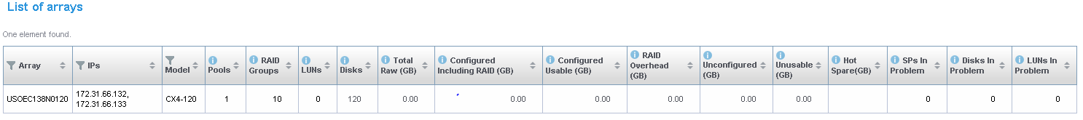

- Once data is shown as missing from the report, a test export can be performed of one of the columns. In this example, column “Total Raw” can be exported to a .csv file. To perform the export select the report from the left pane which is “List of Arrays” and then selecting the “Edit Mode” button in the top right of the screen.
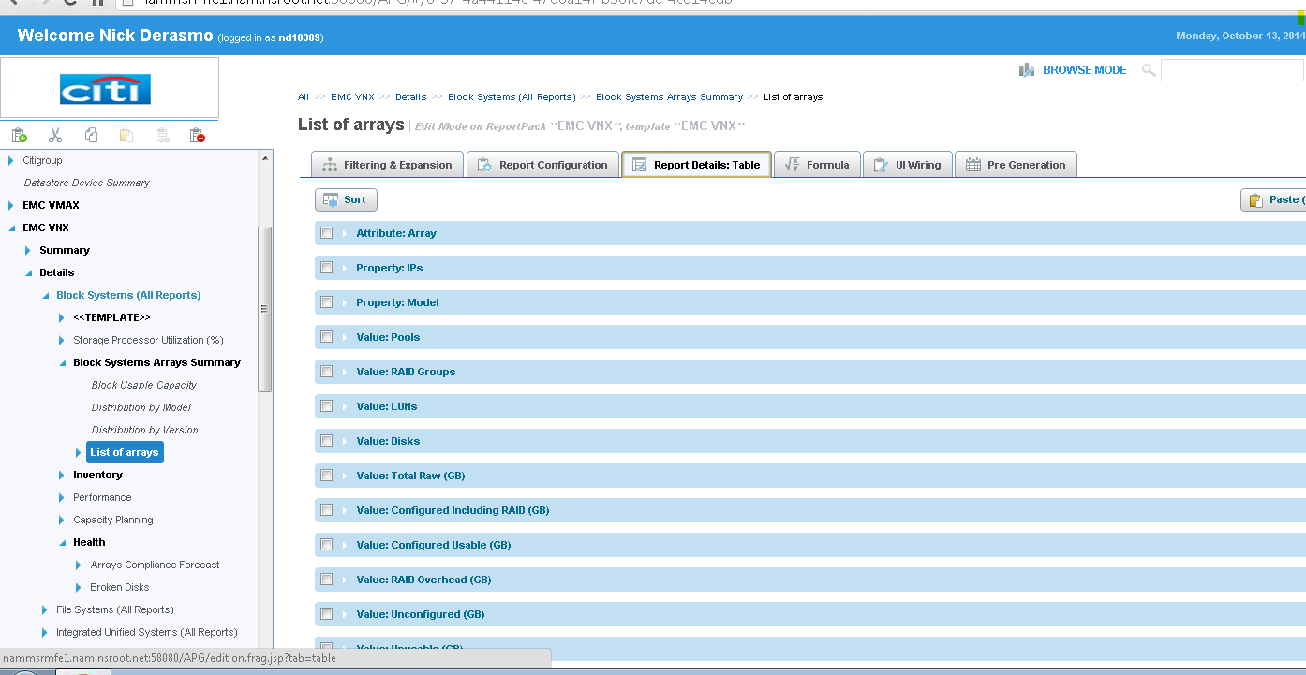

- Then select the “Report Details Table” tab and select the “Value Total Raw” link expanding the view shown below.

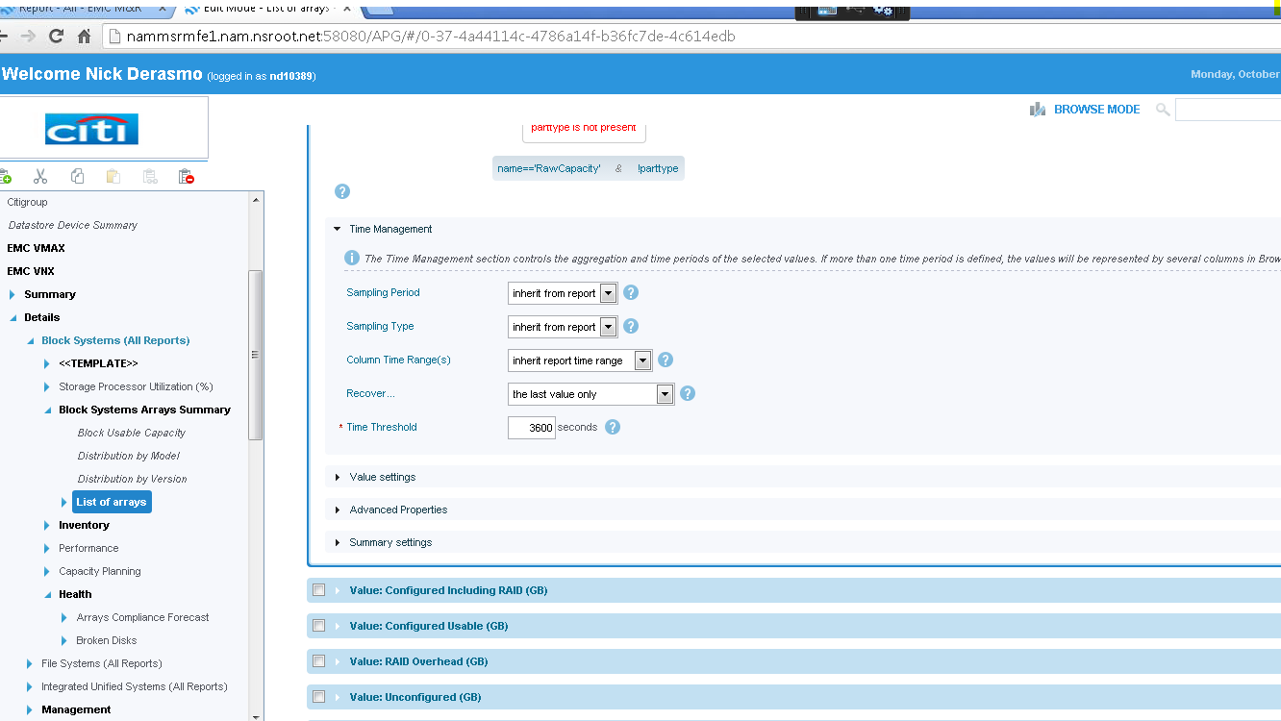

- Expand the “Time Management” setting and proceed to change the values for the following:
- Sampling Period >1 Hour
- Sampling Type > Average
- Column Time Range > Inherent report time range
- Recover > The last value only
- Time Threshold > 2 periods

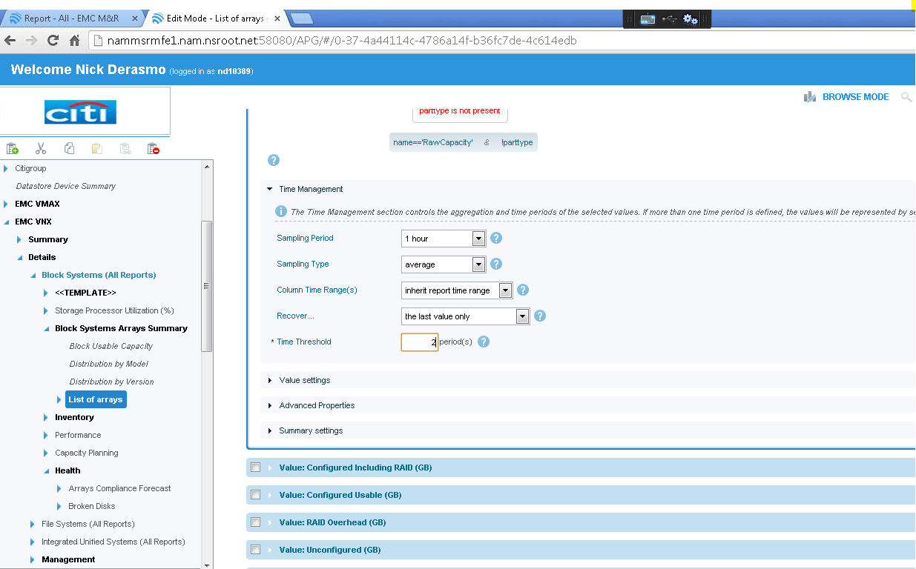

- Select “Save” at the bottom of the screen and then select “Browse Mode” in the upper right of the screen.
- Click the “Export” to .CSV and verify the data is now showing for the “Total Raw” column within the .CSV exported report.

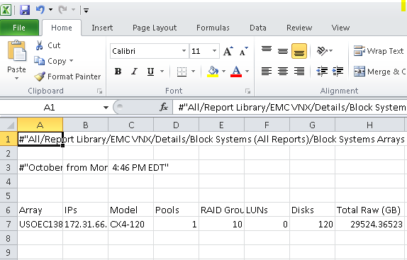

- Repeat the steps given to the rest of the columns missing data within the report.

Discovery – Verifying collector status via logs

We can verify the health of the discovery via monitoring the collection logs per collector instances. To view the “collecting-0-0.log file per collector instance, navigate to Administration>Centralized Management>Physical Overview>”Collector Host”>Instance
Once at the collector instance, navigate to the bottom of the screen and expand the “Log files” tree as shown in the print screen below:
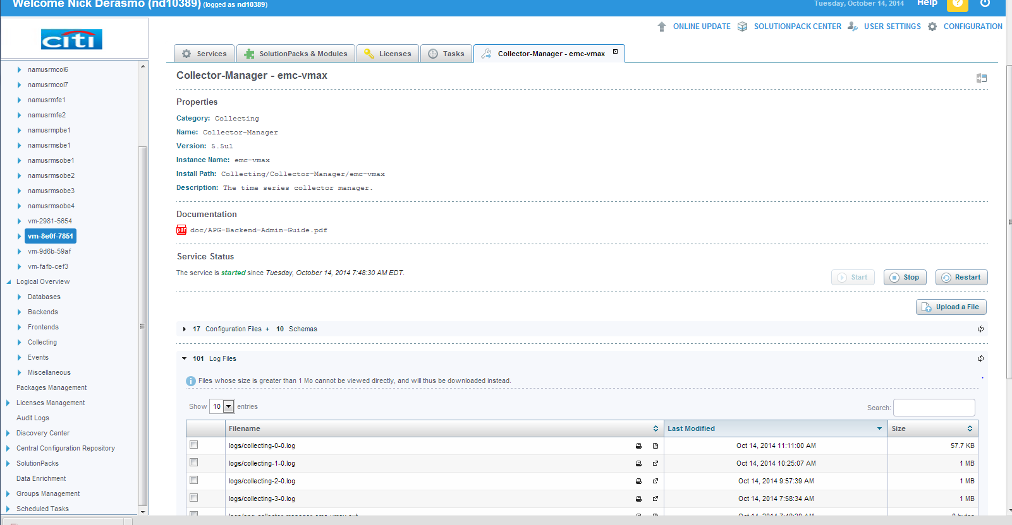

Viewing the “collection-0-0.log file with “tail” view or the file in its entirety

- You want to view the most recent collection data by finding the very first log file at the top of the list.
- Select the “View file” option shown in the print screen below.
- Once viewing the file we can hit the Ctrl+F key to perform a keyword search. The three main keywords are “Severe, Warning, and Successful”
- If any keyword queries are a hit, the log information should provide information that can be looked up on Support.emc.com within the KB articles.

Examples of some log files will be provided in the following print screens.

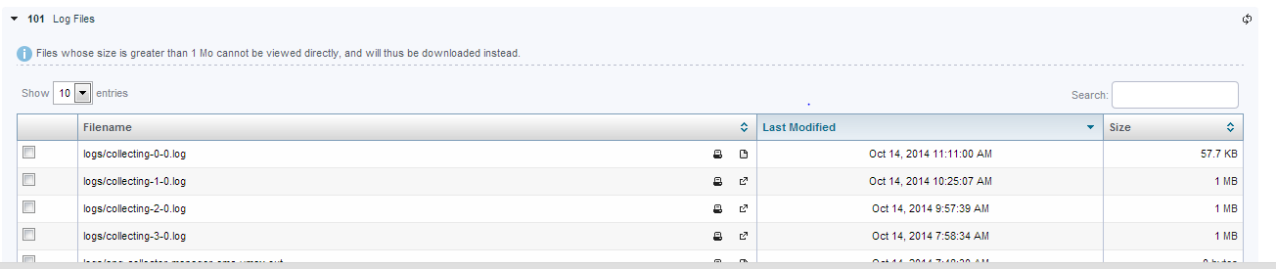

Examples of collector-0-0-.log contents shown below:
RDP Severe Error (Known Issue can be disregarded) this issue is caused from non-configured RDP ports on discovered VMAX.

Successful

Warning

Severe
