ngine OpStor is an enterprise-ready, easy-to-use,and affordable storage infrastructure monitoring solution that helps enterprises to monitor their mission-critical storage resources effectively. It enables you to monitor fiber channel switches, Storage Arrays, Tape Libraries, Host Servers and HBAs which form the backbone of enterprise applications.
ManageEngine OpStor enables Storage Administrators to have a unified view of their heterogenous storage environment through a user-friendly web interface. It helps administrators detect problems early before they affect the business applications. It also help reduce the time to repair through an integrated management solution.

Key Benefits
- Increased visibility with unified view of your storage environment
- Reduced downtime with timely detection of problems
- Saved administrative time with effective reporting and escalations
- Lower Total Cost of Ownership with NO extra software purchases
- Simplified management at an affordable price.

Unified View
ManageEngine® OpStor gives an integrated view of multi-vendor resources that make up your storage environment. It constantly keeps track of resource availability and performance so that critical business applications that depend on storage infrastructure are not affected. Storage Administrators can view the critical status of storage resources and be notified of any alarms in real time.
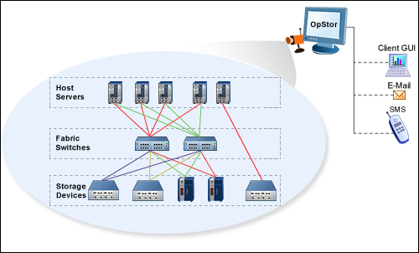

Fabric Switch Monitoring
- Ensure Port availability
- Monitor Port performance and utilization
- Monitor zones, VSANs
- Troubleshoot with real-time graphing
- Secure telnet tunnelling
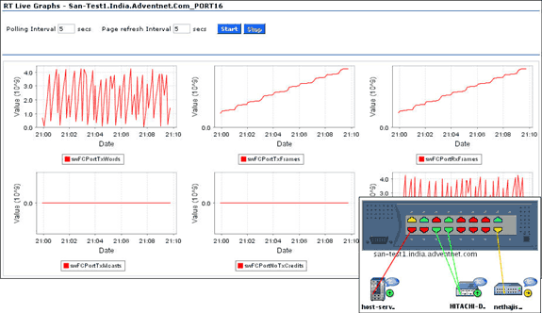

Storage Array Monitoring
- Monitor Physical components - Controllers, ports,drives
- Monitor logical components - LUNs, Volumes, Storage Groups
- Monitor health,availability and utilization of resources
- Monitor sensor faults, battery, Power supply status
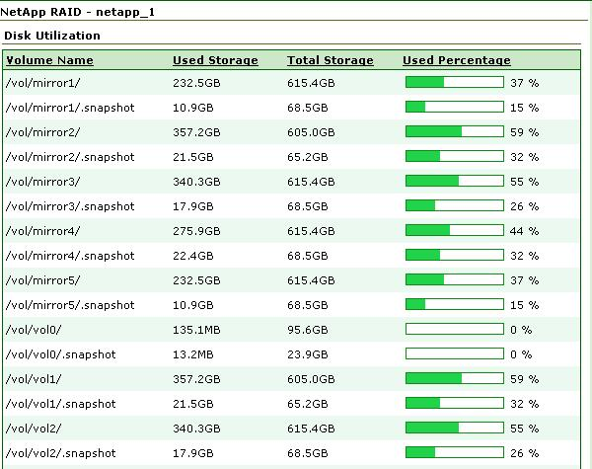

Tape Library Monitoring
- Monitor Physical components - Tape drives,ports,cartridges
- Monitor logical components - Partitions, Movers
- Monitor health,availability and utilization of resources
- Monitor sensor faults, battery, Power supply status
- Launch device manager application from opstor client

HBA Monitoring
- Ensure HBA Port availability
- Monitor HBA Port performance and utilization
- Monitor traffic on HBAs

VMware ESX/ESXi Monitoring
- Monitor VMWare ESX server health, with its virtual machines.
- Monitor VMware HBAs and NIC information.
- Monitor VMware ESX server CPU & Memory Utilization, with its virtual machines.
- Monitor VMware DataStore Utilization.
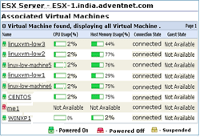

Host Server Monitoring
- Identify SCSI/HBAs mounted on Host servers
- onitor CPU & Memory utilization
- Monitor Disk space Utilization & IO statistics
- Monitor Windows,Linux,Solaris,HP-UX,IBM AIX servers
Notify & Resolve Problems
- Intelligent alarm correlation and color coded alarms
- Automatic escalation of critical and unresolved alarms
- Get notified through e-mail,SMS
- Take corrective actions by executing custom scripts
- Acknowledge and add operator notes
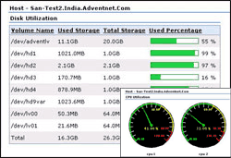

Reports & Graphs
- Reports on storage resource availability & utilization
- Reports on Key performance indicators (KPI)
- Top-N reports on Availability & Performance
- Reports on critical alarms and history
- Real-time graphs at port level to troubleshoot problems
- Generates Storage Capacity Forecasting reports
- Future trend analysis reports on Key performance indicators

Miscellaneous
- Search - To find a device or alarm by specifying a sub-string of the same.
- Help – To guide the user in case he does not understand how to proceed with a particular operation.
- Talkback – To file issues, suggestions, or feature requests in OpStor.
- Export as PDF – To save the reports and other information shown in the client, for future reference.
- Printer Friendly – To print the reports and other information shown in the client.
- Sorting – To enable easy grouping of records, all the tables are sort-able on their column headings.
System Requirements
To know the prerequisites for using OpStor click here

