
- Lab Reports
NetApp OnCommand Insight 7
This ESG Lab Review documents hands-on testing of NetApp OnCommand Insight 7 with a focus on how using advanced analytics can help organizations easily manage and monitor a growing, heterogeneous data center.
Author(s):Aviv Kaufmann, Mike Leone
Published:June 3, 2014
Click for overview
The Challenges
Organizations are constantly being asked to do more with less—less budget, less manpower, less hardware, less everything. Specifically, IT administrators are being asked to create an environment that has a perfect balance of efficiency, utilization, performance, and cost, yet that task is anything but easy. As data sets continue to grow in size, so too does management complexity. This is especially true for larger environments with physical and virtual resources from a heterogeneous mix of server, network, and storage solutions. With each resource within the infrastructure generating important and potentially insightful data, IT administrators need an easy way to analyze and understand that data, from existing resource consumption to potential performance problems. And all of these pain points can be tied back to one underlying goal: allowing IT to intelligently respond to current business needs and future business requests as quickly as possible.
The Solution
NetApp OnCommand Insight 7 is software designed to help manage the complexities of a dynamically changing IT infrastructure. Organizations can use the software to manage and analyze physical and virtual IT environments with heterogeneous server, network, and storage solutions across the domain from multiple vendors. Insight also includes a data warehouse that is used for federated reporting of globally distributed virtualized and cloud infrastructures.
Figure 1. NetApp OnCommand Insight 7
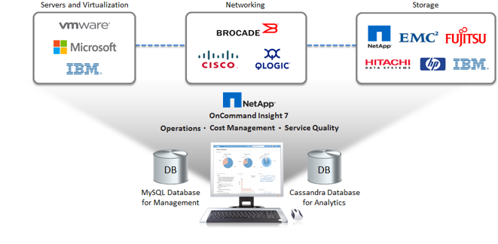

The new version of OnCommand Insight helps address challenges common to any IT organization in three key areas:
- Operations – A new lightweight management interface offers transparency with comprehensive management capabilities for large, multi-vendor IT environments. This web-based interface helps IT quickly and easily complete day-to-day tasks ranging from adding new resources to managing alerts and troubleshooting.
- Cost Management – Organizations will gain insight into their overall capacity needs based on storage usage and requirements to help manage storage as a service. Detailed reporting will uncover the data needed to help make better purchasing decisions based on current and forecasted storage allocation and consumption trends. This also includes information to help organizations understand associated showback and chargeback costs based on current and future storage utilization.
- Service Quality – Through simplified performance profiling, configuration and change management, and improved optimization, IT administrators can right-size the right workloads to the right storage tiers. Organizations can manage their infrastructure from end-to-end with detailed, real-time metrics showing the entire storage service path from host to VM to the underlying storage. Organizations can also set service policies and establish best practices to meet their service level agreements or SLAs. This allows for increased availability by proactively modeling planned changes for major cost saving initiatives such as switch migrations and data center consolidations, as well as proactively load balancing based on resource utilization to avoid potential problems before they impact the business.
OnCommand Insight collects an enormous amount of data that is stored in a data warehouse, where advanced analytics are used to facilitate troubleshooting, performance analysis, capacity, and change management. Insight v7 introduces this new patent-pending analysis, which leverages a new high-performance, Cassandra database to enable increased scale to meet the exponential storage growth in large, diverse IT environments. Since it is a distributed database management system, organizations can expect the necessary high levels of performance, scalability, elasticity, and high availability that are required to efficiently manage IT. This is especially important in environments with mission-critical SLAs. By being able to collect and monitor all the real-time performance metrics that are being generated within a heterogeneous IT infrastructure, organizations can quickly identify potential problems at a server, networking, or storage level and make the right business decisions faster to remediate those problems.
Figure 2. Value Across an IT Organization
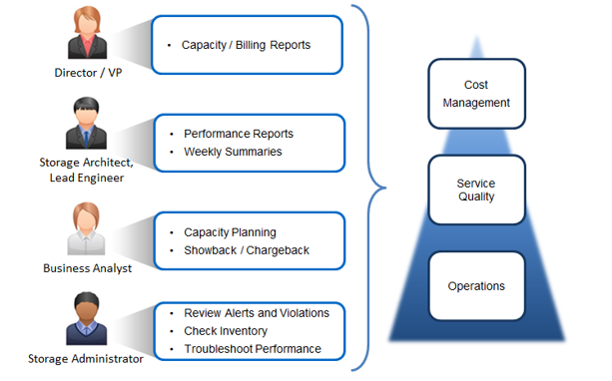
OnCommand Insight 7 offers value across all personnel levels of an IT organization. From a high-level view of a director or vice president down to a storage administrator, OnCommand Insight can provide valuable information to help make better business decisions faster.
Through capacity and billing reports, director- or VP-level personnel can make executive decisions based on costs. Storage architects and lead engineers can leverage reports and summaries to identify areas for improvements to better support business needs, while business analysts can analyze resource utilization trends and forecasting to understand costs associated with showback and chargeback. Finally, storage administrators can monitor the heterogeneous, virtualized infrastructure to check inventory and troubleshoot performance based on alerts and identified violations as well as reclaim and right-size storage.
Getting Started
ESG Lab began testing by looking at the new, web-based user interface with a goal of understanding its comprehensive management capabilities. A dashboard view of a large infrastructure is shown in Figure 3. The main screen, called theAsset Dashboard, displays a real-time summary of everything that is being managed in the infrastructure. Pie charts along the top of the screen show how assets are distributed for capacity by vendor, policy tier, and switch port, and mouse overs provide more detailed information. The bottom portion of the interface includes three panes.
Facts about your environment – Capacity, efficiency, storage network, and virtual infrastructure information is displayed with a focus on utilization, including anything from percentage of capacity used to the number of servers currently virtualized.
Top 10 utilized pools – Utilized capacity and available capacity of the top pools in the storage infrastructure regardless of storage type or vendor are displayed in the bar chart. A mouse over of any bar can provide additional details about a specific pool.
IOPS heat maps – Heat maps for storage and virtual machine IOPS are shown with resource names in differently sized font depending on IOPS consumption; the larger the font, the higher the IOPS.
Figure 3. Assets Dashboard from Insight Web-based Interface
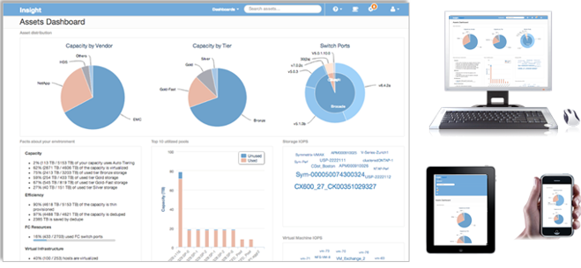
ESG Lab was impressed with the new, responsive, HTML5-based interface that automatically scales to fit any device display, including mobile devices.
Next, ESG Lab went through the process of adding a new data source through the web interface, taking the same steps that an organization would when adding a new device to the existing environment. Two approaches were taken to achieve this and both are highlighted in Figure 4. From the Admin screen, ESG Lab first added a new data source to the infrastructure. Dropdown boxes for supported vendors and models were used to choose from an existing heterogeneous mix of technologies. NetApp and Clustered Data ONTAP were selected. Inventory data is collected by default and ESG Lab also selected Array Performance data to be collected. Additional information was entered in the configuration and advanced configuration sections for the specific data source. Once all information was correctly entered and saved, the new data source could be managed and its performance could be monitored.
Figure 4. Adding a New Data Source
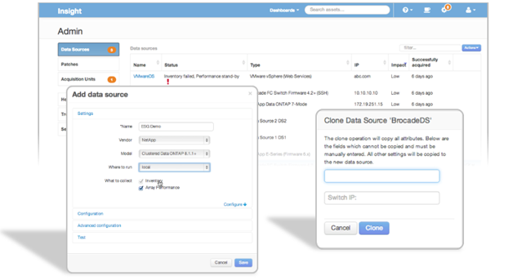
Configuration details and attributes can easily be cloned for new data sources added to the infrastructure that share characteristics with existing data sources. In this example, ESG Lab added a new switch. The new switch was identical to an existing switch already being managed and monitored by Insight. By specifying the name of the data source and the IP address to be cloned, the new data source was quickly added to the infrastructure.

Why This Matters
Managing and monitoring a massive IT infrastructure that quickly and dynamically changes to meet business needs is a complex task for even the most seasoned IT administrators. With different vendors and different management interfaces spread across a global organization, there's a growing need for a solution that ties together vendor-specific management and configuration tools into a single, easy-to-use interface. These flexibility and interoperability requirements are especially true for a global workforce shifting to a more mobile workforce that is constantly on the go.
ESG Lab confirmed that OnCommand Insight can help IT administrators easily manage and monitor a diverse IT infrastructure. By leveraging a sleek new web-based UI that was purpose-built from the ground up with mobility and flexibility in mind, multi-vendor technologies and solutions can easily be added to an existing, virtualized environment in just a few mouse clicks. Inventory and performance metrics from the newly added devices were added to their respective databases and instantly available for real-time monitoring.

Performance Monitoring and Advanced Analytics
With real-time performance monitoring and advanced analytics from OnCommand Insight, organizations can monitor the performance of their environments and potentially fix problems before they significantly impact business operations. Performance metrics of all defined data sources are continuously collected and an optimally designed Cassandra database is utilized to handle the constantly growing data sets with a high rate of change.
ESG Lab was shown a scenario that highlighted how these real-time analytic capabilities could quickly help IT administrators identify the root cause of a performance problem in a simulated real-world environment. The environment included many server, networking, and storage data sources, but focus was put on a virtual machine that shared the same underlying storage as another VM—commonly referred to in the IT industry as the “noisy neighbor” problem.
The simulated problem was identified as a severe spike in latency in a virtual machine running an Exchange database. After selecting the Exchange VM from the available data source list, ESG Lab focused on the Top correlated resources. This list includes resources that share a similar pattern of activity as the resource originally identified as having a problem. In this example, a second storage volume was found to have a similar spike in latency within the same timeframe as the Exchange VM volume. The volume was automatically identified as a top correlated resource with a correlation score of 94% (shown in Figure 5).
Figure 5. Correlation of Latency Spike
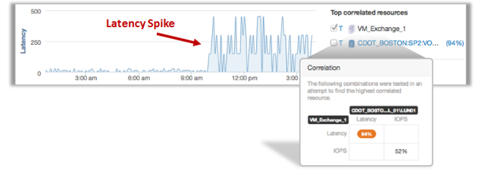
From there, ESG Lab was guided by OnCommand Insight through related data sources based on latency, utilization, and IOPS correlation suggestions. For each data source that was identified as being highly correlated to the problem, performance metrics could be layered on top of one another to ensure the performance spikes occurred at the same time. Figure 6 shows a spike in IOPS of a storage volume that is 99% correlated to the IOPS load of a storage node.
Figure 6. Chart Overlays Identifying Similar Performance Spikes
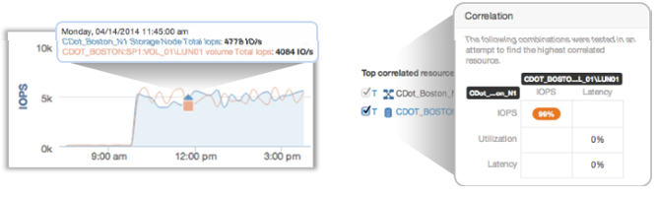
ESG Lab eventually discovered that the underlying problem resided on a seemingly unrelated VM running a travel application that shared the same storage subsystem. A spike in IOPS in the travel application had caused the latency spike in the Exchange VM and this final correlation is shown in Figure 7. From this point, the owners of the travel application can be notified of the problem and take action to remedy the situation, whether that means allocating more storage to the VM or moving the travel application to a different server or storage resource.
Figure 7. Root Cause Identification
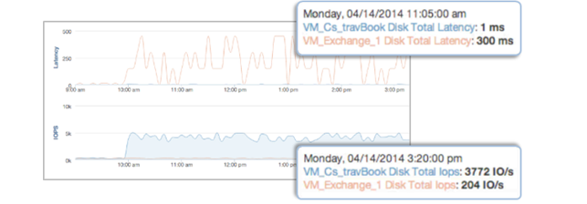
Why This Matters
Identifying performance problems and then pinpointing the root cause in a massive IT infrastructure is a complex task for any IT administrator. Factor in different management interfaces from different vendors for different resources and suddenly, IT administrators have more data than they know what to do with and no fast, easy way to analyze it. A solution that leverages advanced analytics with a lightweight interface that can manage and monitor an entire infrastructure in real time would be a welcome addition to any IT administrator’s toolset.
ESG Lab validated that through the use of analytics and comprehensive resource management and monitoring, organizations can leverage OnCommand Insight 7 to quickly identify and remedy potential performance problems within a large, diverse IT infrastructure. ESG Lab was able to identify a latency spike in one VM, and follow the resource path to the underlying storage node with a correlating performance spike and then back to another VM causing the problem. ESG Lab was particularly impressed with the Cassandra back-end and how quickly the massive amounts of data were instantly accessible and able to be manipulated throughout the root cause analysis.

Service Quality
OnCommand Insight provides organizations the much needed end-to-end visibility required to manage and monitor complex, heterogeneous, virtualized storage environments. Through the use of global service policies, IT administrators can easily view host-to-storage access paths and manage requirements based on application, host, or path. Combined with comprehensive visibility, these customized service policies can be identified as being vulnerable or violated and root cause analysis can be quickly done to resolve issues before they impact the business. Insight also allows organizations to go through “what if” scenarios by helping to model and validate changes to ensure successful infrastructure implementations.
ESG Lab learned about all of the service quality aspects of OnCommand Insight with a goal of understanding how organizations can mitigate risk and increase efficiencies from an availability, performance, configuration, and change management standpoint. The first area of focus was on the comprehensive visibility, particularly for host-to-storage access path views. As shown in Figure 8, many different resources within the infrastructure inventory are available to view. For this example, Paths was selected and ESG Lab eventually viewed the topology of a specific data path from a virtual machine running a travel booking application to its underlying storage cluster. In this example, the data path was healthy and had no path violations, which is shown by the green lines in the topology view. If path violations were present, the interface would identify where the problem was occurring with a red line.
Figure 8. Infrastructure Inventory and Topology
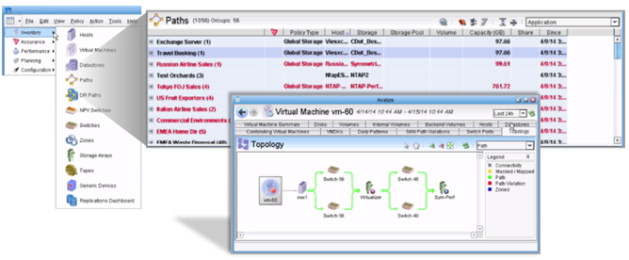
Next, ESG Lab learned how Insight could correlate changes in performance to changes in the environment. In the Changesdashboard, all change events that have occurred throughout the infrastructure are tracked and can be viewed. This is especially important when a performance anomaly has occurred. Within the OnCommand Insight interface, different change events of storage, compute, and networking resources can be viewed to provide insight into what changes occurred and when they occurred. ESG Lab viewed the ongoing performance of the virtual machine resource and by clicking on Show Change Events, was able to see three different changes that had recently occurred. The IOPS, throughput, and response time performance charts then highlighted when the change occurred. In this particular example, a new data source was added to the data path of the virtual machine and ESG Lab witnessed the change event display on the chart of the measured performance metrics. Figure 9 highlights two key pieces of this phase of testing: a view of the list of changes that have occurred in the environment, and performance charts from a virtual machine resource that highlight where a change event occurred.
Figure 9. Change Events and Performance Monitoring
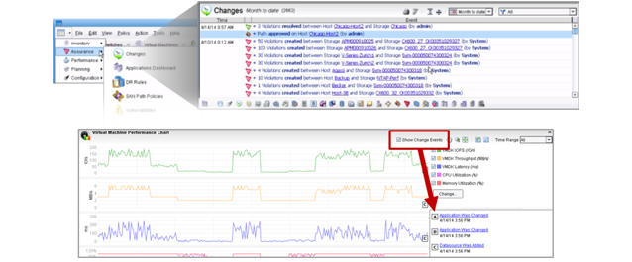
The last area of focus involved the modeling of future changes to the infrastructure and insight into how those potential changes could impact different areas of the infrastructure. These “what if” capabilities allow organizations to understand and plan for any disruptions that may occur when making infrastructure changes. By simulating the infrastructure changes first, issues can be avoided prior to the change actually occurring.
Capacity Management for Chargeback and Reclamation
The importance of understanding resource utilization from a cost perspective is critical to business operations. This is especially true in large IT environments that are leveraged by a multitude of end-users and business units located around the globe. How are resources being utilized? Are more resources needed? Less? How much do the current resources cost? How much should be spent to improve an end-user’s application experience? With global visibility into application resource consumption throughout the IT infrastructure, OnCommand Insight can help organizations quickly make informed business decisions that directly impact the bottom line. For example, one of Insight’s advanced analytics is a multi-variable analytic focusing on node utilization, which helps to quickly identify if there is no more headroom on the node and more storage is needed.
ESG Lab focused this portion of testing on the trending analysis and chargeback capabilities of Insight that work to improve the accountability of business applications and the underlying IT infrastructure that supports them. This has always been important to service providers, but it has also become a necessity for enterprise IT to understand those same costs. ESG Lab looked at the Application Service Level Capacity and Performance Dashboard shown in Figure 10. This dashboard allows IT to provide custom cost-grouping parameters like tenant or application, and then report on how that entity is utilizing its allocated resources. ESG Lab saw IOPS consumption by service level over time and different trend lines ranging from capacity utilization to performance measurements such as IOPS, throughput, and latency.
Figure 10. Application Service Level Capacity and Performance Dashboard
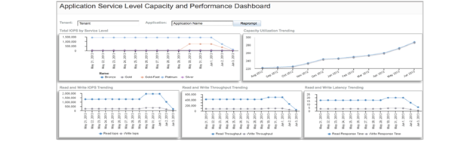

OnCommand Insight can then take this trending and create chargeback reports based on the defined business entities. ESG Lab viewed an example tenant with multiple business applications at varying service levels. The particular chargeback report in Figure 11 focuses on the capacity utilization by application, showing provisioned versus used capacity and the total provisioned cost. Combined with the detailed trending reports, it was apparent to ESG Lab how using OnCommand Insight could enable organizations to make more cost-effective and informed choices about managing and distributing IT resources based on business needs. The process was made easy compared with a common approach of using time-consuming and manual spreadsheets.
Figure 11. Chargeback Reporting
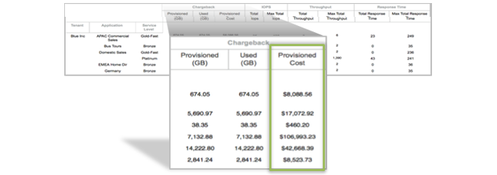
Capacity Reclamation with OnCommand Insight
ESG Lab also learned how OnCommand Insight can be used to better utilize existing hardware investments through the identification and reclamation of unused capacity on existing storage resources. Using the Storage Manager dashboard, ESG Lab was able to quickly and easily identify orphaned capacity by configuration or performance. Orphaned capacity is capacity that was allocated to volumes that have not been growing or have not been accessed heavily (for example, fewer than ten IOPS) or at all over a given time period (for example, in 60 days). As shown in Figure 12, the Storage Manager dashboard identifies key performance metrics like IOPS and response time for each tier of storage and displays the amount of orphaned capacity for each one of those tiers. IT administrators can also select a storage tier and drill down for more detailed metrics.
Figure 12. Identifying Orphaned Capacity with Storage Manager Dashboard
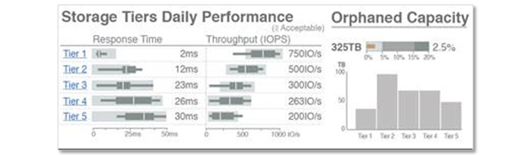
This orphaned capacity can be reintroduced to storage pools or reallocated to other volumes by shrinking or growing volumes based on the displayed metrics. The Orphaned Capacity reports can also be used to identify volumes that would make good potential candidates for migration to cloud-based storage—taking advantage of low-cost alternatives to expensive storage arrays, and reclaiming and redeploying higher cost, higher performance storage capacity. These potential savings and return on investment were key takeaways for ESG Lab, especially after learning that one OnCommand Insight customer reported reclaiming over $1.2 million worth of unused storage.
The Bigger Truth
As organizations strive to align IT with business process improvements, the management complexity of growing, virtualized IT environments is cause for concern. With IT budgets flattening and challenges looming around managing server virtualization, data growth, and transitioning to cloud, the problem is not going away anytime soon. As these environments grow, IT administrators are expected to maintain a perfect balance of resource allocation, resource consumption, and cost while maximizing the efficiency of multiple business units with dissimilar requirements. With new solutions from different vendors being added to fill gaps or fix problems, how can IT be expected to make sure those performance requirements are met? The amount of useful data being generated by each solution is massive, and analyzing all of it in a timely manner to proactively resolve issues and better respond to business needs is near impossible. It’s no longer just a management complexity problem—now, it is also a big data problem.
The latest version of NetApp OnCommand Insight puts these concerns to rest by combining ease of management and advanced analytics into a scalable, flexible solution that can help IT take control of a growing, heterogeneous storage environment. ESG Lab confirmed that with a new, web-based user interface, organizations can easily manage and monitor a multi-vendor environment made up of different server, network, and storage resources. By adding a Cassandra database management engine, performance metrics were constantly being captured and available instantaneously as ESG Lab did root cause analysis for an application performance anomaly. Finally, with the cross-domain intelligence and transparency of OnCommand Insight, resource utilization can be monitored by business unit, tenant, and application to help justify business purchasing decisions based on actual usage.
Since our last hands-on validation of OnCommand Insight back in 2011, ESG Lab has been a major proponent of solutions that simplify the management and monitoring of expansive IT environments with a multitude of different vendors’ solutions. NetApp has continued to make substantial improvements to its already comprehensive and high-performing management and performance analytics solution with even more features and functionality. Notably, a thin, web-based user interface has helped transition from a less flexible java-based client to better serve the modern data center from anywhere, on any device. Though all pieces of the thick client have not yet transitioned to the new user interface, NetApp is working on a new restful API along with continued porting of the thick client to the thin client.
The management complexity of a growing, heterogeneous storage environment is no secret and keeping up with all of the generated data from each resource has turned into a big data problem. If your organization is looking for a way to easily manage operations, cost, and service quality, ESG Lab recommends the latest version of NetApp OnCommand Insight, a lightweight management platform with real-time, big data analytics for dynamically changing, heterogeneous storage environments.

