EMC ViPR SRM

Storage Resource Manager (SRM) will be deployed in the Citi Regional Data Centers across the globe. SRM Front-End and Back-End components will be deployed in SWDC and MWDC as well as in EMEA and ASPAC. SRM collectors will be deployed in all regional data centers
Storage Resource Management Suite is a comprehensive storage resource management solution that enables users to visualize storage relationships, analyze capacity growth, and provide insight to optimize resources.
Visualize
Provides relationship and topology views from virtual or physical hosts down to the logical unit number (LUN) to identify application to storage dependencies.
Analyze
Provides dashboards and reports that track storage consumption. Provide views that help understand capacity.
Optimize
Display historical workloads and response times to help determine whether you’ve selected the right storage tier. Enable creation of charge-back reports to align application requirements with costs
The following highlight the benefits of SRM for Storage engineer and Storage Operations:
- Storage capacity reporting for multivendor storage environments (VNX, VMAX, Centera, XIV, HDS, NetApp, Cisco, Brocade)
- Relationship and topology views for the Storage Infrastructure
- View Performance trends across data paths to help identify hosts competing for resources.
- Collected metrics provide understanding of storage usage to help derive impact of storage change on applications
- Track block and file capacity consumption with reports to help understand who is using capacity, how much they are using, and when more will be required
- Track storage consumption by Disk Technology: RAID, ARRAY, FAST Policy to better understand how capacity is being consumed
- Empowers Storage Administrators with vast metrics to improve Capacity Planning and reduce overall cost
- Near-real metrics collection in conjunction with historical data provide a troubleshooting tool to solve complex storage problems

SRM application is comprised of several vendor components. These components provide specialized services for various aspects of Storage collection and reporting. The SRM suite communicates with the various components of the Storage Infrastructure including the SAN Switches and Element Managers.

Vendor Components include:
- SRM Frontend
- SRM Backend/Database
- SRM Collectors
- SRM Solution Packs

Citi Storage Components:
- SAN Fabric Switches
- Storage Array Element Managers
- NAS Filers
- SAN Hosts

List of Components
Component Name | Capability Description
Base Components
SRM Front-End | Web Front End
SRM Back-End | Data Receiver from Collectors
SRM Database | MySQL Database
SRM Collector | Data Collectors
SRM Solution Packs | Collectors/Reports/Dashboard/Views for Specific Environment
SRM OS/Platforms
VMWARE | All Components are certified to run in a virtual environment.
RHEL 6 | SRM FE/BE/DB/Collectors
Windows 2008 R2 | SRM Centera Collector
Optional Components
(Operational Requirements)
Authentication/Authorization | LDAP/AD Integration

Network Latency Requirements

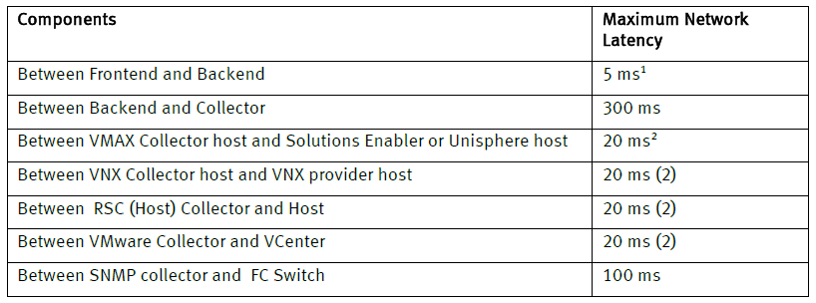

Network Firewall Ports
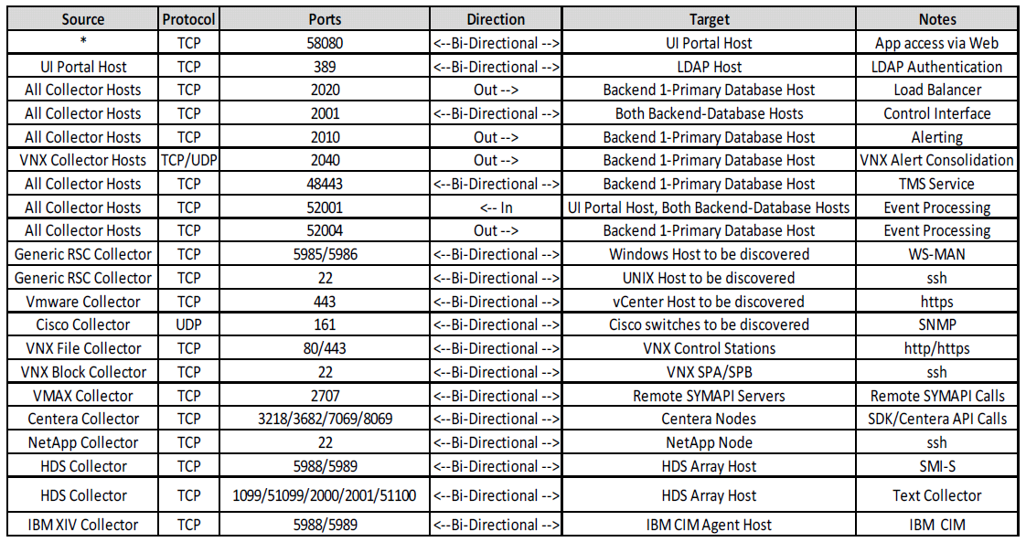

EMC VMAX
Supported Models
- DMX-3 series
- DMX-4 and DMX-4 950 series
- VMAX series
- VMAX SE series
Prerequisites
- Solutions Enabler 7.6.2.8 and later
- Unisphere for VMAX 1.6.2 and later (must be setup to collect performance data)
- SMI-S Provider 4.6.2 and later (required for LUN-level performance metrics)
- Symmetrix communications occur via Gatekeeper devices.
  - Option 1 (Remote Mode) – Assign 2 additional gatekeepers to existing SYMAPI server. SRM will utilize the existing SYMAPI server to communicate with the Symmetrix devices via SYMCLI. No additional software will need to be installed on the SYMAPI server. In the event that the SYMAPI server uses a “nethost” file, ensure the collector hostname or IP address is included (e.g. “vm-29810564 *”).
  - Option 2 (Local Mode) – Assign 2 additional gatekeepers to existing SYMAPI server. Install the VMAX Collector on the SYMAPI server (or a unique server if desired).
- If using ACLs, SRM will run SYMCLI commands as user “srmadmin”.
- Symmetrix Authorization (symauth) requirements are as follows:
  - For Solutions Enabler 7.6.2.25 and higher, only the Monitor role is required for the “srmadmin” user.
  - For versions of Solutions Enabler lower than 7.6.2.25, Admin or Storage Admin is required for the “srmadmin” user.
- The “srmadmin” user requires permission to access the storapid daemon in the “daemon_users” file.
- For Symmetrix Access Control (symacl, if enabled), the user “srmadmin” must be added to an Access Group which has the Access Type “BASE” and “VLOGIX” for all devices.
Pre-discovery Checklist
- Verify Prerequisites, and confirm with Citi “owners” that they want the target to be discovered (e.g. that it is not scheduled to be decommissioned).
- Array Serial Number
- Unisphere hostname or IP address
- Unisphere network port (if not the default 8443)
- Unisphere credentials (Username/Password)
- SYMCLI credentials (if using ACLs)
- Logon to the VMAX collector host as “srmadmin” (or use powerbroker to become “srmadmin”) and issue the following commands to verify SYMAPI connectivity:
  - /opt/emc/SYMCLI/bin/symcfg list
  - /opt/emc/SYMCLI/bin/symcfg list –sid <SID> list -v

EMC VNX
Supported Models
- CLARiiON, VNX and VNX2 models: Flare Code 4.30; 5.31 or higher
- Celerra, VNX andVNX2 models: DART 5.6 and 6.0; VNX OE for File 7.0 or later
- Second generation VNXe modules (as of VNXe 3200): VNXe OE 3.0 (Block and File)
- Note: First generation VNXe models (e.g. VNXe 3100, VNXe 3150 and VNXe 3300) are not supported.
Prerequisites
- Naviseccli (the version should match the Flare code level)
- Performance Statistics need to be enabled on SP-A and SP-B.
- If CIFS and NFS statistics are required, the server_stats service must be enabled.
- A user account (service account) with an Operator role or higher privileges (Block & File accounts).
Pre-discovery checklist
- Verify Prerequisites, and confirm with Citi “owners” that they want the target to be discovered (e.g. that it is not scheduled to be decommissioned).
- Array Serial Number
- IP address for SP-A & SP-B. (Verify the correct IP addresses by using “nslookup” and issue a ping command to the target array from the specified collector host.)
- Credentials

EMC XtremIO
Supported Models
- XtremIO 2.4 and higher
Prerequisites
- A non-admin account with read-only privileges.
Pre-discovery Checklist
- Verify Prerequisites, and confirm with Citi “owners” that they want the target to be discovered (e.g. that it is not scheduled to be decommissioned).
- Unique friendly name for the XtremIO array
- Management Hostname or IP Address
- Credentials

EMC Centera
Supported Models
- EMC Centera
Prerequisites
- Collector must be installed on Windows 2008 or higher.
- Centera 4.3 must be installed on Collector server.
- User account (service account) with the following privileges:
  - The only required roles are “Accesscontrol” and “Monitor”.
  - The “Granted Rights” only need to be set to “Read”.
Pre-discovery Checklist
- Verify Prerequisites, and confirm with Citi “owners” that they want the target to be discovered (e.g. that it is not scheduled to be decommissioned).
- Hostname or IP Address of a node with the management role
- Credentials

HDS
Supported Models
- AMS200 and AMS2100
- USP and USP_V
- HDS9970V
- HUS-VM
- VSP
Prerequisites
- Hitachi Command (“HiCommand”) Suite 7.4.1 or higher (full license; core license is not sufficient)
- CIM/WBEM features must be enabled in Hitachi Device manager
- User account with non-privileged rights to view all.
Pre-discovery Checklist
- Verify Prerequisites, and confirm with Citi “owners” that they want the target to be discovered (e.g. that it is not scheduled to be decommissioned).
- Hostname or IP Address of the Hitachi Device Manager
- Credentials
- SMI-S port

IBM XIV
Supported Models
- IBM XIV
Prerequisites
- The XIV CIM Agent must be running (for v10.1.0 and higher, it is pre-installed & enabled on the admin module)
- A user account with a minimum privilege of Read Only
Pre-discovery Checklist
- Verify Prerequisites, and confirm with Citi “owners” that they want the target to be discovered (e.g. that it is not scheduled to be decommissioned).
- Management hostname or IP Address #1, #2 & #3
- CIMOM Network Port
- Credentials

NetApp
Supported Models
- NetApp Filer 7-mode on Ontap V7 or higher
- NetApp Filer Cluster-mode on Ontap v8 or higher (Note: The cluster management IP must be provided during C-Mode filer discovery)
Prerequisites
- SRM utilizes NetApp CLI via SSH to communicate with NetApp. SSH v2 must be enabled.
- NetApp 7-Mode – SSH connection with the following roles:
  - login-ssh, cli-stats*, cli-snap*, cli-aggr*, cli-ifconfig, cli-qtree, cli-storage, cli-maxfiles, cli-echo, cli-vol*, cli-disk*, cli-lun, cli-fcp, cli-environment, cli-nfs*, cli-cifs* , cli-df, cli-sysconfig, cli-ifconfig, cli-version
- NetApp C-Mode – SSH connection with the following roles:
  - access level 'read only' for the following commands: volume, df, lun, storage, statistics, network, vserver, cluster, sleep
  - access level 'all' for the commands: set, system
Pre-discovery Checklist
- Verify Prerequisites, and confirm with Citi “owners” that they want the target to be discovered (e.g. that it is not scheduled to be decommissioned).
- NetApp Filer Mode (7-Mode or C-Mode)
- Hostname and IP Address (Verify the correct IP addresses by using “nslookup” and issue a ping command to the target array from the specified collector host.)
- Credentials

Cisco Switches
Supported Models
- Cisco MDS (9xxx)
- Cisco ONS (1520x)
- Cisco Nexus (5548, 1000v)
Prerequisites
- The following MIBs are supported:
  - CISCO-FLASH-MIB
  - CISCO-NS-MIB
  - CISCO-DM-MIB
  - CISCO-ENTITY-SENSOR-MIB
  - ENTITY-MIB
  - CISCO-FC-FE-MIB
  - IF-MIB
  - CISCO-ENTITY-FRU-CONTROL-MIB
  - CISCO-VSAN-MIB
  - CISCO-ZS-MIB
  - CISCO-SYSTEM-EXT-MIB
  - SNMPv2-MIB
  - CISCO-FCS-MIB
  - CISCO-FEATURE-CONTROL-MIB
- SNMP must be enabled/configured. SRM supports v1, v2c and v3 (SHA auth & AES128 privacy only).
- The SNMP community name needs a minimum role of network-operator. (Note: If the community string used for switch discovery is assigned to a role that has a VSAN policy set to deny, there is a possibility of a supervisor card fail-over and switch reboot.)
- All switches in the Cisco fabric must have the same SNMP credentials.
Pre-discovery Checklist
- Verify Prerequisites, and confirm with Citi “owners” that they want the target to be discovered (e.g. that it is not scheduled to be decommissioned).
- For SNMP v1/v2, a read-only Community String.
- For SNMP v3:
  - SNMP User Name
  - Authentication Protocol (MD5 od SHA)
  - Authentication Password
  - Encryption Protocol (AES or DES)
  - Encryption Password
  - V3 Context Name
  - V3 Context Engine ID

VMware (vCenter)
Supported Models
- VMware vCenter Server and ESX(i) must be 4.1 or higher (Note: 5.1 or higher is recommended)
- VMware ESX 4.1, 5.0 and 5.1
Prerequisites
- vCenter User Account – Read Only Account with Browse Datastore and all Storage View privileges
- If PowerPath/VE is running and metrics are required, PP/VE 5.8 or higher is required
Pre-discovery Checklist
- Confirm prerequisites
- vCenter Hostname or IP Address
- Credentials

HPNA
Implement automated configuration assurance for SAN appliances via HP Network Automation (HPNA) and using Cititools as the reporting platform.

Scope
Cisco MDS
Hitachi Data Systems HDS SAN
EMC Symmetrix VMAX
EMC VNX CS and SP
IBM XIV
EMC ScaleIO
EMC XTREMIO
Notes:
- Brocade is out of scope as this implementation target date is Q4 2014 and Brocade final replacement will occur in H1 2015.
- Same status for DMX
- Same status for USP-Vs.

Device inventory view
Go to Cititools -> reports -> HPNA device summary: Filter “NI Device Type” on “SAN” and select the summary by Region and Device Family - https://cititools-dev.nam.nsroot.net/NSPortal/Report/HPNADeviceSummary

Managed devices

The HPNA device summary page in cititools lists all types of devices managed in HPNA.
To view Cisco MDS devices, select the device family “Cisco SANOS/NXOS”.
To view HDS devices, select the device family “HDS”.
To view XIV devices, select the device family “XIV”.
To view VNX SP devices, select the device family “VNX SP”.
To view VMAX devices, select the device family “Symmetrix”.
To view ScaleIO devices, select the device family “EMC ScaleIO”.
To view XTREMIO devices, filter on device name contains “xms8”

URL: https://cititools.nam.nsroot.net/NSPortal/Report/HPNADeviceSummary (production)
https://cititools-dev.nam.nsroot.net/NSPortal/Report/HPNADeviceSummary (development)

Device missing from HPNA

Devices are added from Aperture. If it is not present in HPNA, it likely means the device entry in Aperture is not matching the appropriate filter described in the device feed chapter below.
Please make sure the device is correctly entered in Aperture (specifically the IP) and verify it maps to the filter from the device specific feed. If it does and the device is not in HPNA, contact HPNA support.

Device feed

Currently the device feed is coming from Aperture and a seedfile. Aperture takes precedence over the seedfile. All other devices come from Aperture.
- Current Aperture feed filter criteria:
- Hicommand servers: name first 3 letters are "nam", 4th letter is anything, then name finished by "hds03", and the ip_address has to be defined. For EMEA, names ldnctisvhm002 or fftctisvhm002dr
- HDS arrays: model contains 'VSP' or ‘HUS*VM' or 'USP*V'
- XVI: highest mgmt IP for each device, name 3rd letter "o", 5th letter "i", manufacturer "IBM", ip_address defined
- EMC SE: static list maintained in HPNA (no available filter listing these in Aperture) – if list changes, *cti us hpna support needs to be notified:
162.124.213.25,emcse,north america,united states,390g
168.72.74.99,emcse,north america,united states,gtdc
- VNX SP: manufacturer "EMC”, name does not contain "nas", model contains "VNX", last 4 characters of name and serial number match, ip_address defined in the Aperture device network tab.
- VNX CS: manufacturer “EMC”, name contains nas*(x|cs0|cs0dr), model contain VNX. The IP omes from DNS (nslookup using the nsroot.net sub-domains, e.g. nam.nsroot.net, eur.nsroot.net) based on the Aperture name. The Aperture IPs are ignored for VNX CS.
- VMAX: manufacturer "EMC, serial number starts by "ck" or "hk", name 3rd character is not "m", model contains "V-MAX"
- DMX: manufacturer "EMC, serial number starts by "ck" or "hk", name 3rd character is not "m", model contains "DMX"
- Cisco MDS: manufacturer CISCO, model contains "MDS"
- ScaleIO : machine_type = 'ScaleIO_RESTGW' and at least one non ILO IP defined in the Aperture device network tab. The LOWEST IP is selected.
- XTREMIO: device name ends with xms*8xxx – with “x” a number -> 8001, 8002,…
- \For all the above, the business field must contain "CTI" or "Citigroup Technology Infrastructure", or CSI appid 149141.
- filter is not case sensitive
- MDS IP comes from DNS (nslookup using the nsroot.net sub-domains, e.g. nam.nsroot.net, eur.nsroot.net) based on the Aperture name. The Aperture IPs are ignored for MDS.

VMAX
HPNA connects to each SE via sym_cli running from the HPNA server.
The package /net/stealth/export1/home1.localhost/sw/Linux/hpna_client-0.5-1.x86_64.rpm has to be installed on each SE by the local Unix SAs. It creates a Unix local “hpnaro” account. This accounts needs to belong to the “monitor” role and permissioned to access the gns and api daemons.
Successful package installation:
# rpm -ivh /net/stealth/export1/home1.localhost/sw/Linux/hpna_client-0.5-1.x86_64.rpm
Preparing... ########################################### [100%]
1:hpna_client ########################################### [100%]
[Dev root @ namaltswapp01d /opt/app/hpna]
Inventory in development, https://cititools-dev.nam.nsroot.net/NSPortal/Report/HPNADeviceSummary -> select device family “symmetrix” on the left side, and on the right select region and click “update summary:

Rules defined for VMAX:
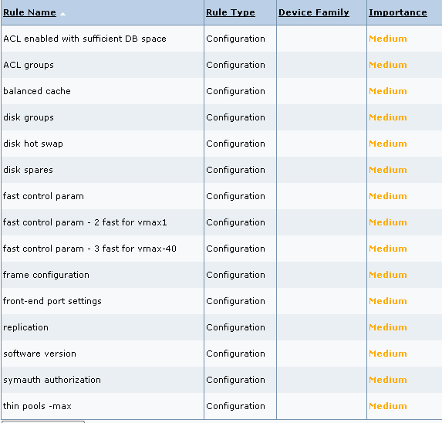

To view the policy and rule definition, go to cititools -> configuration assurance policy catalog. Filter the first column “Name” on “EMC Symmetrix – all”:

Cisco MDS
HPNA connects directly to the Cisco MDS switches. The ID being used to connect to the switches needs to be assigned the MDS facility role in AD.
Ldap user “hpna_mds” for NA, “emea_cisco_hpna” for emea, sgctisvchpnap01 for ASPAC.

The command called is “show run”.
Rules defined in HPNA:
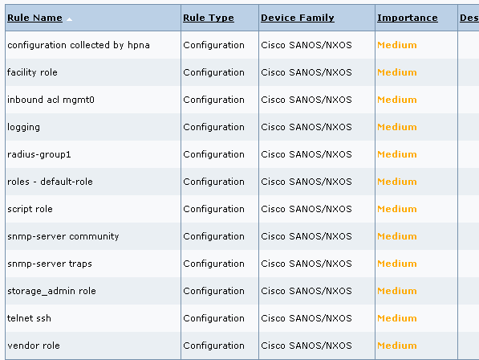
To view the policy and rule definition, go to cititools -> configuration assurance policy catalog. Filter the first column “Name” on “cisco MDS – All”

XIV
HPNA collects the XIV data via the xiv_cli
The commands called are:
‘version_get’,
'access_list',
'ldap_list_servers',
'ldap_config_get',
'dest_list',
'destgroup_list',
'rule_list',
'user_list',
'user_group_list',
'service_list',
'host_list',
'config_get',
'event_threshold_list',
'smsgw_list',
'smtpgw_list ',
'vol_default_ssd_caching_get',
'ipinterface_list',
'support_center_list'

The access account needs to belong to the read only role.
Ldap user “hpna_mds” for NA, “emea_cisco_hpna” for emea, sgctisvchpnap01 for ASPAC.
To view the policy and rule definition, go to cititools -> configuration assurance policy catalog. Filter the first column “Name” on “IBM XIV – All”
List of rules:
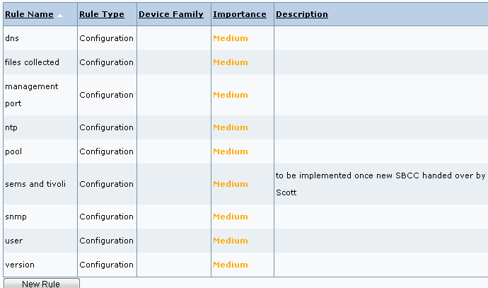

VNX SP
HPNA collect the VNX SP data via naviseccli. The MSAD account used should be permissioned to the monitor group.

Ldap or local user “hpna_mds” for NA, “emea_cisco_hpna” for emea, and “sgctisvchpnap01” for ASPAC.
The IP ACL needs to have ALL the HPNA server IPs: that’s 22 IP addresses! CTC *cti us hpna support for the full list in case you need a FW request.
The commands called are:
‘getall’,
'getsp',
'getsptime',
'networkadmin -get -all',
'arrayname',
'ntp -list -all',
'getcache -wst',
'getcache -mirror',
'getcache -wsz',
'getcache -rsza -rszb',
'getcache -page',
'getcache -high',
'getcache -low',
'security -ldap -listserver',
'security -list',
'environment -list -all',
'eventmonitor -portal -list',
'analyzer -status',
'analyzer -get',
'storagepool -list',
'getdisk -state',
'ndu -list -name -isactive',
'faults -list',
‘getagent’

To view the policy and rule definition, go to cititools -> configuration assurance policy catalog. Filter the first column “Name” on “EMC VNX SP - All”

List of rules:
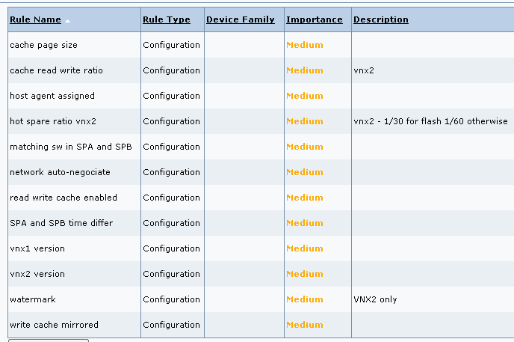

XtremIO
HPNA directly ssh to XtremIO to collect the data, accessing via the global FID gnoctisvcnas01.
It issues numerous commands, like

show-bbus
show-bricks
how-bricks
show-clusters
show-clusters-info
show-clusters-data-protection-properties
show-clusters-parameters
show-clusters-savings
show-clusters-upgrade
show-daes
show-daes-controllers
show-daes-psus
show-data-protection-groups
show-debug-info
show-discovered-initiators-connectivity
show-email-notifier
show-ig-folders
show-infiniband-switches
show-infiniband-switches-ports
show-initiators", commands

Collection for these 5 categories of devices will run once a day for all these devices, midnight GMT for EMEA devices, 6am GMT for the Americas, noon GMT for ASPAC devices.
To access HPNA and Cititools SBCC tracking pages, you need a Cisco Secure TACACS account:
https://cmp.nj.ssmb.com/marketplace/control/product/~productId=43736_66523_GLOBAL#
select the group “HPNA-RO”
The TACACS password is your 4 digit safeword pin followed by “7” (and NOT 8 as during remote access)
If you do not have “host 7” safeword access (or if you do not know you have it -> you most likely don’t), then a SECOND CMP is required:
https://cmp.nj.ssmb.com/marketplace/control/product/~productId=39626_544821_GLOBAL#

Please contact the below personals for any queries regarding HPNA
Grala, Tomasz
Robin, Nicolas
Leavy, Daniel P
Mendoza, Ana
*CTI US HPNA Support
=============================================================

DRA
Disaster Recovery Advisor is a CATE approved piece of software that scans servers and storage and generates information for the purpose of ensuring COB capability
Following activities need to be done for the APAC Unix storage proxies.
1) Install TPM package CITI_Solaris_DRAkey_1.0_A3_1.0.
2) Request “ASPAC Unix - Create Functional ID”. Include all the server that is required.
3) Assign auditor role to FID

TPM Package Details
OS | TPM Package | Included Package
Linux | CITI_RedHat_DRAkey-1.0-A3.noarch_1.0 | DRAkey-1.0-A3.noarch.rpm
AIX | CITI_AIX_IHS.DRAkey.rte_1.0.0.2_1.0 | IHS.DRAkey.1.0.0.2.bff
Solaris | CITI_Solaris_DRAkey_1.0_A3_1.0 | DRAkey.1.0_A3.dstream

DRA TPM packages listed in https://catecollaboration.citigroup.net/domains/platstor/osunix/stdsrelateddocs/RFP-SymantecDRA-DRAkey1.0-A3.pdf

DRA package installation completed on below servers
hkastctilxsan1c.apac.nsroot.net
hkastctilxsan2c.apac.nsroot.net
sgctctilxsan1p.apac.nsroot.net
sgctctilxsan2p.apac.nsroot.net

Following document gives details on DRA.
https://catecollaboration.citigroup.net/domains/platstor/osunix/stdsrelateddocs/RFP-SymantecDRA6.2.1.pdf

Raised following CMP for to create “unix Functional ID”
WS33696960
Please contact the below personals for any queries regarding DRA
Kamat, Vivek
Phillips, Ryan
Shapiro, Jeff
*CTI GLOBAL DRA Support

XtremIO Scripts

We had implemented the xtremIO perl scripts to generate the daily XtremIO status email reports in and us
Please send an email to the below personals whenever there a new XtremIO array added into DCand follow the below format
Location | New XtremIO | IP Address | ESX Cluster
HongKong | hkgctisvxms8009 | 10.85.96.201 | APCHKAAWSDSKBA
Singapore | sinctisvxms8010 | 10.85.64.193 | APCSGCAWSDSKBJ
Singapore | sinctisvxms8012 | 10.85.64.194 | APCSGCAWSDSKBI

Please contact the below personals for any queries regarding XtremIO script reports
Balasubramanian, Raja
Deinhart, Donald M

SRM & HPNA server info for XIV
When there a new XIV arrays are onboard, please include the below source SRM & HPNA servers while raising the firewall & Sec_Acl request
SRM servers : -
HK - apacasrmcol6 - 163.36.109.180
SG - apacnsrmcol4 - 163.36.40.28
HPNA servers : -

194.41.66.135-142
194.41.74.31-38
194.41.66.134
194.41.66.143-145
194.41.67.20
194.41.67.92-93
Function ID Info
HPNA
FID : sgctisvchpnap01
Password : June2015
LDAP Group : aspac_hpna_SAN_VIEW

SRM
FID :srmadmin
Password : W0nderfu1
FID :apg
Password : W0nderfu1
LDP Group : aspac_srm_SAN_VIEW

DRA
FID : drascan

