Oracle as a Service (OraaS) Solution Book

Owners: CATE CitiData, CitiNetwork, CitiStorage, CitiSystems
Scope: Introduction | Order | Assemble | Engineer | Operate
Date Published: TBD
Version: V1.1

1. Introduction
Introduction | Order | Assemble | Engineer | Operate
Contact: Amr Hambazaza

1.1 Oracle as a Service (OraaS) Overview
OraaS leverages the DBaaS framework to automate the delivery of Oracle database environments (RAC and Standalone) using self-service capabilities. It combines engineered commodity hardware, software and automation to assemble and manage complex Oracle environments in compliance with Citi standards in minutes and hours versus weeks. Through this, OraaS provides resiliency, horizontal scalability, performance, and lower licensing and infrastructure cost than existing RAC and standalone Oracle on AIX and RHEL/physical systems.

1.2 Oracle as a Service (OraaS) Solution Book Target Audience
This Solution Book is intended for CTI Infrastructure Solutions for Cloud. The purpose of the document is to aid the CTI Cloud team in ordering and provisioning new OraaS capacity. It is not for general consumption because the OraaS solution is designed to be managed by the CTI Cloud team.

1.3 When and Why Oracle as a Service (OraaS) should be Implemented
OraaS is designed to be the strategic platform for the bulk of Citi’s Oracle needs. Most applications will be able to take advantage of the features of OraaS, but certain use cases may be inappropriate for OraaS, including:
- Licensing considerations that make a multi-tenant environment unsuitable. E.g. requiring a specific licensed option.
- Applications that require direct host access, such as applications that install components directly on the database host.
- Applications that require unsupported Oracle versions. On initial release, OraaS only supports 11.2.0.4; 12cR2 is scheduled for late 2016.

1.4 Policies
- Grid infrastructure will be pre-provisioned on each OraaS cluster. This reduces the complexity of dynamically assigning IP addresses to be managed for scaling and failover.
- Oracle ASM will manage and serve storage volumes. This provides more control to OraaS to mirror, rebalance and support storage maintenance activities. There will be one ASM instance per OraaS cluster.
- A separate private VLAN is required for the Grid Infrastructure interconnect that spans across each grid node.
- An OraaS cluster consists of 5 servers. An OraaS pod is composed of 3 clusters and associated top of rack switches.
- OraaS clusters will host only 20 databases for UAT/Prod and up to 30 databases for Development clusters.

1.5 Hardware Layout
Contact: Jim Lynch
The OraaS solution will start with a single OraaS “pod” which can then be expanded as demand increases. The pod will consist of a single rack with 5 Rack mount X86 servers with Intel Haswell CPUs, Arista ToR switches, and Cisco MDS switches.

An OraaS pod can consist of a single OraaS Cluster, which can be expanded to include multiple OraaS clusters. Every OraaS pod must begin with at least one OraaS Cluster, from there OraaS capacity is expanded by adding OraaS clusters, for a maximum of 3 clusters (15 Servers) in a single rack. Once a rack fills up, another OraaS cluster needs to be provisioned. An OraaS cluster will be the smallest incremental unit that can be provisioned in an OraaS pod.

Note: The rack designs are optimized for our newer North America and European Data Centers. Other regional Data Centers may use this design, but might not be able to implement a fully populated rack (3 OraaS Clusters 10.6 KW) and might be limited to a maximum of 2 OraaS Clusters per rack.

 | Each server has 6 NICs, 2 dual port HBA, 2 connections per FC SW
 | OraaS pod Cluster design
9U for Arista/FC Switches | (1U) Arista 7280 10GE x 48 for User/App/RAC interconnect
9U for Arista/FC Switches | (1U) Arista 7280 10GE x 48 for User/App/RAC interconnect
9U for Arista/FC Switches | (1U) Blank slot for 10GB Arista cables
9U for Arista/FC Switches | (1U) Arista 7280 10GE x 48 for Storage/Actifio
9U for Arista/FC Switches | (1U) Arista 7280 10GE x 48 for Storage/Actifio
9U for Arista/FC Switches | (1U) Blank slot for 10GB Arista cables
9U for Arista/FC Switches | (1U) Cisco MDS 9148S Fibre Channel SAN Switch
9U for Arista/FC Switches | (1U) Cisco MDS 9148S Fibre Channel SAN Switch
9U for Arista/FC Switches | (1U) Blank slot for FC SAN cables
10U for OraaS Cluster 1 | 2U Rack Mount Server with 2 x E5-2680V3 12 core CPUs, 384GB, 6 x 10GbE, 4 x 16Gb FC SAN
10U for OraaS Cluster 1 | 2U Rack Mount Server with 2 x E5-2680V3 12 core CPUs, 384GB, 6 x 10GbE, 4 x 16Gb FC SAN
10U for OraaS Cluster 1 | 2U Rack Mount Server with 2 x E5-2680V3 12 core CPUs, 384GB, 6 x 10GbE, 4 x 16Gb FC SAN
10U for OraaS Cluster 1 | 2U Rack Mount Server with 2 x E5-2680V3 12 core CPUs, 384GB, 6 x 10GbE, 4 x 16Gb FC SAN
10U for OraaS Cluster 1 | 2U Rack Mount Server with 2 x E5-2680V3 12 core CPUs, 384GB, 6 x 10GbE, 4 x 16Gb FC SAN
10U for OraaS Cluster 2 | 2U Rack Mount Server with 2 x E5-2680V3 12 core CPUs, 384GB, 6 x 10GbE, 4 x 16Gb FC SAN
10U for OraaS Cluster 2 | 2U Rack Mount Server with 2 x E5-2680V3 12 core CPUs, 384GB, 6 x 10GbE, 4 x 16Gb FC SAN
10U for OraaS Cluster 2 | 2U Rack Mount Server with 2 x E5-2680V3 12 core CPUs, 384GB, 6 x 10GbE, 4 x 16Gb FC SAN
10U for OraaS Cluster 2 | 2U Rack Mount Server with 2 x E5-2680V3 12 core CPUs, 384GB, 6 x 10GbE, 4 x 16Gb FC SAN
10U for OraaS Cluster 2 | 2U Rack Mount Server with 2 x E5-2680V3 12 core CPUs, 384GB, 6 x 10GbE, 4 x 16Gb FC SAN
10U for OraaS Cluster 3 | 2U Rack Mount Server with 2 x E5-2680V3 12 core CPUs, 384GB, 6 x 10GbE, 4 x 16Gb FC SAN
10U for OraaS Cluster 3 | 2U Rack Mount Server with 2 x E5-2680V3 12 core CPUs, 384GB, 6 x 10GbE, 4 x 16Gb FC SAN
10U for OraaS Cluster 3 | 2U Rack Mount Server with 2 x E5-2680V3 12 core CPUs, 384GB, 6 x 10GbE, 4 x 16Gb FC SAN
10U for OraaS Cluster 3 | 2U Rack Mount Server with 2 x E5-2680V3 12 core CPUs, 384GB, 6 x 10GbE, 4 x 16Gb FC SAN
10U for OraaS Cluster 3 | 2U Rack Mount Server with 2 x E5-2680V3 12 core CPUs, 384GB, 6 x 10GbE, 4 x 16Gb FC SAN

2. Order
Introduction | Order | Assemble | Engineer | Operate
Contact: Jim Lynch

2.1 Order Information

Component | Description | Where to Order |  | Cost
For CTI groups ordering bulk OraaS capacity
Required for New Capacity – Costs indicate one “Cluster” which delivers up to 20 databases (UAT/Prod) or 30 databases (Dev) depending on node sizes – detailed calculation in “Sizing Guidelines and Order Details” section
5 x HP DL380 Gen 9 Servers (required for all NEW Cluster capacity) | The HP DL380 Gen 9 server provides the memory, compute, and I/O infrastructure needed to support run the Oracle Grid software. OraaS orders call for clusters to be ordered in groups of 5 DL380G9 servers, each with Dual Socket 12 core Intel E5-2680 V3 processors, 384GB of RAM, and 6 x 10GbE ports, and 4 FC HBA ports. A single rack can hold a maximum of 3 x 5 node clusters. | ServiceNow Solutions Module | $110,940  Capital
2 x Cisco MDS-9148S (required for each new rack) | The Cisco MDS-9148S Multilayer Fabric Switch provides 48 line-rate 8-Gbps Fiber Channel ports and will be used for accessing the OraaS DB SAN instances. This solution will use a total of 4 connections per server, 2 connections going to each TOR MDS.  2 MDS-9148S per rack.  4 FC SAN connections from each server to the FC SAN fabric in the data center.  Both ports from HBA 1 will connect to Fabric A TOR Cisco MDS  Both ports from HBA 2 will connect to Fabric B TOR Cisco MDS | ServiceNow Solutions Module | $28,401  Capital
4 x Arista 7280E  (required for each new rack) | Arista 7280E-64 switch will provide network connectivity to the IP fabric which is a highly available and resilient, high bandwidth, low-latency. Each Arista 7280E-64 has 46 ports for host connectivity.  4 per rack. | ServiceNow Solutions Module | $75,612  Capital
Required for New Capacity – Costs indicate one “Cluster” which delivers up to 20 databases (UAT/Prod) or 30 databases (Dev) depending on node sizes – detailed calculation in “Sizing Guidelines and Order Details” section
Silver Tier SAN | Each 5 server OraaS Cluster requires a minimum 4 TB of silver tier SAN storage. This will provide the Clustered storage that will be used to hold the OraaS DB instances.  4 TB per 5 node OraaS Prod/UAT and 2TB for Dev clusters to start.  Will be provisioned from data center SAN capacity. | ServiceNow Solutions Module/TCRS | Assuming $5.88 per GB/year $23,520 (Prod/UAT)$11,760 (Dev) Provisioned from DC SAN
Bronze Tier SAN | Storage allocated to Actifio appliance will vary depending on actual utilization, initial allocation should be at 3.4x of production database size. A minimum of 12TB to start and proactive capacity management of each appliance after go live.  Will be provisioned from data center SAN capacity. | ServiceNow Solutions Module/TCRS | Assuming $4.68 per GB/year $56,160  Provisioned from DC SAN
Oracle Licenses | Oracle RAC and Partitioning Licenses for 5 node Cluster. Core factor = 0.5  60 CPU Licenses per 5 node Cluster – not all clusters will be RAC licensed, but ALL will have partitioning. | ServiceNow Solutions Module | $1,150 per 2 x86 cores (RAC)  $575 per 2 x86 cores (Partitioning)
1 Appliance per 75TB of protected DBs, associated software license purchased in 20TB chunks
1 x Actifio CDS  (required for 1st OraaS install in a DC) | The Actifio CDS appliance is gateway device that provides backup and snapshot capabilities for the OraaS DB instances using Actifio-managed storage. Storage for the Actifio CDS appliance will be provided via SAN Bronze Tier storage.  The Actifio CDS has a physical limit of 75TB of protected databases, and requires Managed Data Licenses (MDL) for the total amount of storage that is going to be protected.  MDL details are described separately. | ServiceNow Solutions Module | $40,000  Capital  (List pricing is being negotiated)
Actifio MDL | Actifio Managed Data License 4TB per Cluster. This number will vary based on upon the amount of data protected by Actifio in the OraaS cluster. Not all of the storage in the OraaS cluster will need to be protected. | ServiceNow Solutions Module (TBD) | Purchased in 20TB chunks $80K for perpetual license + $36K for 3 years of support
One Time, or rarely ordered initial Cluster Installation components – Project Request Driven
These would only be ordered after a Project Request is entered.
VM for OEM / OMS | RHEL 6 Virtual Machine in the local data center that will host the OEM Management Server (OMS).  (2 VMs per data center) | ServiceNow Solutions Module | $2,500 per VM
Automation Software | Details regarding the Automation Software. | Marketplace CTI Project Request | N/A

2.2 Sizing Guidelines and Order Details
Both RAC and standalone databases come in standard compute sizes (below), however due to the dynamic nature of size selection in a multitenant environment, exact tenant details must be calculated.

The environment is governed by two limits:
- Database count:
  - A maximum of 20 databases in Prod/UAT per cluster
  - A maximum of 30 databases in Dev per cluster
- Compute Unit (CU)
  - Defined as multiples of Micro (micro = 1, small = 2, medium = 4, large = 8)
  - For RAC, this translates to a cluster max CU capacity of 160
    - This accounts for the N+1 HA design meaning that 2 node RAC is actually 3 instances.
    - For example a 2+1 medium RAC database consumes 12 CUs.
    - Hypothetically if a cluster would have all identical databases (e.g. all small) our max allocations would be:
      - 20 micros or 20 small or 13 medium or 6 large
  - For Standalone, this translates to a cluster max CU capacity of 128
    - This is lower than RAC since server 5 is always a hot spare
    - Hypothetically, if a cluster would have all identical databases (e.g. all small) our max allocations would be:
      - 20 micro or 20 small or 20 medium or 16 large

Size | Memory | CPU
Large | 48GB | 16
Medium | 24GB | 8
Small | 12GB | 4
Micro | 6GB | 2

Click here to view a spreadsheet, which includes a sizing tab that can be used as a guideline for overall system sizing.

3. Assemble
Introduction | Order | Assemble | Engineer | Operate

3.1 Physical Server Assembly Instructions
Contact: Jim Lynch

- OraaS Pod Cluster Rack elevations for a standard 42U rack
  - 1 x Arista switches to be installed in rack locations U42
  - 1 x Arista switches to be installed in rack locations U41
  - 1 x empty slot for Arista cabling in rack location U40
  - 1 x Arista switches to be installed in rack locations U39
  - 1 x Arista switches to be installed in rack locations U38
  - 1 x empty slot for Arista cabling in rack location U37
  - 1 x Cisco MDS switches to be installed in rack locations U36
  - 1 x Cisco MDS switches to be installed in rack locations U35
  - 1 x empty slot for Cisco MDS cabling in rack location U34
  - 1 x 2U x86 Server in rack location U32
  - 1 x 2U x86 Server in rack location U30
  - 1 x 2U x86 Server in rack location U28
  - 1 x 2U x86 Server in rack location U26
  - 1 x 2U x86 Server in rack location U24

- All devices have dual power supplies and need to be balanced across the 2 PDUs in the rack.
  - Connect one power supply from every device to one of the PDUs in the rack.
  - Connect the other remaining power supply from every device to the other PDU in the rack.
- Actifio Appliance (CDS)
  - Actifio Appliance will be installed outside of the OraaaS pod cluster racks.

3.2 Network Assembly Instructions
Contact: John Rhymer

- 3.21 OraaS Pod
  - From an Ethernet network assembly perspective, a single OraaS pod consists of 4 Arista 7280E switches configured as leaf’s and inserting into the Production IP Fabric in the data center. These leaf switches are physically situation in the same cabinet as the servers in the pod and act as Top-of-Rack (TOR) switches. This allows the pod itself to be self-contained and require minimal external cabling up to the Spine routers.

    - The first pair of switches in the rack will be used to terminate the bonded public VLAN. This subnet will be used to provide the primary means to remotely access the nodes of the cluster by users and applications. A second bonded routed VLAN using private space will be configured to support the Actifio servers deployed within the data center. The bonding configuration on these VLANs will allow the SA’s to support either active/backup or transmit load balancing for their bonding modes. This can also support LACP using MLAG, however initial implementation will not have this feature configured on the servers. This can be added later if needed. The IP addressing used will come from a registered /26 split into 4 /28’s to accommodate all of the VLANs needed for this TOR leaf pair. A network diagram depicting this TOR leaf pair is shown below.

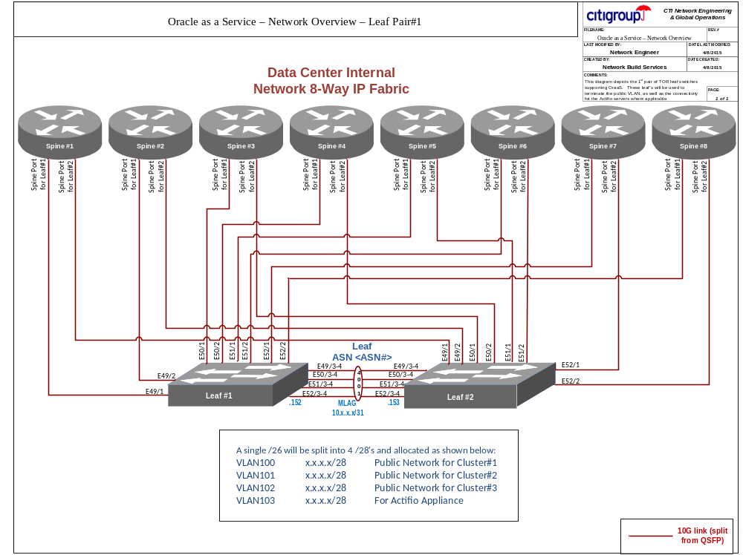

    - The second pair of switches will be used to support both the private VLANs used for Oracle RAC interconnect, as well as the independent VLANs used for ScaleI/O client-side storage. Although I list these switches as a pair, each will reside in their own autonomous system, and each host a unique set of VLANs independently. This configuration is consistent with how other storage client switch pairs are configured in the T++ environments. This also insulates each switch from issues that can occur on the other switch since there is no inter-switch connection or dependency between the switches in this pair. The IP addressing for this TOR leaf pair will come from two areas. The IP Addressing supporting the private VLANs will come out of non-routed RFC1918 space allocated for the data center, and require 6 /28 subnets. Each of the 3 clusters will get 2 /28’s for their private VLANs. These will be split between leaf#3 and leaf#4. All 3 clusters will share a /26 storage client A and a /26 storage client B network. The client storage A network will reside on leaf #3, and the client storage B network will reside on leaf #4.

A network diagram depicting this TOR leaf pair is shown below.

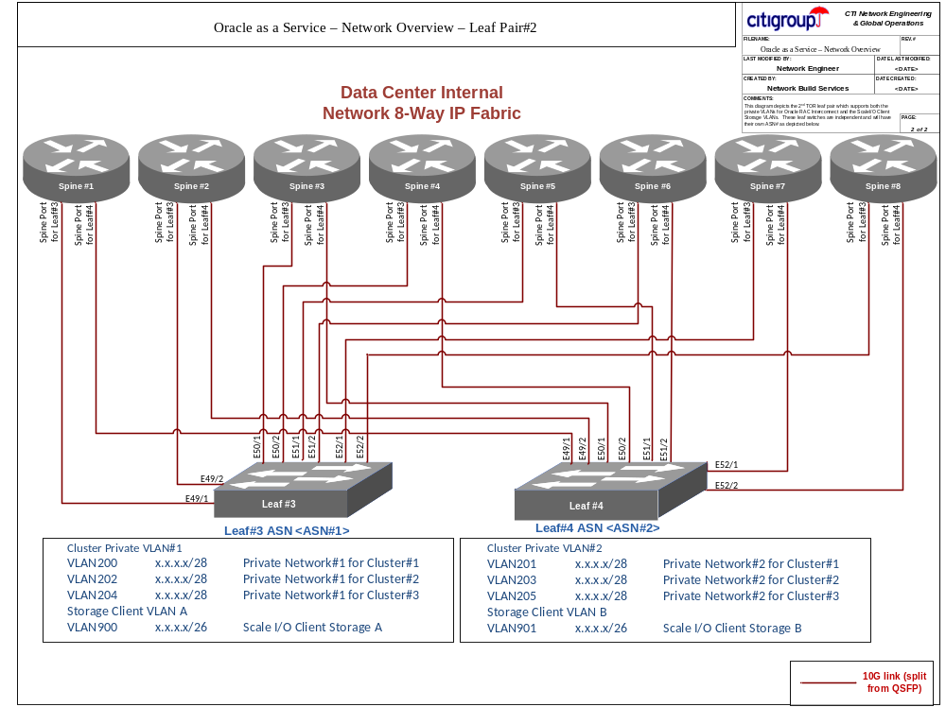

- 3.2.2 Server Connectivity
  - Cluster nodes – each rack will support 3 full 5-node clusters each having 6 10G Ethernet, and 1 1Gbps Ethernet NIC. The 6 10G Ethernet NICs will support connectivity to the Public, Private and Storage Client networks on each leaf pair. To promote riser NIC resiliency, each of these 3 types of networks will be split across the mezzanine, and two onboard PCI NIC adapters as shown in the server cable mapping shown below.

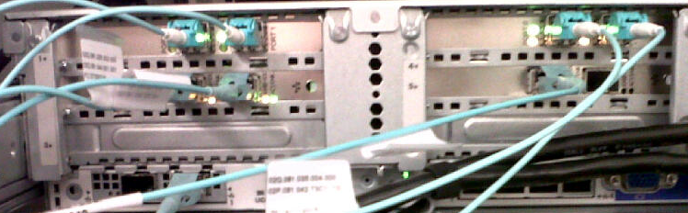

The 10G Ethernet NICs include the 2 mezzanine onboard NICs (OMB.001 and OMB.002), 2 10G PCI NIC Adapter in riser slots 2 and 5 (002.000, 002.001, 005.000 and 005.001). The following primer will be used for each network type on each node for each cluster:

NIC | Leaf Switch | Port | VLAN(s) | Purpose
OMB.001 | Leaf#1 | 1-15 | 100,101,102 (Cluster1,2,3) | Public
OMB.002 | Leaf#3 | 1-15 | 900 | Storage Client A
002.000 | Leaf#2 | 1-15 | 100,101,102 (Cluster1,2,3) | Public
002.001 | Leaf#3 | 16-30 | 200,202,204 (Cluster1,2,3) | Private VLAN#1
005.000 | Leaf#4 | 16-30 | 201,203,205 (Cluster1,2,3) | Private VLAN#2
005.001 | Leaf#4 | 1-15 | 901 | Storage Client B

  - Actifio Appliance – The Actifio appliances require connectivity to a bonded VLAN since their internal configuration uses an Active/Backup NIC layout. Since these appliances will be installed in pairs and support multiple OraaS racks, they will be elevated outside of the OraaS rack, but terminate on ports on the 1st pair of TOR leaf switches in each rack. The diagram below depicts the connectivity for the Actifio appliances.
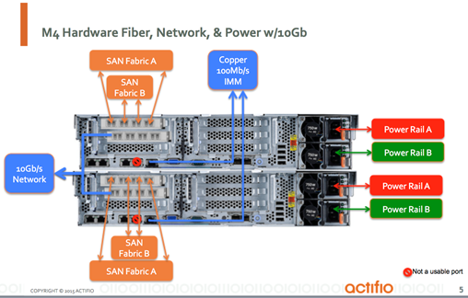

- Network leaf switch configurations - The OraaS environment will prompt the creation of 2 new leaf switch template types. The 1st type will support the 1st TOR leaf pair, and is for the OraaS public and bonded storage client network supporting Actifio. The second switch type will support the 2nd TOR leaf pair supporting Scale I/O Storage Client A/B networks, and Private VLAN for RAC Interconnect. Both of these new template types will provide for fully automated and zero-touch provisioning using CAS. Click here to view the template configurations.

Refer to the applicable tabs (OraaS Public, OraaS Private-Storage) for the configuration templates used by the automation tools.

3.3 Database Build Sheet for System Administrators
Contact: Billy Tong

The database build sheet for System Administrators can be found here.

4. Engineer
Introduction | Order | Assemble | Engineer | Operate

4.1 OraaS Design
Contact: Jim Lynch

Click here to view the OraaS design document, which outlines the servers, network gear, and storage necessary to build an OraaS physical solution.

4.2 Database Engineering
Contact: Billy Tong

Click here to view the Database Engineering document, which outlines how OraaS will be configured.

4.2.1 Actifio CDS
Contact: Simon Davey

The protection for the OraaS databases will be provided by one Actifio Appliance per OraaS POD. This Appliance works by provisioning iSCSI storage to the nodes within the OraaS POD for use by Oracle to create and manage backup ‘snapshots’ via RMAN. The iSCSI storage is provided by Citi SAN storage at the back end. This storage is only visible by the POD nodes via iSCSI.

The Actifio CDS Appliance works in conjunction with a software package, called the connector, installed in the OraaS POD. This will be required on all nodes and will be delivered using the DMA framework. The Oracle instances will manage their data via the connector and the backups will be stored via the Appliance and the SAN.

The Appliance is a two node hardware solution, with each node 2U in size. The location of the Appliance is critical as it needs access to both the SAN fiber channel fabric and the 10Gig IP storage network for iSCSI. The following table summarizes the data center space and connectivity requirements:

 | Actifio CDS Rack Requirements
4U for Actifio CDS Appliance | 2U Rack Mount Node requiring:  2 x 10GbE on Storage IP network (Arista)  2 x 1GbE on GRN network (Cisco)  2 x 16Gb FC SAN (dual fabric)  1 x 100MbE on GRN (Cisco) for ILO/IMM
4U for Actifio CDS Appliance | 2U Rack Mount Node requiring:  2 x 10GbE on Storage IP network (Arista)  2 x 1GbE on GRN network (Cisco)  2 x 16Gb FC SAN (dual fabric)  1 x 100MbE on GRN (Cisco) for ILO/IMM
4U for Actifio CDS Appliance | Notes: Data center location is governed by required access to both SAN fabric and storage IP network. The storage IP network must be accessible to the associated OraaS POD

Storage per Appliance is currently limited to 12TB as per the license purchased. As stated above, this is provided by Citi SAN infrastructure and will need to be allocated in advance. This storage space will be re-provisioned to the POD via iSCSI.

Following the racking of the Appliance, the vendor will come onsite and configure the system so that it is visible to the Citi network and is running the required version of software. From this point, further configuration can be performed over the network. The following tasks will need to be completed before the Appliance is ready for use and will be performed by Citi staff with the assistance of the vendor.

- The Appliance nodes need to be zoned into the Citi fabric following standard practice.
- Both nodes need to be zoned to each other in for cluster heartbeat.
- The Citi SAN storage needs to be provisioned to both nodes via the fabric; this will include a quorum volume.
- The Appliance needs to be configured and tested for active/passive high availability failover.
- Client connectors need to be deployed to the POD hosts for communication with the Appliance
- Clients need to be added and applications ‘discovered’ from the Appliance via the connector.
- Storage for data copies/backups needs to be provisioned to the clients as require via iSCSI

There will be more details available in the Actifio Solutions Document for the relevant storage products, which will be available in late Q4 2015. Currently, data can be protected using the Appliance functionality. This will require the configuration of RMAN and agreement on the protection policies to be applied per database.

5. Operate
Introduction | Order | Assemble | Engineer | Operate
Contact: Billy Tong

5.1 Click here to view the OraaS RACI, which outlines operational tasks and activities related to:

- Apps Objects/Performance
- Automatic Storage Management (ASM)
- Backup & Recovery/COB
- Capacity Planning
- Cluster Ready Services (CRS)
- Database Tenant
- DBaaS Cloud Platform
- Monitoring/Tools
- Incident/Change
- Infrastructure
- Operating System
- Project-Software-Solutioning
- Security

